UNITED STATES
SECURITIES AND EXCHANGE COMMISSION
Washington, D.C. 20549
FORM 10-K
☒ |  |  | ANNUAL REPORT PURSUANT TO SECTION 13 OR 15(d) OF THE SECURITIES EXCHANGE ACT OF 1934
For the fiscal year ended: December 31, 2023
☐ |  |  | TRANSITION REPORT PURSUANT TO SECTION 13 OR 15(d) OF THE SECURITIES EXCHANGE ACT OF 1934
EOS ENERGY ENTERPRISES, INC.
Delaware |  |  |  |  |  | 001-39291 |  |  |  |  |  | 84-4290188
(State or other jurisdiction  of incorporation) |  |  |  |  |  | (Commission  File Number) |  |  |  |  |  | (IRS Employer  Identification No.)
3920 Park Avenue
Edison, New Jersey 08820
(Address of principal executive offices, including zip code)
Registrant’s telephone number, including area code: (732) 225-8400
Securities registered pursuant to Section 12(b) of the Act:
Title of each class |  |  |  |  |  | Trading Symbol(s) |  |  |  |  |  | Name of each exchange on which registered
Common stock, par value $0.0001 per share |  |  |  |  |  | EOSE |  |  |  |  |  | The Nasdaq Stock Market LLC
Warrants, each exercisable for one share of common stock |  |  |  |  |  | EOSEW |  |  |  |  |  | The Nasdaq Stock Market LLC
Indicate by check mark if the registrant is a well-known seasoned issuer, as defined in Rule 405 of the Securities Act. Yes ☐ No ☒

Indicate by check mark if the registrant is not required to file reports pursuant to Section 13 or Section 15(d) of the Act. Yes ☐ No ☒

Indicate by check mark whether the registrant (1) has filed all reports required to be filed by Section 13 or 15(d) of the Securities Exchange Act of 1934 during the preceding 12 months (or for such shorter period that the registrant was required to file such reports), and (2) has been subject to such filing requirements for the past 90 days. Yes ☒ No ☐

Indicate by check mark whether the registrant has submitted electronically every Interactive Data File required to be submitted pursuant to Rule 405 of Regulation S-T during the preceding 12 months (or for such shorter period that the registrant was required to submit such files). Yes ☒ No ☐

Indicate by check mark whether the registrant is a large accelerated filer, an accelerated filer, a non-accelerated filer a smaller reporting company or an emerging growth company. See the definitions of the “large accelerated filer,” “accelerated filer,” “non-accelerated filer,” “smaller reporting company” and “emerging growth company” in Rule 12b-2 of the Exchange Act.

Large accelerated filer |  |  | ☐ |  |  | Accelerated filer |  |  | ☐
Non-accelerated filer |  |  | ☒ |  |  | Smaller reporting company |  |  | ☒
 |  |  |  |  |  | Emerging growth company |  |  | ☐

If an emerging growth company, indicate by check mark if the registrant has elected not to use the extended transition period for complying with any new or revised financial accounting standards provided pursuant to Section 13(a) of the Exchange Act. ☐

Indicate by check mark whether the registrant has filed a report on and attestation to its management’s assessment of the effectiveness of its internal control over financial reporting under Section 404(b) of the Sarbanes-Oxley Act (15 U.S.C. 7262(b)) by the registered public accounting firm that prepared or issued its audit report. Yes ☐ No ☒

If securities are registered pursuant to Section 12(b) of the Act, indicate by check mark whether the financial statements of the registrant included in the filing reflect the correction of an error to previously issued financial statements. ☐

Indicate by check mark whether any of those error corrections are restatements that required a recovery analysis of incentive-based compensation received by any of the registrant’s executive officers during the relevant recovery period pursuant to §240.10D-1(b). ☐

Indicate by check mark whether registrant is a shell company (as defined in Rule 12b-2 of the Act). Yes ☐ No ☒

The aggregate market value of the voting stock held by non-affiliates of the registrant as of the last business day of the registrant’s most recently completed second fiscal quarter, June 30, 2023, was approximately $522.2 million based upon the closing sale price of our common stock of $4.34 on that date. As of February 27, 2024, there were 202,645,716 shares of the registrant’s common stock issued and outstanding.

Table of Contents
 |  |  | Page
Part I |  |  | 1
Item 1. Business |  |  | 3
Item 1A. Risk Factors |  |  | 10
Item 1B. Unresolved Staff Comments |  |  | 32
Item 1C. Cybersecurity |  |  | 32
Item 2. Properties |  |  | 33
Item 3. Legal Proceedings |  |  | 33
Item 4. Mine Safety Disclosures |  |  | 34
Part II |  |  | 34
Item 5. Market for Registrant's Common Equity, Related Stockholder Matters and Issuer Purchases of Equity Securities |  |  | 34
Item 6. [Reserved] |  |  | 34
Item 7. Management's Discussion and Analysis of Financial Condition and Results of Operations |  |  | 34
Item 7A.Quantitative and Qualitative Disclosure about Market Risk |  |  | 47
Item 8. Financial Statements and Supplementary Data |  |  | 48
Item 9. Changes in and Disagreements with Accountants on Accounting and Financial Disclosures |  |  | 48
Item 9A. Controls and Procedures |  |  | 48
Item 9B. Other Information |  |  | 49
Item 9C. Disclosure Regarding Foreign Jurisdictions that Prevent Inspections |  |  | 49
Part III |  |  | 50
Item 10. Directors, Executive Officers and Corporate Governance |  |  | 50
Item 11. Executive Compensation |  |  | 50
Item 12. Security Ownership of Certain Beneficial Owner and Management and Related Stockholder Matters |  |  | 50
Item 13. Certain Relationships and Related Transactions, and Director Independence |  |  | 50
Item 14. Principal Accounting Fees and Services |  |  | 50
Part IV |  |  | 50
Item 15. Exhibits and Financial Statement Schedules |  |  | 50
Item 16. Form 10-K Summary |  |  | 117

Forward-Looking Statements

All statements included in this Annual Report on Form 10-K ("Annual Report"), other than statements or characterizations of historical fact, are forward-looking statements within the meaning of the Private Securities Litigation Reform Act of 1995. The words "anticipate," "believe," "continue," "could," "estimate," "expect," "intends," "may," "might," "plan," "possible," "potential," "predict," "project," "should," "would" and similar expressions, as they relate to us, are intended to identify forward-looking statements. These statements appear in a number of places in this Annual Report and include statements regarding the intent, belief or current expectations of Eos Energy Enterprises, Inc. Forward-looking statements are based on our management’s beliefs, as well as assumptions made by, and information currently available to, them. Because such statements are based on expectations as to future financial and operating results and are not statements of fact, actual results may differ materially from those projected. Factors which may cause actual results to differ materially from current expectations include, but are not limited to:

•changes adversely affecting the business in which we are engaged;
•our ability to forecast trends accurately;

1

•our ability to generate cash, service indebtedness and incur additional indebtedness;
•our ability to raise financing in the future;
•our customers' ability to secure project financing;
•the amount of final tax credits available to our customers or to Eos Energy Enterprises, Inc. pursuant to the Inflation Reduction Act;
•uncertainties around our ability to meet the applicable conditions precedent and secure final approval of a loan in a timely manner or at all from the Department of Energy, Loan Programs Office, or the timing of funding and the final size of any loan if approved;
•the possibility of a government shutdown while we remain in the due diligence phase with the U.S. Department of Energy Loan Programs Office or while we await notice of a decision regarding the issuance of a loan from the Department of Energy Loan Programs Office;
•our ability to develop efficient manufacturing processes to scale and to forecast related costs and efficiencies accurately;
•fluctuations in our revenue and operating results;
•competition from existing or new competitors;
•the failure to convert firm order backlog and pipeline to revenue;
•risks associated with security breaches in our information technology systems;
•risks related to legal proceedings or claims;
•risks associated with evolving energy policies in the United States and other countries and the potential costs of regulatory compliance;
•risks associated with changes to U.S. trade environment;
•risks resulting from the impact of global pandemics, including the novel coronavirus, Covid-19;
•our ability to maintain the listing of our shares of common stock on NASDAQ;
•our ability to grow our business and manage growth profitably, maintain relationships with customers and suppliers and retain our management and key employees;
•risks related to adverse changes in general economic conditions, including inflationary pressures and increased interest rates;
•risk from supply chain disruptions and other impacts of geopolitical conflict;
•changes in applicable laws or regulations;
•other factors detailed under the section entitled “Risk Factors” herein.
More information on these important factors that could cause actual results to differ materially from those projected in the forward-looking statements we make in this Annual Report are set forth in Part I, Item 1A under “Risk Factors”. In addition, there may be other factors of which we are presently unaware or that we currently deem immaterial that could cause our actual results to be materially different from the results referenced in the forward-looking statements.
Forward-looking statements speak only as of the date they are made. Readers are cautioned not to put undue reliance on forward-looking statements, and, except as required by law, the Company assumes no obligation and does not intend to update or revise these forward-looking statements, whether as a result of new information, future events, or otherwise.

2

PART I

ITEM. 1 BUSINESS

General
Eos Energy Enterprises, Inc. (the “Company,” “we,” “us,” “our,” and “Eos”), a Delaware corporation, was originally incorporated in Delaware on June 3, 2019, as a special purpose acquisition company under the name B. Riley Principal Merger Corp. II., in order to acquire a company or companies, through a merger, capital stock exchange, asset acquisition, stock purchase, reorganization or similar business combination. Upon the completion of a business combination on November 16, 2020 (the "Merger"), the Company changed its name to “Eos Energy Enterprises, Inc.” The Company’s common shares started trading under the ticker NASDAQ: EOSE on November 16, 2020.
On April 8, 2021, the Company entered into a unit purchase agreement (the “Purchase Agreement”) with Holtec Power, Inc. (“Holtec”), in accordance with the terms and conditions of which the Company purchased from Holtec the remaining 51% interest in HI-POWER, LLC (“Hi-Power”) that was not already owned by the Company. Hi-Power was incorporated as a joint venture between the Company and Holtec in 2019. In connection with the transaction, the Company also entered into a transition services agreement and a sublease with Holtec. The transaction closed on April 9, 2021. Following the consummation of the transactions set forth in the Purchase Agreement (the “Transactions”), Hi-Power became a 100% indirect, wholly-owned subsidiary of the Company and the obligations of the parties under the Hi-Power joint venture terminated.
The Company designs, develops, manufactures, and markets innovative zinc-based energy storage solutions for utility-scale, microgrid, and commercial & industrial (“C&I”) applications. We believe that our batteries have the potential to emerge as a leading alternative to Lithium-ion (“Li-ion”) batteries for such long-duration applications. The Company has developed a broad range of intellectual property with multiple patents covering unique battery chemistry, mechanical product design, energy block configuration and a software operating system (Battery Management System or "BMS"). The BMS software uses proprietary Eos-developed algorithms and includes ambient and battery temperature sensors, as well as voltage and electric current sensors for the electrical strings and the system. The Company currently focuses on manufacturing and selling turn-key direct current ("DC") battery energy storage systems. The Company plans to develop a turn-key alternating current ("AC") system. The Company’s primary applications focus on integrating battery storage solutions with: (1) renewable energy systems that are connected to the utility power grid; (2) renewable energy systems that are not connected to the utility power grid; (3) storage systems utilized to relieve congestion; and (4) storage systems to assist C&I customers in reducing their peak energy usage or participating in the utilities ancillary and demand response markets. The Company has a manufacturing facility in Turtle Creek, Pennsylvania to produce DC energy blocks with an integrated BMS. The Company’s primary market is North America. The Company has one operating and reportable segment.

Principal Products and Services
The Company offers an innovative Znyth™ technology battery energy storage system ("BESS") designed to provide the operating flexibility to manage increased grid complexity and price volatility resulting from an overall increase in renewable energy generation and a congested grid coming from an increase in electricity demand growth. The Company’s BESS is a validated chemistry with accessible non-precious earth components in a durable design that is intended to deliver results in even the most extreme temperatures and conditions. The system is designed to be safe, flexible, scalable, sustainable and manufactured in the United States, using raw materials primarily sourced in the United States. We believe the Company’s flagship Gen 2.3™ battery module and its newest Z3™ battery module ("Z3") are the core of its innovative systems. The Z3 battery module is the only US designed and manufactured battery module that today provide utilities, independent power producers, renewables developers, and C&I customers with an alternative to lithium-ion and lead-acid monopolar batteries for critical 3- to 12-hour discharge duration applications. We believe the Z3 battery will transform how utility, industrial, and commercial customers store power.

3

In addition to its BESS, the Company currently offers: (a) a BMS which provides a remote asset monitoring capability and service to track the performance and health of the Company’s BESS and to proactively identify future system performance issues through predictive analytics; (b) project management services to ensure the process of implementing the Company’s BESS are coordinated in conjunction with the customer’s overall project plans; (c) commissioning services that ensure the customer’s installation of the BESS meets the performance expected by the customer; and (d) long-term maintenance plans to maintain optimal operating performance of the Company’s systems.

Availability of Raw Materials
While we believe we have sufficient sources for the materials, components, services and supplies used in our manufacturing activities, we are highly dependent on the availability of essential materials, parts and subassemblies from our suppliers. The predominant raw materials that are required for our Z3™ battery product are zinc halide salts, felt, resin, titanium, and conductive polymer.
We use both domestic and international raw materials suppliers to create our Gen 2.3 battery module, as well as the next generation Z3 battery module. We will continue to focus on domesticating our supply chain in an economically sustainable manner.
Additionally, based on the latest Internal Revenue Service ("IRS") guidance, the Company believes that our current Gen 2.3 battery module and our next generation Z3 battery module feature raw materials sourcing sufficient to qualify for the Domestic Content Bonus awarded by the Inflation Reduction Act’s ("IRA") tax credits.

Industry Overview
We believe that energy storage is on the verge of wide-scale global deployment, becoming a critical element of a low-carbon, flexible, resilient future electric grid. In the past several years, there has been a dramatic increase of variable renewable generation in the U.S. power sector, and we expect significant growth in the future. At the same time, there have been significant cost declines in energy storage technologies (particularly batteries) over the past few years, and cheaper energy storage technologies are under development. These converging factors have increased attention on the potential role of energy storage as a critical asset for decarbonization and reliable electricity for the evolving grid. Additionally, there are significant government incentives, such as the recently enacted IRA, that includes significant tax credits, that the Company will benefit from in the near future. See Regulations section in Item 1 - Business.
As batteries increasingly become economical on a levelized cost of storage basis, we believe that utility-scale battery technology will be increasingly beneficial for a variety of solutions, including solar-plus-storage, peaking capacity, grid congestion and wind-plus-storage. We anticipate rapid increases in utility scale, co-located renewable energy-plus-storage projects, especially in the United States, with most near and medium-term installations qualifying as utility scale. By combining a battery with an intermittent renewable energy source, such as wind or solar, the energy stored in the battery can be used when the intermittent source is not available, for example if the wind is not blowing or the sun is not shining.

Strategy
The Company continues to invest in the design, development, and production of its next generation product, the Eos Z3 battery, which builds off the same electrochemistry that has not fundamentally changed for the better part of a decade. The next generation Eos Z3 battery is designed to reduce cost and weight while improving manufacturability and system performance. The Eos Z3 battery is more cost-effective and has a simpler tub design with 50% fewer cells and 98% fewer welds per battery module, compared to Gen 2.3. The Company currently expects the Eos Z3 battery will give customers the benefit of two times the energy density per square foot with the same safety and reliability as the previous generation battery. The Eos Z3 transition is fully underway, and the first semi-automated battery manufacturing line is installed and has started commercial production. Eos Z3 batteries utilize the same chemistry, which has over 3 million cycles, and incorporate a new mechanical design aimed at improving performance, lowering cost and increasing manufacturability.

4

The Company started delivery of its Z3™ battery modules in the third quarter of 2023. The Z3 battery incorporates valuable lessons learned from the past 15 years into a new system design which the Company expects to result in efficiencies as it develops its new state-of-the-art manufacturing line.
The Company believes the simplicity, flexibility, and safety of our products are what the market desires. In addition, we understand that the Inflation Reduction Act gives us a competitive advantage with production tax credits (“PTC”) that can be claimed on battery components manufactured domestically, in addition to a tax credit for customers for projects that satisfy domestic content requirements. See Regulations section in Item 1 - Business. The Company intends to engage with a consortium of community leaders, universities, and supply chain partners in anticipation of pursuing grants made available under the Bipartisan Infrastructure Law of 2021.
Market Trends and Opportunities
The Company believes the world wants to generate energy with sustainable renewable energy sources, however this objective creates imbalances in the existing energy grid. Managing and mitigating those imbalances will require multiple energy storage technologies to provide safe and reliable power. Until now, most energy storage systems have been in short durations, meaning they have reliably provided power for less than four hours. The Company believes the future will require mid-duration (6-12 hour) BESS that provide the flexibility to match intermittency and congestion. The Z3 battery is predominantly composed of five earth-abundant, readily available raw materials with mature supply chains that allow the Company to drive cost down as it scales up production.
Li-ion batteries are the prevailing form of stationary energy storage. This is primarily driven by Electric Vehicles ("EV"), since lithium is one of the key components in EV batteries. According to the Benchmark Source, the lithium industry needs to invest $116 billion by 2030 if the world is to meet the ambitions targets set by governments and the largest automakers. The analysis's high case scenario, which encompasses data from Rho Motion on automakers’ passenger EV targets as well as data from the International Energy Agency on enacted country-level policies, would require 5.3 million tonnes of lithium carbonate equivalent in production today, and we believe the result will be a supply shortage, causing increase in lithium prices.

Intellectual Property
The success of our business depends, in part, on our ability to maintain and protect our proprietary technology, information, processes and know-how. We rely primarily on patent, trademark, copyright and trade secret laws in the United States and similar laws in other countries, confidentiality agreements and procedures and other contractual arrangements. These patents are subject to regulatory approval by the respective governing entity where the patent was filed. A majority of our patents relate to cell chemistry, architecture and battery mechanical design, system packaging and BMS. We continually assess opportunities to seek patent protection for those aspects of our technology, design, methodologies and processes that we believe provide significant competitive advantages.
The Company periodically assesses its patent portfolio in relation to the patents’ utility and materiality to the current operation and future strategy of the business and abandons applications or ceases to maintain patents which are deemed immaterial to our current or future business operations. As of December 31, 2023, we have 23 patent families and 122 patents pending, issued, or published in 28 countries, protecting our technology and system architecture. The Company's key patents, related to its most recent generation product and future products, are not scheduled to expire until 2035 or later.
In addition, the Company relies on trade secret protection and confidentiality agreements to safeguard our interests with respect to proprietary know-how that is not patentable and processes for which patents are difficult to enforce. We believe that many key elements of our manufacturing processes involve proprietary know-how, technology or data that are not covered by patents or patent applications, including technical processes, test equipment designs, algorithms and procedures. All of our research and development personnel have entered into confidentiality and proprietary information agreements with us. These agreements address intellectual property protection issues and requires our employees to assign to us all of the inventions, designs and technologies that Company personnel develop during the course of their employment. We also require our customers and business partners to enter into confidentiality agreements before we disclose any sensitive aspects of our technology or business plans.

5

Regulations

Governmental Programs and Incentives
Globally, both the operations of our business by us and the ownership of our products by our customers are impacted by various government programs, incentives and other arrangements.
U.S. Department of Energy's (DOE) Renewable Energy Project and Efficient Energy Loan Program
In August 2023, the DOE issued a Conditional Commitment Letter to the Company for a loan of an aggregate principal amount of up to $398.6 million through the DOE’s Clean Energy Financing Program. The Conditional Commitment Letter follows an extensive technical, financial and commercial due diligence process by the DOE. If finalized, the loan is expected to fund 80% of eligible costs of the Company’s planned manufacturing expansion in Turtle Creek, Pennsylvania.
Eligible costs include capital expenditures and other costs associated with ramping up the manufacturing lines and facility, for example start-up and shakedown costs, as well as certain material and labor costs before efficiencies are met. The Company is working to finalize the loan documents with the DOE and to fulfill certain conditions precedent. Eos is spending eligible costs now that would be reimbursable at first funding.
Inflation Reduction Act of 2022
On August 16, 2022, President Biden signed the Inflation Reduction Act of 2022 into law. The IRA has significant economic incentives for both energy storage customers and manufacturers for projects placed in service after December 31, 2022. One of the most important features of the IRA is that it offers a 10-year term tax credit, whereas historically similar industrial credits have been shorter in duration. Customers placing new energy storage facilities in service, which include our Gen 2.3 and Z3™ BESS, could qualify for investment tax credit (“ITC”). The IRA also offers an extra ten percent credit if the project is in an “energy community” and another ten percent credit if the project satisfies domestic content requirements, which will be set forth when the implementing regulations are finalized. The ten percent bonus for domestic content could represent a strategic advantage for the Company resulting from the Company’s near-sourcing and Made in America strategy, and we currently anticipate that projects utilizing Eos batteries will qualify for the bonus.
Starting in 2023, there are Production Tax Credits under Internal Revenue Code 45X (“PTC”), that can be claimed on battery components manufactured in the U.S. and sold to U.S. or foreign customers. These tax credits available to manufacturers include a credit for ten percent of the cost incurred to make electrode active materials in addition to credits of $35 per kWh of capacity of battery cells and $10 per kWh of capacity of battery modules. These credits are cumulative, meaning that companies will be able to claim each of the available tax credits based on the battery components produced and sold through 2029, after which the PTC will begin to gradually phase down through 2032. In June 2023, the IRS issued temporary and proposed regulations related to applicable tax credit transferability and direct pay provisions of the Inflation Reduction Act. The Company has reviewed these regulations and believes they do not have a material impact on the financial statements.
These credits are expected to be a new source of cash flow for Eos in the future.

Competition
The markets for our products are competitive, and we compete with manufacturers of traditional Li-ion and other battery storage systems. Factors affecting customers when choosing from different battery storage systems in the market include:
•product performance and features;
•safety and sustainability;
•total lifetime cost of ownership;
•total operational costs related to auxiliary equipment;

6

•total product lifespan and degradation rate;
•power and energy efficiency;
•duration of the battery's storage;
•customer service and support; and
•U.S.-based manufacturing and sourced materials.
Our Znyth™ battery system competes with products from traditional Li-ion battery manufacturers and solution providers such as Panasonic, Samsung Electronics Co., Ltd, LG Chem, Ltd., Tesla, BYD, Sungrow, and Contemporary Amperex Technology Co. Limited. Our longer duration competitors include ESS Inc., Enervenue, Ambri, Form Energy, and Lockheed Martin. We believe that our current and next generation battery system offers significant technology, safety and cost advantages that reflect a competitive differentiation over Li-ion storage technologies.

Competitive Strengths
We believe the following strengths of our business distinguish us from our competitors and position us to capitalize on the expected continued growth in the energy storage market:
•Differentiated Product- Lithium cells must be kept within a narrow temperature range (25 °C +/- 5 °C), otherwise they are at risk of thermal runaway, potentially leading to fire or explosion. The Znyth™ BESS has a significantly wider thermal operating range (-20°C to 50°C), which eliminates the need for costly thermal management measures such as HVAC and fire suppression systems. Additionally, the product is a static modular battery design, which eliminates the need for pumps or compressors, both maintenance prone equipment required for flow batteries. Our battery system can charge and discharge at different durations, covering a wide range of use cases. The charge and discharge rates are fixed for Li-ion, and the life of a Li-ion battery can degrade if it is not charged or discharged at the rate for which it was designed, while the Eos Znyth technology BESS is not subject to the same degradation. This is because Eos batteries are manufactured at zero voltage and a zero percent state of charge, whereas Li-ion batteries must be kept at a specific voltage and state of charge even when not actively being used.
•Minimal Supply Chain Constraints- All materials for producing our Gen 2.3 and next generation Z3™ battery products are widely available commodities with fewer supply chain constraints and minimal competition from electric vehicles. Additionally, the majority of the materials are recyclable at end of product life, helping preserve the environment.
•Proven Technology Solution in the Growing and Evolving Energy Storage Market- As we launch the Z3 battery and ramp up manufacturing to gigawatt-hours (“GWh”) scale, we believe that we will benefit from the overall growth of the energy storage market, which is expected to reach 1,095 GWh by 2040, as projected by BNEF. From an application perspective, the market is evolving to a LDES market. Our technology is tailored to address such a need. While Li-ion has been optimized for shorter duration, the performance of our batteries improves as it moves towards longer duration, making us the prime technology for the long-duration storage market.
•Experienced Technology Team Focused on Continuous Innovation- Our research and development team is responsible for growing and advancing our intellectual property portfolio, protecting our technology and system architecture. We believe that our continued investment in research and development will enable us to improve efficiency, energy density, functionality, and reliability while reducing the cost of our battery solution. We are also focused on leveraging our technology know-how to improve our BMS, expanding the operation of our batteries and increasing our overall performance. This same leverage would allow us to optimize our energy management solution to contextualize the operation of the battery based on the application, expanding our customers' ability to use our Znyth™ BESS in a wider set of use-cases.

7

•Established Global Sales Channels Anchored with Top-Tier Customers- We sell products directly to the electric utility industry and through sales channels to the commercial and industrial market. We continue to build relationships with new customers and enter into agreements to provide battery solutions to new customers.
•Strong management team- We have assembled an executive team focused on accelerating the commercialization of the next-generation Z3™ battery product. With decades of combined, diverse experience in the energy industry and deep expertise in manufacturing, battery storage and executing complex power and energy projects around the world, our management team is able to develop, manufacture and deliver systems at scale to meet the growing demands of the global storage market.

Customers
Our customers include the following:
•Renewable power producers and developers.
•Industrial companies.
•Microgrid developers.
During fiscal year 2023, two customers individually accounted for 49.9% and 45.2%, respectively, of our total revenue.

Environmental, Social and Governance ("ESG")
Since our founding, the Company has been on a mission to accelerate the shift to clean energy by transforming how the world stores power in a safe, scalable, efficient, and sustainable way. We are committed to advancing global sustainable development through our products, working to systematically grow our business to meet the challenges of the global energy transition and combat the global climate crisis. Additionally, the Company has not incurred significant costs to remain in compliance with environmental laws.
Our approach to ESG is intrinsically united to our four product themes: safety, scalability, sustainability, and efficiency. As we continue to scale, we remain committed to driving progress across these themes.

Human Capital
The table below represents our 2023 employees by gender* and ethnicity as a percentage of total headcount across non-exempt and exempt positions:
 |  |  | By Gender |  |  |  |  |  |  |  |  | By Ethnicity
 |  |  | Female |  |  | Male |  |  |  |  |  | African American |  |  | Asian |  |  | Hispanic or Latino |  |  | Two or more races |  |  | White
Non-exempt |  |  | 7 |  | % | 43 |  | % |  |  |  | 24 |  | % | 2 |  | % | 2 |  | % | 2 |  | % | 20 |  | %
Exempt |  |  | 13 |  | % | 37 |  | % |  |  |  | 5 |  | % | 7 |  | % | 4 |  | % | 1 |  | % | 33 |  | %
Total |  |  | 20 |  | % | 80 |  | % |  |  |  | 29 |  | % | 9 |  | % | 6 |  | % | 3 |  | % | 53 |  | %
*While we present male and female, we acknowledge this is not fully encompassing of all gender identities.
As of December 31, 2023, we had 420 total employees, all of which are full-time employees. None of our employees are represented by a labor union. We have not experienced any employment-related work stoppages, and we consider relations with our employees to be good.
Our success is based on the focused passion and dedication of our personnel. We are committed to providing a positive and engaging work environment for our employees and taking an active role in the betterment of the communities in which our employees live and work. Our full-time employees are provided a competitive benefits program, including comprehensive healthcare benefits, a 3% non-elective employer contribution 401(k) plan, equity awards, discretionary bonus and incentive pay opportunities, paid time-off benefits, paid parental leave, wellness programs, and periodic surveys.

8

Available Information
Our Annual Report on Form 10-K, Quarterly Reports on Form 10-Q, Current Reports on Form 8-K and all amendments to these reports filed or furnished pursuant to Section 13(a) or 15(d) of the Securities Exchange Act of 1934 (the "Exchange Act") are available free of charge on our investor website, located at https://investors.eose.com/, as soon as reasonably practicable after they are filed with or furnished to the Securities and Exchange Commission. Our reports are also available on the Securities and Exchange Commission's website at https://www.sec.gov/. The information on our website is not, and shall not be deemed to be, a part hereof or incorporated into this or any of our other filings with the SEC.

9

ITEM 1A. RISK FACTORS
In addition to the factors discussed elsewhere in this Report, the following risks and uncertainties could materially and adversely affect the Company’s business, financial condition, results of operations, and cash flows.

Risk Factors Summary
The following is a summary of the principal risks that could adversely affect our business, operations and financial results.

Risks Related to Our Business and Industry
•We have a history of losses that casts substantial doubt as to our ability to continue as a going concern. We must deliver on our potential for significant business growth and improved manufacturing processes to achieve sustained, long-term profitability and long-term commercial success.
•We believe our ability to utilize our net operating loss carryforwards will likely be substantially limited as a result of an “ownership change,” as defined in Section 382 of the Internal Revenue Code of 1986, as amended.
•We identified material weaknesses in our internal controls over financial reporting, and we may identify additional material weaknesses in the future that may cause us to fail to meet our reporting obligations or result in material misstatements of our financial statements. If we do not effectively remediate these material weaknesses or if we otherwise fail to maintain effective internal controls over financial reporting, we may not be able to accurately and timely report our financial results.
•Our business and financial results have and may continue to be adversely affected by the effects of sustained inflation and increased interest rates.
•Current market conditions and recessionary pressures in one or more of our markets could impact our ability to grow our business.
•The relatively recent commercialization of our products makes it difficult to evaluate our prospects.
• Failure to deliver the benefits offered by our technologies, or the emergence of improvements to competing technologies, could reduce demand for our products and harm our business.
•A decline in lithium prices may result in increased competition from traditional lithium-ion batteries and adversely affect the demand for our products.
•As we endeavor to expand our business, we will incur significant costs and expenses, which could outpace our cash reserves. Unfavorable conditions or disruptions in the capital and credit markets may adversely impact business conditions and the availability of credit.
•Our success depends on the continuing contributions of our key personnel, and the loss of services of any principal member of our management team could adversely affect our business.
•The failure or breach of our network or IT systems, including as a result of a cybersecurity breach, could affect our sales and operations.
•Internal system or service failures, or failures in the systems or services of third parties on which we rely, could disrupt our business and impair our ability to effectively provide our services and products to our customers, which could damage our reputation and adversely affect our business.
•The nature of our business exposes us to potential legal proceedings or claims that could adversely affect our operating results. These claims could conceivably exceed the level of our liability insurance coverage.
•Labor disputes could disrupt our ability to serve our customers and/or lead to higher labor costs.
Risks Related to Our Products and Manufacturing
•We must obtain Underwriters Laboratories and other related certifications for our future generations of our products.
•Compared to traditional Li-ion energy storage technologies, our cells and modules have less power density and round trip efficiency and may be considered inferior to competitors’ products.
•We have limited manufacturing experience and could experience difficulty producing commercial volumes of the battery storage system, establishing manufacturing capacity to scale and in meeting potential cost savings and efficiencies from anticipated improvements to our manufacturing capabilities.
•We may experience delays, disruptions, or quality control problems in our manufacturing operations.
•We may not have sufficient insurance coverage to cover business continuity.

10

•Defects or performance problems in our products could result in loss of customers, reputational damage, and decreased revenue, facing warranty, indemnity, and product liability claims that may arise from defective products.
•We are heavily dependent on third-party suppliers and contractors. Supply chain issues could adversely affect our operations and financial results.
•If we elect to expand our production capacity by constructing one or more new manufacturing facilities, we may encounter challenges relating to the construction, management and operation of such facilities.
•We could incur substantial costs as a result of violations of, or liabilities under, environmental laws.
•Increased scrutiny from stakeholders and regulators regarding ESG practices and disclosures, including those related to sustainability and related disclosures could result in additional costs and risks.

Risks Related to Our Future Growth
•If we fail to manage our recent and future growth effectively, we may be unable to execute our business plan, maintain high levels of customer service, or adequately address competitive challenges.
•Our growth prospects depend on our ability to capitalize on market opportunities.
•We will require additional financing to achieve our long-term goals and a failure to obtain this capital on acceptable terms, or at all, may adversely impact our ability to support our business growth strategy.
•If we fail to meet the covenants in our Senior Secured Term Loan Credit Agreement, we may be subject to default on the loan, which could have a material adverse effect on our business.
•Our planned expansion into new geographic markets or new product lines or services could subject us to additional business, financial, and competitive risks.
•Our results of operations may fluctuate from quarter to quarter, which could make our future performance difficult to predict and could cause our results of operations for a particular period to fall below expectations, resulting in a decline in the price of our common stock.

Risks Related to Our United States Operations
•The reduction, elimination or expiration of government subsidies and economic incentives related to renewable energy solutions could reduce demand for our technologies and harm our business.
•Changes in the U.S. trade environment, including the imposition of import tariffs, could adversely affect the amount or timing of our revenues, results of operations or cash flows.
•We have operations in the United States, which exposes us to multiple federal, state and local regulations.
•Changes in applicable law, regulations or requirements, or our material failure to comply with any of them, can increase our costs and have other negative impacts on our business.
•We are subject to complex and evolving laws, regulations, rules, standards and contractual obligations regarding data privacy and cybersecurity, which could increase the cost of doing business, compliance risks and potential liability.
•We could be adversely affected by any violations of the FCPA, the U.K. Bribery Act, and other foreign anti-bribery laws, as well as violations against export controls and economic embargo regulations.

Risks Related to Intellectual Property
•If we fail to protect, or incur significant costs in defending, our intellectual property and other proprietary rights, then our business and results of operations could be materially harmed.
•Third parties may assert that we are infringing upon their intellectual property rights, which could divert management’s attention, cause us to incur significant costs, and prevent us from selling or using the technology to which such rights relate.

Risk Related to Our Securities
•To the extent that any shares of common stock are issued upon exercise of any of the warrants, the number of shares eligible for resale in the public market would increase.
•Provisions in our third amended and restated certificate of incorporation of the Company (the “Charter”) and Delaware law may have the effect of discouraging lawsuits against our directors and officers.
•Provisions in our Charter may inhibit a takeover of us, which could limit the price investors might be willing to pay in the future for our common stock and could entrench management.
•Our stock price may be volatile and may decline regardless of our operating performance.
•Future resales of our common stock may cause the market price of our securities to drop significantly, even if our business is doing well.

11

•There can be no assurance that our common stock will be able to comply with the continued listing standards of Nasdaq.
•We do not intend to pay dividends on our common stock in the foreseeable future and, consequently, your ability to achieve a return on your investment will depend on appreciation in the price of our common stock.
•We are a “smaller reporting company” and, because we have opted to use the reduced reporting requirements available to us, certain investors may find investing in our securities less attractive.

Risk Factors

An investment in our securities involves a high degree of risk. You should carefully consider the risks described below before making an investment decision. Our business, prospects, financial condition, or operating results could be harmed by any of these risks, as well as other risks not known to us or that we consider immaterial as of the date of this Form 10-K. The trading price of our securities could decline due to any of these risks, and, as a result, you may lose all or part of your investment.

Risks Related to Our Business and Industry

We have a history of losses that casts substantial doubt as to our ability to continue as a going concern. We must deliver on our potential for significant business growth and improved manufacturing processes to achieve sustained, long-term profitability and long-term commercial success.
We have had net losses and negative operating cash flows each fiscal quarter since inception of our business. For the years ended December 31, 2023 and 2022, we had $229.5 million and $229.8 million in net losses, respectively. We expect to continue to incur losses and experience negative operating cash flows for the foreseeable future, as we anticipate continued investment in the development and launch of product with outside capital at the expense of short-term profitability. For the fiscal year ended December 31, 2023, the Company concluded that there was substantial doubt about its ability to continue to operate as a going concern for the 12 months following the issuance of these consolidated financial statements.
Although our available capital has increased substantially since our Merger through the issuance of convertible notes and other financing, we continue to have limited resources relative to certain of our competitors, especially certain Li-ion manufacturers that have a longer history, are part of large multinational corporations and are already operating at a profit. To achieve profitability as well as long-term commercial success, we must continue to execute our plan to expand our business, which will require us to deliver on our existing global sales pipeline in a timely manner, increase our production capacity, improve our cost profile, grow demand for our products, and seize new market opportunities by leveraging our proprietary technology and its manufacturing processes for novel solutions. Failure to do one or more of these things could prevent us from achieving sustained, long-term commercial success.
As a growth company in the early commercialization stage of its lifecycle, Eos is subject to inherent risks and uncertainties associated with the development of an enterprise. Our revenues may not grow as expected for a number of reasons, many of which are outside of our control, including a decline in global demand for battery storage products, increased competition, or our failure to continue to capitalize on growth opportunities. In addition, although we have achieved sales of our products to potential customers, it is not clear to what extent, if any, the products will be profitable and when. The costs of goods associated with production of our battery storage system are significant. While we are working to optimize our supply chain, improve the speed and efficiency of our manufacturing processes, and lower the cost of other input costs such as raw material and conversion costs, there can be no assurance that we will be successful in these efforts. If we are not able to sustain revenue growth, reduce cost and continue to raise the capital necessary to support operations, our failure to achieve or maintain profitability could negatively impact the value of our common stock. Even if we do achieve profitability when expected, we may be unable to sustain or increase our profitability in the future.

12

In order to execute our development strategy, we have historically relied on outside capital through the issuance of equity, debt, and borrowings under financing arrangements (collectively “outside capital”) to fund our cost structure and expect to continue to rely on outside capital for the foreseeable future. While we believe we will eventually reach a scale of profitability to sustain our operations, there can be no assurance we will be able to achieve such profitability or do so in a manner that does not require our continued reliance on outside capital. Moreover, while we have historically been successful in raising outside capital, there can be no assurance we will be able to continue to obtain outside capital in the future or do so on terms that are acceptable to us.
We believe our ability to utilize our net operating loss carryforwards will likely be substantially limited as a result of an “ownership change,” as defined in Section 382 of the Internal Revenue Code of 1986, as amended.
As of December 31, 2023 and 2022, we had approximately $638.5 million and $485.4 million of net operating loss (“NOL”) carryforwards for U.S. federal tax purposes. Under U.S. federal income tax law, we generally would be able to use our NOL carryforwards (and certain related tax credits) to offset ordinary taxable income, thereby reducing our U.S. federal income tax liability, for up to 20 years from the year in which the losses were generated, after which time they will expire. In addition, as of December 31, 2023 and 2022, we had approximately $228.3 million and $235.7 million in state NOL carryforwards (and certain related tax credits) which generally would be useable to offset future state taxable income for approximately 20 years from the year in which the losses are generated, depending on the state, after which time they will expire.
The rate at which we are able to utilize our NOL carryforwards will become subject to a limitation that can be very significant (and that will result in our NOL carryforwards expiring prior to their use) when we experience an “ownership change,” as determined under Section 382 of the Internal Revenue Code. A Section 382 ownership change generally occurs if a stockholder or a group of stockholders who are deemed to own at least 5% of our common stock increase their ownership by more than 50 percentage points over their lowest ownership percentage within a rolling three-year period. If an ownership change occurs, Section 382 generally would impose an annual limit on the amount of post-ownership change taxable income that may be offset with pre-ownership change NOL carryforwards equal to the product of the total value of our outstanding equity immediately prior to the ownership change (reduced by certain items specified in Section 382) and the U.S. federal long-term tax-exempt interest rate in effect at the time of the ownership change. A number of special and complex rules apply in calculating this Section 382 limitation.
While the complexity of Section 382 makes it difficult to determine whether and when an ownership change has occurred, and a formal study has not been performed, we believe that a Section 382 ownership change likely has occurred or will occur as a result of our capital raising efforts through equity financings during fiscal years 2022 and 2023. We believe this Section 382 limitation will likely substantially reduce the amount of federal and state NOLs that may be used by us before they expire. In addition, our ability to use our NOL carryforwards also is limited to the extent we fail to generate enough taxable income in the future before they expire. Existing and future Section 382 limitations and our inability to generate enough taxable income in the future could result in a substantial portion of our NOL carryforwards expiring before they are used. We have recorded a full valuation allowance for our deferred tax assets.

We identified material weaknesses in our internal controls over financial reporting and we may identify additional material weaknesses in the future that may cause us to fail to meet our reporting obligations or result in material misstatements of our financial statements. If we do not effectively remediate these material weaknesses or if we otherwise fail to maintain effective internal controls over financial reporting, we may not be able to accurately and timely report our financial results.

13

Our management is responsible for establishing and maintaining adequate internal controls over financial reporting designed to provide reasonable assurance regarding the reliability of financial reporting and the preparation of financial statements for external purposes in accordance with GAAP. Our management is likewise required, on a quarterly basis, to evaluate the effectiveness of our internal controls and to disclose any changes and material weaknesses identified through such evaluation in those internal controls. A material weakness is a deficiency, or a combination of deficiencies, in internal controls over financial reporting, such that there is a reasonable possibility that a material misstatement of our annual or interim financial statements will not be prevented or detected on a timely basis.
Our management identified material weaknesses in our internal controls over financial reporting as of December 31, 2023 and 2022. See Item 9A, “Controls and Procedures,” in this Annual Report for information regarding the identified material weaknesses and our actions to date to remediate the material weaknesses. As a result of these material weaknesses, our management has concluded that our internal controls over financial reporting were not effective as of December 31, 2023.
We are taking steps to remediate these material weaknesses, which include hiring personnel with the depth of knowledge and experience to join our accounting and finance organization, and designing and implementing improved processes and internal controls. However, our efforts to remediate these material weaknesses may not be effective in preventing a future material weakness or significant deficiency in our internal controls over financial reporting. If we do not effectively remediate these material weaknesses or if we otherwise fail to maintain effective internal controls over financial reporting, we may not be able to accurately and timely report our financial results, which could cause our reported financial results to be materially misstated, result in the loss of investor confidence and cause the market price of our common stock to decline.
We can give no assurance that the measures we have taken or plans to take in the future will remediate the material weaknesses identified or that any additional material weaknesses or restatements of financial results will not arise in the future due to a failure to implement and maintain adequate internal controls over financial reporting or circumvention of these controls.
Our business and financial results have and may continue to be adversely affected by the effects of sustained inflation and increased interest rates.
Inflation has the potential to adversely affect our liquidity, business, financial condition and results of operations by increasing our overall cost structure, particularly if we are unable to achieve commensurate increases in the prices that we charge our customers. The existence of sustained inflation in the economy has resulted in, and may continue to result in, higher interest rates and capital costs, increased shipping costs, supply shortages, increased costs of labor, weakening exchange rates and other similar effects. As interest rates rise or remain elevated to address inflation or otherwise, we may experience further increases in capital and other costs. Further, changes in monetary or other policies here and abroad to combat inflation may lead to an economic downturn in some of our markets. Although we may take measures to mitigate the impact of this inflation, if these measures are not effective, our business, financial condition, results of operations and liquidity could be materially adversely affected. Even if such measures are effective, the benefits of such measures may not be realized until after the costs of inflation have been incurred.
Current market conditions and recessionary pressures in one or more of our markets could impact our ability to grow our business.

14

Over the last few years in the U.S. and globally, market and economic conditions have been challenging. Any negative impact on economic conditions and international markets, continued volatility or deterioration in the debt and equity capital markets, inflation, deflation or other adverse economic conditions may adversely affect our liquidity and financial condition. It may limit our ability to access the capital markets to meet liquidity and/or capital needs, which could have a material adverse effect on our financial condition and results of operations. Ongoing uncertain economic and financial market conditions may also adversely affect the financial condition of our customers, suppliers and other business partners. When our customers’ financial conditions are adversely affected, it could materially and adversely affect our sales and financial results, which could have a material adverse effect on our business, financial condition, cash flows and results of operations and could cause the market value of our common shares to decline. Our global business may be negatively affected by local economic conditions, including inflation, increasing labor costs, potential recession, and currency exchange rate fluctuations, which could adversely affect our cost to manufacture and provide our products and services and revenues generated through sales of such products and services. There is no guarantee that we will be able to fully absorb any such additional costs or revenue declines in the prices for our products and services.
The relatively recent commercialization of our products makes it difficult to evaluate our future prospects.
Since our inception, we have sold a limited quantity of Eos Znyth™ DC battery systems to our customers. We began commercializing our products in mid-2018, and while our research and development activities successfully established the efficiency of our chemistry, we struggled to incorporate our proven technologies into an effective manufacturing design prior to 2018.
We continue to invest in the design and development of the next generation product, the Z3™ battery which builds off the same electrochemistry that has not fundamentally changed for the better part of a decade. The Z3 battery is designed to reduce cost and weight and improve manufacturability and system performance. The Eos Z3 transition is fully underway, and the first semi-automated battery manufacturing line is installed and has started commercial production. The Company started delivery of its Z3 battery modules in the third quarter of 2023.
Our success will depend on our ability to manufacture products at scale and low cost while timely meeting customers’ demands and overcome any negative perception in the market related to our historical manufacturing challenges, and we may not be able to generate sufficient customer confidence in our latest designs and ongoing product improvements and lower the cost due to economies of scale. Our inability to predict the extent of customer adoption of our proprietary technologies in the already-established traditional energy storage market makes it difficult to evaluate our profitability and future prospects.
Failure to deliver the benefits offered by our technologies, or the emergence of improvements to competing technologies, could reduce demand for our products and harm our business.
We believe that, compared to Li-ion batteries, our energy storage solutions offer significant benefits, including the use of widely-available and low-cost materials with no rare earth or toxic components, recyclability at end-of-life, an over twenty (20) year product life requiring minimal maintenance, and a wide thermal operating range that eliminates the need for fire suppression and HVAC, which would otherwise be required for use with Li-ion batteries.
The rates at which electricity is available from a customer’s local electric utility company is subject to change and any changes in such rates may affect the relative benefits of our energy storage systems. Further, if our manufacturing costs do not decrease to the extent we intend, or if our expectations regarding the operation, performance, maintenance and disposal of our products are not realized, we could have difficulty marketing our products as a superior alternative to already-established technologies and impact the market reputation and adaptability of our products. Developments of existing and new technologies could improve their cost and usability profile, reducing any relative benefits currently offered by our products which would negatively impact the likelihood of our products gaining market acceptance.
A decline in lithium prices may result in increased competition from traditional lithium-ion (“Li-ion”) batteries and adversely affect the demand for our products.

15

Currently, global lithium available supply exceeds demand. Decreases in the price of lithium, a key component of traditional Li-ion batteries, may increase the competitiveness of the traditional Li-ion batteries relative to the zinc-based energy storage solutions we provide. Mineral prices fluctuate widely and are affected by numerous factors beyond our control such as global and regional supply and demand, interest rates, exchange rates, inflation or deflation, fluctuation in the value of the United States dollar and foreign currencies, and the political and economic conditions of mineral-producing countries throughout the world. The exact effect of these factors cannot be accurately predicted, but the combination of these factors may result in a decrease in lithium prices, which may adversely affect our business and results of operations.
As we endeavor to expand our business, we will incur significant costs and expenses, which could outpace our cash reserves. Unfavorable conditions or disruptions in the capital and credit markets may adversely impact business conditions and the availability of credit.
We expect to incur additional costs and expenses in the future related to the continued development and expansion of our business, including in connection with expanding our manufacturing capabilities to significantly increase production capacity, developing our products, maintaining and enhancing our research and development operations, expanding our sales, marketing, and business development activities in the United States and internationally, and growing our project management, field services and overall operational capabilities for delivering projects. We do not know whether we will be able to reduce our manufacturing cost and grow our revenue rapidly enough to absorb these costs or the extent of these expenses or their impact on our results of operations.
Disruptions in the global capital and credit markets as a result of an economic downturn, economic uncertainty, changing or increased regulation, or failures of significant financial institutions could adversely affect our customers’ ability to access capital and could adversely affect our access to liquidity needed for business in the future. Our business could be hurt if we are unable to obtain additional capital as required, resulting in a decrease in our revenues and profitability.
Our success depends on the continuing contributions of our key personnel, and the loss of services of any principal member of our management team could adversely affect our business.
We rely heavily on the services of our key executive officers. We are investing significant resources in developing new members of management as we complete our restructuring and strategic transformation, and the loss of services of any principal member of our management team could adversely affect our business. The competition for qualified personnel is intense in our industry, and we may not be successful in attracting and retaining enough qualified personnel to support our anticipated growth. We also cannot guarantee that any employee will remain employed with us for any definite period since all of our employees, including our key executive officers, serve at-will and may terminate their employment at any time for any reason.
The Company’s Compensation Committee of the Board of Directors is committed to working with the management to design compensation plans that attract, retain and motivate the Company’s executives and support business objectives that create shareholder value. In addition, the Board of Directors has implemented procedures to plan for the effective succession of senior management and key personnel. However, we still depend on the experience of our senior management team, including our chief executive officer, chief financial officer and chief accounting officer, and other key personnel, each of whom would be difficult to replace in the event of an unforeseen departure from the Company. Despite successfully managing recent turnover, the loss of any such personnel could have a material adverse effect on our business and our ability to implement our business strategy. All of our employees, including our senior management, are free to terminate their employment relationships with us at any time. We do not maintain key-person insurance for any of our employees, including senior management. In addition, changes and replacement, as well as transition in senior executive leadership could adversely affect our relationships with clients, customers, and employees. We must successfully integrate new key personnel whom we hire within our organization in order to achieve our operating objectives.

16

Additionally, our ability to attract qualified personnel, including senior management and key technical personnel, is critical to the execution of our growth strategy. Competition for qualified senior management personnel and highly skilled individuals with technical expertise is extremely intense. We face and are likely to continue to face challenges identifying, hiring, and retaining qualified personnel in all areas of our business. In addition, integrating new employees into our team could prove disruptive to our operations, require substantial resources and management attention, and ultimately prove unsuccessful. Our failure to attract and retain qualified senior management and other key technical personnel could limit or delay our strategic efforts, which could have a material adverse effect on our business, financial condition, results of operations, and prospects.
The failure or breach of our network or IT systems, including as a result of a cybersecurity breach, could affect our sales and operations.
From time to time, we may face attempts by others to gain unauthorized access to our network or IT systems through various forms of the Internet or try to introduce malicious software to our network or IT systems, including our BMS. We or our products may be a target of computer hackers, organizations or malicious attackers who attempt to:
•gain access to our systems, network or data centers or those of our customers;
•steal proprietary information related to our business, products, employees, and customers; or
•interrupt our infrastructure or those of our customers.
To date, no attempts have resulted in any material adverse impact to our business or operations; however, there can be no guarantee that such intrusions will not be material in the future. While we seek to detect and investigate all unauthorized attempts and attacks against our network and products, and to prevent their recurrence where practicable through changes to our internal processes and tools and/or changes to our products, we remain potentially vulnerable to additional known or unknown threats, such as, among other things, malware and computer virus attacks, ransomware attacks, social engineering attacks (including phishing attacks) or denial-of-service attacks. In addition to intentional third-party cybersecurity breaches, the integrity and confidentiality of Company and customer data may be compromised as a result of human error, fraud or malice on the part of our employees or third parties, product defects, software bugs, server malfunctions, software or hardware failure or other technological failures. Such threats are evolving, may be difficult for long periods of time, and may see their frequency increased and effectiveness enhanced by the use of artificial intelligence. Further, these risks may be heightened in connection with ongoing global conflicts such as the military conflict between Russia and Ukraine and the military conflict between Israel and Hamas. Cybersecurity breaches, whether successful or unsuccessful, and other IT system interruptions, including those resulting from human error and technological failures, could result in us incurring significant costs related to, for example, rebuilding internal systems, reduced inventory value, providing modifications to our products and services, defending against litigation, responding to regulatory inquiries or actions, paying damages, or taking other remedial steps with respect to third parties.
Our IT infrastructure is currently managed by a third party Managed Services Provider ("MSP"). While we regularly review the cybersecurity tools and other security protection provided by this MSP, and this MSP regularly runs intrusion and other security tests on services provided to us, there can be no guarantee that a failure or breach of such systems will not occur. While we generally perform cybersecurity diligence on our other key service providers, we do not control our service providers and our ability to monitor their cybersecurity is limited. Some of our service providers may store or have access to our data and may not have effective controls, processes, or practices to protect our information from loss, unauthorized disclosure, unauthorized use or misappropriation or cybersecurity breaches. A vulnerability in our service providers’ software or systems, a failure of our service providers’ safeguards, policies or procedures, or a cybersecurity breach affecting any of these third parties could harm our business.
We operate a few IT systems throughout our business that could fail for a variety of reasons, including the threats of unauthorized intrusions and attackers. If such failures were to occur, we may not be able to sufficiently recover to avoid the loss of data or any adverse impact on our operations that are dependent on such IT systems. This could result in lost sales as we may not be able to meet the demands for our product.

17

Furthermore, because our IT systems are essential for the exchange of information both internally and in communicating with third parties, including our suppliers and manufacturers, cybersecurity breaches could potentially lead to the unauthorized release of sensitive, confidential or personal data or information, improper use of our systems, or, unauthorized access, use, disclosure, modification or destruction of information or defective products. If these cybersecurity breaches continue, our operations and ability to communicate both internally and with third parties may be negatively impacted. Additionally, if we try to remediate our cybersecurity problems, we could face significant unplanned costs or capital investments and any damage or interruption could have a material adverse effect on our reputation, business, financial condition, and results of operations. Additionally, we cannot be certain that our insurance coverage will be adequate for data security liabilities actually incurred, that insurance will continue to be available to us on economically reasonable terms, or at all, or that our insurer will not deny coverage as to any future claim.
Internal system or service failures, or failures in the systems or services of third parties on which we rely, could disrupt our business and impair our ability to effectively provide our services and products to our customers, which could damage our reputation and adversely affect our business.
Any system or service disruptions, including to our IT systems managed by a MSP, if not anticipated and appropriately mitigated, could materially and adversely affect our business. We, and the service providers on which we rely, are also subject to systems failures, including network, software or hardware failures, whether caused by us, third-party service providers, cybersecurity threats, malicious insiders, natural disasters, power shortages, terrorist attacks, pandemics or other events, which could cause loss of data and interruptions or delays in our business, cause us to incur remediation costs, subject us to claims and damage our reputation. In addition, the failure or disruption of our communications, or those of our service providers, could cause us to interrupt or suspend our operations or otherwise adversely affect our business. Our property and business interruption insurance may be inadequate to compensate us for all losses resulting from any system or operational failure or disruption.
The nature of our business exposes us to potential legal proceedings or claims that could adversely affect our operating results. These claims could conceivably exceed the level of our liability insurance coverage.
We are a party to lawsuits in the normal course of our business. Litigation can be expensive, lengthy and disruptive to normal business operations. Moreover, the results of complex legal proceedings are difficult to predict. Responding to lawsuits brought against us, or legal actions that we may initiate, can be expensive and time-consuming. Unfavorable outcomes from these claims and/or lawsuits could adversely affect our business, results of operations, or financial condition and cash flows, and we could incur substantial monetary liability and/or be required to change our business practices. See Part I, Item 3, “Legal Proceedings.”
Our business may expose us to claims for personal injury, death or property damage resulting from the use of our products or from employee related matters. Additionally, we could be subject to potential litigation associated with compliance with various laws and governmental regulations at the federal, state or local levels, such as those relating to the protection of persons with disabilities, employment, health, safety, security and other regulations under which we operate.
We carry comprehensive insurance, subject to deductibles, at levels we believe are sufficient to cover existing and future claims made during the respective policy periods. However, we may be exposed to multiple claims, and, as a result, could incur significant out-of-pocket costs before reaching the deductible amount, which could adversely affect our financial condition and results of operations. In addition, the cost of such insurance policies may increase significantly upon renewal of those policies as a result of general rate increases for the type of insurance we carry as well as our historical experience and experience in our industry. Although we have not experienced any material losses that were not covered by insurance, our existing or future claims may exceed the coverage level of our insurance, and such insurance may not continue to be available on economically reasonable terms, or at all. If we are required to pay significantly higher premiums for insurance, are not able to maintain insurance coverage at affordable rates or must pay amounts in excess of claims covered by our insurance, then we could experience higher costs that could adversely affect our financial condition and results of operations.
Labor disputes could disrupt our ability to serve our customers and/or lead to higher labor costs.

18

As of December 31, 2023, we had 420 full-time employees, none of whom are represented by unions or covered by collective bargaining agreements. If a union sought to organize any of our employees, such organizing efforts or collective bargaining negotiations could potentially lead to work stoppages and/or slowdowns or strikes by certain of our employees, which could adversely affect our ability to serve our customers. Further, settlement of actual or threatened labor disputes or an increase in the number of our employees covered by collective bargaining agreements can have unknown effects on our labor costs, productivity and flexibility.

Risks Related to Our Products and Manufacturing
We must obtain Underwriters Laboratories ("UL") and other related certifications for our future generations of product.
Our existing generation of battery systems has received Underwriters Laboratories ("UL") 1973 certification and has been tested for UL 9540A. Based on these North American certifications, we also intend to expand our current generation of battery systems product certification to other national standards such as European Conformity (“CE”) marking in the European Union and the international certification of the International Electrotechnical Commission (“IEC”). We also intend to obtain the UL certification and all applicable safety standards for our future products. Failure to obtain UL, IEC or CE certification would have a significant impact on our revenues, as such certifications are required by most of our customers. As Battery Storage is a relatively new market segment, additional rules will be introduced and regulation changes will occur. We must continue to adapt and ensure conformity to new standards and regulations introduced in the market.
Compared to traditional Li-ion energy storage technologies, our cells and modules have less power density and round trip efficiency and may be considered inferior to competitors’ products.
While the energy density of the Eos Z3™ battery enclosure product is significantly improved compared to the Eos Gen 2.3 enclosure product, and we believe that for certain installation sites the Eos Z3 systems may now equal Li-ion energy density per acre of land, traditional Li-ion cells and modules continue to offer higher power density and a lower self-discharge rate than Eos cells and modules. The differences in power density and energy efficiency become lower when comparing full size Li-ion systems to Eos Z3 systems due to the differences in auxiliary loads required by Li-ion systems and safety spacing between enclosures required by Li-ion, however, if customers were to place greater value on power density and efficient power delivery on a cell and module basis, then we could have difficulty positioning our batteries as a viable or compelling alternative to traditional Li-ion batteries and our business would suffer.
We have limited manufacturing experience and could experience difficulty in producing commercial volumes of the battery storage system, establishing manufacturing capacity to scale and in meeting potential cost savings and efficiencies from anticipated improvements to our manufacturing capabilities.
We have limited experience in commercial manufacturing of the battery storage system. On August 21, 2019, we entered into a joint venture agreement with Holtec and formed Hi-Power, which was owned 51% by Holtec and 49% by us. We acquired the 51% equity interest owned by Holtec in April 2021. Because we have limited prior commercial manufacturing experience, we may incur manufacturing inefficiencies, delays or interruptions. Our current manufacturing and testing processes do not require significant technological or production process expertise. However, any change in our processes could cause one or more production errors, requiring a temporary suspension or delay in our production line until the errors can be researched, identified, and properly addressed and rectified. This may occur particularly as we introduce new products, modify our engineering and production techniques, and/or expand our capacity. In addition, our failure to maintain appropriate quality assurance processes could result in increased product failures, loss of customers, increased warranty reserve, decreased production, and logistical costs and delays. Any of these developments could have a material adverse effect on our business, financial condition, and results of operations.

19

To date, we have only manufactured batteries in limited quantities for commercial customers. The output achieved to date is a fraction of what the Company expects will be necessary for full commercialization and to meet the demand we see in the market for our product. The manufacturing process for commercial scale is being refined and improved. There are risks associated with scaling up manufacturing to commercial volumes including, among others, technical or other problems with process scale-up, process reproducibility, stability issues, quality consistency, timely availability of raw materials and cost overruns. There is no assurance that we will be successful in establishing a larger-scale commercial manufacturing process that achieves our objectives for manufacturing capacity and cost per battery, in a timely manner or at all. If we are unable to produce sufficient quantities of product for commercialization on a timely basis and in a cost-effective manner, the Company's commercialization efforts would be impaired which could materially affect our business, financial condition, results of operations and growth prospects.
We may experience delays, disruptions, or quality control problems in our manufacturing operations.
Our operations require significant amounts of certain components and raw materials. We deploy a continuous, company wide process to source the components and raw materials from a few suppliers. If we are unable to source these components or raw materials, our operations may be disrupted, or we could experience a delay or halt in certain of our manufacturing operations. We believe that our supply management and production practices are based on an appropriate balancing of the foreseeable risks and the costs of alternative practices. Nonetheless, reduced availability or interruption in supplies, whether resulting from more stringent regulatory requirements, supplier financial condition, increases in duties and tariff costs, disruptions in transportation, an outbreak of a severe public health pandemic, severe weather, the occurrence or threat of wars, and other geopolitical conflict, including the ongoing Russia-Ukraine war, inflation, or increased interest rates could have an adverse effect on our financial condition, results of operations and cash flows. For example, we have experienced supply chain issues related to the COVID-19 pandemic, including but not limited to suppliers utilizing force majeure provisions under existing contracts.
Some of our customers may experience project delays as a result of delays in site selection and preparation, procedures of obtaining necessary permissions and establishing grid connections. These delays have impacted, and may, from time to time, continue to impact the timing of our product deliveries and our results of operations.
We may not have sufficient insurance coverage to cover business continuity.
We rely on a single manufacturing site in Turtle Creek, Pennsylvania to manufacture the products to our customers. As a result, a sustained or repeated interruption in the manufacturing of our products due to labor shortage, fire, flood, war, pandemic, or natural disasters may interfere with our ability to manufacture our products and fulfill customers’ demands in a timely manner. Failure to manufacture our products and meet customer demands would impair our ability to generate revenues which would adversely affect our financial results.
Defects or performance problems in our products could result in loss of customers, reputational damage, and decreased revenue, facing warranty, indemnity, and product liability claims that may arise from defective products.
Since our inception, our business objectives have been focused on producing a safe, low-cost grid-scale energy storage solution to meet the increasing demand for and adoption of renewable energy generation assets. Our Gen 2.3 battery design has, after years of research and prototype development, resulted in robust control of cell-to-cell spacing using a method which can easily be scaled for mass manufacturing production.

20

Although our products meet our stringent quality requirements, they may contain undetected errors or defects, especially when first introduced or when new generations of products are released. Errors, defects, or poor performance can arise due to design flaws, defects in raw materials or components or manufacturing difficulties, which can affect the quality of our products. In addition, our BMS software may contain errors, bugs, vulnerabilities (including to cyber attacks), design defects or technical limitations. Some errors, bugs or vulnerabilities inherently may be difficult to detect. Any actual or perceived errors, bugs, vulnerabilities, defects, or poor performance in our products could result in the replacement or recall of our products, shipment delays, rejection of our products, damage to our reputation, legal claims, lost revenue, diversion of our engineering personnel from our product development efforts, and increases in customer service and support costs, all of which could have a material adverse effect on our business, financial condition, and results of operations.
Furthermore, defective components may give rise to warranty, indemnity, or product liability claims against us that exceed any revenue or profit we receive from the affected products. Generally, our product comes with an initial two (2) year manufacturing warranty. We also offer customers an extended performance warranty of up to twenty (20) years at an additional cost to the customer. The price charged for any such extended warranty is based on the use case of the customer and the additional performance that such customer desires. For extended warranties, this may require system augmentation or battery replacements, which would be provided at no additional charge beyond the price of the extended warranty paid by such customer.
While we accrued reserves for warranty claims, our estimated warranty costs for previously sold products may change to the extent future products are not compatible with earlier generation products under warranty. Our warranty accruals are based on various assumptions, which are based on a short operating history. As a result, these assumptions could prove to be materially different from the actual performance of our systems, causing us to incur substantial unanticipated expense to repair or replace defective products in the future or to compensate customers for defective products. Our failure to accurately predict future claims could result in unexpected volatility in, and have a material adverse effect on, our financial condition.
If one of our products were to cause injury to someone or cause property damage, due to a result of product malfunctions, defects, or improper installation, we could be exposed to product liability claims. We could incur significant costs and liabilities if we are sued and if damages are awarded against us. Further, any product liability claim we face could be expensive to defend and could divert management’s attention. The successful assertion of a product liability claim against us could result in potentially significant monetary damages, penalties or fines, subject us to adverse publicity, damage our reputation and competitive position, and adversely affect sales of our products. In addition, product liability claims, injuries, defects, or other problems experienced by other companies in the battery industry could lead to unfavorable market conditions for the industry as a whole and may have an adverse effect on our ability to attract new customers, thus harming our growth and financial performance.
We are heavily dependent on third-party suppliers and contractors. Supply chain issues could adversely affect our operations and financial results.
We are heavily dependent on third-party suppliers and contractors and their ability to deliver sufficient quantities of key components, products and services at reasonable prices and in time for us to meet schedules for the delivery of our products and services. In addition, our operations depend on our ability to anticipate and our suppliers’ ability to fulfill, our needs for sufficient quantities of key components and products. Given the diverse distribution of our suppliers and contract manufacturers, and the long lead times required to manufacture, assemble and deliver our products, problems could arise in production, planning and inventory management, and regulatory compliance that could seriously harm our business. Suppliers may face global supply chain challenges, such as transportation delays or reduced access to raw materials, and our business could be negatively impacted if suppliers are forced to reduce their normal operations.
If we elect to expand our production capacity by constructing one or more new manufacturing facilities, we may encounter challenges relating to the construction, management and operation of such facilities.

21

We currently operate our manufacturing facility located in Pennsylvania. We may, however, seek to construct one or more manufacturing facilities designed to meet our product supply needs in the future. Although we currently believe that we can expand our Turtle Creek facility to a 1.2 gigawatt-hour (“GWh”) manufacturing facility, we cannot provide any assurances that we would be able to successfully establish or operate a new manufacturing facility in a timely or profitable manner, or at all, or within any budget that might be forecasted for such a project. The construction of any such facility would require significant capital expenditures and result in significantly increased fixed costs. If we are unable to transition manufacturing operations to any such new facilities in a cost-efficient and timely manner, then we may experience disruptions in operations, which could negatively impact our business and financial results. Further, if the demand for our products decreases or if we do not produce the expected output after any such new facility is operational, we may not be able to spread a significant amount of our fixed costs over the production volume, thereby increasing our product unit fixed cost, which would have a negative impact on our financial condition and results of operations.
Our ability to expand our manufacturing capacity would also greatly depend on our ability to hire, train and retain an adequate number of manufacturing employees, in particular employees with the appropriate level of knowledge, background and skills. Should we be unable to hire such employees, our business and financial results could be negatively impacted.
We could incur substantial costs as a result of violations of, or liabilities under, environmental laws.
Our properties, operations and the products we manufacture are subject to a number of environmental, health and safety laws and regulations in each of the jurisdictions in which we operate. These laws and regulations govern, among other things, air emissions, water discharges, handling and disposal of solid and hazardous substances and wastes, soil and groundwater contamination, employee health and safety and the content of products. Under certain of these laws and regulations, we may be subject to joint and several liability for environmental investigations and remediation, including sites at which waste we generated was disposed, even if the contamination was not caused by us or was lawful at the time it occurred. Our failure to comply with these environmental, health and safety laws and regulations, including failing to obtain any necessary permits, could cause us to incur substantial civil or criminal fines or penalties or enforcement actions, including regulatory or judicial orders enjoining or curtailing our operations or requiring us to conduct or fund remedial or corrective measures, install pollution control equipment or perform other actions. The future identification of presently unidentified environmental conditions, more vigorous enforcement by regulatory agencies, enactment of more stringent laws, regulations or permit requirements, including relating to climate change, or other unanticipated events may arise in the future and give rise to environmental liabilities, which could adversely affect our business, financial condition and results of operations.

Increased scrutiny from stakeholders and regulators regarding environmental, social and governance ("ESG") practices and disclosures, including those related to climate change and sustainability, could result in additional costs and risks.
Companies across many industries are facing increasing scrutiny relating to their environmental, social and governance practices and disclosures. Our failure to satisfy evolving stakeholder expectations for ESG practices and reporting may potentially harm our reputation and impact employee retention, customer relationships and access to capital and financial markets. We have established goals related to ESG matters. These goals reflect our current plans and aspirations and are not guarantees that we will be able to achieve them. Our efforts to accomplish and accurately report on these goals and objectives present numerous operational, reputational, financial, legal and other risks, any of which could have a material negative impact, including on our reputation and the market price of our common stock.

22

Further, certain institutional investors, investor advocacy groups, investment funds, creditors, influential financial markets participants and other stakeholders have become increasingly focused on companies' ESG issues in evaluating their investments and business relationships. Certain organizations also provide ESG ratings, scores and benchmarking studies that assess companies’ ESG practices. Although there are no universally accepted standards for such ratings, scores or benchmarking studies, they are used by some investors to inform their investment and voting decisions. It is possible that our future shareholders or organizations that report on, rate or score ESG practices will not be satisfied with our ESG performance. There are also an increasing number of anti-ESG initiatives that may conflict with other regulatory requirements or our stakeholders’ expectations. Unfavorable press about or ratings or assessments of our ESG practices, regardless of whether or not we comply with applicable legal requirements, may lead to negative investor sentiment toward us, which could have a negative impact on our share price and our access to and cost of capital.
In addition, the adoption of new ESG-related regulations applicable to our business, or pressure from key stakeholders to comply with additional voluntary ESG-related initiatives or frameworks, could require us to make substantial investments in ESG matters, which could impact the results of our operations. Decisions or related investments in this regard could affect consumer perceptions as to our brand. Furthermore, if our competitors’ corporate responsibility or ESG performance is perceived to be better than ours, potential or current investors may elect to invest with our competitors instead. We could also fail, or be perceived to fail, in our achievement of any announced ESG initiatives, goals or objectives, or we could be criticized for the scope of such initiatives, goals or objectives. If we fail to satisfy the expectations of investors and other key stakeholders or our initiatives, goals or objectives are not executed as planned, our reputation, financial results and market price of our common stock and access to and cost of capital could be materially and adversely affected.

Risks Related to Our Future Growth
If we fail to manage our recent and future growth effectively, we may be unable to execute our business plan, maintain high levels of customer service, or adequately address competitive challenges.
We have experienced significant growth in recent periods and intend to continue to expand our business significantly within existing and new markets. This growth has placed, and any future growth may place, a significant strain on our management, operational, and financial infrastructure. We will be required to expand, train, and manage our growing employee base and scale and otherwise improve our information technology (“IT”) infrastructure in tandem with that headcount growth. Our management will also be required to maintain and expand our relationships with customers, suppliers, and other third parties and attract new customers and suppliers, as well as manage multiple geographic locations.
Our current and planned operations, personnel, customer support, IT, information systems, and other systems and procedures might be inadequate to support future growth and may require us to make additional unanticipated investments in its infrastructure. Our success and ability to further scale our business will depend, in part, on our ability to manage these changes in a cost-effective and efficient manner. If we cannot manage our growth, we may be unable to take advantage of market opportunities, execute our business strategies, or respond to competitive pressures. This could also result in declines in quality or customer satisfaction, increased costs, difficulties in introducing new offerings, or other operational difficulties. Any failure to effectively manage growth could adversely impact our business and reputation.
Our growth prospects depend on our ability to capitalize on market opportunities.
We believe that several market opportunities could help fuel our growth prospects, including the following:
•the pervasiveness of electric grid congestion, creating an opportunity to deploy batteries to reduce the peak energy usage of a customer in specific locations where infrastructure constraints create a need for transmission and/or distribution upgrades;
•the demand for co-location of battery assets on solar or wind farms to store off-peak intermittent renewable energy production and provide on-peak energy at the higher price of alternative energy;
•C&I end users’ adoption of alternative energy generation technologies to supplement or replace on-the-grid energy usage; and

23

•carbon reduction targets and lower prices from renewables may be forcing earlier retirement of conventional energy sources and drive demand for energy storage.
If these expected market opportunities do not materialize, or if we fail to capitalize on them, then we may not be able to meet our growth projections.
We will require additional financing to achieve our long-term goals and a failure to obtain this capital on acceptable terms may adversely impact our ability to support our business growth strategy.
We intend to continue to make investments to support our business and will require significant additional funds. In particular, we will require additional funds to enhance existing products and develop new products, expand our operations domestically and internationally, including our sales and marketing organizations and our presence outside of the United States, improve our infrastructure or acquire complementary businesses, technologies, products and other assets. Accordingly, we anticipate that equity or debt financings to secure additional funds will be necessary to support our business strategy. If we raise additional funds through future issuances of equity or convertible debt securities, our stockholders could suffer significant dilution, and any new equity securities we issue could have rights, preferences and privileges superior to those of holders of our common stock. Any debt financing that we may secure in the future could involve restrictive covenants relating to our capital raising activities and other financial and operational matters, which may make it more difficult for us to obtain additional capital and to pursue business opportunities. We may not be able to obtain additional financing on terms favorable to us, if at all. If we are unable to obtain adequate financing when we require it, our ability to continue to support our business growth, scale our infrastructure, develop product enhancements and to respond to business challenges could be significantly impaired, and our business, results of operations and financial condition may be adversely affected.
If we fail to meet the covenants in our Senior Secured Term Loan Credit Agreement, we may be subject to default on the loan, which could have a material adverse effect on our business.
The Senior Secured Term Loan contains customary affirmative and negative covenants, which limit the Company’s and its subsidiaries’ ability to incur indebtedness, make restricted payments, including cash dividends on its common stock, make certain investments, loans and advances, enter into mergers and acquisitions, sell, assign, transfer or otherwise dispose of its assets, enter into transactions with its affiliates and engage in sale and leaseback transactions, among other restrictions. The Senior Secured Term Loan also includes a minimum financial liquidity covenant. The minimum financial liquidity covenant requires that the Company have enough available liquidity as of the last day of each fiscal quarter to meet the Interest Escrow Required Amount (as defined in the Senior Secured Term Loan), which is calculated as the aggregate amount of the four immediately following interest payments on loans under the Senior Secured Term Loan. While the Company was in compliance with this covenant as of December 31, 2023, and expects to remain in compliance as of March 31, 2024, absent the Company’s ability to secure additional outside capital, the Company may be unable to remain in compliance with this covenant beginning on June 30, 2024, and thereafter. There can be no assurance that the Company will be able to secure additional outside capital in order to satisfy the minimum financial liquidity covenant on terms acceptable to the Company, on a timely basis, or at all. In the event the Company is unable to remain in compliance with the minimum financial liquidity covenant and the other covenants under the Senior Secured Term Loan, and the Company is further unable to cure such noncompliance or secure a waiver, the Lender - Atlas Credit Partners (ACP) Post Oak Credit I LLC (Atlas) may, at its discretion, exercise any and all of its existing rights and remedies, which may include, among other things, entering into a forbearance agreement with the Company and/or asserting its rights in the Company’s assets securing the Senior Secured Term Loan. Moreover, the Company’s other lenders may exercise similar rights and remedies under the cross-default provisions of their respective borrowing arrangements with the Company. See Note 12, Borrowings to our consolidated financial statements included elsewhere in this Annual Report.

Our planned expansion into new geographic markets or new product lines or services could subject us to additional business, financial, and competitive risks.

24

During the years ended December 31, 2023 and 2022, we primarily sold our products in the United States. We have in the past, and may in the future, evaluate opportunities to expand into new geographic markets and introduce new product offerings and services that are a natural extension of our existing business. We also may from time to time engage in acquisitions of businesses or product lines with the potential to strengthen our market position, enable us to enter attractive markets, expand our technological capabilities, or provide synergy opportunities.
Our success operating in these new geographic or product markets, or in operating any acquired business, will depend on a number of factors, including our ability to develop solutions to address the requirements of the electric utility industry and C&I end users, our timely qualification and certification of new products, our ability to manage increased manufacturing capacity and production, and our ability to identify and integrate any acquired businesses.
Further, any additional markets that we may enter could have different characteristics from the markets in which we currently sell products, and our success will depend on our ability to adapt properly to these differences. These differences may include regulatory requirements, including tax laws, trade laws, labor regulations, tariffs, export quotas, customs duties, or other trade restrictions, limited or unfavorable intellectual property protection, international, political or economic conditions, restrictions on the repatriation of earnings, longer sales cycles, warranty expectations, product return policies and cost, performance and compatibility requirements. In addition, expanding into new geographic markets will increase our exposure to presently existing and new risks, such as fluctuations in the value of foreign currencies and difficulties and increased expenses in complying with United States and foreign laws, regulations, and trade standards, including the Foreign Corrupt Practices Act of 1977, as amended (the “FCPA”).
Failure to develop and introduce these new products successfully into the market, to successfully integrate acquired businesses or to otherwise manage the risks and challenges associated with our potential expansion into new product and geographic markets, could adversely affect our revenues and our ability to sustain profitability.
Our results of operations may fluctuate from quarter to quarter, which could make our future performance difficult to predict and could cause our results of operations for a particular period to fall below expectations, resulting in a decline in the price of our common stock.
Revenue from our battery sales is primarily recorded upon transfer of ownership of the product to the customer. Under our customer contracts, this transfer typically takes place upon shipment of the battery from our manufacturing facility but, in some instances, occurs upon delivery to a customer site or, even more infrequently, when commercial operation commences. Because our revenues are generally derived from sales of hardware that may take many months to manufacture and prepare for delivery, such revenue can come in peaks and troughs based on the underlying customer arrangements. As a result, our quarterly results of operations are difficult to predict and may fluctuate significantly in the future based on the timing of product deliveries.

Risks Related to Our United States Operations
The reduction, elimination or expiration of government subsidies and economic incentives related to renewable energy solutions could reduce demand for our technologies and harm our business.
To promote renewable energy generation and consumption, federal, state, local and foreign government bodies provide incentives to owners, end users, distributors, system integrators and manufacturers of alternative energy systems in the form of rebates, tax credits and other financial incentives such as system performance payments, issuance of renewable energy credits associated with renewable energy generation and exclusion of certain renewable energy systems from property tax assessments.

25

Our business relies, in part, on the co-location of battery assets with solar and wind technologies. The market for on-grid applications, where solar or wind power is used to supplement a customer’s electricity purchased from the utility network or sold to a utility under tariff, often depends in large part on the availability and size of government and economic incentives that vary by geographic market. The reduction, elimination or expiration of government subsidies and economic incentives for on-grid renewable electricity may negatively affect the competitiveness of alternative electricity generation relative to conventional and nonrenewable sources of electricity and could harm or halt the growth of the alternative electricity industries. Because our C&I end user sales are generally expected to be made into the on-grid market, these changes could harm our business. For example, the Inflation Reduction Act enacted in August 2022 allows owners of new batteries to claim an ITC of between 30% and 70% during 2023 through a period that extends at least into the 2030s and possibly longer. The tax credit amount depends on the location of the battery and amount of domestic content. Companies should have an incentive to buy US-made batteries to qualify for a higher tax credit. A condition to claim tax credits at these levels is the same wages that are paid on federal construction projects must be paid to mechanics and laborers who work at the project site and lay down yard during construction and for the five years after on alterations and repairs, and qualified apprentices must be used during the same periods for as much as 15% of total labor hours.
The Inflation Reduction Act also allows manufacturers of certain battery components made in the United States to claim tax credits. The Internal Revenue Service will pay such manufacturers the tax credit amounts in cash for the first five tax years after the manufacturer starts producing. The tax credits for manufacturers start phasing down in amount after 2029 and end after 2032.
Both sets of tax credits are expected to increase demand for batteries and encourage more US domestic manufacturing of batteries. If in the future, Congress were to repeal or cut back the incentives, it could have an adverse impact on our business, financial condition, and results of operations.
In general, subsidies and incentives may expire on a particular date, end when the allocated funding is exhausted or be reduced or terminated as renewable energy adoption rates increase or as a result of legal challenges, the adoption of new statutes or regulations or the passage of time. These reductions or terminations often occur without warning.
In addition, several jurisdictions have adopted renewable portfolio standards, which mandate that a certain portion of electricity delivered by utilities to customers each year must come from renewable energy resources. Utilities must either generate the renewable electricity themselves or buy renewable energy credits ("REC"s) from independent generators who have been awarded them for generating renewable electricity. Utilities may buy such RECs bundled with renewable electricity. An REC allows the utility to add this electricity to its renewable portfolio requirement total without actually expending the capital for generating facilities. However, there can be no assurances that such policies will continue.
If subsidies and incentives applicable to alternative energy implementation or usage are reduced or eliminated, or the regulatory landscape otherwise becomes less favorable, then there could be reduced demand for alternative energy solutions, which could have an adverse impact on our business, financial condition, and results of operations. See Part I, Item I - Business - Regulations for further discussion of government programs and incentives.
Changes in the U.S. trade environment, including the imposition of import tariffs, could adversely affect the amount or timing of our revenues, results of operations or cash flows.
We currently procure the felt required for our batteries and the electrical cables for the Eos Cube™ from China, as we believe that the materials procured from our Chinese suppliers currently have the best overall performance and price compared to domestic alternatives. Trade tensions between the United States and China have led to certain increased tariffs and trade restrictions. There can be no guarantee that these developments will not negatively impact the price of the felt used in our products. We believe we could obtain a similar performing felt and electrical cabling in the United States, but such sources would likely also charge a higher cost than our current suppliers, which would negatively impact our gross margins. It is difficult to predict what further trade-related actions governments may take, which may include additional or increased tariffs and trade restrictions, and we may be unable to quickly and effectively react to such actions, which could result in supply shortages and increased costs.

26

We have operations in the United States, which exposes us to multiple federal, state and local regulations. Changes in applicable law, regulations or requirements, or our material failure to comply with any of them, can increase our costs and have other negative impacts on our business.
Applicable laws and requirements address multiple aspects of our operations, such as worker safety, consumer rights, privacy, employee benefits and more, and can often have different requirements in different jurisdictions. Changes in these requirements, or any material failure to comply with them, could increase our costs, affect our reputation, limit our business, drain management’s time and attention or otherwise, generally impact our operations in adverse ways.
We are subject to complex and evolving laws, regulations, rules, standards and contractual obligations regarding data privacy and cybersecurity, which could increase the cost of doing business, compliance risks and potential liability.
We are subject to complex and evolving laws, regulations, rules, standards and contractual obligations governing data privacy and cybersecurity and any failure to comply with these laws, regulations, rules, standards and contractual obligations could expose us to liability and/or reputational damage. Compliance with these laws, regulations, rules and standards may require us to change our policies, procedures and technology for cybersecurity, which could, among other things, make us more vulnerable to operational failures and to monetary penalties for breach of such laws, regulations, rules and standards.
In the U.S., there are numerous federal, state and local data privacy and cybersecurity laws and regulations governing the collection, sharing, use, retention, disclosure, security, storage, transfer and other processing of personal information. At the federal level, we are subject to, among other laws and regulations, the rules and regulations promulgated under the authority of the Federal Trade Commission (which has the authority to regulate and enforce against unfair or deceptive acts or practices in or affecting commerce, including acts and practices with respect to data privacy and cybersecurity). Moreover, the U.S. Congress has recently considered, and is currently considering, various proposals for more comprehensive data privacy and cybersecurity legislation, to which we may be subject if passed. At the U.S. state level, we may be subject to laws and regulations such as the California Consumer Privacy Act as amended by the California Privacy Rights Act (collectively, the “CCPA”), which broadly defines personal information and gives California residents expanded privacy rights and protections, such as affording them the right to access and request deletion of their information and to opt out of certain sharing and sales of personal information. Numerous other states also have enacted, or are in the process of enacting or considering, comprehensive state-level data privacy and cybersecurity laws and regulations that share similarities with the CCPA. Moreover, laws in all 50 U.S. states require businesses to provide notice under certain circumstances to consumers whose personal information has been disclosed as a result of a data breach.
Further, while we strive to publish and prominently display privacy policies that are accurate, comprehensive, and compliant with applicable laws, regulations, rules and industry standards, we cannot ensure that our privacy policies and other statements regarding our practices will be sufficient to protect us from claims, proceedings, liability or adverse publicity relating to data privacy and cybersecurity. Although we endeavor to comply with our privacy policies, we may at times fail to do so or be alleged to have failed to do so. The publication of our privacy policies and other documentation that provide promises and assurances about data privacy and cybersecurity can subject us to potential government or legal action if they are found to be deceptive, unfair, or misrepresentative of our actual practices. Any concerns about our data privacy and cybersecurity practices, even if unfounded, could damage our reputation and adversely affect our business.

27

Any failure or perceived failure by us to comply with our privacy policies, or applicable data privacy and cybersecurity laws, regulations, rules, standards or contractual obligations, or any compromise of security that results in unauthorized access to, or unauthorized loss, destruction, use, modification, acquisition, disclosure, release or transfer of personal information, may result in requirements to modify or cease certain operations or practices, the expenditure of substantial costs, time and other resources, proceedings or actions against us, legal liability, governmental investigations, enforcement actions, claims, fines, judgments, awards, penalties, sanctions and costly litigation (including class actions). Any of the foregoing could harm our reputation, distract our management and technical personnel, increase our costs of doing business, adversely affect the demand for our products and services, and ultimately result in the imposition of liability, any of which could have a material adverse effect on our business, financial condition and results of operations.
We could be adversely affected by any violations of the FCPA, the U.K. Bribery Act, and other foreign anti-bribery laws, as well as violations against export controls and economic embargo regulations.
The FCPA prohibits companies and their intermediaries from making improper payments to foreign government officials for the purpose of obtaining or retaining business. Other countries in which we operate also have anti-bribery laws, some of which prohibit improper payments to government and non-government persons and entities. Our policies mandate compliance with these anti-bribery laws. However, we currently operate in and intend to further expand into, many parts of the world that have experienced governmental corruption to some degree and, in certain circumstances, strict compliance with anti-bribery laws may conflict with local customs and practices. In addition, due to the level of regulation in our industry and related energy industries, our entry into certain jurisdictions may require substantial government contact where norms can differ from U.S. standards. Although we expect to maintain strict internal control policies and procedures designed to guard against improper conduct, there can be no guarantee that our employees, agents, and business partners will not take actions in violation of our internal control policies. In the event that we believe or have reason to believe that our employees or agents have or may have violated applicable laws, including anti-corruption laws, we may be required to investigate or have outside counsel investigate the relevant facts and circumstances, and detecting, investigating and resolving actual or alleged violations can be expensive and require significant time and attention from senior management. Any violation of U.S. federal and state and non-U.S. laws, regulations and policies could result in substantial fines, sanctions, civil and/or criminal penalties, and curtailment of operations in the United States or other applicable jurisdictions. In addition, actual or alleged violations could damage our reputation and ability to do business. Any of the foregoing could materially adversely affect our business, financial condition and results of operations.
Furthermore, we are subject to the export controls and economic embargo rules and regulations of the United States, including, but not limited to, the Export Administration Regulations and trade sanctions against embargoed countries, which are administered by the Office of Foreign Assets Control within the Department of the Treasury, as well as the laws and regulations administered by the Department of Commerce. These regulations limit our ability to market, sell, distribute or otherwise transfer our products or technology to prohibited countries or persons. While we do not conduct business with sanctioned and embargoed countries and we expect to maintain strict internal controls policies and procedures designed to guard against improper conduct, a determination that we have failed to comply, whether knowingly or inadvertently, may result in substantial penalties, including fines and enforcement actions and civil and/or criminal sanctions, the disgorgement of profits and the imposition of a court-appointed monitor, as well as the denial of export privileges, and may have an adverse effect on our reputation.

28

Risks Related to Intellectual Property
If we fail to protect, or incur significant costs in defending, our intellectual property and other proprietary rights, then our business and results of operations could be materially harmed.
Our success depends to a significant degree on our ability to protect our intellectual property and other proprietary rights. We rely on a combination of patent, trademark, copyright, trade secret and unfair competition laws, as well as confidentiality and other contractual provisions with our customers, suppliers, employees, and others, to establish and protect our intellectual property and other proprietary rights. Our ability to enforce these rights is subject to general litigation risks, as well as uncertainty as to the enforceability of our intellectual property rights in various countries. When we seek to enforce our rights, we may be subject to claims that our intellectual property rights are invalid or not enforceable. Our assertion of intellectual property rights may result in another party seeking to assert claims against us, which could harm our business. Our inability to enforce intellectual property rights under any of these circumstances would likely harm our competitive position and business.
We have been issued patents in, or have patent applications pending in the United States, North America, Europe, South America, Asia and Australia. We cannot guarantee that any of our pending applications will be approved or that our existing and future intellectual property rights will be sufficiently broad to protect our proprietary technology, and any failure to obtain such approvals or finding that our intellectual property rights are invalid or unenforceable could force us to, among other things, rebrand or redesign our affected products. In countries where we have not applied for patent protection or where effective intellectual property protection is not available to the same extent as in the United States, we may be at greater risk that our proprietary rights will be misappropriated, infringed, or otherwise violated.
Our intellectual property may be stolen or infringed upon, misappropriated or otherwise violated. Despite our implementation of security measures, our IT systems and those of our service providers are vulnerable to circumstances beyond our reasonable control which may lead to the theft of our intellectual property or trade secrets or business disruption, including inappropriate retention or disclosure of trade secrets by current or former employees. To the extent that any disruption or security breach results in a loss or damage to our data or an inappropriate disclosure of confidential information, it could cause significant damage to our reputation, affect our relationships with our customers, suppliers and employees and lead to claims against the company. Any lawsuits that we may initiate to protect our significant investment in our intellectual property also may consume management and financial resources for long periods of time and may not result in favorable outcomes, which may adversely affect our business, results of operations or financial condition.
Third parties may assert that we are infringing upon their intellectual property rights, which could divert management’s attention, cause us to incur significant costs, and prevent us from selling or using the technology to which such rights relate.
Our competitors and other third parties hold numerous patents related to technology used in our industry. From time to time, we may be subject to claims of intellectual property right infringement and related litigation, and, if we gain greater recognition in the market, we will face a higher risk of being the subject of claims that we have violated others’ intellectual property rights. While we believe that our products and technology do not infringe in any material respect upon any valid intellectual property rights of third parties, we cannot be certain that we would be successful in defending against any such claims. If we do not successfully defend or settle intellectual property claims, we could be liable for significant monetary damages and could be prohibited from continuing to use certain technology, business methods, content, or brands. To avoid a prohibition, we could seek a license from the applicable third party, which could require us to pay significant royalties, increasing our operating expenses. If a license is not available at all or not available on reasonable terms, then we may be required to develop or license a non-violating alternative, either of which could require significant effort and expense. If we cannot license or develop a non-violating alternative, we would be forced to limit or stop sales of our offerings and may be unable to effectively compete. Any of these results would adversely affect our business, financial condition, and results of operations.

29

Risks Related to Our Securities
To the extent that any shares of common stock are issued upon exercise of any of the warrants, the number of shares eligible for resale in the public market would increase.
We have outstanding warrants exercisable to purchase shares of common stock at certain exercise prices per share. See Note 13 - Warrants Liability for further discussion. To the extent that any shares of common stock are issued upon exercise of any of the warrants to purchase shares of common stock, there will be an increase in the number of shares of common stock eligible for resale in the public market. Sales of a substantial number of such shares in the public market could adversely affect the market price of our common stock.
Provisions in our Charter and Delaware law may have the effect of discouraging lawsuits against our directors and officers.
Our Charter requires, unless we consent in writing to the selection of an alternative forum, that (i) any derivative action or proceeding brought on our behalf, (ii) any action asserting a claim of breach of a fiduciary duty owed by any director, officer or other employee to us or our stockholders, (iii) any action asserting a claim against us, our directors, officers or employees arising pursuant to any provision of the DGCL or our Charter or our bylaws, or (iv) any action asserting a claim against us or our directors, officers or employees governed by the internal affairs doctrine may be brought only in the Court of Chancery in the State of Delaware, except any claim (A) as to which the Court of Chancery of the State of Delaware determines that there is an indispensable party not subject to the jurisdiction of the Court of Chancery (and the indispensable party does not consent to the personal jurisdiction of the Court of Chancery within 10 days following such determination), (B) which is vested in the exclusive jurisdiction of a court or forum other than the Court of Chancery, (C) for which the Court of Chancery does not have subject matter jurisdiction, or (D) any action arising under the Securities Act of 1933, as amended ("Securities Act"), as to which the Court of Chancery and the federal district court for the District of Delaware shall have concurrent jurisdiction. If an action is brought outside of Delaware, the stockholder bringing the suit will be deemed to have consented to service of process on such stockholder’s counsel. Although we believe that this provision benefits us by providing increased consistency in the application of Delaware law in the types of lawsuits to which it applies, a court may determine that this provision is unenforceable, and to the extent it is enforceable, the provision may have the effect of discouraging lawsuits against our directors and officers, although our stockholders will not be deemed to have waived our compliance with federal securities laws and the rules and regulations thereunder.
Notwithstanding the foregoing, our Charter provides that the exclusive forum provision will not apply to suits brought to enforce a duty or liability created by the Exchange Act or any other claim for which the federal courts have exclusive jurisdiction. Section 27 of the Exchange Act creates exclusive federal jurisdiction over all suits brought to enforce any duty or liability created by the Exchange Act or the rules and regulations thereunder. Although we believe that this provision benefits us by providing increased consistency in the application of Delaware law in the types of lawsuits to which it applies, the provision may have the effect of discouraging lawsuits against our directors and officers.
Provisions in our Charter may inhibit a takeover of us, which could limit the price investors might be willing to pay in the future for our common stock and could entrench management.
Our Charter contains provisions that may hinder unsolicited takeover proposals that stockholders may consider to be in their best interests. We are also subject to anti-takeover provisions under Delaware law, which could delay or prevent a change of control. Together these provisions may make it more difficult to remove management and may discourage transactions that otherwise could involve payment of a premium over prevailing market prices for our securities. These provisions include:
•no cumulative voting in the election of directors, which limits the ability of minority stockholders to elect director candidates;
•a classified board of directors with three-year staggered terms, which could delay the ability of stockholders to change the membership of a majority of the Board;
•the right of our Board to elect a director to fill a vacancy created by the expansion of our Board or the resignation, death or removal of a director in certain circumstances, which prevents stockholders from being able to fill vacancies on our Board;

30

•a prohibition on stockholder action by written consent, which forces stockholder action to be taken at an annual or special meeting of our stockholders;
•advance notice procedures that stockholders must comply with in order to nominate candidates to our Board or to propose matters to be acted upon at a meeting of stockholders, which may discourage or deter a potential acquirer from conducting a solicitation of proxies to elect the acquirer’s own slate of directors or otherwise attempting to obtain control of the Company; and
•the requirement that a meeting of stockholders may only be called by members of our Board or the stockholders holding a majority of our shares, which may delay the ability of our stockholders to force consideration of a proposal or to take action, including the removal of directors.
Our stock price may be volatile and may decline regardless of our operating performance.
Fluctuations in the price of our securities could contribute to the loss of part or all your investment. The trading price of our securities could be volatile and subject to wide fluctuations in response to various factors, some of which are beyond our control. Any of the factors listed below could have a material adverse effect on your investment in our securities and our securities may trade at prices significantly below the price you paid for them. In such circumstances, the trading price of our securities may not recover and may experience a further decline.
Factors affecting the trading price of our securities may include:
•actual or anticipated fluctuations in our quarterly financial results or the quarterly financial results of companies perceived to be similar to us;
•changes in the market’s expectations about our operating results;
•success of competitors;
•our operating results failing to meet the expectation of securities analysts or investors in a particular period;
•changes in financial estimates and recommendations by securities analysts concerning us or the industries in which we operate in general;
•operating and stock price performance of other companies that investors deem comparable to us;
•our ability to market new and enhanced products on a timely basis;
•changes in laws and regulations affecting our business;
•commencement of, or involvement in, litigation involving us;
•changes in our capital structure, such as future issuances of securities or the incurrence of additional debt;
•the volume of shares of our common stock available for public sale;
•any major change in our board of directors or management;
•sales of substantial amounts of our common stock by our directors, executive officers or significant stockholders or the perception that such sales could occur; and
•general economic, political, market conditions such as recessions, inflation, interest rates, fuel prices, international currency fluctuations and acts of war or terrorism.

Future resales of our common stock may cause the market price of our securities to drop significantly, even if our business is doing well.
Broad market and industry factors may materially harm the market price of our securities irrespective of our operating performance. The stock market in general, and Nasdaq, have experienced price and volume fluctuations that have often been unrelated or disproportionate to the operating performance of the companies affected. The trading prices and valuations of these stocks, and of our securities, may not be predictable. A loss of investor confidence in the market for the stocks of other companies that investors perceive to be like us could depress our stock price regardless of our business, prospects, financial conditions, or results of operations. A decline in the market price of our securities also could adversely affect our ability to issue additional securities and our ability to obtain additional financing in the future.
There can be no assurance that our common stock will be able to comply with the continued listing standards of Nasdaq.

31

The shares of our common stock and warrants are listed on Nasdaq. If Nasdaq delists the common stock from trading on its exchange for failure to meet the listing standards, we and our stockholders could face significant material adverse consequences including:
•a limited availability of market quotations for our securities;
•a determination that our common stock is a “penny stock,” which will require brokers trading in our common stock to adhere to more stringent rules, possibly resulting in a reduced level of trading activity in the secondary trading market for our common stock;
•a limited amount of analyst coverage; and
•a decreased ability to issue additional securities or obtain additional financing in the future.
We do not intend to pay dividends on our common stock in the foreseeable future and, consequently, your ability to achieve a return on your investment will depend on appreciation in the price of our common stock.
We have never declared or paid cash dividends on our common stock. We currently do not anticipate paying any cash dividends in the foreseeable future. Any future determination to declare cash dividends will be made at the discretion of our board of directors, subject to applicable laws, and will depend on our financial condition, results of operations, capital requirements, general business conditions and other factors that our board of directors may deem relevant.
We are a “smaller reporting company” and, because we have opted to use the reduced reporting requirements available to us, certain investors may find investing in our securities less attractive.
As a smaller reporting company, we are permitted to comply with scaled-back disclosure obligations in our SEC filings compared to other issuers, including with respect to disclosure obligations regarding executive compensation in our periodic reports and proxy statements. We have elected to adopt the accommodations available to smaller reporting companies. Until we cease to be a smaller reporting company, the scaled-back disclosure in our SEC filings will result in less information about our company being available than for other public companies. If investors consider our common stock less attractive as a result of our election to use the scaled-back disclosure permitted for smaller reporting companies, there may be a less active trading market for our common stock and our share price may be more volatile.
We are also a non-accelerated filer under the Securities Exchange Act of 1934, as amended (the “Exchange Act”), and we are not required to comply with the auditor attestation requirements of Section 404(b) of the Sarbanes-Oxley Act of 2002. Therefore, our internal controls over financial reporting will not receive the level of review provided by the process relating to the auditor attestation included in annual reports of issuers that are subject to the auditor attestation requirements. In addition, we cannot predict if investors will find our common stock less attractive because we are not required to comply with the auditor attestation requirements. We cannot predict if investors will find our securities less attractive because we rely on these available exemptions. If some investors find our securities less attractive as a result, there may be a less active trading market for our securities and the market price of our securities may be more volatile.

ITEM 1B. UNRESOLVED STAFF COMMENTS
None.

ITEM 1C. CYBERSECURITY
At Eos, we leverage a cybersecurity model that focuses on four key areas: prevention, detection, assessment, and remediation through an array of internal and external systems, along with the expertise of third-party service providers. This model is supported internally by Eos' Information Technology Department ("ITD"), along with expertise of external cybersecurity experts. Our model is also supported through security awareness training for all employees during the onboarding process and on a regular basis thereafter.

32

Our Board of Directors has overall oversight responsibility for our cybersecurity model. Our overarching cybersecurity programs are under the direction of the Eos leadership team, and directly supported by the efforts of the ITD. The ITD, led by the Director of ITD, reports to the Chief Financial Officer ("CFO") of the Company. With over 7 years of experience leading cybersecurity teams and programs, our Director of ITD leverages a combination of internal and external systems and security experts to keep our CFO informed of potential risks to the organization. The Director of ITD is responsible for identifying, considering, and assessing material cybersecurity risks on an ongoing basis, establishing processes to ensure that such potential cybersecurity risk exposures are monitored, putting in place appropriate mitigation measures and maintaining cybersecurity programs and systems. Management reports material cybersecurity risks to our Board of Directors on an annual basis. In addition, our management follows a risk-based escalation process to notify the Board of Directors outside of the regular reporting cycle when they identify an emerging risk or material issue.
In 2023, we did not identify any cybersecurity threats that have materially affected or are reasonably likely to materially affect our business strategy, results of operations, or financial condition. However, despite our efforts, we cannot eliminate all risks from cybersecurity threats, or provide assurances that we have not experienced an undetected cybersecurity incident. For more information about these risks, please see Part I, Item 1A- Risk Factors in this Annual Report on Form 10-K.

ITEM 2. PROPERTIES
Our corporate headquarters are located in Edison, New Jersey, in an office consisting of approximately 63,000 square feet of office, testing and product design space. We have a ten-year lease on our corporate headquarters, which expires on September 14, 2026.
Our manufacturing facility is located in the Turtle Creek, Pittsburgh area in Pennsylvania. In January 2022, the Company entered into a new lease agreement for a building next to our existing manufacturing site. In 2023, we entered into lease agreements for additional space and facilities in Turtle Creek, Pittsburgh. See Note 14, Leases for further discussion. We believe that our existing properties are in good condition and are sufficient and suitable for the conduct of our business for the foreseeable future.

ITEM 3. LEGAL PROCEEDINGS
From time to time, the Company may be involved in litigation relating to claims arising out of the Company’s operations. While the outcomes of these types of claims are uncertain, management does not expect that the ultimate costs to resolve these matters will have a material adverse effect on our consolidated financial position, results of operations or cash flows.
The following is also disclosed in Note 16, Commitments and Contingencies to our consolidated financial statements included elsewhere in this Annual Report.
Class Action Complaints
On March 8, 2023, a class action lawsuit (the “Delman Complaint”) was filed in the Court of Chancery of the State of Delaware by plaintiff Richard Delman (the “Delman Plaintiff”) against certain defendants including the Company’s former directors (the “Delman Defendants”). Neither the Company nor Eos Energy Storage LLC were named as a defendant in the Delman Complaint, but each was identified as a relevant non-party, and the Company has indemnification obligations relating to the lawsuit. On February 1, 2024, the parties to the Delman Complaint agreed to a binding Settlement Term Sheet (the “Settlement”) whereby the Delman Plaintiff agreed to resolve the Delman Complaint in exchange for a settlement payment of $8.5 million, consisting of cash payments previously made by the Company of approximately $1.0 million and an additional cash payment of approximately $7.5 million funded by the Company’s D&O liability insurance policies. The settlement is subject to confirmatory discovery and approval by the Court of Chancery.

33

On August 1, 2023, a class action lawsuit was filed in the United States District Court of New Jersey by plaintiff William Houck (the “Houck Complaint”) against the Company and against three individual officers: the Company’s Chief Executive Officer, its former Chief Financial Officer, and its current Chief Financial Officer (with the Company, the “Houck Defendants”). The Houck Complaint alleges that the Houck Defendants violated federal securities laws by making knowingly false or misleading statements about the Company’s contractual relationship with a customer and about the size of the Company’s order backlog and commercial pipeline. The Company has denied the allegations of wrongdoing in the Houck Complaint and intends to continue to vigorously defend against this action.

ITEM 4. MINE SAFETY DISCLOSURES
None.

PART II

ITEM 5. MARKET FOR REGISTRANT’S COMMON EQUITY, RELATED STOCKHOLDER MATTERS, AND ISSUER PURCHASES OF EQUITY SECURITIES

Market Information
Eos's shares of common stock and warrants are traded on The Nasdaq Capital Market under the ticker symbols “EOSE” and “EOSEW”, respectively.
As of February 27, 2024, there were 260 holders of record of Eos common stock.

Dividend Policy
We have never declared or paid cash dividends on our common stock. We currently do not anticipate paying any cash dividends in the foreseeable future. Any future determination to declare cash dividends will be made at the discretion of our board of directors, subject to applicable laws, and will depend on our financial condition, results of operations, and capital requirements, general business conditions and other factors that our board of directors may deem relevant.

Recent Sales of Unregistered Securities
None.

ITEM 6. [Reserved]

ITEM 7. MANAGEMENT’S DISCUSSION AND ANALYSIS OF FINANCIAL CONDITION AND RESULTS OF OPERATIONS
The following discussion should be read in conjunction with our consolidated financial statements and related notes thereto included elsewhere in this Annual Report. In addition to historical information, this discussion contains forward-looking statements that involve risks, uncertainties and assumptions that could cause actual results to differ materially from management’s expectations. Factors that could cause such differences are discussed in “Forward-Looking Statements” and “Risk Factors.”

34

Overview
The Company offers an innovative Znyth™ technology battery energy storage system ("BESS") designed to provide the operating flexibility to manage increased grid complexity and price volatility resulting from an overall increase in renewable energy generation and a congested grid coming from an increase in electricity demand growth. The Company’s BESS is a validated chemistry with accessible non-precious earth components in a durable design that is intended to deliver results in even the most extreme temperatures and conditions. The system is designed to be safe, flexible, scalable, sustainable and manufactured in the United States, using raw materials primarily sourced in the United States. We believe the Company’s flagship Gen 2.3™ battery module and its newest Z3™ battery module are the core of its innovative systems. The Z3 battery module is the only US designed and manufactured battery module that today provide utilities, independent power producers, renewables developers, and C&I customers with an alternative to lithium-ion and lead-acid monopolar batteries for critical 3- to 12-hour discharge duration applications. We believe the Z3 battery will transform how utility, industrial, and commercial customers store power.
In addition to its BESS, the Company currently offers: (a) a BMS which provides a remote asset monitoring capability and service to track the performance and health of the Company’s BESS and to proactively identify future system performance issues through predictive analytics; (b) project management services to ensure the process of implementing the Company’s BESS are coordinated in conjunction with the customer’s overall project plans; (c) commissioning services that ensure the customer’s installation of the BESS meets the performance expected by the customer; and (d) long-term maintenance plans to maintain optimal operating performance of the Company’s systems.
The Company’s growth strategy contemplates increasing sales of battery energy storage systems and related software and services through a direct sales team and sales channel partners. The Company’s current and target customers include utilities, project developers, independent power producers and commercial and industrial companies.

Business Trends
As an SEC-registered and Nasdaq-listed company, we are required to implement procedures and processes to address public company regulatory requirements and customary practices and have, and will continue to, hire additional personnel in this context. We have incurred additional annual expenses as a public company for, among other things, directors’ and officers’ liability insurance, director fees, internal and external accounting, legal, administrative resources, including increased personnel costs, and audit and other professional service fees.
Inflation and cost factors - During 2023, the effects of the Federal Reserve’s interest rate hikes in 2022 and in the first half of 2023 had an impact on reducing inflation. This eased many investor concerns and worked to stabilize the cost of purchasing supplies and raw materials for companies.
U.S. Department of Energy's (DOE) Renewable Energy Project and Efficient Energy Loan Program
In August 2023, the DOE issued a Conditional Commitment Letter to the Company for a loan of an aggregate principal amount of up to $398.6 million through the DOE’s Clean Energy Financing Program. The Conditional Commitment Letter follows an extensive technical, financial and commercial due diligence process by the DOE. If finalized, the loan is expected to fund 80% of eligible costs of the Company’s planned manufacturing expansion in Turtle Creek, Pennsylvania.
Eligible costs include capital expenditures and other costs associated with ramping up the manufacturing lines and facility. Eligible cost include start-up and shakedown costs, as well as certain material and labor costs before efficiencies are met. The Company is working to finalize the loan documents with the DOE and to fulfill certain conditions precedent. Eos is spending eligible costs now that would be reimbursable at first funding.

35

Inflation Reduction Act of 2022 (“IRA”)
On August 16, 2022, President Biden signed the Inflation Reduction Act of 2022 into law. The IRA has significant economic incentives for both energy storage customers and manufacturers for projects placed in service after December 31, 2022. One of the most important features of the IRA is that it offers a 10-year term tax credit, whereas historically similar industrial credits have been shorter in duration. Customers placing new energy storage facilities in service will be allowed to claim at least a thirty percent investment tax credit (“ITC”) under certain conditions. The IRA also offers an extra ten percent credit if the project is in an “energy community” and another ten percent credit if the project satisfies domestic content requirements, which will be set forth when the implementing regulations are finalized. The ten percent bonus for domestic content could represent a strategic advantage for the Company resulting from the Company’s near-sourcing and Made in America strategy, and we currently anticipate that projects utilizing Eos batteries will qualify for the bonus.
Starting in 2023, there are Production Tax Credits under Internal Revenue Code 45X (“PTC”), that can be claimed on battery components manufactured in the U.S. and sold to U.S. or foreign customers. These tax credits available to manufacturers include a credit for ten percent of the cost incurred to make electrode active materials in addition to credits of $35 per kWh of capacity of battery cells and $10 per kWh of capacity of battery modules. These credits are cumulative, meaning that companies will be able to claim each of the available tax credits based on the battery components produced and sold through 2029, after which the PTC will begin to gradually phase down through 2032. In June 2023, the IRS issued temporary and proposed regulations related to applicable tax credit transferability and direct pay provisions of the Inflation Reduction Act. The Company has reviewed these regulations and believes they do not have a material impact on the financial statements.
These credits are expected to be a new source of cash flow for Eos in the future.
Company Highlights
•In January 2023, several investors, including Clear Creek Investments, LLC, Ardsley Advisory Partners LP, and AltEnergy, LLC, and others, made a $13.75 million investment in the Company by purchasing the Company’s 26.5% Convertible Senior PIK Notes due 2026. The proceeds of this funding supported the Company’s strategic growth initiatives. See Note 12, Borrowings to our consolidated financial statements included elsewhere in this Annual Report for further discussion.
•In February 2023, the Company announced an initial 47 MWh renewables plus storage project with one of the largest operators of energy storage in the U.S., along with a separate long-term agreement that contributes 4GWh to the Company’s pipeline.
•During 2023, the Company issued three convertible promissory notes with an aggregate principal amount of $35.0 million in a private placement to YA II PN, Ltd. ("Yorkville") under the second, third and fourth supplemental agreements to the Standby Equity Purchase Agreement (SEPA). During 2023, Yorkville delivered Investor Notices requiring the Company to issue and sell an aggregate of 20,993,417 shares of common stock to Yorkville to offset all outstanding amounts owed to Yorkville under the outstanding Promissory Notes. See Note 12, Borrowings to our consolidated financial statements included elsewhere in this Annual Report for further discussion.
•In February 2023, the Company completed the first Eos Cube powered by the next-generation Eos Z3™ battery.
•In April 2023, the Company issued 16,000,000 shares of the Company’s common stock at a purchase price of $2.50 per share in a registered direct offering. The Company issued in a concurrent private placement unregistered warrants to purchase up to an aggregate of 16,000,000 shares of common stock. The gross proceeds to the Company from the offering were $40.0 million, before deducting advisory fees and other offering expenses payable by the Company.

36

•In May 2023, the Company issued 3,601,980 shares of the Company’s common stock at a purchase price of $2.221 per share in a registered direct offering. The Company issued in a concurrent private placement unregistered warrants to purchase up to an aggregate of 3,601,980 shares of common stock. The gross proceeds to the Company from the offering were $8.0 million, before deducting advisory fees and other offering expenses payable by the Company.
•On August 23, 2023, the Company and Yorkville terminated the SEPA, as amended, by mutual written consent. At the time of termination, there were no outstanding borrowings, advance notices or shares of Common Stock to be issued under the SEPA. In addition, there were no fees due by the Company or Yorkville in connection with the termination of the SEPA.
•In August 2023, the Company signed a Master Supply Agreement with ACRO Automation Systems to partner in the design, development, and implementation of its state-of-the-art high output manufacturing lines. ACRO is a recognized leader in high-speed, custom designed, automated manufacturing systems.
•In August 2023, the Company announced Project AMAZE —American Made Zinc Energy, a $500 million planned expansion and a significant milestone to build 8 GWh of clean energy storage production capacity.
•In August 2023, the U.S. Department of Energy (DOE) issued a Conditional Commitment Letter to the Company for a loan of an aggregate principal amount of up to $398.6 million through the DOE’s Clean Energy Financing Program. The Conditional Commitment Letter follows an extensive technical, financial and commercial due diligence process by the DOE. If finalized, the loan is expected to fund 80% of eligible costs of the Company’s planned manufacturing expansion in Turtle Creek, Pennsylvania.
•In October 2023, the Company announced that Jeff McNeil, former Chief Operating Officer, and Executive Vice President of Enphase, joined the Company’s Board of Directors.
•In December 2023, the Company announced that Eos and Pine Gate Renewables, a leading renewable energy company focused on development and strategic financing of solar and storage projects throughout the United States, entered into a memorandum of understanding (MOU) to expand their existing partnership with a minimum additional volume of 500MWh. The partnership between the two companies launched in 2021 with projects in South Carolina and Utah.
•In December 2023, the Company, in a public offering, issued 34,482,759 shares of its common stock and 34,482,759 common warrants. The combined offering price to the public of each share of common stock and accompanying one common warrant was $1.45. The common warrants have an exercise price of $1.60 per share, are exercisable immediately, and expire five years following the date of issuance. Gross proceeds to the Company from the offering was $50.0 million, before deducting advisory fees and other offering expenses of approximately $2.7 million.
•For the year ended December 31, 2023, the Company recognized the IRA's Production Tax Credit of $3.3 million as a reduction of cost of goods sold on the consolidated statement of operations and comprehensive loss, respectively.

37

Results of Operations
Revenue
 |  |  | For the Years Ended December 31,
($ in thousands) |  |  | 2023 |  |  |  |  |  | 2022 |  |  |  |  |  | $ Change |  |  |  |  |  | % Change
Revenue |  |  | $ | 16,378 |  |  |  |  | $ | 17,924 |  |  |  |  | $ | (1,546) |  |  |  |  | (9) |  | %
The Company generates revenues from the delivery of its BESS and service-related solutions. The Company expects revenues to increase as it scales production to meet customer demand.
Revenue remained relatively flat for the year ended December 31, 2023 compared to the year ended December 31, 2022.
Cost of goods sold
 |  |  | For the Years Ended December 31,
($ in thousands) |  |  | 2023 |  |  |  |  |  | 2022 |  |  |  |  |  | $ Change |  |  |  |  |  | % Change
Cost of goods sold |  |  | $ | 89,798 |  |  |  |  | $ | 153,260 |  |  |  |  | $ | (63,462) |  |  |  |  | (41) |  | %
Cost of goods sold primarily consists of direct costs relating to labor, material and overhead directly tied to product manufacturing, engineering, procurement and construction (“EPC”), project delivery, commissioning, and start-up test procedures. Indirect costs included in cost of goods sold are manufacturing overhead such as manufacturing engineering, equipment maintenance, environmental health and safety, quality and production control procurement, transportation, logistics, depreciation and facility-related costs. As a nascent technology with a new manufacturing process that is early in its product lifecycle, the Company still faces significant costs associated with production start-up, commissioning of various components, modules, and subsystems and other related costs. The Company expects its cost of goods sold to exceed revenues in the near term as it continues to scale production and prepares battery energy storage systems delivered to customers to go-live.
Cost of goods sold decreased by $63.5 million, or 41% from $153.3 million for the year ended December 31, 2022 to $89.8 million for the year ended December 31, 2023. The decrease in cost of goods sold from 2022 to 2023 was primarily due to approximately 44% fewer containers delivered to customers in 2023 compared to 2022. Also, the Company reduced and concluded Gen 2.3 battery system production in the first half of 2023, and ramped up the Gen Z3™ manufacturing process. The focus on Gen Z3 battery system research and development in 2023, and the reduced material orders and other ancillary costs on the retired Gen 2.3. battery system contributed to the decrease in cost of goods sold from 2022. Additionally, all 2022 expenses were related to the higher cost Gen 2.3 battery system. However, in 2023, expenses from the higher cost Gen 2.3 battery systems were replaced with lower cost Gen Z3 battery system expenses.
Research and development expenses
 |  |  | For the Years Ended December 31,
($ in thousands) |  |  | 2023 |  |  |  |  |  | 2022 |  |  |  |  |  | $ Change |  |  |  |  |  | % Change
R&D expenses |  |  | $ | 18,708 |  |  |  |  | $ | 18,469 |  |  |  |  | $ | 239 |  |  |  |  | 1 |  | %
Research and development expenses consist primarily of salaries and other personnel-related costs, materials, third-party services, depreciation, and amortization of intangible assets.
Research and development costs increased by $0.2 million or 1% from $18.5 million for the year ended December 31, 2022, to $18.7 million for the year ended December 31, 2023. The increase in research and development costs was primarily driven by higher payroll and personnel costs, higher materials and supplies, partially offset by lower third party services.

38

Selling, general and administrative expenses
 |  |  | For the Years Ended December 31,
($ in thousands) |  |  | 2023 |  |  |  |  |  | 2022 |  |  |  |  |  | $ Change |  |  |  |  |  | % Change
SG&A expenses |  |  | $ | 53,650 |  |  |  |  | $ | 60,623 |  |  |  |  | $ | (6,973) |  |  |  |  | (12) |  | %
Selling, general and administrative expenses primarily consist of payroll and personnel-related, outside professional services, facilities, depreciation, travel, marketing, and public company costs.
Selling, general and administrative expenses decreased by $7.0 million or 12%, from $60.6 million for the year ended December 31, 2022 to $53.7 million for the year ended December 31, 2023. The decrease was primarily driven by decreases in outside consulting expenses of $7.2 million, duties and insurance fees of $1.5 million, and legal and professional costs of $0.3 million, offset by increases of $1.2 million of payroll and personnel costs and $0.8 million of facility costs.
Loss from write-down on property, plant and equipment
 |  |  | For the Years Ended December 31,
($ in thousands) |  |  | 2023 |  |  |  |  |  | 2022
Loss from write-down on PP&E |  |  | $ | 7,159 |  |  |  |  | $ | 6,846
The Company incurred losses of $7.2 million and $6.8 million from write-downs of property, plant and equipment for the years ended December 31, 2023 and 2022, respectively. The 2023 amount is a result of higher costs for disposal of equipment and tooling that was used for manufacturing of the Gen 2.3 battery, but cannot be repurposed for the Eos Z3 battery production.
Interest expense, net
 |  |  | For the Years Ended December 31,
($ in thousands) |  |  | 2023 |  |  |  |  |  | 2022
Interest expense, net |  |  | $ | (18,770) |  |  |  |  | $ | (7,915)
Interest expense, net includes accrued interest, amortization of debt issuance costs and debt discounts, and interest income. Interest expense, net increased by $10.9 million for the year ended December 31, 2023, compared to the year ended December 31, 2022. This increase is primarily due to 12 months of interest expense recognized in 2023 related to the Senior Secured Term Loan, which was issued in July 2022, compared to five months of expense in 2022. Additionally, the Senior Secured Term Loan has a variable interest rate, therefore, higher 2023 interest rates contributed to the increase. See Note 11, Borrowings for detail of interest expense recognized for the Senior Secured Term Loan for the years ended December 31, 2023 and 2022.
Interest expense - related party
 |  |  | For the Years Ended December 31,
($ in thousands) |  |  | 2023 |  |  |  |  |  | 2022
Interest expense - related party |  |  | $ | (37,466) |  |  |  |  | $ | (10,898)
Interest expense, related party includes accrued interest, amortization of debt issuance costs and debt discounts. Interest expense - related party increased by $26.6 million for the year ended December 31, 2023, compared to the year ended December 31, 2022.

39

For the year ended December 31, 2023, in addition to interest expense on outstanding debt, the Company recognized losses on the issuances of Yorkville Convertible Promissory Notes in the amount of $17.6 million and AFG Convertible Notes in the amount of $2.9 million. These losses were recorded because the fair value of these notes exceeded the total net proceeds received at issuance. See Note 12, Borrowings for further discussion.
Change in fair value of warrants
For the years ended December 31, 2023 and 2022, the change in fair value of warrants was composed of the items below:
 |  |  | For the Year Ended December 31, 2023
($ in thousands) |  |  | Loss on issuance |  |  |  |  |  | Gain on Change in Fair Value |  |  |  |  |  | Net (Loss) Gain
IPO warrants |  |  | — |  |  |  |  |  | 23 |  |  |  |  |  | 23
April 2023 Transaction |  |  | (26,366) |  |  |  |  |  | 18,330 |  |  |  |  |  | (8,036)
May 2023 Transaction |  |  | (5,267) |  |  |  |  |  | 3,403 |  |  |  |  |  | (1,864)
December 2023 Public Offering |  |  | $ | (21,294) |  |  |  |  | $ | 6,191 |  |  |  |  | $ | (15,103)
Change in fair value of warrants |  |  | $ | (52,927) |  |  |  |  | $ | 27,947 |  |  |  |  | $ | (24,980)
 |  |  | For the Year Ended December 31, 2022
($ in thousands) |  |  | Loss on issuance |  |  |  |  |  | Gain on Change in Fair Value |  |  |  |  |  | Net (Loss) Gain
IPO warrants |  |  | — |  |  |  |  |  | 848 |  |  |  |  |  | 848
Change in fair value of warrants |  |  | $ | — |  |  |  |  | $ | 848 |  |  |  |  | $ | 848

Change in fair value of derivatives - related parties
 |  |  | For the Years Ended December 31,
($ in thousands) |  |  | 2023 |  |  |  |  |  | 2022
Change in fair value of derivatives - related parties |  |  | $ | 9,983 |  |  |  |  | $ | 10,880
The change in the fair value of derivatives - related parties, includes the change in fair value of the embedded derivatives in our convertible debt (See Note 12, Borrowings) for the year ended December 31, 2023, compared to the year ended December 31, 2022. The change was largely a result of the change in the Company's stock price.
Loss on debt extinguishment
 |  |  | For the Years Ended December 31,
($ in thousands) |  |  | 2023 |  |  |  |  |  | 2022
Loss on debt extinguishment |  |  | $ | (3,510) |  |  |  |  | $ | (942)
The Company recognized a loss on debt extinguishment of $3.5 million for the year ended December 31, 2023 from the issuance of common stock upon Yorkville's redemption of their Convertible Promissory Notes. See Note 12, Borrowings for further discussion.
The Company recognized a loss on debt extinguishment of $0.9 million for the year ended December 31, 2022 from repayment of the Hi-Power note payable.

40

Other expense
 |  |  | For the Years Ended December 31,
($ in thousands) |  |  | 2023 |  |  |  |  |  | 2022
Other expense |  |  | $ | (1,795) |  |  |  |  | $ | (477)
Other expense of $1.8 million for the year ended December 31, 2023 primarily includes equity issuance costs from the April, May, and December 2023 equity and warrant issuances. See Note 13, Warrants Liability for further discussion.
Other expense of $0.5 million for the year ended December 31, 2022 includes commitment fees of $1.1 million paid upon signing of the SEPA, partially offset by a $0.5 million gain from settlement of the SEPA advance.
Income tax expense
 |  |  | For the Years Ended December 31,
($ in thousands) |  |  | 2023 |  |  |  |  |  | 2022
Income tax expense |  |  | $ | 31 |  |  |  |  | $ | 51
Income tax expense of approximately $0.03 million and $0.1 million was recorded for the years ended December 31, 2023 and 2022. The taxes are attributable to taxable earnings from the Company’s foreign operations which were insignificant for all periods presented.

Liquidity and Capital Resources
Liquidity and Going Concern
As a growth company in the early commercialization stage of its lifecycle, Eos is subject to inherent risks and uncertainties associated with the development of an enterprise. In this regard, substantially all of the Company’s efforts to date have been devoted to the development and manufacturing of battery energy storage systems and complimentary products and services, recruitment of management and technical staff, deployment of capital to expand the Company’s operations to meet customer demand and raising capital to fund the Company’s development. As a result of these efforts, the Company has incurred significant losses and negative cash flows from operations since its inception and expects to continue to incur such losses and negative cash flows for the foreseeable future until such time that the Company can reach a scale of profitability to sustain its operations.
In order to execute its development strategy, the Company has historically relied on outside capital through the issuance of equity, debt, and borrowings under financing arrangements (collectively “outside capital”) to fund its cost structure and expects to continue to rely on outside capital for the foreseeable future. While the Company believes it will eventually reach a scale of profitability to sustain its operations, there can be no assurance the Company will be able to achieve such profitability or do so in a manner that does not require its continued reliance on outside capital. Moreover, while the Company has historically been successful in raising outside capital, there can be no assurance the Company will be able to continue to obtain outside capital in the future or do so on terms that are acceptable to the Company.
As of the date the accompanying consolidated financial statements were issued (the “issuance date”), management evaluated the significance of the following negative financial conditions in accordance with Accounting Standard Codification 205-40, Going Concern:
•Since its inception, the Company has incurred significant losses and negative cash from operations in order to fund its development. During the year ended December 31, 2023, the Company incurred a net loss of $229.5 million, incurred negative cash flows from operations of $145.0 million, and had an accumulated deficit of $875.8 million as of December 31, 2023.

41

•As of December 31, 2023, the Company had $69.5 million of unrestricted cash and cash equivalents available to fund the Company’s operations, no additional borrowings available to fund its operations under pre-existing financing arrangements (see Note 12, Borrowings) and working capital of $61.5 million, inclusive of $3.3 million of outstanding debt that is currently scheduled to mature within the next twelve months beyond the issuance date.
•While the Company has available capacity under certain pre-existing arrangements to issue shares of the Company’s common stock, including the at-the-market (“ATM”) offering program, (see Note 19, Shareholders’ Deficit) to aid in funding the Company’s operations, the Company’s ability to secure such funding is dependent upon certain conditions, such as investors’ willingness to purchase the Company’s common stock and at a price that is acceptable to the Company. Accordingly, as of the issuance date there is no assurance the Company will be able to secure funding under these pre-existing arrangements or on terms that are acceptable to the Company.
•Similarly, while the Company has historically been successful in raising additional outside capital to fund the Company’s operations, as of the issuance date no assurance can be provided the Company will be successful in obtaining additional outside capital or on terms that are acceptable to the Company. In this regard, the Company continues to progress through the Department of Energy (“DOE”) Loan Programs Office’s (“LPO”) process for its Title XVII loan. In August 2023, the DOE issued a Conditional Commitment Letter to the Company for a loan of an aggregate principal amount of up to $398.6 million through the DOE’s Clean Energy Financing Program. Certain technical, legal, and financial conditions must be met and due diligence to the satisfaction of the DOE must be completed before the DOE enters into definitive financing documents with the Company and funds the loan. There can be no assurance that the Company will be able to secure such a loan or on terms that are acceptable to the Company.
•The Company is required to remain in compliance with a quarterly minimum financial liquidity covenant under its Senior Secured Term Loan. While the Company was in compliance with this covenant as of December 31, 2023, and expects to remain in compliance as of March 31, 2024, absent the Company’s ability to secure additional outside capital, the Company may be unable to remain in compliance with this covenant beginning on June 30, 2024 and thereafter. In the event the Company is unable to remain in compliance with the minimum financial liquidity covenant and the other nonfinancial covenants required by the Senior Secured Term Loan, and the Company is further unable to cure such noncompliance or secure a waiver, Atlas may, at its discretion, exercise any and all of its existing rights and remedies, which may include, among other things, entering into a forbearance agreement with the Company, and/or asserting its rights in the Company’s assets securing the loan. Moreover, the Company’s other lenders may exercise similar rights and remedies under the cross-default provisions of their respective borrowing arrangements with the Company.
•Absent an ability to secure additional outside capital in the near term, the Company will be unable to meet its obligations as they become due over the next twelve months beyond the issuance date.
•In the event the Company’s ongoing efforts to raise additional outside capital prove unsuccessful, management will be required to seek other strategic alternatives, which may include, among others, a significant curtailment in the Company’s operations, a sale of certain of the Company’s assets, a sale of the entire Company to strategic or financial investors, and/or allowing the Company to become insolvent.
These uncertainties raise substantial doubt about the Company’s ability to continue as a going concern. The accompanying consolidated financial statements have been prepared on the basis that the Company will continue to operate as a going concern, which contemplates that the Company will be able to realize assets and settle liabilities and commitments in the normal course of business for the foreseeable future. Accordingly, the accompanying consolidated financial statements do not include any adjustments that may result from the outcome of these uncertainties.

42

Financing Arrangements
The Company has historically relied on outside capital to fund its cost structure and expects this reliance to continue for the foreseeable future until the Company reaches profitability through its planned revenue generating activities. During 2023, the Company closed on the following capital transactions:
•On January 18, 2023, the Company raised $13.8 million from the issuance of the AFG Convertible Notes, which mature in June 2026.
•In April 2023, the Company issued 16,000,000 shares of the Company’s common stock at a purchase price of $2.50 per share in a registered direct offering. The Company also issued in a concurrent private placement unregistered warrants to purchase up to an aggregate of 16,000,000 shares of common stock. The gross proceeds to the Company from the offering were $40.0 million, before deducting advisory fees and other offering expenses payable by the Company.
•In May 2023, the Company issued 3,601,980 shares of the Company’s common stock at a purchase price of $2.221 per share in a registered direct offering. The Company also issued in a concurrent private placement unregistered warrants to purchase up to an aggregate of 3,601,980 shares of common stock. The gross proceeds to the Company from the offering were $8.0 million, before deducting advisory fees and other offering expenses payable by the Company.
•For the year ended December 31, 2023, total funds raised under the SEPA, inclusive of net proceeds received from the Yorkville Convertible Promissory Notes, were $35.6 million.
•Under the ATM offering program, for the year ended December 31, 2023, the Company sold 37,126,137 shares raising proceeds of $92.9 million, net of fees paid to Cowen, at an average selling price of $2.58 per share.
•In December 2023, the Company issued in a combined public offering (i) 34,482,759 shares of its common stock and (ii) accompanying common warrants to purchase one share of common stock for each share of common stock sold. The gross proceeds to the Company from the offering were $50.0 million, before deducting underwriting fees and selling concessions at closing.
See Note 12, Borrowings, and Note 19, Shareholders' Deficit for all of the Company’s outstanding debt and equity transactions.
Capital Expenditures
The Company expects capital expenditures and working capital requirements to increase as it seeks to execute its growth strategy. Total capital expenditures for the years ended December 31, 2023 and December 31, 2022 were $29.3 million and $20.1 million, respectively. The increase in capital expenditures in 2023 was primarily driven by costs incurred for development and construction of a fully automated manufacturing line that will be used for the Z3™ battery in 2024 and years thereafter. These costs are classified as Construction in Progress (see Note 6, Property, Plant and Equipment for further discussion).

43

Discussion and Analysis of Cash Flows
The Company relies heavily on private placement of convertible notes, term loans, equipment financing and issuance of common stock and warrants. Our short-term working capital needs are primarily related to funding of debt interest payments, repayment of debt principal, product manufacturing, research and development, and general corporate expenses. The Company’s long-term working capital needs are primarily related to repayment of long-term debt obligations and capital expenses for capacity expansion and maintenance, equipment upgrades and repair of equipment.
The following table summarizes our cash flows from operating, investing and financing activities for the periods presented.
 |  |  |  |  |  | For the Years Ended December 31,
($ in thousands) |  |  |  |  |  | 2023 |  |  |  |  |  | 2022
Net cash used in operating activities |  |  |  |  |  | $ | (145,018) |  |  |  |  | $ | (196,857)
Net cash used in investing activities |  |  |  |  |  | (29,461) |  |  |  |  |  | (17,170)
Net cash provided by financing activities |  |  |  |  |  | 227,918 |  |  |  |  |  | 139,544
Cash flows from operating activities:
Cash flows used in operating activities primarily comprise of costs related to research and development, manufacturing of products, project commissioning and other general and administrative activities.
Net cash used in operating activities of $145.0 million for the year ended December 31, 2023 was primarily driven by a net loss of $229.5 million, adjusted for non-cash items of $94.2 million. Non-cash items included stock-based compensation expense, depreciation and amortization, non-cash interest expense, changes in fair value of warrants and derivatives, and loss from the write-down of property, plant and equipment. The net cash outflows from changes in operating assets and liabilities of $9.7 million was primarily driven by decrease in accounts payable of $11.5 million, increase in contract assets of $6.3 million, increase in other receivables of $7.5 million, and increase in grant receivables of $3.0 million, partially offset by an increase in accrued expenses of $19.3 million.
Net cash used in operating activities of $196.9 million for the year ended December 31, 2022 was primarily driven by a net loss of $229.8 million, adjusted for non-cash items of $31.0 million. Non-cash items included stock-based compensation expense, depreciation and amortization, non-cash interest expense, changes in fair value of warrants and derivatives, and loss from the write-down of property, plant and equipment. The net cash inflows from changes in operating assets and liabilities of $2.0 million was primarily driven by an increase in accounts payable and accrued expenses of $23.4 million, an increase in contract liabilities of $4.0 million, and a decrease in vendor deposits of $6.8 million. These inflows were partially offset by an increase in inventory of $10.3 million and a decrease in the Hi-Power note payable of $19.6 million.

Cash flows from investing activities:
Net cash flows used in investing activities of $29.5 million for the year ended December 31, 2023 were composed of increase in property, plant and equipment of $29.3 million, which includes costs incurred for development and construction of a fully automated manufacturing line that will be used for the Z3™ battery in 2024 and years thereafter.
Net cash flows used in investing activities of $17.2 million for the year ended December 31, 2022 were primarily composed of payments made for purchases of property, plant and equipment of $20.1 million, note receivable advanced to a customer of $0.3 million, partially offset by proceeds from notes receivable of $3.2 million.

44

Cash flows from financing activities:
Net cash provided by financing activities was $227.9 million for the year ended December 31, 2023. This was primarily from the issuance of common stock and warrants in the amount of $192.2 million, as well net proceeds received from the issuance of Yorkville Convertible Promissory Notes and AFG Convertible Notes, totaling $48.1 million. The proceeds were partially offset by equity issuance costs of $5.0 million, debt issuance costs related to the Yorkville Convertible Promissory Notes, AFG Convertible Notes and Senior Secured Term Loan of $4.2 million, payments on the equipment financing facility of $2.9 million and share repurchases from employees for tax withholding purposes of $0.6 million.
Net cash provided by financing activities of $139.5 million for the year ended December 31, 2022, was primarily from net proceeds received from the Senior Secured Term Loan of $98.0 million, issuance of common stock of $43.6 million, issuance of Yorkville Convertible Promissory Notes of $9.3 million, and an increase in the equipment financing facility of $4.2 million. The proceeds were partially offset by debt issuance costs related to the Senior Secured Term Loan of $12.4 million, payments on the equipment financing facility of $1.9 million, and share repurchases from employees for tax withholding purposes of $1.0 million.
Contractual Obligations
The Company has certain obligations and commitments to make future payments under contracts. As of December 31, 2023, this is comprised of the following:
•Open purchase obligations of $0.1 million, related to a supply purchase agreement with a minimum volume commitment. See Note 16, Commitments and Contingencies to our consolidated financial statements included elsewhere in this Annual Report.
•Future lease payments, including interest, under non-cancellable operating and financing leases of $6.1 million. The leases expire at various dates prior to 2028. See Note 14, Leases to our consolidated financial statements included elsewhere in this Annual Report.
•Principal and Interest payments related to the following debt obligations. See Note 12, Borrowings to our consolidated financial statements included elsewhere in this Annual Report.

 |  |  | Future Debt Payments
AFG Convertible Notes - due June 2026 (1) |  |  | $ | 32,468
2021 Convertible Notes Payable – due June 2026 (1) |  |  | 134,261
Senior Secured Term Loan - due March 2026 |  |  | 131,838
Equipment financing facility - due April 2025 and April 2026 |  |  | 6,578
Total |  |  | $ | 305,145
(1) As of December 31, 2023, the Company is obligated to repay future contractual interest payments for the 2021 Convertible Notes and AFG Convertible Notes in-kind.

Critical Accounting Estimates
Our consolidated financial statements are prepared in conformity with U.S. generally accepted accounting principles. In preparing our consolidated financial statements, we make assumptions, judgments, and estimates on historical experience and various other factors that we believe to be reasonable under the circumstances. Actual results could differ materially from these estimates under different assumptions or conditions. We regularly reevaluate our assumptions, judgments, and estimates.

45

Critical accounting estimates are those estimates that involve a significant level of estimation uncertainty and could have a material impact on our financial condition or results of operations.
Warranty Liability
The Company generally provides a standard warranty for a period of two years. We also provide extended warranties and performance guarantees, which are identified as separate performance obligations in the Company's contracts with customers. We accrue warranty reserves at the time of recording the sale. Warranty reserves include management’s best estimate of the projected costs to repair or to replace any items under warranty, which is based on various factors including actual claim data to date, results of lab testing, factory quality data, and field monitoring. Due to limited claim experience since commercialization of our product, and the potential for variability in these underlying factors, the difference between our estimated costs and our actual costs could be material to our consolidated financial statements. If actual product failure rates or the frequency or severity of reported claims differ from our estimates, we may be required to revise our estimated warranty liability. We will also update actual warranty experience to determine warranty reserves as such experience becomes available. We review our reserves at least quarterly, seeking to ensure that our accruals are adequate in meeting expected future warranty obligations, and we will adjust our estimates as needed. Initial warranty data can be limited at the early stage in the commercialization of our products and, the adjustments that we record may be material. Thus, it is likely that as we sell additional BESS, we will acquire additional information on the projected costs to repair or replace items under warranty and may need to make additional adjustments (See Note 9, Accrued Expenses to our consolidated financial statements included elsewhere in this Annual Report).
Warrants Liability
The Company estimated the fair value of the April 2023 warrants, the May 2023 warrants, and the December 2023 warrants using the Black-Scholes model at inception and on subsequent valuation dates. This model incorporates inputs such as the stock price of the Company, exercise price, risk-free interest rate, expected volatility, and time to expiration. The expected volatility involves unobservable inputs classified as Level 3 of the fair value hierarchy. The sensitivity of the fair value calculation to this assumption could create materially different results under different conditions or using different assumptions. See Note 15, Fair Value Measurement to our consolidated financial statements included elsewhere in this Annual Report.
Convertible Notes and Embedded Derivatives
The Company estimated the fair value of the embedded conversion features in the 2021 Convertible Notes and the AFG Convertible Notes using a binomial lattice model at inception and on subsequent valuation dates. This model incorporates inputs such as the stock price of the Company, dividend yield, risk-free interest rate, the effective debt yield and expected volatility. The effective debt yield and volatility involve unobservable inputs classified as Level 3 of the fair value hierarchy. The sensitivity of the fair value calculation to these methods, assumptions, and estimates included could create materially different results under different conditions or using different assumptions. See Note 15, Fair Value Measurements to our consolidated financial statements included elsewhere in this Annual Report.

46

ITEM 7A. QUANTITATIVE AND QUALITATIVE DISCLOSURE ABOUT MARKET RISK

Liquidity Risk
Liquidity risk arises from the general funding needs of the Company's activities and in the management of the Company's assets and liabilities. Our exposure to liquidity risk is dependent on our ability to raise funds to meet our obligations and sustain operations. We manage liquidity risk by continuously monitoring our actual and forecasted working capital requirements to ensure there is capital to meet short-term, long-term obligations, including our liquidity covenants under the Senior Secured Term Loan (see Note 12, Borrowings to our consolidated financial statements included elsewhere in this Annual Report). As disclosed in Note 1, Overview to our consolidated financial statements included elsewhere in this Annual Report, there is a substantial doubt about the Company's ability to continue as a going concern. In order to execute its development strategy, the Company has historically relied on outside capital to fund its cost structure and expects to continue to rely on outside capital for the foreseeable future. While the Company believes it will eventually reach a scale of profitability to sustain its operations, there can be no assurance the Company will be able to achieve such profitability or do so in a manner that does not require its continued reliance on outside capital. Moreover, while the Company has historically been successful in raising outside capital, there can be no assurance the Company will be able to continue to obtain outside capital in the future or do so on terms that are acceptable to the Company.

Equity Price Risk
Equity price risk arises from security price volatility. The Company is subject to this risk due to the warrants issued, since they are measured at fair value. See Note 15, Fair Value Measurement for warrant valuations and fair values, as of December 31, 2023 and 2022, respectively.

47

ITEM 8. FINANCIAL STATEMENTS AND SUPPLEMENTARY DATA
Please see our Financial Statements beginning on page F-1 of this Annual Report on Form 10-K.

ITEM 9. CHANGES IN AND DISAGREEMENTS WITH ACCOUNTANTS ON ACCOUNTING AND FINANCIAL DISCLOSURE
None.

ITEM 9A. CONTROLS AND PROCEDURES

Evaluation of Disclosure Controls and Procedures
Our management, under the supervision of our Chief Executive Officer (CEO) and our Chief Financial Officer (CFO), has carried out an evaluation of the effectiveness of the design and operation of our disclosure controls and procedures (as defined in Rules 13a-15(e) and 15d-15(e) under the Exchange Act) as of December 31, 2023. As initially disclosed in our Annual Report on Form 10-K filed with the SEC on February 25, 2021, our management identified material weaknesses in our internal control over financial reporting. As described below, while our management, with the oversight of the Audit Committee of our Board of Directors, has made progress towards remediating the material weaknesses, our management determined that the material weaknesses have not yet been remediated. Accordingly, based on our management evaluation, the CEO and CFO have concluded that our disclosure controls and procedures were not effective as of December 31, 2023 due to the material weaknesses in internal control over financial reporting described in “Management’s Report on Internal Control Over Financial Reporting” below.
Disclosure controls and procedures are controls and other procedures that are designed to ensure that information required to be disclosed in our reports filed or submitted under the Exchange Act is recorded, processed, summarized and reported, within the time periods specified in the SEC’s rules and forms. Disclosure controls and procedures include controls and procedures designed to ensure that information required to be disclosed in our reports filed under the Exchange Act is accumulated and communicated to management, including our CEO and our CFO, to allow timely decisions regarding required disclosure.
In light of the material weaknesses described below, we performed additional analyses, reconciliations, and other post-closing procedures to determine that our consolidated financial statements are prepared in accordance with U.S. generally accepted accounting principles. Accordingly, management concluded that the consolidated financial statements included in this report fairly present in all material respects our financial condition, results of operations and cash flows for the periods presented.

Management’s Report on Internal Control over Financial Reporting
Our management is responsible for establishing and maintaining adequate internal control over financial reporting, as such term is defined in Exchange Act Rules 13a-15(f) and 15d-15(f) and based upon the criteria established in Internal Control-Integrated Framework (2013) issued by the Committee of Sponsoring Organizations of the Treadway Commission (“the COSO Framework”). Internal control over financial reporting is a process designed to provide reasonable assurance regarding the reliability of our financial reporting and preparation of our financial statements for external reporting purposes in accordance with U.S. generally accepted accounting principles.
An effective internal control system, no matter how well designed, has inherent limitations, including the possibility of human error or overriding controls, and therefore can provide only reasonable assurance with respect to reliable financial reporting. Because of its inherent limitations, our internal control over financial reporting may not prevent or detect all misstatements, including the possibility of human error, the circumvention or overriding of controls, or fraud. Effective internal controls can only provide reasonable assurance with respect to the preparation and fair presentation of financial statements.
Management, including our CEO and CFO, assessed the Company’s internal control over financial reporting and concluded that they were not effective as of December 31, 2023. In making this assessment, management used the criteria set forth by the COSO framework. Based on this evaluation, our management concluded that our internal control over financial reporting was not effective as of December 31, 2023 due to the material weaknesses resulting from our lack of a formalized internal control framework in accordance with COSO, inadequate segregation of duties in the financial reporting process, lack of review and approval of journal entries, and a lack of management review controls.

48
Table of Contents
Management’s Remediation Plan
In response to the material weaknesses, management, with oversight of the Audit Committee has identified and begun to implement steps to remediate the material weaknesses. The Company hired an independent accounting firm to assist with the remediation efforts.
While the Company has made progress with the remediation of these material weaknesses during 2023, the remediation efforts are ongoing, because additional time is needed to complete the remediation and allow for the internal controls to be tested by management. Our continued internal control remediation efforts include the following:
•Developed a framework to identify risks of material misstatement to our consolidated financial statements and made progress towards designing appropriate controls to mitigate those risks.
•Made progress towards enhancing existing policies and procedures and developing new policies and procedures to assist our finance organization in recording transactions appropriately.
•We are in the process of designing accounting processes to provide a more timely and detailed review of complex and non-routine areas.
•Engaged external experts to complement internal resources and to provide support related to more complex applications of GAAP, tax, and internal controls. We will continue to utilize outside resources, as necessary, to supplement our internal team.
•Redesigning accounting period-end close control activities over reconciliations and journal entries, including review and approval controls, and the implementation of an automated financial close solution.
•Designed general information technology controls and in the process of implementing such controls.
•Enhanced communications with the Audit Committee of the Board of Directors related to the Company’s progress on the remediation of these material weaknesses. The Company also continues to formally report quarterly to the Audit Committee and the Board regarding progress against the remediation plan.
The process of implementing an effective financial reporting system is a continuous effort that requires us to anticipate and react to changes in our business and the economic and regulatory environments and to expend significant resources to maintain a financial reporting system that is adequate to satisfy our reporting obligations. As we continue to evaluate and take actions to improve our internal control over financial reporting, we will further refine our remediation plan and take additional actions to address control deficiencies or modify certain of the remediation measures described above.
While progress has been made to enhance our internal control over financial reporting, we are still in the process of designing, implementing, documenting, and testing the effectiveness of these processes, procedures and controls. Additional time is required to complete the implementation and to assess and ensure the sustainability of these procedures. We will continue to devote significant time and attention to these remedial efforts. However, the material weaknesses cannot be considered remediated until the applicable remedial controls are fully implemented, have operated for a sufficient period of time and management has concluded that these controls are operating effectively.
Changes in Internal Control over Financial Reporting
Other than the actions taken as described in Management's Remediation Plan above to improve the Company’s internal control over financial reporting, there have been no changes in our internal control over financial reporting during the quarter ended December 31, 2023 that materially affected, or which are reasonably likely to materially affect, our internal control over financial reporting.

ITEM 9B. OTHER INFORMATION
On February 28, 2024, Audrey Zibelman notified the board of directors (the “Board”) of the Company of her decision not to stand for reelection to the Board at the expiration of her current term at the Company’s 2024 Annual Meeting of Stockholders (the “2024 Annual Meeting”). Ms. Zibelman’s decision not to stand for reelection is not the result of any disagreement with the Company on any matter relating to its operations, policies, practices or otherwise.

ITEM 9C. DISCLOSURE REGARDING FOREIGN JURISDICTIONS THAT PREVENT INSPECTIONS

None.

49
Table of Contents

PART III
ITEM 10. DIRECTORS, EXECUTIVE OFFICERS AND CORPORATE GOVERNANCE
The information required by this item is incorporated by reference to our Proxy Statement relating to our 2023 Annual Meeting of Stockholders. The Proxy Statement will be filed with the Securities and Exchange Commission within 120 days of the fiscal year ended December 31, 2023.
Codes of Business Conduct and Ethics
Our board of directors has adopted a Code of Business Conduct and Ethics that applies to all officers, directors and employees, which is available on our website at https://investors.eose.com under "Governance Documents". We intend to satisfy the disclosure requirement under Item 5.05 of Form 8-K regarding amendments to, or waiver from, a provision of our Code of Business Conduct and Ethics and by posting such information on the website address and location specified above.

ITEM 11. EXECUTIVE COMPENSATION
The information required by this item is incorporated by reference to our Proxy Statement relating to our 2023 Annual Meeting of Stockholders. The Proxy Statement will be filed with the Securities and Exchange Commission within 120 days of the fiscal year ended December 31, 2023.

ITEM 12. SECURITY OWNERSHIP OF CERTAIN BENEFICIAL OWNERS AND MANAGEMENT AND RELATED STOCKHOLDER MATTERS
The information required by this item, including Securities Authorized for Issuance Under Equity Plans, is incorporated by reference to our Proxy Statement relating to our 2023 Annual Meeting of Stockholders. The Proxy Statement will be filed with the Securities and Exchange Commission within 120 days of the fiscal year ended December 31, 2023.

ITEM 13. CERTAIN RELATIONSHIPS AND RELATED TRANSACTIONS, AND DIRECTOR INDEPENDENCE
The information required by this item is incorporated by reference to our Proxy Statement relating to our 2023 Annual Meeting of Stockholders. The Proxy Statement will be filed with the Securities and Exchange Commission within 120 days of the fiscal year ended December 31, 2023.

ITEM 14. PRINCIPAL ACCOUNTING FEES AND SERVICES
The information required by this item is incorporated by reference to our Proxy Statement relating to our 2023 Annual Meeting of Stockholders. The Proxy Statement will be filed with the Securities and Exchange Commission within 120 days of the fiscal year ended December 31, 2023.

PART IV

ITEM 15. EXHIBITS AND FINANCIAL STATEMENT SCHEDULES
(1) Financial statement. The consolidated financial statements and Reports of Independent Registered Accounting Firm are listed in the “Index to Financial Statements” beginning on page F-1.
(2) Financial Statement Schedules and Other Financial Information. No financial statement schedules are submitted because either they are not applicable or because the required information is included in the consolidated financial statements or notes thereto.

50
Table of Contents
(3) Exhibits. Filed as part of this Annual Report are the following exhibits:
 |  |  |  |  |  |  |  |  |  |  |  | Incorporated by Reference
Exhibit Number |  |  |  |  |  | Description of Document |  |  |  |  |  | Schedule/Form |  |  |  |  |  | File Number |  |  |  |  |  | Exhibit |  |  |  |  |  | Filing date
2.1 |  |  |  |  |  | Agreement and Plan of Merger, dated as of September 7, 2020, by and among the Company, BMRG Merger Sub, LLC, BMRG Merger Sub II, LLC, Eos Energy Storage LLC, New Eos Energy LLC and AltEnergy Storage VI, LLC (incorporated by reference to Exhibit 2.1 of the Registrant’s Current Report on Form 8-K filed with the SEC on September 8, 2020) |  |  |  |  |  | Form 8-K |  |  |  |  |  | File No. 001-39291 |  |  |  |  |  | 2.1 |  |  |  |  |  | September 8, 2020
3.1 |  |  |  |  |  | Third Amended and Restated Certificate of Incorporation of the Company, as amended |  |  |  |  |  | Form 10-K |  |  |  |  |  | File No. 001-39291 |  |  |  |  |  | 3.1 |  |  |  |  |  | February 28, 2023
3.2 |  |  |  |  |  | Second Amended and Restated Bylaws of the Company |  |  |  |  |  | Form 8-K |  |  |  |  |  | File No. 001-39291 |  |  |  |  |  | 3.2 |  |  |  |  |  | May 19, 2022
4.1 |  |  |  |  |  | Specimen Common Stock Certificate |  |  |  |  |  | Form 8-K |  |  |  |  |  | File No. 001-39291 |  |  |  |  |  | 4.1 |  |  |  |  |  | November 20, 2020
4.2 |  |  |  |  |  | Specimen Warrant Certificate |  |  |  |  |  | Form 8-K |  |  |  |  |  | File No. 001-39291 |  |  |  |  |  | 4.2 |  |  |  |  |  | November 20, 2020
4.3 |  |  |  |  |  | Eos Energy Enterprises, Inc. 5%/6% Convertible Senior PIK Toggle Note due 2026 |  |  |  |  |  | Form 8-K |  |  |  |  |  | File No. 001-39291 |  |  |  |  |  | 4.1 |  |  |  |  |  | July 7, 2021
4.4 |  |  |  |  |  | Warrant Agreement, dated May 19, 2020, by and between the Registrant and Continental Stock Transfer & Trust Company |  |  |  |  |  | Form 8-K |  |  |  |  |  | File No. 001-39291 |  |  |  |  |  | 4.1 |  |  |  |  |  | May 22, 2020
4.5 |  |  |  |  |  | Description of Securities |  |  |  |  |  | Form 10-K |  |  |  |  |  | File No. 001-39291 |  |  |  |  |  | 4.5 |  |  |  |  |  | February 25, 2022
4.6 |  |  |  |  |  | Indenture, dated April 7, 2022, between the Company and Wilmington Trust, National Association, as trustee (incorporated by reference to Exhibit 10.1 of the Registrant’s Current Report on Form 8-K filed with the SEC on April 13, 2022) |  |  |  |  |  | Form 8-K |  |  |  |  |  | File No. 001-39291 |  |  |  |  |  | 10.1 |  |  |  |  |  | April 13, 2022

51
Table of Contents
 |  |  |  |  |  |  |  |  |  |  |  | Incorporated by Reference
Exhibit Number |  |  |  |  |  | Description of Document |  |  |  |  |  | Schedule/Form |  |  |  |  |  | File Number |  |  |  |  |  | Exhibit |  |  |  |  |  | Filing date
4.7 |  |  |  |  |  | Convertible Promissory Note, dated as of June 13, 2022, between Eos Energy Enterprises, Inc. and YA II PN, LTD. |  |  |  |  |  | Form 8-K |  |  |  |  |  | File No. 001-39291 |  |  |  |  |  | 4.1 |  |  |  |  |  | June 13, 2022
4.8 |  |  |  |  |  | Convertible Promissory Note dated as of December 29, 2022 between Eos Energy Enterprises, Inc. and YA II PN, LTD. |  |  |  |  |  | Form 8-K |  |  |  |  |  | File No. 001-39291 |  |  |  |  |  | 4.1 |  |  |  |  |  | December 29, 2022
4.9 |  |  |  |  |  | Form of Note (including Indenture incorporated by reference therein) |  |  |  |  |  | Form 8-K |  |  |  |  |  | File No. 001-39291 |  |  |  |  |  | 4.1 |  |  |  |  |  | January 19, 2023
4.10 |  |  |  |  |  | Convertible Promissory Note dated as of February 1, 2023 made by Eos Energy Enterprises, Inc. in favor of YA II PN, LTD |  |  |  |  |  | Form 8-K |  |  |  |  |  | File No. 001-39291 |  |  |  |  |  | 4.1 |  |  |  |  |  | February 02, 2023
4.11 |  |  |  |  |  | Convertible Promissory Note dated as of March 17, 2023 between Eos Energy Enterprises, Inc. and YA II PN, LTD |  |  |  |  |  | Form 8-K |  |  |  |  |  | File No. 001-39291 |  |  |  |  |  | 4.1 |  |  |  |  |  | March 17, 2023
4.12 |  |  |  |  |  | Convertible Promissory Note dated as of April 10, 2023 between Eos Energy Enterprises, Inc. and YA II PN, LTD |  |  |  |  |  | Form 8-K |  |  |  |  |  | File No. 001-39291 |  |  |  |  |  | 4.1 |  |  |  |  |  | April 11, 2023
4.13 |  |  |  |  |  | Form of Common Stock Purchase Warrant, dated as of April 12, 2023 |  |  |  |  |  | Form 8-K |  |  |  |  |  | File No. 001-39291 |  |  |  |  |  | 4.1 |  |  |  |  |  | April 14, 2023
4.14 |  |  |  |  |  | Form of Common Stock Purchase Warrant, dated as of May 15, 2023 |  |  |  |  |  | Form 8-K |  |  |  |  |  | File No. 001-39291 |  |  |  |  |  | 4.1 |  |  |  |  |  | May 17, 2023
4.15 |  |  |  |  |  | Indenture, dated May 25, 2023, between the Company and Wilmington Trust, National Association, as trustee |  |  |  |  |  | Form 8-K |  |  |  |  |  | File No. 001-39291 |  |  |  |  |  | 4.1 |  |  |  |  |  | May 25, 2023
4.16 |  |  |  |  |  | Form of Note, dated as of May 25, 2023 |  |  |  |  |  | Form 8-K |  |  |  |  |  | File No. 001-39291 |  |  |  |  |  | 4.2 |  |  |  |  |  | May 25, 2023
4.17 |  |  |  |  |  | Form of Common Stock Purchase Warrant |  |  |  |  |  | Form 8-K |  |  |  |  |  | File No. 001-39291 |  |  |  |  |  | 4.1 |  |  |  |  |  | December 15, 2023
10.1 |  |  |  |  |  | Sponsor Earnout Letter |  |  |  |  |  | Form 8-K |  |  |  |  |  | File No. 001-39291 |  |  |  |  |  | 10.8 |  |  |  |  |  | November 20, 2020

52
Table of Contents
 |  |  |  |  |  |  |  |  |  |  |  | Incorporated by Reference
Exhibit Number |  |  |  |  |  | Description of Document |  |  |  |  |  | Schedule/Form |  |  |  |  |  | File Number |  |  |  |  |  | Exhibit |  |  |  |  |  | Filing date
10.2 |  |  |  |  |  | Eos Energy Enterprises, Inc. 2020 Incentive Plan |  |  |  |  |  | Form 8-K |  |  |  |  |  | File No. 001-39291 |  |  |  |  |  | 10.10 |  |  |  |  |  | November 20, 2020
10.3 |  |  |  |  |  | Form of Indemnity Agreement |  |  |  |  |  | Form 8-K |  |  |  |  |  | File No. 001-39291 |  |  |  |  |  | 10.13 |  |  |  |  |  | November 20, 2020
10.4 |  |  |  |  |  | Employment Agreement, dated February 24, 2021, by and between the Company and Joseph Mastrangelo |  |  |  |  |  | Form 8-K |  |  |  |  |  | File No. 001-39291 |  |  |  |  |  | 99.1 |  |  |  |  |  | March 2, 2021
10.5 |  |  |  |  |  | Offer Letter, dated February 19, 2021, by and between the Company and Jody Markopoulos |  |  |  |  |  | Form 8-K |  |  |  |  |  | File No. 001-39291 |  |  |  |  |  | 10.1 |  |  |  |  |  | March 12, 2021
10.6 |  |  |  |  |  | Employment Agreement, dated March 25, 2021, by and between the Company and Sagar Kurada |  |  |  |  |  | Form 8-K |  |  |  |  |  | File No. 001-39291 |  |  |  |  |  | 10.1 |  |  |  |  |  | March 31, 2021
10.7 |  |  |  |  |  | Unit Purchase Agreement, dated April 8, 2021 |  |  |  |  |  | Form 8-K |  |  |  |  |  | File No. 001-39291 |  |  |  |  |  | 10.1 |  |  |  |  |  | April 14, 2021
10.8 |  |  |  |  |  | Form of Transition Services Agreement (Included in Exhibit 10.08) |  |  |  |  |  | Form 8-K |  |  |  |  |  | File No. 001-39291 |  |  |  |  |  | 10.2 |  |  |  |  |  | April 14, 2021
10.9 |  |  |  |  |  | Amended and Restated Registration Rights Agreement, dated May 10, 2021, by and between the Registrant, B. Riley Principal Sponsor Co. II, LLC and the other parties thereto |  |  |  |  |  | Form 8-K |  |  |  |  |  | File No. 001-39291 |  |  |  |  |  | 4.01 |  |  |  |  |  | May 10, 2021
10.10 |  |  |  |  |  | Amended and Restated Registration Rights Agreement, dated May 10, 2021, by and among the Company and the security holders party thereto |  |  |  |  |  | Form 8-K |  |  |  |  |  | File No. 001-39291 |  |  |  |  |  | 4.02 |  |  |  |  |  | May 10, 2021
10.11 |  |  |  |  |  | Investment Agreement, dated as of July 6, 2021, by and among Eos Energy Enterprises, Inc. and Spring Greek Capital, LLC |  |  |  |  |  | Form 8-K |  |  |  |  |  | File No. 001-39291 |  |  |  |  |  | 10.1 |  |  |  |  |  | July 7, 2021
10.12 |  |  |  |  |  | Master Equipment Financing Agreement, dated September 30, 2021 |  |  |  |  |  | Form 8-K |  |  |  |  |  | File No. 001-39291 |  |  |  |  |  | 10.1 |  |  |  |  |  | October 5, 2021
10.13 |  |  |  |  |  | Guaranty Agreement, dated September 30, 2021 |  |  |  |  |  | Form 8-K |  |  |  |  |  | File No. 001-39291 |  |  |  |  |  | 10.2 |  |  |  |  |  | October 5, 2021

53
Table of Contents
 |  |  |  |  |  |  |  |  |  |  |  | Incorporated by Reference
Exhibit Number |  |  |  |  |  | Description of Document |  |  |  |  |  | Schedule/Form |  |  |  |  |  | File Number |  |  |  |  |  | Exhibit |  |  |  |  |  | Filing date
10.14 |  |  |  |  |  | Separation Agreement, dated December 13, 2021, by and between the Company and Sagar Kurada |  |  |  |  |  | Form 8-K |  |  |  |  |  | File No. 001-39291 |  |  |  |  |  | 10.01 |  |  |  |  |  | December 14, 2021
10.15 |  |  |  |  |  | Employment Agreement, dated December 13, 2021, by and between the Company and Randall B. Gonzales |  |  |  |  |  | Form 8-K |  |  |  |  |  | File No. 001-39291 |  |  |  |  |  | 10.02 |  |  |  |  |  | December 14, 2021
10.16 |  |  |  |  |  | Employment Letter, dated December 29, 2021 by and between the Company and John Tedone |  |  |  |  |  | Form 8-K |  |  |  |  |  | File No. 001-39291 |  |  |  |  |  | 10.1 |  |  |  |  |  | February 14, 2022
10.17 |  |  |  |  |  | Standby Equity Purchase Agreement, dated April 28, 2022, by and between Eos Energy Enterprises, Inc. and YA II PN, Ltd. |  |  |  |  |  | Form 8-K |  |  |  |  |  | File No. 001-39291 |  |  |  |  |  | 10.1 |  |  |  |  |  | April 28, 2022
10.18 |  |  |  |  |  | Joinder to Investment Agreement, dated May 1, 2022 among Eos Energy Enterprises, Inc., Spring Creek Capital, LLC and Wood River Capital, LLC |  |  |  |  |  | Form 10-Q |  |  |  |  |  | File No. 001-39291 |  |  |  |  |  | 10.3 |  |  |  |  |  | May 9, 2022
10.19 |  |  |  |  |  | Amendment No. 1 to the Standby Equity Purchase Agreement, dated as of April 28, 2022, between Eos Energy Enterprises, Inc. and YA II PN, LTD. |  |  |  |  |  | Form 8-K |  |  |  |  |  | File No. 001-39291 |  |  |  |  |  | 10.1 |  |  |  |  |  | June 13, 2022
10.20 |  |  |  |  |  | Supplemental Agreement, dated as of June 13, 2022, to the Standby Equity Purchase Agreement dated as of April 28, 2022 between Eos Energy Enterprises, Inc. and YA II PN, LTD. |  |  |  |  |  | Form 8-K |  |  |  |  |  | File No. 001-39291 |  |  |  |  |  | 10.2 |  |  |  |  |  | June 13, 2022
10.21 |  |  |  |  |  | Senior Secured Term Loan Credit Agreement, dated as of July 29, 2022, by and among Eos Energy Enterprises, Inc., the lenders party thereto, and ACP Post Oak Credit I LLC, as administrative agent and collateral agent. |  |  |  |  |  | Form 8-K |  |  |  |  |  | File No. 001-39291 |  |  |  |  |  | 10.1 |  |  |  |  |  | August 1, 2022

54
Table of Contents
 |  |  |  |  |  |  |  |  |  |  |  | Incorporated by Reference
Exhibit Number |  |  |  |  |  | Description of Document |  |  |  |  |  | Schedule/Form |  |  |  |  |  | File Number |  |  |  |  |  | Exhibit |  |  |  |  |  | Filing date
10.22 |  |  |  |  |  | Guarantee and Collateral Agreement, dated as of July 29, 2022, by and among Eos Energy Enterprises, Inc., the other grantors named therein and ACP Post Oak Credit I LLC, as collateral agent |  |  |  |  |  | Form 8-K |  |  |  |  |  | File No. 001-39291 |  |  |  |  |  | 10.2 |  |  |  |  |  | August 1, 2022
10.23 |  |  |  |  |  | Commitment Increase Agreement, dated as of August 4, 2022, by and among Eos Energy Enterprises, Inc., the guarantors party thereto, ACP Post Oak Credit I LLC, as administrative agent and lender, and certain other lenders party thereto |  |  |  |  |  | Form 8-K |  |  |  |  |  | File No. 001-39291 |  |  |  |  |  | 10.1 |  |  |  |  |  | August 5, 2022
10.24 |  |  |  |  |  | Sales Agreement, dated August 5, 2022, by and between Eos Energy Enterprises, Inc. and Cowen and Company, LLC |  |  |  |  |  | Form 8-K |  |  |  |  |  | File No. 001-39291 |  |  |  |  |  | 10.2 |  |  |  |  |  | August 5, 2022
10.25 |  |  |  |  |  | Amended Director Compensation Policy, dated as of September 7, 2022 |  |  |  |  |  | Form 8-K |  |  |  |  |  | File No. 001-39291 |  |  |  |  |  | 10.1 |  |  |  |  |  | September 9, 2022
10.27 |  |  |  |  |  | Commitment Increase Agreement, dated as of December 7, 2022, by and among Eos Energy Enterprises, Inc. the guarantors party thereto, and ACP Post Oak Credit LLC. |  |  |  |  |  | Form 8-K |  |  |  |  |  | File No. 001-39291 |  |  |  |  |  | 10.1 |  |  |  |  |  | December 8, 2022
10.30 |  |  |  |  |  | Separation Agreement, dated January 20, 2023, by and between the Company and Randall Gonzales |  |  |  |  |  | Form 8-K |  |  |  |  |  | File No. 001-39291 |  |  |  |  |  | 10.1 |  |  |  |  |  | January 20, 203
10.31 |  |  |  |  |  | Employment Agreement, dated January 20, 2023, by and between the Company and Nathan Kroeker |  |  |  |  |  | Form 8-K |  |  |  |  |  | File No. 001-39291 |  |  |  |  |  | 10.2 |  |  |  |  |  | January 20, 203
10.32 |  |  |  |  |  | Investment Agreement, dated January 18, 2023, by and among Eos Energy Enterprises, LLC and the purchasers listed therein |  |  |  |  |  | Form 8-K |  |  |  |  |  | File No. 001-39291 |  |  |  |  |  | 10.1 |  |  |  |  |  | January 19, 2023

55
Table of Contents
 |  |  |  |  |  |  |  |  |  |  |  | Incorporated by Reference
Exhibit Number |  |  |  |  |  | Description of Document |  |  |  |  |  | Schedule/Form |  |  |  |  |  | File Number |  |  |  |  |  | Exhibit |  |  |  |  |  | Filing date
10.33 |  |  |  |  |  | Limited Consent Agreement, dated as of January 17, 2023, among Eos Energy Enterprises, LLC, the lenders party thereto, and ACP Post Oak Credit I LLC, as administrative agent |  |  |  |  |  | Form 8-K |  |  |  |  |  | File No. 001-39291 |  |  |  |  |  | 10.2 |  |  |  |  |  | January 19, 2023
10.38 |  |  |  |  |  | Form of Securities Purchase Agreement, dated as of April 12, 2023 |  |  |  |  |  | Form 8-K |  |  |  |  |  | File No. 001-39291 |  |  |  |  |  | 10.1 |  |  |  |  |  | April 14, 2023
10.39 |  |  |  |  |  | Form of Securities Purchase Agreement, dated as of May 15, 2023 |  |  |  |  |  | Form 8-K |  |  |  |  |  | File No. 001-39291 |  |  |  |  |  | 10.1 |  |  |  |  |  | May 17, 2023
10.40 |  |  |  |  |  | Amendment No. 1 to Common Stock Sales Agreement, dated August 23, 2023, by and between Eos Energy Enterprises, Inc. and Cowen and Company, LLC |  |  |  |  |  | Form 8-K |  |  |  |  |  | File No. 001-39291 |  |  |  |  |  | 10.1 |  |  |  |  |  | August 23, 2023
10.41 |  |  |  |  |  | Master Supply Agreement, dated August 23, 2023, by and between HI-POWER, LLC and ACRO Automation Systems, Inc. |  |  |  |  |  | Form 8-K |  |  |  |  |  | File No. 001-39291 |  |  |  |  |  | 10.2 |  |  |  |  |  | August 23, 2023
10.42 |  |  |  |  |  | Employment Agreement, dated August 27, 2023, by and between the Company and Sumeet Puri |  |  |  |  |  | Form 8-K |  |  |  |  |  | File No. 001-39291 |  |  |  |  |  | 10.1 |  |  |  |  |  | August 28, 2023
10.43* |  |  |  |  |  | Separation Agreement, dated January 19, 2024, by and between the Company and Melissa Berube
10.44* |  |  |  |  |  | Employment Agreement, dated January 17, 2024, by and between the Company and Michael Silberman
21.1 |  |  |  |  |  | Subsidiaries of the Company |  |  |  |  |  | Form 10-K |  |  |  |  |  | File No. 001-39291 |  |  |  |  |  | 21.1 |  |  |  |  |  | February 28, 2023
23.1* |  |  |  |  |  | Consent of Independent Registered Public Accounting Firm
24.1* |  |  |  |  |  | Power of Attorney (included on the signature page herein)

56
Table of Contents
 |  |  |  |  |  |  |  |  |  |  |  | Incorporated by Reference
Exhibit Number |  |  |  |  |  | Description of Document |  |  |  |  |  | Schedule/Form |  |  |  |  |  | File Number |  |  |  |  |  | Exhibit |  |  |  |  |  | Filing date
31.1* |  |  |  |  |  | Certification of the Chief Executive Officer pursuant to Exchange Act Rules 13a-14(a) and 15d-14(a), as adopted pursuant to Section 302 of the Sarbanes-Oxley Act of 2002
31.2* |  |  |  |  |  | Certification of the Chief Financial Officer pursuant to Exchange Act Rules 13a-14(a) and 15d-14(a), as adopted pursuant to Section 302 of the Sarbanes-Oxley Act of 2002
32.1*+ |  |  |  |  |  | Certification of the Chief Executive Officer pursuant to 18 U.S.C. Section 1350, as adopted pursuant to Section 906 of the Sarbanes-Oxley Act of 2002
32.2*+ |  |  |  |  |  | Certification of the Chief Financial Officer pursuant to 18 U.S.C. Section 1350, as adopted pursuant to Section 906 of the Sarbanes-Oxley Act of 2002
97* |  |  |  |  |  | Policy relating to recovery of compensation
101.SCH |  |  |  |  |  | XBRL Taxonomy Extension Schema Document
101.CAL |  |  |  |  |  | XBRL Taxonomy Extension Calculation Linkbase Document
101.LAB |  |  |  |  |  | XBRL Taxonomy Extension Label Linkbase Document
101.PRE |  |  |  |  |  | XBRL Taxonomy Extension Presentation Linkbase Document
101.DEF |  |  |  |  |  | XBRL Taxonomy Extension Definition Linkbase Document
104* |  |  |  |  |  | Inline XBRL for the cover page of this Annual Report on Form 10-K, included in the Exhibit 101 Inline XBRL Document Set

57
Table of Contents
 |  |  |  |  |  |  |  |  |  |  |  | Incorporated by Reference
Exhibit Number |  |  |  |  |  | Description of Document |  |  |  |  |  | Schedule/Form |  |  |  |  |  | File Number |  |  |  |  |  | Exhibit |  |  |  |  |  | Filing date
† |  |  |  |  |  | Certain of the exhibits and schedules to this Exhibit have been omitted in accordance with Regulation S-K Item 601(a)(5). The Registrant agrees to furnish a copy of all omitted exhibits and schedules to the SEC upon its request.
* |  |  |  |  |  | Filed herewith.
+ |  |  |  |  |  | The certifications furnished in Exhibit 32.1 and Exhibit 32.2 hereto are deemed to accompany this Annual Report on Form 10-K and will not be deemed "filed" for purposes of Section 18 of the Securities Exchange Act of 1934, as amended, except to the extent that the registrant specifically incorporates it by reference.

58
Table of Contents
EOS ENERGY ENTERPRISES, INC

Index to Financial Statements
 |  |  | PAGE
Financial Statements
Report of Independent Registered Public Accounting Firm (PCAOB ID No. 34) |  |  | F-2
Consolidated Balance Sheets as of December 31, 2023 and 2022 |  |  | F-4
Consolidated Statements of Operations and Comprehensive Loss for the Years Ended December 31, 2023 and 2022 |  |  | F-6
Consolidated Statements of Shareholders' (Deficit) Equity for the Years Ended December 31, 2023 and 2022 |  |  | F-7
Consolidated Statements of Cash Flows for the Years Ended December 31, 2023 and 2022 |  |  | F-8
Notes to Consolidated Financial Statements |  |  | F-10 to F-44

F-1
Table of Contents
REPORT OF INDEPENDENT REGISTERED PUBLIC ACCOUNTING FIRM

To the shareholders and the Board of Directors of Eos Energy Enterprises, Inc.
Opinion on the Financial Statements
We have audited the accompanying consolidated balance sheets of Eos Energy Enterprises, Inc. (the "Company") as of December 31, 2023 and 2022, the related consolidated statements of operations and comprehensive loss, shareholders’ (deficit) equity, and cash flows, for each of the two years in the period ended December 31, 2023, and the related notes (collectively referred to as the "financial statements"). In our opinion, the financial statements present fairly, in all material respects, the financial position of the Company as of December 31, 2023 and 2022, and the results of its operations and its cash flows for each of the two years in the period ended December 31, 2023, in conformity with accounting principles generally accepted in the United States of America.
Going Concern
The accompanying financial statements have been prepared assuming that the Company will continue as a going concern. As discussed in Note 1 to the financial statements, the Company has suffered recurring losses from operations and may be unable to remain in compliance with a financial covenant required by a borrowing arrangement absent the Company’s ability to secure additional outside capital, which raises substantial doubt about its ability to continue as a going concern. Management’s plans in regard to these matters are also described in Note 1. The financial statements do not include any adjustments that might result from the outcome of this uncertainty.
Basis for Opinion
These financial statements are the responsibility of the Company's management. Our responsibility is to express an opinion on the Company's financial statements based on our audits. We are a public accounting firm registered with the Public Company Accounting Oversight Board (United States) (PCAOB) and are required to be independent with respect to the Company in accordance with the U.S. federal securities laws and the applicable rules and regulations of the Securities and Exchange Commission and the PCAOB.
We conducted our audits in accordance with the standards of the PCAOB. Those standards require that we plan and perform the audit to obtain reasonable assurance about whether the financial statements are free of material misstatement, whether due to error or fraud. The Company is not required to have, nor were we engaged to perform, an audit of its internal control over financial reporting. As part of our audits, we are required to obtain an understanding of internal control over financial reporting but not for the purpose of expressing an opinion on the effectiveness of the Company’s internal control over financial reporting. Accordingly, we express no such opinion.
Our audits included performing procedures to assess the risks of material misstatement of the financial statements, whether due to error or fraud, and performing procedures that respond to those risks. Such procedures included examining, on a test basis, evidence regarding the amounts and disclosures in the financial statements. Our audits also included evaluating the accounting principles used and significant estimates made by management, as well as evaluating the overall presentation of the financial statements. We believe that our audits provide a reasonable basis for our opinion.
Critical Audit Matter
The critical audit matter communicated below is a matter arising from the current-period audit of the financial statements that was communicated or required to be communicated to the audit committee and that (1) relates to accounts or disclosures that are material to the financial statements and (2) involved our especially challenging, subjective, or complex judgments. The communication of critical audit matters does not alter in any way our opinion on the financial statements, taken as a whole, and we are not, by communicating the critical audit matter below, providing a separate opinion on the critical audit matter or on the accounts or disclosures to which it relates.
F-2
Table of Contents
Convertible Notes Payable and Warrants Liability - Refer to Notes 12 and 13 to the financial statements
Critical Audit Matter Description
The Company’s 2021 Convertible Notes and AFG Convertible Notes (collectively "the Convertible Notes") contain embedded conversion features that are required to be bifurcated from the Convertible Notes and measured at fair value at each reporting period.
The Company estimates the fair value of the embedded conversion feature using a binomial lattice model at the inception and on subsequent valuation dates. This model incorporates inputs such as the stock price of the Company, dividend yield, risk-free interest rate, the effective debt yield, and expected volatility. The effective debt yield and the expected volatility involve unobservable inputs.
The Company’s April 2023 Transaction, May 2023 Transaction, and the December 2023 Public Offering include warrants that are required to be measured at fair value at each reporting period. The Company estimates the fair value of the warrants using a Black-Scholes model at the inception and on subsequent valuation dates. This model incorporates inputs such as the stock price of the Company, exercise price, risk-free interest rate, expected volatility, and time to expiration. The expected volatility involves unobservable inputs.
Unlike the fair value of financial instruments that are readily observable and therefore more easily independently corroborated, the valuation of the embedded conversion features and warrants is inherently subjective and involves the use of complex modeling tools. Auditing the fair value of the embedded conversion features and warrants requires a high degree of auditor judgment and an increased extent of effort, including the need to involve our fair value specialists.
How the Critical Audit Matter Was Addressed in the Audit
Our audit procedures related to the valuation of (1) the embedded conversion features in the Convertible Notes and (2) warrants included the following, among others:
•With the assistance of our fair value specialists, we evaluated the reasonableness of management’s valuation methodology and the significant assumptions used in determining the fair value of the embedded conversion features and warrants by:
◦Testing the source information underlying the fair value of the embedded conversion features and warrants and the mathematical accuracy of the calculations.
◦Developing an independent estimate of the inputs and compared those to the inputs used in the fair value of the embedded conversion features and warrants.
•We evaluated the competency and objectivity of management’s expert engaged by the Company to perform the valuation of the embedded conversion features and warrants.

/s/ Deloitte & Touche LLP

New York, NY
March 4, 2024

We have served as the Company's auditor since 2017.

F-3
Table of Contents

EOS ENERGY ENTERPRISES, INC.
CONSOLIDATED BALANCE SHEETS
(In thousands, except share and per share amounts)
 |  |  | December 31,
 |  |  | 2023 |  |  |  |  |  | 2022
ASSETS
Current assets:
Cash and cash equivalents |  |  | $ | 69,473 |  |  |  |  | $ | 17,076
Restricted cash |  |  | 3,439 |  |  |  |  |  | 2,725
Accounts receivable, net |  |  | 3,387 |  |  |  |  |  | 1,666
Inventory, net |  |  | 17,070 |  |  |  |  |  | 23,260
Vendor deposits |  |  | 7,161 |  |  |  |  |  | 4,789
Contract assets, current |  |  | 6,386 |  |  |  |  |  | 1,859
Prepaid expenses |  |  | 1,082 |  |  |  |  |  | 2,289
Grant receivable |  |  | 3,256 |  |  |  |  |  | 263
Other receivables |  |  | 7,500 |  |  |  |  |  | —
Other current assets |  |  | 3,577 |  |  |  |  |  | 1,220
Total current assets |  |  | 122,331 |  |  |  |  |  | 55,147
Property, plant and equipment, net |  |  | 37,855 |  |  |  |  |  | 27,169
Intangible assets, net |  |  | 295 |  |  |  |  |  | 240
Goodwill |  |  | 4,331 |  |  |  |  |  | 4,331
Operating lease right-of-use asset, net |  |  | 4,033 |  |  |  |  |  | 4,316
Long-term restricted cash |  |  | 11,755 |  |  |  |  |  | 11,422
Other assets, net |  |  | 5,892 |  |  |  |  |  | 4,163
Total assets |  |  | $ | 186,492 |  |  |  |  | $ | 106,788
LIABILITIES
Current liabilities:
Accounts payable |  |  | $ | 20,540 |  |  |  |  | $ | 34,669
Accrued expenses |  |  | 32,332 |  |  |  |  |  | 15,359
Operating lease liability, current |  |  | 1,496 |  |  |  |  |  | 1,106
Long-term debt, current |  |  | 3,332 |  |  |  |  |  | 2,872
Convertible notes payable - related party |  |  | — |  |  |  |  |  | 2,688
Contract liabilities, current |  |  | 3,070 |  |  |  |  |  | 3,850
Other current liabilities |  |  | 100 |  |  |  |  |  | 32
Total current liabilities |  |  | 60,870 |  |  |  |  |  | 60,576
Long-term liabilities:
Operating lease liability |  |  | 3,350 |  |  |  |  |  | 4,130
Long-term debt |  |  | 88,002 |  |  |  |  |  | 87,321
Convertible notes payable - related party |  |  | 112,525 |  |  |  |  |  | 82,950
Contract liabilities, long-term |  |  | 3,540 |  |  |  |  |  | 956
Warrants |  |  | 27,461 |  |  |  |  |  | 78
Other liabilities |  |  | 1,544 |  |  |  |  |  | 3,488
Total long-term liabilities |  |  | 236,422 |  |  |  |  |  | 178,923
Total liabilities |  |  | 297,292 |  |  |  |  |  | 239,499
F-4
Table of Contents

EOS ENERGY ENTERPRISES, INC.
CONSOLIDATED BALANCE SHEETS
(In thousands, except share and per share amounts)
 |  |  | December 31,
 |  |  | 2023 |  |  |  |  |  | 2022
COMMITMENTS AND CONTINGENCIES (NOTE 16)
SHAREHOLDERS' DEFICIT
Common Stock, $0.0001 par value, 300,000,000 and 300,000,000 shares authorized, 199,133,827 and 82,653,781 shares outstanding at December 31, 2023 and 2022, respectively |  |  | 21 |  |  |  |  |  | 9
Preferred stock, $0.0001 par value, 1,000,000 shares authorized, no shares outstanding at December 31, 2023 and 2022 |  |  | — |  |  |  |  |  | —
Additional paid in capital |  |  | 765,018 |  |  |  |  |  | 513,614
Accumulated deficit |  |  | (875,846) |  |  |  |  |  | (646,340)
Accumulated other comprehensive income |  |  | 7 |  |  |  |  |  | 6
Total shareholders' deficit |  |  | (110,800) |  |  |  |  |  | (132,711)
Total liabilities and shareholders’ deficit |  |  | $ | 186,492 |  |  |  |  | $ | 106,788
The accompanying notes are an integral part of these consolidated financial statements.

F-5
Table of Contents

EOS ENERGY ENTERPRISES, INC.
CONSOLIDATED STATEMENTS OF OPERATIONS AND COMPREHENSIVE LOSS
(In thousands, except share and per share amounts)
 |  |  | For the Years Ended December 31,
 |  |  | 2023 |  |  |  |  |  | 2022
Revenue
Total revenue |  |  | $ | 16,378 |  |  |  |  | $ | 17,924
Costs and expenses
Cost of goods sold |  |  | 89,798 |  |  |  |  |  | 153,260
Research and development expenses |  |  | 18,708 |  |  |  |  |  | 18,469
Selling, general and administrative expenses |  |  | 53,650 |  |  |  |  |  | 60,623
Loss from write-down of property, plant and equipment |  |  | 7,159 |  |  |  |  |  | 6,846
Grant income, net |  |  | — |  |  |  |  |  | (16)
Total costs and expenses |  |  | 169,315 |  |  |  |  |  | 239,182
Operating loss |  |  | (152,937) |  |  |  |  |  | (221,258)
Other (expense) income
Interest expense, net |  |  | (18,770) |  |  |  |  |  | (7,915)
Interest expense – related party |  |  | (37,466) |  |  |  |  |  | (10,898)
Change in fair value of warrants |  |  | (24,980) |  |  |  |  |  | 848
Change in fair value of derivatives - related parties |  |  | 9,983 |  |  |  |  |  | 10,880
Loss on debt extinguishment |  |  | (3,510) |  |  |  |  |  | (942)
Other expense |  |  | (1,795) |  |  |  |  |  | (477)
Loss before income taxes |  |  | $ | (229,475) |  |  |  |  | $ | (229,762)
Income tax expense |  |  | 31 |  |  |  |  |  | 51
Net loss |  |  | $ | (229,506) |  |  |  |  | $ | (229,813)
Other comprehensive income
Foreign currency translation adjustment, net of tax |  |  | 1 |  |  |  |  |  | 6
Comprehensive loss |  |  | $ | (229,505) |  |  |  |  | $ | (229,807)
Basic and diluted loss per share attributable to common shareholders
Basic |  |  | $ | (1.81) |  |  |  |  | $ | (3.68)
Diluted |  |  | $ | (1.81) |  |  |  |  | $ | (3.68)
Weighted average shares of common stock
Basic |  |  | 126,967,756 |  |  |  |  |  | 62,439,857
Diluted |  |  | 126,967,756 |  |  |  |  |  | 62,439,857
The accompanying notes are an integral part of these consolidated financial statements.

F-6
Table of Contents

EOS ENERGY ENTERPRISES, INC.
CONSOLIDATED STATEMENTS OF SHAREHOLDERS' (DEFICIT) EQUITY
(In thousands, except share and per share amounts)
 |  |  | Common Stock |  |  |  |  |  |  |  |  |  |  |  | Additional Paid in Capital |  |  |  |  |  | Accumulated Other Comprehensive Income |  |  |  |  |  | Accumulated Deficit |  |  |  |  |  | Total
 |  |  | Shares |  |  |  |  |  | Amount
Balances on December 31, 2021 |  |  | 53,786,632 |  |  |  |  |  | $ | 5 |  |  |  |  | $ | 448,969 |  |  |  |  | $ | — |  |  |  |  | $ | (416,527) |  |  |  |  | $ | 32,447
Stock-based compensation |  |  | — |  |  |  |  |  | — |  |  |  |  |  | 13,794 |  |  |  |  |  | — |  |  |  |  |  | — |  |  |  |  |  | 13,794
Exercise of warrants |  |  | 600 |  |  |  |  |  | — |  |  |  |  |  | 7 |  |  |  |  |  | — |  |  |  |  |  | — |  |  |  |  |  | 7
Release of restricted stock units |  |  | 704,178 |  |  |  |  |  | — |  |  |  |  |  | — |  |  |  |  |  | — |  |  |  |  |  | — |  |  |  |  |  | —
Cancellation of shares used to settle payroll tax withholding |  |  | (203,951) |  |  |  |  |  | — |  |  |  |  |  | (978) |  |  |  |  |  | — |  |  |  |  |  | — |  |  |  |  |  | (978)
Issuance of common stock |  |  | 27,901,205 |  |  |  |  |  | 4 |  |  |  |  |  | 50,761 |  |  |  |  |  | — |  |  |  |  |  | — |  |  |  |  |  | 50,765
Commitment fee for SEPA settled by common stock |  |  | 465,117 |  |  |  |  |  | — |  |  |  |  |  | 1,061 |  |  |  |  |  | — |  |  |  |  |  | — |  |  |  |  |  | 1,061
Foreign currency translation adjustment |  |  | — |  |  |  |  |  | — |  |  |  |  |  | — |  |  |  |  |  | 6 |  |  |  |  |  | — |  |  |  |  |  | 6
Net loss |  |  | — |  |  |  |  |  | — |  |  |  |  |  | — |  |  |  |  |  | — |  |  |  |  |  | (229,813) |  |  |  |  |  | (229,813)
Balances on December 31, 2022 |  |  | 82,653,781 |  |  |  |  |  | $ | 9 |  |  |  |  | $ | 513,614 |  |  |  |  | $ | 6 |  |  |  |  | $ | (646,340) |  |  |  |  | $ | (132,711)
Stock-based compensation |  |  | — |  |  |  |  |  | — |  |  |  |  |  | 14,057 |  |  |  |  |  | — |  |  |  |  |  | — |  |  |  |  |  | 14,057
Exercise of stock options |  |  | 262,500 |  |  |  |  |  | — |  |  |  |  |  | 353 |  |  |  |  |  | — |  |  |  |  |  | — |  |  |  |  |  | 353
Release of restricted stock units |  |  | 1,707,292 |  |  |  |  |  | — |  |  |  |  |  | — |  |  |  |  |  | — |  |  |  |  |  | — |  |  |  |  |  | —
Cancellation of shares used to settle payroll tax withholding |  |  | (331,559) |  |  |  |  |  | — |  |  |  |  |  | (633) |  |  |  |  |  | — |  |  |  |  |  | — |  |  |  |  |  | (633)
Issuance of common stock |  |  | 114,841,813 |  |  |  |  |  | 12 |  |  |  |  |  | 237,627 |  |  |  |  |  | — |  |  |  |  |  | — |  |  |  |  |  | 237,639
Foreign currency translation adjustment |  |  | — |  |  |  |  |  | — |  |  |  |  |  | — |  |  |  |  |  | 1 |  |  |  |  |  | — |  |  |  |  |  | 1
Net loss |  |  | — |  |  |  |  |  | — |  |  |  |  |  | — |  |  |  |  |  | — |  |  |  |  |  | (229,506) |  |  |  |  |  | (229,506)
Balances on December 31, 2023 |  |  | 199,133,827 |  |  |  |  |  | $ | 21 |  |  |  |  | $ | 765,018 |  |  |  |  | $ | 7 |  |  |  |  | $ | (875,846) |  |  |  |  | $ | (110,800)
The accompanying notes are an integral part of these consolidated financial statements.

F-7
Table of Contents

EOS ENERGY ENTERPRISES, INC.
CONSOLIDATED STATEMENTS OF CASH FLOWS
(In thousands, except share and per share amounts)
 |  |  | December 31,
 |  |  | 2023 |  |  |  |  |  | 2022
Cash flows from operating activities
Net loss |  |  | $ | (229,506) |  |  |  |  | $ | (229,813)
Adjustment to reconcile net loss to net cash used in operating activities
Stock-based compensation |  |  | 14,057 |  |  |  |  |  | 13,794
Depreciation and amortization |  |  | 9,751 |  |  |  |  |  | 6,814
Loss from write-down of property, plant and equipment |  |  | 7,159 |  |  |  |  |  | 6,846
Amortization of right-of-use assets |  |  | 1,023 |  |  |  |  |  | 865
Non-cash interest expense |  |  | 4,972 |  |  |  |  |  | 1,886
Non-cash interest expense - related party |  |  | 36,903 |  |  |  |  |  | 10,899
Commitment fee for SEPA settled by common stock - related party |  |  | — |  |  |  |  |  | 1,061
Loss on debt extinguishment |  |  | 3,510 |  |  |  |  |  | 942
Change in fair value of warrants |  |  | 24,980 |  |  |  |  |  | (848)
Change in fair value of derivatives - related parties |  |  | (9,983) |  |  |  |  |  | (10,880)
Other |  |  | 1,850 |  |  |  |  |  | (397)
Changes in operating assets and liabilities:
Prepaid expenses |  |  | 1,207 |  |  |  |  |  | 304
Inventory |  |  | 6,190 |  |  |  |  |  | (10,284)
Accounts receivable |  |  | (1,713) |  |  |  |  |  | 234
Vendor deposits |  |  | (2,377) |  |  |  |  |  | 6,808
Contract assets |  |  | (6,322) |  |  |  |  |  | (631)
Grant receivable |  |  | (2,993) |  |  |  |  |  | —
Accounts payable |  |  | (11,475) |  |  |  |  |  | 19,516
Accrued expenses |  |  | 19,349 |  |  |  |  |  | 5,079
Accounts payable and accrued expenses-related parties |  |  | — |  |  |  |  |  | (1,200)
Operating lease liabilities |  |  | (1,130) |  |  |  |  |  | (785)
Contract liabilities |  |  | 1,804 |  |  |  |  |  | 3,957
Note payable |  |  | — |  |  |  |  |  | (19,637)
Other receivables |  |  | (7,500) |  |  |  |  |  | —
Other |  |  | (4,774) |  |  |  |  |  | (1,387)
Net cash used in operating activities |  |  | (145,018) |  |  |  |  |  | (196,857)
Cash flows from investing activities
Investment in notes receivable |  |  | — |  |  |  |  |  | (261)
Proceeds from notes receivable |  |  | — |  |  |  |  |  | 3,163
Purchases of intangible assets |  |  | (138) |  |  |  |  |  | —
Purchases of property, plant and equipment |  |  | (29,323) |  |  |  |  |  | (20,072)
Net cash used in investing activities |  |  | (29,461) |  |  |  |  |  | (17,170)
Cash flows from financing activities
Proceeds from issuance of convertible notes payable – related party, net of discount |  |  | 48,050 |  |  |  |  |  | 9,310
Payment of debt issuance costs - related party |  |  | (1,116) |  |  |  |  |  | (304)
Proceeds received from the Senior Secured Term Loan, net of discount |  |  | — |  |  |  |  |  | 97,992
Payment of debt issuance costs |  |  | (3,046) |  |  |  |  |  | (12,398)
F-8
Table of Contents

EOS ENERGY ENTERPRISES, INC.
CONSOLIDATED STATEMENTS OF CASH FLOWS
(In thousands, except share and per share amounts)
 |  |  | December 31,
 |  |  | 2023 |  |  |  |  |  | 2022
Principal payments on finance lease obligations |  |  | (96) |  |  |  |  |  | (14)
Proceeds from equipment financing facility |  |  | — |  |  |  |  |  | 4,216
Repayment of equipment financing facility |  |  | (2,867) |  |  |  |  |  | (1,913)
Issuance of common stock and warrants |  |  | 192,167 |  |  |  |  |  | 43,626
Payment of equity issuance costs |  |  | (5,003) |  |  |  |  |  | —
Proceeds from exercise of stock options |  |  | 462 |  |  |  |  |  | —
Proceeds from exercise of public warrants |  |  | — |  |  |  |  |  | 7
Repurchase of shares from employees for income tax withholding purposes |  |  | (633) |  |  |  |  |  | (978)
Net cash provided by financing activities |  |  | 227,918 |  |  |  |  |  | 139,544
Effect of foreign exchange on cash, cash equivalents and restricted cash |  |  | 5 |  |  |  |  |  | 14
Net increase (decrease) in cash, cash equivalents and restricted cash |  |  | 53,444 |  |  |  |  |  | (74,469)
Cash, cash equivalents and restricted cash, beginning of year |  |  | 31,223 |  |  |  |  |  | 105,692
Cash, cash equivalents and restricted cash, end of year |  |  | $ | 84,667 |  |  |  |  | $ | 31,223
Non-cash investing and financing activities:
Right-of-use operating lease assets in exchange for lease liabilities |  |  | 718 |  |  |  |  |  | 2,112
Fixed assets acquired with finance lease |  |  | 125 |  |  |  |  |  | 147
Accrued and unpaid capital expenditures |  |  | 548 |  |  |  |  |  | 2,626
Issuance of convertible notes for interest paid-in-kind |  |  | 10,327 |  |  |  |  |  | 6,267
Issuance of common stock upon settlement of Yorkville Convertible Notes |  |  | 51,023 |  |  |  |  |  | 7,534
Accrued and unpaid debt issuance costs |  |  | — |  |  |  |  |  | 5,536
Supplemental disclosures
Cash paid for interest |  |  | $ | 15,133 |  |  |  |  | $ | 5,766
The accompanying notes are an integral part of these consolidated financial statements.

F-9
Table of Contents
EOS ENERGY ENTERPRISES, INC.
NOTES TO THE CONSOLIDATED FINANCIAL STATEMENTS
(In thousands, except share and per share amounts)

1. Overview
Eos Energy Enterprises, Inc. (the “Company,” “we,” “us,” “our,” and “Eos”) designs, develops, manufactures, and markets innovative energy storage solutions for utility-scale, microgrid, and commercial & industrial (“C&I”) applications. Eos developed a broad range of intellectual property with multiple patents covering unique battery chemistry, mechanical product design, energy block configuration and a software operating system (Battery Management System). The Company has only one operating and reportable segment.
Liquidity and Going Concern
As a growth company in the early commercialization stage of its lifecycle, Eos is subject to inherent risks and uncertainties associated with the development of an enterprise. In this regard, substantially all of the Company’s efforts to date have been devoted to the development and manufacturing of battery energy storage systems and complimentary products and services, recruitment of management and technical staff, deployment of capital to expand the Company’s operations to meet customer demand and raising capital to fund the Company’s development. As a result of these efforts, the Company has incurred significant losses and negative cash flows from operations since its inception and expects to continue to incur such losses and negative cash flows for the foreseeable future until such time that the Company can reach a scale of profitability to sustain its operations.
In order to execute its development strategy, the Company has historically relied on outside capital through the issuance of equity, debt, and borrowings under financing arrangements (collectively “outside capital”) to fund its cost structure and expects to continue to rely on outside capital for the foreseeable future. While the Company believes it will eventually reach a scale of profitability to sustain its operations, there can be no assurance the Company will be able to achieve such profitability or do so in a manner that does not require its continued reliance on outside capital. Moreover, while the Company has historically been successful in raising outside capital, there can be no assurance the Company will be able to continue to obtain outside capital in the future or do so on terms that are acceptable to the Company.
As of the date the accompanying consolidated financial statements were issued (the “issuance date”), management evaluated the significance of the following negative financial conditions in accordance with Accounting Standard Codification 205-40, Going Concern:
•Since its inception, the Company has incurred significant losses and negative cash from operations in order to fund its development. During the year ended December 31, 2023, the Company incurred a net loss of $229,506, incurred negative cash flows from operations of $145,018, and had an accumulated deficit of $875,846 as of December 31, 2023.
•As of December 31, 2023, the Company had $69,473 of unrestricted cash and cash equivalents available to fund the Company’s operations, and working capital of $61,461, inclusive of $3,332 of outstanding debt that is currently scheduled to mature within the next twelve months. Additionally, the Company has no additional borrowings available under pre-existing financing arrangements to fund its operations (see Note 12, Borrowings).
•The Company has available capacity under its ATM offering program to issue shares of the Company’s common stock, (see also Note 19, Shareholders’ Deficit) to aid in funding the Company’s operations. However, the Company’s ability to secure such funding is dependent upon certain conditions, such as investors’ willingness to purchase the Company’s common stock and at a price that is acceptable to the Company. Accordingly, as of the issuance date there is no assurance the Company will be able to secure funding under these pre-existing arrangements or on terms that are acceptable to the Company.
F-10
Table of Contents
EOS ENERGY ENTERPRISES, INC.
NOTES TO THE CONSOLIDATED FINANCIAL STATEMENTS
(In thousands, except share and per share amounts)
1. Overview (cont.)
•Similarly, while the Company has historically been successful in raising additional outside capital to fund the Company’s operations, as of the issuance date no assurance can be provided that the Company will be successful in obtaining additional outside capital or on terms that are acceptable to the Company. In this regard, the Company continues to progress through the Department of Energy (“DOE”) Loan Program Office's (“LPO”) process for its Title XVII loan. In August 2023, the DOE issued a conditional commitment letter to the Company for a loan of an aggregate principal amount up to $398,600 through the DOE's Clean Energy Financing Program. Certain technical, legal, and financial conditions must be met and due diligence to the satisfaction of the DOE must be completed before the DOE enters into definitive financing documents with the Company and funds the loan. There can be no assurance that the Company will be able to secure such loan or on terms that are acceptable to the Company.
•The Company is required to remain in compliance with a quarterly minimum financial liquidity covenant under its Senior Secured Term Loan. While the Company was in compliance with this covenant as of December 31, 2023, and expects to remain in compliance as of March 31, 2024, absent the Company’s ability to secure additional outside capital, the Company may be unable to remain in compliance with this covenant beginning on June 30, 2024 and thereafter. In the event the Company is unable to remain in compliance with the minimum financial liquidity covenant and the other nonfinancial covenants required by the Senior Secured Term Loan, and the Company is further unable to cure such noncompliance or secure a waiver, Atlas may, at its discretion, exercise any and all of its existing rights and remedies, which may include, among other things, entering into a forbearance agreement with the Company, and/or asserting its rights in the Company’s assets securing the loan. Moreover, the Company’s other lenders may exercise similar rights and remedies under the cross-default provisions of their respective borrowing arrangements with the Company.
•Absent an ability to secure additional outside capital in the near term, the Company will be unable to meet its obligations as they become due over the next twelve months beyond the issuance date.
•In the event the Company’s ongoing efforts to raise additional outside capital prove unsuccessful, management will be required to seek other strategic alternatives, which may include, among others, a significant curtailment in the Company’s operations, a sale of certain of the Company’s assets, a sale of the entire Company to strategic or financial investors, and/or allowing the Company to become insolvent.
These uncertainties raise substantial doubt about the Company’s ability to continue as a going concern. The accompanying consolidated financial statements have been prepared on the basis that the Company will continue to operate as a going concern, which contemplates that the Company will be able to realize assets and settle liabilities and commitments in the normal course of business for the foreseeable future. Accordingly, the accompanying consolidated financial statements do not include any adjustments that may result from the outcome of these uncertainties.

2. Summary of Significant Accounting Policies
Principles of Consolidation
The Company follows accounting standards established by the Financial Accounting Standards Board (“FASB”) to ensure consistent reporting of financial condition, results of operations and cash flows. References to accounting principles generally accepted in the United States (“GAAP”) in these notes are to the FASB Accounting Standards Codification™ (“ASC”) and related updates (“ASU”). The financial statements include the accounts of the Company and its subsidiaries and have been prepared in accordance with GAAP. All intercompany transactions and balances have been eliminated in consolidation.
Reclassification of Prior Year Presentation
Certain prior year amounts have been reclassified for consistency with the current year presentation.
F-11
Table of Contents
EOS ENERGY ENTERPRISES, INC.
NOTES TO THE CONSOLIDATED FINANCIAL STATEMENTS
(In thousands, except share and per share amounts)

2. Summary of Significant Accounting Policies (cont.)
Foreign Currency
The Company follows the provisions of ASC 830, Foreign Currency Matters. The Company’s foreign subsidiaries use the local currency of their respective countries as their functional currency. The assets and liabilities of foreign operations are translated at the exchange rates in effect at the balance sheet date. The operating results of foreign operations are translated at weighted average exchange rates. The related translation gains or losses are reported as a separate component of shareholders’ (deficit) equity in accumulated other comprehensive loss. Gains and losses from foreign currency transactions, which were insignificant for years ended December 31, 2023 and 2022, are included as other income (expense) in the consolidated statements of operations and comprehensive loss.
Use of Estimates
The preparation of financial statements in conformity with GAAP requires management to make estimates and assumptions that affect the reported amounts of assets and liabilities and disclosure of contingent assets and liabilities at the date of the financial statements and the reported amount of revenues and expenses during the reporting period. Actual results could differ from those estimates.
Allowance for Expected Credit Losses
The Company evaluates the creditworthiness of its customers. If the collection of any specific receivable is doubtful, an allowance is recorded in the allowance for expected credit losses. As of December 31, 2023 and 2022, the allowances for expected credit loss related to Accounts Receivable was $26 and $3, respectively. The Company also has an immaterial allowance related to its Notes Receivable, net, which is included in Other Assets on the accompanying consolidated balance sheets.
Cash, Cash Equivalents, and Restricted Cash
The Company considers all highly liquid investments purchased with an original maturity of three months or less to be cash equivalents. Cash and cash equivalents are recorded at cost, which approximates fair value.
Embedded derivatives
Some of our debt financings contain embedded derivatives, such as conversion features. The Company evaluates each debt agreement to determine whether the embedded derivative feature requires bifurcation from the host liability, in which case would require to be accounted for as a derivative liability. The Company uses valuation models to estimate the fair value of the embedded derivatives. The change in fair value of the embedded derivatives is presented separately on the consolidated statements of operations and comprehensive loss.
Earnings (loss) Per Share
In accordance with the provisions of ASC Topic 260, Earnings per Share, basic earnings per share (“EPS”) is computed by dividing earnings available to common shareholders by the weighted average number of shares of common stock outstanding during the period. Other potentially dilutive common shares, and the related impact to earnings, are considered when calculating EPS on a diluted basis. See Note 19, Shareholders' Deficit for further information.
Fair Value of Financial Instruments
The Company’s financial instruments consist of cash and cash equivalents, restricted cash, accounts receivable, notes receivable, contract assets, accounts payable, warrants, convertible notes payable — related party, contract liabilities and long-term debt.
The carrying value of cash and cash equivalents, restricted cash, accounts receivable, contract assets, contract liabilities and accounts payable are considered to be representative of their fair value due to the short maturity of these instruments.
F-12
Table of Contents
EOS ENERGY ENTERPRISES, INC.
NOTES TO THE CONSOLIDATED FINANCIAL STATEMENTS
(In thousands, except share and per share amounts)

2. Summary of Significant Accounting Policies (cont.)
Fair value is estimated by applying the following hierarchy, which prioritizes the inputs used to measure fair value into three levels and bases the categorization within the hierarchy upon the lowest level of input that is available and significant to the fair value measurement:
Level 1 - Quoted prices in active markets for identical assets or liabilities.
Level 2 - Observable inputs other than quoted prices in active markets for identical assets and liabilities, quoted prices for identical or similar assets or liabilities in inactive markets, or other inputs that are observable or can be corroborated by observable market data for substantially the full term of the assets or liabilities.
Level 3 - Inputs that are generally unobservable and typically reflect management’s estimate of assumptions that market participants would use in pricing the asset or liability.
Goodwill
Goodwill consists of the excess of the purchase price over the fair value of identifiable net assets of businesses acquired. Goodwill is reviewed for impairment each year using a qualitative or quantitative process that is performed at least annually or whenever events or circumstances indicate a likely reduction in the fair value of a reporting unit below its carrying amount.
Prior to performing a quantitative evaluation, an assessment of qualitative factors may be performed to determine whether it is more likely than not that the fair value of a reporting unit exceeds the carrying value. If it is determined that it is unlikely that the carrying value exceeds the fair value, the Company is not required to complete the quantitative goodwill impairment evaluation. If it is determined that the carrying value may exceed fair value when considering qualitative factors, a quantitative goodwill impairment evaluation is performed. When performing the quantitative evaluation, if the carrying value of the reporting unit exceeds its fair value, an impairment loss equal to the difference will be recorded.
The Company completed the annual goodwill impairment test as of November 30, 2023, using a qualitative assessment for the reporting unit. The Company concluded that it is more likely than not that the fair value of the reporting unit is greater than the carrying amount, and a quantitative goodwill impairment test was not necessary. As a result of the annual assessment, there were no impairment charges for the year ended December 31, 2023.
Government Grants
The Company recognizes a grant receivable once it is probable that (1) the Company is eligible to receive the grant and (2) the Company is able to comply with the relevant conditions of the grant. The grant money shall be recognized on a systematic basis over the periods in which the entity recognizes the related expenses or losses for which the grant money is intended to compensate.
Impairment of Long-Lived Assets
The Company reviews its long-lived assets for impairment whenever events or changes in circumstances indicate that the carrying amount of the assets may not be recoverable. An assessment is performed to determine whether the depreciation and amortization of long-lived assets over their remaining lives can be recovered through projected undiscounted future cash flows. The amount of any long-lived asset impairment is measured based on fair value and is charged to operations in the period in which a long-lived assets impairment is determined by management.
F-13
Table of Contents
EOS ENERGY ENTERPRISES, INC.
NOTES TO THE CONSOLIDATED FINANCIAL STATEMENTS
(In thousands, except share and per share amounts)

2. Summary of Significant Accounting Policies (cont.)
Income Taxes and Deferred Taxes
The Company complies with the accounting and reporting requirements of FASB ASC Topic 740, Income Taxes ("ASC 740"). Income taxes are computed under the asset and liability method reflecting both current and deferred taxes, which reflect the tax impact of all events included in the financial statements. The balance sheet approach (i) reflects a current tax liability or asset recognized for estimated taxes payable or refundable on tax returns for the current and prior years, (ii) reflects a deferred tax liability or asset recognized for the estimated future tax effects attributable to temporary differences and carryforwards, (iii) measures current and deferred tax liabilities and assets using the enacted tax rate of which the effects of future changes in tax laws or rates are not anticipated, and (iv) reduces deferred tax assets, if necessary, by the amount of any tax benefits that, based on available evidence, are not expected to be realized.
ASC 740 prescribes a recognition threshold and a measurement attribute for financial statement recognition and measurement of tax positions taken or expected to be taken in a tax return. The Company recognizes deferred tax assets only to the extent that management concludes these assets are more-likely-than-not to be realized. Significant judgement is required in assessing and estimating the more-likely-than-not tax consequences of the events included in the financial statements. Management considers all available positive and negative evidence, including future reversals of existing temporary differences, projected future taxable income, tax-planning strategies, and results of recent operations.
The Company recognizes accrued interest and penalties related to unrecognized tax benefits, if any, as income tax expense. The Company records uncertain tax positions in accordance with ASC 740 on the basis of a two-step process in which (i) management determines whether it is more-likely-than-not that the tax position will be sustained on the technical merits of the position and (ii) for those tax positions that meet the more-likely-than-not recognition threshold, the Company recognizes the largest amount of tax benefit that is more than 50 percent likely to be realized upon ultimate settlement with the related tax authority.
Intangible Assets, net
Intangible assets are stated at their historical cost and amortized on a straight-line basis over their expected useful lives.
Inventory, net
Inventories are stated at the lower of cost or net realizable value. Cost is computed using standard cost which approximates actual cost on a first-in, first-out basis. The Company records inventory when it takes delivery and title to the product according to the terms of each supply contract.
The Company evaluates its ending inventories for excess quantities and obsolescence. A valuation allowance is recorded for inventories that management considers excess or obsolete. Management considers forecasted demand in relation to the inventory on hand, competitiveness of product offerings, market conditions and product life cycles when determining excess and obsolescence and net realizable value adjustments. Once inventory is written down and a new cost basis is established, it is not written back up if demand increases.
Leases
The Company accounts for its leases under ASU 2016-02, Leases (“ASC 842”). Under ASC 842, the right-of-use (“ROU”) assets represent our right to use an underlying asset for the lease term and lease liabilities represent our obligation to make lease payments arising from the lease. ROU assets and lease liabilities are recognized at the lease commencement date based on the present value of lease payments over the lease term. The discount rate used to calculate the present value represents our incremental borrowing rate and is calculated based on the treasury yield curve that is commensurate with the term of each lease, and a spread representative of our borrowing costs. Our lease terms may include options to extend or terminate the lease when it is reasonably certain that we will exercise that option. Leases may be classified as either operating leases or finance leases. Leases with an initial term of 12 months or less are excluded from the scope of ROU assets and liabilities, as allowed by ASC 842.
F-14
Table of Contents
EOS ENERGY ENTERPRISES, INC.
NOTES TO THE CONSOLIDATED FINANCIAL STATEMENTS
(In thousands, except share and per share amounts)

2. Summary of Significant Accounting Policies (cont.)
The Company has lease agreements with lease and non-lease components. The Company has elected the practical expedient to account for non-lease components as part of the lease component for all asset classes. The majority of the Company's lease agreements are real estate leases.
Property, Plant and Equipment, net
Equipment is stated at cost, less accumulated depreciation. Depreciation is computed on a straight-line basis over the estimated useful lives of the assets. Leasehold improvements are amortized on a straight-line basis over the shorter of the estimated useful lives of the improvements or the life of the lease. Maintenance and repair expenditures are expensed as incurred. Expenditures which significantly improve or extend the life of an asset are capitalized.
Construction in Progress
Included in property, plant, and equipment is construction in progress. Costs related to the design, development, and construction of large capital projects are accumulated in construction in progress until the project is complete. A construction project is considered substantially complete upon the cessation of construction and development activities. Once the project is substantially complete and ready for its intended use these costs are amortized on a straight-line basis over the asset's estimated useful life. A portion of construction in progress also includes capitalized interest. Interest costs incurred during construction of large capital projects are capitalized as construction in progress until the underlying asset is ready for its intended use, at which point the interest costs are amortized as depreciation expense over the life of the underlying asset. Interest is capitalized using a weighted average effective interest rate applicable to borrowings outstanding during the period to which it is applied.
Research and Development Expenses
Research and development costs are expensed as incurred, which include materials, supplies, salaries, benefits and other costs related to research, development and testing of products.
Revenue Recognition
Revenue is earned from the sales, installation, and commissioning of BESS, the terms of which are dictated by supply agreements the Company enters into with its customers. Revenue is recognized to depict the transfer of promised goods and/or services to customers in an amount that reflects the consideration to which the Company expects to be entitled in exchange for transferring the promised goods and/or services to the customer. As most contracts contain multiple goods delivered to the customer at different times, the transaction price is allocated to each good based on the relative standalone selling price and revenue is recognized when or as the performance obligation is satisfied. The Company uses either the expected cost-plus margin approach or adjusted market assessment approach to estimate the standalone selling prices of its goods and services.
Product Revenue
Product revenue is comprised of revenue from the BESS, along with other products, including inverters and spare parts, and is recognized at the point in time at which control passes, the determination of which is made in accordance with ASC 606, based on indicators of control. Generally, passage of control will be determined based upon the shipping terms, which vary by contract. Many of the Company’s contracts with customers contain some component of variable consideration. The Company estimates variable consideration, such as refunds, penalties including liquidated damages, and the customer’s right to return, using the expected value method, and adjusts transaction price for its estimate of variable consideration. We update our estimates of variable consideration and adjust the transaction price accordingly by recording an adjustment to net revenue and refund liability with respect to variable consideration such as penalties, refunds, and credits to customers. The Company has concluded that its estimation of variable consideration results in an adjustment to the transaction price such that it is probable that a significant reversal of cumulative revenue would not occur in the future.
Shipping and handling costs are included in cost of goods sold. Sales tax collected from customers are recorded on a net basis and therefore, not included in revenue. Sales tax is recorded as a liability (payable) until remitted to governmental authorities.
F-15
Table of Contents
EOS ENERGY ENTERPRISES, INC.
NOTES TO THE CONSOLIDATED FINANCIAL STATEMENTS
(In thousands, except share and per share amounts)

2. Summary of Significant Accounting Policies (cont.)
Service Revenue
Service revenue includes commissioning, installation and engineering, procurement and construction revenue. As the customer simultaneously receives and consumes the benefits provided by the Company’s performance, these performance obligations are satisfied over time. The Company uses an input method to measure progress towards satisfaction. If at any time management determines that in the case of a particular contract total costs will exceed total contract revenue, a provision for the entire anticipated contract loss is recorded at that time.
Warranty related revenue
In addition to a standard two-year limited warranty against defects, the Company offers customers the option to purchase an extended warranty, a maintenance and monitoring service and/or a performance guarantee. As the standard two-year limited warranty is classified as an assurance-type warranty, based on criteria set forth in ASC 606, it is not accounted for as a separate performance obligation. The extended warranty, maintenance and monitoring service warranty and performance guarantee, however, represent distinct services and are accounted for as separate performance obligations based on a time-lapsed measure of progress resulting in a ratable recognition of revenue over the respective performance period. For these performance obligations, at any time if management determines that in the case of a particular warranty that total costs will exceed total warranty revenue, a provision for the entire anticipated warranty loss is recorded at that time and included in warranty liability on the consolidated balance sheets.
Contract Assets and Contract Liabilities
The Company recognizes contract assets for certain contracts in which revenue recognition performance obligations have been satisfied, however invoicing to the customer has not yet occurred. Contract liabilities primarily relate to advance consideration received from customers in advance of the Company’s satisfying performance obligations under contractual arrangements. Contract balances are reported in a net contract asset or liability position on a contract-by-contract basis at the end of each reporting period. Payment terms are generally aligned with meeting various contractual milestones, beginning with purchase order execution and extending through manufacturing release, ready to ship, delivery and commissioning.
Practical Expedients and Exemptions
As permitted by ASC 606, Revenue from Contracts with Customers (“ASC 606”), the Company elected to use certain practical expedients. The Company treats costs associated with obtaining new contracts as expenses when incurred if the amortization period of the asset recognized by the Company is one year or less.
Segments
The Company’s chief operating decision-maker (“CODM”) is its Chief Executive Officer and President. Operating segments are defined as components of an entity for which separate financial information is available and that is regularly reviewed by the CODM in deciding how to allocate resources to an individual segment and in assessing performance. The Company’s CODM reviews financial information presented on a consolidated basis for purposes of making operating decisions, allocating resources, and evaluating financial performance. As such, the Company has determined that it operates in one operating and one reportable segment.
Stock-Based Compensation
Stock-based compensation is estimated at the grant date based on the fair value of the award and is recognized as expense over the requisite service period of the award. For stock option awards, the Company uses the Black-Scholes option pricing model to estimate the fair value. For restricted stock units awards ("RSU") the Company uses the Company's stock price on date of grant to estimate fair value.
F-16
Table of Contents
EOS ENERGY ENTERPRISES, INC.
NOTES TO THE CONSOLIDATED FINANCIAL STATEMENTS
(In thousands, except share and per share amounts)

2. Summary of Significant Accounting Policies (cont.)
The Company recognizes compensation cost on a straight-line basis over the requisite service period of the award, which is generally the award vesting period. Stock options generally have a term of five to ten years and vest over periods ranging from three months to two years. Restricted Stock Units ("RSU") generally vest over periods from one to three years. For awards with performance conditions, stock-based compensation expense is recognized on a straight-line basis based on management’s estimation of achievement of performance conditions. The estimated performance conditions primarily relate to achievement of sales and financing targets. The Company recognizes forfeitures as incurred.
Warranty liability
Warranty obligations are incurred in connection with the sale of the Company’s products. Costs to provide for warranty obligations are estimated and recorded as a liability at the time of recording the sale. Warranty reserves include management’s best estimate of the projected costs to repair or to replace any items under warranty, which is based on various factors, including the use of actual claim data to date, results of lab testing, factory quality data, and field monitoring.
Recent Accounting Pronouncements
In October 2023, the FASB issued ASU 2023-06, Disclosure Agreements - Codification Amendments in Response to the SEC’s Disclosure Update and Simplification Initiative. This amendment will impact various disclosure areas, including the statement of cash flows, accounting changes and error corrections, earnings per share, debt, equity, derivatives, and transfers of financial assets. The amendments in this ASU 2023-06 will be effective on the date the related disclosures are removed from Regulation S-X or Regulation S-K by the SEC, and will no longer be effective if the SEC has not removed the applicable disclosure requirement by June 30, 2027. Early adoption is prohibited. The Company is currently assessing the potential impact this amendment could have on its disclosures.
In December 2023, the FASB released ASU 2023-09, Improvements to Income Tax Disclosures, which requires additional disclosures related to the effective tax rate reconciliation and taxes paid. The amendment is effective for periods beginning after December 15, 2024, and the Company is currently evaluating the impact on its financial statements and related disclosures.
There were no other accounting standards or updates during the year ended December 31, 2023 that had a material impact on the Company’s consolidated financial statements.

3. Revenue Recognition
The Company's revenues comprised of the following:
 |  |  |  |  |  | For the Years Ended December 31,
 |  |  |  |  |  | 2023 |  |  |  |  |  | 2022
Product revenue |  |  |  |  |  | $ | 16,151 |  |  |  |  | $ | 17,429
Service revenue |  |  |  |  |  | 227 |  |  |  |  |  | 495
Total revenues |  |  |  |  |  | $ | 16,378 |  |  |  |  | $ | 17,924
For the year ended December 31, 2023, we had two customers who accounted for 49.9% and 45.2% of the total revenue. For the year ended December 31, 2022, we had one customer who accounted for 80.8% of the total revenue.
Contract Balances
The following table provides information about contract assets and contract liabilities from contracts with customers. Contract assets - current and contract liabilities, current and long-term are included separately on the consolidated balance sheets and contract assets, long-term are included under other assets.

F-17
Table of Contents
EOS ENERGY ENTERPRISES, INC.
NOTES TO THE CONSOLIDATED FINANCIAL STATEMENTS
(In thousands, except share and per share amounts)
3. Revenue Recognition (cont.)
 |  |  | December 31,
 |  |  | 2023 |  |  |  |  |  | 2022
Contract assets |  |  | $ | 8,322 |  |  |  |  | $ | 2,000
Contract liabilities |  |  | $ | 6,610 |  |  |  |  | $ | 4,806
Contract assets increased by $6,322 during the year ended December 31, 2023 due to recognition of revenues for which invoicing has not yet occurred. Contract liabilities increased by $1,804 during the year ended December 31, 2023, reflecting $10,434 in customer advance payments, partially offset by the recognition of $8,630 of revenue during the year ended December 31, 2023 that was included in the contract liability balance at the beginning of the period.
Contract liabilities of $3,070 as of December 31, 2023 are expected to be recognized within the next twelve months and contract liabilities, long-term of $3,540 are expected to be recognized as revenue within more than a year. Contract assets of $6,386 as of December 31, 2023 are expected to be recognized as accounts receivable within the next twelve months and long-term contract assets of $1,936 are expected to be recognized as accounts receivable within more than a year.

4. Cash, Cash Equivalents and Restricted Cash
Restricted cash - current consists of escrow deposits related to U.S. Custom Bonds insurance and escrow deposits related to our credit card program agreements.
Long-term restricted cash relates to interest that is required to be held in escrow per the Senior Secured Term Loan Agreement in an amount equal to the next four quarterly interest payments owed as of the balance sheet date (see Note 12, Borrowings for further discussion).
Cash, cash equivalents, and restricted cash reported within the accompanying consolidated balance sheets that sum to the total of the same such amounts presented in the accompanying consolidated statements of cash flows consisted of the following:
 |  |  | December 31,
 |  |  | 2023 |  |  |  |  |  | 2022
Cash and cash equivalents |  |  | $ | 69,473 |  |  |  |  | $ | 17,076
Restricted cash - current |  |  | 3,439 |  |  |  |  |  | 2,725
Long-term restricted cash |  |  | 11,755 |  |  |  |  |  | 11,422
Total cash, cash equivalents, and restricted cash |  |  | $ | 84,667 |  |  |  |  | $ | 31,223

5. Inventory
The following table provides information about inventory balances:
 |  |  | December 31,
 |  |  | 2023 |  |  |  |  |  | 2022
Raw materials |  |  | $ | 15,487 |  |  |  |  | $ | 22,899
Work-in-process |  |  | 1,105 |  |  |  |  |  | 361
Finished goods |  |  | 478 |  |  |  |  |  | —
Total Inventory, net |  |  | $ | 17,070 |  |  |  |  | $ | 23,260

F-18
Table of Contents
EOS ENERGY ENTERPRISES, INC.
NOTES TO THE CONSOLIDATED FINANCIAL STATEMENTS
(In thousands, except share and per share amounts)

6. Property, Plant and Equipment, Net
The following table provides information about property, plant and equipment, net balances:
 |  |  |  |  |  |  |  |  |  |  |  |  |  |  | December 31,
 |  |  | Useful lives |  |  |  |  |  |  |  |  |  |  |  | 2023 |  |  |  |  |  | 2022
Equipment |  |  | 5 |  |  | — |  |  | 10 years |  |  |  |  |  | $ | 20,559 |  |  |  |  | $ | 23,653
Finance lease |  |  | 5 |  |  | — |  |  | years |  |  |  |  |  | 504 |  |  |  |  |  | 379
Furniture |  |  | 5 |  |  | — |  |  | 10 years |  |  |  |  |  | 2,103 |  |  |  |  |  | 1,868
Leasehold improvements |  |  | Lesser of useful life/remaining lease |  |  |  |  |  |  |  |  |  |  |  | 7,718 |  |  |  |  |  | 6,303
Tooling |  |  | 2 |  |  | — |  |  | 3 years |  |  |  |  |  | 7,045 |  |  |  |  |  | 6,926
Construction in progress |  |  |  |  |  |  |  |  |  |  |  |  |  |  | 17,958 |  |  |  |  |  | —
Total |  |  |  |  |  |  |  |  |  |  |  |  |  |  | 55,887 |  |  |  |  |  | 39,129
Less: Accumulated depreciation |  |  |  |  |  |  |  |  |  |  |  |  |  |  | (18,032) |  |  |  |  |  | (11,960)
Total property, plant and equipment, net |  |  |  |  |  |  |  |  |  |  |  |  |  |  | $ | 37,855 |  |  |  |  | $ | 27,169
Depreciation expense related to property, plant and equipment was $9,668 and $6,774 during the years ended December 31, 2023 and 2022, respectively. For the years ended December 31, 2023 and 2022, the Company recorded a loss from write-down of property, plant and equipment of $7,159 and $6,846, respectively, mainly due to replacement of equipment, outsourcing of certain production processes, and the shift in production from the Gen 2.3 battery system to the Z3™ battery system.
Included in construction in progress assets is capitalized interest costs of $966 as of December 31, 2023. Depreciation will commence after the assets under construction are placed in service.

7. Intangible Assets
Intangible assets consisted of various patents valued at $400, which represents the cost to acquire the patents. These patents are determined to have useful lives and are amortized into the results of operations over ten years. During the years ended December 31, 2023 and 2022, the Company recorded amortization expense of $40 for each period, related to patents.
During the year ended December 31, 2023, the Company also capitalized $138 of costs for internal-use software. The software has a useful life and is amortized into the results of operations over 3 years. The Company recorded amortization expense of $43 for the year ended December 31, 2023, related to software.
Estimated future amortization expense of intangible assets as of December 31, 2023 are as follows:
 |  |  | Amortization Expense
2024 |  |  | $ | 86
2025 |  |  | 86
2026 |  |  | 43
2027 |  |  | 40
2028 |  |  | 40
 |  |  | $ | 295

8. Notes Receivable, Net and Variable Interest Entities (“VIEs”) Consideration
Notes receivable primarily consist of amounts due to the Company related to the financing we offered to certain customers. The Company reports notes receivable at the principal balance outstanding less an allowance for losses.
F-19
Table of Contents
EOS ENERGY ENTERPRISES, INC.
NOTES TO THE CONSOLIDATED FINANCIAL STATEMENTS
(In thousands, except share and per share amounts)

8. Notes Receivable, Net and Variable Interest Entities (“VIEs”) Consideration (cont.)
The estimate of credit losses is based on historical trends, customers’ financial condition and current economic trends. The Company charges interest at a fixed rate and calculates interest income by applying the effective rate to the outstanding principal balance.
The Company had notes receivable, net of $863 outstanding as of December 31, 2023 and 2022, respectively. These amounts are included in other assets and other current assets in the accompanying consolidated balance sheets. As of December 31, 2023 and 2022, respectively, the allowance for expected credit loss related to the notes receivable amounted to $2.
The customer to whom the Company offers financing through notes receivables is a VIE. However, the Company is not the primary beneficiary, because the Company does not have power to direct the activities of the VIE that most significantly impacts the VIE’s economic performance. Therefore, the VIE is not consolidated into the Company’s consolidated financial statements. The maximum loss exposure is limited to the carrying value of notes receivable as of the balances sheet dates.

9. Accrued Expenses
Accrued expenses were as follows:
 |  |  |  |  |  | December 31,
 |  |  |  |  |  | 2023 |  |  |  |  |  | 2022
Accrued payroll |  |  |  |  |  | $ | 4,553 |  |  |  |  | $ | 2,706
Warranty reserve (1) |  |  |  |  |  | 6,197 |  |  |  |  |  | 3,836
Accrued legal and professional expenses |  |  |  |  |  | 10,710 |  |  |  |  |  | 840
Provision for contract losses |  |  |  |  |  | 3,351 |  |  |  |  |  | 2,561
Insurance premium payable, current (2) |  |  |  |  |  | 2,605 |  |  |  |  |  | 2,607
Other |  |  |  |  |  | 4,916 |  |  |  |  |  | 2,809
Total accrued expenses |  |  |  |  |  | $ | 32,332 |  |  |  |  | $ | 15,359
(1) Refer to the table below for the warranty reserve activity.
(2) Refer to Note 12, Borrowings for additional information.
The following table summarizes warranty reserve activity:
 |  |  |  |  |  | For the Years Ended December 31,
 |  |  |  |  |  | 2023 |  |  |  |  |  | 2022
Warranty reserve - beginning of period |  |  |  |  |  | $ | 3,836 |  |  |  |  | $ | 2,112
Additions for current year deliveries |  |  |  |  |  | 811 |  |  |  |  |  | 2,460
Changes in the warranty reserve estimate |  |  |  |  |  | 2,070 |  |  |  |  |  | 1,284
Warranty costs incurred |  |  |  |  |  | (520) |  |  |  |  |  | (2,020)
Warranty reserve - end of period |  |  |  |  |  | $ | 6,197 |  |  |  |  | $ | 3,836

10. Government Grants
California Energy Commission
From time-to-time, the Company has entered into grant agreements with the California Energy Commission (“CEC”) for conducting studies to demonstrate the benefits of certain energy-saving technologies to utility companies and consumers in the State of California. Under such agreements, the Company is entitled to receive reimbursement of costs incurred by the Company covered by the grants.
F-20
Table of Contents
EOS ENERGY ENTERPRISES, INC.
NOTES TO THE CONSOLIDATED FINANCIAL STATEMENTS
(In thousands, except share and per share amounts)
10. Government Grants (cont.)
As of December 31, 2023 and 2022, the Company had grant receivables in the amounts of $0 and $263 from the CEC recorded in the accompanying consolidated balance sheets, respectively. There was no deferred grant income as of December 31, 2023 and 2022. Related expenses incurred by the Company are offset against grant income earned or received from the CEC.
During the years ended December 31, 2023 and 2022, grant (income) expense, net was $0 and $(16), respectively related to the CEC.
Inflation Reduction Act of 2022 (“IRA”)
On August 16, 2022, President Biden signed the Inflation Reduction Act of 2022 into law. The IRA has significant economic incentives for both energy storage customers and manufacturers for projects placed in service after December 31, 2022. Starting in 2023, there are Production Tax Credits under Internal Revenue Code 45X (“PTC”), that can be claimed on battery components manufactured in the U.S. and sold to U.S. or foreign customers. These tax credits available to manufacturers include a credit for ten percent of the cost incurred to make electrode active materials in addition to credits of $35 per kWh of capacity of battery cells and $10 per kWh of capacity of battery modules. These credits are cumulative, meaning that companies will be able to claim each of the available tax credits based on the battery components produced and sold through 2029, after which the PTC will begin to gradually phase down through 2032. In June 2023, the IRS issued temporary and proposed regulations related to applicable tax credit transferability and direct pay provisions of the Inflation Reduction Act. The Company has reviewed these regulations and believes they do not have a material impact on the financial statements.
Since the PTC is a refundable credit (i.e., a credit with a direct-pay option available), the PTC is outside the scope of ASC 740. Therefore, the Company accounts for the PTC under a government grant model. GAAP does not address the accounting for government grants received by a business entity that are outside the scope of ASC 740. The Company’s accounting policy is to analogize to IAS 20, Accounting for Government Grants and Disclosure of Government Assistance, under IFRS Accounting Standards. Under IAS 20, once it is reasonably assured that the entity will comply with the conditions of the grant, the grant money should be recognized on a systematic basis over the periods in which the entity recognizes the related expenses or losses for which the grant money is intended to compensate. The Company recognizes grants once it is probable that both of the following conditions will be met: (1) the Company is eligible to receive the grant and (2) the Company is able to comply with the relevant conditions of the grant.
The PTC is recorded as the applicable items become finished goods and the conditions in the preceding paragraph are met. For the year ended December 31, 2023, the Company recognized PTC of $3,256 as a reduction of cost of goods sold on the consolidated statement of operations and comprehensive loss. As of December 31, 2023, grant receivable related to the PTC of $3,256 is recorded in the consolidated balance sheets.

11. Related Party Transactions
2021 Convertible Notes Payable
In July 2021, the Company issued $100,000 aggregate principal amount of convertible notes to Spring Creek Capital, LLC, a wholly-owned, indirect subsidiary of Koch Industries, Inc., (the “2021 Convertible Notes”). In connection with these 2021 Convertible Notes, the Company paid $3,000 to B. Riley Securities, Inc., a related party, who acted as a placement agent. Refer to Note 12, Borrowings, for additional information.
AFG Convertible Notes
In January 2023, the Company issued and sold $13,750 of 26.5% Convertible Senior PIK Notes due 2026 (“AFG Convertible Notes”) to Great American Insurance Company, Ardsley Partners Renewable Energy, LP, CCI SPV III, LP, Denman Street LLC, John B. Bending Irrevocable Children’s Trust, John B. Berding, and AE Convert, LLC (together, the “Purchasers”). AE Convert LLC, a Delaware limited liability company is managed by Russell Stidolph, a related party as Mr. Stidolph is a director of the Company. In connection with the issuance and sale of the AFG Convertible Notes, the Company entered into an investment agreement (the “Investment Agreement”) with the Purchasers. Refer to Note 12, Borrowings, for additional information.
F-21
Table of Contents
EOS ENERGY ENTERPRISES, INC.
NOTES TO THE CONSOLIDATED FINANCIAL STATEMENTS
(In thousands, except share and per share amounts)

11. Related Party Transactions (cont.)
Standby Equity Purchase Agreement (SEPA)
On April 28, 2022, the Company entered into the SEPA under which the Company had the right, but not the obligation, to sell to Yorkville shares of its common stock at the Company’s request. On August 23, 2023, the Company and Yorkville terminated the SEPA, as amended, by mutual written consent. See Note 12, Borrowings for pre-advance loans in form of convertible promissory notes and Note 19, Shareholders' Deficit for additional information.

12. Borrowings
The Company’s borrowings consist of the following related and third-party borrowings:
 |  |  |  |  |  |  |  |  | December 31, 2023 |  |  |  |  |  |  |  |  |  |  |  | December 31, 2022
 |  |  | Maturity Date |  |  |  |  |  | Borrowing Outstanding |  |  |  |  |  | Carrying Value* |  |  |  |  |  | Borrowing Outstanding |  |  |  |  |  | Carrying Value*
2021 Convertible Notes Payable |  |  | June 2026 |  |  |  |  |  | 115,815 |  |  |  |  |  | 94,386 |  |  |  |  |  | 109,167 |  |  |  |  |  | 82,950
Senior Secured Term Loan |  |  | March 2026 |  |  |  |  |  | 100,000 |  |  |  |  |  | 85,624 |  |  |  |  |  | 100,000 |  |  |  |  |  | 81,616
AFG Convertible Note |  |  | June 2026 |  |  |  |  |  | 17,429 |  |  |  |  |  | 18,139 |  |  |  |  |  | — |  |  |  |  |  | —
Equipment financing facility |  |  | April 2026 |  |  |  |  |  | 5,718 |  |  |  |  |  | 5,710 |  |  |  |  |  | 8,577 |  |  |  |  |  | 8,577
Yorkville Convertible Promissory Note |  |  | June 2023 |  |  |  |  |  | $ | — |  |  |  |  | $ | — |  |  |  |  | $ | 2,000 |  |  |  |  | $ | 2,688
Total borrowings |  |  |  |  |  |  |  |  | 238,962 |  |  |  |  |  | 203,859 |  |  |  |  |  | 219,744 |  |  |  |  |  | $ | 175,831
Current portion |  |  |  |  |  |  |  |  | 3,332 |  |  |  |  |  | 3,332 |  |  |  |  |  | 5,560 |  |  |  |  |  | 5,560
Total borrowings, non-current |  |  |  |  |  |  |  |  | $ | 235,630 |  |  |  |  | $ | 200,527 |  |  |  |  | $ | 214,184 |  |  |  |  | $ | 170,271
*Carrying value includes unamortized deferred financing costs, unamortized discounts, and fair value of embedded derivative liabilities.
Yorkville Convertible Promissory Notes - Related Party
On December 29, 2022, the Company issued a convertible promissory note (the "December 2022 Promissory Note") with an aggregate principal amount of $2,000 in a private placement to Yorkville under a second supplemental agreement to the SEPA. In January 2023, Yorkville delivered Investor Notices requiring the Company to issue and sell an aggregate of 1,953,612 shares of common stock to Yorkville to offset all outstanding amounts owed to Yorkville under the December 2022 Promissory Note.
During the first half of 2023, the Company issued three additional convertible promissory notes (the “2023 Promissory Notes”) with an aggregate principal amount of $35,000 in a private placement to Yorkville under the second, third and fourth supplemental agreements to the SEPA, respectively. The fair values of the 2023 Promissory Notes at issuance was greater than the proceeds received. As such, the Company recorded the excess of fair value of the issued 2023 Promissory Notes over the proceeds received as interest expense - related party in the amount of $17,571, which is reflected in the consolidated statements of operations and comprehensive loss.
On various dates during the first half of 2023, Yorkville delivered Investor Notices requiring the Company to issue and sell an aggregate of 20,993,417 shares of common stock to Yorkville to offset all outstanding amounts owed to Yorkville under the outstanding 2023 Promissory Notes.
The Company recognized a loss on debt extinguishment from the issuance of common stock from the December 2022 Promissory Note and the 2023 Promissory Notes (collectively referred to as the “Yorkville Promissory Notes”) of $3,510 for the year ended December 31, 2023, which is reflected in the consolidated statements of operations and comprehensive loss.
F-22
Table of Contents

EOS ENERGY ENTERPRISES, INC.
NOTES TO THE CONSOLIDATED FINANCIAL STATEMENTS
(In thousands, except share and per share amounts)
12. Borrowings (cont.)
Embedded derivatives- Yorkville Convertible Promissory Notes - Related party
The conversion feature for each of the Yorkville Promissory Notes discussed above did not qualify for the scope exception to derivative accounting, therefore bifurcation was required for each issuance. Upon extinguishment of each Yorkville Promissory Note, the embedded derivatives were adjusted to fair value. This remeasurement resulted in net gains of $6,922 for the year ended December 31, 2023, which is included in change in fair value of derivatives - related parties on the consolidated statements of operations and comprehensive loss.
As of December 31, 2023, there were no outstanding amounts under the Yorkville Promissory Notes.
2021 Convertible Notes Payable - Related Party
On July 6, 2021, the Company entered into an investment agreement with Spring Creek Capital, LLC, a wholly-owned, indirect subsidiary of Koch Industries. The investment agreement provides for the issuance and sale to Koch of convertible notes in the aggregate principal amount of $100,000. The maturity date of the 2021 Convertible Notes is June 30, 2026, subject to earlier conversion, redemption, or repurchase.
Contractual Interest Rates - The 2021 Convertible Notes bear interest at a rate of 5% per year if interest is paid in cash, or 6% per year if interest is paid in-kind. Interest on the 2021 Convertible Notes is payable semi-annually in arrears on June 30 and December 30.
Conversion Rights - The 2021 Convertible Notes are convertible at the option of the holder at any time until the business day prior to the maturity date, including in connection with a redemption by the Company. The 2021 Convertible Notes will be convertible into shares of the Company's common stock based on an initial conversion rate of 49.9910 shares of the Company’s common stock, which is equal to an initial conversion price of approximately $20.00 per share, in each case subject to customary anti-dilution and other adjustments. The Company has the right to settle conversions in shares of common stock, cash, or any combination thereof.
Optional Redemption - On or after June 30, 2024, the 2021 Convertible Notes will be redeemable by the Company in the event that the closing sale price of the Company’s common stock has been at least 130% of the conversion price then in effect for at least 20 trading days during any 30 consecutive trading day period ending on, and including, the trading day immediately preceding the date on which the Company provides the redemption notice at a redemption price of 100% of the principal amount of such 2021 Convertible Notes, plus accrued and unpaid interest.
If, following the Company’s delivery of a redemption notice, the 2021 Convertible Notes are converted pursuant to the holders’ conversion rights, the Company is required to make an additional cash payment to the converting holder equal to the present value of all interest payments the holder would have been entitled to receive had such 2021 Convertible Notes remained outstanding until June 30, 2026 (the “interest make-whole payment”). The present value is calculated using a discount rate equal to the risk-free rate plus 50 basis points and assuming interest accrued at the cash interest rate of 5% per year.
Contingent Redemption - With certain exceptions, upon the occurrence of certain events, fundamental changes described in the 2021 Convertible Notes Agreement, the holders of the 2021 Convertible Notes may require that the Company repurchase all or part of the principal amount of the Notes at a purchase price of 100% of the principal amount of such 2021 Convertible Notes, plus accrued and unpaid interest.
Embedded Derivatives - The interest make-whole payment can be triggered only in connection with an induced conversion, and therefore represents an adjustment to the settlement amount of the embedded conversion feature. Because this adjustment is calculated in a manner in which the cash payout may exceed the time value of the embedded conversion feature, the embedded conversion feature is precluded from being considered indexed to the Company’s own stock. Therefore, the embedded conversion feature does not qualify for the scope exceptions to derivative accounting prescribed by ASC 815.
F-23
Table of Contents

EOS ENERGY ENTERPRISES, INC.
NOTES TO THE CONSOLIDATED FINANCIAL STATEMENTS
(In thousands, except share and per share amounts)
12. Borrowings (cont.)
Interest expense recognized on the 2021 Convertible Notes is as follows:
 |  |  | For the Years Ended December 31,
 |  |  | 2023 |  |  |  |  |  | 2022
Contractual interest expense |  |  | $ | 6,648 |  |  |  |  | $ | 6,267
Amortization of debt discount |  |  | 5,237 |  |  |  |  |  | 3,588
Amortization of debt issuance costs |  |  | 508 |  |  |  |  |  | 388
Total |  |  | $ | 12,393 |  |  |  |  | $ | 10,243

The carrying value for the 2021 Convertible Notes is as follows:
 |  |  | December 31,
 |  |  | 2023 |  |  |  |  |  | 2022
Principal |  |  | $ | 115,815 |  |  |  |  | $ | 109,167
Unamortized debt discount |  |  | (19,612) |  |  |  |  |  | (24,733)
Unamortized debt issuance costs |  |  | (1,895) |  |  |  |  |  | (2,402)
Embedded derivative liability |  |  | 78 |  |  |  |  |  | 918
Aggregate carrying value |  |  | $ | 94,386 |  |  |  |  | $ | 82,950
The gain from the change in fair value of the embedded derivative liability for the years ended December 31, 2023 and 2022 was $840 and $11,488, respectively. See Note 15, Fair Value Measurement for the assumptions used to determine the fair value of the embedded derivative. The Company is obligated to repay all contractual interest attributable to the 2021 Convertible Notes in-kind on a semi-annual basis, in accordance with the terms under the Senior Secured Term Loan.
During the year ended December 31, 2023, contractual interest in-kind of $6,648 was recorded as an increase to the 2021 Convertible Notes' principal balance on the consolidated balance sheet.
AFG Convertible Notes - Related Party
On January 18, 2023, the Company entered into the Investment Agreement with the Purchasers relating to the issuance and sale to the Purchasers of $13,750 in aggregate principal amount of the Company’s AFG Convertible Notes.
Contractual Interest Rates - The AFG Convertible Notes bear interest at a rate of 26.5% per annum, which is entirely paid-in-kind. All interest payments are made through an increase in the principal amount of the outstanding AFG Convertible Notes or through the issuance of additional notes (such interest is referred to herein as “PIK Interest”). Interest on the AFG Convertible Notes is payable semi-annually in arrears on June 30 and December 30, commencing on June 30, 2023. It is expected that the Notes will mature on June 30, 2026, subject to earlier conversion, redemption or repurchase.
Conversion Rights - The AFG Convertible Notes are convertible at the option of the holder (the “Conversion Option”) at any time until the business day prior to the maturity date, including in connection with a redemption by the Company. The AFG Convertible Notes are convertible into shares of the Company’s common stock, par value $0.0001 per share, based on an initial conversion price of approximately $1.67 per share subject to customary anti-dilution and other adjustments. The Company has the right to settle conversions in shares of common stock, cash, or any combination thereof.
F-24
Table of Contents

EOS ENERGY ENTERPRISES, INC.
NOTES TO THE CONSOLIDATED FINANCIAL STATEMENTS
(In thousands, except share and per share amounts)
12. Borrowings (cont.)
Optional Redemption - On or after June 30, 2024, provided that the Company has obtained stockholder approval, the AFG Convertible Notes are redeemable by the Company in the event that the closing sale price of the Company’s common stock has been at least 130% of the conversion price then in effect for at least 20 trading days (whether or not consecutive) during any 30 consecutive trading day period ending on, and including, the trading day immediately preceding the date on which the Company provides the redemption notice. The redemption price will be equal to the then current principal amount of the AFG Convertible Notes (inclusive of all PIK Interest), plus the aggregate amount of all interest payments on the AFG Convertible Notes that the holders of the AFG Convertible Notes to be redeemed would have been entitled to receive had the AFG Convertible Notes remained outstanding to the maturity date.
Contingent Redemption - With certain exceptions, upon the occurrence of certain events and fundamental changes described in the AFG Convertible Notes Agreement, the holders of the AFG Convertible Notes may require that the Company repurchase all or part of the principal amount of the AFG Convertible Notes at a purchase price of 100% of the principal amount of the AFG Convertible Notes, plus accrued and unpaid interest.
Embedded Derivative - The Conversion Option includes an exercise contingency, which requires the Company to obtain shareholder approval for conversions subject to the Exchange Cap. If shareholder approval is not obtained, following commercially reasonable efforts, the Company will be required to settle the conversion in excess of the Exchange Cap in cash. Since settlement in cash may be required in absence of shareholder approval, the embedded conversion feature fails the equity classification guidance in ASC 815 and is thus precluded from being classified in equity. Therefore, the embedded conversion feature is required to be bifurcated from the AFG Convertible Notes and accounted for at fair value at each reporting date, with changes in fair value recognized on the consolidated statements of operations and comprehensive loss.
The fair value of the AFG Convertible Notes at issuance was $16,623, which was greater than the proceeds received. The Company recorded the difference of $2,873 as interest expense on the accompanying consolidated statement of operations and comprehensive loss.
Interest expense recognized on the AFG Convertible Notes is as follows:
 |  |  | Year Ended
 |  |  | December 31, 2023
Contractual interest expense |  |  | $ | 3,679
Amortization of debt discount |  |  | 743
Amortization of debt issuance costs |  |  | 209
Total |  |  | $ | 4,631
The balance for the AFG Convertible Notes is as follows:
 |  |  | December 31, 2023
Principal |  |  | $ | 17,429
Unamortized debt discount |  |  | (2,835)
Unamortized debt issuance costs |  |  | (800)
Embedded conversion feature |  |  | 4,345
Aggregate carrying value |  |  | $ | 18,139
F-25
Table of Contents

EOS ENERGY ENTERPRISES, INC.
NOTES TO THE CONSOLIDATED FINANCIAL STATEMENTS
(In thousands, except share and per share amounts)
12. Borrowings (cont.)
The gain from the change in fair value of the embedded derivative for the year ended December 31, 2023 amounted to $2,106. See Note 15, Fair Value Measurement for the assumptions used to determine the fair value of the embedded derivative as of December 31, 2023 and as of the date of issuance. The Company is obligated to repay all contractual interest attributable to the AFG Convertible Notes in-kind on a semi-annual basis, in accordance with the terms of the Investment Agreement. During the year ended December 31, 2023, contractual interest in-kind of $3,679 was recorded as an increase to the AFG Convertible Notes' principal balance on the consolidated balance sheet.
Senior Secured Term Loan
On July 29, 2022 (the "Closing Date"), the Company entered into a $100,000 Senior Secured Term Loan Credit Agreement with Atlas Credit Partners (ACP) Post Oak Credit I LLC (Atlas), as administrative agent for the lenders and collateral agent for the secured parties. The Senior Secured Term Loan is scheduled to mature on the earlier of (i) July 29, 2026, and (ii) 91 days prior to the current maturity date of the 2021 Convertible Notes of June 30, 2026. The Company has the right at any time to prepay any Borrowing in whole or in part in an amount of not less than $500.
The outstanding principal balance of the Senior Secured Term Loan bears interest, at the applicable margin plus, at the Company’s election, either (i) the benchmark secured overnight financing rate (“SOFR”), which is a per annum rate equal to (y) the Adjusted Term SOFR plus 0.2616%, or (ii) the alternate base rate (“ABR”), which is a per annum rate equal to the greatest of (x) the U.S. Prime Lending Rate, (y) the NYFRB Rate (as defined in the Senior Secured Term Loan Agreement) plus 0.5% and (z) the SOFR. The applicable margin under the Credit Agreement is 8.5% per annum with respect to SOFR loans, and 7.5% per annum with respect to ABR loans. Interest on the Senior Secured Term Loan accrues at a variable interest rate, and interest payments are due quarterly. The Company may elect to convert SOFR Loans to ABR (and ABR Loans to SOFR). As of December 31, 2023, the interest rate in effect for the Senior Secured Term Loan's fourth quarter of 2023 interest payment was 14.15%.
Any repayment of principal prior to the second anniversary of the issuance date is subject to a call premium. The call premium is equal to the present value of all interest payments due through June 30, 2024, calculated using a discount rate equal to the applicable treasury rate as of the repayment date plus 50 basis points. The Company deemed that the fair value of the embedded derivative features which qualify for bifurcation was de minimis.
Additionally, interest is required to be escrowed based on the principle outstanding. This amount was $11,755 at December 31, 2023. This escrowed amount is classified as restricted cash on the consolidated balance sheets.
The agreements also contain customary affirmative and negative covenants. They limit the Company’s and its subsidiaries’ ability to incur indebtedness, make restricted payments, including cash dividends on its common stock, make certain investments, loans and advances, enter into mergers and acquisitions, sell, assign, transfer or otherwise dispose of its assets, enter into transactions with its affiliates and engage in sale and leaseback transactions, among other restrictions. Furthermore, the limitation on the Company’s ability to incur indebtedness also requires payment of principal and interest in kind on the 2021 Convertible Notes. While the Company was in compliance with this covenant as of December 31, 2023, and currently expects to remain in compliance as of March 31, 2024, absent the Company’s ability to secure additional outside capital, the Company may be unable to remain in compliance with this covenant beginning on June 30, 2024 and thereafter (see Note 1, Overview for further discussion).
The following table summarizes interest expense recognized on the Senior Secured Term Loan:
 |  |  | For the Years Ended December 31,
 |  |  | 2023 |  |  |  |  |  | 2022
Contractual interest expense |  |  | $ | 13,943 |  |  |  |  | $ | 4,887
Amortization of debt discount |  |  | 407 |  |  |  |  |  | 142
Amortization of debt issuance costs |  |  | 3,601 |  |  |  |  |  | 1,320
Total |  |  | $ | 17,951 |  |  |  |  | $ | 6,349
F-26
Table of Contents

EOS ENERGY ENTERPRISES, INC.
NOTES TO THE CONSOLIDATED FINANCIAL STATEMENTS
(In thousands, except share and per share amounts)
12. Borrowings (cont.)
The carrying value of the Senior Secured Term Loan is as follows:
 |  |  | December 31,
 |  |  | 2023 |  |  |  |  |  | 2022
Principal |  |  | $ | 100,000 |  |  |  |  | $ | 100,000
Unamortized debt discount |  |  | (1,459) |  |  |  |  |  | (1,866)
Unamortized debt issuance costs |  |  | (12,917) |  |  |  |  |  | (16,518)
Aggregate carrying value |  |  | $ | 85,624 |  |  |  |  | $ | 81,616
Equipment Financing facility
The Company entered into an agreement on September 30, 2021 with Trinity Capital Inc. ("Trinity") for a $25,000 equipment financing facility, the proceeds of which will be used to acquire certain manufacturing equipment, subject to Trinity's approval. Each draw is executed under a separate payment schedule (a “Schedule”) that constitutes a separate financial instrument. The financing fees included in each Schedule are established through monthly payment factors determined by Trinity. Such monthly payment factors are based on the Prime Rate reported in The Wall Street Journal in effect on the first day of the month in which a Schedule is executed.
Date of Draw |  |  | Gross Amount of Initial Draw |  |  |  |  |  | Coupon Interest Rate |  |  |  |  |  | Debt Issuance Costs
September 2021 |  |  | $ | 7,000 |  |  |  |  | 14.3% |  |  |  |  |  | $ | 175
September 2022 |  |  | 4,216 |  |  |  |  |  | 16.2% |  |  |  |  |  | 96
Total Equipment Financing loans |  |  | $ | 11,216 |  |  |  |  |  |  |  |  |  |  | $ | 271
On September 30, 2022, the equipment facility’s unused commitment of $13,784 expired.
As of December 31, 2023 and December 31, 2022, total equipment financing debt outstanding was $5,710 and $8,577, respectively of which $3,332 and $2,872 are recorded as a current liability on the consolidated balance sheets, respectively. For the years ended December 31, 2023 and 2022, the Company recognized $1,111 and $922 as interest expense attributable to the equipment financing agreement, respectively.

13. Warrants Liability
The Company has issued private placement warrants to various counterparties since the initial public offering (“IPO”), some of which are exercisable and outstanding as of December 31, 2023 and December 31, 2022.
In April 2023, the Company issued 16,000,000 shares of common stock and 16,000,000 private placement warrants to purchase shares of common stock, and in May 2023, the Company issued another 3,601,980 shares of common stock and 3,601,980 private placement warrants to purchase shares of common stock (the “April 2023 Transaction” and “May 2023 Transaction”, respectively). The proceeds from the April 2023 Transaction and May 2023 Transaction were $40,000, and $8,000, respectively. The fair value of the warrants and common stock for the April 2023 Transaction and May 2023 Transaction at issuance was $66,366 and $13,267, respectively, which was greater than the proceeds. As such, the Company recorded the excess as losses in the amounts of $26,366 and $5,267, respectively, as a component of change in fair value of warrants in the Company’s consolidated statements of operations and comprehensive loss. The Company paid $2,328 in underwriting fees at closing related to the Transactions.
The April 2023 Transaction and the May 2023 Transactions at issuance were considered a related party transaction due to the number of common shares and warrants issued. The ownership percentage exceeded the thresholds defined by SEC and US GAAP for a related party. However, as of December 31, 2023, all shareholders and warrant holders did not exceed the related party threshold. As such, the warrants liability as disclosed on the consolidated balance sheets and elsewhere in this document are not classified as related party.
F-27
Table of Contents
EOS ENERGY ENTERPRISES, INC.
NOTES TO THE CONSOLIDATED FINANCIAL STATEMENTS
(In thousands, except share and per share amounts)
13. Warrants Liability (cont.)

In December 2023, the Company issued in a combined public offering (i) 34,482,759 shares of its common stock and (ii) accompanying common warrants to purchase one share of common stock for each share of common stock sold (the "December 2023 Public Offering"). The gross proceeds to the Company from the December 2023 Public Offering were $50,000, before deducting underwriting fees at closing. The offering price for each share of common stock and accompanying warrant was $1.45. The fair value of the warrants and common stock for the December 2023 Public Offering at issuance was $71,294, which was greater than the proceeds. As such, the Company recorded the excess as losses in the amount of $21,294, as a component of change in fair value of warrants in the Company’s consolidated statements of operations and comprehensive loss. The Company paid $2,500 in underwriting fees at closing and incurred an additional $175 in legal fees related to the offering.
The 2023 warrants do not qualify for equity classification guidance in ASC 815-40 and are measured at fair value at each reporting period.
The amount of warrants outstanding and fair value for all warrants as of December 31, 2023 and 2022 are as follows:
 |  |  | December 31, 2023 |  |  |  |  |  |  |  |  |  |  |  | December 31, 2022
 |  |  | Warrants  Outstanding |  |  |  |  |  | Fair Value |  |  |  |  |  | Warrants Outstanding |  |  |  |  |  | Fair Value
IPO warrants |  |  | 274,400 |  |  |  |  |  | $ | 55 |  |  |  |  | 325,000 |  |  |  |  |  | $ | 78
April 2023 warrants |  |  | 16,000,000 |  |  |  |  |  | 6,276 |  |  |  |  |  | — |  |  |  |  |  | —
May 2023 warrants |  |  | 3,601,980 |  |  |  |  |  | 1,544 |  |  |  |  |  | — |  |  |  |  |  | —
December 2023 warrants |  |  | 34,482,759 |  |  |  |  |  | 19,586 |  |  |  |  |  | — |  |  |  |  |  | —
Total |  |  | 54,359,139 |  |  |  |  |  | $ | 27,461 |  |  |  |  | 325,000 |  |  |  |  |  | $ | 78
For all warrants in aggregate, the change in fair value for the years ended December 31, 2023 and 2022 has been recognized in change in fair value of warrants on the Company’s consolidated statements of operations and comprehensive loss. The fair value for the warrants are included in warrants liability on the consolidated balance sheets. See Note 15, Fair Value Measurements for further information.

F-28
Table of Contents
EOS ENERGY ENTERPRISES, INC.
NOTES TO THE CONSOLIDATED FINANCIAL STATEMENTS
(In thousands, except share and per share amounts)
14. Leases
The Company leases machinery, manufacturing facilities, office space, land, and equipment under both operating and finance leases. Lease assets and lease liabilities as of December 31, 2023 and 2022 were as follows:
 |  |  |  |  |  |  |  |  | December 31,
 |  |  | Classification on Balance Sheet |  |  |  |  |  | 2023 |  |  |  |  |  | 2022
Assets
ROU operating lease assets |  |  | Operating lease right-of-use asset, net |  |  |  |  |  | $ | 4,033 |  |  |  |  | $ | 4,316
Finance lease assets |  |  | Property, plant and equipment, net |  |  |  |  |  | 209 |  |  |  |  |  | 153
Total lease assets |  |  |  |  |  |  |  |  | $ | 4,242 |  |  |  |  | $ | 4,469
 |  |  |  |  |  |  |  |  | December 31,
 |  |  | Classification on Balance Sheet |  |  |  |  |  | 2023 |  |  |  |  |  | 2022
Liabilities
Current
Operating lease liability |  |  | Operating lease liability, current |  |  |  |  |  | $ | 1,496 |  |  |  |  | $ | 1,106
Finance lease liability |  |  | Other current liabilities |  |  |  |  |  | 100 |  |  |  |  |  | 32
Long-term
Operating lease liability |  |  | Operating lease liability |  |  |  |  |  | 3,350 |  |  |  |  |  | 4,130
Finance lease liability |  |  | Other liabilities |  |  |  |  |  | 88 |  |  |  |  |  | 126
Total lease liabilities |  |  |  |  |  |  |  |  | $ | 5,034 |  |  |  |  | $ | 5,394
Operating lease costs for the years ended December 31, 2023 and 2022, were $1,573 and $1,370, respectively. As of December 31, 2023 and 2022, the weighted average remaining term (in years) for the operating leases was 2.77 and 3.82 years, respectively and the weighted average discount rate was 16.0% and 10.4%, respectively. As of December 31, 2023 and 2022, the weighted average remaining term (in years) for the finance leases was 2.54 and 3.94 years, respectively, and the weighted average discount rate was 26.3% and 19.9%, respectively.
Future minimum lease payments as of December 31, 2023 were as follows:
 |  |  | Operating leases |  |  |  |  |  | Finance leases |  |  |  |  |  | Total
2024 |  |  | $ | 2,063 |  |  |  |  | $ | 135 |  |  |  |  | $ | 2,198
2025 |  |  | 2,175 |  |  |  |  |  | 56 |  |  |  |  |  | 2,231
2026 |  |  | 1,610 |  |  |  |  |  | 35 |  |  |  |  |  | 1,645
2027 |  |  | — |  |  |  |  |  | 19 |  |  |  |  |  | 19
Total minimum lease payments |  |  | $ | 5,848 |  |  |  |  | $ | 245 |  |  |  |  | $ | 6,093
Less amounts representing interest |  |  | (1,002) |  |  |  |  |  | (57) |  |  |  |  |  | (1,059)
Present value of minimum lease payments |  |  | $ | 4,846 |  |  |  |  | $ | 188 |  |  |  |  | $ | 5,034
Lessor
The Company currently leases BESS to one customer with a 20-year term through sales-type leases. Leases offered by the Company include purchase options during the lease term with a bargain purchase option at the end of the term. At the time of accepting a lease that qualifies as a sales-type lease, the Company records the gross amount of lease payments receivable, estimated residual value of the leased equipment and unearned finance income. The unearned finance income is recognized interest income over the lease term using the interest method.
F-29
Table of Contents
EOS ENERGY ENTERPRISES, INC.
NOTES TO THE CONSOLIDATED FINANCIAL STATEMENTS
(In thousands, except share and per share amounts)

14. Leases (cont.)
For the years ended December 31, 2023 and 2022, the Company recognized revenue of $0 and $1,166 from the sales-type lease, respectively. Net sales-type lease receivables of $1,512 and $1,471, net of unearned finance income are recorded under other assets on the consolidated balance sheets as of December 31, 2023 and 2022, respectively.

15. Fair Value Measurement
The Company’s financial instruments consist of cash and cash equivalents, restricted cash, accounts receivable, notes receivable, contract assets, accounts payable, warrants, convertible notes payable — related party, contract liabilities and long-term debt.
Accounting standards require financial assets and liabilities to be classified based on the lowest level of input that is significant to the fair value measurement. The Company’s assessment of the significance of a particular input to the fair value measurement requires judgment and may affect the valuation of the fair value of assets and liabilities and their placement within the fair value hierarchy levels.
The carrying value of cash and cash equivalents, restricted cash, accounts receivable, contract assets, contract liabilities and accounts payable are considered to be representative of their fair value due to the short maturity of these instruments.
The table below summarizes the fair values of certain liabilities that are included within the Company's accompanying consolidated balance sheets, and their designations among the three fair value measurement categories:
 |  |  | December 31, 2023 |  |  |  |  |  |  |  |  |  |  |  |  |  |  |  |  |  | December 31, 2022
 |  |  | Level 1 |  |  |  |  |  | Level 2 |  |  |  |  |  | Level 3 |  |  |  |  |  | Level 1 |  |  |  |  |  | Level 2 |  |  |  |  |  | Level 3
Liabilities
Warrants |  |  | $ | — |  |  |  |  | $ | 55 |  |  |  |  | $ | 27,406 |  |  |  |  | $ | — |  |  |  |  | $ | 78 |  |  |  |  | $ | —
Embedded derivatives |  |  | $ | — |  |  |  |  | $ | — |  |  |  |  | $ | 4,423 |  |  |  |  | $ | — |  |  |  |  | $ | — |  |  |  |  | $ | 1,945
Warrants
The IPO warrants are classified as Level 2 financial instruments in the table above. They are valued on the basis of the quoted price of the Company’s public warrants, adjusted for insignificant difference between the public warrants and the private placement warrants.
The April 2023 warrants, May 2023 warrants, and the December 2023 warrants are classified as Level 3 financial instruments in the table above. The Company estimated the fair value of these warrants using the Black-Scholes model at inception and on subsequent valuation dates. This model incorporates inputs such as the stock price of the Company, risk-free interest rate, volatility, and time to expiration. The volatility involves unobservable inputs classified as Level 3 of the fair value hierarchy.
F-30
Table of Contents
EOS ENERGY ENTERPRISES, INC.
NOTES TO THE CONSOLIDATED FINANCIAL STATEMENTS
(In thousands, except share and per share amounts)

15. Fair Value Measurement (cont.)
The inputs used to determine the fair value of the April 2023 warrants, May 2023 warrants, and the December 2023 warrants are as follows:
April 2023 warrants |  |  | December 31, 2023 |  |  |  |  |  | April 12, 2023
Time to expiration |  |  | 4.79 years |  |  |  |  |  | 5.51 years
Common stock price |  |  | $ | 1.09 |  |  |  |  | $ | 2.61
Risk-free interest rate |  |  | 3.8 |  | % |  |  |  | 3.4 |  | %
Volatility |  |  | 70.0 |  | % |  |  |  | 70.0 |  | %
May 2023 warrants |  |  | December 31, 2023 |  |  |  |  |  | May 15, 2023
Time to expiration |  |  | 4.54 years |  |  |  |  |  | 5.17 years
Common stock price |  |  | $ | 1.09 |  |  |  |  | $ | 2.31
Risk-free interest rate |  |  | 3.8 |  | % |  |  |  | 3.4 |  | %
Volatility |  |  | 70.0 |  | % |  |  |  | 70.0 |  | %
December 2023 warrants |  |  | December 31,  2023 |  |  |  |  |  | December 14,  2023
Time to expiration |  |  | 4.96 years |  |  |  |  |  | 5.00 years
Common stock price |  |  | $ | 1.09 |  |  |  |  | $ | 1.32
Risk-free interest rate |  |  | 3.8 |  | % |  |  |  | 3.9 |  | %
Volatility |  |  | 70.0 |  | % |  |  |  | 70.0 |  | %
Embedded derivatives
The Company estimated the fair value of the embedded conversion features in the 2021 Convertible Note and AFG Convertible Note using a binomial lattice model at inception and on subsequent valuation dates. This model incorporates inputs such as the stock price of the Company, dividend yield, risk-free interest rate, the effective debt yield and expected volatility. The effective debt yield and volatility involve unobservable inputs classified as Level 3 of the fair value hierarchy.

F-31
Table of Contents
EOS ENERGY ENTERPRISES, INC.
NOTES TO THE CONSOLIDATED FINANCIAL STATEMENTS
(In thousands, except share and per share amounts)

15. Fair Value Measurement (cont.)
The inputs used to determine the fair value of the embedded derivative liabilities are as follows:
2021 Convertible Note |  |  | December 31, 2023 |  |  |  |  |  | December 31, 2022
Term |  |  | 2.50 years |  |  |  |  |  | 3.50 years
Dividend yield |  |  | — |  | % |  |  |  | — |  | %
Risk-free interest rate |  |  | 4.1 |  | % |  |  |  | 4.1 |  | %
Volatility |  |  | 70.0 |  | % |  |  |  | 80.0 |  | %
Effective debt yield |  |  | 40.0 |  | % |  |  |  | 25.0 |  | %
AFG Convertible Note |  |  | December 31, 2023 |  |  |  |  |  | January 18, 2023
Term |  |  | 2.50 years |  |  |  |  |  | 3.45 years
Dividend yield |  |  | — |  | % |  |  |  | — |  | %
Risk-free interest rate |  |  | 4.1 |  | % |  |  |  | 3.6 |  | %
Volatility |  |  | 70.0 |  | % |  |  |  | 70.0 |  | %
Effective debt yield |  |  | 40.0 |  | % |  |  |  | 40.0 |  | %
Level 3

The following table summarizes the changes in the fair value of liabilities that are included within the Company’s accompanying consolidated balance sheets and are designated as Level 3:
 |  |  | For the Years Ended December 31,
 |  |  | 2023 |  |  |  |  |  | 2022
Embedded derivatives
Balance at beginning of the period |  |  | $ | 1,945 |  |  |  |  | $ | 12,359
Additions |  |  | 30,619 |  |  |  |  |  | 466
Change in fair value of derivatives - related party |  |  | (28,141) |  |  |  |  |  | (10,880)
Balance at end of the period |  |  | $ | 4,423 |  |  |  |  | $ | 1,945
Warrants
Balance at beginning of the period |  |  | $ | — |  |  |  |  | $ | —
Additions |  |  | 55,330 |  |  |  |  |  | —
Change in fair value of warrants |  |  | (27,924) |  |  |  |  |  | —
Balance at end of the period |  |  | $ | 27,406 |  |  |  |  | $ | —

F-32
Table of Contents
EOS ENERGY ENTERPRISES, INC.
NOTES TO THE CONSOLIDATED FINANCIAL STATEMENTS
(In thousands, except share and per share amounts)

15. Fair Value Measurement (cont.)

The estimated fair value of financial instruments not carried at fair value in the consolidated balance sheets was as follows:
 |  |  | Level in fair value hierarchy |  |  | December 31, 2023 |  |  |  |  |  |  |  |  |  |  |  | December 31, 2022
 |  |  |  |  |  | Carrying Value |  |  |  |  |  | Fair Value |  |  |  |  |  | Carrying Value |  |  |  |  |  | Fair Value
Notes receivable |  |  | 3 |  |  | $ | 863 |  |  |  |  | $ | 719 |  |  |  |  | $ | 863 |  |  |  |  | $ | 677
2021 Convertible Notes* |  |  | 3 |  |  | 94,386 |  |  |  |  |  | 57,998 |  |  |  |  |  | 82,950 |  |  |  |  |  | 62,421
Senior Secured Term Loan |  |  | 3 |  |  | 85,624 |  |  |  |  |  | 61,360 |  |  |  |  |  | 81,616 |  |  |  |  |  | 77,576
AFG Convertible Notes* |  |  | 3 |  |  | 18,139 |  |  |  |  |  | 18,352 |  |  |  |  |  | — |  |  |  |  |  | —
Equipment financing facility |  |  | 3 |  |  | 5,710 |  |  |  |  |  | 4,826 |  |  |  |  |  | 8,577 |  |  |  |  |  | 6,282
Yorkville Convertible Notes* |  |  | 3 |  |  | — |  |  |  |  |  | — |  |  |  |  |  | 2,688 |  |  |  |  |  | 2,908
Total |  |  |  |  |  | $ | 204,722 |  |  |  |  | $ | 143,255 |  |  |  |  | $ | 176,694 |  |  |  |  | $ | 149,864
*Includes the embedded derivative liabilities.

16. Commitments and Contingencies
Lease commitments
The Company has lease commitments under lease agreements. See Note 14, Leases, for additional information.
Minimum Volume Commitment
In June 2022, the Company entered into a long-term supply agreement with a minimum volume commitment with a third party, which provides services to process certain raw materials. Any purchase order issued under this supply agreement will be non-cancellable. To the extent the Company fails to order the guaranteed minimum volume defined in the contract at the end of the term, the Company is required to pay the counterparty an amount equal to the shortfall, if any, multiplied by a fee. As of December 31, 2023, the Company had open purchase commitments of $113 under this agreement. The Company believes that the probability of failing to meet the minimum volume commitment is remote and no shortfall penalty has been accrued as of December 31, 2023.
Legal Proceedings
Class Action Complaints
On March 8, 2023, a class action lawsuit (the “Delman Complaint”) was filed in the Court of Chancery of the State of Delaware by plaintiff Richard Delman (the “Delman Plaintiff”) against certain defendants including the Company’s former directors (the “Delman Defendants”). Neither the Company nor Eos Energy Storage LLC were named as a defendant in the Delman Complaint, but each was identified as a relevant non-party, and the Company has indemnification obligations relating to the lawsuit. On February 1, 2024, the parties to the Delman Compliant agreed to a binding Settlement Term Sheet (the “Settlement”) whereby the Delman Plaintiff agreed to resolve the Delman Complaint in exchange for a settlement payment of $8,500, consisting of cash payments previously made by the Company of approximately $1,000 and an additional cash payment of approximately $7,500 funded by the Company’s D&O liability insurance policies. The settlement is subject to confirmatory discovery and approval by the Court of Chancery.
F-33
Table of Contents
EOS ENERGY ENTERPRISES, INC.
NOTES TO THE CONSOLIDATED FINANCIAL STATEMENTS
(In thousands, except share and per share amounts)
16. Commitments and Contingencies (cont.)
On August 1, 2023, a class action lawsuit was filed in the United States District Court of New Jersey by plaintiff William Houck (the “Houck Complaint”) against the Company and against three individual officers: the Company’s Chief Executive Officer, its former Chief Financial Officer, and its current Chief Financial Officer (with the Company, the “Houck Defendants”). The Houck Complaint alleges that the Houck Defendants violated federal securities laws by making knowingly false or misleading statements about the Company’s contractual relationship with a customer and about the size of the Company’s order backlog and commercial pipeline. The Company has denied the allegations of wrongdoing in the Houck Complaint and intends to continue to vigorously defend against this action.

17. Stock-Based Compensation
Stock-based compensation expense included in the consolidated statements of operations and comprehensive loss was as follows:
 |  |  | For the years ended December 31,
 |  |  | 2023 |  |  |  |  |  | 2022
Stock options |  |  | $ | 2,468 |  |  |  |  | $ | 3,002
Restricted stock units |  |  | 11,589 |  |  |  |  |  | 10,792
Total |  |  | $ | 14,057 |  |  |  |  | $ | 13,794
The stock compensation has been recorded in cost of goods sold, research and development expenses and selling, general and administrative expenses.
The following table summarizes stock option activity during the years ended December 31, 2023 and 2022:

 |  |  | Units |  |  |  |  |  | Weighted-Average  Exercise Price |  |  |  |  |  | Weighted-Average  Remaining  Contractual Term  (years)
Options Outstanding at December 31, 2021 |  |  | 2,023,460 |  |  |  |  |  | $ | 9.51 |  |  |  |  | 6.3
Granted |  |  | 3,275,224 |  |  |  |  |  | 1.33
Cancelled/Forfeited |  |  | (953,872) |  |  |  |  |  | 4.84
Options Outstanding at December 31, 2022 |  |  | 4,344,812 |  |  |  |  |  | 4.37 |  |  |  |  |  | 7.7
Granted |  |  | 649,865 |  |  |  |  |  | 2.27
Cancelled/Forfeited |  |  | (504,550) |  |  |  |  |  | 2.39
Exercised |  |  | (262,500) |  |  |  |  |  | 1.35
Options Outstanding at December 31, 2023 |  |  | 4,227,627 |  |  |  |  |  | 4.47 |  |  |  |  |  | 5.2
Options Exercisable at December 31, 2023 |  |  | 3,590,262 |  |  |  |  |  | 4.86 |  |  |  |  |  | 5.3

A summary of restricted stock units (RSU) activity for the years ended December 31, 2023 and 2022 is as follows:

F-34
Table of Contents
EOS ENERGY ENTERPRISES, INC.
NOTES TO THE CONSOLIDATED FINANCIAL STATEMENTS
(In thousands, except share and per share amounts)
17. Stock-Based Compensation (cont.)
 |  |  | Units |  |  |  |  |  | Weighted-Average  Grant-Date Fair Value
RSUs Outstanding at December 31, 2021 |  |  | 2,194,756 |  |  |  |  |  | $ | 16.36
Granted |  |  | 2,557,263 |  |  |  |  |  | 2.87
Cancelled/Forfeited |  |  | (1,051,951) |  |  |  |  |  | 8.55
Vested |  |  | (704,178) |  |  |  |  |  | 15.02
RSUs Outstanding at December 31, 2022 |  |  | 2,995,890 |  |  |  |  |  | 7.89
Granted |  |  | 4,804,057 |  |  |  |  |  | 3.42
Cancelled/Forfeited |  |  | (898,525) |  |  |  |  |  | 4.86
Vested |  |  | (1,453,964) |  |  |  |  |  | 7.39
RSUs Outstanding at December 31, 2023 |  |  | 5,447,458 |  |  |  |  |  | 4.58
In 2023, the Company reserved an additional 8,000,000 shares for the Amended and Restated 2020 Incentive Plan. As of December 31, 2023 and 2022, 5,015,893 and 994,108 shares remain for future issuance, respectively. Options generally have a term of five to ten years and vest over periods ranging from three months to two years. RSUs generally vest over periods from one to three years.
During the year ended December 31, 2023, the Company granted 40,000 RSUs and 0 options with performance and service conditions. Stock compensation is recognized on a straight-line basis over the requisite service period of the award, which is generally the award vesting term. For awards with performance conditions, compensation expense is recognized using an accelerated attribution method over the vesting period. The performance conditions primarily relate to achievement of sales and financing targets. In June 2023, the Company modified 550,000 performance-based stock options that were issued in June 2022 and December 2022 by extending the period to meet certain performance conditions. During the year ended December 31, 2023, all performance conditions were met for these 550,000 options, therefore accelerating the vesting and respective expense.
As of December 31, 2023, total unrecognized stock compensation expense was $15,314 of which $15,051 was attributable to unvested RSUs and $263 attributable to unvested stock options. Compensation expense for these unvested awards is expected to be recognized over a weighted-average remaining vesting period of 0.4 years for stock options and 2.3 years for RSUs.
The weighted average assumptions used to determine the fair value of stock options granted in 2023 and 2022 are as follows:
 |  |  | 2023 |  |  |  |  |  | 2022
Volatility |  |  | 62.60 |  | % |  |  |  | 61.36 |  | %
Risk free interest rate |  |  | 4.07 |  | % |  |  |  | 3.27 |  | %
Expected life (years) |  |  | 3.00 |  |  |  |  |  | 4.67
Dividend yield |  |  | 0 |  | % |  |  |  | 0 |  | %
The weighted average grant date fair value of all stock options granted was $1.02 and $0.72 per option for the years ended December 31, 2023 and 2022, respectively.

18. Income Taxes
The Company is subject to U.S., Italy and India tax laws, regulations and policies. Changes to these laws or regulations may affect the Company’s tax liability, return on investments and business operations.
Earnings before income taxes
Net income (losses) before income taxes for the years ended December 31, 2023 and 2022 was as follows:
F-35
Table of Contents
EOS ENERGY ENTERPRISES, INC.
NOTES TO THE CONSOLIDATED FINANCIAL STATEMENTS
(In thousands, except share and per share amounts)
18. Income Taxes (cont.)
 |  |  | For the years ended December 31,
 |  |  | 2023 |  |  |  |  |  | 2022
U.S. |  |  | $ | (229,585) |  |  |  |  | $ | (229,923)
Non-U.S. |  |  | 110 |  |  |  |  |  | 161
Total income (loss) before income tax |  |  | $ | (229,475) |  |  |  |  | $ | (229,762)
Income expense (benefit)
Income tax expense (benefit) was as follows:
 |  |  | For the years ended December 31,
 |  |  | 2023 |  |  |  |  |  | 2022
Current expense (benefit):
U.S. federal |  |  | $ | — |  |  |  |  | $ | —
U.S. state and local |  |  | — |  |  |  |  |  | —
Non-U.S. |  |  | 31 |  |  |  |  |  | 51
Total current income tax (benefit) provision |  |  | $ | 31 |  |  |  |  | $ | 51
Deferred expense (benefit):
U.S. federal |  |  | $ | — |  |  |  |  | $ | —
U.S. state and local |  |  | — |  |  |  |  |  | —
Non-U.S. |  |  | — |  |  |  |  |  | —
Total deferred income tax (benefit) provision |  |  | — |  |  |  |  |  | —
Total income tax (benefit) provision |  |  | $ | 31 |  |  |  |  | $ | 51
The Company has a tax provision of $31 and $51 for the years ended December 31, 2023 and 2022, respectively, due to foreign taxable income and the generation of U.S. taxable losses offset by a valuation allowance on the deferred tax assets.
Reconciliation of U.S. Federal Statutory income tax rate to actual income tax rate
The reconciliation from the statutory U.S. federal income tax rate to the effective tax rate is as follows:
F-36
Table of Contents
EOS ENERGY ENTERPRISES, INC.
NOTES TO THE CONSOLIDATED FINANCIAL STATEMENTS
(In thousands, except share and per share amounts)
18. Income Taxes (cont.)
 |  |  | For the years ended December 31,
 |  |  | 2023 |  |  |  |  |  | 2022
Income (loss) before income taxes |  |  | $ | (229,475) |  |  |  |  | $ | (229,762)
Statutory U.S. federal income tax (21%) |  |  | (48,190) |  |  |  |  |  | (48,250)
State and local income tax |  |  | 330 |  |  |  |  |  | (12,051)
Income taxed at rates other than statutory |  |  | 8 |  |  |  |  |  | 17
Non-deductible convertible debt |  |  | 8,420 |  |  |  |  |  | (2,220)
Non-deductible warrant cost |  |  | (5) |  |  |  |  |  | (178)
Stock-based compensation |  |  | 1,687 |  |  |  |  |  | 1,622
Non-deductible officers compensation |  |  | 2,580 |  |  |  |  |  | —
Valuation allowance |  |  | 34,821 |  |  |  |  |  | 60,444
Other |  |  | 380 |  |  |  |  |  | 667
Total income tax expense |  |  | $ | 31 |  |  |  |  | $ | 51
Effective tax rate |  |  | — |  |  |  |  |  | —
The reported income tax provision differs from the amount computed by applying the statutory U.S. federal income tax rate of 21% to the income before income taxes primarily due to pretax losses in the U.S. for which no tax benefit has been provided, non-deductible convertible debt, as well as stock-based compensation.
Deferred Income Taxes
The Company records deferred income taxes to reflect the net tax effects of temporary differences, if any, between the carrying amounts of assets and liabilities for financial reporting and the amounts used for income tax purposes. The components of deferred tax assets and liabilities at December 31, 2023 and 2022 were as follows:
F-37
Table of Contents
EOS ENERGY ENTERPRISES, INC.
NOTES TO THE CONSOLIDATED FINANCIAL STATEMENTS
(In thousands, except share and per share amounts)
18. Income Taxes (cont.)
 |  |  | December 31,
 |  |  | 2023 |  |  |  |  |  | 2022
Deferred tax assets:
NOL carryforwards |  |  | $ | 152,380 |  |  |  |  | $ | 121,142
Capital loss carryforwards |  |  | 235 |  |  |  |  |  | 235
Tax credit carryforwards |  |  | 65 |  |  |  |  |  | 65
Goodwill |  |  | 6,735 |  |  |  |  |  | 7,427
Capitalized research & experimental costs |  |  | 8,213 |  |  |  |  |  | 3,952
Stock-based compensation |  |  | 3,819 |  |  |  |  |  | 4,819
Accruals and reserves |  |  | 2,503 |  |  |  |  |  | 1,678
Organizational costs |  |  | 124 |  |  |  |  |  | 140
Lease liability |  |  | 1,309 |  |  |  |  |  | 1,413
Fixed assets |  |  | 268 |  |  |  |  |  | 316
Inventory |  |  | 977 |  |  |  |  |  | 663
Transaction costs |  |  | 244 |  |  |  |  |  | 266
Deferred tax assets, gross |  |  | $ | 176,872 |  |  |  |  | $ | 142,116
Valuation allowance |  |  | (175,680) |  |  |  |  |  | (140,858)
Total deferred tax assets, net |  |  | $ | 1,192 |  |  |  |  | $ | 1,258
Deferred tax liabilities:
Right of use asset |  |  | (1,144) |  |  |  |  |  | (1,194)
Intangibles |  |  | (41) |  |  |  |  |  | (63)
Other |  |  | (7) |  |  |  |  |  | (1)
Deferred tax liabilities |  |  | (1,192) |  |  |  |  |  | (1,258)
Total deferred tax asset (liability) |  |  | $ | — |  |  |  |  | $ | —
The Tax Cuts & Jobs Act of 2017 ("TCJA") mandated that R&E costs incurred in tax years beginning after December 31, 2021 must be capitalized and amortized over five years if the research is performed in the United States and over 15 years if performed outside the United States. As of December 31, 2023 and December 31, 2022, the Company has capitalized and will amortize these costs over the required periods.
The Company maintains a valuation allowance where it is more-likely-than-not that all or a portion of a deferred tax asset may not be realized. Changes in the valuation allowance are included in the Company’s income tax provision in the period of change. In determining whether a valuation allowance is required, the Company evaluates factors such as prior earnings history, expected future earnings, reversal of existing taxable temporary differences, carry back and carry forward periods and tax planning strategies that could potentially enhance the likelihood of the realization of a deferred tax asset. The Company has determined that it is more-likely-than-not that it will not be able to utilize its U.S. deferred tax assets at December 31, 2023 and 2022 due to a history of cumulative losses. As such, the Company has a valuation allowance against its net deferred tax assets.
The valuation allowance increased by $34,822 between December 31, 2023 and 2022. The increase was primarily attributable to an increase in NOL carryforwards. At December 31, 2023, the valuation allowance is $175,680, of which $1,762 would be allocated to additional paid-in capital if released. The remaining valuation allowance of $173,918 would be released through continuing operations.
F-38
Table of Contents
EOS ENERGY ENTERPRISES, INC.
NOTES TO THE CONSOLIDATED FINANCIAL STATEMENTS
(In thousands, except share and per share amounts)
18. Income Taxes (cont.)
Net Operating Losses & Tax Credits
As of December 31, 2023 and 2022, the Company has federal research and development tax credits (“R&D credit”) of approximately $3,733 for both years, which begin to expire in varying amounts from 2031 – 2038, subject to the annual limitation described below. In addition, the Company has state R&D credits of approximately $65 for the years ended December 31, 2023 and 2022, which will expire in 2024.
The Company has NOL carryforwards for tax purposes and other deferred tax assets that are available to offset future taxable income, subject to the annual limitation described below.
As of December 31, 2023 and 2022, the Company has gross federal NOL carryforwards of approximately $638,507 and $485,351, respectively. As of December 31, 2023 and 2022, the Company has state NOL carryforwards of $228,333 and $235,679, respectively. Regarding the federal NOL for the year ended December 31, 2023, $89,051 begins to expire in varying amounts from 2032 through 2036, while $549,456 has an indefinite carryforward period. Regarding the state NOL carryforwards for the year ended December 31, 2023, $222,764 begins to expire in varying amounts from 2033 through 2043, while $5,569 has an indefinite carryforward period. The U.S. (federal and state) operating loss carryforwards and credits may be subject to an annual limitation due to the “change in ownership” provisions of the Internal Revenue Code, and similar state provisions. In 2020, the Company determined that the merger transaction constitutes a change of ownership as defined under Internal Revenue Code Section 382 and Section 383. Based on management’s Section 382 Limitation Analysis, it is expected that all NOL carryforwards that existed as of the transaction date will be allowable under Section 382. Subsequent changes in ownership could have occurred through December 31, 2023, which could further severely limit the use of losses. Management believes such limitation will not have a material adverse effect on the financial statements as the Company is currently in a net loss position, and the deferred tax asset on the Company’s NOL carryforward is offset by a full valuation allowance. Management will further evaluate the impact, if any, on the allowable net operating loss carryforward. Based on management’s Section 383 Limitation Analysis, it is expected that as of December 31, 2023 and December 31, 2022, $3,733 of federal R&D credits will expire unused.
On August 16, 2022, President Biden signed the Inflation Reduction Act of 2022 into law. There are two major corporate tax provisions included in the Act. In general, the IRA creates a 15% corporate alternative minimum tax (“CAMT”) on any corporation that has (or has had) average annual “adjusted financial statement income” for a three-year period preceding the tax year that exceeds $1 billion. The CAMT is effective for tax years beginning after December 31, 2022. The IRA also imposes on publicly traded U.S. corporations a 1% excise tax on certain repurchases of their stock. The excise tax is effective for stock repurchases after December 31, 2022. The Company does not expect the aforementioned provisions in the IRA to have any material impact on the Company’s financial statements.
In addition to the CAMT discussed above, the IRA has production tax credits that are discussed in Note 10, Government Grants.
Unrecognized Tax Benefits
The Company is subject to income taxes in the United States (federal and state), India, and Italy. Significant judgment is required in evaluating the Company’s tax positions and determining the Company’s provision for income taxes. During the ordinary course of business, there are transactions and calculations for which the ultimate tax determination is uncertain. The Company records a liability for uncertain tax positions on the basis of a two-step process in which (i) management determines whether it is more-likely-than-not that the tax position will be sustained on the technical merits of the position and (ii) for those tax positions that meet the more-likely-than-not recognition threshold, the Company recognizes the largest amount of tax benefit that is more than 50 percent likely to be realized upon ultimate settlement with the related tax authority.
F-39
Table of Contents
EOS ENERGY ENTERPRISES, INC.
NOTES TO THE CONSOLIDATED FINANCIAL STATEMENTS
(In thousands, except share and per share amounts)
18. Income Taxes (cont.)
The Company has unrecognized tax benefits associated with uncertain tax positions as of December 31, 2023 and 2022 as follows:
 |  |  | For the years ended December 31,
 |  |  | 2023 |  |  |  |  |  | 2022
Gross unrecognized tax benefits as of January 1 |  |  | $ | 685 |  |  |  |  | $ | 719
Additions:
Current year tax positions |  |  | — |  |  |  |  |  | —
Prior year tax positions |  |  | — |  |  |  |  |  | —
Rate change |  |  | (5) |  |  |  |  |  | (34)
Settlements |  |  | — |  |  |  |  |  | —
Lapse of statute of limitations |  |  | — |  |  |  |  |  | —
Gross unrecognized tax benefits as of December 31 |  |  | $ | 680 |  |  |  |  | $ | 685
The total amount of gross unrecognized tax benefits was $680 and $685 for the years ended December 31, 2023 and 2022, respectively. The decrease in gross unrecognized tax benefits in 2023 was due to a change in state deferred tax rate.
Included in the balance of unrecognized tax benefits at December 31, 2023 are potential benefits of nil that, if recognized, would affect the effective tax rate on income from continuing operations. The open tax years for federal returns are 2020 and forward, and the open tax years for state returns are generally 2019 and forward. Net operating losses and R&D credits generated in closed years and utilized in open years are subject to adjustment by the tax authorities. The Company is not currently under examination by any taxing jurisdiction.
The Company regularly assesses the adequacy of its provision for income tax contingencies in accordance with ASC 740, Income Taxes. As a result, the Company may adjust the reserves for unrecognized tax benefits for the impact of new facts and developments, such as changes to interpretation of relevant tax law, assessments from taxing authorities, settlements with tax authorities and lapses of statute of limitations.

19. Shareholders' Deficit
Preferred Shares
The Company is authorized to issue 1,000,000 shares of preferred stock with such designations, voting and other rights and preferences as may be determined from time to time by the Company’s board of directors. At December 31, 2023 and 2022, there were no shares of preferred stock issued or outstanding.
Common Stock
The Company is authorized to issue 300,000,000 shares of common stock at $0.0001 par value. The holders of the Company’s common stock are entitled to one vote for each share held. At December 31, 2023 and 2022, there were 199,133,827 and 82,653,781 shares of common stock issued and outstanding.
Treasury Stock
For the years ended December 31, 2023 and 2022, the Company recorded treasury stock of $633 and $978 for shares withheld from employees to cover the payroll tax liability of RSUs vested, respectively. The treasury stock was immediately retired.
F-40
Table of Contents
EOS ENERGY ENTERPRISES, INC.
NOTES TO THE CONSOLIDATED FINANCIAL STATEMENTS
(In thousands, except share and per share amounts)
19. Shareholders' Deficit (cont.)
Public Warrants
In 2020, the Company issued public and private warrants to purchase 9,075,000 shares of the Company's common stock. Each public warrant entitles the holder to purchase a share of common stock at a price of $11.50 per share. For the years ended December 31, 2023 and 2022, 0 and 600 public warrants were exercised, respectively. On December 31, 2023 and 2022, there were 7,052,254 and 7,001,654 public warrants outstanding, respectively. See Note 13, Warrants Liability for private warrants outstanding as of December 31, 2023 and 2022.
April 2023 Transaction and May 2023 Transaction
As discussed in Note 13, Warrants Liability, the April 2023 Transaction consisted of issuance of 16,000,000 shares of common stock at a price of $2.50 per share. The Company also issued 16,000,000 private placement warrants to purchase 16,000,000 shares of common stock. The warrants have an exercise price of $3.14 per share, became exercisable in October 2023 and expire five and one-half years from the date of issuance (see Note 13, Warrants Liability for further discussion).
The May 2023 Transaction consisted of issuance of 3,601,980 shares of common stock at a price of $2.221 per share. The Company also issued 3,601,980 private placement warrants to purchase 3,601,980 shares of common stock. The warrants have an exercise price of $2.50 per share, and became exercisable in July 2023. The warrants expire five years from the date they were initially exercisable (see Note 13, Warrants Liability for further discussion).
The gross proceeds to the Company from the April and May Transactions were $40,000 and $8,000, respectively, before deducting underwriting fees.
December 2023 Public Offering
In December 2023, the Company issued in a combined public offering (i) 34,482,759 shares of its common stock and (ii) accompanying common warrants to purchase one share of common stock for each share of common stock sold. The gross proceeds to the Company from the offering were $50,000, before deducting underwriting fees. The offering price for each share of common stock and accompanying warrant was $1.45. Each warrant has an exercise price of $1.60 per share, is immediately exercisable and will expire on the fifth anniversary of the original issuance date (see Note 13, Warrants Liability for further discussion).
Standby Equity Purchase Agreement
On April 28, 2022, the Company entered into the SEPA with Yorkville. Pursuant to the SEPA, as amended, the Company has the right, but not the obligation, to sell to Yorkville up to $75,000 of shares of its common stock at the Company’s request at any time during the commitment period, which commenced on April 28, 2022 and will end on the earlier of (i) May 1, 2024, or (ii) the date on which Yorkville shall have made payment of advances requested by the Company totaling up to the commitment amount of $75,000. Each sale the Company requests under the SEPA (an “Advance”) may be for a number of shares of common stock with an aggregate value of up to $20,000. The SEPA provides for shares to be sold to Yorkville at 97.0% of market price. Pursuant to the terms and conditions set forth in the SEPA, 465,117 shares were issued to Yorkville in April 2022 as consideration for its irrevocable commitment to purchase shares of common stock. The fair value of these shares of $1,061 was recorded as other expense in the consolidated statements of operations and comprehensive loss for the year ended December 31, 2022.
For the year ended December 31, 2023, total funds raised under the SEPA, inclusive of proceeds received from the 2023 Promissory Notes, were $35,550. Total shares issued under the SEPA for the year ended December 31, 2023 were 23,630,937.
F-41
Table of Contents
EOS ENERGY ENTERPRISES, INC.
NOTES TO THE CONSOLIDATED FINANCIAL STATEMENTS
(In thousands, except share and per share amounts)
19. Shareholders' Deficit (cont.)
For the year ended December 31, 2022, total funds raised under the SEPA, inclusive of proceeds received from the December 2022 Promissory Note, were $14,500. Total shares issued under the SEPA for the year ended December 31, 2022 were 7,361,602.
On August 23, 2023, the Company and Yorkville terminated the SEPA, as amended, by mutual written consent. At the time of termination, there were no outstanding borrowings, advance notices or shares of Common Stock to be issued under the SEPA. In addition, there were no fees due by the Company or Yorkville in connection with the termination of the SEPA.
At-the-Market Offering Program
On August 5, 2022, the Company entered into the Sales Agreement with Cowen and Company, LLC, with respect to an at-the-market offering program under which the Company may offer and sell, from time to time at its sole discretion, shares of its common stock, par value $0.0001 per share, having an aggregate offering price of up to $100,000 (the “Placement Shares”) through Cowen as its sales agent and/or principal. On August 23, 2023, Amendment No. 1 to the ATM increased the maximum aggregate offering price from $100,000 to $200,000.
The Company will pay Cowen a commission equal to 3.0% of the gross sales proceeds of any Placement Shares sold. The Company will also reimburse Cowen for certain expenses incurred in connection with the Sales Agreement. The Sales Agreement will terminate upon the earlier of (i) the sale of all Placement Shares subject to the Sales Agreement or (ii) termination of the Sales Agreement in accordance with the terms and conditions set forth therein.
During the year ended December 31, 2023, the Company sold 37,126,137 shares raising net proceeds of $92,916, net of fees paid to Cowen, at an average selling price of $2.58 per share, included in the consolidated statement of shareholders' equity.
During the year ended December 31, 2022, the Company sold 20,539,603 shares raising net proceeds of $38,626, net of fees paid to Cowen, at an average selling price of $1.94 per share, included in the consolidated statement of shareholders' equity.
Earnings (loss) Per Share
Basic earnings per share (“EPS”) is computed by dividing earnings available to common shareholders by the weighted average number of shares of common stock outstanding during the period. Other potentially dilutive common shares, and the related impact to earnings, are considered when calculating EPS on a diluted basis. As the Company incurred a net loss for the years ended December 31, 2023 and 2022, the potential dilutive shares from stock options, restricted stock units, warrants, and convertible redeemable notes were excluded from the calculation of diluted net loss per share because their effect would have been anti-dilutive for the periods presented. Therefore, basic and diluted EPS are computed using the same number of weighted average shares for the years ended December 31, 2023 and 2022.

The following potentially dilutive shares were excluded from the calculation of diluted net loss per share because their effect would have been anti-dilutive for the periods presented:
 |  |  | For the years ended December 31,
 |  |  | 2023 |  |  |  |  |  | 2022
Stock options and restricted stock units |  |  | 9,675,085 |  |  |  |  |  | 7,340,702
Warrants |  |  | 61,411,393 |  |  |  |  |  | 7,326,654
Convertible Notes |  |  | 16,226,124 |  |  |  |  |  | 7,422,371

F-42
Table of Contents
EOS ENERGY ENTERPRISES, INC.
NOTES TO THE CONSOLIDATED FINANCIAL STATEMENTS
(In thousands, except share and per share amounts)
20. Subsequent Events
On January 8, 2024, Hi-Power entered into an Amended and Restated Manufacturing Purchase and Supply Agreement (the “Supply Agreement”) with TETRA Technologies, Inc. (“TETRA”), a Delaware corporation, to govern the provision of TETRA PureFlow® zinc bromide and the manufacturing and provision of Eos’s proprietary electrolyte solution (collectively, the “Products”) by TETRA to Eos. Pursuant to the Supply Agreement, TETRA has provided certain volume supply commitments in exchange for serving as Eos’ preferred supplier of the Products. As Eos’s preferred supplier, Eos has agreed to purchase 100% of its requirement of zinc bromide products, including TETRA PureFlow® zinc bromide, and 75% of its requirement of Eos’ proprietary electrolyte solution from TETRA, and has provided TETRA a right of first refusal prior to entering into a supply agreement for such Products from a third-party. The Supply Agreement does not contain any minimum purchase volume requirements. As part of the Supply Agreement, TETRA is granted a non-exclusive, non-sub-licensable, non-transferable license to Hi-Power’s proprietary electrolyte formula, solely in connection with manufacturing and provision of Eos’ proprietary electrolyte solution to Eos. The Supply Agreement expires on December 31, 2027 and contains customary default provisions, liquidated damages, suspension clauses and remedies in the event of any uncured default by Hi-Power.
On January 31, 2024, Hi-Power entered into a Pricing Agreement (“Pricing Agreement”) with SHPP US LLC (“Sabic”) to govern the pricing terms for sales of certain resin (the “Product”) to Hi-Power authorized purchasers by Sabic. Pursuant to the Pricing Agreement, Sabic has provided certain pricing commitments in exchange for serving as Hi-Power’s exclusive supplier of the Products. As Hi-Power’s exclusive supplier, Hi-Power has agreed to require that its authorized suppliers purchase 100% of Hi-Power’s requirement of Product from Sabic. The Pricing Agreement also contains certain minimum purchase volume requirements, in exchange for which Sabic granted Hi-Power and/or its authorized suppliers the exclusive right to purchase the Product within the market space of zinc-bromine bi-polar electrodes for use in stationary utility storage. The Pricing Agreement expires on December 31, 2028.
On February 1, 2024, the Company entered into a binding Settlement Term Sheet (the “Settlement”) to resolve a pending stockholder class complaint brought by Richard Delman in the Court of Chancery of the State of Delaware the (“Delman Complaint”) against certain of the Company’s former directors that served prior to the Company’s business combination transaction in 2020. Neither the Company or Eos Energy Storage LLC was named as a defendant in the complaint, but each was identified as a relevant non-party and the Company owes certain indemnification obligations relating to the lawsuit to the Company’s former directors. Pursuant to the Settlement, the Delman Plaintiff agreed to resolve the Delman Complaint in exchange for a settlement payment of $8,500, consisting of cash payments previously made by the Company of approximately $1,000 and an additional cash payment of approximately $7,500 funded by the Company’s D&O liability insurance policies. The settlement is subject to confirmatory discovery and approval by the Court of Chancery.

F-43

ITEM 16. FORM 10-K SUMMARY

Not applicable.

117

SIGNATURES

Pursuant to the requirements of Section 13 or 15(d) of the Securities Exchange Act of 1934, as amended, the registrant has duly caused this Report to be signed on its behalf by the undersigned, thereunto duly authorized in the City of Edison, State of New Jersey, on March 4, 2024.
EOS ENERGY ENTERPRISES, INC.
By: /s/ Nathan Kroeker
Chief Financial Officer
KNOW ALL PERSONS BY THESE PRESENTS, that each person whose signature appears below constitutes and appoints Joseph Mastrangelo and Nathan Kroeker and each or any one of them, his true and lawful attorney-in-fact and agent, with full power of substitution and resubstitution, for him and in his name, place and stead, in any and all capacities, to sign any and all amendments to this Annual Report on Form 10-K, and to file the same, with all exhibits thereto, and other documents in connection therewith, with the United States Securities and Exchange Commission, granting unto said attorneys-in-fact and agents, and each of them, full power and authority to do and perform each and every act and thing requisite and necessary to be done in connection therewith, as fully to all intents and purposes as he might or could do in person, hereby ratifying and confirming all that said attorneys-in-fact and agents, or any of them, or their or his substitutes or substitute, may lawfully do or cause to be done by virtue hereof.
Pursuant to the requirements of the Securities Exchange Act of 1934, this report has been signed below by the following persons on behalf of the Registrant and in the capacities and on the dates indicated:

Name |  |  | Position |  |  | Date
/s/ Joseph Mastrangelo |  |  | Chief Executive Officer and Director |  |  | March 4, 2024
Joseph Mastrangelo |  |  | (Principal Executive Officer)
/s/ Nathan Kroeker |  |  | Chief Financial Officer |  |  | March 4, 2024
Nathan Kroeker |  |  | (Principal Financial Officer)
/s/ Sumeet Puri |  |  | Chief Accounting Officer |  |  | March 4, 2024
Sumeet Puri |  |  | (Principal Accounting Officer)
/s/ Jeffrey Bornstein |  |  | Director |  |  | March 4, 2024
Jeffrey Bornstein
/s/ Alex Dimitrief |  |  | Director |  |  | March 4, 2024
Alex Dimitrief
/s/ Claude Demby |  |  | Director |  |  | March 4, 2024
Claude Demby
/s/ Jeffrey McNeil |  |  | Director |  |  | March 4, 2024
Jeffrey McNeil
/s/ Russell Stidolph |  |  | Director |  |  | March 4, 2024
Russell Stidolph
/s/ Marian "Mimi" Walters |  |  | Director |  |  | March 4, 2024
Marian "Mimi" Walters
/s/ Audrey Zibelman |  |  | Director |  |  | March 4, 2024
Audrey Zibelman
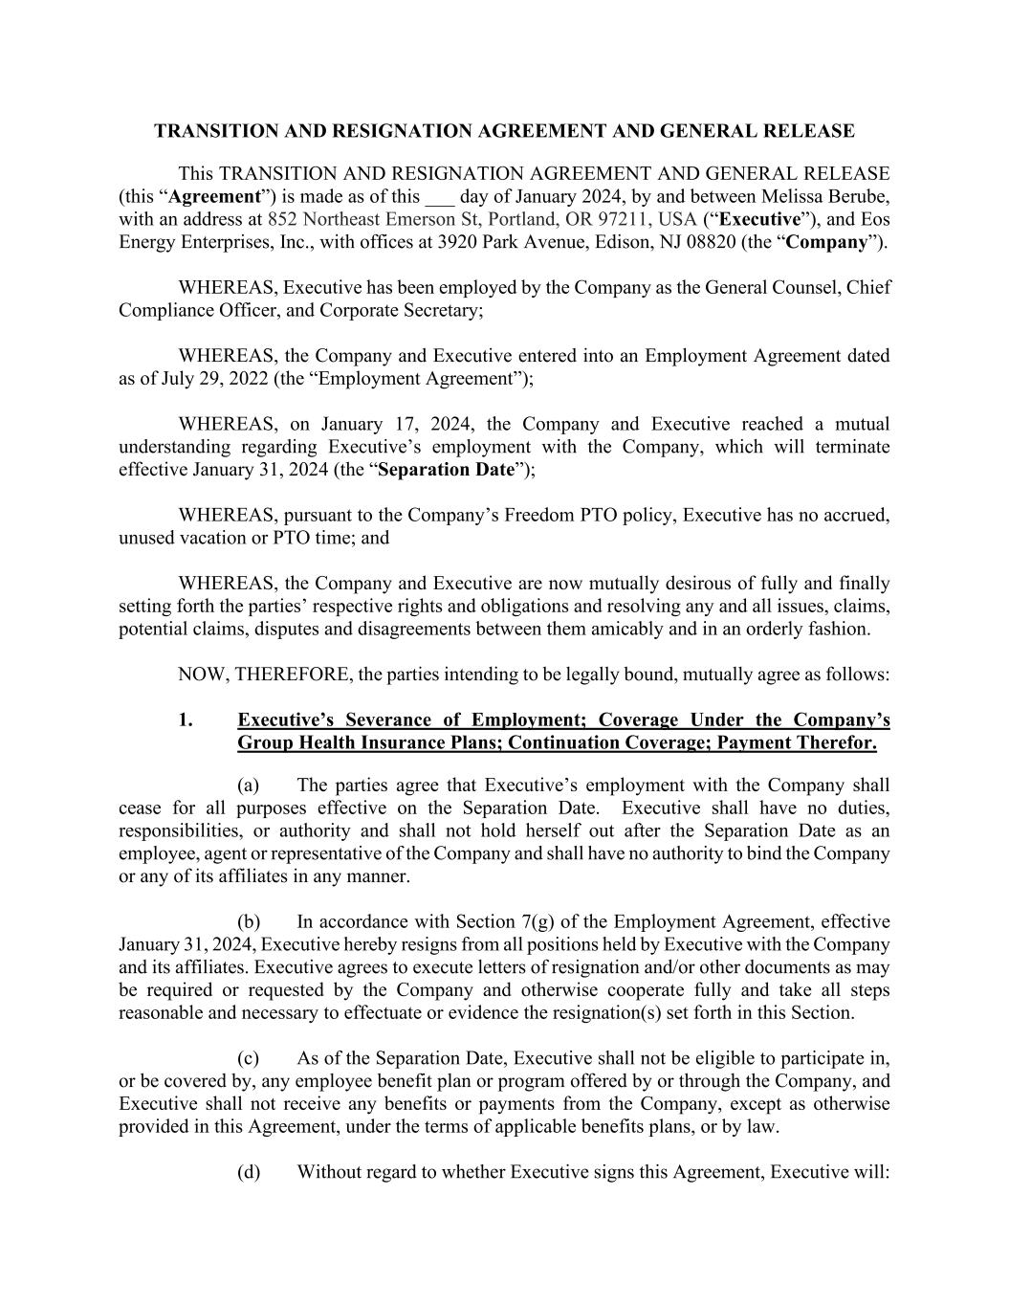

TRANSITION AND RESIGNATION AGREEMENT AND GENERAL RELEASE This TRANSITION AND RESIGNATION AGREEMENT AND GENERAL RELEASE (this “Agreement”) is made as of this ___ day of January 2024, by and between Melissa Berube, with an address at 852 Northeast Emerson St, Portland, OR 97211, USA (“Executive”), and Eos Energy Enterprises, Inc., with offices at 3920 Park Avenue, Edison, NJ 08820 (the “Company”). WHEREAS, Executive has been employed by the Company as the General Counsel, Chief Compliance Officer, and Corporate Secretary; WHEREAS, the Company and Executive entered into an Employment Agreement dated as of July 29, 2022 (the “Employment Agreement”); WHEREAS, on January 17, 2024, the Company and Executive reached a mutual understanding regarding Executive’s employment with the Company, which will terminate effective January 31, 2024 (the “Separation Date”); WHEREAS, pursuant to the Company’s Freedom PTO policy, Executive has no accrued, unused vacation or PTO time; and WHEREAS, the Company and Executive are now mutually desirous of fully and finally setting forth the parties’ respective rights and obligations and resolving any and all issues, claims, potential claims, disputes and disagreements between them amicably and in an orderly fashion. NOW, THEREFORE, the parties intending to be legally bound, mutually agree as follows: 1. Executive’s Severance of Employment; Coverage Under the Company’s Group Health Insurance Plans; Continuation Coverage; Payment Therefor. (a) The parties agree that Executive’s employment with the Company shall cease for all purposes effective on the Separation Date. Executive shall have no duties, responsibilities, or authority and shall not hold herself out after the Separation Date as an employee, agent or representative of the Company and shall have no authority to bind the Company or any of its affiliates in any manner. (b) In accordance with Section 7(g) of the Employment Agreement, effective January 31, 2024, Executive hereby resigns from all positions held by Executive with the Company and its affiliates. Executive agrees to execute letters of resignation and/or other documents as may be required or requested by the Company and otherwise cooperate fully and take all steps reasonable and necessary to effectuate or evidence the resignation(s) set forth in this Section. (c) As of the Separation Date, Executive shall not be eligible to participate in, or be covered by, any employee benefit plan or program offered by or through the Company, and Executive shall not receive any benefits or payments from the Company, except as otherwise provided in this Agreement, under the terms of applicable benefits plans, or by law. (d) Without regard to whether Executive signs this Agreement, Executive will:

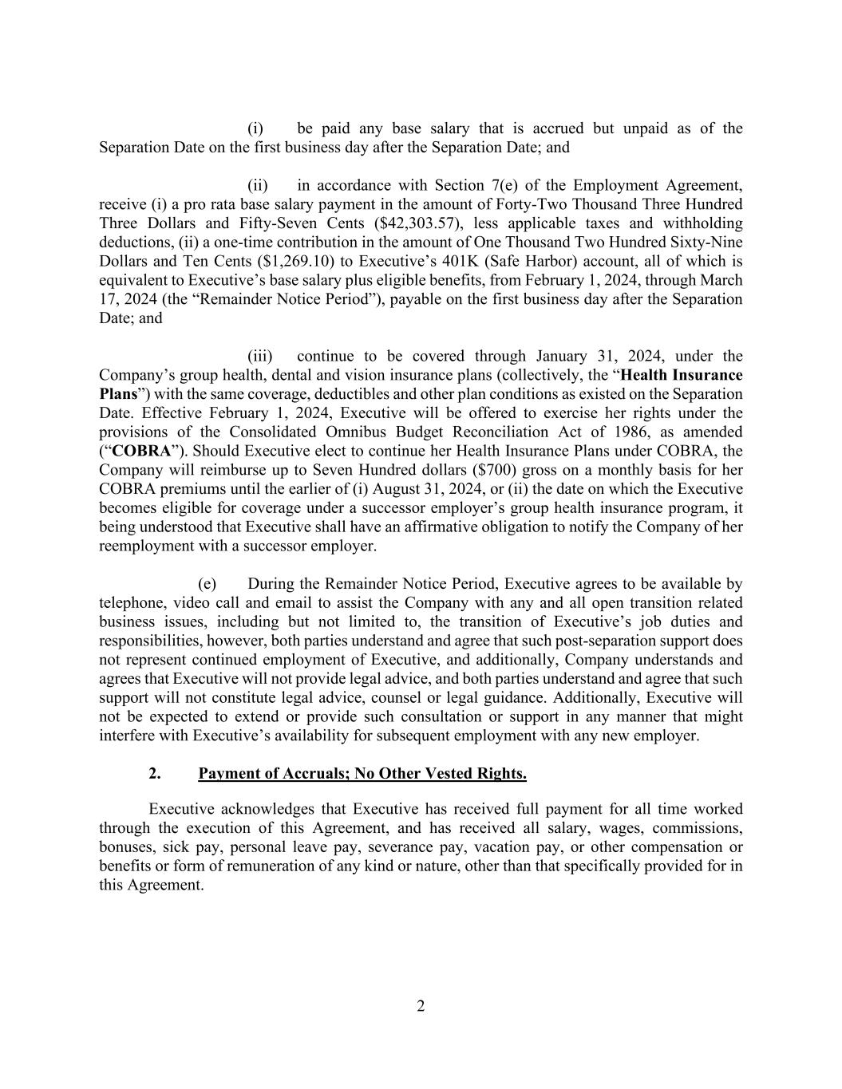
2 (i) be paid any base salary that is accrued but unpaid as of the Separation Date on the first business day after the Separation Date; and (ii) in accordance with Section 7(e) of the Employment Agreement, receive (i) a pro rata base salary payment in the amount of Forty-Two Thousand Three Hundred Three Dollars and Fifty-Seven Cents ($42,303.57), less applicable taxes and withholding deductions, (ii) a one-time contribution in the amount of One Thousand Two Hundred Sixty-Nine Dollars and Ten Cents ($1,269.10) to Executive’s 401K (Safe Harbor) account, all of which is equivalent to Executive’s base salary plus eligible benefits, from February 1, 2024, through March 17, 2024 (the “Remainder Notice Period”), payable on the first business day after the Separation Date; and (iii) continue to be covered through January 31, 2024, under the Company’s group health, dental and vision insurance plans (collectively, the “Health Insurance Plans”) with the same coverage, deductibles and other plan conditions as existed on the Separation Date. Effective February 1, 2024, Executive will be offered to exercise her rights under the provisions of the Consolidated Omnibus Budget Reconciliation Act of 1986, as amended (“COBRA”). Should Executive elect to continue her Health Insurance Plans under COBRA, the Company will reimburse up to Seven Hundred dollars ($700) gross on a monthly basis for her COBRA premiums until the earlier of (i) August 31, 2024, or (ii) the date on which the Executive becomes eligible for coverage under a successor employer’s group health insurance program, it being understood that Executive shall have an affirmative obligation to notify the Company of her reemployment with a successor employer. (e) During the Remainder Notice Period, Executive agrees to be available by telephone, video call and email to assist the Company with any and all open transition related business issues, including but not limited to, the transition of Executive’s job duties and responsibilities, however, both parties understand and agree that such post-separation support does not represent continued employment of Executive, and additionally, Company understands and agrees that Executive will not provide legal advice, and both parties understand and agree that such support will not constitute legal advice, counsel or legal guidance. Additionally, Executive will not be expected to extend or provide such consultation or support in any manner that might interfere with Executive’s availability for subsequent employment with any new employer. 2. Payment of Accruals; No Other Vested Rights. Executive acknowledges that Executive has received full payment for all time worked through the execution of this Agreement, and has received all salary, wages, commissions, bonuses, sick pay, personal leave pay, severance pay, vacation pay, or other compensation or benefits or form of remuneration of any kind or nature, other than that specifically provided for in this Agreement.

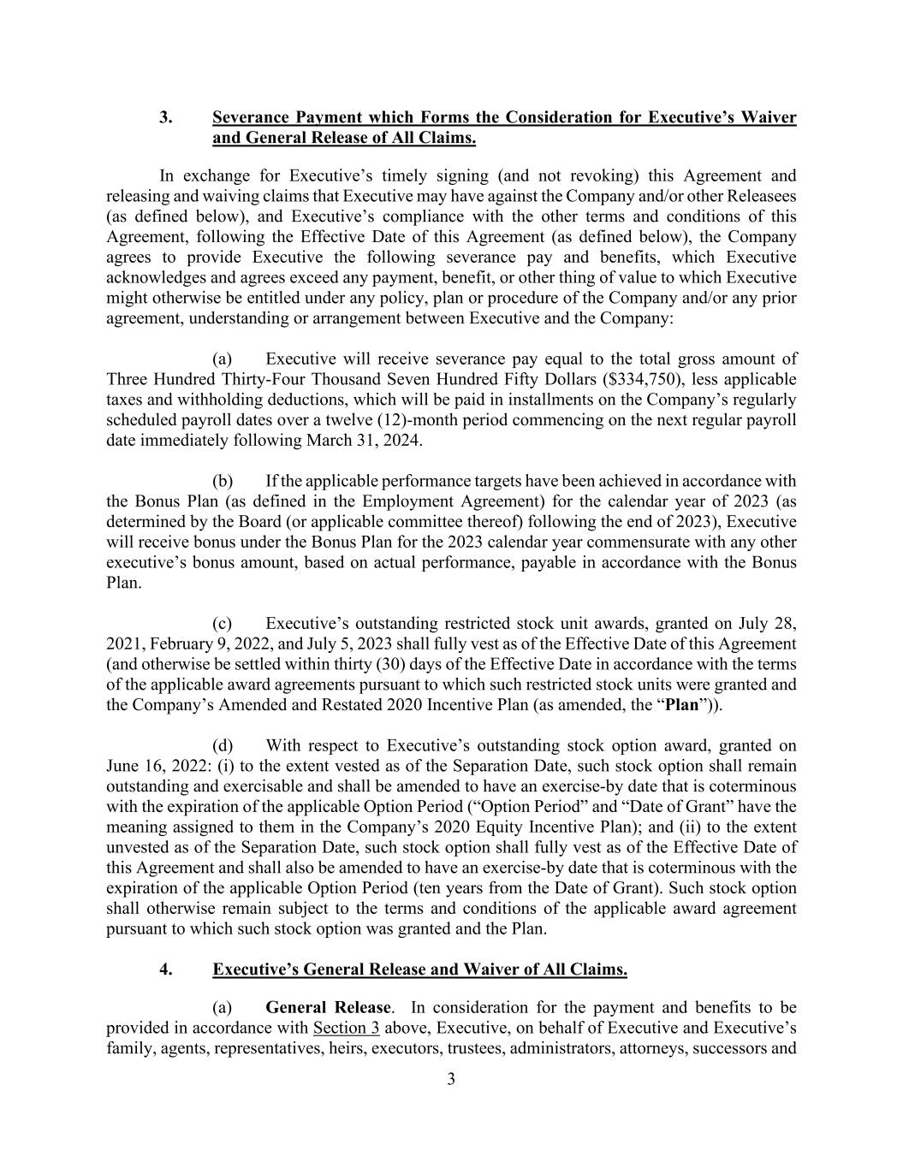
3 3. Severance Payment which Forms the Consideration for Executive’s Waiver and General Release of All Claims. In exchange for Executive’s timely signing (and not revoking) this Agreement and releasing and waiving claims that Executive may have against the Company and/or other Releasees (as defined below), and Executive’s compliance with the other terms and conditions of this Agreement, following the Effective Date of this Agreement (as defined below), the Company agrees to provide Executive the following severance pay and benefits, which Executive acknowledges and agrees exceed any payment, benefit, or other thing of value to which Executive might otherwise be entitled under any policy, plan or procedure of the Company and/or any prior agreement, understanding or arrangement between Executive and the Company: (a) Executive will receive severance pay equal to the total gross amount of Three Hundred Thirty-Four Thousand Seven Hundred Fifty Dollars ($334,750), less applicable taxes and withholding deductions, which will be paid in installments on the Company’s regularly scheduled payroll dates over a twelve (12)-month period commencing on the next regular payroll date immediately following March 31, 2024. (b) If the applicable performance targets have been achieved in accordance with the Bonus Plan (as defined in the Employment Agreement) for the calendar year of 2023 (as determined by the Board (or applicable committee thereof) following the end of 2023), Executive will receive bonus under the Bonus Plan for the 2023 calendar year commensurate with any other executive’s bonus amount, based on actual performance, payable in accordance with the Bonus Plan. (c) Executive’s outstanding restricted stock unit awards, granted on July 28, 2021, February 9, 2022, and July 5, 2023 shall fully vest as of the Effective Date of this Agreement (and otherwise be settled within thirty (30) days of the Effective Date in accordance with the terms of the applicable award agreements pursuant to which such restricted stock units were granted and the Company’s Amended and Restated 2020 Incentive Plan (as amended, the “Plan”)). (d) With respect to Executive’s outstanding stock option award, granted on June 16, 2022: (i) to the extent vested as of the Separation Date, such stock option shall remain outstanding and exercisable and shall be amended to have an exercise-by date that is coterminous with the expiration of the applicable Option Period (“Option Period” and “Date of Grant” have the meaning assigned to them in the Company’s 2020 Equity Incentive Plan); and (ii) to the extent unvested as of the Separation Date, such stock option shall fully vest as of the Effective Date of this Agreement and shall also be amended to have an exercise-by date that is coterminous with the expiration of the applicable Option Period (ten years from the Date of Grant). Such stock option shall otherwise remain subject to the terms and conditions of the applicable award agreement pursuant to which such stock option was granted and the Plan. 4. Executive’s General Release and Waiver of All Claims. (a) General Release. In consideration for the payment and benefits to be provided in accordance with Section 3 above, Executive, on behalf of Executive and Executive’s family, agents, representatives, heirs, executors, trustees, administrators, attorneys, successors and

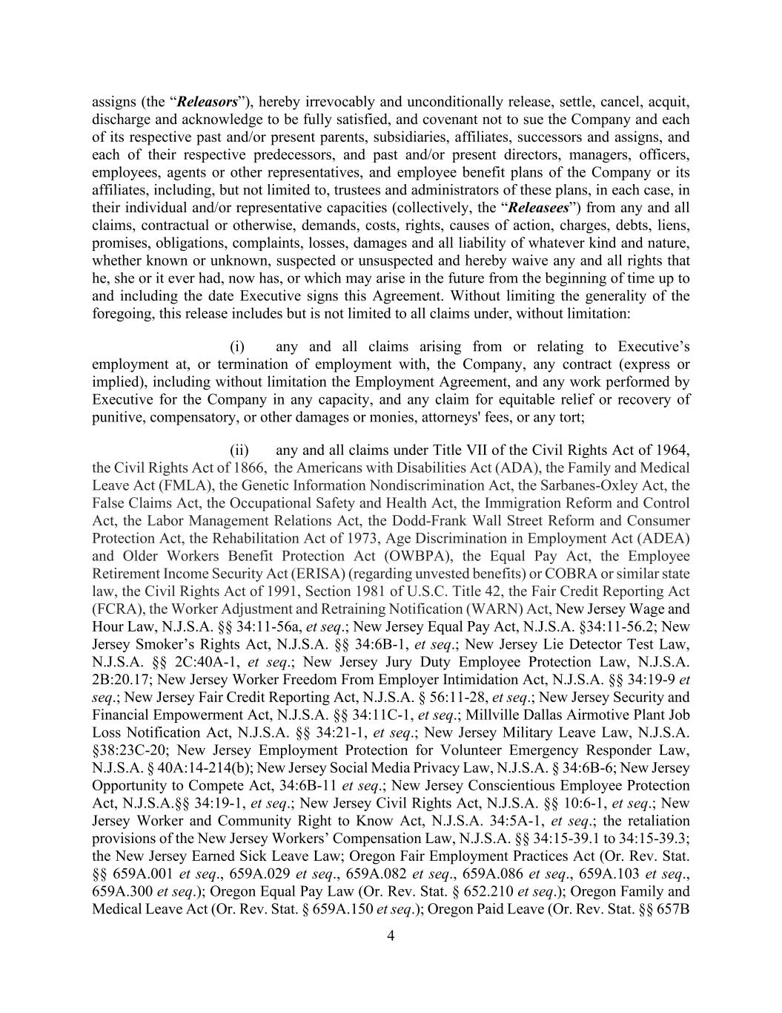
4 assigns (the “Releasors”), hereby irrevocably and unconditionally release, settle, cancel, acquit, discharge and acknowledge to be fully satisfied, and covenant not to sue the Company and each of its respective past and/or present parents, subsidiaries, affiliates, successors and assigns, and each of their respective predecessors, and past and/or present directors, managers, officers, employees, agents or other representatives, and employee benefit plans of the Company or its affiliates, including, but not limited to, trustees and administrators of these plans, in each case, in their individual and/or representative capacities (collectively, the “Releasees”) from any and all claims, contractual or otherwise, demands, costs, rights, causes of action, charges, debts, liens, promises, obligations, complaints, losses, damages and all liability of whatever kind and nature, whether known or unknown, suspected or unsuspected and hereby waive any and all rights that he, she or it ever had, now has, or which may arise in the future from the beginning of time up to and including the date Executive signs this Agreement. Without limiting the generality of the foregoing, this release includes but is not limited to all claims under, without limitation: (i) any and all claims arising from or relating to Executive’s employment at, or termination of employment with, the Company, any contract (express or implied), including without limitation the Employment Agreement, and any work performed by Executive for the Company in any capacity, and any claim for equitable relief or recovery of punitive, compensatory, or other damages or monies, attorneys' fees, or any tort; (ii) any and all claims under Title VII of the Civil Rights Act of 1964, the Civil Rights Act of 1866, the Americans with Disabilities Act (ADA), the Family and Medical Leave Act (FMLA), the Genetic Information Nondiscrimination Act, the Sarbanes-Oxley Act, the False Claims Act, the Occupational Safety and Health Act, the Immigration Reform and Control Act, the Labor Management Relations Act, the Dodd-Frank Wall Street Reform and Consumer Protection Act, the Rehabilitation Act of 1973, Age Discrimination in Employment Act (ADEA) and Older Workers Benefit Protection Act (OWBPA), the Equal Pay Act, the Employee Retirement Income Security Act (ERISA) (regarding unvested benefits) or COBRA or similar state law, the Civil Rights Act of 1991, Section 1981 of U.S.C. Title 42, the Fair Credit Reporting Act (FCRA), the Worker Adjustment and Retraining Notification (WARN) Act, New Jersey Wage and Hour Law, N.J.S.A. §§ 34:11-56a, et seq.; New Jersey Equal Pay Act, N.J.S.A. §34:11-56.2; New Jersey Smoker’s Rights Act, N.J.S.A. §§ 34:6B-1, et seq.; New Jersey Lie Detector Test Law, N.J.S.A. §§ 2C:40A-1, et seq.; New Jersey Jury Duty Employee Protection Law, N.J.S.A. 2B:20.17; New Jersey Worker Freedom From Employer Intimidation Act, N.J.S.A. §§ 34:19-9 et seq.; New Jersey Fair Credit Reporting Act, N.J.S.A. § 56:11-28, et seq.; New Jersey Security and Financial Empowerment Act, N.J.S.A. §§ 34:11C-1, et seq.; Millville Dallas Airmotive Plant Job Loss Notification Act, N.J.S.A. §§ 34:21-1, et seq.; New Jersey Military Leave Law, N.J.S.A. §38:23C-20; New Jersey Employment Protection for Volunteer Emergency Responder Law, N.J.S.A. § 40A:14-214(b); New Jersey Social Media Privacy Law, N.J.S.A. § 34:6B-6; New Jersey Opportunity to Compete Act, 34:6B-11 et seq.; New Jersey Conscientious Employee Protection Act, N.J.S.A.§§ 34:19-1, et seq.; New Jersey Civil Rights Act, N.J.S.A. §§ 10:6-1, et seq.; New Jersey Worker and Community Right to Know Act, N.J.S.A. 34:5A-1, et seq.; the retaliation provisions of the New Jersey Workers’ Compensation Law, N.J.S.A. §§ 34:15-39.1 to 34:15-39.3; the New Jersey Earned Sick Leave Law; Oregon Fair Employment Practices Act (Or. Rev. Stat. §§ 659A.001 et seq., 659A.029 et seq., 659A.082 et seq., 659A.086 et seq., 659A.103 et seq., 659A.300 et seq.); Oregon Equal Pay Law (Or. Rev. Stat. § 652.210 et seq.); Oregon Family and Medical Leave Act (Or. Rev. Stat. § 659A.150 et seq.); Oregon Paid Leave (Or. Rev. Stat. §§ 657B

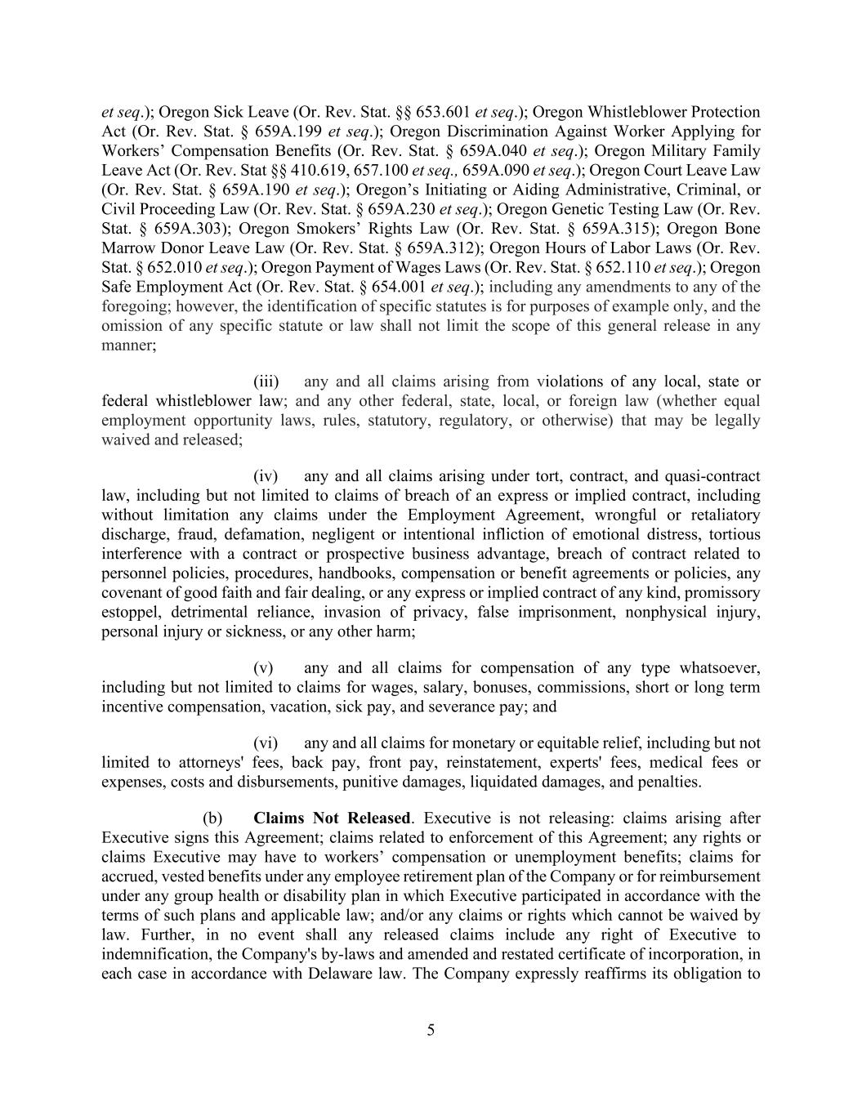
5 et seq.); Oregon Sick Leave (Or. Rev. Stat. §§ 653.601 et seq.); Oregon Whistleblower Protection Act (Or. Rev. Stat. § 659A.199 et seq.); Oregon Discrimination Against Worker Applying for Workers’ Compensation Benefits (Or. Rev. Stat. § 659A.040 et seq.); Oregon Military Family Leave Act (Or. Rev. Stat §§ 410.619, 657.100 et seq., 659A.090 et seq.); Oregon Court Leave Law (Or. Rev. Stat. § 659A.190 et seq.); Oregon’s Initiating or Aiding Administrative, Criminal, or Civil Proceeding Law (Or. Rev. Stat. § 659A.230 et seq.); Oregon Genetic Testing Law (Or. Rev. Stat. § 659A.303); Oregon Smokers’ Rights Law (Or. Rev. Stat. § 659A.315); Oregon Bone Marrow Donor Leave Law (Or. Rev. Stat. § 659A.312); Oregon Hours of Labor Laws (Or. Rev. Stat. § 652.010 et seq.); Oregon Payment of Wages Laws (Or. Rev. Stat. § 652.110 et seq.); Oregon Safe Employment Act (Or. Rev. Stat. § 654.001 et seq.); including any amendments to any of the foregoing; however, the identification of specific statutes is for purposes of example only, and the omission of any specific statute or law shall not limit the scope of this general release in any manner; (iii) any and all claims arising from violations of any local, state or federal whistleblower law; and any other federal, state, local, or foreign law (whether equal employment opportunity laws, rules, statutory, regulatory, or otherwise) that may be legally waived and released; (iv) any and all claims arising under tort, contract, and quasi-contract law, including but not limited to claims of breach of an express or implied contract, including without limitation any claims under the Employment Agreement, wrongful or retaliatory discharge, fraud, defamation, negligent or intentional infliction of emotional distress, tortious interference with a contract or prospective business advantage, breach of contract related to personnel policies, procedures, handbooks, compensation or benefit agreements or policies, any covenant of good faith and fair dealing, or any express or implied contract of any kind, promissory estoppel, detrimental reliance, invasion of privacy, false imprisonment, nonphysical injury, personal injury or sickness, or any other harm; (v) any and all claims for compensation of any type whatsoever, including but not limited to claims for wages, salary, bonuses, commissions, short or long term incentive compensation, vacation, sick pay, and severance pay; and (vi) any and all claims for monetary or equitable relief, including but not limited to attorneys' fees, back pay, front pay, reinstatement, experts' fees, medical fees or expenses, costs and disbursements, punitive damages, liquidated damages, and penalties. (b) Claims Not Released. Executive is not releasing: claims arising after Executive signs this Agreement; claims related to enforcement of this Agreement; any rights or claims Executive may have to workers’ compensation or unemployment benefits; claims for accrued, vested benefits under any employee retirement plan of the Company or for reimbursement under any group health or disability plan in which Executive participated in accordance with the terms of such plans and applicable law; and/or any claims or rights which cannot be waived by law. Further, in no event shall any released claims include any right of Executive to indemnification, the Company's by-laws and amended and restated certificate of incorporation, in each case in accordance with Delaware law. The Company expressly reaffirms its obligation to

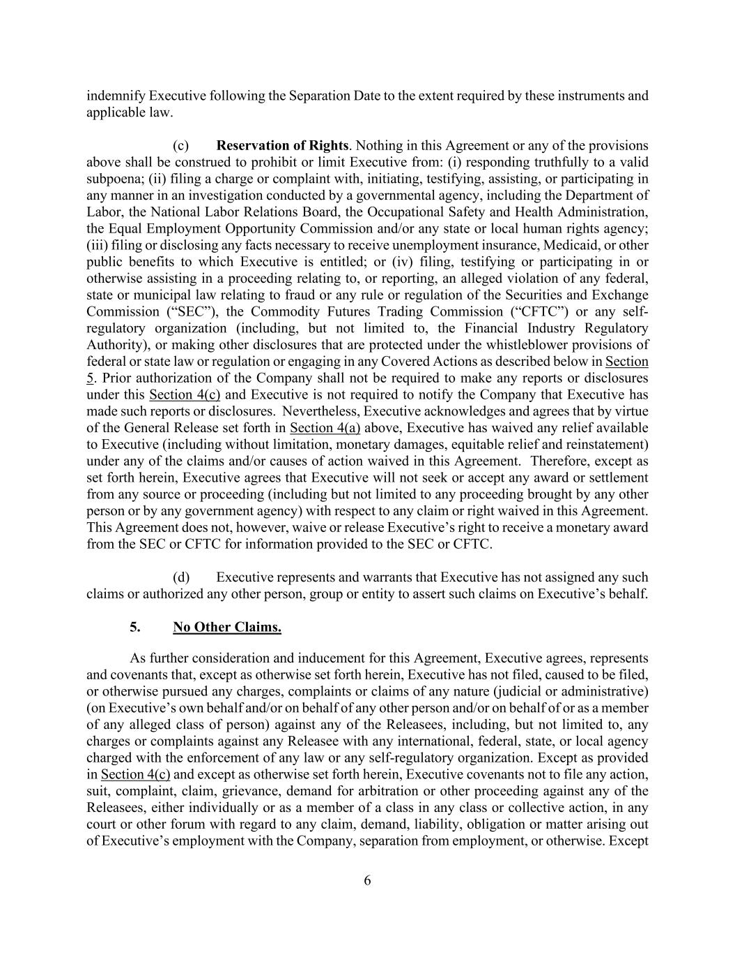
6 indemnify Executive following the Separation Date to the extent required by these instruments and applicable law. (c) Reservation of Rights. Nothing in this Agreement or any of the provisions above shall be construed to prohibit or limit Executive from: (i) responding truthfully to a valid subpoena; (ii) filing a charge or complaint with, initiating, testifying, assisting, or participating in any manner in an investigation conducted by a governmental agency, including the Department of Labor, the National Labor Relations Board, the Occupational Safety and Health Administration, the Equal Employment Opportunity Commission and/or any state or local human rights agency; (iii) filing or disclosing any facts necessary to receive unemployment insurance, Medicaid, or other public benefits to which Executive is entitled; or (iv) filing, testifying or participating in or otherwise assisting in a proceeding relating to, or reporting, an alleged violation of any federal, state or municipal law relating to fraud or any rule or regulation of the Securities and Exchange Commission (“SEC”), the Commodity Futures Trading Commission (“CFTC”) or any self- regulatory organization (including, but not limited to, the Financial Industry Regulatory Authority), or making other disclosures that are protected under the whistleblower provisions of federal or state law or regulation or engaging in any Covered Actions as described below in Section 5. Prior authorization of the Company shall not be required to make any reports or disclosures under this Section 4(c) and Executive is not required to notify the Company that Executive has made such reports or disclosures. Nevertheless, Executive acknowledges and agrees that by virtue of the General Release set forth in Section 4(a) above, Executive has waived any relief available to Executive (including without limitation, monetary damages, equitable relief and reinstatement) under any of the claims and/or causes of action waived in this Agreement. Therefore, except as set forth herein, Executive agrees that Executive will not seek or accept any award or settlement from any source or proceeding (including but not limited to any proceeding brought by any other person or by any government agency) with respect to any claim or right waived in this Agreement. This Agreement does not, however, waive or release Executive’s right to receive a monetary award from the SEC or CFTC for information provided to the SEC or CFTC. (d) Executive represents and warrants that Executive has not assigned any such claims or authorized any other person, group or entity to assert such claims on Executive’s behalf. 5. No Other Claims. As further consideration and inducement for this Agreement, Executive agrees, represents and covenants that, except as otherwise set forth herein, Executive has not filed, caused to be filed, or otherwise pursued any charges, complaints or claims of any nature (judicial or administrative) (on Executive’s own behalf and/or on behalf of any other person and/or on behalf of or as a member of any alleged class of person) against any of the Releasees, including, but not limited to, any charges or complaints against any Releasee with any international, federal, state, or local agency charged with the enforcement of any law or any self-regulatory organization. Except as provided in Section 4(c) and except as otherwise set forth herein, Executive covenants not to file any action, suit, complaint, claim, grievance, demand for arbitration or other proceeding against any of the Releasees, either individually or as a member of a class in any class or collective action, in any court or other forum with regard to any claim, demand, liability, obligation or matter arising out of Executive’s employment with the Company, separation from employment, or otherwise. Except

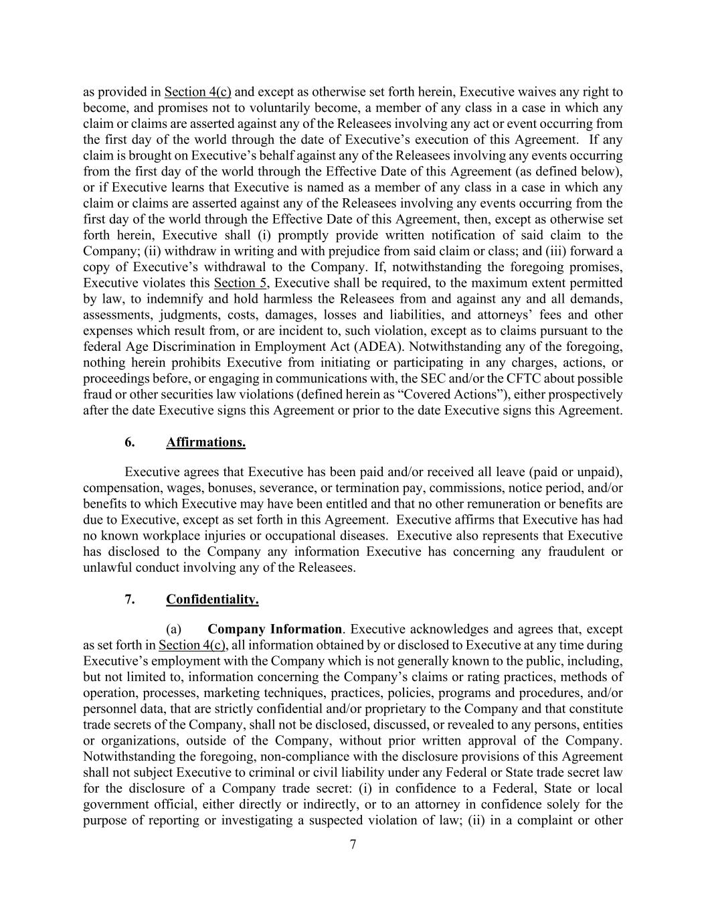
7 as provided in Section 4(c) and except as otherwise set forth herein, Executive waives any right to become, and promises not to voluntarily become, a member of any class in a case in which any claim or claims are asserted against any of the Releasees involving any act or event occurring from the first day of the world through the date of Executive’s execution of this Agreement. If any claim is brought on Executive’s behalf against any of the Releasees involving any events occurring from the first day of the world through the Effective Date of this Agreement (as defined below), or if Executive learns that Executive is named as a member of any class in a case in which any claim or claims are asserted against any of the Releasees involving any events occurring from the first day of the world through the Effective Date of this Agreement, then, except as otherwise set forth herein, Executive shall (i) promptly provide written notification of said claim to the Company; (ii) withdraw in writing and with prejudice from said claim or class; and (iii) forward a copy of Executive’s withdrawal to the Company. If, notwithstanding the foregoing promises, Executive violates this Section 5, Executive shall be required, to the maximum extent permitted by law, to indemnify and hold harmless the Releasees from and against any and all demands, assessments, judgments, costs, damages, losses and liabilities, and attorneys’ fees and other expenses which result from, or are incident to, such violation, except as to claims pursuant to the federal Age Discrimination in Employment Act (ADEA). Notwithstanding any of the foregoing, nothing herein prohibits Executive from initiating or participating in any charges, actions, or proceedings before, or engaging in communications with, the SEC and/or the CFTC about possible fraud or other securities law violations (defined herein as “Covered Actions”), either prospectively after the date Executive signs this Agreement or prior to the date Executive signs this Agreement. 6. Affirmations. Executive agrees that Executive has been paid and/or received all leave (paid or unpaid), compensation, wages, bonuses, severance, or termination pay, commissions, notice period, and/or benefits to which Executive may have been entitled and that no other remuneration or benefits are due to Executive, except as set forth in this Agreement. Executive affirms that Executive has had no known workplace injuries or occupational diseases. Executive also represents that Executive has disclosed to the Company any information Executive has concerning any fraudulent or unlawful conduct involving any of the Releasees. 7. Confidentiality. (a) Company Information. Executive acknowledges and agrees that, except as set forth in Section 4(c), all information obtained by or disclosed to Executive at any time during Executive’s employment with the Company which is not generally known to the public, including, but not limited to, information concerning the Company’s claims or rating practices, methods of operation, processes, marketing techniques, practices, policies, programs and procedures, and/or personnel data, that are strictly confidential and/or proprietary to the Company and that constitute trade secrets of the Company, shall not be disclosed, discussed, or revealed to any persons, entities or organizations, outside of the Company, without prior written approval of the Company. Notwithstanding the foregoing, non-compliance with the disclosure provisions of this Agreement shall not subject Executive to criminal or civil liability under any Federal or State trade secret law for the disclosure of a Company trade secret: (i) in confidence to a Federal, State or local government official, either directly or indirectly, or to an attorney in confidence solely for the purpose of reporting or investigating a suspected violation of law; (ii) in a complaint or other

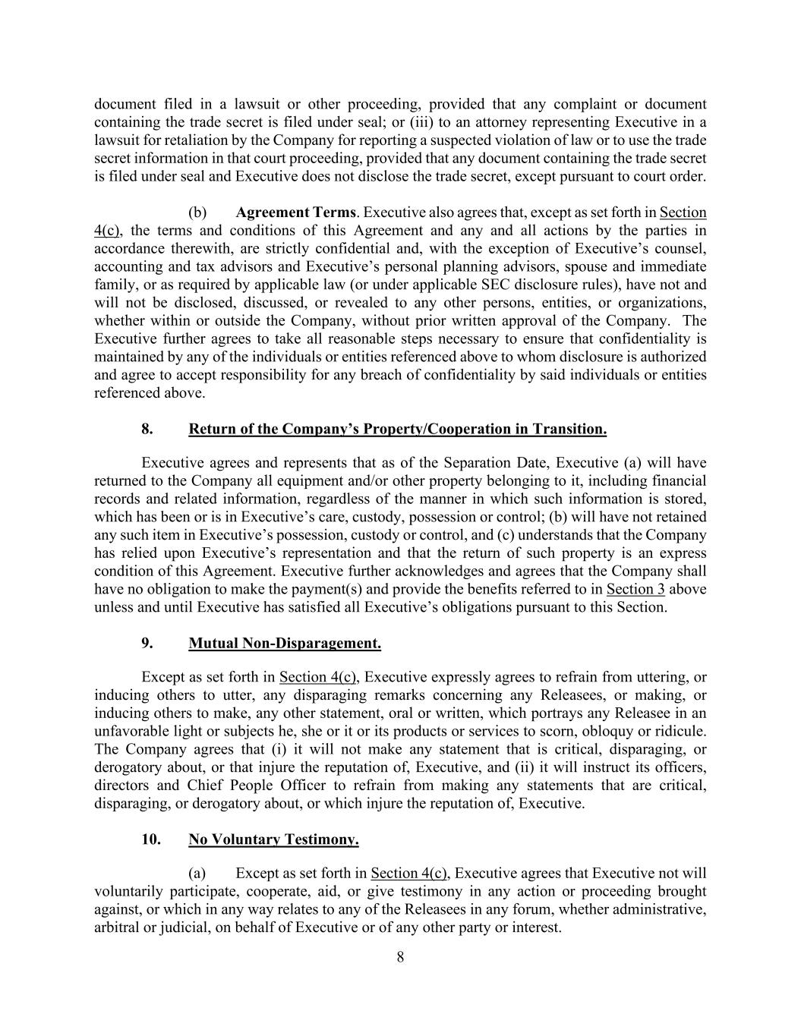
8 document filed in a lawsuit or other proceeding, provided that any complaint or document containing the trade secret is filed under seal; or (iii) to an attorney representing Executive in a lawsuit for retaliation by the Company for reporting a suspected violation of law or to use the trade secret information in that court proceeding, provided that any document containing the trade secret is filed under seal and Executive does not disclose the trade secret, except pursuant to court order. (b) Agreement Terms. Executive also agrees that, except as set forth in Section 4(c), the terms and conditions of this Agreement and any and all actions by the parties in accordance therewith, are strictly confidential and, with the exception of Executive’s counsel, accounting and tax advisors and Executive’s personal planning advisors, spouse and immediate family, or as required by applicable law (or under applicable SEC disclosure rules), have not and will not be disclosed, discussed, or revealed to any other persons, entities, or organizations, whether within or outside the Company, without prior written approval of the Company. The Executive further agrees to take all reasonable steps necessary to ensure that confidentiality is maintained by any of the individuals or entities referenced above to whom disclosure is authorized and agree to accept responsibility for any breach of confidentiality by said individuals or entities referenced above. 8. Return of the Company’s Property/Cooperation in Transition. Executive agrees and represents that as of the Separation Date, Executive (a) will have returned to the Company all equipment and/or other property belonging to it, including financial records and related information, regardless of the manner in which such information is stored, which has been or is in Executive’s care, custody, possession or control; (b) will have not retained any such item in Executive’s possession, custody or control, and (c) understands that the Company has relied upon Executive’s representation and that the return of such property is an express condition of this Agreement. Executive further acknowledges and agrees that the Company shall have no obligation to make the payment(s) and provide the benefits referred to in Section 3 above unless and until Executive has satisfied all Executive’s obligations pursuant to this Section. 9. Mutual Non-Disparagement. Except as set forth in Section 4(c), Executive expressly agrees to refrain from uttering, or inducing others to utter, any disparaging remarks concerning any Releasees, or making, or inducing others to make, any other statement, oral or written, which portrays any Releasee in an unfavorable light or subjects he, she or it or its products or services to scorn, obloquy or ridicule. The Company agrees that (i) it will not make any statement that is critical, disparaging, or derogatory about, or that injure the reputation of, Executive, and (ii) it will instruct its officers, directors and Chief People Officer to refrain from making any statements that are critical, disparaging, or derogatory about, or which injure the reputation of, Executive. 10. No Voluntary Testimony. (a) Except as set forth in Section 4(c), Executive agrees that Executive not will voluntarily participate, cooperate, aid, or give testimony in any action or proceeding brought against, or which in any way relates to any of the Releasees in any forum, whether administrative, arbitral or judicial, on behalf of Executive or of any other party or interest.

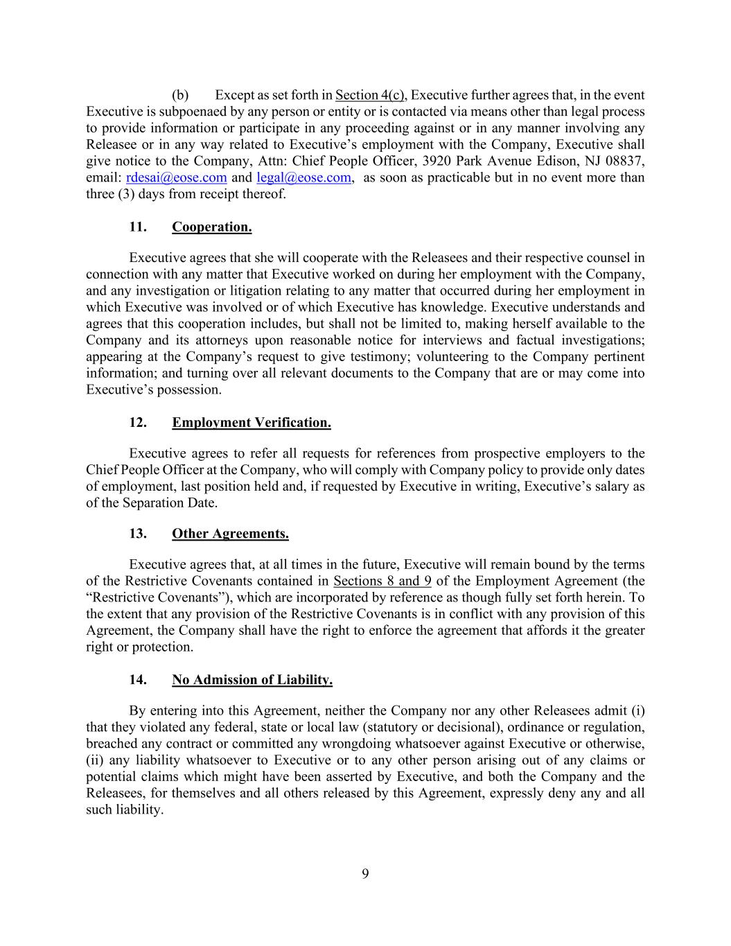
9 (b) Except as set forth in Section 4(c), Executive further agrees that, in the event Executive is subpoenaed by any person or entity or is contacted via means other than legal process to provide information or participate in any proceeding against or in any manner involving any Releasee or in any way related to Executive’s employment with the Company, Executive shall give notice to the Company, Attn: Chief People Officer, 3920 Park Avenue Edison, NJ 08837, email: rdesai@eose.com and legal@eose.com, as soon as practicable but in no event more than three (3) days from receipt thereof. 11. Cooperation. Executive agrees that she will cooperate with the Releasees and their respective counsel in connection with any matter that Executive worked on during her employment with the Company, and any investigation or litigation relating to any matter that occurred during her employment in which Executive was involved or of which Executive has knowledge. Executive understands and agrees that this cooperation includes, but shall not be limited to, making herself available to the Company and its attorneys upon reasonable notice for interviews and factual investigations; appearing at the Company’s request to give testimony; volunteering to the Company pertinent information; and turning over all relevant documents to the Company that are or may come into Executive’s possession. 12. Employment Verification. Executive agrees to refer all requests for references from prospective employers to the Chief People Officer at the Company, who will comply with Company policy to provide only dates of employment, last position held and, if requested by Executive in writing, Executive’s salary as of the Separation Date. 13. Other Agreements. Executive agrees that, at all times in the future, Executive will remain bound by the terms of the Restrictive Covenants contained in Sections 8 and 9 of the Employment Agreement (the “Restrictive Covenants”), which are incorporated by reference as though fully set forth herein. To the extent that any provision of the Restrictive Covenants is in conflict with any provision of this Agreement, the Company shall have the right to enforce the agreement that affords it the greater right or protection. 14. No Admission of Liability. By entering into this Agreement, neither the Company nor any other Releasees admit (i) that they violated any federal, state or local law (statutory or decisional), ordinance or regulation, breached any contract or committed any wrongdoing whatsoever against Executive or otherwise, (ii) any liability whatsoever to Executive or to any other person arising out of any claims or potential claims which might have been asserted by Executive, and both the Company and the Releasees, for themselves and all others released by this Agreement, expressly deny any and all such liability.

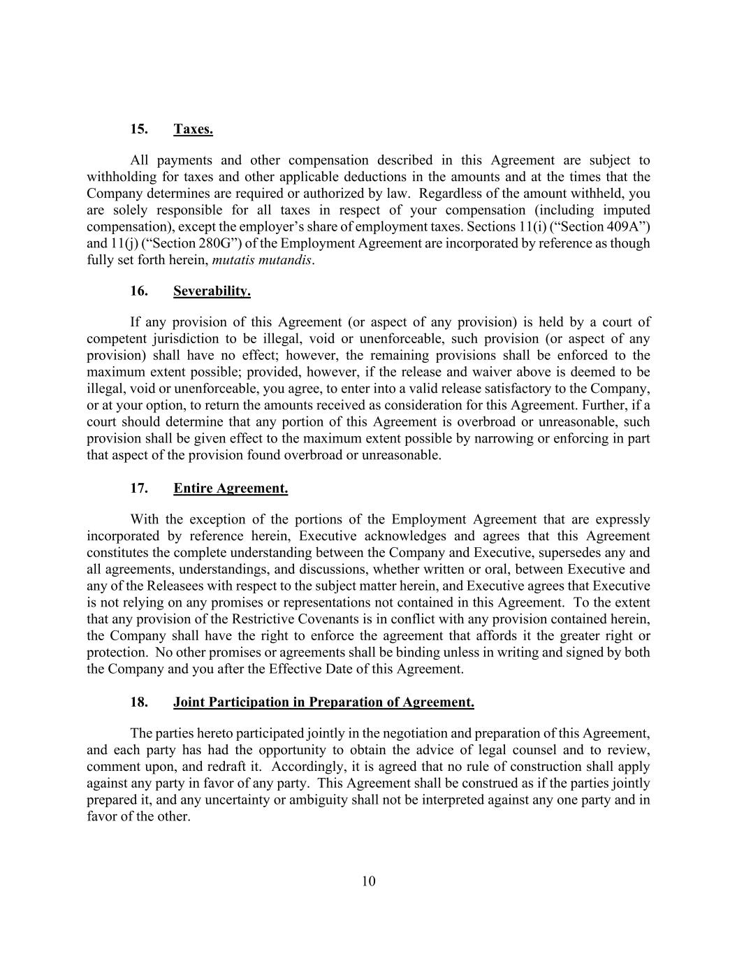
10 15. Taxes. All payments and other compensation described in this Agreement are subject to withholding for taxes and other applicable deductions in the amounts and at the times that the Company determines are required or authorized by law. Regardless of the amount withheld, you are solely responsible for all taxes in respect of your compensation (including imputed compensation), except the employer’s share of employment taxes. Sections 11(i) (“Section 409A”) and 11(j) (“Section 280G”) of the Employment Agreement are incorporated by reference as though fully set forth herein, mutatis mutandis. 16. Severability. If any provision of this Agreement (or aspect of any provision) is held by a court of competent jurisdiction to be illegal, void or unenforceable, such provision (or aspect of any provision) shall have no effect; however, the remaining provisions shall be enforced to the maximum extent possible; provided, however, if the release and waiver above is deemed to be illegal, void or unenforceable, you agree, to enter into a valid release satisfactory to the Company, or at your option, to return the amounts received as consideration for this Agreement. Further, if a court should determine that any portion of this Agreement is overbroad or unreasonable, such provision shall be given effect to the maximum extent possible by narrowing or enforcing in part that aspect of the provision found overbroad or unreasonable. 17. Entire Agreement. With the exception of the portions of the Employment Agreement that are expressly incorporated by reference herein, Executive acknowledges and agrees that this Agreement constitutes the complete understanding between the Company and Executive, supersedes any and all agreements, understandings, and discussions, whether written or oral, between Executive and any of the Releasees with respect to the subject matter herein, and Executive agrees that Executive is not relying on any promises or representations not contained in this Agreement. To the extent that any provision of the Restrictive Covenants is in conflict with any provision contained herein, the Company shall have the right to enforce the agreement that affords it the greater right or protection. No other promises or agreements shall be binding unless in writing and signed by both the Company and you after the Effective Date of this Agreement. 18. Joint Participation in Preparation of Agreement. The parties hereto participated jointly in the negotiation and preparation of this Agreement, and each party has had the opportunity to obtain the advice of legal counsel and to review, comment upon, and redraft it. Accordingly, it is agreed that no rule of construction shall apply against any party in favor of any party. This Agreement shall be construed as if the parties jointly prepared it, and any uncertainty or ambiguity shall not be interpreted against any one party and in favor of the other.

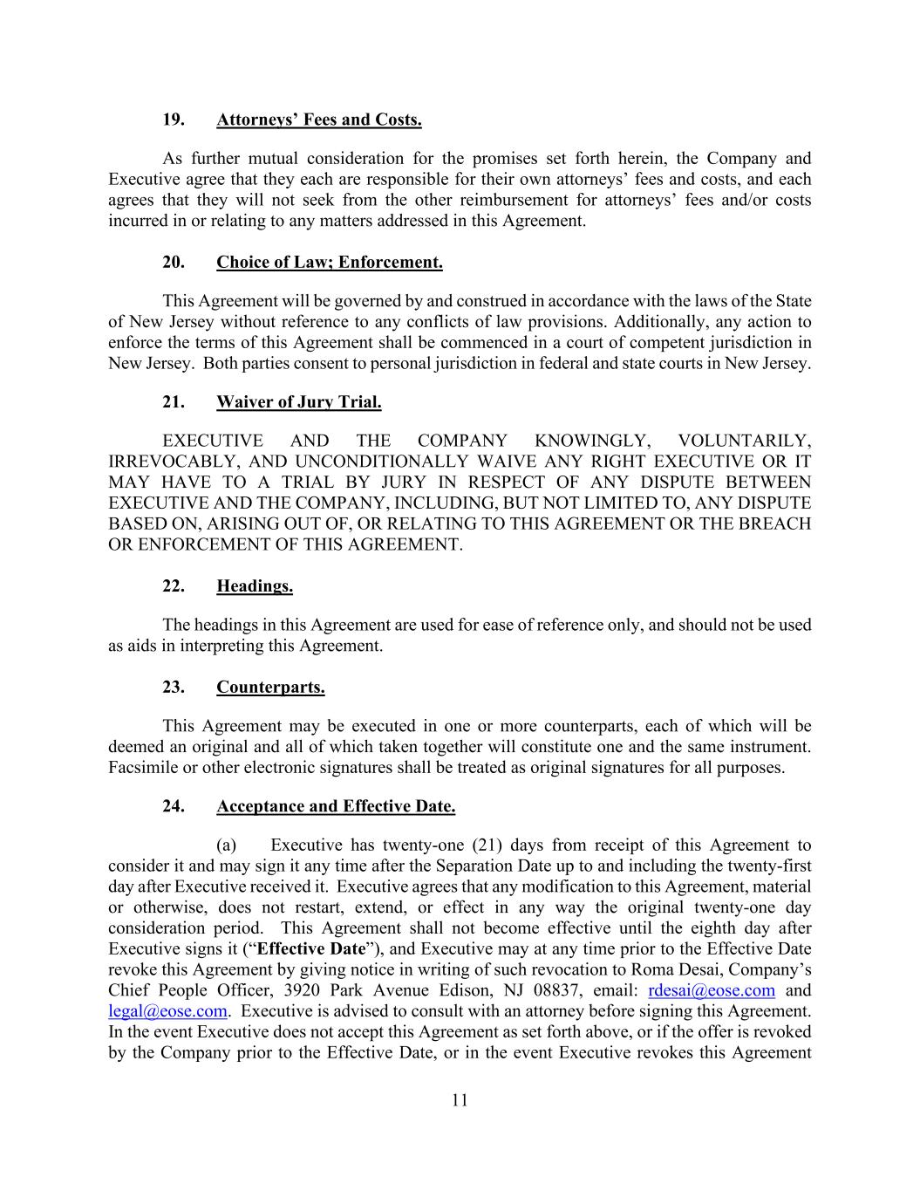
11 19. Attorneys’ Fees and Costs. As further mutual consideration for the promises set forth herein, the Company and Executive agree that they each are responsible for their own attorneys’ fees and costs, and each agrees that they will not seek from the other reimbursement for attorneys’ fees and/or costs incurred in or relating to any matters addressed in this Agreement. 20. Choice of Law; Enforcement. This Agreement will be governed by and construed in accordance with the laws of the State of New Jersey without reference to any conflicts of law provisions. Additionally, any action to enforce the terms of this Agreement shall be commenced in a court of competent jurisdiction in New Jersey. Both parties consent to personal jurisdiction in federal and state courts in New Jersey. 21. Waiver of Jury Trial. EXECUTIVE AND THE COMPANY KNOWINGLY, VOLUNTARILY, IRREVOCABLY, AND UNCONDITIONALLY WAIVE ANY RIGHT EXECUTIVE OR IT MAY HAVE TO A TRIAL BY JURY IN RESPECT OF ANY DISPUTE BETWEEN EXECUTIVE AND THE COMPANY, INCLUDING, BUT NOT LIMITED TO, ANY DISPUTE BASED ON, ARISING OUT OF, OR RELATING TO THIS AGREEMENT OR THE BREACH OR ENFORCEMENT OF THIS AGREEMENT. 22. Headings. The headings in this Agreement are used for ease of reference only, and should not be used as aids in interpreting this Agreement. 23. Counterparts. This Agreement may be executed in one or more counterparts, each of which will be deemed an original and all of which taken together will constitute one and the same instrument. Facsimile or other electronic signatures shall be treated as original signatures for all purposes. 24. Acceptance and Effective Date. (a) Executive has twenty-one (21) days from receipt of this Agreement to consider it and may sign it any time after the Separation Date up to and including the twenty-first day after Executive received it. Executive agrees that any modification to this Agreement, material or otherwise, does not restart, extend, or effect in any way the original twenty-one day consideration period. This Agreement shall not become effective until the eighth day after Executive signs it (“Effective Date”), and Executive may at any time prior to the Effective Date revoke this Agreement by giving notice in writing of such revocation to Roma Desai, Company’s Chief People Officer, 3920 Park Avenue Edison, NJ 08837, email: rdesai@eose.com and legal@eose.com. Executive is advised to consult with an attorney before signing this Agreement. In the event Executive does not accept this Agreement as set forth above, or if the offer is revoked by the Company prior to the Effective Date, or in the event Executive revokes this Agreement

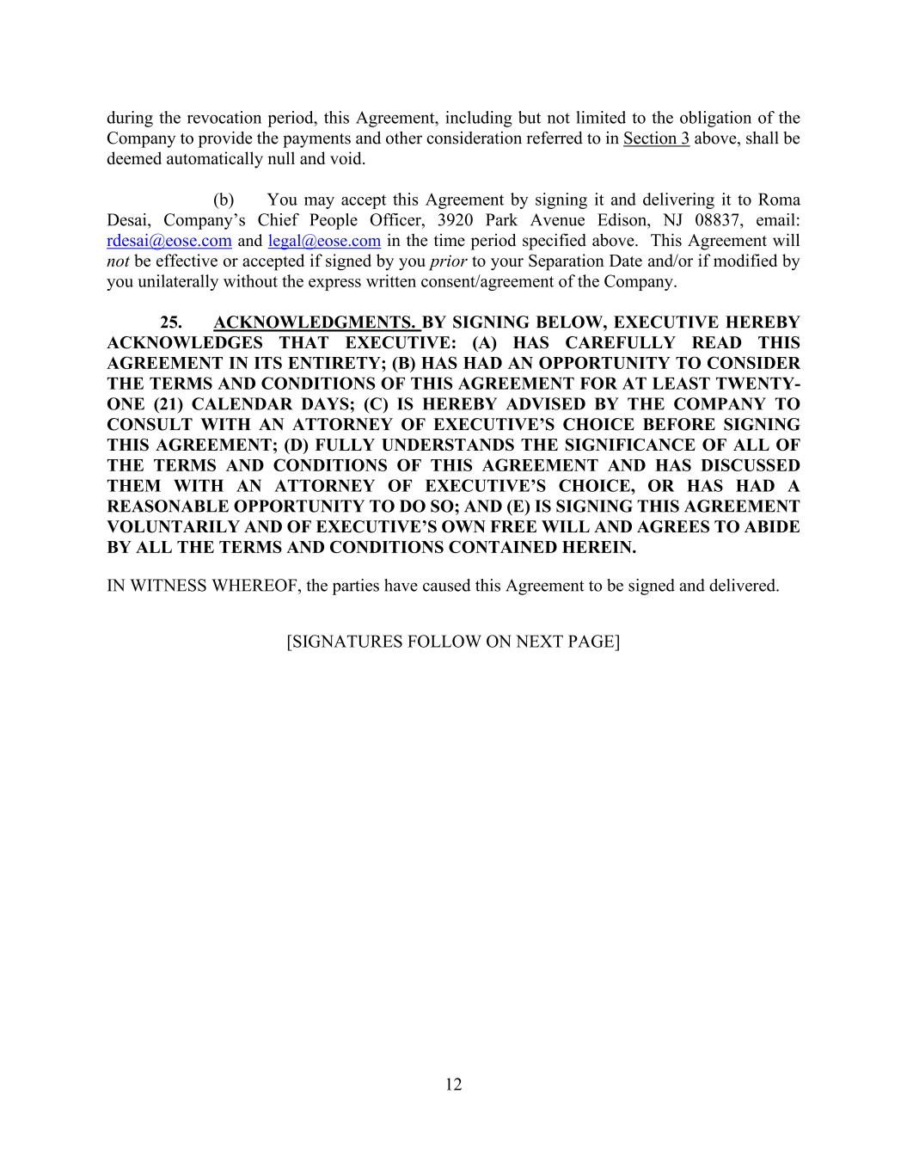
12 during the revocation period, this Agreement, including but not limited to the obligation of the Company to provide the payments and other consideration referred to in Section 3 above, shall be deemed automatically null and void. (b) You may accept this Agreement by signing it and delivering it to Roma Desai, Company’s Chief People Officer, 3920 Park Avenue Edison, NJ 08837, email: rdesai@eose.com and legal@eose.com in the time period specified above. This Agreement will not be effective or accepted if signed by you prior to your Separation Date and/or if modified by you unilaterally without the express written consent/agreement of the Company. 25. ACKNOWLEDGMENTS. BY SIGNING BELOW, EXECUTIVE HEREBY ACKNOWLEDGES THAT EXECUTIVE: (A) HAS CAREFULLY READ THIS AGREEMENT IN ITS ENTIRETY; (B) HAS HAD AN OPPORTUNITY TO CONSIDER THE TERMS AND CONDITIONS OF THIS AGREEMENT FOR AT LEAST TWENTY- ONE (21) CALENDAR DAYS; (C) IS HEREBY ADVISED BY THE COMPANY TO CONSULT WITH AN ATTORNEY OF EXECUTIVE’S CHOICE BEFORE SIGNING THIS AGREEMENT; (D) FULLY UNDERSTANDS THE SIGNIFICANCE OF ALL OF THE TERMS AND CONDITIONS OF THIS AGREEMENT AND HAS DISCUSSED THEM WITH AN ATTORNEY OF EXECUTIVE’S CHOICE, OR HAS HAD A REASONABLE OPPORTUNITY TO DO SO; AND (E) IS SIGNING THIS AGREEMENT VOLUNTARILY AND OF EXECUTIVE’S OWN FREE WILL AND AGREES TO ABIDE BY ALL THE TERMS AND CONDITIONS CONTAINED HEREIN. IN WITNESS WHEREOF, the parties have caused this Agreement to be signed and delivered. [SIGNATURES FOLLOW ON NEXT PAGE]

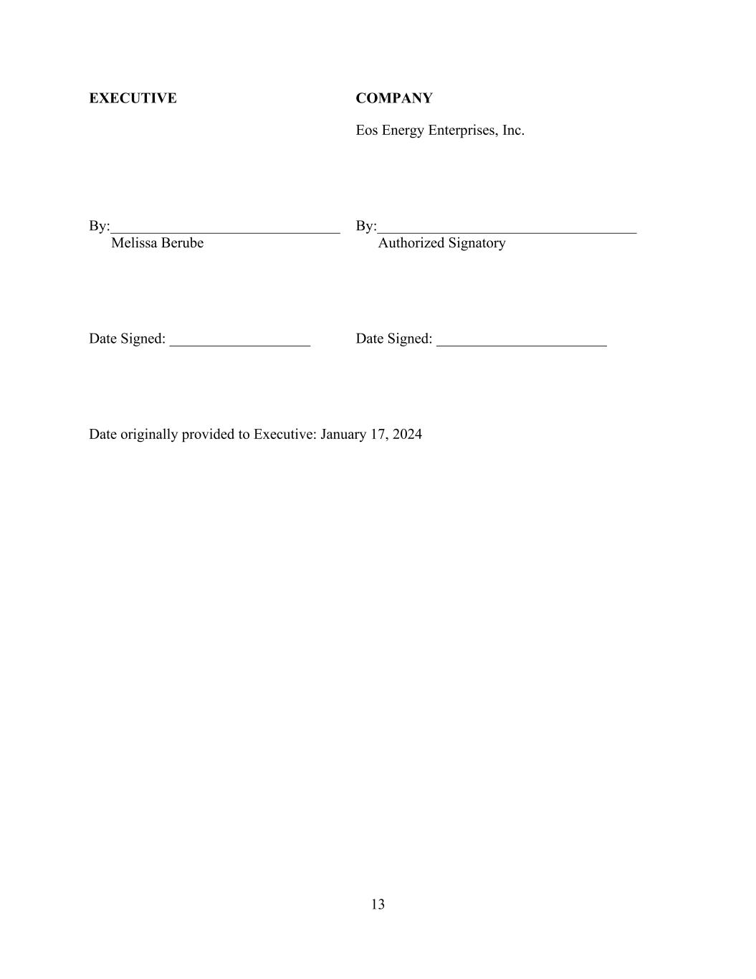
13 EXECUTIVE COMPANY Eos Energy Enterprises, Inc. By:_______________________________ By:___________________________________ Melissa Berube Authorized Signatory Date Signed: ___________________ Date Signed: _______________________ Date originally provided to Executive: January 17, 2024

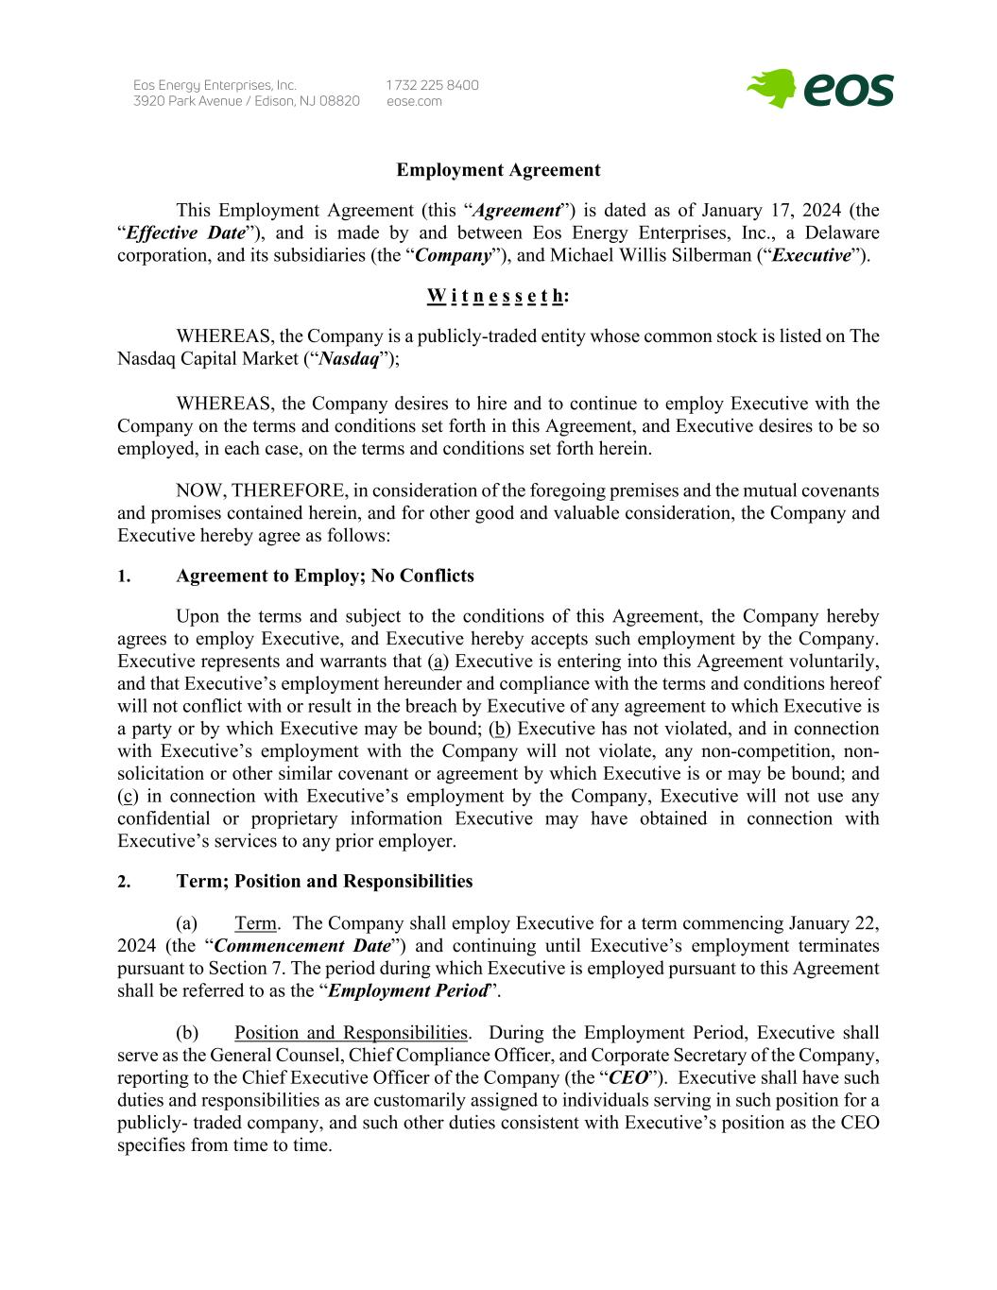
Employment Agreement This Employment Agreement (this “Agreement”) is dated as of January 17, 2024 (the “Effective Date”), and is made by and between Eos Energy Enterprises, Inc., a Delaware corporation, and its subsidiaries (the “Company”), and Michael Willis Silberman (“Executive”). W i t n e s s e t h: WHEREAS, the Company is a publicly-traded entity whose common stock is listed on The Nasdaq Capital Market (“Nasdaq”); WHEREAS, the Company desires to hire and to continue to employ Executive with the Company on the terms and conditions set forth in this Agreement, and Executive desires to be so employed, in each case, on the terms and conditions set forth herein. NOW, THEREFORE, in consideration of the foregoing premises and the mutual covenants and promises contained herein, and for other good and valuable consideration, the Company and Executive hereby agree as follows: 1. Agreement to Employ; No Conflicts Upon the terms and subject to the conditions of this Agreement, the Company hereby agrees to employ Executive, and Executive hereby accepts such employment by the Company. Executive represents and warrants that (a) Executive is entering into this Agreement voluntarily, and that Executive’s employment hereunder and compliance with the terms and conditions hereof will not conflict with or result in the breach by Executive of any agreement to which Executive is a party or by which Executive may be bound; (b) Executive has not violated, and in connection with Executive’s employment with the Company will not violate, any non-competition, non- solicitation or other similar covenant or agreement by which Executive is or may be bound; and (c) in connection with Executive’s employment by the Company, Executive will not use any confidential or proprietary information Executive may have obtained in connection with Executive’s services to any prior employer. 2. Term; Position and Responsibilities (a) Term. The Company shall employ Executive for a term commencing January 22, 2024 (the “Commencement Date”) and continuing until Executive’s employment terminates pursuant to Section 7. The period during which Executive is employed pursuant to this Agreement shall be referred to as the “Employment Period”. (b) Position and Responsibilities. During the Employment Period, Executive shall serve as the General Counsel, Chief Compliance Officer, and Corporate Secretary of the Company, reporting to the Chief Executive Officer of the Company (the “CEO”). Executive shall have such duties and responsibilities as are customarily assigned to individuals serving in such position for a publicly- traded company, and such other duties consistent with Executive’s position as the CEO specifies from time to time.

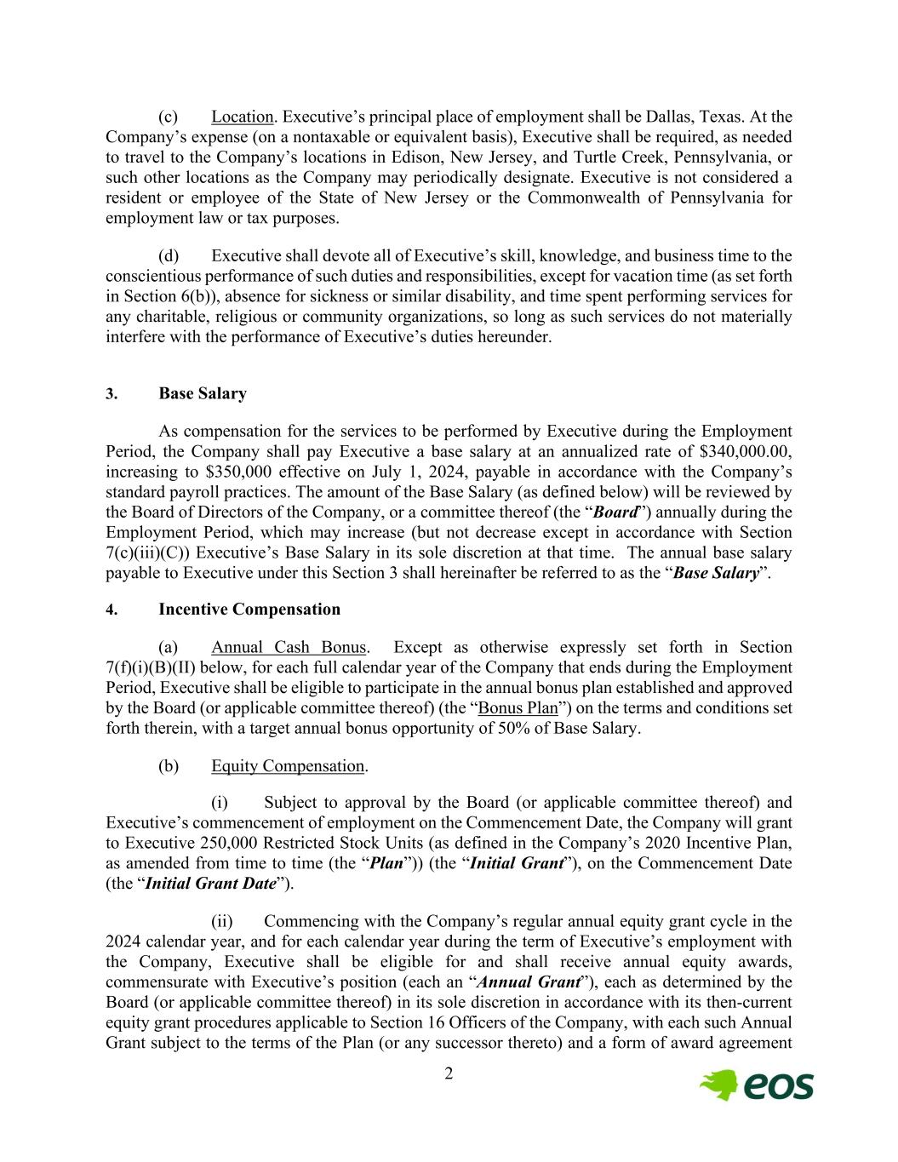
2 (c) Location. Executive’s principal place of employment shall be Dallas, Texas. At the Company’s expense (on a nontaxable or equivalent basis), Executive shall be required, as needed to travel to the Company’s locations in Edison, New Jersey, and Turtle Creek, Pennsylvania, or such other locations as the Company may periodically designate. Executive is not considered a resident or employee of the State of New Jersey or the Commonwealth of Pennsylvania for employment law or tax purposes. (d) Executive shall devote all of Executive’s skill, knowledge, and business time to the conscientious performance of such duties and responsibilities, except for vacation time (as set forth in Section 6(b)), absence for sickness or similar disability, and time spent performing services for any charitable, religious or community organizations, so long as such services do not materially interfere with the performance of Executive’s duties hereunder. 3. Base Salary As compensation for the services to be performed by Executive during the Employment Period, the Company shall pay Executive a base salary at an annualized rate of $340,000.00, increasing to $350,000 effective on July 1, 2024, payable in accordance with the Company’s standard payroll practices. The amount of the Base Salary (as defined below) will be reviewed by the Board of Directors of the Company, or a committee thereof (the “Board”) annually during the Employment Period, which may increase (but not decrease except in accordance with Section 7(c)(iii)(C)) Executive’s Base Salary in its sole discretion at that time. The annual base salary payable to Executive under this Section 3 shall hereinafter be referred to as the “Base Salary”. 4. Incentive Compensation (a) Annual Cash Bonus. Except as otherwise expressly set forth in Section 7(f)(i)(B)(II) below, for each full calendar year of the Company that ends during the Employment Period, Executive shall be eligible to participate in the annual bonus plan established and approved by the Board (or applicable committee thereof) (the “Bonus Plan”) on the terms and conditions set forth therein, with a target annual bonus opportunity of 50% of Base Salary. (b) Equity Compensation. (i) Subject to approval by the Board (or applicable committee thereof) and Executive’s commencement of employment on the Commencement Date, the Company will grant to Executive 250,000 Restricted Stock Units (as defined in the Company’s 2020 Incentive Plan, as amended from time to time (the “Plan”)) (the “Initial Grant”), on the Commencement Date (the “Initial Grant Date”). (ii) Commencing with the Company’s regular annual equity grant cycle in the 2024 calendar year, and for each calendar year during the term of Executive’s employment with the Company, Executive shall be eligible for and shall receive annual equity awards, commensurate with Executive’s position (each an “Annual Grant”), each as determined by the Board (or applicable committee thereof) in its sole discretion in accordance with its then-current equity grant procedures applicable to Section 16 Officers of the Company, with each such Annual Grant subject to the terms of the Plan (or any successor thereto) and a form of award agreement

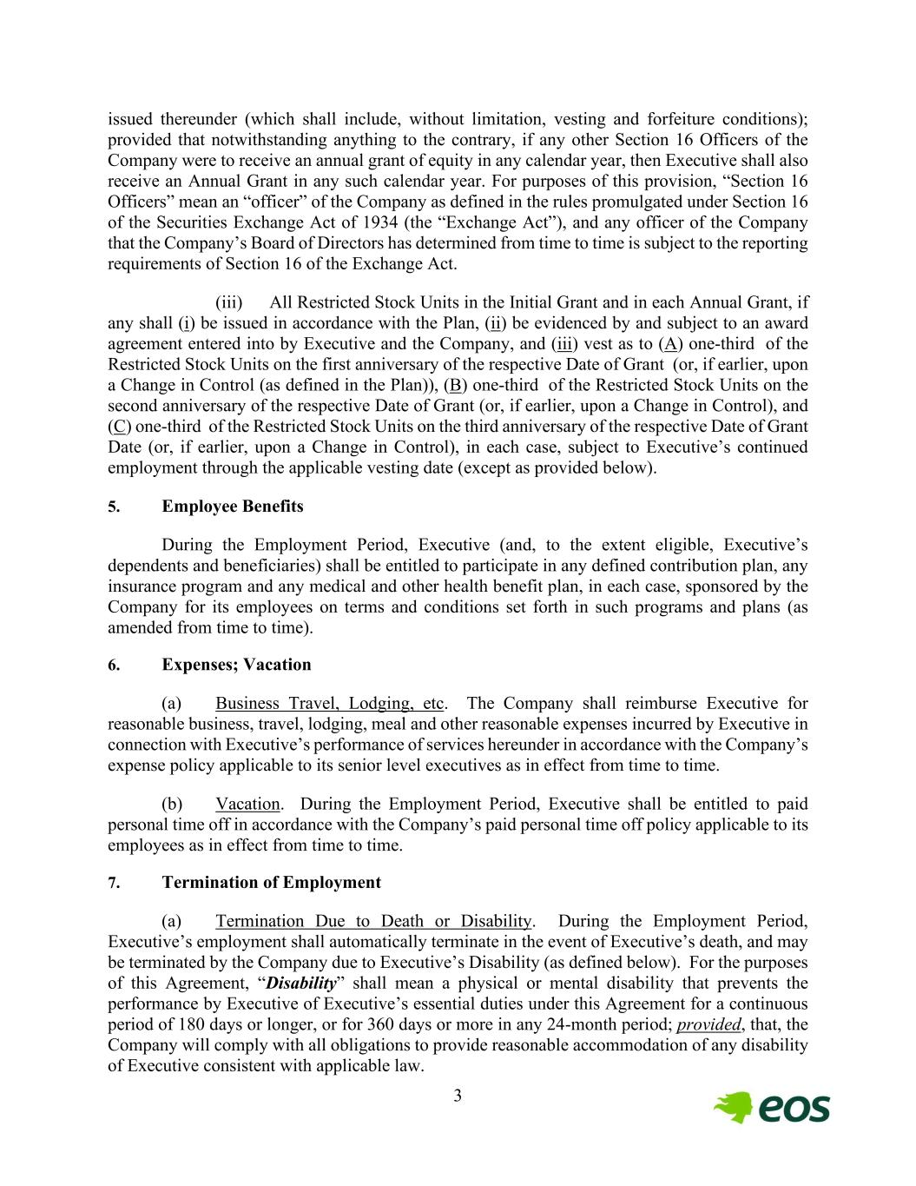
3 issued thereunder (which shall include, without limitation, vesting and forfeiture conditions); provided that notwithstanding anything to the contrary, if any other Section 16 Officers of the Company were to receive an annual grant of equity in any calendar year, then Executive shall also receive an Annual Grant in any such calendar year. For purposes of this provision, “Section 16 Officers” mean an “officer” of the Company as defined in the rules promulgated under Section 16 of the Securities Exchange Act of 1934 (the “Exchange Act”), and any officer of the Company that the Company’s Board of Directors has determined from time to time is subject to the reporting requirements of Section 16 of the Exchange Act. (iii) All Restricted Stock Units in the Initial Grant and in each Annual Grant, if any shall (i) be issued in accordance with the Plan, (ii) be evidenced by and subject to an award agreement entered into by Executive and the Company, and (iii) vest as to (A) one-third of the Restricted Stock Units on the first anniversary of the respective Date of Grant (or, if earlier, upon a Change in Control (as defined in the Plan)), (B) one-third of the Restricted Stock Units on the second anniversary of the respective Date of Grant (or, if earlier, upon a Change in Control), and (C) one-third of the Restricted Stock Units on the third anniversary of the respective Date of Grant Date (or, if earlier, upon a Change in Control), in each case, subject to Executive’s continued employment through the applicable vesting date (except as provided below). 5. Employee Benefits During the Employment Period, Executive (and, to the extent eligible, Executive’s dependents and beneficiaries) shall be entitled to participate in any defined contribution plan, any insurance program and any medical and other health benefit plan, in each case, sponsored by the Company for its employees on terms and conditions set forth in such programs and plans (as amended from time to time). 6. Expenses; Vacation (a) Business Travel, Lodging, etc. The Company shall reimburse Executive for reasonable business, travel, lodging, meal and other reasonable expenses incurred by Executive in connection with Executive’s performance of services hereunder in accordance with the Company’s expense policy applicable to its senior level executives as in effect from time to time. (b) Vacation. During the Employment Period, Executive shall be entitled to paid personal time off in accordance with the Company’s paid personal time off policy applicable to its employees as in effect from time to time. 7. Termination of Employment (a) Termination Due to Death or Disability. During the Employment Period, Executive’s employment shall automatically terminate in the event of Executive’s death, and may be terminated by the Company due to Executive’s Disability (as defined below). For the purposes of this Agreement, “Disability” shall mean a physical or mental disability that prevents the performance by Executive of Executive’s essential duties under this Agreement for a continuous period of 180 days or longer, or for 360 days or more in any 24-month period; provided, that, the Company will comply with all obligations to provide reasonable accommodation of any disability of Executive consistent with applicable law.

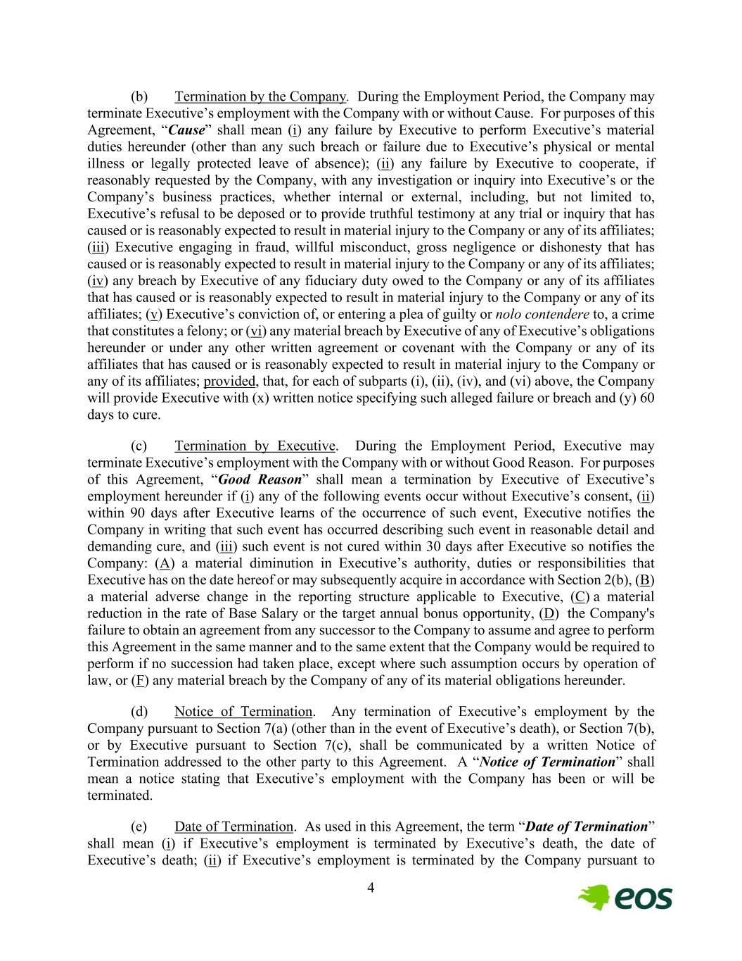
4 (b) Termination by the Company. During the Employment Period, the Company may terminate Executive’s employment with the Company with or without Cause. For purposes of this Agreement, “Cause” shall mean (i) any failure by Executive to perform Executive’s material duties hereunder (other than any such breach or failure due to Executive’s physical or mental illness or legally protected leave of absence); (ii) any failure by Executive to cooperate, if reasonably requested by the Company, with any investigation or inquiry into Executive’s or the Company’s business practices, whether internal or external, including, but not limited to, Executive’s refusal to be deposed or to provide truthful testimony at any trial or inquiry that has caused or is reasonably expected to result in material injury to the Company or any of its affiliates; (iii) Executive engaging in fraud, willful misconduct, gross negligence or dishonesty that has caused or is reasonably expected to result in material injury to the Company or any of its affiliates; (iv) any breach by Executive of any fiduciary duty owed to the Company or any of its affiliates that has caused or is reasonably expected to result in material injury to the Company or any of its affiliates; (v) Executive’s conviction of, or entering a plea of guilty or nolo contendere to, a crime that constitutes a felony; or (vi) any material breach by Executive of any of Executive’s obligations hereunder or under any other written agreement or covenant with the Company or any of its affiliates that has caused or is reasonably expected to result in material injury to the Company or any of its affiliates; provided, that, for each of subparts (i), (ii), (iv), and (vi) above, the Company will provide Executive with (x) written notice specifying such alleged failure or breach and (y) 60 days to cure. (c) Termination by Executive. During the Employment Period, Executive may terminate Executive’s employment with the Company with or without Good Reason. For purposes of this Agreement, “Good Reason” shall mean a termination by Executive of Executive’s employment hereunder if (i) any of the following events occur without Executive’s consent, (ii) within 90 days after Executive learns of the occurrence of such event, Executive notifies the Company in writing that such event has occurred describing such event in reasonable detail and demanding cure, and (iii) such event is not cured within 30 days after Executive so notifies the Company: (A) a material diminution in Executive’s authority, duties or responsibilities that Executive has on the date hereof or may subsequently acquire in accordance with Section 2(b), (B) a material adverse change in the reporting structure applicable to Executive, (C) a material reduction in the rate of Base Salary or the target annual bonus opportunity, (D) the Company's failure to obtain an agreement from any successor to the Company to assume and agree to perform this Agreement in the same manner and to the same extent that the Company would be required to perform if no succession had taken place, except where such assumption occurs by operation of law, or (F) any material breach by the Company of any of its material obligations hereunder. (d) Notice of Termination. Any termination of Executive’s employment by the Company pursuant to Section 7(a) (other than in the event of Executive’s death), or Section 7(b), or by Executive pursuant to Section 7(c), shall be communicated by a written Notice of Termination addressed to the other party to this Agreement. A “Notice of Termination” shall mean a notice stating that Executive’s employment with the Company has been or will be terminated. (e) Date of Termination. As used in this Agreement, the term “Date of Termination” shall mean (i) if Executive’s employment is terminated by Executive’s death, the date of Executive’s death; (ii) if Executive’s employment is terminated by the Company pursuant to

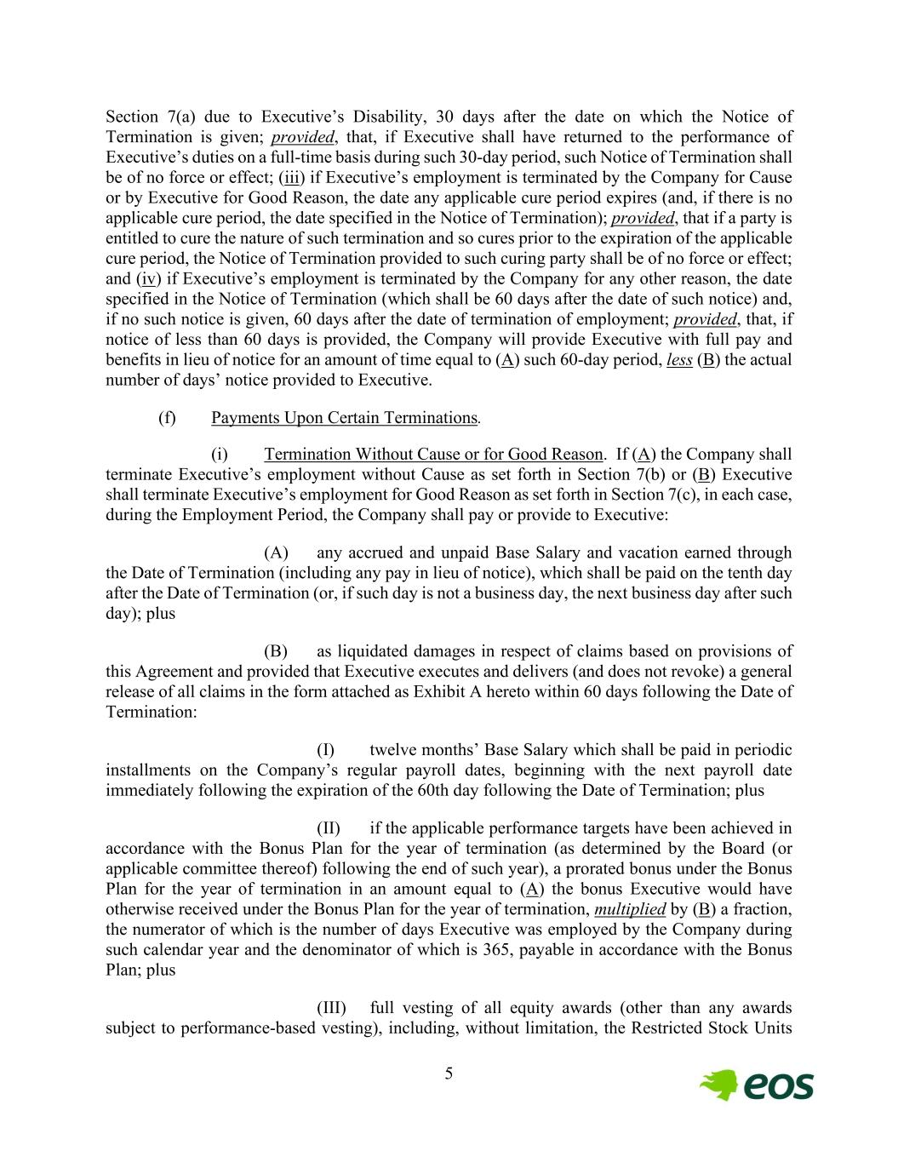
5 Section 7(a) due to Executive’s Disability, 30 days after the date on which the Notice of Termination is given; provided, that, if Executive shall have returned to the performance of Executive’s duties on a full-time basis during such 30-day period, such Notice of Termination shall be of no force or effect; (iii) if Executive’s employment is terminated by the Company for Cause or by Executive for Good Reason, the date any applicable cure period expires (and, if there is no applicable cure period, the date specified in the Notice of Termination); provided, that if a party is entitled to cure the nature of such termination and so cures prior to the expiration of the applicable cure period, the Notice of Termination provided to such curing party shall be of no force or effect; and (iv) if Executive’s employment is terminated by the Company for any other reason, the date specified in the Notice of Termination (which shall be 60 days after the date of such notice) and, if no such notice is given, 60 days after the date of termination of employment; provided, that, if notice of less than 60 days is provided, the Company will provide Executive with full pay and benefits in lieu of notice for an amount of time equal to (A) such 60-day period, less (B) the actual number of days’ notice provided to Executive. (f) Payments Upon Certain Terminations. (i) Termination Without Cause or for Good Reason. If (A) the Company shall terminate Executive’s employment without Cause as set forth in Section 7(b) or (B) Executive shall terminate Executive’s employment for Good Reason as set forth in Section 7(c), in each case, during the Employment Period, the Company shall pay or provide to Executive: (A) any accrued and unpaid Base Salary and vacation earned through the Date of Termination (including any pay in lieu of notice), which shall be paid on the tenth day after the Date of Termination (or, if such day is not a business day, the next business day after such day); plus (B) as liquidated damages in respect of claims based on provisions of this Agreement and provided that Executive executes and delivers (and does not revoke) a general release of all claims in the form attached as Exhibit A hereto within 60 days following the Date of Termination: (I) twelve months’ Base Salary which shall be paid in periodic installments on the Company’s regular payroll dates, beginning with the next payroll date immediately following the expiration of the 60th day following the Date of Termination; plus (II) if the applicable performance targets have been achieved in accordance with the Bonus Plan for the year of termination (as determined by the Board (or applicable committee thereof) following the end of such year), a prorated bonus under the Bonus Plan for the year of termination in an amount equal to (A) the bonus Executive would have otherwise received under the Bonus Plan for the year of termination, multiplied by (B) a fraction, the numerator of which is the number of days Executive was employed by the Company during such calendar year and the denominator of which is 365, payable in accordance with the Bonus Plan; plus (III) full vesting of all equity awards (other than any awards subject to performance-based vesting), including, without limitation, the Restricted Stock Units

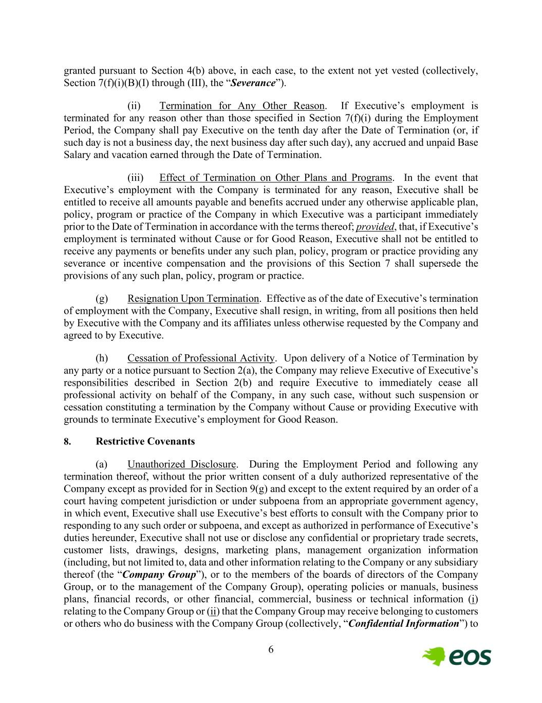
6 granted pursuant to Section 4(b) above, in each case, to the extent not yet vested (collectively, Section 7(f)(i)(B)(I) through (III), the “Severance”). (ii) Termination for Any Other Reason. If Executive’s employment is terminated for any reason other than those specified in Section 7(f)(i) during the Employment Period, the Company shall pay Executive on the tenth day after the Date of Termination (or, if such day is not a business day, the next business day after such day), any accrued and unpaid Base Salary and vacation earned through the Date of Termination. (iii) Effect of Termination on Other Plans and Programs. In the event that Executive’s employment with the Company is terminated for any reason, Executive shall be entitled to receive all amounts payable and benefits accrued under any otherwise applicable plan, policy, program or practice of the Company in which Executive was a participant immediately prior to the Date of Termination in accordance with the terms thereof; provided, that, if Executive’s employment is terminated without Cause or for Good Reason, Executive shall not be entitled to receive any payments or benefits under any such plan, policy, program or practice providing any severance or incentive compensation and the provisions of this Section 7 shall supersede the provisions of any such plan, policy, program or practice. (g) Resignation Upon Termination. Effective as of the date of Executive’s termination of employment with the Company, Executive shall resign, in writing, from all positions then held by Executive with the Company and its affiliates unless otherwise requested by the Company and agreed to by Executive. (h) Cessation of Professional Activity. Upon delivery of a Notice of Termination by any party or a notice pursuant to Section 2(a), the Company may relieve Executive of Executive’s responsibilities described in Section 2(b) and require Executive to immediately cease all professional activity on behalf of the Company, in any such case, without such suspension or cessation constituting a termination by the Company without Cause or providing Executive with grounds to terminate Executive’s employment for Good Reason. 8. Restrictive Covenants (a) Unauthorized Disclosure. During the Employment Period and following any termination thereof, without the prior written consent of a duly authorized representative of the Company except as provided for in Section 9(g) and except to the extent required by an order of a court having competent jurisdiction or under subpoena from an appropriate government agency, in which event, Executive shall use Executive’s best efforts to consult with the Company prior to responding to any such order or subpoena, and except as authorized in performance of Executive’s duties hereunder, Executive shall not use or disclose any confidential or proprietary trade secrets, customer lists, drawings, designs, marketing plans, management organization information (including, but not limited to, data and other information relating to the Company or any subsidiary thereof (the “Company Group”), or to the members of the boards of directors of the Company Group, or to the management of the Company Group), operating policies or manuals, business plans, financial records, or other financial, commercial, business or technical information (i) relating to the Company Group or (ii) that the Company Group may receive belonging to customers or others who do business with the Company Group (collectively, “Confidential Information”) to

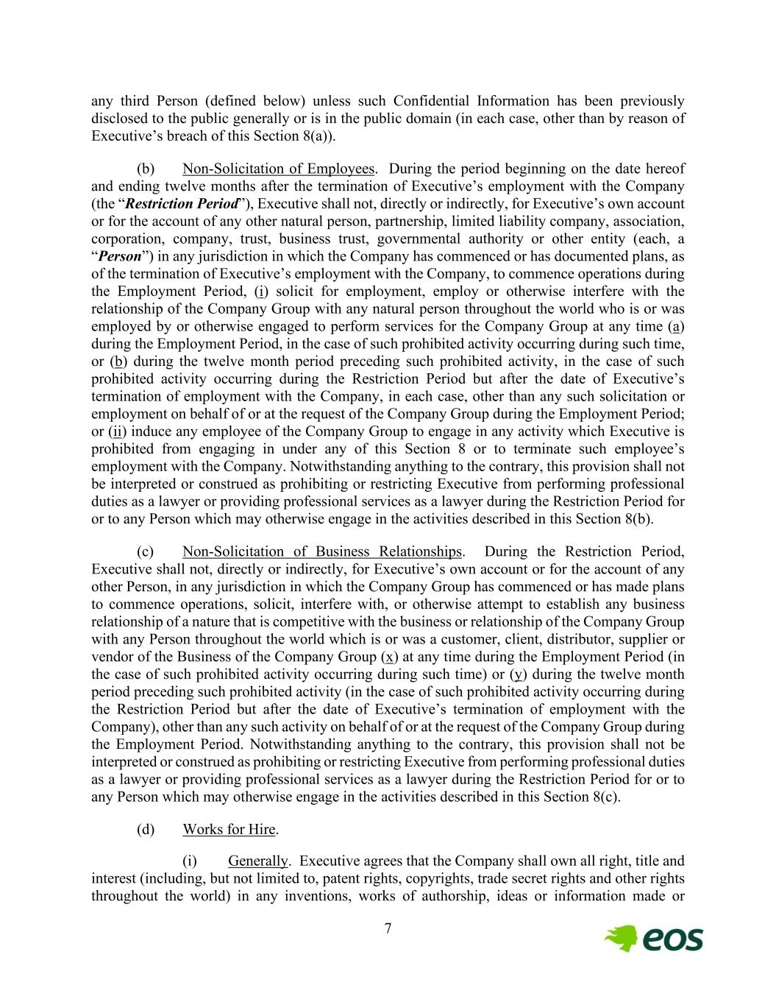
7 any third Person (defined below) unless such Confidential Information has been previously disclosed to the public generally or is in the public domain (in each case, other than by reason of Executive’s breach of this Section 8(a)). (b) Non-Solicitation of Employees. During the period beginning on the date hereof and ending twelve months after the termination of Executive’s employment with the Company (the “Restriction Period”), Executive shall not, directly or indirectly, for Executive’s own account or for the account of any other natural person, partnership, limited liability company, association, corporation, company, trust, business trust, governmental authority or other entity (each, a “Person”) in any jurisdiction in which the Company has commenced or has documented plans, as of the termination of Executive’s employment with the Company, to commence operations during the Employment Period, (i) solicit for employment, employ or otherwise interfere with the relationship of the Company Group with any natural person throughout the world who is or was employed by or otherwise engaged to perform services for the Company Group at any time (a) during the Employment Period, in the case of such prohibited activity occurring during such time, or (b) during the twelve month period preceding such prohibited activity, in the case of such prohibited activity occurring during the Restriction Period but after the date of Executive’s termination of employment with the Company, in each case, other than any such solicitation or employment on behalf of or at the request of the Company Group during the Employment Period; or (ii) induce any employee of the Company Group to engage in any activity which Executive is prohibited from engaging in under any of this Section 8 or to terminate such employee’s employment with the Company. Notwithstanding anything to the contrary, this provision shall not be interpreted or construed as prohibiting or restricting Executive from performing professional duties as a lawyer or providing professional services as a lawyer during the Restriction Period for or to any Person which may otherwise engage in the activities described in this Section 8(b). (c) Non-Solicitation of Business Relationships. During the Restriction Period, Executive shall not, directly or indirectly, for Executive’s own account or for the account of any other Person, in any jurisdiction in which the Company Group has commenced or has made plans to commence operations, solicit, interfere with, or otherwise attempt to establish any business relationship of a nature that is competitive with the business or relationship of the Company Group with any Person throughout the world which is or was a customer, client, distributor, supplier or vendor of the Business of the Company Group (x) at any time during the Employment Period (in the case of such prohibited activity occurring during such time) or (y) during the twelve month period preceding such prohibited activity (in the case of such prohibited activity occurring during the Restriction Period but after the date of Executive’s termination of employment with the Company), other than any such activity on behalf of or at the request of the Company Group during the Employment Period. Notwithstanding anything to the contrary, this provision shall not be interpreted or construed as prohibiting or restricting Executive from performing professional duties as a lawyer or providing professional services as a lawyer during the Restriction Period for or to any Person which may otherwise engage in the activities described in this Section 8(c). (d) Works for Hire. (i) Generally. Executive agrees that the Company shall own all right, title and interest (including, but not limited to, patent rights, copyrights, trade secret rights and other rights throughout the world) in any inventions, works of authorship, ideas or information made or

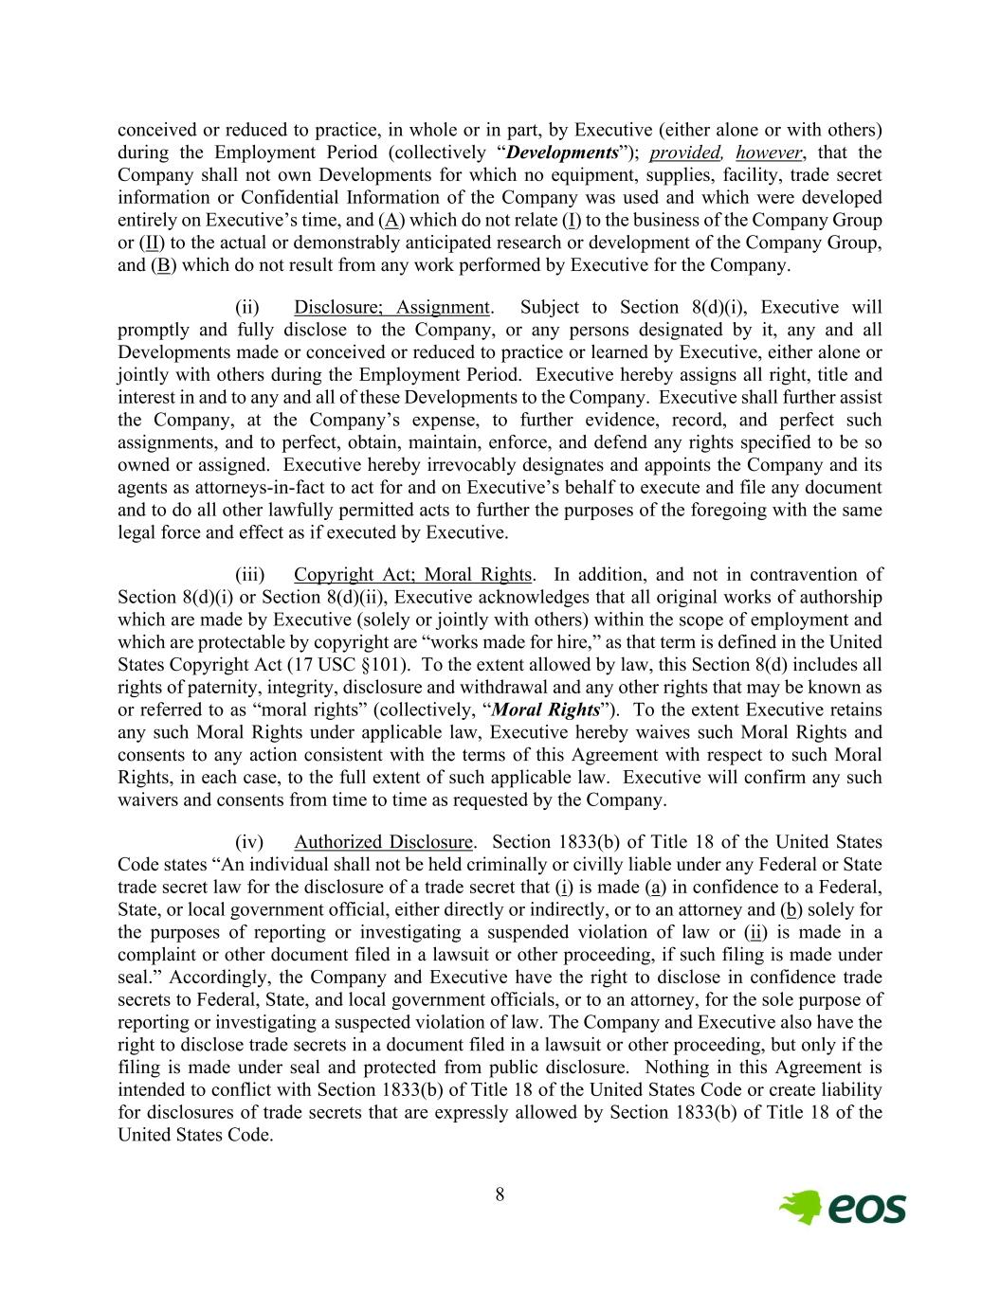
8 conceived or reduced to practice, in whole or in part, by Executive (either alone or with others) during the Employment Period (collectively “Developments”); provided, however, that the Company shall not own Developments for which no equipment, supplies, facility, trade secret information or Confidential Information of the Company was used and which were developed entirely on Executive’s time, and (A) which do not relate (I) to the business of the Company Group or (II) to the actual or demonstrably anticipated research or development of the Company Group, and (B) which do not result from any work performed by Executive for the Company. (ii) Disclosure; Assignment. Subject to Section 8(d)(i), Executive will promptly and fully disclose to the Company, or any persons designated by it, any and all Developments made or conceived or reduced to practice or learned by Executive, either alone or jointly with others during the Employment Period. Executive hereby assigns all right, title and interest in and to any and all of these Developments to the Company. Executive shall further assist the Company, at the Company’s expense, to further evidence, record, and perfect such assignments, and to perfect, obtain, maintain, enforce, and defend any rights specified to be so owned or assigned. Executive hereby irrevocably designates and appoints the Company and its agents as attorneys-in-fact to act for and on Executive’s behalf to execute and file any document and to do all other lawfully permitted acts to further the purposes of the foregoing with the same legal force and effect as if executed by Executive. (iii) Copyright Act; Moral Rights. In addition, and not in contravention of Section 8(d)(i) or Section 8(d)(ii), Executive acknowledges that all original works of authorship which are made by Executive (solely or jointly with others) within the scope of employment and which are protectable by copyright are “works made for hire,” as that term is defined in the United States Copyright Act (17 USC §101). To the extent allowed by law, this Section 8(d) includes all rights of paternity, integrity, disclosure and withdrawal and any other rights that may be known as or referred to as “moral rights” (collectively, “Moral Rights”). To the extent Executive retains any such Moral Rights under applicable law, Executive hereby waives such Moral Rights and consents to any action consistent with the terms of this Agreement with respect to such Moral Rights, in each case, to the full extent of such applicable law. Executive will confirm any such waivers and consents from time to time as requested by the Company. (iv) Authorized Disclosure. Section 1833(b) of Title 18 of the United States Code states “An individual shall not be held criminally or civilly liable under any Federal or State trade secret law for the disclosure of a trade secret that (i) is made (a) in confidence to a Federal, State, or local government official, either directly or indirectly, or to an attorney and (b) solely for the purposes of reporting or investigating a suspended violation of law or (ii) is made in a complaint or other document filed in a lawsuit or other proceeding, if such filing is made under seal.” Accordingly, the Company and Executive have the right to disclose in confidence trade secrets to Federal, State, and local government officials, or to an attorney, for the sole purpose of reporting or investigating a suspected violation of law. The Company and Executive also have the right to disclose trade secrets in a document filed in a lawsuit or other proceeding, but only if the filing is made under seal and protected from public disclosure. Nothing in this Agreement is intended to conflict with Section 1833(b) of Title 18 of the United States Code or create liability for disclosures of trade secrets that are expressly allowed by Section 1833(b) of Title 18 of the United States Code.

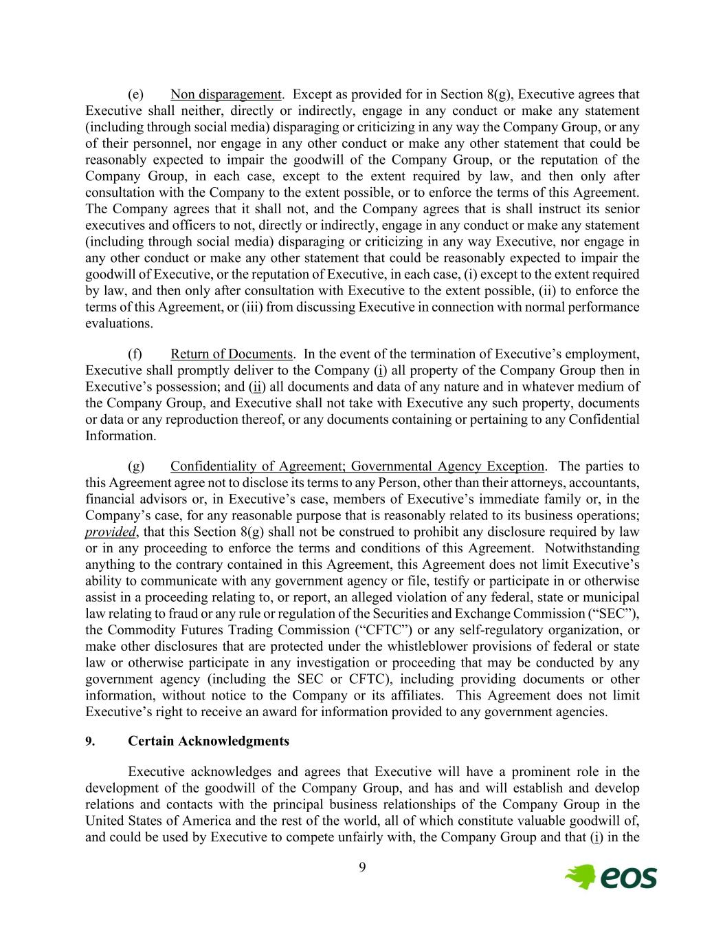
9 (e) Non disparagement. Except as provided for in Section 8(g), Executive agrees that Executive shall neither, directly or indirectly, engage in any conduct or make any statement (including through social media) disparaging or criticizing in any way the Company Group, or any of their personnel, nor engage in any other conduct or make any other statement that could be reasonably expected to impair the goodwill of the Company Group, or the reputation of the Company Group, in each case, except to the extent required by law, and then only after consultation with the Company to the extent possible, or to enforce the terms of this Agreement. The Company agrees that it shall not, and the Company agrees that is shall instruct its senior executives and officers to not, directly or indirectly, engage in any conduct or make any statement (including through social media) disparaging or criticizing in any way Executive, nor engage in any other conduct or make any other statement that could be reasonably expected to impair the goodwill of Executive, or the reputation of Executive, in each case, (i) except to the extent required by law, and then only after consultation with Executive to the extent possible, (ii) to enforce the terms of this Agreement, or (iii) from discussing Executive in connection with normal performance evaluations. (f) Return of Documents. In the event of the termination of Executive’s employment, Executive shall promptly deliver to the Company (i) all property of the Company Group then in Executive’s possession; and (ii) all documents and data of any nature and in whatever medium of the Company Group, and Executive shall not take with Executive any such property, documents or data or any reproduction thereof, or any documents containing or pertaining to any Confidential Information. (g) Confidentiality of Agreement; Governmental Agency Exception. The parties to this Agreement agree not to disclose its terms to any Person, other than their attorneys, accountants, financial advisors or, in Executive’s case, members of Executive’s immediate family or, in the Company’s case, for any reasonable purpose that is reasonably related to its business operations; provided, that this Section 8(g) shall not be construed to prohibit any disclosure required by law or in any proceeding to enforce the terms and conditions of this Agreement. Notwithstanding anything to the contrary contained in this Agreement, this Agreement does not limit Executive’s ability to communicate with any government agency or file, testify or participate in or otherwise assist in a proceeding relating to, or report, an alleged violation of any federal, state or municipal law relating to fraud or any rule or regulation of the Securities and Exchange Commission (“SEC”), the Commodity Futures Trading Commission (“CFTC”) or any self-regulatory organization, or make other disclosures that are protected under the whistleblower provisions of federal or state law or otherwise participate in any investigation or proceeding that may be conducted by any government agency (including the SEC or CFTC), including providing documents or other information, without notice to the Company or its affiliates. This Agreement does not limit Executive’s right to receive an award for information provided to any government agencies. 9. Certain Acknowledgments Executive acknowledges and agrees that Executive will have a prominent role in the development of the goodwill of the Company Group, and has and will establish and develop relations and contacts with the principal business relationships of the Company Group in the United States of America and the rest of the world, all of which constitute valuable goodwill of, and could be used by Executive to compete unfairly with, the Company Group and that (i) in the

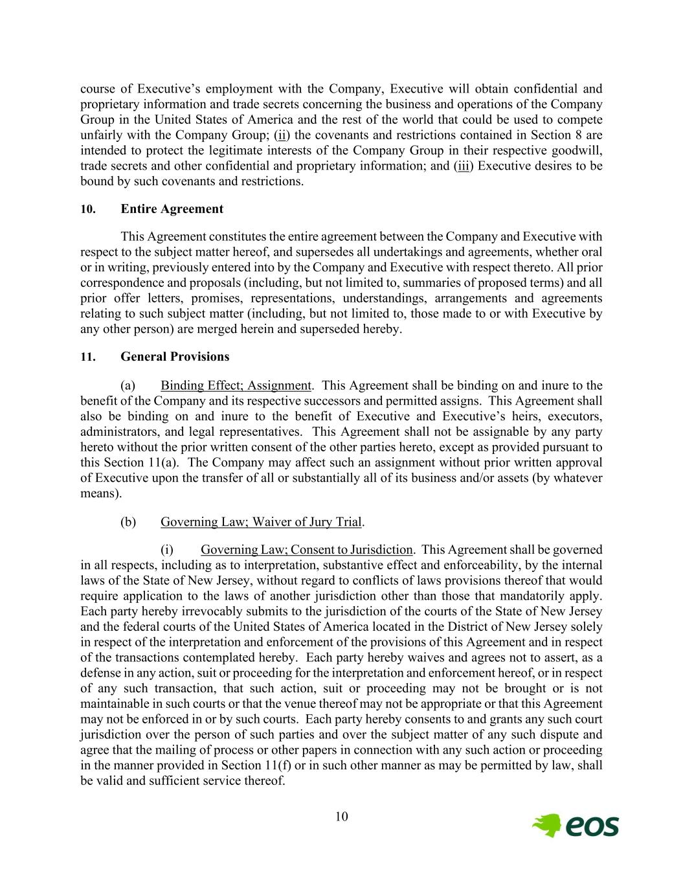
10 course of Executive’s employment with the Company, Executive will obtain confidential and proprietary information and trade secrets concerning the business and operations of the Company Group in the United States of America and the rest of the world that could be used to compete unfairly with the Company Group; (ii) the covenants and restrictions contained in Section 8 are intended to protect the legitimate interests of the Company Group in their respective goodwill, trade secrets and other confidential and proprietary information; and (iii) Executive desires to be bound by such covenants and restrictions. 10. Entire Agreement This Agreement constitutes the entire agreement between the Company and Executive with respect to the subject matter hereof, and supersedes all undertakings and agreements, whether oral or in writing, previously entered into by the Company and Executive with respect thereto. All prior correspondence and proposals (including, but not limited to, summaries of proposed terms) and all prior offer letters, promises, representations, understandings, arrangements and agreements relating to such subject matter (including, but not limited to, those made to or with Executive by any other person) are merged herein and superseded hereby. 11. General Provisions (a) Binding Effect; Assignment. This Agreement shall be binding on and inure to the benefit of the Company and its respective successors and permitted assigns. This Agreement shall also be binding on and inure to the benefit of Executive and Executive’s heirs, executors, administrators, and legal representatives. This Agreement shall not be assignable by any party hereto without the prior written consent of the other parties hereto, except as provided pursuant to this Section 11(a). The Company may affect such an assignment without prior written approval of Executive upon the transfer of all or substantially all of its business and/or assets (by whatever means). (b) Governing Law; Waiver of Jury Trial. (i) Governing Law; Consent to Jurisdiction. This Agreement shall be governed in all respects, including as to interpretation, substantive effect and enforceability, by the internal laws of the State of New Jersey, without regard to conflicts of laws provisions thereof that would require application to the laws of another jurisdiction other than those that mandatorily apply. Each party hereby irrevocably submits to the jurisdiction of the courts of the State of New Jersey and the federal courts of the United States of America located in the District of New Jersey solely in respect of the interpretation and enforcement of the provisions of this Agreement and in respect of the transactions contemplated hereby. Each party hereby waives and agrees not to assert, as a defense in any action, suit or proceeding for the interpretation and enforcement hereof, or in respect of any such transaction, that such action, suit or proceeding may not be brought or is not maintainable in such courts or that the venue thereof may not be appropriate or that this Agreement may not be enforced in or by such courts. Each party hereby consents to and grants any such court jurisdiction over the person of such parties and over the subject matter of any such dispute and agree that the mailing of process or other papers in connection with any such action or proceeding in the manner provided in Section 11(f) or in such other manner as may be permitted by law, shall be valid and sufficient service thereof.

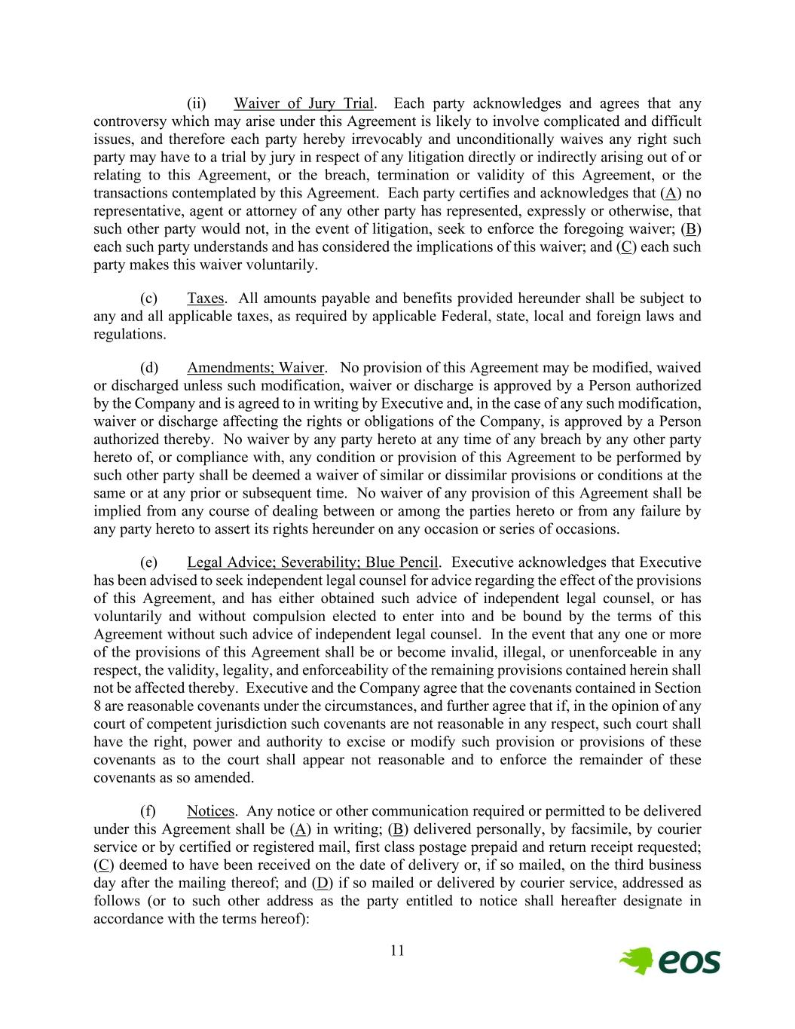
11 (ii) Waiver of Jury Trial. Each party acknowledges and agrees that any controversy which may arise under this Agreement is likely to involve complicated and difficult issues, and therefore each party hereby irrevocably and unconditionally waives any right such party may have to a trial by jury in respect of any litigation directly or indirectly arising out of or relating to this Agreement, or the breach, termination or validity of this Agreement, or the transactions contemplated by this Agreement. Each party certifies and acknowledges that (A) no representative, agent or attorney of any other party has represented, expressly or otherwise, that such other party would not, in the event of litigation, seek to enforce the foregoing waiver; (B) each such party understands and has considered the implications of this waiver; and (C) each such party makes this waiver voluntarily. (c) Taxes. All amounts payable and benefits provided hereunder shall be subject to any and all applicable taxes, as required by applicable Federal, state, local and foreign laws and regulations. (d) Amendments; Waiver. No provision of this Agreement may be modified, waived or discharged unless such modification, waiver or discharge is approved by a Person authorized by the Company and is agreed to in writing by Executive and, in the case of any such modification, waiver or discharge affecting the rights or obligations of the Company, is approved by a Person authorized thereby. No waiver by any party hereto at any time of any breach by any other party hereto of, or compliance with, any condition or provision of this Agreement to be performed by such other party shall be deemed a waiver of similar or dissimilar provisions or conditions at the same or at any prior or subsequent time. No waiver of any provision of this Agreement shall be implied from any course of dealing between or among the parties hereto or from any failure by any party hereto to assert its rights hereunder on any occasion or series of occasions. (e) Legal Advice; Severability; Blue Pencil. Executive acknowledges that Executive has been advised to seek independent legal counsel for advice regarding the effect of the provisions of this Agreement, and has either obtained such advice of independent legal counsel, or has voluntarily and without compulsion elected to enter into and be bound by the terms of this Agreement without such advice of independent legal counsel. In the event that any one or more of the provisions of this Agreement shall be or become invalid, illegal, or unenforceable in any respect, the validity, legality, and enforceability of the remaining provisions contained herein shall not be affected thereby. Executive and the Company agree that the covenants contained in Section 8 are reasonable covenants under the circumstances, and further agree that if, in the opinion of any court of competent jurisdiction such covenants are not reasonable in any respect, such court shall have the right, power and authority to excise or modify such provision or provisions of these covenants as to the court shall appear not reasonable and to enforce the remainder of these covenants as so amended. (f) Notices. Any notice or other communication required or permitted to be delivered under this Agreement shall be (A) in writing; (B) delivered personally, by facsimile, by courier service or by certified or registered mail, first class postage prepaid and return receipt requested; (C) deemed to have been received on the date of delivery or, if so mailed, on the third business day after the mailing thereof; and (D) if so mailed or delivered by courier service, addressed as follows (or to such other address as the party entitled to notice shall hereafter designate in accordance with the terms hereof):

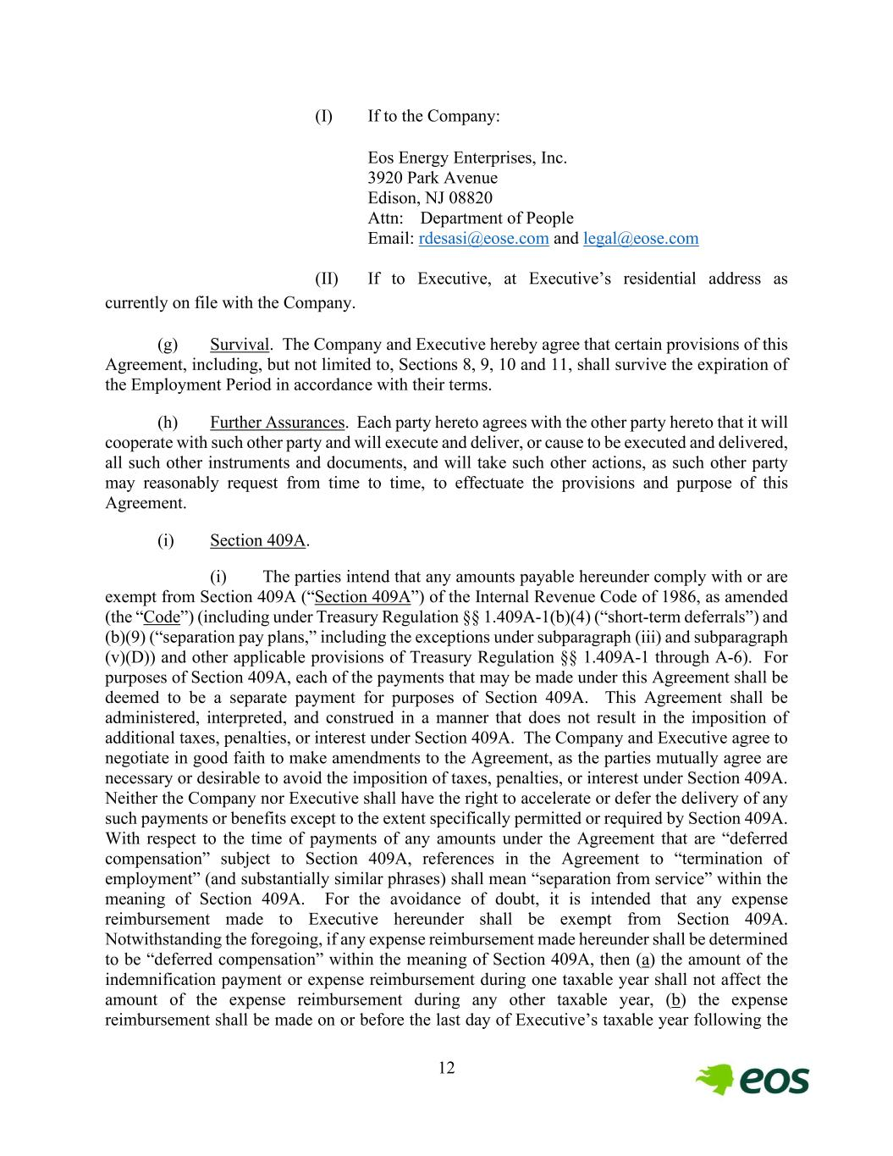
12 (I) If to the Company: Eos Energy Enterprises, Inc. 3920 Park Avenue Edison, NJ 08820 Attn: Department of People Email: rdesasi@eose.com and legal@eose.com (II) If to Executive, at Executive’s residential address as currently on file with the Company. (g) Survival. The Company and Executive hereby agree that certain provisions of this Agreement, including, but not limited to, Sections 8, 9, 10 and 11, shall survive the expiration of the Employment Period in accordance with their terms. (h) Further Assurances. Each party hereto agrees with the other party hereto that it will cooperate with such other party and will execute and deliver, or cause to be executed and delivered, all such other instruments and documents, and will take such other actions, as such other party may reasonably request from time to time, to effectuate the provisions and purpose of this Agreement. (i) Section 409A. (i) The parties intend that any amounts payable hereunder comply with or are exempt from Section 409A (“Section 409A”) of the Internal Revenue Code of 1986, as amended (the “Code”) (including under Treasury Regulation §§ 1.409A-1(b)(4) (“short-term deferrals”) and (b)(9) (“separation pay plans,” including the exceptions under subparagraph (iii) and subparagraph (v)(D)) and other applicable provisions of Treasury Regulation §§ 1.409A-1 through A-6). For purposes of Section 409A, each of the payments that may be made under this Agreement shall be deemed to be a separate payment for purposes of Section 409A. This Agreement shall be administered, interpreted, and construed in a manner that does not result in the imposition of additional taxes, penalties, or interest under Section 409A. The Company and Executive agree to negotiate in good faith to make amendments to the Agreement, as the parties mutually agree are necessary or desirable to avoid the imposition of taxes, penalties, or interest under Section 409A. Neither the Company nor Executive shall have the right to accelerate or defer the delivery of any such payments or benefits except to the extent specifically permitted or required by Section 409A. With respect to the time of payments of any amounts under the Agreement that are “deferred compensation” subject to Section 409A, references in the Agreement to “termination of employment” (and substantially similar phrases) shall mean “separation from service” within the meaning of Section 409A. For the avoidance of doubt, it is intended that any expense reimbursement made to Executive hereunder shall be exempt from Section 409A. Notwithstanding the foregoing, if any expense reimbursement made hereunder shall be determined to be “deferred compensation” within the meaning of Section 409A, then (a) the amount of the indemnification payment or expense reimbursement during one taxable year shall not affect the amount of the expense reimbursement during any other taxable year, (b) the expense reimbursement shall be made on or before the last day of Executive’s taxable year following the

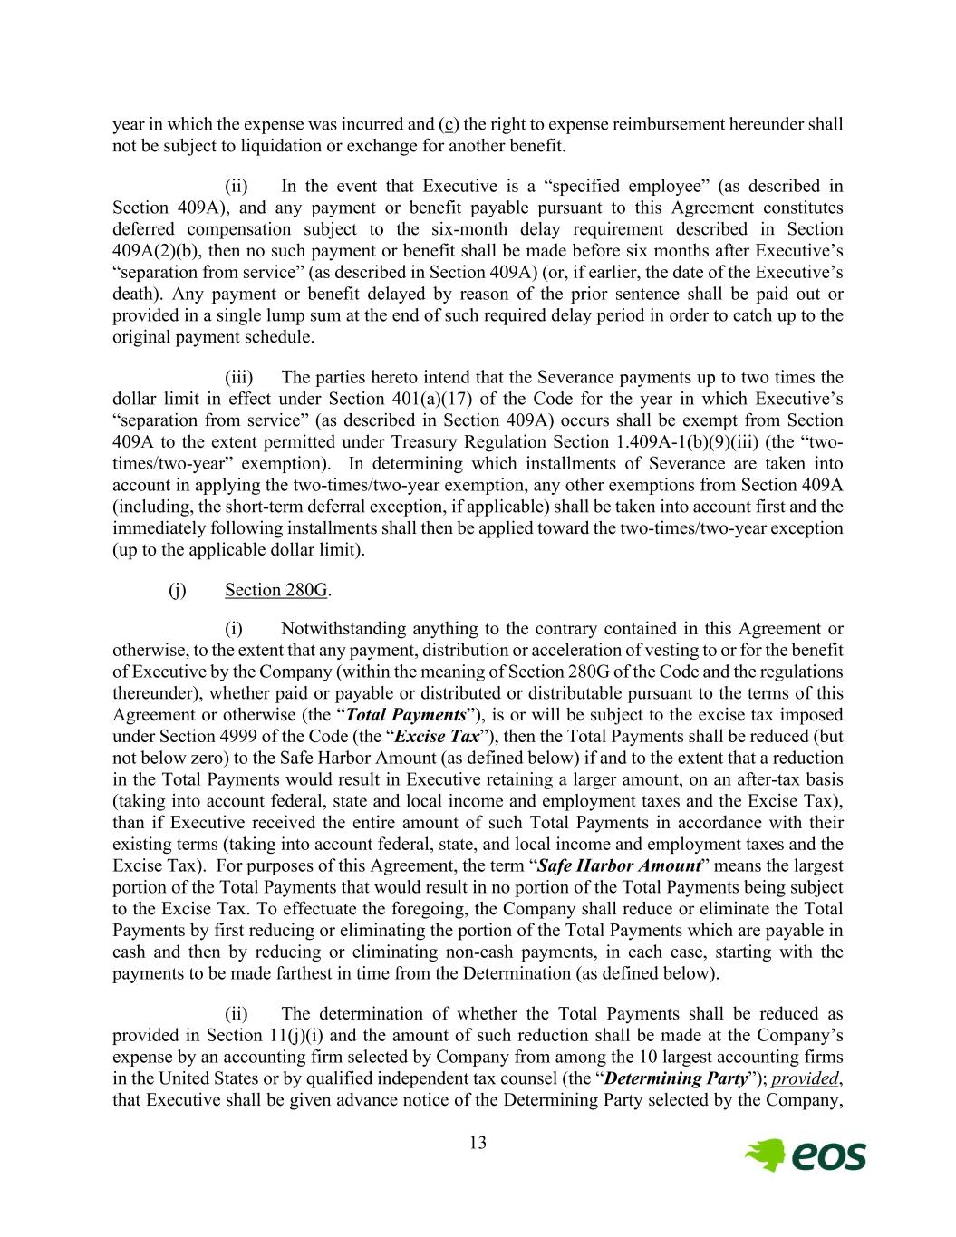
13 year in which the expense was incurred and (c) the right to expense reimbursement hereunder shall not be subject to liquidation or exchange for another benefit. (ii) In the event that Executive is a “specified employee” (as described in Section 409A), and any payment or benefit payable pursuant to this Agreement constitutes deferred compensation subject to the six-month delay requirement described in Section 409A(2)(b), then no such payment or benefit shall be made before six months after Executive’s “separation from service” (as described in Section 409A) (or, if earlier, the date of the Executive’s death). Any payment or benefit delayed by reason of the prior sentence shall be paid out or provided in a single lump sum at the end of such required delay period in order to catch up to the original payment schedule. (iii) The parties hereto intend that the Severance payments up to two times the dollar limit in effect under Section 401(a)(17) of the Code for the year in which Executive’s “separation from service” (as described in Section 409A) occurs shall be exempt from Section 409A to the extent permitted under Treasury Regulation Section 1.409A-1(b)(9)(iii) (the “two- times/two-year” exemption). In determining which installments of Severance are taken into account in applying the two-times/two-year exemption, any other exemptions from Section 409A (including, the short-term deferral exception, if applicable) shall be taken into account first and the immediately following installments shall then be applied toward the two-times/two-year exception (up to the applicable dollar limit). (j) Section 280G. (i) Notwithstanding anything to the contrary contained in this Agreement or otherwise, to the extent that any payment, distribution or acceleration of vesting to or for the benefit of Executive by the Company (within the meaning of Section 280G of the Code and the regulations thereunder), whether paid or payable or distributed or distributable pursuant to the terms of this Agreement or otherwise (the “Total Payments”), is or will be subject to the excise tax imposed under Section 4999 of the Code (the “Excise Tax”), then the Total Payments shall be reduced (but not below zero) to the Safe Harbor Amount (as defined below) if and to the extent that a reduction in the Total Payments would result in Executive retaining a larger amount, on an after-tax basis (taking into account federal, state and local income and employment taxes and the Excise Tax), than if Executive received the entire amount of such Total Payments in accordance with their existing terms (taking into account federal, state, and local income and employment taxes and the Excise Tax). For purposes of this Agreement, the term “Safe Harbor Amount” means the largest portion of the Total Payments that would result in no portion of the Total Payments being subject to the Excise Tax. To effectuate the foregoing, the Company shall reduce or eliminate the Total Payments by first reducing or eliminating the portion of the Total Payments which are payable in cash and then by reducing or eliminating non-cash payments, in each case, starting with the payments to be made farthest in time from the Determination (as defined below). (ii) The determination of whether the Total Payments shall be reduced as provided in Section 11(j)(i) and the amount of such reduction shall be made at the Company’s expense by an accounting firm selected by Company from among the 10 largest accounting firms in the United States or by qualified independent tax counsel (the “Determining Party”); provided, that Executive shall be given advance notice of the Determining Party selected by the Company,

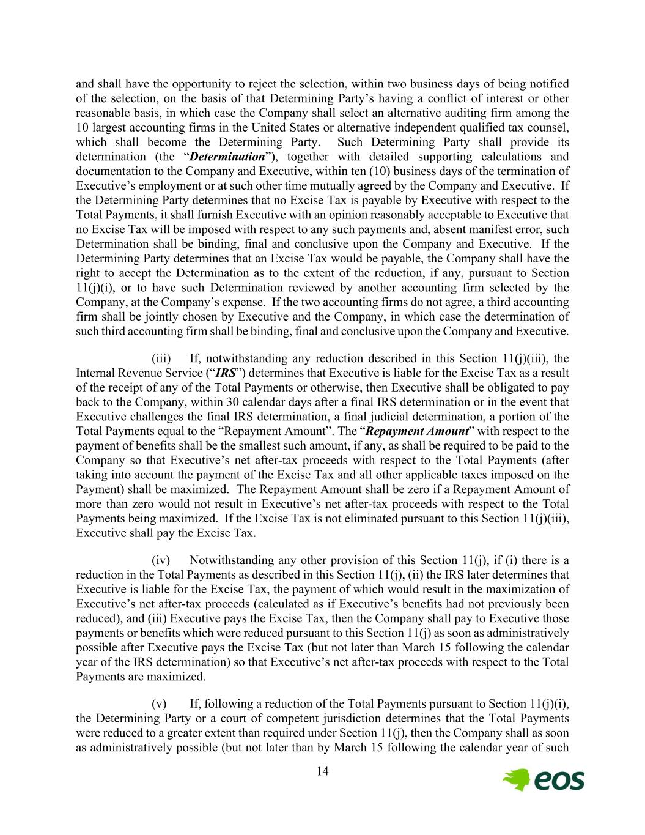
14 and shall have the opportunity to reject the selection, within two business days of being notified of the selection, on the basis of that Determining Party’s having a conflict of interest or other reasonable basis, in which case the Company shall select an alternative auditing firm among the 10 largest accounting firms in the United States or alternative independent qualified tax counsel, which shall become the Determining Party. Such Determining Party shall provide its determination (the “Determination”), together with detailed supporting calculations and documentation to the Company and Executive, within ten (10) business days of the termination of Executive’s employment or at such other time mutually agreed by the Company and Executive. If the Determining Party determines that no Excise Tax is payable by Executive with respect to the Total Payments, it shall furnish Executive with an opinion reasonably acceptable to Executive that no Excise Tax will be imposed with respect to any such payments and, absent manifest error, such Determination shall be binding, final and conclusive upon the Company and Executive. If the Determining Party determines that an Excise Tax would be payable, the Company shall have the right to accept the Determination as to the extent of the reduction, if any, pursuant to Section 11(j)(i), or to have such Determination reviewed by another accounting firm selected by the Company, at the Company’s expense. If the two accounting firms do not agree, a third accounting firm shall be jointly chosen by Executive and the Company, in which case the determination of such third accounting firm shall be binding, final and conclusive upon the Company and Executive. (iii) If, notwithstanding any reduction described in this Section 11(j)(iii), the Internal Revenue Service (“IRS”) determines that Executive is liable for the Excise Tax as a result of the receipt of any of the Total Payments or otherwise, then Executive shall be obligated to pay back to the Company, within 30 calendar days after a final IRS determination or in the event that Executive challenges the final IRS determination, a final judicial determination, a portion of the Total Payments equal to the “Repayment Amount”. The “Repayment Amount” with respect to the payment of benefits shall be the smallest such amount, if any, as shall be required to be paid to the Company so that Executive’s net after-tax proceeds with respect to the Total Payments (after taking into account the payment of the Excise Tax and all other applicable taxes imposed on the Payment) shall be maximized. The Repayment Amount shall be zero if a Repayment Amount of more than zero would not result in Executive’s net after-tax proceeds with respect to the Total Payments being maximized. If the Excise Tax is not eliminated pursuant to this Section 11(j)(iii), Executive shall pay the Excise Tax. (iv) Notwithstanding any other provision of this Section 11(j), if (i) there is a reduction in the Total Payments as described in this Section 11(j), (ii) the IRS later determines that Executive is liable for the Excise Tax, the payment of which would result in the maximization of Executive’s net after-tax proceeds (calculated as if Executive’s benefits had not previously been reduced), and (iii) Executive pays the Excise Tax, then the Company shall pay to Executive those payments or benefits which were reduced pursuant to this Section 11(j) as soon as administratively possible after Executive pays the Excise Tax (but not later than March 15 following the calendar year of the IRS determination) so that Executive’s net after-tax proceeds with respect to the Total Payments are maximized. (v) If, following a reduction of the Total Payments pursuant to Section 11(j)(i), the Determining Party or a court of competent jurisdiction determines that the Total Payments were reduced to a greater extent than required under Section 11(j), then the Company shall as soon as administratively possible (but not later than by March 15 following the calendar year of such

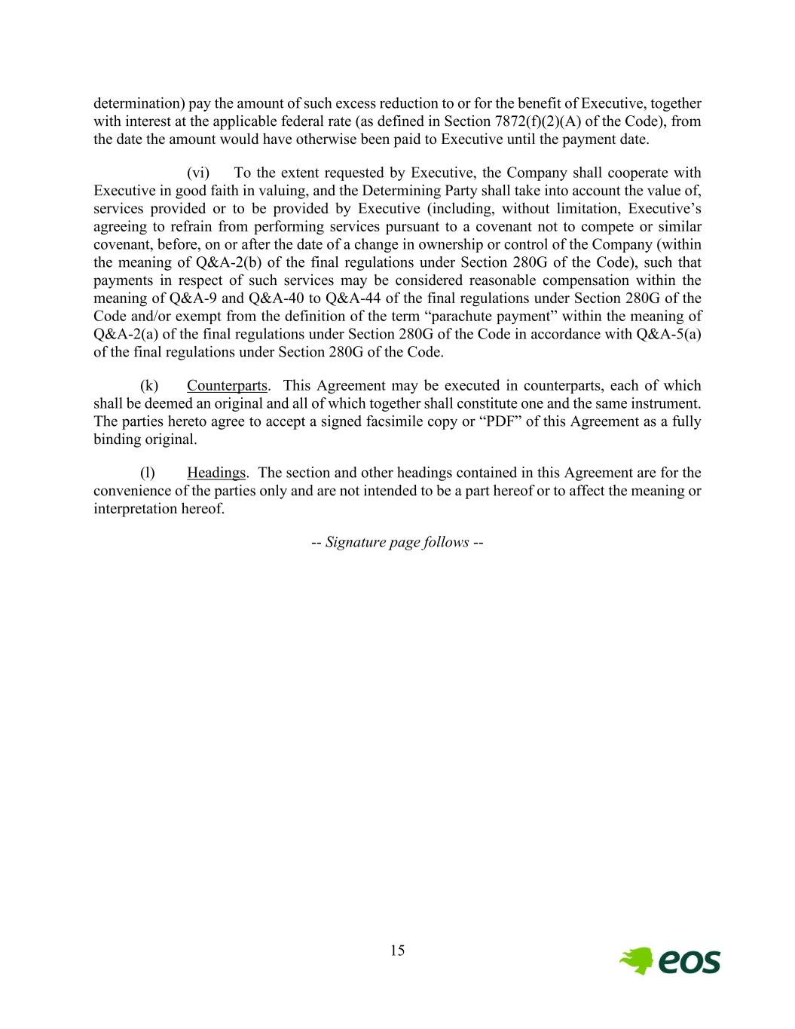
15 determination) pay the amount of such excess reduction to or for the benefit of Executive, together with interest at the applicable federal rate (as defined in Section 7872(f)(2)(A) of the Code), from the date the amount would have otherwise been paid to Executive until the payment date. (vi) To the extent requested by Executive, the Company shall cooperate with Executive in good faith in valuing, and the Determining Party shall take into account the value of, services provided or to be provided by Executive (including, without limitation, Executive’s agreeing to refrain from performing services pursuant to a covenant not to compete or similar covenant, before, on or after the date of a change in ownership or control of the Company (within the meaning of Q&A-2(b) of the final regulations under Section 280G of the Code), such that payments in respect of such services may be considered reasonable compensation within the meaning of Q&A-9 and Q&A-40 to Q&A-44 of the final regulations under Section 280G of the Code and/or exempt from the definition of the term “parachute payment” within the meaning of Q&A-2(a) of the final regulations under Section 280G of the Code in accordance with Q&A-5(a) of the final regulations under Section 280G of the Code. (k) Counterparts. This Agreement may be executed in counterparts, each of which shall be deemed an original and all of which together shall constitute one and the same instrument. The parties hereto agree to accept a signed facsimile copy or “PDF” of this Agreement as a fully binding original. (l) Headings. The section and other headings contained in this Agreement are for the convenience of the parties only and are not intended to be a part hereof or to affect the meaning or interpretation hereof. -- Signature page follows --

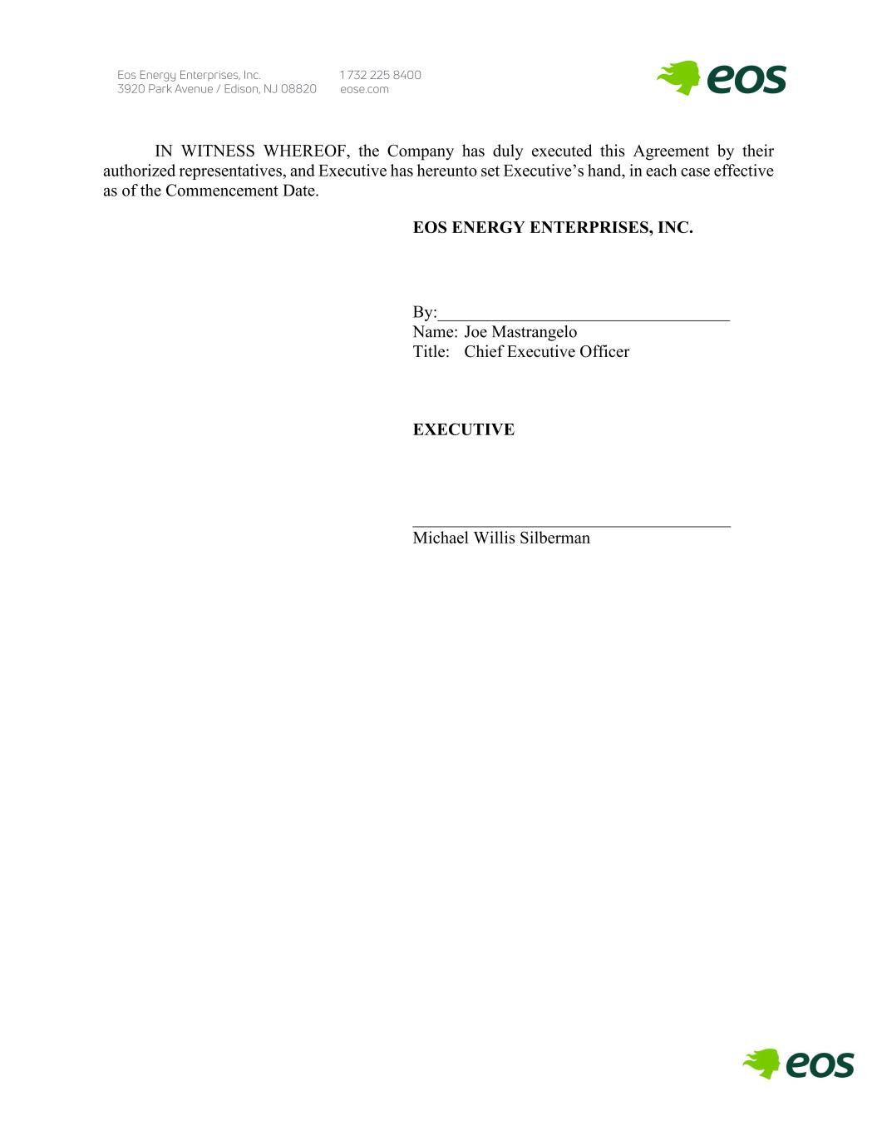
IN WITNESS WHEREOF, the Company has duly executed this Agreement by their authorized representatives, and Executive has hereunto set Executive’s hand, in each case effective as of the Commencement Date. EOS ENERGY ENTERPRISES, INC. By:__________________________________ Name: Joe Mastrangelo Title: Chief Executive Officer EXECUTIVE _____________________________________ Michael Willis Silberman

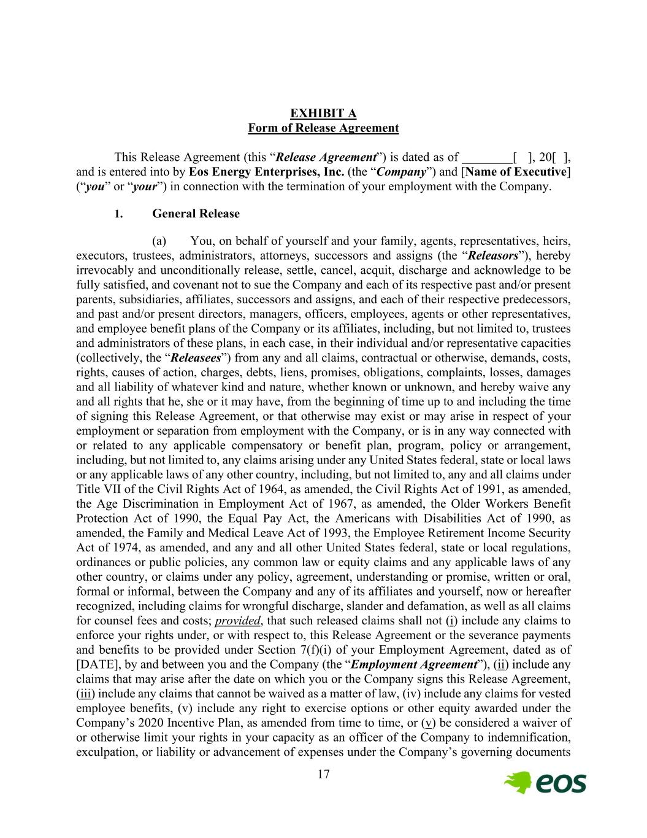
17 EXHIBIT A Form of Release Agreement This Release Agreement (this “Release Agreement”) is dated as of ________[ ], 20[ ], and is entered into by Eos Energy Enterprises, Inc. (the “Company”) and [Name of Executive] (“you” or “your”) in connection with the termination of your employment with the Company. 1. General Release (a) You, on behalf of yourself and your family, agents, representatives, heirs, executors, trustees, administrators, attorneys, successors and assigns (the “Releasors”), hereby irrevocably and unconditionally release, settle, cancel, acquit, discharge and acknowledge to be fully satisfied, and covenant not to sue the Company and each of its respective past and/or present parents, subsidiaries, affiliates, successors and assigns, and each of their respective predecessors, and past and/or present directors, managers, officers, employees, agents or other representatives, and employee benefit plans of the Company or its affiliates, including, but not limited to, trustees and administrators of these plans, in each case, in their individual and/or representative capacities (collectively, the “Releasees”) from any and all claims, contractual or otherwise, demands, costs, rights, causes of action, charges, debts, liens, promises, obligations, complaints, losses, damages and all liability of whatever kind and nature, whether known or unknown, and hereby waive any and all rights that he, she or it may have, from the beginning of time up to and including the time of signing this Release Agreement, or that otherwise may exist or may arise in respect of your employment or separation from employment with the Company, or is in any way connected with or related to any applicable compensatory or benefit plan, program, policy or arrangement, including, but not limited to, any claims arising under any United States federal, state or local laws or any applicable laws of any other country, including, but not limited to, any and all claims under Title VII of the Civil Rights Act of 1964, as amended, the Civil Rights Act of 1991, as amended, the Age Discrimination in Employment Act of 1967, as amended, the Older Workers Benefit Protection Act of 1990, the Equal Pay Act, the Americans with Disabilities Act of 1990, as amended, the Family and Medical Leave Act of 1993, the Employee Retirement Income Security Act of 1974, as amended, and any and all other United States federal, state or local regulations, ordinances or public policies, any common law or equity claims and any applicable laws of any other country, or claims under any policy, agreement, understanding or promise, written or oral, formal or informal, between the Company and any of its affiliates and yourself, now or hereafter recognized, including claims for wrongful discharge, slander and defamation, as well as all claims for counsel fees and costs; provided, that such released claims shall not (i) include any claims to enforce your rights under, or with respect to, this Release Agreement or the severance payments and benefits to be provided under Section 7(f)(i) of your Employment Agreement, dated as of [DATE], by and between you and the Company (the “Employment Agreement”), (ii) include any claims that may arise after the date on which you or the Company signs this Release Agreement, (iii) include any claims that cannot be waived as a matter of law, (iv) include any claims for vested employee benefits, (v) include any right to exercise options or other equity awarded under the Company’s 2020 Incentive Plan, as amended from time to time, or (v) be considered a waiver of or otherwise limit your rights in your capacity as an officer of the Company to indemnification, exculpation, or liability or advancement of expenses under the Company’s governing documents

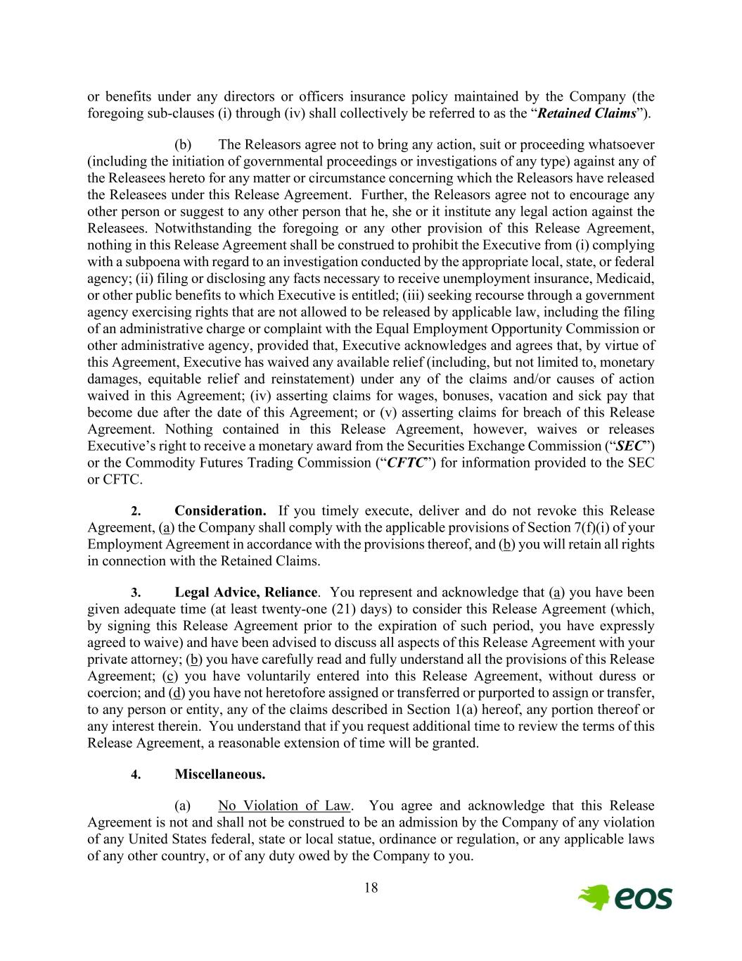
18 or benefits under any directors or officers insurance policy maintained by the Company (the foregoing sub-clauses (i) through (iv) shall collectively be referred to as the “Retained Claims”). (b) The Releasors agree not to bring any action, suit or proceeding whatsoever (including the initiation of governmental proceedings or investigations of any type) against any of the Releasees hereto for any matter or circumstance concerning which the Releasors have released the Releasees under this Release Agreement. Further, the Releasors agree not to encourage any other person or suggest to any other person that he, she or it institute any legal action against the Releasees. Notwithstanding the foregoing or any other provision of this Release Agreement, nothing in this Release Agreement shall be construed to prohibit the Executive from (i) complying with a subpoena with regard to an investigation conducted by the appropriate local, state, or federal agency; (ii) filing or disclosing any facts necessary to receive unemployment insurance, Medicaid, or other public benefits to which Executive is entitled; (iii) seeking recourse through a government agency exercising rights that are not allowed to be released by applicable law, including the filing of an administrative charge or complaint with the Equal Employment Opportunity Commission or other administrative agency, provided that, Executive acknowledges and agrees that, by virtue of this Agreement, Executive has waived any available relief (including, but not limited to, monetary damages, equitable relief and reinstatement) under any of the claims and/or causes of action waived in this Agreement; (iv) asserting claims for wages, bonuses, vacation and sick pay that become due after the date of this Agreement; or (v) asserting claims for breach of this Release Agreement. Nothing contained in this Release Agreement, however, waives or releases Executive’s right to receive a monetary award from the Securities Exchange Commission (“SEC”) or the Commodity Futures Trading Commission (“CFTC”) for information provided to the SEC or CFTC. 2. Consideration. If you timely execute, deliver and do not revoke this Release Agreement, (a) the Company shall comply with the applicable provisions of Section 7(f)(i) of your Employment Agreement in accordance with the provisions thereof, and (b) you will retain all rights in connection with the Retained Claims. 3. Legal Advice, Reliance. You represent and acknowledge that (a) you have been given adequate time (at least twenty-one (21) days) to consider this Release Agreement (which, by signing this Release Agreement prior to the expiration of such period, you have expressly agreed to waive) and have been advised to discuss all aspects of this Release Agreement with your private attorney; (b) you have carefully read and fully understand all the provisions of this Release Agreement; (c) you have voluntarily entered into this Release Agreement, without duress or coercion; and (d) you have not heretofore assigned or transferred or purported to assign or transfer, to any person or entity, any of the claims described in Section 1(a) hereof, any portion thereof or any interest therein. You understand that if you request additional time to review the terms of this Release Agreement, a reasonable extension of time will be granted. 4. Miscellaneous. (a) No Violation of Law. You agree and acknowledge that this Release Agreement is not and shall not be construed to be an admission by the Company of any violation of any United States federal, state or local statue, ordinance or regulation, or any applicable laws of any other country, or of any duty owed by the Company to you.

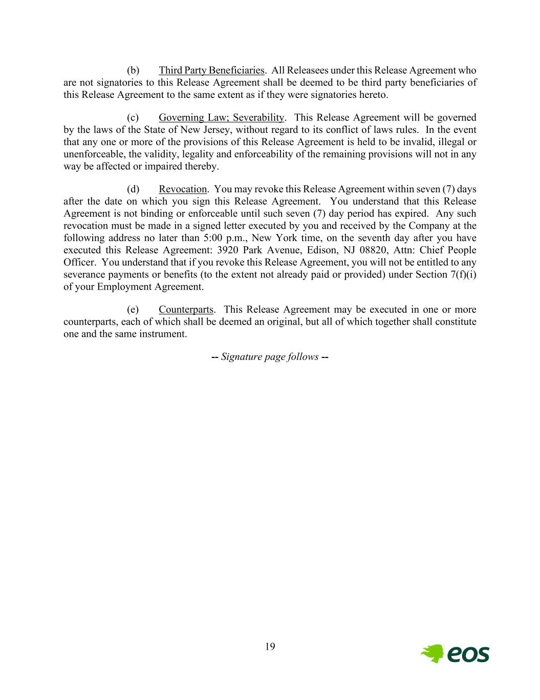
19 (b) Third Party Beneficiaries. All Releasees under this Release Agreement who are not signatories to this Release Agreement shall be deemed to be third party beneficiaries of this Release Agreement to the same extent as if they were signatories hereto. (c) Governing Law; Severability. This Release Agreement will be governed by the laws of the State of New Jersey, without regard to its conflict of laws rules. In the event that any one or more of the provisions of this Release Agreement is held to be invalid, illegal or unenforceable, the validity, legality and enforceability of the remaining provisions will not in any way be affected or impaired thereby. (d) Revocation. You may revoke this Release Agreement within seven (7) days after the date on which you sign this Release Agreement. You understand that this Release Agreement is not binding or enforceable until such seven (7) day period has expired. Any such revocation must be made in a signed letter executed by you and received by the Company at the following address no later than 5:00 p.m., New York time, on the seventh day after you have executed this Release Agreement: 3920 Park Avenue, Edison, NJ 08820, Attn: Chief People Officer. You understand that if you revoke this Release Agreement, you will not be entitled to any severance payments or benefits (to the extent not already paid or provided) under Section 7(f)(i) of your Employment Agreement. (e) Counterparts. This Release Agreement may be executed in one or more counterparts, each of which shall be deemed an original, but all of which together shall constitute one and the same instrument. -- Signature page follows --

CONSENT OF INDEPENDENT REGISTERED PUBLIC ACCOUNTING FIRM
We consent to the incorporation by reference in Registration Statement No. 333-275863 on Form S-3 and Registration Statement Nos. 333-265708, 333-256766, and 333-272848 on Form S-8 of our report dated March 4, 2024, relating to the financial statements of Eos Energy Enterprises, Inc. appearing in this Annual Report on Form 10-K for the year ended December 31, 2023.

/s/ Deloitte & Touche LLP

New York, NY
March 4, 2024

CERTIFICATION OF CHIEF EXECUTIVE OFFICER
PURSUANT TO
RULES 13a-14(a) AND 15d-14(a) UNDER THE SECURITIES EXCHANGE ACT OF 1934,
AS ADOPTED PURSUANT TO
SECTION 302 OF THE SARBANES-OXLEY ACT OF 2002

I, Joseph Mastrangelo, certify that:
1. I have reviewed this Annual Report on Form 10-K (the “Annual Report”) of Eos Energy Enterprises, Inc. (the “Registrant”);
2. Based on my knowledge, this Annual Report does not contain any untrue statement of a material fact or omit to state a material fact necessary to make the statements made, in light of the circumstances under which such statements were made, not misleading with respect to the period covered by this Annual Report;
3. Based on my knowledge, the financial statements, and other financial information included in this Annual Report, fairly present in all material respects the financial condition, results of operations and cash flows of the Registrant as of, and for, the periods presented in this Annual Report;
4. The Registrant’s other certifying officer and I are responsible for establishing and maintaining disclosure controls and procedures (as defined in Exchange Act Rules 13a-15(e) and 15d-15(e)) for the Registrant and internal control over financial reporting (as defined in Exchange Act Rules 13a-15(f) and 15d-15(f)) for the Registrant and have:
(a) Designed such disclosure controls and procedures, or caused such disclosure controls and procedures to be designed under our supervision, to ensure that material information relating to the Registrant, including its consolidated subsidiaries, is made known to us by others within those entities, particularly during the period in which this Annual Report is being prepared;
(b) Designed such internal control over financial reporting, or caused such internal control over financial reporting to be designed under our supervision, to provide reasonable assurance regarding the reliability of financial reporting and the preparation of financial statements for external purposes in accordance with generally accepted accounting principles;
(c) Evaluated the effectiveness of the Registrant’s disclosure controls and procedures and presented in this Annual Report our conclusions about the effectiveness of the disclosure controls and procedures, as of the end of the period covered by this Annual Report based on such evaluation; and
(d) Disclosed in this Annual Report any change in the Registrant 's internal control over financial reporting that occurred during the Registrant 's fourth fiscal quarter that has materially affected, or is reasonably likely to materially affect, the Registrant 's internal control over financial reporting; and
5. The Registrant’s other certifying officer and I have disclosed, based on our most recent evaluation of internal control over financial reporting, to the Registrant’s auditors and the audit committee of the Registrant's board of directors (or persons performing the equivalent functions):
(a) All significant deficiencies and material weaknesses in the design or operation of internal control over financial reporting which are reasonably likely to adversely affect the Registrant’s ability to record, process, summarize and report financial information; and
(b) Any fraud, whether or not material, that involves management or other employees who have a significant role in the Registrant's internal control over financial reporting.

Date |  |  | March 4, 2024 |  |  |  |  |  | /s/ Joseph Mastrangelo
 |  |  |  |  |  |  |  |  | Joseph Mastrangelo
 |  |  |  |  |  |  |  |  | Chief Executive Officer
 |  |  |  |  |  |  |  |  | (Principal Executive Officer)

CERTIFICATION OF CHIEF FINANCIAL OFFICER
PURSUANT TO
RULES 13a-14(a) AND 15d-14(a) UNDER THE SECURITIES EXCHANGE ACT OF 1934,
AS ADOPTED PURSUANT TO
SECTION 302 OF THE SARBANES-OXLEY ACT OF 2002

I, Nathan Kroeker, certify that:
1. I have reviewed this Annual Report on Form 10-K (the “Annual Report”) of Eos Energy Enterprises, Inc. (the “Registrant”);
2. Based on my knowledge, this Annual Report does not contain any untrue statement of a material fact or omit to state a material fact necessary to make the statements made, in light of the circumstances under which such statements were made, not misleading with respect to the period covered by this Annual Report;
3. Based on my knowledge, the financial statements, and other financial information included in this Annual Report, fairly present in all material respects the financial condition, results of operations and cash flows of the Registrant as of, and for, the periods presented in this Annual Report;
4. The Registrant’s other certifying officer and I are responsible for establishing and maintaining disclosure controls and procedures (as defined in Exchange Act Rules 13a-15(e) and 15d-15(e)) for the Registrant and internal control over financial reporting (as defined in Exchange Act Rules 13a-15(f) and 15d-15(f)) for the Registrant and have:
(a) Designed such disclosure controls and procedures, or caused such disclosure controls and procedures to be designed under our supervision, to ensure that material information relating to the Registrant, including its consolidated subsidiaries, is made known to us by others within those entities, particularly during the period in which this Annual Report is being prepared;
(b) Designed such internal control over financial reporting, or caused such internal control over financial reporting to be designed under our supervision, to provide reasonable assurance regarding the reliability of financial reporting and the preparation of financial statements for external purposes in accordance with generally accepted accounting principles;
(c) Evaluated the effectiveness of the Registrant’s disclosure controls and procedures and presented in this Annual Report our conclusions about the effectiveness of the disclosure controls and procedures, as of the end of the period covered by this Annual Report based on such evaluation; and
(d) Disclosed in this Annual Report any change in the Registrant 's internal control over financial reporting that occurred during the Registrant 's fourth fiscal quarter that has materially affected, or is reasonably likely to materially affect, the Registrant 's internal control over financial reporting; and
5. The Registrant’s other certifying officer and I have disclosed, based on our most recent evaluation of internal control over financial reporting, to the Registrant’s auditors and the audit committee of the Registrant's board of directors (or persons performing the equivalent functions):
(a) All significant deficiencies and material weaknesses in the design or operation of internal control over financial reporting which are reasonably likely to adversely affect the Registrant’s ability to record, process, summarize and report financial information; and
(b) Any fraud, whether or not material, that involves management or other employees who have a significant role in the Registrant's internal control over financial reporting.

Date |  |  | March 4, 2024 |  |  |  |  |  | /s/ Nathan Kroeker
 |  |  |  |  |  |  |  |  | Nathan Kroeker
 |  |  |  |  |  |  |  |  | Chief Financial Officer
 |  |  |  |  |  |  |  |  | (Principal Financial Officer)

CERTIFICATION OF CHIEF EXECUTIVE OFFICER
PURSUANT TO
18 U.S.C. SECTION 1350,
AS ADOPTED PURSUANT TO
SECTION 906 OF THE SARBANES-OXLEY ACT OF 2002

In connection with the Annual Report of Eos Energy Enterprises, Inc. (the “Registrant”) on Form 10-K for the year ended December 31, 2022 as filed with the Securities and Exchange Commission on the date hereof (the “Report”), I, Joseph Mastrangelo, hereby certify, in the capacity and on the date indicated below, pursuant to 18 U.S.C. § 1350, as adopted pursuant to Section 906 of the Sarbanes-Oxley Act of 2002, that, to my knowledge:

(1) The Report fully complies with the requirements of section 13(a) or 15(d) of the Securities Exchange Act of 1934, as amended; and

(2) The information contained in the Report fairly presents, in all material respects, the financial condition and results of operations of the Registrant.

Date |  |  | March 4, 2024 |  |  |  |  |  | /s/ Joseph Mastrangelo
 |  |  |  |  |  |  |  |  | Joseph Mastrangelo
 |  |  |  |  |  |  |  |  | Chief Executive Officer
 |  |  |  |  |  |  |  |  | (Principal Executive Officer)

A signed original of this written statement required by Section 906 has been provided to the Company and will be retained by the Company and furnished to the Securities and Exchange Commission or its staff upon request.

CERTIFICATION OF CHIEF FINANCIAL OFFICER
PURSUANT TO
18 U.S.C. SECTION 1350,
AS ADOPTED PURSUANT TO
SECTION 906 OF THE SARBANES-OXLEY ACT OF 2002

In connection with the Annual Report of Eos Energy Enterprises, Inc. (the “Registrant”) on Form 10-K for the year ended December 31, 2023 as filed with the Securities and Exchange Commission on the date hereof (the “Report”), I, Nathan Kroeker, hereby certify, in the capacity and on the date indicated below, pursuant to 18 U.S.C. § 1350, as adopted pursuant to Section 906 of the Sarbanes-Oxley Act of 2002, that, to my knowledge:

(1) The Report fully complies with the requirements of section 13(a) or 15(d) of the Securities Exchange Act of 1934, as amended; and

(2) The information contained in the Report fairly presents, in all material respects, the financial condition and results of operations of the Registrant.

Date |  |  | March 4, 2024 |  |  |  |  |  | /s/ Nathan Kroeker
 |  |  |  |  |  |  |  |  | Nathan Kroeker
 |  |  |  |  |  |  |  |  | Chief Financial Officer
 |  |  |  |  |  |  |  |  | (Principal Financial Officer)

A signed original of this written statement required by Section 906 has been provided to the Company and will be retained by the Company and furnished to the Securities and Exchange Commission or its staff upon request.
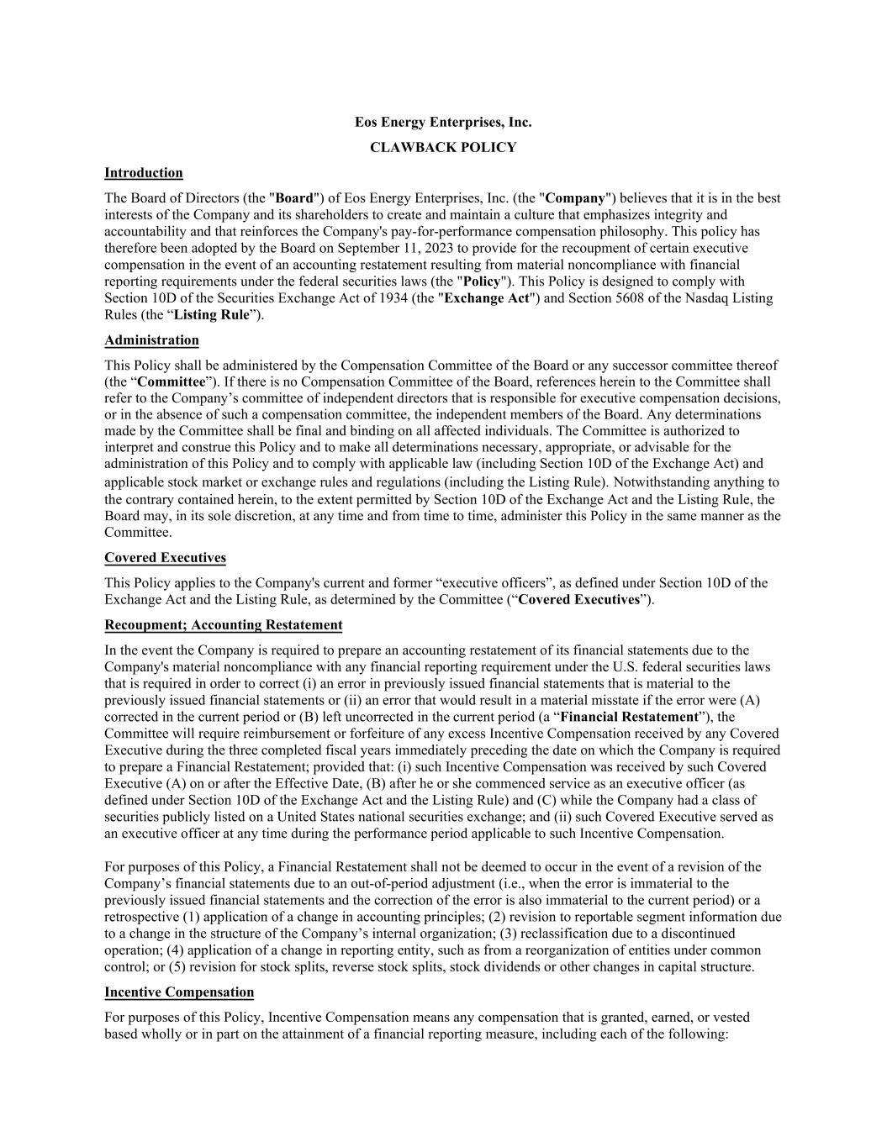

Eos Energy Enterprises, Inc. CLAWBACK POLICY Introduction The Board of Directors (the "Board") of Eos Energy Enterprises, Inc. (the "Company") believes that it is in the best interests of the Company and its shareholders to create and maintain a culture that emphasizes integrity and accountability and that reinforces the Company's pay-for-performance compensation philosophy. This policy has therefore been adopted by the Board on September 11, 2023 to provide for the recoupment of certain executive compensation in the event of an accounting restatement resulting from material noncompliance with financial reporting requirements under the federal securities laws (the "Policy"). This Policy is designed to comply with Section 10D of the Securities Exchange Act of 1934 (the "Exchange Act") and Section 5608 of the Nasdaq Listing Rules (the “Listing Rule”). Administration This Policy shall be administered by the Compensation Committee of the Board or any successor committee thereof (the “Committee”). If there is no Compensation Committee of the Board, references herein to the Committee shall refer to the Company’s committee of independent directors that is responsible for executive compensation decisions, or in the absence of such a compensation committee, the independent members of the Board. Any determinations made by the Committee shall be final and binding on all affected individuals. The Committee is authorized to interpret and construe this Policy and to make all determinations necessary, appropriate, or advisable for the administration of this Policy and to comply with applicable law (including Section 10D of the Exchange Act) and applicable stock market or exchange rules and regulations (including the Listing Rule). Notwithstanding anything to the contrary contained herein, to the extent permitted by Section 10D of the Exchange Act and the Listing Rule, the Board may, in its sole discretion, at any time and from time to time, administer this Policy in the same manner as the Committee. Covered Executives This Policy applies to the Company's current and former “executive officers”, as defined under Section 10D of the Exchange Act and the Listing Rule, as determined by the Committee (“Covered Executives”). Recoupment; Accounting Restatement In the event the Company is required to prepare an accounting restatement of its financial statements due to the Company's material noncompliance with any financial reporting requirement under the U.S. federal securities laws that is required in order to correct (i) an error in previously issued financial statements that is material to the previously issued financial statements or (ii) an error that would result in a material misstate if the error were (A) corrected in the current period or (B) left uncorrected in the current period (a “Financial Restatement”), the Committee will require reimbursement or forfeiture of any excess Incentive Compensation received by any Covered Executive during the three completed fiscal years immediately preceding the date on which the Company is required to prepare a Financial Restatement; provided that: (i) such Incentive Compensation was received by such Covered Executive (A) on or after the Effective Date, (B) after he or she commenced service as an executive officer (as defined under Section 10D of the Exchange Act and the Listing Rule) and (C) while the Company had a class of securities publicly listed on a United States national securities exchange; and (ii) such Covered Executive served as an executive officer at any time during the performance period applicable to such Incentive Compensation. For purposes of this Policy, a Financial Restatement shall not be deemed to occur in the event of a revision of the Company’s financial statements due to an out-of-period adjustment (i.e., when the error is immaterial to the previously issued financial statements and the correction of the error is also immaterial to the current period) or a retrospective (1) application of a change in accounting principles; (2) revision to reportable segment information due to a change in the structure of the Company’s internal organization; (3) reclassification due to a discontinued operation; (4) application of a change in reporting entity, such as from a reorganization of entities under common control; or (5) revision for stock splits, reverse stock splits, stock dividends or other changes in capital structure. Incentive Compensation For purposes of this Policy, Incentive Compensation means any compensation that is granted, earned, or vested based wholly or in part on the attainment of a financial reporting measure, including each of the following:

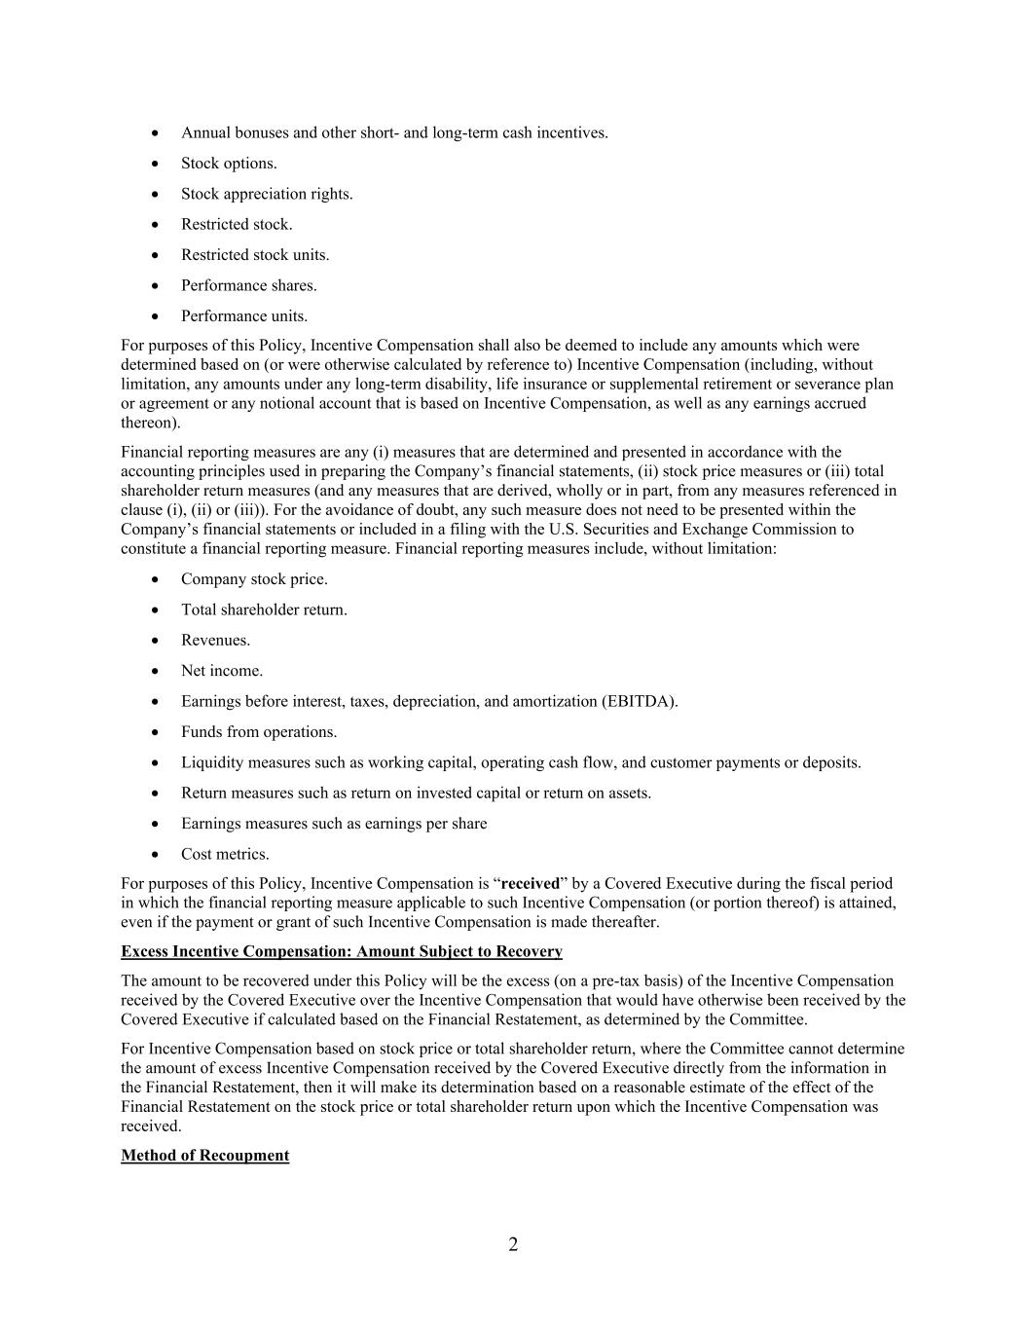
2 • Annual bonuses and other short- and long-term cash incentives. • Stock options. • Stock appreciation rights. • Restricted stock. • Restricted stock units. • Performance shares. • Performance units. For purposes of this Policy, Incentive Compensation shall also be deemed to include any amounts which were determined based on (or were otherwise calculated by reference to) Incentive Compensation (including, without limitation, any amounts under any long-term disability, life insurance or supplemental retirement or severance plan or agreement or any notional account that is based on Incentive Compensation, as well as any earnings accrued thereon). Financial reporting measures are any (i) measures that are determined and presented in accordance with the accounting principles used in preparing the Company’s financial statements, (ii) stock price measures or (iii) total shareholder return measures (and any measures that are derived, wholly or in part, from any measures referenced in clause (i), (ii) or (iii)). For the avoidance of doubt, any such measure does not need to be presented within the Company’s financial statements or included in a filing with the U.S. Securities and Exchange Commission to constitute a financial reporting measure. Financial reporting measures include, without limitation: • Company stock price. • Total shareholder return. • Revenues. • Net income. • Earnings before interest, taxes, depreciation, and amortization (EBITDA). • Funds from operations. • Liquidity measures such as working capital, operating cash flow, and customer payments or deposits. • Return measures such as return on invested capital or return on assets. • Earnings measures such as earnings per share • Cost metrics. For purposes of this Policy, Incentive Compensation is “received” by a Covered Executive during the fiscal period in which the financial reporting measure applicable to such Incentive Compensation (or portion thereof) is attained, even if the payment or grant of such Incentive Compensation is made thereafter. Excess Incentive Compensation: Amount Subject to Recovery The amount to be recovered under this Policy will be the excess (on a pre-tax basis) of the Incentive Compensation received by the Covered Executive over the Incentive Compensation that would have otherwise been received by the Covered Executive if calculated based on the Financial Restatement, as determined by the Committee. For Incentive Compensation based on stock price or total shareholder return, where the Committee cannot determine the amount of excess Incentive Compensation received by the Covered Executive directly from the information in the Financial Restatement, then it will make its determination based on a reasonable estimate of the effect of the Financial Restatement on the stock price or total shareholder return upon which the Incentive Compensation was received. Method of Recoupment

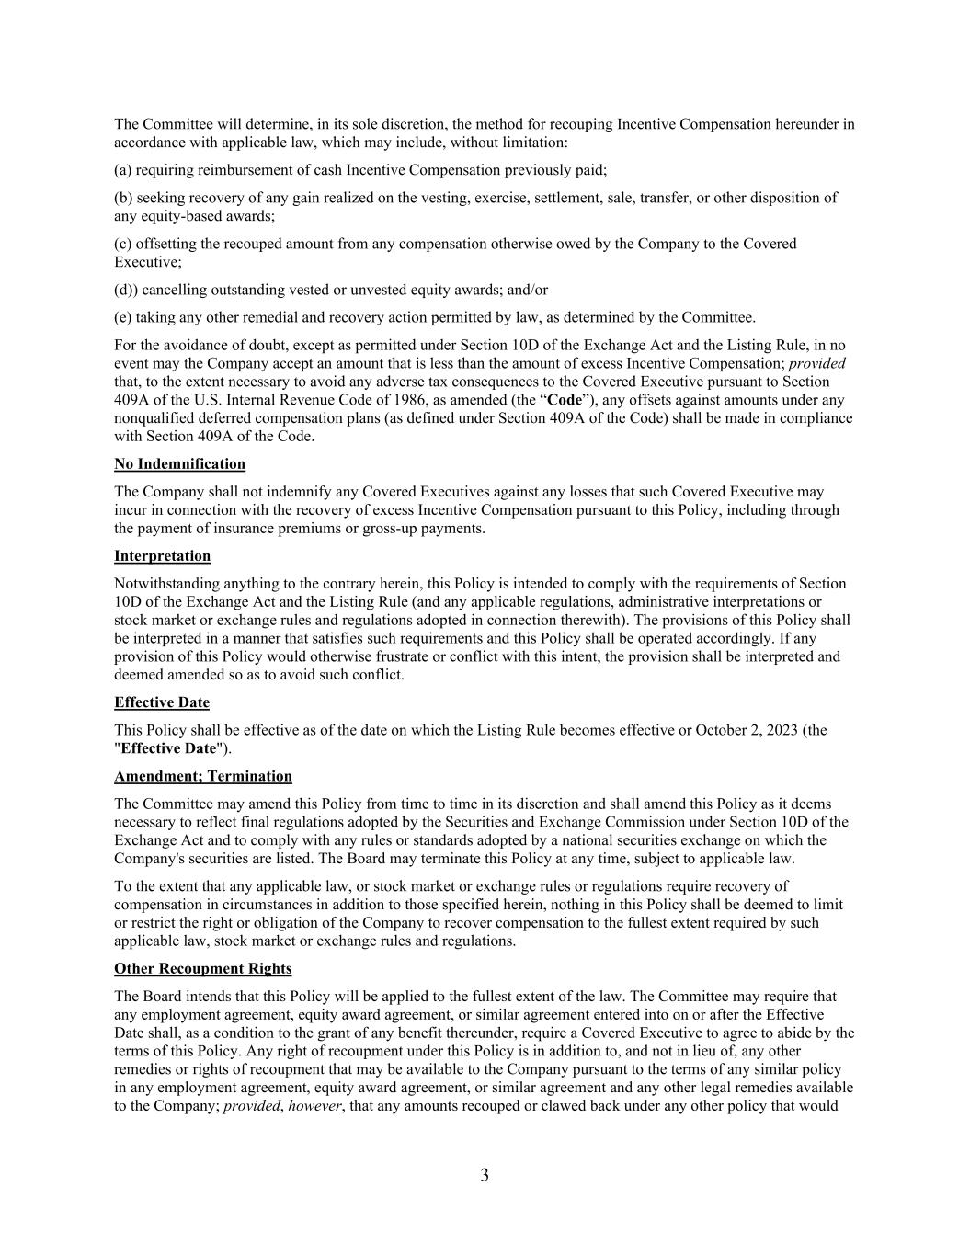
3 The Committee will determine, in its sole discretion, the method for recouping Incentive Compensation hereunder in accordance with applicable law, which may include, without limitation: (a) requiring reimbursement of cash Incentive Compensation previously paid; (b) seeking recovery of any gain realized on the vesting, exercise, settlement, sale, transfer, or other disposition of any equity-based awards; (c) offsetting the recouped amount from any compensation otherwise owed by the Company to the Covered Executive; (d)) cancelling outstanding vested or unvested equity awards; and/or (e) taking any other remedial and recovery action permitted by law, as determined by the Committee. For the avoidance of doubt, except as permitted under Section 10D of the Exchange Act and the Listing Rule, in no event may the Company accept an amount that is less than the amount of excess Incentive Compensation; provided that, to the extent necessary to avoid any adverse tax consequences to the Covered Executive pursuant to Section 409A of the U.S. Internal Revenue Code of 1986, as amended (the “Code”), any offsets against amounts under any nonqualified deferred compensation plans (as defined under Section 409A of the Code) shall be made in compliance with Section 409A of the Code. No Indemnification The Company shall not indemnify any Covered Executives against any losses that such Covered Executive may incur in connection with the recovery of excess Incentive Compensation pursuant to this Policy, including through the payment of insurance premiums or gross-up payments. Interpretation Notwithstanding anything to the contrary herein, this Policy is intended to comply with the requirements of Section 10D of the Exchange Act and the Listing Rule (and any applicable regulations, administrative interpretations or stock market or exchange rules and regulations adopted in connection therewith). The provisions of this Policy shall be interpreted in a manner that satisfies such requirements and this Policy shall be operated accordingly. If any provision of this Policy would otherwise frustrate or conflict with this intent, the provision shall be interpreted and deemed amended so as to avoid such conflict. Effective Date This Policy shall be effective as of the date on which the Listing Rule becomes effective or October 2, 2023 (the "Effective Date"). Amendment; Termination The Committee may amend this Policy from time to time in its discretion and shall amend this Policy as it deems necessary to reflect final regulations adopted by the Securities and Exchange Commission under Section 10D of the Exchange Act and to comply with any rules or standards adopted by a national securities exchange on which the Company's securities are listed. The Board may terminate this Policy at any time, subject to applicable law. To the extent that any applicable law, or stock market or exchange rules or regulations require recovery of compensation in circumstances in addition to those specified herein, nothing in this Policy shall be deemed to limit or restrict the right or obligation of the Company to recover compensation to the fullest extent required by such applicable law, stock market or exchange rules and regulations. Other Recoupment Rights The Board intends that this Policy will be applied to the fullest extent of the law. The Committee may require that any employment agreement, equity award agreement, or similar agreement entered into on or after the Effective Date shall, as a condition to the grant of any benefit thereunder, require a Covered Executive to agree to abide by the terms of this Policy. Any right of recoupment under this Policy is in addition to, and not in lieu of, any other remedies or rights of recoupment that may be available to the Company pursuant to the terms of any similar policy in any employment agreement, equity award agreement, or similar agreement and any other legal remedies available to the Company; provided, however, that any amounts recouped or clawed back under any other policy that would

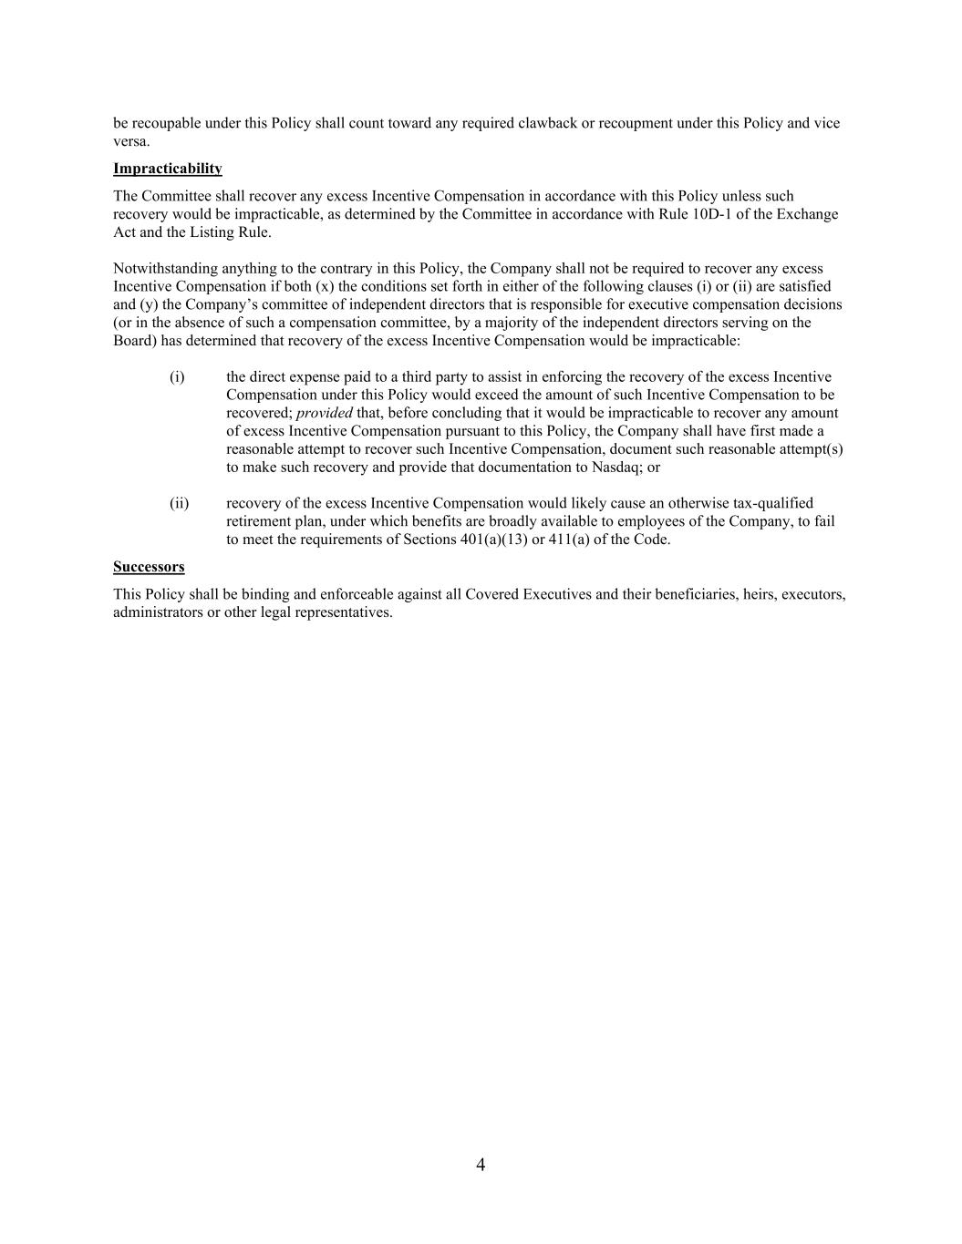
4 be recoupable under this Policy shall count toward any required clawback or recoupment under this Policy and vice versa. Impracticability The Committee shall recover any excess Incentive Compensation in accordance with this Policy unless such recovery would be impracticable, as determined by the Committee in accordance with Rule 10D-1 of the Exchange Act and the Listing Rule. Notwithstanding anything to the contrary in this Policy, the Company shall not be required to recover any excess Incentive Compensation if both (x) the conditions set forth in either of the following clauses (i) or (ii) are satisfied and (y) the Company’s committee of independent directors that is responsible for executive compensation decisions (or in the absence of such a compensation committee, by a majority of the independent directors serving on the Board) has determined that recovery of the excess Incentive Compensation would be impracticable: (i) the direct expense paid to a third party to assist in enforcing the recovery of the excess Incentive Compensation under this Policy would exceed the amount of such Incentive Compensation to be recovered; provided that, before concluding that it would be impracticable to recover any amount of excess Incentive Compensation pursuant to this Policy, the Company shall have first made a reasonable attempt to recover such Incentive Compensation, document such reasonable attempt(s) to make such recovery and provide that documentation to Nasdaq; or (ii) recovery of the excess Incentive Compensation would likely cause an otherwise tax-qualified retirement plan, under which benefits are broadly available to employees of the Company, to fail to meet the requirements of Sections 401(a)(13) or 411(a) of the Code. Successors This Policy shall be binding and enforceable against all Covered Executives and their beneficiaries, heirs, executors, administrators or other legal representatives.

