SEC Form 3
FORM 3 | UNITED STATES SECURITIES AND EXCHANGE COMMISSION  Washington, D.C. 20549  INITIAL STATEMENT OF BENEFICIAL OWNERSHIP OF SECURITIES  Filed pursuant to Section 16(a) of the Securities Exchange Act of 1934  or Section 30(h) of the Investment Company Act of 1940
  OMB APPROVAL
  OMB Number: | 3235-0104
  Estimated average burden
  hours per response: | 0.5
1. Name and Address of Reporting Person*  (Street) | 2. Date of Event Requiring Statement (Month/Day/Year)  07/09/2026 | 3. Issuer Name and Ticker or Trading Symbol  Eos Energy Enterprises, Inc. [ EOSE ]
  Song Haiyan
  (Last) | (First) | (Middle)
  C/O EOS ENERGY ENTERPRISES, INC.
  TWO ALLEGHENY CENTER, NOVA TOWER 2
  PITTSBURGH | PA | 15212
  (City) | (State) | (Zip)
 |  | 4. Relationship of Reporting Person(s) to Issuer  (Check all applicable) | 5. If Amendment, Date of Original Filed (Month/Day/Year)
   | Director |  | 10% Owner
   | Officer (give title below) |  | Other (specify below)
6. Individual or Joint/Group Filing (Check Applicable Line)
Form filed by One Reporting Person
Form filed by More than One Reporting Person

Table I - Non-Derivative Securities Beneficially Owned
1. Title of Security (Instr. 4) | 2. Amount of Securities Beneficially Owned (Instr. 4) | 3. Ownership Form: Direct (D) or Indirect (I) (Instr. 5) | 4. Nature of Indirect Beneficial Ownership (Instr. 5)
Table II - Derivative Securities Beneficially Owned
(e.g., puts, calls, warrants, options, convertible securities)
1. Title of Derivative Security (Instr. 4) | 2. Date Exercisable and Expiration Date (Month/Day/Year) |  | 3. Title and Amount of Securities Underlying Derivative Security (Instr. 4) |  | 4. Conversion or Exercise Price of Derivative Security | 5. Ownership Form: Direct (D) or Indirect (I) (Instr. 5) | 6. Nature of Indirect Beneficial Ownership (Instr. 5)
1. Title of Derivative Security (Instr. 4) | Date Exercisable | Expiration Date | Title | Amount or Number of Shares | 4. Conversion or Exercise Price of Derivative Security | 5. Ownership Form: Direct (D) or Indirect (I) (Instr. 5) | 6. Nature of Indirect Beneficial Ownership (Instr. 5)
Explanation of Responses:
Remarks:
Exhibit 24 - Power of Attorney
No securities are beneficially owned.
 | /s/ Marie Martin as attorney-in-fact for Haiyan Song | 07/15/2026
 | ** Signature of Reporting Person | Date
Reminder: Report on a separate line for each class of securities beneficially owned directly or indirectly.
* If the form is filed by more than one reporting person, see Instruction 5 (b)(v).
** Intentional misstatements or omissions of facts constitute Federal Criminal Violations See 18 U.S.C. 1001 and 15 U.S.C. 78ff(a).
Note: File three copies of this Form, one of which must be manually signed. If space is insufficient, see Instruction 6 for procedure.
Persons who respond to the collection of information contained in this form are not required to respond unless the form displays a currently valid OMB Number.
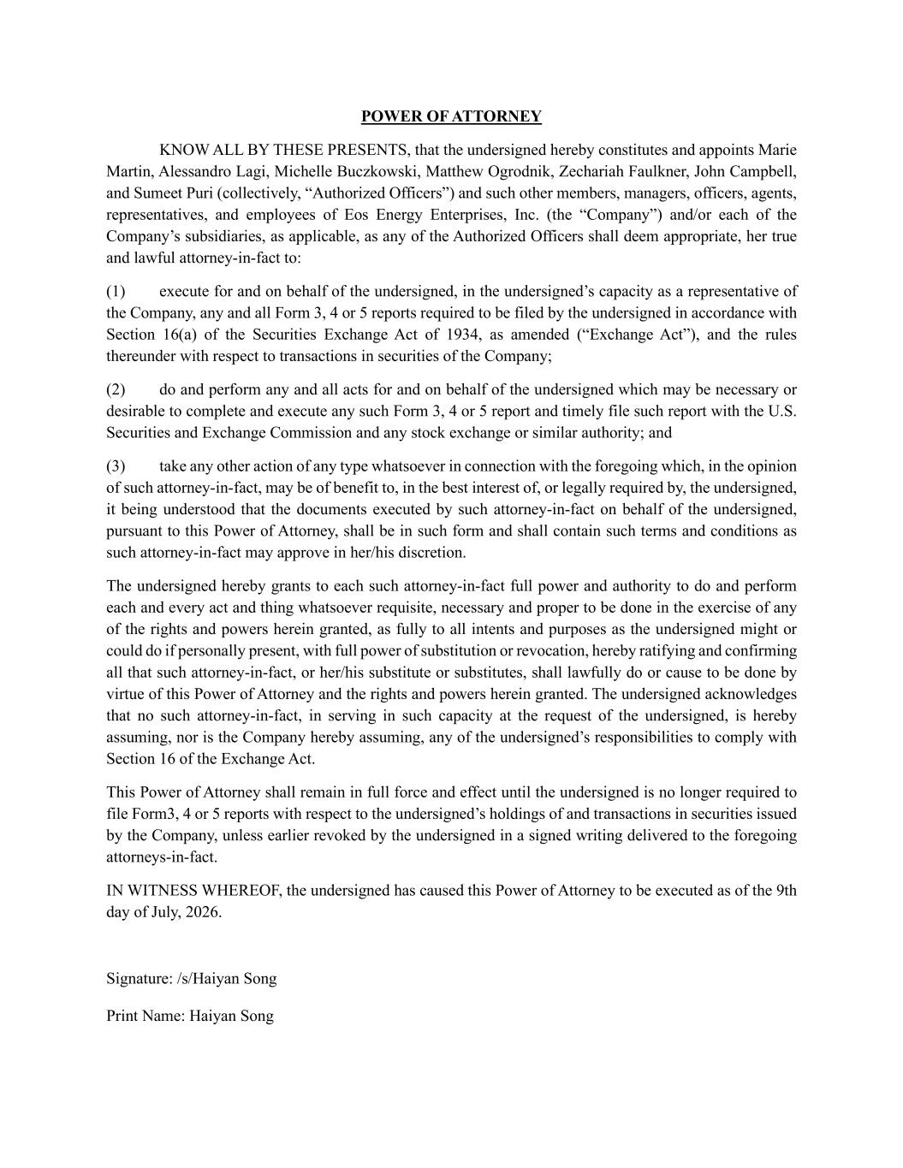
POWER OF ATTORNEY KNOW ALL BY THESE PRESENTS, that the undersigned hereby constitutes and appoints Marie Martin, Alessandro Lagi, Michelle Buczkowski, Matthew Ogrodnik, Zechariah Faulkner, John Campbell, and Sumeet Puri (collectively, “Authorized Officers”) and such other members, managers, officers, agents, representatives, and employees of Eos Energy Enterprises, Inc. (the “Company”) and/or each of the Company’s subsidiaries, as applicable, as any of the Authorized Officers shall deem appropriate, her true and lawful attorney-in-fact to: (1) execute for and on behalf of the undersigned, in the undersigned’s capacity as a representative of the Company, any and all Form 3, 4 or 5 reports required to be filed by the undersigned in accordance with Section 16(a) of the Securities Exchange Act of 1934, as amended (“Exchange Act”), and the rules thereunder with respect to transactions in securities of the Company; (2) do and perform any and all acts for and on behalf of the undersigned which may be necessary or desirable to complete and execute any such Form 3, 4 or 5 report and timely file such report with the U.S. Securities and Exchange Commission and any stock exchange or similar authority; and (3) take any other action of any type whatsoever in connection with the foregoing which, in the opinion of such attorney-in-fact, may be of benefit to, in the best interest of, or legally required by, the undersigned, it being understood that the documents executed by such attorney-in-fact on behalf of the undersigned, pursuant to this Power of Attorney, shall be in such form and shall contain such terms and conditions as such attorney-in-fact may approve in her/his discretion. The undersigned hereby grants to each such attorney-in-fact full power and authority to do and perform each and every act and thing whatsoever requisite, necessary and proper to be done in the exercise of any of the rights and powers herein granted, as fully to all intents and purposes as the undersigned might or could do if personally present, with full power of substitution or revocation, hereby ratifying and confirming all that such attorney-in-fact, or her/his substitute or substitutes, shall lawfully do or cause to be done by virtue of this Power of Attorney and the rights and powers herein granted. The undersigned acknowledges that no such attorney-in-fact, in serving in such capacity at the request of the undersigned, is hereby assuming, nor is the Company hereby assuming, any of the undersigned’s responsibilities to comply with Section 16 of the Exchange Act. This Power of Attorney shall remain in full force and effect until the undersigned is no longer required to file Form3, 4 or 5 reports with respect to the undersigned’s holdings of and transactions in securities issued by the Company, unless earlier revoked by the undersigned in a signed writing delivered to the foregoing attorneys-in-fact. IN WITNESS WHEREOF, the undersigned has caused this Power of Attorney to be executed as of the 9th day of July, 2026. Signature: /s/Haiyan Song Print Name: Haiyan Song

