UNITED STATES
SECURITIES AND EXCHANGE COMMISSION
Washington, D.C. 20549

FORM 10-Q
☒ |  |  | QUARTERLY REPORT PURSUANT TO SECTION 13 OR 15(d) OF THE SECURITIES EXCHANGE ACT OF 1934
For the quarterly period ended March 31, 2025
OR
☐ |  |  | TRANSITION REPORT PURSUANT TO SECTION 13 OR 15(d) OF THE SECURITIES EXCHANGE ACT OF 1934
For the transition period from to

Commission file number 001-39291
EOS ENERGY ENTERPRISES, INC.
(Exact name of registrant as specified in its charter)
Delaware |  |  |  |  |  |  |  |  | 84-4290188
(State or other jurisdiction of incorporation or organization) |  |  |  |  |  |  |  |  | (I.R.S. Employer Identification No.)
3920 Park Avenue |  |  | Edison |  |  | NJ |  |  | 08820
(Address of Principal Executive Offices) |  |  |  |  |  |  |  |  | (Zip Code)
(732) 225-8400
Registrant’s telephone number, including area code
Securities registered pursuant to Section 12(b) of the Act:
Title of each class |  |  | Trading Symbol(s) |  |  | Name of each exchange on which registered
Common stock, par value $0.0001 per share |  |  | EOSE |  |  | The Nasdaq Stock Market LLC
Warrants, each exercisable for one share of common stock |  |  | EOSEW |  |  | The Nasdaq Stock Market LLC
Indicate by check mark whether the registrant: (1) has filed all reports required to be filed by Section 13 or 15(d) of the Securities Exchange Act of 1934 during the preceding 12 months (or for such shorter period that the registrant was required to file such reports); and (2) has been subject to such filing requirements for the past 90 days. Yes ☒ No ☐
Indicate by check mark whether the registrant has submitted electronically and posted on its corporate web site, if any, every Interactive Data File required to be submitted and posted pursuant to Rule 405 of Regulation S-T (§232.405 of this chapter) during the preceding 12 months (or for such shorter period that the registrant was required to submit and post such files). Yes ☒ No ☐
Indicate by check mark whether the registrant is a large accelerated filer, an accelerated filer, a non-accelerated filer, or a smaller reporting company. See the definitions of “large accelerated filer,” “accelerated filer” and “smaller reporting company” in Rule 12b-2 of the Exchange Act. (Check one):
Large accelerated filer |  |  | ☐ |  |  | Accelerated filer |  |  | ☐
Non-accelerated filer |  |  | ☒ |  |  | Smaller reporting company |  |  | ☒
 |  |  |  |  |  | Emerging growth company |  |  | ☐
If an emerging growth company, indicate by check mark if the registrant has elected not to use the extended transition period for complying with any new or revised financial accounting standards provided pursuant to Section 13(a) of the Exchange Act. ☐
Indicate by check mark whether the registrant is a shell company (as defined in Rule 12b-2 of the Act). Yes ☐ No ☒
The registrant had outstanding 227,589,833 shares of common stock as of May 1, 2025.

Table of Contents
Table of Contents
 |  |  |  |  |  | Page
 |  |  | PART I - FINANCIAL INFORMATION
Item 1. |  |  | Financial Statements |  |  | 4
 |  |  | Unaudited Condensed Consolidated Balance Sheets as of March 31, 2025 and December 31, 2024 |  |  | 4
 |  |  | Unaudited Condensed Consolidated Statements of Operations and Comprehensive Income (Loss) for the Three Months Ended March 31, 2025 and 2024 |  |  | 6
 |  |  | Unaudited Condensed Consolidated Statements of Shareholders’ Deficit for the Three Months Ended March 31, 2025 and 2024 |  |  | 7
 |  |  | Unaudited Condensed Consolidated Statements of Cash Flows for the Three Months Ended March 31, 2025 and 2024 |  |  | 8
 |  |  | Notes to the Unaudited Condensed Consolidated Financial Statements |  |  | 10
Item 2. |  |  | Management’s Discussion and Analysis of Financial Condition and Results of Operations |  |  | 44
Item 3. |  |  | Quantitative and Qualitative Disclosures About Market Risk |  |  | 52
Item 4. |  |  | Controls and Procedures |  |  | 52
 |  |  | PART II - OTHER INFORMATION
Item 1. |  |  | Legal Proceedings |  |  | 54
Item 1a. |  |  | Risk Factors |  |  | 54
Item 2. |  |  | Unregistered Sales of Equity Securities and Use of Proceeds |  |  | 54
Item 3. |  |  | Defaults Upon Senior Securities |  |  | 54
Item 4. |  |  | Mine Safety Disclosures |  |  | 54
Item 5. |  |  | Other Information |  |  | 54
Item 6. |  |  | Exhibits |  |  | 56
Signatures |  |  |  |  |  | 58

1
Table of Contents
FORWARD-LOOKING INFORMATION
All statements included in this Quarterly Report on Form 10-Q (“Quarterly Report”), other than statements or characterizations of historical fact, are forward-looking statements within the meaning of the Private Securities Litigation Reform Act of 1995. The words “anticipate,” “believe,” “continue,” “could,” “estimate,” “expect,” “intends,” “may,” “might,” “plan,” “possible,” “potential,” “predict,” “project,” “should,” “would” and similar expressions, as they relate to us, are intended to identify forward-looking statements. These statements appear in a number of places in this Quarterly Report and include statements regarding the intent, belief or current expectations of Eos Energy Enterprises, Inc. Forward-looking statements are based on our management’s beliefs, as well as assumptions made by and information currently available to, them. Because such statements are based on expectations as to future financial and operating results and are not statements of fact, actual results may differ materially from those projected. Factors which may cause actual results to differ materially from current expectations include, but are not limited to:
•changes adversely affecting the business in which we are engaged;
•our ability to forecast trends accurately;
•our ability to generate cash, service indebtedness and incur additional indebtedness;
•our ability to raise financing in the future;
•our customer’s ability to secure project financing;
•risks associated with the Credit Agreement (defined below), including risks of default, dilution of outstanding common stock, consequences for failure to meet milestones and contractual lockup of shares;
•the amount of final tax credits available to our customers or to Eos pursuant to the Inflation Reduction Act;
•the timing and availability of future funding under the Department of Energy Loan Facility;
•our ability to continue to develop efficient manufacturing processes to scale and to forecast related costs and efficiencies accurately;
•fluctuations in our revenue and operating results;
•competition from existing or new competitors;
•our ability to convert firm order backlog and pipeline to revenue;
•risks associated with security breaches in our information technology systems;
•risks related to legal proceedings or claims;
•risks associated with evolving energy policies in the United States and other countries and the potential costs of regulatory compliance;
•risks associated with changes to the U.S. trade environment;
•our ability to maintain the listing of our shares of common stock on NASDAQ;
•our ability to grow our business and manage growth profitably, maintain relationships with customers and suppliers and retain our management and key employees;
•risks related to adverse changes in general economic conditions, including inflationary pressures and increased interest rates;
•risk from supply chain disruptions and other impacts of geopolitical conflict;
•changes in applicable laws or regulations; and
•other factors detailed under the section titled “Risk Factors” herein.
2
Table of Contents
Should one or more of these risks or uncertainties materialize, or should any of our assumptions prove incorrect, actual results may vary in material respects from those projected in these forward-looking statements. Forward-looking statements speak only as of the date they are made. Readers are cautioned not to put undue reliance on forward-looking statements and, except as required by law, the Company assumes no obligation and does not intend to update or revise these forward-looking statements, whether as a result of new information, future events, or otherwise. See also Part I, Item 1A, “Risk Factors” disclosures contained in the Company’s Annual Report on Form 10-K for the year ended December 31, 2024 for additional discussion of the risks and uncertainties that could cause the Company’s actual results to differ materially from those expressed or implied in its forward-looking statements.

3
Table of Contents
Part I - Financial Information
EOS ENERGY ENTERPRISES, INC.
UNAUDITED CONDENSED CONSOLIDATED BALANCE SHEETS
(In thousands, except share and per share amounts)

 |  |  | March 31,  2025 |  |  |  |  |  | December 31,  2024
ASSETS
Current assets:
Cash and cash equivalents |  |  | $ | 82,553 |  |  |  |  | $ | 74,292
Restricted cash |  |  | 14,141 |  |  |  |  |  | 14,070
Loan commitment assets - related party |  |  | — |  |  |  |  |  | 21,731
Accounts receivable, net |  |  | 7,145 |  |  |  |  |  | 3,038
Inventory |  |  | 40,315 |  |  |  |  |  | 32,826
Vendor deposits |  |  | 21,938 |  |  |  |  |  | 17,419
Contract assets, current |  |  | 13,049 |  |  |  |  |  | 13,096
Prepaid expenses |  |  | 1,275 |  |  |  |  |  | 938
Grant receivable, net |  |  | 4,082 |  |  |  |  |  | 2,283
Other current assets |  |  | 1,003 |  |  |  |  |  | 219
Total current assets |  |  | 185,501 |  |  |  |  |  | 179,912
Property, plant and equipment, net |  |  | 43,955 |  |  |  |  |  | 45,660
Intangible assets, net |  |  | 216 |  |  |  |  |  | 240
Goodwill |  |  | 4,331 |  |  |  |  |  | 4,331
Operating lease right-of-use asset, net |  |  | 2,561 |  |  |  |  |  | 2,909
Long-term restricted cash |  |  | 15,000 |  |  |  |  |  | 15,000
Other assets, net |  |  | 11,719 |  |  |  |  |  | 12,266
Total assets |  |  | $ | 263,283 |  |  |  |  | $ | 260,318
LIABILITIES
Current liabilities:
Accounts payable |  |  | $ | 24,286 |  |  |  |  | $ | 16,723
Accrued expenses |  |  | 21,655 |  |  |  |  |  | 22,032
Operating lease liability, current |  |  | 1,919 |  |  |  |  |  | 1,879
Long-term debt, current |  |  | 1,472 |  |  |  |  |  | 2,014
Contract liabilities, current |  |  | 39,684 |  |  |  |  |  | 22,039
Other current liabilities |  |  | 1,679 |  |  |  |  |  | 288
Total current liabilities |  |  | 90,695 |  |  |  |  |  | 64,975
Long-term liabilities:
Operating lease liability |  |  | 1,168 |  |  |  |  |  | 1,628
Long-term debt |  |  | 66,215 |  |  |  |  |  | 65,823
Notes payable - related party |  |  | 257,827 |  |  |  |  |  | 249,059
Interest payable - related party |  |  | 3,324 |  |  |  |  |  | —
Contract liabilities, long-term |  |  | 3,729 |  |  |  |  |  | 4,310
Warrants liability |  |  | 124,766 |  |  |  |  |  | 189,591
Warrants liability - related party |  |  | 146,793 |  |  |  |  |  | 266,630
Other liabilities |  |  | 65 |  |  |  |  |  | 69
Total long-term liabilities |  |  | 603,887 |  |  |  |  |  | 777,110
Total liabilities |  |  | 694,582 |  |  |  |  |  | 842,085
4
Table of Contents
EOS ENERGY ENTERPRISES, INC.
UNAUDITED CONDENSED CONSOLIDATED BALANCE SHEETS
(In thousands, except share and per share amounts)
 |  |  | March 31,  2025 |  |  |  |  |  | December 31,  2024
COMMITMENTS AND CONTINGENCIES (NOTE 16)
SERIES B PREFERRED STOCK (NOTE 3) - related party |  |  | 510,884 |  |  |  |  |  | 488,696
SHAREHOLDERS' DEFICIT
Common stock, $0.0001 par value, 600,000,000 shares authorized, 227,049,683 and 221,791,205 shares outstanding on March 31, 2025 and December 31, 2024, respectively |  |  | 23 |  |  |  |  |  | 23
Additional paid in capital |  |  | 647,863 |  |  |  |  |  | 534,726
Accumulated deficit |  |  | (1,546,580) |  |  |  |  |  | (1,561,716)
Accumulated other comprehensive loss - related party |  |  | (43,490) |  |  |  |  |  | (43,490)
Accumulated other comprehensive income (loss) |  |  | 1 |  |  |  |  |  | (6)
Total shareholders' deficit |  |  | (942,183) |  |  |  |  |  | (1,070,463)
Total liabilities, preferred stock and shareholders' deficit |  |  | $ | 263,283 |  |  |  |  | $ | 260,318
The accompanying notes are an integral part of these Unaudited Condensed Consolidated Financial Statements.

5
Table of Contents
EOS ENERGY ENTERPRISES, INC.
UNAUDITED CONDENSED CONSOLIDATED STATEMENTS OF OPERATIONS AND COMPREHENSIVE INCOME (LOSS)
(In thousands, except share and per share amounts)
 |  |  |  |  |  | Three Months Ended March 31,
 |  |  |  |  |  | 2025 |  |  |  |  |  | 2024
Revenue |  |  |  |  |  | $ | 10,457 |  |  |  |  | $ | 6,601
Cost of goods sold |  |  |  |  |  | 34,996 |  |  |  |  |  | 28,229
Gross profit (loss) |  |  |  |  |  | (24,539) |  |  |  |  |  | (21,628)
Operating expenses
Research and development expenses |  |  |  |  |  | 6,837 |  |  |  |  |  | 5,200
Selling, general and administrative expenses |  |  |  |  |  | 20,995 |  |  |  |  |  | 14,242
Loss from write-down of property, plant and equipment |  |  |  |  |  | 561 |  |  |  |  |  | 65
Total operating expenses |  |  |  |  |  | 28,393 |  |  |  |  |  | 19,507
Operating Income (loss) |  |  |  |  |  | (52,932) |  |  |  |  |  | (41,135)
Other (expense) income
Interest expense, net |  |  |  |  |  | (164) |  |  |  |  |  | (4,267)
Interest expense - related party |  |  |  |  |  | (5,781) |  |  |  |  |  | (4,851)
Change in fair value of debt - related party |  |  |  |  |  | (5,933) |  |  |  |  |  | —
Change in fair value of warrants |  |  |  |  |  | 45,925 |  |  |  |  |  | 2,900
Change in fair value of derivatives - related parties |  |  |  |  |  | 34,586 |  |  |  |  |  | 534
Other (expense) income |  |  |  |  |  | (560) |  |  |  |  |  | 136
Income (loss) before income taxes |  |  |  |  |  | $ | 15,141 |  |  |  |  | $ | (46,683)
Income tax expense |  |  |  |  |  | 5 |  |  |  |  |  | 25
Net income (loss) attributable to shareholders |  |  |  |  |  | $ | 15,136 |  |  |  |  | $ | (46,708)
Remeasurement of Preferred Stock - related party |  |  |  |  |  | 79,997 |  |  |  |  |  | —
Net income (loss) attributable to common shareholders |  |  |  |  |  | $ | 95,133 |  |  |  |  | $ | (46,708)
Other comprehensive income (loss)
Foreign currency translation adjustment |  |  |  |  |  | 7 |  |  |  |  |  | (5)
Comprehensive income (loss) attributable to common shareholders |  |  |  |  |  | $ | 95,140 |  |  |  |  | $ | (46,713)
Basic and diluted income (loss) per share attributable to common shareholders
Basic |  |  |  |  |  | $ | 0.42 |  |  |  |  | $ | (0.23)
Diluted |  |  |  |  |  | $ | (0.20) |  |  |  |  | $ | (0.23)
Weighted average shares of common stock
Basic |  |  |  |  |  | 225,474,247 |  |  |  |  |  | 201,306,905
Diluted |  |  |  |  |  | 436,368,282 |  |  |  |  |  | 201,306,905
The accompanying notes are an integral part of these Unaudited Condensed Consolidated Financial Statements.

6
Table of Contents
EOS ENERGY ENTERPRISES, INC.
UNAUDITED CONDENSED CONSOLIDATED STATEMENTS OF SHAREHOLDERS' DEFICIT
(In thousands, except share and per share amounts)
 |  |  | Common Stock |  |  |  |  |  |  |  |  |  |  |  | Additional Paid in capital |  |  |  |  |  | Accumulated Other Comprehensive Income (Loss) |  |  |  |  |  | Accumulated Deficit |  |  |  |  |  | Total
 |  |  | Shares |  |  |  |  |  | Amount
Balances on December 31, 2023 |  |  | 199,133,827 |  |  |  |  |  | $ | 21 |  |  |  |  | $ | 765,018 |  |  |  |  | $ | 7 |  |  |  |  | $ | (875,846) |  |  |  |  | $ | (110,800)
Stock-based compensation |  |  | — |  |  |  |  |  | — |  |  |  |  |  | 2,941 |  |  |  |  |  | — |  |  |  |  |  | — |  |  |  |  |  | 2,941
Release of restricted stock units |  |  | 657,605 |  |  |  |  |  | — |  |  |  |  |  | — |  |  |  |  |  | — |  |  |  |  |  | — |  |  |  |  |  | —
Cancellation of shares used to settle payroll tax withholding |  |  | (251,967) |  |  |  |  |  | — |  |  |  |  |  | (308) |  |  |  |  |  | — |  |  |  |  |  | — |  |  |  |  |  | (308)
Issuance of common stock |  |  | 7,239,982 |  |  |  |  |  | 1 |  |  |  |  |  | 7,206 |  |  |  |  |  | — |  |  |  |  |  | — |  |  |  |  |  | 7,207
Foreign currency translation adjustment |  |  | — |  |  |  |  |  | — |  |  |  |  |  | — |  |  |  |  |  | (5) |  |  |  |  |  | — |  |  |  |  |  | (5)
Net loss |  |  | — |  |  |  |  |  | — |  |  |  |  |  | — |  |  |  |  |  | — |  |  |  |  |  | (46,708) |  |  |  |  |  | (46,708)
Balances on March 31, 2024 |  |  | 206,779,447 |  |  |  |  |  | $ | 22 |  |  |  |  | $ | 774,857 |  |  |  |  | $ | 2 |  |  |  |  | $ | (922,554) |  |  |  |  | $ | (147,673)
Balances on December 31, 2024 |  |  | 221,791,205 |  |  |  |  |  | $ | 23 |  |  |  |  | $ | 534,726 |  |  |  |  | $ | (43,496) |  |  |  |  | $ | (1,561,716) |  |  |  |  | $ | (1,070,463)
Stock-based compensation |  |  | — |  |  |  |  |  | — |  |  |  |  |  | 7,447 |  |  |  |  |  | — |  |  |  |  |  | — |  |  |  |  |  | 7,447
Exercise of warrants |  |  | 4,393,102 |  |  |  |  |  | — |  |  |  |  |  | 25,862 |  |  |  |  |  | — |  |  |  |  |  | — |  |  |  |  |  | 25,862
Exercise of stock options |  |  | 198,398 |  |  |  |  |  | — |  |  |  |  |  | 319 |  |  |  |  |  | — |  |  |  |  |  | — |  |  |  |  |  | 319
Release of restricted stock units |  |  | 749,416 |  |  |  |  |  | — |  |  |  |  |  | — |  |  |  |  |  | — |  |  |  |  |  | — |  |  |  |  |  | —
Cancellation of shares used to settle payroll tax withholding |  |  | (82,438) |  |  |  |  |  | — |  |  |  |  |  | (488) |  |  |  |  |  | — |  |  |  |  |  | — |  |  |  |  |  | (488)
Remeasurement of Preferred Stock |  |  | — |  |  |  |  |  | — |  |  |  |  |  | 79,997 |  |  |  |  |  | — |  |  |  |  |  | — |  |  |  |  |  | 79,997
Foreign currency translation adjustment |  |  | — |  |  |  |  |  | — |  |  |  |  |  | — |  |  |  |  |  | 7 |  |  |  |  |  | — |  |  |  |  |  | 7
Net income |  |  | — |  |  |  |  |  | — |  |  |  |  |  | — |  |  |  |  |  | — |  |  |  |  |  | 15,136 |  |  |  |  |  | 15,136
Balances on March 31, 2025 |  |  | 227,049,683 |  |  |  |  |  | $ | 23 |  |  |  |  | $ | 647,863 |  |  |  |  | $ | (43,489) |  |  |  |  | $ | (1,546,580) |  |  |  |  | $ | (942,183)

7
Table of Contents
EOS ENERGY ENTERPRISES, INC.
UNAUDITED CONDENSED CONSOLIDATED STATEMENTS OF CASH FLOWS
(In thousands, except share and per share amounts)
Three Months Ended
March 31,
 |  |  | 2025 |  |  |  |  |  | 2024
Cash flows from operating activities
Net income (loss) |  |  | $ | 15,136 |  |  |  |  | $ | (46,708)
Adjustment to reconcile net loss to net cash used in operating activities
Stock-based compensation |  |  | 7,574 |  |  |  |  |  | 2,941
Depreciation and amortization |  |  | 2,680 |  |  |  |  |  | 1,197
Loss from write-down of property, plant and equipment |  |  | 561 |  |  |  |  |  | 65
Amortization of right-of-use assets |  |  | 373 |  |  |  |  |  | 298
Non-cash interest expense |  |  | 899 |  |  |  |  |  | 885
Non-cash interest expense - related parties |  |  | 2,457 |  |  |  |  |  | 1,549
Change in fair value of debt - related party |  |  | 5,933 |  |  |  |  |  | —
Change in fair value of warrants |  |  | (45,925) |  |  |  |  |  | (2,900)
Change in fair value of derivatives - related parties |  |  | (34,586) |  |  |  |  |  | (534)
Other |  |  | (821) |  |  |  |  |  | —
Changes in operating assets and liabilities:
Prepaid expenses |  |  | (337) |  |  |  |  |  | (196)
Inventory |  |  | (6,101) |  |  |  |  |  | 2,677
Accounts receivable |  |  | (4,107) |  |  |  |  |  | (566)
Vendor deposits |  |  | (1,681) |  |  |  |  |  | (204)
Contract assets |  |  | (140) |  |  |  |  |  | (4,572)
Grant receivable |  |  | (1,799) |  |  |  |  |  | (1,542)
Accounts payable |  |  | 8,130 |  |  |  |  |  | (2,593)
Accrued expenses |  |  | (380) |  |  |  |  |  | 6,159
Interest payable - related party |  |  | 3,324 |  |  |  |  |  | 2,892
Operating lease liabilities |  |  | (445) |  |  |  |  |  | (350)
Contract liabilities |  |  | 17,064 |  |  |  |  |  | 501
Other |  |  | 3,267 |  |  |  |  |  | 527
Net cash used in operating activities |  |  | (28,924) |  |  |  |  |  | (40,474)
Cash flows from investing activities
Purchases of property, plant and equipment |  |  | (4,918) |  |  |  |  |  | (4,042)
Net cash used in investing activities |  |  | (4,918) |  |  |  |  |  | (4,042)
Cash flows from financing activities
Principal payments on finance lease obligations |  |  | (11) |  |  |  |  |  | (2)
Proceeds from exercise of stock options |  |  | 319 |  |  |  |  |  | —
Proceeds from exercise of warrants |  |  | 7,029 |  |  |  |  |  | —
Proceeds received from Credit and Securities Purchase Transaction, net - related party |  |  | 38,475 |  |  |  |  |  | —
Payment of debt issuance costs |  |  | (2,250) |  |  |  |  |  | —
Repayment of equipment financing facility |  |  | (912) |  |  |  |  |  | (786)
Proceeds from issuance of common stock |  |  | — |  |  |  |  |  | 7,207
Repurchase of shares from employees for income tax withholding purposes |  |  | (488) |  |  |  |  |  | (308)
8
Table of Contents
EOS ENERGY ENTERPRISES, INC.
UNAUDITED CONDENSED CONSOLIDATED STATEMENTS OF CASH FLOWS
(In thousands, except share and per share amounts)
Three Months Ended
March 31,
 |  |  | 2025 |  |  |  |  |  | 2024
Net cash provided by financing activities |  |  | 42,162 |  |  |  |  |  | 6,111
Effect of exchange rate changes on cash, cash equivalents and restricted cash |  |  | 12 |  |  |  |  |  | (6)
Net increase (decrease) in cash, cash equivalents and restricted cash |  |  | 8,332 |  |  |  |  |  | (38,411)
Cash, cash equivalents and restricted cash, beginning of the period |  |  | 103,362 |  |  |  |  |  | 84,667
Cash, cash equivalents and restricted cash, end of the period |  |  | $ | 111,694 |  |  |  |  | $ | 46,256
Non-cash investing and financing activities
Accrued and unpaid capital expenditures |  |  | $ | 730 |  |  |  |  | $ | 384
Accrued and unpaid debt issuance costs |  |  | 1,581 |  |  |  |  |  | —
Accrued and unpaid capitalized internal-use software |  |  | — |  |  |  |  |  | 8
Remeasurement of preferred stock - related party |  |  | (79,997) |  |  |  |  |  | —
Right-of-use operating lease assets in exchange for lease liabilities |  |  | 25 |  |  |  |  |  | —
Supplemental disclosures
Cash paid for interest |  |  | $ | 73 |  |  |  |  | $ | 238
The accompanying notes are an integral part of these Unaudited Condensed Consolidated Financial Statements.

9
Table of Contents

EOS ENERGY ENTERPRISES, INC.
NOTES TO THE UNAUDITED CONDENSED CONSOLIDATED FINANCIAL STATEMENTS
(In thousands, except share and per share amounts)

1.Overview
Nature of Operations
Eos Energy Enterprises, Inc. (the “Company,” “we,” “us,” “our,” and “Eos”) designs, develops, manufactures and markets innovative energy storage solutions for utility-scale, microgrid and commercial & industrial (“C&I”) applications. Eos developed a broad range of intellectual property with multiple patents covering unique battery chemistry, mechanical product design, energy block configuration and a software operating system (Battery Management System). The Company has only one operating and reportable segment.
Liquidity and Going Concern
As a growth company in the early commercialization stage of its lifecycle, Eos is subject to inherent risks and uncertainties associated with the development of an enterprise. In this regard, substantially all of the Company’s efforts to date have been devoted to the development and manufacturing of battery energy storage systems and complementary products and services, recruitment of management and technical staff, deployment of capital to expand the Company’s operations to meet customer demand and raising capital to fund the Company’s development. However, as a result of these efforts, the Company has incurred significant losses and negative cash flows from operations since its inception and expects to continue to incur such losses and negative cash flows for the foreseeable future until such time that the Company can reach a scale of profitability to sustain its operations.
In order to execute its development strategy, the Company has historically relied on outside capital through the issuance of equity, debt and borrowings under financing arrangements (collectively “outside capital”) to fund its cost structure. While the Company believes its recent entry into new credit facilities as discussed below has significantly improved its capital position and provides a path to sustainable operations and profitability, there can be no assurance the Company will be able to achieve such profitability or do so in a manner that does not require additional outside capital. Moreover, while the Company has historically been successful in raising outside capital, there can be no assurance the Company will be able to continue to obtain outside capital in the future or do so on terms that are acceptable to the Company.
As disclosed in Note 3, Credit and Securities Purchase Transaction, on June 21, 2024, the Company entered into a financing transaction with CCM Denali Debt Holdings, LP, an affiliate of Cerberus Capital Management LP (herein after referred to as “Cerberus”, “Denali”, “Lender”, “Holder”). As a result of this transaction, Cerberus agreed to provide a $210,500 secured multi-draw facility, to be made in four installments (the “Delayed Draw Term Loan”) as well as a $105,000 revolving credit facility (“Revolving Facility”), to be made available beginning June 21, 2026, at Cerberus’ sole discretion and only if the Delayed Draw Term Loan is fully funded. As of the date the accompanying Unaudited Condensed Consolidated Financial Statements were issued (the “issuance date”), the Delayed Draw Term Loan was fully funded. As part of the Credit and Securities Purchase Transaction, Cerberus received warrants and preferred stock resulting in a 33% ownership position in the Company as of the issuance date. This ownership percentage represents $814,346 in market capitalization based on the May 01, 2025 closing share price of the Company’s common stock.
10
Table of Contents
EOS ENERGY ENTERPRISES, INC.
NOTES TO THE UNAUDITED CONDENSED CONSOLIDATED FINANCIAL STATEMENTS
(In thousands, except share and per share amounts)

1. Overview (cont.)
As disclosed in Note 13, Borrowings, on November 26, 2024, the Company successfully closed on the DOE Loan Facility, which provides the Company with up to $303,450 in funding, including capitalized interest, subject to the achievement of certain funding conditions. The DOE Loan Facility provides for a multi draw term loan facility under a series of at least two tranches and, if the Company elects, up to four tranches, subject to the achievement of certain conditions. Each tranche corresponds to the production, maintenance and development, and operation of a given production line to be funded using the proceeds of such tranche. The DOE Loan Facility specifies the maximum amount subject to each tranche (Tranche 1: $101,979; Tranche 2: $117,326; Tranche 3: $71,836; and Tranche 4: $12,309), and any amounts which are not withdrawn under a specified tranche cannot be allocated to another tranche. Through March 31, 2025, the Company had drawn down $68,279 under Tranche 1.
As of the issuance date, management evaluated the significance of the following negative financial conditions in accordance with Accounting Standard Codification 205-40, Going Concern:
•Since its inception, the Company has incurred significant losses and negative cash from operations in order to fund its development. During the three months ended March 31, 2025, the Company had net income of $15,136. Adjustments to reconcile net income to cash used in operations are primarily from non-cash items on the Unaudited Condensed Consolidated Statements of Cash Flows. The non-cash items totaled $60,855. The Company incurred negative cash flows from operations of $28,924 and had an accumulated deficit of $1,546,580 as of March 31, 2025.
•As of March 31, 2025, the Company had $82,553 of unrestricted cash and cash equivalents available to fund the Company’s operations and working capital of $94,806.
•On June 21, 2024, upon closing of the Credit and Securities Purchase Transaction, Cerberus funded the Company $75,000 of the initial draw, and the Company received $71,250, net of the 5.0% original issue discount. On August 29, 2024, Cerberus funded the Company $30,000 (“August Draw”), and the Company received $28,500, net of the 5.0% original issue discount. On November 1, 2024, Cerberus funded the Company $65,000 related to the October 31, 2024 tranche (“October Draw” or “October Tranche”), and the Company received $61,750, net of the 5.0% original issue discount. On January 24, 2025, Cerberus funded the Company the final $40,500 and the Company received $38,475, net of the 5.0% original issue discount, related to the January 31, 2025 tranche (“January 2025 Draw”). Subsequent to the January 2025 Draw, the Delayed Draw Term Loan has been fully funded.
•Through March 31, 2025, under the DOE Loan Facility, the Company drew down $68,279 for the eligible project cost that the Company had incurred through December 6, 2024. These costs are a portion of Tranche 1 of the DOE Loan Facility. Tranche 1 provides up to $101,979 for eligible costs in connection with the design, construction, installation, startup and shakedown of a battery automation line and related tools. In the event the Company does not achieve certain funding milestone conditions and the DOE chooses not to continue funding, the Company would need to seek alternative sources of capital, which may not be available on favorable terms or at all.
11
Table of Contents
EOS ENERGY ENTERPRISES, INC.
NOTES TO THE UNAUDITED CONDENSED CONSOLIDATED FINANCIAL STATEMENTS
(In thousands, except share and per share amounts)

1. Overview (cont.)
•The Credit and Securities Purchase Transaction and the DOE Loan Facility contain certain quarterly financial covenants which include (a) Minimum Liquidity, (b) Minimum Consolidated EBITDA, and (c) Minimum Consolidated Revenue (collectively, the “financial covenants”). As of March 31, 2025, the only financial covenant in effect was Minimum Liquidity. As of March 31, 2025, the Company was in compliance with this covenant and non-financial covenants, and the Company expects to remain in compliance with the Minimum Liquidity covenant over the next twelve months beyond the issuance date. The Minimum Consolidated EBITDA and Minimum Consolidated Revenue financial covenants become effective beginning December 31, 2025. As of March 31, 2025, the Company expects that it may be unable to remain in compliance with the Minimum Consolidated EBITDA and Minimum Consolidated Revenue financial covenants beginning December 31, 2025, absent the Company’s ability to secure a waiver or amend the Credit and Securities Purchase Transaction and the DOE Loan Facility. The Company continues to be in regular communication with Cerberus and DOE regarding these covenants. In the event the Company is unable to comply with the financial and non-financial covenants beginning December 31, 2025, and the Company is unable to secure a waiver, Cerberus and the DOE may, at their discretion, enter into a forbearance agreement with the Company and/or exercise any and all of their existing rights and remedies, which may include, among other things, asserting their rights in the Company’s assets securing the loans. Moreover, the Company’s other lenders may exercise similar rights and remedies under the cross-default provisions of their respective borrowing agreements with the Company.
•In the event the Company’s ongoing efforts to raise additional outside capital are unsuccessful, the Company will be unable to meet its obligations as they come due over the next twelve months beyond the issuance date. In such an event, management will be required to seek other strategic alternatives, which may include, among others, a significant curtailment in the Company’s operations, a sale of certain of the Company’s assets, a sale of the entire Company to strategic or financial investors and/or allowing the Company to become insolvent.
These uncertainties raise substantial doubt about the Company’s ability to continue as a going concern. The accompanying Unaudited Condensed Consolidated Financial Statements have been prepared on the basis that the Company will continue to operate as a going concern, which contemplates that the Company will be able to realize assets and settle liabilities and commitments in the normal course of business for the foreseeable future. Accordingly, the accompanying Unaudited Condensed Consolidated Financial Statements do not include any adjustments that may result from the outcome of these uncertainties.

2. Summary of Significant Accounting Policies
Basis of Presentation
The accompanying Unaudited Condensed Consolidated Financial Statements include the accounts of the Company and its 100% owned, direct and indirect subsidiaries and have been prepared in accordance with U.S. generally accepted accounting principles (“GAAP”). All intercompany transactions and balances have been eliminated in the preparation of the Unaudited Condensed Consolidated Financial Statements. These statements reflect all adjustments, consisting of normal recurring adjustments, which, in the opinion of management, are necessary for fair presentation of the information contained therein. Certain information and footnote disclosures normally included in financial statements prepared in accordance with GAAP have been condensed or omitted pursuant to the rules and regulations of the U.S. Securities and Exchange Commission (“SEC”). The interim financial statements should be read in conjunction with the audited consolidated financial statements, including the notes thereto, included in our 2024 Annual Report on Form 10-K. These interim results are not necessarily indicative of results for the full year.
Use of Estimates
The preparation of financial statements in conformity with GAAP requires management to make estimates and assumptions that affect the reported amounts of assets and liabilities and disclosure of contingent assets and liabilities at the date of the financial statements and the reported amount of revenues and expenses during the reporting period. Actual results could differ from those estimates.
12
Table of Contents
EOS ENERGY ENTERPRISES, INC.
NOTES TO THE UNAUDITED CONDENSED CONSOLIDATED FINANCIAL STATEMENTS
(In thousands, except share and per share amounts)
2. Summary of Significant Accounting Policies (cont.)
Change to Prior Year Presentation
In the Unaudited Condensed Consolidated Statements of Operations, Gross profit (loss) has been introduced, reflecting Total revenue less Cost of goods sold. This addition does not impact the reported Net income (loss).
Series A and B Preferred Stock
As discussed in Note 3, Credit and Securities Purchase Transaction, the Company issued shares of (1) Series A-1 Preferred Stock and Series A-2 Preferred Stock (collectively "Series A Preferred Stock") in June 2024 and August 2024, respectively, which were subsequently converted into shares of Series B-1 Preferred Stock and Series B-2 Preferred Stock, respectively, in September 2024, (2) Series B-3 Preferred Stock in November 2024 and Series B-4 Preferred Stock in January 2025 (collectively, with the Series B-1 Preferred Stock, Series B-2 Preferred Stock, Series B-3 Preferred Stock and Series B-4 Preferred Stock, the “Series B Preferred Stock” and together with Series A Preferred Stock, “the Preferred Stock”). The Preferred Stock is redeemable based upon the passage of time and therefore meets the criteria to be classified within temporary equity. Management has elected to recognize changes in the redemption value pursuant to ASC 480-10-S99-3A-15(b). As a result, the Company will remeasure the Preferred Stock to the maximum redemption value at each reporting date but will never be adjusted below its initial carrying value. Adjustments are reflected in Additional paid in capital on the Company’s Unaudited Condensed Consolidated Balance Sheets.
Production Tax Credits under Internal Revenue Code 45X (“PTC”)
Since the PTC is a refundable credit (i.e., a credit with a direct-pay option available), the PTC is outside the scope of ASC 740. Therefore, the Company accounts for the PTC under a government grant model. GAAP does not address the accounting for government grants received by a business entity that are outside the scope of ASC 740. The Company’s accounting policy is to analogize to IAS 20, Accounting for Government Grants and Disclosure of Government Assistance, under IFRS Accounting Standards. Under IAS 20, once it is reasonably assured that the entity will comply with the conditions of the grant, the grant money is recognized on a systematic basis over the periods in which the entity recognizes the related expenses or losses for which the grant money is intended to compensate. The Company recognizes grants once it is probable that both of the following conditions will be met: (1) the Company is eligible to receive the grant and (2) the Company is able to comply with the relevant conditions of the grant. The PTC is a non-monetary asset since the Company’s intention is to sell the tax credit to a third-party and is recorded at the value that is expected to be received from the sale in Grant Receivable, net on the Company’s Unaudited Condensed Consolidated Balance Sheets and is subsequently recognized in Cost of goods sold in the Unaudited Condensed Consolidated Statements of Operations and Comprehensive Income (Loss) when the inventory is sold. In the event the PTC is sold, upon the receipt of the cash payments, the Company will record offsets to Grant Receivable, net. Differences in the recorded value of the PTC and the sale price will be recognized as an adjustment to cost of goods sold in the Unaudited Condensed Consolidated Statements of Operations and Comprehensive Income (Loss).
Fair Value Option
The Company has elected the option under ASC 825-10, Financial Instruments ("ASC 825"), to measure the Delayed Draw Term Loan, including all tranches of fundings received in 2024 (see Note 3, Credit and Securities Purchase Transaction) at fair value. The fair value option may be elected on an instrument-by-instrument basis and is irrevocable unless a new election date occurs. When the fair value option is elected for an instrument, unrealized gains and losses for such instrument is reported in the Unaudited Condensed Consolidated Statements of Operations and Comprehensive Income (Loss) at each subsequent reporting date. Upfront costs and fees related to items for which the fair value option is elected shall be recognized in earnings as incurred and not deferred. These amounts are included in Other expense in the Unaudited Condensed Consolidated Statements of Operations and Comprehensive Income (Loss). The gains or losses attributable to changes in instrument-specific risk are included in Change in fair value of debt - credit risk - related party in Accumulated other comprehensive loss.
13
Table of Contents
EOS ENERGY ENTERPRISES, INC.
NOTES TO THE UNAUDITED CONDENSED CONSOLIDATED FINANCIAL STATEMENTS
(In thousands, except share and per share amounts)
2. Summary of Significant Accounting Policies (cont.)
Recent Accounting Pronouncements
In October 2023, the FASB issued ASU 2023-06, Disclosure Agreements - Codification Amendments in Response to the SEC’s Disclosure Update and Simplification Initiative. This amendment will impact various disclosure areas, including the statement of cash flows, accounting changes and error corrections, earnings per share, debt, equity, derivatives, and transfers of financial assets. The amendments in this ASU 2023-06 will be effective on the date the related disclosures are removed from Regulation S-X or Regulation S-K by the SEC. If the SEC has not removed the applicable disclosure requirement by June 30, 2027, these amendments will not be effective. Early adoption is prohibited. The Company is currently assessing the potential impact this amendment could have on its disclosures.
In December 2023, the FASB issued ASU 2023-09, Improvements to Income Tax Disclosures, which requires additional disclosures related to the effective tax rate reconciliation and taxes paid. The amendment is effective for annual periods beginning after December 15, 2024, and the Company does not anticipate a material change in the financial statements and related disclosure.
In November 2024, the FASB issued ASU 2024-03, Income Statement—Reporting Comprehensive Income—Expense Disaggregation Disclosures (Subtopic 220-40). The amendments in this update require disaggregation of certain expense captions into specified categories in disclosures within the footnotes to the financial statements. This update is effective for annual reporting periods beginning after December 15, 2026, and interim reporting periods beginning after December 15, 2027, though early adoption is permitted. The Company is currently assessing the potential impact this amendment could have on its financial statements and disclosures.
In November 2024, the FASB issued ASU 2024-04, Debt-Debt with Conversion and Other Options (Subtopic 470-20): Induced Conversions of Convertible Debt Instruments. The amendments in this update clarify the requirements for determining whether certain settlements of convertible debt instruments should be accounted for as induced conversions rather than as debt extinguishments. This update is effective for annual periods beginning after December 15, 2025, including interim periods within those fiscal years, though early adoption is permitted. The Company is currently assessing the potential impact this amendment could have on its financial statements and disclosures.
In January 2025, the FASB issued ASU 2025-01, Income Statement-Reporting Comprehensive Income-Expense Disaggregation Disclosures (Subtopic 220-40): Clarifying the Effective Date (“ASU 2025-01”), which requires disaggregated disclosure of income statement expenses for public business entities. The ASU does not change the expense captions an entity presents on the face of the income statement; rather, it requires disaggregation of certain expense captions into specified categories in disclosures within the footnotes to the financial statements. ASU 2025-01 is effective for fiscal years beginning after December 15, 2027. Early adoption is permitted. Entities should apply the amendments in ASU 2023-07 retrospectively to all prior periods presented in the financial statements. The Company is currently evaluating the impact of adopting ASU 2025-01 and does not expect it to have a material impact on the Company’s financial position, results of operations and cash flows.

3. Credit and Securities Purchase Transaction
Credit and Guaranty Agreement (“Credit Agreement”)
Delayed Draw Term Loan
On June 21, 2024, the Company entered into a credit and guaranty agreement (the “Credit Agreement”) with CCM Denali Debt Holdings, LP, an affiliate of Cerberus Capital Management LP (herein after referred to as “Cerberus”, “Denali”, “Lender”, “Holder”). As a result of this transaction, Cerberus agreed to provide a $210,500 secured multi-draw facility to be made in four installments (“tranches”, and collectively, the (“Delayed Draw Term Loan” or “DDTL”) as well as a $105,000 revolving credit facility (“Revolving Facility”), to be made available at the Lenders’ sole discretion and only if the Delayed Draw Term Loan is fully funded. On June 21, 2024 the initial $75,000 installment was funded (the “Initial Draw”). On August 29, 2024, the full amount of the August tranche of $30,000 was funded. On October 31, 2024, the full amount of the October tranche of $65,000 was funded. The final tranche in the amount of $40,500 was funded on January 24, 2025, completing the scheduled fundings under the Delayed Draw Term Loan.
14
Table of Contents
EOS ENERGY ENTERPRISES, INC.
NOTES TO THE UNAUDITED CONDENSED CONSOLIDATED FINANCIAL STATEMENTS
(In thousands, except share and per share amounts)
3. Credit Agreement and Securities Purchase Transaction (cont.)
On November 26, 2024, the Company amended the Credit Agreement (the “Credit Agreement Amendment”), by and among the Company, certain of the Company’s subsidiaries as guarantors party thereto and the Lender, pursuant to which among other things, the applicability of the Consolidated Revenue and EBITDA financial covenants were deferred until December 31, 2025 and certain provisions were amended to conform with comparable provisions in the DOE Loan Facility. See Note 13, Borrowings, for further discussion.
Securities Purchase Agreement
On June 21, 2024, the Company entered into a Securities Purchase Agreement (the “SPA”) with CCM Denali Equity Holdings, LP (the “Purchaser”).
SPA Warrant
Under the SPA, the Company issued a warrant to purchase 43,276,194 shares of common stock representing a collective ownership of 19.9% (the “SPA Warrant”) of our outstanding shares of (inclusive of Series A-1 Preferred Stock – see below) common stock prior to the issuance. The SPA Warrant has a ten-year term and an exercise price of $0.01 per share. The SPA Warrant includes anti-dilutive rights, subject to certain excluded issuances, in the event any shares of common stock, options, warrants, convertible securities or other equity or equity equivalent securities payable in common stock are issued at a price per share of less than the fair market value (as defined in the Warrant) of a share of common stock on the issuance date of the Warrant, subject to adjustment. Until the Company received stockholder approval on September 10, 2024, the Company could not issue additional shares of common stock exceeding 19.99% of shares of common stock issued and outstanding as of the date of the Initial Draw (such percentage, as may be adjusted in accordance with the terms of the Warrant, the “Conversion Cap”) upon exercise of the Warrant, and would have been required to issue, at the option of the Lender, Series A Preferred Stock or additional warrants on common stock upon a draw under the Delayed Draw Term Loan. Following shareholder approval received, the Conversion Cap increased to 49.9% of the number of shares of common stock issued and outstanding as of the applicable measurement date; and the holder of the Warrant has the option to amend the Conversion Cap to any percentage less than 49.9%.
The SPA Warrant is exercisable at the holder’s discretion for cash or on a cashless basis. The SPA Warrant is subject to automatic cashless exercise on the expiration date if the fair market value of one share is greater than the exercise price then in effect. Upon an acceleration under the Credit Agreement, the Company may be required to purchase the SPA Warrant from the holder at an amount equal to the closing sale price of underlying common stock less the SPA Warrant exercise price at the request of the holder. The SPA Warrant meets the criteria for liability classification under ASC 480 and is recognized at fair value with changes in fair value included in Change in fair value of derivatives - related parties in the Unaudited Condensed Consolidated Statements of Operations and Comprehensive Income (Loss).
Contingent Warrants
Upon the achievement of performance milestones on dates specified in the Credit Agreement, the Company received additional funds and issued at the option of the Lender, Preferred Stock (Series A Preferred Stock, if prior to shareholder approval or Series B Preferred Stock if after shareholder approval) or warrants on common stock (collectively “Contingent Warrants”) under the SPA in an amount equal to the applicable percentage, up to an aggregate of 33.0% ownership limitation on a fully diluted basis at such time the Delayed Draw Term Loan is fully drawn. As of the balance sheet date the applicable percentage is subject to increase by up to 4.0% to up to 37.0% on a fully diluted basis to the extent that milestones are not met on the final measurement date on April 30, 2025, in which case additional Contingent Warrants would be issuable. See Note 22, Subsequent Events, for further discussion of the applicable percentage and final measurement date. The Contingent Warrants meet the criteria for liability classification under ASC 480. The change in fair value of the Contingent warrants is included in Change in fair value of derivatives - related parties on the Company’s Unaudited Condensed Consolidated Statements of Operations and Comprehensive Income (Loss). See Note 14, Warrants Liability, for further discussion of the SPA Warrant and Contingent Warrants.
15
Table of Contents
EOS ENERGY ENTERPRISES, INC.
NOTES TO THE UNAUDITED CONDENSED CONSOLIDATED FINANCIAL STATEMENTS
(In thousands, except share and per share amounts)
3. Credit Agreement and Securities Purchase Transaction (cont.)
Series A-1 Preferred Stock
On June 21, 2024, the Company filed with the Secretary of State of the State of Delaware the Series A-1 Certificate of Designation and issued 59 shares of Series A-1 Preferred Stock to satisfy the terms of the Credit Agreement. Under the terms of the Series A-1 Certificate of Designation, each share of Series A-1 Preferred Stock had an original issue price of $455,822.59 (the “A-1 Original Issue Price”) and a liquidation value, payable with the common stock, as if such shares were convertible into an aggregate of 31,940,063 shares of common stock, subject to adjustment. The Series A-1 Preferred Stock was non-voting and non-convertible into common stock. Holders of the Series A-1 Preferred Stock were entitled to receive dividends or distributions on each share of Series A-1 Preferred Stock equal to dividends or distributions actually paid on each share of common stock, multiplied by the number of shares of common stock represented by the Series A-1 Preferred Stock Liquidation Value (as defined in the Series A-1 Certificate of Designation).
The 59 shares of Series A-1 Preferred Stock issued to Cerberus converted into shares of Series B-1 Preferred Stock once stockholder approval was obtained on September 10, 2024. See Series B Preferred Stock discussion below.
Series A-2 Preferred Stock
On August 29, 2024, the Company filed with the Secretary of State of the State of Delaware the Series A-2 Certificate of Designation (the “Series A-2 Certificate of Designation”) and the shares issuable thereunder, the “Series A-2 Preferred Stock”).
Under the terms of the Series A-2 Certificate of Designation, each share of Series A-2 Preferred Stock had an original issue price of $9,555,515.30 (the “A-2 Original Issue Price”) and a liquidation value, payable pari passu with the common stock, as if such share was convertible into an aggregate of 28,806,463 shares of common stock, subject to adjustment. The Series A-2 Preferred Stock was non-voting and non-convertible into common stock. Holders of the Series A-2 Preferred Stock are entitled to receive dividends or distributions on each share of Series A-2 Preferred Stock equal to dividends or distributions actually paid on each share of common stock, multiplied by the number of shares of common stock represented by the Series A-2 Preferred Stock Liquidation Value (as defined in the Series A-2 Certificate of Designation). The Series A-2 Preferred Stock terms were substantially identical to the Series A-1 Preferred Stock.
On August 29, 2024, in connection with the August Draw, and pursuant to the terms and conditions of the Credit Agreement between the Company and Cerberus, the applicable percentage increased by 4.9%, and as a result the Company issued to Cerberus 7 shares of Series A-2 Preferred Stock.
The 7 shares of Series A-2 Preferred issued to Cerberus converted into shares of Series B-2 Preferred Stock once stockholder approval was obtained on September 10, 2024. See Series B Preferred Stock discussion below.
Series B Preferred Stock
On September 11, 2024, the Company filed with the Secretary of State of the State of Delaware the Certificate of Designation of Series B-1 Non-Voting Convertible Preferred Stock (the “Series B-1 Certificate of Designation” and the shares issuable thereunder, the “Series B-1 Preferred Stock”) and the Certificate of Designation of Series B-2 Non-Voting Convertible Preferred Stock (the “Series B-2 Certificate of Designation” and the shares issuable thereunder, the “Series B-2 Preferred Stock”). On November 1, 2024, the Company filed with the Secretary of State of the State of Delaware the Certificate of Designation of Series B-3 Non-Voting Convertible Preferred Stock (the “Series B-3 Certificate of Designation” and the shares issuable thereunder, the “Series B-3 Preferred Stock”). On January 24, 2025, the Company filed with the Secretary of State of the State of Delaware the Certificate of Designation of Series B-4 Non-Voting Convertible Preferred Stock (the “Series B-4 Certificate of Designation” and the shares issuable thereunder, the “Series B-4 Preferred Stock”).
16
Table of Contents
EOS ENERGY ENTERPRISES, INC.
NOTES TO THE UNAUDITED CONDENSED CONSOLIDATED FINANCIAL STATEMENTS
(In thousands, except share and per share amounts)
3. Credit Agreement and Securities Purchase Transaction (cont.)
Each Series B Preferred Stock has a par value of $0.0001 per share. The table below summarizes the Company’s outstanding Series B Preferred Stock as of March 31, 2025.
Preferred Stock |  |  |  |  |  | Issuance Date |  |  |  |  |  | Shares Issued |  |  |  |  |  | Original Issue Price |  |  |  |  |  | Shares Outstanding |  |  |  |  |  | Common Stock Equivalent
Series B-1 Preferred Stock |  |  |  |  |  | 9/12/2024 |  |  |  |  |  | 31.940063 |  |  |  |  |  | $ | 841,999.99 |  |  |  |  | 31.940063 |  |  |  |  |  | 31,940,063
Series B-2 Preferred Stock |  |  |  |  |  | 9/12/2024 |  |  |  |  |  | 28.806463 |  |  |  |  |  | $ | 2,322,000 |  |  |  |  | 28.806463 |  |  |  |  |  | 28,806,463
Series B-3 Preferred Stock |  |  |  |  |  | 11/1/2024 |  |  |  |  |  | 38.259864 |  |  |  |  |  | $ | 3,358,000 |  |  |  |  | 38.259864 |  |  |  |  |  | 38,259,864
Series B-4 Preferred Stock |  |  |  |  |  | 1/24/2025 |  |  |  |  |  | 16.150528 |  |  |  |  |  | $ | 5,990,000 |  |  |  |  | 16.150528 |  |  |  |  |  | 16,150,528
Conversion rights: The Series B Preferred Stock is convertible into common stock at a conversion ratio of 1.0 million shares of common stock per share of Series B Preferred Stock (“Conversion Ratio”). The Conversion Ratio is subject to antidilution protection that is triggered if the Company issues equity for a price per share that is less than the conversion price then in effect, subject to certain exceptions.
Dividends: Holders of the Series B Preferred Stock are entitled to receive dividends or distributions on each share of Series B Preferred Stock equal to dividends or distributions actually paid on each share of common stock on an as-converted basis.
Appointment of Directors: At all times when the holders of the Preferred Stock beneficially own at least 10%, 15% or 30% of the capital stock of the Company, the Preferred Stock shareholders, exclusively and voting together as a separate class, will have the right to appoint a maximum of 1, 2 or 3 Directors to the Board of Directors of the Company (the “Board”), respectively. At all times when the holders of the Preferred Stock beneficially own at least 40% of the capital stock of the Company, the Preferred Stock shareholders, exclusively and voting together as a separate class, will have the right to nominate a fourth director, who shall be nominated by the Board or the nominating committee of the Board to a class of common directors and thereafter stand for election as a common director on the Board. The Preferred Stock shareholders will have the right to nominate a fourth director to the Board only if such appointment does not result in a change of control under any Company governing documents or violate any applicable laws, including requirements of the SEC and Nasdaq, and any such fourth director appointment shall be subject to and conditioned upon compliance by the holders of the Preferred Stock with the Hart-Scott-Rodino Antitrust Improvements Act of 1976, including the submission of any required filings and the expiration or termination of any applicable waiting periods.
Preemptive rights: The Series B Certificates of Designation contain customary preemptive rights that permit the Holders of Series B Preferred Stock to participate in certain future equity offerings by the Company.
Rights to distributions upon liquidation of the Company: In the event of a voluntary or involuntary liquidation, dissolution, or winding up of the Company, the holders of the Series B Preferred Stock are entitled to receive distribution of any of the assets or surplus funds of the Company pro rata with the holders of the common stock and any other holders of the preferred stock of the Company issued pursuant to the SPA and the Credit Agreement (the “Investor Preferred Stock”), including the Series B Preferred Stock, in an amount equal to such amount per share as would have been payable had all shares of Series B Preferred Stock been converted to common stock.

Protective provisions: The Company is prohibited from taking certain actions that could adversely affect the rights of the Preferred Stock without the affirmative vote of a majority of the outstanding shares of Preferred Stock until the later of (i) such time when the holders of Investor Preferred Stock shall no longer beneficially own at least 5% of the outstanding capital stock of the Corporation and (ii) June 21, 2029, in the case of the Series B-1 Preferred Stock, August 29, 2029, in the case of the Series B-2 Preferred Stock, November 1, 2029 in the case of the Series B-3 Preferred Stock or January 24, 2030 in the case of Series B-4 Preferred Stock.

17
Table of Contents
EOS ENERGY ENTERPRISES, INC.
NOTES TO THE UNAUDITED CONDENSED CONSOLIDATED FINANCIAL STATEMENTS
(In thousands, except share and per share amounts)
3. Credit Agreement and Securities Purchase Transaction (cont.)
Redemption Rights: At any time after June 21, 2029, in the case of the Series B-1 Preferred Stock, August 29, 2029, in the case of the Series B-2 Preferred Stock, November 1, 2029 in the case of the Series B-3 Preferred Stock or January 24, 2030 in the case of Series B-4 Preferred Stock, the outstanding shares of Series B Preferred Stock held by any holder become redeemable for cash at the redemption price. The redemption price will be an amount per share equal to the greater of (i) the B-1 Original Issue Price, the B-2 Original Issue Price, the B-3 Original Issue Price or the Series B-4 Preferred Stock Original Issue, as applicable, plus all accrued and unpaid dividends thereon, up to and including the date of redemption and (ii) the number of shares of common stock issuable upon conversion of the applicable Series B Preferred Stock multiplied by the average of the closing sale price of the common stock for the five (5) business days immediately prior to the date of redemption plus all accrued and unpaid dividends thereon, up to and including the date of redemption.
As of March 31, 2025, all then outstanding shares of Series B Preferred Stock were classified as mezzanine equity on the Unaudited Condensed Consolidated Balance Sheets at its redemption value because it is probable of becoming redeemable. The Company recorded remeasurement of the Series B Preferred Stock, which reduces additional paid-in capital, on the Unaudited Condensed Statements of Shareholders' Deficit.
Atlas Payoff Letter and Insurer Letter Agreement
On June 21, 2024 (the “Atlas Facility Termination Date”), the Company entered into a payoff letter agreement (the “Atlas Payoff Letter”), by and among the Company, ACP Post Oak Credit I LLC (“Atlas”) and the Atlas Lenders (as defined below) relating to the Company’s Senior Secured Term Loan (see Note 13, Borrowings), dated as of July 29, 2022 (the “Atlas Credit Agreement”), by and among the Company and Atlas, as lender, administrative agent and collateral agent, and the lenders from time to time party thereto (collectively with Atlas, the “Atlas Lenders”). Pursuant to the Atlas Payoff Letter, as of the Atlas Facility Termination Date, all outstanding obligations under the Atlas Credit Agreement and the related facility documents were deemed paid and satisfied in full and all security interests and other liens granted to or held by the Atlas Lenders were terminated and released. Under the Atlas Payoff Letter, the Company agreed to pay to the Atlas Lenders on the Atlas Facility Termination Date (a) approximately $11,900 (which was released from the interest escrow account maintained pursuant to the Atlas Credit Agreement, and (b) $8,000. Atlas also agreed, in lieu of amounts due from the Company, to receive a $1,000 participation in the Credit Agreement, as negotiated between Atlas and the Lender. The Company has no obligation under the participation agreement between Atlas and the Lender. The payoff of the Senior Secured Term Loan resulted in a restructuring gain. See Note 13, Borrowings, for further discussion.
In connection with the termination of the Atlas Credit Agreement, the Company entered into an insurer letter agreement, dated as of June 21, 2024 (the “Insurer Letter Agreement”), with the insurance companies that issued insurance policies to certain Atlas Lenders in connection with the Atlas Credit Agreement (the “Atlas Insurers”) pursuant to which the Company and the Atlas Insurers agreed that the Company will pay to the Atlas Insurers, subject to the terms and conditions of the Insurer Letter Agreement, $3,000 on December 31, 2024, and on June 30, 2025, subject to the absence of certain events of default under the Credit Agreement, an additional $4,000. The Company paid $3,000 in December 2024, and the remaining $4,000 is included in Accrued expenses on the Unaudited Condensed Consolidated Balance Sheets.

18
Table of Contents
EOS ENERGY ENTERPRISES, INC.
NOTES TO THE UNAUDITED CONDENSED CONSOLIDATED FINANCIAL STATEMENTS
(In thousands, except share and per share amounts)
4. Revenue Recognition
The Company primarily earns revenue from sales of its energy storage systems and services including installation, commissioning and extended warranty services. Product revenues, which are generally recognized at a point in time, and service revenues, which are generally recognized over time, are as follows:
 |  |  | For the Three Months Ended March 31,
 |  |  | 2025 |  |  |  |  |  | 2024
Product revenue |  |  | $ | 9,927 |  |  |  |  | $ | 6,501
Service revenue |  |  | 530 |  |  |  |  |  | 100
Total revenues |  |  | $ | 10,457 |  |  |  |  | $ | 6,601
For the three months ended March 31, 2025, the Company had two customers who accounted for 57.0% and 39.2% of the total revenue. For the three months ended March 31, 2024, we had one customer who accounted for 88.1% of the total revenue.
Contract assets and Contract liabilities
The following table provides information about contract assets and contract liabilities from contracts with customers. Contract assets, current, Contract liabilities, current and Contract liabilities, long-term are included separately on the Unaudited Condensed Consolidated Balance Sheets and contract assets expected to be recognized in greater than twelve months are included under Other assets, net.
 |  |  | March 31, 2025 |  |  |  |  |  | December 31, 2024
Contract assets |  |  | $ | 14,199 |  |  |  |  | $ | 14,059
Contract liabilities |  |  | $ | 43,413 |  |  |  |  | $ | 26,349
Contract assets increased by $140 during the three months ended March 31, 2025, due to recognition of revenues for which invoicing has not yet occurred.
The following table provides information about changes in Contract liabilities:
 |  |  | For the Three Months Ended March 31,
 |  |  | 2025 |  |  |  |  |  | 2024
Contract liabilities, beginning of the period |  |  | $ | 26,349 |  |  |  |  | $ | 6,610
Amounts in beginning balance recognized in revenue |  |  | (2,512) |  |  |  |  |  | (524)
Revenue recognized in current period |  |  | (3,987) |  |  |  |  |  | (1,310)
Advance payments received from customers |  |  | 23,563 |  |  |  |  |  | 2,335
Contract liabilities, end of the period |  |  | $ | 43,413 |  |  |  |  | $ | 7,111
Contract liabilities of $39,684 as of March 31, 2025, are expected to be recognized within the next twelve months and long-term contract liabilities of $3,729 are expected to be recognized as revenue in greater than twelve months. Contract assets of $13,049 as of March 31, 2025, are expected to be recognized within the next twelve months and long-term contract assets of $1,150 are expected to be recognized as accounts receivable in greater than twelve months.
19
Table of Contents
EOS ENERGY ENTERPRISES, INC.
NOTES TO THE UNAUDITED CONDENSED CONSOLIDATED FINANCIAL STATEMENTS
(In thousands, except share and per share amounts)
4. Revenue Recognition (cont.)
Remaining Performance Obligations
Remaining performance obligations (“RPO”) represent the allocated transaction price of unsatisfied or partially unsatisfied performance obligations. The Company expects to recognize revenue related to the RPOs as the performance obligations are satisfied in accordance with the Company’s revenue recognition policy, which can be found in Note 2, Summary of Significant Accounting Policies, of the Company’s Annual Report on Form 10-K for the year ended December 31, 2024. As of March 31, 2025, the Company's remaining performance obligations were approximately $112,169. The Company expects to recognize revenue of approximately 85% of the remaining performance obligations over the next twelve months, with the remainder recognized thereafter.

5. Cash, Cash Equivalents and Restricted Cash
Restricted cash - current as of March 31, 2025, consists of accounts related to the DOE Loan Facility for reserves related to warranty claims, debt servicing, the Davis Bacon Act and secured letters of credit.
Restricted cash - current as of March 31, 2024, consists of escrow deposits related to U.S. Custom Bonds insurance and escrow deposits related to our credit card program agreements.
Long-term restricted cash as of March 31, 2025, relates to, as defined in the Credit Agreement, the Minimum Liquidity covenant, Prior to the first tranche funding the Minimum Liquidity covenant, as defined in the Credit Agreement and the DOE Loan Facility, the Company shall not permit cash and cash equivalents at any time be less than $15,000.
Long-term restricted cash as of March 31, 2024, relates to interest that was required to be held in escrow per the Senior Secured Term Loan Agreement in an amount equal to the next four quarterly interest payments owed as of the balance sheet date. In connection with the June 2024 SPA and the Credit Agreement, the Company reached an agreement to payoff and terminate the Senior Secured Term Loan. Accordingly, the restricted cash held in the related escrow account was released (see Note 13, Borrowings and Note 3, Credit Agreement and Securities Purchase Transaction for further discussion).
The following table reconciles reported amounts from the Unaudited Condensed Consolidated Balance Sheets to Cash, Cash Equivalents and Restricted Cash reported within the Unaudited Condensed Consolidated Statements of Cash Flows:
 |  |  | March 31, 2025 |  |  |  |  |  | March 31, 2024
Cash and cash equivalents |  |  | $ | 82,553 |  |  |  |  | $ | 31,773
Restricted cash - current |  |  | 14,141 |  |  |  |  |  | 2,625
Long-term restricted cash |  |  | 15,000 |  |  |  |  |  | 11,858
Total cash, cash equivalents and restricted cash |  |  | $ | 111,694 |  |  |  |  | $ | 46,256

6. Inventory
The following table provides information about Inventory balances:
 |  |  | March 31, 2025 |  |  |  |  |  | December 31, 2024
Raw materials |  |  | $ | 34,112 |  |  |  |  | $ | 25,126
Work-in-process |  |  | 5,735 |  |  |  |  |  | 6,665
Finished goods |  |  | 468 |  |  |  |  |  | 1,035
Total Inventory |  |  | $ | 40,315 |  |  |  |  | $ | 32,826

20
Table of Contents
EOS ENERGY ENTERPRISES, INC.
NOTES TO THE UNAUDITED CONDENSED CONSOLIDATED FINANCIAL STATEMENTS
(In thousands, except share and per share amounts)
7. Property, Plant and Equipment, Net
The following table provides information about Property, plant and equipment, net balances:
 |  |  | Estimated Useful lives |  |  |  |  |  |  |  |  |  |  |  | March 31, 2025 |  |  |  |  |  | December 31, 2024
Equipment |  |  | 5 |  |  | - |  |  | 10 years |  |  |  |  |  | $ | 51,918 |  |  |  |  | $ | 51,874
Finance lease |  |  | 5 |  |  |  |  |  | years |  |  |  |  |  | 504 |  |  |  |  |  | 504
Furniture |  |  | 5 |  |  | - |  |  | 10 years |  |  |  |  |  | 2,453 |  |  |  |  |  | 2,369
Leasehold improvements |  |  | Lesser of useful life/  remaining lease |  |  |  |  |  |  |  |  |  |  |  | 10,210 |  |  |  |  |  | 9,674
Tooling |  |  | 2 |  |  | - |  |  | 3 years |  |  |  |  |  | 9,893 |  |  |  |  |  | 9,955
Construction in progress (“CIP”) |  |  |  |  |  |  |  |  |  |  |  |  |  |  | — |  |  |  |  |  | —
Total |  |  |  |  |  |  |  |  |  |  |  |  |  |  | 74,978 |  |  |  |  |  | 74,376
Less: Accumulated depreciation |  |  |  |  |  |  |  |  |  |  |  |  |  |  | (31,023) |  |  |  |  |  | (28,716)
Total property, plant and equipment, net |  |  |  |  |  |  |  |  |  |  |  |  |  |  | $ | 43,955 |  |  |  |  | $ | 45,660
Depreciation expense related to property, plant and equipment was $2,656 and $1,175 for the three months ended March 31, 2025, and 2024 respectively.
The Company recorded a loss from write-down of property, plant and equipment of $561 and $65 for the three months ended March 31, 2025, and 2024. The write-downs were mainly due to design changes from the Z3™-Phase 1 to Z3™-Phase 2 production in which the Phase 1 production assets could not be utilized or repurposed for Phase 2 production. Additionally, the loss from write-down of property, plant and equipment contains costs for disposal of miscellaneous equipment and tooling that cannot be repurposed.
On June 28, 2024, the Company successfully began commercial operations on the first manufacturing line. Accordingly, the assets classified as construction in progress were reclassified to equipment, leasehold improvements, furniture and tooling as of June 28, 2024. Included in construction in progress prior to the reclassification were capitalized interest costs of $850 for the three months ended March 31, 2024. There were no capitalized interest costs recognized for the three months ended March 31, 2025.

8. Intangible Assets
Intangible assets consisted of various patents valued at $400, which represents the cost to acquire the patents. These patents are determined to have useful lives and are amortized into the results of operations over ten years. The Company recorded amortization expense of $10 for the three months ended March 31, 2025, and 2024, related to patents.
The Company capitalized $172 of costs for internal-use software. The software has a useful life and is amortized into the results of operations over three years. The Company recorded amortization expense of $14 and $12 for the three months ended March 31, 2025, and 2024, respectively, related to software.

9. Notes Receivable, Net and Variable Interest Entities (“VIEs”) Consideration
Notes receivable, net, relates to financing the Company offered to a customer. The Company reports the notes receivable at the principal balance outstanding less an allowance for losses. The estimate of credit losses is based on historical trends, the customer’s financial condition and current economic trends. The Company charges interest at a fixed rate and calculates interest income by applying the effective rate to the outstanding principal balance.
21
Table of Contents
EOS ENERGY ENTERPRISES, INC.
NOTES TO THE UNAUDITED CONDENSED CONSOLIDATED FINANCIAL STATEMENTS
(In thousands, except share and per share amounts)
9. Notes Receivable, Net and Variable Interest Entities (“VIEs”) Consideration (cont.)

The Company had notes receivable, net, of $847 outstanding as of March 31, 2025 and December 31, 2024. These amounts are included in Other assets, net and Other current assets in the accompanying Unaudited Condensed Consolidated Balance Sheets. As of March 31, 2025 and December 31, 2024, the allowance for expected credit loss related to the notes receivable amounted to $37.
The customer to whom the Company offers financing through notes receivable is a VIE. However, the Company is not the primary beneficiary, because the Company does not have power to direct the activities of the VIE that most significantly impact the VIE’s economic performance. Therefore, the VIE is not consolidated into the Company’s Unaudited Condensed Consolidated Financial Statements. The maximum loss exposure is limited to the carrying value of notes receivable as of the balances sheet dates.

10. Accrued Expenses
Accrued expenses were as follows:
 |  |  | March 31, 2025 |  |  |  |  |  | December 31, 2024
Accrued payroll |  |  | $ | 5,036 |  |  |  |  | $ | 4,811
Warranty reserve (1) |  |  | 4,753 |  |  |  |  |  | 5,102
Accrued legal and professional expenses |  |  | 1,702 |  |  |  |  |  | 1,709
Provision for contract losses |  |  | 4,408 |  |  |  |  |  | 4,724
Other (2) |  |  | 5,756 |  |  |  |  |  | 5,686
Total accrued expenses |  |  | $ | 21,655 |  |  |  |  | $ | 22,032
(1) Refer to the table below for the warranty reserve activity for the three months ended March 31, 2025.
(2) Included in Other accrued expenses in the table above as of March 31, 2025 and December 31, 2024, is $4,000 payable in accordance with the Insurer Letter Agreement. See Note 3, Credit and Securities Purchase Transaction for further discussion.

The following table summarizes warranty reserve activity:

 |  |  | Three Months Ended March 31,
 |  |  | 2025 |  |  |  |  |  | 2024
Warranty reserve - beginning of period |  |  | $ | 5,102 |  |  |  |  | $ | 6,197
Additions for current period deliveries |  |  | 407 |  |  |  |  |  | 265
Changes in the warranty reserve estimate |  |  | — |  |  |  |  |  | (949)
Warranty costs incurred |  |  | (756) |  |  |  |  |  | —
Warranty reserve - end of period |  |  | $ | 4,753 |  |  |  |  | $ | 5,513

11. Government Grants
Inflation Reduction Act of 2022 (“IRA”)
On August 16, 2022, President Biden signed the Inflation Reduction Act of 2022 into law. The IRA has significant economic incentives for both energy storage customers and manufacturers for projects placed in service after December 31, 2022. Starting in 2023, there are PTCs, which can be claimed on battery components manufactured in the U.S. and sold to U.S. or foreign customers. The tax credits available to manufacturers include a credit for ten percent of the cost incurred to make electrode active materials in addition to credits of $35 per kWh of capacity of battery cells and $10 per kWh of capacity of battery modules. These credits are cumulative, meaning that companies will be able to claim each of the available tax credits based on the battery components produced and sold through 2029, after which the PTC will begin to gradually phase down through 2032.
The Department of Treasury and Internal Revenue Service issued final regulations in 2024 regarding the transferability of certain energy tax credits and guidance on the PTCs established by the IRA. The Company has reviewed these regulations and believes they do not have a material impact on the financial statements.
22
Table of Contents
EOS ENERGY ENTERPRISES, INC.
NOTES TO THE UNAUDITED CONDENSED CONSOLIDATED FINANCIAL STATEMENTS
(In thousands, except share and per share amounts)
11. Government Grants (cont.)

Since the PTC is a refundable credit (i.e., a credit with a direct-pay option available), the PTC is outside the scope of ASC 740. Therefore, the Company accounts for the PTC under a government grant model. GAAP does not address the accounting for government grants received by a business entity that are outside the scope of ASC 740. The Company’s accounting policy is to analogize to IAS 20, Accounting for Government Grants and Disclosure of Government Assistance, under IFRS Accounting Standards. Under IAS 20, once it is reasonably assured that the entity will comply with the conditions of the grant, the grant money is recognized on a systematic basis over the periods in which the entity recognizes the related expenses or losses for which the grant money is intended to compensate. The Company recognizes grants once it is probable that both of the following conditions will be met: (1) the Company is eligible to receive the grant and (2) the Company is able to comply with the relevant conditions of the grant.
The PTC is recorded as the applicable items become finished goods and the conditions in the preceding paragraph are met.
The Company recognized PTC credits of $1,799 and $1,542 for the three months ended March 31, 2025 and March 31, 2024 respectively, as a reduction of cost of goods sold on the Unaudited Condensed Consolidated Statements of Operations and Comprehensive Income (Loss). As of March 31, 2025, and December 31, 2024, grant receivable related to the PTC in the amount of $4,082 and $2,283, respectively, is recorded in the Unaudited Condensed Consolidated Balance Sheets.

12. Related Party Transactions
2021 Convertible Notes Payable
In July 2021, the Company issued $100,000 aggregate principal amount of convertible notes to Spring Creek Capital, LLC, a wholly-owned, indirect subsidiary of Koch Industries, Inc. (the “2021 Convertible Notes”). In connection with these 2021 Convertible Notes, the Company paid $3,000 to B. Riley Securities, Inc., a related party, who acted as a placement agent. Refer to Note 13, Borrowings, for additional information.
AFG Convertible Notes
In January 2023, the Company issued and sold $13,750 of 26.5% Convertible Senior PIK Notes due 2026 (“AFG Convertible Notes”) to Great American Insurance Company, Ardsley Partners Renewable Energy, LP, CCI SPV III, LP, Denman Street LLC, John B. Bending Irrevocable Children’s Trust, John B. Berding and AE Convert, LLC (together, the “Purchasers”). AE Convert LLC, a Delaware limited liability company is managed by Russell Stidolph who is a related party as a director of the Company. In connection with the issuance and sale of the AFG Convertible Notes, the Company entered into an investment agreement (the “Investment Agreement”) with the Purchasers. Refer to Note 13, Borrowings, for additional information.
Credit and Securities Purchase Transaction
Pursuant to the terms and conditions of Credit and Securities Purchase Transaction, Cerberus and CCM Denali Equity Holdings, LP, are considered related parties as result of the transactions. Refer to Note 3, Credit and Securities Purchase Transaction for detailed discussion.
During the three months ended March 31, 2025, the Company incurred manufacturing costs of $241 and advisory fees of $670 from two vendors affiliated with Cerberus. As of March 31, 2025, $566 of the costs were paid and the remaining $345 of the costs are included in Accounts payable in the Unaudited Condensed Consolidated Balance Sheets. The fees are included in Cost of goods sold and Selling, general and administrative expenses, respectively, in the Unaudited Condensed Consolidated Statements of Operations and Comprehensive Income (Loss).

23
Table of Contents
EOS ENERGY ENTERPRISES, INC.
NOTES TO THE UNAUDITED CONDENSED CONSOLIDATED FINANCIAL STATEMENTS
(In thousands, except share and per share amounts)
13. Borrowings

The Company’s debt obligations consist of the following:
 |  |  |  |  |  |  |  |  | March 31, 2025 |  |  |  |  |  |  |  |  |  |  |  | December 31, 2024
 |  |  | Maturity Date |  |  |  |  |  | Principal Outstanding |  |  |  |  |  | Carrying Value* |  |  |  |  |  | Principal Outstanding |  |  |  |  |  | Carrying Value*
2021 Convertible Note Payable |  |  | June 2026 |  |  |  |  |  | $ | 122,868 |  |  |  |  | $ | 110,925 |  |  |  |  | $ | 122,868 |  |  |  |  | $ | 109,838
Delayed Draw Term Loan |  |  | June 2034 |  |  |  |  |  | 228,031 |  |  |  |  |  | 99,433 |  |  |  |  |  | 179,542 |  |  |  |  |  | 76,188
AFG Convertible Notes |  |  | June 2026 |  |  |  |  |  | 22,353 |  |  |  |  |  | 47,469 |  |  |  |  |  | 22,353 |  |  |  |  |  | 63,033
Notes payable - related party |  |  |  |  |  |  |  |  | 373,252 |  |  |  |  |  | 257,827 |  |  |  |  |  | 324,763 |  |  |  |  |  | 249,059
Equipment financing facility |  |  | April 2026 |  |  |  |  |  | 1,473 |  |  |  |  |  | 1,472 |  |  |  |  |  | 2,386 |  |  |  |  |  | 2,385
DOE Loan Facility |  |  | June 2034 |  |  |  |  |  | 69,068 |  |  |  |  |  | 66,215 |  |  |  |  |  | 68,386 |  |  |  |  |  | 65,452
Total borrowings |  |  |  |  |  |  |  |  | 443,793 |  |  |  |  |  | 325,514 |  |  |  |  |  | 395,535 |  |  |  |  |  | 316,896
Current portion |  |  |  |  |  |  |  |  | 1,473 |  |  |  |  |  | 1,472 |  |  |  |  |  | 2,014 |  |  |  |  |  | 2,014
Total borrowings, non-current |  |  |  |  |  |  |  |  | $ | 442,320 |  |  |  |  | $ | 324,042 |  |  |  |  | $ | 393,521 |  |  |  |  | $ | 314,882
*Carrying value includes unamortized deferred financing costs, unamortized discounts and fair value of embedded derivative liabilities, except for the Delayed Draw Term Loan, which is carried at fair value.
Delayed Draw Term Loan (“DDTL”)
As discussed in Note 3, Credit and Securities Purchase Transaction, the Company borrowed an Initial Draw of $75,000, and received $70,075, net of the 5.0% original issue discount and lender fees paid from Delayed Draw Term Loan facility on June 21, 2024. On August 29, 2024, the Company met the first tranche milestones and submitted a borrowing request under the Credit Agreement for the scheduled $30,000, and received $28,500, net of the 5.0% original issue discount. On October 31, 2024, the Company met the second tranche milestones and submitted a borrowing request under the Credit Agreement for the scheduled $65,000, and received $61,750, net of the 5.0% original issue discount. On January 24, 2025, the Company announced the achievement of all four of the third tranche milestones previously agreed upon between Eos and Cerberus. Achieving these performance milestones enabled the Company to draw an additional $40,500 and received $38,475, net of the 5.0% original issue discount on January 24, 2025, completing the scheduled fundings under the Delayed Draw Term Loan. See Note 3, Credit Agreement and Securities Purchase Transaction for additional information on this transaction.
Each tranche under the Delayed Draw Term Loan is subject to a 5.0% original issue discount payable at the time of each draw. Borrowings under the Credit Agreement are subject to certain fees, including (i) an exit fee equal to 5.0% of the aggregate principal amount of Loans, or Revolving Loans being paid, repaid, prepaid, refinanced or replaced in a prepayment event, (ii) a make-whole payment for certain prepayments prior to March 31, 2028, as amended on November 26, 2024 and (iii) a prepayment premium for any prepayments prior to the scheduled maturity date. The Credit and Guaranty Agreement includes a Minimum Liquidity requirement under which the Company shall not permit liquidity at any time be less than $15,000 following the Company's first indebtedness incurred through the DOE LPO in December 2024.
Milestones
In the event the Company failed to achieve any milestones on any predetermined tranche date or the one additional milestone measurement date, the Company would not have received the specific tranche unless waived by the Lenders, and would be subject to a penalty represented by an up to 4.0% increase in the applicable percentage in the form of additional warrants or preferred shares at each missed milestone measurement date. As a result of meeting the third performance milestones, if the Company fails to achieve the remaining milestones as of the final milestone measurement date, the applicable percentage will be subject to up to a 4.0% increase for the missed milestones or an increase in the overall applicable percentage of up to 37.0%.
24
Table of Contents
EOS ENERGY ENTERPRISES, INC.
NOTES TO THE UNAUDITED CONDENSED CONSOLIDATED FINANCIAL STATEMENTS
(In thousands, except share and per share amounts)
13. Borrowings (cont.)
Covenants
On November 26, 2024, the Company amended the Credit Agreement, by and among the Company, certain of the Company’s subsidiaries as guarantors party thereto and the Lender, pursuant to which among other things, the applicability of the Consolidated Revenue and EBITDA financial covenants were deferred until December 31, 2025 and certain provisions were amended to conform with comparable provisions in the DOE Loan Facility.
The Credit Agreement, as amended, contains the following financial covenants, including (each as defined in the Credit Agreement, as amended):
•Minimum Consolidated EBITDA- not applicable for March 31, 2025.
•Minimum Consolidated Revenue- not applicable for March 31, 2025.
•Minimum Liquidity

As of and for the three months ended March 31, 2025, the Company was in compliance with the Minimum Liquidity financial covenant.
The facilities are subject to certain events of default which can be triggered by, among other things, (i) breach of payment obligations and other obligations and representations in the Credit Agreement or related documents, (ii) default under other debt facilities with a principal above a predetermined amount, (iii) failure to perform or comply with certain covenants in the Credit Agreement, (iv) entry into a decree or order for relief in respect of the Company or any of its subsidiaries in an involuntary case under the Bankruptcy Code of the United States or under any other debtor relief law, (v) any money judgment, writ or warrant of attachment or similar process involving in the aggregate at any time an amount in excess of $2,500, (vi) any order, judgement or decree entered against the Company or the Guarantors decreeing the dissolution or split up of such entity, (vii) the failure of the common stock to be listed on an internationally recognized stock exchange in the United States and (viii) a change of control.
The Company elected the fair value option to account for all draws under the Delayed Draw Term Loan for operational purposes. The financial liability was initially measured at its issue-date fair value and is subsequently remeasured at fair value on a recurring basis at each reporting period date. The Company also elected the fair value option for the August Draw, October Draw and January Draw. The Initial Draw fair value, the August Draw fair value, the October Draw fair value as well as the January Draw fair value (collectively the "DDTL"), was $25,653, $12,528, $28,340 and $17,312 respectively, at issuance. As of March 31, 2025, the fair value for the DDTL was $99,433. A loss of $5,933 was recognized for the three months ended March 31, 2025. This is included in Change in fair value of debt - related party on the Unaudited Condensed Consolidated Statements of Operations and Comprehensive Income (Loss).
The Company did not separately report interest expense attributable to the DDTL because such interest was included in the determination of the fair value of the Note. See Note 15, Fair Value Measurement for the assumptions used to determine the fair value the Delayed Draw Term Loan at issuance and at March 31, 2025.
Contractual Interest Rates - Borrowings under the Credit Agreement bear interest at an annual rate equal to 15.0% per annum, subject to the following increases: (i) an additional 5.0% per annum upon the occurrence of an event of default under the Credit Agreement. The Company may elect to add accrued and unpaid interest on the loans to the principal amount of the loans (capitalized interest).
Maturity - The DDTL is scheduled to mature on the earlier of (i) June 15, 2034 as amended on November 26, 2024, and (ii) 91 days prior to the maturity of certain of the Company’s outstanding convertible notes. See Note 3, Credit Agreement and Securities Purchase Transaction for additional information on this transaction.
25
Table of Contents
EOS ENERGY ENTERPRISES, INC.
NOTES TO THE UNAUDITED CONDENSED CONSOLIDATED FINANCIAL STATEMENTS
(In thousands, except share and per share amounts)
13. Borrowings (cont.)
2021 Convertible Note Payable – Related Party
On July 6, 2021, the Company entered into an investment agreement with Spring Creek Capital, LLC, a wholly-owned, indirect subsidiary of Koch Industries, Inc. The investment agreement provides for the issuance and sale to Koch Industries of the 2021 Convertible Note in the aggregate principal amount of $100,000. The maturity date of the 2021 Convertible Notes is June 30, 2026, subject to earlier conversion, redemption or repurchase.
The 2021 Convertible Note contains an embedded derivative feature, which is presented on the Unaudited Condensed Consolidated Balance Sheets as a component of Notes payable - related party. See Note 15, Fair Value Measurement for the assumptions used to determine the fair value of the embedded derivative as of March 31, 2025 and December 31, 2024.
Interest expense recognized on the 2021 Convertible Note is as follows:
 |  |  | Three Months Ended March 31,
 |  |  | 2025 |  |  |  |  |  | 2024
Contractual interest expense |  |  | $ | 1,843 |  |  |  |  | $ | 1,737
Amortization of debt discount |  |  | 1,915 |  |  |  |  |  | 1,531
Amortization of debt issuance costs |  |  | 184 |  |  |  |  |  | 148
Total |  |  | $ | 3,942 |  |  |  |  | $ | 3,416

The balances for the 2021 Convertible Note are as follows:
 |  |  | March 31, 2025 |  |  |  |  |  | December 31, 2024
Principal |  |  | $ | 122,868 |  |  |  |  | $ | 122,868
Unamortized debt discount |  |  | (11,131) |  |  |  |  |  | (13,045)
Unamortized debt issuance costs |  |  | (1,072) |  |  |  |  |  | (1,257)
Embedded conversion feature |  |  | 260 |  |  |  |  |  | 1,272
Aggregate carrying value |  |  | $ | 110,925 |  |  |  |  | $ | 109,838
The Company is obligated to repay all contractual interest attributable to the 2021 Convertible Note in-kind on a semi-annual basis, in accordance with the terms under the Delayed Draw Term Loan. Therefore, as of March 31, 2025 and December 31, 2024, interest payable attributable for the 2021 Convertible Note was $1,843 and $—, respectively.
DOE Loan Facility
On November 26, 2024, the Company entered into a loan agreement with the United States Federal Financing Bank ("FFB") and the United States DOE Loan Programs Office (“LPO”) (“the DOE Loan Facility"). The loan provides for a principal amount of up to $277,497 of borrowings and capitalized interest amount of up to $25,953.
26
Table of Contents
EOS ENERGY ENTERPRISES, INC.
NOTES TO THE UNAUDITED CONDENSED CONSOLIDATED FINANCIAL STATEMENTS
(In thousands, except share and per share amounts)
13. Borrowings (cont.)
The DOE Loan Facility provides for a multi draw term loan facility under a series of at least two tranches and, if the Company elects, up to four tranches of the loan (each, a “Tranche”), subject to the achievement of certain funding conditions. Each Tranche corresponds to the production, maintenance, development, and operation of a given production line to be funded using the proceeds of such Tranche. The principal amount of each Tranche consists of a maximum principal amount designated for such Tranche in the DOE Loan Facility. Each Tranche provides the Company funding for 80% of the Eligible Project Costs. Eligible Project Costs means Project Costs that satisfy each of the following conditions: (a) DOE has determined the Project Costs to be eligible costs in accordance with Sections 609.2 and 609.10 of the Applicable Regulations; (b) the Project Costs have not been paid and are not expected to be paid any time after the First Advance Date with: (i) any federal grants, assistance, or loans (excluding the DOE Loan Facility); or (ii) other funds guaranteed by the Federal Government; (c) the Project Costs are identified in the Construction Budget; (d) the Project Costs do not constitute Cost Overruns; and (e) the Project Costs were incurred after the Eligibility Effective Date.) associated with the corresponding production line, with the Company responsible for funding the remaining 20% of the Project Costs.
The DOE Loan Facility specifies the maximum amount subject to each tranche (Tranche 1: $101,979; Tranche 2: $117,326; Tranche 3: $71,836; and Tranche 4: $12,309), and any amounts not withdrawn under a specified tranche cannot be allocated to another tranche.
Through March 31, 2025, the Company had drawn down $68,279 under the DOE Loan Facility, at an interest rate of 4.791%, for eligible project costs incurred through December 6, 2024. These costs are a portion of Tranche 1 of the DOE Loan Facility. Tranche 1 provides up to $101,979 for eligible costs in connection with the design, construction, installation, startup and shakedown of a battery automation line and related tools, with a projected annual production capacity of approximately 1.25 GWh ("Line 1"), as defined in the DOE Loan Facility.
Interest expense recognized on the DOE Loan Facility is as follows:
 |  |  | For the Three Months Ended March 31, 2025
Contractual interest expense |  |  | $ | 808
Amortization of debt issuance costs |  |  | 91
Total |  |  | $ | 899

The carrying value for the DOE Loan Facility is as follows:
 |  |  | March 31, 2025
Principal (life to date draw-downs) |  |  | $ | 68,279
Capitalized PIK Interest |  |  | 915
Unamortized debt issuance costs |  |  | (2,979)
Aggregate carrying value |  |  | $ | 66,215
The final scheduled maturity date for the DOE Loan Facility is June 15, 2034. The DOE Loan Facility bears interest at the applicable U.S. Treasury rate plus a spread equal to 0.375%. The interest is paid in-kind ("Capitalized PIK Interest"). Payment of the Capitalized PIK Interest on the DOE Loan Facility commences in 2028.
Covenants
The DOE Loan facility, contains the following financial covenants, including (each as defined in the DOE Loan facility) as of March 31, 2025:
•Minimum Liquidity - as defined in the Loan Guarantee Agreement
As of March 31, 2025, the Company was in compliance with the Minimum Liquidity financial covenant. The DOE Loan Facility also contains financial covenants related to Minimum Consolidated Revenue and Minimum Consolidated EBITDA beginning December 31, 2025.
27
Table of Contents
EOS ENERGY ENTERPRISES, INC.
NOTES TO THE UNAUDITED CONDENSED CONSOLIDATED FINANCIAL STATEMENTS
(In thousands, except share and per share amounts)
13. Borrowings (cont.)
In addition, the DOE Loan Facility contains certain representations and warranties customary for the facilities extended under the DOE Loan Facility, including, among other things, representations and warranties regarding: (i) the organization and existence of the Company, (ii) authority and the absence of any conflicts, (iii) capitalization, (iv) solvency and (v) compliance with applicable law and the DOE Loan Program.
AFG Convertible Notes - Related Party
On January 18, 2023, the Company entered into the Investment Agreement with the AFG Convertible Notes Purchasers relating to the issuance and sale to the AFG Convertible Notes Purchasers of $13,750 in aggregate principal amount of the Company’s AFG Convertible Notes. The AFG Convertible Notes bear interest at a rate of 26.5% per annum, which is entirely paid-in-kind (“PIK Interest”) semi-annually in arrears on June 30 and December 30. It is expected that the Notes will mature on June 30, 2026, subject to earlier conversion, redemption or repurchase. The AFG Convertible Notes are convertible into shares of the Company’s common stock, par value $0.0001 per share, based on an initial conversion price of approximately $1.67 per share subject to customary anti-dilution and other adjustments. The Company has the right to settle conversions in shares of common stock, cash, or any combination thereof.
The Conversion Option includes an exercise contingency, which requires the Company to obtain stockholder approval for conversions subject to the Exchange Cap. If stockholder approval of the issuance of additional shares of Common Stock is not obtained, following commercially reasonable efforts, the Company will be required to settle the conversion in excess of the Exchange Cap in cash. Since settlement in cash may be required in absence of stockholder approval, the embedded conversion feature fails the equity classification guidance in ASC 815 and is thus precluded from being classified in equity. Therefore, the embedded conversion feature is required to be bifurcated from the AFG Convertible Notes and accounted for at fair value at each reporting date, with changes in fair value recognized on the Unaudited Condensed Consolidated Statements of Operations and Comprehensive Income (Loss). The embedded derivative is presented on the Unaudited Condensed Consolidated Balance Sheets as a component of Notes payable - related party. The fair value of the embedded derivative was $27,202 and $43,124 as of March 31, 2025 and December 31, 2024, respectively.
Interest expense recognized on the AFG Convertible Notes is as follows:
 |  |  | Three Months Ended March 31,
 |  |  | 2025 |  |  |  |  |  | 2024
Contractual interest expense |  |  | $ | 1,481 |  |  |  |  | $ | 1,155
Amortization of debt discount |  |  | 279 |  |  |  |  |  | 218
Amortization of issuance costs |  |  | 79 |  |  |  |  |  | 62
Total |  |  | $ | 1,839 |  |  |  |  | $ | 1,435
The balances for the AFG Convertible Notes are as follows:
 |  |  | March 31, 2025 |  |  |  |  |  | December 31, 2024
Principal |  |  | $ | 22,353 |  |  |  |  | $ | 22,353
Unamortized debt discount |  |  | (1,627) |  |  |  |  |  | (1,906)
Unamortized debt issuance costs |  |  | (459) |  |  |  |  |  | (538)
Embedded conversion feature |  |  | 27,202 |  |  |  |  |  | 43,124
Aggregate carrying value |  |  | $ | 47,469 |  |  |  |  | $ | 63,033
The Company is obligated to repay all contractual interest attributable to the AFG Convertible Notes in-kind on a semi-annual basis, in accordance with the terms of the Investment Agreement. Therefore, as of March 31, 2025 and December 31, 2024, interest payable attributable to the AFG Convertible Notes was $1,481 and $—, respectively.
28
Table of Contents
EOS ENERGY ENTERPRISES, INC.
NOTES TO THE UNAUDITED CONDENSED CONSOLIDATED FINANCIAL STATEMENTS
(In thousands, except share and per share amounts)
13. Borrowings (cont.)
Senior Secured Term Loan
On July 29, 2022, the Company entered into a $100,000 Senior Secured Term Loan Credit Agreement with Atlas Credit Partners (ACP) Post Oak Credit I LLC, as administrative agent for the lenders and collateral agent for the secured parties. The Senior Secured Term Loan was scheduled to mature on the earlier of (i) July 29, 2026 and (ii) 91 days prior to the current maturity date of the 2021 Convertible Note of June 30, 2026.
The outstanding principal balance of the Senior Secured Term Loan bore interest, at the applicable margin plus, at the Company’s election, either (i) the benchmark secured overnight financing rate (“SOFR”), which is a per annum rate equal to (y) the Adjusted Term SOFR plus 0.2616%, or (ii) the alternate base rate (“ABR”), which is a per annum rate equal to the greatest of (x) the U.S. Prime Lending Rate, (y) the NYFRB Rate (as defined in the agreement) plus 0.5% and (z) the SOFR. The applicable margin under the Credit Agreement was 8.5% per annum with respect to SOFR loans and 7.5% per annum with respect to ABR loans. Interest on the Senior Secured Term Loan accrued at a variable interest rate and interest payments were due quarterly.
Termination of the Senior Secured Term Loan
On June 21, 2024, the Atlas Credit Agreement, and the subsequent commitment increase agreements thereto, which provided for a $100,000 Senior Secured Term Loan Credit Agreement, were terminated pursuant to the terms of the Atlas Payoff Letter and the Insurer Letter Agreement, and all security interests and other liens granted to or held by the Atlas Lenders were terminated and released.
In accordance with the Atlas Payoff Letter, the Company agreed to payoff the Senior Secured Term Loan for (a) approximately $11,900 (which was released from the interest escrow account maintained pursuant to the Atlas Credit Agreement and (b) $1,000 for the account of Atlas; provided that Atlas agreed to accept a participation in the Credit Agreement in lieu of such $1,000 payment, and (c) $8,000. In accordance with the Insurer Letter Agreement, the Company shall pay to the Atlas Insurers (i) on December 31, 2024, subject to the absence of certain events of default under the Credit Agreement, $3,000 and (ii) on June 30, 2025, subject to the absence of certain events of default under the Credit Agreement, $4,000.
Absent termination, the Senior Secured Term Loan would have matured on the earlier of (i) July 29, 2026 and (ii) 91 days prior to the maturity of certain of the Company’s outstanding convertible notes. The aggregate principal amount of the Senior Secured Term Loan outstanding was $100,000 at the time of termination.
The following table summarizes interest expense recognized:
 |  |  | Three Months Ended March 31,
 |  |  | 2025 |  |  |  |  |  | 2024
Contractual interest expense |  |  | $ | — |  |  |  |  | $ | 3,684
Amortization of debt discount |  |  | — |  |  |  |  |  | 115
Amortization of debt issuance costs |  |  | — |  |  |  |  |  | 1,017
Total |  |  | $ | — |  |  |  |  | $ | 4,816
Equipment Financing facility
The Company entered into an agreement on September 30, 2021 with Trinity Capital Inc. (“Trinity”) for a $25,000 equipment financing facility, the proceeds of which will be used to acquire certain manufacturing equipment, subject to Trinity’s approval. Each draw is executed under a separate payment schedule (a “Schedule”) that constitutes a separate financial instrument. The financing fees included in each Schedule are established through monthly payment factors determined by Trinity. Such monthly payment factors are based on the Prime Rate reported in The Wall Street Journal in effect on the first day of the month in which a Schedule is executed. The Company has drawn a portion of the facility as follows:
29
Table of Contents
EOS ENERGY ENTERPRISES, INC.
NOTES TO THE UNAUDITED CONDENSED CONSOLIDATED FINANCIAL STATEMENTS
(In thousands, except share and per share amounts)
13. Borrowings (cont.)
Date of Draw |  |  | Gross Amount of Initial Draw |  |  |  |  |  | Coupon Interest Rate |  |  |  |  |  | Debt Issuance Costs
September 2021 |  |  | $ | 7,000 |  |  |  |  | 14.3% |  |  |  |  |  | $ | 175
September 2022 |  |  | 4,216 |  |  |  |  |  | 16.2% |  |  |  |  |  | 96
Total Equipment Financing loans |  |  | $ | 11,216 |  |  |  |  |  |  |  |  |  |  | $ | 271
As of March 31, 2025 and December 31, 2024, total equipment financing carrying value was $1,472 and $2,385, respectively of which $1,472 and $2,014 are recorded as a current liability on the Unaudited Condensed Consolidated Balance Sheets, respectively. Interest expense attributable to the equipment financing agreement for the three months ended March 31, 2025 and 2024, attributable to the equipment financing agreement was $82 and $208, respectively.

14. Warrants Liability
The amount of warrants outstanding and fair value for all warrants as of March 31, 2025 and December 31, 2024 are as follows:
 |  |  |  |  |  | March 31, 2025 |  |  |  |  |  |  |  |  |  |  |  | December 31, 2024
 |  |  | Exercise Price |  |  | Number of Warrants Outstanding |  |  |  |  |  | Fair Value |  |  |  |  |  | Number of Warrants Outstanding |  |  |  |  |  | Fair Value
Warrants liability
IPO warrants |  |  | $11.50 |  |  | 224,400 |  |  |  |  |  | $ | 67 |  |  |  |  | 274,400 |  |  |  |  |  | $ | 269
April 2023 warrants |  |  | $3.14 |  |  | 16,000,000 |  |  |  |  |  | 40,161 |  |  |  |  |  | 16,000,000 |  |  |  |  |  | 56,400
May 2023 warrants |  |  | $2.50 |  |  | 3,601,980 |  |  |  |  |  | 9,401 |  |  |  |  |  | 3,601,980 |  |  |  |  |  | 13,126
December 2023 warrants |  |  | $1.60 |  |  | 25,406,890 |  |  |  |  |  | 75,204 |  |  |  |  |  | 29,799,992 |  |  |  |  |  | 119,796
Total |  |  |  |  |  | 45,233,270 |  |  |  |  |  | $ | 124,833 |  |  |  |  | 49,676,372 |  |  |  |  |  | $ | 189,591
Warrants liability - related party
SPA Warrant |  |  | $0.01 |  |  | 1 |  |  |  |  |  | 146,793 |  |  |  |  |  | 1 |  |  |  |  |  | 188,857
Contingent warrants(a) |  |  | N/A |  |  | — |  |  |  |  |  | — |  |  |  |  |  | — |  |  |  |  |  | 77,773
Total |  |  |  |  |  | 1 |  |  |  |  |  | 146,793 |  |  |  |  |  | 1 |  |  |  |  |  | 266,630
(a) Contingent warrants represent future issuable shares of stock. See Note 3, Credit and Securities Purchase Transaction for further discussion.

The change in fair value for IPO Warrants, April 2023 Warrants, May 2023 Warrants and December 2023 Warrants have been recognized in change in fair value of warrants on the Company’s Unaudited Condensed Consolidated Statements of Operations and Comprehensive Income (Loss). The April, May, and December 2023 Warrants are classified as Warrants liability and the IPO warrants are included in Other current liabilities on the Unaudited Condensed Consolidated Balance Sheets. The change in fair value for the SPA Warrant and Contingent Warrants have been recognized in Change in fair value of derivatives - related parties on the Company’s Unaudited Condensed Consolidated Statements of Operations and Comprehensive Income (Loss). The fair value for these warrants is included in Warrants liability - related party on the Unaudited Condensed Consolidated Balance Sheets. See Note 15, Fair Value Measurements for further information.
30
Table of Contents
EOS ENERGY ENTERPRISES, INC.
NOTES TO THE UNAUDITED CONDENSED CONSOLIDATED FINANCIAL STATEMENTS
(In thousands, except share and per share amounts)
14. Warrants Liability (cont.)
Warrants liability
The Company issued private placement warrants to B. Riley Financial, Inc. in conjunction with its initial public offering 2020 (“IPO warrants”). During the three months ended March 31, 2025, 50,000 IPO warrants that were issued to various counterparties became public warrants.
In April 2023, the Company issued 16,000,000 shares of common stock and 16,000,000 private placement warrants to purchase shares of common stock. In May 2023, the Company issued another 3,601,980 shares of common stock and 3,601,980 private placement warrants to purchase shares of common stock (the “April 2023 warrants” and “May 2023 warrants”, respectively).
In December 2023, the Company issued in a combined public offering 34,482,759 shares of common stock and 34,482,759 accompanying common warrants to purchase shares of common stock (the "December 2023 warrants"). For the three months ended March 31, 2025, 4,393,102 of the December 2023 warrants were exercised.
The 2023 warrants do not qualify for equity classification guidance in ASC 815-40 and are measured at fair value at each reporting period.
Warrants liability - related party
SPA Warrant
As discussed in Note 3, Credit Agreement and Securities Purchase Transaction, the Company issued to the Purchaser, one warrant to purchase 43,276,194 shares of common stock. The warrant has a ten-year term, a $0.01 per share exercise price, and is exercisable at the Purchaser’s discretion for cash or on a cashless basis. Upon an acceleration under the Credit Agreement, the Company could be required to purchase the warrant from the holder at an amount equal to the most recently quoted price. Following stockholder approval on September 10, 2024, the Warrant Conversion Cap increased to 49.9%. See Note 3, Credit Agreement and Securities Purchase Transaction for additional information on this transaction.
Contingent Warrants
Following the Initial Draw, on three separate predetermined draw dates upon the achievement of the corresponding performance milestone for each such draw date, the Company received additional funds under the Credit Agreement and issued securities under the SPA in an amount equal to the applicable percentage, up to an aggregate of 33.0% ownership limitation on a fully-diluted basis at such time the Delayed Draw Term Loan was fully drawn. Although these contingent warrants were not issued or exercisable until additional draws occurred, they meet the guidance under ASC 480 and are recognized at fair value with changes in fair value reported in the Unaudited Condensed Consolidated Statements of Operations and Comprehensive Income (Loss). As of the balance sheet date the applicable percentage is subject to increase by 4.0% up to 37.0% on a fully diluted basis to the extent that milestones are not met on the final measurement date on April 30, 2025, in which case additional Contingent Warrants would be issuable. See Note 22, Subsequent Events, for further discussion of the applicable percentage and final measurement date.

15. Fair Value Measurement
Accounting standards establish a hierarchy, which prioritizes the inputs used to measure fair value into three levels and bases the categorization within the hierarchy upon the lowest level of input that is available and significant to the fair value measurement:
Level 1 - Quoted prices in active markets for identical assets or liabilities.
Level 2 - Observable inputs other than quoted prices in active markets for identical assets and liabilities, quoted prices for identical or similar assets or liabilities in inactive markets, or other inputs that are observable or can be corroborated by observable market data for substantially the full term of the assets or liabilities.
31
Table of Contents
EOS ENERGY ENTERPRISES, INC.
NOTES TO THE UNAUDITED CONDENSED CONSOLIDATED FINANCIAL STATEMENTS
(In thousands, except share and per share amounts)

15. Fair Value Measurement (cont.)
Level 3 - Inputs that are generally unobservable and typically reflect management’s estimate of assumptions that market participants would use in pricing the asset or liability.
The carrying value of cash and cash equivalents, restricted cash, accounts receivable and accounts payable are considered to be representative of their fair value due to the short maturity of these instruments.
The following tables set forth the Company's financial liabilities measured at fair values based on the fair value hierarchy, as described above. These should also be read with Note 2, Summary of Significant Accounting Policies, in the Company’s Annual Report on Form 10-K for the year ended December 31, 2024.
 |  |  | March 31, 2025 |  |  |  |  |  |  |  |  |  |  |  |  |  |  |  |  |  | December 31, 2024
 |  |  | Level 1 |  |  |  |  |  | Level 2 |  |  |  |  |  | Level 3 |  |  |  |  |  | Level 1 |  |  |  |  |  | Level 2 |  |  |  |  |  | Level 3
Liabilities
SPA Warrant (a) |  |  | $ | — |  |  |  |  | $ | — |  |  |  |  | $ | 146,793 |  |  |  |  | $ | — |  |  |  |  | $ | — |  |  |  |  | $ | 188,857
Contingent warrants (a) |  |  | $ | — |  |  |  |  | $ | — |  |  |  |  | $ | — |  |  |  |  | $ | — |  |  |  |  | $ | — |  |  |  |  | $ | 77,773
IPO, April, May and December 2023 Warrants (b) |  |  | $ | — |  |  |  |  | $ | 67 |  |  |  |  | $ | 124,766 |  |  |  |  | $ | — |  |  |  |  | $ | 269 |  |  |  |  | $ | 189,322
Delayed Draw Term Loan |  |  | $ | — |  |  |  |  | $ | — |  |  |  |  | $ | 99,433 |  |  |  |  | $ | — |  |  |  |  | $ | — |  |  |  |  | $ | 76,188
Embedded derivatives(c) |  |  | $ | — |  |  |  |  | $ | — |  |  |  |  | $ | 27,462 |  |  |  |  | $ | — |  |  |  |  | $ | — |  |  |  |  | $ | 44,396
Total liabilities |  |  | — |  |  |  |  |  | $ | 67 |  |  |  |  | $ | 398,454 |  |  |  |  | $ | — |  |  |  |  | $ | 269 |  |  |  |  | $ | 576,536
(a) Included in Warrants liability - Related party on the Unaudited Condensed Consolidated Balance Sheets.
(b) All these instruments are Level 3, except for the IPO warrants (Level 2). These are included in Warrants liability on the Unaudited
Condensed Consolidated Balance Sheets.
(c) Included in Notes Payable - Related Party on the Unaudited Condensed Consolidated Balance Sheets.

Each of the following recurring level 2 and level 3 instruments’ valuation model used to determine fair value is disclosed in the Company’s Annual Report on the Form 10-K for the year ended December 31, 2024.
IPO Warrants
The IPO warrants are valued on the basis of the quoted price of the Company’s public warrants, adjusted for insignificant difference between the public warrants and the private placement warrants.
April 2023 warrants, May 2023 warrants and December 2023 warrants
The April 2023 warrants, May 2023 warrants and December 2023 warrants all are valued using the Black-Scholes model at inception and on subsequent valuation dates. This model incorporates inputs such as the stock price of the Company, risk-free interest rate, volatility and time to expiration. The volatility is a significant unobservable input classified as Level 3 of the fair value hierarchy.
The inputs used to determine the fair value of the April 2023 warrants, May 2023 warrants, and the December 2023 warrants are as follows:
32
Table of Contents
EOS ENERGY ENTERPRISES, INC.
NOTES TO THE UNAUDITED CONDENSED CONSOLIDATED FINANCIAL STATEMENTS
(In thousands, except share and per share amounts)

15. Fair Value Measurement (cont.)
April 2023 warrants |  |  | March 31, 2025 |  |  |  |  |  | December 31, 2024
Time to expiration |  |  | 3.54 years |  |  |  |  |  | 3.79 Years
Common stock price |  |  | $ | 3.78 |  |  |  |  | $ | 4.86
Risk-free interest rate |  |  | 3.9 |  | % |  |  |  | 4.3 |  | %
Volatility |  |  | 90.0 |  | % |  |  |  | 90.0 |  | %
May 2023 warrants |  |  | March 31, 2025 |  |  |  |  |  | December 31, 2024
Time to expiration |  |  | 3.29 years |  |  |  |  |  | 3.54 Years
Common stock price |  |  | $ | 3.78 |  |  |  |  | $ | 4.86
Risk-free interest rate |  |  | 3.9 |  | % |  |  |  | 4.3 |  | %
Volatility |  |  | 90.0 |  | % |  |  |  | 90.0 |  | %
December 2023 warrants |  |  | March 31, 2025 |  |  |  |  |  | December 31, 2024
Time to expiration |  |  | 3.71 Years |  |  |  |  |  | 3.96 Years
Common stock price |  |  | $ | 3.78 |  |  |  |  | $ | 4.86
Risk-free interest rate |  |  | 3.9 |  | % |  |  |  | 4.3 |  | %
Volatility |  |  | 90.0 |  | % |  |  |  | 90.0 |  | %
Embedded derivatives
The Company estimated the fair value of the embedded conversion features in the 2021 Convertible Note and the AFG Convertible Notes using a binomial lattice model at inception and on subsequent valuation dates. This model incorporates inputs such as the stock price of the Company, dividend yield, risk-free interest rate, the effective debt yield and expected volatility. The effective debt yield and volatility involve unobservable inputs classified as Level 3 of the fair value hierarchy.
The inputs used to determine the fair value of the embedded derivative liabilities are as follows:
2021 Convertible Note |  |  | March 31, 2025 |  |  |  |  |  | December 31, 2024
Term |  |  | 1.25 Years |  |  |  |  |  | 1.50 Years
Dividend yield |  |  | — |  | % |  |  |  | — |  | %
Risk-free interest rate |  |  | 4.0 |  | % |  |  |  | 4.2 |  | %
Volatility |  |  | 65.0 |  | % |  |  |  | 65.0 |  | %
Effective debt yield |  |  | 30.0 |  | % |  |  |  | 30.0 |  | %
AFG Convertible Note |  |  | March 31, 2025 |  |  |  |  |  | December 31, 2024
Term |  |  | 1.25 Years |  |  |  |  |  | 1.50 Years
Dividend yield |  |  | — |  | % |  |  |  | — |  | %
Risk-free interest rate |  |  | 4.0 |  | % |  |  |  | 4.2 |  | %
Volatility |  |  | 65.0 |  | % |  |  |  | 65.0 |  | %
Effective debt yield |  |  | 30.0 |  | % |  |  |  | 30.0 |  | %
33
Table of Contents
EOS ENERGY ENTERPRISES, INC.
NOTES TO THE UNAUDITED CONDENSED CONSOLIDATED FINANCIAL STATEMENTS
(In thousands, except share and per share amounts)

15. Fair Value Measurement (cont.)
Accounting for instruments resulting from the Credit and Securities Purchase Transaction
The Loan commitment assets were measured at fair value as of June 21, 2024 (see Note 3, Credit and Securities Purchase Transaction). The fair value was $76,091 at issuance calculated using the discounted cash flow model. They will not be subsequently remeasured at fair value.
The following table summarizes instruments that were initially and subsequently measured at fair value. (see Note 3, Credit and Securities Purchase Transaction):
Instrument |  |  |  |  |  | Initial measurement date |  |  |  |  |  | Initial Fair Value
Initial Draw of the Delayed Draw Term Loan |  |  |  |  |  | 6/21/2024 |  |  |  |  |  | $ | 25,653
SPA Warrant |  |  |  |  |  | 6/21/2024 |  |  |  |  |  | $ | 32,903
Contingent Warrants |  |  |  |  |  | 6/21/2024 |  |  |  |  |  | $ | 62,191
August Draw of the Delayed Draw Term Loan |  |  |  |  |  | 8/29/2024 |  |  |  |  |  | $ | 12,528
October Draw of the Delayed Draw Term Loan |  |  |  |  |  | 10/31/2024 |  |  |  |  |  | $ | 28,340
January Draw of the Delayed Draw Term Loan |  |  |  |  |  | 1/24/2025 |  |  |  |  |  | $ | 17,312
The fair value of each draw of the Delayed Draw Term Loan was estimated using a discounted cash flow (“DCF”) method, based on the contractual cash flows discounted at a debt yield and considering the probability of achieving certain milestones.
The fair value for the SPA warrant is estimated based on its intrinsic value, using the Eos common stock closing price adjusted by a discount for lack of marketability (“DLOM”), less the exercise price of $0.01 for the SPA Warrant. A DLOM was applied considering the underlying shares of the SPA Warrants are unregistered.
The fair value of the Contingent Warrants is estimated based on the underlying Eos common stock closing price adjusted by a DLOM using Black-Scholes option pricing model, considering the probability of achieving certain milestones. A DLOM was applied considering the underlying shares of the Contingent Warrants are unregistered.
The fair values for all the above instruments are designated as level 3 measurements as they rely on significant unobservable inputs. The significant unobservable inputs for each of these instruments are disclosed in the tables below. All other inputs used are observable.

Quantitative information about all significant unobservable inputs used in the fair value measurement for non-recurring level 3 measurements:

Loan Commitment Assets: |  |  |  |  |  | June 21, 2024
Milestones achievement expectations |  |  |  |  |  | Very high probability
Debt yield |  |  |  |  |  | 47.5 |  | %
Quantitative information about all significant unobservable inputs used in the fair value measurement for recurring level 3 measurements:

Delayed Draw Term Loan Initial Tranche |  |  |  |  |  | June 21, 2024 |  |  |  |  |  | December 31, 2024 |  |  |  |  |  | March 31, 2025
Debt yield |  |  |  |  |  | 47.5 |  | % |  |  |  | 30.0 |  | % |  |  |  | 30.0 |  | %
Contingent Warrants- all tranches |  |  |  |  |  | June 21, 2024 |  |  |  |  |  | December 31, 2024
Milestones achievement expectations |  |  |  |  |  | Very high probability |  |  |  |  |  | Very high probability
Volatility |  |  |  |  |  | 70.0 |  | % |  |  |  | 65.0 |  | %
Discount for lack of marketability (“DLOM”) |  |  |  |  |  | 10.0 |  | % |  |  |  | 10.0 |  | %
34
Table of Contents
EOS ENERGY ENTERPRISES, INC.
NOTES TO THE UNAUDITED CONDENSED CONSOLIDATED FINANCIAL STATEMENTS
(In thousands, except share and per share amounts)

15. Fair Value Measurement (cont.)
SPA Warrant |  |  |  |  |  | June 21, 2024 |  |  |  |  |  | December 31, 2024 |  |  |  |  |  | March 31, 2025
Discount for lack of marketability (“DLOM”) |  |  |  |  |  | 10.0 |  | % |  |  |  | 10.0 |  | % |  |  |  | 10.0 |  | %
Delayed Draw Term Loan August Draw |  |  |  |  |  | August 31, 2024 |  |  |  |  |  | December 31, 2024 |  |  |  |  |  | March 31, 2025
Debt yield |  |  |  |  |  | 42.5 |  | % |  |  |  | 30.0 |  | % |  |  |  | 30.0 |  | %
Delayed Draw Term Loan October Draw |  |  |  |  |  | October 31, 2024 |  |  |  |  |  | December 31, 2024 |  |  |  |  |  | March 31, 2025
Debt yield |  |  |  |  |  | 42.5 |  | % |  |  |  | 30.0 |  | % |  |  |  | 30.0 |  | %
Delayed Draw Term Loan January Draw |  |  |  |  |  | January 24, 2025 |  |  |  |  |  | March 31, 2025
Debt yield |  |  |  |  |  | 30.0 |  | % |  |  |  | 30.0 |  | %
Level 3 Rollforward for Liabilities Measured at Fair Value on a Recurring Basis
The following table summarizes the changes in the fair value of liabilities that are included within the Company’s accompanying Unaudited Condensed Consolidated Balance Sheets and are designated as Level 3:
 |  |  | Three Months Ended March 31,
 |  |  | 2025 |  |  |  |  |  | 2024
Delayed Draw Term Loan
Balance at beginning of the period |  |  | $ | 76,188 |  |  |  |  | $ | —
Additions - January Draw |  |  | 17,312 |  |  |  |  |  | —
Change in fair value of Term Loan |  |  | 5,933 |  |  |  |  |  | —
Balance at end of the period |  |  | $ | 99,433 |  |  |  |  | $ | —
SPA Warrant and Contingent Warrants
Balance at beginning of the period |  |  | $ | 266,630 |  |  |  |  | $ | —
Conversion to preferred stock |  |  | (102,185) |  |  |  |  |  | —
Change in fair value of warrants |  |  | (17,652) |  |  |  |  |  | —
Balance at end of the period |  |  | $ | 146,793 |  |  |  |  | $ | —
April, May, and December 2023 Warrants
Balance at beginning of the period |  |  | $ | 189,322 |  |  |  |  | $ | 27,406
Exercised warrants |  |  | (18,768) |  |  |  |  |  | —
Change in fair value of warrants |  |  | (45,788) |  |  |  |  |  | (2,894)
Balance at end of the period |  |  | $ | 124,766 |  |  |  |  | $ | 24,512
Embedded derivatives
Balance at beginning of the period |  |  | $ | 44,396 |  |  |  |  | $ | 4,423
Change in fair value of derivatives - related parties |  |  | (16,934) |  |  |  |  |  | (534)
Balance at end of the period |  |  | $ | 27,462 |  |  |  |  | $ | 3,889

35
Table of Contents
EOS ENERGY ENTERPRISES, INC.
NOTES TO THE UNAUDITED CONDENSED CONSOLIDATED FINANCIAL STATEMENTS
(In thousands, except share and per share amounts)

15. Fair Value Measurement (cont.)
The estimated fair value of financial instruments not carried at fair value in the Unaudited Condensed Consolidated Balance Sheets was as follows:
 |  |  | Level in fair value hierarchy |  |  | March 31, 2025 |  |  |  |  |  |  |  |  |  |  |  | December 31, 2024
 |  |  |  |  |  | Carrying Value |  |  |  |  |  | Fair Value |  |  |  |  |  | Carrying Value |  |  |  |  |  | Fair Value
Notes receivable |  |  | 3 |  |  | $ | 847 |  |  |  |  | $ | 719 |  |  |  |  | $ | 847 |  |  |  |  | $ | 740
Loan commitment assets |  |  | 3 |  |  | — |  |  |  |  |  | — |  |  |  |  |  | 21,731 |  |  |  |  |  | 21,051
2021 Convertible Note* |  |  | 3 |  |  | 110,925 |  |  |  |  |  | 96,998 |  |  |  |  |  | 109,838 |  |  |  |  |  | 91,951
AFG Convertible Notes* |  |  | 3 |  |  | 47,469 |  |  |  |  |  | 50,596 |  |  |  |  |  | 63,033 |  |  |  |  |  | 65,053
Equipment financing facility |  |  | 3 |  |  | 1,472 |  |  |  |  |  | 1,376 |  |  |  |  |  | 2,385 |  |  |  |  |  | 2,097
Preferred Stock |  |  | 3 |  |  | 510,884 |  |  |  |  |  | 436,507 |  |  |  |  |  | 488,696 |  |  |  |  |  | 454,581
DOE Loan Facility |  |  | 3 |  |  | 66,215 |  |  |  |  |  | 70,064 |  |  |  |  |  | 65,452 |  |  |  |  |  | 67,740
Total |  |  |  |  |  | $ | 737,812 |  |  |  |  | $ | 656,260 |  |  |  |  | $ | 751,982 |  |  |  |  | $ | 703,213
*Includes the embedded derivative liabilities.

16. Commitments and Contingencies
Minimum Volume Commitment
In June 2022, the Company entered into a long-term supply agreement with a minimum volume commitment with a third party which provides services to process certain raw materials. Any purchase order issued under this supply agreement will be non-cancellable. To the extent the Company fails to order the guaranteed minimum volume defined in the contract at the end of the term, the Company is required to pay the counterparty an amount equal to the shortfall, if any, multiplied by a fee. The Company is currently negotiating a new long-term supply agreement with the counterparty. As part of the ongoing negotiations, during the fourth quarter of 2024, the Company paid the counterparty $1,250 as a shortfall penalty and transferred equipment with a net book value of approximately $600. As a result, the Company has been released of any minimum volume commitments as part of the original agreement.
Legal Proceedings
Class Action Complaints
On August 1, 2023, a class action lawsuit (the “Houck Complaint”) was filed in the United States District Court of New Jersey by plaintiff William Houck (the “Houck Plaintiff”) against the Company and three individual officers: the Company’s Chief Executive Officer, its former Chief Financial Officer, and its current Chief Financial Officer (with the Company, the “Houck Defendants”). The Houck Complaint alleges that the Houck Defendants violated federal securities laws by making knowingly false or misleading statements about the Company’s contractual relationship with a customer and about the size of the Company’s order backlog and commercial pipeline. On November 8, 2024, the District Court granted the renewed motion to dismiss filed by the Houck Defendants. On March 13, 2025, the District Court entered the Final Judgment and Order of Dismissal.
On November 5, 2024, a shareholder derivative lawsuit (the “Hyung Complaint”) was filed in the United States District Court of the District of New Jersey by plaintiff Jung Jae Hyung (the “Hyung Plaintiff”) against certain defendants including the Company’s current Chief Executive Officer, the Company’s current Chief Financial Officer, and five of the Company’s current Directors and one former Director (the “Hyung Defendants”). The Hyung Complaint alleges that the Hyung Defendants breached their fiduciary duties to the Company by allowing the Company to make knowingly false or misleading statements about the Company’s contractual relationship with a customer and about the size of the Company’s order backlog and commercial pipeline. The Company intends to vigorously contest this matter.

36
Table of Contents
EOS ENERGY ENTERPRISES, INC.
NOTES TO THE UNAUDITED CONDENSED CONSOLIDATED FINANCIAL STATEMENTS
(In thousands, except share and per share amounts)
17. Stock-Based Compensation
Stock-based compensation expense included in the Unaudited Condensed Consolidated Statements of Operations and Comprehensive Income (Loss) was as follows:
 |  |  | Three Months Ended March 31,
 |  |  | 2025 |  |  |  |  |  | 2024
Stock options |  |  | $ | — |  |  |  |  | $ | 174
Performance-based restricted stock units |  |  | 4,092 |  |  |  |  |  | —
Restricted stock units |  |  | 3,482 |  |  |  |  |  | 2,767
Total |  |  | $ | 7,574 |  |  |  |  | $ | 2,941
The stock compensation expense has been recorded in cost of goods sold, research and development expenses and selling, general and administrative expenses.
Restricted Stock Units (“RSU”)
As of March 31, 2025, there was $24,150 of unrecognized compensation expense attributable to unvested RSUs, expected to be recognized over a weighted-average remaining vesting period of 2.2 years.
Performance-Based Restricted Stock Units (“PRSU”)
During the third quarter of 2024, the Company granted contingent shares to select key executives that may be earned based on the Company’s total shareholder return (“TSR”) over a two and three-year period following the grant date. TSR awards are paid out in stock at the end of the vesting period based on the Company’s stock performance. The performance is measured by determining the percentile rank of the total shareholder return of the Company’s common stock relative to the TSR of the Russell 2000 index peer group for the two and three-year period following the grant date. This peer group includes the entire Russell 2000 index as it existed at the beginning of the performance period, excluding any companies that were removed from the index during the performance period. The payment of awards following the two and three-year award period is based on performance achieved in accordance with the scale set forth in the plan agreement and may range from 0% to 200% of the initial grant. The fair value of the TSR awards is estimated using a Monte Carlo simulation in an option pricing framework.
The following summarizes the key assumptions used to estimate the fair value of the TSR awards that were granted, and the resulting weighted average grant date fair value.

 |  |  | TSR awards
Company share price |  |  | $ | 1.74
Company volatility |  |  | 115.3 |  | %
Company correlation |  |  | 36.1 |  | %
Company dividend yield |  |  | — |  | %
Weighted average performance term |  |  | 2.4 years
Weighted average risk-free interest rate |  |  | 4.3 |  | %
Peer group average volatility |  |  | 54.3 |  | %
Peer group average correlation |  |  | 44.2 |  | %
Weighted average grant date fair value |  |  | $ | 3.19

37
Table of Contents
EOS ENERGY ENTERPRISES, INC.
NOTES TO THE UNAUDITED CONDENSED CONSOLIDATED FINANCIAL STATEMENTS
(In thousands, except share and per share amounts)

17. Stock-Based Compensation (cont.)
During the third quarter of 2024, the Company also granted shares contingent upon the achievement of certain performance milestones related to the Credit Agreement that may be earned over the performance period following the grant date. The contingent share awards (“Milestone PRSU”) are paid out in stock at the end of the vesting period based on the Company’s achievement of the performance milestones.
As of March 31, 2025, there was $3,821 of unrecognized compensation expense attributable to unvested PRSUs, expected to be recognized over a weighted-average remaining vesting period of 1.2 years.

18. Income Taxes
Income tax expense was $5 and $25 for the three months ended March 31, 2025 and 2024, respectively, related to taxable earnings from foreign operations. The 2024 expense also includes state margin tax adjustments. The income tax expense differs from the amount computed by applying the statutory U.S. federal income tax rate of 21% to the loss before income taxes. This is due to fair value adjustments - debt and warrants, derecognition of loan commitment asset, foreign operations and pre-tax losses for which no tax benefit can be recognized for U.S. income tax purposes.
The Company estimates and applies the annual effective tax rate to its ordinary earnings each interim period. Any significant unusual or infrequent items are not included in the estimation of the annual effective tax rate; instead, these items and their related income tax expense are separately stated in the interim period in which they occur. The quarterly estimate of the annual effective tax rate and related tax expense is subject to variation due to a multitude of factors, including, but are not limited to, the inability to accurately predict the Company’s pre-tax and taxable income and loss.
At each balance sheet date, management assesses the likelihood that the Company will be able to realize its deferred tax assets. Management considered all available positive and negative evidence in assessing the need for a valuation allowance. The realization of deferred tax assets depends on the generation of sufficient taxable income of the appropriate character and in the appropriate taxing jurisdiction during the future periods in which the related temporary differences become deductible. Management has determined that it is unlikely that the Company will be able to utilize its U.S. deferred tax assets at March 31, 2025 and December 31, 2024 due to cumulative losses. Therefore, the Company has a valuation allowance against its net U.S. deferred tax assets.
As of March 31, 2025 and December 31, 2024, the Company has unrecognized tax benefits associated with uncertain tax positions that, if recognized, would not affect the effective tax rate on income from continuing operations. The Company is currently under examination by the IRS related to tax year 2022. The Company is not under examination by any other taxing jurisdictions and none of the unrecognized tax benefits are expected to reverse within the next 12 months.
The Company files income tax returns in U.S. federal and various state jurisdictions, as well as in Italy and India. The open tax years for federal returns are 2021 and forward and open tax years for state returns are generally 2019 and forward. In addition, net operating losses generated in closed years and utilized in open years are subject to adjustment by the tax authorities.

19. Shareholders’ Deficit
Preferred Stock
The Company is authorized to issue 1,000,000 shares of preferred stock with such designations, voting and other rights and preferences as may be determined from time to time by the Company’s Board of Directors. The preferred stock has a par value of $0.0001 As of March 31, 2025 and December 31, 2024, there were no shares of preferred stock issued or outstanding.
38
Table of Contents
EOS ENERGY ENTERPRISES, INC.
NOTES TO THE UNAUDITED CONDENSED CONSOLIDATED FINANCIAL STATEMENTS
(In thousands, except share and per share amounts)
19. Shareholders’ Deficit (cont.)
Common Stock
The Company is authorized to issue 600,000,000 shares of common stock at $0.0001 par value as of March 31, 2025. The holders of the Company’s common stock are entitled to one vote for each share held. At March 31, 2025 and December 31, 2024, there were 227,049,683 and 221,791,205 shares of common stock issued and outstanding, respectively.
Treasury Stock
The Company recorded treasury stock of $488 and $308 for the three months ended March 31, 2025 and 2024, for shares withheld from employees to cover the payroll tax liability of RSUs vested. The treasury stock was immediately retired.
Public Warrants
The Company sold warrants to purchase 9,075,000 shares of the Company’s common stock in a public offering on May 22, 2020 (the “Public Warrants”). Each Public Warrant entitles the holder to purchase a share of common stock at a price of $11.50 per share. There were no Public Warrants exercised during the three months ended March 31, 2025 and 2024. During the three months ended March 31, 2025, 50,000 IPO warrants that were issued to various counterparties became public warrants. As of March 31, 2025 and December 31, 2024, there were 7,102,254 and 7,052,254 public warrants outstanding for both periods, respectively.
At-the-Market Offering Program
The Company has a sales agreement with Cowen and Company, LLC (“Cowen”), with respect to an at-the-market offering (“ATM”) program under which the Company may offer and sell, from time to time at its sole discretion, shares of its common stock, having an aggregate offering price of up to $200,000 through Cowen as its sales agent and/or principal.
During the three months ended March 31, 2024, the Company sold 7,239,982 shares raising proceeds of $7,206, net of fees paid to Cowen, at an average selling price of $1.03 per share.

20. Earnings Per Share
The following table provides the numerators and denominators used in computing basic and diluted net income (loss) per share for the three months ended March 31, 2025 and 2024:
39
Table of Contents
EOS ENERGY ENTERPRISES, INC.
NOTES TO THE UNAUDITED CONDENSED CONSOLIDATED FINANCIAL STATEMENTS
(In thousands, except share and per share amounts)
20. Earnings Per Share (cont.)
 |  |  | Three Months Ended March 31,
 |  |  | 2025 |  |  |  |  |  | 2024
Net income (loss) for basic earnings per share |  |  | $ | 95,133 |  |  |  |  | $ | (46,708)
Effect of potentially dilutive shares:
Adjustment for interest on convertible notes |  |  | 1,839 |  |  |  |  |  | —
Adjustment for change in fair value on embedded derivatives for convertible notes |  |  | (15,922) |  |  |  |  |  | —
Adjustment for change in fair value on SPA Warrant |  |  | (42,064) |  |  |  |  |  | —
Adjustment for change in fair value on April, May and December 2023 Warrants |  |  | (46,896) |  |  |  |  |  | —
Adjustment for remeasurement of Series B Preferred Stock |  |  | (79,997)
Net income (loss) for diluted earnings per share |  |  | $ | (87,907) |  |  |  |  | (46,708)
Weighted-average basic common shares outstanding |  |  | 225,474,247 |  |  |  |  |  | 201,306,905
Dilutive effect of convertible notes |  |  | 13,385,305 |  |  |  |  |  | —
Dilutive effect of Series B Preferred Stock |  |  | 110,850,111 |  |  |  |  |  | —
Dilutive effect of warrants |  |  | 68,498,537 |  |  |  |  |  | —
Dilutive effect of RSUs |  |  | 8,621,012 |  |  |  |  |  | —
Dilutive effect of PRSUs |  |  | 8,017,961 |  |  |  |  |  | —
Dilutive effect of stock options |  |  | 1,521,109 |  |  |  |  |  | —
Weighted-average dilutive common shares outstanding |  |  | 436,368,282 |  |  |  |  |  | 201,306,905
Earnings per share:
Basic |  |  | $ | 0.42 |  |  |  |  | $ | (0.23)
Diluted |  |  | $ | (0.20) |  |  |  |  | $ | (0.23)
For the three months ended March 31, 2025, the following potentially dilutive shares were excluded from the calculation of diluted net loss per share because their effect would have been anti-dilutive.
Three Months Ended
March 31, 2025
Public and private placement warrants |  |  |  |  |  | 7,326,654
Contingent warrants |  |  |  |  |  | 15,320,062
Stock options |  |  |  |  |  | 1,585,056
Convertible Notes (if converted) |  |  |  |  |  | 6,142,293
Generally, basic earnings per share (“EPS”) is computed by dividing earnings available to common shareholders by the weighted average number of shares of common stock outstanding during the period. The SPA Warrant, Preferred Series B and 2023 Warrants are participating securities that do not have the obligation to share in the losses of the Company. Therefore, the more dilutive of the “if-converted” and “two-class” method must be applied when calculating EPS for the common shares.
40
Table of Contents
EOS ENERGY ENTERPRISES, INC.
NOTES TO THE UNAUDITED CONDENSED CONSOLIDATED FINANCIAL STATEMENTS
(In thousands, except share and per share amounts)
20. Earnings Per Share (cont.)
Management has elected to recognize changes in the redemption value of the Series B Preferred Stock. At each balance sheet date, the redemption value of the Series B Preferred Stock will be calculated, and if the redemption value is greater than the carrying value, the carrying value will be accreted to the redemption value. The remeasurement is recorded as a deemed dividend, which, in the absence of Retained earnings, reduces additional paid in capital and earnings available to common shareholders in computing basic and diluted EPS. Other potentially dilutive common shares and the related impact to earnings are considered when calculating EPS on a diluted basis.
Since the Company incurred a net loss for the three months ended March 31, 2024, the potential dilutive shares from stock options, restricted stock units, warrants, and convertible notes were excluded from the calculation of diluted net loss per share because their effect would have been anti-dilutive for the periods presented. Therefore, basic and diluted EPS are computed using the same number of weighted-average shares for the three months ended March 31, 2024. The following potentially dilutive shares were excluded from the calculation of diluted net loss per share because their effect would have been anti-dilutive for the three months ended March 31, 2024:

 |  |  |  |  |  | Three Months Ended March 31, 2024
Stock options, RSUs, PRSUs |  |  |  |  |  | 9,048,602
Public and private placement warrants |  |  |  |  |  | 61,411,393
Convertible Notes (if converted) |  |  |  |  |  | 16,226,124

21. Segment Reporting
The Company’s chief operating decision-maker (“CODM”) is its Chief Executive Officer and President. Operating segments are defined as components of an entity for which separate financial information is available and that is regularly reviewed by the CODM in deciding how to allocate resources to an individual segment and in assessing performance. The Company’s CODM reviews financial information presented on a consolidated basis for purposes of making operating decisions, allocating resources, and evaluating financial performance. As such, the Company has determined that it operates in one operating and one reportable segment.
The Company designs, develops, manufactures, and markets innovative zinc-based energy storage solutions for utility-scale, microgrid and commercial & industrial (C&I) applications. The Company operates and holds long-lived assets in a single geographical region, with nearly all of its revenue coming from customers in the United States.
The CODM reviews financial information on a consolidated basis and uses Gross profit (loss) and Net income (loss) to assess financial performance considering budget-to-actual variances when making key decisions on how to allocate company resources.
41
Table of Contents
EOS ENERGY ENTERPRISES, INC.
NOTES TO THE UNAUDITED CONDENSED CONSOLIDATED FINANCIAL STATEMENTS
(In thousands, except share and per share amounts)
21. Segment Reporting (cont.)
The Company’s segment information is summarized as follows:

 |  |  |  |  |  | For the Three Months Ended March 31,
 |  |  |  |  |  | 2025 |  |  |  |  |  | 2024
Product revenue |  |  |  |  |  | $ | 9,927 |  |  |  |  | $ | 6,501
Service revenue |  |  |  |  |  | 530 |  |  |  |  |  | 100
Total revenue |  |  |  |  |  | 10,457 |  |  |  |  |  | 6,601
Less:
Cost of goods sold |  |  |  |  |  | 34,996 |  |  |  |  |  | 28,229
Gross profit (loss) |  |  |  |  |  | (24,539) |  |  |  |  |  | (21,628)
Less:
Research and development |  |  |  |  |  | 6,837 |  |  |  |  |  | 5,200
General and administrative |  |  |  |  |  | 20,995 |  |  |  |  |  | 14,242
Other segment items(a) |  |  |  |  |  | (67,507) |  |  |  |  |  | 5,638
Net income (loss) |  |  |  |  |  | $ | 15,136 |  |  |  |  | $ | (46,708)
(a) Other segment items include loss from write-down of property, plant and equipment, interest expense, net, change in fair value of debt, change in fair value of warrants, change in fair value of derivatives, and costs related to the credit and securities purchase transaction.

Additional segment financial information is summarized as follows:
 |  |  |  |  |  | For the Three Months Ended March 31,
 |  |  |  |  |  | 2025 |  |  |  |  |  | 2024
Segment assets |  |  |  |  |  | $ | 263,283 |  |  |  |  | $ | 155,682
Depreciation and amortization |  |  |  |  |  | $ | 2,680 |  |  |  |  | $ | 1,197
Interest income |  |  |  |  |  | $ | 814 |  |  |  |  | $ | 140
Interest expense |  |  |  |  |  | $ | 6,759 |  |  |  |  | $ | 9,258
Capital expenditures |  |  |  |  |  | $ | 4,918 |  |  |  |  | $ | 4,042

22. Subsequent Events
As previously disclosed, on June 21, 2024, the Company entered into a credit and guaranty agreement (the “Credit Agreement”), and was subsequently amended by that certain omnibus amendment entered into on November 26, 2024 (the “Credit Agreement Amendment”), by and among the Company, certain of the Company’s subsidiaries as guarantors party thereto, CCM Denali Debt Holdings, LP, acting through Cerberus Capital Management II, L.P. (“Cerberus”), as administrative agent and collateral agent and the lenders party thereto from time to time (the “Lenders”), pursuant to which the Lenders have provided a $210,500 secured multi-draw facility (the “Delayed Draw Term Loan”) that was made in four installments and a $105,000 revolving credit facility, to be made available at the Lenders’ sole discretion and only if the Delayed Draw Term Loan is fully funded, on terms and subject to conditions set forth in the Credit Agreement.
42
Table of Contents
EOS ENERGY ENTERPRISES, INC.
NOTES TO THE UNAUDITED CONDENSED CONSOLIDATED FINANCIAL STATEMENTS
(In thousands, except share and per share amounts)
22. Subsequent Events (cont.)

On April 30, 2025, the Company entered into that certain First Amendment to Credit and Guaranty Agreement, by and among the Company, certain of the Company’s subsidiaries as guarantors thereto and the Lenders, pursuant to which, the measurement period for achieving Sales Milestone 4 (as defined in the Credit Agreement) was extended until July 31, 2025. On April 30, 2025, the Company and Cerberus mutually agreed that the Company achieved three of the four Fourth Milestone Components (as defined in the Credit Agreement) related to the Company’s materials cost, Z3 technology and automated line. No additional Preferred Stock or Warrants will be issued to Cerberus related to the three Fourth Milestone Components achieved by the Company. With this achievement, the Company has achieved, to date, a total of fifteen of the sixteen possible Milestone Components (as defined in the Credit Agreement). If the Company fails to meet Sales Milestone 4 on July 31, 2025, then the Applicable Percentage is subject to up to a final 1% increase, and as a result Cerberus would be entitled to receive Preferred Stock or Warrants aggregating to a maximum aggregate Applicable Percentage of 34% (as compared to the original maximum adjustment for all four Milestones of up to 49%), or assuming the number of the Company’s outstanding shares of common stock on a fully diluted basis does not change after April 30, 2025, Preferred Stock and Warrants with respect to an aggregate of 166,645,514 shares of common stock, including the securities already issued to Cerberus.

43
Table of Contents
MANAGEMENT’S DISCUSSION AND ANALYSIS OF
FINANCIAL CONDITION AND RESULTS OF OPERATIONS
The following discussion should be read in conjunction with the accompanying Unaudited Condensed Consolidated Financial Statements for the three months ended March 31, 2025 and 2024 and the Company’s Annual Report on Form 10-K for the year ended December 31, 2024, including the financial statements and notes thereto.

Overview
The Company offers an innovative Znyth™ technology battery energy storage system ("BESS") designed to provide the operating flexibility to manage increased grid complexity and price volatility resulting from an overall increase in renewable energy generation and a congested grid coming from an increase in electricity demand growth. The Company’s BESS utilizes a validated chemistry with accessible non-precious earth components in a durable design that is intended to deliver results in even the most extreme temperatures and conditions. The system is designed to be safe, flexible, scalable, sustainable and manufactured in the United States using raw materials primarily sourced in the United States. We believe the Company’s Z3™ battery module is the core of its innovative systems. The Z3 battery module is the only US designed and manufactured battery module that today provide utilities, independent power producers, renewables developers and C&I customers with an alternative to lithium-ion and lead-acid monopolar batteries for critical 3- to 12-hour discharge duration applications. We believe the Z3 battery will transform how utility, industrial and commercial customers store power.
In addition to its BESS, the Company currently offers: (a) a Battery Management System (“BMS”) which provides a remote asset monitoring capability and service to track the performance and health of the Company’s BESS and to proactively identify future system performance issues through predictive analytics; (b) project management services to ensure the process of implementing the Company’s BESS are coordinated in conjunction with the customer’s overall project plans; (c) commissioning services that ensure the customer’s installation of the BESS meets the performance expected by the customer; and (d) long-term maintenance plans to maintain optimal operating performance of the Company’s systems.
The Company’s growth strategy contemplates increasing sales of battery energy storage systems and related software and services through a direct sales team and sales channel partners. The Company’s current and target customers include utilities, project developers, independent power producers and commercial and industrial companies.

Strategy
The Company continues to invest in the design, development, and production of its next-generation product, the Eos Z3 battery. This new battery builds upon the same electrochemistry that has remained largely unchanged for nearly a decade. The Eos Z3 is engineered to reduce costs and weight while enhancing manufacturability and overall system performance. Compared to the previous Gen 2.3, the Z3 features a more cost-effective design with a simplified tub structure, 50% fewer cells, and 98% fewer welds per battery module. We believe that the Eos Z3 will offer customers twice the energy density per square foot, while maintaining the same level of safety and reliability as the previous generation.
The transition to the Eos Z3 is progressing as planned, with the first fully-automated battery manufacturing line now installed and in commercial production. The Z3 uses the same chemistry, known for its ability to endure over 3 million cycles, but introduces a new mechanical design aimed at improving performance, reducing costs, and enhancing manufacturability. The Company began delivering Z3 battery modules in the third quarter of 2023. The Z3 incorporates valuable lessons learned from the past fifteen years, which the Company expects will drive efficiencies as it scales its state-of-the-art manufacturing capabilities.
The Company believes that the simplicity, flexibility, and safety of its products are key attributes desired by the market. Moreover, the Company recognizes the competitive advantage offered by the Inflation Reduction Act, which provides production tax credits (PTC) for domestically manufactured battery components, as well as tax credits for customers involved in projects meeting domestic content requirements. The Company also plans to collaborate with a consortium of community leaders, universities, and supply chain partners to pursue funding opportunities under the Bipartisan Infrastructure Law of 2021.

44
Table of Contents
U.S. Department of Energy (“DOE”)
On November 26, 2024, the Company entered into the DOE Loan Facility. The DOE Loan Facility is a key step in advancing the Company's Project American Made Zinc Energy ("AMAZE") and is expected to fund the expansion of Eos’ manufacturing capacity to 8 GWh by 2027 to meet the growing demand for longer duration battery energy storage systems. The DOE Loan Facility provides for up to $303.5 million in funding, including capitalized interest.
The DOE Loan Facility provides for a multi draw term loan facility under a series of at least two and, if the Company elects, up to four tranches of the loan (each, a “Tranche”), subject to the achievement of certain funding conditions, with each Tranche corresponding to the production, maintenance and development, and operation of a given production line to be funded using the proceeds of such Tranche and the principal amount of each Tranche consisting of a maximum principal amount designated for such Tranche in the DOE Loan Facility. Each Tranche provides the Company funding for 80% of the Eligible Project Costs (as defined in the DOE Loan Facility) associated with the corresponding production line, with the Company responsible for funding the remaining 20% of the Eligible Project Costs.
Through March 31, 2025, the Company has received funding under the DOE Loan Facility for an aggregate amount of $68.3 million, at an interest rate of 4.791% for eligible project costs incurred through December 6, 2024. These costs are a portion of Tranche 1 of the DOE Loan Facility. Tranche 1 provides up to $102.0 million for eligible costs in connection with the design, construction, installation, startup and shakedown of a battery automation line and related tools, with a projected annual production capacity of approximately 1.25 GWh ("Line 1").
Inflation Reduction Act of 2022 (“IRA”)
On August 16, 2022, President Biden signed the Inflation Reduction Act of 2022 into law. The IRA has significant economic incentives for both energy storage customers and manufacturers for projects placed in service after December 31, 2022. One of the most important features of the IRA is that it offers a 10-year term tax credit, whereas historically similar industrial credits have been shorter in duration. Customers placing new energy storage facilities in service, which include our Gen 2.3 and Z3™ BESS, could qualify for an investment tax credit (“ITC”). In December 2024, the IRS and U.S. Department of the Treasury published final regulations that clarified certain investment tax credit eligibility requirements for Section 48 energy investment tax credits that were enacted as part of the IRA. The IRA offers an extra ten percent credit if the project is in an “energy community” and another ten percent credit if the project satisfies domestic content requirements. The ten percent bonus for domestic content could represent a strategic advantage for the Company resulting from the Company’s near-sourcing and Made in America strategy, and we believe that projects utilizing Eos batteries qualify for the bonus and meet safe harbor requirements. The Company is observing accelerated customer activity in 2025 as customers seek to commence construction and incur qualifying costs prior to the end of 2025 in order to secure eligibility for the current ITC safe harbor provisions, before fully transitioning to the technology-neutral Section 48E framework effective for projects initiated thereafter.
Production Tax Credits under Internal Revenue Code 45X (“PTC”) can be claimed on battery components manufactured in the U.S. and sold to U.S. or foreign customers. These tax credits available to manufacturers include a credit for ten percent of the cost incurred to make electrode active materials in addition to credits of $35 per kWh of capacity of battery cells and $10 per kWh of capacity of battery modules. These credits are cumulative, meaning that companies will be able to claim each of the available tax credits based on the battery components produced and sold through 2029, after which the PTC will begin to gradually phase down through 2032. In April 2024, the IRS issued final regulations related to applicable tax credit transferability and direct pay provisions of the Inflation Reduction Act. The Company has reviewed these regulations and believes they do not have a material impact on the financial statements.

Company Highlights
•In January 2025, the Company successfully achieved all operational milestones that guaranteed the final $40.5 million under the fully funded $210.5 million Delayed Draw Term Loan ("DDTL") to further solidify its position as a leader in American energy storage systems. Successfully meeting these performance milestones will enable the Company to fuel its ongoing operations, U.S. production expansion, and the creation of an American energy storage powerhouse, without the need to raise additional capital via debt or additional equity offerings.
45
Table of Contents
•With the Delayed Draw Term Loan fully funded, combined with DOE Loan Facility's first disbursement in December 2024, Eos has a strong foundation and sufficient capital to continue implementing Project AMAZE. The Company is executing its strategy to scale production into strong customer demand for long duration energy storage. Cash from customer projects now play an important role in funding working capital and our American-made system can play a critical role in America achieving energy independence. The $210.5 million Delayed Draw Term Loan is now fully funded, driven by the Company consistently achieving key operational milestones related to the Company’s state-of-the-art manufacturing line, raw materials cost-out, Z3 technology performance improvement and orders backlog cash conversion. The Company surpassed its January raw materials cost-out target by 6% while delivering manufacturing cycle times below 10 seconds to further demonstrate continued operational efficiency and progress.
•In March 2025, the Company announced an $8 million standalone BESS order for the Naval Base of San Diego. Fully funded by a grant from the California Energy Commission (“CEC”), this order highlights Eos’ critical role in supporting U.S. national security infrastructure with American-made energy storage.
•In March 2025, the Company announced Nathan Kroeker’s transition from Chief Financial Officer role to become Eos' Chief Commercial Officer. In conjunction with this strategic transition, the Company has appointed Eric Javidi as its new Chief Financial Officer, bringing extensive investing, operating and organizational leadership experience in the energy and energy infrastructure spaces. Nathan's background as Chief Financial Officer gives him a unique advantage in understanding both the financial and commercial landscapes of the industry, allowing him to create customer-centric solutions that are not only impactful, but also financially sustainable.
•In March 2025, the Company announced that Joseph Nigro, former CFO of Exelon Corporation (NADSDAQ: EXC) and CEO of Constellation Energy (then operating division of Exelon), joined the Company’s Board of Directors.

Results of Operations
Revenue
 |  |  | For the Three Months Ended March 31,
($ in thousands) |  |  | 2025 |  |  |  |  |  | 2024 |  |  |  |  |  | $ Change |  |  |  |  |  | % Change
Revenue |  |  | $ | 10,457 |  |  |  |  | $ | 6,601 |  |  |  |  | 3,856 |  |  |  |  |  | 58 |  | %
The Company generates revenues from the delivery of its BESS and service-related solutions. The Company expects revenues to increase as it scales production to meet customer demand.
For the three months ended March 31, 2025, Revenue increased by $3.9 million or 58% from $6.6 million. The increase for the three months is due to higher product sales and higher selling price.
Cost of goods sold
 |  |  | For the Three Months Ended March 31,
($ in thousands) |  |  | 2025 |  |  |  |  |  | 2024 |  |  |  |  |  | $ Change |  |  |  |  |  | % Change
Cost of goods sold |  |  | $ | 34,996 |  |  |  |  | $ | 28,229 |  |  |  |  | 6,767 |  |  |  |  |  | 24 |  | %
Cost of goods sold primarily consists of direct costs relating to labor, material and overhead directly tied to product assembly, procurement and construction (“EPC”), project delivery, commissioning and start-up test procedures. Indirect costs included in cost of goods sold are manufacturing overhead such as equipment maintenance, environmental health and safety, quality and production control procurement, transportation, logistics, depreciation and facility-related costs. As a nascent technology with a new manufacturing process that is early in its product lifecycle, the Company still faces significant costs associated with production start-up, commissioning of various components, modules and subsystems and other related costs. The Company expects its cost of goods sold to exceed revenues in the near term as it continues to scale production and prepares battery energy storage systems delivered to customers to go-live.
For the three months ended March 31, 2025, Cost of goods sold increased by $6.8 million or 24% from $28.2 million. The increase for the three months ended March 31, 2025 was primarily due to an increase in product sales volume, partially offset by a decrease in unit production cost.
46
Table of Contents
Research and development expenses
 |  |  | For the Three Months Ended March 31,
($ in thousands) |  |  | 2025 |  |  |  |  |  | 2024 |  |  |  |  |  | $ Change |  |  |  |  |  | % Change
R&D expenses |  |  | $ | 6,837 |  |  |  |  | $ | 5,200 |  |  |  |  | 1,637 |  |  |  |  |  | 31 |  | %
Research and development expenses consist primarily of salaries and other personnel-related costs, materials, third-party services, depreciation and amortization of intangible assets.
For the three months ended March 31, 2025, Research and development costs increased by $1.6 million or 31% from $5.2 million. The increase for the three months was driven by higher payroll, stock based compensation and consulting costs for key growth areas in support of scaling the business.
Selling, general and administrative expenses
 |  |  | For the Three Months Ended March 31,
($ in thousands) |  |  | 2025 |  |  |  |  |  | 2024 |  |  |  |  |  | $ Change |  |  |  |  |  | % Change
SG&A expenses |  |  | $ | 20,995 |  |  |  |  | $ | 14,242 |  |  |  |  | 6,753 |  |  |  |  |  | 47 |  | %
Selling, general and administrative expenses primarily consist of payroll, personnel cost, outside professional services, facilities, depreciation, travel, marketing and public company costs.
For the three months ended March 31, 2025, Selling, general and administrative expenses increased by $6.8 million or 47% from $14.2 million. The increase for the three months was primarily driven by payroll and stock based compensation costs relating to expanded headcount in key growth areas in support of scaling the business.
Loss from write-down of property, plant and equipment
 |  |  | For the Three Months Ended March 31,
($ in thousands) |  |  | 2025 |  |  |  |  |  | 2024
Loss from write-down of property, plant and equipment |  |  | $ | 561 |  |  |  |  | $ | 65
The Company incurred a loss of $0.6 million and $0.1 million from write-down of property, plant and equipment for the three months ended March 31, 2025 and 2024, respectively. The write-downs were mainly due to design changes from the Z3™-Phase 1 to Z3™-Phase 2 production in which the Phase 1 production assets could not be utilized or repurposed for Phase 2 production. Additionally, the loss from write-down of property, plant and equipment contains costs for disposal of miscellaneous equipment and tooling that cannot be repurposed for more automated processes.
Interest expense, net
 |  |  | For the Three Months Ended March 31,
($ in thousands) |  |  | 2025 |  |  |  |  |  | 2024
Interest expense, net |  |  | $ | (164) |  |  |  |  | $ | (4,267)
Interest expense, net includes expenses for accrued interest, amortization of debt issuance costs and debt discounts, partially offset by capitalized interest costs on CIP assets. For the three months ended March 31, 2025, Interest expense, net decreased $4.1 million, mainly due to lower interest expense recognized from the Senior Secured Term Loan due to the payoff of the Atlas Credit Facility in 2024.
47
Table of Contents
Interest expense - related party
 |  |  | For the Three Months Ended March 31,
($ in thousands) |  |  | 2025 |  |  |  |  |  | 2024
2021 Convertible Note Payable interest and amortization |  |  | $ | (3,942) |  |  |  |  | $ | (3,416)
AFG Convertible Note interest and amortization |  |  | (1,839) |  |  |  |  |  | (1,435)
Interest expense, related party |  |  | $ | (5,781) |  |  |  |  | $ | (4,851)
See Note 13, Borrowings to our Unaudited Condensed Consolidated Financial Statements included elsewhere in this Quarterly Report for further discussion.
Change in fair value of debt - related party
The change in the fair value of debt - related party of $5.9 million for the three months ended March 31, 2025, relates to the Delayed Draw Term Loan.
Change in fair value of warrants
For the three months ended March 31, 2025 and 2024, the change in fair value of warrants was composed of the items below:

 |  |  | For the Three Months Ended March 31,
($ in thousands) |  |  | 2025 |  |  |  |  |  | 2024
IPO warrants |  |  | $ | (138) |  |  |  |  | $ | 6
April 2023 warrants |  |  | (16,239) |  |  |  |  |  | 782
May 2023 warrants |  |  | (3,725) |  |  |  |  |  | 186
December 2023 warrants |  |  | (25,823) |  |  |  |  |  | 1,926
Change in fair value of warrants |  |  | $ | (45,925) |  |  |  |  | $ | 2,900

Change in fair value of derivatives - related parties

Gain (Loss) |  |  | For the Three Months Ended March 31,
($ in thousands) |  |  | 2025 |  |  |  |  |  | 2024
Change in fair value of embedded derivatives - related parties |  |  | $ | 16,934 |  |  |  |  | $ | 534
Change in fair value of warrants - related parties |  |  | 17,652 |  |  |  |  |  | —
Change in fair value of derivatives - related parties |  |  | $ | 34,586 |  |  |  |  | $ | 534

The change in the fair value of embedded derivatives - related parties, was due to our convertible debt (See Note 13, Borrowings) and the change in fair value of warrants - related parties was due to changes in fair value of our SPA Warrant and contingent warrants (See Note 14, Warrants Liability).
Other (expense) income
 |  |  | For the Three Months Ended March 31,
($ in thousands) |  |  | 2025 |  |  |  |  |  | 2024
Other (expense) income |  |  | $ | (560) |  |  |  |  | $ | 136
For the three months ended March 31, 2025, compared to the three months ended March 31, 2024, Other (expense) income increased by $0.7 million, respectively, primarily due to recognition of financing issuance costs from the Credit and Securities Purchase Transaction.
48
Table of Contents
Income tax expense
 |  |  | For the Three Months Ended March 31,
($ in thousands) |  |  | 2025 |  |  |  |  |  | 2024
Income tax expense |  |  | $ | 5 |  |  |  |  | $ | 25
The Company incurred income tax expense for the three months ended March 31, 2025 and 2024, attributable to taxable earnings from the Company’s foreign operations which were insignificant for all periods presented.

Liquidity and Going Concern
As a growth company in the early commercialization stage of its lifecycle, Eos is subject to inherent risks and uncertainties associated with the development of an enterprise. In this regard, substantially all of the Company’s efforts to date have been devoted to the development and manufacturing of battery energy storage systems and complementary products and services, recruitment of management and technical staff, deployment of capital to expand the Company’s operations to meet customer demand and raising capital to fund the Company’s development. However, as a result of these efforts, the Company has incurred significant losses and negative cash flows from operations since its inception and expects to continue to incur such losses and negative cash flows for the foreseeable future until such time that the Company can reach a scale of profitability to sustain its operations.
In order to execute its development strategy, the Company has historically relied on outside capital through the issuance of equity, debt and borrowings under financing arrangements (collectively “outside capital”) to fund its cost structure. While the Company believes its recent entry into new credit facilities as discussed below has significantly improved its capital position and provides a path to sustainable operations and profitability, there can be no assurance the Company will be able to achieve such profitability or do so in a manner that does not require additional outside capital. Moreover, while the Company has historically been successful in raising outside capital, there can be no assurance the Company will be able to continue to obtain outside capital in the future or do so on terms that are acceptable to the Company.
As disclosed in Note 3, Credit and Securities Purchase Transaction, on June 21, 2024, the Company entered into a financing transaction with CCM Denali Debt Holdings, LP, an affiliate of Cerberus Capital Management LP (herein after referred to as “Cerberus”, “Denali”, “Lender”, “Holder”). As a result of this transaction, Cerberus agreed to provide a $210.5 million secured multi-draw facility to be made in four installments (the “Delayed Draw Term Loan”) as well as a $105.0 million revolving credit facility (“Revolving Facility”), to be made available beginning June 21, 2026, at Cerberus’ sole discretion and only if the Delayed Draw Term Loan is fully funded. As of the date the accompanying Unaudited Condensed Consolidated Financial Statements were issued (the “issuance date”), the Delayed Draw Term Loan was fully funded. As part of the Credit and Securities Purchase Transaction, Cerberus received warrants and preferred stock resulting in a 33% ownership position in the Company as of the issuance date. This ownership percentage represents $814.3 Million in market capitalization based on the May 01, 2025 closing share price of the Company’s common stock.
As disclosed in Note 13, Borrowings, on November 26, 2024, the Company successfully closed on the DOE Loan Facility, which provides the Company with up to $303.5 million in funding, including capitalized interest, subject to the achievement of certain funding conditions. The DOE Loan Facility provides for a multi draw term loan facility under a series of at least two tranches and, if the Company elects, up to four tranches, subject to the achievement of certain conditions. Each tranche corresponds to the production, maintenance and development, and operation of a given production line to be funded using the proceeds of such tranche. The DOE Loan Facility specifies the maximum amount subject to each tranche (Tranche 1: $102.0 million; Tranche 2: $117.3 million; Tranche 3: $71.8 million; and Tranche 4: $12.3 million), and any amounts which are not withdrawn under a specified tranche cannot be allocated to another tranche. Through March 31, 2025, the Company had drawn down $68.3 million under Tranche 1.
As of the issuance date, management evaluated the significance of the following negative financial conditions in accordance with Accounting Standard Codification 205-40, Going Concern:
•Since its inception, the Company has incurred significant losses and negative cash from operations in order to fund its development. During the three months ended March 31, 2025, the Company had net income of $15.1 million, Adjustments to reconcile net income to cash used in operations are primarily from non-cash items on the Unaudited Condensed Consolidated Statements of Cash Flows. The non-cash items totaled $60.9 million. The Company incurred negative cash flows from operations of $28.9 million and had an accumulated deficit of $1,546.6 million as of March 31, 2025.
49
Table of Contents
•As of March 31, 2025, the Company had $82.6 million of unrestricted cash and cash equivalents available to fund the Company’s operations and working capital of $94.8 million.
•On June 21, 2024, upon closing of the Credit and Securities Purchase Transaction, Cerberus funded the Company $75.0 million of the initial draw, and the Company received $71.3 million, net of the 5.0% original issue discount. On August 29, 2024, Cerberus funded the Company $30.0 million (“August Draw”), and the Company received $28.5 million, net of the 5.0% original issue discount. On November 1, 2024, Cerberus funded the Company $65 million related to the October 31, 2024 tranche (“October Draw” or “October Tranche”), and the Company received $61.8 million, net of the 5.0% original issue discount. On January 24, 2025, Cerberus funded the Company the final $40.5 million and the Company received $38.5 million, net of the 5.0% original issue discount, related to the January 31, 2025 tranche (“January 2025 Draw”). Subsequent to the January 2025 Draw, the Delayed Draw Term Loan has been fully funded.
•Through March 31, 2025, under the DOE Loan Facility, the Company drew down $68.3 million for the eligible project cost that the Company had incurred through December 6, 2024. These costs are a portion of Tranche 1 of the DOE Loan Facility. Tranche 1 provides up to $102.0 million for eligible costs in connection with the design, construction, installation, startup and shakedown of a battery automation line and related tools. In the event the Company does not achieve certain funding milestone conditions and the DOE chooses not to continue funding, the Company would need to seek alternative sources of capital, which may not be available on favorable terms or at all.
•The Credit and Securities Purchase Transaction and the DOE Loan Facility contain certain quarterly financial covenants, which include (a) Minimum Liquidity, (b) Minimum Consolidated EBITDA, and (c) Minimum Consolidated Revenue (collectively, the “financial covenants”). As of March 31, 2025, the only financial covenant in effect was Minimum Liquidity. As of March 31, 2025, the Company was in compliance with this covenant and non-financial covenants, and the Company expects to remain in compliance with the Minimum Liquidity covenant over the next twelve months beyond the issuance date. The Minimum Consolidated EBITDA and Minimum Consolidated Revenue financial covenants become effective beginning December 31, 2025. As of March 31, 2025, the Company expects that it may be unable to remain in compliance with the Minimum Consolidated EBITDA and Minimum Consolidated Revenue financial covenants beginning December 31, 2025, absent the Company’s ability to secure a waiver or amend the Credit and Securities Purchase Transaction and the DOE Loan Facility. The Company continues to be in regular communication with Cerberus and DOE regarding these covenants. In the event the Company is unable to comply with the financial and non-financial covenants beginning December 31, 2025, and the Company is unable to secure a waiver, Cerberus and the DOE may, at their discretion, enter into a forbearance agreement with the Company and/or exercise any and all of their existing rights and remedies, which may include, among other things, asserting their rights in the Company’s assets securing the loans. Moreover, the Company’s other lenders may exercise similar rights and remedies under the cross-default provisions of their respective borrowing agreements with the Company.
•In the event the Company’s ongoing efforts to raise additional outside capital are unsuccessful, the Company will be unable to meet its obligations as they come due over the next twelve months beyond the issuance date. In such an event, management will be required to seek other strategic alternatives, which may include, among others, a significant curtailment in the Company’s operations, a sale of certain of the Company’s assets, a sale of the entire Company to strategic or financial investors and/or allowing the Company to become insolvent.
These uncertainties raise substantial doubt about the Company’s ability to continue as a going concern. The accompanying Unaudited Condensed Consolidated Financial Statements have been prepared on the basis that the Company will continue to operate as a going concern, which contemplates that the Company will be able to realize assets and settle liabilities and commitments in the normal course of business for the foreseeable future. Accordingly, the accompanying Unaudited Condensed Consolidated Financial Statements do not include any adjustments that may result from the outcome of these uncertainties.
Financing Arrangements
The Company has historically relied on outside capital to fund its cost structure and expects this reliance to continue for the foreseeable future until the Company reaches profitability through its planned revenue generating activities. During the three months ended March 31, 2025, the Company closed on the following capital transactions:
•In 2024, the Company secured a strategic investment of up to $315.5 million from Cerberus. The investment by Cerberus is structured as a $210.5 million Delayed Draw Term Loan to be made in four installments. On June 21, 2024 the first installment of $75.0 million was funded, and on August 29, 2024, the second draw of $30.0 million was funded, on October 31, 2024 the third draw of $65.0 million was funded, and on January 24, 2025, the final draw of $40.5 million was funded. As part of the strategic investment, a $105.0 million Revolving Facility can be made available to the Company at the Lenders’ sole discretion and only if the Delayed Draw Term Loan is fully funded.
50
Table of Contents
Capital Expenditures
The Company expects capital expenditures and working capital requirements to increase as it seeks to execute its growth strategy, total capital expenditures for the three months ended March 31, 2025 and March 31, 2024 were $4.9 million and $4.0 million, respectively. See Note 7, Property, Plant and Equipment for further discussion.
Discussion and Analysis of Cash Flows
The Company relies heavily on private placement of convertible notes, term loans, equipment financing and issuance of common stock and warrants. Our short-term working capital needs are primarily related to funding of debt interest payments, repayment of debt principal, product manufacturing, research and development and general corporate expenses. The Company’s long-term working capital needs are primarily related to repayment of long-term debt obligations and capital expenses for capacity expansion and maintenance, equipment upgrades and repair of equipment.
The following table summarizes the Company’s cash flows from operating, investing and financing activities for the periods presented.
 |  |  |  |  |  | Three Months Ended March 31,
($ in thousands) |  |  |  |  |  | 2025 |  |  |  |  |  | 2024 |  |  |  |  |  | $ Change
Net cash used in operating activities |  |  |  |  |  | $ | (28,924) |  |  |  |  | $ | (40,474) |  |  |  |  | $ | 11,550
Net cash used in investing activities |  |  |  |  |  | $ | (4,918) |  |  |  |  | $ | (4,042) |  |  |  |  | $ | (876)
Net cash provided by financing activities |  |  |  |  |  | $ | 42,162 |  |  |  |  | $ | 6,111 |  |  |  |  | $ | 36,051
Cash flows from operating activities:
Cash flows used in operating activities primarily comprise of costs related to research and development, manufacturing of products, project commissioning and other general and administrative activities.
Net cash used in operating activities of $28.9 million for the three months ended March 31, 2025, adjusted for non-cash items of $60.9 million, primarily related to changes in fair value of warrants and derivatives and partially offset by stock compensation expense relating to expanded headcount in engineering, sales, manufacturing engineering and R&D. Additionally, offsets included depreciation and amortization, non-cash interest expense and the change in fair value of debt. The net cash inflows from changes in operating assets and liabilities was $16.8 million, primarily driven by an increase in contract liabilities of $17.1 million due to customer cash receipts and increase in accounts payable of $8.1 million, partially offset by an increase in inventory of $6.1 million for future production and increased 2025 volumes, increase in accounts receivable of $4.1 million due to customer invoicing and increase in grant receivable of $1.8 million.
Net cash used in operating activities was $40.5 million for the three months ended March 31, 2024, primarily driven by a net loss of $46.7 million, adjusted for non-cash items of $3.5 million, primarily related to stock compensation expense, depreciation and amortization, non-cash interest expense and changes in fair value of warrants and derivatives. The net cash inflows from changes in operating assets and liabilities was $2.7 million, primarily driven by increase in accrued expenses of $6.2 million, increase in interest payable of $2.9 million, decrease in inventory of $2.7 million, partially offset by increase in contract assets of $4.6 million, decrease in accounts payable of $2.6 million and increase in grant receivable of $1.5 million.
Cash flows from investing activities:
Net cash flows used in investing activities for the three months ended March 31, 2025 and March 31, 2024 was $4.9 million and $4.0 million, respectively, for payments made for purchases of property, plant and equipment for the improvement of manufacturing facilities.
Cash flows from financing activities:
Net cash provided by financing activities was $42.2 million for the three months ended March 31, 2025, primarily due to the proceeds received from the Credit and Securities Purchase Transaction of $38.5 million and from the exercise of warrants of $7.0 million. The proceeds were partially offset by payments on the equipment financing facility of $0.9 million and share repurchases from employees for tax withholding of $0.5 million.
Net cash provided by financing activities was $6.1 million for the three months ended March 31, 2024, primarily due to the issuance of common stock of $7.2 million. The proceeds were partially offset by payments on the equipment financing facility of $0.8 million and share repurchases from employees for tax withholding purposes of $0.3 million.

51
Table of Contents
Contractual Obligations
The Company has certain obligations and commitments to make future payments under contracts. As of March 31, 2025, this is composed of the following:
•Future lease payments, including interest, under non-cancellable operating and financing leases of $3.6 million. The leases expire at various dates prior to 2028.
•In accordance with the Insurer Letter Agreement, the Company shall pay to the Atlas Insurers on June 30, 2025, subject to the absence of certain events of default under the Credit Agreement, $4.0 million.
•Principal and Interest payments related to the following debt obligations (see Note 13, Borrowings to our Unaudited Condensed Consolidated Financial Statements included elsewhere in this Quarterly Report):
 |  |  | Future Debt Payments
Delayed Draw Term Loan - due June 2034 (1) |  |  | $ | 858,174
2021 Convertible Note Payable - due June 2026 (1) |  |  | 134,261
AFG Convertible Notes - due June 2026 (1) |  |  | 32,468
Equipment financing facility - due April 2025 and April 2026 |  |  | 1,600
DOE Loan Facility - due June 2034 (1) |  |  | 91,470
Total |  |  | $ | 1,117,973
(1) As of March 31, 2025, the Company is obligated to repay future contractual interest payments for these borrowings in-kind.

Critical Accounting Estimates (“CAE”)
The Company’s Unaudited Condensed Consolidated Financial Statements are prepared in conformity with U.S. generally accepted accounting principles (U.S. GAAP). In preparing the Company’s Unaudited Condensed Consolidated Financial Statements, management makes assumptions, judgments and estimates on historical experience and various other factors that we believe to be reasonable under the circumstances. Actual results could differ materially from these estimates under different assumptions or conditions. We regularly reevaluate our assumptions, judgments and estimates. The Company’s significant accounting policies are described in the Company’s Annual Report on Form 10-K for the year ended December 31, 2024.
Critical accounting estimates are those estimates that involve a significant level of estimation uncertainty and could have a material impact on our financial condition or results of operations.
There have been no material changes in the CAE’s in the Company’s Annual Report on Form 10-K for the year ended December 31, 2024.

Item 3. Quantitative and Qualitative Disclosures About Market Risk
There have been no material changes in the Company’s market risk exposures for the three months ended March 31, 2025, as compared to those discussed in its Annual Report on Form 10-K for the year ended December 31, 2024.

Item 4. Controls and Procedures
Evaluation of Disclosure Controls and Procedures
Our management, with the participation and supervision of our Chief Executive Officer and our Chief Financial Officer, have evaluated our disclosure controls and procedures (as defined in Rules 13a-15(e) and 15d-15(e)) under the Exchange Act as of the end of the period covered by this report. Based upon that evaluation and consistent with the evaluations previously reported in prior periods, the CEO and CFO have concluded that, as of the end of the period covered by this Report our disclosure controls and procedures were effective to provide reasonable assurance that information we are required to disclose in reports that we file or submit under the Exchange Act is recorded, processed, summarized, and reported within the time periods specified in SEC rules and forms, and that such information is accumulated and communicated to our management, including our Chief Executive Officer and Chief Financial Officer, as appropriate, to allow timely decisions regarding required disclosure. Management recognizes that any controls and procedures, no matter how well designed and operated, can provide only reasonable assurance of achieving their objectives, and management necessarily applies its judgment in evaluating the cost-benefit relationship of possible controls and procedures.
52
Table of Contents
Changes in Internal Control Over Financial Reporting
There were no changes in our internal control over financial reporting during the quarter ended March 31, 2025, that have materially affected, or are reasonably likely to materially affect, our internal control over financial reporting.

53
Table of Contents
Part II - Other information

Item 1. Legal Proceedings
From time to time, the Company may be involved in litigation relating to claims arising out of the Company’s operations. While the outcomes of these types of claims are uncertain, management does not expect that the ultimate costs to resolve these matters will have a material adverse effect on our consolidated financial position, results of operations or cash flows.
The following is also disclosed in Note 16, Commitments and Contingencies to our Unaudited Condensed Consolidated Financial Statements:
Class Action Complaints
On August 1, 2023, a class action lawsuit (the “Houck Complaint”) was filed in the United States District Court of New Jersey by plaintiff William Houck (the “Houck Plaintiff”) against the Company and three individual officers: the Company’s Chief Executive Officer, its former Chief Financial Officer, and its current Chief Financial Officer (with the Company, the “Houck Defendants”). The Houck Complaint alleges that the Houck Defendants violated federal securities laws by making knowingly false or misleading statements about the Company’s contractual relationship with a customer and about the size of the Company’s order backlog and commercial pipeline. On November 8, 2024, the District Court granted the renewed motion to dismiss filed by the Houck Defendants. On March 13, 2025, the District Court entered the Final Judgment and Order of Dismissal.
On November 5, 2024, a shareholder derivative lawsuit (the “Hyung Complaint”) was filed in the United States District Court of the District of New Jersey by plaintiff Jung Jae Hyung (the “Hyung Plaintiff”) against certain defendants including the Company’s current Chief Executive Officer, the Company’s current Chief Financial Officer, and five of the Company’s current Directors and one former Director (the “Hyung Defendants”). The Hyung Complaint alleges that the Hyung Defendants breached their fiduciary duties to the Company by allowing the Company to make knowingly false or misleading statements about the Company’s contractual relationship with a customer and about the size of the Company’s order backlog and commercial pipeline. The Company intends to vigorously contest this matter.

Item 1A. Risk Factors
As of the date of this Quarterly Report on Form 10-Q, there have been no additional material changes to the risk factors disclosed in our annual report on Form 10-K for the fiscal year ended December 31, 2024. We may disclose changes to such risk factors or disclose additional risk factors from time to time in our future filings with the SEC.

Item 2. Unregistered Sales of Equity Securities and Use of Proceeds
None

Item 3. Defaults Upon Senior Securities
None

Item 4. Mine Safety Disclosures
None

Item 5. Other Information
Rule 10b5-1 Trading Plans
Our directors and officers (as defined in Section 16 of the Exchange Act (“Section 16”)) may from time to time enter into plans for the purchase or sale of Eos stock that are intended to satisfy the affirmative defense conditions of Rule 10b5-1(c) under the Exchange Act.
On March 14, 2025, the following Section 16 officers adopted a “Rule 10b5-1 trading arrangement” (as defined in Item 408 under Regulation S-K of the Exchange Act):
•Joseph Mastrangelo, Chief Executive Officer and Director
•Nathan Kroeker, Chief Commercial Officer
•Michael Silberman, Chief Legal Officer and Corporate Secretary
•Sumeet Puri, Chief Accounting Officer
54
Table of Contents
The Rule 10b5-1 trading arrangements described above terminate on March 14, 2026 and provide for the sale of a predetermined percentage of each Section 16 officer’s restricted stock unit award vesting, sufficient to cover the tax liability for each such Section 16 officer.
Amendment to Cerberus Credit Agreement
As previously disclosed, on June 21, 2024, the Company entered into a credit and guaranty agreement (the “Credit Agreement”), and was subsequently amended by that certain omnibus amendment entered into on November 26, 2024 (the “Credit Agreement Amendment”), by and among the Company, certain of the Company’s subsidiaries as guarantors party thereto, CCM Denali Debt Holdings, LP, acting through Cerberus Capital Management II, L.P. (“Cerberus”), as administrative agent and collateral agent and the lenders party thereto from time to time (the “Lenders”), pursuant to which the Lenders have provided a $210.5 million secured multi-draw facility (the “Delayed Draw Term Loan”) that was made in four installments and a $105 million revolving credit facility, to be made available at the Lenders’ sole discretion and only if the Delayed Draw Term Loan is fully funded, on terms and subject to conditions set forth in the Credit Agreement.
On April 30, 2025, the Company entered into that certain First Amendment to Credit and Guaranty Agreement, by and among the Company, certain of the Company’s subsidiaries as guarantors thereto and the Lenders, pursuant to which, the measurement period for achieving Sales Milestone 4 (as defined in the Credit Agreement) was extended until July 31, 2025. On April 30, 2025, the Company and Cerberus mutually agreed that the Company achieved three of the four Fourth Milestone Components (as defined in the Credit Agreement) related to the Company’s materials cost, Z3 technology and automated line. No additional Preferred Stock or Warrants will be issued to Cerberus related to the three Fourth Milestone Components achieved by the Company. With this achievement, the Company has achieved, to date, a total of fifteen of the sixteen possible Milestone Components (as defined in the Credit Agreement). If the Company fails to meet Sales Milestone 4 on July 31, 2025, then the Applicable Percentage is subject to up to a final 1% increase, and as a result Cerberus would be entitled to receive Preferred Stock or Warrants aggregating to a maximum aggregate Applicable Percentage of 34% (as compared to the original maximum adjustment for all four Milestones of up to 49%), or assuming the number of the Company’s outstanding shares of common stock on a fully diluted basis does not change after April 30, 2025, Preferred Stock and Warrants with respect to an aggregate of 166,645,514 shares of common stock, including the securities already issued to Cerberus.

55
Table of Contents
(a) Exhibits
 |  |  |  |  |  |  |  |  |  |  |  | Incorporated by Reference
Exhibit Number |  |  |  |  |  | Description of Document |  |  |  |  |  | Schedule/Form |  |  |  |  |  | File Number |  |  |  |  |  | Exhibits |  |  |  |  |  | Filing Date
3.1 |  |  |  |  |  | Third Amended and Restated Certificate of Incorporation of the Company, as amended |  |  |  |  |  | Form 10-K |  |  |  |  |  | File No. 001-39291 |  |  |  |  |  | 3.1 |  |  |  |  |  | February 28, 2023
3.2 |  |  |  |  |  | Certificate of Amendment to the Third Amended and Restated Certificate of Incorporation of the Company, as amended |  |  |  |  |  | Form 10-Q |  |  |  |  |  | File No. 001-39291 |  |  |  |  |  | 3.2 |  |  |  |  |  | May 14, 2024
3.3 |  |  |  |  |  | Second Amended and Restated Bylaws of the Company |  |  |  |  |  | Form 8-K |  |  |  |  |  | File No. 001-39291 |  |  |  |  |  | 3.1 |  |  |  |  |  | May 19, 2022
3.4 |  |  |  |  |  | Series A-1 Preferred Stock Certificate of Designation |  |  |  |  |  | Form 8-K |  |  |  |  |  | File No. 001-39291 |  |  |  |  |  | 3.1 |  |  |  |  |  | June 24, 2024
3.5 |  |  |  |  |  | Series A-2 Preferred Stock Certificate of Designation. |  |  |  |  |  | Form 8-K |  |  |  |  |  | File No. 001-39291 |  |  |  |  |  | 3.1 |  |  |  |  |  | August 30, 2024
3.6 |  |  |  |  |  | Certificate of Designation of Series B-1 Non-Voting Convertible Preferred Stock |  |  |  |  |  | Form 8-K |  |  |  |  |  | File No. 001-39291 |  |  |  |  |  | 3.1 |  |  |  |  |  | September 12, 2024
3.7 |  |  |  |  |  | Certificate of Designation of Series B-2 Non-Voting Convertible Preferred Stock |  |  |  |  |  | Form 8-K |  |  |  |  |  | File No. 001-39291 |  |  |  |  |  | 3.2 |  |  |  |  |  | September 12, 2024
3.8 |  |  |  |  |  | Certificate of Designation of Series B-3 Non-Voting Convertible Preferred Stock |  |  |  |  |  | Form 8-K |  |  |  |  |  | File No. 001-39291 |  |  |  |  |  | 3.1 |  |  |  |  |  | November 4, 2024
3.9 |  |  |  |  |  | Certificate of Designation of Series B-4 Non-Voting Convertible Preferred Stock |  |  |  |  |  | Form 8-K |  |  |  |  |  | File No. 001-39291 |  |  |  |  |  | 3.1 |  |  |  |  |  | January 27, 2025
10.1 |  |  |  |  |  | Offer Letter, dated March 3, 2025, by and between the Company and Eric Javidi |  |  |  |  |  | Form 8-K |  |  |  |  |  | File No. 001-39291 |  |  |  |  |  | 10.1 |  |  |  |  |  | March 5, 2025
10.2 |  |  |  |  |  | Eos Energy Enterprises, Inc. Short-Term Incentive Compensation Plan |  |  |  |  |  | Form 8-K |  |  |  |  |  | File No. 001-39291 |  |  |  |  |  | 10.2 |  |  |  |  |  | March 5, 2025
10.3*# |  |  |  |  |  | First Amendment to Credit and Guaranty Agreement, dated April 30, 2025, by and between Eos Energy Enterprises, Inc. and Cerberus US Servicing, LLC
31.1* |  |  |  |  |  | Certification of Chief Executive Officer pursuant to Exchange Act Rules 13a-14(a) and 15d-14(a), as adopted pursuant to Section 302 of the Sarbanes-Oxley Act of 2002
31.2* |  |  |  |  |  | Certification of Chief Financial Officer pursuant to Exchange Act Rules 13a-14(a) and 15d-14(a), as adopted pursuant to Section 302 of the Sarbanes-Oxley Act of 2002
32* |  |  |  |  |  | Certification of Chief Executive Officer and Chief Financial Officer pursuant to 18 U.S.C. Section 1350, as adopted pursuant to Section 906 of the Sarbanes-Oxley Act of 2002
56
Table of Contents
 |  |  |  |  |  |  |  |  |  |  |  | Incorporated by Reference
Exhibit Number |  |  |  |  |  | Description of Document |  |  |  |  |  | Schedule/Form |  |  |  |  |  | File Number |  |  |  |  |  | Exhibits |  |  |  |  |  | Filing Date
101.INS |  |  |  |  |  | XBRL Instance Document - the instance document does not appear in the Interactive Data File because its XBRL tags are embedded within the Inline XBRL document.
101.SCH |  |  |  |  |  | XBRL Taxonomy Extension Schema Document
101.CAL |  |  |  |  |  | XBRL Taxonomy Extension Calculation Linkbase Document
101.DEF |  |  |  |  |  | XBRL Taxonomy Extension Definition Linkbase Document
101.LAB |  |  |  |  |  | XBRL Taxonomy Extension Label Linkbase Document
101.PRE |  |  |  |  |  | XBRL Taxonomy Extension Presentation Linkbase Document
104 |  |  |  |  |  | Cover page Interactive Data File (formatted as Inline XBRL and contained in Exhibit 101)
___________________________
*Filed herewith.
# Portions of this exhibit have been omitted pursuant to Item 601(b)(10) of Regulation S-K because they are both (i) not material and (ii) contain the type of information that the Company customarily and actually treats as private or confidential.

57
Table of Contents
SIGNATURES
Pursuant to the requirements of the Securities Exchange Act of 1934, the registrant has duly caused this report to be signed on its behalf by the undersigned, thereunto duly authorized.
 |  |  | EOS ENERGY ENTERPRISES, INC.
Date: May 6, 2025 |  |  | By: |  |  | /s/ Joseph Mastrangelo
 |  |  | Name: |  |  | Joseph Mastrangelo
 |  |  | Title: |  |  | Chief Executive Officer and Director  (Principal Executive Officer)
Date: May 6, 2025 |  |  | By: |  |  | /s/ Eric Javidi
 |  |  | Name: |  |  | Eric Javidi
 |  |  | Title: |  |  | Chief Financial Officer  (Principal Financial Officer)

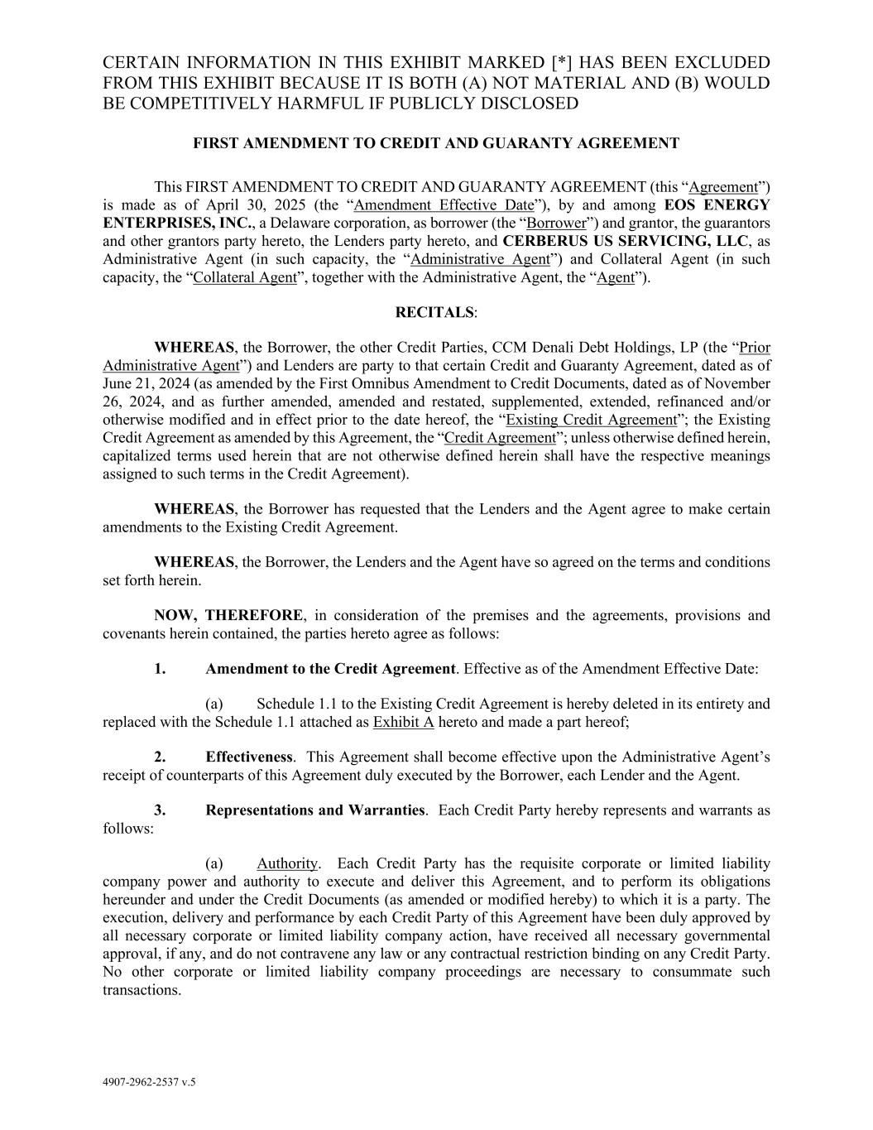
58
4907-2962-2537 v.5 CERTAIN INFORMATION IN THIS EXHIBIT MARKED [*] HAS BEEN EXCLUDED FROM THIS EXHIBIT BECAUSE IT IS BOTH (A) NOT MATERIAL AND (B) WOULD BE COMPETITIVELY HARMFUL IF PUBLICLY DISCLOSED FIRST AMENDMENT TO CREDIT AND GUARANTY AGREEMENT This FIRST AMENDMENT TO CREDIT AND GUARANTY AGREEMENT (this “Agreement”) is made as of April 30, 2025 (the “Amendment Effective Date”), by and among EOS ENERGY ENTERPRISES, INC., a Delaware corporation, as borrower (the “Borrower”) and grantor, the guarantors and other grantors party hereto, the Lenders party hereto, and CERBERUS US SERVICING, LLC, as Administrative Agent (in such capacity, the “Administrative Agent”) and Collateral Agent (in such capacity, the “Collateral Agent”, together with the Administrative Agent, the “Agent”). RECITALS: WHEREAS, the Borrower, the other Credit Parties, CCM Denali Debt Holdings, LP (the “Prior Administrative Agent”) and Lenders are party to that certain Credit and Guaranty Agreement, dated as of June 21, 2024 (as amended by the First Omnibus Amendment to Credit Documents, dated as of November 26, 2024, and as further amended, amended and restated, supplemented, extended, refinanced and/or otherwise modified and in effect prior to the date hereof, the “Existing Credit Agreement”; the Existing Credit Agreement as amended by this Agreement, the “Credit Agreement”; unless otherwise defined herein, capitalized terms used herein that are not otherwise defined herein shall have the respective meanings assigned to such terms in the Credit Agreement). WHEREAS, the Borrower has requested that the Lenders and the Agent agree to make certain amendments to the Existing Credit Agreement. WHEREAS, the Borrower, the Lenders and the Agent have so agreed on the terms and conditions set forth herein. NOW, THEREFORE, in consideration of the premises and the agreements, provisions and covenants herein contained, the parties hereto agree as follows: 1. Amendment to the Credit Agreement. Effective as of the Amendment Effective Date: (a) Schedule 1.1 to the Existing Credit Agreement is hereby deleted in its entirety and replaced with the Schedule 1.1 attached as Exhibit A hereto and made a part hereof; 2. Effectiveness. This Agreement shall become effective upon the Administrative Agent’s receipt of counterparts of this Agreement duly executed by the Borrower, each Lender and the Agent. 3. Representations and Warranties. Each Credit Party hereby represents and warrants as follows: (a) Authority. Each Credit Party has the requisite corporate or limited liability company power and authority to execute and deliver this Agreement, and to perform its obligations hereunder and under the Credit Documents (as amended or modified hereby) to which it is a party. The execution, delivery and performance by each Credit Party of this Agreement have been duly approved by all necessary corporate or limited liability company action, have received all necessary governmental approval, if any, and do not contravene any law or any contractual restriction binding on any Credit Party. No other corporate or limited liability company proceedings are necessary to consummate such transactions.

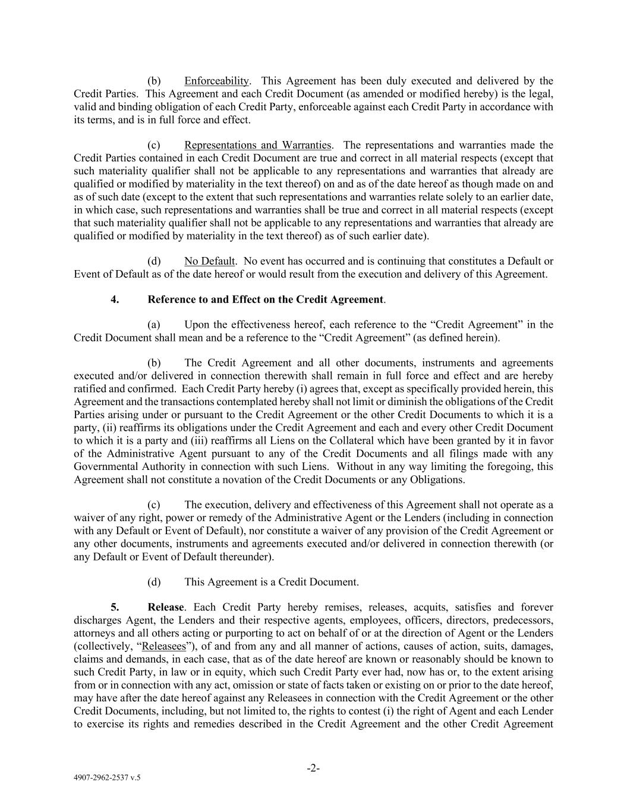
4907-2962-2537 v.5 -2- (b) Enforceability. This Agreement has been duly executed and delivered by the Credit Parties. This Agreement and each Credit Document (as amended or modified hereby) is the legal, valid and binding obligation of each Credit Party, enforceable against each Credit Party in accordance with its terms, and is in full force and effect. (c) Representations and Warranties. The representations and warranties made the Credit Parties contained in each Credit Document are true and correct in all material respects (except that such materiality qualifier shall not be applicable to any representations and warranties that already are qualified or modified by materiality in the text thereof) on and as of the date hereof as though made on and as of such date (except to the extent that such representations and warranties relate solely to an earlier date, in which case, such representations and warranties shall be true and correct in all material respects (except that such materiality qualifier shall not be applicable to any representations and warranties that already are qualified or modified by materiality in the text thereof) as of such earlier date). (d) No Default. No event has occurred and is continuing that constitutes a Default or Event of Default as of the date hereof or would result from the execution and delivery of this Agreement. 4. Reference to and Effect on the Credit Agreement. (a) Upon the effectiveness hereof, each reference to the “Credit Agreement” in the Credit Document shall mean and be a reference to the “Credit Agreement” (as defined herein). (b) The Credit Agreement and all other documents, instruments and agreements executed and/or delivered in connection therewith shall remain in full force and effect and are hereby ratified and confirmed. Each Credit Party hereby (i) agrees that, except as specifically provided herein, this Agreement and the transactions contemplated hereby shall not limit or diminish the obligations of the Credit Parties arising under or pursuant to the Credit Agreement or the other Credit Documents to which it is a party, (ii) reaffirms its obligations under the Credit Agreement and each and every other Credit Document to which it is a party and (iii) reaffirms all Liens on the Collateral which have been granted by it in favor of the Administrative Agent pursuant to any of the Credit Documents and all filings made with any Governmental Authority in connection with such Liens. Without in any way limiting the foregoing, this Agreement shall not constitute a novation of the Credit Documents or any Obligations. (c) The execution, delivery and effectiveness of this Agreement shall not operate as a waiver of any right, power or remedy of the Administrative Agent or the Lenders (including in connection with any Default or Event of Default), nor constitute a waiver of any provision of the Credit Agreement or any other documents, instruments and agreements executed and/or delivered in connection therewith (or any Default or Event of Default thereunder). (d) This Agreement is a Credit Document. 5. Release. Each Credit Party hereby remises, releases, acquits, satisfies and forever discharges Agent, the Lenders and their respective agents, employees, officers, directors, predecessors, attorneys and all others acting or purporting to act on behalf of or at the direction of Agent or the Lenders (collectively, “Releasees”), of and from any and all manner of actions, causes of action, suits, damages, claims and demands, in each case, that as of the date hereof are known or reasonably should be known to such Credit Party, in law or in equity, which such Credit Party ever had, now has or, to the extent arising from or in connection with any act, omission or state of facts taken or existing on or prior to the date hereof, may have after the date hereof against any Releasees in connection with the Credit Agreement or the other Credit Documents, including, but not limited to, the rights to contest (i) the right of Agent and each Lender to exercise its rights and remedies described in the Credit Agreement and the other Credit Agreement

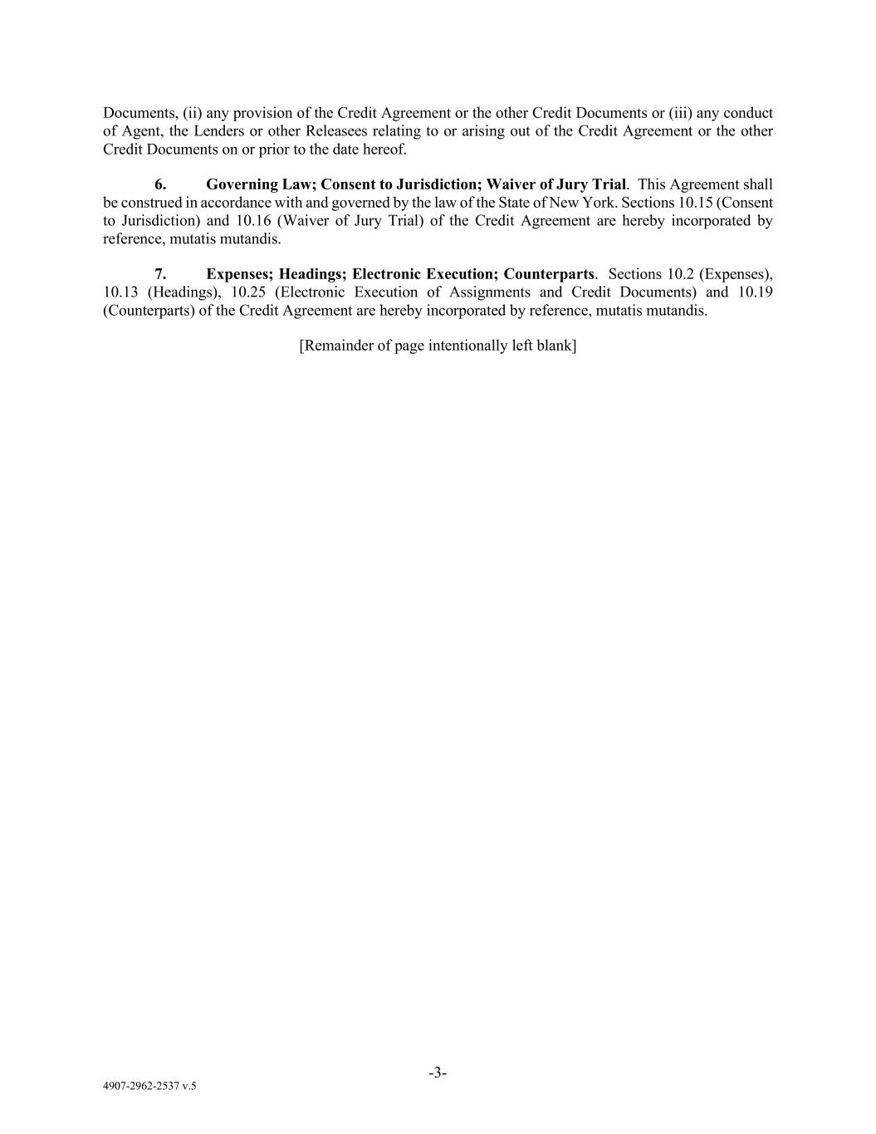
4907-2962-2537 v.5 -3- Documents, (ii) any provision of the Credit Agreement or the other Credit Documents or (iii) any conduct of Agent, the Lenders or other Releasees relating to or arising out of the Credit Agreement or the other Credit Documents on or prior to the date hereof. 6. Governing Law; Consent to Jurisdiction; Waiver of Jury Trial. This Agreement shall be construed in accordance with and governed by the law of the State of New York. Sections 10.15 (Consent to Jurisdiction) and 10.16 (Waiver of Jury Trial) of the Credit Agreement are hereby incorporated by reference, mutatis mutandis. 7. Expenses; Headings; Electronic Execution; Counterparts. Sections 10.2 (Expenses), 10.13 (Headings), 10.25 (Electronic Execution of Assignments and Credit Documents) and 10.19 (Counterparts) of the Credit Agreement are hereby incorporated by reference, mutatis mutandis. [Remainder of page intentionally left blank]

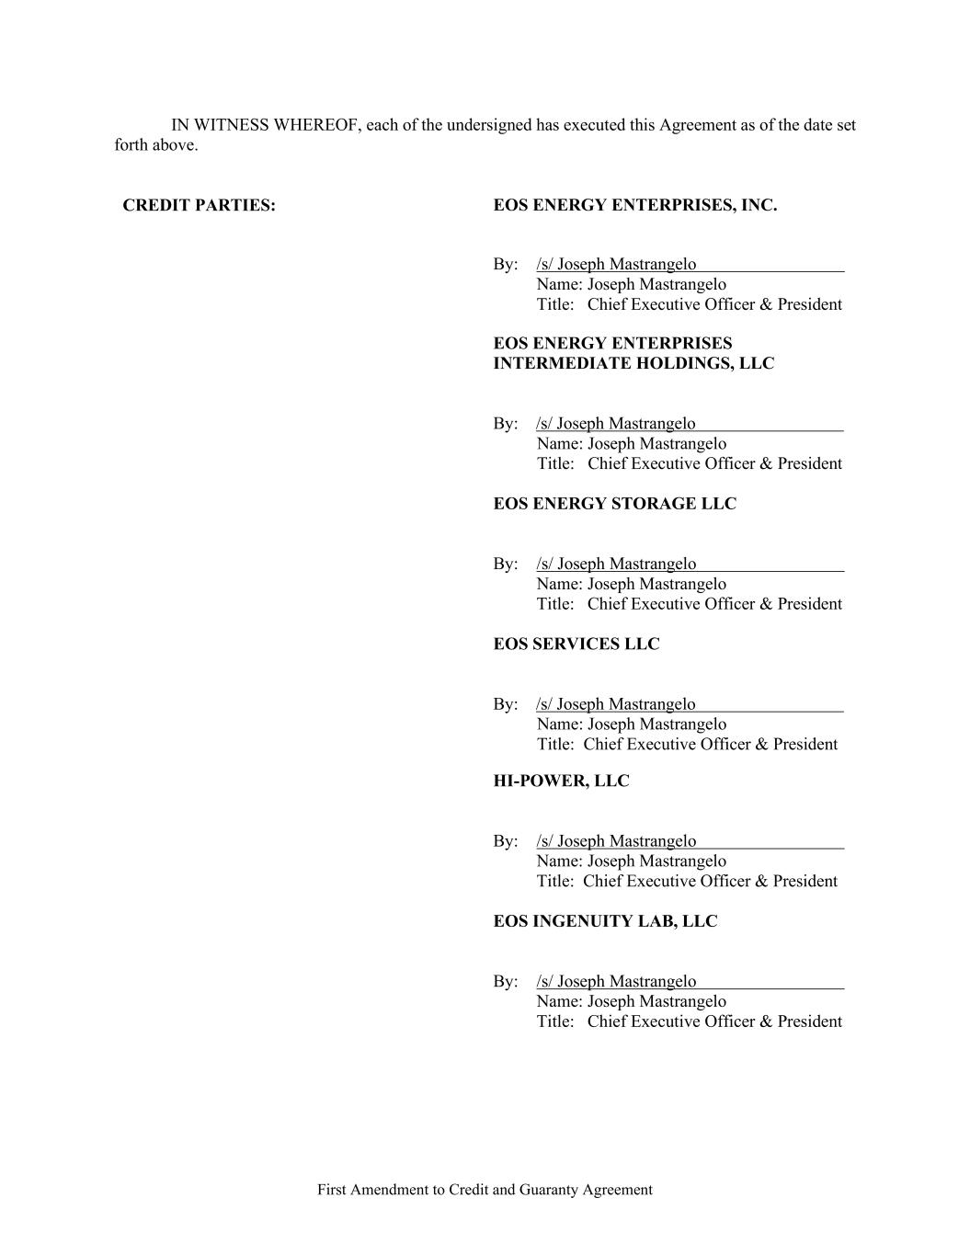
First Amendment to Credit and Guaranty Agreement IN WITNESS WHEREOF, each of the undersigned has executed this Agreement as of the date set forth above. CREDIT PARTIES: EOS ENERGY ENTERPRISES, INC. By: /s/ Joseph Mastrangelo Name: Joseph Mastrangelo Title: Chief Executive Officer & President EOS ENERGY ENTERPRISES INTERMEDIATE HOLDINGS, LLC By: /s/ Joseph Mastrangelo Name: Joseph Mastrangelo Title: Chief Executive Officer & President EOS ENERGY STORAGE LLC By: /s/ Joseph Mastrangelo Name: Joseph Mastrangelo Title: Chief Executive Officer & President EOS SERVICES LLC By: /s/ Joseph Mastrangelo Name: Joseph Mastrangelo Title: Chief Executive Officer & President HI-POWER, LLC By: /s/ Joseph Mastrangelo Name: Joseph Mastrangelo Title: Chief Executive Officer & President EOS INGENUITY LAB, LLC By: /s/ Joseph Mastrangelo Name: Joseph Mastrangelo Title: Chief Executive Officer & President

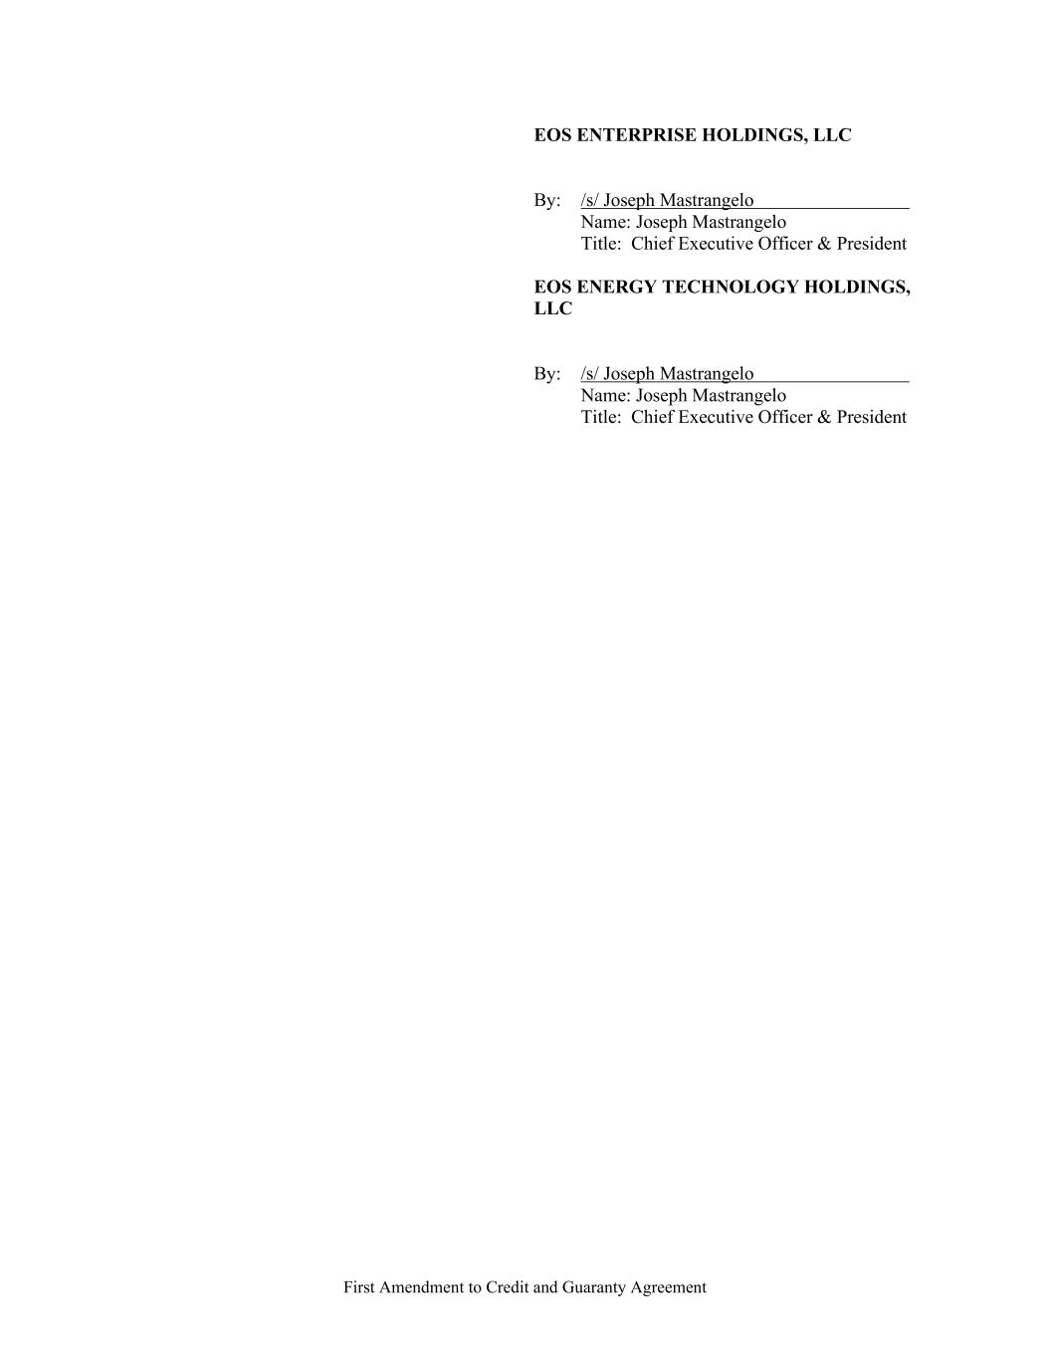
First Amendment to Credit and Guaranty Agreement EOS ENTERPRISE HOLDINGS, LLC By: /s/ Joseph Mastrangelo Name: Joseph Mastrangelo Title: Chief Executive Officer & President EOS ENERGY TECHNOLOGY HOLDINGS, LLC By: /s/ Joseph Mastrangelo Name: Joseph Mastrangelo Title: Chief Executive Officer & President

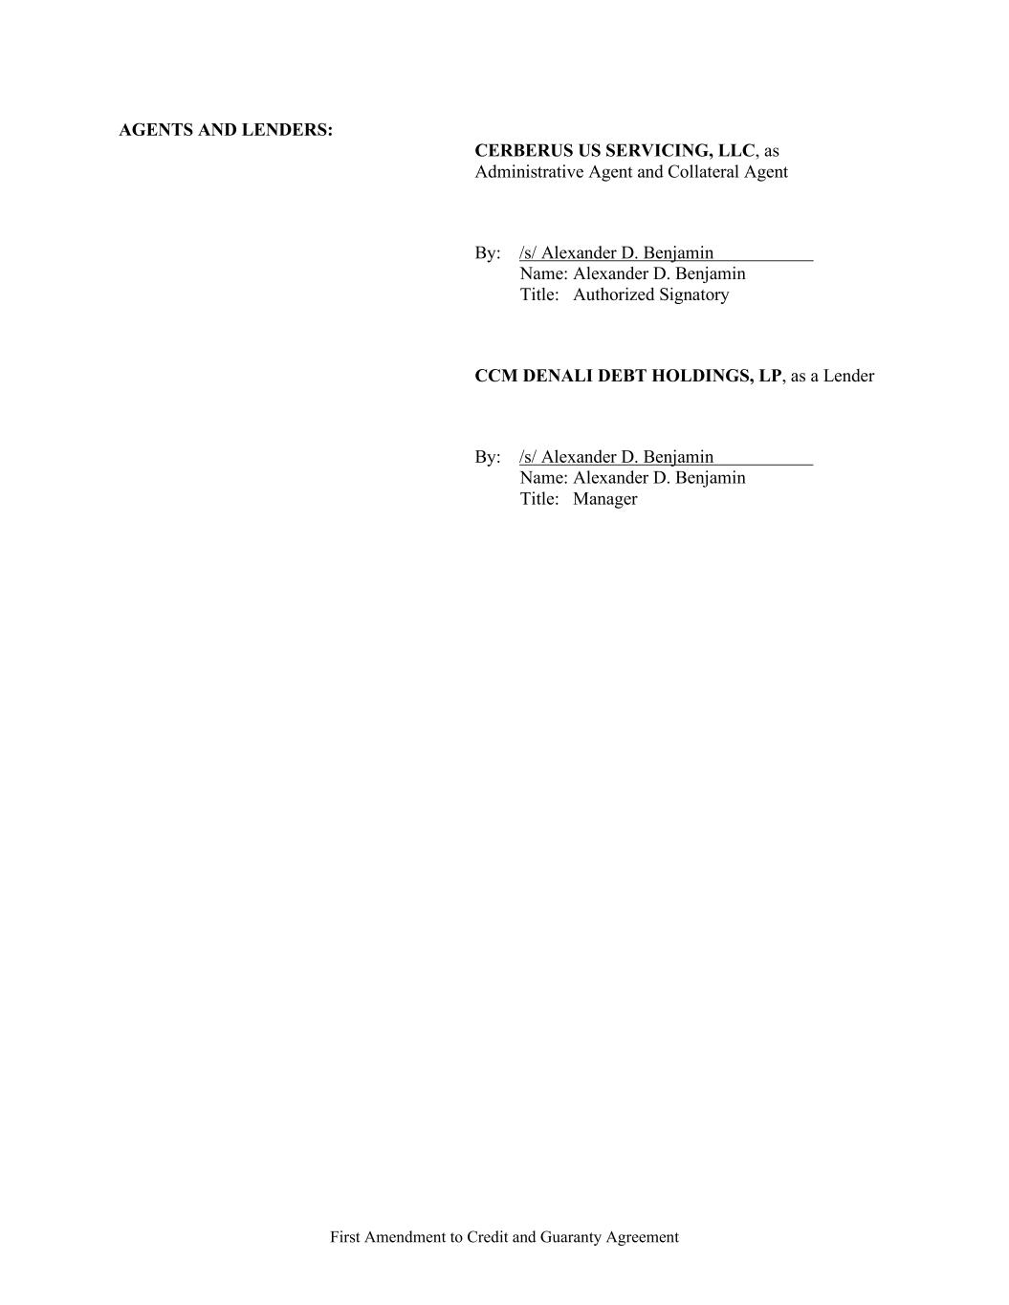
First Amendment to Credit and Guaranty Agreement AGENTS AND LENDERS: CERBERUS US SERVICING, LLC, as Administrative Agent and Collateral Agent By: /s/ Alexander D. Benjamin Name: Alexander D. Benjamin Title: Authorized Signatory CCM DENALI DEBT HOLDINGS, LP, as a Lender By: /s/ Alexander D. Benjamin Name: Alexander D. Benjamin Title: Manager


4907-2962-2537 v.5 Exhibit A Schedule 1.1 to the Credit Agreement Attached.

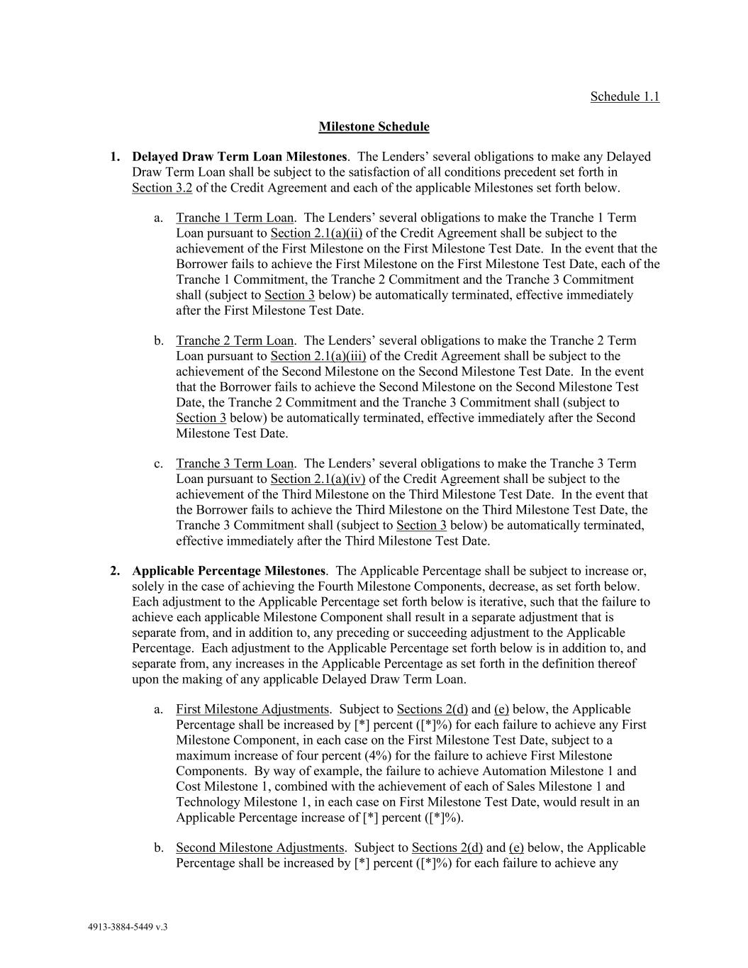
4913-3884-5449 v.3 Schedule 1.1 Milestone Schedule 1. Delayed Draw Term Loan Milestones. The Lenders’ several obligations to make any Delayed Draw Term Loan shall be subject to the satisfaction of all conditions precedent set forth in Section 3.2 of the Credit Agreement and each of the applicable Milestones set forth below. a. Tranche 1 Term Loan. The Lenders’ several obligations to make the Tranche 1 Term Loan pursuant to Section 2.1(a)(ii) of the Credit Agreement shall be subject to the achievement of the First Milestone on the First Milestone Test Date. In the event that the Borrower fails to achieve the First Milestone on the First Milestone Test Date, each of the Tranche 1 Commitment, the Tranche 2 Commitment and the Tranche 3 Commitment shall (subject to Section 3 below) be automatically terminated, effective immediately after the First Milestone Test Date. b. Tranche 2 Term Loan. The Lenders’ several obligations to make the Tranche 2 Term Loan pursuant to Section 2.1(a)(iii) of the Credit Agreement shall be subject to the achievement of the Second Milestone on the Second Milestone Test Date. In the event that the Borrower fails to achieve the Second Milestone on the Second Milestone Test Date, the Tranche 2 Commitment and the Tranche 3 Commitment shall (subject to Section 3 below) be automatically terminated, effective immediately after the Second Milestone Test Date. c. Tranche 3 Term Loan. The Lenders’ several obligations to make the Tranche 3 Term Loan pursuant to Section 2.1(a)(iv) of the Credit Agreement shall be subject to the achievement of the Third Milestone on the Third Milestone Test Date. In the event that the Borrower fails to achieve the Third Milestone on the Third Milestone Test Date, the Tranche 3 Commitment shall (subject to Section 3 below) be automatically terminated, effective immediately after the Third Milestone Test Date. 2. Applicable Percentage Milestones. The Applicable Percentage shall be subject to increase or, solely in the case of achieving the Fourth Milestone Components, decrease, as set forth below. Each adjustment to the Applicable Percentage set forth below is iterative, such that the failure to achieve each applicable Milestone Component shall result in a separate adjustment that is separate from, and in addition to, any preceding or succeeding adjustment to the Applicable Percentage. Each adjustment to the Applicable Percentage set forth below is in addition to, and separate from, any increases in the Applicable Percentage as set forth in the definition thereof upon the making of any applicable Delayed Draw Term Loan. a. First Milestone Adjustments. Subject to Sections 2(d) and (e) below, the Applicable Percentage shall be increased by [*] percent ([*]%) for each failure to achieve any First Milestone Component, in each case on the First Milestone Test Date, subject to a maximum increase of four percent (4%) for the failure to achieve First Milestone Components. By way of example, the failure to achieve Automation Milestone 1 and Cost Milestone 1, combined with the achievement of each of Sales Milestone 1 and Technology Milestone 1, in each case on First Milestone Test Date, would result in an Applicable Percentage increase of [*] percent ([*]%). b. Second Milestone Adjustments. Subject to Sections 2(d) and (e) below, the Applicable Percentage shall be increased by [*] percent ([*]%) for each failure to achieve any

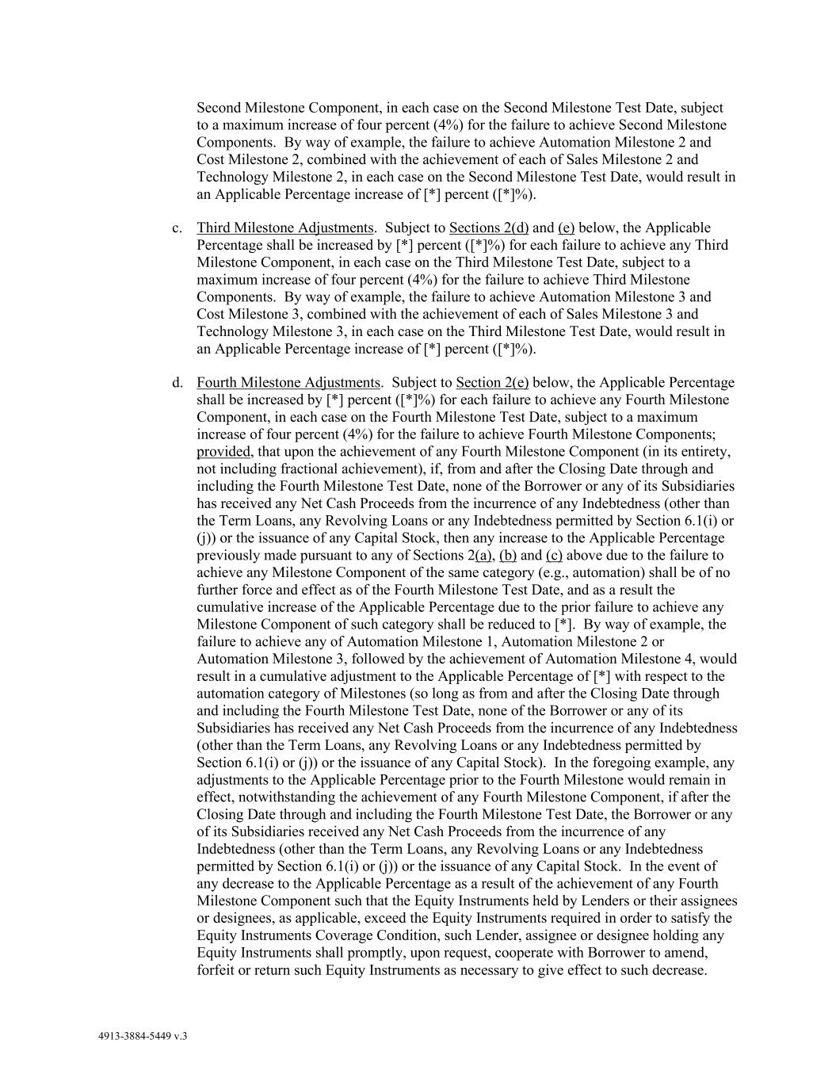
4913-3884-5449 v.3 Second Milestone Component, in each case on the Second Milestone Test Date, subject to a maximum increase of four percent (4%) for the failure to achieve Second Milestone Components. By way of example, the failure to achieve Automation Milestone 2 and Cost Milestone 2, combined with the achievement of each of Sales Milestone 2 and Technology Milestone 2, in each case on the Second Milestone Test Date, would result in an Applicable Percentage increase of [*] percent ([*]%). c. Third Milestone Adjustments. Subject to Sections 2(d) and (e) below, the Applicable Percentage shall be increased by [*] percent ([*]%) for each failure to achieve any Third Milestone Component, in each case on the Third Milestone Test Date, subject to a maximum increase of four percent (4%) for the failure to achieve Third Milestone Components. By way of example, the failure to achieve Automation Milestone 3 and Cost Milestone 3, combined with the achievement of each of Sales Milestone 3 and Technology Milestone 3, in each case on the Third Milestone Test Date, would result in an Applicable Percentage increase of [*] percent ([*]%). d. Fourth Milestone Adjustments. Subject to Section 2(e) below, the Applicable Percentage shall be increased by [*] percent ([*]%) for each failure to achieve any Fourth Milestone Component, in each case on the Fourth Milestone Test Date, subject to a maximum increase of four percent (4%) for the failure to achieve Fourth Milestone Components; provided, that upon the achievement of any Fourth Milestone Component (in its entirety, not including fractional achievement), if, from and after the Closing Date through and including the Fourth Milestone Test Date, none of the Borrower or any of its Subsidiaries has received any Net Cash Proceeds from the incurrence of any Indebtedness (other than the Term Loans, any Revolving Loans or any Indebtedness permitted by Section 6.1(i) or (j)) or the issuance of any Capital Stock, then any increase to the Applicable Percentage previously made pursuant to any of Sections 2(a), (b) and (c) above due to the failure to achieve any Milestone Component of the same category (e.g., automation) shall be of no further force and effect as of the Fourth Milestone Test Date, and as a result the cumulative increase of the Applicable Percentage due to the prior failure to achieve any Milestone Component of such category shall be reduced to [*]. By way of example, the failure to achieve any of Automation Milestone 1, Automation Milestone 2 or Automation Milestone 3, followed by the achievement of Automation Milestone 4, would result in a cumulative adjustment to the Applicable Percentage of [*] with respect to the automation category of Milestones (so long as from and after the Closing Date through and including the Fourth Milestone Test Date, none of the Borrower or any of its Subsidiaries has received any Net Cash Proceeds from the incurrence of any Indebtedness (other than the Term Loans, any Revolving Loans or any Indebtedness permitted by Section 6.1(i) or (j)) or the issuance of any Capital Stock). In the foregoing example, any adjustments to the Applicable Percentage prior to the Fourth Milestone would remain in effect, notwithstanding the achievement of any Fourth Milestone Component, if after the Closing Date through and including the Fourth Milestone Test Date, the Borrower or any of its Subsidiaries received any Net Cash Proceeds from the incurrence of any Indebtedness (other than the Term Loans, any Revolving Loans or any Indebtedness permitted by Section 6.1(i) or (j)) or the issuance of any Capital Stock. In the event of any decrease to the Applicable Percentage as a result of the achievement of any Fourth Milestone Component such that the Equity Instruments held by Lenders or their assignees or designees, as applicable, exceed the Equity Instruments required in order to satisfy the Equity Instruments Coverage Condition, such Lender, assignee or designee holding any Equity Instruments shall promptly, upon request, cooperate with Borrower to amend, forfeit or return such Equity Instruments as necessary to give effect to such decrease.

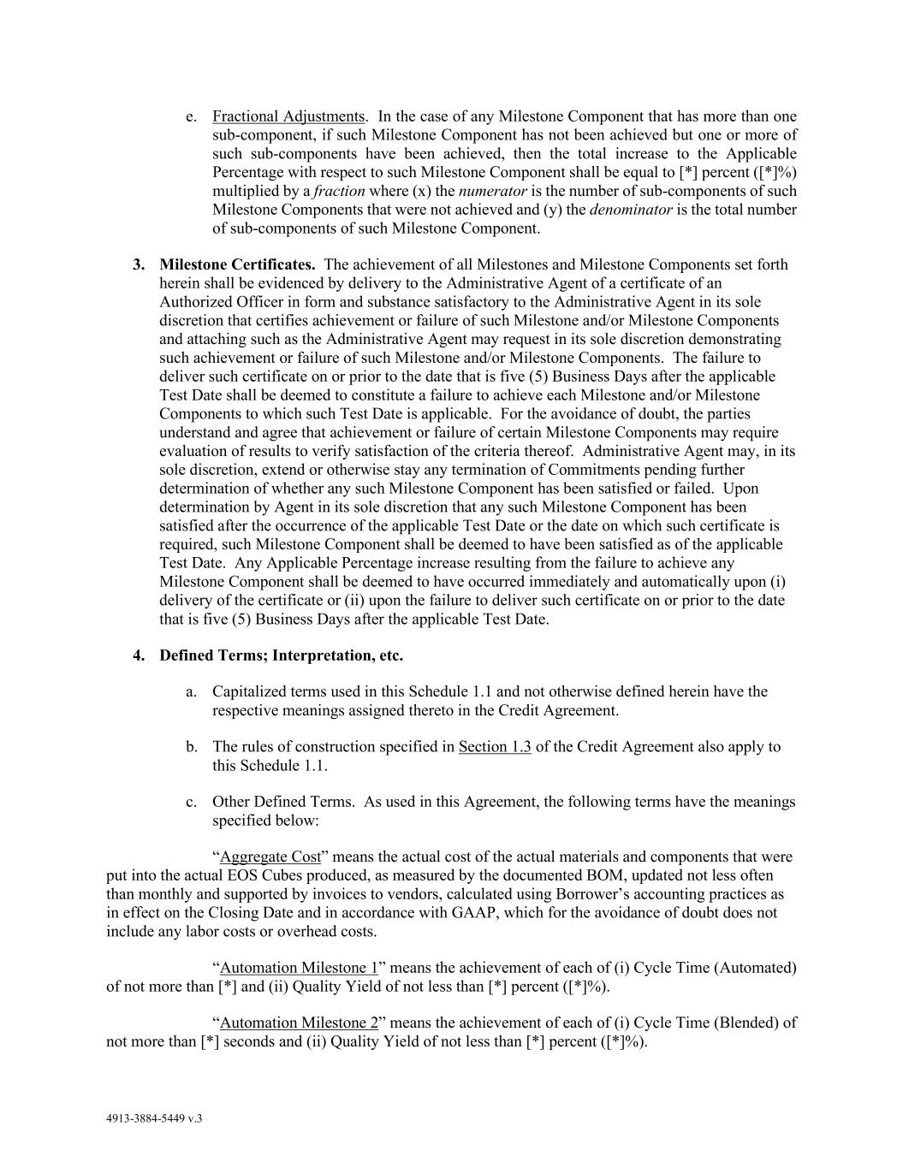
4913-3884-5449 v.3 e. Fractional Adjustments. In the case of any Milestone Component that has more than one sub-component, if such Milestone Component has not been achieved but one or more of such sub-components have been achieved, then the total increase to the Applicable Percentage with respect to such Milestone Component shall be equal to [*] percent ([*]%) multiplied by a fraction where (x) the numerator is the number of sub-components of such Milestone Components that were not achieved and (y) the denominator is the total number of sub-components of such Milestone Component. 3. Milestone Certificates. The achievement of all Milestones and Milestone Components set forth herein shall be evidenced by delivery to the Administrative Agent of a certificate of an Authorized Officer in form and substance satisfactory to the Administrative Agent in its sole discretion that certifies achievement or failure of such Milestone and/or Milestone Components and attaching such as the Administrative Agent may request in its sole discretion demonstrating such achievement or failure of such Milestone and/or Milestone Components. The failure to deliver such certificate on or prior to the date that is five (5) Business Days after the applicable Test Date shall be deemed to constitute a failure to achieve each Milestone and/or Milestone Components to which such Test Date is applicable. For the avoidance of doubt, the parties understand and agree that achievement or failure of certain Milestone Components may require evaluation of results to verify satisfaction of the criteria thereof. Administrative Agent may, in its sole discretion, extend or otherwise stay any termination of Commitments pending further determination of whether any such Milestone Component has been satisfied or failed. Upon determination by Agent in its sole discretion that any such Milestone Component has been satisfied after the occurrence of the applicable Test Date or the date on which such certificate is required, such Milestone Component shall be deemed to have been satisfied as of the applicable Test Date. Any Applicable Percentage increase resulting from the failure to achieve any Milestone Component shall be deemed to have occurred immediately and automatically upon (i) delivery of the certificate or (ii) upon the failure to deliver such certificate on or prior to the date that is five (5) Business Days after the applicable Test Date. 4. Defined Terms; Interpretation, etc. a. Capitalized terms used in this Schedule 1.1 and not otherwise defined herein have the respective meanings assigned thereto in the Credit Agreement. b. The rules of construction specified in Section 1.3 of the Credit Agreement also apply to this Schedule 1.1. c. Other Defined Terms. As used in this Agreement, the following terms have the meanings specified below: “Aggregate Cost” means the actual cost of the actual materials and components that were put into the actual EOS Cubes produced, as measured by the documented BOM, updated not less often than monthly and supported by invoices to vendors, calculated using Borrower’s accounting practices as in effect on the Closing Date and in accordance with GAAP, which for the avoidance of doubt does not include any labor costs or overhead costs. “Automation Milestone 1” means the achievement of each of (i) Cycle Time (Automated) of not more than [*] and (ii) Quality Yield of not less than [*] percent ([*]%). “Automation Milestone 2” means the achievement of each of (i) Cycle Time (Blended) of not more than [*] seconds and (ii) Quality Yield of not less than [*] percent ([*]%).

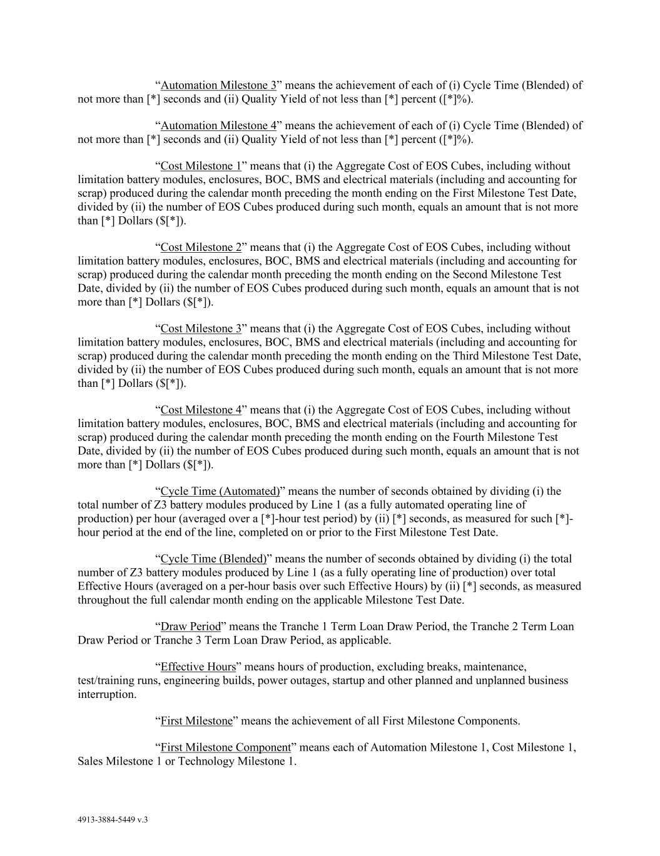
4913-3884-5449 v.3 “Automation Milestone 3” means the achievement of each of (i) Cycle Time (Blended) of not more than [*] seconds and (ii) Quality Yield of not less than [*] percent ([*]%). “Automation Milestone 4” means the achievement of each of (i) Cycle Time (Blended) of not more than [*] seconds and (ii) Quality Yield of not less than [*] percent ([*]%). “Cost Milestone 1” means that (i) the Aggregate Cost of EOS Cubes, including without limitation battery modules, enclosures, BOC, BMS and electrical materials (including and accounting for scrap) produced during the calendar month preceding the month ending on the First Milestone Test Date, divided by (ii) the number of EOS Cubes produced during such month, equals an amount that is not more than [*] Dollars ($[*]). “Cost Milestone 2” means that (i) the Aggregate Cost of EOS Cubes, including without limitation battery modules, enclosures, BOC, BMS and electrical materials (including and accounting for scrap) produced during the calendar month preceding the month ending on the Second Milestone Test Date, divided by (ii) the number of EOS Cubes produced during such month, equals an amount that is not more than [*] Dollars ($[*]). “Cost Milestone 3” means that (i) the Aggregate Cost of EOS Cubes, including without limitation battery modules, enclosures, BOC, BMS and electrical materials (including and accounting for scrap) produced during the calendar month preceding the month ending on the Third Milestone Test Date, divided by (ii) the number of EOS Cubes produced during such month, equals an amount that is not more than [*] Dollars ($[*]). “Cost Milestone 4” means that (i) the Aggregate Cost of EOS Cubes, including without limitation battery modules, enclosures, BOC, BMS and electrical materials (including and accounting for scrap) produced during the calendar month preceding the month ending on the Fourth Milestone Test Date, divided by (ii) the number of EOS Cubes produced during such month, equals an amount that is not more than [*] Dollars ($[*]). “Cycle Time (Automated)” means the number of seconds obtained by dividing (i) the total number of Z3 battery modules produced by Line 1 (as a fully automated operating line of production) per hour (averaged over a [*]-hour test period) by (ii) [*] seconds, as measured for such [*]- hour period at the end of the line, completed on or prior to the First Milestone Test Date. “Cycle Time (Blended)” means the number of seconds obtained by dividing (i) the total number of Z3 battery modules produced by Line 1 (as a fully operating line of production) over total Effective Hours (averaged on a per-hour basis over such Effective Hours) by (ii) [*] seconds, as measured throughout the full calendar month ending on the applicable Milestone Test Date. “Draw Period” means the Tranche 1 Term Loan Draw Period, the Tranche 2 Term Loan Draw Period or Tranche 3 Term Loan Draw Period, as applicable. “Effective Hours” means hours of production, excluding breaks, maintenance, test/training runs, engineering builds, power outages, startup and other planned and unplanned business interruption. “First Milestone” means the achievement of all First Milestone Components. “First Milestone Component” means each of Automation Milestone 1, Cost Milestone 1, Sales Milestone 1 or Technology Milestone 1.

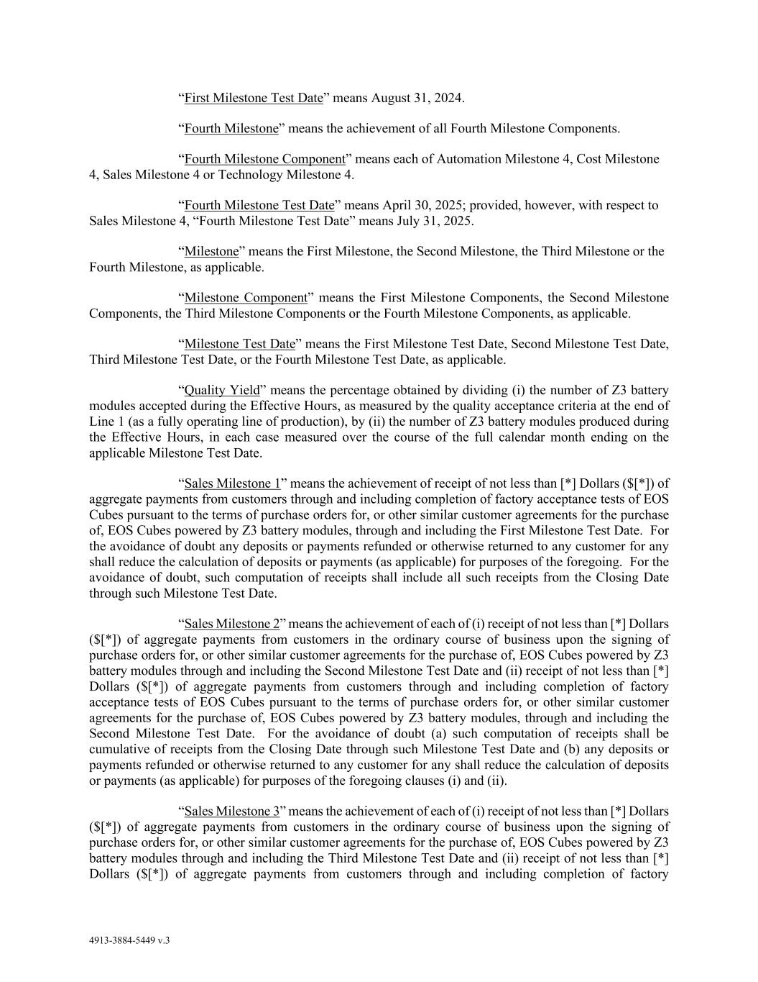
4913-3884-5449 v.3 “First Milestone Test Date” means August 31, 2024. “Fourth Milestone” means the achievement of all Fourth Milestone Components. “Fourth Milestone Component” means each of Automation Milestone 4, Cost Milestone 4, Sales Milestone 4 or Technology Milestone 4. “Fourth Milestone Test Date” means April 30, 2025; provided, however, with respect to Sales Milestone 4, “Fourth Milestone Test Date” means July 31, 2025. “Milestone” means the First Milestone, the Second Milestone, the Third Milestone or the Fourth Milestone, as applicable. “Milestone Component” means the First Milestone Components, the Second Milestone Components, the Third Milestone Components or the Fourth Milestone Components, as applicable. “Milestone Test Date” means the First Milestone Test Date, Second Milestone Test Date, Third Milestone Test Date, or the Fourth Milestone Test Date, as applicable. “Quality Yield” means the percentage obtained by dividing (i) the number of Z3 battery modules accepted during the Effective Hours, as measured by the quality acceptance criteria at the end of Line 1 (as a fully operating line of production), by (ii) the number of Z3 battery modules produced during the Effective Hours, in each case measured over the course of the full calendar month ending on the applicable Milestone Test Date. “Sales Milestone 1” means the achievement of receipt of not less than [*] Dollars ($[*]) of aggregate payments from customers through and including completion of factory acceptance tests of EOS Cubes pursuant to the terms of purchase orders for, or other similar customer agreements for the purchase of, EOS Cubes powered by Z3 battery modules, through and including the First Milestone Test Date. For the avoidance of doubt any deposits or payments refunded or otherwise returned to any customer for any shall reduce the calculation of deposits or payments (as applicable) for purposes of the foregoing. For the avoidance of doubt, such computation of receipts shall include all such receipts from the Closing Date through such Milestone Test Date. “Sales Milestone 2” means the achievement of each of (i) receipt of not less than [*] Dollars ($[*]) of aggregate payments from customers in the ordinary course of business upon the signing of purchase orders for, or other similar customer agreements for the purchase of, EOS Cubes powered by Z3 battery modules through and including the Second Milestone Test Date and (ii) receipt of not less than [*] Dollars ($[*]) of aggregate payments from customers through and including completion of factory acceptance tests of EOS Cubes pursuant to the terms of purchase orders for, or other similar customer agreements for the purchase of, EOS Cubes powered by Z3 battery modules, through and including the Second Milestone Test Date. For the avoidance of doubt (a) such computation of receipts shall be cumulative of receipts from the Closing Date through such Milestone Test Date and (b) any deposits or payments refunded or otherwise returned to any customer for any shall reduce the calculation of deposits or payments (as applicable) for purposes of the foregoing clauses (i) and (ii). “Sales Milestone 3” means the achievement of each of (i) receipt of not less than [*] Dollars ($[*]) of aggregate payments from customers in the ordinary course of business upon the signing of purchase orders for, or other similar customer agreements for the purchase of, EOS Cubes powered by Z3 battery modules through and including the Third Milestone Test Date and (ii) receipt of not less than [*] Dollars ($[*]) of aggregate payments from customers through and including completion of factory

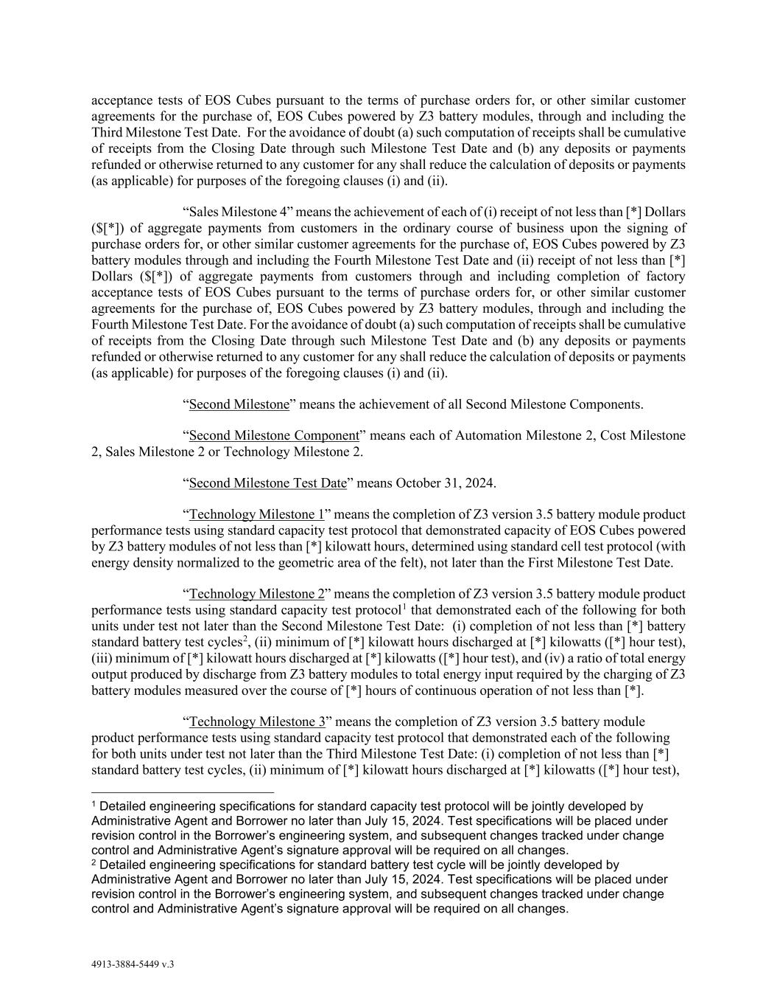
4913-3884-5449 v.3 acceptance tests of EOS Cubes pursuant to the terms of purchase orders for, or other similar customer agreements for the purchase of, EOS Cubes powered by Z3 battery modules, through and including the Third Milestone Test Date. For the avoidance of doubt (a) such computation of receipts shall be cumulative of receipts from the Closing Date through such Milestone Test Date and (b) any deposits or payments refunded or otherwise returned to any customer for any shall reduce the calculation of deposits or payments (as applicable) for purposes of the foregoing clauses (i) and (ii). “Sales Milestone 4” means the achievement of each of (i) receipt of not less than [*] Dollars ($[*]) of aggregate payments from customers in the ordinary course of business upon the signing of purchase orders for, or other similar customer agreements for the purchase of, EOS Cubes powered by Z3 battery modules through and including the Fourth Milestone Test Date and (ii) receipt of not less than [*] Dollars ($[*]) of aggregate payments from customers through and including completion of factory acceptance tests of EOS Cubes pursuant to the terms of purchase orders for, or other similar customer agreements for the purchase of, EOS Cubes powered by Z3 battery modules, through and including the Fourth Milestone Test Date. For the avoidance of doubt (a) such computation of receipts shall be cumulative of receipts from the Closing Date through such Milestone Test Date and (b) any deposits or payments refunded or otherwise returned to any customer for any shall reduce the calculation of deposits or payments (as applicable) for purposes of the foregoing clauses (i) and (ii). “Second Milestone” means the achievement of all Second Milestone Components. “Second Milestone Component” means each of Automation Milestone 2, Cost Milestone 2, Sales Milestone 2 or Technology Milestone 2. “Second Milestone Test Date” means October 31, 2024. “Technology Milestone 1” means the completion of Z3 version 3.5 battery module product performance tests using standard capacity test protocol that demonstrated capacity of EOS Cubes powered by Z3 battery modules of not less than [*] kilowatt hours, determined using standard cell test protocol (with energy density normalized to the geometric area of the felt), not later than the First Milestone Test Date. “Technology Milestone 2” means the completion of Z3 version 3.5 battery module product performance tests using standard capacity test protocol1 that demonstrated each of the following for both units under test not later than the Second Milestone Test Date: (i) completion of not less than [*] battery standard battery test cycles2, (ii) minimum of [*] kilowatt hours discharged at [*] kilowatts ([*] hour test), (iii) minimum of [*] kilowatt hours discharged at [*] kilowatts ([*] hour test), and (iv) a ratio of total energy output produced by discharge from Z3 battery modules to total energy input required by the charging of Z3 battery modules measured over the course of [*] hours of continuous operation of not less than [*]. “Technology Milestone 3” means the completion of Z3 version 3.5 battery module product performance tests using standard capacity test protocol that demonstrated each of the following for both units under test not later than the Third Milestone Test Date: (i) completion of not less than [*] standard battery test cycles, (ii) minimum of [*] kilowatt hours discharged at [*] kilowatts ([*] hour test), 1 Detailed engineering specifications for standard capacity test protocol will be jointly developed by Administrative Agent and Borrower no later than July 15, 2024. Test specifications will be placed under revision control in the Borrower’s engineering system, and subsequent changes tracked under change control and Administrative Agent’s signature approval will be required on all changes. 2 Detailed engineering specifications for standard battery test cycle will be jointly developed by Administrative Agent and Borrower no later than July 15, 2024. Test specifications will be placed under revision control in the Borrower’s engineering system, and subsequent changes tracked under change control and Administrative Agent’s signature approval will be required on all changes.

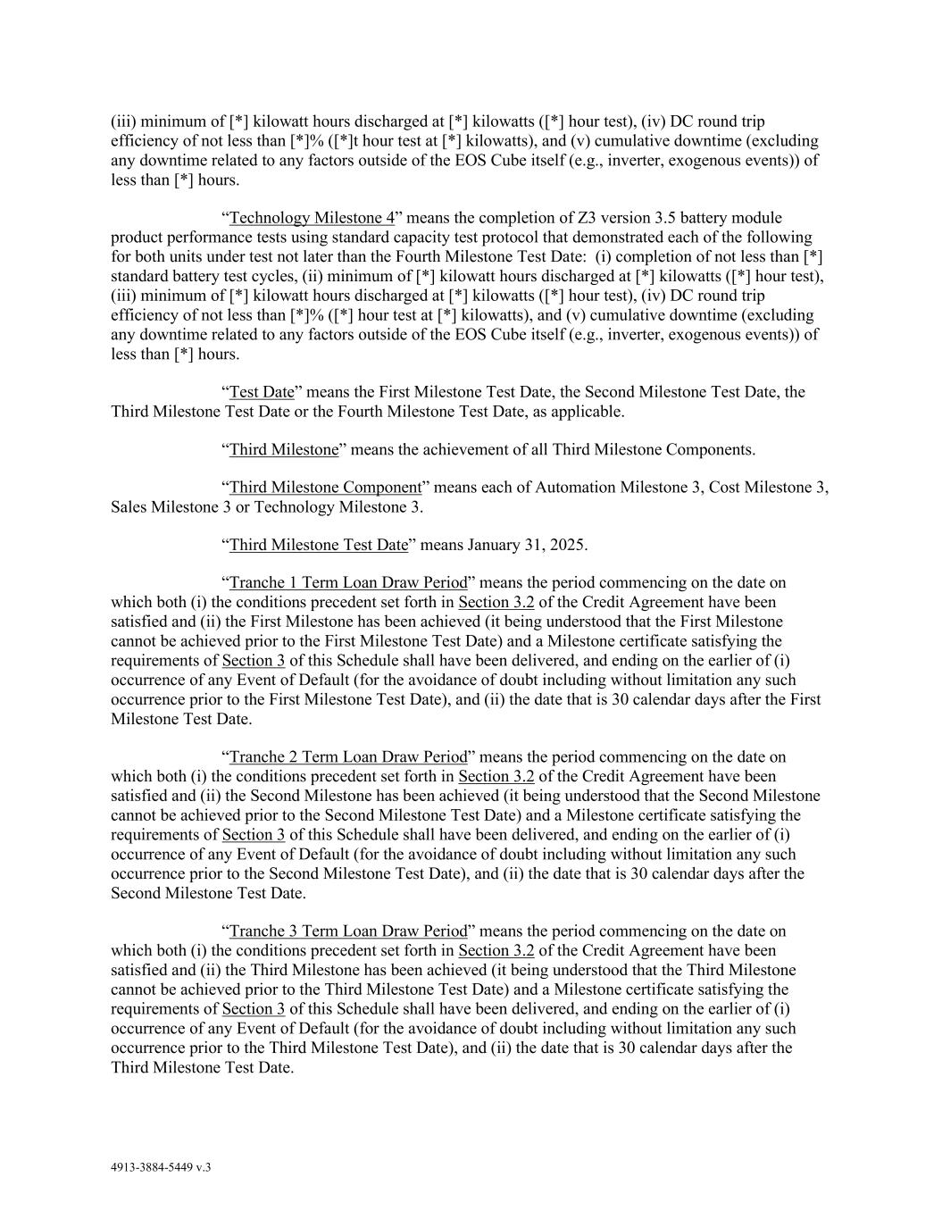
4913-3884-5449 v.3 (iii) minimum of [*] kilowatt hours discharged at [*] kilowatts ([*] hour test), (iv) DC round trip efficiency of not less than [*]% ([*]t hour test at [*] kilowatts), and (v) cumulative downtime (excluding any downtime related to any factors outside of the EOS Cube itself (e.g., inverter, exogenous events)) of less than [*] hours. “Technology Milestone 4” means the completion of Z3 version 3.5 battery module product performance tests using standard capacity test protocol that demonstrated each of the following for both units under test not later than the Fourth Milestone Test Date: (i) completion of not less than [*] standard battery test cycles, (ii) minimum of [*] kilowatt hours discharged at [*] kilowatts ([*] hour test), (iii) minimum of [*] kilowatt hours discharged at [*] kilowatts ([*] hour test), (iv) DC round trip efficiency of not less than [*]% ([*] hour test at [*] kilowatts), and (v) cumulative downtime (excluding any downtime related to any factors outside of the EOS Cube itself (e.g., inverter, exogenous events)) of less than [*] hours. “Test Date” means the First Milestone Test Date, the Second Milestone Test Date, the Third Milestone Test Date or the Fourth Milestone Test Date, as applicable. “Third Milestone” means the achievement of all Third Milestone Components. “Third Milestone Component” means each of Automation Milestone 3, Cost Milestone 3, Sales Milestone 3 or Technology Milestone 3. “Third Milestone Test Date” means January 31, 2025. “Tranche 1 Term Loan Draw Period” means the period commencing on the date on which both (i) the conditions precedent set forth in Section 3.2 of the Credit Agreement have been satisfied and (ii) the First Milestone has been achieved (it being understood that the First Milestone cannot be achieved prior to the First Milestone Test Date) and a Milestone certificate satisfying the requirements of Section 3 of this Schedule shall have been delivered, and ending on the earlier of (i) occurrence of any Event of Default (for the avoidance of doubt including without limitation any such occurrence prior to the First Milestone Test Date), and (ii) the date that is 30 calendar days after the First Milestone Test Date. “Tranche 2 Term Loan Draw Period” means the period commencing on the date on which both (i) the conditions precedent set forth in Section 3.2 of the Credit Agreement have been satisfied and (ii) the Second Milestone has been achieved (it being understood that the Second Milestone cannot be achieved prior to the Second Milestone Test Date) and a Milestone certificate satisfying the requirements of Section 3 of this Schedule shall have been delivered, and ending on the earlier of (i) occurrence of any Event of Default (for the avoidance of doubt including without limitation any such occurrence prior to the Second Milestone Test Date), and (ii) the date that is 30 calendar days after the Second Milestone Test Date. “Tranche 3 Term Loan Draw Period” means the period commencing on the date on which both (i) the conditions precedent set forth in Section 3.2 of the Credit Agreement have been satisfied and (ii) the Third Milestone has been achieved (it being understood that the Third Milestone cannot be achieved prior to the Third Milestone Test Date) and a Milestone certificate satisfying the requirements of Section 3 of this Schedule shall have been delivered, and ending on the earlier of (i) occurrence of any Event of Default (for the avoidance of doubt including without limitation any such occurrence prior to the Third Milestone Test Date), and (ii) the date that is 30 calendar days after the Third Milestone Test Date.

EXHIBIT 31.1
CERTIFICATION PURSUANT TO RULE 13a-14(a) OR 15d-14(a) OF
THE SECURITIES EXCHANGE ACT OF 1934, AS ADOPTED PURSUANT TO SECTION 302
OF THE SARBANES-OXLEY ACT OF 2002

I, Joseph Mastrangelo, certify that:
1. I have reviewed this quarterly report on Form 10-Q (the “Report”) of Eos Energy Enterprises, Inc. (the “Registrant”);
2. Based on my knowledge, this Report does not contain any untrue statement of a material fact or omit to state a material fact necessary to make the statements made, in light of the circumstances under which such statements were made, not misleading with respect to the period covered by this Report;
3. Based on my knowledge, the financial statements, and other financial information included in this Report, fairly present in all material respects the financial condition, results of operations and cash flows of the Registrant as of, and for, the periods presented in this Report;
4. The Registrant’s other certifying officer and I are responsible for establishing and maintaining disclosure controls and procedures (as defined in Exchange Act Rules 13a-15(e) and 15d-15(e)) and internal control over financial reporting (as defined in Exchange Act Rules 13a-15(f) and 15d-15(f)) for the Registrant and have:
a. Designed such disclosure controls and procedures, or caused such disclosure controls and procedures to be designed under our supervision, to ensure that material information relating to the Registrant, including its consolidated subsidiaries, is made known to us by others within those entities, particularly during the period in which this Report is being prepared;
b. Designed such internal control over financial reporting, or caused such internal control over financial reporting to be designed under our supervision, to provide reasonable assurance regarding the reliability of financial reporting and the preparation of financial statements for external purposes in accordance with generally accepted accounting principles;
c. Evaluated the effectiveness of the Registrant’s disclosure controls and procedures and presented in this Report our conclusions about the effectiveness of the disclosure controls and procedures, as of the end of the period covered by this Report based on such evaluation; and
d. Disclosed in this Report any change in the Registrant’s internal control over financial reporting that occurred during the Registrant’s most recent fiscal quarter that has materially affected, or is reasonably likely to materially affect, the Registrant’s internal control over financial reporting; and
5. The Registrant’s other certifying officer and I have disclosed, based on our most recent evaluation of internal control over financial reporting, to the Registrant’s auditors and the audit committee of the Registrant’s board of directors (or persons performing the equivalent functions):
a. All significant deficiencies and material weaknesses in the design or operation of internal control over financial reporting which are reasonably likely to adversely affect the Registrant’s ability to record, process, summarize and report financial information; and
b. Any fraud, whether or not material, that involves management or other employees who have a significant role in the Registrant’s internal control over financial reporting.
Date: May 6, 2025 |  |  |  |  |  |  |  |  | By: |  |  |  |  |  |  |  |  | /s/ Joseph Mastrangelo
 |  |  |  |  |  |  |  |  |  |  |  |  |  |  |  |  |  | Joseph Mastrangelo
 |  |  |  |  |  |  |  |  |  |  |  |  |  |  |  |  |  | Chief Executive Officer
 |  |  |  |  |  |  |  |  |  |  |  |  |  |  |  |  |  | (Principal Executive Officer)

EXHIBIT 31.2
CERTIFICATION PURSUANT TO RULE 13a-14(a) OR 15d-14(a) OF
THE SECURITIES EXCHANGE ACT OF 1934, AS ADOPTED PURSUANT TO SECTION 302
OF THE SARBANES-OXLEY ACT OF 2002

I, Eric Javidi, certify that:
1. I have reviewed this quarterly report on Form 10-Q (the “Report”) of Eos Energy Enterprises, Inc. (the Registrant”);
2. Based on my knowledge, this Report does not contain any untrue statement of a material fact or omit to state a material fact necessary to make the statements made, in light of the circumstances under which such statements were made, not misleading with respect to the period covered by this Report;
3. Based on my knowledge, the financial statements, and other financial information included in this Report, fairly present in all material respects the financial condition, results of operations and cash flows of the Registrant as of, and for, the periods presented in this Report;
4. The Registrant’s other certifying officer and I are responsible for establishing and maintaining disclosure controls and procedures (as defined in Exchange Act Rules 13a-15(e) and 15d-15(e)) and internal control over financial reporting (as defined in Exchange Act Rules 13a-15(f) and 15d-15(f)) for the Registrant and have:
a. Designed such disclosure controls and procedures, or caused such disclosure controls and procedures to be designed under our supervision, to ensure that material information relating to the Registrant, including its consolidated subsidiaries, is made known to us by others within those entities, particularly during the period in which this Report is being prepared;
b. Designed such internal control over financial reporting, or caused such internal control over financial reporting to be designed under our supervision, to provide reasonable assurance regarding the reliability of financial reporting and the preparation of financial statements for external purposes in accordance with generally accepted accounting principles;
c. Evaluated the effectiveness of the Registrant’s disclosure controls and procedures and presented in this Report our conclusions about the effectiveness of the disclosure controls and procedures, as of the end of the period covered by this Report based on such evaluation; and
d. Disclosed in this Report any change in the Registrant’s internal control over financial reporting that occurred during the Registrant’s most recent fiscal quarter that has materially affected, or is reasonably likely to materially affect, the Registrant’s internal control over financial reporting; and
5. The Registrant’s other certifying officer and I have disclosed, based on our most recent evaluation of internal control over financial reporting, to the Registrant’s auditors and the audit committee of the registrant’s board of directors (or persons performing the equivalent functions):
a. All significant deficiencies and material weaknesses in the design or operation of internal control over financial reporting which are reasonably likely to adversely affect the Registrant’s ability to record, process, summarize and report financial information; and
b. Any fraud, whether or not material, that involves management or other employees who have a significant role in the Registrant’s internal control over financial reporting.
Date: May 6, 2025 |  |  |  |  |  |  |  |  | By: |  |  |  |  |  |  |  |  | /s/ Eric Javidi
 |  |  |  |  |  |  |  |  |  |  |  |  |  |  |  |  |  | Eric Javidi
 |  |  |  |  |  |  |  |  |  |  |  |  |  |  |  |  |  | Chief Financial Officer
 |  |  |  |  |  |  |  |  |  |  |  |  |  |  |  |  |  | (Principal Financial Officer)

EXHIBIT 32
CERTIFICATION PURSUANT TO 18 U.S.C. SECTION 1350,
AS ADOPTED PURSUANT TO SECTION 906 OF THE SARBANES-OXLEY ACT OF 2002

In connection with the Quarterly Report on Form 10-Q of Eos Energy Enterprises, Inc. (the “Registrant”), for the quarterly period ended March 31, 2025 as filed with the Securities and Exchange Commission on the date hereof (the “Report”), I, Joseph Mastrangelo, hereby certify, in the capacity and on the date indicated below, pursuant to 18 U.S.C. §1350, as adopted pursuant to Section 906 of the Sarbanes-Oxley Act of 2002, that, to my knowledge:

(1)The Report fully complies with the requirements of section 13(a) or 15(d) of the Securities Exchange Act of 1934, as amended; and
(2)The information contained in the Report fairly presents, in all material respects, the financial condition and results of operations of the Registrant.
Date: May 6, 2025 |  |  |  |  |  |  |  |  | By: |  |  |  |  |  |  |  |  | /s/ Joseph Mastrangelo
 |  |  |  |  |  |  |  |  |  |  |  |  |  |  |  |  |  | Joseph Mastrangelo
 |  |  |  |  |  |  |  |  |  |  |  |  |  |  |  |  |  | Chief Executive Officer
 |  |  |  |  |  |  |  |  |  |  |  |  |  |  |  |  |  | (Principal Executive Officer)

In connection with the Quarterly Report on Form 10-Q of Eos Energy Enterprises, Inc. (the “Registrant”), for the quarterly period ended March 31, 2025 as filed with the Securities and Exchange Commission on the date hereof (the “Report”), I, Eric Javidi, hereby certify, in the capacity and on the date indicated below, pursuant to 18 U.S.C. §1350, as adopted pursuant to Section 906 of the Sarbanes-Oxley Act of 2002, that, to my knowledge:

(1)The Report fully complies with the requirements of section 13(a) or 15(d) of the Securities Exchange Act of 1934, as amended; and
(2)The information contained in the Report fairly presents, in all material respects, the financial condition and results of operations of the Registrant.
Date: May 6, 2025 |  |  |  |  |  |  |  |  |  |  |  | By: |  |  |  |  |  |  |  |  | /s/ Eric Javidi
 |  |  |  |  |  |  |  |  |  |  |  |  |  |  |  |  |  |  |  |  | Eric Javidi
 |  |  |  |  |  |  |  |  |  |  |  |  |  |  |  |  |  |  |  |  | Chief Financial Officer
 |  |  |  |  |  |  |  |  |  |  |  |  |  |  |  |  |  |  |  |  | (Principal Financial Officer)

