UNITED STATES
SECURITIES AND EXCHANGE COMMISSION
Washington, D.C. 20549
FORM 8-K
CURRENT REPORT
PURSUANT TO SECTION 13 OR 15(d) OF THE
SECURITIES EXCHANGE ACT OF 1934
Date of Report (Date of earliest event reported): February 26, 2026
EOS ENERGY ENTERPRISES, INC.
(Exact name of registrant as specified in its charter)
Delaware |  |  |  |  |  | 001-39291 |  |  |  |  |  | 84-4290188
(State or other jurisdiction  of incorporation) |  |  |  |  |  | (Commission  File Number) |  |  |  |  |  | (IRS Employer  Identification No.)

3920 Park Avenue
Edison, New Jersey 08820
(Address of principal executive offices, including zip code)
Registrant’s telephone number, including area code: (732) 225-8400
N/A
(Former name or former address, if changed since last report)
Check the appropriate box below if the Form 8-K filing is intended to simultaneously satisfy the filing obligation of the registrant under any of the following provisions:
☐ |  |  | Written communications pursuant to Rule 425 under the Securities Act (17 CFR 230.425)
☐ |  |  | Soliciting material pursuant to Rule 14a-12 under the Exchange Act (17 CFR 240.14a-12)
☐ |  |  | Pre-commencement communications pursuant to Rule 14d-2(b) under the Exchange Act (17 CFR 240.14d-2(b))
☐ |  |  | Pre-commencement communications pursuant to Rule 13e-4(c) under the Exchange Act (17 CFR 240.13e-4(c))
Securities registered pursuant to Section 12(b) of the Act:
Title of each class |  |  |  |  |  | Trading Symbol(s) |  |  |  |  |  | Name of each exchange on which registered
Common stock, par value $0.0001 per share |  |  |  |  |  | EOSE |  |  |  |  |  | The Nasdaq Stock Market LLC
Indicate by check mark whether the registrant is an emerging growth company as defined in Rule 405 of the Securities Act of 1933 (§230.405 of this chapter) or Rule 12b-2 of the Securities Exchange Act of 1934 (§240.12b-2 of this chapter).
Emerging growth company ☐
If an emerging growth company, indicate by check mark if the registrant has elected not to use the extended transition period for complying with any new or revised financial accounting standards provided pursuant to Section 13(a) of the Exchange Act. ☐

1

Item 2.02 Results of Operations and Financial Condition
On February 26, 2026, Eos Energy Enterprises, Inc. (the “Company”) issued a press release announcing its financial results for the year ended December 31, 2025. A copy of the press release is furnished herewith as Exhibit 99.1.
The information furnished under this Item 2.02 and in the accompanying Exhibit 99.1 shall not be deemed “filed” for purposes of Section 18 of the Securities Exchange Act of 1934, as amended (the “Exchange Act”), or incorporated by reference in any filing under the Securities Act of 1933, as amended, or the Exchange Act regardless of any general incorporation language in such filing, unless expressly incorporated by specific reference in such filing.

Item 9.01 Financial Statement and Exhibits.
(d) Exhibits
Exhibit  Number |  |  |  |  |  | Description of Document
99.1 |  |  |  |  |  | Press release announcing financial results, dated February 26, 2026
104 |  |  |  |  |  | Cover page of this Current Report on Form 8-K formatted in Inline XBRL

2

SIGNATURE
Pursuant to the requirements of the Securities Exchange Act of 1934, the registrant has duly caused this report to be signed on its behalf by the undersigned hereunto duly authorized.
 |  |  | EOS ENERGY ENTERPRISES, INC.
Dated: February 26, 2026 |  |  | By: |  |  | /s/ Nathan Kroeker
 |  |  |  |  |  | Name: |  |  | Nathan Kroeker
 |  |  |  |  |  | Title: |  |  | Interim Chief Financial Officer
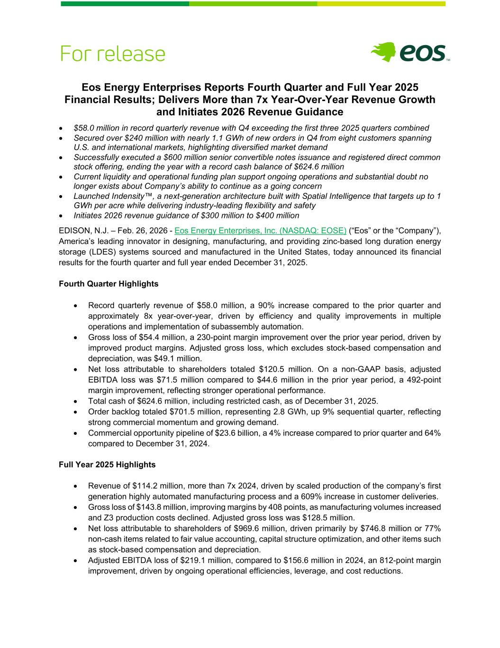
3
Eos Energy Enterprises Reports Fourth Quarter and Full Year 2025 Financial Results; Delivers More than 7x Year-Over-Year Revenue Growth and Initiates 2026 Revenue Guidance • $58.0 million in record quarterly revenue with Q4 exceeding the first three 2025 quarters combined • Secured over $240 million with nearly 1.1 GWh of new orders in Q4 from eight customers spanning U.S. and international markets, highlighting diversified market demand • Successfully executed a $600 million senior convertible notes issuance and registered direct common stock offering, ending the year with a record cash balance of $624.6 million • Current liquidity and operational funding plan support ongoing operations and substantial doubt no longer exists about Company’s ability to continue as a going concern • Launched Indensity™, a next-generation architecture built with Spatial Intelligence that targets up to 1 GWh per acre while delivering industry-leading flexibility and safety • Initiates 2026 revenue guidance of $300 million to $400 million EDISON, N.J. – Feb. 26, 2026 - Eos Energy Enterprises, Inc. (NASDAQ: EOSE) (“Eos” or the “Company”), America’s leading innovator in designing, manufacturing, and providing zinc-based long duration energy storage (LDES) systems sourced and manufactured in the United States, today announced its financial results for the fourth quarter and full year ended December 31, 2025. Fourth Quarter Highlights • Record quarterly revenue of $58.0 million, a 90% increase compared to the prior quarter and approximately 8x year-over-year, driven by efficiency and quality improvements in multiple operations and implementation of subassembly automation. • Gross loss of $54.4 million, a 230-point margin improvement over the prior year period, driven by improved product margins. Adjusted gross loss, which excludes stock-based compensation and depreciation, was $49.1 million. • Net loss attributable to shareholders totaled $120.5 million. On a non-GAAP basis, adjusted EBITDA loss was $71.5 million compared to $44.6 million in the prior year period, a 492-point margin improvement, reflecting stronger operational performance. • Total cash of $624.6 million, including restricted cash, as of December 31, 2025. • Order backlog totaled $701.5 million, representing 2.8 GWh, up 9% sequential quarter, reflecting strong commercial momentum and growing demand. • Commercial opportunity pipeline of $23.6 billion, a 4% increase compared to prior quarter and 64% compared to December 31, 2024. Full Year 2025 Highlights • Revenue of $114.2 million, more than 7x 2024, driven by scaled production of the company’s first generation highly automated manufacturing process and a 609% increase in customer deliveries. • Gross loss of $143.8 million, improving margins by 408 points, as manufacturing volumes increased and Z3 production costs declined. Adjusted gross loss was $128.5 million. • Net loss attributable to shareholders of $969.6 million, driven primarily by $746.8 million or 77% non-cash items related to fair value accounting, capital structure optimization, and other items such as stock-based compensation and depreciation. • Adjusted EBITDA loss of $219.1 million, compared to $156.6 million in 2024, an 812-point margin improvement, driven by ongoing operational efficiencies, leverage, and cost reductions.

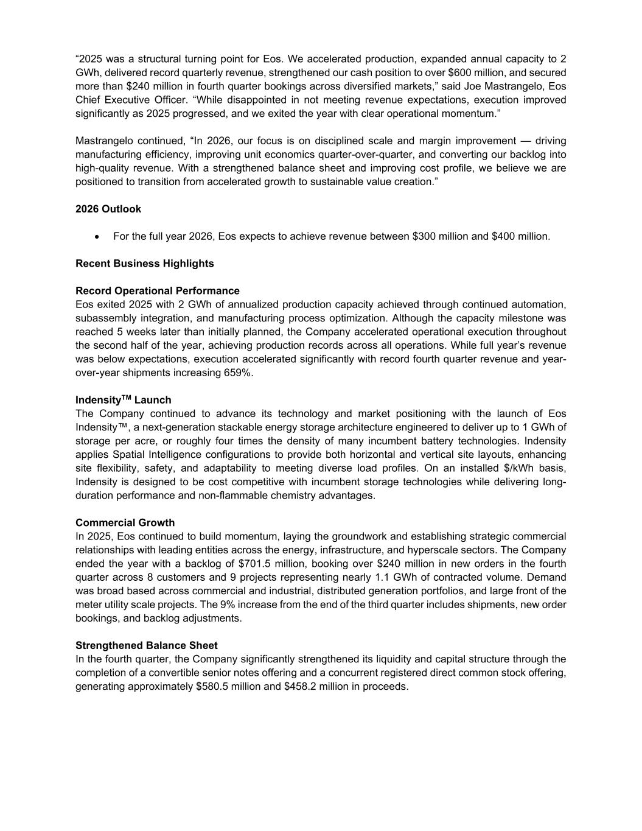
“2025 was a structural turning point for Eos. We accelerated production, expanded annual capacity to 2 GWh, delivered record quarterly revenue, strengthened our cash position to over $600 million, and secured more than $240 million in fourth quarter bookings across diversified markets,” said Joe Mastrangelo, Eos Chief Executive Officer. “While disappointed in not meeting revenue expectations, execution improved significantly as 2025 progressed, and we exited the year with clear operational momentum.” Mastrangelo continued, “In 2026, our focus is on disciplined scale and margin improvement — driving manufacturing efficiency, improving unit economics quarter-over-quarter, and converting our backlog into high-quality revenue. With a strengthened balance sheet and improving cost profile, we believe we are positioned to transition from accelerated growth to sustainable value creation.” 2026 Outlook • For the full year 2026, Eos expects to achieve revenue between $300 million and $400 million. Recent Business Highlights Record Operational Performance Eos exited 2025 with 2 GWh of annualized production capacity achieved through continued automation, subassembly integration, and manufacturing process optimization. Although the capacity milestone was reached 5 weeks later than initially planned, the Company accelerated operational execution throughout the second half of the year, achieving production records across all operations. While full year’s revenue was below expectations, execution accelerated significantly with record fourth quarter revenue and year- over-year shipments increasing 659%. IndensityTM Launch The Company continued to advance its technology and market positioning with the launch of Eos Indensity™, a next-generation stackable energy storage architecture engineered to deliver up to 1 GWh of storage per acre, or roughly four times the density of many incumbent battery technologies. Indensity applies Spatial Intelligence configurations to provide both horizontal and vertical site layouts, enhancing site flexibility, safety, and adaptability to meeting diverse load profiles. On an installed $/kWh basis, Indensity is designed to be cost competitive with incumbent storage technologies while delivering long- duration performance and non-flammable chemistry advantages. Commercial Growth In 2025, Eos continued to build momentum, laying the groundwork and establishing strategic commercial relationships with leading entities across the energy, infrastructure, and hyperscale sectors. The Company ended the year with a backlog of $701.5 million, booking over $240 million in new orders in the fourth quarter across 8 customers and 9 projects representing nearly 1.1 GWh of contracted volume. Demand was broad based across commercial and industrial, distributed generation portfolios, and large front of the meter utility scale projects. The 9% increase from the end of the third quarter includes shipments, new order bookings, and backlog adjustments. Strengthened Balance Sheet In the fourth quarter, the Company significantly strengthened its liquidity and capital structure through the completion of a convertible senior notes offering and a concurrent registered direct common stock offering, generating approximately $580.5 million and $458.2 million in proceeds.

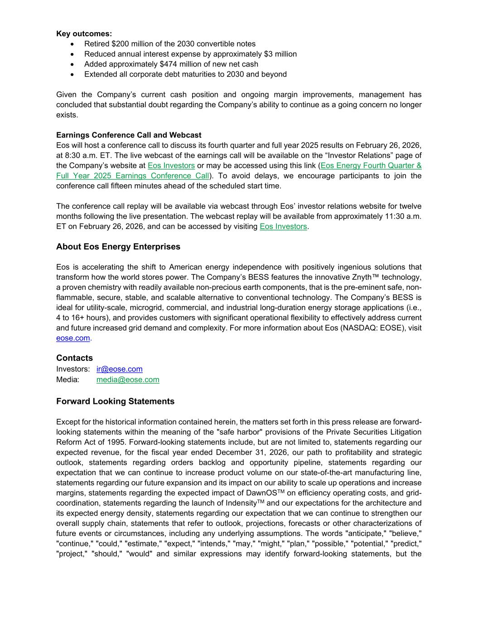
Key outcomes: • Retired $200 million of the 2030 convertible notes • Reduced annual interest expense by approximately $3 million • Added approximately $474 million of new net cash • Extended all corporate debt maturities to 2030 and beyond Given the Company’s current cash position and ongoing margin improvements, management has concluded that substantial doubt regarding the Company’s ability to continue as a going concern no longer exists. Earnings Conference Call and Webcast Eos will host a conference call to discuss its fourth quarter and full year 2025 results on February 26, 2026, at 8:30 a.m. ET. The live webcast of the earnings call will be available on the “Investor Relations” page of the Company’s website at Eos Investors or may be accessed using this link (Eos Energy Fourth Quarter & Full Year 2025 Earnings Conference Call). To avoid delays, we encourage participants to join the conference call fifteen minutes ahead of the scheduled start time. The conference call replay will be available via webcast through Eos’ investor relations website for twelve months following the live presentation. The webcast replay will be available from approximately 11:30 a.m. ET on February 26, 2026, and can be accessed by visiting Eos Investors. About Eos Energy Enterprises Eos is accelerating the shift to American energy independence with positively ingenious solutions that transform how the world stores power. The Company’s BESS features the innovative Znyth™ technology, a proven chemistry with readily available non-precious earth components, that is the pre-eminent safe, non- flammable, secure, stable, and scalable alternative to conventional technology. The Company’s BESS is ideal for utility-scale, microgrid, commercial, and industrial long-duration energy storage applications (i.e., 4 to 16+ hours), and provides customers with significant operational flexibility to effectively address current and future increased grid demand and complexity. For more information about Eos (NASDAQ: EOSE), visit eose.com. Contacts Investors: ir@eose.com Media: media@eose.com Forward Looking Statements Except for the historical information contained herein, the matters set forth in this press release are forward- looking statements within the meaning of the "safe harbor" provisions of the Private Securities Litigation Reform Act of 1995. Forward-looking statements include, but are not limited to, statements regarding our expected revenue, for the fiscal year ended December 31, 2026, our path to profitability and strategic outlook, statements regarding orders backlog and opportunity pipeline, statements regarding our expectation that we can continue to increase product volume on our state-of-the-art manufacturing line, statements regarding our future expansion and its impact on our ability to scale up operations and increase margins, statements regarding the expected impact of DawnOSTM on efficiency operating costs, and grid- coordination, statements regarding the launch of IndensityTM and our expectations for the architecture and its expected energy density, statements regarding our expectation that we can continue to strengthen our overall supply chain, statements that refer to outlook, projections, forecasts or other characterizations of future events or circumstances, including any underlying assumptions. The words "anticipate," "believe," "continue," "could," "estimate," "expect," "intends," "may," "might," "plan," "possible," "potential," "predict," "project," "should," "would" and similar expressions may identify forward-looking statements, but the

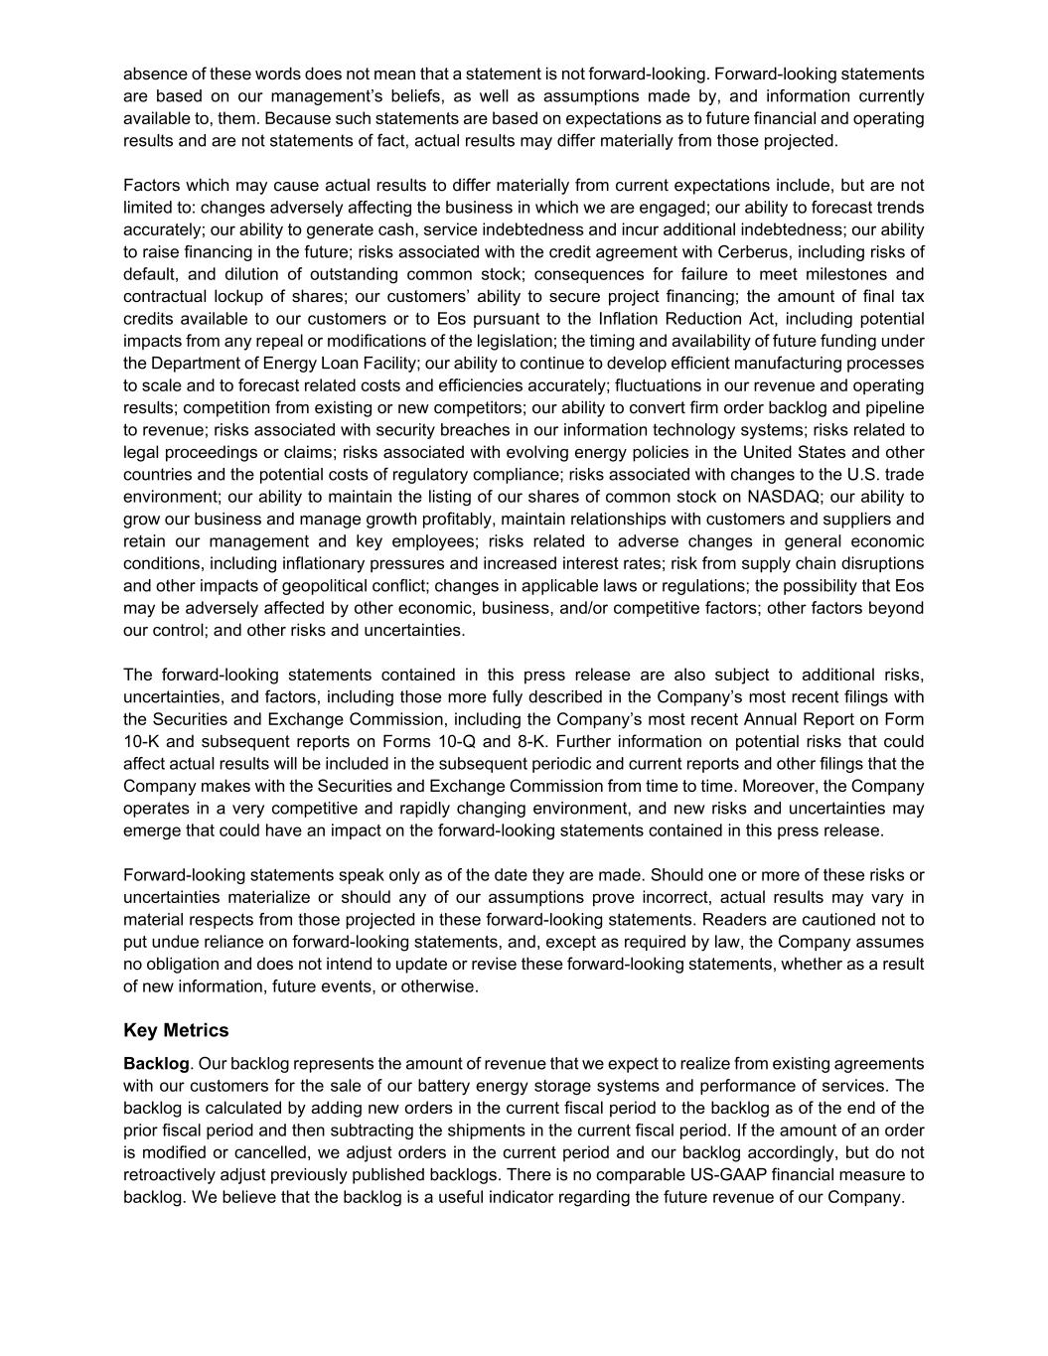
absence of these words does not mean that a statement is not forward-looking. Forward-looking statements are based on our management’s beliefs, as well as assumptions made by, and information currently available to, them. Because such statements are based on expectations as to future financial and operating results and are not statements of fact, actual results may differ materially from those projected. Factors which may cause actual results to differ materially from current expectations include, but are not limited to: changes adversely affecting the business in which we are engaged; our ability to forecast trends accurately; our ability to generate cash, service indebtedness and incur additional indebtedness; our ability to raise financing in the future; risks associated with the credit agreement with Cerberus, including risks of default, and dilution of outstanding common stock; consequences for failure to meet milestones and contractual lockup of shares; our customers’ ability to secure project financing; the amount of final tax credits available to our customers or to Eos pursuant to the Inflation Reduction Act, including potential impacts from any repeal or modifications of the legislation; the timing and availability of future funding under the Department of Energy Loan Facility; our ability to continue to develop efficient manufacturing processes to scale and to forecast related costs and efficiencies accurately; fluctuations in our revenue and operating results; competition from existing or new competitors; our ability to convert firm order backlog and pipeline to revenue; risks associated with security breaches in our information technology systems; risks related to legal proceedings or claims; risks associated with evolving energy policies in the United States and other countries and the potential costs of regulatory compliance; risks associated with changes to the U.S. trade environment; our ability to maintain the listing of our shares of common stock on NASDAQ; our ability to grow our business and manage growth profitably, maintain relationships with customers and suppliers and retain our management and key employees; risks related to adverse changes in general economic conditions, including inflationary pressures and increased interest rates; risk from supply chain disruptions and other impacts of geopolitical conflict; changes in applicable laws or regulations; the possibility that Eos may be adversely affected by other economic, business, and/or competitive factors; other factors beyond our control; and other risks and uncertainties. The forward-looking statements contained in this press release are also subject to additional risks, uncertainties, and factors, including those more fully described in the Company’s most recent filings with the Securities and Exchange Commission, including the Company’s most recent Annual Report on Form 10-K and subsequent reports on Forms 10-Q and 8-K. Further information on potential risks that could affect actual results will be included in the subsequent periodic and current reports and other filings that the Company makes with the Securities and Exchange Commission from time to time. Moreover, the Company operates in a very competitive and rapidly changing environment, and new risks and uncertainties may emerge that could have an impact on the forward-looking statements contained in this press release. Forward-looking statements speak only as of the date they are made. Should one or more of these risks or uncertainties materialize or should any of our assumptions prove incorrect, actual results may vary in material respects from those projected in these forward-looking statements. Readers are cautioned not to put undue reliance on forward-looking statements, and, except as required by law, the Company assumes no obligation and does not intend to update or revise these forward-looking statements, whether as a result of new information, future events, or otherwise. Key Metrics Backlog. Our backlog represents the amount of revenue that we expect to realize from existing agreements with our customers for the sale of our battery energy storage systems and performance of services. The backlog is calculated by adding new orders in the current fiscal period to the backlog as of the end of the prior fiscal period and then subtracting the shipments in the current fiscal period. If the amount of an order is modified or cancelled, we adjust orders in the current period and our backlog accordingly, but do not retroactively adjust previously published backlogs. There is no comparable US-GAAP financial measure to backlog. We believe that the backlog is a useful indicator regarding the future revenue of our Company.

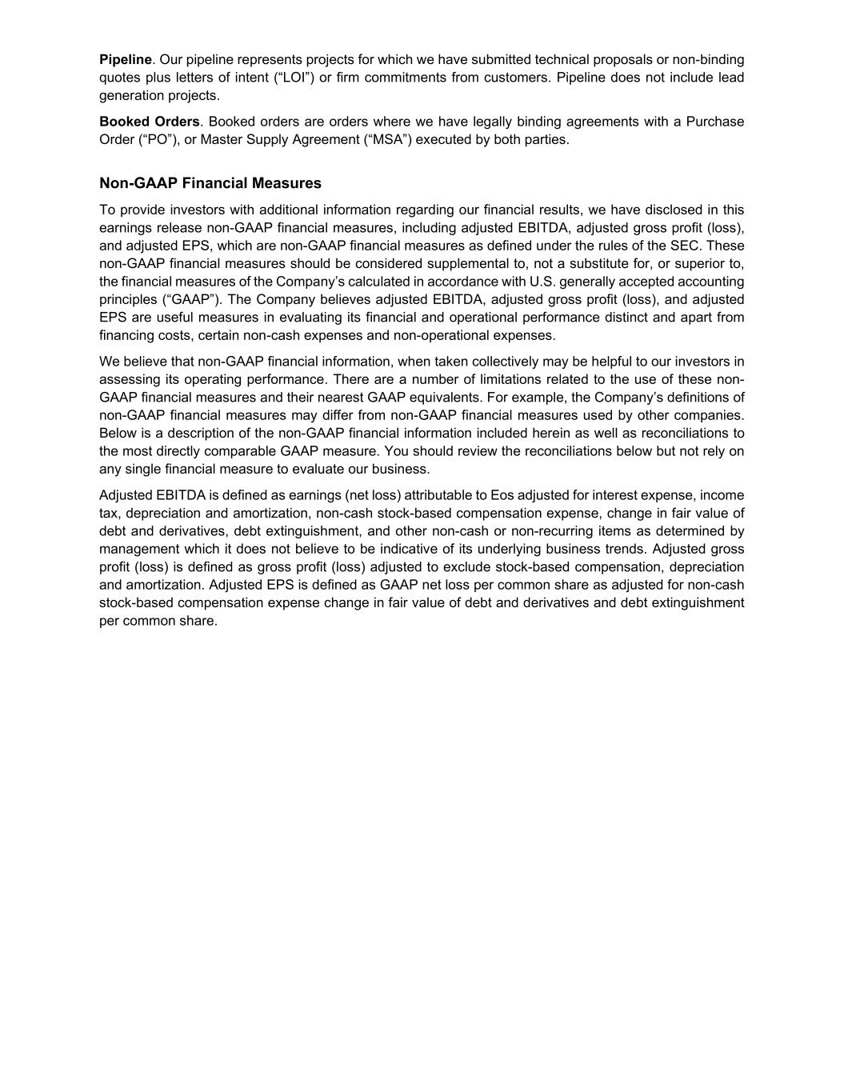
Pipeline. Our pipeline represents projects for which we have submitted technical proposals or non-binding quotes plus letters of intent (“LOI”) or firm commitments from customers. Pipeline does not include lead generation projects. Booked Orders. Booked orders are orders where we have legally binding agreements with a Purchase Order (“PO”), or Master Supply Agreement (“MSA”) executed by both parties. Non-GAAP Financial Measures To provide investors with additional information regarding our financial results, we have disclosed in this earnings release non-GAAP financial measures, including adjusted EBITDA, adjusted gross profit (loss), and adjusted EPS, which are non-GAAP financial measures as defined under the rules of the SEC. These non-GAAP financial measures should be considered supplemental to, not a substitute for, or superior to, the financial measures of the Company’s calculated in accordance with U.S. generally accepted accounting principles (“GAAP”). The Company believes adjusted EBITDA, adjusted gross profit (loss), and adjusted EPS are useful measures in evaluating its financial and operational performance distinct and apart from financing costs, certain non-cash expenses and non-operational expenses. We believe that non-GAAP financial information, when taken collectively may be helpful to our investors in assessing its operating performance. There are a number of limitations related to the use of these non- GAAP financial measures and their nearest GAAP equivalents. For example, the Company’s definitions of non-GAAP financial measures may differ from non-GAAP financial measures used by other companies. Below is a description of the non-GAAP financial information included herein as well as reconciliations to the most directly comparable GAAP measure. You should review the reconciliations below but not rely on any single financial measure to evaluate our business. Adjusted EBITDA is defined as earnings (net loss) attributable to Eos adjusted for interest expense, income tax, depreciation and amortization, non-cash stock-based compensation expense, change in fair value of debt and derivatives, debt extinguishment, and other non-cash or non-recurring items as determined by management which it does not believe to be indicative of its underlying business trends. Adjusted gross profit (loss) is defined as gross profit (loss) adjusted to exclude stock-based compensation, depreciation and amortization. Adjusted EPS is defined as GAAP net loss per common share as adjusted for non-cash stock-based compensation expense change in fair value of debt and derivatives and debt extinguishment per common share.

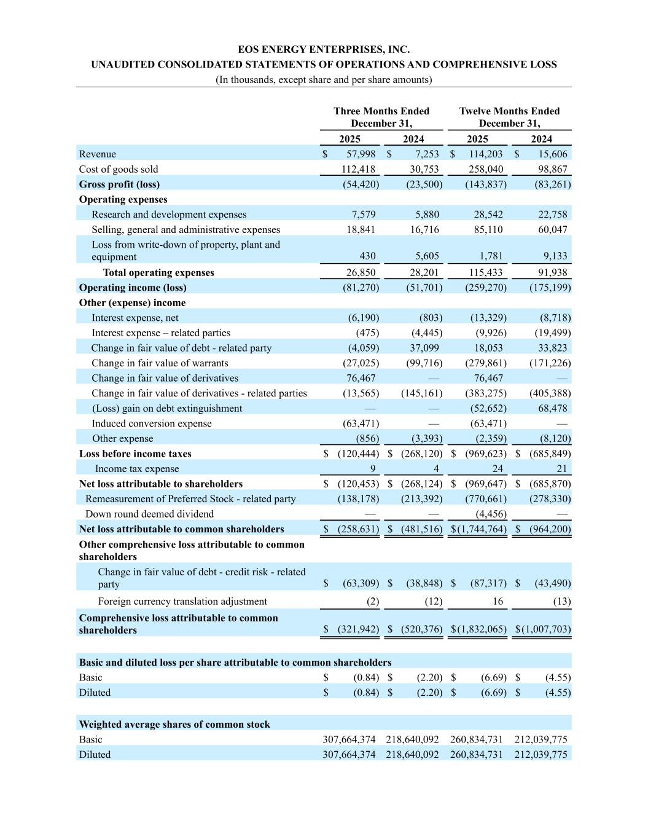
EOS ENERGY ENTERPRISES, INC. UNAUDITED CONSOLIDATED STATEMENTS OF OPERATIONS AND COMPREHENSIVE LOSS (In thousands, except share and per share amounts) Three Months Ended December 31, Twelve Months Ended December 31, 2025 2024 2025 2024 Revenue $ 57,998 $ 7,253 $ 114,203 $ 15,606 Cost of goods sold 112,418 30,753 258,040 98,867 Gross profit (loss) (54,420) (23,500) (143,837) (83,261) Operating expenses Research and development expenses 7,579 5,880 28,542 22,758 Selling, general and administrative expenses 18,841 16,716 85,110 60,047 Loss from write-down of property, plant and equipment 430 5,605 1,781 9,133 Total operating expenses 26,850 28,201 115,433 91,938 Operating income (loss) (81,270) (51,701) (259,270) (175,199) Other (expense) income Interest expense, net (6,190) (803) (13,329) (8,718) Interest expense – related parties (475) (4,445) (9,926) (19,499) Change in fair value of debt - related party (4,059) 37,099 18,053 33,823 Change in fair value of warrants (27,025) (99,716) (279,861) (171,226) Change in fair value of derivatives 76,467 — 76,467 — Change in fair value of derivatives - related parties (13,565) (145,161) (383,275) (405,388) (Loss) gain on debt extinguishment — — (52,652) 68,478 Induced conversion expense (63,471) — (63,471) — Other expense (856) (3,393) (2,359) (8,120) Loss before income taxes $ (120,444) $ (268,120) $ (969,623) $ (685,849) Income tax expense 9 4 24 21 Net loss attributable to shareholders $ (120,453) $ (268,124) $ (969,647) $ (685,870) Remeasurement of Preferred Stock - related party (138,178) (213,392) (770,661) (278,330) Down round deemed dividend — — (4,456) — Net loss attributable to common shareholders $ (258,631) $ (481,516) $ (1,744,764) $ (964,200) Other comprehensive loss attributable to common shareholders Change in fair value of debt - credit risk - related party $ (63,309) $ (38,848) $ (87,317) $ (43,490) Foreign currency translation adjustment (2) (12) 16 (13) Comprehensive loss attributable to common shareholders $ (321,942) $ (520,376) $ (1,832,065) $ (1,007,703) Basic and diluted loss per share attributable to common shareholders Basic $ (0.84) $ (2.20) $ (6.69) $ (4.55) Diluted $ (0.84) $ (2.20) $ (6.69) $ (4.55) Weighted average shares of common stock Basic 307,664,374 218,640,092 260,834,731 212,039,775 Diluted 307,664,374 218,640,092 260,834,731 212,039,775

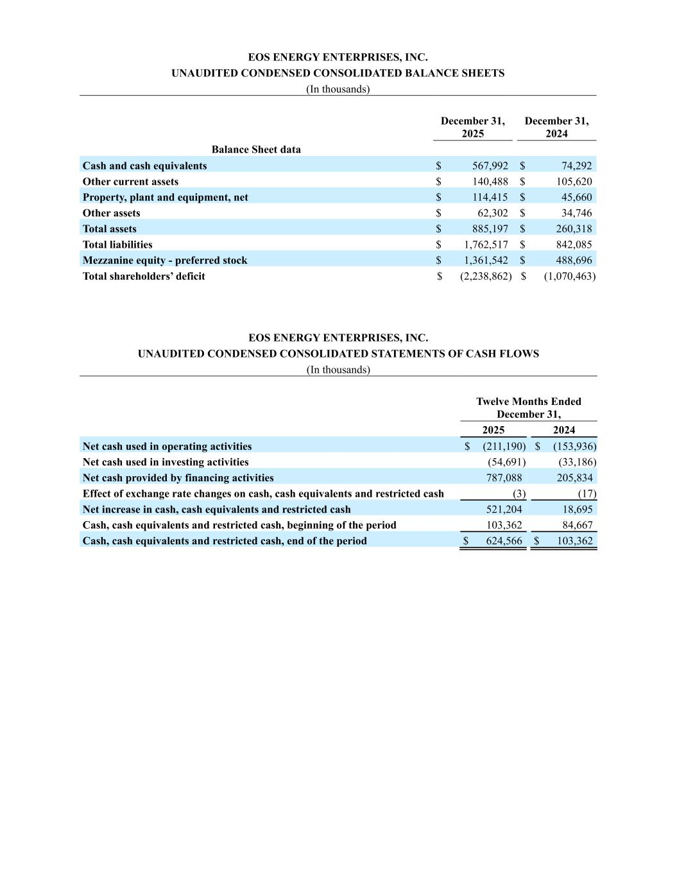
EOS ENERGY ENTERPRISES, INC. UNAUDITED CONDENSED CONSOLIDATED BALANCE SHEETS (In thousands) December 31, 2025 December 31, 2024 Balance Sheet data Cash and cash equivalents $ 567,992 $ 74,292 Other current assets $ 140,488 $ 105,620 Property, plant and equipment, net $ 114,415 $ 45,660 Other assets $ 62,302 $ 34,746 Total assets $ 885,197 $ 260,318 Total liabilities $ 1,762,517 $ 842,085 Mezzanine equity - preferred stock $ 1,361,542 $ 488,696 Total shareholders’ deficit $ (2,238,862) $ (1,070,463) EOS ENERGY ENTERPRISES, INC. UNAUDITED CONDENSED CONSOLIDATED STATEMENTS OF CASH FLOWS (In thousands) Twelve Months Ended December 31, 2025 2024 Net cash used in operating activities $ (211,190) $ (153,936) Net cash used in investing activities (54,691) (33,186) Net cash provided by financing activities 787,088 205,834 Effect of exchange rate changes on cash, cash equivalents and restricted cash (3) (17) Net increase in cash, cash equivalents and restricted cash 521,204 18,695 Cash, cash equivalents and restricted cash, beginning of the period 103,362 84,667 Cash, cash equivalents and restricted cash, end of the period $ 624,566 $ 103,362

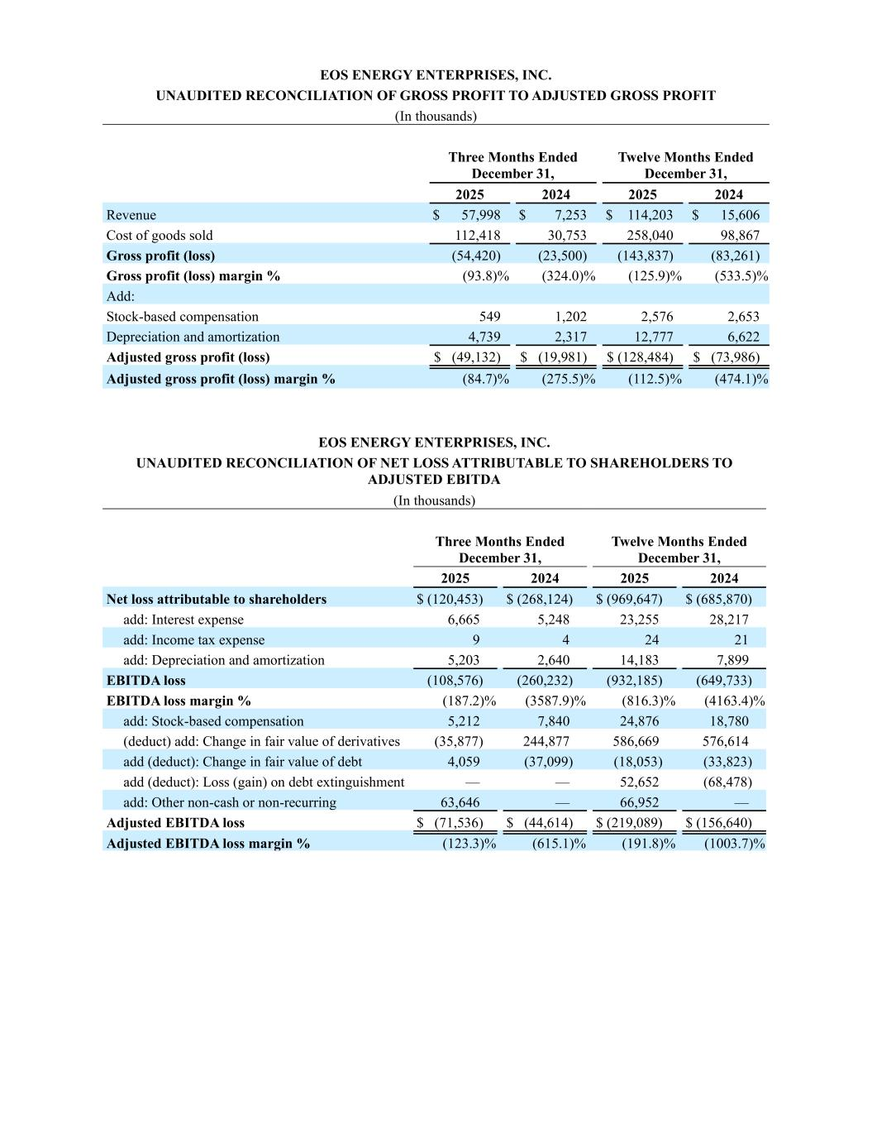
EOS ENERGY ENTERPRISES, INC. UNAUDITED RECONCILIATION OF GROSS PROFIT TO ADJUSTED GROSS PROFIT (In thousands) Three Months Ended December 31, Twelve Months Ended December 31, 2025 2024 2025 2024 Revenue $ 57,998 $ 7,253 $ 114,203 $ 15,606 Cost of goods sold 112,418 30,753 258,040 98,867 Gross profit (loss) (54,420) (23,500) (143,837) (83,261) Gross profit (loss) margin % (93.8) % (324.0) % (125.9) % (533.5) % Add: Stock-based compensation 549 1,202 2,576 2,653 Depreciation and amortization 4,739 2,317 12,777 6,622 Adjusted gross profit (loss) $ (49,132) $ (19,981) $ (128,484) $ (73,986) Adjusted gross profit (loss) margin % (84.7) % (275.5) % (112.5) % (474.1) % EOS ENERGY ENTERPRISES, INC. UNAUDITED RECONCILIATION OF NET LOSS ATTRIBUTABLE TO SHAREHOLDERS TO ADJUSTED EBITDA (In thousands) Three Months Ended December 31, Twelve Months Ended December 31, 2025 2024 2025 2024 Net loss attributable to shareholders $ (120,453) $ (268,124) $ (969,647) $ (685,870) add: Interest expense 6,665 5,248 23,255 28,217 add: Income tax expense 9 4 24 21 add: Depreciation and amortization 5,203 2,640 14,183 7,899 EBITDA loss (108,576) (260,232) (932,185) (649,733) EBITDA loss margin % (187.2) % (3587.9) % (816.3) % (4163.4) % add: Stock-based compensation 5,212 7,840 24,876 18,780 (deduct) add: Change in fair value of derivatives (35,877) 244,877 586,669 576,614 add (deduct): Change in fair value of debt 4,059 (37,099) (18,053) (33,823) add (deduct): Loss (gain) on debt extinguishment — — 52,652 (68,478) add: Other non-cash or non-recurring 63,646 — 66,952 — Adjusted EBITDA loss $ (71,536) $ (44,614) $ (219,089) $ (156,640) Adjusted EBITDA loss margin % (123.3) % (615.1) % (191.8) % (1003.7) %

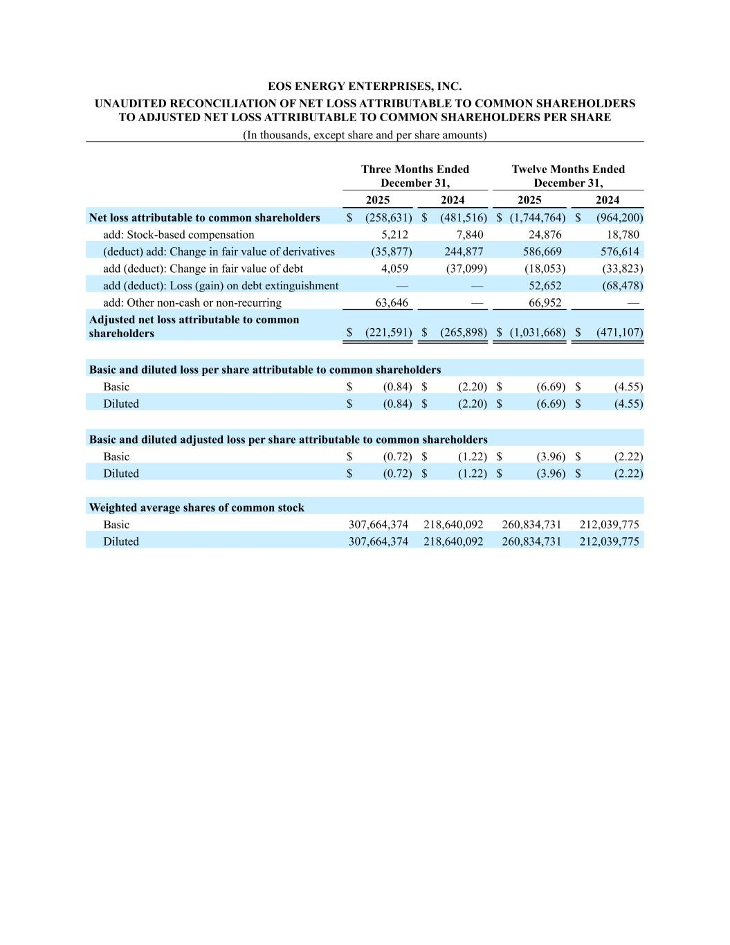
EOS ENERGY ENTERPRISES, INC. UNAUDITED RECONCILIATION OF NET LOSS ATTRIBUTABLE TO COMMON SHAREHOLDERS TO ADJUSTED NET LOSS ATTRIBUTABLE TO COMMON SHAREHOLDERS PER SHARE (In thousands, except share and per share amounts) Three Months Ended December 31, Twelve Months Ended December 31, 2025 2024 2025 2024 Net loss attributable to common shareholders $ (258,631) $ (481,516) $ (1,744,764) $ (964,200) add: Stock-based compensation 5,212 7,840 24,876 18,780 (deduct) add: Change in fair value of derivatives (35,877) 244,877 586,669 576,614 add (deduct): Change in fair value of debt 4,059 (37,099) (18,053) (33,823) add (deduct): Loss (gain) on debt extinguishment — — 52,652 (68,478) add: Other non-cash or non-recurring 63,646 — 66,952 — Adjusted net loss attributable to common shareholders $ (221,591) $ (265,898) $ (1,031,668) $ (471,107) Basic and diluted loss per share attributable to common shareholders Basic $ (0.84) $ (2.20) $ (6.69) $ (4.55) Diluted $ (0.84) $ (2.20) $ (6.69) $ (4.55) Basic and diluted adjusted loss per share attributable to common shareholders Basic $ (0.72) $ (1.22) $ (3.96) $ (2.22) Diluted $ (0.72) $ (1.22) $ (3.96) $ (2.22) Weighted average shares of common stock Basic 307,664,374 218,640,092 260,834,731 212,039,775 Diluted 307,664,374 218,640,092 260,834,731 212,039,775

