UNITED STATES
SECURITIES AND EXCHANGE COMMISSION
Washington, D.C. 20549
FORM 10-K
☒ |  |  | ANNUAL REPORT PURSUANT TO SECTION 13 OR 15(d) OF THE SECURITIES EXCHANGE ACT OF 1934
For the fiscal year ended: December 31, 2025
☐ |  |  | TRANSITION REPORT PURSUANT TO SECTION 13 OR 15(d) OF THE SECURITIES EXCHANGE ACT OF 1934
EOS ENERGY ENTERPRISES, INC.
Delaware |  |  |  |  |  | 001-39291 |  |  |  |  |  | 84-4290188
(State or other jurisdiction  of incorporation) |  |  |  |  |  | (Commission  File Number) |  |  |  |  |  | (IRS Employer  Identification No.)
3920 Park Avenue
Edison, New Jersey 08820
(Address of principal executive offices, including zip code)
Registrant’s telephone number, including area code: (732) 225-8400
Securities registered pursuant to Section 12(b) of the Act:
Title of each class |  |  |  |  |  | Trading Symbol(s) |  |  |  |  |  | Name of each exchange on which registered
Common stock, par value $0.0001 per share |  |  |  |  |  | EOSE |  |  |  |  |  | The Nasdaq Stock Market LLC
Indicate by check mark if the registrant is a well-known seasoned issuer, as defined in Rule 405 of the Securities Act. Yes ☐ No ☒

Indicate by check mark if the registrant is not required to file reports pursuant to Section 13 or Section 15(d) of the Act. Yes ☐ No ☒

Indicate by check mark whether the registrant (1) has filed all reports required to be filed by Section 13 or 15(d) of the Securities Exchange Act of 1934 during the preceding 12 months (or for such shorter period that the registrant was required to file such reports), and (2) has been subject to such filing requirements for the past 90 days. Yes ☒ No ☐

Indicate by check mark whether the registrant has submitted electronically every Interactive Data File required to be submitted pursuant to Rule 405 of Regulation S-T during the preceding 12 months (or for such shorter period that the registrant was required to submit such files). Yes ☒ No ☐

Indicate by check mark whether the registrant is a large accelerated filer, an accelerated filer, a non-accelerated filer a smaller reporting company or an emerging growth company. See the definitions of the “large accelerated filer,” “accelerated filer,” “non-accelerated filer,” “smaller reporting company” and “emerging growth company” in Rule 12b-2 of the Exchange Act.

Large accelerated filer |  |  | ☐ |  |  | Accelerated filer |  |  | ☐
Non-accelerated filer |  |  | ☒ |  |  | Smaller reporting company |  |  | ☒
 |  |  |  |  |  | Emerging growth company |  |  | ☐

If an emerging growth company, indicate by check mark if the registrant has elected not to use the extended transition period for complying with any new or revised financial accounting standards provided pursuant to Section 13(a) of the Exchange Act. ☐

Indicate by check mark whether the registrant has filed a report on and attestation to its management’s assessment of the effectiveness of its internal control over financial reporting under Section 404(b) of the Sarbanes-Oxley Act (15 U.S.C. 7262(b)) by the registered public accounting firm that prepared or issued its audit report. Yes ☐ No ☒

If securities are registered pursuant to Section 12(b) of the Act, indicate by check mark whether the financial statements of the registrant included in the filing reflect the correction of an error to previously issued financial statements. ☐

Indicate by check mark whether any of those error corrections are restatements that required a recovery analysis of incentive-based compensation received by any of the registrant’s executive officers during the relevant recovery period pursuant to §240.10D-1(b). ☐

Indicate by check mark whether registrant is a shell company (as defined in Rule 12b-2 of the Act). Yes ☐ No ☒

The aggregate market value of the voting stock held by non-affiliates of the registrant as of the last business day of the registrant’s most recently completed second fiscal quarter, June 30, 2025, was approximately $1,283 million based upon the closing sale price of our common stock of $5.12 on that date. As of February 24, 2026, there were 339,434,259 shares of the registrant’s common stock issued and outstanding.

Table of Contents
 |  |  | Page
Part I |  |  | 1
Item 1. Business |  |  | 3
Item 1A. Risk Factors |  |  | 12
Item 1B. Unresolved Staff Comments |  |  | 35
Item 1C. Cybersecurity |  |  | 36
Item 2. Properties |  |  | 37
Item 3. Legal Proceedings |  |  | 37
Item 4. Mine Safety Disclosures |  |  | 37
Part II |  |  | 37
Item 5. Market for Registrant's Common Equity, Related Stockholder Matters and Issuer Purchases of Equity Securities |  |  | 37
Item 6. [Reserved] |  |  | 38
Item 7. Management's Discussion and Analysis of Financial Condition and Results of Operations |  |  | 38
Item 7A. Quantitative and Qualitative Disclosure about Market Risk |  |  | 52
Item 8. Financial Statements and Supplementary Data |  |  | 53
Item 9. Changes in and Disagreements with Accountants on Accounting and Financial Disclosures |  |  | 120
Item 9A. Controls and Procedures |  |  | 120
Item 9B. Other Information |  |  | 120
Item 9C. Disclosure Regarding Foreign Jurisdictions that Prevent Inspections |  |  | 120
Part III |  |  | 121
Item 10. Directors, Executive Officers and Corporate Governance |  |  | 121
Item 11. Executive Compensation |  |  | 121
Item 12. Security Ownership of Certain Beneficial Owner and Management and Related Stockholder Matters |  |  | 121
Item 13. Certain Relationships and Related Transactions and Director Independence |  |  | 121
Item 14. Principal Accounting Fees and Services |  |  | 121
Part IV |  |  | 121
Item 15. Exhibits and Financial Statement Schedules |  |  | 121
Item 16. Form 10-K Summary |  |  | 129
Signatures

Forward-Looking Statements

All statements included in this Annual Report on Form 10-K ("Annual Report"), other than statements or characterizations of historical fact, are forward-looking statements within the meaning of the Private Securities Litigation Reform Act of 1995. The words "anticipate," "believe," "continue," "could," "estimate," "expect," "intends," "may," "might," "plan," "possible," "potential," "predict," "project," "should," "would" and similar expressions, as they relate to us, are intended to identify forward-looking statements. These statements appear in a number of places in this Annual Report and include statements regarding the intent, belief or current expectations of Eos Energy Enterprises, Inc. Forward-looking statements are based on our management’s beliefs, as well as assumptions made by and information currently available to, them. Because such statements are based on expectations as to future financial and operating results and are not statements of fact, actual results may differ materially from those projected. Factors which may cause actual results to differ materially from current expectations include, but are not limited to:

•changes adversely affecting the business in which we are engaged;

1

•our ability to forecast trends accurately;
•our ability to generate cash, service indebtedness and incur additional indebtedness;
•our ability to raise financing in the future;
•our customer's ability to secure project financing;
•risks associated with the Credit Agreement (defined below), including risks of default, dilution of outstanding common stock, consequences for failure to meet milestones and contractual lockup of shares;
•the amount of final tax credits available to our customers or to Eos pursuant to the Inflation Reduction Act including potential impacts from any repeal or modification of the legislation;
•the timing and availability of future funding under the Department of Energy Loan Facility;
•our ability to continue to develop efficient manufacturing processes to scale and to forecast related costs and efficiencies accurately;
•fluctuations in our revenue and operating results;
•competition from existing or new competitors;
•our ability to convert firm order backlog and pipeline to revenue;
•risks associated with security breaches in our information technology systems;
•risks related to legal proceedings or claims;
•risks associated with evolving energy policies in the United States and other countries and the potential costs of regulatory compliance;
•risks associated with changes to the U.S. trade environment;
•our ability to maintain the listing of our shares of common stock on NASDAQ;
•our ability to grow our business and manage growth profitably, maintain relationships with customers and suppliers and retain our management and key employees;
•risks related to adverse changes in general economic conditions, including inflationary pressures and increased interest rates;
•risk from supply chain disruptions and other impacts of geopolitical conflict;
•changes in applicable laws or regulations; and
•other factors detailed under the section titled “Risk Factors” herein.
More information on these important factors that could cause actual results to differ materially from those projected in the forward-looking statements we make in this Annual Report are set forth in Part I, Item 1A under “Risk Factors”. In addition, there may be other factors of which we are presently unaware or that we currently deem immaterial that could cause our actual results to be materially different from the results referenced in the forward-looking statements.
Forward-looking statements speak only as of the date they are made. Readers are cautioned not to put undue reliance on forward-looking statements, and, except as required by law, the Company assumes no obligation and does not intend to update or revise these forward-looking statements, whether as a result of new information, future events, or otherwise.

2

PART I

ITEM. 1 BUSINESS

General
Eos Energy Enterprises, Inc. (NASDAQ: EOSE) (“Eos”, “we,” “us,” “our,” or “Company”) is an American energy company and America’s leading innovator in designing, manufacturing and providing zinc-based battery energy storage systems ("BESS"), sourced and manufactured in the United States. The Eos BESS are safe, non-flammable, secure and sustainable alternatives to lithium-ion batteries, making them ideal for utility-scale, microgrid and commercial and industrial long-duration applications.
The Company designs, develops, manufactures and markets zinc-based energy storage systems intended for utility-scale, microgrid and commercial and industrial (“C&I”) applications. The Company believes its technology serves as a viable alternative to lithium-ion (“Li-ion”) batteries for long-duration energy storage use cases.
The Company has developed a broad intellectual property portfolio, including multiple patents covering its battery chemistry, mechanical product design, energy block configuration and proprietary software operating system, the Battery Management System (“BMS”). The BMS incorporates Eos-developed algorithms and utilizes ambient and battery temperature sensors, as well as voltage and current sensors for electrical strings and system-level monitoring.
The Company currently focuses on the manufacture and sale of turnkey direct current (“DC”) battery energy storage systems and plans to expand its product portfolio to include turnkey alternating current (“AC”) systems. The Company’s primary applications include:
(a) integration with renewable energy systems that are connected to the utility grid;
(b) integration with renewable energy systems that are not grid-connected;
(c) deployment in systems designed to relieve grid congestion; and
(d) installations that enable C&I customers to reduce peak energy usage or participate in utility ancillary and demand-response markets.
These applications are increasingly relevant as overall electricity demand continues to rise, including incremental load growth associated with the expansion of artificial intelligence ("AI"), high-performance computing ("HPC") and data center infrastructure, which is contributing to greater system capacity needs and grid-level constraints.
The Company operates a manufacturing facility in Turtle Creek, Pennsylvania, which produces DC energy blocks incorporating the Company’s BMS. The Company also maintains a facility in Warrendale, Pennsylvania, which is not currently operational and is expected to become operational in 2026. Currently, the Company’s primary geographic market is North America, and the Company operates as one operating and reportable segment.

Principal Products and Services
The Company provides an innovative Znyth™ battery energy storage system (“BESS”) engineered to deliver the operational flexibility needed to address rising grid complexity and price volatility. These challenges are being driven by the rapid expansion of renewable energy generation, accelerating electricity demand, including significant increases tied to the growth of artificial intelligence and data center activity and the resulting congestion across the power grid. The Company’s BESS utilizes a proven chemistry made from abundant, non-precious earth materials in a robust design capable of maintaining performance in extreme temperatures and harsh environments. The system is built for safety, flexibility, scalability and sustainability, and is manufactured in the United States using raw materials primarily sourced domestically. We believe the Company’s Z3 battery module serves as the foundation of its advanced systems. The Z3 module is currently the only U.S.-designed and manufactured battery module that offers utilities, independent power producers, renewable developers and C&I customers a viable alternative to lithium-ion and lead-acid monopolar batteries for critical 3- to 12-hour, or longer, discharge-duration applications. We believe the Z3 battery is reshaping how utility, industrial and commercial customers store and manage power.
In addition to its BESS, the Company currently provides:

3

(a) a battery management system (“BMS”) that enables remote asset monitoring and analytics to assess the performance and health of the Company’s BESS and to identify potential future performance issues through predictive analytics;
(b) project management services designed to coordinate the installation and integration of the Company’s BESS within a customer’s broader project plan;
(c) commissioning services intended to verify that the customer’s installation of the BESS meets expected performance requirements; and
(d) long-term maintenance programs designed to support sustained, optimal operating performance of the Company’s systems.

Availability of Raw Materials
The Company procures materials from various third parties and across commodities, including chemicals and substrates, fabricated metal products, plastics, electronics and electrical components. We use both domestic and international raw materials suppliers to create our current Z3 battery module. We will continue to focus on domesticating our supply chain in an economically sustainable manner.
While we believe we have sufficient sources for the materials, components, services and supplies used in our manufacturing activities, we are highly dependent on the availability of essential materials, parts and subassemblies from our suppliers. The predominant raw materials that are required for our Z3 battery product are zinc halide salts, felt, resin, titanium and conductive polymer.
The Company effectively manages its supply chain through close relationships with key suppliers. We engage in formal agreements with our strategic supplier partners and continually look to implement strategies and opportunities to ensure a resilient supply network.
Additionally, based on the latest Internal Revenue Service ("IRS") guidance, the Company believes that our current Z3 battery module feature raw materials sourcing sufficient to qualify for the Domestic Content Bonus awarded by the Inflation Reduction Act’s ("IRA") tax credits.

Industry Overview
We believe the energy storage industry has become a critical component of modern electricity infrastructure. The Company’s solutions support the evolving needs of the power sector and complement existing resources in meeting growing global demand for reliable and flexible energy. As electricity consumption increases, driven in part by the rapid expansion of AI, HPC and data center infrastructure, energy storage plays an essential role in enhancing grid stability, providing capacity support and improving system resilience.
The global market for energy storage continues to demonstrate strong growth, supported by the rising need for grid reliability, increasing system capacity requirements and advancements in storage technologies. We believe the market is positioned for meaningful expansion over the next decade. Key industry growth drivers include grid modernization initiatives, cost reductions across storage technologies, increased electrification and a growing focus on energy security.
Government policies, subsidies and incentives in certain countries are further supporting the development and deployment of energy storage solutions. In the United States, the Department of Energy (“DOE”) has long supported energy storage research and development, and several states have implemented mandates or incentive programs to promote broader adoption.
Energy storage remains a rapidly evolving sector that we believe is foundational to the future of global energy systems. The Eos Z3 BESS offers a differentiated long-duration solution that can serve as standalone storage and help address capacity constraints and infrastructure challenges across the electricity grid. We believe the technology, safety characteristics, and wide operating range of our BESS position it as a durable and reliable asset for grid operators and customers.

4

Strategy
The Company continues to invest in the design, development and production of its next-generation product, the Eos Z3 battery. The Z3 builds upon the same underlying electrochemistry the Company has utilized for nearly a decade. The Eos Z3 is engineered to reduce cost and weight while improving manufacturability and overall system performance. Compared to the Company’s prior Gen 2.3 product, the Z3 incorporates a more cost-effective design, including a simplified tub structure, approximately 50% fewer cells, and approximately 98% fewer welds per battery module. The Company believes the Eos Z3 will provide customers with approximately twice the energy density per square foot while maintaining the safety and reliability characteristics of the previous generation.
The Company has successfully transitioned to the Eos Z3 platform, enabled by the commissioning and commercial operation of its first fully automated battery manufacturing line. The Z3 leverages the same proven underlying chemistry, which has demonstrated durability over more than 3 million cycles, while incorporating a redesigned mechanical architecture that enhances performance, reduces costs and improves manufacturability. Z3 battery modules have been shipped since the third quarter of 2023, and the transition reflects over fifteen years of accumulated insights and operational experience. The Company believes this experience will continue to drive manufacturing efficiencies as production scales and its state-of-the-art operations expand.
In 2025, the Company introduced DawnOS, a software platform designed to enhance the value, reliability and safety of the Company’s BESS. DawnOS builds upon the Z3 battery architecture through a fully integrated hardware and software solution. It serves as the system’s intelligence layer and is designed to manage large numbers of battery modules in real time. The platform provides precise balancing, dynamic switching and continuous system operation, including in situations where individual modules within a string become imbalanced. DawnOS is intended to increase usable energy per cycle, reduce field service requirements and operate with embedded security and automation features. Through its advanced control capabilities, the Company expects DawnOS to be an integral component of its product portfolio going forward, reflecting its role in improving system resilience, efficiency and overall operational performance.
In 2026, the Company introduced Eos Indensity, an energy storage architecture that uses a spatial intelligence design framework to provide high density storage with flexibility and safety in constrained as well as traditional sites. The system targets up to 1 GWh per acre, roughly four times most incumbent footprints, through stackable Indensity Core units that integrate Eos Z3 battery modules with the Eos DawnOS controls platform. The modular self contained form factor enables efficient transport, simplified installation and long term serviceability. Eos Indensity can be deployed indoors or outdoors, including inside existing buildings. It addresses long duration, response driven use cases across data centers, military bases, manufacturing facilities and critical infrastructure, supported by a domestic FEOC compliant supply chain. The Company expects Indensity to be an integral component of its product portfolio going forward.
The Company believes that the simplicity, flexibility and safety characteristics of its products represent important attributes valued by the market. In addition, the Company benefits from legislative incentives, including the Inflation Reduction Act and the One Big Beautiful Bill Act ("OBBBA"), which provide production tax credits (“PTC”) for domestically manufactured battery components, as well as tax credits available to customers for projects that satisfy domestic content requirements (see “Regulations” in Item 1 – Business). The Company also intends to continue working with a consortium of community organizations, universities and supply chain partners to pursue available funding opportunities under the Bipartisan Infrastructure Law of 2021.
Market Trends and Opportunities
The Company believes the rapid adoption of AI, HPC and data-intensive technologies is creating significant new demands on global power infrastructure. As AI models grow in scale and data centers expand at an unprecedented pace, energy systems must be equipped to manage increasingly complex load profiles and heightened reliability requirements. The Company sees this shift as a major opportunity for advanced, resilient energy storage solutions that help stabilize grids, support peak demand and ensure uninterrupted power for mission-critical computing.
Historically, most energy storage deployments have relied on short-duration systems capable of providing less than four hours of power. The Company anticipates that the next generation of digital infrastructure, particularly

5

AI-driven facilities and high-density compute environments, will require mid-duration (6–12 hour) BESS capable of managing sustained load fluctuations and alleviating capacity constraints.
The Z3 battery is uniquely positioned to serve this emerging market. It is composed primarily of five earth-abundant, readily available raw materials with well-established supply chains, enabling the Company to continue driving down costs as production scales. Although lithium-ion is currently the installed base leader, zinc-based batteries are gaining traction in applications prioritizing safety, abundant/recyclable inputs and flexible duration performance under demanding cycle conditions.
Safety is a core strength. As concerns grow regarding lithium-ion battery risks, such as thermal runaway, fires and explosions, the Company’s non-flammable, inherently stable chemistry offers a compelling alternative for environments where reliability and safety are paramount. This includes data centers, AI compute campuses and other facilities requiring continuous, secure and risk-mitigated power. The Z3 technology avoids the failure modes associated with lithium-ion electrolytes, providing a significantly enhanced safety profile and supporting the Company’s commitment to delivering dependable and robust energy storage solutions.

Intellectual Property
The success of our business depends, in part, on our ability to maintain and protect our proprietary technology, information, processes and know-how. We rely primarily on patent, trademark, copyright and trade secret laws in the United States and similar laws in other countries, confidentiality agreements and procedures and other contractual arrangements. These patents are subject to regulatory approval by the respective governing entity where the patent was filed. A majority of our patents relate to cell chemistry, architecture and battery mechanical design, system packaging and BMS. We continually assess opportunities to seek patent protection for those aspects of our technology, design, methodologies and processes that we believe provide significant competitive advantages.
The Company periodically assesses its patent portfolio in relation to the patents’ utility and materiality to the current operation and future strategy of the business and abandons applications or ceases to maintain patents which are deemed immaterial to our current or future business operations. As of December 31, 2025, we have 31 patent families and 202 patents pending, issued, or published in 30 countries, protecting our technology and system architecture. The Company's key patents, related to its most recent generation product and future products, are not scheduled to expire until 2035 or later.
In addition, the Company relies on trade secret protection and confidentiality agreements to safeguard our interests with respect to proprietary know-how that is not patentable and processes for which patents are difficult to enforce. We believe that many key elements of our manufacturing processes involve proprietary know-how, technology or data that are not covered by patents or patent applications, including technical processes, test equipment designs, algorithms and procedures. All of our research and development personnel have entered into confidentiality and proprietary information agreements with us. These agreements address intellectual property protection issues and requires our employees to assign to us all of the inventions, designs and technologies that Company personnel develop during the course of their employment. We also require our customers and business partners to enter into confidentiality agreements before we disclose any sensitive aspects of our technology or business plans.

Regulations

Governmental Programs and Incentives
Globally, both the operations of our business by us and the ownership of our products by our customers are impacted by various government programs, incentives and other arrangements.
DOE Loan Facility
On November 26, 2024, the Company entered into a note purchase agreement with the United States Federal Financing Bank ("FFB") and the United States DOE Loan Programs Office (“LPO”) ("DOE Loan Facility") pursuant to which, among other things, the DOE provided a guarantee of the Company’s (x) obligations to repay the term loan borrowings provided by the FFB to the Company and evidenced by a future advance promissory note (the “FFB Promissory Note”) and (y) the Company’s other obligations owing to FFB in respect of such guaranteed loan,

6

and in connection and concurrently therewith, the Company entered into a Loan Guarantee Agreement with the DOE (collectively, such agreements provide for a multi draw term loan facility, the DOE Loan Facility), marking the first Title XVII battery loan closed. The DOE Loan Facility is a key step in advancing the Company's Project American Made Zinc Energy ("AMAZE") and is expected to fund the expansion of Eos’ manufacturing capacity to 8 GWh by 2027 to meet the growing demand for longer duration battery energy storage systems. The DOE Loan Facility provides for up to $303.5 million in funding, including capitalized interest.
The DOE Loan Facility provides for a multi draw term loan facility under a series of at least two and, if the Company elects, up to four tranches of the loan (each, a “Tranche”), subject to the achievement of certain funding conditions, with each Tranche corresponding to the production, maintenance and development and operation of a given production line to be funded using the proceeds of such Tranche and the principal amount of each Tranche consisting of a maximum principal amount designated for such Tranche in the DOE Loan Facility. Each Tranche provides the Company funding for 80% of the Eligible Project Costs (as defined in the DOE Loan Facility) associated with the corresponding production line, with the Company responsible for funding the remaining 20% of the Eligible Project Costs.
As of December 31, 2025, the Company had drawn down $90.9 million under the DOE Loan Facility, utilizing the full commitment available for Tranche 1. The initial draw of $68.3 million was made at an interest rate of 4.791%, for eligible project costs incurred through December 6, 2024. The second draw of $22.7 million was made at an interest rate of 4.286%, for eligible project costs incurred through June 4, 2025. These costs represent Tranche 1 that provided $90.9 million for eligible costs in connection with the design, construction, installation, startup and shakedown of a battery automation line and related tools, with a projected annual production capacity of approximately 1.25 GWh ("Line 1"), as defined in the DOE Loan Facility.

For further discussion, see Note 13, Borrowings, to the Consolidated Financial Statements.
Inflation Reduction Act of 2022
On August 16, 2022, President Biden signed the Inflation Reduction Act of 2022 into law. The IRA has significant economic incentives for both energy storage customers and manufacturers for projects placed in service after December 31, 2022. One of the most important features of the IRA is that it offers a 10-year term tax credit, whereas historically similar industrial credits have been shorter in duration. Customers placing new energy storage facilities in service, which include our Gen 2.3 and Z3 BESS, could qualify for investment tax credit (“ITC”). The IRA also offers an extra ten percent credit if the project is in an “energy community” and another ten percent credit if the project satisfies domestic content requirements, which have been set forth. The ten percent bonus for domestic content could represent a strategic advantage for the Company resulting from the Company’s near-sourcing and Made in America strategy, and we currently anticipate that projects utilizing Eos batteries will qualify for the bonus.
The Production Tax Credits under Internal Revenue Code 45X (“PTC”), can be claimed on battery components manufactured in the U.S. and sold to U.S. or foreign customers. These tax credits available to manufacturers include a credit for ten percent of the cost incurred to make electrode active materials in addition to credits of $35 per kWh of capacity of battery cells and $10 per kWh of capacity of battery modules. These credits are cumulative, meaning that companies will be able to claim each of the available tax credits based on the battery components produced and sold through 2029, after which the PTC will begin to gradually phase down through 2032.
One Big Beautiful Bill Act
On July 4, 2025, President Trump signed the One Big Beautiful Bill Act into law, introducing several modifications to the energy-related tax incentives originally established under the Inflation Reduction Act. The OBBBA introduces new limitations related to the sourcing of materials from a prohibited foreign entity ("PFE") for taxable years beginning after July 4, 2025. These provisions restrict eligibility for credits where material assistance is received from such entities. Additionally, the PFE-related restrictions include ownership and effective control related provisions concerning 'specified foreign entities' and 'foreign-influenced entities'.

7

Competition
The markets for our products are competitive, and we compete with manufacturers of traditional Li-ion and other battery storage systems. Factors affecting customers when choosing from different battery storage systems in the market include:
•product performance and features;
•safety and sustainability;
•total lifetime cost of ownership;
•total operational costs related to auxiliary equipment;
•total product lifespan and degradation rate;
•power and energy efficiency;
•duration of the battery's storage;
•customer service and support; and
•U.S.-based manufacturing and sourced materials.
Our Znyth™ battery system competes with products from traditional Li-ion battery manufacturers and solution providers such as Fluence Energy, Panasonic, Samsung Electronics Co. Ltd., LG Chem Ltd., Tesla, BYD, Sungrow and Contemporary Amperex Technology Co. Limited. Our longer duration competitors include ESS Inc., Enervenue, Ambri and Form Energy. We believe that our current and next generation battery system offers significant technology, safety and cost advantages that reflect a competitive differentiation over Li-ion storage technologies.

Competitive Strengths
We believe the following strengths of our business distinguish us from our competitors and position us to capitalize on the expected continued growth in the energy storage market:
•Differentiated Product- The Company believes its Znyth™ BESS offers meaningful performance, safety and operational advantages over traditional lithium-ion and flow battery systems. Unlike lithium-ion cells, which must operate within a narrow temperature band to avoid thermal runaway, the Znyth™ BESS functions across a much wider range (-20°C to 50°C). This broad operating window reduces the need for costly thermal management systems, including HVAC and specialized fire suppression.
The Znyth™ BESS also features a static, modular design with no pumps or compressors, lowering maintenance requirements compared to flow batteries. In addition, its flexible charge and discharge capabilities support a wide range of durations and use cases. Lithium-ion batteries typically have fixed rate parameters and may degrade when operated outside their design specifications, whereas Znyth™ technology is not subject to the same limitations.
Eos batteries are manufactured at zero voltage and zero percent state of charge, they avoid degradation associated with maintaining specific charge levels during idle periods, a requirement for lithium-ion systems. The Company believes these characteristics position the Znyth™ BESS as a reliable, cost-efficient and versatile energy storage solution.
•Minimal Supply Chain Constraints- All materials used in the production of the Company’s Z3 battery products are widely available commodity inputs with fewer supply-chain constraints and limited competition from electric-vehicle demand. In addition, most of these materials are recyclable through commercially established processes at end of life, supporting responsible material management.

8

•Proven Technology Solution in the Growing and Evolving Energy Storage Market- As the Company continues to scale manufacturing to gigawatt-hour (“GWh”) capacity, it expects to benefit from continued growth in the global energy storage market, which BloombergNEF projects will reach approximately 7,250 GWh by 2035. The market is also shifting toward long-duration energy storage (“LDES”) applications, reflecting the need for systems capable of supporting extended operational requirements. The Company believes its technology is well positioned to meet this demand. While lithium-ion solutions are generally optimized for shorter-duration applications, the performance characteristics of the Company’s batteries improve as storage duration increases, making the Z3 a strong fit for long-duration use cases.
•Experienced Technology Team Focused on Continuous Innovation- The Company’s research and development team is responsible for advancing its technology platform and expanding and protecting its intellectual property portfolio. The Company believes that continued investment in research and development will support improvements in efficiency, energy density, functionality and reliability, while further reducing the cost of its battery solutions.
The Company is also focused on applying its technical expertise to enhance its BMS, broaden operating capabilities, and improve overall system performance. These efforts are expected to support the optimization of the Company’s energy management solutions, enabling operating parameters to be aligned with specific applications and expanding the range of use cases for the Znyth™ BESS.
•Established Global Sales Channels Anchored with Top-Tier Customers- We sell products directly to the electric utility industry and through sales channels to the commercial and industrial market. We continue to build relationships with new customers and enter into agreements to provide battery solutions to new customers.
•Strong management team- The Company has assembled an executive leadership team focused on the successful commercialization and scale-up of the next-generation Z3 battery product. The team brings decades of combined experience across the energy sector, including deep expertise in manufacturing, battery storage, and the execution of complex power and energy projects globally. This breadth of experience supports the Company’s ability to develop, manufacture and deliver systems at scale to meet the growing demands of the energy storage market.

Customers
Our customers include the following:
•Unity Scale renewable developers
•Independent power producers
•Industrial companies
•Microgrid developers
During fiscal year 2025, two customers individually accounted for 51.5% and 18.8% of our total revenue.

Environmental, Social and Governance ("ESG")
Eos is accelerating the shift to American energy independence by transforming how the world stores power in a safe, scalable, efficient and sustainable way. We are committed to advancing global sustainable development through our products, working to systematically grow our business to meet the challenges of the global energy transition and combat the global climate change. Additionally, the Company has not incurred significant costs to remain in compliance with environmental laws.
Our approach to ESG is intrinsically united to our four product themes: safety, scalability, sustainability and efficiency. As we continue to scale, we remain committed to driving progress across these themes.

9

Human Capital
As of December 31, 2025, we have 787 total employees, all of which are full-time employees. We have not experienced any employment-related work stoppages, and we consider relations with our employees to be good.
Our success is based on the focused passion and dedication of our personnel. We are committed to providing a positive and engaging work environment for our employees and taking an active role in the betterment of the communities in which our employees live and work. Our full-time employees are provided a competitive benefits program, including comprehensive healthcare benefits, a 3% non-elective employer contribution 401(k) plan, equity awards, discretionary bonus and incentive pay opportunities, paid time-off benefits, paid parental leave, wellness programs and periodic surveys.

Available Information
Our Annual Report on Form 10-K, Quarterly Reports on Form 10-Q, Current Reports on Form 8-K and all amendments to these reports filed or furnished pursuant to Section 13(a) or 15(d) of the Securities Exchange Act of 1934 (the "Exchange Act") are available free of charge on our investor website, located at https://investors.eose.com/, as soon as reasonably practicable after they are filed with or furnished to the Securities and Exchange Commission. Our reports are also available on the Securities and Exchange Commission's website at https://www.sec.gov/. The information on our website is not, and shall not be deemed to be, a part hereof or incorporated into this or any of our other filings with the SEC.
Information About Our Executive Officers
The following table provides information on our executive officers as of February 26, 2026.
Officers |  |  | Age |  |  | Position
Joe Mastrangelo |  |  | 57 |  |  | Chief Executive Officer
Nathan Kroeker |  |  | 52 |  |  | Chief Commercial Officer and Interim Chief Financial Officer
Michelle Buczkowski |  |  | 41 |  |  | Chief Administration Officer

Joe Mastrangelo has served as a director and the Chief Executive Officer since the closing of the Company’s business combination with B. Riley Principal Merger Corp. II in 2020. He joined EES LLC as a board advisor in March 2018 and assumed the role of Chief Executive Officer from August 2019 until the closing of the Business Combination. Before coming to Eos, Mr. Mastrangelo was president and chief executive officer of General Electric’s (“GE”) Gas Power Systems since September 2015. As an energy industry leader for the past two decades, Mr. Mastrangelo has extensive experience leading diverse teams to develop and deploy commercial-scale projects around the world. Mr. Mastrangelo has broad operating experience across the energy value chain including serving as Chief Executive Officer of GE’s Power Conversion business, applying science and systems of power conversion to increase the efficiency of the world’s energy infrastructure. Mr. Mastrangelo spent ten years with GE Oil & Gas, in leadership roles in finance, quality, and commercial operations, culminating in being named a GE Corporate Officer in 2008. Mr. Mastrangelo began his career with GE in the company’s Financial Management Program and then joined GE’s Corporate Audit Staff. Originally from New York, Mr. Mastrangelo earned a Bachelor of Science in Finance from Clarkson University and an Associate of Science, Business Administration and Management from Westchester Community College. Mr. Mastrangelo’s qualifications to serve on our board of directors include: his extensive experience in operations management at executive level positions, as well as his educational background in finance and business.

Nathan Kroeker joined Eos as Chief Financial Officer in January 2023. In March 2025, Mr. Kroeker transitioned to the role of Chief Commercial Officer. In this position, Mr. Kroeker is responsible for overseeing all commercial operations for the Company driving the Company’s growth by strengthening customer relationships and bankability, expanding the Company into new geographies, driving customer project financing, and ensuring that the Company’s offering is aligned with the diverse needs of its customer base. Prior to this role, Mr. Kroeker served as the Chief Financial Officer where he was responsible for the overall financial strategy and direction at Eos, overseeing all financial functions including controller, treasury, shareholder relations, accounting, tax, financial planning, and

10

internal audit functions. Prior to joining Eos, Mr. Kroeker spent ten years with Spark Energy, a retail energy services company, serving as Chief Financial Officer and then as Chief Executive Officer. As Spark Energy’s Chief Executive Officer, he led the company through its initial public offering and subsequent mergers and acquisitions transactions. From 2009 to 2010, Mr. Kroeker served as Senior VP, Head of Energy Finance for Macquarie Bank, and from 2004 to 2009 worked for Direct Energy, a provider of home and business energy services, ultimately becoming VP of Finance. Mr. Kroeker began his career in public accounting with Coopers & Lybrand and Arthur Andersen, before transitioning into a transaction advisory role with Ernst & Young. Mr. Kroeker holds a Bachelor of Commerce in Accounting from the University of Manitoba and is a Certified Public Accountant.

Michelle Buczkowski joined Eos in 2024 and currently serves as Chief Administration Officer bringing nearly 20 years of experience in talent acquisition and development, workforce transformation, and organizational culture and communications. Prior to joining Eos, Ms. Buczkowski served as Managing Director, Human Resources at Duquesne Light Company from September 2021 through October 2024. Before her position at Duquesne Light Company, Ms. Buczkowski worked at PNC Bank where she held multiple positions including Vice President, Sr. Talent Manager from 2016 to 2020 and Vice President, Sr. Strategy and Planning Manager – Retail National Expansion from 2019 to 2021. Prior to her time at PNC Bank, Ms. Buczkowski held the position of Manager – Talent Strategies at Consol Energy. Throughout her career in and around Pittsburgh, one of the United States’ historic centers of industrial leadership, Ms. Buczkowski has led the alignment of people strategies with organizational goals, unlocking employee potential to drive corporate impact. Ms. Buczkowski graduated with a Bachelor's Degree from the University of Pittsburgh in Communication Studies/Business Management. Ms. Buczkowski currently serves on the board of United States Collegiate Athletic Association.

11

ITEM 1A. RISK FACTORS
In addition to the factors discussed elsewhere in this Report, the following risks and uncertainties could materially and adversely affect the Company’s business, financial condition, results of operations and cash flows.

Risk Factors Summary
The following is a summary of the principal risks that could adversely affect our business, operations and financial results.

Risks Related to Our Business and Industry
•Our history of losses puts the onus on us to deliver on our potential for significant business growth and to improve our manufacturing processes to achieve sustained, long-term profitability and commercial success.
•The relatively recent commercialization of our products makes it difficult to evaluate our prospects.
• Failure to deliver the benefits offered by our technologies, or the emergence of improvements to competing technologies, could reduce demand for our products and harm our business.
•As we endeavor to expand our business, we will incur significant costs and expenses, which could outpace our cash reserves. Unfavorable conditions or disruptions in the capital and credit markets may adversely impact business conditions and the availability of credit.
•Our success depends on the continuing contributions of our key personnel, and the loss of services of any principal member of our management team could adversely affect our business.
•Labor disputes could disrupt our ability to serve our customers and/or lead to higher labor costs.
•The imposition of tariffs, sanctions, restrictions on imports or other trade barriers between the United States and various countries may impact our revenue and results of operations.
Risks Related to Our Products and Manufacturing
•Compared to traditional Li-ion energy storage technologies, our cells and modules have less power density and may be considered inferior to competitors’ products.
•We have limited manufacturing experience and could experience difficulty producing commercial volumes of the battery storage system, establishing manufacturing capacity to scale and in meeting potential cost savings and efficiencies from anticipated improvements to our manufacturing capabilities.
•We may experience delays, disruptions, or quality control problems in our manufacturing operations.
•A disruption in the operations of our manufacturing facility could have a significant negative impact on our ability to manufacture our products.
•We may not have sufficient insurance coverage to cover business continuity.
•Defects or performance problems in our products could result in loss of customers, reputational damage and decreased revenue, facing warranty, indemnity and product liability claims that may arise from defective products.
•We are heavily dependent on third-party suppliers and contractors. Supply chain issues could adversely affect our operations and financial results.
•If we elect to expand our production capacity by constructing one or more new manufacturing facilities, we may encounter challenges relating to the construction, management and operation of such facilities.

Risks Related to Our Future Growth
•If we fail to manage our recent and future growth effectively, we may be unable to execute our business plan, maintain high levels of customer service, or adequately address competitive challenges.
•Our growth prospects depend on our ability to capitalize on market opportunities.
•If we fail to meet the covenants in either the DOE Loan Facility or the Credit Agreement, we may be subject to default under the credit facilities, which could have a material adverse effect on our business.
•The Company may need to seek alternative sources of capital, or risk its ability to continue operations, in the event it fails to meet a funding condition under the terms of the DOE Loan Facility or in the event that the government enacts laws and governmental regulations that could affect the availability of funding under the DOE Loan Facility.
•A substantial number of shares of the Company’s common stock that are issuable upon the exercise or conversion of securities issued under the Credit Agreement and the SPA are subject to a contractual lockup.
•Our results of operations may fluctuate from quarter to quarter, which could make our future performance difficult to predict and could cause our results of operations for a particular period to fall below expectations, resulting in a decline in the price of our common stock.

12

Risks Related to Our United States Operations
•Some of our customers receive federal, state and local government incentives for renewable energy solutions. The reduction, elimination or expiration of government subsidies and economic incentives related to renewable energy solutions could reduce demand for our technologies and harm our business.
•We have operations in the United States, which exposes us to multiple federal, state and local regulations.
•Changes in applicable law, regulations or requirements, or our material failure to comply with any of them, can increase our costs and have other negative impacts on our business.

Risks Related to Intellectual Property
•If we fail to protect, or incur significant costs in defending, our intellectual property and other proprietary rights, then our business and results of operations could be materially harmed.
•Third parties may assert that we are infringing, misappropriating or otherwise violating their intellectual property rights, which could divert management’s attention, cause us to incur significant costs and prevent us from selling or using the technology to which such rights relate.

Risk Related to Our Securities
•Under the terms of the Credit Agreement, the SPA and the securities issued thereunder, current stockholders may be subject to significant dilution, and the voting power of the currently outstanding common stock could be significantly diluted.
•We currently have a significant number of outstanding securities outstanding that are exercisable for or convertible into our common stock, which could result in significant additional dilution and downward pressure on our stock price. Future issuances of our common stock, including common stock that may be issuable pursuant to outstanding warrants or other convertible securities, could result in additional dilution of the percentage ownership of our stockholders and could cause our stock price to fall.
•Our stock price may be volatile and may decline regardless of our operating performance.
•Future resales of our common stock may cause the market price of our securities to drop significantly, even if our business is doing well.
•We do not intend to pay dividends on our common stock in the foreseeable future and, consequently, your ability to achieve a return on your investment will depend on appreciation in the price of our common stock.
•We are a “smaller reporting company” and, because we have opted to use the reduced reporting requirements available to us, certain investors may find investing in our securities less attractive.

Risk Factors

An investment in our securities involves a high degree of risk. You should carefully consider the risks described below before making an investment decision. Our business, prospects, financial condition, or operating results could be harmed by any of these risks, as well as other risks not known to us or that we consider immaterial as of the date of this Form 10-K. The trading price of our securities could decline due to any of these risks, and, as a result, you may lose all or part of your investment.

Risks Related to Our Business and Industry

Our history of losses puts the onus on us to deliver on our potential for significant business growth and to improve our manufacturing processes to achieve sustained, long-term profitability and commercial success.

We have had net losses and negative operating cash flows each fiscal year since inception of our business. For the years ended December 31, 2025 and 2024, we had $969.6 million and $685.9 million in net losses, respectively. We expect to continue to incur losses and experience negative operating cash flows for the foreseeable future, as we anticipate continued investment in the development and launch of product with outside capital at the expense of short-term profitability.
Although our available capital has increased substantially through the issuance of convertible notes and other financing, we continue to have limited resources relative to certain of our competitors, especially certain Li-ion manufacturers that have a longer history, are part of large multinational corporations and are already operating at a profit. To achieve profitability as well as long-term commercial success, we must continue to execute our plan to expand our business, which will require us to deliver on our existing global sales pipeline in a timely manner,

13

increase our production capacity, improve our cost profile, grow demand for our products and seize new market opportunities by leveraging our proprietary technology and its manufacturing processes for novel solutions. Failure to do one or more of these things could prevent us from achieving sustained, long-term commercial success.
As a growth company in the early commercialization stage of its lifecycle, Eos is subject to inherent risks and uncertainties associated with the development of an enterprise. Our revenues may not grow as expected for a number of reasons, many of which are outside of our control, including a decline in global demand for battery storage products, increased competition, or our failure to continue to capitalize on growth opportunities. In addition, although we have achieved sales of our products to potential customers, it is not clear to what extent, if any, the products will be profitable and when. The costs of goods associated with production of our battery storage system are significant. While we are working to optimize our supply chain, improve the speed and efficiency of our manufacturing processes, and lower the cost of other input costs such as raw material and conversion costs, there can be no assurance that we will be successful in these efforts. If we are not able to sustain revenue growth, reduce cost and continue to raise the capital necessary to support operations, our failure to achieve or maintain profitability could negatively impact the value of our common stock. Even if we do achieve profitability when expected, we may be unable to sustain or increase our profitability in the future.
While, in order to execute our development strategy, we have historically relied on outside capital through the issuance of equity, debt, and borrowings under financing arrangements (collectively “outside capital”) to fund our cost structure. Moving forward, our primary objective is to achieve a scale of operations that generates sufficient internal cash flow to sustain our business and eliminate our historical reliance on outside capital. While we intend to reach and maintain profitability, there can be no assurance we will be able to achieve such profitability or do so in a manner that does not require our continued reliance on outside capital. Moreover, while we have historically been successful in raising outside capital, there can be no assurance we will be able to continue to obtain outside capital in the future or do so on terms that are acceptable to us.
The relatively recent commercialization of our products makes it difficult to evaluate our future prospects.
Since our inception, we have sold a limited quantity of Eos Znyth™ DC battery systems to our customers. We began commercializing our products in mid-2018, and while our research and development activities successfully established the efficiency of our chemistry, we struggled to incorporate our proven technologies into an effective manufacturing design prior to 2018.
We continue to invest in the design and development of the next generation product, the Z3 battery which builds off the same electrochemistry that has not fundamentally changed for the better part of a decade. The Z3 battery is designed to reduce cost and weight and improve manufacturability and system performance. The Eos Z3 transition is fully underway, and the first semi-automated battery manufacturing line is installed and has started commercial production. The Company started delivery of its Z3 battery modules in the third quarter of 2023.
Our success will depend on our ability to manufacture products at scale and low cost while timely meeting customers’ demands and overcome any negative perception in the market related to our historical manufacturing challenges, and we may not be able to generate sufficient customer confidence in our latest designs and ongoing product improvements and lower the cost due to economies of scale. Our inability to predict the extent of customer adoption of our proprietary technologies in the already-established traditional energy storage market makes it difficult to evaluate our profitability and future prospects.
Failure to deliver the benefits offered by our technologies, or the emergence of improvements to competing technologies, could reduce demand for our products and harm our business.
We believe that, compared to Li-ion batteries, our energy storage solutions offer significant benefits, including the use of widely-available and low-cost materials with no rare earth or toxic components, recyclability at end-of-life, an over twenty (20) year product life requiring minimal maintenance, and a wide thermal operating range that eliminates the need for fire suppression and HVAC, which would otherwise be required for use with Li-ion batteries.
The rates at which electricity is available from a customer’s local electric utility company is subject to change and any changes in such rates may affect the relative benefits of our energy storage systems. Further, if our

14

manufacturing costs do not decrease to the extent we intend, or if our expectations regarding the operation, performance, maintenance and disposal of our products are not realized, we could have difficulty marketing our products as a superior alternative to already-established technologies and impact the market reputation and adaptability of our products. Developments of existing and new technologies could improve their cost and usability profile, reducing any relative benefits currently offered by our products which would negatively impact the likelihood of our products gaining market acceptance. Additionally, our competitors may lower their sales prices in response to market competition. Some competitors, particularly in China, may have lower operating expenses due to greater vertical integration and supportive regulatory frameworks, allowing them to operate with minimal or even negative margins over time. This has hindered and may in the future hinder our ability to compete in certain markets, which may lead to reduced net sales and negatively impact our operating results. In response to such competitive pressures, we may also choose to adjust our pricing strategy in certain markets or reduce our margin expectations, which could further affect our financial performance.
A decline in lithium prices may result in increased competition from traditional lithium-ion (“Li-ion”) batteries and adversely affect the demand for our products.
Currently, global lithium available supply exceeds demand. Decreases in the price of lithium, a key component of traditional Li-ion batteries, may increase the competitiveness of the traditional Li-ion batteries relative to the zinc-based energy storage solutions we provide. Mineral prices fluctuate widely and are affected by numerous factors beyond our control such as global and regional supply and demand, interest rates, exchange rates, inflation or deflation, fluctuation in the value of the United States dollar and foreign currencies, and the political and economic conditions of mineral-producing countries throughout the world. The exact effect of these factors cannot be accurately predicted, but the combination of these factors may result in a decrease in lithium prices, which may adversely affect our business and results of operations.
Under certain circumstances, our customers can modify or terminate their contracts.
We have ongoing arrangements with our customers and target customers. Some of these arrangements are evidenced by early-stage agreements that are intended to be used to memorialize desired development with a party but will require renegotiation at later stages of development or production or more definitive agreements that have yet to be negotiated or executed, each of which may or may not materialize into next-stage contracts or long-term contract partnership arrangements. If these arrangements are modified or terminated or if we are unable to enter into next-stage contracts or long-term operational contracts, our business, prospects, financial condition, and operating results may be materially adversely affected. Modifications or termination of our existing contracts may also directly impact our business, prospects and financial condition, including by reducing backlog by significant amounts.
As we endeavor to expand our business, we will incur significant costs and expenses, which could outpace our cash reserves. Unfavorable conditions or disruptions in the capital and credit markets may adversely impact business conditions and the availability of credit.
We expect to incur additional costs and expenses in the future related to the continued development and expansion of our business, including in connection with expanding our manufacturing capabilities to significantly increase production capacity, developing our products, maintaining and enhancing our research and development operations, expanding our sales, marketing, and business development activities in the United States and internationally, and growing our project management, field services and overall operational capabilities for delivering projects. We do not know whether we will be able to reduce our manufacturing cost and grow our revenue rapidly enough to absorb these costs or the extent of these expenses or their impact on our results of operations.
Disruptions in the global capital and credit markets as a result of an economic downturn, economic uncertainty, changing or increased regulation, or failures of significant financial institutions could adversely affect our customers’ ability to access capital and could adversely affect our access to liquidity needed for business in the future. Our business could be hurt if we are unable to obtain additional capital as required, resulting in a decrease in our revenues and profitability.
Our success depends on the continuing contributions of our key personnel, and the loss of services of any principal member of our management team could adversely affect our business.

15

We rely heavily on the services of our key executive officers. We are investing significant resources in developing new members of management as we complete our restructuring and strategic transformation, and the loss of services of any principal member of our management team could adversely affect our business. The competition for qualified personnel is intense in our industry, and we may not be successful in attracting and retaining enough qualified personnel to support our anticipated growth. We also cannot guarantee that any employee will remain employed with us for any definite period since all of our employees, including our key executive officers, serve at-will and may terminate their employment at any time for any reason.
The Company’s Compensation Committee of the Board of Directors is committed to working with the management to design compensation plans that attract, retain and motivate the Company’s executives and support business objectives that create shareholder value. In addition, the Board of Directors has implemented procedures to plan for the effective succession of senior management and key personnel. However, we still depend on the experience of our senior management team, including our chief executive officer, chief financial officer and chief accounting officer, and other key personnel, each of whom would be difficult to replace in the event of an unforeseen departure from the Company. Despite successfully managing recent turnover, the loss of any such personnel could have a material adverse effect on our business and our ability to implement our business strategy. All of our employees, including our senior management, are free to terminate their employment relationships with us at any time. We do not maintain key-person insurance for any of our employees, including senior management. In addition, changes and replacement, as well as transition in senior executive leadership could adversely affect our relationships with clients, customers, and employees. We must successfully integrate new key personnel whom we hire within our organization in order to achieve our operating objectives.
Additionally, our ability to attract qualified personnel, including senior management and key technical personnel, is critical to the execution of our growth strategy. Competition for qualified senior management personnel and highly skilled individuals with technical expertise is extremely intense. We face and are likely to continue to face challenges identifying, hiring, and retaining qualified personnel in all areas of our business. In addition, integrating new employees into our team could prove disruptive to our operations, require substantial resources and management attention, and ultimately prove unsuccessful. Our failure to attract and retain qualified senior management and other key technical personnel could limit or delay our strategic efforts, which could have a material adverse effect on our business, financial condition, results of operations and prospects.
Changes in accounting principles or their application to us could result in unfavorable accounting charges or effects, which could adversely affect our operating results and prospects.
We prepare our financial statements in accordance with accounting principles generally accepted in the United States. The accounting for our business is subject to change based on the evolution of our business model, interpretations of relevant accounting principles, enforcement of existing or new regulations, and changes in policies, rules, regulations, and interpretations, of accounting and financial reporting requirements of the SEC or other regulatory agencies. A change in any of these principles or guidance, or in their interpretations or application to us, may have a significant effect on our reported results, as well as our processes and related controls, and may retroactively affect previously reported results. The adoption of new or revised accounting principles may require us to make changes to our systems, processes and internal controls, which could have a significant effect on our reported financial results and internal controls, cause unexpected financial reporting fluctuations, retroactively affect previously reported results or require us to make costly changes to our operational processes and accounting systems upon our following the adoption of these standards. Any of these results could adversely affect our business.
If our internal controls are found to be ineffective, our results of operations or our stock price may be adversely affected.
Our most recent evaluation resulted in our conclusion that, as of December 31, 2025, our internal controls over financial reporting were effective. We believe that we currently have adequate internal control procedures in place for future periods. However, if our internal control over financial reporting is found to be ineffective, investors may lose confidence in the reliability of our financial statements, which may adversely affect our results of operations or stock price.

16

The failure or breach of our network or Information Technology ("IT") systems, including as a result of a cybersecurity breach, could affect our sales and operations.
From time to time, we may face attempts by others to gain unauthorized access to our network or IT systems through various forms of the Internet or try to introduce malicious software to our network or IT systems, including our BMS. We or our products may be a target of computer hackers, organizations or malicious attackers who attempt to:
•gain access to our systems, network or data centers or those of our customers;
•steal proprietary information related to our business, products, employees and customers; or
•interrupt our infrastructure or those of our customers.
To date, no attempts to gain unauthorized access to our network or IT systems have resulted in any material adverse impact to our business or operations; however, there can be no guarantee that such intrusions will not be material in the future. While we seek to detect and investigate all unauthorized attempts and attacks against our IT systems, network and products, and to prevent their recurrence where practicable through changes to our internal processes and tools and/or changes to our products, we remain potentially vulnerable to additional known or unknown threats, such as, among other things, malware and computer virus attacks, ransomware attacks, social engineering attacks (including phishing attacks), credential stuffing, terrorist attacks, civil unrest, military conflict, supply chain attacks, or denial-of-service attacks. In addition to intentional third-party cybersecurity breaches, the integrity and confidentiality of Company and customer data may be compromised as a result of human error, fraud or malice on the part of our employees or third parties, product defects, software bugs, programming errors, design flaws, server malfunctions, software or hardware failure or other technological failures, or bad weather or natural disasters. Such threats are evolving, may be difficult for long periods of time, and may see their frequency increased and effectiveness enhanced by the use of AI. Any integration of AI in our or any third-party providers’ operations, products or services is expected to pose new or unknown cybersecurity risks and challenges. Further, cybersecurity risks may be heightened in connection with ongoing global conflicts such as the military conflict between Russia and Ukraine and the military conflict between Israel and Hamas. Cybersecurity breaches, whether successful or unsuccessful, and other IT system or network interruptions, including those resulting from human error and technological failures, could result in us incurring significant costs related to, for example, rebuilding internal systems, reduced inventory value, providing modifications to our products and services, defending against litigation, responding to regulatory inquiries or actions, paying damages, or taking other remedial steps with respect to third parties.
Our IT infrastructure is currently managed by a third party Managed Services Provider ("MSP"). While we regularly review the cybersecurity tools and other security protection provided by this MSP, and this MSP regularly runs intrusion and other security tests on services provided to us, there can be no guarantee that a failure or breach of such systems will not occur. While we generally perform cybersecurity diligence on our other key service providers, we do not control our service providers and our ability to monitor their cybersecurity is limited. Some of our service providers may store or have access to our data and may not have effective controls, processes, or practices to protect our information from loss, unauthorized disclosure, unauthorized use or misappropriation or cybersecurity breaches. A vulnerability in our service providers’ software or systems, a failure of our service providers’ safeguards, policies or procedures, or a cybersecurity breach affecting any of these third parties could harm our business.
We operate a few IT systems throughout our business that could fail for a variety of reasons, including the threats of unauthorized intrusions and attackers and any other known or unknown threats described above. If such failures were to occur, we may not be able to sufficiently recover to avoid the loss of data or any adverse impact on our operations that are dependent on such IT systems. This could result in lost sales as we may not be able to meet the demands for our product.

17

Furthermore, because our IT systems are essential for the exchange of information both internally and in communicating with third parties, including our suppliers and manufacturers, cybersecurity breaches and other failures or interruptions to our systems, products or networks could potentially lead to the unauthorized access to or release of sensitive, confidential, proprietary or personal data or information or intellectual property, improper use of our systems, or, unauthorized access, use, disclosure, modification or destruction of information or defective products. If these cybersecurity breaches continue, our operations and ability to communicate both internally and with third parties may be negatively impacted. Additionally, if we try to remediate our cybersecurity problems, we could face significant unplanned costs or capital investments and any damage or interruption could have a material adverse effect on our reputation, business, financial condition, and results of operations. Additionally, we cannot be certain that our insurance coverage will be adequate for data security liabilities actually incurred, that insurance will continue to be available to us on economically reasonable terms, or at all, or that our insurer will not deny coverage as to any future claim.
Internal system or service failures, or failures in the systems or services of third parties on which we rely, could disrupt our business and impair our ability to effectively provide our services and products to our customers, which could damage our reputation and adversely affect our business.
Any system or service disruptions, including to our IT systems managed by a MSP, if not anticipated and appropriately mitigated, could materially and adversely affect our business. We, and the service providers on which we rely, are also subject to systems failures, including network, software or hardware failures, whether caused by us, third-party service providers, cybersecurity threats, malicious insiders, malware and computer virus attacks, ransomware attacks, social engineering attacks, supply chain attacks, human error, software bugs, programming errors, design flaws, other software or hardware failures, bad weather, natural disasters, power shortages, terrorist attacks, pandemics or other events, which could cause loss of data and interruptions or delays in our business, cause us to incur remediation costs, subject us to claims and damage our reputation. In addition, the failure or disruption of our communications, or those of our service providers, could cause us to interrupt or suspend our operations or otherwise adversely affect our business. Our property and business interruption insurance may be inadequate to compensate us for all losses resulting from any system or operational failure or disruption. As a result, we could suffer material financial and reputational losses in the future from any internal system or service failures, or failures in the systems or services of third parties on which we rely, or the perception thereof, whether or not this perception is correct.
Uncertainty in the development, deployment or use of AI in our products and services, as well as our business more broadly, may adversely affect our business, financial condition, and results of operations.
As with many new and emerging technologies, AI presents numerous risks and challenges that could adversely affect our business. The development, deployment and use of AI technology remains in early stages and ineffective or inadequate development or application practices by us or third parties may result in unintended consequences. For example, if the models underlying the AI are, or are perceived to be, incorrectly designed or implemented, trained or reliant on incomplete, inadequate, inaccurate, biased or otherwise poor quality data, or on data to which we do not have sufficient rights or in relation to which we and/or the providers of such data have not implemented sufficient legal compliance measures (including with respect to the processing and protection of such data), used without sufficient oversight and governance to ensure their responsible and ethical use, and/or adversely impacted by unforeseen defects, technical challenges, cybersecurity threats or material performance issues, then our business, as well as our reputation, could suffer or we could incur liability resulting from harm to individuals, civil claims or the violation of laws or contracts to which we are a party.
There also may be real or perceived social harm, unfairness or other impacts to privacy, employment or other social issues or outcomes that undermine public confidence in the use and deployment of AI. On the other hand, if we fail to keep pace with rapidly evolving technological developments in AI, our competitive position and business may suffer. Our competitors or other third parties may adopt AI capabilities more quickly or more effectively than we do, which could adversely impact our ability to compete. In addition, developing, testing, and deploying resource-intensive AI solutions may require additional investment and increase our costs, and there can be no assurance that the usage of or our investments in such AI technologies will always enhance our products or services or be

18

beneficial to our business, including our efficiency or profitability. Any of the foregoing may adversely affect our business, financial condition, results of operations and prospects.
Further, the legal and regulatory landscape surrounding AI is rapidly evolving and uncertain, including in the areas of intellectual property, cybersecurity, privacy and data protection. For example, there is uncertainty around the validity and enforceability of intellectual property rights related to use or development of AI tools. Compliance with new or changing laws, regulations or industry standards related to AI may impose significant operational costs and may limit our ability to develop, deploy or use AI technologies in certain use cases. Failure to appropriately respond to this evolving landscape may result in legal liability, regulatory action or reputational harm.

The nature of our business exposes us to potential legal proceedings or claims that could adversely affect our operating results. These claims could conceivably exceed the level of our liability insurance coverage.
We are a party to lawsuits in the normal course of our business. Litigation can be expensive, lengthy and disruptive to normal business operations. Moreover, the results of complex legal proceedings are difficult to predict. Responding to lawsuits brought against us, or legal actions that we may initiate, can be expensive and time-consuming. Unfavorable outcomes from these claims and/or lawsuits could adversely affect our business, results of operations, or financial condition and cash flows, and we could incur substantial monetary liability and/or be required to change our business practices. See Part I, Item 3, “Legal Proceedings.”
Our business may expose us to claims for personal injury, death or property damage resulting from the use of our products or from employee related matters. Additionally, we could be subject to potential litigation associated with compliance with various laws and governmental regulations at the federal, state or local levels, such as those relating to the protection of persons with disabilities, employment, health, safety, security and other regulations under which we operate.
We carry comprehensive insurance, subject to deductibles, at levels we believe are sufficient to cover existing and future claims made during the respective policy periods. However, we may be exposed to multiple claims, and, as a result, could incur significant out-of-pocket costs before reaching the deductible amount, which could adversely affect our financial condition and results of operations. In addition, the cost of such insurance policies may increase significantly upon renewal of those policies as a result of general rate increases for the type of insurance we carry as well as our historical experience and experience in our industry. Although we have not experienced any material losses that were not covered by insurance, our existing or future claims may exceed the coverage level of our insurance, and such insurance may not continue to be available on economically reasonable terms, or at all. If we are required to pay significantly higher premiums for insurance, are not able to maintain insurance coverage at affordable rates or must pay amounts in excess of claims covered by our insurance, then we could experience higher costs that could adversely affect our financial condition and results of operations.
Labor disputes could disrupt our ability to serve our customers and/or lead to higher labor costs.
As of December 31, 2025, we have 787 full-time employees.
Approximately 420 production and maintenance employees at our facilities in Turtle Creek and East Pittsburgh, Pennsylvania are represented by the United Steel, Paper and Forestry, Rubber, Manufacturing, Energy, Allied Industrial and Service Workers International Union, AFL-CIO/CLC (“USW”).
We entered our first collective bargaining agreement (“CBA”) with USW applicable to the USW-represented employees on February 14, 2025, and the agreement was ratified and became effective on February 19, 2025 and expires on April 30, 2028. The CBA retains a probationary period and existing entry-level wage rates for new employees, provides seniority-based wage progression for entry-level positions and includes general wage increases for other positions. No wage increases become effective until May 1, 2026. The CBA allows for employee participation in existing and future Company benefits, including 401(k) and health and welfare benefits, as offered to our other non-represented employees. The wage and benefit costs agreed in the CBA do not materially increase our previously planned budgetary expenditures at our facilities.

19

The CBA also allows for substantial operational flexibility with broad management rights, subcontracting rights, flexible shift and overtime scheduling and work rules to preserve reliability and performance of the production facilities. Finally, the CBA contains other common agreement provisions, including non-discrimination, no-strike/no-lockout, union security, safety, discipline and grievance and arbitration procedures.
We maintain a positive and collaborative relationship with the USW, which led to relatively quick agreement on CBA terms. Management considers union relations to be good and the USW as a valuable partner for workforce training and management.
The imposition of tariffs, sanctions, restrictions on imports or other trade barriers between the United States and various countries may impact our revenue and results of operations.
Beginning in early 2025, the current U.S. administration has imposed significant tariffs on imports under multiple legal authorities, some targeting specific countries or products, and others applying on a global basis. Numerous other countries have imposed retaliatory tariffs or other import measures in response to the U.S.’s actions, and the scope and amount of tariffs has changed repeatedly over the course of the past year through the introduction of new tariffs, as a result of trade negotiations and through exemptions unilaterally granted by the U.S. government. Certain of the tariffs are also subject to ongoing legal challenge, the results of which are uncertain. If maintained, these tariffs and other potential tariffs yet to be announced or imposed may have an adverse impact on general economic conditions and our business, the exact outcomes of which are uncertain and depend on various factors, such as negotiations between the U.S. and China or other foreign countries, the duration of such tariffs, the responses of other countries or regions to such tariffs, the actual increases in the costs of imported foreign products and raw materials, and exemptions or exclusions that may be granted.
Further changes in U.S. tariffs are likely, though there is significant uncertainty as to the nature and scope of such changes. Should tariffs increase and be sustained for an extended period of time, our inventory acquisition and carrying costs may be increased, which costs may be passed on to us and consumers through higher prices for our products. These increased prices may adversely impact our new product sales and demand for such products, potentially impacting our ability to sell them profitably. It is difficult to predict what further trade-related actions governments may take, which may include additional or increased tariffs and trade restrictions, and we may be unable to quickly and effectively react to such actions, which could result in supply shortages and increased costs.
We cannot predict whether, and to what extent, there may be changes to international trade agreements or whether quotas, duties, tariffs, exchange controls or other restrictions on our products will be changed or imposed. If we are unable to source our products from the countries where we wish to purchase them, either because of regulatory changes or for any other reason, or if the cost of doing so increases, it could have a material adverse effect on our business, financial condition and results of operations. Furthermore, imposition of tariffs may result in local sourcing initiatives, or other developments that make it more difficult to sell our products in foreign countries, which would negatively impact our business and operating results.

Risks Related to Our Products and Manufacturing
We must obtain Underwriters Laboratories ("UL") and other related certifications for our future generations of product.
Our existing generation of battery systems has received Underwriters Laboratories ("UL") 1973 and 9540 certifications and has been tested for UL 9540A. Based on these North American certifications, we also intend to expand our current generation of battery systems product certification to other national standards such as European Conformity (“CE”) marking in the European Union and the international certification of the International Electrotechnical Commission (“IEC”). We also intend to obtain the UL certification and all applicable safety standards for our future products. Failure to obtain UL, IEC or CE certification would have a significant impact on our revenues, as such certifications are required by most of our customers. As Battery Storage is a relatively new market segment, additional rules will be introduced and regulation changes will occur. We must continue to adapt and ensure conformity to new standards and regulations introduced in the market.
Compared to traditional Li-ion energy storage technologies, our cells and modules have less power density and may be considered inferior to competitors’ products.

20

While the energy density of the Eos Z3 battery enclosure product is significantly improved compared to the Eos Gen 2.3 enclosure product, and we believe that for certain installation sites the Eos Z3 systems may now equal Li-ion energy density per acre of land, traditional Li-ion cells and modules continue to offer higher power density than Eos cells and modules. The differences in power density become lower when comparing full size Li-ion systems to Eos Z3 systems due to the differences in auxiliary loads required by Li-ion systems and safety spacing between enclosures required by Li-ion, however, if customers were to place greater value on power density on a cell and module basis, then we could have difficulty positioning our batteries as a viable or compelling alternative to traditional Li-ion batteries and our business would suffer.
We have limited manufacturing experience and could experience difficulty in producing commercial volumes of the battery storage system, establishing manufacturing capacity to scale and in meeting potential cost savings and efficiencies from anticipated improvements to our manufacturing capabilities.
We have limited experience in commercial manufacturing of the battery storage system. On August 21, 2019, we entered into a joint venture agreement with Holtec and formed Hi-Power, which was owned 51% by Holtec and 49% by us. We acquired the 51% equity interest owned by Holtec in April 2021. Because we have limited prior commercial manufacturing experience, we may incur manufacturing inefficiencies, delays or interruptions. Our current manufacturing and testing processes do not require significant technological or production process expertise. However, any change in our processes could cause one or more production errors, requiring a temporary suspension or delay in our production line until the errors can be researched, identified, and properly addressed and rectified. This may occur particularly as we introduce new products, modify our engineering and production techniques, and/or expand our capacity. In addition, our failure to maintain appropriate quality assurance processes could result in increased product failures, loss of customers, increased warranty reserve, decreased production and logistical costs and delays. Any of these developments could have a material adverse effect on our business, financial condition and results of operations.
To date, we have only manufactured batteries in limited quantities for a limited number of commercial customers. The output achieved to date is a fraction of what the Company expects will be necessary for full commercialization and to meet the demand we see in the market for our product. The manufacturing process for commercial scale is being refined and improved. There are risks associated with scaling up manufacturing to commercial volumes including, among others, technical or other problems with process scale-up, process reproducibility, stability issues, quality consistency, timely availability of raw materials and cost overruns. There is no assurance that we will be successful in establishing a larger-scale commercial manufacturing process that achieves our objectives for manufacturing capacity and cost per battery, in a timely manner or at all. If we are unable to produce sufficient quantities of product for commercialization on a timely basis and in a cost-effective manner, the Company's commercialization efforts would be impaired which could materially affect our business, financial condition, results of operations and growth prospects.
We may experience delays, disruptions, or quality control problems in our manufacturing operations.
Our operations require significant amounts of certain components and raw materials. We deploy a continuous, company wide process to source the components and raw materials from a few suppliers. If we are unable to source these components or raw materials, our operations may be disrupted, or we could experience a delay or halt in certain of our manufacturing operations. We believe that our supply management and production practices are based on an appropriate balancing of the foreseeable risks and the costs of alternative practices. Nonetheless, reduced availability or interruption in supplies, whether resulting from more stringent regulatory requirements, supplier financial condition, increases in duties and tariff costs, disruptions in transportation, an outbreak of a severe public health pandemic, severe weather, the occurrence or threat of wars and other geopolitical conflict could have an adverse effect on our financial condition, results of operations and cash flows.
Some of our customers may experience project delays as a result of delays in site selection and preparation, procedures of obtaining necessary permissions and establishing grid connections. These delays have impacted, and may, from time to time, continue to impact the timing of our product deliveries and our results of operations.
A disruption in the operations of our manufacturing facility could have a significant negative impact on our ability to manufacture our products.

21

We currently rely on a single manufacturing site in Turtle Creek, Pennsylvania to manufacture our products, and we expect our facility in Warrendale, Pennsylvania to become operational in 2026. As a result, a sustained or repeated interruption in the manufacturing of our products due to labor shortage, fire, flood, war, pandemic or natural disasters of the current or future facilities may interfere with our ability to manufacture our products and fulfill customers’ demands in a timely manner. Failure to manufacture our products and meet customer demands would impair our ability to generate revenues which would adversely affect our financial results.
Defects or performance problems in our products could result in loss of customers, reputational damage, and decreased revenue, facing warranty, indemnity and product liability claims that may arise from defective products.
Since our inception, our business objectives have been focused on producing a safe, low-cost grid-scale energy storage solution to meet the increasing demand for and adoption of renewable energy generation assets. Our Z3 battery design has, after years of research and prototype development, resulted in robust control of cell-to-cell spacing using a method which can easily be scaled for mass manufacturing production.
Although our products meet our stringent quality requirements, we have experienced quality issues in the field and our products may contain undetected errors or defects, especially when first introduced or when new generations of products are released. Errors, defects, or poor performance can arise due to design flaws, defects in raw materials, components or manufacturing difficulties or products used outside of recommended parameters or maintenance programs which can affect the quality of our products. In addition, our BMS software may contain errors, bugs, vulnerabilities (including to cyber attacks), design defects or technical limitations. Some errors, bugs or vulnerabilities inherently may be difficult to detect. Any actual or perceived errors, bugs, vulnerabilities, defects, or poor performance in our products could result in the replacement or recall of our products, shipment delays, rejection of our products, damage to our reputation, legal claims, lost revenue, diversion of our engineering personnel from our product development efforts, and increases in customer service and support costs, all of which could have a material adverse effect on our business, financial condition and results of operations.
Furthermore, defective components may give rise to warranty, indemnity, or product liability claims against us that exceed any revenue or profit we receive from the affected products. Generally, our product comes with an initial manufacturing warranty. We also offer customers an extended performance warranty of up to twenty-five (25) years at an additional cost to the customer. The price charged for any such extended warranty is based on the use case of the customer and the additional performance that such customer desires. For extended warranties, this may require system augmentation or battery replacements, which would be provided at no additional charge beyond the price of the extended warranty paid by such customer.
While we accrued reserves for warranty claims, our estimated warranty costs for previously sold products may change to the extent future products are not compatible with earlier generation products under warranty. Our warranty accruals are based on various assumptions, which are based on a short operating history. As a result, these assumptions could prove to be materially different from the actual performance of our systems, causing us to incur substantial unanticipated expense to repair or replace defective products in the future or to compensate customers for defective products. Our failure to accurately predict future claims could result in unexpected volatility in, and have a material adverse effect on, our financial condition.
If one of our products were to cause injury to someone or cause property damage, due to a result of product malfunctions, defects, or improper installation, we could be exposed to product liability claims. We could incur significant costs and liabilities if we are sued and if damages are awarded against us. Further, any product liability claim we face could be expensive to defend and could divert management’s attention. The successful assertion of a product liability claim against us could result in potentially significant monetary damages, penalties or fines, subject us to adverse publicity, damage our reputation and competitive position, and adversely affect sales of our products. In addition, product liability claims, injuries, defects, or other problems experienced by other companies in the battery industry could lead to unfavorable market conditions for the industry as a whole and may have an adverse effect on our ability to attract new customers, thus harming our growth and financial performance.
We are heavily dependent on third-party suppliers and contractors. Supply chain issues could adversely affect our operations and financial results.

22

We are heavily dependent on third-party suppliers and contractors and their ability to deliver sufficient quantities of key components, products and services at reasonable prices and in time for us to meet schedules for the delivery of our products and services. In addition, our operations depend on our ability to anticipate and our suppliers’ ability to fulfill, our needs for sufficient quantities of key components and products. Given the diverse distribution of our suppliers and contract manufacturers, and the long lead times required to manufacture, assemble and deliver our products, problems could arise in production, planning and inventory management and regulatory compliance that could seriously harm our business. Suppliers may face global supply chain challenges, such as transportation delays or reduced access to raw materials, and our business could be negatively impacted if suppliers are forced to reduce their normal operations.
If we elect to expand our production capacity by constructing one or more new manufacturing facilities, we may encounter challenges relating to the construction, management and operation of such facilities.
We currently operate our manufacturing facility located in Pennsylvania. We may, however, seek to construct one or more manufacturing facilities designed to meet our product supply needs in the future. Although we currently believe that we can expand our Turtle Creek facility to a 2 gigawatt-hour (“GWh”) manufacturing facility, we cannot provide any assurances that we would be able to successfully establish or operate a new manufacturing facility in a timely or profitable manner, or at all, or within any budget that might be forecasted for such a project. In addition, in order to access Tranche 3 and Tranche 4 under the DOE Loan Agreement, the Company would be required to open a new manufacturing facility satisfactory to the DOE to complete Lines 3 and 4 (as defined in the DOE Loan Agreement). The construction of any such facility would require significant capital expenditures and result in significantly increased fixed costs. If we are unable to transition manufacturing operations to any such new facilities in a cost-efficient and timely manner, then we may experience disruptions in operations, which could negatively impact our business and financial results. Further, if the demand for our products decreases or if we do not produce the expected output after any such new facility is operational, we may not be able to spread a significant amount of our fixed costs over the production volume, thereby increasing our product unit fixed cost, which would have a negative impact on our financial condition and results of operations.
Our ability to expand our manufacturing capacity would also greatly depend on our ability to hire, train and retain an adequate number of manufacturing employees, in particular employees with the appropriate level of knowledge, background and skills. Should we be unable to hire such employees, our business and financial results could be negatively impacted.
We could incur substantial costs as a result of violations of, or liabilities under, environmental laws.
Our properties, operations and the products we manufacture are subject to a number of environmental, health and safety laws and regulations in each of the jurisdictions in which we operate. These laws and regulations govern, among other things, air emissions, water discharges, handling and disposal of solid and hazardous substances and wastes, soil and groundwater contamination, employee health and safety and the content of products. Under certain of these laws and regulations, we may be subject to joint and several liability for environmental investigations and remediation, at our current or former sites or sites at which waste we generated was disposed, even if the contamination was not caused by us or was lawful at the time it occurred. Our failure to comply with these environmental, health and safety laws and regulations, including failing to obtain any necessary permits, could cause us to incur substantial civil or criminal fines or penalties or enforcement actions, including regulatory or judicial orders enjoining or curtailing our operations or requiring us to conduct or fund remedial or corrective measures, install pollution control equipment or perform other actions. The future identification of presently unidentified environmental conditions, more vigorous enforcement by regulatory agencies, enactment of more stringent laws, regulations or permit requirements, including relating to climate change, or other unanticipated events may arise in the future and give rise to environmental liabilities, which could adversely affect our business, financial condition and results of operations.

Increased scrutiny from stakeholders and regulators regarding environmental, social and governance practices and disclosures, including those related to climate change and sustainability, as well as recent U.S. based anti-ESG efforts, could result in additional costs and risks.

23

Companies across many industries are facing increasing scrutiny relating to their environmental, social and governance practices and disclosures. Our failure to satisfy evolving stakeholder expectations for ESG practices and reporting may potentially harm our reputation and impact employee retention, customer relationships and access to capital and financial markets.
Further, certain institutional investors, investor advocacy groups, investment funds, creditors, influential financial markets participants and other stakeholders have become increasingly focused on companies' ESG issues in evaluating their investments and business relationships. Certain organizations also provide ESG ratings, scores and benchmarking studies that assess companies’ ESG practices. Although there are no universally accepted standards for such ratings, scores or benchmarking studies, they are used by some investors to inform their investment and voting decisions. It is possible that our future shareholders or organizations that report on, rate or score ESG practices will not be satisfied with our ESG performance. At the same time, some stakeholders and regulators have increasingly expressed or pursued opposing views, legislation and investment expectations with respect to ESG, including the enactment or proposal of legislation or policies restricting, discouraging or otherwise regulating the consideration of ESG factors. Unfavorable press about or ratings or assessments of our ESG practices, regardless of whether or not we comply with applicable legal requirements, may lead to negative investor sentiment toward us, which could have a negative impact on our share price and our access to and cost of capital.
In addition, the adoption of new ESG-related regulations, or changes to existing ESG-related regulations, applicable to our business, or pressure from key stakeholders to comply with additional voluntary ESG-related initiatives or frameworks, could require us to make substantial investments in ESG matters, which could impact the results of our operations. Decisions or related investments in this regard could affect consumer perceptions as to our brand. We could also fail, or be perceived to fail, in our achievement of any announced ESG initiatives, goals or objectives, or we could be criticized for the scope of such initiatives, goals or objectives. If we fail to satisfy the expectations of investors and other key stakeholders or our initiatives, goals or objectives are not executed as planned, our reputation, financial results and market price of our common stock and access to and cost of capital could be materially and adversely affected.

Risks Related to Our Future Growth
If we fail to manage our recent and future growth effectively, we may be unable to execute our business plan, maintain high levels of customer service, or adequately address competitive challenges.
We have experienced significant growth in recent periods and intend to continue to expand our business significantly within existing and new markets. This growth has placed, and any future growth may place, a significant strain on our management, operational and financial infrastructure. We will be required to expand, train and manage our growing employee base and scale and otherwise improve our IT infrastructure in tandem with that headcount growth. Our management will also be required to maintain and expand our relationships with customers, suppliers and other third parties and attract new customers and suppliers, as well as manage multiple geographic locations.
Our current and planned operations, personnel, customer support, IT, information systems and other systems and procedures might be inadequate to support future growth and may require us to make additional unanticipated investments in its infrastructure. Our success and ability to further scale our business will depend, in part, on our ability to manage these changes in a cost-effective and efficient manner. If we cannot manage our growth, we may be unable to take advantage of market opportunities, execute our business strategies, or respond to competitive pressures. This could also result in declines in quality or customer satisfaction, increased costs, difficulties in introducing new offerings, or other operational difficulties. Any failure to effectively manage growth could adversely impact our business and reputation.
Our growth prospects depend on our ability to capitalize on market opportunities.
We believe that several market opportunities could help fuel our growth prospects, including the following:
•the pervasiveness of electric grid congestion, creating an opportunity to deploy batteries to reduce the peak energy usage of a customer in specific locations where infrastructure constraints create a need for transmission and/or distribution upgrades;

24

•the demand for co-location of battery assets on solar or wind farms to store off-peak intermittent renewable energy production and provide on-peak energy at the higher price of alternative energy;
•C&I end users’ adoption of alternative energy generation technologies to supplement or replace on-the-grid energy usage; and
•the rapidly expanding data center market, where the surge in AI-driven workloads creates volatile, high-magnitude load swings that necessitates battery energy storage systems.
If these expected market opportunities do not materialize, or if we fail to capitalize on them, then we may not be able to meet our growth projections.
If we fail to meet the covenants in either the DOE Loan Facility or the Credit Agreement, we may be subject to default under the credit facilities, which could have a material adverse effect on our business.
The DOE Loan Facility and Credit Agreement contain various affirmative and negative covenants applicable to the Company including, among others, as defined in the Credit Agreement (i) meeting certain Minimum Consolidated EBITDA, Minimum Consolidated Revenue and Minimum Liquidity (the cash in accounts controlled by the collateral agent) measured quarterly, (ii) reporting and information covenants including the delivery of annual, quarterly and monthly financial statements, daily cash reports, annual financial plans and forecasts with weekly progress reports and updates, (iii) monthly meetings with the lenders and the engagement of advisors and consultants requested by the lenders, and (iv) restrictions on business and activities including debt incurrence, asset dispositions, distributions, investments and modifications to or terminations of various material contracts. The DOE Loan Facility and the Credit Agreement are subject to certain events of default which can be triggered by, among other things, (i) breach of payment obligations and other obligations and representations in the DOE Loan Facility, Credit Agreement or related documents, (ii) default under other debt facilities with a principal above a predetermined amount, (iii) failure to perform or comply with certain covenants in the DOE Loan Facility and the Credit Agreement, (iv) entry into a decree or order for relief in respect of the Company or any of its subsidiaries in an involuntary case under the Bankruptcy Code of the United States or under any other debtor relief law, (v) any money judgment, writ or warrant of attachment or similar process involving in the aggregate at any time an amount in excess of $2.5 million, (vi) any order, judgment or decree entered against the Company or the any of its subsidiaries decreeing the dissolution or split up of such entity, (vii) the failure of the common stock to be listed on an internationally recognized stock exchange in the United States and (viii) a change of control.
On November 26, 2024, the Company entered into the Credit Agreement Amendment, pursuant to which among other things, the applicability of the Minimum Consolidated Revenue and Minimum Consolidated EBITDA financial covenants were deferred until December 31, 2025 and certain provisions were modified to conform with comparable provisions in the DOE Loan Facility and with the terms of the Intercreditor Agreement. On May 28, 2025, the Company entered into the Limited Consent Agreement, pursuant to which among other things, the applicability of the Minimum Consolidated Revenue and Minimum Consolidated EBITDA financial covenants were deferred until March 31, 2027 and certain provisions were added to conform with comparable provisions in the Delayed Draw Term Loan. In the event the Company is unable to comply with all financial covenants when required under the Credit Agreement or the DOE Loan Facility, and the Company is unable to secure another waiver or amendment to the Credit Agreement or the DOE Loan Facility, the lenders may, at their discretion, exercise any and all of their existing rights and remedies, which may include, among other things, asserting their rights in the Company’s assets securing the loan, and the lender under the DOE Loan Facility may no longer be required to continue funding. There can be no assurance that the Company will be able to secure funding under the DOE Loan Facility or outside sources of capital in the event it fails to meet a funding condition or comply with the various covenants applicable to the Company and its subsidiaries under the DOE Loan Facility or the Credit Agreement. Moreover, the Company’s other lenders may exercise similar rights and remedies under the cross-default provisions of their respective borrowing arrangements with the Company. Any such default on the Credit Agreement or the DOE Loan Facility could have a material adverse effect on our business.
The Credit Agreement and the DOE Loan Facility are secured by a substantial portion of the assets of the Company and its subsidiaries, resulting in a lack of substantial remaining assets available for incurring additional indebtedness and requiring significant cash flow that the business may not be able to generate to service its substantial debt.

25

The Credit Agreement is guaranteed by certain subsidiaries of the Company and it is secured by perfected first priority security interests (subject to customary exceptions and permitted liens) over the assets of the Company and of its subsidiaries. In addition, the DOE Loan Facility is guaranteed by certain subsidiaries of the Company and is secured by a lien (subject to customary exceptions and permitted liens) on all real and personal property and all intellectual property collateral of the Company and its subsidiaries, including its Turtle Creek manufacturing site.
Because a substantial portion of the Company’s assets secure the Credit Agreement and the DOE Loan Facility, we do not have substantial remaining assets available to secure other indebtedness. Accordingly, we may not be able to incur additional secured indebtedness in the future. In addition, the terms of each of the Credit Agreement and the DOE Loan Facility significantly limit our ability to incur additional debt, including secured debt. If we are unable in the future to incur additional indebtedness, including secured indebtedness, to finance our operations and projects, such limitation could have an adverse effect on our business plans, financial condition and results of operations.
Moreover, our ability to make scheduled payments of the principal of, to pay interest on or to refinance our indebtedness, including under the DOE Loan Facility, the Credit Agreement, the May 2025 Convertible Notes and the November 2025 Convertible Notes, depends on our future performance, which is subject to economic, financial, competitive and other factors beyond our control. Our business may not continue to generate cash flow from operations in the future sufficient to service our debt and make necessary capital expenditures. If we are unable to generate such cash flow, we may be required to adopt one or more alternatives, such as selling assets, restructuring debt or obtaining additional equity capital on terms that may be onerous or highly dilutive. Our ability to refinance our indebtedness will depend on the capital markets and our financial condition at such time. We may not be able to engage in any of these activities or engage in these activities on desirable terms, which could result in a default on our debt obligations. In particular, unless and until we increase the number of authorized shares of our common stock, or otherwise increase the number of shares of our common stock available to settle conversions of the November 2025 Convertible Notes, and, in each case, reserve the required number of shares solely for issuance upon conversion of the November 2025 Convertible Notes, we will be required to settle all conversions of the November 2025 Convertible Notes entirely in cash. We may not have enough available cash or be able to obtain financing at the time we are required to pay any cash amounts due upon conversion of the November 2025 Convertible Notes.
The Company may need to seek alternative sources of capital, or risk its ability to continue operations, in the event it fails to meet a funding condition under the terms of the DOE Loan Facility or in the event that the government enacts laws and governmental regulations that could affect the availability of funding under the DOE Loan Facility.
Pursuant to the terms of the DOE Loan Facility, the lender is not required to provide funding under the DOE Loan Facility in the event that the Company does not meet the necessary funding conditions stipulated in the DOE Loan Facility. In the event the Company does not meet these funding conditions and the lender chooses not to continue funding, the Company would need to seek alternative sources of capital, which may not be available on acceptable terms or at all. If the lender does not continue funding, and the Company’s efforts to raise additional outside capital prove unsuccessful, management would be required to seek other strategic alternatives, which may include, among others, a significant curtailment in the Company’s operations, a sale of certain of the Company’s assets, a sale of the entire Company to strategic or financial investors and/or allowing the Company to become insolvent.
A substantial number of shares of the Company’s common stock that are issuable upon the exercise or conversion of securities issued under the Credit Agreement and the SPA are subject to a contractual lockup.
Under the terms of the Credit Agreement and the SPA, the holders of our securities issued hereunder are subject to a contractual lockup that expires on June 21, 2026. Such securities represent a substantial portion of our outstanding shares of common stock and, subject to beneficial ownership limitations, have the potential to represent an even larger portion of our outstanding shares of common Stock, and we are obligated to register the resale of these shares of common stock by the holders.
Upon the effectiveness of the resale registration statement or otherwise in accordance with Rule 144 under the Securities Act and after expiration or waiver of the lock-up, the holders may sell our common stock in the open market or in privately negotiated transactions, which could have the effect of increasing the volatility in the trading price of our common stock or putting significant downward pressure on the price of our common stock.

26

The resale, or expected or potential resale, of a substantial number of shares of our common stock in the public market could adversely affect the market price for our common stock and make it more difficult for you to sell your common stock at times and prices that you feel are appropriate. Furthermore, because there will be a large number of shares registered pursuant to the registration statement, selling holders could continue to offer the securities covered by the registration statement for a significant period of time, the precise duration of which cannot be predicted. Accordingly, the adverse market and price pressures resulting from an offering pursuant to a registration statement may continue for an extended period of time.
Further, sales of our common stock upon expected expiration of resale restrictions could encourage short sales by market participants. Generally, short selling means selling a security, contract or commodity not owned by the seller. The seller is committed to eventually purchase the financial instrument previously sold. Short sales are used to capitalize on an expected decline in the security’s price. As such, short sales of our common stock could have a tendency to depress the price of our common stock, which could further increase the potential for short sales.
We cannot predict the size of future issuances or sales of our common stock or the effect, if any, that future issuances and sales of our common stock will have on the market price of our common stock. Sales of substantial amounts of our common stock, including issuances made in the ordinary course of the Company’s business, or the perception that such sales could occur, may materially and adversely affect prevailing market prices of our common stock.
Our planned expansion into new geographic markets or new product lines or services could subject us to additional business, financial and competitive risks.
During the years ended December 31, 2025 and 2024, we primarily sold our products in the United States. We have in the past, and may in the future, evaluate opportunities to expand into new geographic markets and introduce new product offerings and services that are a natural extension of our existing business. We also may from time to time engage in acquisitions of businesses or product lines with the potential to strengthen our market position, enable us to enter attractive markets, expand our technological capabilities, or provide synergy opportunities.
Our success operating in these new geographic or product markets, or in operating any acquired business, will depend on a number of factors, including our ability to develop solutions to address the requirements of the electric utility industry and C&I end users, our timely qualification and certification of new products, our ability to manage increased manufacturing capacity and production, and our ability to identify and integrate any acquired businesses.
Further, any additional markets that we may enter could have different characteristics from the markets in which we currently sell products, and our success will depend on our ability to adapt properly to these differences. These differences may include regulatory requirements, including tax laws, trade laws, labor regulations, tariffs, export quotas, customs duties, or other trade restrictions, limited or unfavorable intellectual property protection, international, political or economic conditions, restrictions on the repatriation of earnings, longer sales cycles, warranty expectations, product return policies and cost, performance and compatibility requirements. In addition, expanding into new geographic markets will increase our exposure to presently existing and new risks, such as fluctuations in the value of foreign currencies and difficulties and increased expenses in complying with United States and foreign laws, regulations and trade standards, including the Foreign Corrupt Practices Act of 1977, as amended (the “FCPA”).
Failure to develop and introduce these new products successfully into the market, to successfully integrate acquired businesses or to otherwise manage the risks and challenges associated with our potential expansion into new product and geographic markets, could adversely affect our revenues and our ability to sustain profitability.
Our results of operations may fluctuate from quarter to quarter, which could make our future performance difficult to predict and could cause our results of operations for a particular period to fall below expectations, resulting in a decline in the price of our common stock.

27

Revenue from our battery sales is primarily recorded upon transfer of ownership of the product to the customer. Under our customer contracts, this transfer typically takes place upon shipment of the battery from our manufacturing facility but, in some instances, occurs upon delivery to a customer site or, even more infrequently, when commercial operation commences. Because our revenues are generally derived from sales of hardware that may take many months to manufacture and prepare for delivery, such revenue can come in peaks and troughs based on the underlying customer arrangements. As a result, our quarterly results of operations are difficult to predict and may fluctuate significantly in the future based on the timing of product deliveries.

Risks Related to Our United States Operations
Some of our customers receive federal, state and local government incentives for renewable energy solutions. The reduction, elimination or expiration of government subsidies and economic incentives related to renewable energy solutions could reduce demand for our technologies and harm our business.
To promote renewable energy generation and consumption, federal, state, local and foreign government bodies provide incentives to owners, end users, distributors, system integrators and manufacturers of alternative energy systems in the form of rebates, tax credits and other financial incentives such as system performance payments, issuance of renewable energy credits associated with renewable energy generation and exclusion of certain renewable energy systems from property tax assessments. Some of our customers receive these incentives for investment in energy storage projects.
Our business relies, in part, on the co-location of battery assets with generation, including solar and wind technologies. The market for on-grid applications, where solar or wind power is used to supplement a customer’s electricity purchased from the utility network or sold to a utility under tariff, often depends in large part on the availability and size of government and economic incentives that vary by geographic market. The reduction, elimination or expiration of government subsidies and economic incentives for on-grid renewable electricity, or the implementation of operational mandates for fossil fuels, such as the December 2025 “Must-Run” Emergency Orders issued by the Department of Energy requiring coal-fired power plant facilities scheduled for retirement to continue generating power, may negatively affect the competitiveness of alternative electricity generation relative to conventional and nonrenewable sources of electricity and could harm or halt the growth of the alternative electricity industries. Because our C&I end user sales are generally expected to be made into the on-grid market, these changes could harm our business. For example, the IRA allows owners of new batteries to claim an ITC of 6%, which can increase to 30% if certain wage and apprenticeship standards are met, and to 70% depending on the location of the battery system and amount of domestic content. The credit is available for battery systems put into service during 2023 through a period that extends at least into 2033 (and possibly longer). Although the OBBBA maintains the ITC for energy storage systems, it generally extends the restrictions relating to PFEs described above under "Item 1. Business—Regulations--Governmental Programs and Incentives--One Big Beautiful Bill Act" to the availability of the tax credit.
The IRA also allows manufacturers of certain battery components made in the United States to claim tax credits. Under Internal Revenue Code Section 6417(d), certain eligible taxpayers, including such manufacturers, can elect direct payment, enabling the Internal Revenue Service to treat the tax credit amount as a deemed tax payment and refund any excess as a cash tax payment, even if the taxpayer has no tax liability. This election can be made for any taxable year in which the taxpayer qualifies for the credit, and, once made, applies to that taxable year and the subsequent four taxable years, resulting in five consecutive years of direct payment. The tax credits for manufacturers start phasing down in amount after 2029 and end after 2032. The PFE restrictions introduced under the OBBBA generally apply to this tax credit program as well.
Uncertainty relating to the interpretation and implementation of federal renewable energy tax credits has in the past caused certain customers to take an extended period to evaluate, negotiate, and enter energy storage arrangements, which has impacted our business and results of operations. Current uncertainty related to changes imposed by the OBBBA may in the future similarly cause customers to delay contracting decisions or may cause customers to delay or cancel existing projects as they navigate such uncertainty. In addition, these federal renewable energy tax credit programs may be subject to future changes, restrictions, or repeal. Any such developments could have an adverse

28

impact on our business, financial condition, and results of operations, which could have a material negative effect on our business and results of operations.
The full impact of the modifications to the tax credits and PFE restrictions in the OBBBA, its accompanying guidance, and potential changes in law that may apply to our business and operations as well as our customers’ and suppliers’ businesses cannot be known with certainty and we may not recognize the full extent of benefits we currently anticipate, which may materially and adversely impact our business, financial condition, and results of operations. We are continuing to evaluate the potential overall impact and applicability of these tax credits, as modified by the OBBBA, and any potential future changes in law on our business and operations.
In general, subsidies and incentives may expire on a particular date, end when the allocated funding is exhausted or be reduced or terminated as renewable energy adoption rates increase or as a result of legal challenges, the adoption of new statutes or regulations or the passage of time. These reductions or terminations often occur without warning.
In addition, several jurisdictions have adopted renewable portfolio standards, which mandate that a certain portion of electricity delivered by utilities to customers each year must come from renewable energy resources. Utilities must either generate the renewable electricity themselves or buy renewable energy credits ("REC"s) from independent generators who have been awarded them for generating renewable electricity. Utilities may buy such RECs bundled with renewable electricity. A REC allows the utility to add this electricity to its renewable portfolio requirement total without actually expending the capital for generating facilities. However, there can be no assurances that such policies will continue or will not be subject to changes.
If subsidies and incentives applicable to alternative energy implementation or usage are reduced or eliminated, or the regulatory landscape otherwise becomes less favorable, then there could be reduced demand for alternative energy solutions, which could have an adverse impact on our business, financial condition, and results of operations. The current presidential administration and Congress may seek to repeal or curtail existing federal renewable energy tax credits, as well as other policies intended to incentivize or favor renewable energy technologies. Changes in laws related to federal renewable energy tax credits under the IRA or the OBBBA, or changes in interpretations of such laws, communications with regulatory agencies, transactions or agreements with third parties, and/or evolving interpretations of regulations may result in a material change in our estimate of tax credits to which we may be entitled, which could materially affect our business, financial position and results of operations. Finally, the Supreme Court’s recent decision in Loper Bright Enterprises v. Raimondo, which restricted federal agencies’ ability to interpret vague or broad legislation, could introduce uncertainty around applicable agency regulations and, therefore, negatively impact the demand for our products or services. See Part I, Item 1 - Business - Regulations - Governmental Programs and Incentives for further discussion of government programs and incentives.
We have operations in the United States, which exposes us to multiple federal, state and local regulations. Changes in applicable law, regulations or requirements, or our material failure to comply with any of them, can increase our costs and have other negative impacts on our business.
Applicable laws and requirements address multiple aspects of our operations, such as worker safety, consumer rights, data privacy, cybersecurity, employee benefits and more, and can often have different requirements in different jurisdictions. Changes in these requirements, or any material failure to comply with them, could increase our costs, affect our reputation, limit our business, drain management’s time and attention or otherwise, generally impact our operations in adverse ways.
We are subject to complex and evolving laws, regulations, rules, standards and contractual obligations regarding data privacy and cybersecurity, which could increase the cost of doing business, compliance risks and potential liability.
We are subject to complex and evolving laws, regulations, rules, standards and contractual obligations governing data privacy and cybersecurity and any failure to comply with these laws, regulations, rules, standards and contractual obligations could expose us to liability and/or reputational damage. Compliance with these laws, regulations, rules and standards may require us to change our policies, procedures, products and technology for data privacy and cybersecurity, which could, among other things, make us more vulnerable to operational failures and to monetary penalties for breach of such laws, regulations, rules and standards.

29

In the U.S., there are numerous federal, state and local data privacy and cybersecurity laws and regulations governing the collection, sharing, use, retention, disclosure, security, storage, transfer and other processing of personal information. At the federal level, we are subject to, among other laws and regulations, the rules and regulations promulgated under the authority of the Federal Trade Commission (which has the authority to regulate and enforce against unfair or deceptive acts or practices in or affecting commerce, including acts and practices with respect to data privacy and cybersecurity). Moreover, the U.S. Congress has recently considered, and is currently considering, various proposals for more comprehensive data privacy and cybersecurity legislation, to which we may be subject if passed. At the U.S. state level, we may be subject to laws and regulations such as the California Consumer Privacy Act as amended by the California Privacy Rights Act (collectively, the “CCPA”), which broadly defines personal information and gives California residents expanded privacy rights and protections, such as affording them the right to access and request deletion of their information and to opt out of certain sharing and sales of personal information. Numerous other states also have enacted, or are in the process of enacting or considering, comprehensive state-level data privacy and cybersecurity laws and regulations that share similarities with the CCPA. Moreover, laws in all 50 U.S. states require businesses to provide notice under certain circumstances to consumers whose personal information has been disclosed as a result of a data breach.
Further, while we strive to publish and prominently display privacy policies that are accurate, comprehensive and compliant with applicable laws, regulations, rules and industry standards, we cannot ensure that our privacy policies and other statements regarding our practices will be sufficient to protect us from claims, proceedings, liability or adverse publicity relating to data privacy and cybersecurity. Although we endeavor to comply with our privacy policies, we may at times fail to do so or be alleged to have failed to do so. The publication of our privacy policies and other documentation that provide promises and assurances about data privacy and cybersecurity can subject us to potential government or legal action if they are found to be deceptive, unfair, or misrepresentative of our actual practices. Any concerns about our data privacy and cybersecurity practices, even if unfounded, could damage our reputation and adversely affect our business.
Any failure or perceived failure by us to comply with our privacy policies, or applicable data privacy and cybersecurity laws, regulations, rules, standards or contractual obligations, or any compromise of security that results in unauthorized access to, or unauthorized loss, destruction, use, modification, acquisition, disclosure, release or transfer of personal information, may result in requirements to modify or cease certain operations or practices, the expenditure of substantial costs, time and other resources, proceedings or actions against us, legal liability, governmental investigations, enforcement actions, claims, fines, judgments, awards, penalties, sanctions and costly litigation (including class actions). Any of the foregoing could harm our reputation, distract our management and technical personnel, increase our costs of doing business, adversely affect the demand for our products and services and ultimately result in the imposition of liability, any of which could have a material adverse effect on our business, financial condition and results of operations.
Changes in tax laws or tax rulings could materially affect our business, financial position and results of operations.
The tax regimes to which we are subject or under which we operate are unsettled and may be subject to significant change. Changes in tax laws or tax rulings, or changes in interpretations of existing laws, could materially affect our business, financial position and results of operations. For instance, we expect a material portion of our produced batteries and battery cells will qualify for production tax credits under Section 45X of the IRA. For more information, see Part I, Item 1—Business—Regulations—Governmental Programs and Incentives—Inflation Reduction Act of 2022. The IRA contains production tax credits for certain battery cells and battery modules. The Company's ability to benefit from Section 45X production tax credits is not guaranteed and is dependent upon the federal government's ongoing implementation, guidance, regulations, and/or rulemakings. We closely monitor tax developments in the countries where we operate. We regularly assess the likely outcomes of our tax audits and disputes to determine the appropriateness of our tax reserves. However, any tax authority could take a position on tax treatment that is contrary to our expectations, which could result in tax liabilities in excess of reserves

We could be adversely affected by any violations of the FCPA, the U.K. Bribery Act and other foreign anti-bribery laws, as well as violations against export controls and economic embargo regulations.

30

The FCPA prohibits companies and their intermediaries from making improper payments to foreign government officials for the purpose of obtaining or retaining business. Other countries in which we operate also have anti-bribery laws, some of which prohibit improper payments to government and non-government persons and entities. Our policies mandate compliance with these anti-bribery laws. However, we currently operate in and intend to further expand into, many parts of the world that have experienced governmental corruption to some degree and, in certain circumstances, strict compliance with anti-bribery laws may conflict with local customs and practices. In addition, due to the level of regulation in our industry and related energy industries, our entry into certain jurisdictions may require substantial government contact where norms can differ from U.S. standards. Although we expect to maintain strict internal control policies and procedures designed to guard against improper conduct, there can be no guarantee that our employees, agents and business partners will not take actions in violation of our internal control policies. In the event that we believe or have reason to believe that our employees or agents have or may have violated applicable laws, including anti-corruption laws, we may be required to investigate or have outside counsel investigate the relevant facts and circumstances, and detecting, investigating and resolving actual or alleged violations can be expensive and require significant time and attention from senior management. Any violation of U.S. federal and state and non-U.S. laws, regulations and policies could result in substantial fines, sanctions, civil and/or criminal penalties and curtailment of operations in the United States or other applicable jurisdictions. In addition, actual or alleged violations could damage our reputation and ability to do business. Any of the foregoing could materially adversely affect our business, financial condition and results of operations.
Furthermore, we are subject to the export controls and economic embargo rules and regulations of the United States, including, but not limited to, the Export Administration Regulations and trade sanctions against embargoed countries, which are administered by the Office of Foreign Assets Control within the Department of the Treasury, as well as the laws and regulations administered by the Department of Commerce. These regulations limit our ability to market, sell, distribute or otherwise transfer our products or technology to prohibited countries or persons. While we do not conduct business with sanctioned and embargoed countries and we expect to maintain strict internal controls policies and procedures designed to guard against improper conduct, a determination that we have failed to comply, whether knowingly or inadvertently, may result in substantial penalties, including fines and enforcement actions and civil and/or criminal sanctions, the disgorgement of profits and the imposition of a court-appointed monitor, as well as the denial of export privileges, and may have an adverse effect on our reputation.

Risks Related to Intellectual Property
If we fail to protect, or incur significant costs in defending, our intellectual property and other proprietary rights, then our business and results of operations could be materially harmed.
Our success depends to a significant degree on our ability to protect our intellectual property and other proprietary rights. We rely on a combination of patent, trademark, copyright, trade secret and unfair competition laws, as well as confidentiality and other contractual provisions with our customers, suppliers, employees and others, to establish and protect our intellectual property and other proprietary rights. Our ability to enforce these rights is subject to general litigation risks, as well as uncertainty as to the enforceability of our intellectual property rights in various countries. When we seek to enforce our rights, we may be subject to claims that our intellectual property rights are invalid or not enforceable. Our assertion of intellectual property rights may result in another party seeking to assert claims against us, which could harm our business. Our inability to enforce intellectual property rights under any of these circumstances would likely harm our competitive position and business.
We have been issued patents in, or have patent applications pending in the United States, North America, Europe, South America, Asia and Australia. We cannot guarantee that any of our pending applications will be approved or that our existing and future intellectual property rights will be sufficiently broad to protect our proprietary technology, and any failure to obtain such approvals or finding that our intellectual property rights are invalid or unenforceable could force us to, among other things, rebrand or redesign our affected products. In countries where we have not applied for patent protection or where effective intellectual property protection is not available to the same extent as in the United States, we may be at greater risk that our proprietary rights will be infringed, misappropriated or otherwise violated.

31

Our intellectual property may be stolen or infringed, misappropriated or otherwise violated. Despite our implementation of security measures, our IT systems and those of our service providers are vulnerable to circumstances beyond our reasonable control which may lead to the theft of our intellectual property or trade secrets or business disruption, including inappropriate retention or disclosure of trade secrets by current or former employees. To the extent that any disruption or security breach results in a loss or damage to our data or an inappropriate disclosure of confidential information, it could cause significant damage to our reputation, affect our relationships with our customers, suppliers and employees and lead to claims against the company. Any lawsuits that we may initiate to protect our significant investment in our intellectual property also may consume management and financial resources for long periods of time and may not result in favorable outcomes, which may adversely affect our business, results of operations or financial condition.
Third parties may assert that we are infringing, misappropriating or otherwise violating their intellectual property rights, which could divert management’s attention, cause us to incur significant costs and prevent us from selling or using the technology to which such rights relate.
Our competitors and other third parties hold numerous patents related to technology used in our industry. From time to time, we may be subject to claims of intellectual property infringement, misappropriation or other violation and related litigation, and, if we gain greater recognition in the market, we will face a higher risk of being the subject of claims that we have violated others’ intellectual property rights. While we believe that our products, technology and brands do not infringe, misappropriate or otherwise violate in any material respect upon any valid intellectual property rights of third parties, we cannot be certain that we would be successful in defending against any such claims. If we do not successfully defend or settle intellectual property claims, we could be liable for significant monetary damages and could be prohibited from continuing to use certain technology, business methods, content, or brands. To avoid a prohibition, we could seek a license from the applicable third party, which could require us to pay significant royalties, increasing our operating expenses. If a license is not available at all or not available on reasonable terms, then we may be required to develop or license a non-violating alternative, either of which could require significant effort and expense. If we cannot license or develop a non-violating alternative, we would be forced to limit or stop sales of our offerings and may be unable to effectively compete. Any of these results would adversely affect our business, financial condition and results of operations.

Risks Related to Our Securities
Under the terms of the Credit Agreement, the SPA and the securities issued thereunder, current stockholders may be subject to significant dilution and the voting power of the currently outstanding common stock could be significantly diluted.
As of February 24, 2026, there were 339,434,259 shares of common stock issued and outstanding and an aggregate of 218,541,252 shares of common stock issuable upon the conversion or exercise of outstanding convertible securities (as calculated under the Credit Agreement and the SPA), including 159,587,654 shares of common stock underlying the Warrant (as defined below) and Preferred Stock (as defined below) issued to Cerberus under the Credit Agreement and the SPA (the “Cerberus Securities”).
The Certificates of Designation governing the Series B Preferred Stock (the “Series B Certificates of Designation”) contain preemptive rights that permit the holders of Series B Preferred Stock to participate in certain future equity offerings by the Company.
In addition, if the Company were to issue additional shares of common stock or securities convertible or exercisable into common stock or trigger anti-dilution protection under the Cerberus Securities, the Cerberus Securities may become convertible or exercisable into additional shares of common stock. The issuance, pursuant to the terms of the Cerberus Securities, of common stock will dilute the percentage ownership interest of all stockholders, could dilute the book value per share of the common stock and will increase the number of the Company’s outstanding shares, and upon conversion or exercise would dilute the voting power of the common stock, which could cause the market price of our common stock to decrease. Depressed trading prices of our common stock could further impair our ability to raise sufficient capital to carry on our business.

32

We currently have a significant number of outstanding securities that are exercisable for or convertible into our common stock, which could result in significant additional dilution and downward pressure on our stock price. Future issuances of our common stock, including common stock that may be issuable pursuant to outstanding warrants or other convertible securities, could result in additional dilution of the percentage ownership of our stockholders and could cause our stock price to fall.
In addition to the Cerberus Securities, the Company has issued the May 2025 Convertible Notes, November 2025 Convertible Notes, DOE Warrants and warrants issued pursuant to the April, May and December 2023 offerings, which are each exercisable for or convertible into common stock at certain exercise or conversion prices per share. See Note 13, Borrowings and Note 14, Warrants Liability for further discussion. The issuance of shares of common stock upon exercise or conversion of our warrants or convertible securities would result in significant additional dilution to our current stockholders, which could adversely affect the price of our common stock and the terms on which we could raise additional capital. If we sell additional shares of common stock, convertible securities or other equity securities, investors may be materially diluted by subsequent sales. Such sales may also result in material dilution to our existing stockholders, and new investors could gain rights, preferences and privileges senior to the holders of our common stock.
To the extent that any shares of common stock are issued upon exercise or conversion of any of these securities, there will be an increase in the number of shares of common stock eligible for resale in the public market. Sales of a substantial number of such shares in the public market could adversely affect the market price of our common stock.
Provisions in our Charter and Delaware law may have the effect of discouraging lawsuits against our directors and officers.
Our Charter requires, unless we consent in writing to the selection of an alternative forum, that (i) any derivative action or proceeding brought on our behalf, (ii) any action asserting a claim of breach of a fiduciary duty owed by any director, officer or other employee to us or our stockholders, (iii) any action asserting a claim against us, our directors, officers or employees arising pursuant to any provision of the DGCL or our Charter or our bylaws, or (iv) any action asserting a claim against us or our directors, officers or employees governed by the internal affairs doctrine may be brought only in the Court of Chancery in the State of Delaware, except any claim (A) as to which the Court of Chancery of the State of Delaware determines that there is an indispensable party not subject to the jurisdiction of the Court of Chancery (and the indispensable party does not consent to the personal jurisdiction of the Court of Chancery within 10 days following such determination), (B) which is vested in the exclusive jurisdiction of a court or forum other than the Court of Chancery, (C) for which the Court of Chancery does not have subject matter jurisdiction, or (D) any action arising under the Securities Act of 1933, as amended ("Securities Act"), as to which the Court of Chancery and the federal district court for the District of Delaware shall have concurrent jurisdiction. If an action is brought outside of Delaware, the stockholder bringing the suit will be deemed to have consented to service of process on such stockholder’s counsel. Although we believe that this provision benefits us by providing increased consistency in the application of Delaware law in the types of lawsuits to which it applies, a court may determine that this provision is unenforceable, and to the extent it is enforceable, the provision may have the effect of discouraging lawsuits against our directors and officers, although our stockholders will not be deemed to have waived our compliance with federal securities laws and the rules and regulations thereunder.
Notwithstanding the foregoing, our Charter provides that the exclusive forum provision will not apply to suits brought to enforce a duty or liability created by the Exchange Act or any other claim for which the federal courts have exclusive jurisdiction. Section 27 of the Exchange Act creates exclusive federal jurisdiction over all suits brought to enforce any duty or liability created by the Exchange Act or the rules and regulations thereunder. Although we believe that this provision benefits us by providing increased consistency in the application of Delaware law in the types of lawsuits to which it applies, the provision may have the effect of discouraging lawsuits against our directors and officers.
Provisions in our Charter may inhibit a takeover of us, which could limit the price investors might be willing to pay in the future for our common stock and could entrench management.

33

Our Charter contains provisions that may hinder unsolicited takeover proposals that stockholders may consider to be in their best interests. We are also subject to anti-takeover provisions under Delaware law, which could delay or prevent a change of control. Together these provisions may make it more difficult to remove management and may discourage transactions that otherwise could involve payment of a premium over prevailing market prices for our securities. These provisions include:
•no cumulative voting in the election of directors, which limits the ability of minority stockholders to elect director candidates;
•a classified board of directors with three-year staggered terms, which could delay the ability of stockholders to change the membership of a majority of the Board;
•the right of our Board to elect a director to fill a vacancy created by the expansion of our Board or the resignation, death or removal of a director in certain circumstances, which prevents stockholders from being able to fill vacancies on our Board;
•a prohibition on stockholder action by written consent, which forces stockholder action to be taken at an annual or special meeting of our stockholders;
•advance notice procedures that stockholders must comply with in order to nominate candidates to our Board or to propose matters to be acted upon at a meeting of stockholders, which may discourage or deter a potential acquirer from conducting a solicitation of proxies to elect the acquirer’s own slate of directors or otherwise attempting to obtain control of the Company; and
•the requirement that a meeting of stockholders may only be called by members of our Board or the stockholders holding a majority of our shares, which may delay the ability of our stockholders to force consideration of a proposal or to take action, including the removal of directors.
Our stock price may be volatile and may decline regardless of our operating performance.
Fluctuations in the price of our securities could contribute to the loss of part or all your investment. The trading price of our securities could be volatile and subject to wide fluctuations in response to various factors, some of which are beyond our control. Any of the factors listed below could have a material adverse effect on your investment in our securities and our securities may trade at prices significantly below the price you paid for them. In such circumstances, the trading price of our securities may not recover and may experience a further decline.
Factors affecting the trading price of our securities may include:
•actual or anticipated fluctuations in our quarterly financial results or the quarterly financial results of companies perceived to be similar to us;
•changes in the market’s expectations about our operating results;
•success of competitors;
•our operating results failing to meet the expectation of securities analysts or investors in a particular period;
•changes in financial estimates and recommendations by securities analysts concerning us or the industries in which we operate in general;
•operating and stock price performance of other companies that investors deem comparable to us;
•our ability to market new and enhanced products on a timely basis;
•changes in laws and regulations affecting our business;
•commencement of, or involvement in, litigation involving us;
•changes in our capital structure, such as future issuances of securities or the incurrence of additional debt;
•the volume of shares of our common stock available for public sale;
•any major change in our board of directors or management;
•sales of substantial amounts of our common stock by our directors, executive officers or significant stockholders or the perception that such sales could occur; and
•general economic, political, market conditions such as recessions, inflation, interest rates, fuel prices, international currency fluctuations and acts of war or terrorism.

Short sellers may engage in manipulative activity intended to drive down the market price of our common stock, which has and could in the future result in related governmental and regulatory scrutiny, among other effects.

34

Short selling is the practice of selling securities that the seller does not own but rather has borrowed or intends to borrow from a third party with the intention of later buying lower priced identical securities to return to the lender. Accordingly, it is in the interest of a short seller of our common stock for the price to decline. At any time, short sellers may publish, or arrange for the publication of, opinions or characterizations that are intended to create negative market momentum. Short sellers have in the past and may in the future publish such reports with respect to us. Short selling reports can cause increased volatility in an issuer’s stock price, and result in regulatory and governmental inquiries. Any inquiries or investigations conducted by a governmental organization or other regulatory body, or any internal investigation could result in a material diversion of our management’s time and result in substantial cost and, in the event of an adverse finding, could have a material adverse effect on our business and results of operations. In addition, any perceived or actual failure by us to comply with applicable laws, rules, regulations, and standards could have a significant impact on our reputation and expose us to legal risk and potential criminal and civil liability.

Future resales of our common stock may cause the market price of our securities to drop significantly, even if our business is doing well.
Broad market and industry factors may materially harm the market price of our securities irrespective of our operating performance. The stock market in general, and Nasdaq, have experienced price and volume fluctuations that have often been unrelated or disproportionate to the operating performance of the companies affected. The trading prices and valuations of these stocks, and of our securities, may not be predictable. A loss of investor confidence in the market for the stocks of other companies that investors perceive to be like us could depress our stock price regardless of our business, prospects, financial conditions, or results of operations. A decline in the market price of our securities also could adversely affect our ability to issue additional securities and our ability to obtain additional financing in the future.
We do not intend to pay dividends on our common stock in the foreseeable future and, consequently, your ability to achieve a return on your investment will depend on appreciation in the price of our common stock.
We have never declared or paid cash dividends on our common stock. We currently do not anticipate paying any cash dividends in the foreseeable future. Any future determination to declare cash dividends will be made at the discretion of our board of directors, subject to applicable laws and will depend on our financial condition, results of operations, capital requirements, general business conditions and other factors that our board of directors may deem relevant.
We are a “smaller reporting company” and, because we have opted to use the reduced reporting requirements available to us, certain investors may find investing in our securities less attractive.
As a smaller reporting company, we are permitted to comply with scaled-back disclosure obligations in our SEC filings compared to other issuers, including with respect to disclosure obligations regarding executive compensation in our periodic reports and proxy statements. We have elected to adopt the accommodations available to smaller reporting companies. Until we cease to be a smaller reporting company, the scaled-back disclosure in our SEC filings will result in less information about our company being available than for other public companies. If investors consider our common stock less attractive as a result of our election to use the scaled-back disclosure permitted for smaller reporting companies, there may be a less active trading market for our common stock and our share price may be more volatile.
We are also a non-accelerated filer under the Securities Exchange Act of 1934, as amended (the “Exchange Act”), and we are not required to comply with the auditor attestation requirements of Section 404(b) of the Sarbanes-Oxley Act of 2002. Therefore, our internal controls over financial reporting will not receive the level of review provided by the process relating to the auditor attestation included in annual reports of issuers that are subject to the auditor attestation requirements. In addition, we cannot predict if investors will find our common stock less attractive because we are not required to comply with the auditor attestation requirements. We cannot predict if investors will find our securities less attractive because we rely on these available exemptions. If some investors find our securities less attractive as a result, there may be a less active trading market for our securities and the market price of our securities may be more volatile.

ITEM 1B. UNRESOLVED STAFF COMMENTS

35

None.

ITEM 1C. CYBERSECURITY
Cybersecurity Risk Management and Strategy
We recognize the importance of assessing, identifying, and managing material risks associated with cybersecurity threats, as such term is defined in Item 106(a) of Regulation S-K. These risks include, among other things: operational risks, intellectual property theft, fraud, extortion, harm to employees or customers and violation of data privacy or security laws.
Identifying and assessing cybersecurity risk is integrated into our overall risk management processes. Cybersecurity risks related to our business, technical operations, privacy and compliance issues are identified and addressed through a multi-faceted approach including third party assessments, internal IT Audit, IT security, governance, risk and compliance reviews. To defend, detect and respond to cybersecurity incidents, we, among other things: conduct proactive privacy and cybersecurity reviews of systems and applications, audit applicable data policies, perform penetration testing using external third-party tools and techniques to test security controls, conduct employee training, monitor emerging laws and regulations related to data protection and information security, and implement appropriate changes.
Our incident response processes have four overarching and interconnected stages: 1) preparation for a cybersecurity incident, 2) detection and analysis of a security incident, 3) containment, eradication and recovery, and 4) post-incident analysis. Such incident responses are overseen by leaders from our IT, Legal and Compliance teams regarding matters of cybersecurity. Security events and data incidents are evaluated, ranked by severity and prioritized for response and remediation. Incidents are evaluated to determine materiality as well as operational and business impact and reviewed for privacy impact.
While we generally perform cybersecurity diligence to assess third party service providers and potential fourth-party risks when and/or processing our employee, business or customer data on our other key service providers such as vendors, suppliers, and other business partners, we do not control our service providers and our ability to monitor their cybersecurity is limited. Some of our service providers may store or have access to our data and may not have effective controls, processes, or practices to protect our information from loss, unauthorized disclosure, unauthorized use or misappropriation or cybersecurity breaches. A vulnerability in our service providers’ software or systems, a failure of our service providers’ safeguards, policies or procedures, or a cybersecurity breach affecting any of these third parties could harm our business.
We describe whether and how risks from identified cybersecurity threats, including as a result of any previous cybersecurity incidents, have materially affected or are reasonably likely to materially affect us, including our business strategy, results of operations, or financial condition, included as part of our risk factor disclosures at Item 1A of this Annual Report on Form 10-K.

Cybersecurity Governance
Cybersecurity is an important part of our risk management processes and an area of focus for our Board and management. Our Audit Committee is responsible for the oversight of risks from cybersecurity threats. Members of the Audit Committee receive updates on a quarterly basis from senior management, including leaders from our IT Legal, and Compliance teams regarding matters of cybersecurity. This includes existing and new cybersecurity risks, status on how management is addressing and/or mitigating those risks, cybersecurity and data privacy incidents (if any) and status on key information security initiatives. Our Board members also engage in ad hoc conversations with management on cybersecurity-related news events and discuss any updates to our cybersecurity risk management and strategy programs.
Our cybersecurity risk management and strategy processes are overseen by our CIO and leaders from our Legal and Compliance teams. Our CIO has over 15 years of prior work experience in various roles involving information technology, including security, auditing, compliance, systems and programming. These individuals are informed about, and monitor the prevention, mitigation, detection and remediation of cybersecurity incidents through their

36

management of, and participation in, the cybersecurity risk management and strategy processes described above, including the operation of our incident response plan, and report to the Audit Committee on any appropriate items. To date, no attempts to gain unauthorized access to our network or IT systems have resulted in any material adverse impact to our business or operations; however, there can be no guarantee that such intrusions will not be material in the future. While we seek to detect and investigate all unauthorized attempts and attacks against our IT systems. network and products, and to prevent their recurrence where practicable through changes to our internal processes and tools and/or changes to our products, we remain potentially vulnerable to additional known or unknown threats, such as, among other things, malware and computer virus attacks, ransomware attacks, social engineering attacks (including phishing attacks), denial-of-service attacks, credential stuffing, terrorist attacks, civil unrest, military
conflict or supply chain attacks.

ITEM 2. PROPERTIES
The Company's corporate headquarters are located in Edison, New Jersey. The Company's manufacturing facilities are located in Turtle Creek, Pennsylvania and Warrendale, Pennsylvania. The Company believes its facilities and equipment are generally in good condition and are adequate for its present and immediate projected needs. Leases on the facilities are long-term.
The following table provides certain summary information about the principal facilities leased by the Company as of December 31, 2025.
Location |  |  |  |  |  | Primary Use |  |  |  |  |  | Approximate Square Feet
Edison, NJ |  |  |  |  |  | Research and Development/Office |  |  |  |  |  | 63,000
Pittsburgh, PA |  |  |  |  |  | Office |  |  |  |  |  | 41,000
Turtle Creek, PA |  |  |  |  |  | Manufacturing/Office |  |  |  |  |  | 254,575
Warrendale, PA |  |  |  |  |  | Manufacturing/Office |  |  |  |  |  | 432,000

ITEM 3. LEGAL PROCEEDINGS
From time to time, the Company may be involved in various legal proceedings and litigation arising in the ordinary course of business. While the outcomes of these types of claims are uncertain, management does not expect that the ultimate costs to resolve these matters will have a material adverse effect on our consolidated financial position, results of operations or cash flows.
Class Action Complaints
We are not currently involved in any material legal proceedings or litigation.

ITEM 4. MINE SAFETY DISCLOSURES
None.

PART II

ITEM 5. MARKET FOR REGISTRANT’S COMMON EQUITY, RELATED STOCKHOLDER MATTERS, AND ISSUER PURCHASES OF EQUITY SECURITIES

Market Information
Eos's shares of common stock are traded on The Nasdaq Capital Market under the ticker symbols “EOSE”.
As of February 24, 2026, there were 339,434,259 shares of Common Stock outstanding by approximately 105 holders of record.

37

Dividend Policy
We have never declared or paid cash dividends on our common stock. We currently do not anticipate paying any cash dividends in the foreseeable future. Any future determination to declare cash dividends will be made at the discretion of our board of directors, subject to applicable laws, and will depend on our financial condition, results of operations and capital requirements, general business conditions and other factors that our board of directors may deem relevant.

Recent Sales of Unregistered Securities
None.

ITEM 6. [Reserved]

ITEM 7. MANAGEMENT’S DISCUSSION AND ANALYSIS OF FINANCIAL CONDITION AND RESULTS OF OPERATIONS
The following discussion should be read in conjunction with our Consolidated Financial Statements and related notes thereto included elsewhere in this Annual Report. In addition to historical information, this discussion contains forward-looking statements that involve risks, uncertainties and assumptions that could cause actual results to differ materially from management’s expectations. Factors that could cause such differences are discussed in “Forward-Looking Statements” and “Risk Factors.”

Overview
The Company offers an innovative Znyth™ technology battery energy storage system ("BESS") designed to provide the operating flexibility to manage increased grid complexity and price volatility resulting from an overall increase in renewable energy generation and a congested grid coming from an increase in electricity demand growth. The Company’s BESS is a validated chemistry with accessible non-precious earth components in a durable design that is intended to deliver results in even the most extreme temperatures and conditions. The system is designed to be safe, flexible, scalable, sustainable and manufactured in the United States, using raw materials primarily sourced in the United States. We believe the Company’s Z3 battery module is the core of its innovative systems. The Z3 battery module is the only US designed and manufactured battery module that today provide utilities, independent power producers, renewables developers and C&I customers with an alternative to lithium-ion and lead-acid monopolar batteries for critical 3- to 12-hour discharge duration applications. We believe the Z3 battery will transform how utility, industrial and commercial customers store power.
In addition to its BESS, the Company currently offers: (a) a BMS which provides a remote asset monitoring capability and service to track the performance and health of the Company’s BESS and to proactively identify future system performance issues through predictive analytics; (b) project management services to ensure the process of implementing the Company’s BESS are coordinated in conjunction with the customer’s overall project plans; (c) commissioning services that ensure the customer’s installation of the BESS meets the performance expected by the customer; and (d) long-term maintenance plans to maintain optimal operating performance of the Company’s systems.
The Company’s growth strategy contemplates increasing sales of battery energy storage systems and related software and services through a direct sales team and sales channel partners. The Company’s current and target customers include utilities, project developers, independent power producers and commercial and industrial companies.

38

Business Trends
As an SEC-registered and Nasdaq-listed company, we are required to implement procedures and processes to address public company regulatory requirements and customary practices and have, and will continue to, hire additional personnel in this context. We have incurred additional annual expenses as a public company for, among other things, directors’ and officers’ liability insurance, director fees, internal and external accounting, legal, administrative resources, including increased personnel costs and audit and other professional service fees.
During 2025, the effects of the Federal Reserve’s current year interest rate reductions have allowed for continued growth for the Company. These interest rate reductions have allowed the Company to reduce the cost of capital. These interest rate reductions have eased many investor concerns and worked to stabilize the cost of labor, purchasing supplies and raw materials for the Company.
DOE Loan Facility
On November 26, 2024, the Company entered into the DOE Loan Facility. The DOE Loan Facility is a key step in advancing the Company's Project American Made Zinc Energy ("AMAZE") and is expected to fund the expansion of Eos’ manufacturing capacity to 8 GWh by 2027 to meet the growing demand for longer duration battery energy storage systems. The DOE Loan Facility provides for a principal amount of up to $277.5 million of borrowings and capitalized interest amount of up to $26.0 million.
The DOE Loan Facility provides for a multi draw term loan facility under a series of at least two and, if the Company elects, up to four tranches of the loan (each, a “Tranche”), subject to the achievement of certain funding conditions, with each Tranche corresponding to the production, maintenance and development and operation of a given production line to be funded using the proceeds of such Tranche and the principal amount of each Tranche consisting of a maximum principal amount designated for such Tranche in the DOE Loan Facility. Each Tranche provides the Company funding for 80% of the Eligible Project Costs (as defined in the DOE Loan Facility) associated with the corresponding production line, with the Company responsible for funding the remaining 20% of the Eligible Project Costs.
As of December 31, 2025, the Company has received funding under the DOE Loan Facility for an aggregate amount of $90.9 million utilizing the full commitment available for Tranche 1. The initial draw of $68.3 million was made at an interest rate of 4.791% for eligible project costs incurred through December 6, 2024. The second draw of $22.7 million was made at an interest rate of 4.286%, for eligible costs incurred through June 4, 2025. These costs represent Tranche 1 that provided $90.9 million for eligible costs in connection with the design, construction, installation, startup and shakedown of a battery automation line and related tools.
Inflation Reduction Act of 2022 (“IRA”)
On August 16, 2022, President Biden signed the Inflation Reduction Act of 2022 into law. The IRA has significant economic incentives for both energy storage customers and manufacturers for projects placed in service after December 31, 2022. One of the most important features of the IRA is that it offers a 10-year term tax credit, whereas historically similar industrial credits have been shorter in duration. Customers placing new energy storage facilities in service, which include our Gen 2.3 and Z3 BESS, could qualify for an investment tax credit (“ITC”). The IRA also offers an extra ten percent credit if the project is in an “energy community” and another ten percent credit if the project satisfies domestic content requirements. The ten percent bonus for domestic content could represent a strategic advantage for the Company resulting from the Company’s near-sourcing and Made in America strategy, and we believe that projects utilizing Eos batteries qualify for the bonus.
Production Tax Credits under Internal Revenue Code 45X (“PTC”) can be claimed on battery components manufactured in the U.S. and sold to U.S. or foreign customers. These tax credits available to manufacturers include a credit for ten percent of the cost incurred to make electrode active materials in addition to credits of $35 per kWh of capacity of battery cells and $10 per kWh of capacity of battery modules. These credits are cumulative, meaning that companies will be able to claim each of the available tax credits based on the battery components produced and sold through 2029, after which the PTC will begin to gradually phase down through 2032. In April 2024, the IRS issued final regulations related to applicable tax credit transferability and direct pay provisions of the Inflation Reduction Act.

39

Company Highlights
•In January 2025, the Company successfully achieved all operational milestones that guaranteed the final $40.5 million under the fully funded $210.5 million Delayed Draw Term Loan ("DDTL") to further solidify its position as a leader in American energy storage systems. Successfully meeting these performance milestones will enable the Company to fuel its ongoing operations, U.S. production expansion, and the creation of an American energy storage powerhouse, without the need to raise additional capital via debt or additional equity offerings.
•With the DDTL fully funded, combined with DOE Loan Facility's first disbursement in December 2024, Eos has a strong foundation and sufficient capital to continue implementing Project AMAZE. The Company is executing its strategy to scale production into strong customer demand for long duration energy storage. Cash from customer projects now play an important role in funding working capital and our American-made system can play a critical role in America achieving energy independence. The $210.5 million DDTL is now fully funded, driven by the Company consistently achieving key operational milestones related to the Company’s state-of-the-art manufacturing line, raw materials cost-out, Z3 technology performance improvement and orders backlog cash conversion. The Company surpassed its January raw materials cost-out target by 6% while delivering manufacturing cycle times below 10 seconds to further demonstrate continued operational efficiency and progress.
•In March 2025, the Company announced an $8 million standalone BESS order for the Naval Base of San Diego. Fully funded by a grant from the California Energy Commission (“CEC”), this order highlights Eos’ critical role in supporting U.S. national security infrastructure with American-made energy storage.
•In March 2025, the Company announced Nathan Kroeker’s transition from Chief Financial Officer role to become Eos' Chief Commercial Officer. Mr. Kroeker's background as Chief Financial Officer gives him a unique advantage in understanding both the financial and commercial landscapes of the industry, allowing him to create customer-centric solutions that are not only impactful, but also financially sustainable.
•In March 2025, the Company announced that Joseph Nigro, former CFO of Exelon Corporation (NADSDAQ: EXC) and CEO of Constellation Energy (then operating division of Exelon), joined the Company’s Board of Directors.
•In April 2025, the Company announced it has signed a memorandum of understanding with Frontier Power Ltd. (“Frontier”), a UK-based energy developer, for a 5 GWh energy storage framework agreement. The agreement marks Eos’ entrance into a new international market and supports Frontier’s plans to submit multiple bids utilizing Eos’ Znyth™ battery technology in the first application window of Ofgem’s new long-duration energy storage (LDES) cap and floor scheme.
•In May 2025, the Company announced it has secured an order with Faraday Microgrids to deploy a 3 MW / 15 MWh Eos Z3 system for a commercial microgrid application on tribal land in California.
•In May 2025, the Company announced an offering of 18,750,000 shares of common stock with an option, exercisable within 30 days after May 29, 2025, to purchase up to an additional 2,812,500 shares of the Company’s common stock at a price to the public of $4.00 per share, made pursuant to the Securities Act of 1933. The Underwriters exercised this option to purchase additional shares in full. The issuance and sale of 21,562,500 shares of the Company’s common stock was completed in June 2025, raising net proceeds of $81.1 million, after deducting underwriting discounts and commissions.
•In June 2025, the Company issued an offering of $225.0 million aggregate principal amount of May 2025 Convertible Notes in a private offering. The Company granted initial purchasers an option to purchase, for settlement within a period of thirteen days from the date the May 2025 Convertible Notes were first issued, up to an additional $25.0 million principal amounts which were exercised in full.
•In July 2025, the Company received its second loan advance from the DOE Loan Programs Office in the amount of $22.7 million under the DOE Loan Facility. The Company has fully drawn the maximum allowable amount under the first tranche of $90.9 million in connection with the completion of its first state-of-the-art manufacturing line.

40

•In August 2025, the Company appointed industry veteran John Mahaz as Chief Operating Officer to lead the Company’s operations, supply chain and manufacturing strategy as the Company enters a critical phase of commercial scale-up.
•In September 2025, the Company announced the launch of its new proprietary battery management system, software, controls and analytics platform, DawnOS, designed to revolutionize the way energy storage systems are managed, optimized and integrated into the grid. Fully designed, engineered and developed in the United States, DawnOS represents a new standard in American-made battery energy storage software – with technical excellence and national security designed into the platform.
•In October 2025, the Company announced a supply agreement for as much as 750 MWh with MN8 Energy, one of the largest independent renewable companies in the United States, to deploy Eos next-generation Z3 energy storage systems supporting a portfolio of projects that include providing clean, dispatchable power for large load applications.
•In October 2025, the Company and Talen Energy Corporation announced a strategic collaboration to develop energy storage capacity across Pennsylvania to help meet the state’s growing demand and support AI infrastructure.
•In October 2025, the Company and Frontier Power Ltd. announced a strategic 228 megawatt-hour (MWh) order to deploy Eos Z3 energy storage systems across Frontier’s expanding portfolio of storage and grid-reliability projects.
•During 2025, holders of the Company's public warrants exercised approximately 7.0 million warrants, resulting in proceeds of approximately $80.2 million to the Company.
•In November 2025, the Company announced the closing of its offering of November 2025 Convertible Notes, including the full exercise of the initial purchasers’ option to purchase additional notes, for aggregate net proceeds of approximately $580.5 million. Following the exercise of the option, $600 million aggregate principal amount of November 2025 Convertible Notes were issued and outstanding. Concurrently, Eos announced the closing of its registered direct offering of 35,855,647 shares of common stock at a price of $12.78 per share to a limited number of purchasers, for aggregate proceeds of approximately $458.2 million.

41

Results of Operations
Revenue
 |  |  | For the Years Ended December 31, |  |  |  |  |  |  |  |  |  | 2025 vs. 2024
($ in thousands) |  |  | 2025 |  |  |  |  |  | 2024 |  |  |  |  |  |  |  | $ Change |  |  |  |  |  | % Change
Revenue |  |  | $ | 114,203 |  |  |  |  | $ | 15,606 |  |  |  |  |  |  | $ | 98,597 |  |  |  |  | 632 |  | %
The Company generates revenues from the delivery of its BESS and service-related solutions. The Company expects revenues to increase as it continues to scale production to meet customer demand.
Revenue increased $98.6 million, a 632% change for the year ended December 31, 2025 compared to the year ended December 31, 2024. The increase is due to increased production and deliveries as well as improved pricing.
Cost of goods sold
 |  |  | For the Years Ended December 31, |  |  |  |  |  |  |  |  |  | 2025 vs. 2024
($ in thousands) |  |  | 2025 |  |  |  |  |  | 2024 |  |  |  |  |  |  |  | $ Change |  |  |  |  |  | % Change
Cost of goods sold |  |  | $ | 258,040 |  |  |  |  | $ | 98,867 |  |  |  |  |  |  | $ | 159,173 |  |  |  |  | 161 |  | %
Cost of goods sold primarily consists of direct costs relating to labor, material and overhead directly tied to product assembly, procurement and construction (“EPC”), project delivery, commissioning and start-up test procedures. Indirect costs included in cost of goods sold are manufacturing overhead such as equipment maintenance, environmental health and safety, quality and production control procurement, transportation, logistics, depreciation and facility-related costs. As a nascent technology with a new manufacturing process that is early in its product lifecycle, the Company still faces significant costs associated with production start-up, commissioning of various components, modules and subsystems and other related costs. For the year ended December 31, 2025 and 2024 the Company recognized $21.3 million and $3.8 million, respectively, reduction of cost of goods sold related to the IRA PTC. The Company expects its cost of goods sold to exceed revenues in the near term as it continues to scale production and prepares battery energy storage systems delivered to customers to go-live.
Cost of goods sold increased $159.2 million, or 161% for the year ended December 31, 2025 compared to the year ended December 31, 2024. The increase in Cost of goods sold was was driven by higher manufacturing volumes, project execution costs due to third-party materials and services required to commission customer deliveries, higher warranty accruals aligned with the increase in volumes and higher non-cash depreciation. These increases were partially offset by lower inventory related adjustments and higher PTCs.
Research and development expenses
 |  |  | For the Years Ended December 31, |  |  |  |  |  |  |  |  |  | 2025 vs. 2024
($ in thousands) |  |  | 2025 |  |  |  |  |  | 2024 |  |  |  |  |  |  |  | $ Change |  |  |  |  |  | % Change
R&D expenses |  |  | $ | 28,542 |  |  |  |  | $ | 22,758 |  |  |  |  |  |  | $ | 5,784 |  |  |  |  | 25 |  | %
Research and development expenses consist primarily of salaries and other personnel-related costs, materials, third-party services, depreciation and amortization of intangible assets.
Research and development costs increased $5.8 million or 25% for the year ended December 31, 2025 compared to the year ended December 31, 2024. The increase was primarily driven by higher spending on outside services and payroll, partially offset by a decrease in materials and supplies.

42

Selling, general and administrative expenses
 |  |  | For the Years Ended December 31, |  |  |  |  |  |  |  |  |  | 2025 vs. 2024
($ in thousands) |  |  | 2025 |  |  |  |  |  | 2024 |  |  |  |  |  |  |  | $ Change |  |  |  |  |  | % Change
SG&A expenses |  |  | $ | 85,110 |  |  |  |  | $ | 60,047 |  |  |  |  |  |  | $ | 25,063 |  |  |  |  | 42 |  | %
Selling, general and administrative expenses primarily consist of payroll and personnel-related, outside professional services, facilities, depreciation, travel, marketing and public company costs.
Selling, general and administrative expenses increased by $25.1 million, or 42%, for the year ended December 31, 2025 compared to the year ended December 31, 2024. The increase was primarily driven by higher consulting and legal fees, payroll and personnel costs. Of the total increase approximately $7.1 million were non-cash expenses related to bad debt and stock compensation.
Loss from write-down on property, plant and equipment
 |  |  | For the Years Ended December 31,
($ in thousands) |  |  | 2025 |  |  |  |  |  | 2024
Loss from write-down on property, plant and equipment |  |  | $ | 1,781 |  |  |  |  | $ | 9,133
The Company incurred losses of $1.8 million and $9.1 million from write-downs of property, plant and equipment for the years ended December 31, 2025 and 2024, respectively. The 2025 and 2024 write-downs were due to design changes from the Z3-Phase 1 to Z3-Phase 2 production in which the Phase 1 production assets could not be utilized or repurposed for Phase 2 production. Additionally, the 2024, amount contains costs for disposal of equipment and tooling that was used for manufacturing of the Gen 2.3 battery, but cannot be repurposed for the Eos Z3 battery production. Additionally, the loss from write-down of property, plant and equipment contains costs for disposal of miscellaneous equipment and tooling that cannot be repurposed for more automated processes.
Interest expense, net
 |  |  | For the Years Ended December 31,
($ in thousands) |  |  | 2025 |  |  |  |  |  | 2024
Interest expense, net |  |  | $ | (13,329) |  |  |  |  | $ | (8,718)
Interest expense, net includes expenses for accrued interest, amortization of debt issuance costs and debt discounts, partially offset by capitalized interest costs on CIP assets and interest income.
Interest expense, net increased by $4.6 million for the year ended December 31, 2025, compared to the year ended December 31, 2024 due to a full year of interest expense recognized on the DOE Loan Facility and partial year of interest expense for the May 2025 Convertible Notes and November 2025 Convertible Notes. This increase was partially offset due to lower interest expense recognized from the Senior Secured Term Loan due to the payoff of the Atlas Credit Facility in 2024 and additional interest income due to increased cash balances.
Interest expense - related parties
 |  |  | For the Years Ended December 31,
($ in thousands) |  |  | 2025 |  |  |  |  |  | 2024
2021 Convertible Note Payable interest and amortization |  |  | $ | (6,613) |  |  |  |  | $ | (14,299)
AFG Convertible Note interest and amortization |  |  | (3,313) |  |  |  |  |  | (6,114)
Capitalized interest from construction in progress assets |  |  | — |  |  |  |  |  | 914
Interest expense, related parties |  |  | $ | (9,926) |  |  |  |  | $ | (19,499)

43

See Note 13, Borrowings for further discussion.
Change in fair value of debt - related party

 |  |  | For the Years Ended December 31,
($ in thousands) |  |  | 2025 |  |  |  |  |  | 2024
Change in fair value of debt - related party |  |  | $ | 18,053 |  |  |  |  | $ | 33,823
The Change in the fair value of debt - related party related to the Delayed Draw Term Loan. The Change in the fair value of debt - related party of $18.1 million for the year ended December 31, 2025, primarily related to a decrease in the loan principal balance partially offset by the reduction in the contractual interest rate from 15% to 7% per annum of the Delayed Draw Term Loan.

The Change in fair value of debt - related party of $33.8 million for the year ended December 31, 2024, primarily related to the extension of the maturity date and timing of future cash flows of the DDTL.
Change in fair value of warrants

For the years ended December 31, 2025 and 2024, the change in fair value of warrants was composed of the items below:
 |  |  | For the Year Ended December 31,
($ in thousands) |  |  | 2025 |  |  |  |  |  | 2024
IPO warrants |  |  | $ | (922) |  |  |  |  | $ | (214)
April 2023 Transaction |  |  | (97,041) |  |  |  |  |  | (50,124)
May 2023 Transaction |  |  | (22,137) |  |  |  |  |  | (11,582)
December 2023 Public Offering |  |  | (159,761) |  |  |  |  |  | (109,306)
Change in fair value of warrants |  |  | $ | (279,861) |  |  |  |  | $ | (171,226)
The change is largely driven by the Company's common stock price increase year over year.

Change in fair value of derivatives
 |  |  | For the Years Ended December 31,
($ in thousands) |  |  | 2025 |  |  |  |  |  | 2024
Change in fair value of derivatives |  |  | $ | 76,467 |  |  |  |  | $ | —
For the year ended December 31, 2025 the Change in fair value of derivatives of $76.5 million primarily reflected (i) the non-option embedded derivative recognized in connection with the induced conversion of the May 2025 Convertible Notes and (ii) the mark-to-market adjustment of the embedded derivative associated with the November 2025 Convertible Notes. On November 19, 2025, the Company agreed to settle $200.0 million aggregate principal amount of the May 2025 Convertible Notes, which settled on November 24, 2025, and was accounted for as an induced conversion under ASC 470-20. In connection with the induced conversion, the Company recognized a non-option embedded derivative, resulting in a $23.1 million gain recorded in Change in fair value of derivatives. On November 24, 2025, the Company also issued $600.0 million principal amount of November 2025 Convertible Notes. The conversion feature associated with these notes does not meet the criteria for equity classification and does not qualify for the scope exception under ASC 815-40. The conversion feature was recorded as an embedded derivative, resulting in a fair value gain of approximately $53.4 million from inception through December 31, 2025.

Change in fair value of derivatives - related parties

44

 |  |  | For the Years Ended December 31,
($ in thousands) |  |  | 2025 |  |  |  |  |  | 2024
Change in fair value of embedded derivatives - related parties |  |  | $ | (77,004) |  |  |  |  | $ | (39,932)
Change in fair value of warrants - related parties |  |  | (306,271) |  |  |  |  |  | (365,456)
Change in fair value of derivatives - related parties |  |  | $ | (383,275) |  |  |  |  | $ | (405,388)
The Change in the fair value of derivatives - related parties, was due to the 2021 Convertible Note Payable and AFG Convertible Notes (See Note 13, Borrowings) and the Change in fair value of warrants - related parties was due to changes in fair value of our SPA Warrant and Contingent warrants (See Note 14, Warrants Liability). The change is largely driven by the Company's common stock price increase year over year.
(Loss) Gain on debt extinguishment
 |  |  | For the Years Ended December 31,
($ in thousands) |  |  | 2025 |  |  |  |  |  | 2024
(Loss) gain on debt extinguishment |  |  | $ | (52,652) |  |  |  |  | $ | 68,478
The Company recognized a loss on debt extinguishment of $52.7 million for the year ended December 31, 2025 from the payoff of the 2021 Convertible Notes, prepayment of the DDTL and modification of the Non-Affiliated AFG Convertible Notes.
The Company recognized a gain on debt extinguishment of $68.5 million for the year ended December 31, 2024 from the payoff of the Senior Secured Term Loan.
Induced conversion expense
The Company recognized an induced conversion expense of $63.5 million for the year ended December 31, 2025 related to the May 2025 Convertible Notes See Note 13, Borrowings for further discussion.
Other expense
 |  |  | For the Years Ended December 31,
($ in thousands) |  |  | 2025 |  |  |  |  |  | 2024
Other expense |  |  | $ | (2,359) |  |  |  |  | $ | (8,120)
Other expense of $2.4 million for the year ended December 31, 2025 primarily relates to costs associated with professional fees related to the Cerberus Amendments, extinguishment of the 2021 Convertible Notes, recognition of financing issuance costs from the Credit and Securities Purchase Transaction, professional fees associated with the amendment of the AFG Convertible Notes and repayment of the May 2025 Convertible Notes.
Other expense of $8.1 million for the year ended December 31, 2024 primarily relates to the loss from derecognition of loan commitment assets during 2024 from the Credit and Securities Purchase Transaction. See Note 3, Credit and Securities Purchase Transaction, for more information.
Income tax expense
 |  |  | For the Years Ended December 31,
($ in thousands) |  |  | 2025 |  |  |  |  |  | 2024
Income tax expense |  |  | $ | 24 |  |  |  |  | $ | 21
Income tax expense of approximately $0.02 million was recorded for the years ended December 31, 2025 and 2024. The taxes are attributable to taxable earnings from the Company’s foreign operations which were insignificant for all periods presented.

45

Liquidity and Capital Resources
During the year ended December 31, 2025, the Company incurred a net loss of $969.6 million. Adjustments to reconcile the net loss to cash used in operations are primarily from non-cash items on the Consolidated Statements of Cash Flows. The non-cash items totaled $746.4 million. The Company incurred negative cash flows from operations of $211.2 million and had an accumulated deficit of $2,535.8 million as of December 31, 2025.
As of December 31, 2025, the Company had $568.0 million of unrestricted cash and cash equivalents available to fund the Company’s operations, and working capital of $564.9 million on the Consolidated Balance Sheets. Additionally, the Company had $56.6 million of restricted cash, refer to Note 5, Cash, Cash Equivalents and Restricted Cash for further discussion.
Through December 31, 2025, under the DOE Loan Facility, the Company drew down $90.9 million for the eligible project cost that the Company had incurred through June 4, 2025. These costs represent Tranche 1 of the DOE Loan Facility for eligible costs in connection with the design, construction, installation, startup and shakedown of a battery automation line and related tools. In the event the Company does not achieve certain funding conditions and the DOE chooses not to continue funding, the Company may need to seek alternative sources of capital, which may not be available on favorable terms or at all.
Financing Arrangements
The Company has historically relied on outside capital to fund its cost structure and expects this reliance to continue for the foreseeable future until the Company reaches profitability through its planned revenue generating activities. The Company has sufficient working capital for the next twelve months, however the Company may rely upon profitability and outside capital in the long term. During 2025, the Company closed on the following capital transactions:
In January 2025, the final $40.5 million draw under the Delayed Draw Term Loan was funded, resulting in $38.5 million of cash proceeds after discount. Additionally, as part of the strategic investment under the Credit and Guaranty Agreement, the Company may access a $105.0 million Revolving Facility at the sole discretion of the Lenders as the Delayed Draw Term Loan has been fully funded as of January 24, 2025.
In May 2025, the Company announced an offering of 18,750,000 shares of common stock with an option, exercisable within 30 days after May 29, 2025, to purchase up to an additional 2,812,500 shares of the Company’s common stock at a price to the public of $4.00 per share. The Underwriters exercised this option to purchase additional shares in full. The issuance and sale of 21,562,500 shares of the Company’s common stock was completed in June 2025, raising net proceeds of $81.1 million.
In June 2025, the Company issued $225.0 million of aggregate principal amount of May 2025 Convertible notes in a private offering. The Company granted initial purchasers an option to purchase, for settlement within a period of thirteen days from the date the May 2025 Convertible Notes were first issued, up to an additional $25.0 million principal amounts which were exercised in full. In June 2025, $250.0 million aggregate principal amount of the May 2025 Convertible Notes were issued, raising net proceeds of $240.0 million.
In November 2025, the Company issued $525.0 million of aggregate principal amount of November 2025 Convertible Notes in a private offering. The Company granted initial purchasers an option to purchase, for settlement within a period of thirteen days from the date the November 2025 Convertible Notes were first issued, up to an additional $75.0 million principal amounts which were exercised in full. In November 2025, $600.0 million aggregate principal amount of the November 2025 Convertible Notes were issued, raising net proceeds of $580.5 million. Until shareholder approval is obtained to authorize additional common stock, the notes are required to be settled entirely in cash.
Additionally in November 2025, the Company entered into certain share purchase agreements, by the Company, pursuant to which the Company agreed to sell 35,855,647 shares of the Company's common stock in a registered direct offering at a price of $12.78 per share. The issuance and sale of 35,855,647 shares of the Company's common stock was completed on November 24, 2025, raising proceeds of $458.2 million.
As of December 31, 2025, the Company had drawn down $90.9 million under the DOE Loan Facility, utilizing the full commitment available for Tranche 1. The initial draw of $68.3 million was made for eligible project costs

46

incurred through December 6, 2024. The second draw of $22.7 million was made for eligible project costs incurred through June 4, 2025. These costs represent Tranche 1 that provided $90.9 million for eligible costs in connection with the design, construction, installation, startup and shakedown of a battery automation line and related tools. See Note 13, Borrowings and Note 20, Shareholders' Equity for all of the Company’s outstanding debt and equity transactions.
As of the date the accompanying Consolidated Financial Statements were issued (the “issuance date”), management evaluated the significance of the following negative financial conditions in accordance with Accounting Standard Codification 205-40, Going Concern: As a growth company in the early commercialization stage of its lifecycle, Eos is subject to inherent risks and uncertainties associated with the development of an enterprise. In this regard, substantially all of the Company’s efforts historically have been devoted to the development and manufacturing of battery energy storage systems and complementary products and services, recruitment of management and technical staff, deployment of capital to expand the Company’s operations to meet customer demand and raising capital to fund the Company’s development. As a result of these efforts, the Company has incurred significant losses and negative cash flows from operations since its inception.
During the year ended December 31, 2025, the Company achieved a series of significant operational, commercial, financial and strategic milestones that collectively strengthened its liquidity position and long-term outlook. Throughout 2025, the Company expanded its market presence through new orders while also enhancing its technology portfolio with the launch of DawnOS, a proprietary U.S.-engineered battery management and analytics platform. The Company executed several successful financing arrangements of outside capital, including proceeds from the Delayed Draw Term Loan ($38.5 million), equity offerings ($539.3 million), warrant exercises ($108.6 million), convertible note issuances (net proceeds of $240.0 million in May 2025 and $580.5 million in November 2025), and proceeds from the DOE ($22.7 million), collectively raising approximately $1.5 billion during the year. The Company repurchased $122.9 million in principal and $3.1 million of interest payable of the 2021 Convertible Notes for $126.0 million, net of repurchase premium returned to the Company, $200.0 million in principal of the May 2025 Convertible Notes for $564.6 million and made a $50.0 million partial repayment of the Delayed Draw Term Loan, resulting in net proceeds from financing transactions of $789.2 million. These achievements, combined with ongoing operational improvements such as reduced manufacturing cycle times, raw material cost reductions and consistent milestone execution, substantially enhanced liquidity and financial flexibility.
The Company considered the covenants in place as of December 31, 2025 which relate to the Credit Agreement and the DOE Loan Facility which contain certain quarterly financial covenants. These covenants include (a) Minimum Liquidity, (b) Minimum Consolidated EBITDA and (c) Minimum Consolidated Revenue (collectively, the “financial covenants”). As of the fiscal quarter ended December 31, 2025, the only financial covenant in effect was Minimum Liquidity. As of December 31, 2025, the Company was in compliance with this covenant, as well as all non-financial covenants and expects to remain in compliance with the Minimum Liquidity covenant over the next twelve months beyond the issuance date. The Minimum Consolidated EBITDA and Minimum Consolidated Revenue financial covenants are effective starting fiscal quarter ending March 31, 2027.
In light of the significant amount of capital raised in 2025 and our anticipated ability to meet the covenants associated with the debt instruments held by the Company, management has concluded that there is no longer substantial doubt about our ability to continue as a going concern within one year after the date that the Consolidated Financial Statements are issued.
Capital Expenditures
The Company expects capital expenditures and working capital requirements to increase as it seeks to execute its growth strategy, total capital expenditures for the years ended December 31, 2025 and 2024 were $54.7 million, $33.2 million, respectively. See Note 7, Property, Plant and Equipment and Note 8, Intangible Assets for further discussion.

47

Discussion and Analysis of Cash Flows
The Company relies heavily on private placement of convertible notes, term loans, equipment financing and issuance of common stock and warrants. Our short-term working capital needs are primarily related to funding of debt interest payments, repayment of debt principal, product manufacturing, research and development and general corporate expenses. The Company’s long-term working capital needs are primarily related to repayment of long-term debt obligations and capital expenses for capacity expansion and maintenance, equipment upgrades and repair of equipment.
The following table summarizes our cash flows from operating, investing and financing activities for the periods presented.
 |  |  |  |  |  | For the Years Ended December 31,
($ in thousands) |  |  |  |  |  | 2025 |  |  |  |  |  | 2024
Net cash used in operating activities |  |  |  |  |  | $ | (211,190) |  |  |  |  | $ | (153,936)
Net cash used in investing activities |  |  |  |  |  | $ | (54,691) |  |  |  |  | $ | (33,186)
Net cash provided by financing activities |  |  |  |  |  | $ | 787,088 |  |  |  |  | $ | 205,834
Cash flows from operating activities:
Cash flows used in operating activities primarily comprise of costs related to research and development, manufacturing of products, project commissioning and other general and administrative activities.
Net cash used in operating activities of $211.2 million for the year ended December 31, 2025 was primarily driven by a net loss of $969.6 million, adjusted for non-cash items of $746.4 million. Non-cash items included stock-based compensation expense, depreciation and amortization, non-cash interest expense, loss on debt extinguishment, induced conversion expense, loss from the write-down of property, plant and equipment and changes in the fair value of debt, warrants and derivatives. The net cash inflow from changes in operating assets and liabilities of $12.1 million was primarily driven by an increase in accounts payable of $62.1 million and accrued expenses of $3.3 million, partially offset by an increase in inventory of $22.4 million, grant receivable of $8.7 million, accounts receivable of $4.0 million, vendor deposits $2.9 million and a decrease in contract liabilities of $8.9 million.
Net cash used in operating activities of $153.9 million for the year ended December 31, 2024 was primarily driven by a net loss of $685.9 million, adjusted for non-cash items of $549.2 million. Non-cash items primarily related to stock compensation expense, depreciation and amortization, non-cash interest expense, gain on debt extinguishment, loss from the write-down of property, plant and equipment, and changes in fair value of debt, warrants and derivatives. The net cash outflows from changes in operating assets and liabilities of $17.2 million was primarily driven by an increase in inventory of $20.5 million, decrease in accrued expenses of $14.7 million, and increase in contract assets of $5.7 million, partially offset by an increase in contract liabilities of $19.7 million.
Cash flows from investing activities:
Net cash flows used in investing activities for the year ended December 31, 2025 were primarily composed of payments made for purchases of property, plant and equipment of $53.8 million.
Net cash flows used in investing activities for the year ended December 31, 2024 were primarily composed of payments made for purchases of property, plant and equipment of $33.2 million.
Cash flows from financing activities:

48

Net cash provided by financing activities was $787.1 million for the year ended December 31, 2025. This was primarily due to the proceeds received from the issuance of common stock of $539.3 million, the November 2025 Convertible Notes of $580.5 million, May 2025 Convertible Notes of $240.0 million, exercise of warrants of $108.6 million, Credit and Securities Purchase Transaction of $38.5 million and DOE Loan of $22.7 million. The proceeds were partially offset by the partial payoff of the May 2025 Convertible Notes of $558.2 million, payoff of the 2021 Convertible Notes of $130.9 million, partial payoff of the DDTL of $50.0 million, debt issuance costs related to the Credit and Securities Purchase Transaction and DOE Loan of $7.0 million and payments on the equipment financing facility of $1.6 million.
Net cash provided by financing activities was $205.8 million for the year ended December 31, 2024. This was primarily due to the proceeds received from the Credit and Securities Purchase Transaction of $160.3 million, DOE Loan of $66.6 million, and issuance of common stock of $14.1 million. The proceeds were partially offset by payoff of the Senior Secured Term Loan of $19.9 million, debt issuance costs related to the Credit and Securities Purchase Transaction and DOE Loan of $18.1 million, payments on the equipment financing facility of $3.3 million and share repurchases from employees for tax withholding of $1.2 million.
Contractual Obligations
The Company has certain obligations and commitments to make future payments under contracts. As of December 31, 2025, this is comprised of the following:
•Future lease payments, including interest, under non-cancellable operating and financing leases of $58.9 million. The leases expire at various dates prior to 2039. See Note 15, Leases to our Consolidated Financial Statements included elsewhere in this Annual Report.
•Principal and Interest payments related to the following debt obligations. See Note 13, Borrowings to our Consolidated Financial Statements included elsewhere in this Annual Report.

 |  |  | Future Debt Payments
Delayed Draw Term Loan - due June 2034 (1)(2) |  |  | 348,386
Equipment financing facility - due April 2026 |  |  | 382
DOE Loan Facility - due June 2034 (1) (2) |  |  | 120,284
May 2025 Convertible Notes - due June 2030 |  |  | 65,187
November 2025 Convertible Notes - due December 2031 |  |  | 663,204
Total |  |  | $ | 1,197,443
(1) As of December 31, 2025, the Company is obligated to repay future contractual interest payments for these borrowings in-kind.
(2) The DDTL and DOE Loan Facility contain springing maturity dates that could make the debt payments March 14, 2030 ("Springing Maturity").

Critical Accounting Estimates
Our Consolidated Financial Statements are prepared in conformity with U.S. generally accepted accounting principles. In preparing our Consolidated Financial Statements, we make assumptions, judgments and estimates on historical experience and various other factors that we believe to be reasonable under the circumstances. Actual results could differ materially from these estimates under different assumptions or conditions. We regularly reevaluate our assumptions, judgments and estimates.
Critical accounting estimates are those estimates that involve a significant level of estimation uncertainty and could have a material impact on our financial condition or results of operations.

49

Warranty Liability
The Company generally provides a standard warranty. We also provide extended warranties and performance guarantees, which are identified as separate performance obligations in the Company's contracts with customers. We accrue warranty reserves at the time of recording the sale. Warranty reserves include management’s best estimate of the projected costs to repair or to replace any items under warranty, which is based on various factors including actual claim data to date, results of lab testing, factory quality data and field monitoring. Due to limited claim experience since commercialization of our product, and the potential for variability in these underlying factors, the difference between our estimated costs and our actual costs could be material to our Consolidated Financial Statements. If actual product failure rates or the frequency or severity of reported claims differ from our estimates, we may be required to revise our estimated warranty liability. We will also update actual warranty experience to determine warranty reserves as such experience becomes available. We review our reserves at least quarterly, seeking to ensure that our accruals are adequate in meeting expected future warranty obligations, and we will adjust our estimates as needed. Initial warranty data can be limited at the early stage in the commercialization of our products and, the adjustments that we record may be material. Thus, it is likely that as we sell additional BESS, we will acquire additional information on the projected costs to repair or replace items under warranty and may need to make additional adjustments (See Note 10, Accrued Expenses to our Consolidated Financial Statements included elsewhere in this Annual Report).
Warrants Liability
The Company estimated the fair value of the April 2023 warrants, the May 2023 warrants and the December 2023 warrants using the Black-Scholes model at inception and on subsequent valuation dates. This model incorporates inputs such as the stock price of the Company, exercise price, risk-free interest rate, expected volatility and time to expiration. The expected volatility involves unobservable inputs classified as Level 3 of the fair value hierarchy. The sensitivity of the fair value calculation to this assumption could create materially different results under different conditions or using different assumptions. See Note 16, Fair Value Measurement to our Consolidated Financial Statements included elsewhere in this Annual Report.
Convertible Notes and Embedded Derivatives
The Company estimated the fair value of the embedded conversion features in the May 2025 Convertible Notes, November 2025 Convertible Notes, 2021 Convertible Notes and the AFG Convertible Notes using a binomial lattice model at inception and on subsequent valuation dates. This model incorporates inputs such as the stock price of the Company, dividend yield, risk-free interest rate, the effective debt yield and expected volatility. The effective debt yield and volatility involve unobservable inputs classified as Level 3 of the fair value hierarchy. The sensitivity of the fair value calculation to these methods, assumptions and estimates included could create materially different results under different conditions or using different assumptions. See Note 16, Fair Value Measurements to our Consolidated Financial Statements included elsewhere in this Annual Report.
Instruments issued under the Credit and Securities Purchase Transaction (see Note 16, Fair Value Measurement)
The fair value of the Delayed Draw Term Loan was estimated using a discounted cash flow (“DCF”) method, based on the contractual cash flows discounted at an effective debt yield. The fair value of the loan commitment asset was estimated using the discounted cash flow model, based on the contractual cash flows discounted at the effective debt yield and considering the probability of achieving certain milestones. The fair value for the SPA Warrant is estimated based on its intrinsic value, using the Eos common stock closing price adjusted by a discount for lack of marketability (“DLOM”), less the exercise price of $0.01 for the SPA Warrant. A DLOM was applied considering the SPA Warrants are unregistered. The fair value of the Contingent Warrants is estimated based on the underlying Eos common stock closing price adjusted by a DLOM using a Black-Scholes model, considering the probability of achieving certain milestones. A DLOM was applied considering the Contingent Warrants are unregistered. The fair values for all these instruments are designated as level 3 measurements as they rely on significant unobservable inputs. The significant unobservable inputs for each of these instruments are detailed in Note 16, Fair Value Measurement), which include debt yield, DLOM and milestones achievement expectations. The sensitivity of the fair value calculation to debt yield, DLOM and milestones achievement expectations could create materially

50

different results under different conditions or using different assumptions.
DOE Warrants
The fair value for the DOE Warrants is estimated based on their intrinsic value, using the Eos common stock closing price adjusted by a DLOM less the exercise price of $0.01. A DLOM was applied considering the DOE Warrants are unregistered. The fair values for these instruments are designated as level 3 measurements as they rely on significant unobservable inputs. The sensitivity of the fair value calculation to these methods, assumptions and estimates could create materially different results under different conditions or using different assumptions.

51

ITEM 7A. QUANTITATIVE AND QUALITATIVE DISCLOSURE ABOUT MARKET RISK

Liquidity Risk
Liquidity risk arises from the general funding needs of the Company's activities and in the management of the Company's assets and liabilities. Our exposure to liquidity risk is dependent on our ability to raise funds to meet our obligations and sustain operations. We manage liquidity risk by continuously monitoring our actual and forecasted working capital requirements to ensure there is capital to meet short-term, long-term obligations, including our financial covenants under the DOE Loan Facility and Credit and Securities Purchase Transaction (see Note 13, Borrowings to our Consolidated Financial Statements included elsewhere in this Annual Report). In order to execute its development strategy, the Company has historically relied on outside capital to fund its cost structure and expects to continue to rely on outside capital for the foreseeable future. While the Company believes it will eventually reach a scale of profitability to sustain its operations, there can be no assurance the Company will be able to achieve such profitability or do so in a manner that does not require its continued reliance on outside capital. Moreover, while the Company has historically been successful in raising outside capital, there can be no assurance the Company will be able to continue to obtain outside capital in the future or do so on terms that are acceptable to the Company.

Equity Price Risk
Equity price risk arises from security price volatility. The Company is subject to this risk due to the warrants issued, since they are measured at fair value. See Note 16, Fair Value Measurement for warrant valuations and fair values, as of December 31, 2025 and 2024, respectively.

52

ITEM 8. FINANCIAL STATEMENTS AND SUPPLEMENTARY DATA

EOS ENERGY ENTERPRISES, INC.

Index to Financial Statements
 |  |  | PAGE
Financial Statements
Report of Independent Registered Public Accounting Firm (PCAOB ID No. 34) |  |  | 54
Consolidated Balance Sheets as of December 31, 2025 and 2024 |  |  | 58
Consolidated Statements of Operations and Comprehensive Loss for the Years Ended December 31, 2025 and 2024 |  |  | 60
Consolidated Statements of Shareholders' Deficit for the Years Ended December 31, 2025 and 2024 |  |  | 61
Consolidated Statements of Cash Flows for the Years Ended December 31, 2025 and 2024 |  |  | 62
Notes to Consolidated Financial Statements |  |  | 64 to 119

53

REPORT OF INDEPENDENT REGISTERED PUBLIC ACCOUNTING FIRM
To the shareholders and the Board of Directors of Eos Energy Enterprises, Inc.
Opinion on the Financial Statements
We have audited the accompanying consolidated balance sheets of Eos Energy Enterprises, Inc. (the "Company") as of December 31, 2025 and 2024, the related consolidated statements of operations and comprehensive loss, shareholders’ deficit, and cash flows, for each of the two years in the period ended December 31, 2025, and the related notes (collectively referred to as the "financial statements"). In our opinion, the financial statements present fairly, in all material respects, the financial position of the Company as of December 31, 2025 and 2024, and the results of its operations and its cash flows for each of the two years in the period ended December 31, 2025, in conformity with accounting principles generally accepted in the United States of America.
Basis for Opinion
These financial statements are the responsibility of the Company's management. Our responsibility is to express an opinion on the Company's financial statements based on our audits. We are a public accounting firm registered with the Public Company Accounting Oversight Board (United States) (PCAOB) and are required to be independent with respect to the Company in accordance with the U.S. federal securities laws and the applicable rules and regulations of the Securities and Exchange Commission and the PCAOB.
We conducted our audits in accordance with the standards of the PCAOB. Those standards require that we plan and perform the audit to obtain reasonable assurance about whether the financial statements are free of material misstatement, whether due to error or fraud. The Company is not required to have, nor were we engaged to perform, an audit of its internal control over financial reporting. As part of our audits, we are required to obtain an understanding of internal control over financial reporting but not for the purpose of expressing an opinion on the effectiveness of the Company’s internal control over financial reporting. Accordingly, we express no such opinion.
Our audits included performing procedures to assess the risks of material misstatement of the financial statements, whether due to error or fraud, and performing procedures that respond to those risks. Such procedures included examining, on a test basis, evidence regarding the amounts and disclosures in the financial statements. Our audits also included evaluating the accounting principles used and significant estimates made by management, as well as evaluating the overall presentation of the financial statements. We believe that our audits provide a reasonable basis for our opinion.
54

Critical Audit Matters
The critical audit matters communicated below are matters arising from the current-period audit of the financial statements that were communicated or required to be communicated to the audit committee and that (1) relate to accounts or disclosures that are material to the financial statements and (2) involved our especially challenging, subjective, or complex judgments. The communication of critical audit matters does not alter in any way our opinion on the financial statements, taken as a whole, and we are not, by communicating the critical audit matters below, providing a separate opinion on the critical audit matters or on the accounts or disclosures to which they relate.
Convertible Notes and Warrants Liability - Refer to Notes 13, 14 and 16 to the financial statements
Critical Audit Matter Description
On June 3, 2025, the Company issued the May 2025 Convertible Notes and used a portion of the proceeds to extinguish the 2021 Convertible Notes. On July 29, 2025, the Company amended the AFG Convertible Notes, and during August 2025 and November 2025 settled the AFG Convertible Notes in shares of common stock. On November 24, 2025, the Company issued the November 2025 Convertible Notes, and subsequent to the issuance of the November 2025 Convertible Notes settled a portion of the May 2025 Convertible Notes in cash.
Auditing the accounting for the (1) issuance of the May 2025 Convertible Notes and the November 2025 Convertible Notes, (2) extinguishment of the 2021 Convertible Notes, (3) amendment and subsequent conversion of the AFG Convertible Notes, and (4) partial settlement of the May 2025 Convertible Notes, required a high degree of auditor judgment and an increased extent of effort, including the need to involve professionals in our firm with expertise in accounting for financial instruments.
The Company’s 2021 Convertible Notes, the AFG Convertible Notes, and the November 2025 Convertible Notes (collectively “the Convertible Notes”) contain embedded conversion features that are required to be bifurcated from the Convertible Notes and measured at fair value at inception and at each valuation date. The Company estimates the fair value of the embedded conversion features using a binomial lattice model at inception and on subsequent valuation dates. This model incorporates inputs such as the stock price of the Company, dividend yield, risk-free interest rate, the effective debt yield, and expected volatility. The effective debt yield and the expected volatility involve unobservable inputs.
The Company’s April 2023 Transaction, May 2023 Transaction, and the December 2023 Public Offering included warrants that are required to be measured at fair value at each reporting period. The Company estimates the fair value of the warrants using a Black-Scholes model at inception and on subsequent valuation dates. This model incorporates inputs such as the stock price of the Company, exercise price, risk-free interest rate, expected volatility, and time to expiration. The expected volatility involves unobservable inputs.
Unlike the fair value of financial instruments that are readily observable and therefore more easily independently corroborated, the valuation of warrants and the embedded conversion features in the Convertible Notes is inherently subjective and involves the use of complex modeling tools. Auditing the fair value of warrants and the embedded conversion features in the Convertible Notes required a high degree of auditor judgment and an increased extent of effort, including the need to involve our fair value specialists.
How the Critical Audit Matter Was Addressed in the Audit
Our audit procedures related to the (1) accounting for (a) the issuance of the May 2025 Convertible Notes and the November 2025 Convertible Notes, (b) the extinguishment of the 2021 Convertible Notes, (c) the amendment and subsequent conversion of the AFG Convertible Notes, and (d) the partial settlement of the May 2025 Convertible Notes, and (2) valuation of the warrants and embedded conversion features in the Convertible Notes, included the following, among others:
•With the assistance of professionals in our firm with expertise in accounting for financial instruments, we evaluated the appropriateness of management’s accounting conclusions related to (a) issuance of the May 2025 Convertible Notes and the November 2025 Convertible Notes, (b) the extinguishment of the 2021
55

Convertible Notes, (c) the amendment and subsequent conversion of the AFG Convertible Notes, and (d) the partial settlement of the May 2025 Convertible Notes.
•With the assistance of our fair value specialists, we evaluated the reasonableness of management’s valuation methodology and the significant assumptions used in determining the fair value of the warrants and the embedded conversion features in the Convertible Notes by::
◦Testing the source information underlying the fair value of the warrants and the embedded conversion features in the Convertible Notes, and the mathematical accuracy of the calculations.
◦Developing an independent estimate of the inputs and comparing those to the inputs used in the fair value of the warrants and the embedded conversion features in the Convertible Notes.
•We evaluated the competency and objectivity of management’s expert engaged by the Company to perform the valuation of the warrants and the embedded conversion features in the Convertible Notes.
Financial Instruments Associated with the Credit and Securities Purchase Transaction - Refer to Notes 3, 13, 14 and 16 to the financial statements
Critical Audit Matter Description
On June 21, 2024, the Company entered into a (1) credit and guaranty agreement (the “Credit Agreement”) with CCM Denali Debt Holdings, LP, and (2) Securities Purchase Agreement (the “SPA”) with CCM Denali Equity Holdings, LP (collectively, CCM Denali Debt Holdings, LP and CCM Denali Equity Holdings, LP referred to as “Cerberus”) (collectively, the Credit Agreement and the SPA referred to as “Cerberus Agreements”).
Under the terms of the Credit Agreement, Cerberus agreed to provide a (1) $210.5 million secured multi-draw facility to be made in four installments (the “Delayed Draw Term Loan”) upon the achievement of certain performance milestones on dates specified in the Credit Agreement, and (2) $105.0 million revolving credit facility, to be made available beginning June 21, 2026, at Cerberus’ sole discretion and only if the Delayed Draw Term Loan is fully funded. The Delayed Draw Term Loan was fully funded in 2025.
Under the terms of the SPA, during 2024 and 2025 the Company issued the following (1) a warrant to purchase 43,276,194 shares of Common Stock (the “SPA Warrant”), (2) 59 shares of Series A-1 Preferred Stock, and (3) preferred stock or warrants upon the achievement of performance milestones on dates specified in the Credit Agreement, up to an aggregate of 33.0% ownership limitation on a fully diluted basis at such time the Delayed Draw Term Loan is fully drawn (the “Contingent Warrants”). The Contingent Warrants were settled in Preferred Stock upon the successful funding of the Delayed Draw Term Loan on dates specified in the Credit Agreement.
The Company estimates the fair value of the debt issued under the Delayed Draw Term Loan at inception and on subsequent valuation dates using a discounted cash flow method, based on the contractual cash flows discounted at the effective debt yield. The effective debt yield involves unobservable inputs.
The Company estimates the fair value for the SPA warrant issued under the Securities Purchase Agreement at inception and on subsequent valuation dates based on its intrinsic value, using the Company’s common stock closing price adjusted by a discount for lack of marketability (“DLOM”), less the exercise price. The DLOM involves unobservable inputs.
The Company estimates the fair value of the Contingent Warrants (issued under the Securities Purchase Agreement), which were subsequently settled in Preferred Stock, on subsequent valuation dates based on the Company’s common stock closing price adjusted by a DLOM using Black-Scholes option pricing model. The expected volatility, and the DLOM involve unobservable inputs.
Unlike the fair value of financial instruments that are readily observable and therefore more easily independently corroborated, the valuation of the financial instruments associated with the Cerberus Agreements is inherently subjective and involves the use of complex modeling tools. Auditing the fair value of the financial instruments associated with the Cerberus Agreements required a high degree of auditor judgment and an increased extent of effort, including the need to involve our fair value specialists.
56

How the Critical Audit Matter Was Addressed in the Audit
Our audit procedures related to the valuation of the financial instruments associated with the Cerberus Agreements included the following, among others:
•With the assistance of our fair value specialists, we evaluated the reasonableness of management’s valuation methodology and the significant assumptions used in determining the fair value of the financial instruments issued under the Cerberus Agreements by:
◦Testing the source information underlying the fair value of the financial instruments issued under the Cerberus Agreements and the mathematical accuracy of the calculations.
◦Developing an independent estimate of the inputs and compared those to the inputs used in the fair value of the financial instruments issued under the Cerberus Agreements.
•We evaluated the competency and objectivity of management’s expert engaged by the Company to perform the accounting and valuation of the financial instruments associated with the Cerberus Agreements.
/s/ Deloitte & Touche LLP
New York, NY
February 26, 2026
We have served as the Company's auditor since 2017.

57
Table of Contents

EOS ENERGY ENTERPRISES, INC.
CONSOLIDATED BALANCE SHEETS
(In thousands, except share and per share amounts)
 |  |  | December 31,
 |  |  | 2025 |  |  |  |  |  | 2024
ASSETS
Current assets:
Cash and cash equivalents |  |  | $ | 567,992 |  |  |  |  | $ | 74,292
Restricted cash |  |  | 34,636 |  |  |  |  |  | 14,070
Loan commitment assets - related party |  |  | — |  |  |  |  |  | 21,731
Accounts receivable, net |  |  | 6,779 |  |  |  |  |  | 3,038
Inventory |  |  | 59,026 |  |  |  |  |  | 32,826
Vendor deposits |  |  | 11,756 |  |  |  |  |  | 17,419
Contract assets, current |  |  | 13,972 |  |  |  |  |  | 13,096
Prepaid expenses |  |  | 2,701 |  |  |  |  |  | 938
Grant receivable, net |  |  | 11,028 |  |  |  |  |  | 2,283
Other current assets |  |  | 590 |  |  |  |  |  | 219
Total current assets |  |  | 708,480 |  |  |  |  |  | 179,912
Property, plant and equipment, net |  |  | 114,415 |  |  |  |  |  | 45,660
Intangible assets, net |  |  | 979 |  |  |  |  |  | 240
Goodwill |  |  | 4,331 |  |  |  |  |  | 4,331
Operating lease right-of-use asset, net |  |  | 20,420 |  |  |  |  |  | 2,909
Long-term restricted cash |  |  | 21,938 |  |  |  |  |  | 15,000
Other assets, net |  |  | 14,634 |  |  |  |  |  | 12,266
Total assets |  |  | $ | 885,197 |  |  |  |  | $ | 260,318
LIABILITIES
Current liabilities:
Accounts payable |  |  | $ | 99,915 |  |  |  |  | $ | 16,723
Accrued expenses |  |  | 25,794 |  |  |  |  |  | 22,032
Operating lease liability, current |  |  | 1,960 |  |  |  |  |  | 1,879
Long-term debt, current |  |  | 372 |  |  |  |  |  | 2,014
Contract liabilities, current |  |  | 14,975 |  |  |  |  |  | 22,039
Other current liabilities |  |  | 524 |  |  |  |  |  | 288
Total current liabilities |  |  | 143,540 |  |  |  |  |  | 64,975
Long-term liabilities:
Operating lease liability |  |  | 19,182 |  |  |  |  |  | 1,628
Long-term debt |  |  | 662,467 |  |  |  |  |  | 65,823
Notes payable - related party |  |  | 150,427 |  |  |  |  |  | 249,059
Contract liabilities, long-term |  |  | 2,506 |  |  |  |  |  | 4,310
Warrants liability |  |  | 313,253 |  |  |  |  |  | 189,591
Warrants liability - related party |  |  | 470,715 |  |  |  |  |  | 266,630
Other liabilities |  |  | 427 |  |  |  |  |  | 69
Total long-term liabilities |  |  | 1,618,977 |  |  |  |  |  | 777,110
Total liabilities |  |  | 1,762,517 |  |  |  |  |  | 842,085
58
Table of Contents

EOS ENERGY ENTERPRISES, INC.
CONSOLIDATED BALANCE SHEETS
(In thousands, except share and per share amounts)
 |  |  | December 31,
 |  |  | 2025 |  |  |  |  |  | 2024
COMMITMENTS AND CONTINGENCIES (NOTE 17)
SERIES B PREFERRED STOCK - related party (NOTE 3) |  |  | 1,361,542 |  |  |  |  |  | 488,696
SHAREHOLDERS' DEFICIT
Common Stock, $0.0001 par value, 600,000,000 shares authorized, 337,132,374 and 221,791,205 shares outstanding at December 31, 2025 and 2024, respectively |  |  | 32 |  |  |  |  |  | 23
Additional paid in capital |  |  | 427,722 |  |  |  |  |  | 534,726
Accumulated deficit |  |  | (2,535,819) |  |  |  |  |  | (1,561,716)
Accumulated other comprehensive loss - related party |  |  | (130,807) |  |  |  |  |  | (43,490)
Accumulated other comprehensive income (loss) |  |  | 10 |  |  |  |  |  | (6)
Total shareholders' deficit |  |  | (2,238,862) |  |  |  |  |  | (1,070,463)
Total liabilities, preferred stock and shareholders' deficit |  |  | $ | 885,197 |  |  |  |  | $ | 260,318
The accompanying notes are an integral part of these Consolidated Financial Statements.

59
Table of Contents

EOS ENERGY ENTERPRISES, INC.
CONSOLIDATED STATEMENTS OF OPERATIONS AND COMPREHENSIVE LOSS
(In thousands, except share and per share amounts)
 |  |  | For the Years Ended December 31,
 |  |  | 2025 |  |  |  |  |  | 2024
Revenue |  |  | $ | 114,203 |  |  |  |  | $ | 15,606
Cost of goods sold |  |  | 258,040 |  |  |  |  |  | 98,867
Gross profit (loss) |  |  | (143,837) |  |  |  |  |  | (83,261)
Operating expenses
Research and development expenses |  |  | 28,542 |  |  |  |  |  | 22,758
Selling, general and administrative expenses |  |  | 85,110 |  |  |  |  |  | 60,047
Loss from write-down of property, plant and equipment |  |  | 1,781 |  |  |  |  |  | 9,133
Total operating expenses |  |  | 115,433 |  |  |  |  |  | 91,938
Operating income (loss) |  |  | (259,270) |  |  |  |  |  | (175,199)
Other (expense) income
Interest expense, net |  |  | (13,329) |  |  |  |  |  | (8,718)
Interest expense – related parties |  |  | (9,926) |  |  |  |  |  | (19,499)
Change in fair value of debt - related party |  |  | 18,053 |  |  |  |  |  | 33,823
Change in fair value of warrants |  |  | (279,861) |  |  |  |  |  | (171,226)
Change in fair value of derivatives |  |  | 76,467 |  |  |  |  |  | —
Change in fair value of derivatives - related parties |  |  | (383,275) |  |  |  |  |  | (405,388)
(Loss) gain on debt extinguishment |  |  | (52,652) |  |  |  |  |  | 68,478
Induced conversion expense |  |  | (63,471) |  |  |  |  |  | —
Other expense |  |  | (2,359) |  |  |  |  |  | (8,120)
Loss before income taxes |  |  | $ | (969,623) |  |  |  |  | $ | (685,849)
Income tax expense |  |  | 24 |  |  |  |  |  | 21
Net loss attributable to shareholders |  |  | $ | (969,647) |  |  |  |  | $ | (685,870)
Remeasurement of Preferred Stock - related party |  |  | (770,661) |  |  |  |  |  | (278,330)
Down round deemed dividend |  |  | $ | (4,456) |  |  |  |  | $ | —
Net loss attributable to common shareholders |  |  | $ | (1,744,764) |  |  |  |  | $ | (964,200)
Other comprehensive loss attributable to common shareholders
Change in fair value of debt - credit risk - related party |  |  | (87,317) |  |  |  |  |  | (43,490)
Foreign currency translation adjustment |  |  | 16 |  |  |  |  |  | (13)
Comprehensive loss attributable to common shareholders |  |  | $ | (1,832,065) |  |  |  |  | $ | (1,007,703)
Basic and diluted loss per share attributable to common shareholders
Basic |  |  | $ | (6.69) |  |  |  |  | $ | (4.55)
Diluted |  |  | $ | (6.69) |  |  |  |  | $ | (4.55)
Weighted average shares of common stock
Basic |  |  | 260,834,731 |  |  |  |  |  | 212,039,775
Diluted |  |  | 260,834,731 |  |  |  |  |  | 212,039,775
The accompanying notes are an integral part of these Consolidated Financial Statements.

60
Table of Contents

EOS ENERGY ENTERPRISES, INC.
CONSOLIDATED STATEMENTS OF SHAREHOLDERS' DEFICIT
(In thousands, except share and per share amounts)
 |  |  | Common Stock |  |  |  |  |  |  |  |  |  |  |  | Additional Paid in Capital |  |  |  |  |  | Accumulated Other Comprehensive Income (Loss) |  |  |  |  |  | Accumulated Deficit |  |  |  |  |  | Total
 |  |  | Shares |  |  |  |  |  | Amount
Balances on December 31, 2023 |  |  | 199,133,827 |  |  |  |  |  | $ | 21 |  |  |  |  | $ | 765,018 |  |  |  |  | $ | 7 |  |  |  |  | $ | (875,846) |  |  |  |  | $ | (110,800)
Stock-based compensation |  |  | — |  |  |  |  |  | — |  |  |  |  |  | 18,533 |  |  |  |  |  | — |  |  |  |  |  | — |  |  |  |  |  | 18,533
Exercise of warrants |  |  | 4,682,767 |  |  |  |  |  | — |  |  |  |  |  | 16,590 |  |  |  |  |  | — |  |  |  |  |  | — |  |  |  |  |  | 16,590
Exercise of stock options |  |  | 44,000 |  |  |  |  |  | — |  |  |  |  |  | 56 |  |  |  |  |  | — |  |  |  |  |  | — |  |  |  |  |  | 56
Release of restricted stock units |  |  | 2,052,963 |  |  |  |  |  | — |  |  |  |  |  | — |  |  |  |  |  | — |  |  |  |  |  | — |  |  |  |  |  | —
Cancellation of shares used to settle payroll tax withholding |  |  | (749,875) |  |  |  |  |  | — |  |  |  |  |  | (1,228) |  |  |  |  |  | — |  |  |  |  |  | — |  |  |  |  |  | (1,228)
Issuance of common stock |  |  | 16,627,523 |  |  |  |  |  | 2 |  |  |  |  |  | 14,087 |  |  |  |  |  | — |  |  |  |  |  | — |  |  |  |  |  | 14,089
Remeasurement of Preferred Stock - related party |  |  | — |  |  |  |  |  | — |  |  |  |  |  | (278,330) |  |  |  |  |  | — |  |  |  |  |  | — |  |  |  |  |  | (278,330)
Foreign currency translation adjustment |  |  | — |  |  |  |  |  | — |  |  |  |  |  | — |  |  |  |  |  | (13) |  |  |  |  |  | — |  |  |  |  |  | (13)
Change in fair value of debt - credit risk - related party |  |  | — |  |  |  |  |  | — |  |  |  |  |  | — |  |  |  |  |  | (43,490) |  |  |  |  |  | — |  |  |  |  |  | (43,490)
Net loss |  |  | — |  |  |  |  |  | — |  |  |  |  |  | — |  |  |  |  |  | — |  |  |  |  |  | (685,870) |  |  |  |  |  | (685,870)
Balances on December 31, 2024 |  |  | 221,791,205 |  |  |  |  |  | $ | 23 |  |  |  |  | $ | 534,726 |  |  |  |  | $ | (43,496) |  |  |  |  | $ | (1,561,716) |  |  |  |  | $ | (1,070,463)
Stock-based compensation |  |  | — |  |  |  |  |  | — |  |  |  |  |  | 23,881 |  |  |  |  |  | — |  |  |  |  |  | — |  |  |  |  |  | 23,881
Exercise of warrants |  |  | 24,760,252 |  |  |  |  |  | 2 |  |  |  |  |  | 264,814 |  |  |  |  |  | — |  |  |  |  |  | — |  |  |  |  |  | 264,816
Exercise of stock options |  |  | 938,628 |  |  |  |  |  | — |  |  |  |  |  | 2,522 |  |  |  |  |  | — |  |  |  |  |  | — |  |  |  |  |  | 2,522
Release of restricted stock units and performance-based restricted stock units |  |  | 12,864,479 |  |  |  |  |  | — |  |  |  |  |  | — |  |  |  |  |  | — |  |  |  |  |  | — |  |  |  |  |  | —
Cancellation of shares used to settle payroll tax withholding |  |  | (82,438) |  |  |  |  |  | — |  |  |  |  |  | (488) |  |  |  |  |  | — |  |  |  |  |  | — |  |  |  |  |  | (488)
Issuance of common stock |  |  | 76,860,248 |  |  |  |  |  | 7 |  |  |  |  |  | 687,064 |  |  |  |  |  | — |  |  |  |  |  | — |  |  |  |  |  | 687,071
Remeasurement of Preferred Stock - related party |  |  | — |  |  |  |  |  | — |  |  |  |  |  | (770,661) |  |  |  |  |  | — |  |  |  |  |  | — |  |  |  |  |  | (770,661)
Repurchase of May 2025 Convertible Notes |  |  | — |  |  |  |  |  | — |  |  |  |  |  | (325,886) |  |  |  |  |  | — |  |  |  |  |  | — |  |  |  |  |  | (325,886)
Issuance of DOE Warrants |  |  | — |  |  |  |  |  | — |  |  |  |  |  | 7,294 |  |  |  |  |  | — |  |  |  |  |  | — |  |  |  |  |  | 7,294
Foreign currency translation adjustment |  |  | — |  |  |  |  |  | — |  |  |  |  |  | — |  |  |  |  |  | 16 |  |  |  |  |  | — |  |  |  |  |  | 16
Change in fair value of debt - credit risk - related party |  |  | — |  |  |  |  |  | — |  |  |  |  |  | — |  |  |  |  |  | (87,317) |  |  |  |  |  | — |  |  |  |  |  | (87,317)
Down round deemed dividend |  |  | — |  |  |  |  |  | — |  |  |  |  |  | 4,456 |  |  |  |  |  | — |  |  |  |  |  | (4,456) |  |  |  |  |  | —
Net loss |  |  | — |  |  |  |  |  | — |  |  |  |  |  | — |  |  |  |  |  | — |  |  |  |  |  | (969,647) |  |  |  |  |  | (969,647)
Balances on December 31, 2025 |  |  | 337,132,374 |  |  |  |  |  | $ | 32 |  |  |  |  | $ | 427,722 |  |  |  |  | $ | (130,797) |  |  |  |  | $ | (2,535,819) |  |  |  |  | $ | (2,238,862)
The accompanying notes are an integral part of these Consolidated Financial Statements.

61
Table of Contents

EOS ENERGY ENTERPRISES, INC.
CONSOLIDATED STATEMENTS OF CASH FLOWS
(In thousands, except share and per share amounts)
 |  |  | December 31,
 |  |  | 2025 |  |  |  |  |  | 2024
Cash flows from operating activities
Net loss |  |  | $ | (969,647) |  |  |  |  | $ | (685,870)
Adjustment to reconcile net loss to net cash used in operating activities
Stock-based compensation |  |  | 24,876 |  |  |  |  |  | 18,780
Depreciation and amortization |  |  | 14,183 |  |  |  |  |  | 7,899
Loss from write-down of property, plant and equipment |  |  | 1,781 |  |  |  |  |  | 9,133
Amortization of right-of-use assets |  |  | 1,888 |  |  |  |  |  | 1,233
Non-cash interest expense |  |  | 9,054 |  |  |  |  |  | 5,333
Non-cash interest expense - related parties |  |  | 9,926 |  |  |  |  |  | 19,499
(Gain) loss on debt extinguishment |  |  | 52,652 |  |  |  |  |  | (68,478)
Induced conversion expense |  |  | 63,471 |  |  |  |  |  | —
Change in fair value of debt - related party |  |  | (18,053) |  |  |  |  |  | (33,823)
Change in fair value of warrants |  |  | 279,861 |  |  |  |  |  | 171,226
Change in fair value of derivatives - related parties |  |  | 383,275 |  |  |  |  |  | 405,388
Change in fair value of derivatives |  |  | (76,467) |  |  |  |  |  | —
Other |  |  | (96) |  |  |  |  |  | 12,984
Changes in operating assets and liabilities:
Prepaid expenses |  |  | (1,763) |  |  |  |  |  | 144
Inventory |  |  | (22,423) |  |  |  |  |  | (20,498)
Accounts receivable |  |  | (3,957) |  |  |  |  |  | 349
Vendor deposits |  |  | (2,919) |  |  |  |  |  | 350
Contract assets |  |  | (1,676) |  |  |  |  |  | (5,737)
Grant receivable |  |  | (8,745) |  |  |  |  |  | 973
Accounts payable |  |  | 62,139 |  |  |  |  |  | (4,565)
Accrued expenses |  |  | 3,266 |  |  |  |  |  | (14,687)
Operating lease liabilities |  |  | (1,764) |  |  |  |  |  | (1,448)
Contract liabilities |  |  | (8,868) |  |  |  |  |  | 19,739
Other receivables |  |  | — |  |  |  |  |  | 7,500
Other |  |  | (1,184) |  |  |  |  |  | 640
Net cash used in operating activities |  |  | (211,190) |  |  |  |  |  | (153,936)
Cash flows from investing activities
Investment in internally developed software |  |  | (913) |  |  |  |  |  | (34)
Purchases of property, plant and equipment |  |  | (53,778) |  |  |  |  |  | (33,152)
Net cash used in investing activities |  |  | (54,691) |  |  |  |  |  | (33,186)
Cash flows from financing activities
Proceeds received from Credit and Securities Purchase Transaction, net - related party |  |  | 38,475 |  |  |  |  |  | 160,325
Proceeds received from DOE Loan, net of fees paid to lender |  |  | 22,666 |  |  |  |  |  | 66,614
Proceeds received from May 2025 Convertible Notes, net |  |  | 240,000 |  |  |  |  |  | —
Proceeds received from November 2025 Convertible Notes, net |  |  | 580,500 |  |  |  |  |  | —
Payment of debt extinguishment costs - related party |  |  | (1,680) |  |  |  |  |  | —
Payment of debt issuance costs - related party |  |  | (398) |  |  |  |  |  | (12,238)
62
Table of Contents

EOS ENERGY ENTERPRISES, INC.
CONSOLIDATED STATEMENTS OF CASH FLOWS
(In thousands, except share and per share amounts)
 |  |  | December 31,
 |  |  | 2025 |  |  |  |  |  | 2024
Payoff of Senior Secured Term Loan |  |  | — |  |  |  |  |  | (19,946)
Payment of debt and equity issuance costs |  |  | (6,591) |  |  |  |  |  | (5,905)
Payoff of Notes Payable - related party |  |  | (180,940) |  |  |  |  |  | —
Payoff of May 2025 Convertible Notes |  |  | (558,236) |  |  |  |  |  | —
Return of debt repurchase premium |  |  | 5,000 |  |  |  |  |  | —
Principal payments on finance lease obligations |  |  | (57) |  |  |  |  |  | (99)
Repayment of equipment financing facility |  |  | (1,613) |  |  |  |  |  | (3,326)
Proceeds from issuance of common stock |  |  | 539,310 |  |  |  |  |  | 14,089
Proceeds from exercise of stock options |  |  | 2,522 |  |  |  |  |  | 56
Proceeds from exercise of warrants |  |  | 108,618 |  |  |  |  |  | 7,492
Repurchase of shares from employees for income tax withholding purposes |  |  | (488) |  |  |  |  |  | (1,228)
Net cash provided by financing activities |  |  | 787,088 |  |  |  |  |  | 205,834
Effect of foreign exchange on cash, cash equivalents and restricted cash |  |  | (3) |  |  |  |  |  | (17)
Net increase in cash, cash equivalents and restricted cash |  |  | 521,204 |  |  |  |  |  | 18,695
Cash, cash equivalents and restricted cash, beginning of year |  |  | 103,362 |  |  |  |  |  | 84,667
Cash, cash equivalents and restricted cash, end of year |  |  | $ | 624,566 |  |  |  |  | $ | 103,362
Non-cash investing and financing activities:
Right-of-use operating lease assets in exchange for lease liabilities |  |  | $ | 19,399 |  |  |  |  | $ | 109
Fixed assets acquired with finance lease |  |  | 252 |  |  |  |  |  | —
Accrued and unpaid debt issuance costs |  |  | 519 |  |  |  |  |  | 3,278
Accrued and unpaid capital expenditures |  |  | 22,327 |  |  |  |  |  | 1,298
Remeasurement of preferred stock - related party |  |  | 770,661 |  |  |  |  |  | 278,330
Issuance of convertible notes for interest paid-in-kind - related parties |  |  | 2,962 |  |  |  |  |  | 11,977
Issuance of common stock upon settlement of AFG Convertible Notes |  |  | 148,121 |  |  |  |  |  | —
Paid-in kind interest added to principal |  |  | 3,632 |  |  |  |  |  | —
Down round deemed dividend |  |  | 4,456 |  |  |  |  |  | —
Issuance of DOE Warrants |  |  | 7,294 |  |  |  |  |  | —
Supplemental disclosures
Cash paid for interest |  |  | $ | 8,403 |  |  |  |  | $ | 4,395
The accompanying notes are an integral part of these Consolidated Financial Statements.

63
Table of Contents
EOS ENERGY ENTERPRISES, INC.
NOTES TO THE CONSOLIDATED FINANCIAL STATEMENTS
(In thousands, except share and per share amounts)

1. Overview
Eos Energy Enterprises, Inc. (the “Company,” “we,” “us,” “our,” and “Eos”) designs, develops, manufactures and markets innovative energy storage solutions for utility-scale, microgrid and commercial & industrial (“C&I”) applications. Eos developed a broad range of intellectual property with multiple patents covering unique battery chemistry, mechanical product design, energy block configuration and a software operating system (Battery Management System). The Company has only one operating and reportable segment. See Note 22, Segment Reporting, for further discussion.

2. Summary of Significant Accounting Policies
Principles of Consolidation
The Company follows accounting standards established by the Financial Accounting Standards Board (“FASB”) to ensure consistent reporting of financial condition, results of operations and cash flows. References to accounting principles generally accepted in the United States (“GAAP”) in these notes are to the FASB Accounting Standards Codification™ (“ASC”) and related updates (“ASU”). The financial statements include the accounts of the Company and its subsidiaries and have been prepared in accordance with GAAP. All intercompany transactions and balances have been eliminated in consolidation.
As a growth company in the early commercialization stage of its lifecycle, the Company is subject to inherent risks and uncertainties associated with the development of an enterprise. Given the significant capital raised during 2025 and our anticipated ability to meet covenants associated with debt instruments held by the Company (refer to Note 13, Borrowings and Note 20, Shareholders’ Deficit), management has concluded that there is no longer substantial doubt about our ability to continue as a going concern within one year after the date that the consolidated financial statements are issued.
Foreign Currency
The Company follows the provisions of ASC 830, Foreign Currency Matters. The Company’s foreign subsidiaries use the local currency of their respective countries as their functional currency. The assets and liabilities of foreign operations are translated at the exchange rates in effect at the balance sheet date. The operating results of foreign operations are translated at weighted average exchange rates. The related translation gains or losses are reported as a separate component of shareholders’ deficit in accumulated other comprehensive loss. Gains and losses from foreign currency transactions, which were insignificant for years ended December 31, 2025 and 2024, are included as other expense in the Consolidated Statements of Operations and Comprehensive Loss.
Use of Estimates
The preparation of financial statements in conformity with GAAP requires management to make estimates and assumptions that affect the reported amounts of assets and liabilities and disclosure of contingent assets and liabilities at the date of the financial statements and the reported amount of revenues and expenses during the reporting period. Actual results could differ from those estimates.
Allowance for Expected Credit Losses
The Company evaluates the creditworthiness of its customers. If the collection of any specific receivable is doubtful, an allowance is recorded in the allowance for expected credit losses. As of December 31, 2025 and 2024, the allowances for expected credit loss related to Accounts Receivable was $255 and $40, respectively. The Company also has an allowance related to its Notes Receivable, net, of which is included in Other assets on the accompanying Consolidated Balance Sheets. As of December 31, 2025 and 2024, the allowance for expected credit loss related to the notes receivable amounted to $884 and $37, respectively. Refer to Note 9 Notes Receivable, Net and Variable Interest Entities (“VIEs”) Consideration for further information.
Cash, Cash Equivalents and Restricted Cash
64
Table of Contents
EOS ENERGY ENTERPRISES, INC.
NOTES TO THE CONSOLIDATED FINANCIAL STATEMENTS
(In thousands, except share and per share amounts)

2. Summary of Significant Accounting Policies (cont.)
The Company considers all highly liquid investments purchased with an original maturity of three months or less to be cash equivalents. Cash and cash equivalents are recorded at cost, which approximates fair value.
Embedded derivatives
Some of our debt and preferred stock financings contain embedded features, such as conversion features and redemption features. The Company evaluates each agreement to determine whether the embedded feature requires bifurcation from the host instrument, in which case would require to be accounted for as a derivative liability. The Company uses valuation models to estimate the fair value of the embedded derivatives. The change in fair value of the embedded derivatives is presented separately on the Consolidated Statements of Operations and Comprehensive Loss.
Earnings (loss) Per Share
In accordance with the provisions of ASC Topic 260, Earnings per Share, basic earnings per share (“EPS”) is computed by dividing earnings available to common shareholders by the weighted average number of shares of common stock outstanding during the period. In accordance with ASC 260, the DOE Warrants are included in basic EPS as the shares are issuable for little cash consideration. The SPA Warrant, Series B Preferred Stock, 2023 Warrants, May 2025 Convertible Notes and November 2025 Convertible Notes are participating securities that do not have the obligation to share in the losses of the Company. Therefore, the more dilutive of the “if-converted” and “two-class” method must be applied when calculating EPS for the common shares. Management has elected to recognize changes in the redemption value of the Series B Preferred Stock. At each balance sheet date, the redemption value of the Series B Preferred Stock will be calculated, and if the redemption value is greater than the carrying value, the carrying value will be remeasured to the redemption value. The remeasurement is recorded as a deemed dividend, which, in the absence of Retained earnings, reduces additional paid in capital and earnings available to common shareholders in computing basic and diluted EPS. Other potentially dilutive common shares and the related impact to earnings, are considered when calculating EPS on a diluted basis. See Note 21, Earnings Per Share for further information.
Fair Value of Financial Instruments
The Company’s financial instruments consist of cash and cash equivalents, restricted cash, accounts receivable, notes receivable, contract assets, accounts payable, accrued expenses, warrants, notes payable — related party, contract liabilities and long-term debt.
The carrying value of cash and cash equivalents, restricted cash, accounts receivable, contract assets, contract liabilities, accrued expenses and accounts payable are considered to be representative of their fair value due to the short maturity of these instruments.
Fair value is estimated by applying the following hierarchy, which prioritizes the inputs used to measure fair value into three levels and bases the categorization within the hierarchy upon the lowest level of input that is available and significant to the fair value measurement:
Level 1 - Quoted prices in active markets for identical assets or liabilities.
Level 2 - Observable inputs other than quoted prices in active markets for identical assets and liabilities, quoted prices for identical or similar assets or liabilities in inactive markets, or other inputs that are observable or can be corroborated by observable market data for substantially the full term of the assets or liabilities.
Level 3 - Inputs that are generally unobservable and typically reflect management’s estimate of assumptions that market participants would use in pricing the asset or liability.
Goodwill
Goodwill consists of the excess of the purchase price over the fair value of identifiable net assets of businesses acquired. Goodwill is reviewed for impairment each year using a qualitative or quantitative process that is
65
Table of Contents
EOS ENERGY ENTERPRISES, INC.
NOTES TO THE CONSOLIDATED FINANCIAL STATEMENTS
(In thousands, except share and per share amounts)

2. Summary of Significant Accounting Policies (cont.)
performed at least annually or whenever events or circumstances indicate a likely reduction in the fair value of a reporting unit below its carrying amount.
Prior to performing a quantitative evaluation, an assessment of qualitative factors may be performed to determine whether it is more likely than not that the fair value of a reporting unit exceeds the carrying value. If it is determined that it is unlikely that the carrying value exceeds the fair value, the Company is not required to complete the quantitative goodwill impairment evaluation. If it is determined that the carrying value may exceed fair value when considering qualitative factors, a quantitative goodwill impairment evaluation is performed. When performing the quantitative evaluation, if the carrying value of the reporting unit exceeds its fair value, an impairment loss equal to the difference will be recorded.
The Company completed the annual goodwill impairment test as of November 30, 2025, using a qualitative assessment for the reporting unit. The Company concluded that it is more likely than not that the fair value of the reporting unit is greater than the carrying amount, and a quantitative goodwill impairment test was not necessary. As a result of the annual assessment, there were no impairment charges for the year ended December 31, 2025.
Impairment of Long-Lived Assets
The Company reviews its long-lived assets for impairment whenever events or changes in circumstances indicate that the carrying amount of the assets may not be recoverable. An assessment is performed to determine whether the depreciation and amortization of long-lived assets over their remaining lives can be recovered through projected undiscounted future cash flows. The amount of any long-lived asset impairment is measured based on fair value and is charged to operations in the period in which a long-lived assets impairment is determined by management.
Income Taxes and Deferred Taxes
The Company complies with the accounting and reporting requirements of FASB ASC Topic 740, Income Taxes ("ASC 740"). Income taxes are computed under the asset and liability method reflecting both current and deferred taxes, which reflect the tax impact of all events included in the financial statements. The balance sheet approach (i) reflects a current tax liability or asset recognized for estimated taxes payable or refundable on tax returns for the current and prior years, (ii) reflects a deferred tax liability or asset recognized for the estimated future tax effects attributable to temporary differences and carryforwards, (iii) measures current and deferred tax liabilities and assets using the enacted tax rate of which the effects of future changes in tax laws or rates are not anticipated, and (iv) reduces deferred tax assets, if necessary, by the amount of any tax benefits that, based on available evidence, are not expected to be realized.
ASC 740 prescribes a recognition threshold and a measurement attribute for financial statement recognition and measurement of tax positions taken or expected to be taken in a tax return. The Company recognizes deferred tax assets only to the extent that management concludes these assets are more-likely-than-not to be realized. Significant judgment is required in assessing and estimating the more-likely-than-not tax consequences of the events included in the financial statements. Management considers all available positive and negative evidence, including future reversals of existing temporary differences, projected future taxable income, tax-planning strategies and results of recent operations.
The Company recognizes accrued interest and penalties related to unrecognized tax benefits, if any, as income tax expense. The Company records uncertain tax positions in accordance with ASC 740 on the basis of a two-step process in which (i) management determines whether it is more-likely-than-not that the tax position will be sustained on the technical merits of the position and (ii) for those tax positions that meet the more-likely-than-not recognition threshold, the Company recognizes the largest amount of tax benefit that is more than 50 percent likely to be realized upon ultimate settlement with the related tax authority.
Intangible Assets, net
Intangible assets are stated at their historical cost and amortized on a straight-line basis over their expected useful lives.
66
Table of Contents
EOS ENERGY ENTERPRISES, INC.
NOTES TO THE CONSOLIDATED FINANCIAL STATEMENTS
(In thousands, except share and per share amounts)

2. Summary of Significant Accounting Policies (cont.)
Software Development Costs
The Company capitalizes certain costs associated with the acquisition and development of software, which consist of internally developed software and software purchased from third parties for internal use. The Company amortizes these costs using the straight-line method over the estimated useful lives of the software, which is generally three years. Certain upgrades or modifications to the Company’s internally-used software are capitalized if they enhance the software’s functionality or extend its useful life. These costs are included within Intangible Assets, net on the Company’s Consolidated Balance Sheets.
Inventory
Inventories are stated at the lower of cost or net realizable value. Cost is computed using standard cost which approximates actual cost on a first-in, first-out basis. The Company records inventory when it takes title to the product according to the terms of each supply contract.
The Company evaluates its ending inventories for excess quantities and obsolescence. An inventory reserve is recorded for inventories that management considers excess or obsolete. Management considers forecasted demand in relation to the inventory on hand, competitiveness of product offerings, market conditions and product life cycles when determining excess and obsolescence and net realizable value adjustments. Once inventory is written down and a new cost basis is established, it is not written back up if demand increases.
Leases
The Company accounts for its leases under ASU 2016-02, Leases (“ASC 842”). Under ASC 842, the right-of-use (“ROU”) assets represent our right to use an underlying asset for the lease term and lease liabilities represent our obligation to make lease payments arising from the lease. ROU assets and lease liabilities are recognized at the lease commencement date based on the present value of lease payments over the lease term. The discount rate used to calculate the present value represents our collateralized incremental borrowing rate and is calculated based on the treasury yield curve that is commensurate with the term of each lease, and a spread representative of our borrowing costs. Our lease terms may include options to extend or terminate the lease when it is reasonably certain that we will exercise that option. Leases may be classified as either operating leases or finance leases. Leases with an initial term of 12 months or less are excluded from the scope of ROU assets and liabilities, as allowed by ASC 842.
The Company has lease agreements with lease and non-lease components. The Company has elected the practical expedient to account for non-lease components as part of the lease component for all asset classes. The majority of the Company's lease agreements are real estate leases.
Property, Plant and Equipment, net
Equipment is stated at cost, less accumulated depreciation. Depreciation is computed on a straight-line basis over the estimated useful lives of the assets. Leasehold improvements are amortized on a straight-line basis over the shorter of the estimated useful lives of the improvements or the life of the lease. Maintenance and repair expenditures are expensed as incurred. Expenditures which significantly improve or extend the life of an asset are capitalized.
Construction in Progress
Included in property, plant and equipment is construction in progress. Costs related to the design, development and construction of large capital projects are accumulated in construction in progress until the project is complete. A construction project is considered substantially complete upon the cessation of construction and development activities. Once the project is substantially complete and ready for its intended use these costs are amortized on a straight-line basis over the asset's estimated useful life. A portion of construction in progress also includes capitalized interest. Interest costs incurred during construction of large capital projects are capitalized as construction in progress until the underlying asset is ready for its intended use, at which point the interest costs are amortized as depreciation expense over the life of the underlying asset. Interest is capitalized using a weighted average effective interest rate applicable to borrowings outstanding during the period to which it is applied.
67
Table of Contents
EOS ENERGY ENTERPRISES, INC.
NOTES TO THE CONSOLIDATED FINANCIAL STATEMENTS
(In thousands, except share and per share amounts)

2. Summary of Significant Accounting Policies (cont.)
Research and Development Expenses
Research and development costs are expensed as incurred, which include materials, supplies, salaries, benefits and other costs related to research, development and testing of products.
Revenue Recognition
Revenue is earned from the sales, installation and commissioning of BESS, the terms of which are dictated by supply agreements the Company enters into with its customers. Revenue is recognized to depict the transfer of promised goods and/or services to customers in an amount that reflects the consideration to which the Company expects to be entitled in exchange for transferring the promised goods and/or services to the customer. As most contracts contain multiple goods or services delivered to the customer at different times, the transaction price is allocated to each good or service based on the relative standalone selling price and revenue is recognized when or as the performance obligation is satisfied. The Company uses either the expected cost-plus margin approach or adjusted market assessment approach to estimate the standalone selling prices of its goods and services.
Product Revenue
Product revenue is comprised of revenue from the BESS, along with other products, including marshalling cabinets, spare parts, transformers and inverters. It is recognized when control transfers, as determined by the specific terms outlined in each contract. If not specifically defined in the contract, the timing around the transfer of control is based on the shipping terms, which vary by contract, but are generally either Delivered-at-Place ("DAP") Destination or Exworks. Many of the Company’s contracts with customers contain some component of variable consideration. The Company estimates variable consideration, such as refunds, penalties including liquidated damages and the customer’s right to return, using the expected value method, and adjusts transaction price for its estimate of variable consideration. We update our estimates of variable consideration and adjust the transaction price accordingly by recording an adjustment to net revenue and refund liability with respect to variable consideration such as penalties, refunds and credits to customers. The Company has concluded that its estimation of variable consideration results in an adjustment to the transaction price such that it is probable that a significant reversal of cumulative revenue would not occur in the future.
Shipping and handling costs are included in cost of goods sold. Sales tax collected from customers are recorded on a net basis and therefore, not included in revenue. Sales tax is recorded as a liability (payable) until remitted to governmental authorities.
Service Revenue
Service revenue includes commissioning, installation and engineering, procurement and construction revenue. As the customer simultaneously receives and consumes the benefits provided by the Company’s performance, these performance obligations are satisfied over time. The Company uses an input method to measure progress towards satisfaction. If at any time management determines that in the case of a particular contract total costs will exceed total contract revenue, a provision for the entire anticipated contract loss is recorded at that time.
Warranty Related Revenue
In addition to a standard limited warranty against defects, the Company offers customers the option to purchase an extended warranty, a maintenance and monitoring service and/or a performance guarantee. As the standard limited warranty is classified as an assurance-type warranty, based on criteria set forth in ASC 606, it is not accounted for as a separate performance obligation. The extended warranty, maintenance and monitoring service warranty and performance guarantee, however, represent distinct services and are accounted for as separate performance obligations based on a time-lapsed measure of progress resulting in a ratable recognition of revenue over the respective performance period. For these performance obligations, at any time if management determines that in the case of a particular warranty that total costs will exceed total warranty revenue, a provision for the entire anticipated warranty loss is recorded at that time and included in warranty liability on the Consolidated Balance Sheets.
68
Table of Contents
EOS ENERGY ENTERPRISES, INC.
NOTES TO THE CONSOLIDATED FINANCIAL STATEMENTS
(In thousands, except share and per share amounts)

2. Summary of Significant Accounting Policies (cont.)
Contract Assets and Contract Liabilities
The Company recognizes contract assets for certain contracts in which revenue recognition performance obligations have been satisfied, however invoicing to the customer has not yet occurred. Contract liabilities primarily relate to consideration received from customers in advance of the Company’s satisfying performance obligations under contractual arrangements. Contract balances are reported in a net contract asset or liability position on a contract-by-contract basis at the end of each reporting period. Payment terms are generally aligned with meeting various contractual milestones, beginning with purchase order execution and extending through manufacturing release, ready to ship, delivery and commissioning.
Practical Expedients and Exemptions
As permitted by ASC 606, Revenue from Contracts with Customers (“ASC 606”), the Company elected to use certain practical expedients.
•The Company treats costs associated with obtaining new contracts as expenses when incurred if the amortization period of the asset recognized by the Company is one year or less.
•The Company has elected to exclude sales and other similar taxes from the transaction price.
•If shipping and handling activities are performed after a customer obtains control of the good, the Company has elected to account for shipping and handling as activities to fulfil the promise to transfer the good. All elections are consistently applied to similar transactions.
Stock-Based Compensation
The Company's stock-based compensation expense consists of:
•Stock options.
•Restricted stock units awards ("RSU").
•Performance-based milestone awards, performance-based restricted stock units and contingent shares that may be earned based on the Company’s total shareholder return (“TSR”) collectively, (“PRSU”).
Stock-based compensation is estimated at the grant date based on the fair value of the award and is recognized as expense over the requisite service period of the award. For stock option awards, the Company uses the Black-Scholes option pricing model to estimate the fair value. For RSUs and Milestone PRSUs, the Company uses the Company's stock price on date of grant to estimate fair value. For TSRs , the fair value is estimated using a Monte Carlo simulation in an option pricing framework.
The Company recognizes compensation cost on a straight-line basis over the requisite service period of the award, which is generally the award vesting period. Stock options generally have a term of five to ten years and vest over periods ranging from three months to two years. RSUs generally vest over periods from one to three years. PRSUs generally vest over two to three years. For Performance-based milestone awards and performance-based restricted stock units, stock-based compensation expense is recognized on a straight-line basis based on management’s estimation of achievement of performance conditions (see Note 18, Stock Based Compensation for further discussion). The Company recognizes forfeitures as incurred.
Warranty Liability
Warranty obligations are incurred in connection with the sale of the Company’s products. Costs to provide for warranty obligations are estimated and recorded as a liability at the time of recording the sale. Warranty reserves include management’s best estimate of the projected costs to repair or to replace any items under warranty, which is based on various factors, including the use of actual claim data to date, results of lab testing, factory quality data and field monitoring.
Series A and B Preferred Stock
As discussed in Note 3, Credit and Securities Purchase Transaction, the Company issued shares of (1) Series A-1 Preferred Stock and Series A-2 Preferred Stock (collectively "Series A Preferred Stock") in June 2024 and August
69
Table of Contents
EOS ENERGY ENTERPRISES, INC.
NOTES TO THE CONSOLIDATED FINANCIAL STATEMENTS
(In thousands, except share and per share amounts)

2. Summary of Significant Accounting Policies (cont.)
2024, respectively, which were subsequently converted into shares of Series B-1 Preferred Stock and Series B-2 Preferred Stock, respectively, in September 2024, (2) Series B-3 Preferred Stock in November 2024 and (3) Series B-4 Preferred Stock, the “Series B Preferred Stock” and together with Series A Preferred Stock, “the Preferred Stock”. The Preferred Stock is redeemable based upon the passage of time and therefore meets the criteria to be classified within temporary equity. Management has elected to recognize changes in the redemption value pursuant to ASC 480-10-S99-3A-15(b). As a result, the Company will remeasure the Preferred Stock to the maximum redemption value at each reporting date but will never be adjusted below its initial carrying value. Adjustments are reflected in Additional paid in capital on the Company’s Consolidated Balance Sheets.
Production Tax Credits under Internal Revenue Code 45X (“PTC”)
Since the PTC is a refundable credit (i.e., a credit with a direct-pay option available), the PTC is outside the scope of ASC 740. Therefore, the Company accounts for the PTC under a government grant model. GAAP does not address the accounting for government grants received by a business entity that are outside the scope of ASC 740. The Company’s accounting policy is to analogize to IAS 20, Accounting for Government Grants and Disclosure of Government Assistance, under IFRS Accounting Standards. Under IAS 20, once it is reasonably assured that the entity will comply with the conditions of the grant, the grant money is recognized on a systematic basis over the periods in which the entity recognizes the related expenses or losses for which the grant money is intended to compensate. The Company recognizes grants once it is probable that both of the following conditions will be met: (1) the Company is eligible to receive the grant and (2) the Company is able to comply with the relevant conditions of the grant. The PTC is a non-monetary asset since the Company’s intention is to sell the tax credit to a third-party and is recorded at the value that is expected to be received from the sale in Grant Receivable, net on the Company’s Consolidated Balance Sheets and is subsequently recognized in Cost of goods sold in the Consolidated Statements of Operations and Comprehensive Loss when the inventory is sold. In the event the PTC is sold, upon the receipt of the cash payments, the Company will record offsets to Grant Receivable, net. Differences in the recorded value of the PTC and the sale price will be recognized as an adjustment to cost of goods sold in the Consolidated Statements of Operations and Comprehensive Loss.
Fair Value Option
The Company has elected the option under ASC 825-10, Financial Instruments ("ASC 825"), to measure the Delayed Draw Term Loan, including all tranches of fundings received in 2025 and 2024 (see Note 3, Credit and Securities Purchase Transaction) at fair value. The fair value option may be elected on an instrument-by-instrument basis and is irrevocable unless a new election date occurs. When the fair value option is elected for an instrument, unrealized gains and losses for such instrument is reported in the Consolidated Statements of Operations and Comprehensive Loss at each subsequent reporting date. Upfront costs and fees related to items for which the fair value option is elected shall be recognized in earnings as incurred and not deferred. These amounts are included in Other expense in the Consolidated Statements of Operations and Comprehensive Loss. The gains or losses attributable to changes in instrument-specific risk are included in Change in fair value of debt – credit risk in Accumulated other comprehensive loss - related party.
Recently Adopted Accounting Pronouncements
In December 2023, the FASB issued ASU 2023-09, Improvements to Income Tax Disclosures, which requires additional disclosures related to the effective tax rate reconciliation and taxes paid. The amendment is effective for annual periods beginning after December 15, 2024. Entities have the option to apply the amendments in ASU 2023-09 prospectively or retrospectively to periods presented in the financial statements. The Company adopted ASU 2023-09 retrospectively for all prior periods presented as of December 31, 2025. See Note 19, Income Taxes for further discussion.
70
Table of Contents
EOS ENERGY ENTERPRISES, INC.
NOTES TO THE CONSOLIDATED FINANCIAL STATEMENTS
(In thousands, except share and per share amounts)

2. Summary of Significant Accounting Policies (cont.)
In November 2024, the FASB issued ASU 2024-04, Debt-Debt with Conversion and Other Options (Subtopic 470-20): Induced Conversions of Convertible Debt Instruments. The amendments in this update clarify the requirements for determining whether certain settlements of convertible debt instruments should be accounted for as induced conversions rather than as debt extinguishments. This update is effective for annual periods beginning after December 15, 2025, including interim periods within those fiscal years, though early adoption is permitted. The Company adopted ASU 2024-04 as of December 31, 2025. See Note 13, Borrowings for further discussion.
Recently Issued Accounting Pronouncements
In October 2023, the FASB issued ASU 2023-06, Disclosure Agreements - Codification Amendments in Response to the SEC’s Disclosure Update and Simplification Initiative. This amendment will impact various disclosure areas, including the statement of cash flows, accounting changes and error corrections, earnings per share, debt, equity, derivatives and transfers of financial assets. The amendments in this ASU 2023-06 will be effective on the date the related disclosures are removed from Regulation S-X or Regulation S-K by the SEC. If the SEC has not removed the applicable disclosure requirement by June 30, 2027, these amendments will not be effective. Early adoption is prohibited. The Company is currently assessing the potential impact this amendment could have on its disclosures.
In November 2024, the FASB issued ASU 2024-03, Income Statement—Reporting Comprehensive Income—Expense Disaggregation Disclosures (Subtopic 220-40). The amendments in this update require disaggregation of certain expense captions into specified categories in disclosures within the footnotes to the financial statements. This update is effective for annual reporting periods beginning after December 15, 2026, and interim reporting periods beginning after December 15, 2027, though early adoption is permitted. The Company is currently assessing the potential impact this amendment could have on its financial statements and disclosures.
In January 2025, the FASB issued ASU 2025-01, Income Statement-Reporting Comprehensive Income-Expense Disaggregation Disclosures (Subtopic 220-40): Clarifying the Effective Date (“ASU 2025-01”), which requires disaggregated disclosure of income statement expenses for public business entities. The ASU does not change the expense captions an entity presents on the face of the income statement; rather, it requires disaggregation of certain expense captions into specified categories in disclosures within the footnotes to the financial statements. ASU 2025-01 is effective for fiscal years beginning after December 15, 2027. Early adoption is permitted. Entities should apply the amendments in ASU 2023-07 retrospectively to all prior periods presented in the financial statements. The Company is currently assessing the potential impact this ASU could have on its financial statements and disclosures.
In July 2025, the FASB issued ASU 2025-05, Financial Instruments - Credit Losses (Topic 326). The amendments in this update introduce a practical expedient aimed at simplifying the estimation of expected credit losses for current accounts receivable and current contract assets. The update is effective for annual periods beginning after December 15, 2025, including interim periods within those fiscal years, though early adoption is permitted. The Company is currently evaluating the impact of this amendment and does not expect that the adoption of this guidance will have a material impact on its financial position, results of operations, or cash flows.
In September 2025, the FASB issued ASU 2025-06, Intangibles—Goodwill and Other—Internal-Use Software (Subtopic 350-40): Improvements to the Accounting for Internal-Use Software. The amendments in this update clarify and refine the guidance for capitalizing costs related to internal-use software, including development phases and implementation activities. The update is effective for annual periods beginning after December 15, 2027, including interim periods within those fiscal years. Early adoption is permitted beginning in fiscal year 2026. The Company is currently assessing its plans for adoption and evaluating the potential impact this amendment could have on its financial statements and related disclosures.
On December 4, 2025, the FASB issued ASU 2025-10, which adds guidance to ASC 832 on the recognition, measurement, and presentation of government grants. In the absence of such guidance, many for-profit entities historically have analogized to other GAAP, including IAS 20 or ASC 958-605, when accounting for government grants. The amendments in this Update are effective for interim reporting periods within annual reporting periods beginning after December 15, 2028, for public business entities, Early adoption is permitted. The Company is currently assessing its plans for adoption and evaluating the potential impact this amendment could have on its financial statements and related disclosures.
71
Table of Contents
EOS ENERGY ENTERPRISES, INC.
NOTES TO THE CONSOLIDATED FINANCIAL STATEMENTS
(In thousands, except share and per share amounts)

2. Summary of Significant Accounting Policies (cont.)
On December 8, 2025, the FASB issued ASU 2025-11, which is intended to improve the navigability of the guidance in ASC 270 and clarify when it applies. Under the amendments, an entity is subject to ASC 270 if it provides “interim financial statements and notes in accordance with GAAP.” The ASU also addresses the form and content of such financial statements, adds lists to ASC 270 of the interim disclosures required by all other Codification topics, and establishes a principle under which an entity must “disclose events since the end of the last annual reporting period that have a material impact on the entity.” As the Board stated in the proposed guidance and reiterates in the ASU, the amendments are not intended to “change the fundamental nature of interim reporting or expand or reduce current interim disclosure requirements”. The amendments in this Update are effective for interim reporting periods within annual reporting periods beginning after December 15, 2027, for public business entities, early adoption is permitted. The Company is currently assessing its plans for adoption and evaluating the potential impact this amendment could have on its financial statements and related disclosures.
On December 17, 2025, the FASB issued ASU 2025-12 “Codification Improvements” to address suggestions received from stakeholders on the Accounting Standards Codification and to make other incremental improvements to U.S. GAAP. The update represents changes to the Codification that (1) clarify, (2) correct errors, or (3) make minor improvements. The amendments make the Codification easier to understand and apply. The guidance is effective for fiscal years beginning after December 15, 2026, including interim periods within those fiscal years. The Company is currently assessing its plans for adoption and evaluating the potential impact this amendment could have on its financial statements and related disclosures.
There were no other accounting standards or updates during the year ended December 31, 2025 that had a material impact on the Company’s Consolidated Financial Statements.

3. Credit Agreement and Securities Purchase Transaction
Credit and Guaranty Agreement (“Credit Agreement”)
Delayed Draw Term Loan
On June 21, 2024, the Company entered into a credit and guaranty agreement (the “Credit Agreement”) with CCM Denali Debt Holdings, LP, an affiliate of Cerberus Capital Management LP (herein after referred to as “Cerberus”, “Denali”, “Lender”, “Holder”). As a result of this transaction, Cerberus agreed to provide a $210,500 secured multi-draw facility to be made in four installments (“tranches”, and collectively, the (“Delayed Draw Term Loan” or “DDTL”) as well as a $105,000 revolving credit facility (“Revolving Facility”), to be made available at the Lenders’ sole discretion and only if the Delayed Draw Term Loan is fully funded. On June 21, 2024, the initial $75,000 installment was funded (the “Initial Draw”). On August 29, 2024, the full amount of the August tranche of $30,000 was funded. On October 31, 2024, the full amount of the October tranche of $65,000 was funded. The final tranche in the amount of $40,500 was funded on January 24, 2025, completing the scheduled fundings under the Delayed Draw Term Loan.
On November 26, 2024, the Company amended the Credit Agreement (the “Credit Agreement Amendment”), by and among the Company, certain of the Company’s subsidiaries as guarantors party thereto and the Lender, pursuant to which among other things, the applicability of the Consolidated Revenue and EBITDA financial covenants were deferred until December 31, 2025 and certain provisions were amended to conform with comparable provisions in the DOE Loan Facility.
72
Table of Contents
EOS ENERGY ENTERPRISES, INC.
NOTES TO THE CONSOLIDATED FINANCIAL STATEMENTS
(In thousands, except share and per share amounts)

3. Credit Agreement and Securities Purchase Transaction (cont.)
On April 30, 2025, the Company entered into that certain First Amendment to the Credit Agreement (“First Credit Agreement Amendment”), with Cerberus US Servicing LLC as Administrative Agent under the Credit Agreement and the lenders party thereto, pursuant to which, the measurement period for achieving Sales Milestone 4 (as defined in the Credit Agreement) was extended until July 31, 2025. On April 30, 2025, the Company and Cerberus mutually agreed that the Company achieved three of the four Fourth Milestone Components (as defined in the Credit Agreement) related to the Company’s materials cost, Z3 technology and automated line. No additional Preferred Stock or Warrants will be issued to Cerberus related to the three of the four Fourth Milestone Components achieved by the Company. If the Company had failed to meet Sales Milestone 4 on July 31, 2025, then the Applicable Percentage would have been subject to up to a final 1% increase, and as a result Cerberus would have been entitled to receive Preferred Stock or Warrants aggregating to a maximum aggregate Applicable Percentage of 34% (as compared to the original maximum adjustment for all four Milestones of up to 49%).
On May 28, 2025, the Company entered into that certain Second Amendment to Credit Agreement (the “Second Credit Agreement Amendment”), with Cerberus US Servicing LLC as Administrative Agent under the Credit Agreement and the lenders party thereto. The Second Credit Agreement Amendment permitted the Company to raise proceeds by the issuance and sale of common stock and/or convertible notes (called a “Specified Refinancing Transaction’) under the following conditions: (a) $50,000 of the net cash proceeds be applied to prepay the obligations under the Credit Agreement, (b) the Specified Refinancing Transaction result in the full repurchase, tender, redemption. exchange or other refinancing or retirement in full of the Company’s outstanding 2021 Convertible Note Payable and (c) other legal and contractual requirements. Upon closing of the Specified Refinancing Transaction and the satisfaction of certain other conditions precedent set forth in the Second Credit Agreement Amendment, three significant modifications to the Credit Agreement became effective: (i) the interest rate on outstanding borrowings reduced from 15% to 7% per annum, (ii) the Consolidated Revenue and EBITDA financial covenants were deferred until March 31, 2027 and (iii) the equity to be issued to Cerberus in the event the Company fails to meet the final component of the last milestone under the Credit Agreement would be limited to warrants for shares of common stock or shares of convertible preferred stock equal to 1% of the fully diluted outstanding shares of the Company on the final milestone measurement date (including the securities issued pursuant to the Specified Refinancing Transaction).
On May 29, 2025, the Company entered into that certain Third Amendment to Credit Agreement (the “Third Credit Agreement Amendment”), with Cerberus US Servicing LLC as Administrative Agent under the Credit Agreement and the lenders party thereto, pursuant to which, among other things, the Credit Agreement was further amended to modify the definition of Specified Refinancing Transaction by increasing the maximum cash component of consideration that may be given for the repurchase, tender, redemption, exchange or other refinancing or retirement of the Company’s outstanding 2021 Convertible Note Payable to $115,000.
On July 29, 2025, the Company entered into that certain Fourth Amendment to Credit Agreement, (the “Fourth Credit Agreement Amendment”), with Cerberus US Servicing LLC as Administrative Agent under the Credit Agreement and the lenders party thereto, pursuant to which the measurement period for achieving Sales Milestone 4 (as defined in the Credit Agreement) was extended until October 31, 2025. If the Company fails to meet Sales Milestone 4 on October 31, 2025, then the applicable percentage is subject to up to a final 1% increase, and as a result Cerberus would be entitled to Preferred Stock or Warrants equal to 1% of the fully diluted outstanding shares of the Company on the final milestone measurement date (including the securities already issued to Cerberus and securities issued pursuant to the Specified Refinancing Transaction).
On October 31, 2025, the Company satisfied its final performance milestones comprising of Sales Milestone 4 for the Fourth Milestone Test Date, as defined under the Credit Agreement, pursuant to the terms thereof. No additional preferred stock or warrants will be issued to Cerberus at this time.
73
Table of Contents
EOS ENERGY ENTERPRISES, INC.
NOTES TO THE CONSOLIDATED FINANCIAL STATEMENTS
(In thousands, except share and per share amounts)

3. Credit Agreement and Securities Purchase Transaction (cont.)
On November 18, 2025, the Company entered into the Fifth Amendment to Credit Agreement, (the "Fifth Credit Agreement Amendment"), with Cerberus US Servicing LLC as Administrative Agent under the Credit Agreement and the lenders party thereto, pursuant to which, among other things, the Credit Agreement was further amended to (a) to permit the Company’s issuance and sale of common stock, par value $0.0001 per share (“Common Stock”), and/or convertible notes in a transaction or a series of transactions (each an “Offering” and together, the “Offerings”) and the repurchase of May 2025 Convertible Senior Notes due 2030 (the “May 2025 Convertible Notes”) issued by the Company provided that up to $200,000 of the net cash proceeds of the Offerings may be applied to repurchase the May 2025 Convertible Notes. Upon the consummation of the Offering of convertible notes and the satisfaction of certain other conditions precedent set forth in the Credit Agreement Amendment, the convertible notes issued pursuant to such Offering will be permitted indebtedness of the Company for purposes of the Credit Agreement.
On November 19, 2025 the Company entered into the Sixth Amendment to the Credit Agreement, (the "Sixth Credit Agreement Amendment") with Cerberus US Servicing LLC as Administrative Agent under the Credit Agreement and the lenders party thereto, pursuant to which, among other things, permits the Company to settle conversions of the November 2025 Convertible Notes due 2031 (the "November 2025 Convertible Notes") in cash in accordance with the terms of the November 2025 Convertible Notes until such time as an affirmative vote from the minimum number of shareholders required to approve an increase in the number of the Company’s authorized shares has been taken.
Refer to Note 13, Borrowings for further information on the DDTL accounting treatment from the First Credit Agreement Amendment, Second Credit Agreement Amendment, Third Credit Agreement Amendment, Fourth Credit Agreement Amendment, Fifth Credit Agreement Amendment and the Sixth Credit Agreement Amendment (collectively, the “Cerberus Amendments”).
Securities Purchase Agreement
On June 21, 2024, the Company entered into a Securities Purchase Agreement (the “SPA”) with CCM Denali Equity Holdings, LP (the “Purchaser”).
SPA Warrant
Under the SPA, the Company issued a warrant to purchase 43,276,194 shares of common stock representing a collective ownership of 19.9% (the “SPA Warrant”) of our outstanding shares of (inclusive of Series A-1 Preferred Stock – see below) common stock prior to the issuance. The SPA Warrant has a ten-year term and an exercise price of $0.01 per share. The SPA Warrant includes anti-dilutive rights, subject to certain excluded issuances, in the event any shares of common stock, options, warrants, convertible securities or other equity or equity equivalent securities payable in common stock are issued at a price per share of less than the fair market value (as defined in the Warrant) of a share of common stock on the issuance date of the Warrant, subject to adjustment. Until the Company received stockholder approval on September 10, 2024, the Company could not issue additional shares of common stock exceeding 19.99% of shares of common stock issued and outstanding as of the date of the Initial Draw (such percentage, as may be adjusted in accordance with the terms of the Warrant, the “Conversion Cap”) upon exercise of the Warrant, and would have been required to issue, at the option of the Lender, Series A Preferred Stock or additional warrants on common stock upon a draw under the Delayed Draw Term Loan. Following shareholder approval received, the Conversion Cap increased to 49.9% of the number of shares of common stock issued and outstanding as of the applicable measurement date; and the holder of the Warrant has the option to amend the Conversion Cap to any percentage less than 49.9%.
The SPA Warrant is exercisable at the holder’s discretion for cash or on a cashless basis. The SPA Warrant is subject to automatic cashless exercise on the expiration date if the fair market value of one share is greater than the exercise price then in effect. Upon an acceleration under the Credit Agreement, the Company may be required to purchase the SPA Warrant from the holder at an amount equal to the closing sale price of underlying common stock less the SPA Warrant exercise price at the request of the holder. The SPA Warrant meets the criteria for liability classification under ASC 480 and is recognized at fair value with changes in fair value included in Change in fair value of derivatives - related parties in the Consolidated Statements of Operations and Comprehensive Loss.
74
Table of Contents
EOS ENERGY ENTERPRISES, INC.
NOTES TO THE CONSOLIDATED FINANCIAL STATEMENTS
(In thousands, except share and per share amounts)

3. Credit Agreement and Securities Purchase Transaction (cont.)
Contingent Warrants
Upon the achievement of performance milestones on dates specified in the Credit Agreement, the Company received additional funds and issued at the option of the Lender, Preferred Stock (Series A Preferred Stock, if prior to shareholder approval or Series B Preferred Stock if after shareholder approval) or warrants on common stock (collectively “Contingent Warrants”) under the SPA in an amount equal to the applicable percentage, up to an aggregate of 33.0% ownership limitation on a fully diluted basis at such time the Delayed Draw Term Loan is fully drawn. As of December 31, 2025, the Company has achieved all performance milestones and the Delayed Draw Term Loan is fully funded. As of December 31, 2024, the Contingent Warrants are included in Warrants liability - related party on the Consolidated Balance Sheets at fair value. The change in fair value of the Contingent Warrants is included in Change in fair value of derivatives - related parties on the Company’s Consolidated Statements of Operations and Comprehensive Loss. There are no Contingent Warrants outstanding as of December 31, 2025. See Note 14, Warrants Liability, for further discussion of the SPA Warrant and Contingent Warrants.
Series A-1 Preferred Stock
On June 21, 2024, the Company filed with the Secretary of State of the State of Delaware the Certificate of Designation of Series A-1 Non-Voting Non-Convertible Preferred Stock (the “Series A-1 Certificate of Designation” and the shares issuable thereunder, the “Series A-1 Preferred Stock”) and issued 59 shares of Series A-1 Preferred Stock to satisfy the terms of the Credit Agreement. Under the terms of the Series A-1 Certificate of Designation, each share of Series A-1 Preferred Stock had an original issue price of $455,822.59 (the “A-1 Original Issue Price”) and a liquidation value, payable with the common stock, as if such shares were convertible into an aggregate of 31,940,063 shares of common stock, subject to adjustment. The Series A-1 Preferred Stock was non-voting and non-convertible into common stock. Holders of the Series A-1 Preferred Stock were entitled to receive dividends or distributions on each share of Series A-1 Preferred Stock equal to dividends or distributions actually paid on each share of common stock, multiplied by the number of shares of common stock represented by the Series A-1 Preferred Stock Liquidation Value (as defined in the Series A-1 Certificate of Designation).
The 59 shares of Series A-1 Preferred Stock issued to Cerberus converted into shares of Series B-1 Preferred Stock once stockholder approval was obtained on September 10, 2024. See Series B Preferred Stock discussion below.
Series A-2 Preferred Stock
On August 29, 2024, the Company filed with the Secretary of State of the State of Delaware the Series A-2 Certificate of Designation (the “Series A-2 Certificate of Designation”) and the shares issuable thereunder, the “Series A-2 Preferred Stock”).
Under the terms of the Series A-2 Certificate of Designation, each share of Series A-2 Preferred Stock had an original issue price of $9,555,515.30 (the “A-2 Original Issue Price”) and a liquidation value, payable pari passu with the common stock, as if such share was convertible into an aggregate of 28,806,463 shares of common stock, subject to adjustment. The Series A-2 Preferred Stock was non-voting and non-convertible into common stock. Holders of the Series A-2 Preferred Stock were entitled to receive dividends or distributions on each share of Series A-2 Preferred Stock equal to dividends or distributions actually paid on each share of common stock, multiplied by the number of shares of common stock represented by the Series A-2 Preferred Stock Liquidation Value (as defined in the Series A-2 Certificate of Designation). The Series A-2 Preferred Stock terms were substantially identical to the Series A-1 Preferred Stock.
On August 29, 2024, in connection with the August 2024 Draw, and pursuant to the terms and conditions of the Credit Agreement between the Company and Cerberus, the applicable percentage increased by 4.9%, and as a result the Company issued to Cerberus 7 shares of Series A-2 Preferred Stock.
The 7 shares of Series A-2 Preferred issued to Cerberus converted into shares of Series B-2 Preferred Stock once stockholder approval was obtained on September 10, 2024. See Series B Preferred Stock discussion below.
75
Table of Contents
EOS ENERGY ENTERPRISES, INC.
NOTES TO THE CONSOLIDATED FINANCIAL STATEMENTS
(In thousands, except share and per share amounts)

3. Credit Agreement and Securities Purchase Transaction (cont.)
Series B Preferred Stock
On September 11, 2024, the Company filed with the Secretary of State of the State of Delaware the Certificate of Designation of Series B-1 Non-Voting Convertible Preferred Stock (the “Series B-1 Certificate of Designation” and the shares issuable thereunder, the “Series B-1 Preferred Stock”) and the Certificate of Designation of Series B-2 Non-Voting Convertible Preferred Stock (the “Series B-2 Certificate of Designation” and the shares issuable thereunder, the “Series B-2 Preferred Stock”).
On November 1, 2024, the Company filed with the Secretary of State of the State of Delaware the Certificate of Designation of Series B-3 Non-Voting Convertible Preferred Stock (the “Series B-3 Certificate of Designation” and the shares issuable thereunder, the “Series B-3 Preferred Stock”).
On January 24, 2025, the Company filed with the Secretary of State of the State of Delaware the Certificate of Designation of Series B-4 Non-Voting Convertible Preferred Stock (the “Series B-4 Certificate of Designation” and the shares issuable thereunder, the “Series B-4 Preferred Stock”).
Each Series B Preferred Stock has a par value of $0.0001 per share. The table below summarizes the Company’s outstanding Series B Preferred Stock as of December 31, 2025.
Preferred Stock |  |  | Issuance Date |  |  |  |  |  | Shares Issued |  |  |  |  |  | Original Issue Price |  |  |  |  |  | Shares Outstanding |  |  |  |  |  | Common Stock Equivalent
Series B-1 Preferred Stock |  |  | 9/12/2024 |  |  |  |  |  | 31.940063 |  |  |  |  |  | $ | 841,999.99 |  |  |  |  | 31.940063 |  |  |  |  |  | 31,940,063
Series B-2 Preferred Stock |  |  | 9/12/2024 |  |  |  |  |  | 28.806463 |  |  |  |  |  | $ | 2,322,000 |  |  |  |  | 28.806463 |  |  |  |  |  | 28,806,463
Series B-3 Preferred Stock |  |  | 11/1/2024 |  |  |  |  |  | 38.259864 |  |  |  |  |  | $ | 3,358,000 |  |  |  |  | 38.259864 |  |  |  |  |  | 38,259,864
Series B-4 Preferred Stock |  |  | 1/24/2025 |  |  |  |  |  | 16.150528 |  |  |  |  |  | $ | 5,990,000 |  |  |  |  | 16.150528 |  |  |  |  |  | 17,305,070
Conversion rights: The Series B Preferred Stock is convertible into common stock at a conversion ratio of 1.0 million shares of common stock per share of Series B Preferred Stock (“Conversion Ratio”). The Conversion Ratio is subject to antidilution protection that is triggered if the Company issues equity for a price per share that is less than the conversion price then in effect, subject to certain exceptions.
During the second quarter of 2025, the Company’s issuance of the May 2025 Convertible Notes and common stock through the public offering triggered an adjustment to the Series B-4 Preferred Stock liquidation value under the terms of the Securities Purchase Agreement. The number of common shares issuable upon conversion of the Series B-4 increased by 1,154,542 to 17,305,070. The Company recorded a down round deemed dividend of $4,456 increasing additional paid-in capital and accumulated deficit on the Consolidated Statements of Shareholders' Deficit.
Dividends: Holders of the Series B Preferred Stock are entitled to receive dividends or distributions on each share of Series B Preferred Stock equal to dividends or distributions actually paid on each share of common stock on an as-converted basis.
76
Table of Contents
EOS ENERGY ENTERPRISES, INC.
NOTES TO THE CONSOLIDATED FINANCIAL STATEMENTS
(In thousands, except share and per share amounts)

3. Credit Agreement and Securities Purchase Transaction (cont.)
Appointment of Directors: At all times when the holders of the Preferred Stock beneficially own at least 10%, 15% or 30% of the capital stock of the Company, the Preferred Stock shareholders, exclusively and voting together as a separate class, will have the right to appoint a maximum of 1, 2 or 3 Directors to the Board of Directors of the Company (the “Board”), respectively. At all times when the holders of the Preferred Stock beneficially own at least 40% of the capital stock of the Company, the Preferred Stock shareholders, exclusively and voting together as a separate class, will have the right to nominate a fourth director, who shall be nominated by the Board or the nominating committee of the Board to a class of common directors and thereafter stand for election as a common director on the Board. The Preferred Stock shareholders will have the right to nominate a fourth director to the Board only if such appointment does not result in a change of control under any Company governing documents or violate any applicable laws, including requirements of the SEC and Nasdaq and any such fourth director appointment shall be subject to and conditioned upon compliance by the holders of the Preferred Stock with the Hart-Scott-Rodino Antitrust Improvements Act of 1976, including the submission of any required filings and the expiration or termination of any applicable waiting periods.
Preemptive rights: The Series B Certificates of Designation contain customary preemptive rights that permit the Holders of Series B Preferred Stock to participate in certain future equity offerings by the Company.
Rights to distributions upon liquidation of the Company: In the event of a voluntary or involuntary liquidation, dissolution, or winding up of the Company, the holders of the Series B Preferred Stock are entitled to receive distribution of any of the assets or surplus funds of the Company pro rata with the holders of the common stock and any other holders of the preferred stock of the Company issued pursuant to the SPA and the Credit Agreement (the “Investor Preferred Stock”), including the Series B Preferred Stock, in an amount equal to such amount per share as would have been payable had all shares of Series B Preferred Stock been converted to common stock.

Protective provisions: The Company is prohibited from taking certain actions that could adversely affect the rights of the Preferred Stock without the affirmative vote of a majority of the outstanding shares of Preferred Stock until the later of (i) such time when the holders of Investor Preferred Stock shall no longer beneficially own at least 5% of the outstanding capital stock of the Corporation and (ii) June 21, 2029, in the case of the Series B-1 Preferred Stock, August 29, 2029, in the case of the Series B-2 Preferred Stock, November 1, 2029 in the case of the Series B-3 Preferred Stock or January 24, 2030 in the case of Series B-4 Preferred Stock.

Redemption Rights: At any time after June 21, 2029, in the case of the Series B-1 Preferred Stock, August 29, 2029, in the case of the Series B-2 Preferred Stock, November 1, 2029 in the case of the Series B-3 Preferred Stock or January 24, 2030 in the case of Series B-4 Preferred Stock, the outstanding shares of Series B Preferred Stock held by any holder become redeemable for cash at the redemption price. The redemption price will be an amount per share equal to the greater of (i) the B-1 Original Issue Price, the B-2 Original Issue Price, the B-3 Original Issue Price or the Series B-4 Preferred Stock Original Issue, as applicable, plus all accrued and unpaid dividends thereon, up to and including the date of redemption and (ii) the number of shares of common stock issuable upon conversion of the applicable Series B Preferred Stock multiplied by the average of the closing sale price of the common stock for the five (5) business days immediately prior to the date of redemption plus all accrued and unpaid dividends thereon, up to and including the date of redemption.
As of December 31, 2025 and 2024, all then outstanding shares of Series B Preferred Stock were classified as mezzanine equity on the Consolidated Balance Sheets at its redemption value because it is probable of becoming redeemable. The Company recorded remeasurement of the Series B Preferred Stock, which reduces additional paid-in capital, on the Consolidated Statements of Shareholders' Deficit.
77
Table of Contents
EOS ENERGY ENTERPRISES, INC.
NOTES TO THE CONSOLIDATED FINANCIAL STATEMENTS
(In thousands, except share and per share amounts)

3. Credit Agreement and Securities Purchase Transaction (cont.)
Atlas Payoff Letter and Insurer Letter Agreement
On June 21, 2024 (the “Atlas Facility Termination Date”), the Company entered into a payoff letter agreement (the “Atlas Payoff Letter”), by and among the Company, ACP Post Oak Credit I LLC (“Atlas”) and the Atlas Lenders (as defined below) relating to the Company’s Senior Secured Term Loan (see Note 13, Borrowings), dated as of July 29, 2022 (the “Atlas Credit Agreement”), by and among the Company and Atlas, as lender, administrative agent and collateral agent and the lenders from time to time party thereto (collectively with Atlas, the “Atlas Lenders”). Pursuant to the Atlas Payoff Letter, as of the Atlas Facility Termination Date, all outstanding obligations under the Atlas Credit Agreement and the related facility documents were deemed paid and satisfied in full and all security interests and other liens granted to or held by the Atlas Lenders were terminated and released. Under the Atlas Payoff Letter, the Company agreed to pay to the Atlas Lenders on the Atlas Facility Termination Date (a) approximately $11,900 (which was released from the interest escrow account maintained pursuant to the Atlas Credit Agreement, and (b) $8,000. Atlas also agreed, in lieu of amounts due from the Company, to receive a $1,000 participation in the Credit Agreement, as negotiated between Atlas and the Lender. The Company has no obligation under the participation agreement between Atlas and the Lender. The payoff of the Senior Secured Term Loan resulted in a restructuring gain. See Note 13, Borrowings, for further discussion.
In connection with the termination of the Atlas Credit Agreement, the Company entered into an insurer letter agreement, dated as of June 21, 2024 (the “Insurer Letter Agreement”), with the insurance companies that issued insurance policies to certain Atlas Lenders in connection with the Atlas Credit Agreement (the “Atlas Insurers”) pursuant to which the Company and the Atlas Insurers agreed that the Company will pay to the Atlas Insurers, subject to the terms and conditions of the Insurer Letter Agreement, $3,000 on December 31, 2024, and on June 30, 2025, subject to the absence of certain events of default under the Credit Agreement, an additional $4,000. The Company paid $3,000 in December 2024 and $4,000 in June 2025 to the Atlas Insurers.

4. Revenue Recognition
The Company's revenues comprised of the following:
 |  |  |  |  |  | For the Years Ended December 31,
 |  |  |  |  |  | 2025 |  |  |  |  |  | 2024
Product revenue |  |  |  |  |  | $ | 111,979 |  |  |  |  | $ | 14,503
Service revenue |  |  |  |  |  | 2,224 |  |  |  |  |  | 1,103
Total revenues |  |  |  |  |  | $ | 114,203 |  |  |  |  | $ | 15,606
For the year ended December 31, 2025, we had two customers who accounted for 51.5% and 18.8% of the total revenue. For the year ended December 31, 2024, we had two customers who accounted for 50.6% and 33.2% of the total revenue.
Contract Assets and Contract Liabilities
The following table provides information about contract assets and contract liabilities from contracts with customers. Contract assets, current, Contract liabilities, current and Contract liabilities, long-term are included separately on the Consolidated Balance Sheets and contract assets expected to be recognized in greater than twelve months are included under Other assets, net.
 |  |  | December 31,
 |  |  | 2025 |  |  |  |  |  | 2024
Contract assets |  |  | $ | 15,488 |  |  |  |  | $ | 14,059
Contract liabilities |  |  | $ | 17,481 |  |  |  |  | $ | 26,349
Contract assets increased by $1,429 during the year ended December 31, 2025 due to recognition of revenues for which invoicing has not yet occurred.
78
Table of Contents
EOS ENERGY ENTERPRISES, INC.
NOTES TO THE CONSOLIDATED FINANCIAL STATEMENTS
(In thousands, except share and per share amounts)
4. Revenue Recognition (cont.)
The following table provides information about changes in Contract liabilities:
 |  |  | For the Years Ended December 31,
 |  |  | 2025 |  |  |  |  |  | 2024
Contract liabilities, beginning of the period |  |  | $ | 26,349 |  |  |  |  | $ | 6,610
Amounts in beginning balance recognized in revenue |  |  | (22,102) |  |  |  |  |  | (2,795)
Revenue recognized in current period |  |  | (86,190) |  |  |  |  |  | (6,956)
Advance payments received from customers |  |  | 99,424 |  |  |  |  |  | 29,490
Contract liabilities, end of the period |  |  | $ | 17,481 |  |  |  |  | $ | 26,349
Contract liabilities of $14,975 as of December 31, 2025 are expected to be recognized within the next twelve months and long-term contract liabilities of $2,506 are expected to be recognized as revenue in greater than twelve months. Contract assets of $13,972 as of December 31, 2025 are expected to be recognized within the next twelve months and long-term contract assets of $1,516 are expected to be recognized as accounts receivable in greater than twelve months.
Remaining Performance Obligations
Remaining performance obligations (“RPO”) represent the allocated transaction price of unsatisfied or partially unsatisfied performance obligations. The Company expects to recognize revenue related to the RPOs as the performance obligations are satisfied in accordance with the Company’s revenue recognition policy, which can be found in Note 2, Summary of Significant Accounting Policies. As of December 31, 2025, the Company's remaining performance obligations were approximately $45,781. The Company expects to recognize revenue of approximately 83% of the remaining performance obligations over the next twelve months, with the remainder recognized thereafter.

5. Cash, Cash Equivalents and Restricted Cash
Restricted cash - current as of December 31, 2025, consists of (i) accounts related to the DOE Loan Facility for reserves related to warranty claims, debt servicing, the Davis Bacon Act, secured letters of credit, escrow deposits related to U.S. Custom Bonds insurance and escrow deposits related to our credit card program agreements and (ii) the interest reserve account maintained pursuant to the second Limited Consent Agreement between the Company and the DOE (the “Second DOE Limited Consent Agreement”), which is equivalent to twelve months of interest payments of the May 2025 Convertible Notes and the November 2025 Convertible Notes.
Restricted cash - current as of December 31, 2024 consists of accounts related to the DOE Loan Facility for reserves related to warranty claims, debt servicing, the Davis Bacon Act and secured letters of credit.
Long-term restricted cash as of December 31, 2025, relates to, as defined in the Credit Agreement, the Minimum Liquidity covenant. Under the Minimum Liquidity covenant, as defined in the Credit Agreement and the DOE Loan Facility, the Company shall not permit cash and cash equivalents at any time be less than $15,000. The remainder of Long-term restricted cash relates to an interest reserve account maintained pursuant to the Second DOE Limited Consent Agreement equivalent to six months of interest payments of the May 2025 Convertible Notes and the November 2025 Convertible Notes. Restricted cash per the Second DOE Limited Consent Agreement shall be reduced by the amounts of any actual interest payments made for the May 2025 Convertible Notes and the November 2025 Convertible Notes, but shall not be less than all interest payments on the May 2025 Convertible Notes and the November 2025 Convertible Notes due within 12 months.
Long-term restricted cash as of December 31, 2024 relates to, the Minimum Liquidity covenant, as defined in the Credit Agreement and the DOE Loan Facility, the Company shall not permit cash and cash equivalents at any time be less than $15,000.
79
Table of Contents
EOS ENERGY ENTERPRISES, INC.
NOTES TO THE CONSOLIDATED FINANCIAL STATEMENTS
(In thousands, except share and per share amounts)
5. Cash, Cash Equivalents and Restricted Cash (cont.)
Cash, cash equivalents and restricted cash reported within the accompanying Consolidated Balance Sheets that sum to the total of the same such amounts presented in the accompanying Consolidated Statements of Cash Flows consisted of the following:
 |  |  | December 31,
 |  |  | 2025 |  |  |  |  |  | 2024
Cash and cash equivalents |  |  | $ | 567,992 |  |  |  |  | $ | 74,292
Restricted cash - current |  |  | 34,636 |  |  |  |  |  | 14,070
Long-term restricted cash |  |  | 21,938 |  |  |  |  |  | 15,000
Total cash, cash equivalents and restricted cash |  |  | $ | 624,566 |  |  |  |  | $ | 103,362

6. Inventory
The following table provides information about inventory balances:
 |  |  | December 31,
 |  |  | 2025 |  |  |  |  |  | 2024
Raw materials |  |  | $ | 44,501 |  |  |  |  | $ | 25,126
Work-in-process |  |  | 13,701 |  |  |  |  |  | 6,665
Finished goods |  |  | 824 |  |  |  |  |  | 1,035
Total Inventory |  |  | $ | 59,026 |  |  |  |  | $ | 32,826

7. Property, Plant and Equipment, Net
The following table provides information about property, plant and equipment, net balances:
 |  |  |  |  |  |  |  |  |  |  |  |  |  |  | December 31,
 |  |  | Useful lives |  |  |  |  |  |  |  |  |  |  |  | 2025 |  |  |  |  |  | 2024
Equipment |  |  | 5 |  |  | - |  |  | 10 years |  |  |  |  |  | $ | 79,272 |  |  |  |  | $ | 52,378
Furniture |  |  | 5 |  |  | - |  |  | 10 years |  |  |  |  |  | 3,149 |  |  |  |  |  | 2,369
Leasehold improvements |  |  | Lesser of useful life/remaining lease |  |  |  |  |  |  |  |  |  |  |  | 14,146 |  |  |  |  |  | 9,674
Tooling |  |  | 2 |  |  | - |  |  | 3 years |  |  |  |  |  | 16,192 |  |  |  |  |  | 9,955
Construction in progress |  |  |  |  |  |  |  |  |  |  |  |  |  |  | 36,644 |  |  |  |  |  | —
Total |  |  |  |  |  |  |  |  |  |  |  |  |  |  | 149,403 |  |  |  |  |  | 74,376
Less: Accumulated depreciation |  |  |  |  |  |  |  |  |  |  |  |  |  |  | (34,988) |  |  |  |  |  | (28,716)
Total property, plant and equipment, net |  |  |  |  |  |  |  |  |  |  |  |  |  |  | $ | 114,415 |  |  |  |  | $ | 45,660
Depreciation expense related to property, plant and equipment was $14,009 and $7,809 during the years ended December 31, 2025 and 2024, respectively.
For the years ended December 31, 2025 and 2024 the Company recorded a loss from write-down of property, plant and equipment of $1,781 and $9,133, respectively. The 2025 and 2024 write-downs were mainly due to design changes from the Z3-Phase 1 to Z3-Phase 2 production in which the Phase 1 production assets could not be utilized or repurposed for Phase 2 production. Additionally, the loss from write-down of property, plant and equipment contains costs for disposal of miscellaneous equipment and tooling that cannot be repurposed.

For the years ended December 31, 2025 and 2024, interest costs capitalized during the period was $904 and $1,841, respectively.

80
Table of Contents
EOS ENERGY ENTERPRISES, INC.
NOTES TO THE CONSOLIDATED FINANCIAL STATEMENTS
(In thousands, except share and per share amounts)
8. Intangible Assets
Intangible assets consisted of various patents and internal-use software. The patents are determined to have useful lives and are amortized into the results of operations over ten years. The internal-use software has a useful life and is amortized into the results of operations over three years.

 |  |  | December 31, 2025 |  |  |  |  |  |  |  |  |  |  |  |  |  |  |  |  |  | December 31, 2024
 |  |  | Gross Carrying Amount |  |  |  |  |  | Accumulated Amortization |  |  |  |  |  | Net Carrying Amount |  |  |  |  |  | Gross Carrying Amount |  |  |  |  |  | Accumulated Amortization |  |  |  |  |  | Net Carrying Amount
Patents |  |  | $ | 400 |  |  |  |  | $ | 280 |  |  |  |  | $ | 120 |  |  |  |  | $ | 400 |  |  |  |  | $ | 240 |  |  |  |  | $ | 160
Internal-Use Software |  |  | 1,085 |  |  |  |  |  | 226 |  |  |  |  |  | 859 |  |  |  |  |  | 172 |  |  |  |  |  | 92 |  |  |  |  |  | 80
Total Intangible Assets |  |  | $ | 1,485 |  |  |  |  | $ | 506 |  |  |  |  | $ | 979 |  |  |  |  | $ | 572 |  |  |  |  | $ | 332 |  |  |  |  | $ | 240
The Company recorded amortization expense of $174 and $90 for the years ended December 31, 2025 and 2024, respectively.
Estimated future amortization expense of intangible assets as of December 31, 2025 are as follows:
 |  |  | Amortization Expense
2026 |  |  | $ | 359
2027 |  |  | 352
2028 |  |  | 268
2029 |  |  | —
2030 |  |  | —
 |  |  | $ | 979

9. Notes Receivable, Net and Variable Interest Entities (“VIEs”) Consideration
Notes receivable, net, relates to financing the Company offered to a customer. The Company reports the notes receivable at the principal balance outstanding less an allowance for losses. The estimate of credit losses is based on historical trends, the customer’s financial condition and current economic trends. The Company charges interest at a fixed rate and calculates interest income by applying the effective rate to the outstanding principal balance.
As of December 31, 2024, the Company had notes receivable, net, outstanding of $847, included in Other assets, net and Other current assets in the accompanying Consolidated Balance Sheets. During the second quarter of 2025, the Company recorded a full allowance against the notes receivable, resulting in a zero balance as of December 31, 2025
As of December 31, 2025 and 2024, the allowance for expected credit loss related to the notes receivable amounted to $884 and $37, respectively. Recognition of the allowance results in an expense classified within Selling, general and administrative expenses in the Consolidated Statements of Operations and Comprehensive Loss.
The customer to whom the Company offers financing through notes receivable is a VIE. However, the Company is not the primary beneficiary, because the Company does not have power to direct the activities of the VIE that most significantly impact the VIE’s economic performance. Therefore, the VIE is not consolidated into the Company’s Consolidated Financial Statements. The maximum loss exposure is limited to the carrying value of notes receivable as of the balances sheet dates.

81
Table of Contents
EOS ENERGY ENTERPRISES, INC.
NOTES TO THE CONSOLIDATED FINANCIAL STATEMENTS
(In thousands, except share and per share amounts)
10. Accrued Expenses
Accrued expenses were as follows:
 |  |  |  |  |  | December 31,
 |  |  |  |  |  | 2025 |  |  |  |  |  | 2024
Accrued payroll |  |  |  |  |  | $ | 4,471 |  |  |  |  | $ | 4,811
Warranty reserve (1) |  |  |  |  |  | 9,469 |  |  |  |  |  | 5,102
Accrued legal and professional expenses |  |  |  |  |  | 1,570 |  |  |  |  |  | 1,709
Provision for contract losses |  |  |  |  |  | 6,138 |  |  |  |  |  | 4,724
Accrued interest |  |  |  |  |  | 1,196 |  |  |  |  |  | 41
Other (2) |  |  |  |  |  | 2,950 |  |  |  |  |  | 5,645
Total accrued expenses |  |  |  |  |  | $ | 25,794 |  |  |  |  | $ | 22,032
(1) Refer to the table below for the warranty reserve activity.
(2) Included in Other accrued expenses in the table above as of December 31, 2024, is $4,000 payable in accordance with the Insurer Letter Agreement. See Note 3, Credit and Securities Purchase Transaction for further discussion.
The following table summarizes warranty reserve activity:
 |  |  |  |  |  | For the Years Ended December 31,
 |  |  |  |  |  | 2025 |  |  |  |  |  | 2024
Warranty reserve - beginning of period |  |  |  |  |  | $ | 5,102 |  |  |  |  | $ | 6,197
Additions for current year deliveries |  |  |  |  |  | 3,296 |  |  |  |  |  | 576
Changes in the warranty reserve estimate |  |  |  |  |  | 2,946 |  |  |  |  |  | (482)
Warranty costs incurred |  |  |  |  |  | (1,875) |  |  |  |  |  | (1,189)
Warranty reserve - end of period |  |  |  |  |  | $ | 9,469 |  |  |  |  | $ | 5,102

11. Government Grants
Inflation Reduction Act of 2022 (“IRA”)
On August 16, 2022, President Biden signed the Inflation Reduction Act of 2022 into law. The IRA has significant economic incentives for both energy storage customers and manufacturers for projects placed in service after December 31, 2022. Starting in 2023, there are PTCs, which can be claimed on battery components manufactured in the U.S. and sold to U.S. or foreign customers. The tax credits available to manufacturers include a credit for ten percent of the cost incurred to make electrode active materials in addition to credits of $35 per kWh of capacity of battery cells and $10 per kWh of capacity of battery modules. These credits are cumulative, meaning that companies will be able to claim each of the available tax credits based on the battery components produced and sold through 2029, after which the PTC will begin to gradually phase down through 2032.

One Big Beautiful Bill Act (“OBBBA”)

82
Table of Contents
EOS ENERGY ENTERPRISES, INC.
NOTES TO THE CONSOLIDATED FINANCIAL STATEMENTS
(In thousands, except share and per share amounts)
11. Government Grants (cont.)
On July 4, 2025, President Trump signed the One Big Beautiful Bill Act into law, introducing several modifications to the energy-related tax incentives originally established under the Inflation Reduction Act. The OBBBA introduces new limitations related to the sourcing of materials from a prohibited foreign entity starting for taxable years beginning after July 4, 2025. These provisions restrict eligibility for credits where material assistance is received from such entities. Additionally, the PFE-related restrictions include ownership and effective control related provisions concerning 'specified foreign entities' and 'foreign-influenced entities'. The Company has evaluated the OBBBA enacted during the year and determined there is no impact on the financial statements. The Company is evaluating the future impact of the OBBBA; however, it does not anticipate a material impact from either the material sourcing or ownership-related provisions. The Company will evaluate additional guidance as it becomes available.
Since the PTC is a refundable credit (i.e., a credit with a direct-pay option available), the PTC is outside the scope of ASC 740. Therefore, the Company accounts for the PTC under a government grant model. On December 4, 2025, the FASB issued ASU 2025-10, which adds guidance to ASC 832 on the recognition, measurement and presentation of government grants. Early adoption is permitted. The Company’s accounting policy is to analogize to IAS 20, Accounting for Government Grants and Disclosure of Government Assistance, under IFRS Accounting Standards until the Company formally adopts ASU 2025-10. Under IAS 20, once it is reasonably assured that the entity will comply with the conditions of the grant, the grant money is recognized on a systematic basis over the periods in which the entity recognizes the related expenses or losses for which the grant money is intended to compensate. The Company recognizes grants once it is probable that both of the following conditions will be met: (1) the Company is eligible to receive the grant and (2) the Company is able to comply with the relevant conditions of the grant.
The PTC is recorded as the applicable items become finished goods and the conditions in the preceding paragraph are met.
During the second quarter of 2025, the Company entered into tax credit purchase agreement to sell and transfer all of the remaining PTCs related to the production and sale of battery cells and battery modules and electrode active materials produced in calendar year 2024, that were eligible to be claimed on the Company’s tax return. The transferred tax credits were sold at 90% of their value and the cash purchase price of the PTCs was $2,055.

During the fourth quarter of 2025, the Company entered into tax credit purchase agreement to sell and transfer all of the PTCs related to the production and sale of battery cells and battery modules produced through September 30, 2025, that were eligible to be claimed on the Company’s tax return. The transferred tax credits were sold at 90% of their value and the cash purchase price of the PTCs was $10,592.
Cash was received from the buyers in April and November of 2025, after the completed registration requirements were filed through the IRS-provided electronic portal, inclusive of registration numbers needed to claim the credit on the Buyer’s tax return. Upon the receipt of the cash payments, the Company recorded offsets to the PTC/Grant Receivable account. There were minimal differences between the recorded fair value of the PTC receivable and the amount of consideration received. Any differences will be recognized as an adjustment to cost of goods sold.
The Company recognized PTC credits of $21,259 and $3,789 for the years ended December 31, 2025 and 2024, respectively, as a reduction of cost of goods sold on the Consolidated Statements of Operations and Comprehensive Loss. As of December 31, 2025 and 2024, grant receivable related to the PTC in the amount of $11,028 and $2,283, respectively, is recorded in the Consolidated Balance Sheets.

83
Table of Contents
EOS ENERGY ENTERPRISES, INC.
NOTES TO THE CONSOLIDATED FINANCIAL STATEMENTS
(In thousands, except share and per share amounts)

12. Related Party Transactions
AFG Convertible Notes
In January 2023, the Company issued and sold $13,750 of 26.5% Convertible Senior PIK Notes due 2026 (“AFG Convertible Notes”) to Great American Insurance Company, Ardsley Partners Renewable Energy, LP, CCI SPV III, LP, Denman Street LLC, John B. Bending Irrevocable Children’s Trust, John B. Berding and AE Convert, LLC (the "Affiliated Purchasers") (together, the “Purchasers”). AE Convert LLC, a Delaware limited liability company was managed by Russell Stidolph, a related party as Mr. Stidolph is a director of the Company. In connection with the issuance and sale of the AFG Convertible Notes, the Company entered into an investment agreement (the “Investment Agreement”) with the Purchasers. On July 29, 2025, the Company entered into the First Supplemental Indenture (as defined herein) dated as of July 28, 2025, providing for certain amendments to the terms of the AFG Convertible Notes. Refer to Note 13, Borrowings, for additional information.
Credit and Securities Purchase Transaction
Pursuant to the terms and conditions of Credit and Securities Purchase Transaction, Cerberus and CCM Denali Equity Holdings, LP, are considered related parties as result of the transactions. During the year ended December 31, 2025, the Company entered into the Cerberus Amendments, with Cerberus US Servicing LLC acting as the Administrative Agent to the Cerberus Amendments. Refer to Note 3, Credit and Securities Purchase Transaction for detailed discussion.
During the year ended December 31, 2025, the Company incurred manufacturing costs of $1,902 and advisory fees of $3,348 from four vendors affiliated with Cerberus. As of December 31, 2025 $4,965 of the costs were paid and the remaining $285 of the costs are included in Accounts payable in the Consolidated Balance Sheets. The fees are included in Cost of goods sold and Selling, general and administrative expenses, respectively, in the Consolidated Statements of Operations and Comprehensive Loss and Intangible assets, net in the Consolidated Balance Sheets.

13. Borrowings
The Company’s borrowings consist of the following related and third-party borrowings:
 |  |  |  |  |  |  |  |  |  |  |  |  | December 31, 2025 |  |  |  |  |  |  |  |  |  |  |  | December 31, 2024
 |  |  |  |  |  |  | Maturity Date |  |  |  |  |  | Principal Outstanding |  |  |  |  |  | Carrying Value* |  |  |  |  |  | Principal Outstanding |  |  |  |  |  | Carrying Value*
2021 Convertible Notes Payable |  |  |  |  |  |  | June 2026 |  |  |  |  |  | $ | — |  |  |  |  | $ | — |  |  |  |  | $ | 122,868 |  |  |  |  | $ | 109,838
AFG Convertible Note |  |  |  |  |  |  | September 2034 |  |  |  |  |  | — |  |  |  |  |  | — |  |  |  |  |  | 22,353 |  |  |  |  |  | 63,033
Delayed Draw Term Loan(1) |  |  |  |  |  |  | June 2034 |  |  |  |  |  | 194,419 |  |  |  |  |  | 150,427 |  |  |  |  |  | 179,542 |  |  |  |  |  | 76,188
Notes payable - related party |  |  |  |  |  |  |  |  |  |  |  |  | 194,419 |  |  |  |  |  | 150,427 |  |  |  |  |  | 324,763 |  |  |  |  |  | 249,059
Equipment Financing Facility |  |  |  |  |  |  | April 2026 |  |  |  |  |  | 372 |  |  |  |  |  | 372 |  |  |  |  |  | 2,386 |  |  |  |  |  | 2,385
May 2025 Convertible Notes |  |  |  |  |  |  | June 2030 |  |  |  |  |  | 50,000 |  |  |  |  |  | 48,044 |  |  |  |  |  | — |  |  |  |  |  | —
November 2025 Convertible Notes |  |  |  |  |  |  | December 2031 |  |  |  |  |  | 600,000 |  |  |  |  |  | 530,096 |  |  |  |  |  | — |  |  |  |  |  | —
DOE Loan Facility(1) |  |  |  |  |  |  | June 2034 |  |  |  |  |  | 94,685 |  |  |  |  |  | 84,327 |  |  |  |  |  | 68,386 |  |  |  |  |  | 65,452
Total borrowings |  |  |  |  |  |  |  |  |  |  |  |  | 939,476 |  |  |  |  |  | 813,266 |  |  |  |  |  | 395,535 |  |  |  |  |  | 316,896
Less: current portion |  |  |  |  |  |  |  |  |  |  |  |  | 372 |  |  |  |  |  | 372 |  |  |  |  |  | 2,014 |  |  |  |  |  | 2,014
Total borrowings, non-current |  |  |  |  |  |  |  |  |  |  |  |  | $ | 939,104 |  |  |  |  | $ | 812,894 |  |  |  |  | $ | 393,521 |  |  |  |  | $ | 314,882
*Carrying value includes unamortized deferred financing costs, unamortized discounts and fair value of embedded derivative liabilities, except for the Delayed Draw Term Loan, which is carried at fair value.
(1) The DDTL and DOE Loan Facility contain Springing Maturity dates that could make the debt due March 14, 2030.
84
Table of Contents

EOS ENERGY ENTERPRISES, INC.
NOTES TO THE CONSOLIDATED FINANCIAL STATEMENTS
(In thousands, except share and per share amounts)
13. Borrowings (cont.)
As of December 31, 2025, the annual repayment requirements for debt obligations are as follows:
Year |  |  |  |  |  | Total Debt Payment Obligations (1)
2026 |  |  |  |  |  | $ | 372
2027 |  |  |  |  |  | —
2028 |  |  |  |  |  | 28,006
2029 |  |  |  |  |  | 30,555
2030 |  |  |  |  |  | 80,713
Thereafter |  |  |  |  |  | 963,006
Total |  |  |  |  |  | $ | 1,102,652
(1) The DDTL and DOE Loan Facility contain Springing Maturity dates that could make the debt payments due March 14, 2030. Included within the table above is $315,827, as reduced by paid-in-kind amounts, that would be payable on March 14, 2030 upon a debt payment requirement under Springing Maturity for the DDTL and DOE Loan Facility.
2021 Convertible Notes Payable - Related Party
On July 6, 2021, the Company entered into an investment agreement with Spring Creek Capital, LLC, a wholly-owned, indirect subsidiary of Koch Industries. The investment agreement provides for the issuance and sale to Koch of convertible notes in the aggregate principal amount of $100,000. The maturity date of the 2021 Convertible Notes was June 30, 2026, subject to earlier conversion, redemption or repurchase.
Contractual Interest Rates - The 2021 Convertible Notes bear interest at a rate of 5% per year if interest is paid in cash, or 6% per year if interest is paid in-kind. Interest on the 2021 Convertible Notes is payable semi-annually in arrears on June 30 and December 30.
Conversion Rights - The 2021 Convertible Notes were convertible at the option of the holder at any time until the business day prior to the maturity date, including in connection with a redemption by the Company. The 2021 Convertible Notes would have been convertible into shares of the Company's common stock based on an initial conversion rate of 49.9910 shares of the Company’s common stock, which is equal to an initial conversion price of approximately $20.00 per share, in each case subject to customary anti-dilution and other adjustments. The Company had the right to settle conversions in shares of common stock, cash or any combination thereof.
Optional Redemption - On or after June 30, 2024, the 2021 Convertible Notes were redeemable by the Company in the event that the closing sale price of the Company’s common stock has been at least 130% of the conversion price then in effect for at least 20 trading days during any 30 consecutive trading day period ending on, and including, the trading day immediately preceding the date on which the Company provides the redemption notice at a redemption price of 100% of the principal amount of such 2021 Convertible Notes, plus accrued and unpaid interest.
If, following the Company’s delivery of a redemption notice, the 2021 Convertible Notes were converted pursuant to the holders’ conversion rights, the Company would have been required to make an additional cash payment to the converting holder equal to the present value of all interest payments the holder would have been entitled to receive had such 2021 Convertible Notes remained outstanding until June 30, 2026 (the “interest make-whole payment”). The present value is calculated using a discount rate equal to the risk-free rate plus 50 basis points and assuming interest accrued at the cash interest rate of 5% per year.
Contingent Redemption - With certain exceptions, upon the occurrence of certain events, fundamental changes described in the 2021 Convertible Notes Agreement, the holders of the 2021 Convertible Notes may have required that the Company repurchase all or part of the principal amount of the Notes at a purchase price of 100% of the principal amount of such 2021 Convertible Notes, plus accrued and unpaid interest.
Embedded Derivatives - The interest make-whole payment could be triggered only in connection with an induced conversion, and therefore represents an adjustment to the settlement amount of the embedded conversion feature. Because this adjustment is calculated in a manner in which the cash payout may exceed the time value of the embedded conversion feature, the embedded conversion feature is precluded from being considered indexed to the
85
Table of Contents

EOS ENERGY ENTERPRISES, INC.
NOTES TO THE CONSOLIDATED FINANCIAL STATEMENTS
(In thousands, except share and per share amounts)
13. Borrowings (cont.)
Company’s own stock. Therefore, the embedded conversion feature did not qualify for the scope exceptions to derivative accounting prescribed by ASC 815.
Interest expense recognized on the 2021 Convertible Notes is as follows:
 |  |  | For the Years Ended December 31,
 |  |  | 2025 |  |  |  |  |  | 2024
Contractual interest expense |  |  | $ | 3,072 |  |  |  |  | $ | 7,053
Amortization of debt discount |  |  | 3,230 |  |  |  |  |  | 6,608
Amortization of debt issuance costs |  |  | 311 |  |  |  |  |  | 638
Total |  |  | $ | 6,613 |  |  |  |  | $ | 14,299

The carrying value for the 2021 Convertible Notes is as follows:
 |  |  | December 31,
 |  |  | 2025 |  |  |  |  |  | 2024
Principal |  |  | $ | — |  |  |  |  | $ | 122,868
Unamortized debt discount |  |  | — |  |  |  |  |  | (13,045)
Unamortized debt issuance costs |  |  | — |  |  |  |  |  | (1,257)
Embedded derivative liability |  |  | — |  |  |  |  |  | 1,272
Aggregate carrying value |  |  | $ | — |  |  |  |  | $ | 109,838
Termination of the 2021 Convertible Notes
On June 3, 2025, the Company repurchased the full $122,868 aggregate principal amount, in addition to $3,072 of interest payable outstanding for $131,000 inclusive of a repurchase premium in a privately negotiated transaction. The holders of the 2021 Convertible Notes was contingently required to reimburse the Company for up to $5,000 of the repurchase premium based on the holders' overall return on its investment in the Company. On June 13, 2025 the Company received the $5,000 repurchase premium. Neither the holders of the 2021 Convertible Notes, nor the Company have any outstanding contractual obligations. Absent termination, the 2021 Convertible Notes would have matured on June 30, 2026.
The Company accounted for the termination of the 2021 Convertible Notes in accordance with ASC 470-50, Debt- Modifications and Extinguishments. As a result, the Company recognized a loss on debt extinguishment for the 2021 Convertible Notes of $10,688 in the Consolidated Statements of Operations and Comprehensive Loss for the year ended December 31, 2025.
AFG Convertible Notes - Related Party
On January 18, 2023, the Company entered into the Investment Agreement with the Purchasers relating to the issuance and sale to the Purchasers of $13,750 in aggregate principal amount of the Company’s AFG Convertible Notes.
Contractual Interest Rates - The AFG Convertible Notes bear interest at a rate of 26.5% per annum as amended, to be reduced to 7.0%, commencing on June 30, 2026 (the “Original Maturity Date”), which was entirely paid-in-kind. All interest payments were made through an increase in the principal amount of the outstanding AFG Convertible Notes or through the issuance of additional notes (such interest is referred to herein as “PIK Interest”). Interest on the AFG Convertible Notes is payable semi-annually in arrears on June 30 and December 30, commencing on June 30, 2023.
86
Table of Contents

EOS ENERGY ENTERPRISES, INC.
NOTES TO THE CONSOLIDATED FINANCIAL STATEMENTS
(In thousands, except share and per share amounts)
13. Borrowings (cont.)
Conversion Rights - The AFG Convertible Notes were convertible at the option of the holder (the “Conversion Option”) at any time until the business day prior to the maturity date, including in connection with a redemption by the Company. The AFG Convertible Notes are convertible into shares of the Company’s common stock, par value $0.0001 per share, based on an initial conversion price of approximately $1.67 per share subject to customary anti-dilution and other adjustments. The Company had the right to settle conversions in shares of common stock, cash or any combination thereof.
Optional Redemption - On or after June 30, 2024, provided that the Company has obtained stockholder approval, the AFG Convertible Notes were redeemable by the Company in the event that the closing sale price of the Company’s common stock had been at least 130% of the conversion price then in effect for at least 20 trading days (whether or not consecutive) during any 30 consecutive trading day period ending on, and including, the trading day immediately preceding the date on which the Company provided the redemption notice. The redemption price was equal to the then current principal amount of the AFG Convertible Notes (inclusive of all PIK Interest), plus the aggregate amount of all interest payments on the AFG Convertible Notes that the holders of the AFG Convertible Notes to be redeemed would have been entitled to receive had the AFG Convertible Notes remained outstanding to the Original Maturity Date. At the Special Meeting of Stockholders of the Company, held on October 16, 2025, the Company’s stockholders approved, for purposes of complying with Nasdaq Listing Rules, including, but not limited to, Rule 5635, the Company’s issuance of shares of the Company’s common stock to the Affiliated Purchaser upon redemption or conversion of the AFG Convertible Notes pursuant to the AFG Indenture as supplemented by the First Supplemental Indenture. Refer to Conversion of AFG Convertible Notes below for further information.
Contingent Redemption - With certain exceptions, upon the occurrence of certain events and fundamental changes described in the Investment Agreement, the holders of the AFG Convertible Notes may have required that the Company repurchase all or part of the principal amount of the AFG Convertible Notes at a purchase price of 100% of the principal amount of the AFG Convertible Notes, plus accrued and unpaid interest.
Embedded Derivative - The Conversion Option included an exercise contingency, which required the Company to obtain shareholder approval for conversions subject to the Exchange Cap. If shareholder approval had not been obtained, following commercially reasonable efforts, the Company would have been required to settle the conversion in excess of the Exchange Cap in cash. Since settlement in cash may have been required in absence of shareholder approval, the embedded conversion feature fails the equity classification guidance in ASC 815 and is thus precluded from being classified in equity. Therefore, the embedded conversion feature was required to be bifurcated from the AFG Convertible Notes and accounted for at fair value at each reporting date, with changes in fair value recognized on the Consolidated Statements of Operations and Comprehensive Loss.
87
Table of Contents

EOS ENERGY ENTERPRISES, INC.
NOTES TO THE CONSOLIDATED FINANCIAL STATEMENTS
(In thousands, except share and per share amounts)
13. Borrowings (cont.)
On July 29, 2025, the Company entered into a first supplemental indenture dated as of July 28, 2025 to the indenture dated May 25, 2023 (the “AFG Indenture”) with Wilmington Trust, National Association, as trustee, relating to the AFG Convertible Notes (the “First Supplemental Indenture”) to (1) extend the maturity date of the AFG Convertible Notes to September 30, 2034; (2) reduce the interest rate of the AFG Convertible Notes to 7.0%, commencing on June 30, 2026; (3) amend the optional redemption provision therein to allow for optional redemption pro rata excluding the Affiliated Purchaser; and (4) amend the meaning of redemption price therein to include the optional redemption price payable to the holders that will vary depending on the timing of the redemption relative to the Original Maturity Date of the AFG Convertible Notes. If redeemed on or before the Original Maturity Date, holders receive the capitalized principal plus all interest they would have earned through the Original Maturity Date, including interest on capitalized interest. If redeemed after the Original Maturity Date, holders receive the capitalized principal plus accrued interest up to, but not-including, the redemption date. As a result of this amendment, the conversion option embedded in the AFG Convertible Notes held by the Non-Affiliated Purchasers qualified for equity classification, as conversions by these holders no longer required stockholder approval and no circumstances remained that could require cash settlement outside the Company’s control. The conversion option met both the indexation and settlement criteria under ASC 815, and the Company had sufficient authorized and unissued shares to settle the conversion feature. Accordingly, the conversion option associated with the amended AFG Notes held by the Non-Affiliated Purchasers satisfied the derivative scope exception and fair value of the embedded derivative associated with the conversion option of $79,587 was reclassified to Additional paid-in capital.
In connection with the First Supplemental Indenture, the Company was required to hold a special meeting of stockholders to satisfy the stockholder approval requirement applicable to conversions or redemptions of the AFG Notes held by the Affiliated Purchaser. On October 16, 2025, the Company obtained the required stockholder approval, eliminating the prior cash-settlement contingency and providing the Company with the unilateral ability to settle the conversion feature entirely in shares. As a result, the embedded conversion option no longer met the criteria for bifurcation and qualified for the ASC 815 scope exception, and the Company had sufficient authorized and unissued shares to settle the conversion feature. Accordingly, the conversion option satisfied the derivative scope exception and $41,726 was reclassified to Additional paid-in capital.
Under ASC 470-50, Debt- Modifications and Extinguishments, the First Supplemental Indenture was accounted for as a substantial modification pertaining to the Non-Affiliated Purchasers. As a result, the Company recognized a loss on debt extinguishment for the Non-Affiliated AFG Convertible Notes of $3,589 in the Consolidated Statements of Operations and Comprehensive Loss for the year ended December 31, 2025. Additionally, the subsequent approval by stockholders was accounted for as a non-substantial modification under ASC 470-50 pertaining to the notes held by Affiliated Purchaser. As a result, no loss on debt extinguishment for the affiliated AFG Convertible Notes was recognized in the Consolidated Statements of Operations and Comprehensive Loss for the year ended December 31, 2025.
Conversion of AFG Convertible Notes
On August 1, 2025, the Company issued a Notice of Redemption of Non-Affiliated Purchasers for all outstanding AFG Convertible Notes, pursuant to which the Company intended to fully redeem the AFG Convertible Notes (other than those held by the Affiliated Purchaser) on August 18, 2025 for a redemption price equal to the then current capitalized principal amount of the AFG Convertible Notes (other than those held by the Affiliated Purchaser) plus the aggregate amount of all accrued and unpaid or uncapitalized interest payments on the capitalized principal amount of the AFG Convertible Notes (other than those held by the Affiliated Purchaser) that the holders of the AFG Convertible Notes to be redeemed would have been entitled to receive had the AFG Convertible Notes remained outstanding to June 30, 2026. In accordance with the terms of the AFG Indenture and the Notice of Redemption of Non-Affiliated Purchasers, each of the holders of the AFG Convertible Notes (other than those held by the Affiliated Purchaser) opted to exercise its conversion right to convert all of such holder’s outstanding AFG Convertible Notes into shares of Common Stock at a conversion rate equal to 598.8024 shares of Common Stock per $1,000 capitalized principal amount of AFG Convertible Notes. During the third quarter of 2025, the Company issued 16,578,810 shares of Common Stock in the aggregate to such holders of the AFG Convertible Notes (other than those held by the Affiliated Purchaser).
88
Table of Contents

EOS ENERGY ENTERPRISES, INC.
NOTES TO THE CONSOLIDATED FINANCIAL STATEMENTS
(In thousands, except share and per share amounts)
13. Borrowings (cont.)
At the Special Meeting of Stockholders of the Company, held on October 16, 2025, the Company’s stockholders approved, for purposes of complying with Nasdaq Listing Rules, including, but not limited to, Rule 5635, the Company’s issuance of shares of the Company’s common stock to the Affiliated Purchaser upon redemption or conversion of the AFG Convertible Notes pursuant to the AFG Indenture as supplemented by the First Supplemental Indenture. After obtaining the stockholder approval the Company issued a notice of redemption to the Affiliated Purchaser on October 24, 2025 for all outstanding AFG Convertible Notes held by the Affiliated Purchaser, pursuant to which the Company intended to fully redeem the remaining AFG Convertible Notes on November 10, 2025 for a redemption price equal to the then current capitalized principal amount of the AFG Convertible Notes plus the aggregate amount of all accrued and unpaid or un-capitalized interest payments on the capitalized principal amount of the AFG Convertible Notes that the Affiliated Purchaser would have been entitled to receive had the AFG Convertible Notes remained outstanding at the Original Maturity Date. In accordance with the terms of the AFG Indenture and the notice of redemption, on October 28, 2025, the Affiliated Purchaser opted to exercise its conversion right to convert all of its outstanding AFG Convertible Notes into shares of Common Stock at a conversion rate equal to 598.8024 shares of Common Stock per $1,000 capitalized principal amount of AFG Convertible Notes. During the fourth quarter of 2025, the Company issued 2,863,291 shares of Common Stock to the Affiliated Purchaser.
Interest expense recognized on the AFG Convertible Notes are as follows:
 |  |  | For the Years Ended December 31,
 |  |  | 2025 |  |  |  |  |  | 2024
Contractual interest expense |  |  | $ | 3,300 |  |  |  |  | $ | 4,924
Amortization of debt discount |  |  | 108 |  |  |  |  |  | 928
Amortization of debt issuance costs |  |  | (95) |  |  |  |  |  | 262
Total |  |  | $ | 3,313 |  |  |  |  | $ | 6,114
The balance for the AFG Convertible Notes are as follows:
 |  |  | December 31,
 |  |  | 2025 |  |  |  |  |  | 2024
Principal |  |  | $ | — |  |  |  |  | $ | 22,353
Unamortized debt discount |  |  | — |  |  |  |  |  | (1,906)
Unamortized debt issuance costs |  |  | — |  |  |  |  |  | (538)
Embedded conversion feature |  |  | — |  |  |  |  |  | 43,124
Aggregate carrying value |  |  | $ | — |  |  |  |  | $ | 63,033
The loss from the change in fair value of the embedded derivative for the year ended December 31, 2025 was $78,189, the gain from the change in fair value of the embedded derivative liability for the year ended December 31, 2024 was $38,779. See Note 16, Fair Value Measurement for the assumptions used to determine the fair value of the embedded derivative as of December 31, 2024 and as of the date of issuance. The Company was obligated to repay all contractual interest attributable to the AFG Convertible Notes in-kind on a semi-annual basis, in accordance with the terms of the Investment Agreement. During the year ended December 31, 2025, contractual interest in-kind of $2,962 was recorded as an increase to the AFG Convertible Notes' principal balance on the Consolidated Balance Sheets. During the year ended December 31, 2024, contractual interest in-kind of $4,924 was recorded as an increase to the AFG Convertible Notes' principal balance on the Consolidated Balance Sheets.
Delayed Draw Term Loan
89
Table of Contents

EOS ENERGY ENTERPRISES, INC.
NOTES TO THE CONSOLIDATED FINANCIAL STATEMENTS
(In thousands, except share and per share amounts)
13. Borrowings (cont.)
As discussed in Note 3, Credit Agreement and Securities Purchase Transaction, on June 21, 2024, the Company borrowed an Initial Draw of $75,000, and received $70,075, net of the 5.0% original issue discount and lender fees paid. On August 29, 2024, the Company met the first tranche milestones and submitted a borrowing request under the Credit Agreement for the scheduled $30,000, and received $28,500, net of the 5.0% original issue discount. On October 31, 2024, the Company met the second tranche milestones and submitted a borrowing request under the Credit Agreement for the scheduled $65,000, and received $61,750, net of the 5.0% original issue discount. On January 24, 2025, the Company met the third tranche milestones previously agreed upon between Eos and Cerberus. Achieving these performance milestones enabled the Company to draw an additional $40,500 and received $38,475, net of the 5.0% original issue discount on January 24, 2025, completing the scheduled fundings under the Delayed Draw Term Loan. See Note 3, Credit Agreement and Securities Purchase Transaction for additional information on this transaction.
Each tranche under the Delayed Draw Term Loan is subject to a 5.0% original issue discount payable at the time of each draw. Borrowings under the Credit Agreement are subject to certain fees, including (i) an exit fee equal to 5.0% of the aggregate principal amount of Loans, or Revolving Loans being paid, repaid, prepaid, refinanced or replaced in a prepayment event, (ii) a make-whole payment for certain prepayments prior to March 31, 2028, as amended on November 26, 2024 and (iii) a prepayment premium for any prepayments prior to the scheduled maturity date. The Credit and Guaranty Agreement includes a Minimum Liquidity requirement under which the Company shall not permit liquidity at any time be less than $15,000 following the Company's first indebtedness incurred through the DOE LPO in December 2024.
Milestones
In the event the Company failed to achieve any of the remaining milestones under the Credit and Securities Purchase Transaction on the one additional milestone measurement date, the Company would not have received the specific tranche unless waived by the Lender, the Company would have been subject to a penalty represented by an up to 4.0% increase in the applicable percentage in the form of additional Warrants or Preferred Stock at the final missed milestone measurement date, which could have resulted in the issuance of additional shares of Preferred Stock or Warrants up to an applicable percentage increase of up to 16.0% for all missed milestones, or up to a 49.0% overall applicable percentage taking into account the 33.0% applicable percentage. As of December 31, 2025, the Company had met all applicable milestones resulting in no additional preferred stock or warrants being issued.
Covenants
On May 28, 2025, the Company entered into the Second Credit Agreement Amendment, by and among the Company, certain of the Company’s subsidiaries as guarantors party thereto and the Lender, pursuant to which among other things, the applicability of the Minimum Consolidated Revenue and Minimum Consolidated Earnings before interest, tax, depreciation and amortization ("EBITDA") financial covenants were deferred until March 31, 2027 and certain provisions were amended to conform with comparable provisions in the DOE Loan Facility.
The Credit Agreement, as amended, contains the following financial covenants, including (each as defined in the Credit Agreement, as amended):
•Minimum Consolidated EBITDA- not applicable for December 31, 2025.
•Minimum Consolidated Revenue- not applicable for December 31, 2025.
•Minimum Liquidity
As of December 31, 2025 and December 31, 2024, the Company was in compliance with the Minimum Liquidity financial covenant.
The facilities are subject to certain events of default which can be triggered by, among other things, (i) breach of payment obligations and other obligations and representations in the Credit Agreement or related documents, (ii) default under other debt facilities with a principal above a predetermined amount, (iii) failure to perform or comply with certain covenants in the Credit Agreement, (iv) entry into a decree or order for relief in respect of the Company or any of its subsidiaries in an involuntary case under the Bankruptcy Code of the United States or under any other
90
Table of Contents

EOS ENERGY ENTERPRISES, INC.
NOTES TO THE CONSOLIDATED FINANCIAL STATEMENTS
(In thousands, except share and per share amounts)
13. Borrowings (cont.)
debtor relief law, (v) any money judgment, writ or warrant of attachment or similar process involving in the aggregate at any time an amount in excess of $2,500, (vi) any order, judgment or decree entered against the Company or the Guarantors decreeing the dissolution or split up of such entity, (vii) the failure of the common stock to be listed on an internationally recognized stock exchange in the United States and (viii) a change of control.
The Company elected the fair value option to account for all draws under the Delayed Draw Term Loan for operational purposes. The financial liability was initially measured at its issue-date fair value and is subsequently remeasured at fair value on a recurring basis at each reporting period date. The Company also elected the fair value option for the August 2024 Draw, the October 2024 Draw and the January 2025 Draw. The Initial Draw fair value, the August 2024 Draw fair value, October 2024 Draw fair value as well as the January 2025 Draw (collectively the "DDTL"), was $25,653, $12,528, $28,340 and $17,312 respectively, at issuance.
 |  |  | For the Years Ended December 31,
 |  |  | 2025 |  |  |  |  |  | 2024
Gain on change in fair value(a) |  |  | 18,053 |  |  |  |  |  | 33,823
Loss attributable to changes in instrument-specific credit risk(b) |  |  | 87,317 |  |  |  |  |  | 43,490
(a) This is included in Change in fair value of debt - related party on the Consolidated Statements of Operations and Comprehensive Loss.
(b)This is included in Change in fair value of debt - credit risk - related party in Accumulated other comprehensive (loss) income.
The Company did not separately report interest expense attributable to the DDTL because such interest was included in the determination of the fair value of the Note. See Note 16, Fair Value Measurement for the assumptions used to determine the fair value the Delayed Draw Term Loan as of issuance, December 31, 2025 and December 31, 2024.
Contractual Interest Rates - Borrowings under the Credit Agreement bear interest at an annual rate equal to 7.0% per annum (as amended), subject to the following increases: (i) an additional 5.0% per annum upon the occurrence of an event of default under the Credit Agreement. The Company may elect to add accrued and unpaid interest on the loans to the principal amount of the loans (capitalized interest).
Maturity - The DDTL is scheduled to mature on the earlier of (i) June 15, 2034, as amended on November 26, 2024, and (ii) the date that all the loans shall become due and payable in full, whether by acceleration or otherwise; provided that, if on any Springing Maturity Date any Convertible Notes remain outstanding, the Maturity Date shall instead be the Springing Maturity. The Springing Maturity Date is defined as the 91st day prior to the date on which any convertible note may be redeemed, repurchased, converted or exchanged in satisfaction of the obligations (“Convertible Note Maturity”). As of December 31, 2025, May 2025 Convertible Notes and November 2025 Convertible Notes, remain outstanding and are scheduled to mature on June 15, 2030 and December 1, 2031, respectively.
Prepayments - On May 28, 2025, the Company made a prepayment of $47,619 on the Delayed Draw Term Loan, net of an end of term fee of $2,381, as in accordance with the terms the Delayed Draw Term Loan, as amended May 28, 2025.
Modification of the DDTL - In accordance with applicable accounting standards, the prepayment and Cerberus Amendments were evaluated under the debt modification and extinguishment guidance in ASC 470-50, Debt - Modification and Extinguishments. The Cerberus Amendments did not qualify for the extinguishment accounting under ASC 470-50 as a whole, and were accounted for as a modification. The total prepayment of $50,000 as required by Second Credit Agreement Amendment was accounted for as a partial extinguishment. The loss on partial extinguishment was $38,375 after reclassification of accumulated other comprehensive income through earnings for $16,245. Refer to Note 3, Credit Agreement and Securities Purchase Transaction for additional information on this transaction.
91
Table of Contents

EOS ENERGY ENTERPRISES, INC.
NOTES TO THE CONSOLIDATED FINANCIAL STATEMENTS
(In thousands, except share and per share amounts)
13. Borrowings (cont.)
Equipment Financing facility
The Company entered into an agreement on September 30, 2021 with Trinity Capital Inc. ("Trinity") for a $25,000 equipment financing facility (the "Equipment Financing Facility"), the proceeds of which will be used to acquire certain manufacturing equipment, subject to Trinity's approval. Each draw is executed under a separate payment schedule (a “Schedule”) that constitutes a separate financial instrument. The financing fees included in each Schedule are established through monthly payment factors determined by Trinity. Such monthly payment factors are based on the Prime Rate reported in The Wall Street Journal in effect on the first day of the month in which a Schedule is executed.
Contractual Interest Rates - Borrowings under the Equipment Financing Facility were subject to a coupon interest rate of 14.3% for the draw made in September of 2021, and are subject to a coupon interest rate of 16.2% for the draw made in September of 2022.
Maturity - There were no outstanding borrowings as of December 31, 2025 relating to the draw made in September of 2021. The Draw made in September of 2022 is payable in monthly installments ending in April of 2026.
Date of Draw |  |  | Gross Amount of Initial Draw |  |  |  |  |  | Coupon Interest Rate |  |  |  |  |  | Debt Issuance Costs
September 2021 |  |  | $ | 7,000 |  |  |  |  | 14.3% |  |  |  |  |  | $ | 175
September 2022 |  |  | 4,216 |  |  |  |  |  | 16.2% |  |  |  |  |  | 96
Total Equipment Financing loans |  |  | $ | 11,216 |  |  |  |  |  |  |  |  |  |  | $ | 271
As of December 31, 2025 and December 31, 2024, total equipment financing debt outstanding was $372 and $2,385, respectively of which $372 and $2,014 are recorded as a current liability on the Consolidated Balance Sheets, respectively. For the years ended December 31, 2025 and 2024, the Company recognized $199 and $650 as interest expense attributable to the equipment financing agreement, respectively.
May 2025 Convertible Notes
On June 3, 2025, the Company issued $225,000 principal amounts of its Convertible Notes due 2030. The Company granted initial purchasers an option to purchase, for settlement within a period of thirteen days from the date the May 2025 Convertible Notes were first issued, up to an additional $25,000 principal amounts which were exercised in full.
Contractual Interest Rates - The May 2025 Convertible Notes will accrue interest at a rate of 6.75% per annum, payable semi-annually in arrears on June 15 and December 15, beginning on December 15, 2025.
Maturity- The May 2025 Convertible Notes will mature on June 15, 2030, absent conditions described below.
Conversion Rights - The May 2025 Convertible Notes can be converted into shares of our common stock under certain conditions before March 15, 2030:
•Stock Price Trigger: If, during any calendar quarter starting after September 30, 2025, our stock price closes above 130% of the conversion price for at least 20 out of the last 30 trading days of that quarter.
•Trading Price Condition: If, during a 10-day period, the trading price of the notes falls below 98% of the product of the last reported sale price per share of our common stock on such trading day and the conversion rate on such trading day, then conversion is allowed during the five business days that follow.
•Corporate Events: Upon the occurrence of certain corporate events or distributions on our common stock, as described in this offering memorandum.
•Redemption: If the Company calls such notes for redemption on or after June 20, 2028, then the holders may choose to convert them at that time.
Beginning March 15, 2030, the notes can be converted at any time until two trading days prior to maturity.
92
Table of Contents

EOS ENERGY ENTERPRISES, INC.
NOTES TO THE CONSOLIDATED FINANCIAL STATEMENTS
(In thousands, except share and per share amounts)
13. Borrowings (cont.)
The initial conversion price is approximately $5.10 per share, and the Company may choose to settle conversions in stock, cash or a mix of both. The conversion price is subject to customary adjustments upon the occurrence of certain events. If a make-whole fundamental change (as defined in the May 2025 Convertible Notes Indenture) occurs, the conversion rate may temporarily increase to provide additional value.
Redemption - The May 2025 Convertible Notes will be redeemable, in whole or in part, at the Company’s option at any time, and from time to time, on or after June 20, 2028 and on or before the 41st scheduled trading day immediately before the maturity date, but only if certain liquidity conditions are satisfied and the last reported sale price per shares of the Company’s common stock exceeds 130% of the conversion price on (i) each of at least 20 trading days, whether or not consecutive, during the thirty consecutive trading days ending on, and including, the trading day immediately before the date the Company sends the related redemption notice; and (ii) the trading day immediately before the date the Company sends such redemption notice. However, the Company may not redeem less than all of the outstanding notes unless at least $75,000 aggregate principal amount of notes are outstanding and not called for redemption as of the time the Company sends the related redemption notice. The redemption price is equivalent to the principal amount of the May 2025 Convertible Notes called for redemption, plus accrued and unpaid interest. In addition, calling any note for redemption will constitute a make-whole fundamental change with respect to that note, in which case the conversion rate applicable to the conversion of that note will be increased in certain circumstances if it is converted after it is called for redemption.
Embedded Derivatives - The May 2025 Convertible Notes include certain embedded features, such as provisions for fundamental change, additional interest, special interest and indemnification. In accordance with ASC 815, the Company assessed these embedded features to determine whether bifurcation and separate accounting as derivatives was required. Although these features are not clearly and closely related to the host debt contract and meet the definition of a derivative under ASC 815, the Company determined that the combined fair value of these embedded derivatives is de minimis. Accordingly, these features have not been bifurcated from the host contract and are not accounted for separately. The Company will continue to evaluate these features for any changes in facts or circumstances that may warrant reconsideration of this assessment.
Additionally, the conversion feature embedded in the May 2025 Convertible Notes qualifies for the scope exception under ASC 815-40 and, therefore, is not required to be bifurcated and accounted for separately.
Interest expense recognized on the May 2025 Convertible Notes is as follows:
 |  |  | For the Year Ended December 31, 2025
Contractual interest expense |  |  | $ | 8,353
Amortization of debt discount |  |  | 853
Amortization of debt issuance costs |  |  | 75
Total |  |  | $ | 9,281
The carrying value for the May 2025 Convertible Notes is as follows:
 |  |  | December 31, 2025 |  |  |  |  |  | June 13, 2025 |  |  |  |  |  | June 11, 2025 |  |  |  |  |  | June 03, 2025
Principal |  |  | $ | 50,000 |  |  |  |  | $ | 250,000 |  |  |  |  | $ | 237,500 |  |  |  |  | $ | 225,000
Unamortized debt discount |  |  | (1,799) |  |  |  |  |  | (10,000) |  |  |  |  |  | (9,500) |  |  |  |  |  | (9,000)
Unamortized debt issuance costs |  |  | (157) |  |  |  |  |  | (874) |  |  |  |  |  | (874) |  |  |  |  |  | (874)
Aggregate carrying value |  |  | $ | 48,044 |  |  |  |  | $ | 239,126 |  |  |  |  | $ | 227,126 |  |  |  |  | $ | 215,126
The Company is obligated to repay all contractual interest attributable to the May 2025 Convertible Notes on a semi-annual basis in cash. As of December 31, 2025, $141 of interest payable attributable for the May 2025 Convertible Notes was included in Accrued expenses in the Consolidated Balance Sheets.
93
Table of Contents

EOS ENERGY ENTERPRISES, INC.
NOTES TO THE CONSOLIDATED FINANCIAL STATEMENTS
(In thousands, except share and per share amounts)
13. Borrowings (cont.)
In November 2025, the Company settled $200,000 aggregate principal amount of the $250,000 outstanding May 2025 Convertible Notes for $564,648. The settlement was accounted for as an induced conversion in accordance with ASC 470-20 Debt with Conversion and Other Options. The induced conversion resulted in the recognition of an inducement expense of $63,471, included in Induced conversion expense in the Consolidated Statements of Operations and Comprehensive Loss. In connection with the induced conversion, the Company recognized a non-option embedded derivative of the May 2025 Convertible Notes. The derivative resulted in the recognition of a gain of $23,132 at the time of induced conversion, included in Change in fair value of derivatives in the Consolidated Statements of Operations and Comprehensive Loss.
November 2025 Convertible Notes
On November 24, 2025, the Company issued $525,000 principal amounts of its Convertible Notes due 2031. The Company granted initial purchasers an option to purchase, for settlement within a period of thirteen days from the date the November 2025 Convertible Notes were first issued, up to an additional $75,000 principal amounts which were exercised in full on November 24, 2025.
Contractual Interest Rates - The November 2025 Convertible Notes will accrue interest at a rate of 1.75% per annum, payable semi-annually in arrears on June 1 and December 1 of each year, beginning on June 1, 2026.
Maturity- The November 2025 Convertible Notes will mature on December 1, 2031, absent conditions described below.
Conversion Rights - The November 2025 Convertible Notes can be converted into shares of our common stock under certain conditions before September 3, 2031:
•Stock Price Trigger: If, during any calendar quarter starting after June 30, 2026, our stock price closes above 130% of the conversion price for at least 20 out of 30 trading days ending on, and including, the trading day immediately before the date the Company sends the related redemption notice.
•Trading Price Condition: If, during a 10-day period, the trading price of the notes falls below 98% of the product of the last reported sale price per share of our common stock on such trading day and the conversion rate on such trading day, then conversion is allowed during the five business days that follow.
•Corporate Events: Upon the occurrence of certain corporate events or distributions on our common stock, as described in this offering memorandum.
•Redemption: If the Company calls such notes for redemption on or after December 5, 2028, then the holders may choose to convert them at that time.
Beginning September 3, 2031, the notes can be converted at any time until two trading days prior to maturity.
The initial conversion price is approximately $16.29 per share, and the Company may choose to settle conversions in stock, cash or a mix of both. The conversion price is subject to customary adjustments upon the occurrence of certain events. If a make-whole fundamental change (as defined in the November 2025 Convertible Notes Indenture) occurs, the conversion rate may temporarily increase to provide additional value.
94
Table of Contents

EOS ENERGY ENTERPRISES, INC.
NOTES TO THE CONSOLIDATED FINANCIAL STATEMENTS
(In thousands, except share and per share amounts)
13. Borrowings (cont.)
Redemption - The November 2025 Convertible Notes will be redeemable, in whole or in part, at the Company’s option at any time, and from time to time, on or after December 5, 2028 and on or before the 41st scheduled trading day immediately before the maturity date, but only if certain liquidity conditions are satisfied and the last reported sale price per shares of the Company’s common stock exceeds 130% of the conversion price on (i) each of at least 20 trading days, whether or not consecutive, during the thirty consecutive trading days ending on, and including, the trading day immediately before the date the Company sends the related redemption notice; and (ii) the trading day immediately before the date the Company sends such redemption notice. However, the Company may not redeem less than all of the outstanding notes unless at least $75,000 aggregate principal amount of notes are outstanding and not called for redemption as of the time the Company sends the related redemption notice. The redemption price is equivalent to the principal amount of the November 2025 Convertible Notes called for redemption, plus accrued and unpaid interest. In addition, calling any note for redemption will constitute a make-whole fundamental change with respect to that note, in which case the conversion rate applicable to the conversion of that note will be increased in certain circumstances if it is converted after it is called for redemption. Prior to obtaining shareholder approval for the issuance of common stock upon conversion, the Company will be required to settle all conversions in cash.
Embedded Derivatives - The November 2025 Convertible Notes include certain embedded features, such as provisions for fundamental change, additional interest, special interest, conversion feature and indemnification. In accordance with ASC 815, the Company assessed these embedded features to determine whether bifurcation and separate accounting as derivatives was required. The Company concluded the embedded features meet the bifurcation criteria because the economic characteristics and the risks of the embedded features are not clearly and closely related to the debt host, the host is not remeasured at fair value and the embedded features would meet the definition of a derivative if freestanding. The Company also evaluated indexation and equity classification guidance with respect to the conversion feature. Although the conversion feature is considered indexed to the Company's own stock, it does not qualify for equity classification at issuance, as prior to the first date on which the Company reserves the maximum number of convertible shares, and before shareholder approval is obtained to authorize additional shares, all conversions are required to be cash-settled, and shareholder approval to increase authorized shares is not solely within the Company's control. As a result, the conversion feature did not qualify for the derivative scope exception in ASC 815 at issuance. At issuance, the Company recognized the embedded derivative at its fair value, with an offset to debt discount. The embedded derivative is remeasured at fair value each reporting period, and changes in fair value are recognized in Change in fair value of derivatives on the Company’s Consolidated Statements of Operations and Comprehensive Loss. The Company will continue to evaluate these features for any changes in facts or circumstances that may warrant reconsideration of this assessment.

95
Table of Contents

EOS ENERGY ENTERPRISES, INC.
NOTES TO THE CONSOLIDATED FINANCIAL STATEMENTS
(In thousands, except share and per share amounts)
13. Borrowings (cont.)
Interest expense recognized on the November 2025 Convertible Notes is as follows:
 |  |  | For the Year Ended December 31, 2025
Contractual interest expense |  |  | $ | 1,050
Amortization of debt discount |  |  | 3,257
Amortization of debt issuance costs |  |  | 4
Total |  |  | $ | 4,311
The carrying value for the November 2025 Convertible Notes is as follows:
 |  |  | December 31, 2025 |  |  |  |  |  | November 24, 2025
Principal |  |  | $ | 600,000 |  |  |  |  | $ | 600,000
Unamortized debt discount |  |  | (298,297) |  |  |  |  |  | (301,554)
Unamortized debt issuance costs |  |  | (326) |  |  |  |  |  | (330)
Embedded conversion feature |  |  | $ | 228,719 |  |  |  |  | $ | 282,054
Aggregate carrying value |  |  | $ | 530,096 |  |  |  |  | $ | 580,170
The Company is obligated to repay all contractual interest attributable to the November 2025 Convertible Notes on a semi-annual basis in cash. As of December 31, 2025, $1,050 of interest payable attributable for the November 2025 Convertible Notes was included in Accrued expenses in the Consolidated Balance Sheets.
DOE Loan Facility
On November 26, 2024, the Company entered into a loan agreement with the United States Federal Financing Bank ("FFB") and the United States DOE Loan Programs Office (“LPO”) (“the DOE Loan Facility"). The loan provides for a principal amount of up to $277,497 of borrowings and capitalized interest amount of up to $25,953.
The DOE Loan Facility provides for a multi-draw term loan facility under a series of at least two and, if the Company elects, up to four tranches of the loan (each, a “Tranche”), subject to the achievement of certain funding conditions, with each Tranche corresponding to the production, maintenance and development, and operation of a given production line to be funded using the proceeds of such Tranche and the principal amount of each Tranche consisting of an a maximum principal amount designated for such Tranche in the DOE Loan Facility. Each Tranche provides the Company funding for 80% of the Eligible Project Costs. Eligible Project Costs means Project Costs that satisfy each of the following conditions: (a) DOE has determined the Project Costs to be eligible costs in accordance with Sections 609.2 and 609.10 of the Applicable Regulations; (b) the Project Costs have not been paid and are not expected to be paid any time after the First Advance Date with: (i) any federal grants, assistance, or loans (excluding the DOE Loan Facility); or (ii) other funds guaranteed by the Federal Government; (c) the Project Costs are identified in the Construction Budget; (d) the Project Costs do not constitute Cost Overruns; and (e) the Project Costs were incurred after the Eligibility Effective Date.) associated with the corresponding production line, with the Company responsible for funding the remaining 20% of the Project Costs.
The DOE Loan Facility specifies the maximum amount subject to each tranche (Tranche 1: $101,979; Tranche 2: $117,326; Tranche 3: $71,836; and Tranche 4: $12,309), and any amounts not withdrawn under a specified tranche cannot be allocated to another tranche.
On April 16, 2025, the Company amended the DOE Loan Facility in order to clarify the maximum Tranche Commitment principal amounts by excluding capitalized interest (Tranche 1: $90,945; Tranche 2: $106,733; Tranche 3: $67,529; and Tranche 4: $12,290). The Amendment does not materially alter rights, obligations, or meaning of the DOE Loan Facility.
96
Table of Contents

EOS ENERGY ENTERPRISES, INC.
NOTES TO THE CONSOLIDATED FINANCIAL STATEMENTS
(In thousands, except share and per share amounts)
13. Borrowings (cont.)
The Company issued 570,000 warrants to the DOE in November 2025 to purchase shares of common stock at a price of $0.01 per share. The DOE warrants meet the requirements for equity classification guidance in ASC 815-40. The DOE warrants were recognized at fair value upon issuance of $7,294 which was recorded as Additional paid in capital with an offset to debt discount related to the DOE Loan Facility.
As of December 31, 2025, the Company had drawn down $90,945 under the DOE Loan Facility, utilizing the full commitment available for Tranche 1. The initial draw of $68,279 was made at an interest rate of 4.791%, for eligible project costs incurred through December 6, 2024. The second draw of $22,666 was made at an interest rate of 4.286%, for eligible project costs incurred through June 4, 2025. These costs represent Tranche 1 that provided $90,945 for eligible costs in connection with the design, construction, installation, startup and shakedown of a battery automation line and related tools, with a projected annual production capacity of approximately 1.25 GWh ("Line 1"), as defined in the DOE Loan Facility.
Maturity - The Maturity Date is defined as the earlier of (i) June 15, 2034, and (ii) the date that all the loans shall become due and payable in full, whether by acceleration or otherwise; provided that, if on any Springing Maturity Date any Convertible Notes remain outstanding, the Maturity Date shall instead be the Springing Maturity. The Springing Maturity Date is defined as the 91st day prior to the Convertible Note Maturity. As of December 31, 2025, the May 2025 Convertible Notes and November 2025 Convertible Notes, remain outstanding and are scheduled to mature on June 15, 2030 and December 1, 2031, respectively.
Contractual Interest Rates - The DOE Loan Facility bears interest at the applicable U.S. Treasury rate plus a spread equal to 0.375%. The interest is paid in-kind ("Capitalized PIK Interest"). Payment of the Capitalized PIK Interest on the DOE Loan Facility commences in 2028.
The DOE Loan Facility draw-downs were as follows:
 |  |  | Loan Facility Available  for Future Draw-downs Tranche 1 |  |  |  |  |  | Interest Rate
Beginning Balance, November 26, 2024 |  |  | $ | 90,945
Draw-downs received during the year ended December 31, 2024 |  |  | (68,279) |  |  |  |  |  | 4.791 |  | %
Draw-downs received during the year ended December 31, 2025 |  |  | $ | (22,666) |  |  |  |  | 4.286 |  | %
Remaining Balance, December 31, 2025 |  |  | $ | —
The Company has not drawn on Tranches 2, 3 or 4 as of December 31, 2025.
Interest expense recognized on the DOE Loan Facility is as follows:
 |  |  | For the Years Ended December 31,
 |  |  | 2025 |  |  |  |  |  | 2024
Contractual interest expense |  |  | $ | 3,826 |  |  |  |  | $ | 107
Amortization of debt issuance costs |  |  | 1,760 |  |  |  |  |  | 9
Amortization of debt discount |  |  | 181 |  |  |  |  |  | —
Total |  |  | $ | 5,767 |  |  |  |  | $ | 116

97
Table of Contents

EOS ENERGY ENTERPRISES, INC.
NOTES TO THE CONSOLIDATED FINANCIAL STATEMENTS
(In thousands, except share and per share amounts)
13. Borrowings (cont.)
The carrying value for the DOE Loan Facility is as follows:
 |  |  | For the Years Ended December 31,
 |  |  | 2025 |  |  |  |  |  | 2024
Principal (life to date draw-downs) |  |  | $ | 90,945 |  |  |  |  | $ | 68,279
Capitalized PIK Interest |  |  | 3,740 |  |  |  |  |  | 107
Unamortized debt issuance costs |  |  | (2,749) |  |  |  |  |  | (2,934)
Unamortized debt discount |  |  | $ | (7,609) |  |  |  |  | $ | —
Aggregate carrying value |  |  | $ | 84,327 |  |  |  |  | $ | 65,452
The Company is obligated to reimburse the DOE for any payments the DOE is required to make to the FFB in connection with the DOE Loan Facility and have been included as part of the debt issuance costs. The Company’s reimbursement obligations to the DOE under the DOE Loan Facility, together with all other obligations of the Company owing to DOE, FFB and other secured parties thereunder, are full recourse and secured by a lien on all real and personal property and all intellectual property collateral of the Company and its subsidiaries.
The approval and funding of any disbursements of the DOE Loan Facility will be subject to the satisfaction of conditions precedent, including, but not limited to, evidence of satisfaction of certain technical and performance-related conditions precedent, adequate project funding, reports from certain technical consultants and advisors and the receipt of certain financial models demonstrating compliance with the financial covenants set forth in the DOE Loan Facility.
Covenants
Under the DOE Loan Facility, the Company is subject to certain borrower and other affirmative and negative covenants customary for loan facilities extended under the DOE Loan Program including, among other things, covenants regarding (i) financial testing compliance, (ii) restrictions on operations and use, (iii) change of control, (iv) project-related reporting and information requirements and (v) compliance with the requirements of applicable law and the DOE Loan Program.
On May 28, 2025, the Company and the DOE entered into a Limited Consent Agreement (“First DOE Limited Consent Agreement”), pursuant to which among other things, the applicability of the Minimum Consolidated Revenue and Minimum Consolidated EBITDA financial covenants were deferred until March 31, 2027 and certain provisions were added to conform with comparable provisions in the Delayed Draw Term Loan. Additionally, the First DOE Limited Consent Agreement required the Company to reserve 24 months of interest payments for the May 2025 Convertible Notes. Restricted cash per the First DOE Limited Consent Agreement would have been reduced by the amounts of any actual interest payments made for the May 2025 Convertible Notes, but shall not have been less than all interest payments on the May 2025 Convertible Notes due within 12 months.
On November 18, 2025, the Company and the DOE entered into the Second DOE Limited Consent Agreement, allowing the Company to, among other things, (i) offer common stock and new convertible unsecured senior notes, (ii) issue securities related to those offerings, (iii) issue common stock if the November 2025 Convertible Notes are converted, (iv) make cash payments on the November 2025 Convertible Notes and (v) confirm that the November 2025 Convertible Notes count as permitted indebtedness under the DOE Loan Facility.
Under the Second DOE Limited Consent Agreement, following the issuance of the November 2025 Convertible Notes, the company must maintain adequate cash reserves to cover all interest payments due on both the May 2025 Convertible Notes and November 2025 Convertible Notes for a period of 18 months. This reserve will decrease as interest payments are made, but shall not be less than all interest payments on the May 2025 Convertible Notes and the November 2025 Convertible Notes due within 12 months. Refer to Note 5, Cash, Cash Equivalents and Restricted Cash for further information.
The DOE Loan Facility, contains the following financial covenants, including (each as defined in the DOE Loan facility) as of December 31, 2025.:
98
Table of Contents

EOS ENERGY ENTERPRISES, INC.
NOTES TO THE CONSOLIDATED FINANCIAL STATEMENTS
(In thousands, except share and per share amounts)
13. Borrowings (cont.)
•Minimum Consolidated EBITDA- not applicable for December 31, 2025.
•Minimum Consolidated Revenue- not applicable for December 31, 2025.
•Minimum Liquidity - as defined in the Loan Guarantee Agreement.
As of December 31, 2025 and December 31, 2024, the Company was in compliance with the Minimum Liquidity financial covenant.
In addition, the DOE Loan Facility contains certain representations and warranties customary for the facilities extended under the DOE Loan Facility, including, among other things, representations and warranties regarding: (i) the organization and existence of the Company, (ii) authority and the absence of any conflicts, (iii) capitalization, (iv) solvency and (v) compliance with applicable law and the DOE Loan Program.
Senior Secured Term Loan
On July 29, 2022 (the "Closing Date"), the Company entered into a $100,000 Senior Secured Term Loan Credit Agreement with Atlas Credit Partners (ACP) Post Oak Credit I LLC (Atlas), as administrative agent for the Atlas Lenders and collateral agent for the secured parties. The Senior Secured Term Loan was scheduled to mature on the earlier of (i) July 29, 2026, and (ii) 91 days prior to the current maturity date of the 2021 Convertible Notes of June 30, 2026. The Company had the right at any time to prepay any Borrowing in whole or in part in an amount of not less than $500.
The outstanding principal balance of the Senior Secured Term Loan bore interest, at the applicable margin plus, at the Company’s election, either (i) the benchmark secured overnight financing rate (“SOFR”), which is a per annum rate equal to (y) the Adjusted Term SOFR plus 0.2616%, or (ii) the alternate base rate (“ABR”), which is a per annum rate equal to the greatest of (x) the U.S. Prime Lending Rate, (y) the NYFRB Rate (as defined in the Senior Secured Term Loan Agreement) plus 0.5% and (z) the SOFR. The applicable margin under the Credit Agreement was 8.5% per annum with respect to SOFR loans, and 7.5% per annum with respect to ABR loans. Interest on the Senior Secured Term Loan accrued at a variable interest rate, and interest payments are due quarterly. The Company may elect to convert SOFR Loans to ABR (and ABR Loans to SOFR).
Termination of the Senior Secured Term Loan
On June 21, 2024, the Atlas Credit Agreement, and the subsequent commitment increase agreements thereto, which provided for a $100,000 Senior Secured Term Loan Credit Agreement, were terminated pursuant to the terms of the Atlas Payoff Letter and the Insurer Letter Agreement, and all security interests and other liens granted to or held by the Atlas Lenders were terminated and released.
In accordance with the Atlas Payoff Letter, the Company agreed to payoff the Senior Secured Term Loan for (a) approximately $11,900 (which was released from the interest escrow account maintained pursuant to the Atlas Credit Agreement and (b) $1,000 for the account of Atlas; provided that Atlas agreed to accept a participation in the Credit Agreement in lieu of such $1,000 payment, and (c) $8,000. In accordance with the Insurer Letter Agreement, the Company paid to the Atlas Insurers (i) on December 31, 2024, $3,000 and (ii) on June 30, 2025, $4,000.
Absent termination, the Senior Secured Term Loan would have matured on the earlier of (i) July 29, 2026 and (ii) 91 days prior to the maturity of certain of the Company’s outstanding convertible notes. The aggregate principal amount of the Senior Secured Term Loan outstanding was $100,000 at the time of termination.
The Company accounted for the termination of the Senior Secured Term Loan in accordance with ASC 470-60, Troubled Debt Restructurings. As a result, the Company recognized a restructuring gain of $68,478 in the Consolidated Statements of Operations and Comprehensive Loss for the twelve months ended December 31, 2024.
See Note 3, Credit Agreement and Securities Purchase Transaction for additional information on this transaction.
99
Table of Contents

EOS ENERGY ENTERPRISES, INC.
NOTES TO THE CONSOLIDATED FINANCIAL STATEMENTS
(In thousands, except share and per share amounts)
13. Borrowings (cont.)
The following table summarizes interest expense recognized on the Senior Secured Term Loan:
 |  |  |  |  |  | For the Year Ended December 31,
 |  |  |  |  |  | 2024
Contractual interest expense |  |  |  |  |  | $ | 6,858
Amortization of debt discount |  |  |  |  |  | 224
Amortization of debt issuance costs |  |  |  |  |  | 1,980
Total |  |  |  |  |  | $ | 9,062
There were no outstanding borrowings for the years ended December 31, 2025 and December 31, 2024,

14. Warrants Liability
The exercise price, amount of warrants outstanding and fair value for all warrants as of December 31, 2025 and 2024 are as follows:
 |  |  |  |  |  | December 31, 2025 |  |  |  |  |  |  |  |  |  |  |  | December 31, 2024
 |  |  | Exercise Price |  |  | Warrants  Outstanding |  |  |  |  |  | Fair Value |  |  |  |  |  | Warrants Outstanding |  |  |  |  |  | Fair Value
IPO warrants |  |  | $11.50 |  |  | — |  |  |  |  |  | $ | — |  |  |  |  | 274,400 |  |  |  |  |  | $ | 269
April 2023 warrants |  |  | $3.14 |  |  | 16,000,000 |  |  |  |  |  | 153,440 |  |  |  |  |  | 16,000,000 |  |  |  |  |  | 56,400
May 2023 warrants |  |  | $2.50 |  |  | 3,601,980 |  |  |  |  |  | 35,263 |  |  |  |  |  | 3,601,980 |  |  |  |  |  | 13,126
December 2023 warrants |  |  | $1.60 |  |  | 12,010,566 |  |  |  |  |  | 124,550 |  |  |  |  |  | 29,799,992 |  |  |  |  |  | 119,796
Total |  |  |  |  |  | 31,612,546 |  |  |  |  |  | 313,253 |  |  |  |  |  | 49,676,372 |  |  |  |  |  | 189,591
Warrants liability - related party
SPA Warrant |  |  | $0.01 |  |  | 1 |  |  |  |  |  | 470,715 |  |  |  |  |  | 1 |  |  |  |  |  | 188,857
Contingent warrants(a) |  |  | n/a |  |  | — |  |  |  |  |  | — |  |  |  |  |  | — |  |  |  |  |  | 77,773
Total |  |  |  |  |  | 1 |  |  |  |  |  | $ | 470,715 |  |  |  |  | 1 |  |  |  |  |  | $ | 266,630
(a) Contingent warrants represent future issuable shares of stock. See Note 3, Credit and Securities Purchase Transaction for further discussion.
The change in fair value for IPO Warrants, April 2023 Warrants, May 2023 Warrants and December 2023 Warrants have been recognized in change in fair value of warrants on the Company’s Consolidated Statements of Operations and Comprehensive Loss. The fair value for these warrants is included in Warrants liability on the Consolidated Balance Sheets. The change in fair value for the SPA warrant and Contingent Warrants have been recognized in Change in fair value of derivatives - related parties on the Company’s Consolidated Statements of Operations and Comprehensive Loss. The fair value for these warrants is included in Warrants liability - related party on the Consolidated Balance Sheets. See Note 16, Fair Value Measurements for further information.

Warrants liability
The Company issued private placement warrants to B. Riley Financial, Inc. in conjunction with its initial public offering 2020 (“IPO warrants”). During the year ended December 31, 2025, 274,400 IPO warrants that were issued to various counterparties became public warrants.
In April 2023, the Company issued 16,000,000 shares of common stock and 16,000,000 private placement warrants to purchase shares of common stock, and in May 2023, the Company issued another 3,601,980 shares of common stock and 3,601,980 private placement warrants to purchase shares of common stock (the “April 2023 Transaction” and “May 2023 Transaction”, respectively). There were no April 2023 warrants or May 2023 warrants exercised during the year ended December 31, 2025.
100
Table of Contents
EOS ENERGY ENTERPRISES, INC.
NOTES TO THE CONSOLIDATED FINANCIAL STATEMENTS
(In thousands, except share and per share amounts)
14. Warrants Liability (cont.)

In December 2023, the Company issued in a combined public offering (i) 34,482,759 shares of its common stock and (ii) accompanying common warrants to purchase one share of common stock for each share of common stock sold (the "December 2023 Public Offering"). For the year ended December 31, 2025, 17,789,426 of the December 2023 warrants were exercised generating approximately $28,463 for the Company. For the year ended December 31, 2024, 4,682,767 of the December 2023 warrants were exercised generating approximately $7,492 for the Company.
The warrants issued in 2023 do not qualify for equity classification guidance in ASC 815-40 and are measured at fair value at each reporting period.
Warrants liability - related party
SPA Warrant
As discussed in Note 3, Credit Agreement and Securities Purchase Transaction, the Company issued to the Purchaser, one warrant to purchase 43,276,194 shares of common stock. The warrant has a Ten-year term, a $0.01 per share exercise price, and is exercisable at the Purchaser’s discretion for cash or on a cashless basis. Upon an acceleration under the Credit Agreement, the Company could be required to purchase the warrant from the holder at an amount equal to the most recently quoted price. Following stockholder approval on September 10, 2024, the Conversion Cap increased to 49.9%. See Note 3, Credit Agreement and Securities Purchase Transaction for additional information on this transaction.
Contingent Warrants
Following the Initial Draw, on three separate predetermined draw dates upon the achievement of the corresponding performance milestone for each such draw date, the Company received additional funds under the Credit Agreement and issued securities under the SPA in an amount equal to the applicable percentage, up to an aggregate of 33.0% ownership limitation on a fully-diluted basis as of the time the Delayed Draw Term Loan was fully drawn. Although these contingent warrants were not issued or exercisable until additional draws occurred, they meet the guidance under ASC 480 and are recognized at fair value with changes in fair value reported in the Consolidated Statements of Operations and Comprehensive Loss. As of December 31, 2025, the Company has achieved all performance milestones.

101
Table of Contents
EOS ENERGY ENTERPRISES, INC.
NOTES TO THE CONSOLIDATED FINANCIAL STATEMENTS
(In thousands, except share and per share amounts)
15. Leases
The Company leases machinery, manufacturing facilities, office space, land and equipment under both operating and finance leases. Lease assets and lease liabilities as of December 31, 2025 and 2024 were as follows:
 |  |  |  |  |  |  |  |  | December 31,
 |  |  | Classification on Balance Sheet |  |  |  |  |  | 2025 |  |  |  |  |  | 2024
Assets
ROU operating lease assets |  |  | Operating lease right-of-use asset, net |  |  |  |  |  | $ | 20,420 |  |  |  |  | $ | 2,909
Finance lease assets |  |  | Property, plant and equipment, net |  |  |  |  |  | 262 |  |  |  |  |  | 106
Total lease assets |  |  |  |  |  |  |  |  | $ | 20,682 |  |  |  |  | $ | 3,015
 |  |  |  |  |  |  |  |  | December 31,
 |  |  | Classification on Balance Sheet |  |  |  |  |  | 2025 |  |  |  |  |  | 2024
Liabilities
Current
Operating lease liability |  |  | Operating lease liability, current |  |  |  |  |  | $ | 1,960 |  |  |  |  | $ | 1,879
Finance lease liability |  |  | Other current liabilities |  |  |  |  |  | 84 |  |  |  |  |  | 42
Long-term
Operating lease liability |  |  | Operating lease liability |  |  |  |  |  | 19,182 |  |  |  |  |  | 1,628
Finance lease liability |  |  | Other liabilities |  |  |  |  |  | 199 |  |  |  |  |  | 46
Total lease liabilities |  |  |  |  |  |  |  |  | $ | 21,425 |  |  |  |  | $ | 3,595
Operating lease costs for the years ended, weighted average remaining term (in years) for the operating leases, weighted average discount rate, weighted average remaining term (in years) for the finance leases and the weighted average discount rate are as follows:

 |  |  |  |  |  | December 31,
 |  |  |  |  |  | 2025 |  |  |  |  |  | 2024
Operating lease costs |  |  |  |  |  | $ | 2,729 |  |  |  |  | $ | 1,938
Weighted average discount rate (Operating) |  |  |  |  |  | 20.4 |  | % |  |  |  | 18.3 |  | %
Weighted average discount rate (Finance) |  |  |  |  |  | 23.7 |  | % |  |  |  | 20.8 |  | %
Weighted average remaining term (Operating) |  |  |  |  |  | 10.1 years |  |  |  |  |  | 1.8 years
Weighted average remaining term (Finance) |  |  |  |  |  | 3.4 years |  |  |  |  |  | 2.2 years

102
Table of Contents
EOS ENERGY ENTERPRISES, INC.
NOTES TO THE CONSOLIDATED FINANCIAL STATEMENTS
(In thousands, except share and per share amounts)

15. Leases (cont.)
Future minimum lease payments as of December 31, 2025 were as follows:
 |  |  | Operating leases |  |  |  |  |  | Finance leases |  |  |  |  |  | Total
2026 |  |  | $ | 3,784 |  |  |  |  | $ | 140 |  |  |  |  | $ | 3,924
2027 |  |  | 3,878 |  |  |  |  |  | 115 |  |  |  |  |  | 3,993
2028 |  |  | 4,983 |  |  |  |  |  | 73 |  |  |  |  |  | 5,056
2029 |  |  | 5,095 |  |  |  |  |  | 54 |  |  |  |  |  | 5,149
2030 |  |  | 5,228 |  |  |  |  |  | 28 |  |  |  |  |  | 5,256
Thereafter |  |  | 35,530 |  |  |  |  |  | — |  |  |  |  |  | 35,530
Total minimum lease payments |  |  | 58,498 |  |  |  |  |  | 410 |  |  |  |  |  | 58,908
Less amounts representing interest |  |  | (37,356) |  |  |  |  |  | (127) |  |  |  |  |  | (37,483)
Present value of minimum lease payments |  |  | $ | 21,142 |  |  |  |  | $ | 283 |  |  |  |  | $ | 21,425

16. Fair Value Measurement
The Company’s financial instruments consist of cash and cash equivalents, restricted cash, accounts receivable, notes receivable, contract assets, accounts payable, accrued expenses, warrants, notes payable — related party, contract liabilities and debt obligations.
Accounting standards require financial assets and liabilities to be classified based on the lowest level of input that is significant to the fair value measurement. The Company’s assessment of the significance of a particular input to the fair value measurement requires judgment and may affect the valuation of the fair value of assets and liabilities and their placement within the fair value hierarchy levels.
Level 1 - Quoted prices in active markets for identical assets or liabilities.
Level 2 - Observable inputs other than quoted prices in active markets for identical assets and liabilities, quoted prices for identical or similar assets or liabilities in inactive markets, or other inputs that are observable or can be corroborated by observable market data for substantially the full term of the assets or liabilities.
Level 3 - Inputs that are generally unobservable and typically reflect management’s estimate of assumptions that market participants would use in pricing the asset or liability.
The carrying value of cash and cash equivalents, restricted cash, accounts receivable, contract assets, contract liabilities and accounts payable and DOE Loan Facility are considered to be representative of their fair value.
The table below summarizes the fair values of certain liabilities that are included within the Company's accompanying Consolidated Balance Sheets, and their designations among the three fair value measurement categories:
 |  |  | December 31, 2025 |  |  |  |  |  |  |  |  |  |  |  |  |  |  |  |  |  | December 31, 2024
 |  |  | Level 1 |  |  |  |  |  | Level 2 |  |  |  |  |  | Level 3 |  |  |  |  |  | Level 1 |  |  |  |  |  | Level 2 |  |  |  |  |  | Level 3
Liabilities
SPA Warrant (a) |  |  | $ | — |  |  |  |  | $ | — |  |  |  |  | $ | 470,715 |  |  |  |  | $ | — |  |  |  |  | $ | — |  |  |  |  | $ | 188,857
Contingent warrants (a) |  |  | — |  |  |  |  |  | — |  |  |  |  |  | — |  |  |  |  |  | — |  |  |  |  |  | $ | — |  |  |  |  | 77,773
IPO, April, May and December 2023 Warrants (b) |  |  | — |  |  |  |  |  | — |  |  |  |  |  | 313,253 |  |  |  |  |  | — |  |  |  |  |  | 269 |  |  |  |  |  | 189,322
Delayed Draw Term Loan |  |  | — |  |  |  |  |  | — |  |  |  |  |  | 150,427 |  |  |  |  |  | — |  |  |  |  |  | — |  |  |  |  |  | 76,188
Embedded derivatives(c) |  |  | — |  |  |  |  |  | — |  |  |  |  |  | 228,719 |  |  |  |  |  | — |  |  |  |  |  | — |  |  |  |  |  | 44,396
Total liabilities |  |  | $ | — |  |  |  |  | $ | — |  |  |  |  | $ | 1,163,114 |  |  |  |  | $ | — |  |  |  |  | $ | 269 |  |  |  |  | $ | 576,536
(a) Included in Warrants liability - Related party on the Consolidated Balance Sheets.
(b) All these instruments are Level 3, except for the IPO warrants (Level 2). These are included in Warrants liability on the Consolidated Balance Sheets.
103
Table of Contents
EOS ENERGY ENTERPRISES, INC.
NOTES TO THE CONSOLIDATED FINANCIAL STATEMENTS
(In thousands, except share and per share amounts)

16. Fair Value Measurement (cont.)
(c) Included in Long-term debt for the year ended December 31, 2025, and Notes Payable - Related Party for the year ended December 31, 2024 on the Consolidated Balance Sheets.
IPO Warrants
The IPO warrants are classified as Level 2 financial instruments in the table above. They are valued on the basis of the quoted price of the Company’s public warrants, adjusted for insignificant difference between the public warrants and the private placement warrants.
April 2023 warrants, May 2023 warrants and December 2023 warrants
The April 2023 warrants, May 2023 warrants and the December 2023 warrants are classified as Level 3 financial instruments in the table above. The Company estimated the fair value of these warrants using the Black-Scholes model at inception and on subsequent valuation dates. This model incorporates inputs such as the stock price of the Company, risk-free interest rate, volatility and time to expiration. The volatility involves unobservable inputs classified as Level 3 of the fair value hierarchy.
The inputs used to determine the fair value of the April 2023 warrants, May 2023 warrants and the December 2023 warrants are as follows:
April 2023 warrants |  |  | December 31, 2025 |  |  |  |  |  | December 31, 2024
Time to expiration |  |  | 2.79 years |  |  |  |  |  | 3.79 years
Common stock price |  |  | $ | 11.46 |  |  |  |  | $ | 4.86
Risk-free interest rate |  |  | 3.5 |  | % |  |  |  | 4.3 |  | %
Volatility |  |  | 105.0 |  | % |  |  |  | 90.0 |  | %
May 2023 warrants |  |  | December 31, 2025 |  |  |  |  |  | December 31, 2024
Time to expiration |  |  | 2.54 years |  |  |  |  |  | 3.54 years
Common stock price |  |  | $ | 11.46 |  |  |  |  | $ | 4.86
Risk-free interest rate |  |  | 3.5 |  | % |  |  |  | 4.3 |  | %
Volatility |  |  | 105.0 |  | % |  |  |  | 90.0 |  | %
December 2023 warrants |  |  | December 31, 2025 |  |  |  |  |  | December 31, 2024
Time to expiration |  |  | 2.96 years |  |  |  |  |  | 3.96 years
Common stock price |  |  | $ | 11.46 |  |  |  |  | $ | 4.86
Risk-free interest rate |  |  | 3.5 |  | % |  |  |  | 4.3 |  | %
Volatility |  |  | 105.0 |  | % |  |  |  | 90.0 |  | %

104
Table of Contents
EOS ENERGY ENTERPRISES, INC.
NOTES TO THE CONSOLIDATED FINANCIAL STATEMENTS
(In thousands, except share and per share amounts)

16. Fair Value Measurement (cont.)
Embedded derivatives
The Company estimated the fair value of the embedded conversion features in the 2021 Convertible Note and AFG Convertible Notes using a binomial lattice model at inception and on subsequent valuation dates. This model incorporates inputs such as the stock price of the Company, dividend yield, risk-free interest rate, the effective debt yield and expected volatility. The effective debt yield and volatility involve unobservable inputs classified as Level 3 of the fair value hierarchy. On June 3, 2025, the Company repurchased the full $122,868 aggregate principal amount outstanding for the 2021 Convertible Note in a privately negotiated transaction. As such there was no derivative liability associated with the 2021 Convertible Note at December 31, 2025. On August 1, 2025 the Company issued a notice of redemption of Non-Affiliated Purchasers for all outstanding AFG Convertible Notes. On October 24, 2025 the Company issued a notice of redemption to the Affiliated Purchaser for all outstanding AFG Convertible Notes held by the Affiliated Purchaser. As such, there was no derivative liability associated with the AFG Convertible Notes at December 31, 2025. Refer to Note 13, Borrowings for further information on the conversion of AFG Convertible Notes.
In November 2025, the Company settled $200,000 aggregate principal amount of the $250,000 outstanding May 2025 Convertible Notes which was accounted for as induced conversion in accordance with ASC 470-20, Debt with Conversion and Other Options (Subtopic 470-20). In connection with the induced conversion, the Company recognized a non-option embedded derivative of the May 2025 Convertible Notes. The derivative resulted in the recognition of a gain of $23,132, included in Change in fair value of derivatives in the Consolidated Statements of Operations and Comprehensive Loss.
Refer to Note 13, Borrowings, for further information on the induced conversion and the non-option embedded derivative for the May 2025 Convertible Notes.
The inputs used to determine the fair value of the embedded derivative liabilities are as follows:
2021 Convertible Note |  |  | June 03, 2025 |  |  |  |  |  | December 31, 2024
Term |  |  | 1.08 Years |  |  |  |  |  | 1.50 Years
Dividend yield |  |  | — |  | % |  |  |  | — |  | %
Risk-free interest rate |  |  | 4.1 |  | % |  |  |  | 4.2 |  | %
Volatility |  |  | 60.0 |  | % |  |  |  | 65.0 |  | %
Effective debt yield |  |  | 24.0 |  | % |  |  |  | 30.0 |  | %

AFG Convertible Note |  |  | October 16, 2025 |  |  |  |  |  | July 28, 2025 |  |  |  |  |  | December 31, 2024
Term |  |  | 8.96 Years |  |  |  |  |  | 0.93 Years |  |  |  |  |  | 1.50 years
Dividend yield |  |  | — |  | % |  |  |  | — |  | % |  |  |  | — |  | %
Risk-free interest rate |  |  | 3.9 |  | % |  |  |  | 4.1 |  | % |  |  |  | 4.2 |  | %
Volatility |  |  | 60.0 |  | % |  |  |  | 60.0 |  | % |  |  |  | 65.0 |  | %
Effective debt yield |  |  | 14.5 |  | % |  |  |  | 23.2 |  | % |  |  |  | 30.0 |  | %
May 2025 Convertible Note |  |  | November 24, 2025 |  |  |  |  |  | November 19, 2025
Term |  |  | 4.56 Years |  |  |  |  |  | 4.57 Years
Dividend yield |  |  | — |  | % |  |  |  | — |  | %
Risk-free interest rate |  |  | 3.6 |  | % |  |  |  | 3.7 |  | %
Volatility |  |  | 60.0 |  | % |  |  |  | 60.0 |  | %
Effective debt yield |  |  | 10.5 |  | % |  |  |  | 11.5 |  | %

105
Table of Contents
EOS ENERGY ENTERPRISES, INC.
NOTES TO THE CONSOLIDATED FINANCIAL STATEMENTS
(In thousands, except share and per share amounts)

16. Fair Value Measurement (cont.)
November 2025 Convertible Note |  |  | December 31, 2025 |  |  |  |  |  | November 24, 2025
Term |  |  | 5.92 Years |  |  |  |  |  | 6.02 Years
Dividend yield |  |  | — |  | % |  |  |  | — |  | %
Risk-free interest rate |  |  | 3.8 |  | % |  |  |  | 3.7 |  | %
Volatility |  |  | 60.0 |  | % |  |  |  | 60.0 |  | %
Effective debt yield |  |  | 11.7 |  | % |  |  |  | 12.8 |  | %
Accounting for instruments resulting from the Credit and Securities Purchase Transaction
The Loan commitment assets were measured at fair value as of June 21, 2024 (see Note 3, Credit and Securities Purchase Transaction). The fair value was $76,091 at issuance calculated using the discounted cash flow model. They will not be subsequently remeasured at fair value.
The following table summarizes instruments that were initially and subsequently measured at fair value. (see Note 3, Credit and Securities Purchase Transaction):
Instrument |  |  |  |  |  | Initial measurement date |  |  |  |  |  | Initial Fair Value
Initial Draw of the Delayed Draw Term Loan |  |  |  |  |  | 6/21/2024 |  |  |  |  |  | $ | 25,653
SPA Warrant |  |  |  |  |  | 6/21/2024 |  |  |  |  |  | $ | 32,903
Contingent Warrants |  |  |  |  |  | 6/21/2024 |  |  |  |  |  | $ | 62,191
August 2024 Draw of the Delayed Draw Term Loan |  |  |  |  |  | 8/29/2024 |  |  |  |  |  | $ | 12,528
October 2024 Draw of the Delayed Draw Term Loan |  |  |  |  |  | 10/31/2024 |  |  |  |  |  | $ | 28,340
January 2025 Draw of the Delayed Draw Term Loan |  |  |  |  |  | 1/24/2025 |  |  |  |  |  | $ | 17,312
The fair value of each draw of the Delayed Draw Term Loan was estimated using a discounted cash flow (“DCF”) method, based on the contractual cash flows discounted at a debt yield and considering the probability of achieving certain milestones.
The fair value for the SPA warrant is estimated based on its intrinsic value, using the Eos common stock closing price adjusted by a discount for lack of marketability (“DLOM”), less the exercise price of $0.01 for the SPA Warrant. A DLOM was applied considering the SPA Warrants are unregistered.
The fair value of the Contingent Warrants is estimated based on the underlying Eos common stock closing price adjusted by a DLOM using Black-Scholes option pricing model, considering the probability of achieving certain milestones. A DLOM was applied considering the underlying shares of the Contingent Warrants were unregistered.
The fair values for all the above instruments are designated as level 3 measurements as they rely on significant unobservable inputs. The significant unobservable inputs for each of these instruments are disclosed in the tables below. All other inputs used are observable.
Quantitative information about all significant unobservable inputs used in the fair value measurement for non-recurring level 3 measurements:

Loan Commitment Assets: |  |  |  |  |  | June 21, 2024
Milestones achievement expectations |  |  |  |  |  | Very high probability
Debt yield |  |  |  |  |  | 47.5 |  | %
106
Table of Contents
EOS ENERGY ENTERPRISES, INC.
NOTES TO THE CONSOLIDATED FINANCIAL STATEMENTS
(In thousands, except share and per share amounts)

16. Fair Value Measurement (cont.)
Quantitative information about all significant unobservable inputs used in the fair value measurement for recurring level 3 measurements:

Delayed Draw Term Loan Initial Tranche |  |  |  |  |  | December 31, 2025 |  |  |  |  |  | December 31, 2024 |  |  |  |  |  | June 21, 2024
Debt yield |  |  |  |  |  | 11.9 |  | % |  |  |  | 30.0 |  | % |  |  |  | 47.5 |  | %
Contingent Warrants- all tranches |  |  |  |  |  | December 31, 2024 |  |  |  |  |  | June 21, 2024
Milestones achievement expectations |  |  |  |  |  | Very high probability |  |  |  |  |  | Very high probability
Volatility |  |  |  |  |  | 65.0 |  | % |  |  |  | 70.0 |  | %
Discount for lack of marketability (“DLOM”) |  |  |  |  |  | 10.0 |  | % |  |  |  | 10.0 |  | %
SPA Warrant |  |  |  |  |  | December 31, 2025 |  |  |  |  |  | December 31, 2024 |  |  |  |  |  | June 21, 2024
Discount for lack of marketability (“DLOM”) |  |  |  |  |  | 5.0 |  | % |  |  |  | 10.0 |  | % |  |  |  | 10.0 |  | %
Delayed Draw Term Loan August 2024 Draw |  |  |  |  |  | December 31, 2025 |  |  |  |  |  | December 31, 2024 |  |  |  |  |  | August 31, 2024
Debt yield |  |  |  |  |  | 11.9 |  | % |  |  |  | 30.0 |  | % |  |  |  | 42.5 |  | %
Delayed Draw Term Loan October 2024 Draw |  |  |  |  |  | December 31, 2025 |  |  |  |  |  | December 31, 2024 |  |  |  |  |  | October 31, 2024
Debt yield |  |  |  |  |  | 11.9 |  | % |  |  |  | 30.0 |  | % |  |  |  | 42.5 |  | %
Delayed Draw Term Loan January 2025 Draw |  |  | December 31, 2025 |  |  |  |  |  |  |  | January 24, 2025
Debt yield |  |  | 11.9 |  | % |  |  |  |  |  | 30.0 |  | %
Delayed Draw Term Loan Prepayment |  |  |  |  |  | June 4, 2025
Debt yield |  |  |  |  |  | 25.0 |  | %

107
Table of Contents
EOS ENERGY ENTERPRISES, INC.
NOTES TO THE CONSOLIDATED FINANCIAL STATEMENTS
(In thousands, except share and per share amounts)

16. Fair Value Measurement (cont.)
Level 3
The following table summarizes the changes in the fair value of liabilities that are included within the Company’s accompanying Consolidated Balance Sheets and are designated as Level 3:
 |  |  | For the Years Ended December 31,
 |  |  | 2025 |  |  |  |  |  | 2024
Delayed Draw Term Loan
Balance at beginning of the period |  |  | $ | 76,188 |  |  |  |  | $ | —
Additions- Initial Draw |  |  | — |  |  |  |  |  | 25,653
Additions- August 2024 Draw |  |  | — |  |  |  |  |  | 12,528
Additions- October 2024 Draw |  |  | — |  |  |  |  |  | 28,340
Additions - January 2025 Draw |  |  | 17,312 |  |  |  |  |  | —
Prepayment of the Term Loan |  |  | (28,582) |  |  |  |  |  | —
Change in fair value of Term Loan |  |  | 85,509 |  |  |  |  |  | 9,667
Balance at end of the period |  |  | $ | 150,427 |  |  |  |  | $ | 76,188
SPA Warrant and Contingent Warrants
Balance at beginning of the period |  |  | $ | 266,630 |  |  |  |  | $ | —
Additions |  |  | — |  |  |  |  |  | 95,094
Conversion to preferred stock |  |  | (102,186) |  |  |  |  |  | (193,920)
Change in fair value of warrants |  |  | 306,271 |  |  |  |  |  | 365,456
Balance at end of the period |  |  | $ | 470,715 |  |  |  |  | $ | 266,630
Embedded derivatives
Balance at beginning of the period |  |  | $ | 44,396 |  |  |  |  | $ | 4,423
Extinguishment of the 2021 Convertible Notes embedded derivatives |  |  | (87) |  |  |  |  |  | —
Extinguishment of the AFG Convertible Notes embedded derivatives |  |  | (121,313) |  |  |  |  |  | —
Additions |  |  | 282,054 |  |  |  |  |  | 41
Change in fair value of derivatives - related party |  |  | 77,004 |  |  |  |  |  | 39,932
Change in fair value of derivatives |  |  | (76,467) |  |  |  |  |  | —
Settlement of non-option embedded derivative for May 2025 Convertible notes |  |  | 23,132 |  |  |  |  |  | —
Balance at end of the period |  |  | $ | 228,719 |  |  |  |  | $ | 44,396
April, May and December 2023 Warrants
Balance at beginning of the period |  |  | $ | 189,322 |  |  |  |  | $ | 27,406
Exercised warrants |  |  | (155,008) |  |  |  |  |  | (9,096)
Change in fair value of warrants |  |  | 278,939 |  |  |  |  |  | 171,012
Balance at end of the period |  |  | $ | 313,253 |  |  |  |  | $ | 189,322

108
Table of Contents
EOS ENERGY ENTERPRISES, INC.
NOTES TO THE CONSOLIDATED FINANCIAL STATEMENTS
(In thousands, except share and per share amounts)

16. Fair Value Measurement (cont.)

The estimated fair value of financial instruments not carried at fair value in the Consolidated Balance Sheets was as follows:
 |  |  | Level in fair value hierarchy |  |  | December 31, 2025 |  |  |  |  |  |  |  |  |  |  |  | December 31, 2024
 |  |  |  |  |  | Carrying Value |  |  |  |  |  | Fair Value |  |  |  |  |  | Carrying Value |  |  |  |  |  | Fair Value
Notes receivable |  |  | 3 |  |  | $ | — |  |  |  |  | $ | — |  |  |  |  | $ | 847 |  |  |  |  | $ | 740
Loan commitment assets |  |  | 3 |  |  | — |  |  |  |  |  | — |  |  |  |  |  | 21,731 |  |  |  |  |  | 21,051
2021 Convertible Notes* |  |  | 3 |  |  | — |  |  |  |  |  | — |  |  |  |  |  | 109,838 |  |  |  |  |  | 91,951
May 2025 Convertible Notes |  |  | 3 |  |  | 48,044 |  |  |  |  |  | 123,000 |  |  |  |  |  | — |  |  |  |  |  | —
November 2025 Convertible Notes |  |  | 3 |  |  | 530,096 |  |  |  |  |  | 586,237 |  |  |  |  |  | — |  |  |  |  |  | —
Senior Secured Term Loan |  |  | 3 |  |  | — |  |  |  |  |  | — |  |  |  |  |  | — |  |  |  |  |  | —
AFG Convertible Notes* |  |  | 3 |  |  | — |  |  |  |  |  | — |  |  |  |  |  | 63,033 |  |  |  |  |  | 65,053
Equipment financing facility |  |  | 3 |  |  | 372 |  |  |  |  |  | 375 |  |  |  |  |  | 2,385 |  |  |  |  |  | 2,097
Preferred Stock |  |  | 3 |  |  | 1,361,542 |  |  |  |  |  | 1,292,216 |  |  |  |  |  | 488,696 |  |  |  |  |  | 454,581
DOE Loan Facility |  |  | 3 |  |  | 84,327 |  |  |  |  |  | 95,427 |  |  |  |  |  | 65,452 |  |  |  |  |  | 67,740
Total |  |  |  |  |  | $ | 2,024,381 |  |  |  |  | $ | 2,097,255 |  |  |  |  | $ | 751,982 |  |  |  |  | $ | 703,213
*Includes the embedded derivative liabilities.

17. Commitments and Contingencies
Lease commitments
The Company has lease commitments under lease agreements. See Note 15, Leases, for additional information.
Minimum Volume Commitment
In June 2022, the Company entered into a long-term supply agreement with a minimum volume commitment with a third party which provides services to process certain raw materials. Any purchase order issued under this supply agreement would have been non-cancellable. To the extent the Company failed to order the guaranteed minimum volume defined in the contract at the end of the term, the Company would have been required to pay the counterparty an amount equal to the shortfall, if any, multiplied by a fee. As part of the negotiations, during the fourth quarter of 2024, the Company paid the counterparty $1,250 as a shortfall penalty and transferred equipment with a net book value of approximately $600. As a result, the Company has been released of any minimum volume commitments as part of the original agreement. During 2025, the Company entered into a new long-term supply agreement with the third party for the processing of certain raw materials. The new long term-term supply agreement does not include any minimum volume commitments. Purchase orders that have been accepted by the third party shall not be modified or canceled except upon written agreement of the parties.
Legal Proceedings
From time to time, the Company may be involved in various legal proceedings and litigation arising in the ordinary course of business. We are not currently involved in any material legal proceedings or litigation.

18. Stock-Based Compensation
Stock-based compensation expense included in the Consolidated Statements of Operations and Comprehensive Loss was as follows:
109
Table of Contents
EOS ENERGY ENTERPRISES, INC.
NOTES TO THE CONSOLIDATED FINANCIAL STATEMENTS
(In thousands, except share and per share amounts)
18. Stock-Based Compensation (cont.)
 |  |  | For the years ended December 31,
 |  |  | 2025 |  |  |  |  |  | 2024
Stock options |  |  | $ | — |  |  |  |  | $ | 264
Performance-based restricted stock units |  |  | 6,690 |  |  |  |  |  | 8,332
Restricted stock units |  |  | 18,186 |  |  |  |  |  | 10,184
Total |  |  | $ | 24,876 |  |  |  |  | $ | 18,780
The stock compensation has been recorded in cost of goods sold, research and development expenses and selling, general and administrative expenses. There were no net tax benefits recognized in the accompanying Consolidated Statements of Operations and Comprehensive Loss for stock-based compensation arrangements for the years ended December 31, 2025 and 2024 due to the Company having a full valuation allowance against its deferred tax assets.
Stock options
The following table summarizes stock options activity during the years ended December 31, 2025 and 2024:

 |  |  | Units |  |  |  |  |  | Weighted-Average  Exercise Price |  |  |  |  |  | Weighted-Average  Remaining  Contractual Term  (years)
Options Outstanding at December 31, 2023 |  |  | 4,227,627 |  |  |  |  |  | 4.47 |  |  |  |  |  | 5.2
Granted |  |  | — |  |  |  |  |  | —
Cancelled/Forfeited |  |  | (225,000) |  |  |  |  |  | 1.39
Exercised |  |  | (44,000) |  |  |  |  |  | 1.28
Options Outstanding at December 31, 2024 |  |  | 3,958,627 |  |  |  |  |  | 4.68 |  |  |  |  |  | 4.0
Granted |  |  | — |  |  |  |  |  | —
Cancelled/Forfeited |  |  | (28,090) |  |  |  |  |  | 16.32
Exercised |  |  | (938,628) |  |  |  |  |  | 2.69
Options Outstanding at December 31, 2025 |  |  | 2,991,909 |  |  |  |  |  | 5.20 |  |  |  |  |  | 4.2
Options Exercisable at December 31, 2025 |  |  | 2,991,909 |  |  |  |  |  | 5.20 |  |  |  |  |  | 4.2
There were no stock options granted for the years ended December 31, 2025 and 2024.
Restricted Stock Units (“RSU”)
The following table summarizes RSU activity during the years ended years ended December 31, 2025 and 2024

110
Table of Contents
EOS ENERGY ENTERPRISES, INC.
NOTES TO THE CONSOLIDATED FINANCIAL STATEMENTS
(In thousands, except share and per share amounts)
18. Stock-Based Compensation (cont.)
 |  |  | Units |  |  |  |  |  | Weighted-Average  Grant-Date Fair Value
RSUs Outstanding at December 31, 2023 |  |  | 5,447,458 |  |  |  |  |  | $ | 4.58
Granted |  |  | 12,135,118 |  |  |  |  |  | 1.87
Cancelled/Forfeited |  |  | (1,238,231) |  |  |  |  |  | 2.25
Vested |  |  | (2,371,609) |  |  |  |  |  | 6.05
RSUs Outstanding at December 31, 2024 |  |  | 13,972,736 |  |  |  |  |  | 2.18
Granted |  |  | 5,640,492 |  |  |  |  |  | 7.33
Cancelled/Forfeited |  |  | (1,787,571) |  |  |  |  |  | 2.52
Vested |  |  | (5,945,930) |  |  |  |  |  | 2.51
RSUs Outstanding at December 31, 2025 |  |  | 11,879,727 |  |  |  |  |  | 4.41
As of December 31, 2025, there was $44,336 of unrecognized compensation expense attributable to unvested RSUs, expected to be recognized over a weighted-average remaining vesting period of 2.4 years.
Performance-Based Restricted Stock Units (“PRSU”)
The following table summarizes PRSU activity during the years ended December 31, 2025 and 2024:
 |  |  | Units |  |  |  |  |  | Weighted-Average  Grant-Date Fair Value
PRSUs Outstanding at December 31, 2023 |  |  | — |  |  |  |  |  | $ | —
Granted |  |  | 9,192,500 |  |  |  |  |  | 1.92
Cancelled/Forfeited |  |  | (387,500) |  |  |  |  |  | 1.74
Vested |  |  | — |  |  |  |  |  | —
PRSUs Outstanding at December 31, 2024 |  |  | 8,805,000 |  |  |  |  |  | 1.93
Granted |  |  | 1,197,278 |  |  |  |  |  | 5.43
Cancelled/Forfeited |  |  | (656,245) |  |  |  |  |  | 1.87
Vested |  |  | (7,032,842) |  |  |  |  |  | 1.74
PRSUs Outstanding at December 31, 2025 |  |  | 2,313,191 |  |  |  |  |  | 4.33
During the third quarter of 2024, the Company granted contingent shares to select key executives that may be earned based on the Company’s total TSR over a two and three-year period following the grant date (“2024 TSR Awards”). During the second quarter of 2025, the Company also granted contingent shares to select key employees that may be earned based on the Company’s TSR over three individual one-year periods and a cumulative three-year period following the grant date (“2025 TSR Awards”).
TSR awards are paid out in stock at the end of the vesting period based on the Company’s stock performance. The performance is measured by determining the percentile rank of the total shareholder return of the Company’s common stock relative to the TSR of the Russell 2000 index peer group for the two and three-year period following the grant date. This peer group includes the entire Russell 2000 index as it existed at the beginning of the performance period, excluding any companies that were removed from the index during the performance period. The payment of awards following the two and three-year award period is based on performance achieved in accordance with the scale set forth in the plan agreement and may range from 0% to 200% of the initial grant. The fair value of the TSR awards is estimated using a Monte Carlo simulation in an option pricing framework.
During the second quarter of 2025, the Company granted shares contingent upon the achievement of certain performance targets for fiscal year 2025 and continued employment through the vesting period.
111
Table of Contents
EOS ENERGY ENTERPRISES, INC.
NOTES TO THE CONSOLIDATED FINANCIAL STATEMENTS
(In thousands, except share and per share amounts)
18. Stock-Based Compensation (cont.)
During the third quarter of 2024, the Company also granted shares contingent upon the achievement of certain performance milestones related to the Credit Agreement that may be earned over the performance period following the grant date. The contingent share awards (“Milestone PRSU”) are paid out in stock at the end of the vesting period based on the Company’s achievement of the performance milestones.
The following summarizes the key assumptions used to estimate the fair value of the TSR awards that were granted, and the resulting weighted average grant date fair value.

 |  |  | 2025 TSR awards |  |  |  |  |  | 2024 TSR awards
Company share price |  |  | $ | 4.54 |  |  |  |  | $ | 1.74
Company volatility |  |  | 117.2 |  | % |  |  |  | 115.3 |  | %
Company correlation |  |  | 30.6 |  | % |  |  |  | 36.1 |  | %
Company dividend yield |  |  | — |  | % |  |  |  | — |  | %
Weighted average performance term |  |  | 2.3 years |  |  |  |  |  | 2.4 years
Weighted average risk-free interest rate |  |  | 3.7 |  | % |  |  |  | 4.3 |  | %
Peer group average volatility |  |  | 55.9 |  | % |  |  |  | 54.3 |  | %
Peer group average correlation |  |  | 47.1 |  | % |  |  |  | 44.2 |  | %
Weighted average grant date fair value |  |  | $ | 6.84 |  |  |  |  | $ | 3.19
As of December 31, 2025, there was $3,964 of unrecognized compensation expense attributable to unvested PRSUs, expected to be recognized over a weighted-average remaining vesting period of 9.0 years.
In 2024 and 2025, the Company reserved an additional 19,000,000 and 5,000,000 shares, respectively, for the Amended and Restated 2020 Incentive Plan. As of December 31, 2025 and 2024, 5,180,081 and 4,552,831 shares remain for future issuance, respectively.

19. Income Taxes
The Company is subject to U.S., Italy and India tax laws, regulations and policies. Changes to these laws or regulations may affect the Company’s tax liability, return on investments and business operations.
Loss before income taxes
Loss before income taxes for the years ended December 31, 2025 and 2024 were as follows:
 |  |  | For the years ended December 31,
 |  |  | 2025 |  |  |  |  |  | 2024
U.S. |  |  | $ | (969,714) |  |  |  |  | $ | (685,809)
Non-U.S. |  |  | 91 |  |  |  |  |  | (40)
Total loss before income tax |  |  | $ | (969,623) |  |  |  |  | $ | (685,849)
Income expense (benefit)
Income tax expense (benefit) was as follows:
112
Table of Contents
EOS ENERGY ENTERPRISES, INC.
NOTES TO THE CONSOLIDATED FINANCIAL STATEMENTS
(In thousands, except share and per share amounts)
19. Income Taxes (cont.)
 |  |  | For the years ended December 31,
 |  |  | 2025 |  |  |  |  |  | 2024
Current expense (benefit):
U.S. federal |  |  | $ | — |  |  |  |  | $ | —
U.S. state and local |  |  | — |  |  |  |  |  | —
Non-U.S. |  |  | 24 |  |  |  |  |  | 21
Total current income tax provision |  |  | $ | 24 |  |  |  |  | $ | 21
Deferred expense (benefit):
U.S. federal |  |  | $ | — |  |  |  |  | $ | —
U.S. state and local |  |  | — |  |  |  |  |  | —
Non-U.S. |  |  | — |  |  |  |  |  | —
Total deferred income tax provision |  |  | — |  |  |  |  |  | —
Total income tax provision |  |  | $ | 24 |  |  |  |  | $ | 21
The Company has a tax provision of $24 and $21 for the years ended December 31, 2025 and 2024, respectively, due to foreign taxable income and the generation of U.S. taxable losses offset by a valuation allowance on the deferred tax assets.
Reconciliation of U.S. Federal Statutory income tax rate to actual income tax rate
The reconciliation from the statutory U.S. federal income tax rate to the effective tax rate is as follows:
 |  |  | For the years ended December 31,
 |  |  | 2025 |  |  |  |  |  |  |  |  | 2024
 |  |  | Amount |  |  | Percentage |  |  |  |  |  | Amount |  |  | Percentage
Loss before income taxes |  |  | $ | (969,623) |  |  |  |  |  |  |  | $ | (685,849)
Statutory U.S. federal income tax |  |  | (203,621) |  |  | 21.0 |  | % |  |  |  | (144,029) |  |  | 21.0 |  | %
Foreign tax effects |  |  | 5 |  |  | — |  | % |  |  |  | 29 |  |  | — |  | %
Changes in valuation allowances |  |  | 74,433 |  |  | (7.7) |  | % |  |  |  | 22,182 |  |  | (3.2) |  | %
Non-taxable or non-deductible items
Fair value adjustments – derivatives |  |  | 75,630 |  |  | (7.8) |  | % |  |  |  | (1,984) |  |  | 0.3 |  | %
Fair value adjustments – warrants |  |  | 58,771 |  |  | (6.1) |  | % |  |  |  | 112,703 |  |  | (16.4) |  | %
Derecognition of loan commitment asset |  |  | 4,564 |  |  | (0.5) |  | % |  |  |  | 11,416 |  |  | (1.7) |  | %
Stock compensation |  |  | (13,693) |  |  | 1.4 |  | % |  |  |  | 2,190 |  |  | (0.3) |  | %
Other |  |  | (1,018) |  |  | 0.1 |  | % |  |  |  | (1,889) |  |  | 0.3 |  | %
Other adjustments |  |  | 4,953 |  |  | (0.5) |  | % |  |  |  | (597) |  |  | — |  | %
Effective tax rate |  |  | 24 |  |  | — |  | % |  |  |  | 21 |  |  | — |  | %
The reported income tax provision differs from the amount computed by applying the statutory U.S. federal income tax rate of 21% to the income before income taxes primarily due to pretax losses in the U.S. for which no tax benefit has been provided, fair value adjustments - derivatives and warrants, and stock-based compensation.
Income Taxes Paid
Cash paid for income taxes was immaterial for the years ended December 31, 2025 and 2024.
113
Table of Contents
EOS ENERGY ENTERPRISES, INC.
NOTES TO THE CONSOLIDATED FINANCIAL STATEMENTS
(In thousands, except share and per share amounts)
19. Income Taxes (cont.)
Deferred Income Taxes
The Company records deferred income taxes to reflect the net tax effects of temporary differences, if any, between the carrying amounts of assets and liabilities for financial reporting and the amounts used for income tax purposes. The components of deferred tax assets and liabilities at December 31, 2025 and 2024 were as follows:
 |  |  | December 31,
 |  |  | 2025 |  |  |  |  |  | 2024
Deferred tax assets:
Net operating loss carryforwards |  |  | $ | 292,046 |  |  |  |  | $ | 178,561
Capital loss carryforwards |  |  | 228 |  |  |  |  |  | 235
Goodwill |  |  | 5,160 |  |  |  |  |  | 6,109
Capitalized research & experimental costs |  |  | 7,009 |  |  |  |  |  | 9,737
Stock-based compensation |  |  | 2,224 |  |  |  |  |  | 4,841
Accruals and reserves |  |  | 5,433 |  |  |  |  |  | 3,455
Organizational costs |  |  | 92 |  |  |  |  |  | 111
Lease liability |  |  | 5,195 |  |  |  |  |  | 936
Fixed assets |  |  | — |  |  |  |  |  | 1,419
Inventory |  |  | 1,131 |  |  |  |  |  | 1,709
Transaction costs |  |  | 3,772 |  |  |  |  |  | 7,386
Debt instruments |  |  | 11,466 |  |  |  |  |  | 8,508
Other |  |  | 62 |  |  |  |  |  | 10
Deferred tax assets, gross |  |  | 333,818 |  |  |  |  |  | 223,017
Valuation allowance |  |  | (327,138) |  |  |  |  |  | (222,122)
Total deferred tax assets, net |  |  | $ | 6,680 |  |  |  |  | $ | 895
Deferred tax liabilities:
Right of use asset |  |  | (5,018) |  |  |  |  |  | (853)
Intangibles |  |  | (232) |  |  |  |  |  | (42)
Fixed assets |  |  | (1,430) |  |  |  |  |  | —
Deferred tax liabilities |  |  | (6,680) |  |  |  |  |  | (895)
Total deferred tax asset (liability) |  |  | $ | — |  |  |  |  | $ | —
The Company maintains a valuation allowance where it is more-likely-than-not that all or a portion of a deferred tax asset may not be realized. Changes in the valuation allowance are included in the Company’s income tax provision in the period of change. In determining whether a valuation allowance is required, the Company evaluates factors such as prior earnings history, expected future earnings, reversal of existing taxable temporary differences, carry back and carry forward periods and tax planning strategies that could potentially enhance the likelihood of the realization of a deferred tax asset. The Company has determined that it is more-likely-than-not that it will not be able to utilize its U.S. deferred tax assets at December 31, 2025 and 2024 due to a history of cumulative losses. As such, the Company has a valuation allowance against its net deferred tax assets.
The valuation allowance increased by $105,016 between December 31, 2025 and 2024. The increase was primarily attributable to an increase in net operating loss ("NOL") carryforwards and the impact of debt instruments. At December 31, 2025, the valuation allowance is $327,138 of which $13,890 would be allocated to equity if released. The remaining valuation allowance of $313,248 would be released through continuing operations.
114
Table of Contents
EOS ENERGY ENTERPRISES, INC.
NOTES TO THE CONSOLIDATED FINANCIAL STATEMENTS
(In thousands, except share and per share amounts)
19. Income Taxes (cont.)
Net Operating Losses & Tax Credits
As of December 31, 2025 and 2024, the Company has federal research and development tax credits (“R&D credit”) of approximately $3,733 for both years, which begin to expire in varying amounts from 2031 – 2038, subject to the annual limitation described below.
The Company has NOL carryforwards for tax purposes and other deferred tax assets that are available to offset future taxable income, subject to the annual limitation described below.
As of December 31, 2025 and 2024, the Company has gross federal NOL carryforwards of approximately $1,224,051 and $741,178, respectively. As of December 31, 2025 and 2024, the Company has state NOL carryforwards of $450,059 and $1,032,728, respectively. Regarding the federal NOL, for the year ended December 31, 2025, $89,051 begins to expire in varying amounts from 2032 through 2036, while $1,135,000 has an indefinite carryforward period. Regarding the state NOL carryforwards for the year ended December 31, 2025, $422,893 begins to expire in varying amounts from 2033 through 2045, while $27,166 has an indefinite carryforward period. The U.S. (federal and state) operating loss carryforwards and credits may be subject to an annual limitation due to the “change in ownership” provisions of the Internal Revenue Code, and similar state provisions. In 2020, the Company determined that the merger transaction constituted a change of ownership as defined under Internal Revenue Code Section 382. In 2024, the Company determined that an ownership change occurred within the meaning of Sections 382 of the Code. Based on our ownership change limitations, the timing of the Company’s ability to utilize its pre-change federal NOLs and tax credits may be limited subject to the Section 382 limitation. However, we do not expect that the limitation due to the ownership change will result in any of the NOLs expiring unutilized as a significant amount have an indefinite life carryforward. Assuming there is sufficient projected taxable income, a majority of the Section 382 limited net operating losses will be available prior to the year ended December 31, 2029. Management believes such limitation will not have a material adverse effect on the financial statements as the Company is currently in a net loss position, and the deferred tax asset on the Company’s NOL carryforward is offset by a full valuation allowance. Based on management’s 2020 Section 383 limitation analysis, it is expected that as of December 31, 2025 and December 31, 2024, $3,733 of federal R&D credits will expire unused.

On July 4, 2025, the One Big Beautiful Bill Act (OBBBA) was signed into law, extending key provisions of the 2017 Tax Cuts and Jobs Act including, but not limited to, federal bonus depreciation, deductions for domestic research and development expenditures and the business interest expense limitation. The impacts of the book to tax differences resulted in additional net operating losses. The Company has evaluated the OBBBA enacted during the year and determined there is no impact on the financial statements.

See Note 11, Government Grants for impact of the OBBBA on the energy-related tax incentives.
Unrecognized Tax Benefits
The Company is subject to income taxes in the United States (federal and state), India and Italy. Significant judgment is required in evaluating the Company’s tax positions and determining the Company’s provision for income taxes. During the ordinary course of business, there are transactions and calculations for which the ultimate tax determination is uncertain. The Company records a liability for uncertain tax positions on the basis of a two-step process in which (i) management determines whether it is more-likely-than-not that the tax position will be sustained on the technical merits of the position and (ii) for those tax positions that meet the more-likely-than-not recognition threshold, the Company recognizes the largest amount of tax benefit that is more than 50 percent likely to be realized upon ultimate settlement with the related tax authority.
115
Table of Contents
EOS ENERGY ENTERPRISES, INC.
NOTES TO THE CONSOLIDATED FINANCIAL STATEMENTS
(In thousands, except share and per share amounts)
19. Income Taxes (cont.)
The Company has unrecognized tax benefits associated with uncertain tax positions as of December 31, 2025 and 2024 as follows:
 |  |  | For the years ended December 31,
 |  |  | 2025 |  |  |  |  |  | 2024
Gross unrecognized tax benefits as of January 1 |  |  | $ | 1,571 |  |  |  |  | $ | 680
Additions:
Current year tax positions |  |  | 644 |  |  |  |  |  | 890
Prior year tax positions |  |  | 1,090 |  |  |  |  |  | —
Less:
Current year tax positions |  |  | — |  |  |  |  |  | —
Prior year tax positions |  |  | (890) |  |  |  |  |  | —
Rate change |  |  | (39) |  |  |  |  |  | 1
Settlements |  |  | — |  |  |  |  |  | —
Lapse of statute of limitations |  |  | — |  |  |  |  |  | —
Gross unrecognized tax benefits as of December 31 |  |  | $ | 2,376 |  |  |  |  | $ | 1,571
The total amount of gross unrecognized tax benefits was $2,376 and $1,571 for the years ended December 31, 2025 and 2024, respectively. The increase in gross unrecognized tax benefits in 2025 was related to deferred revenue, payroll costs and nondeductible expenses. The decrease in gross unrecognized tax benefits was related to payroll costs.
Included in the balance of unrecognized tax benefits at December 31, 2025 are potential benefits of nil that, if recognized, would affect the effective tax rate on income from continuing operations. The open tax years for federal returns are 2022 and forward, and the open tax years for state returns are generally 2020 and forward. Net operating losses and R&D credits generated in closed years and utilized in open years are subject to adjustment by the tax authorities. The Company is currently under examination by the IRS related to tax year 2022. The Company is not under examination by any other taxing jurisdictions.
The Company regularly assesses the adequacy of its provision for income tax contingencies in accordance with ASC 740, Income Taxes. As a result, the Company may adjust the reserves for unrecognized tax benefits for the impact of new facts and developments, such as changes to interpretation of relevant tax law, assessments from taxing authorities, settlements with tax authorities and lapses of statute of limitations.

20. Shareholders' Deficit
Preferred Shares
The Company is authorized to issue 1,000,000 shares of preferred stock with such designations, voting and other rights and preferences as may be determined from time to time by the Company’s Board of Directors. The preferred stock has a par value of $0.0001. As of December 31, 2025 and 2024, there were no shares of preferred stock issued or outstanding.
Common Stock
The Company is authorized to issue 600,000,000 shares of common stock at $0.0001 par value. The holders of the Company’s common stock are entitled to one vote for each share held. At December 31, 2025 and 2024, there were 337,132,374 and 221,791,205 shares of common stock issued and outstanding, respectively.
116
Table of Contents
EOS ENERGY ENTERPRISES, INC.
NOTES TO THE CONSOLIDATED FINANCIAL STATEMENTS
(In thousands, except share and per share amounts)
20. Shareholders' Deficit (cont.)
Treasury Stock
For the years ended December 31, 2025 and 2024, the Company recorded treasury stock of $488 and $1,228 for shares withheld from employees to cover the payroll tax liability of RSUs vested, respectively. The treasury stock was immediately retired.
Public Warrants
The Company sold warrants to purchase 9,075,000 shares of the Company's common stock in a public offering on May 22, 2020 (the “Public Warrants”). Each public warrant entitles the holder to purchase a share of common stock at a price of $11.50 per share. During the twelve months ended December 31, 2025, 274,400 IPO warrants that were issued to various counterparties became public warrants. There were 6,970,826 Public Warrants exercised for the years ended December 31, 2025 and zero Public Warrants exercised for the years ended December 31, 2024. As of December 31, 2025 and 2024, there were zero and 7,052,254 public warrants outstanding, respectively.

At-the-Market Offering Program
The Company has a sales agreement with Cowen and Company, LLC (“Cowen”), with respect to an at-the-market offering (“ATM”) program under which the Company may offer and sell, from time to time at its sole discretion, shares of its common stock, having an aggregate offering price of up to $200,000 through Cowen as its sales agent and/or principal.
During the year ended December 31, 2024, the Company sold 16,627,523 shares raising proceeds of $14,089, net of fees paid to Cowen, at an average selling price of $0.87 per share, included in the Consolidated Statement of Shareholders' Equity.
There were no sales made during the year ended December 31, 2025.
May 2025 Public Offering
The Company entered into an underwriting agreement on May 29, 2025, with Jefferies LLC and J.P. Morgan Securities LLC as representatives of the several underwriters (collectively, the “Underwriters”) pursuant to which the Company agreed to sell 18,750,000 shares of the Company’s common stock at a public offering price of $4.00 per share. In addition, the Company granted the Underwriters an option, exercisable within 30 days after May 29, 2025, to purchase up to an additional 2,812,500 shares of the Company’s common stock. On May 30, 2025, the Underwriters exercised such option to purchase additional shares in full. The issuance and sale of 21,562,500 shares of the Company’s common stock was completed on June 2, 2025, raising proceeds of $81,075, net of fees paid to Jefferies LLC and J.P. Morgan Securities LLC.
November 2025 Registered Direct Offering
On November 19, 2025, the Company entered into certain share purchase agreements, by the Company, pursuant to which the Company agreed to sell 35,855,647 shares of the Company's common stock in a registered direct offering at a price of $12.78 per share. The issuance and sale of 35,855,647 shares of the Company's common stock was completed on November 24, 2025, raising proceeds of $458,235.

117
Table of Contents
EOS ENERGY ENTERPRISES, INC.
NOTES TO THE CONSOLIDATED FINANCIAL STATEMENTS
(In thousands, except share and per share amounts)
21. Earnings Per Share
Generally, basic earnings per share (“EPS”) is computed by dividing earnings available to common shareholders by the weighted average number of shares of common stock outstanding during the period. In accordance with ASC 260, the DOE Warrants are included in basic EPS as the shares are issuable for little cash consideration. The SPA Warrant, Series B Preferred Stock, 2023 Warrants, May 2025 Convertible Notes and November 2025 Convertible Notes are participating securities that do not have the obligation to share in the losses of the Company. Therefore, the more dilutive of the “if-converted” and “two-class” method must be applied when calculating EPS for the common shares.
Management has elected to recognize changes in the redemption value of the Series B Preferred Stock. At each balance sheet date, the redemption value of the Series B Preferred Stock will be calculated, and if the redemption value is greater than the carrying value, the carrying value will be remeasured to the redemption value. The remeasurement is recorded as a deemed dividend, which, in the absence of Retained earnings, reduces additional paid in capital and earnings available to common shareholders in computing basic and diluted EPS. Other potentially dilutive common shares and the related impact to earnings are considered when calculating EPS on a diluted basis.
Since the Company incurred a net loss for the year ended December 31, 2025 and December 31, 2024 the potential dilutive shares from stock options, restricted stock units, warrants and convertible notes were excluded from the calculation of diluted net loss per share because their effect would have been anti-dilutive for the periods presented. Therefore, basic and diluted EPS are computed using the same number of weighted-average shares for the year ended December 31, 2025 and December 31, 2024. The following potentially dilutive shares were excluded from the calculation of diluted net loss per share because their effect would have been anti-dilutive for the year ended December 31, 2025 and December 31, 2024:
 |  |  | For the years ended December 31,
 |  |  | 2025 |  |  |  |  |  | 2024
Stock options, RSUs, PRSUs |  |  | 18,059,586 |  |  |  |  |  | 26,736,363
Public and private placement warrants |  |  | 74,888,740 |  |  |  |  |  | 100,004,820
Convertible Notes (if converted) |  |  | 11,074,195 |  |  |  |  |  | 19,527,599
Series B Preferred Stock |  |  | 116,311,460 |  |  |  |  |  | 99,006,390

22. Segment Reporting
The Company’s chief operating decision-maker (“CODM”) is its Chief Executive Officer and President. Operating segments are defined as components of an entity for which separate financial information is available and that is regularly reviewed by the CODM in deciding how to allocate resources to an individual segment and in assessing performance. The Company’s CODM reviews financial information presented on a consolidated basis for purposes of making operating decisions, allocating resources and evaluating financial performance. As such, the Company has determined that it operates in one operating and one reportable segment.
The Company designs, develops, manufactures and markets innovative zinc-based energy storage solutions for utility-scale, microgrid and commercial & industrial (C&I) applications. The Company operates and holds long-lived assets in a single geographical region.
The CODM reviews financial information on a consolidated basis and uses Gross profit (loss) and Net income (loss) to assess financial performance considering budget-to-actual variances when making key decisions on how to allocate company resources.
118
Table of Contents
EOS ENERGY ENTERPRISES, INC.
NOTES TO THE CONSOLIDATED FINANCIAL STATEMENTS
(In thousands, except share and per share amounts)
22. Segment Reporting (cont.)
The Company’s segment information is summarized as follows:

 |  |  |  |  |  | For the years ended December 31,
 |  |  |  |  |  | 2025 |  |  |  |  |  | 2024
Product revenue |  |  |  |  |  | $ | 111,979 |  |  |  |  | $ | 14,503
Service revenue |  |  |  |  |  | 2,224 |  |  |  |  |  | 1,103
Total revenue |  |  |  |  |  | 114,203 |  |  |  |  |  | 15,606
Less:
Cost of goods sold |  |  |  |  |  | 258,040 |  |  |  |  |  | 98,867
Gross profit (loss) |  |  |  |  |  | (143,837) |  |  |  |  |  | (83,261)
Less:
Research and development |  |  |  |  |  | 28,542 |  |  |  |  |  | 22,758
Selling, general and administrative expenses |  |  |  |  |  | 85,110 |  |  |  |  |  | 60,047
Other segment items(a) |  |  |  |  |  | 712,158 |  |  |  |  |  | 519,804
Net loss |  |  |  |  |  | $ | (969,647) |  |  |  |  | $ | (685,870)
(a) Other segment items include loss from write-down of property, plant and equipment, interest expense, net, change in fair value of debt, change in fair value of warrants, change in fair value of derivatives, gain and loss on debt extinguishment, costs related to the Company's debt transactions and other miscellaneous items.

Additional segment financial information is summarized as follows:
 |  |  |  |  |  | For the years ended December 31,
 |  |  |  |  |  | 2025 |  |  |  |  |  | 2024
Segment assets |  |  |  |  |  | $ | 885,197 |  |  |  |  | $ | 260,318
Depreciation and amortization |  |  |  |  |  | $ | 14,183 |  |  |  |  | $ | 7,899
Interest income |  |  |  |  |  | $ | 5,321 |  |  |  |  | $ | 623
Interest expense |  |  |  |  |  | $ | 28,576 |  |  |  |  | $ | 28,840
Capital expenditures(b) |  |  |  |  |  | $ | 54,691 |  |  |  |  | $ | 33,152
(b) Includes Intangible assets.

The following geographic area data includes nets sales based on product shipment destination.

 |  |  |  |  |  | For the years ended December 31,
 |  |  |  |  |  | 2025 |  |  |  |  |  | 2024
United States |  |  |  |  |  | $ | 92,685 |  |  |  |  | $ | 15,606
United Kingdom |  |  |  |  |  | 21,518 |  |  |  |  |  | —
Total |  |  |  |  |  | $ | 114,203 |  |  |  |  | $ | 15,606

23. Subsequent Events
The Company has evaluated subsequent events through the issuance date of these financial statements. No material subsequent events were identified that require disclosure.

119
Table of Contents
ITEM 9. CHANGES IN AND DISAGREEMENTS WITH ACCOUNTANTS ON ACCOUNTING AND FINANCIAL DISCLOSURE
None.

ITEM 9A. CONTROLS AND PROCEDURES

Evaluation of Disclosure Controls and Procedures
Our management, with the participation and supervision of our Chief Executive Officer and our Chief Financial Officer, have evaluated our disclosure controls and procedures (as defined in Rules 13a-15(e) and 15d-15(e)) under the Exchange Act as of the end of the period covered by this Annual Report on Form 10-K. Based on that evaluation, our Chief Executive Officer and our Chief Financial Officer have concluded that, as of the end of the period covered by this Annual Report on Form 10-K, our disclosure controls and procedures were effective to provide reasonable assurance that information we are required to disclose in reports that we file or submit under the Exchange Act is recorded, processed, summarized and reported within the time periods specified in SEC rules and forms, and that such information is accumulated and communicated to our management, including our Chief Executive Officer and Chief Financial Officer, as appropriate, to allow timely decisions regarding required disclosure. Management recognizes that any controls and procedures, no matter how well designed and operated, can provide only reasonable assurance of achieving their objectives, and management necessarily applies its judgment in evaluating the cost-benefit relationship of possible controls and procedures.

Management’s Annual Report on Internal Control over Financial Reporting
Our management is responsible for establishing and maintaining adequate internal control over financial reporting, as defined in Exchange Act Rules 13a-15(f) and 15d-15(f). Our internal control over financial reporting is designed under the supervision of our Chief Executive Officer and Chief Financial Officer to provide reasonable assurance regarding the reliability of financial reporting and the preparation of consolidated financial statements for external purposes in accordance with generally accepted accounting principles. Because of its inherent limitations, internal control over financial reporting may not prevent or detect misstatements. Also, projections of any evaluation of effectiveness to future periods are subject to the risk that controls may become inadequate because of changes in conditions, or that the degree of compliance with the policies or procedures may deteriorate.
Our management, including the CEO and CFO, assessed the effectiveness of our internal control over financial reporting based on the framework set forth by the Committee of Sponsoring Organizations of the Treadway Commission (“COSO”) in Internal Control—Integrated Framework (2013 Framework). Based on our assessment, we concluded that our internal control over financial reporting was effective as of December 31, 2025.
Changes in Internal Control over Financial Reporting
There were no changes to our internal control over financial reporting which were identified in connection with the evaluation required by Rules 13a-15(d) or 15d-15(d) under the Exchange Act during the fourth quarter of 2025 that have materially affected, or are reasonably likely to materially affect, our internal control over financial reporting.

ITEM 9B. OTHER INFORMATION
Our directors and officers (as defined in Section 16 of the Exchange Act (“Section 16”)) may from time to time enter into plans for the purchase or sale of Eos stock that are intended to satisfy the affirmative defense conditions of Rule 10b5-1(c) under the Exchange Act.
On December 11, 2025 Michelle Buczkowski, Chief Administration Officer, adopted a new Rule 10b5-1 trading plan. This plan will terminate on December 9, 2026 and provides for the sale of a predetermined percentage the Section 16 officer’s restricted stock unit award vesting, sufficient to cover the tax liability for the Section 16 officer.

ITEM 9C. DISCLOSURE REGARDING FOREIGN JURISDICTIONS THAT PREVENT INSPECTIONS

None.

120
Table of Contents

PART III
ITEM 10. DIRECTORS, EXECUTIVE OFFICERS AND CORPORATE GOVERNANCE
The information required by this item is incorporated by reference to our Proxy Statement relating to our 2025 Annual Meeting of Stockholders. The Proxy Statement will be filed with the Securities and Exchange Commission within 120 days of the fiscal year ended December 31, 2025.
Codes of Business Conduct and Ethics
Our board of directors has adopted a Code of Business Conduct and Ethics that applies to all officers, directors and employees, which is available on our website at https://investors.eose.com under "Governance Documents". We intend to satisfy the disclosure requirement under Item 5.05 of Form 8-K regarding amendments to, or waiver from, a provision of our Code of Business Conduct and Ethics and by posting such information on the website address and location specified above.

ITEM 11. EXECUTIVE COMPENSATION
The information required by this item is incorporated by reference to our Proxy Statement relating to our 2025 Annual Meeting of Stockholders. The Proxy Statement will be filed with the Securities and Exchange Commission within 120 days of the fiscal year ended December 31, 2025.

ITEM 12. SECURITY OWNERSHIP OF CERTAIN BENEFICIAL OWNERS AND MANAGEMENT AND RELATED STOCKHOLDER MATTERS
The information required by this item, including Securities Authorized for Issuance Under Equity Plans, is incorporated by reference to our Proxy Statement relating to our 2025 Annual Meeting of Stockholders. The Proxy Statement will be filed with the Securities and Exchange Commission within 120 days of the fiscal year ended December 31, 2025.

ITEM 13. CERTAIN RELATIONSHIPS AND RELATED TRANSACTIONS, AND DIRECTOR INDEPENDENCE
The information required by this item is incorporated by reference to our Proxy Statement relating to our 2025 Annual Meeting of Stockholders. The Proxy Statement will be filed with the Securities and Exchange Commission within 120 days of the fiscal year ended December 31, 2025.

ITEM 14. PRINCIPAL ACCOUNTING FEES AND SERVICES
The information required by this item is incorporated by reference to our Proxy Statement relating to our 2025 Annual Meeting of Stockholders. The Proxy Statement will be filed with the Securities and Exchange Commission within 120 days of the fiscal year ended December 31, 2025.

PART IV

ITEM 15. EXHIBITS AND FINANCIAL STATEMENT SCHEDULES
(1) Financial Statements. The Consolidated Financial Statements and Report of Independent Registered Accounting Firm are listed under Part II, Item 8. Financial Statements and Supplementary Data of this Annual Report.
(2) Financial Statement Schedules and Other Financial Information. No financial statement schedules are submitted because either they are not applicable or because the required information is included in the Consolidated Financial Statements or notes thereto.
121
Table of Contents
(3) Exhibits. Filed as part of this Annual Report are the following exhibits:
 |  |  |  |  |  |  |  |  |  |  |  | Incorporated by Reference
Exhibit Number |  |  |  |  |  | Description of Document |  |  |  |  |  | Schedule/Form |  |  |  |  |  | File Number |  |  |  |  |  | Exhibit |  |  |  |  |  | Filing date
3.1 |  |  |  |  |  | Third Amended and Restated Certificate of Incorporation of the Company, as amended |  |  |  |  |  | Form 10-K |  |  |  |  |  | File No. 001-39291 |  |  |  |  |  | 3.1 |  |  |  |  |  | February 28, 2023
3.2 |  |  |  |  |  | Second Amended and Restated Bylaws of the Company |  |  |  |  |  | Form 8-K |  |  |  |  |  | File No. 001-39291 |  |  |  |  |  | 3.2 |  |  |  |  |  | May 19, 2022
3.3 |  |  |  |  |  | Certificate of Amendment to the Third Amended and Restated Certificate of Incorporation of the Company, as amended |  |  |  |  |  | Form 10-Q |  |  |  |  |  | File No. 001-39291 |  |  |  |  |  | 3.2 |  |  |  |  |  | May 14, 2024
3.4 |  |  |  |  |  | Series A-1 Preferred Stock Certificate of Designation |  |  |  |  |  | Form 8-K |  |  |  |  |  | File No. 001-39291 |  |  |  |  |  | 3.1 |  |  |  |  |  | June 24, 2024
3.5 |  |  |  |  |  | Series A-2 Preferred Stock Certificate of Designation. |  |  |  |  |  | Form 8-K |  |  |  |  |  | File No. 001-39291 |  |  |  |  |  | 3.1 |  |  |  |  |  | August 30, 2024
3.6 |  |  |  |  |  | Certificate of Designation of Series B-1 Non-Voting Convertible Preferred Stock. |  |  |  |  |  | Form 8-K |  |  |  |  |  | File No. 001-39291 |  |  |  |  |  | 3.1 |  |  |  |  |  | September 12, 2024
3.7 |  |  |  |  |  | Certificate of Designation of Series B-2 Non-Voting Convertible Preferred Stock. |  |  |  |  |  | Form 8-K |  |  |  |  |  | File No. 001-39291 |  |  |  |  |  | 3.2 |  |  |  |  |  | September 12, 2024
4.1 |  |  |  |  |  | Specimen Common Stock Certificate |  |  |  |  |  | Form 8-K |  |  |  |  |  | File No. 001-39291 |  |  |  |  |  | 4.1 |  |  |  |  |  | November 20, 2020
4.2 |  |  |  |  |  | Description of Securities |  |  |  |  |  | Form 10-K |  |  |  |  |  | File No. 001-39291 |  |  |  |  |  | 4.5 |  |  |  |  |  | February 25, 2022
4.3 |  |  |  |  |  | Form of Common Stock Purchase Warrant, dated as of April 12, 2023 |  |  |  |  |  | Form 8-K |  |  |  |  |  | File No. 001-39291 |  |  |  |  |  | 4.1 |  |  |  |  |  | April 14, 2023
4.4 |  |  |  |  |  | Form of Common Stock Purchase Warrant, dated as of May 15, 2023 |  |  |  |  |  | Form 8-K |  |  |  |  |  | File No. 001-39291 |  |  |  |  |  | 4.1 |  |  |  |  |  | May 17, 2023
4.5 |  |  |  |  |  | Form of Common Stock Purchase Warrant |  |  |  |  |  | Form 8-K |  |  |  |  |  | File No. 001-39291 |  |  |  |  |  | 4.1 |  |  |  |  |  | December 15, 2023
4.6 |  |  |  |  |  | Indenture, dated as of June 3, 2025, between Eos Energy Enterprises, Inc. and Wilmington Trust, National Association, as trustee |  |  |  |  |  | Form 8-K |  |  |  |  |  | File No. 001-39291 |  |  |  |  |  | 4.1 |  |  |  |  |  | June 3, 2025
122
Table of Contents
 |  |  |  |  |  |  |  |  |  |  |  | Incorporated by Reference
Exhibit Number |  |  |  |  |  | Description of Document |  |  |  |  |  | Schedule/Form |  |  |  |  |  | File Number |  |  |  |  |  | Exhibit |  |  |  |  |  | Filing date
4.7 |  |  |  |  |  | Indenture, dated November 24, 2025, between the Company and Wilmington Trust, National Association, as trustee |  |  |  |  |  | Form 8-K |  |  |  |  |  | File No. 001-39291 |  |  |  |  |  | 4.1 |  |  |  |  |  | November 24, 2025
10.1 |  |  |  |  |  | Eos Energy Enterprises, Inc. 2020 Incentive Plan |  |  |  |  |  | Form 8-K |  |  |  |  |  | File No. 001-39291 |  |  |  |  |  | 10.10 |  |  |  |  |  | November 20, 2020
10.2 |  |  |  |  |  | Form of Indemnity Agreement |  |  |  |  |  | Form 8-K |  |  |  |  |  | File No. 001-39291 |  |  |  |  |  | 10.13 |  |  |  |  |  | November 20, 2020
10.3 |  |  |  |  |  | Employment Agreement, dated February 24, 2021, by and between the Company and Joseph Mastrangelo |  |  |  |  |  | Form 8-K |  |  |  |  |  | File No. 001-39291 |  |  |  |  |  | 99.1 |  |  |  |  |  | March 2, 2021
10.4 |  |  |  |  |  | Amended and Restated Registration Rights Agreement, dated May 10, 2021, by and among the Company and the security holders party thereto |  |  |  |  |  | Form 8-K |  |  |  |  |  | File No. 001-39291 |  |  |  |  |  | 4.02 |  |  |  |  |  | May 10, 2021
10.5 |  |  |  |  |  | Master Equipment Financing Agreement, dated September 30, 2021 |  |  |  |  |  | Form 8-K |  |  |  |  |  | File No. 001-39291 |  |  |  |  |  | 10.1 |  |  |  |  |  | October 5, 2021
10.6 |  |  |  |  |  | Guaranty Agreement, dated September 30, 2021 |  |  |  |  |  | Form 8-K |  |  |  |  |  | File No. 001-39291 |  |  |  |  |  | 10.2 |  |  |  |  |  | October 5, 2021
10.7 |  |  |  |  |  | Sales Agreement, dated August 5, 2022, by and between Eos Energy Enterprises, Inc. and Cowen and Company, LLC |  |  |  |  |  | Form 8-K |  |  |  |  |  | File No. 001-39291 |  |  |  |  |  | 10.2 |  |  |  |  |  | August 5, 2022
10.8 |  |  |  |  |  | Amended Director Compensation Policy, dated as of September 7, 2022 |  |  |  |  |  | Form 8-K |  |  |  |  |  | File No. 001-39291 |  |  |  |  |  | 10.1 |  |  |  |  |  | September 9, 2022
10.9 |  |  |  |  |  | Employment Agreement, dated January 20, 2023, by and between the Company and Nathan Kroeker |  |  |  |  |  | Form 8-K |  |  |  |  |  | File No. 001-39291 |  |  |  |  |  | 10.2 |  |  |  |  |  | January 20, 2023
10.10 |  |  |  |  |  | Form of Securities Purchase Agreement, dated as of April 12, 2023 |  |  |  |  |  | Form 8-K |  |  |  |  |  | File No. 001-39291 |  |  |  |  |  | 10.1 |  |  |  |  |  | April 14, 2023
10.11 |  |  |  |  |  | Form of Securities Purchase Agreement, dated as of May 15, 2023 |  |  |  |  |  | Form 8-K |  |  |  |  |  | File No. 001-39291 |  |  |  |  |  | 10.1 |  |  |  |  |  | May 17, 2023
123
Table of Contents
 |  |  |  |  |  |  |  |  |  |  |  | Incorporated by Reference
Exhibit Number |  |  |  |  |  | Description of Document |  |  |  |  |  | Schedule/Form |  |  |  |  |  | File Number |  |  |  |  |  | Exhibit |  |  |  |  |  | Filing date
10.12 |  |  |  |  |  | Amendment No. 1 to Common Stock Sales Agreement, dated August 23, 2023, by and between Eos Energy Enterprises, Inc. and Cowen and Company, LLC |  |  |  |  |  | Form 8-K |  |  |  |  |  | File No. 001-39291 |  |  |  |  |  | 10.1 |  |  |  |  |  | August 23, 2023
10.13 |  |  |  |  |  | Master Supply Agreement, dated August 23, 2023, by and between HI-POWER, LLC and ACRO Automation Systems, Inc. |  |  |  |  |  | Form 8-K |  |  |  |  |  | File No. 001-39291 |  |  |  |  |  | 10.2 |  |  |  |  |  | August 23, 2023
10.14 |  |  |  |  |  | Employment Agreement, dated August 27, 2023, by and between the Company and Sumeet Puri |  |  |  |  |  | Form 8-K |  |  |  |  |  | File No. 001-39291 |  |  |  |  |  | 10.1 |  |  |  |  |  | August 28, 2023
10.15 |  |  |  |  |  | Employment Agreement, dated January 17, 2024, by and between the Company and Michael Silberman |  |  |  |  |  | Form 10-K |  |  |  |  |  | File No. 001-39291 |  |  |  |  |  | 10.44 |  |  |  |  |  | March 4, 2024
10.16 |  |  |  |  |  | First Amendment to the Amended and Restated 2020 Incentive Plan |  |  |  |  |  | Form S-8 |  |  |  |  |  | File No. 333-265708 |  |  |  |  |  | 99.2 |  |  |  |  |  | June 17, 2022
10.17 |  |  |  |  |  | Second Amendment to the Amended and Restated 2020 Incentive Plan |  |  |  |  |  | Form S-8 |  |  |  |  |  | File No. 333-272848 |  |  |  |  |  | 99.3 |  |  |  |  |  | June 23, 2023
10.18† |  |  |  |  |  | Amended and Restated Manufacturing Purchase and Supply Agreement dated January 8, 2024, by and between HI-POWER, LLC and TETRA Technologies, Inc. |  |  |  |  |  | Form 8-K |  |  |  |  |  | File No. 001-39291 |  |  |  |  |  | 10.1 |  |  |  |  |  | January 9, 2024
10.19† |  |  |  |  |  | Pricing Agreement dated January 31, 2024, by and between HI-POWER, LLC and SHP US LLC |  |  |  |  |  | Form 8-K |  |  |  |  |  | File No. 001-39291 |  |  |  |  |  | 10.1 |  |  |  |  |  | February 1, 2024
10.20 |  |  |  |  |  | Third Amendment to the Amended and Restated 2020 Incentive Plan |  |  |  |  |  | Form 10-Q |  |  |  |  |  | File No. 001-39291 |  |  |  |  |  | 10.6 |  |  |  |  |  | May 14, 2024
10.21 |  |  |  |  |  | Credit Agreement, dated June 21, 2024, by and between Eos Energy Enterprises, Inc. and Cerberus Capital Management L.P. |  |  |  |  |  | Form 8-K |  |  |  |  |  | File No. 001-39291 |  |  |  |  |  | 10.1 |  |  |  |  |  | June 24, 2024
124
Table of Contents
 |  |  |  |  |  |  |  |  |  |  |  | Incorporated by Reference
Exhibit Number |  |  |  |  |  | Description of Document |  |  |  |  |  | Schedule/Form |  |  |  |  |  | File Number |  |  |  |  |  | Exhibit |  |  |  |  |  | Filing date
10.22 |  |  |  |  |  | Securities Purchase Agreement, dated June 21, 2024, by and between Eos Energy Enterprises, Inc. and Cerberus Capital Management L.P. |  |  |  |  |  | Form 8-K |  |  |  |  |  | File No. 001-39291 |  |  |  |  |  | 10.2 |  |  |  |  |  | June 24, 2024
10.23 |  |  |  |  |  | Form of Warrant |  |  |  |  |  | Form 8-K |  |  |  |  |  | File No. 001-39291 |  |  |  |  |  | 10.3 |  |  |  |  |  | June 24, 2024
10.24 |  |  |  |  |  | Form of Indemnification Agreement for Preferred Stock directors |  |  |  |  |  | Form 8-K |  |  |  |  |  | File No. 001-39291 |  |  |  |  |  | 10.6 |  |  |  |  |  | June 24, 2024
10.25 |  |  |  |  |  | Second Amended and Restated 2020 Incentive Plan |  |  |  |  |  | Form 8-K |  |  |  |  |  | File No. 001-39291 |  |  |  |  |  | 10.1 |  |  |  |  |  | July 30, 2024
10.26 |  |  |  |  |  | Form of Employee Time-Based Restricted Stock Unit Award Agreement under the Eos Energy Enterprises, Inc. Amended and Restated 2020 Incentive Plan |  |  |  |  |  | Form 10-Q |  |  |  |  |  | File No. 001-39291 |  |  |  |  |  | 10.12 |  |  |  |  |  | August 6, 2024
10.27 |  |  |  |  |  | Form of Employee Performance-Based Restricted Stock Unit Award Agreement under the Eos Energy Enterprises, Inc. Amended and Restated 2020 Incentive Plan |  |  |  |  |  | Form 10-Q |  |  |  |  |  | File No. 001-39291 |  |  |  |  |  | 10.13 |  |  |  |  |  | August 6, 2024
10.28 |  |  |  |  |  | Form of Director Restricted Stock Unit Award Agreement under the Eos Energy Enterprises, Inc. Amended and Restated 2020 Incentive Plan |  |  |  |  |  | Form 10-Q |  |  |  |  |  | File No. 001-39291 |  |  |  |  |  | 10.14 |  |  |  |  |  | August 6, 2024
10.29 |  |  |  |  |  | Form of Director Option Award Agreement under the Eos Energy Enterprises, Inc. 2020 Incentive Plan |  |  |  |  |  | Form 10-Q |  |  |  |  |  | File No. 001-39291 |  |  |  |  |  | 10.15 |  |  |  |  |  | August 6, 2024
10.30 |  |  |  |  |  | Form of Executive Restricted Stock Unit Award Agreement under the Eos Energy Enterprises, Inc. 2020 Incentive Plan |  |  |  |  |  | Form 10-Q |  |  |  |  |  | File No. 001-39291 |  |  |  |  |  | 10.16 |  |  |  |  |  | August 6, 2024
10.31 |  |  |  |  |  | Form of Employee Restricted Stock Unit Award Agreement under the Eos Energy Enterprises, Inc. 2020 Incentive Plan |  |  |  |  |  | Form 10-Q |  |  |  |  |  | File No. 001-39291 |  |  |  |  |  | 10.17 |  |  |  |  |  | August 6, 2024
125
Table of Contents
 |  |  |  |  |  |  |  |  |  |  |  | Incorporated by Reference
Exhibit Number |  |  |  |  |  | Description of Document |  |  |  |  |  | Schedule/Form |  |  |  |  |  | File Number |  |  |  |  |  | Exhibit |  |  |  |  |  | Filing date
10.32 |  |  |  |  |  | Note Purchase Agreement, dated November 26, 2024, by and among Eos Energy Enterprises, Inc., the U.S. Department of Energy and the Federal Financing Bank |  |  |  |  |  | Form 8-K |  |  |  |  |  | File No. 001-39291 |  |  |  |  |  | 10.1 |  |  |  |  |  | December 3, 2024
10.33 |  |  |  |  |  | Future Advance Promissory Note of Eos Energy Enterprises, Inc., dated November 26, 2024 |  |  |  |  |  | Form 8-K |  |  |  |  |  | File No. 001-39291 |  |  |  |  |  | 10.2 |  |  |  |  |  | December 3, 2024
10.34† |  |  |  |  |  | Loan Guarantee Agreement, dated November 26, 2024, by and between Eos Energy Enterprises, Inc. and the U.S. Department of Energy |  |  |  |  |  | Form 8-K |  |  |  |  |  | File No. 001-39291 |  |  |  |  |  | 10.3 |  |  |  |  |  | December 3, 2024
10.35† |  |  |  |  |  | Amendment to Credit Agreement, dated June 21, 2024, by and between Eos Energy Enterprises, Inc. and Cerberus Capital Management L.P. |  |  |  |  |  | Form 8-K |  |  |  |  |  | File No. 001-39291 |  |  |  |  |  | 10.4 |  |  |  |  |  | December 3, 2024
10.36 |  |  |  |  |  | First Amendment to Credit and Guaranty Agreement, dated April 30, 2025, by and between Eos Energy Enterprises, Inc. and Cerberus US Servicing, LLC |  |  |  |  |  | Form 10-Q |  |  |  |  |  | File No. 001-39291 |  |  |  |  |  | 10.3 |  |  |  |  |  | May 6, 2025
10.37 |  |  |  |  |  | Second Amendment to Credit and Guaranty Agreement, dated May 28, 2025, by and between Eos Energy Enterprises, Inc. and Cerberus US Servicing, LLC |  |  |  |  |  | Form 8-K |  |  |  |  |  | File No. 001-39291 |  |  |  |  |  | 10.1 |  |  |  |  |  | May 29, 2025
10.38 |  |  |  |  |  | Limited Consent to Loan Guarantee Agreement, dated May 28, 2025, by and between Eos Energy Enterprises, Inc. and the United States Department of Energy Inc. and the United States Department of Energy |  |  |  |  |  | Form 8-K |  |  |  |  |  | File No. 001-39291 |  |  |  |  |  | 10.2 |  |  |  |  |  | May 29, 2025
10.39 |  |  |  |  |  | Third Amendment to Credit and Guaranty Agreement, dated May 30, 2025, by and between Eos Energy Enterprises, Inc. and Cerberus US Servicing, LLC |  |  |  |  |  | Form 8-K |  |  |  |  |  | File No. 001-39291 |  |  |  |  |  | 10.1 |  |  |  |  |  | June 2, 2025
126
Table of Contents
 |  |  |  |  |  |  |  |  |  |  |  | Incorporated by Reference
Exhibit Number |  |  |  |  |  | Description of Document |  |  |  |  |  | Schedule/Form |  |  |  |  |  | File Number |  |  |  |  |  | Exhibit |  |  |  |  |  | Filing date
10.40 |  |  |  |  |  | Fourth Amendment to Credit and Guaranty Agreement, dated July 29, 2025, by and between Eos Energy Enterprises, Inc. and Cerberus US Servicing, LLC |  |  |  |  |  | Form 10-Q |  |  |  |  |  | File No. 001-39291 |  |  |  |  |  | 10.5 |  |  |  |  |  | July 30, 2025
10.41 |  |  |  |  |  | Fifth Amendment to Credit and Guaranty Agreement, dated November 18, 2025, by and between Eos Energy Enterprises, Inc. and Cerberus US Servicing, LLC |  |  |  |  |  | Form 8-K |  |  |  |  |  | File No. 001-39291 |  |  |  |  |  | 10.1 |  |  |  |  |  | November 18, 2025
10.42 |  |  |  |  |  | Warrant Agreement, dated November 18, 2025, by and between Eos Energy Enterprises, Inc. and the U.S. Department of Energy |  |  |  |  |  | Form 8-K |  |  |  |  |  | File No. 001-39291 |  |  |  |  |  | 10.2 |  |  |  |  |  | November 18, 2025
10.43 |  |  |  |  |  | Sixth Amendment to Credit and Guaranty Agreement, dated November 19, 2025, by and between Eos Energy Enterprises, Inc. and Cerberus US Servicing, LLC |  |  |  |  |  | Form 8-K |  |  |  |  |  | File No. 001-39291 |  |  |  |  |  | 10.1 |  |  |  |  |  | November 24, 2025
10.44* |  |  |  |  |  | Amendment to Loan Guarantee Agreement, dated March 25, 2025, by and between Eos Energy Enterprises, Inc. and the U.S. Department of Energy
10.45* |  |  |  |  |  | Limited Consent to Loan Guarantee Agreement, dated November 18, 2025, by and between Eos Energy Enterprises, Inc. and the United States Department of Energy
10.46 |  |  |  |  |  | Second Amendment to Loan Guarantee Agreement, dated February 13, 2026, by and between Eos Energy Enterprises, Inc. and the United States Department of Energy |  |  |  |  |  | Form 8-K |  |  |  |  |  | File No. 001-39291 |  |  |  |  |  | 10.1 |  |  |  |  |  | February 17, 2026
19.1* |  |  |  |  |  | Insider Trading Policy
21.1 |  |  |  |  |  | Subsidiaries of the Company |  |  |  |  |  | Form 10-K |  |  |  |  |  | File No. 001-39291 |  |  |  |  |  | 21.1 |  |  |  |  |  | February 28, 2023
127
Table of Contents
 |  |  |  |  |  |  |  |  |  |  |  | Incorporated by Reference
Exhibit Number |  |  |  |  |  | Description of Document |  |  |  |  |  | Schedule/Form |  |  |  |  |  | File Number |  |  |  |  |  | Exhibit |  |  |  |  |  | Filing date
23.1* |  |  |  |  |  | Consent of Independent Registered Public Accounting Firm
24.1* |  |  |  |  |  | Power of Attorney (included on the signature page herein)
31.1* |  |  |  |  |  | Certification of the Chief Executive Officer pursuant to Exchange Act Rules 13a-14(a) and 15d-14(a), as adopted pursuant to Section 302 of the Sarbanes-Oxley Act of 2002
31.2* |  |  |  |  |  | Certification of the Chief Financial Officer pursuant to Exchange Act Rules 13a-14(a) and 15d-14(a), as adopted pursuant to Section 302 of the Sarbanes-Oxley Act of 2002
32.1*+ |  |  |  |  |  | Certification of the Chief Executive Officer pursuant to 18 U.S.C. Section 1350, as adopted pursuant to Section 906 of the Sarbanes-Oxley Act of 2002
32.2*+ |  |  |  |  |  | Certification of the Chief Financial Officer pursuant to 18 U.S.C. Section 1350, as adopted pursuant to Section 906 of the Sarbanes-Oxley Act of 2002
97 |  |  |  |  |  | Policy relating to recovery of compensation |  |  |  |  |  | Form 10-K |  |  |  |  |  | File No. 001-39291 |  |  |  |  |  | 97 |  |  |  |  |  | March 4, 2024
101.SCH |  |  |  |  |  | XBRL Taxonomy Extension Schema Document
101.CAL |  |  |  |  |  | XBRL Taxonomy Extension Calculation Linkbase Document
101.LAB |  |  |  |  |  | XBRL Taxonomy Extension Label Linkbase Document
101.PRE |  |  |  |  |  | XBRL Taxonomy Extension Presentation Linkbase Document
101.DEF |  |  |  |  |  | XBRL Taxonomy Extension Definition Linkbase Document
128
Table of Contents
 |  |  |  |  |  |  |  |  |  |  |  | Incorporated by Reference
Exhibit Number |  |  |  |  |  | Description of Document |  |  |  |  |  | Schedule/Form |  |  |  |  |  | File Number |  |  |  |  |  | Exhibit |  |  |  |  |  | Filing date
104* |  |  |  |  |  | Inline XBRL for the cover page of this Annual Report on Form 10-K, included in the Exhibit 101 Inline XBRL Document Set
† |  |  |  |  |  | Certain of the exhibits and schedules to this Exhibit have been omitted in accordance with Regulation S-K Item 601(a)(5). The Registrant agrees to furnish a copy of all omitted exhibits and schedules to the SEC upon its request.
* |  |  |  |  |  | Filed herewith.
+ |  |  |  |  |  | The certifications furnished in Exhibit 32.1 and Exhibit 32.2 hereto are deemed to accompany this Annual Report on Form 10-K and will not be deemed "filed" for purposes of Section 18 of the Securities Exchange Act of 1934, as amended, except to the extent that the registrant specifically incorporates it by reference.

ITEM 16. FORM 10-K SUMMARY

Not applicable.

129

SIGNATURES

Pursuant to the requirements of Section 13 or 15(d) of the Securities Exchange Act of 1934, as amended, the registrant has duly caused this Report to be signed on its behalf by the undersigned, thereunto duly authorized in the City of Edison, State of New Jersey, on February 26, 2026.
EOS ENERGY ENTERPRISES, INC.
By: /s/ Nathan Kroeker
Chief Financial Officer
KNOW ALL PERSONS BY THESE PRESENTS, that each person whose signature appears below constitutes and appoints Joseph Mastrangelo and Nathan Kroeker and each or any one of them, his true and lawful attorney-in-fact and agent, with full power of substitution and resubstitution, for him and in his name, place and stead, in any and all capacities, to sign any and all amendments to this Annual Report on Form 10-K, and to file the same, with all exhibits thereto, and other documents in connection therewith, with the United States Securities and Exchange Commission, granting unto said attorneys-in-fact and agents, and each of them, full power and authority to do and perform each and every act and thing requisite and necessary to be done in connection therewith, as fully to all intents and purposes as he might or could do in person, hereby ratifying and confirming all that said attorneys-in-fact and agents, or any of them, or their or his substitutes or substitute, may lawfully do or cause to be done by virtue hereof.
Pursuant to the requirements of the Securities Exchange Act of 1934, this report has been signed below by the following persons on behalf of the Registrant and in the capacities and on the dates indicated:

Name |  |  | Position |  |  | Date
/s/ Joseph Mastrangelo |  |  | Chief Executive Officer and Director |  |  | February 26, 2026
Joseph Mastrangelo |  |  | (Principal Executive Officer)
/s/ Nathan Kroeker |  |  | Chief Financial Officer |  |  | February 26, 2026
Nathan Kroeker |  |  | (Principal Financial Officer)
/s/ Sumeet Puri |  |  | Chief Accounting Officer |  |  | February 26, 2026
Sumeet Puri |  |  | (Principal Accounting Officer)
/s/ Joseph Nigro |  |  | Director |  |  | February 26, 2026
Joseph Nigro
/s/ Jeffrey Bornstein |  |  | Director |  |  | February 26, 2026
Jeffrey Bornstein
/s/ Alex Dimitrief |  |  | Director |  |  | February 26, 2026
Alex Dimitrief
/s/ Claude Demby |  |  | Director |  |  | February 26, 2026
Claude Demby
/s/ Gregory Nixon |  |  | Director |  |  | February 26, 2026
Gregory Nixon
/s/ Jeffrey McNeil |  |  | Director |  |  | February 26, 2026
Jeffrey McNeil
/s/ Nick Robinson |  |  | Director |  |  | February 26, 2026
Nick Robinson

Name |  |  | Position |  |  | Date
/s/ David Urban |  |  | Director |  |  | February 26, 2026
David Urban
/s/ Marian "Mimi" Walters |  |  | Director |  |  | February 26, 2026
Marian "Mimi" Walters
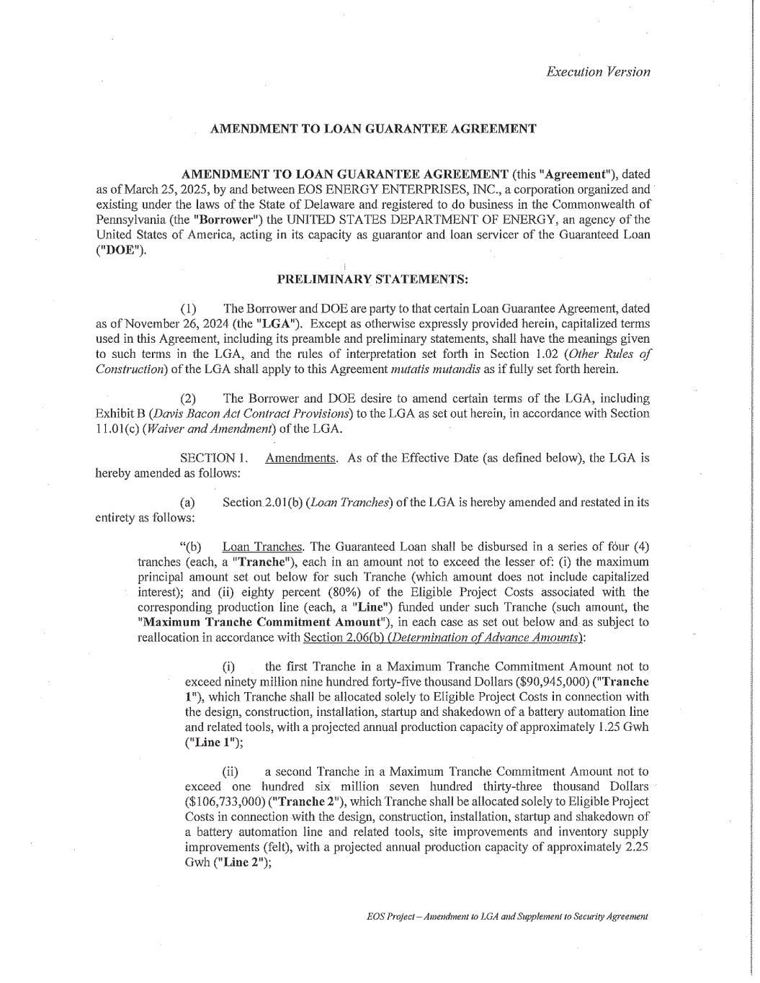

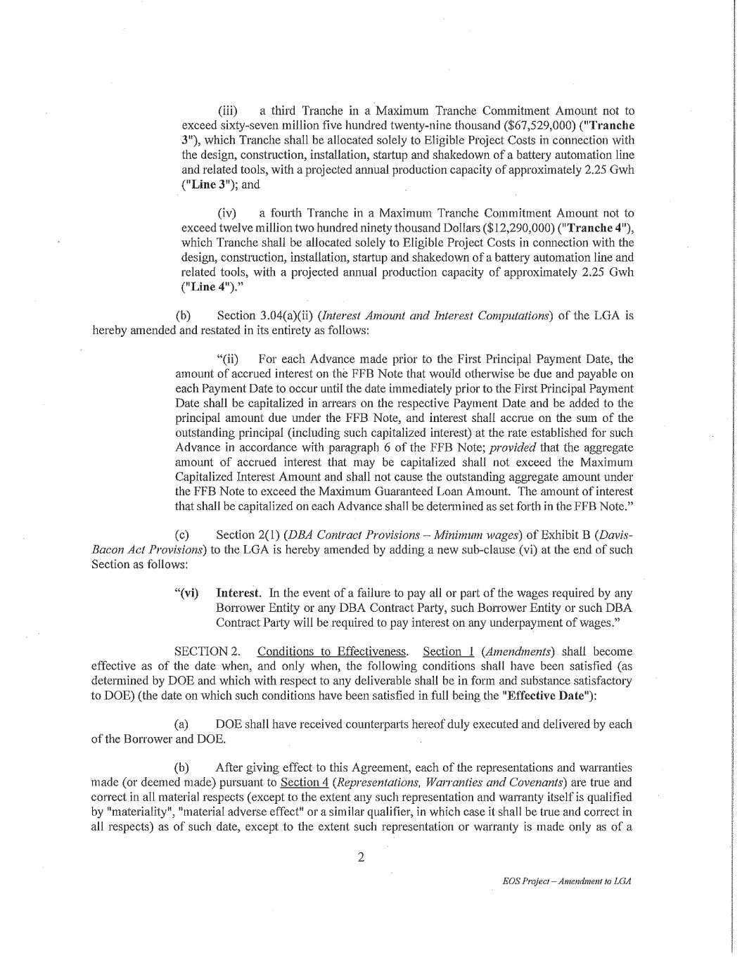

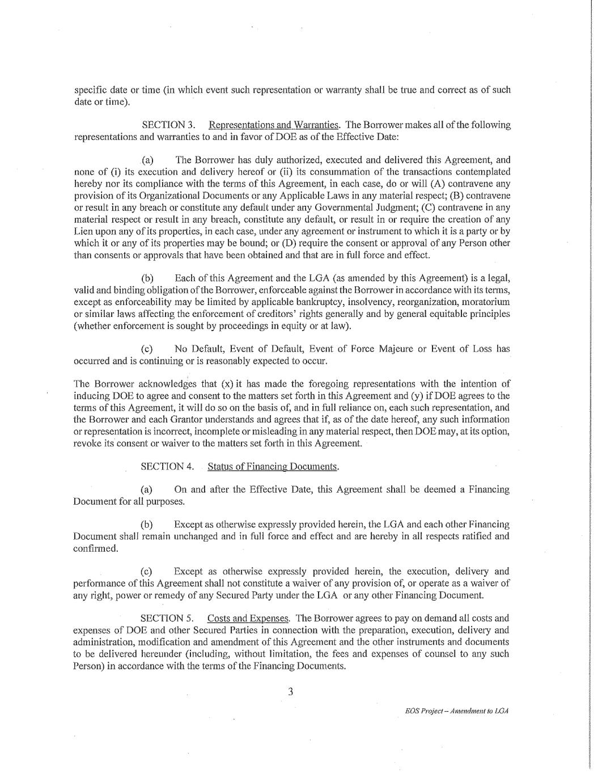





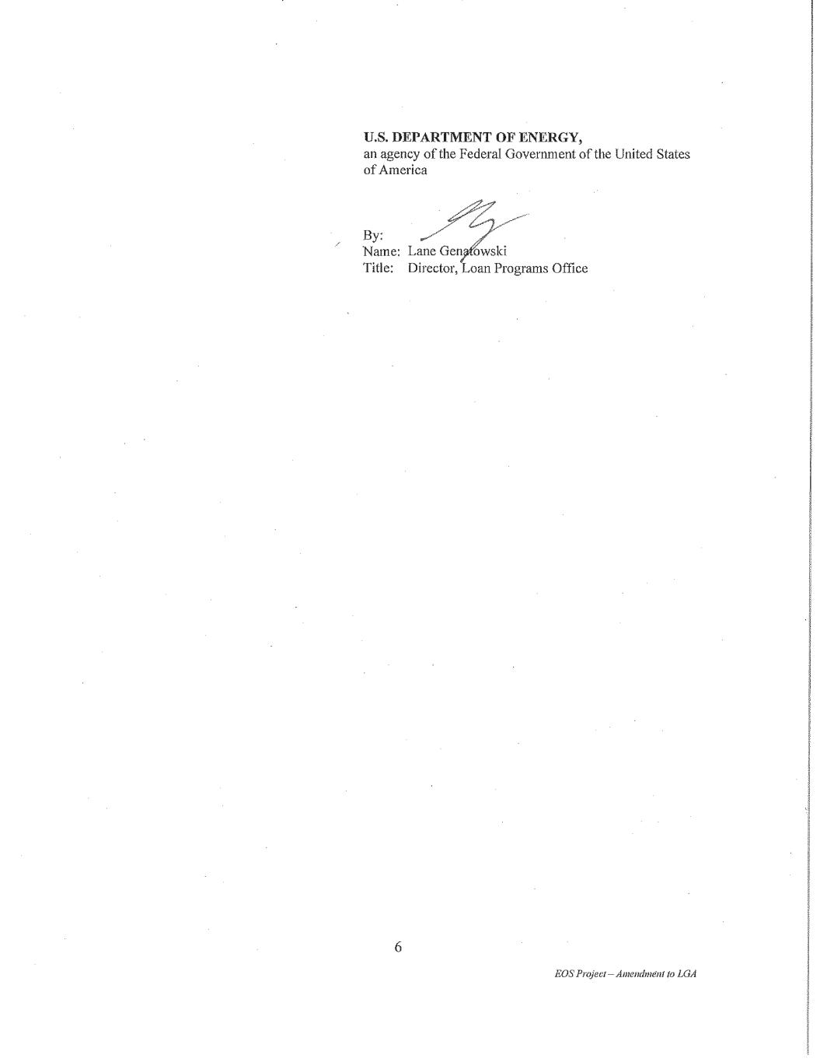

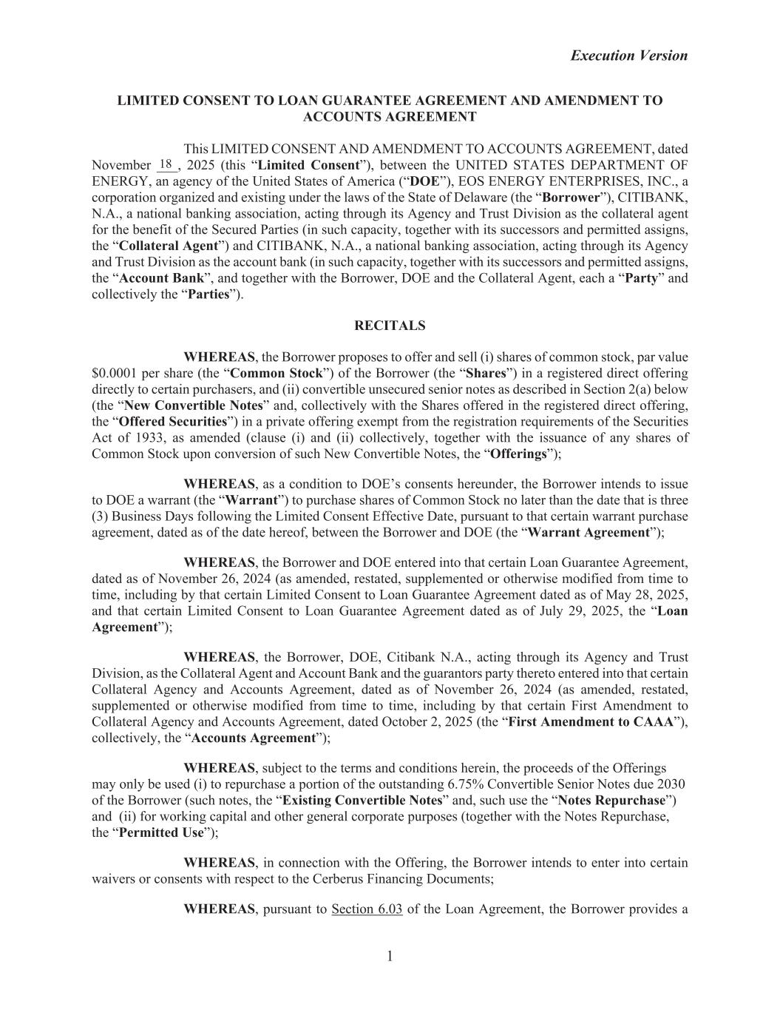
Execution Version 1 LIMITED CONSENT TO LOAN GUARANTEE AGREEMENT AND AMENDMENT TO ACCOUNTS AGREEMENT This LIMITED CONSENT AND AMENDMENT TO ACCOUNTS AGREEMENT, dated November ___, 2025 (this “Limited Consent”), between the UNITED STATES DEPARTMENT OF ENERGY, an agency of the United States of America (“DOE”), EOS ENERGY ENTERPRISES, INC., a corporation organized and existing under the laws of the State of Delaware (the “Borrower”), CITIBANK, N.A., a national banking association, acting through its Agency and Trust Division as the collateral agent for the benefit of the Secured Parties (in such capacity, together with its successors and permitted assigns, the “Collateral Agent”) and CITIBANK, N.A., a national banking association, acting through its Agency and Trust Division as the account bank (in such capacity, together with its successors and permitted assigns, the “Account Bank”, and together with the Borrower, DOE and the Collateral Agent, each a “Party” and collectively the “Parties”). RECITALS WHEREAS, the Borrower proposes to offer and sell (i) shares of common stock, par value $0.0001 per share (the “Common Stock”) of the Borrower (the “Shares”) in a registered direct offering directly to certain purchasers, and (ii) convertible unsecured senior notes as described in Section 2(a) below (the “New Convertible Notes” and, collectively with the Shares offered in the registered direct offering, the “Offered Securities”) in a private offering exempt from the registration requirements of the Securities Act of 1933, as amended (clause (i) and (ii) collectively, together with the issuance of any shares of Common Stock upon conversion of such New Convertible Notes, the “Offerings”); WHEREAS, as a condition to DOE’s consents hereunder, the Borrower intends to issue to DOE a warrant (the “Warrant”) to purchase shares of Common Stock no later than the date that is three (3) Business Days following the Limited Consent Effective Date, pursuant to that certain warrant purchase agreement, dated as of the date hereof, between the Borrower and DOE (the “Warrant Agreement”); WHEREAS, the Borrower and DOE entered into that certain Loan Guarantee Agreement, dated as of November 26, 2024 (as amended, restated, supplemented or otherwise modified from time to time, including by that certain Limited Consent to Loan Guarantee Agreement dated as of May 28, 2025, and that certain Limited Consent to Loan Guarantee Agreement dated as of July 29, 2025, the “Loan Agreement”); WHEREAS, the Borrower, DOE, Citibank N.A., acting through its Agency and Trust Division, as the Collateral Agent and Account Bank and the guarantors party thereto entered into that certain Collateral Agency and Accounts Agreement, dated as of November 26, 2024 (as amended, restated, supplemented or otherwise modified from time to time, including by that certain First Amendment to Collateral Agency and Accounts Agreement, dated October 2, 2025 (the “First Amendment to CAAA”), collectively, the “Accounts Agreement”); WHEREAS, subject to the terms and conditions herein, the proceeds of the Offerings may only be used (i) to repurchase a portion of the outstanding 6.75% Convertible Senior Notes due 2030 of the Borrower (such notes, the “Existing Convertible Notes” and, such use the “Notes Repurchase”) and (ii) for working capital and other general corporate purposes (together with the Notes Repurchase, the “Permitted Use”); WHEREAS, in connection with the Offering, the Borrower intends to enter into certain waivers or consents with respect to the Cerberus Financing Documents; WHEREAS, pursuant to Section 6.03 of the Loan Agreement, the Borrower provides a 18

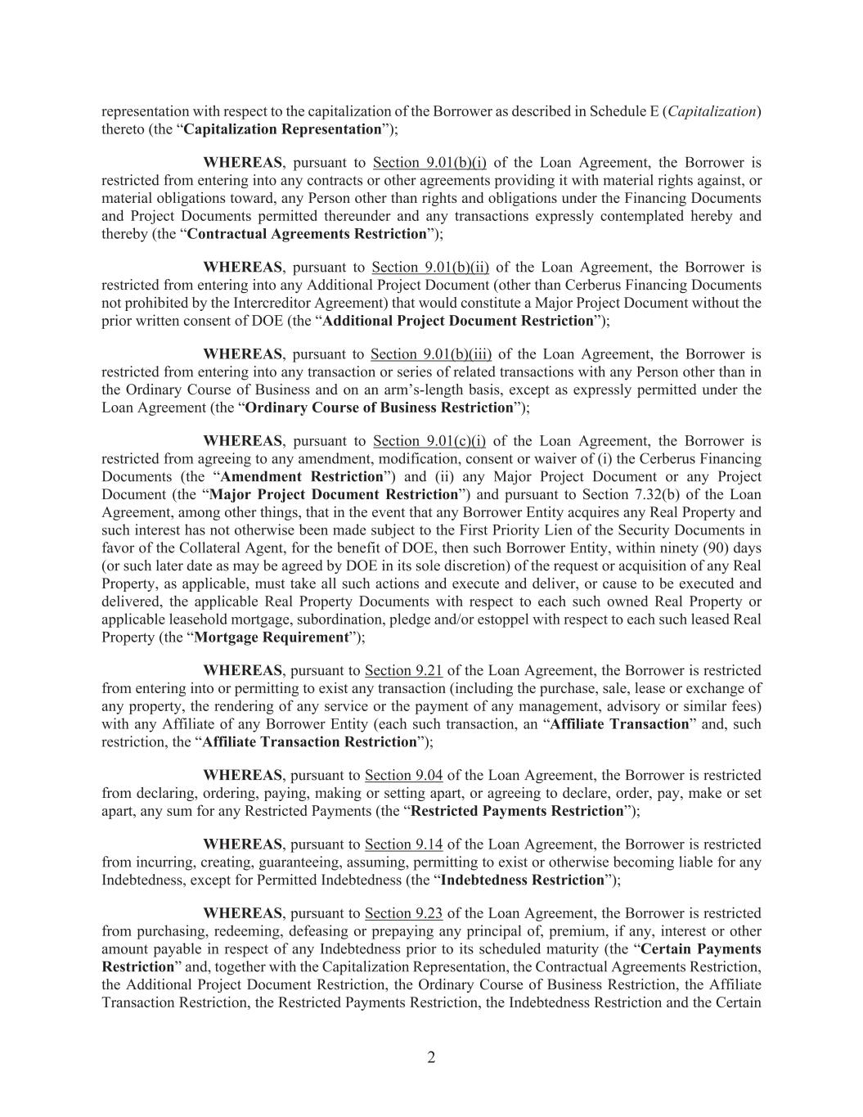
2 representation with respect to the capitalization of the Borrower as described in Schedule E (Capitalization) thereto (the “Capitalization Representation”); WHEREAS, pursuant to Section 9.01(b)(i) of the Loan Agreement, the Borrower is restricted from entering into any contracts or other agreements providing it with material rights against, or material obligations toward, any Person other than rights and obligations under the Financing Documents and Project Documents permitted thereunder and any transactions expressly contemplated hereby and thereby (the “Contractual Agreements Restriction”); WHEREAS, pursuant to Section 9.01(b)(ii) of the Loan Agreement, the Borrower is restricted from entering into any Additional Project Document (other than Cerberus Financing Documents not prohibited by the Intercreditor Agreement) that would constitute a Major Project Document without the prior written consent of DOE (the “Additional Project Document Restriction”); WHEREAS, pursuant to Section 9.01(b)(iii) of the Loan Agreement, the Borrower is restricted from entering into any transaction or series of related transactions with any Person other than in the Ordinary Course of Business and on an arm’s-length basis, except as expressly permitted under the Loan Agreement (the “Ordinary Course of Business Restriction”); WHEREAS, pursuant to Section 9.01(c)(i) of the Loan Agreement, the Borrower is restricted from agreeing to any amendment, modification, consent or waiver of (i) the Cerberus Financing Documents (the “Amendment Restriction”) and (ii) any Major Project Document or any Project Document (the “Major Project Document Restriction”) and pursuant to Section 7.32(b) of the Loan Agreement, among other things, that in the event that any Borrower Entity acquires any Real Property and such interest has not otherwise been made subject to the First Priority Lien of the Security Documents in favor of the Collateral Agent, for the benefit of DOE, then such Borrower Entity, within ninety (90) days (or such later date as may be agreed by DOE in its sole discretion) of the request or acquisition of any Real Property, as applicable, must take all such actions and execute and deliver, or cause to be executed and delivered, the applicable Real Property Documents with respect to each such owned Real Property or applicable leasehold mortgage, subordination, pledge and/or estoppel with respect to each such leased Real Property (the “Mortgage Requirement”); WHEREAS, pursuant to Section 9.21 of the Loan Agreement, the Borrower is restricted from entering into or permitting to exist any transaction (including the purchase, sale, lease or exchange of any property, the rendering of any service or the payment of any management, advisory or similar fees) with any Affiliate of any Borrower Entity (each such transaction, an “Affiliate Transaction” and, such restriction, the “Affiliate Transaction Restriction”); WHEREAS, pursuant to Section 9.04 of the Loan Agreement, the Borrower is restricted from declaring, ordering, paying, making or setting apart, or agreeing to declare, order, pay, make or set apart, any sum for any Restricted Payments (the “Restricted Payments Restriction”); WHEREAS, pursuant to Section 9.14 of the Loan Agreement, the Borrower is restricted from incurring, creating, guaranteeing, assuming, permitting to exist or otherwise becoming liable for any Indebtedness, except for Permitted Indebtedness (the “Indebtedness Restriction”); WHEREAS, pursuant to Section 9.23 of the Loan Agreement, the Borrower is restricted from purchasing, redeeming, defeasing or prepaying any principal of, premium, if any, interest or other amount payable in respect of any Indebtedness prior to its scheduled maturity (the “Certain Payments Restriction” and, together with the Capitalization Representation, the Contractual Agreements Restriction, the Additional Project Document Restriction, the Ordinary Course of Business Restriction, the Affiliate Transaction Restriction, the Restricted Payments Restriction, the Indebtedness Restriction and the Certain

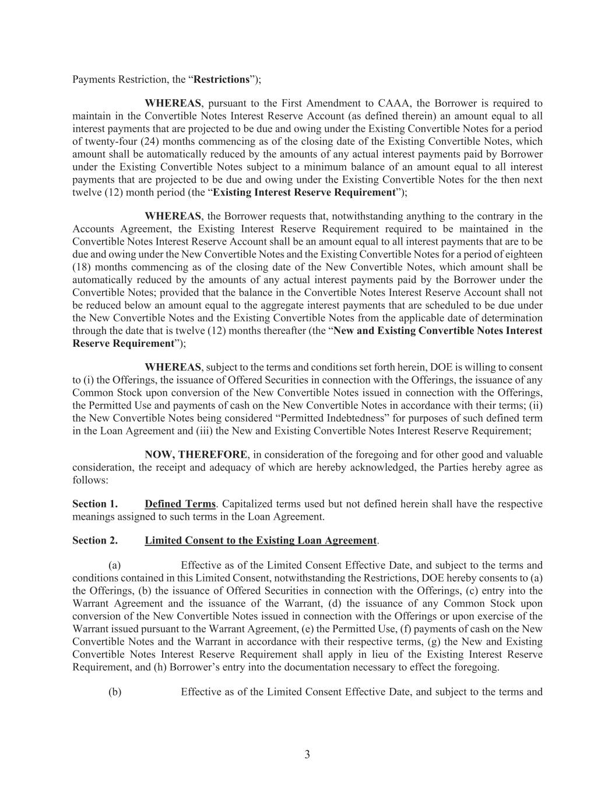
3 Payments Restriction, the “Restrictions”); WHEREAS, pursuant to the First Amendment to CAAA, the Borrower is required to maintain in the Convertible Notes Interest Reserve Account (as defined therein) an amount equal to all interest payments that are projected to be due and owing under the Existing Convertible Notes for a period of twenty-four (24) months commencing as of the closing date of the Existing Convertible Notes, which amount shall be automatically reduced by the amounts of any actual interest payments paid by Borrower under the Existing Convertible Notes subject to a minimum balance of an amount equal to all interest payments that are projected to be due and owing under the Existing Convertible Notes for the then next twelve (12) month period (the “Existing Interest Reserve Requirement”); WHEREAS, the Borrower requests that, notwithstanding anything to the contrary in the Accounts Agreement, the Existing Interest Reserve Requirement required to be maintained in the Convertible Notes Interest Reserve Account shall be an amount equal to all interest payments that are to be due and owing under the New Convertible Notes and the Existing Convertible Notes for a period of eighteen (18) months commencing as of the closing date of the New Convertible Notes, which amount shall be automatically reduced by the amounts of any actual interest payments paid by the Borrower under the Convertible Notes; provided that the balance in the Convertible Notes Interest Reserve Account shall not be reduced below an amount equal to the aggregate interest payments that are scheduled to be due under the New Convertible Notes and the Existing Convertible Notes from the applicable date of determination through the date that is twelve (12) months thereafter (the “New and Existing Convertible Notes Interest Reserve Requirement”); WHEREAS, subject to the terms and conditions set forth herein, DOE is willing to consent to (i) the Offerings, the issuance of Offered Securities in connection with the Offerings, the issuance of any Common Stock upon conversion of the New Convertible Notes issued in connection with the Offerings, the Permitted Use and payments of cash on the New Convertible Notes in accordance with their terms; (ii) the New Convertible Notes being considered “Permitted Indebtedness” for purposes of such defined term in the Loan Agreement and (iii) the New and Existing Convertible Notes Interest Reserve Requirement; NOW, THEREFORE, in consideration of the foregoing and for other good and valuable consideration, the receipt and adequacy of which are hereby acknowledged, the Parties hereby agree as follows: Section 1. Defined Terms. Capitalized terms used but not defined herein shall have the respective meanings assigned to such terms in the Loan Agreement. Section 2. Limited Consent to the Existing Loan Agreement. (a) Effective as of the Limited Consent Effective Date, and subject to the terms and conditions contained in this Limited Consent, notwithstanding the Restrictions, DOE hereby consents to (a) the Offerings, (b) the issuance of Offered Securities in connection with the Offerings, (c) entry into the Warrant Agreement and the issuance of the Warrant, (d) the issuance of any Common Stock upon conversion of the New Convertible Notes issued in connection with the Offerings or upon exercise of the Warrant issued pursuant to the Warrant Agreement, (e) the Permitted Use, (f) payments of cash on the New Convertible Notes and the Warrant in accordance with their respective terms, (g) the New and Existing Convertible Notes Interest Reserve Requirement shall apply in lieu of the Existing Interest Reserve Requirement, and (h) Borrower’s entry into the documentation necessary to effect the foregoing. (b) Effective as of the Limited Consent Effective Date, and subject to the terms and

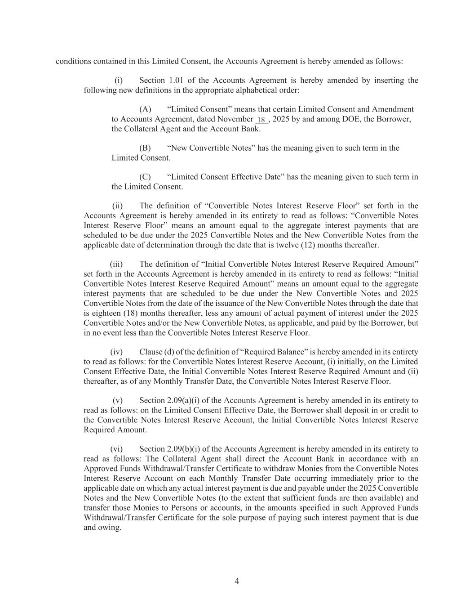
4 conditions contained in this Limited Consent, the Accounts Agreement is hereby amended as follows: (i) Section 1.01 of the Accounts Agreement is hereby amended by inserting the following new definitions in the appropriate alphabetical order: (A) “Limited Consent” means that certain Limited Consent and Amendment to Accounts Agreement, dated November ___, 2025 by and among DOE, the Borrower, the Collateral Agent and the Account Bank. (B) “New Convertible Notes” has the meaning given to such term in the Limited Consent. (C) “Limited Consent Effective Date” has the meaning given to such term in the Limited Consent. (ii) The definition of “Convertible Notes Interest Reserve Floor” set forth in the Accounts Agreement is hereby amended in its entirety to read as follows: “Convertible Notes Interest Reserve Floor” means an amount equal to the aggregate interest payments that are scheduled to be due under the 2025 Convertible Notes and the New Convertible Notes from the applicable date of determination through the date that is twelve (12) months thereafter. (iii) The definition of “Initial Convertible Notes Interest Reserve Required Amount” set forth in the Accounts Agreement is hereby amended in its entirety to read as follows: “Initial Convertible Notes Interest Reserve Required Amount” means an amount equal to the aggregate interest payments that are scheduled to be due under the New Convertible Notes and 2025 Convertible Notes from the date of the issuance of the New Convertible Notes through the date that is eighteen (18) months thereafter, less any amount of actual payment of interest under the 2025 Convertible Notes and/or the New Convertible Notes, as applicable, and paid by the Borrower, but in no event less than the Convertible Notes Interest Reserve Floor. (iv) Clause (d) of the definition of “Required Balance” is hereby amended in its entirety to read as follows: for the Convertible Notes Interest Reserve Account, (i) initially, on the Limited Consent Effective Date, the Initial Convertible Notes Interest Reserve Required Amount and (ii) thereafter, as of any Monthly Transfer Date, the Convertible Notes Interest Reserve Floor. (v) Section 2.09(a)(i) of the Accounts Agreement is hereby amended in its entirety to read as follows: on the Limited Consent Effective Date, the Borrower shall deposit in or credit to the Convertible Notes Interest Reserve Account, the Initial Convertible Notes Interest Reserve Required Amount. (vi) Section 2.09(b)(i) of the Accounts Agreement is hereby amended in its entirety to read as follows: The Collateral Agent shall direct the Account Bank in accordance with an Approved Funds Withdrawal/Transfer Certificate to withdraw Monies from the Convertible Notes Interest Reserve Account on each Monthly Transfer Date occurring immediately prior to the applicable date on which any actual interest payment is due and payable under the 2025 Convertible Notes and the New Convertible Notes (to the extent that sufficient funds are then available) and transfer those Monies to Persons or accounts, in the amounts specified in such Approved Funds Withdrawal/Transfer Certificate for the sole purpose of paying such interest payment that is due and owing. 18

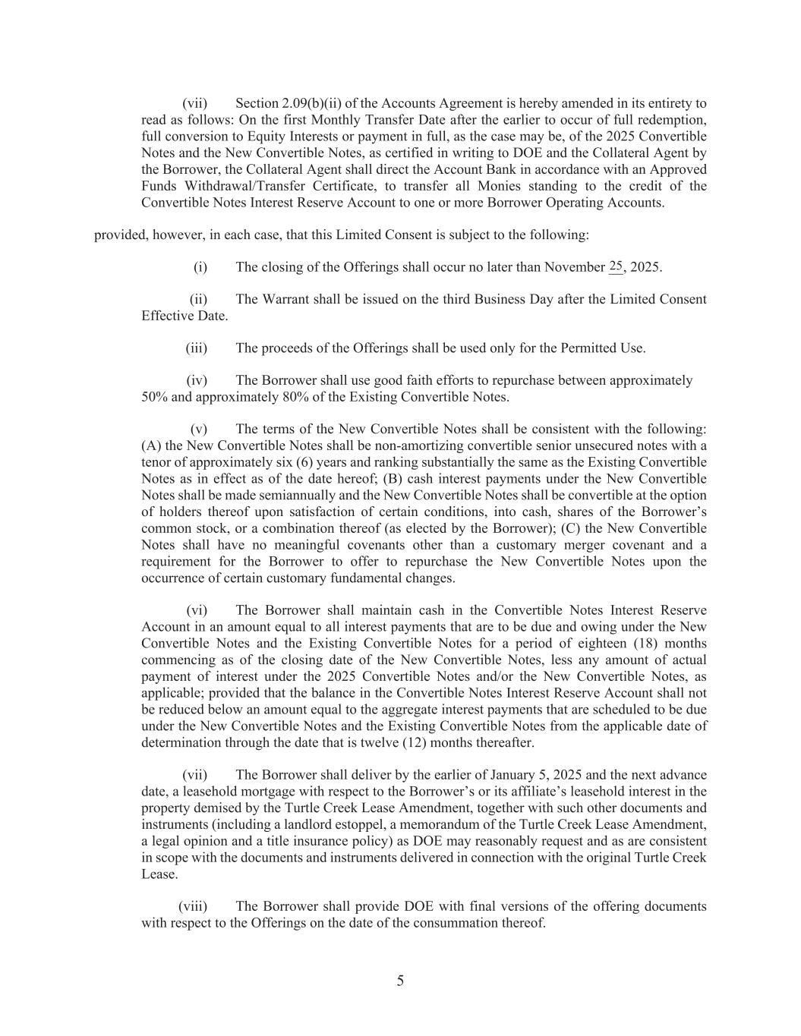
5 (vii) Section 2.09(b)(ii) of the Accounts Agreement is hereby amended in its entirety to read as follows: On the first Monthly Transfer Date after the earlier to occur of full redemption, full conversion to Equity Interests or payment in full, as the case may be, of the 2025 Convertible Notes and the New Convertible Notes, as certified in writing to DOE and the Collateral Agent by the Borrower, the Collateral Agent shall direct the Account Bank in accordance with an Approved Funds Withdrawal/Transfer Certificate, to transfer all Monies standing to the credit of the Convertible Notes Interest Reserve Account to one or more Borrower Operating Accounts. provided, however, in each case, that this Limited Consent is subject to the following: (i) The closing of the Offerings shall occur no later than November __, 2025. (ii) The Warrant shall be issued on the third Business Day after the Limited Consent Effective Date. (iii) The proceeds of the Offerings shall be used only for the Permitted Use. (iv) The Borrower shall use good faith efforts to repurchase between approximately 50% and approximately 80% of the Existing Convertible Notes. (v) The terms of the New Convertible Notes shall be consistent with the following: (A) the New Convertible Notes shall be non-amortizing convertible senior unsecured notes with a tenor of approximately six (6) years and ranking substantially the same as the Existing Convertible Notes as in effect as of the date hereof; (B) cash interest payments under the New Convertible Notes shall be made semiannually and the New Convertible Notes shall be convertible at the option of holders thereof upon satisfaction of certain conditions, into cash, shares of the Borrower’s common stock, or a combination thereof (as elected by the Borrower); (C) the New Convertible Notes shall have no meaningful covenants other than a customary merger covenant and a requirement for the Borrower to offer to repurchase the New Convertible Notes upon the occurrence of certain customary fundamental changes. (vi) The Borrower shall maintain cash in the Convertible Notes Interest Reserve Account in an amount equal to all interest payments that are to be due and owing under the New Convertible Notes and the Existing Convertible Notes for a period of eighteen (18) months commencing as of the closing date of the New Convertible Notes, less any amount of actual payment of interest under the 2025 Convertible Notes and/or the New Convertible Notes, as applicable; provided that the balance in the Convertible Notes Interest Reserve Account shall not be reduced below an amount equal to the aggregate interest payments that are scheduled to be due under the New Convertible Notes and the Existing Convertible Notes from the applicable date of determination through the date that is twelve (12) months thereafter. (vii) The Borrower shall deliver by the earlier of January 5, 2025 and the next advance date, a leasehold mortgage with respect to the Borrower’s or its affiliate’s leasehold interest in the property demised by the Turtle Creek Lease Amendment, together with such other documents and instruments (including a landlord estoppel, a memorandum of the Turtle Creek Lease Amendment, a legal opinion and a title insurance policy) as DOE may reasonably request and as are consistent in scope with the documents and instruments delivered in connection with the original Turtle Creek Lease. (viii) The Borrower shall provide DOE with final versions of the offering documents with respect to the Offerings on the date of the consummation thereof. 25

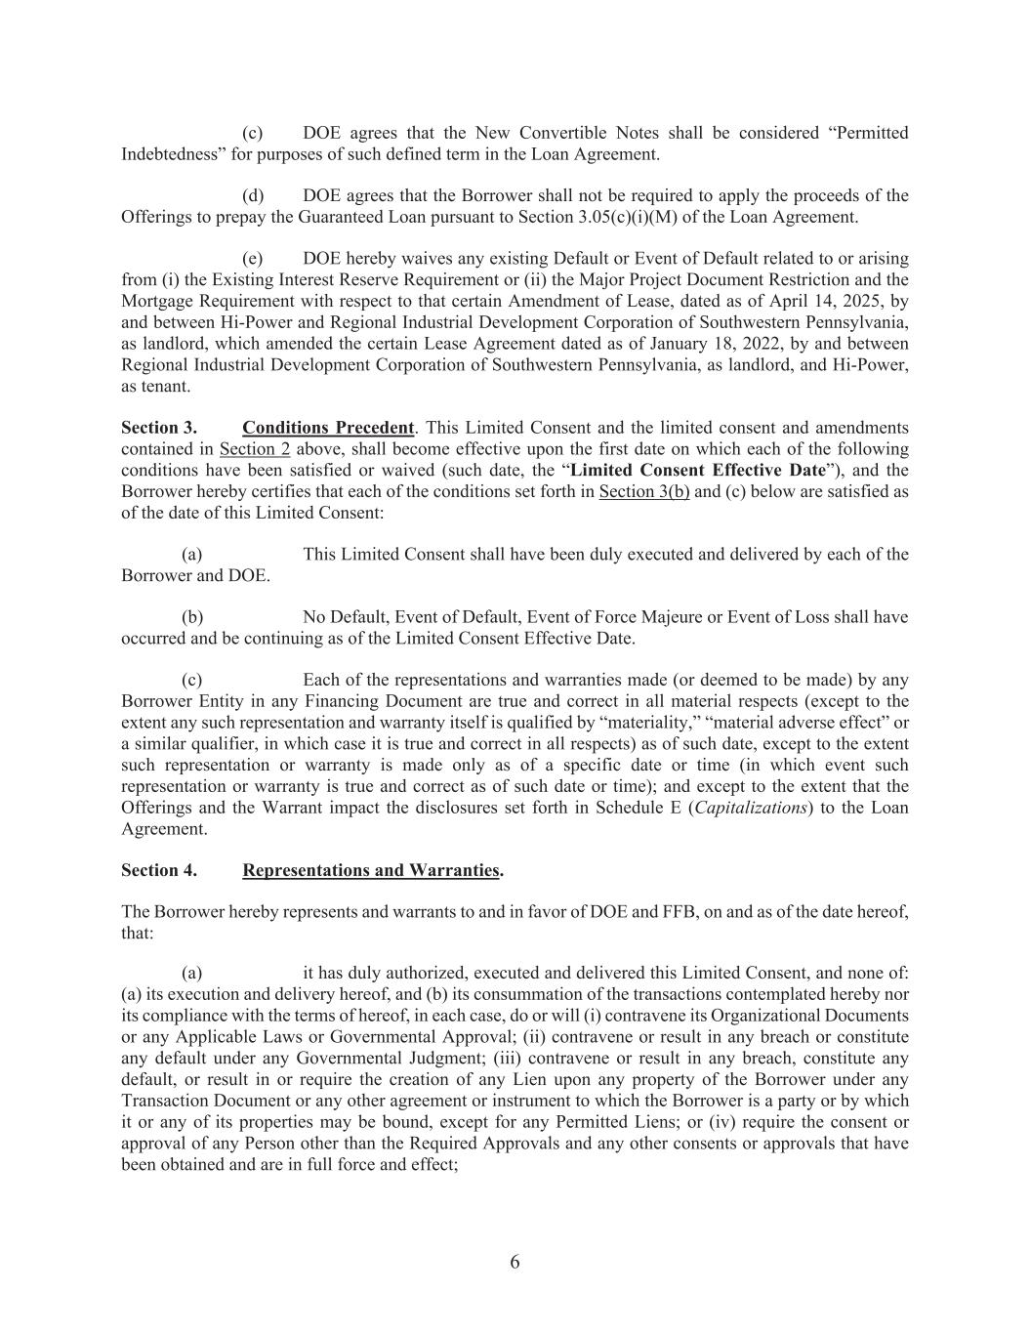
6 (c) DOE agrees that the New Convertible Notes shall be considered “Permitted Indebtedness” for purposes of such defined term in the Loan Agreement. (d) DOE agrees that the Borrower shall not be required to apply the proceeds of the Offerings to prepay the Guaranteed Loan pursuant to Section 3.05(c)(i)(M) of the Loan Agreement. (e) DOE hereby waives any existing Default or Event of Default related to or arising from (i) the Existing Interest Reserve Requirement or (ii) the Major Project Document Restriction and the Mortgage Requirement with respect to that certain Amendment of Lease, dated as of April 14, 2025, by and between Hi-Power and Regional Industrial Development Corporation of Southwestern Pennsylvania, as landlord, which amended the certain Lease Agreement dated as of January 18, 2022, by and between Regional Industrial Development Corporation of Southwestern Pennsylvania, as landlord, and Hi-Power, as tenant. Section 3. Conditions Precedent. This Limited Consent and the limited consent and amendments contained in Section 2 above, shall become effective upon the first date on which each of the following conditions have been satisfied or waived (such date, the “Limited Consent Effective Date”), and the Borrower hereby certifies that each of the conditions set forth in Section 3(b) and (c) below are satisfied as of the date of this Limited Consent: (a) This Limited Consent shall have been duly executed and delivered by each of the Borrower and DOE. (b) No Default, Event of Default, Event of Force Majeure or Event of Loss shall have occurred and be continuing as of the Limited Consent Effective Date. (c) Each of the representations and warranties made (or deemed to be made) by any Borrower Entity in any Financing Document are true and correct in all material respects (except to the extent any such representation and warranty itself is qualified by “materiality,” “material adverse effect” or a similar qualifier, in which case it is true and correct in all respects) as of such date, except to the extent such representation or warranty is made only as of a specific date or time (in which event such representation or warranty is true and correct as of such date or time); and except to the extent that the Offerings and the Warrant impact the disclosures set forth in Schedule E (Capitalizations) to the Loan Agreement. Section 4. Representations and Warranties. The Borrower hereby represents and warrants to and in favor of DOE and FFB, on and as of the date hereof, that: (a) it has duly authorized, executed and delivered this Limited Consent, and none of: (a) its execution and delivery hereof, and (b) its consummation of the transactions contemplated hereby nor its compliance with the terms of hereof, in each case, do or will (i) contravene its Organizational Documents or any Applicable Laws or Governmental Approval; (ii) contravene or result in any breach or constitute any default under any Governmental Judgment; (iii) contravene or result in any breach, constitute any default, or result in or require the creation of any Lien upon any property of the Borrower under any Transaction Document or any other agreement or instrument to which the Borrower is a party or by which it or any of its properties may be bound, except for any Permitted Liens; or (iv) require the consent or approval of any Person other than the Required Approvals and any other consents or approvals that have been obtained and are in full force and effect;

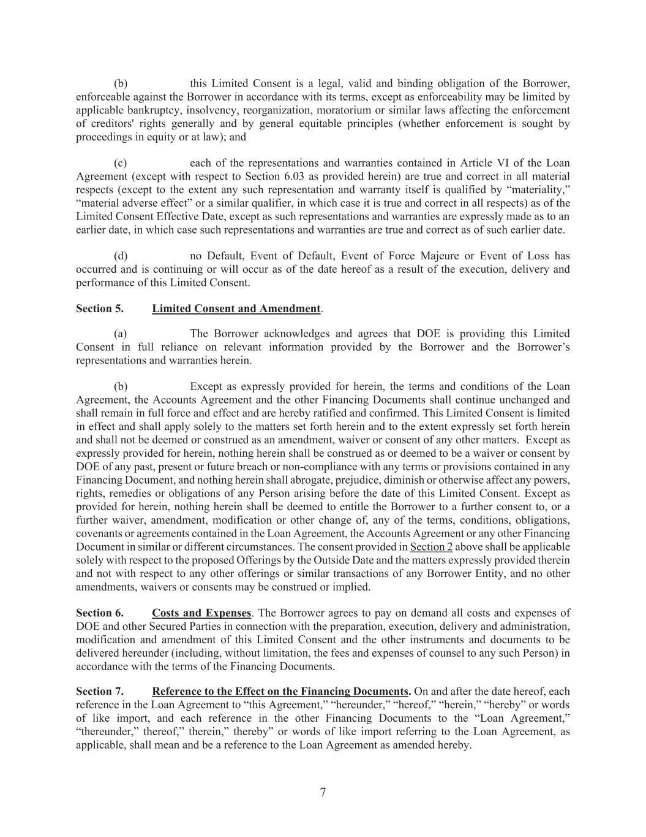
7 (b) this Limited Consent is a legal, valid and binding obligation of the Borrower, enforceable against the Borrower in accordance with its terms, except as enforceability may be limited by applicable bankruptcy, insolvency, reorganization, moratorium or similar laws affecting the enforcement of creditors' rights generally and by general equitable principles (whether enforcement is sought by proceedings in equity or at law); and (c) each of the representations and warranties contained in Article VI of the Loan Agreement (except with respect to Section 6.03 as provided herein) are true and correct in all material respects (except to the extent any such representation and warranty itself is qualified by “materiality,” “material adverse effect” or a similar qualifier, in which case it is true and correct in all respects) as of the Limited Consent Effective Date, except as such representations and warranties are expressly made as to an earlier date, in which case such representations and warranties are true and correct as of such earlier date. (d) no Default, Event of Default, Event of Force Majeure or Event of Loss has occurred and is continuing or will occur as of the date hereof as a result of the execution, delivery and performance of this Limited Consent. Section 5. Limited Consent and Amendment. (a) The Borrower acknowledges and agrees that DOE is providing this Limited Consent in full reliance on relevant information provided by the Borrower and the Borrower’s representations and warranties herein. (b) Except as expressly provided for herein, the terms and conditions of the Loan Agreement, the Accounts Agreement and the other Financing Documents shall continue unchanged and shall remain in full force and effect and are hereby ratified and confirmed. This Limited Consent is limited in effect and shall apply solely to the matters set forth herein and to the extent expressly set forth herein and shall not be deemed or construed as an amendment, waiver or consent of any other matters. Except as expressly provided for herein, nothing herein shall be construed as or deemed to be a waiver or consent by DOE of any past, present or future breach or non-compliance with any terms or provisions contained in any Financing Document, and nothing herein shall abrogate, prejudice, diminish or otherwise affect any powers, rights, remedies or obligations of any Person arising before the date of this Limited Consent. Except as provided for herein, nothing herein shall be deemed to entitle the Borrower to a further consent to, or a further waiver, amendment, modification or other change of, any of the terms, conditions, obligations, covenants or agreements contained in the Loan Agreement, the Accounts Agreement or any other Financing Document in similar or different circumstances. The consent provided in Section 2 above shall be applicable solely with respect to the proposed Offerings by the Outside Date and the matters expressly provided therein and not with respect to any other offerings or similar transactions of any Borrower Entity, and no other amendments, waivers or consents may be construed or implied. Section 6. Costs and Expenses. The Borrower agrees to pay on demand all costs and expenses of DOE and other Secured Parties in connection with the preparation, execution, delivery and administration, modification and amendment of this Limited Consent and the other instruments and documents to be delivered hereunder (including, without limitation, the fees and expenses of counsel to any such Person) in accordance with the terms of the Financing Documents. Section 7. Reference to the Effect on the Financing Documents. On and after the date hereof, each reference in the Loan Agreement to “this Agreement,” “hereunder,” “hereof,” “herein,” “hereby” or words of like import, and each reference in the other Financing Documents to the “Loan Agreement,” “thereunder,” thereof,” therein,” thereby” or words of like import referring to the Loan Agreement, as applicable, shall mean and be a reference to the Loan Agreement as amended hereby.

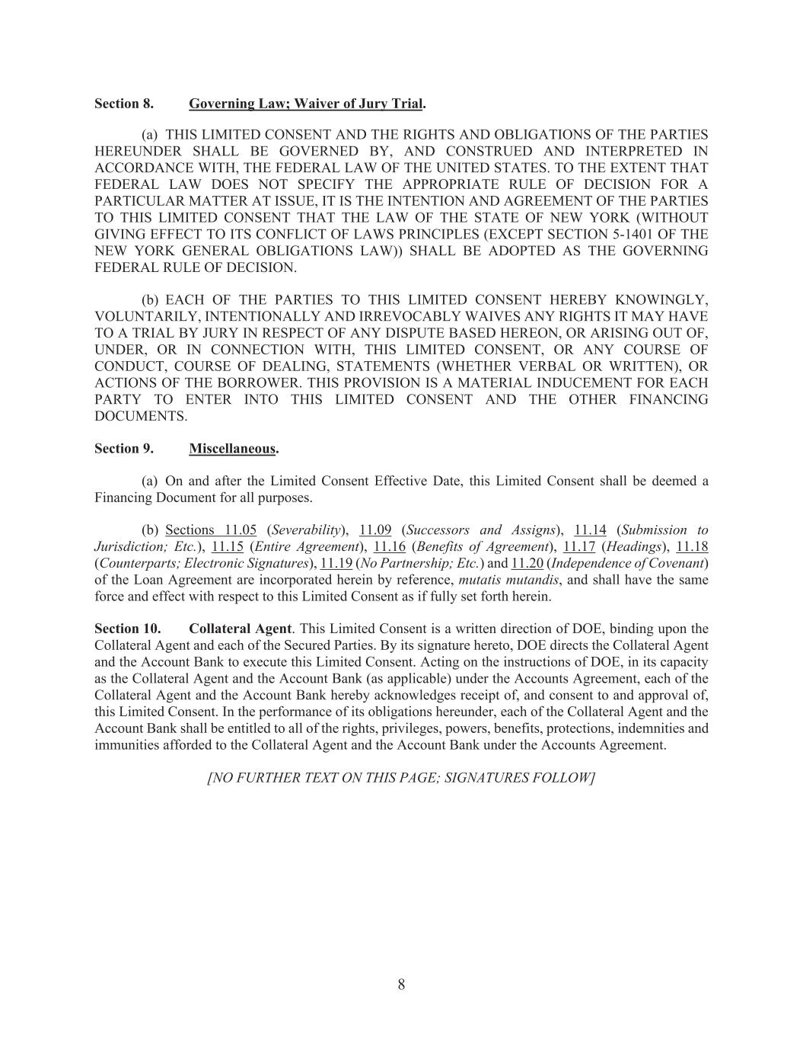
8 Section 8. Governing Law; Waiver of Jury Trial. (a) THIS LIMITED CONSENT AND THE RIGHTS AND OBLIGATIONS OF THE PARTIES HEREUNDER SHALL BE GOVERNED BY, AND CONSTRUED AND INTERPRETED IN ACCORDANCE WITH, THE FEDERAL LAW OF THE UNITED STATES. TO THE EXTENT THAT FEDERAL LAW DOES NOT SPECIFY THE APPROPRIATE RULE OF DECISION FOR A PARTICULAR MATTER AT ISSUE, IT IS THE INTENTION AND AGREEMENT OF THE PARTIES TO THIS LIMITED CONSENT THAT THE LAW OF THE STATE OF NEW YORK (WITHOUT GIVING EFFECT TO ITS CONFLICT OF LAWS PRINCIPLES (EXCEPT SECTION 5-1401 OF THE NEW YORK GENERAL OBLIGATIONS LAW)) SHALL BE ADOPTED AS THE GOVERNING FEDERAL RULE OF DECISION. (b) EACH OF THE PARTIES TO THIS LIMITED CONSENT HEREBY KNOWINGLY, VOLUNTARILY, INTENTIONALLY AND IRREVOCABLY WAIVES ANY RIGHTS IT MAY HAVE TO A TRIAL BY JURY IN RESPECT OF ANY DISPUTE BASED HEREON, OR ARISING OUT OF, UNDER, OR IN CONNECTION WITH, THIS LIMITED CONSENT, OR ANY COURSE OF CONDUCT, COURSE OF DEALING, STATEMENTS (WHETHER VERBAL OR WRITTEN), OR ACTIONS OF THE BORROWER. THIS PROVISION IS A MATERIAL INDUCEMENT FOR EACH PARTY TO ENTER INTO THIS LIMITED CONSENT AND THE OTHER FINANCING DOCUMENTS. Section 9. Miscellaneous. (a) On and after the Limited Consent Effective Date, this Limited Consent shall be deemed a Financing Document for all purposes. (b) Sections 11.05 (Severability), 11.09 (Successors and Assigns), 11.14 (Submission to Jurisdiction; Etc.), 11.15 (Entire Agreement), 11.16 (Benefits of Agreement), 11.17 (Headings), 11.18 (Counterparts; Electronic Signatures), 11.19 (No Partnership; Etc.) and 11.20 (Independence of Covenant) of the Loan Agreement are incorporated herein by reference, mutatis mutandis, and shall have the same force and effect with respect to this Limited Consent as if fully set forth herein. Section 10. Collateral Agent. This Limited Consent is a written direction of DOE, binding upon the Collateral Agent and each of the Secured Parties. By its signature hereto, DOE directs the Collateral Agent and the Account Bank to execute this Limited Consent. Acting on the instructions of DOE, in its capacity as the Collateral Agent and the Account Bank (as applicable) under the Accounts Agreement, each of the Collateral Agent and the Account Bank hereby acknowledges receipt of, and consent to and approval of, this Limited Consent. In the performance of its obligations hereunder, each of the Collateral Agent and the Account Bank shall be entitled to all of the rights, privileges, powers, benefits, protections, indemnities and immunities afforded to the Collateral Agent and the Account Bank under the Accounts Agreement. [NO FURTHER TEXT ON THIS PAGE; SIGNATURES FOLLOW]

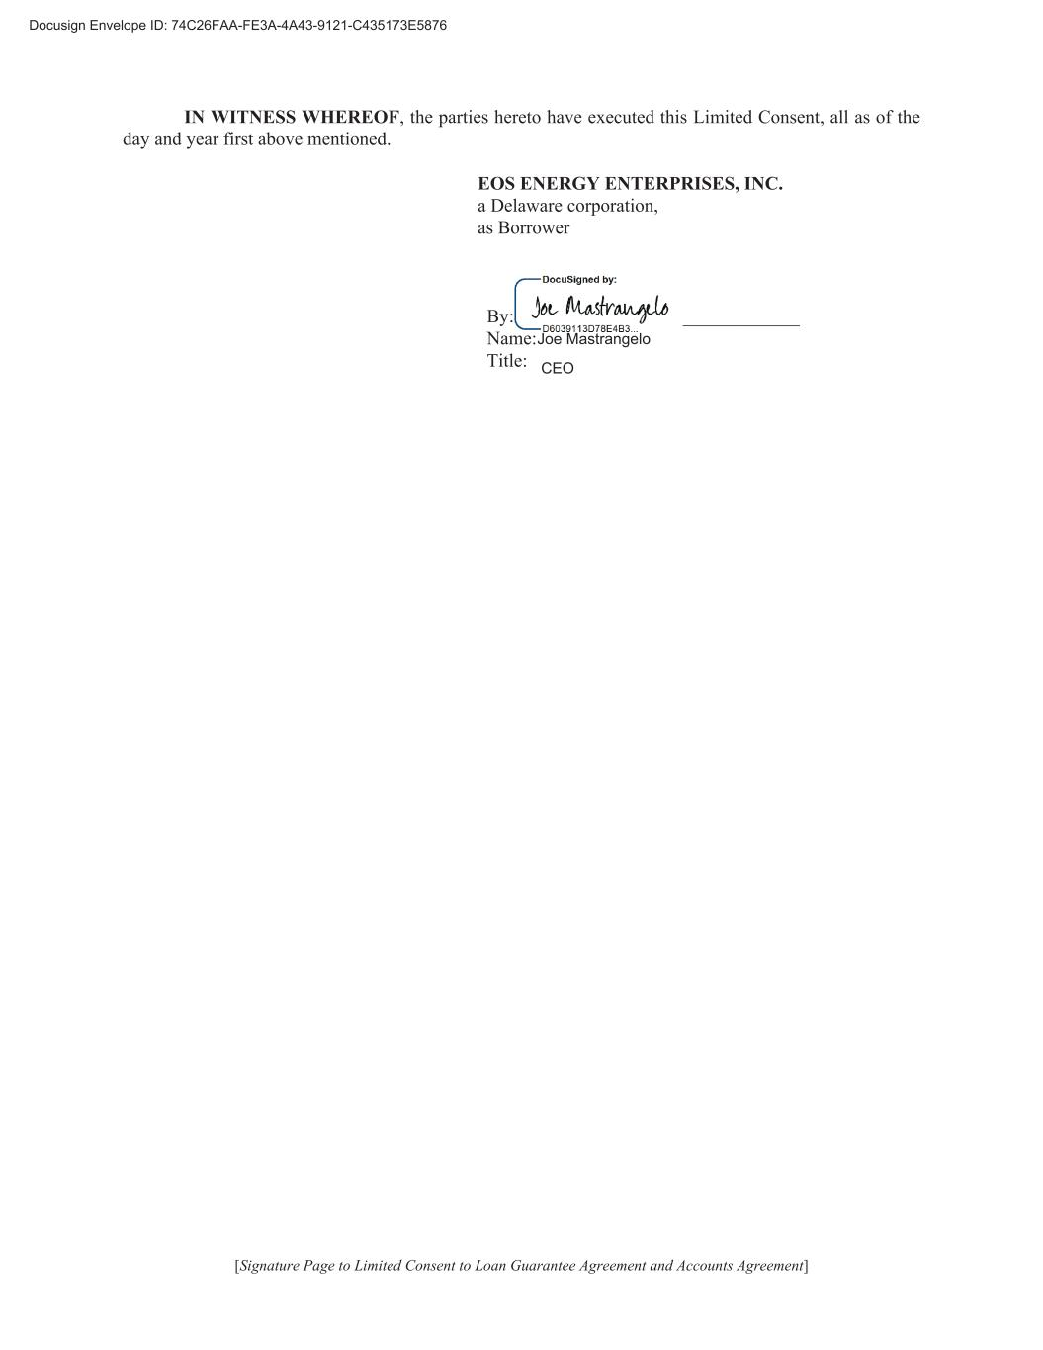
IN WITNESS WHEREOF, the parties hereto have executed this Limited Consent, all as of the day and year first above mentioned. EOS ENERGY ENTERPRISES, INC. a Delaware corporation, as Borrower By: ______________________________ Name: Title: [Signature Page to Limited Consent to Loan Guarantee Agreement and Accounts Agreement]


[Signature Page to Limited Consent to Loan Guarantee Agreement and Accounts Agreement] U.S. DEPARTMENT OF ENERGY, an agency of the federal government of the United States of America By: ______________________________ Name: Title: Rupinder Kaur Director, Portfolio Management Division Loan Programs Office Rupinder Kaur Digitally signed by Rupinder Kaur Date: 2025.11.17 23:54:42 -05'00'


[Signature Page to Limited Consent to Loan Guarantee Agreement and Accounts Agreement] CITIBANK, N.A., acting through its Agency and Trust Division, not in its individual capacity but solely as Collateral Agent By: ______________________________ Name: Marion Zinowski Title: Senior Trust Officer


[Signature Page to Limited Consent to Loan Guarantee Agreement and Accounts Agreement] CITIBANK, N.A., acting through its Agency and Trust Division, not in its individual capacity but solely as Account Bank By: ______________________________ Name: Marion Zinowski Title: Senior Trust Officer

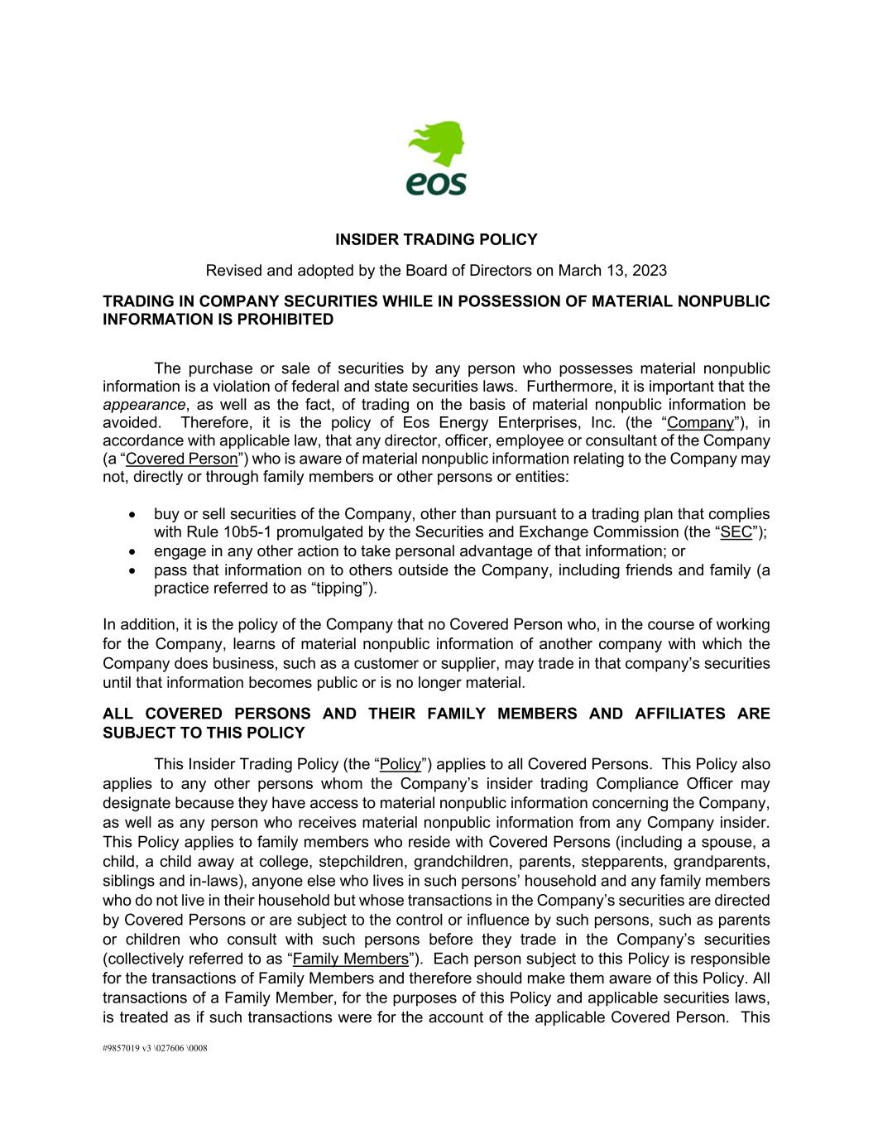
#9857019 v3 \027606 \0008 INSIDER TRADING POLICY Revised and adopted by the Board of Directors on March 13, 2023 TRADING IN COMPANY SECURITIES WHILE IN POSSESSION OF MATERIAL NONPUBLIC INFORMATION IS PROHIBITED The purchase or sale of securities by any person who possesses material nonpublic information is a violation of federal and state securities laws. Furthermore, it is important that the appearance, as well as the fact, of trading on the basis of material nonpublic information be avoided. Therefore, it is the policy of Eos Energy Enterprises, Inc. (the “Company”), in accordance with applicable law, that any director, officer, employee or consultant of the Company (a “Covered Person”) who is aware of material nonpublic information relating to the Company may not, directly or through family members or other persons or entities: • buy or sell securities of the Company, other than pursuant to a trading plan that complies with Rule 10b5-1 promulgated by the Securities and Exchange Commission (the “SEC”); • engage in any other action to take personal advantage of that information; or • pass that information on to others outside the Company, including friends and family (a practice referred to as “tipping”). In addition, it is the policy of the Company that no Covered Person who, in the course of working for the Company, learns of material nonpublic information of another company with which the Company does business, such as a customer or supplier, may trade in that company’s securities until that information becomes public or is no longer material. ALL COVERED PERSONS AND THEIR FAMILY MEMBERS AND AFFILIATES ARE SUBJECT TO THIS POLICY This Insider Trading Policy (the “Policy”) applies to all Covered Persons. This Policy also applies to any other persons whom the Company’s insider trading Compliance Officer may designate because they have access to material nonpublic information concerning the Company, as well as any person who receives material nonpublic information from any Company insider. This Policy applies to family members who reside with Covered Persons (including a spouse, a child, a child away at college, stepchildren, grandchildren, parents, stepparents, grandparents, siblings and in-laws), anyone else who lives in such persons’ household and any family members who do not live in their household but whose transactions in the Company’s securities are directed by Covered Persons or are subject to the control or influence by such persons, such as parents or children who consult with such persons before they trade in the Company’s securities (collectively referred to as “Family Members”). Each person subject to this Policy is responsible for the transactions of Family Members and therefore should make them aware of this Policy. All transactions of a Family Member, for the purposes of this Policy and applicable securities laws, is treated as if such transactions were for the account of the applicable Covered Person. This

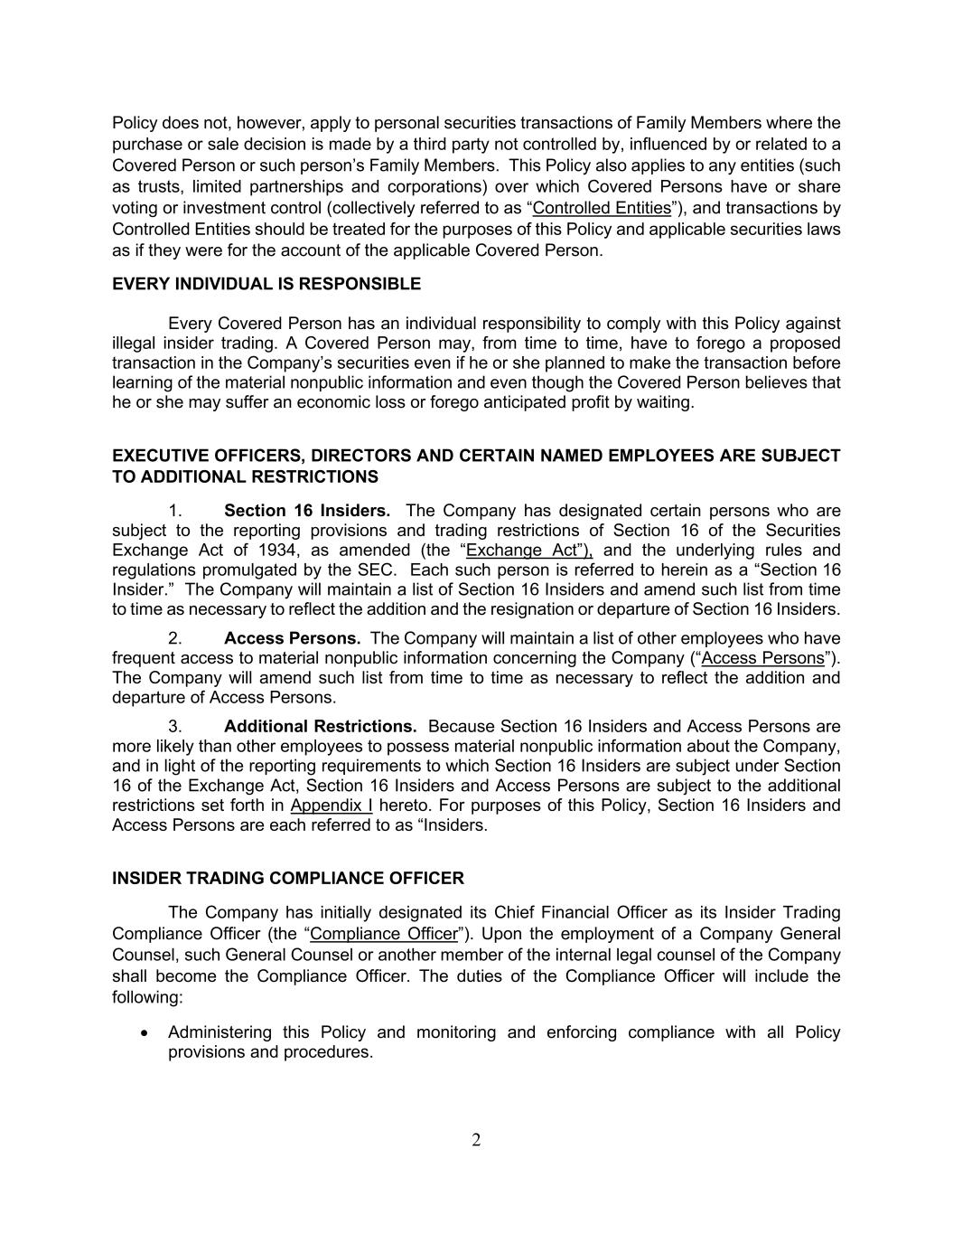
2 Policy does not, however, apply to personal securities transactions of Family Members where the purchase or sale decision is made by a third party not controlled by, influenced by or related to a Covered Person or such person’s Family Members. This Policy also applies to any entities (such as trusts, limited partnerships and corporations) over which Covered Persons have or share voting or investment control (collectively referred to as “Controlled Entities”), and transactions by Controlled Entities should be treated for the purposes of this Policy and applicable securities laws as if they were for the account of the applicable Covered Person. EVERY INDIVIDUAL IS RESPONSIBLE Every Covered Person has an individual responsibility to comply with this Policy against illegal insider trading. A Covered Person may, from time to time, have to forego a proposed transaction in the Company’s securities even if he or she planned to make the transaction before learning of the material nonpublic information and even though the Covered Person believes that he or she may suffer an economic loss or forego anticipated profit by waiting. EXECUTIVE OFFICERS, DIRECTORS AND CERTAIN NAMED EMPLOYEES ARE SUBJECT TO ADDITIONAL RESTRICTIONS 1. Section 16 Insiders. The Company has designated certain persons who are subject to the reporting provisions and trading restrictions of Section 16 of the Securities Exchange Act of 1934, as amended (the “Exchange Act”), and the underlying rules and regulations promulgated by the SEC. Each such person is referred to herein as a “Section 16 Insider.” The Company will maintain a list of Section 16 Insiders and amend such list from time to time as necessary to reflect the addition and the resignation or departure of Section 16 Insiders. 2. Access Persons. The Company will maintain a list of other employees who have frequent access to material nonpublic information concerning the Company (“Access Persons”). The Company will amend such list from time to time as necessary to reflect the addition and departure of Access Persons. 3. Additional Restrictions. Because Section 16 Insiders and Access Persons are more likely than other employees to possess material nonpublic information about the Company, and in light of the reporting requirements to which Section 16 Insiders are subject under Section 16 of the Exchange Act, Section 16 Insiders and Access Persons are subject to the additional restrictions set forth in Appendix I hereto. For purposes of this Policy, Section 16 Insiders and Access Persons are each referred to as “Insiders. INSIDER TRADING COMPLIANCE OFFICER The Company has initially designated its Chief Financial Officer as its Insider Trading Compliance Officer (the “Compliance Officer”). Upon the employment of a Company General Counsel, such General Counsel or another member of the internal legal counsel of the Company shall become the Compliance Officer. The duties of the Compliance Officer will include the following: • Administering this Policy and monitoring and enforcing compliance with all Policy provisions and procedures.

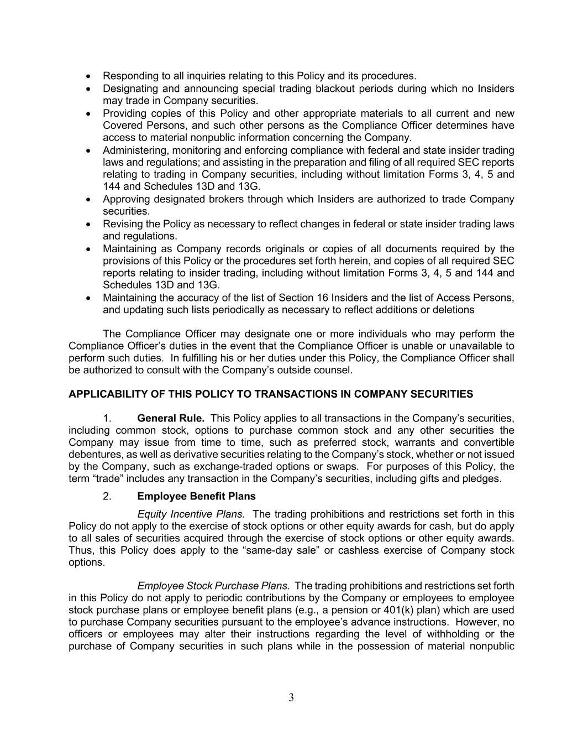
3 • Responding to all inquiries relating to this Policy and its procedures. • Designating and announcing special trading blackout periods during which no Insiders may trade in Company securities. • Providing copies of this Policy and other appropriate materials to all current and new Covered Persons, and such other persons as the Compliance Officer determines have access to material nonpublic information concerning the Company. • Administering, monitoring and enforcing compliance with federal and state insider trading laws and regulations; and assisting in the preparation and filing of all required SEC reports relating to trading in Company securities, including without limitation Forms 3, 4, 5 and 144 and Schedules 13D and 13G. • Approving designated brokers through which Insiders are authorized to trade Company securities. • Revising the Policy as necessary to reflect changes in federal or state insider trading laws and regulations. • Maintaining as Company records originals or copies of all documents required by the provisions of this Policy or the procedures set forth herein, and copies of all required SEC reports relating to insider trading, including without limitation Forms 3, 4, 5 and 144 and Schedules 13D and 13G. • Maintaining the accuracy of the list of Section 16 Insiders and the list of Access Persons, and updating such lists periodically as necessary to reflect additions or deletions The Compliance Officer may designate one or more individuals who may perform the Compliance Officer’s duties in the event that the Compliance Officer is unable or unavailable to perform such duties. In fulfilling his or her duties under this Policy, the Compliance Officer shall be authorized to consult with the Company’s outside counsel. APPLICABILITY OF THIS POLICY TO TRANSACTIONS IN COMPANY SECURITIES 1. General Rule. This Policy applies to all transactions in the Company’s securities, including common stock, options to purchase common stock and any other securities the Company may issue from time to time, such as preferred stock, warrants and convertible debentures, as well as derivative securities relating to the Company’s stock, whether or not issued by the Company, such as exchange-traded options or swaps. For purposes of this Policy, the term “trade” includes any transaction in the Company’s securities, including gifts and pledges. 2. Employee Benefit Plans Equity Incentive Plans. The trading prohibitions and restrictions set forth in this Policy do not apply to the exercise of stock options or other equity awards for cash, but do apply to all sales of securities acquired through the exercise of stock options or other equity awards. Thus, this Policy does apply to the “same-day sale” or cashless exercise of Company stock options. Employee Stock Purchase Plans. The trading prohibitions and restrictions set forth in this Policy do not apply to periodic contributions by the Company or employees to employee stock purchase plans or employee benefit plans (e.g., a pension or 401(k) plan) which are used to purchase Company securities pursuant to the employee’s advance instructions. However, no officers or employees may alter their instructions regarding the level of withholding or the purchase of Company securities in such plans while in the possession of material nonpublic

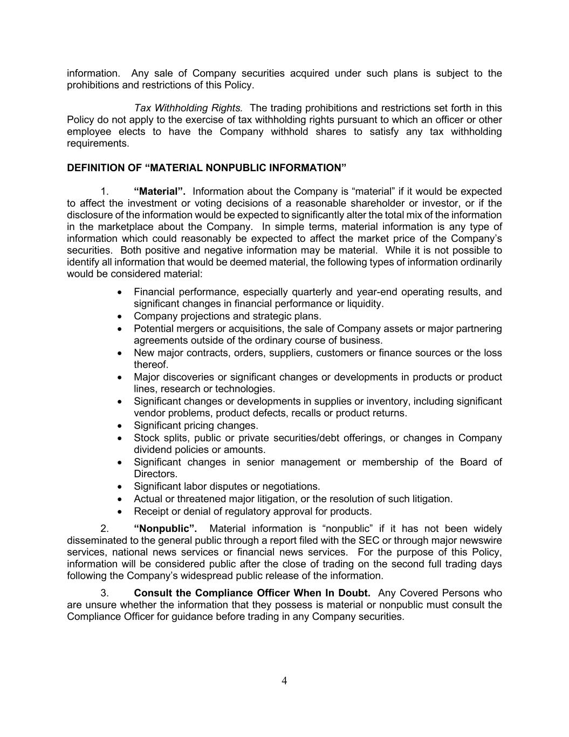
4 information. Any sale of Company securities acquired under such plans is subject to the prohibitions and restrictions of this Policy. Tax Withholding Rights. The trading prohibitions and restrictions set forth in this Policy do not apply to the exercise of tax withholding rights pursuant to which an officer or other employee elects to have the Company withhold shares to satisfy any tax withholding requirements. DEFINITION OF “MATERIAL NONPUBLIC INFORMATION” 1. “Material”. Information about the Company is “material” if it would be expected to affect the investment or voting decisions of a reasonable shareholder or investor, or if the disclosure of the information would be expected to significantly alter the total mix of the information in the marketplace about the Company. In simple terms, material information is any type of information which could reasonably be expected to affect the market price of the Company’s securities. Both positive and negative information may be material. While it is not possible to identify all information that would be deemed material, the following types of information ordinarily would be considered material: • Financial performance, especially quarterly and year-end operating results, and significant changes in financial performance or liquidity. • Company projections and strategic plans. • Potential mergers or acquisitions, the sale of Company assets or major partnering agreements outside of the ordinary course of business. • New major contracts, orders, suppliers, customers or finance sources or the loss thereof. • Major discoveries or significant changes or developments in products or product lines, research or technologies. • Significant changes or developments in supplies or inventory, including significant vendor problems, product defects, recalls or product returns. • Significant pricing changes. • Stock splits, public or private securities/debt offerings, or changes in Company dividend policies or amounts. • Significant changes in senior management or membership of the Board of Directors. • Significant labor disputes or negotiations. • Actual or threatened major litigation, or the resolution of such litigation. • Receipt or denial of regulatory approval for products. 2. “Nonpublic”. Material information is “nonpublic” if it has not been widely disseminated to the general public through a report filed with the SEC or through major newswire services, national news services or financial news services. For the purpose of this Policy, information will be considered public after the close of trading on the second full trading days following the Company’s widespread public release of the information. 3. Consult the Compliance Officer When In Doubt. Any Covered Persons who are unsure whether the information that they possess is material or nonpublic must consult the Compliance Officer for guidance before trading in any Company securities.

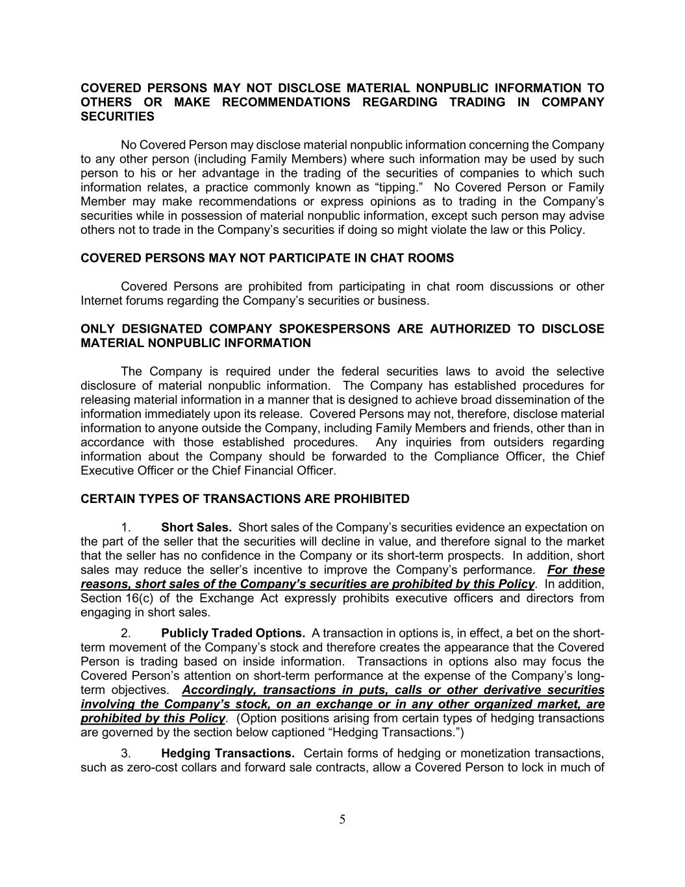
5 COVERED PERSONS MAY NOT DISCLOSE MATERIAL NONPUBLIC INFORMATION TO OTHERS OR MAKE RECOMMENDATIONS REGARDING TRADING IN COMPANY SECURITIES No Covered Person may disclose material nonpublic information concerning the Company to any other person (including Family Members) where such information may be used by such person to his or her advantage in the trading of the securities of companies to which such information relates, a practice commonly known as “tipping.” No Covered Person or Family Member may make recommendations or express opinions as to trading in the Company’s securities while in possession of material nonpublic information, except such person may advise others not to trade in the Company’s securities if doing so might violate the law or this Policy. COVERED PERSONS MAY NOT PARTICIPATE IN CHAT ROOMS Covered Persons are prohibited from participating in chat room discussions or other Internet forums regarding the Company’s securities or business. ONLY DESIGNATED COMPANY SPOKESPERSONS ARE AUTHORIZED TO DISCLOSE MATERIAL NONPUBLIC INFORMATION The Company is required under the federal securities laws to avoid the selective disclosure of material nonpublic information. The Company has established procedures for releasing material information in a manner that is designed to achieve broad dissemination of the information immediately upon its release. Covered Persons may not, therefore, disclose material information to anyone outside the Company, including Family Members and friends, other than in accordance with those established procedures. Any inquiries from outsiders regarding information about the Company should be forwarded to the Compliance Officer, the Chief Executive Officer or the Chief Financial Officer. CERTAIN TYPES OF TRANSACTIONS ARE PROHIBITED 1. Short Sales. Short sales of the Company’s securities evidence an expectation on the part of the seller that the securities will decline in value, and therefore signal to the market that the seller has no confidence in the Company or its short-term prospects. In addition, short sales may reduce the seller’s incentive to improve the Company’s performance. For these reasons, short sales of the Company’s securities are prohibited by this Policy. In addition, Section 16(c) of the Exchange Act expressly prohibits executive officers and directors from engaging in short sales. 2. Publicly Traded Options. A transaction in options is, in effect, a bet on the short- term movement of the Company’s stock and therefore creates the appearance that the Covered Person is trading based on inside information. Transactions in options also may focus the Covered Person’s attention on short-term performance at the expense of the Company’s long- term objectives. Accordingly, transactions in puts, calls or other derivative securities involving the Company’s stock, on an exchange or in any other organized market, are prohibited by this Policy. (Option positions arising from certain types of hedging transactions are governed by the section below captioned “Hedging Transactions.”) 3. Hedging Transactions. Certain forms of hedging or monetization transactions, such as zero-cost collars and forward sale contracts, allow a Covered Person to lock in much of

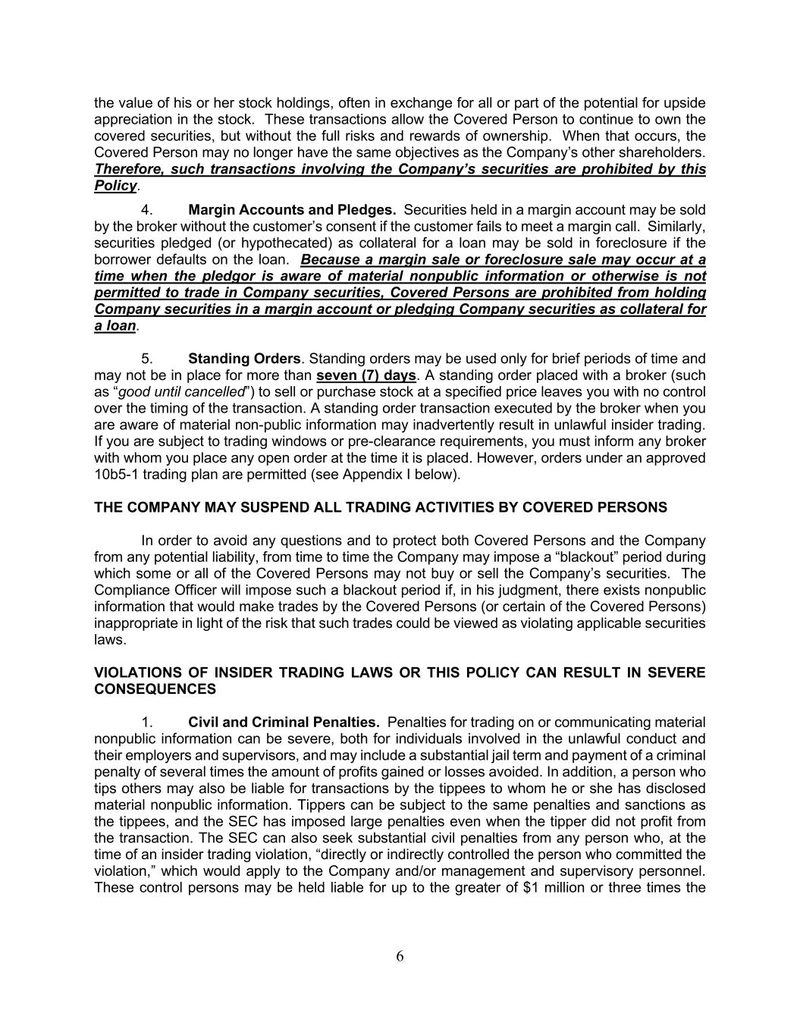
6 the value of his or her stock holdings, often in exchange for all or part of the potential for upside appreciation in the stock. These transactions allow the Covered Person to continue to own the covered securities, but without the full risks and rewards of ownership. When that occurs, the Covered Person may no longer have the same objectives as the Company’s other shareholders. Therefore, such transactions involving the Company’s securities are prohibited by this Policy. 4. Margin Accounts and Pledges. Securities held in a margin account may be sold by the broker without the customer’s consent if the customer fails to meet a margin call. Similarly, securities pledged (or hypothecated) as collateral for a loan may be sold in foreclosure if the borrower defaults on the loan. Because a margin sale or foreclosure sale may occur at a time when the pledgor is aware of material nonpublic information or otherwise is not permitted to trade in Company securities, Covered Persons are prohibited from holding Company securities in a margin account or pledging Company securities as collateral for a loan. 5. Standing Orders. Standing orders may be used only for brief periods of time and may not be in place for more than seven (7) days. A standing order placed with a broker (such as “good until cancelled”) to sell or purchase stock at a specified price leaves you with no control over the timing of the transaction. A standing order transaction executed by the broker when you are aware of material non-public information may inadvertently result in unlawful insider trading. If you are subject to trading windows or pre-clearance requirements, you must inform any broker with whom you place any open order at the time it is placed. However, orders under an approved 10b5-1 trading plan are permitted (see Appendix I below). THE COMPANY MAY SUSPEND ALL TRADING ACTIVITIES BY COVERED PERSONS In order to avoid any questions and to protect both Covered Persons and the Company from any potential liability, from time to time the Company may impose a “blackout” period during which some or all of the Covered Persons may not buy or sell the Company’s securities. The Compliance Officer will impose such a blackout period if, in his judgment, there exists nonpublic information that would make trades by the Covered Persons (or certain of the Covered Persons) inappropriate in light of the risk that such trades could be viewed as violating applicable securities laws. VIOLATIONS OF INSIDER TRADING LAWS OR THIS POLICY CAN RESULT IN SEVERE CONSEQUENCES 1. Civil and Criminal Penalties. Penalties for trading on or communicating material nonpublic information can be severe, both for individuals involved in the unlawful conduct and their employers and supervisors, and may include a substantial jail term and payment of a criminal penalty of several times the amount of profits gained or losses avoided. In addition, a person who tips others may also be liable for transactions by the tippees to whom he or she has disclosed material nonpublic information. Tippers can be subject to the same penalties and sanctions as the tippees, and the SEC has imposed large penalties even when the tipper did not profit from the transaction. The SEC can also seek substantial civil penalties from any person who, at the time of an insider trading violation, “directly or indirectly controlled the person who committed the violation,” which would apply to the Company and/or management and supervisory personnel. These control persons may be held liable for up to the greater of $1 million or three times the

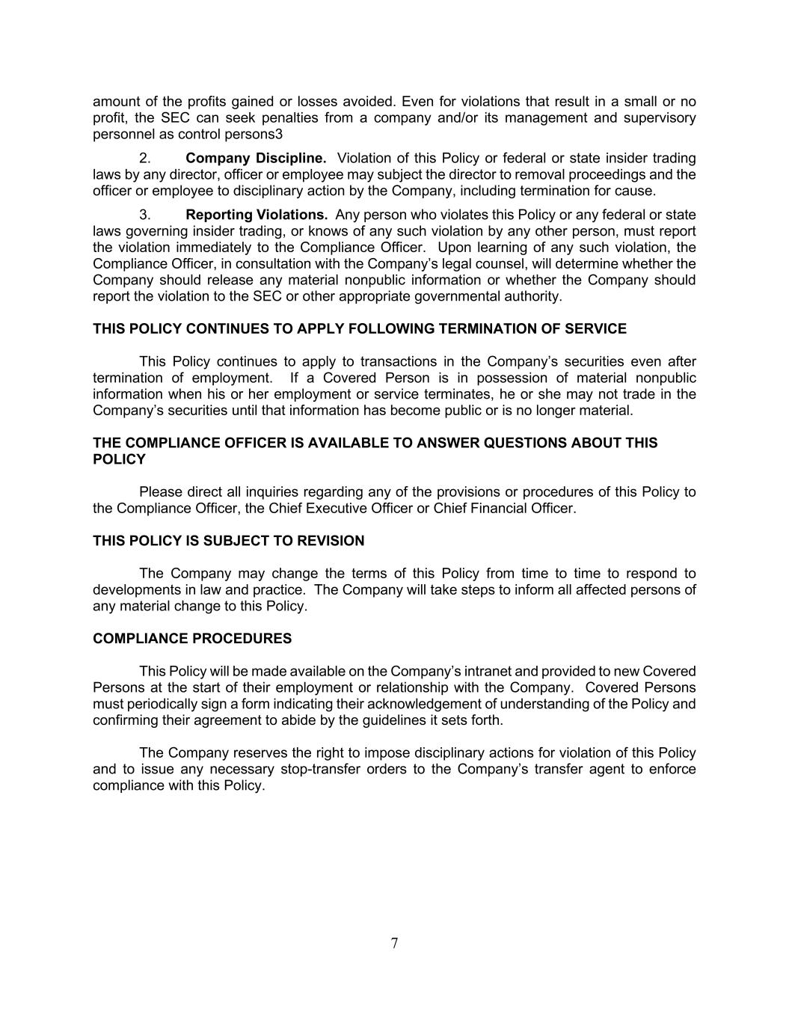
7 amount of the profits gained or losses avoided. Even for violations that result in a small or no profit, the SEC can seek penalties from a company and/or its management and supervisory personnel as control persons3 2. Company Discipline. Violation of this Policy or federal or state insider trading laws by any director, officer or employee may subject the director to removal proceedings and the officer or employee to disciplinary action by the Company, including termination for cause. 3. Reporting Violations. Any person who violates this Policy or any federal or state laws governing insider trading, or knows of any such violation by any other person, must report the violation immediately to the Compliance Officer. Upon learning of any such violation, the Compliance Officer, in consultation with the Company’s legal counsel, will determine whether the Company should release any material nonpublic information or whether the Company should report the violation to the SEC or other appropriate governmental authority. THIS POLICY CONTINUES TO APPLY FOLLOWING TERMINATION OF SERVICE This Policy continues to apply to transactions in the Company’s securities even after termination of employment. If a Covered Person is in possession of material nonpublic information when his or her employment or service terminates, he or she may not trade in the Company’s securities until that information has become public or is no longer material. THE COMPLIANCE OFFICER IS AVAILABLE TO ANSWER QUESTIONS ABOUT THIS POLICY Please direct all inquiries regarding any of the provisions or procedures of this Policy to the Compliance Officer, the Chief Executive Officer or Chief Financial Officer. THIS POLICY IS SUBJECT TO REVISION The Company may change the terms of this Policy from time to time to respond to developments in law and practice. The Company will take steps to inform all affected persons of any material change to this Policy. COMPLIANCE PROCEDURES This Policy will be made available on the Company’s intranet and provided to new Covered Persons at the start of their employment or relationship with the Company. Covered Persons must periodically sign a form indicating their acknowledgement of understanding of the Policy and confirming their agreement to abide by the guidelines it sets forth. The Company reserves the right to impose disciplinary actions for violation of this Policy and to issue any necessary stop-transfer orders to the Company’s transfer agent to enforce compliance with this Policy.

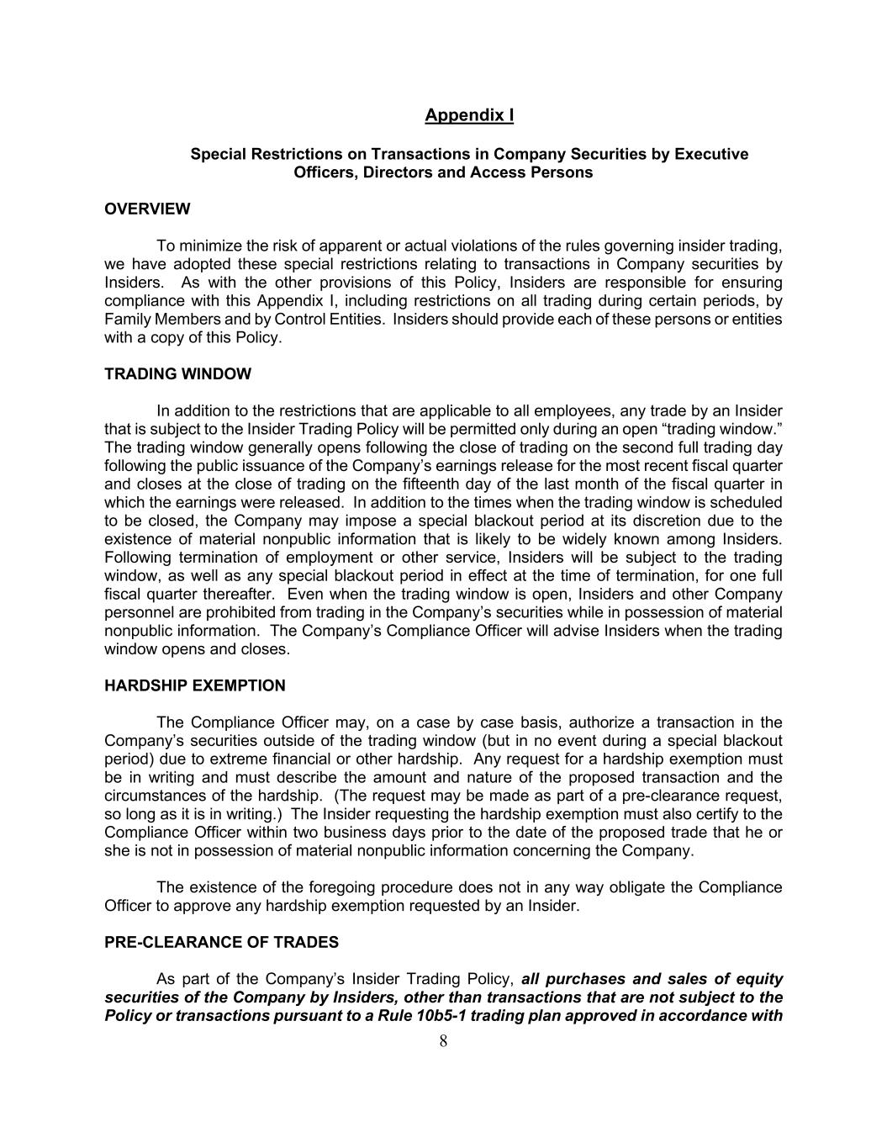
8 Appendix I Special Restrictions on Transactions in Company Securities by Executive Officers, Directors and Access Persons OVERVIEW To minimize the risk of apparent or actual violations of the rules governing insider trading, we have adopted these special restrictions relating to transactions in Company securities by Insiders. As with the other provisions of this Policy, Insiders are responsible for ensuring compliance with this Appendix I, including restrictions on all trading during certain periods, by Family Members and by Control Entities. Insiders should provide each of these persons or entities with a copy of this Policy. TRADING WINDOW In addition to the restrictions that are applicable to all employees, any trade by an Insider that is subject to the Insider Trading Policy will be permitted only during an open “trading window.” The trading window generally opens following the close of trading on the second full trading day following the public issuance of the Company’s earnings release for the most recent fiscal quarter and closes at the close of trading on the fifteenth day of the last month of the fiscal quarter in which the earnings were released. In addition to the times when the trading window is scheduled to be closed, the Company may impose a special blackout period at its discretion due to the existence of material nonpublic information that is likely to be widely known among Insiders. Following termination of employment or other service, Insiders will be subject to the trading window, as well as any special blackout period in effect at the time of termination, for one full fiscal quarter thereafter. Even when the trading window is open, Insiders and other Company personnel are prohibited from trading in the Company’s securities while in possession of material nonpublic information. The Company’s Compliance Officer will advise Insiders when the trading window opens and closes. HARDSHIP EXEMPTION The Compliance Officer may, on a case by case basis, authorize a transaction in the Company’s securities outside of the trading window (but in no event during a special blackout period) due to extreme financial or other hardship. Any request for a hardship exemption must be in writing and must describe the amount and nature of the proposed transaction and the circumstances of the hardship. (The request may be made as part of a pre-clearance request, so long as it is in writing.) The Insider requesting the hardship exemption must also certify to the Compliance Officer within two business days prior to the date of the proposed trade that he or she is not in possession of material nonpublic information concerning the Company. The existence of the foregoing procedure does not in any way obligate the Compliance Officer to approve any hardship exemption requested by an Insider. PRE-CLEARANCE OF TRADES As part of the Company’s Insider Trading Policy, all purchases and sales of equity securities of the Company by Insiders, other than transactions that are not subject to the Policy or transactions pursuant to a Rule 10b5-1 trading plan approved in accordance with

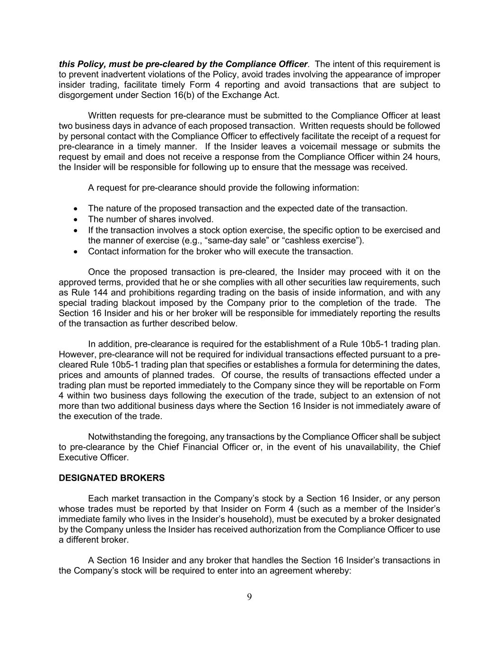
9 this Policy, must be pre-cleared by the Compliance Officer. The intent of this requirement is to prevent inadvertent violations of the Policy, avoid trades involving the appearance of improper insider trading, facilitate timely Form 4 reporting and avoid transactions that are subject to disgorgement under Section 16(b) of the Exchange Act. Written requests for pre-clearance must be submitted to the Compliance Officer at least two business days in advance of each proposed transaction. Written requests should be followed by personal contact with the Compliance Officer to effectively facilitate the receipt of a request for pre-clearance in a timely manner. If the Insider leaves a voicemail message or submits the request by email and does not receive a response from the Compliance Officer within 24 hours, the Insider will be responsible for following up to ensure that the message was received. A request for pre-clearance should provide the following information: • The nature of the proposed transaction and the expected date of the transaction. • The number of shares involved. • If the transaction involves a stock option exercise, the specific option to be exercised and the manner of exercise (e.g., “same-day sale” or “cashless exercise”). • Contact information for the broker who will execute the transaction. Once the proposed transaction is pre-cleared, the Insider may proceed with it on the approved terms, provided that he or she complies with all other securities law requirements, such as Rule 144 and prohibitions regarding trading on the basis of inside information, and with any special trading blackout imposed by the Company prior to the completion of the trade. The Section 16 Insider and his or her broker will be responsible for immediately reporting the results of the transaction as further described below. In addition, pre-clearance is required for the establishment of a Rule 10b5-1 trading plan. However, pre-clearance will not be required for individual transactions effected pursuant to a pre- cleared Rule 10b5-1 trading plan that specifies or establishes a formula for determining the dates, prices and amounts of planned trades. Of course, the results of transactions effected under a trading plan must be reported immediately to the Company since they will be reportable on Form 4 within two business days following the execution of the trade, subject to an extension of not more than two additional business days where the Section 16 Insider is not immediately aware of the execution of the trade. Notwithstanding the foregoing, any transactions by the Compliance Officer shall be subject to pre-clearance by the Chief Financial Officer or, in the event of his unavailability, the Chief Executive Officer. DESIGNATED BROKERS Each market transaction in the Company’s stock by a Section 16 Insider, or any person whose trades must be reported by that Insider on Form 4 (such as a member of the Insider’s immediate family who lives in the Insider’s household), must be executed by a broker designated by the Company unless the Insider has received authorization from the Compliance Officer to use a different broker. A Section 16 Insider and any broker that handles the Section 16 Insider’s transactions in the Company’s stock will be required to enter into an agreement whereby:

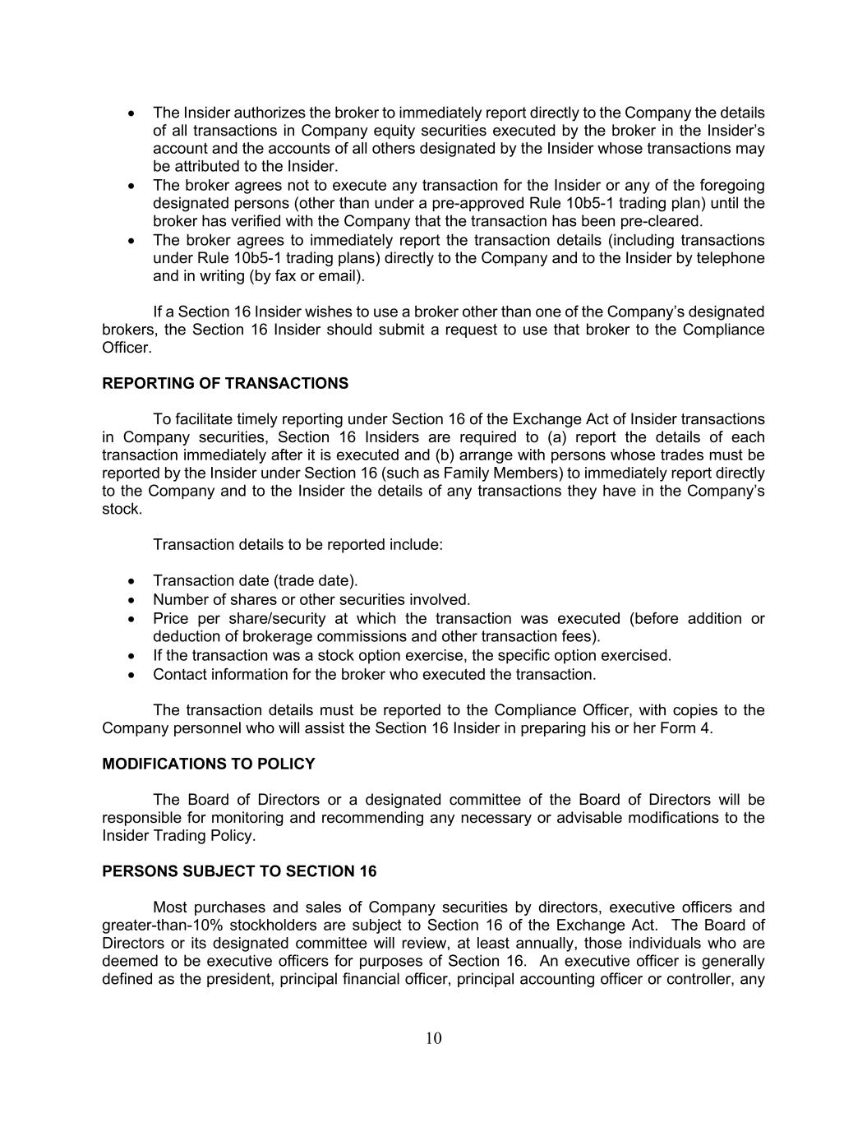
10 • The Insider authorizes the broker to immediately report directly to the Company the details of all transactions in Company equity securities executed by the broker in the Insider’s account and the accounts of all others designated by the Insider whose transactions may be attributed to the Insider. • The broker agrees not to execute any transaction for the Insider or any of the foregoing designated persons (other than under a pre-approved Rule 10b5-1 trading plan) until the broker has verified with the Company that the transaction has been pre-cleared. • The broker agrees to immediately report the transaction details (including transactions under Rule 10b5-1 trading plans) directly to the Company and to the Insider by telephone and in writing (by fax or email). If a Section 16 Insider wishes to use a broker other than one of the Company’s designated brokers, the Section 16 Insider should submit a request to use that broker to the Compliance Officer. REPORTING OF TRANSACTIONS To facilitate timely reporting under Section 16 of the Exchange Act of Insider transactions in Company securities, Section 16 Insiders are required to (a) report the details of each transaction immediately after it is executed and (b) arrange with persons whose trades must be reported by the Insider under Section 16 (such as Family Members) to immediately report directly to the Company and to the Insider the details of any transactions they have in the Company’s stock. Transaction details to be reported include: • Transaction date (trade date). • Number of shares or other securities involved. • Price per share/security at which the transaction was executed (before addition or deduction of brokerage commissions and other transaction fees). • If the transaction was a stock option exercise, the specific option exercised. • Contact information for the broker who executed the transaction. The transaction details must be reported to the Compliance Officer, with copies to the Company personnel who will assist the Section 16 Insider in preparing his or her Form 4. MODIFICATIONS TO POLICY The Board of Directors or a designated committee of the Board of Directors will be responsible for monitoring and recommending any necessary or advisable modifications to the Insider Trading Policy. PERSONS SUBJECT TO SECTION 16 Most purchases and sales of Company securities by directors, executive officers and greater-than-10% stockholders are subject to Section 16 of the Exchange Act. The Board of Directors or its designated committee will review, at least annually, those individuals who are deemed to be executive officers for purposes of Section 16. An executive officer is generally defined as the president, principal financial officer, principal accounting officer or controller, any

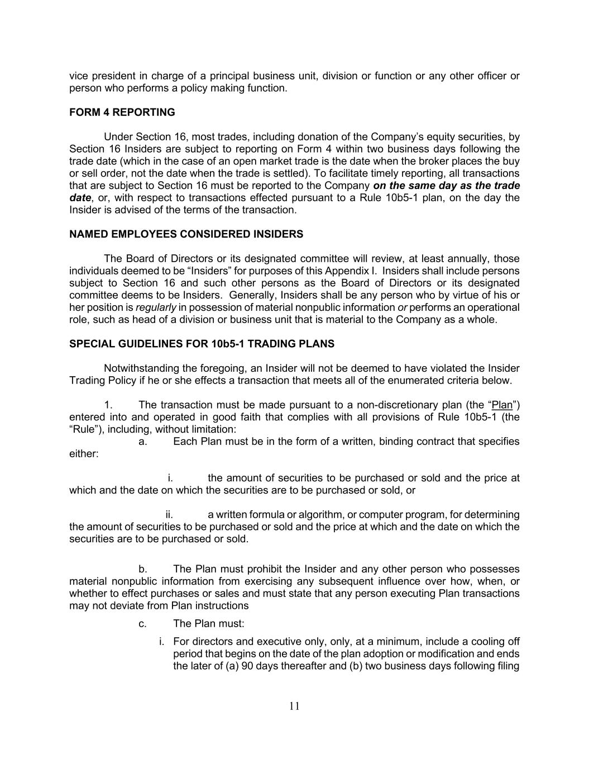
11 vice president in charge of a principal business unit, division or function or any other officer or person who performs a policy making function. FORM 4 REPORTING Under Section 16, most trades, including donation of the Company’s equity securities, by Section 16 Insiders are subject to reporting on Form 4 within two business days following the trade date (which in the case of an open market trade is the date when the broker places the buy or sell order, not the date when the trade is settled). To facilitate timely reporting, all transactions that are subject to Section 16 must be reported to the Company on the same day as the trade date, or, with respect to transactions effected pursuant to a Rule 10b5-1 plan, on the day the Insider is advised of the terms of the transaction. NAMED EMPLOYEES CONSIDERED INSIDERS The Board of Directors or its designated committee will review, at least annually, those individuals deemed to be “Insiders” for purposes of this Appendix I. Insiders shall include persons subject to Section 16 and such other persons as the Board of Directors or its designated committee deems to be Insiders. Generally, Insiders shall be any person who by virtue of his or her position is regularly in possession of material nonpublic information or performs an operational role, such as head of a division or business unit that is material to the Company as a whole. SPECIAL GUIDELINES FOR 10b5-1 TRADING PLANS Notwithstanding the foregoing, an Insider will not be deemed to have violated the Insider Trading Policy if he or she effects a transaction that meets all of the enumerated criteria below. 1. The transaction must be made pursuant to a non-discretionary plan (the “Plan”) entered into and operated in good faith that complies with all provisions of Rule 10b5-1 (the “Rule”), including, without limitation: a. Each Plan must be in the form of a written, binding contract that specifies either: i. the amount of securities to be purchased or sold and the price at which and the date on which the securities are to be purchased or sold, or ii. a written formula or algorithm, or computer program, for determining the amount of securities to be purchased or sold and the price at which and the date on which the securities are to be purchased or sold. b. The Plan must prohibit the Insider and any other person who possesses material nonpublic information from exercising any subsequent influence over how, when, or whether to effect purchases or sales and must state that any person executing Plan transactions may not deviate from Plan instructions c. The Plan must: i. For directors and executive only, only, at a minimum, include a cooling off period that begins on the date of the plan adoption or modification and ends the later of (a) 90 days thereafter and (b) two business days following filing

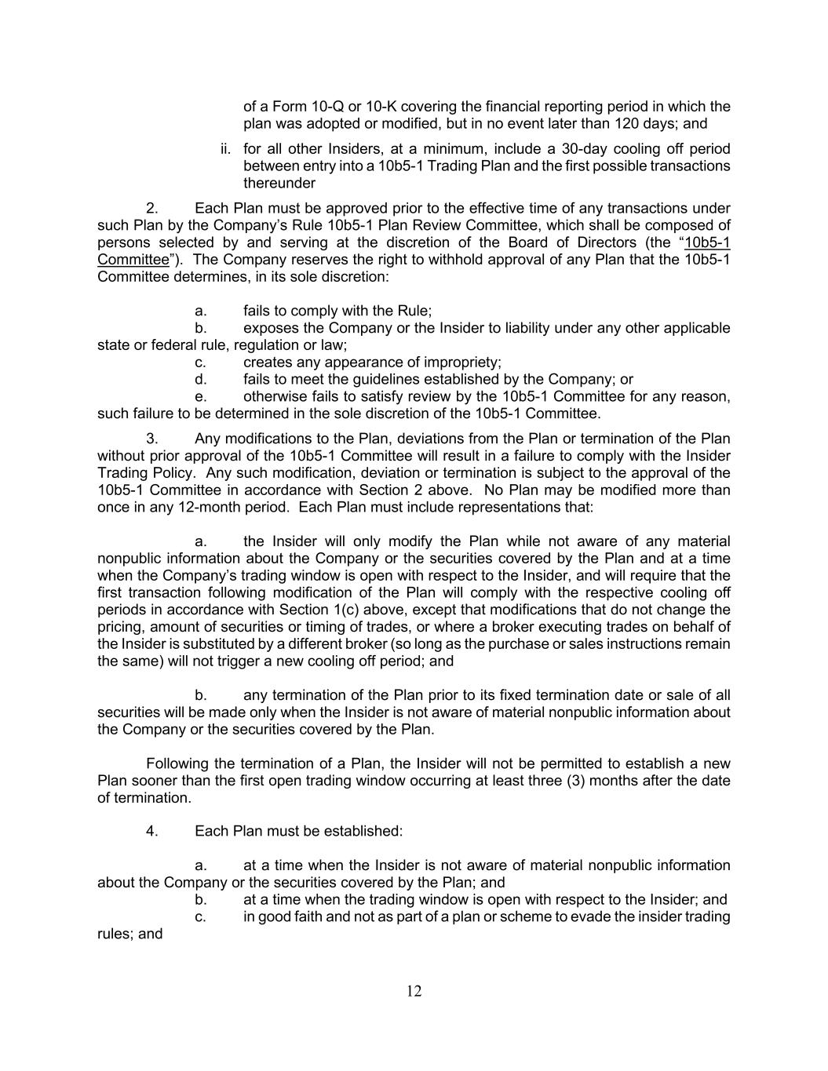
12 of a Form 10-Q or 10-K covering the financial reporting period in which the plan was adopted or modified, but in no event later than 120 days; and ii. for all other Insiders, at a minimum, include a 30-day cooling off period between entry into a 10b5-1 Trading Plan and the first possible transactions thereunder 2. Each Plan must be approved prior to the effective time of any transactions under such Plan by the Company’s Rule 10b5-1 Plan Review Committee, which shall be composed of persons selected by and serving at the discretion of the Board of Directors (the “10b5-1 Committee”). The Company reserves the right to withhold approval of any Plan that the 10b5-1 Committee determines, in its sole discretion: a. fails to comply with the Rule; b. exposes the Company or the Insider to liability under any other applicable state or federal rule, regulation or law; c. creates any appearance of impropriety; d. fails to meet the guidelines established by the Company; or e. otherwise fails to satisfy review by the 10b5-1 Committee for any reason, such failure to be determined in the sole discretion of the 10b5-1 Committee. 3. Any modifications to the Plan, deviations from the Plan or termination of the Plan without prior approval of the 10b5-1 Committee will result in a failure to comply with the Insider Trading Policy. Any such modification, deviation or termination is subject to the approval of the 10b5-1 Committee in accordance with Section 2 above. No Plan may be modified more than once in any 12-month period. Each Plan must include representations that: a. the Insider will only modify the Plan while not aware of any material nonpublic information about the Company or the securities covered by the Plan and at a time when the Company’s trading window is open with respect to the Insider, and will require that the first transaction following modification of the Plan will comply with the respective cooling off periods in accordance with Section 1(c) above, except that modifications that do not change the pricing, amount of securities or timing of trades, or where a broker executing trades on behalf of the Insider is substituted by a different broker (so long as the purchase or sales instructions remain the same) will not trigger a new cooling off period; and b. any termination of the Plan prior to its fixed termination date or sale of all securities will be made only when the Insider is not aware of material nonpublic information about the Company or the securities covered by the Plan. Following the termination of a Plan, the Insider will not be permitted to establish a new Plan sooner than the first open trading window occurring at least three (3) months after the date of termination. 4. Each Plan must be established: a. at a time when the Insider is not aware of material nonpublic information about the Company or the securities covered by the Plan; and b. at a time when the trading window is open with respect to the Insider; and c. in good faith and not as part of a plan or scheme to evade the insider trading rules; and

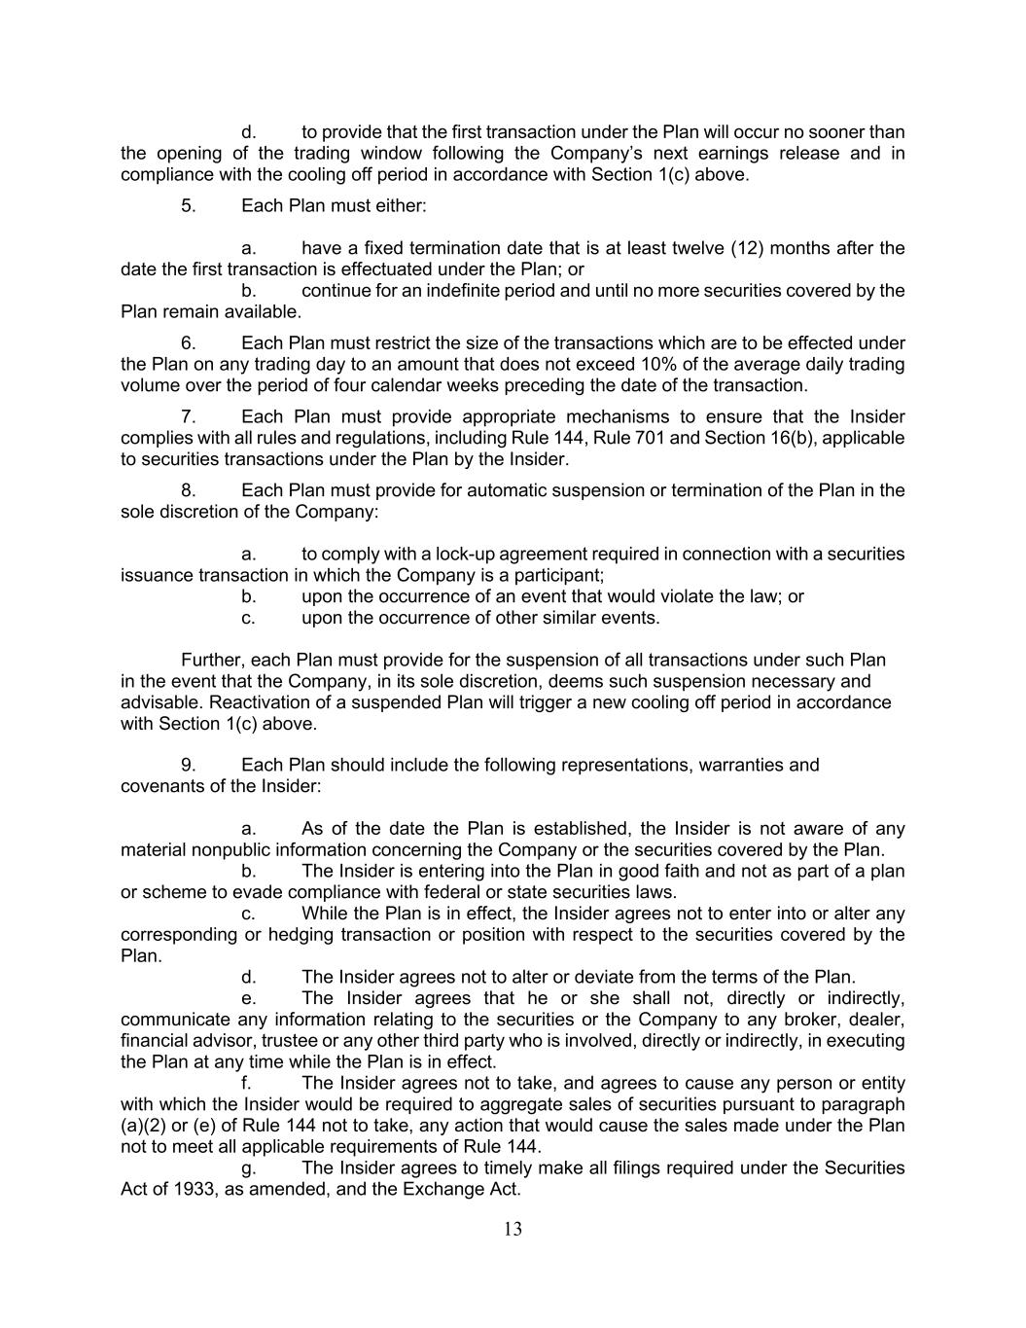
13 d. to provide that the first transaction under the Plan will occur no sooner than the opening of the trading window following the Company’s next earnings release and in compliance with the cooling off period in accordance with Section 1(c) above. 5. Each Plan must either: a. have a fixed termination date that is at least twelve (12) months after the date the first transaction is effectuated under the Plan; or b. continue for an indefinite period and until no more securities covered by the Plan remain available. 6. Each Plan must restrict the size of the transactions which are to be effected under the Plan on any trading day to an amount that does not exceed 10% of the average daily trading volume over the period of four calendar weeks preceding the date of the transaction. 7. Each Plan must provide appropriate mechanisms to ensure that the Insider complies with all rules and regulations, including Rule 144, Rule 701 and Section 16(b), applicable to securities transactions under the Plan by the Insider. 8. Each Plan must provide for automatic suspension or termination of the Plan in the sole discretion of the Company: a. to comply with a lock-up agreement required in connection with a securities issuance transaction in which the Company is a participant; b. upon the occurrence of an event that would violate the law; or c. upon the occurrence of other similar events. Further, each Plan must provide for the suspension of all transactions under such Plan in the event that the Company, in its sole discretion, deems such suspension necessary and advisable. Reactivation of a suspended Plan will trigger a new cooling off period in accordance with Section 1(c) above. 9. Each Plan should include the following representations, warranties and covenants of the Insider: a. As of the date the Plan is established, the Insider is not aware of any material nonpublic information concerning the Company or the securities covered by the Plan. b. The Insider is entering into the Plan in good faith and not as part of a plan or scheme to evade compliance with federal or state securities laws. c. While the Plan is in effect, the Insider agrees not to enter into or alter any corresponding or hedging transaction or position with respect to the securities covered by the Plan. d. The Insider agrees not to alter or deviate from the terms of the Plan. e. The Insider agrees that he or she shall not, directly or indirectly, communicate any information relating to the securities or the Company to any broker, dealer, financial advisor, trustee or any other third party who is involved, directly or indirectly, in executing the Plan at any time while the Plan is in effect. f. The Insider agrees not to take, and agrees to cause any person or entity with which the Insider would be required to aggregate sales of securities pursuant to paragraph (a)(2) or (e) of Rule 144 not to take, any action that would cause the sales made under the Plan not to meet all applicable requirements of Rule 144. g. The Insider agrees to timely make all filings required under the Securities Act of 1933, as amended, and the Exchange Act.

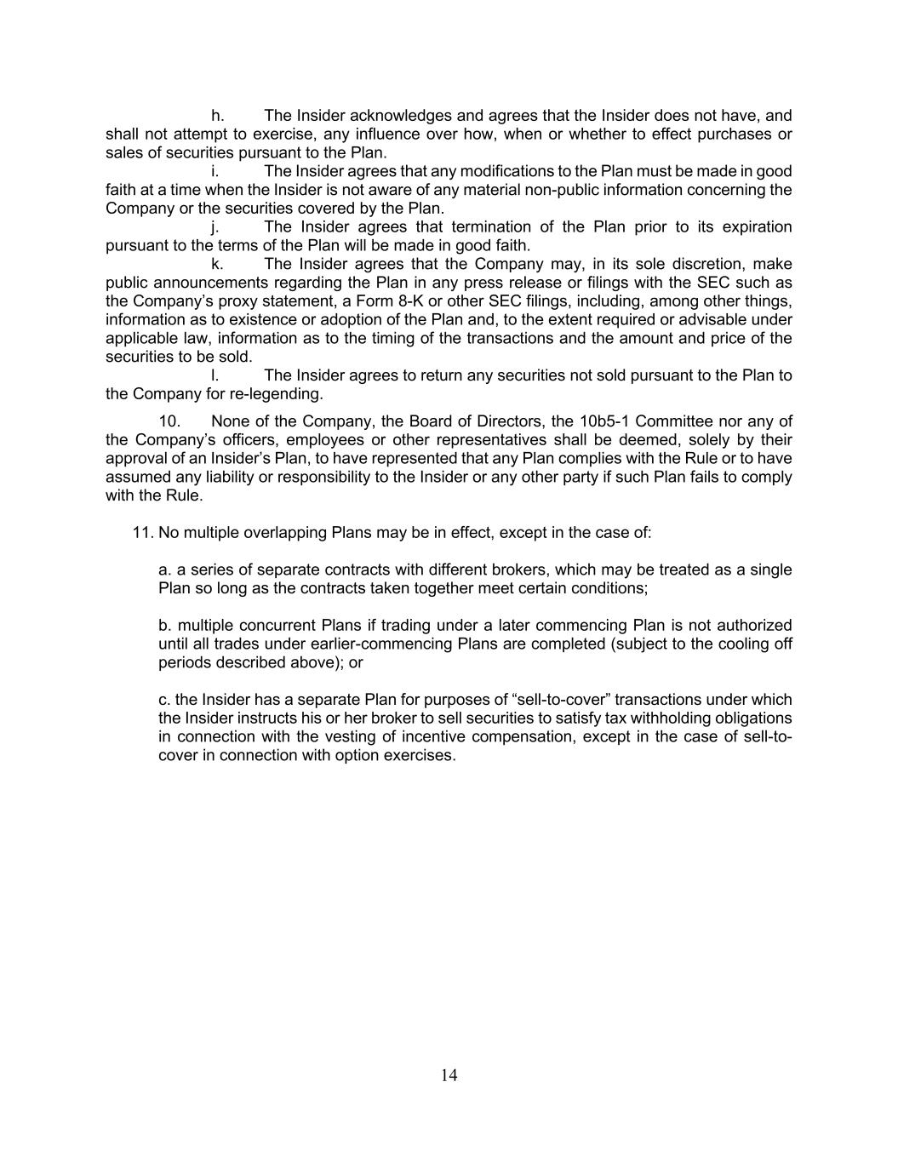
14 h. The Insider acknowledges and agrees that the Insider does not have, and shall not attempt to exercise, any influence over how, when or whether to effect purchases or sales of securities pursuant to the Plan. i. The Insider agrees that any modifications to the Plan must be made in good faith at a time when the Insider is not aware of any material non-public information concerning the Company or the securities covered by the Plan. j. The Insider agrees that termination of the Plan prior to its expiration pursuant to the terms of the Plan will be made in good faith. k. The Insider agrees that the Company may, in its sole discretion, make public announcements regarding the Plan in any press release or filings with the SEC such as the Company’s proxy statement, a Form 8-K or other SEC filings, including, among other things, information as to existence or adoption of the Plan and, to the extent required or advisable under applicable law, information as to the timing of the transactions and the amount and price of the securities to be sold. l. The Insider agrees to return any securities not sold pursuant to the Plan to the Company for re-legending. 10. None of the Company, the Board of Directors, the 10b5-1 Committee nor any of the Company’s officers, employees or other representatives shall be deemed, solely by their approval of an Insider’s Plan, to have represented that any Plan complies with the Rule or to have assumed any liability or responsibility to the Insider or any other party if such Plan fails to comply with the Rule. 11. No multiple overlapping Plans may be in effect, except in the case of: a. a series of separate contracts with different brokers, which may be treated as a single Plan so long as the contracts taken together meet certain conditions; b. multiple concurrent Plans if trading under a later commencing Plan is not authorized until all trades under earlier-commencing Plans are completed (subject to the cooling off periods described above); or c. the Insider has a separate Plan for purposes of “sell-to-cover” transactions under which the Insider instructs his or her broker to sell securities to satisfy tax withholding obligations in connection with the vesting of incentive compensation, except in the case of sell-to- cover in connection with option exercises.

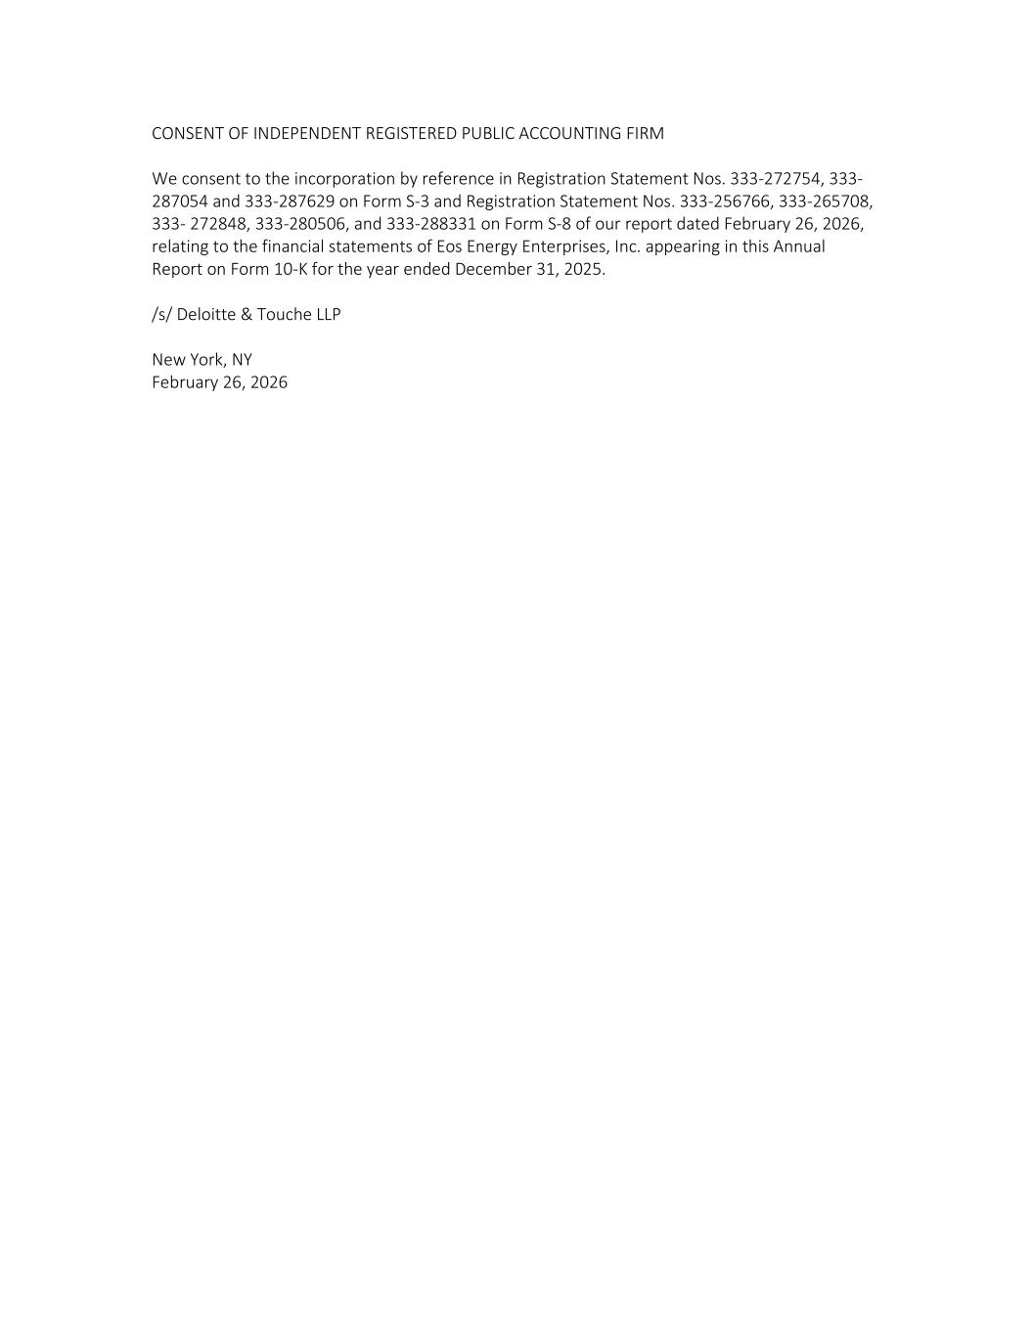
CONSENT OF INDEPENDENT REGISTERED PUBLIC ACCOUNTING FIRM We consent to the incorporation by reference in Registration Statement Nos. 333-272754, 333- 287054 and 333-287629 on Form S-3 and Registration Statement Nos. 333-256766, 333-265708, 333- 272848, 333-280506, and 333-288331 on Form S-8 of our report dated February 26, 2026, relating to the financial statements of Eos Energy Enterprises, Inc. appearing in this Annual Report on Form 10-K for the year ended December 31, 2025. /s/ Deloitte & Touche LLP New York, NY February 26, 2026

CERTIFICATION OF CHIEF EXECUTIVE OFFICER
PURSUANT TO
RULES 13a-14(a) AND 15d-14(a) UNDER THE SECURITIES EXCHANGE ACT OF 1934,
AS ADOPTED PURSUANT TO
SECTION 302 OF THE SARBANES-OXLEY ACT OF 2002

I, Joseph Mastrangelo, certify that:
1. I have reviewed this Annual Report on Form 10-K (the “Annual Report”) of Eos Energy Enterprises, Inc. (the “Registrant”);
2. Based on my knowledge, this Annual Report does not contain any untrue statement of a material fact or omit to state a material fact necessary to make the statements made, in light of the circumstances under which such statements were made, not misleading with respect to the period covered by this Annual Report;
3. Based on my knowledge, the financial statements, and other financial information included in this Annual Report, fairly present in all material respects the financial condition, results of operations and cash flows of the Registrant as of, and for, the periods presented in this Annual Report;
4. The Registrant’s other certifying officer and I are responsible for establishing and maintaining disclosure controls and procedures (as defined in Exchange Act Rules 13a-15(e) and 15d-15(e)) for the Registrant and internal control over financial reporting (as defined in Exchange Act Rules 13a-15(f) and 15d-15(f)) for the Registrant and have:
(a) Designed such disclosure controls and procedures, or caused such disclosure controls and procedures to be designed under our supervision, to ensure that material information relating to the Registrant, including its consolidated subsidiaries, is made known to us by others within those entities, particularly during the period in which this Annual Report is being prepared;
(b) Designed such internal control over financial reporting, or caused such internal control over financial reporting to be designed under our supervision, to provide reasonable assurance regarding the reliability of financial reporting and the preparation of financial statements for external purposes in accordance with generally accepted accounting principles;
(c) Evaluated the effectiveness of the Registrant’s disclosure controls and procedures and presented in this Annual Report our conclusions about the effectiveness of the disclosure controls and procedures, as of the end of the period covered by this Annual Report based on such evaluation; and
(d) Disclosed in this Annual Report any change in the Registrant 's internal control over financial reporting that occurred during the Registrant 's fourth fiscal quarter that has materially affected, or is reasonably likely to materially affect, the Registrant 's internal control over financial reporting; and
5. The Registrant’s other certifying officer and I have disclosed, based on our most recent evaluation of internal control over financial reporting, to the Registrant’s auditors and the audit committee of the Registrant's board of directors (or persons performing the equivalent functions):
(a) All significant deficiencies and material weaknesses in the design or operation of internal control over financial reporting which are reasonably likely to adversely affect the Registrant’s ability to record, process, summarize and report financial information; and
(b) Any fraud, whether or not material, that involves management or other employees who have a significant role in the Registrant's internal control over financial reporting.

Date: |  |  | February 26, 2026 |  |  |  |  |  | /s/ Joseph Mastrangelo
 |  |  |  |  |  |  |  |  | Joseph Mastrangelo
 |  |  |  |  |  |  |  |  | Chief Executive Officer
 |  |  |  |  |  |  |  |  | (Principal Executive Officer)

CERTIFICATION OF CHIEF FINANCIAL OFFICER
PURSUANT TO
RULES 13a-14(a) AND 15d-14(a) UNDER THE SECURITIES EXCHANGE ACT OF 1934,
AS ADOPTED PURSUANT TO
SECTION 302 OF THE SARBANES-OXLEY ACT OF 2002

I, Nathan Kroeker, certify that:
1. I have reviewed this Annual Report on Form 10-K (the “Annual Report”) of Eos Energy Enterprises, Inc. (the “Registrant”);
2. Based on my knowledge, this Annual Report does not contain any untrue statement of a material fact or omit to state a material fact necessary to make the statements made, in light of the circumstances under which such statements were made, not misleading with respect to the period covered by this Annual Report;
3. Based on my knowledge, the financial statements, and other financial information included in this Annual Report, fairly present in all material respects the financial condition, results of operations and cash flows of the Registrant as of, and for, the periods presented in this Annual Report;
4. The Registrant’s other certifying officer and I are responsible for establishing and maintaining disclosure controls and procedures (as defined in Exchange Act Rules 13a-15(e) and 15d-15(e)) for the Registrant and internal control over financial reporting (as defined in Exchange Act Rules 13a-15(f) and 15d-15(f)) for the Registrant and have:
(a) Designed such disclosure controls and procedures, or caused such disclosure controls and procedures to be designed under our supervision, to ensure that material information relating to the Registrant, including its consolidated subsidiaries, is made known to us by others within those entities, particularly during the period in which this Annual Report is being prepared;
(b) Designed such internal control over financial reporting, or caused such internal control over financial reporting to be designed under our supervision, to provide reasonable assurance regarding the reliability of financial reporting and the preparation of financial statements for external purposes in accordance with generally accepted accounting principles;
(c) Evaluated the effectiveness of the Registrant’s disclosure controls and procedures and presented in this Annual Report our conclusions about the effectiveness of the disclosure controls and procedures, as of the end of the period covered by this Annual Report based on such evaluation; and
(d) Disclosed in this Annual Report any change in the Registrant 's internal control over financial reporting that occurred during the Registrant 's fourth fiscal quarter that has materially affected, or is reasonably likely to materially affect, the Registrant 's internal control over financial reporting; and
5. The Registrant’s other certifying officer and I have disclosed, based on our most recent evaluation of internal control over financial reporting, to the Registrant’s auditors and the audit committee of the Registrant's board of directors (or persons performing the equivalent functions):
(a) All significant deficiencies and material weaknesses in the design or operation of internal control over financial reporting which are reasonably likely to adversely affect the Registrant’s ability to record, process, summarize and report financial information; and
(b) Any fraud, whether or not material, that involves management or other employees who have a significant role in the Registrant's internal control over financial reporting.

Date: |  |  | February 26, 2026 |  |  |  |  |  | /s/ Nathan Kroeker
 |  |  |  |  |  |  |  |  | Nathan Kroeker
 |  |  |  |  |  |  |  |  | Interim Chief Financial Officer
 |  |  |  |  |  |  |  |  | (Principal Financial Officer)

CERTIFICATION OF CHIEF EXECUTIVE OFFICER
PURSUANT TO
18 U.S.C. SECTION 1350,
AS ADOPTED PURSUANT TO
SECTION 906 OF THE SARBANES-OXLEY ACT OF 2002

In connection with the Annual Report of Eos Energy Enterprises, Inc. (the “Registrant”) on Form 10-K for the year ended December 31, 2025 as filed with the Securities and Exchange Commission on the date hereof (the “Report”), I, Joseph Mastrangelo, hereby certify, in the capacity and on the date indicated below, pursuant to 18 U.S.C. § 1350, as adopted pursuant to Section 906 of the Sarbanes-Oxley Act of 2002, that, to my knowledge:

(1) The Report fully complies with the requirements of section 13(a) or 15(d) of the Securities Exchange Act of 1934, as amended; and

(2) The information contained in the Report fairly presents, in all material respects, the financial condition and results of operations of the Registrant.

Date: |  |  | February 26, 2026 |  |  |  |  |  | /s/ Joseph Mastrangelo
 |  |  |  |  |  |  |  |  | Joseph Mastrangelo
 |  |  |  |  |  |  |  |  | Chief Executive Officer
 |  |  |  |  |  |  |  |  | (Principal Executive Officer)

A signed original of this written statement required by Section 906 has been provided to the Company and will be retained by the Company and furnished to the Securities and Exchange Commission or its staff upon request.

CERTIFICATION OF CHIEF FINANCIAL OFFICER
PURSUANT TO
18 U.S.C. SECTION 1350,
AS ADOPTED PURSUANT TO
SECTION 906 OF THE SARBANES-OXLEY ACT OF 2002

In connection with the Annual Report of Eos Energy Enterprises, Inc. (the “Registrant”) on Form 10-K for the year ended December 31, 2025 as filed with the Securities and Exchange Commission on the date hereof (the “Report”), I, Nathan Kroeker, hereby certify, in the capacity and on the date indicated below, pursuant to 18 U.S.C. § 1350, as adopted pursuant to Section 906 of the Sarbanes-Oxley Act of 2002, that, to my knowledge:

(1) The Report fully complies with the requirements of section 13(a) or 15(d) of the Securities Exchange Act of 1934, as amended; and

(2) The information contained in the Report fairly presents, in all material respects, the financial condition and results of operations of the Registrant.

Date: |  |  | February 26, 2026 |  |  |  |  |  | /s/ Nathan Kroeker
 |  |  |  |  |  |  |  |  | Nathan Kroeker
 |  |  |  |  |  |  |  |  | Interim Chief Financial Officer
 |  |  |  |  |  |  |  |  | (Principal Financial Officer)

A signed original of this written statement required by Section 906 has been provided to the Company and will be retained by the Company and furnished to the Securities and Exchange Commission or its staff upon request.

