9

UNITED STATES
SECURITIES AND EXCHANGE COMMISSION
Washington, D.C. 20549
FORM 8-K
CURRENT REPORT
PURSUANT TO SECTION 13 OR 15(d) OF THE
SECURITIES EXCHANGE ACT OF 1934
Date of Report (Date of earliest event reported): September 10, 2026
EOS ENERGY ENTERPRISES, INC.
(Exact name of registrant as specified in its charter)
Delaware |  |  |  |  |  | 001-39291 |  |  |  |  |  | 84-4290188
(State or other jurisdiction  of incorporation) |  |  |  |  |  | (Commission  File Number) |  |  |  |  |  | (IRS Employer  Identification No.)
Two Allegheny Center
Nova Tower 2
Pittsburgh, Pennsylvania 15212
(Address of principal executive offices, including zip code)
Registrant’s telephone number, including area code: (732) 225-8400
N/A
(Former name or former address, if changed since last report)
Check the appropriate box below if the Form 8-K filing is intended to simultaneously satisfy the filing obligation of the registrant under any of the following provisions:
☐ |  |  | Written communications pursuant to Rule 425 under the Securities Act (17 CFR 230.425)
☐ |  |  | Soliciting material pursuant to Rule 14a-12 under the Exchange Act (17 CFR 240.14a-12)
☐ |  |  | Pre-commencement communications pursuant to Rule 14d-2(b) under the Exchange Act (17 CFR 240.14d-2(b))
☐ |  |  | Pre-commencement communications pursuant to Rule 13e-4(c) under the Exchange Act (17 CFR 240.13e-4(c))
Securities registered pursuant to Section 12(b) of the Act:
Title of each class |  |  |  |  |  | Trading Symbol(s) |  |  |  |  |  | Name of each exchange on which registered
Common stock, par value $0.0001 per share |  |  |  |  |  | EOSE |  |  |  |  |  | The Nasdaq Stock Market LLC
Warrant, each whole warrant exercisable to purchase one share of Common Stock at an exercise price of $5.481 |  |  |  |  |  | EOSEW |  |  |  |  |  | The Nasdaq Stock Market LLC
Indicate by check mark whether the registrant is an emerging growth company as defined in Rule 405 of the Securities Act of 1933 (§230.405 of this chapter) or Rule 12b-2 of the Securities Exchange Act of 1934 (§240.12b-2 of this chapter).
Emerging growth company ☐
If an emerging growth company, indicate by check mark if the registrant has elected not to use the extended transition period for complying with any new or revised financial accounting standards provided pursuant to Section 13(a) of the Exchange Act. ☐

1

Item 2.03 Creation of a Direct Financial Obligation or an Obligation under an Off-Balance Sheet Arrangement of a Registrant.
As previously disclosed, on November 26, 2024, (i) Eos Energy Enterprises, Inc. (the “Company”), the U.S. Department of Energy (the “DOE”) and the Federal Financing Bank (the “FFB”) entered into a Note Purchase Agreement (the “FFB Note Purchase Agreement”) pursuant to which, among other things, the DOE provided a guarantee (the “DOE Guarantee”) of the Company’s (x) obligations to repay the term loan borrowings (such loans, collectively, the “Guaranteed Loan”) provided by the FFB to the Company and evidenced by a future advance promissory note (the “FFB Promissory Note”) and (y) the Company’s other obligations owing to FFB in respect of the Guaranteed Loan and (ii) in connection and concurrently therewith, the Company entered into a Loan Guarantee Agreement (the “DOE Loan Guarantee Agreement,” and together with the FFB Note Purchase Agreement, the FFB Promissory Note, the DOE Guarantee and the other documents executed and delivered in connection therewith, the “DOE Transaction Documents”) with the DOE. The FFB Promissory Note provides for the extension of the Guaranteed Loan in an aggregate maximum principal amount of up to $277,497,000 and an aggregate maximum amount of capitalized interest of up to $25,953,000. On December 19, 2024, the FFB funded an initial advance of $68,279,365 under the FFB Promissory Note. On July 1, 2025, the FFB funded a second advance of $22,665,635 under the FFB Promissory Note.
On August 24, 2026, the Company delivered to the DOE and the FFB a third advance request, and on September 10, 2026, the FFB funded $87,018,601 under the FFB Promissory Note (the “third loan advance”).

Item 7.01 Regulation FD Disclosure
On September 14, 2026, the Company issued a press release announcing the third loan advance. A copy of this press release is attached hereto as Exhibit 99.1 to this Report and is incorporated herein by reference.
The information in Item 7.01 of this Report, including Exhibit 99.1, is being furnished and shall not be deemed “filed” for the purposes of Section 18 of the Securities Exchange Act of 1934, as amended (the “Exchange Act”), or otherwise subject to the liabilities under that section. Further, the information in Item 7.01 of this Report, including Exhibit 99.1, shall not be deemed to be incorporated by reference into the filings of the Company under the Securities Act of 1933, as amended (the “Securities Act”) or the Exchange Act, whether made before or after the date hereof and regardless of any general incorporation language in such filing.
Forward-Looking Statements
Except for the historical information contained herein, the matters set forth in this Report are forward-looking statements within the meaning of the “safe harbor” provisions of the Private Securities Litigation Reform Act of 1995. Forward-looking statements include, but are not limited to, statements regarding our expected revenue, our path to profitability and strategic outlook, statements regarding orders backlog and opportunity pipeline, statements regarding our expectation that we can continue to increase product volume on our state-of-the-art manufacturing line, statements regarding our future expansion and its impact on our ability to scale up operations, statements regarding our expectation that we can continue to strengthen our overall supply chain, statements regarding our expectation that our new comprehensive insurance program will provide increased operational and economic certainty, statements that refer to the delayed draw term loan with Cerberus, milestones thereunder and the anticipated use of proceeds, statements that refer to outlook, projections, forecasts or other characterizations of future events or circumstances, including any underlying assumptions. The words “anticipate,” “believe,” “continue,” “could,” “estimate,” “expect,” “intends,” “may,” “might,” “plan,” “possible,” “potential,” “predict,” “project,” “should,” “would” and similar expressions may identify forward-looking statements, but the absence of these words does not mean that a statement is not forward-looking. Forward-looking statements are based on our management’s beliefs, as well as assumptions made by and information currently available to them. Because such statements are based on expectations as to future financial and operating results and are not statements of fact, actual results may differ materially from those projected.
Factors which may cause actual results to differ materially from current expectations include, but are not limited to: changes adversely affecting the business in which we are engaged; our ability to forecast trends accurately; our ability to generate cash, service indebtedness and incur additional indebtedness; our ability to raise financing in the future; our customers’ ability to secure project financing; risks associated with the credit agreements with the DOE and with Cerberus, including risks of default, dilution of outstanding common stock, consequences for failure to meet milestones and contractual lockup of shares; the amount of final tax credits available to our customers or to Eos pursuant to the Inflation Reduction Act, including potential impacts from any repeal or modification of the legislation; the timing and availability of future funding under the DOE loan facility; our ability to continue to develop efficient manufacturing processes to scale and to forecast related costs and efficiencies accurately; fluctuations in our revenue and operating results; competition from existing or new competitors; our ability to convert firm order backlog and pipeline to revenue; risks associated with security breaches in our information technology systems; risks related to legal proceedings or claims; risks associated with evolving energy policies in the United States and other countries and the potential costs of regulatory compliance; risks associated with changes to the U.S. trade
2

environment; our ability to maintain the listing of our shares of common stock on NASDAQ; our ability to grow our business and manage growth profitably, maintain relationships with customers and suppliers and retain our management and key employees; risks related to the adverse changes in general economic conditions, including inflationary pressures and increased interest rates; risk from supply chain disruptions and other impacts of geopolitical conflict; changes in applicable laws or regulations; the possibility that Eos may be adversely affected by other economic, business, and/or competitive factors; other factors beyond our control; risks related to adverse changes in general economic conditions; and other risks and uncertainties.
The forward-looking statements contained in this Report are also subject to additional risks, uncertainties, and factors, including those more fully described in the Company’s most recent filings with the SEC, including the Company’s most recent Annual Report on Form 10-K and subsequent reports on Forms 10-Q and 8-K. Further information on potential risks that could affect actual results will be included in the subsequent periodic and current reports and other filings that the Company makes with the SEC from time to time. Moreover, the Company operates in a very competitive and rapidly changing environment, and new risks and uncertainties may emerge that could have an impact on the forward-looking statements contained in this Report.
Forward-looking statements speak only as of the date they are made. Readers are cautioned not to put undue reliance on forward-looking statements, and, except as required by law, the Company assumes no obligation and does not intend to update or revise these forward-looking statements, whether as a result of new information, future events, or otherwise.

Item 9.01 Financial Statement and Exhibits.
(d) Exhibits
Exhibit  Number |  |  |  |  |  | Description of Document
99.1 |  |  |  |  |  | Press release, dated September 14, 2026, issued by Eos Energy Enterprises, Inc. (furnished pursuant to Item 7.01)
104 |  |  |  |  |  | Cover Page Interactive Date File (embedded with the Inline XBRL document).

3

SIGNATURE
Pursuant to the requirements of the Securities Exchange Act of 1934, the registrant has duly caused this report to be signed on its behalf by the undersigned hereunto duly authorized.
 |  |  | EOS ENERGY ENTERPRISES, INC.
Dated: September 14, 2026 |  |  | By: |  |  | /s/ Alessandro Lagi
 |  |  |  |  |  | Name: |  |  | Alessandro Lagi
 |  |  |  |  |  | Title: |  |  | Chief Financial Officer
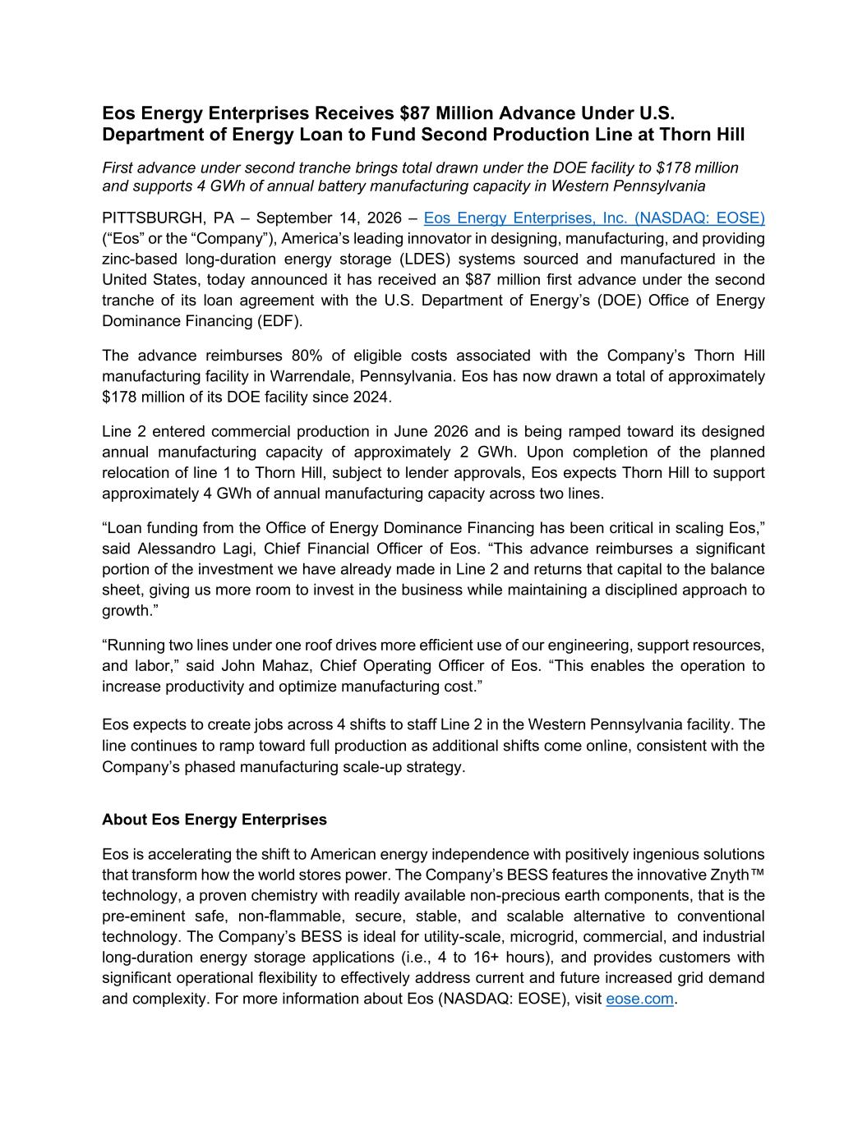
4
Eos Energy Enterprises Receives $87 Million Advance Under U.S. Department of Energy Loan to Fund Second Production Line at Thorn Hill First advance under second tranche brings total drawn under the DOE facility to $178 million and supports 4 GWh of annual battery manufacturing capacity in Western Pennsylvania PITTSBURGH, PA – September 14, 2026 – Eos Energy Enterprises, Inc. (NASDAQ: EOSE) (“Eos” or the “Company”), America’s leading innovator in designing, manufacturing, and providing zinc-based long-duration energy storage (LDES) systems sourced and manufactured in the United States, today announced it has received an $87 million first advance under the second tranche of its loan agreement with the U.S. Department of Energy’s (DOE) Office of Energy Dominance Financing (EDF). The advance reimburses 80% of eligible costs associated with the Company’s Thorn Hill manufacturing facility in Warrendale, Pennsylvania. Eos has now drawn a total of approximately $178 million of its DOE facility since 2024. Line 2 entered commercial production in June 2026 and is being ramped toward its designed annual manufacturing capacity of approximately 2 GWh. Upon completion of the planned relocation of line 1 to Thorn Hill, subject to lender approvals, Eos expects Thorn Hill to support approximately 4 GWh of annual manufacturing capacity across two lines. “Loan funding from the Office of Energy Dominance Financing has been critical in scaling Eos,” said Alessandro Lagi, Chief Financial Officer of Eos. “This advance reimburses a significant portion of the investment we have already made in Line 2 and returns that capital to the balance sheet, giving us more room to invest in the business while maintaining a disciplined approach to growth.” “Running two lines under one roof drives more efficient use of our engineering, support resources, and labor,” said John Mahaz, Chief Operating Officer of Eos. “This enables the operation to increase productivity and optimize manufacturing cost.” Eos expects to create jobs across 4 shifts to staff Line 2 in the Western Pennsylvania facility. The line continues to ramp toward full production as additional shifts come online, consistent with the Company’s phased manufacturing scale-up strategy. About Eos Energy Enterprises Eos is accelerating the shift to American energy independence with positively ingenious solutions that transform how the world stores power. The Company’s BESS features the innovative Znyth™ technology, a proven chemistry with readily available non-precious earth components, that is the pre-eminent safe, non-flammable, secure, stable, and scalable alternative to conventional technology. The Company’s BESS is ideal for utility-scale, microgrid, commercial, and industrial long-duration energy storage applications (i.e., 4 to 16+ hours), and provides customers with significant operational flexibility to effectively address current and future increased grid demand and complexity. For more information about Eos (NASDAQ: EOSE), visit eose.com.

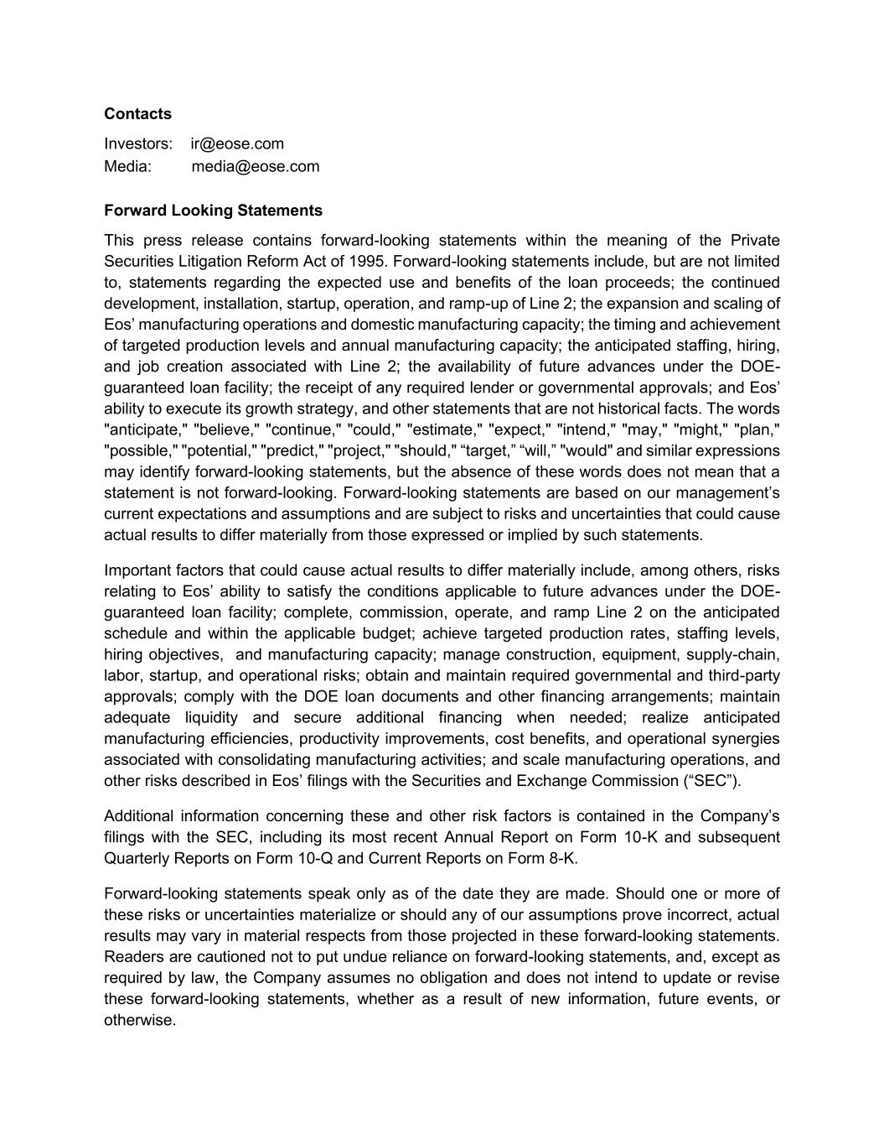
Contacts Investors: ir@eose.com Media: media@eose.com Forward Looking Statements This press release contains forward-looking statements within the meaning of the Private Securities Litigation Reform Act of 1995. Forward-looking statements include, but are not limited to, statements regarding the expected use and benefits of the loan proceeds; the continued development, installation, startup, operation, and ramp-up of Line 2; the expansion and scaling of Eos’ manufacturing operations and domestic manufacturing capacity; the timing and achievement of targeted production levels and annual manufacturing capacity; the anticipated staffing, hiring, and job creation associated with Line 2; the availability of future advances under the DOE- guaranteed loan facility; the receipt of any required lender or governmental approvals; and Eos’ ability to execute its growth strategy, and other statements that are not historical facts. The words "anticipate," "believe," "continue," "could," "estimate," "expect," "intend," "may," "might," "plan," "possible," "potential," "predict," "project," "should," “target,” “will,” "would" and similar expressions may identify forward-looking statements, but the absence of these words does not mean that a statement is not forward-looking. Forward-looking statements are based on our management’s current expectations and assumptions and are subject to risks and uncertainties that could cause actual results to differ materially from those expressed or implied by such statements. Important factors that could cause actual results to differ materially include, among others, risks relating to Eos’ ability to satisfy the conditions applicable to future advances under the DOE- guaranteed loan facility; complete, commission, operate, and ramp Line 2 on the anticipated schedule and within the applicable budget; achieve targeted production rates, staffing levels, hiring objectives, and manufacturing capacity; manage construction, equipment, supply-chain, labor, startup, and operational risks; obtain and maintain required governmental and third-party approvals; comply with the DOE loan documents and other financing arrangements; maintain adequate liquidity and secure additional financing when needed; realize anticipated manufacturing efficiencies, productivity improvements, cost benefits, and operational synergies associated with consolidating manufacturing activities; and scale manufacturing operations, and other risks described in Eos’ filings with the Securities and Exchange Commission (“SEC”). Additional information concerning these and other risk factors is contained in the Company’s filings with the SEC, including its most recent Annual Report on Form 10-K and subsequent Quarterly Reports on Form 10-Q and Current Reports on Form 8-K. Forward-looking statements speak only as of the date they are made. Should one or more of these risks or uncertainties materialize or should any of our assumptions prove incorrect, actual results may vary in material respects from those projected in these forward-looking statements. Readers are cautioned not to put undue reliance on forward-looking statements, and, except as required by law, the Company assumes no obligation and does not intend to update or revise these forward-looking statements, whether as a result of new information, future events, or otherwise.

