UNITED STATES
SECURITIES AND EXCHANGE COMMISSION
Washington, D.C. 20549
FORM 8-K
CURRENT REPORT
PURSUANT TO SECTION 13 OR 15(d) OF THE
SECURITIES EXCHANGE ACT OF 1934
Date of Report (Date of earliest event reported): July 15, 2026
EOS ENERGY ENTERPRISES, INC.
(Exact name of registrant as specified in its charter)
Delaware |  |  |  |  |  | 001-39291 |  |  |  |  |  | 84-4290188
(State or other jurisdiction  of incorporation) |  |  |  |  |  | (Commission  File Number) |  |  |  |  |  | (IRS Employer  Identification No.)
Two Allegheny Center
Nova Tower 2
Pittsburgh, Pennsylvania 15212
(Address of principal executive offices, including zip code)
Registrant’s telephone number, including area code: (732) 225-8400
N/A
(Former name or former address, if changed since last report)
Check the appropriate box below if the Form 8-K filing is intended to simultaneously satisfy the filing obligation of the registrant under any of the following provisions:
☐ |  |  | Written communications pursuant to Rule 425 under the Securities Act (17 CFR 230.425)
☐ |  |  | Soliciting material pursuant to Rule 14a-12 under the Exchange Act (17 CFR 240.14a-12)
☐ |  |  | Pre-commencement communications pursuant to Rule 14d-2(b) under the Exchange Act (17 CFR 240.14d-2(b))
☐ |  |  | Pre-commencement communications pursuant to Rule 13e-4(c) under the Exchange Act (17 CFR 240.13e-4(c))
Securities registered pursuant to Section 12(b) of the Act:
Title of each class |  |  |  |  |  | Trading Symbol(s) |  |  |  |  |  | Name of each exchange on which registered
Common stock, par value $0.0001 per share |  |  |  |  |  | EOSE |  |  |  |  |  | The Nasdaq Stock Market LLC
Rights to Purchase Units, each Unit consisting of one share of Common Stock and 0.4388 of a Warrant |  |  |  |  |  | EOSER |  |  |  |  |  | The Nasdaq Stock Market LLC
Indicate by check mark whether the registrant is an emerging growth company as defined in Rule 405 of the Securities Act of 1933 (§230.405 of this chapter) or Rule 12b-2 of the Securities Exchange Act of 1934 (§240.12b-2 of this chapter).
Emerging growth company ☐
If an emerging growth company, indicate by check mark if the registrant has elected not to use the extended transition period for complying with any new or revised financial accounting standards provided pursuant to Section 13(a) of the Exchange Act. ☐

1

Item 2.02 Results of Operations and Financial Condition.
On July 15, 2026, the Company issued a press release providing its preliminary results for the quarter ended June 30, 2026 and certain other business updates. A copy of the press release is furnished herewith as Exhibit 99.1.
The information furnished under this Item 2.02 and in the accompanying Exhibit 99.1 shall not be deemed “filed” for purposes of Section 18 of the Securities Exchange Act of 1934, as amended (the “Exchange Act”), or incorporated by reference in any filing under the Securities Act of 1933, as amended, or the Exchange Act regardless of any general incorporation language in such filing, unless expressly incorporated by specific reference in such filing.

Item 7.01 Regulation FD Disclosure.
Item 2.02 above is incorporated herein by reference.
The information furnished under this Item 7.01 and in the accompanying Exhibit 99.1 shall not be deemed “filed” for purposes of Section 18 of the Exchange Act, or incorporated by reference in any filing under the Securities Act of 1933, as amended, or the Exchange Act regardless of any general incorporation language in such filing, unless expressly incorporated by specific reference in such filing.

Item 8.01 Other Events.
Based on preliminary financial information, Eos currently expects:
•Revenue of $68 million to $69 million for the three-month period ended June 30, 2026, driven by a more than three-fold increase in shipments compared to the prior-year period.
•Gross margin loss between 69% and 73%, for the three-month period ended June 30, 2026 reflecting continued progress in manufacturing scale and operational execution. The second quarter marked the Company's transition to operating two commercial production lines across two manufacturing facilities. Battery Line 2 commenced commercial production in late June and has delivered strong initial results, with yield performance and cycle times exceeding those already achieved on Battery Line 1. While start-up costs and lower initial production volumes are expected to create near-term cost absorption pressure, as is typical during the early stages of a production ramp-up, the expansion significantly increases capacity and establishes the foundation for stronger unit economics and expected margin improvement over time.
•Total Cash, including restricted cash, of approximately $364 million as of June 30, 2026.
These preliminary results for the second quarter ended June 30, 2026 are preliminary and estimated based on the information available to us at this time, and should not be viewed as a substitute for our interim unaudited condensed consolidated financial statements prepared in accordance with GAAP. Actual financial results for the second quarter ended June 30, 2026, may differ materially from the preliminary financial results. Accordingly, you should not place undue reliance on these preliminary results. The preliminary results for the second quarter ended June 30, 2026 have been prepared by and are the responsibility of management. Neither our independent registered public accounting firm, nor any other independent accountants, have audited, reviewed, compiled or performed any procedures with respect to the preliminary results, nor have they expressed any opinion or any other form of assurance with respect thereto.

Item 9.01 Financial Statement and Exhibits.
(d) Exhibits
Exhibit  Number |  |  |  |  |  | Description of Document
99.1 |  |  |  |  |  | Press release of Eos Energy Enterprises, Inc., dated July 15, 2026
104 |  |  |  |  |  | Cover page of this Current Report on Form 8-K formatted in Inline XBRL

2

SIGNATURE
Pursuant to the requirements of the Securities Exchange Act of 1934, the registrant has duly caused this report to be signed on its behalf by the undersigned hereunto duly authorized.
 |  |  | EOS ENERGY ENTERPRISES, INC.
Dated: July 15, 2026 |  |  | By: |  |  | /s/ Alessandro Lagi
 |  |  |  |  |  | Name: |  |  | Alessandro Lagi
 |  |  |  |  |  | Title: |  |  | Chief Financial Officer
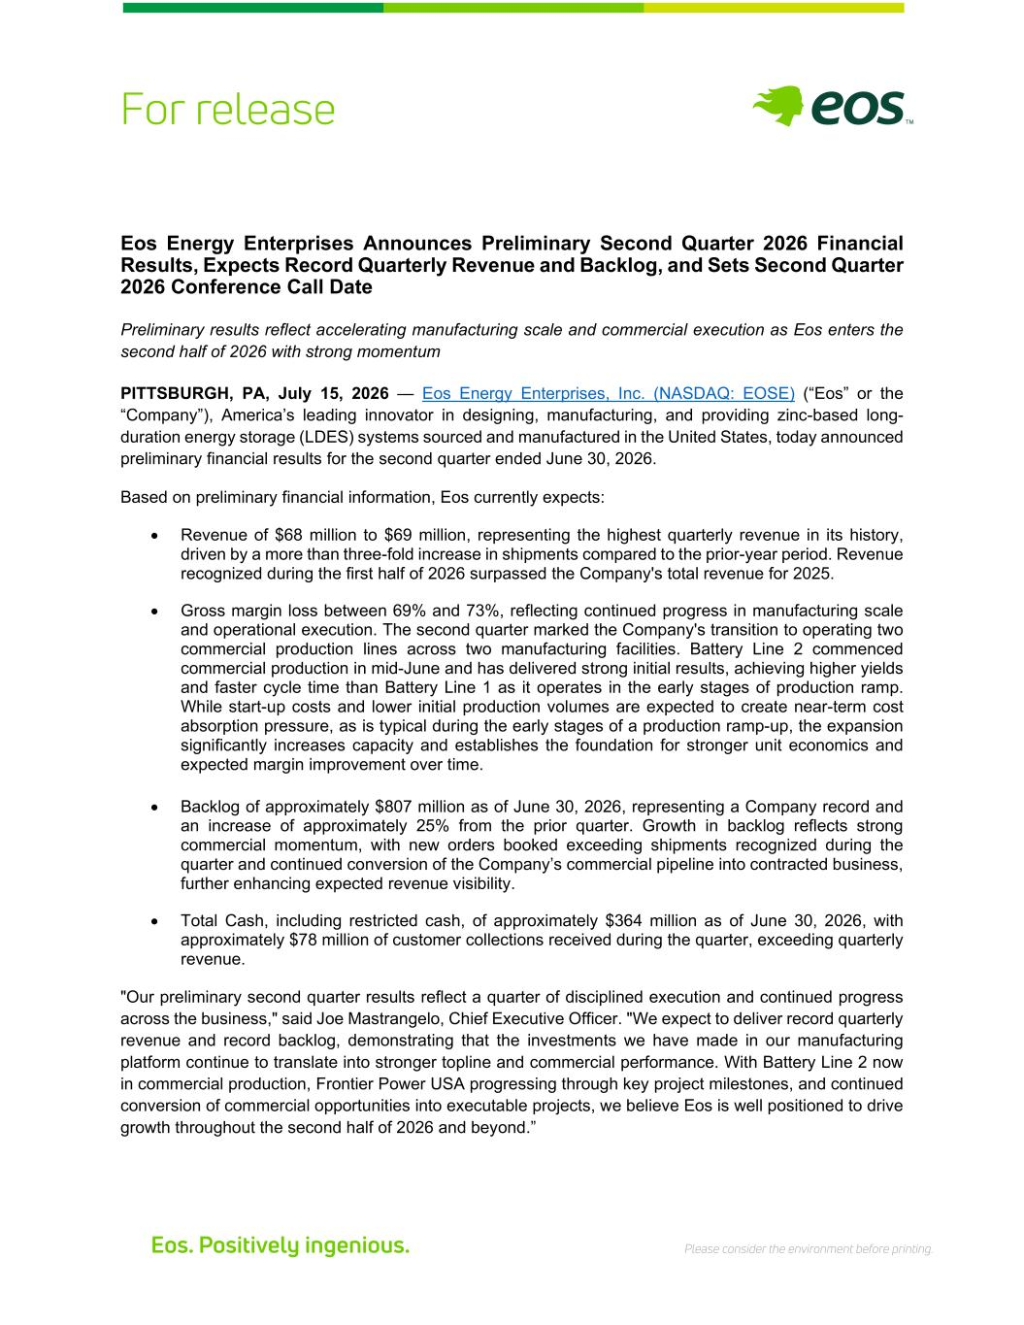
3
Eos Energy Enterprises Announces Preliminary Second Quarter 2026 Financial Results, Expects Record Quarterly Revenue and Backlog, and Sets Second Quarter 2026 Conference Call Date Preliminary results reflect accelerating manufacturing scale and commercial execution as Eos enters the second half of 2026 with strong momentum PITTSBURGH, PA, July 15, 2026 — Eos Energy Enterprises, Inc. (NASDAQ: EOSE) (“Eos” or the “Company”), America’s leading innovator in designing, manufacturing, and providing zinc-based long- duration energy storage (LDES) systems sourced and manufactured in the United States, today announced preliminary financial results for the second quarter ended June 30, 2026. Based on preliminary financial information, Eos currently expects: • Revenue of $68 million to $69 million, representing the highest quarterly revenue in its history, driven by a more than three-fold increase in shipments compared to the prior-year period. Revenue recognized during the first half of 2026 surpassed the Company's total revenue for 2025. • Gross margin loss between 69% and 73%, reflecting continued progress in manufacturing scale and operational execution. The second quarter marked the Company's transition to operating two commercial production lines across two manufacturing facilities. Battery Line 2 commenced commercial production in mid-June and has delivered strong initial results, achieving higher yields and faster cycle time than Battery Line 1 as it operates in the early stages of production ramp. While start-up costs and lower initial production volumes are expected to create near-term cost absorption pressure, as is typical during the early stages of a production ramp-up, the expansion significantly increases capacity and establishes the foundation for stronger unit economics and expected margin improvement over time. • Backlog of approximately $807 million as of June 30, 2026, representing a Company record and an increase of approximately 25% from the prior quarter. Growth in backlog reflects strong commercial momentum, with new orders booked exceeding shipments recognized during the quarter and continued conversion of the Company’s commercial pipeline into contracted business, further enhancing expected revenue visibility. • Total Cash, including restricted cash, of approximately $364 million as of June 30, 2026, with approximately $78 million of customer collections received during the quarter, exceeding quarterly revenue. "Our preliminary second quarter results reflect a quarter of disciplined execution and continued progress across the business," said Joe Mastrangelo, Chief Executive Officer. "We expect to deliver record quarterly revenue and record backlog, demonstrating that the investments we have made in our manufacturing platform continue to translate into stronger topline and commercial performance. With Battery Line 2 now in commercial production, Frontier Power USA progressing through key project milestones, and continued conversion of commercial opportunities into executable projects, we believe Eos is well positioned to drive growth throughout the second half of 2026 and beyond.”

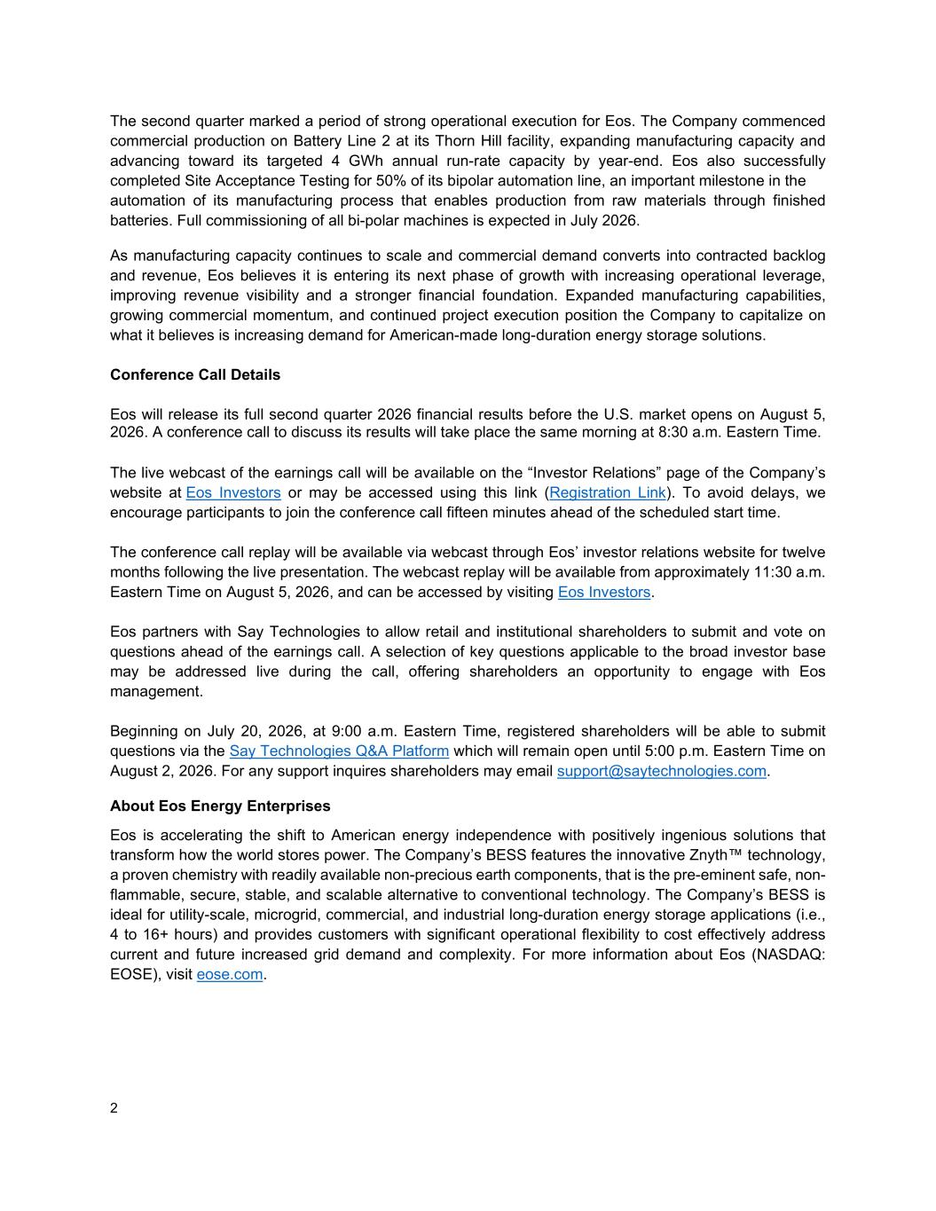
2 The second quarter marked a period of strong operational execution for Eos. The Company commenced commercial production on Battery Line 2 at its Thorn Hill facility, expanding manufacturing capacity and advancing toward its targeted 4 GWh annual run-rate capacity by year-end. Eos also successfully completed Site Acceptance Testing for 50% of its bipolar automation line, an important milestone in the automation of its manufacturing process that enables production from raw materials through finished batteries. Full commissioning of all bi-polar machines is expected in July 2026. As manufacturing capacity continues to scale and commercial demand converts into contracted backlog and revenue, Eos believes it is entering its next phase of growth with increasing operational leverage, improving revenue visibility and a stronger financial foundation. Expanded manufacturing capabilities, growing commercial momentum, and continued project execution position the Company to capitalize on what it believes is increasing demand for American-made long-duration energy storage solutions. Conference Call Details Eos will release its full second quarter 2026 financial results before the U.S. market opens on August 5, 2026. A conference call to discuss its results will take place the same morning at 8:30 a.m. Eastern Time. The live webcast of the earnings call will be available on the “Investor Relations” page of the Company’s website at Eos Investors or may be accessed using this link (Registration Link). To avoid delays, we encourage participants to join the conference call fifteen minutes ahead of the scheduled start time. The conference call replay will be available via webcast through Eos’ investor relations website for twelve months following the live presentation. The webcast replay will be available from approximately 11:30 a.m. Eastern Time on August 5, 2026, and can be accessed by visiting Eos Investors. Eos partners with Say Technologies to allow retail and institutional shareholders to submit and vote on questions ahead of the earnings call. A selection of key questions applicable to the broad investor base may be addressed live during the call, offering shareholders an opportunity to engage with Eos management. Beginning on July 20, 2026, at 9:00 a.m. Eastern Time, registered shareholders will be able to submit questions via the Say Technologies Q&A Platform which will remain open until 5:00 p.m. Eastern Time on August 2, 2026. For any support inquires shareholders may email support@saytechnologies.com. About Eos Energy Enterprises Eos is accelerating the shift to American energy independence with positively ingenious solutions that transform how the world stores power. The Company’s BESS features the innovative Znyth™ technology, a proven chemistry with readily available non-precious earth components, that is the pre-eminent safe, non- flammable, secure, stable, and scalable alternative to conventional technology. The Company’s BESS is ideal for utility-scale, microgrid, commercial, and industrial long-duration energy storage applications (i.e., 4 to 16+ hours) and provides customers with significant operational flexibility to cost effectively address current and future increased grid demand and complexity. For more information about Eos (NASDAQ: EOSE), visit eose.com.


3 Contacts Investors: ir@eose.com Media: media@eose.com Forward-Looking Statements and Important Information Except for the historical information contained herein, the matters set forth in this press release are forward- looking statements within the meaning of the “safe harbor” provisions of the Private Securities Litigation Reform Act of 1995. Forward-looking statements include, but are not limited to, statements regarding preliminary revenue, gross margin, adjusted gross margin, backlog, total cash, customer collections, manufacturing capacity, Battery Line 2 performance, expected commissioning activities, anticipated throughput and efficiency improvements, expected revenue visibility, and the Company’s ability to achieve its operational, and commercial and production-capacity objectives, the extent to which any purchase orders, capacity reservations, or project pipeline may ultimately result in executed contracts, construction activities, or revenue; and the anticipated benefits of the FPUSA platform and the Company’s relationships with developers. The words “anticipate,” “believe,” “continue,” “could,” “estimate,” “expect,” “intends,” “may,” “might,” “plan,” “possible,” “potential,” “predict,” “project,” “should,” “would” and similar expressions may identify forward-looking statements, but the absence of these words does not mean that a statement is not forward-looking. Forward-looking statements are based on our management’s beliefs, as well as assumptions made by, and the information currently available to, them. Because such statements are based on expectations as to future financial and operating results and are not statements of fact, actual results may differ materially from those projected. Factors which may cause actual results to differ materially from current expectations include, but are not limited to: the preliminary financial information remains subject to changes and finalization based upon management’s ongoing review of results for the second quarter ended June 30, 2026 and the completion of all quarter closing procedures; risks related to the development, financing, construction, and commissioning of projects, including timelines and the ability of counterparties to perform; the timing, issuance, and size of future project-level purchase orders and the conversion of framework agreements, capacity reservations, backlog, and pipeline into revenue; risks related to FPUSA, including its ability to source, acquire, finance, and execute projects, and risks related to Eos’ intended equity interest in FPUSA and any related-party considerations; risks associated with the credit agreement with Cerberus, including risks of default, dilution of outstanding Common Stock, and contractual lockup of shares; our customers’ and project counterparties’ ability to secure project financing; changes adversely affecting the business in which we are engaged; our ability to generate cash, service indebtedness, and raise financing in the future; our ability to continue to develop efficient manufacturing processes to scale and to forecast related costs and efficiencies accurately; risks related to the preliminary nature of the financial information included in this release, including the risk that final results may differ materially from the preliminary results presented herein following completion of quarter-end closing procedures, management review, Audit Committee review, independent auditor review procedures, and finalization of the Company’s financial statements and periodic report; risks related to manufacturing ramp-up, including start-up costs, lower initial production volumes, cost absorption, equipment commissioning, battery line performance, throughput, yield, scrap, labor, materials, supply chain availability and operational efficiency; the amount of final tax credits available pursuant to the Inflation Reduction Act; the timing and availability of future funding under the Department of Energy Loan Facility; competition from existing or new competitors; risks related to legal proceedings or claims; risks associated with evolving energy policies in the United States and the potential costs of regulatory compliance; changes in applicable laws or regulations; our ability to maintain the listing of our shares of common stock on NASDAQ; our ability to grow our business and manage growth profitably and

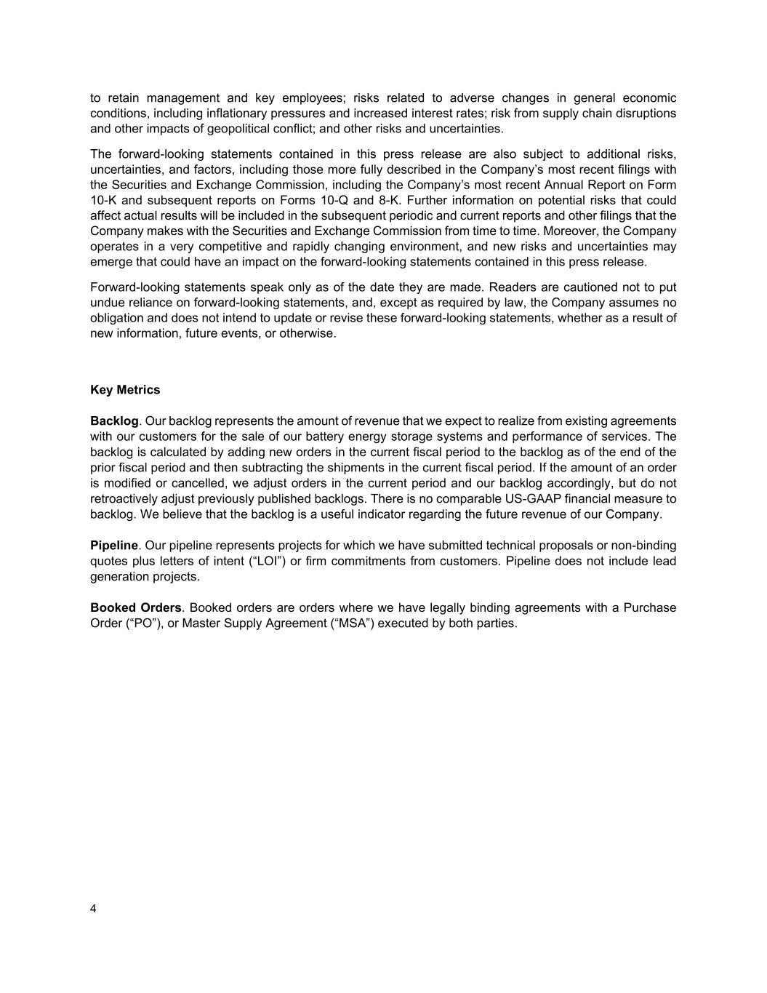
4 to retain management and key employees; risks related to adverse changes in general economic conditions, including inflationary pressures and increased interest rates; risk from supply chain disruptions and other impacts of geopolitical conflict; and other risks and uncertainties. The forward-looking statements contained in this press release are also subject to additional risks, uncertainties, and factors, including those more fully described in the Company’s most recent filings with the Securities and Exchange Commission, including the Company’s most recent Annual Report on Form 10-K and subsequent reports on Forms 10-Q and 8-K. Further information on potential risks that could affect actual results will be included in the subsequent periodic and current reports and other filings that the Company makes with the Securities and Exchange Commission from time to time. Moreover, the Company operates in a very competitive and rapidly changing environment, and new risks and uncertainties may emerge that could have an impact on the forward-looking statements contained in this press release. Forward-looking statements speak only as of the date they are made. Readers are cautioned not to put undue reliance on forward-looking statements, and, except as required by law, the Company assumes no obligation and does not intend to update or revise these forward-looking statements, whether as a result of new information, future events, or otherwise. Key Metrics Backlog. Our backlog represents the amount of revenue that we expect to realize from existing agreements with our customers for the sale of our battery energy storage systems and performance of services. The backlog is calculated by adding new orders in the current fiscal period to the backlog as of the end of the prior fiscal period and then subtracting the shipments in the current fiscal period. If the amount of an order is modified or cancelled, we adjust orders in the current period and our backlog accordingly, but do not retroactively adjust previously published backlogs. There is no comparable US-GAAP financial measure to backlog. We believe that the backlog is a useful indicator regarding the future revenue of our Company. Pipeline. Our pipeline represents projects for which we have submitted technical proposals or non-binding quotes plus letters of intent (“LOI”) or firm commitments from customers. Pipeline does not include lead generation projects. Booked Orders. Booked orders are orders where we have legally binding agreements with a Purchase Order (“PO”), or Master Supply Agreement (“MSA”) executed by both parties.

