UNITED STATES
SECURITIES AND EXCHANGE COMMISSION
Washington, D.C. 20549

FORM 10-Q
☒ |  |  | QUARTERLY REPORT PURSUANT TO SECTION 13 OR 15(d) OF THE SECURITIES EXCHANGE ACT OF 1934
For the quarterly period ended June 30, 2025
OR
☐ |  |  | TRANSITION REPORT PURSUANT TO SECTION 13 OR 15(d) OF THE SECURITIES EXCHANGE ACT OF 1934
For the transition period from to

Commission file number 001-39291
EOS ENERGY ENTERPRISES, INC.
(Exact name of registrant as specified in its charter)
Delaware |  |  |  |  |  |  |  |  | 84-4290188
(State or other jurisdiction of incorporation or organization) |  |  |  |  |  |  |  |  | (I.R.S. Employer Identification No.)
3920 Park Avenue |  |  | Edison |  |  | NJ |  |  | 08820
(Address of Principal Executive Offices) |  |  |  |  |  |  |  |  | (Zip Code)
(732) 225-8400
Registrant’s telephone number, including area code
Securities registered pursuant to Section 12(b) of the Act:
Title of each class |  |  | Trading Symbol(s) |  |  | Name of each exchange on which registered
Common stock, par value $0.0001 per share |  |  | EOSE |  |  | The Nasdaq Stock Market LLC
Warrants, each exercisable for one share of common stock |  |  | EOSEW |  |  | The Nasdaq Stock Market LLC
Indicate by check mark whether the registrant: (1) has filed all reports required to be filed by Section 13 or 15(d) of the Securities Exchange Act of 1934 during the preceding 12 months (or for such shorter period that the registrant was required to file such reports); and (2) has been subject to such filing requirements for the past 90 days. Yes ☒ No ☐
Indicate by check mark whether the registrant has submitted electronically and posted on its corporate web site, if any, every Interactive Data File required to be submitted and posted pursuant to Rule 405 of Regulation S-T (§232.405 of this chapter) during the preceding 12 months (or for such shorter period that the registrant was required to submit and post such files). Yes ☒ No ☐
Indicate by check mark whether the registrant is a large accelerated filer, an accelerated filer, a non-accelerated filer, or a smaller reporting company. See the definitions of “large accelerated filer,” “accelerated filer” and “smaller reporting company” in Rule 12b-2 of the Exchange Act. (Check one):
Large accelerated filer |  |  | ☐ |  |  | Accelerated filer |  |  | ☐
Non-accelerated filer |  |  | ☒ |  |  | Smaller reporting company |  |  | ☒
 |  |  |  |  |  | Emerging growth company |  |  | ☐
If an emerging growth company, indicate by check mark if the registrant has elected not to use the extended transition period for complying with any new or revised financial accounting standards provided pursuant to Section 13(a) of the Exchange Act. ☐
Indicate by check mark whether the registrant is a shell company (as defined in Rule 12b-2 of the Act). Yes ☐ No ☒
The registrant had outstanding 259,853,606 shares of common stock as of July 25, 2025.

Table of Contents
Table of Contents
 |  |  |  |  |  | Page
 |  |  | PART I - FINANCIAL INFORMATION
Item 1. |  |  | Financial Statements |  |  | 4
 |  |  | Unaudited Condensed Consolidated Balance Sheets as of June 30, 2025 and December 31, 2024 |  |  | 4
 |  |  | Unaudited Condensed Consolidated Statements of Operations and Comprehensive Loss for the Three and Six Months Ended June 30, 2025 and 2024 |  |  | 6
 |  |  | Unaudited Condensed Consolidated Statements of Shareholders’ Deficit for the Three and Six Months Ended June 30, 2025 and 2024 |  |  | 7
 |  |  | Unaudited Condensed Consolidated Statements of Cash Flows for the Six Months Ended June 30, 2025 and 2024 |  |  | 9
 |  |  | Notes to the Unaudited Condensed Consolidated Financial Statements |  |  | 11
Item 2. |  |  | Management’s Discussion and Analysis of Financial Condition and Results of Operations |  |  | 51
Item 3. |  |  | Quantitative and Qualitative Disclosures About Market Risk |  |  | 61
Item 4. |  |  | Controls and Procedures |  |  | 61
 |  |  | PART II - OTHER INFORMATION
Item 1. |  |  | Legal Proceedings |  |  | 62
Item 1a. |  |  | Risk Factors |  |  | 62
Item 2. |  |  | Unregistered Sales of Equity Securities and Use of Proceeds |  |  | 62
Item 3. |  |  | Defaults Upon Senior Securities |  |  | 62
Item 4. |  |  | Mine Safety Disclosures |  |  | 62
Item 5. |  |  | Other Information |  |  | 62
Item 6. |  |  | Exhibits |  |  | 64
Signatures |  |  |  |  |  | 66

1
Table of Contents
FORWARD-LOOKING INFORMATION
All statements included in this Quarterly Report on Form 10-Q (“Quarterly Report”), other than statements or characterizations of historical fact, are forward-looking statements within the meaning of the Private Securities Litigation Reform Act of 1995. The words “anticipate,” “believe,” “continue,” “could,” “estimate,” “expect,” “intends,” “may,” “might,” “plan,” “possible,” “potential,” “predict,” “project,” “should,” “would” and similar expressions, as they relate to us, are intended to identify forward-looking statements. These statements appear in a number of places in this Quarterly Report and include statements regarding the intent, belief or current expectations of Eos Energy Enterprises, Inc. Forward-looking statements are based on our management’s beliefs, as well as assumptions made by and information currently available to, them. Because such statements are based on expectations as to future financial and operating results and are not statements of fact, actual results may differ materially from those projected. Factors which may cause actual results to differ materially from current expectations include, but are not limited to:
•changes adversely affecting the business in which we are engaged;
•our ability to forecast trends accurately;
•our ability to generate cash, service indebtedness and incur additional indebtedness;
•our ability to raise financing in the future;
•our customer’s ability to secure project financing;
•risks associated with the Credit Agreement (defined below), including risks of default, dilution of outstanding common stock, consequences for failure to meet milestones and contractual lockup of shares;
•the amount of final tax credits available to our customers or to Eos pursuant to the Inflation Reduction Act;
•the timing and availability of future funding under the Department of Energy Loan Facility;
•our ability to continue to develop efficient manufacturing processes to scale and to forecast related costs and efficiencies accurately;
•fluctuations in our revenue and operating results;
•competition from existing or new competitors;
•our ability to convert firm order backlog and pipeline to revenue;
•risks associated with security breaches in our information technology systems;
•risks related to legal proceedings or claims;
•risks associated with evolving energy policies in the United States and other countries and the potential costs of regulatory compliance;
•risks associated with changes to the U.S. trade environment;
•our ability to maintain the listing of our shares of common stock on NASDAQ;
•our ability to grow our business and manage growth profitably, maintain relationships with customers and suppliers and retain our management and key employees;
•risks related to adverse changes in general economic conditions, including inflationary pressures and increased interest rates;
•risk from supply chain disruptions and other impacts of geopolitical conflict;
•changes in applicable laws or regulations; and
•other factors detailed under the section titled “Risk Factors” herein.
2
Table of Contents
Should one or more of these risks or uncertainties materialize, or should any of our assumptions prove incorrect, actual results may vary in material respects from those projected in these forward-looking statements. Forward-looking statements speak only as of the date they are made. Readers are cautioned not to put undue reliance on forward-looking statements and, except as required by law, the Company assumes no obligation and does not intend to update or revise these forward-looking statements, whether as a result of new information, future events, or otherwise. See also Part I, Item 1A, “Risk Factors” disclosures contained in the Company’s Annual Report on Form 10-K for the year ended December 31, 2024 for additional discussion of the risks and uncertainties that could cause the Company’s actual results to differ materially from those expressed or implied in its forward-looking statements.

3
Table of Contents
Part I - Financial Information
EOS ENERGY ENTERPRISES, INC.
UNAUDITED CONDENSED CONSOLIDATED BALANCE SHEETS
(In thousands, except share and per share amounts)

 |  |  | June 30,  2025 |  |  |  |  |  | December 31,  2024
ASSETS
Current assets:
Cash and cash equivalents |  |  | $ | 120,225 |  |  |  |  | $ | 74,292
Restricted cash |  |  | 31,830 |  |  |  |  |  | 14,070
Loan commitment assets - related party |  |  | — |  |  |  |  |  | 21,731
Accounts receivable, net |  |  | 3,250 |  |  |  |  |  | 3,038
Inventory |  |  | 41,128 |  |  |  |  |  | 32,826
Vendor deposits |  |  | 11,197 |  |  |  |  |  | 17,419
Contract assets, current |  |  | 14,601 |  |  |  |  |  | 13,096
Prepaid expenses |  |  | 2,005 |  |  |  |  |  | 938
Grant receivable, net |  |  | 6,589 |  |  |  |  |  | 2,283
Other current assets |  |  | 1,452 |  |  |  |  |  | 219
Total current assets |  |  | 232,277 |  |  |  |  |  | 179,912
Property, plant and equipment, net |  |  | 75,533 |  |  |  |  |  | 45,660
Intangible assets, net |  |  | 192 |  |  |  |  |  | 240
Goodwill |  |  | 4,331 |  |  |  |  |  | 4,331
Operating lease right-of-use asset, net |  |  | 2,624 |  |  |  |  |  | 2,909
Long-term restricted cash |  |  | 31,120 |  |  |  |  |  | 15,000
Other assets, net |  |  | 14,918 |  |  |  |  |  | 12,266
Total assets |  |  | $ | 360,995 |  |  |  |  | $ | 260,318
LIABILITIES
Current liabilities:
Accounts payable |  |  | $ | 39,728 |  |  |  |  | $ | 16,723
Accrued expenses |  |  | 23,647 |  |  |  |  |  | 22,032
Operating lease liability, current |  |  | 2,195 |  |  |  |  |  | 1,879
Long-term debt, current |  |  | 1,073 |  |  |  |  |  | 2,014
Contract liabilities, current |  |  | 37,438 |  |  |  |  |  | 22,039
Other current liabilities |  |  | 171 |  |  |  |  |  | 288
Total current liabilities |  |  | 104,252 |  |  |  |  |  | 64,975
Long-term liabilities:
Operating lease liability |  |  | 871 |  |  |  |  |  | 1,628
Long-term debt |  |  | 307,274 |  |  |  |  |  | 65,823
Notes payable - related party |  |  | 136,930 |  |  |  |  |  | 249,059
Contract liabilities, long-term |  |  | 2,099 |  |  |  |  |  | 4,310
Warrants liability |  |  | 181,093 |  |  |  |  |  | 189,591
Warrants liability - related party |  |  | 198,984 |  |  |  |  |  | 266,630
Other liabilities |  |  | 190 |  |  |  |  |  | 69
Total long-term liabilities |  |  | 827,441 |  |  |  |  |  | 777,110
Total liabilities |  |  | 931,693 |  |  |  |  |  | 842,085
4
Table of Contents
EOS ENERGY ENTERPRISES, INC.
UNAUDITED CONDENSED CONSOLIDATED BALANCE SHEETS
(In thousands, except share and per share amounts)
 |  |  | June 30,  2025 |  |  |  |  |  | December 31,  2024
COMMITMENTS AND CONTINGENCIES (NOTE 16)
SERIES B PREFERRED STOCK (NOTE 3) - related party |  |  | 532,269 |  |  |  |  |  | 488,696
SHAREHOLDERS' DEFICIT
Common stock, $0.0001 par value, 600,000,000 shares authorized, 256,476,521 and 221,791,205 shares outstanding on June 30, 2025 and December 31, 2024, respectively |  |  | 25 |  |  |  |  |  | 23
Additional paid in capital |  |  | 720,680 |  |  |  |  |  | 534,726
Accumulated deficit |  |  | (1,773,973) |  |  |  |  |  | (1,561,716)
Accumulated other comprehensive loss - related party |  |  | (49,714) |  |  |  |  |  | (43,490)
Accumulated other comprehensive income (loss) |  |  | 15 |  |  |  |  |  | (6)
Total shareholders' deficit |  |  | (1,102,967) |  |  |  |  |  | (1,070,463)
Total liabilities, preferred stock and shareholders' deficit |  |  | $ | 360,995 |  |  |  |  | $ | 260,318
The accompanying notes are an integral part of these Unaudited Condensed Consolidated Financial Statements.

5
Table of Contents
EOS ENERGY ENTERPRISES, INC.
UNAUDITED CONDENSED CONSOLIDATED STATEMENTS OF OPERATIONS AND COMPREHENSIVE LOSS
(In thousands, except share and per share amounts)
 |  |  |  |  |  | Three Months Ended  June 30, |  |  |  |  |  |  |  |  |  |  |  | Six Months Ended  June 30,
 |  |  |  |  |  | 2025 |  |  |  |  |  | 2024 |  |  |  |  |  | 2025 |  |  |  |  |  | 2024
Revenue |  |  |  |  |  | $ | 15,236 |  |  |  |  | $ | 898 |  |  |  |  | $ | 25,693 |  |  |  |  | $ | 7,499
Cost of goods sold |  |  |  |  |  | 46,189 |  |  |  |  |  | 14,121 |  |  |  |  |  | 81,185 |  |  |  |  |  | 42,350
Gross profit (loss) |  |  |  |  |  | (30,953) |  |  |  |  |  | (13,223) |  |  |  |  |  | (55,492) |  |  |  |  |  | (34,851)
Operating expenses
Research and development expenses |  |  |  |  |  | 7,201 |  |  |  |  |  | 4,250 |  |  |  |  |  | 14,038 |  |  |  |  |  | 9,450
Selling, general and administrative expenses |  |  |  |  |  | 25,488 |  |  |  |  |  | 11,293 |  |  |  |  |  | 46,483 |  |  |  |  |  | 25,535
Loss from write-down of property, plant and equipment |  |  |  |  |  | 205 |  |  |  |  |  | 271 |  |  |  |  |  | 766 |  |  |  |  |  | 336
Total operating expenses |  |  |  |  |  | 32,894 |  |  |  |  |  | 15,814 |  |  |  |  |  | 61,287 |  |  |  |  |  | 35,321
Operating Loss |  |  |  |  |  | (63,847) |  |  |  |  |  | (29,037) |  |  |  |  |  | (116,779) |  |  |  |  |  | (70,172)
Other (expense) income
Interest expense, net |  |  |  |  |  | (2,129) |  |  |  |  |  | (3,515) |  |  |  |  |  | (2,293) |  |  |  |  |  | (7,782)
Interest expense - related party |  |  |  |  |  | (4,510) |  |  |  |  |  | (4,912) |  |  |  |  |  | (10,291) |  |  |  |  |  | (9,763)
Change in fair value of debt - related party |  |  |  |  |  | 31,615 |  |  |  |  |  | (240) |  |  |  |  |  | 25,682 |  |  |  |  |  | (240)
Change in fair value of warrants |  |  |  |  |  | (57,936) |  |  |  |  |  | (7,941) |  |  |  |  |  | (12,011) |  |  |  |  |  | (5,041)
Change in fair value of derivatives - related parties |  |  |  |  |  | (76,455) |  |  |  |  |  | (47,727) |  |  |  |  |  | (41,869) |  |  |  |  |  | (47,193)
(Loss) gain on debt extinguishment |  |  |  |  |  | (49,063) |  |  |  |  |  | 68,478 |  |  |  |  |  | (49,063) |  |  |  |  |  | 68,478
Other expense |  |  |  |  |  | (606) |  |  |  |  |  | (3,270) |  |  |  |  |  | (1,166) |  |  |  |  |  | (3,134)
Loss before income taxes |  |  |  |  |  | $ | (222,931) |  |  |  |  | $ | (28,164) |  |  |  |  | $ | (207,790) |  |  |  |  | $ | (74,847)
Income tax expense |  |  |  |  |  | 6 |  |  |  |  |  | 8 |  |  |  |  |  | 11 |  |  |  |  |  | 33
Net Loss attributable to shareholders |  |  |  |  |  | $ | (222,937) |  |  |  |  | $ | (28,172) |  |  |  |  | $ | (207,801) |  |  |  |  | $ | (74,880)
Remeasurement of Preferred Stock - related party |  |  |  |  |  | (21,385) |  |  |  |  |  | (23,671) |  |  |  |  |  | 58,612 |  |  |  |  |  | (23,671)
Down round deemed dividend |  |  |  |  |  | (4,456) |  |  |  |  |  | — |  |  |  |  |  | (4,456) |  |  |  |  |  | —
Net Loss attributable to common shareholders |  |  |  |  |  | $ | (248,778) |  |  |  |  | $ | (51,843) |  |  |  |  | $ | (153,645) |  |  |  |  | $ | (98,551)
Other Comprehensive Loss
Change in fair value of debt - credit risk - related party |  |  |  |  |  | $ | (6,224) |  |  |  |  | $ | — |  |  |  |  | $ | (6,224) |  |  |  |  | $ | —
Foreign currency translation adjustment |  |  |  |  |  | 14 |  |  |  |  |  | 1 |  |  |  |  |  | 21 |  |  |  |  |  | (4)
Comprehensive Loss attributable to common shareholders |  |  |  |  |  | $ | (254,988) |  |  |  |  | $ | (51,842) |  |  |  |  | $ | (159,848) |  |  |  |  | $ | (98,555)
Basic and diluted Loss per share attributable to common shareholders
Basic |  |  |  |  |  | $ | (1.05) |  |  |  |  | $ | (0.25) |  |  |  |  | $ | (0.66) |  |  |  |  | $ | (0.48)
Diluted |  |  |  |  |  | $ | (1.05) |  |  |  |  | $ | (0.25) |  |  |  |  | $ | (0.66) |  |  |  |  | $ | (0.48)
Weighted average shares of common stock
Basic |  |  |  |  |  | 237,741,328 |  |  |  |  |  | 211,137,189 |  |  |  |  |  | 231,616,540 |  |  |  |  |  | 206,225,126
Diluted |  |  |  |  |  | 237,741,328 |  |  |  |  |  | 211,137,189 |  |  |  |  |  | 231,616,540 |  |  |  |  |  | 206,225,126
The accompanying notes are an integral part of these Unaudited Condensed Consolidated Financial Statements.

6
Table of Contents
EOS ENERGY ENTERPRISES, INC.
UNAUDITED CONDENSED CONSOLIDATED STATEMENTS OF SHAREHOLDERS' DEFICIT
(In thousands, except share and per share amounts)
 |  |  | Common Stock |  |  |  |  |  |  |  |  |  |  |  | Additional Paid in capital |  |  |  |  |  | Accumulated Other Comprehensive Income (Loss) |  |  |  |  |  | Accumulated Deficit |  |  |  |  |  | Total
 |  |  | Shares |  |  |  |  |  | Amount
Balances on March 31, 2024 |  |  | 206,779,447 |  |  |  |  |  | $ | 22 |  |  |  |  | $ | 774,857 |  |  |  |  | $ | 2 |  |  |  |  | $ | (922,554) |  |  |  |  | $ | (147,673)
Stock-based compensation |  |  | — |  |  |  |  |  | — |  |  |  |  |  | 1,857 |  |  |  |  |  | — |  |  |  |  |  | — |  |  |  |  |  | 1,857
Release of restricted stock units |  |  | 370,586 |  |  |  |  |  | — |  |  |  |  |  | — |  |  |  |  |  | — |  |  |  |  |  | — |  |  |  |  |  | —
Cancellation of shares used to settle payroll tax withholding |  |  | (46,359) |  |  |  |  |  | — |  |  |  |  |  | (43) |  |  |  |  |  | — |  |  |  |  |  | — |  |  |  |  |  | (43)
Issuance of common stock |  |  | 9,387,541 |  |  |  |  |  | 1 |  |  |  |  |  | 6,881 |  |  |  |  |  | — |  |  |  |  |  | — |  |  |  |  |  | 6,882
Remeasurement of Preferred Stock |  |  | — |  |  |  |  |  | — |  |  |  |  |  | (23,671) |  |  |  |  |  | — |  |  |  |  |  | — |  |  |  |  |  | (23,671)
Foreign currency translation adjustment |  |  | — |  |  |  |  |  | — |  |  |  |  |  | — |  |  |  |  |  | 1 |  |  |  |  |  | — |  |  |  |  |  | 1
Net loss |  |  | — |  |  |  |  |  | — |  |  |  |  |  | — |  |  |  |  |  | — |  |  |  |  |  | (28,172) |  |  |  |  |  | (28,172)
Balances on June 30, 2024 |  |  | 216,491,215 |  |  |  |  |  | 23 |  |  |  |  |  | 759,881 |  |  |  |  |  | 3 |  |  |  |  |  | (950,726) |  |  |  |  |  | (190,819)
Balances on March 31, 2025 |  |  | 227,049,683 |  |  |  |  |  | $ | 23 |  |  |  |  | $ | 647,863 |  |  |  |  | $ | (43,489) |  |  |  |  | $ | (1,546,580) |  |  |  |  | $ | (942,183)
Stock-based compensation |  |  | — |  |  |  |  |  | — |  |  |  |  |  | 6,664 |  |  |  |  |  | — |  |  |  |  |  | — |  |  |  |  |  | 6,664
Exercise of warrants |  |  | 500,000 |  |  |  |  |  | — |  |  |  |  |  | 2,370 |  |  |  |  |  | — |  |  |  |  |  | — |  |  |  |  |  | 2,370
Release of restricted stock units and performance-based restricted stock units |  |  | 7,364,338 |  |  |  |  |  | — |  |  |  |  |  | — |  |  |  |  |  | — |  |  |  |  |  | — |  |  |  |  |  | —
Issuance of common stock |  |  | 21,562,500 |  |  |  |  |  | 2 |  |  |  |  |  | 80,712 |  |  |  |  |  | — |  |  |  |  |  | — |  |  |  |  |  | 80,714
Remeasurement of Preferred Stock |  |  | — |  |  |  |  |  | — |  |  |  |  |  | (21,385) |  |  |  |  |  | — |  |  |  |  |  | — |  |  |  |  |  | (21,385)
Foreign currency translation adjustment |  |  | — |  |  |  |  |  | — |  |  |  |  |  | — |  |  |  |  |  | 14 |  |  |  |  |  | — |  |  |  |  |  | 14
Change in fair value of debt - credit risk - related party |  |  | — |  |  |  |  |  | — |  |  |  |  |  | — |  |  |  |  |  | (6,224) |  |  |  |  |  | — |  |  |  |  |  | (6,224)
Down round deemed dividend |  |  | — |  |  |  |  |  | — |  |  |  |  |  | 4,456 |  |  |  |  |  | — |  |  |  |  |  | (4,456) |  |  |  |  |  | —
Net loss |  |  | — |  |  |  |  |  | — |  |  |  |  |  | — |  |  |  |  |  | — |  |  |  |  |  | (222,937) |  |  |  |  |  | (222,937)
Balances on June 30, 2025 |  |  | 256,476,521 |  |  |  |  |  | $ | 25 |  |  |  |  | $ | 720,680 |  |  |  |  | $ | (49,699) |  |  |  |  | $ | (1,773,973) |  |  |  |  | $ | (1,102,967)
7
Table of Contents
EOS ENERGY ENTERPRISES, INC.
UNAUDITED CONDENSED CONSOLIDATED STATEMENTS OF SHAREHOLDERS' DEFICIT
(In thousands, except share and per share amounts)
 |  |  | Common Stock |  |  |  |  |  |  |  |  |  |  |  | Additional Paid in capital |  |  |  |  |  | Accumulated Other Comprehensive Income (Loss) |  |  |  |  |  | Accumulated Deficit |  |  |  |  |  | Total
 |  |  | Shares |  |  |  |  |  | Amount
Balances on December 31, 2023 |  |  | 199,133,827 |  |  |  |  |  | $ | 21 |  |  |  |  | $ | 765,018 |  |  |  |  | $ | 7 |  |  |  |  | $ | (875,846) |  |  |  |  | $ | (110,800)
Stock-based compensation |  |  | — |  |  |  |  |  | — |  |  |  |  |  | 4,798 |  |  |  |  |  | — |  |  |  |  |  | — |  |  |  |  |  | 4,798
Release of restricted stock units |  |  | 1,028,191 |  |  |  |  |  | — |  |  |  |  |  | — |  |  |  |  |  | — |  |  |  |  |  | — |  |  |  |  |  | —
Cancellation of shares used to settle payroll tax withholding |  |  | (298,326) |  |  |  |  |  | — |  |  |  |  |  | (351) |  |  |  |  |  | — |  |  |  |  |  | — |  |  |  |  |  | (351)
Issuance of common stock |  |  | 16,627,523 |  |  |  |  |  | 2 |  |  |  |  |  | 14,087 |  |  |  |  |  | — |  |  |  |  |  | — |  |  |  |  |  | 14,089
Remeasurement of Preferred Stock |  |  | — |  |  |  |  |  | — |  |  |  |  |  | (23,671) |  |  |  |  |  | — |  |  |  |  |  | — |  |  |  |  |  | (23,671)
Foreign currency translation adjustment |  |  | — |  |  |  |  |  | — |  |  |  |  |  | — |  |  |  |  |  | (4) |  |  |  |  |  | — |  |  |  |  |  | (4)
Net loss |  |  | — |  |  |  |  |  | — |  |  |  |  |  | — |  |  |  |  |  | — |  |  |  |  |  | (74,880) |  |  |  |  |  | (74,880)
Balances on June 30, 2024 |  |  | 216,491,215 |  |  |  |  |  | $ | 23 |  |  |  |  | $ | 759,881 |  |  |  |  | $ | 3 |  |  |  |  | $ | (950,726) |  |  |  |  | $ | (190,819)
Balances on December 31, 2024 |  |  | 221,791,205 |  |  |  |  |  | $ | 23 |  |  |  |  | $ | 534,726 |  |  |  |  | $ | (43,496) |  |  |  |  | $ | (1,561,716) |  |  |  |  | $ | (1,070,463)
Stock-based compensation |  |  | — |  |  |  |  |  | — |  |  |  |  |  | 14,111 |  |  |  |  |  | — |  |  |  |  |  | — |  |  |  |  |  | 14,111
Exercise of warrants |  |  | 4,893,102 |  |  |  |  |  | — |  |  |  |  |  | 28,232 |  |  |  |  |  | — |  |  |  |  |  | — |  |  |  |  |  | 28,232
Exercise of stock options |  |  | 198,398 |  |  |  |  |  | — |  |  |  |  |  | 319 |  |  |  |  |  | — |  |  |  |  |  | — |  |  |  |  |  | 319
Release of restricted stock units and performance-based restricted stock units |  |  | 8,113,754 |  |  |  |  |  | — |  |  |  |  |  | — |  |  |  |  |  | — |  |  |  |  |  | — |  |  |  |  |  | —
Cancellation of shares used to settle payroll tax withholding |  |  | (82,438) |  |  |  |  |  | — |  |  |  |  |  | (488) |  |  |  |  |  | — |  |  |  |  |  | — |  |  |  |  |  | (488)
Issuance of common stock |  |  | 21,562,500 |  |  |  |  |  | 2 |  |  |  |  |  | 80,712 |  |  |  |  |  | — |  |  |  |  |  | — |  |  |  |  |  | 80,714
Remeasurement of Preferred Stock |  |  | — |  |  |  |  |  | — |  |  |  |  |  | 58,612 |  |  |  |  |  | — |  |  |  |  |  | — |  |  |  |  |  | 58,612
Foreign currency translation adjustment |  |  | — |  |  |  |  |  | — |  |  |  |  |  | — |  |  |  |  |  | 21 |  |  |  |  |  | — |  |  |  |  |  | 21
Change in fair value of debt - credit risk - related party |  |  | — |  |  |  |  |  | — |  |  |  |  |  | — |  |  |  |  |  | (6,224) |  |  |  |  |  | — |  |  |  |  |  | (6,224)
Down round deemed dividend |  |  | — |  |  |  |  |  | — |  |  |  |  |  | 4,456 |  |  |  |  |  | — |  |  |  |  |  | (4,456) |  |  |  |  |  | —
Net loss |  |  | — |  |  |  |  |  | — |  |  |  |  |  | — |  |  |  |  |  | — |  |  |  |  |  | (207,801) |  |  |  |  |  | (207,801)
Balances on June 30, 2025 |  |  | 256,476,521 |  |  |  |  |  | $ | 25 |  |  |  |  | $ | 720,680 |  |  |  |  | $ | (49,699) |  |  |  |  | $ | (1,773,973) |  |  |  |  | $ | (1,102,967)

8
Table of Contents
EOS ENERGY ENTERPRISES, INC.
UNAUDITED CONDENSED CONSOLIDATED STATEMENTS OF CASH FLOWS
(In thousands, except share and per share amounts)
Six Months Ended
June 30,
 |  |  | 2025 |  |  |  |  |  | 2024
Cash flows from operating activities
Net Loss |  |  | $ | (207,801) |  |  |  |  | $ | (74,880)
Adjustment to reconcile net loss to net cash used in operating activities
Stock-based compensation |  |  | 14,701 |  |  |  |  |  | 4,798
Depreciation and amortization |  |  | 5,615 |  |  |  |  |  | 2,568
Loss (gain) on debt extinguishment |  |  | 49,063 |  |  |  |  |  | (68,478)
Loss from write-down of property, plant and equipment |  |  | 766 |  |  |  |  |  | 336
Amortization of right-of-use assets |  |  | 805 |  |  |  |  |  | 608
Non-cash interest expense |  |  | 3,826 |  |  |  |  |  | 5,117
Non-cash interest expense - related parties |  |  | 10,291 |  |  |  |  |  | 8,987
Change in fair value of debt - related party |  |  | (25,682) |  |  |  |  |  | 240
Change in fair value of warrants |  |  | 12,011 |  |  |  |  |  | 5,041
Change in fair value of derivatives - related parties |  |  | 41,869 |  |  |  |  |  | 47,193
Other |  |  | (6,317) |  |  |  |  |  | 3,264
Changes in operating assets and liabilities:
Prepaid expenses |  |  | (1,067) |  |  |  |  |  | (206)
Inventory |  |  | (90) |  |  |  |  |  | (769)
Accounts receivable |  |  | (424) |  |  |  |  |  | (1,174)
Vendor deposits |  |  | (5,093) |  |  |  |  |  | 837
Contract assets |  |  | (2,776) |  |  |  |  |  | (4,552)
Grant receivable |  |  | (4,306) |  |  |  |  |  | 1,763
Accounts payable |  |  | 10,165 |  |  |  |  |  | 543
Accrued expenses |  |  | (1,273) |  |  |  |  |  | (1,977)
Operating lease liabilities |  |  | (961) |  |  |  |  |  | (711)
Contract liabilities |  |  | 13,188 |  |  |  |  |  | 2,592
Other |  |  | (1,556) |  |  |  |  |  | 2,053
Net cash used in operating activities |  |  | (95,046) |  |  |  |  |  | (66,807)
Cash flows from investing activities
Purchases of intangible assets |  |  | — |  |  |  |  |  | (8)
Purchases of property, plant and equipment |  |  | (11,959) |  |  |  |  |  | (10,291)
Net cash used in investing activities |  |  | (11,959) |  |  |  |  |  | (10,299)
Cash flows from financing activities
Principal payments on finance lease obligations |  |  | (22) |  |  |  |  |  | (4)
Proceeds from exercise of stock options |  |  | 319 |  |  |  |  |  | —
Proceeds from exercise of warrants |  |  | 7,829 |  |  |  |  |  | —
Proceeds from the issuance of 2025 Convertible Notes, net of discount |  |  | 240,000 |  |  |  |  |  | —
Proceeds received from Credit and Securities Purchase Transaction, net - related party |  |  | 38,475 |  |  |  |  |  | 70,075
Payment of debt issuance costs |  |  | (2,836) |  |  |  |  |  | —
Payment of debt issuance costs - related party |  |  | — |  |  |  |  |  | (12,238)
9
Table of Contents
EOS ENERGY ENTERPRISES, INC.
UNAUDITED CONDENSED CONSOLIDATED STATEMENTS OF CASH FLOWS
(In thousands, except share and per share amounts)
Six Months Ended
June 30,
 |  |  | 2025 |  |  |  |  |  | 2024
Payoff of notes payable - related parties |  |  | (180,940) |  |  |  |  |  | —
Payment of debt extinguishment costs |  |  | (680) |  |  |  |  |  | —
Return of debt repurchase premium |  |  | 5,000 |  |  |  |  |  | —
Payoff of Senior Secured Term Loan |  |  | — |  |  |  |  |  | (19,946)
Repayment of equipment financing facility |  |  | (912) |  |  |  |  |  | (1,601)
Proceeds from issuance of common stock |  |  | 81,075 |  |  |  |  |  | 14,089
Repurchase of shares from employees for income tax withholding purposes |  |  | (488) |  |  |  |  |  | (351)
Net cash provided by financing activities |  |  | 186,820 |  |  |  |  |  | 50,024
Effect of exchange rate changes on cash, cash equivalents and restricted cash |  |  | (2) |  |  |  |  |  | (6)
Net increase (decrease) in cash, cash equivalents and restricted cash |  |  | 79,813 |  |  |  |  |  | (27,088)
Cash, cash equivalents and restricted cash, beginning of the period |  |  | 103,362 |  |  |  |  |  | 84,667
Cash, cash equivalents and restricted cash, end of the period |  |  | $ | 183,175 |  |  |  |  | $ | 57,579
Non-cash investing and financing activities
Accrued and unpaid capital expenditures |  |  | $ | 13,872 |  |  |  |  | $ | 3,578
Paid-in kind interest added to principal |  |  | 4,576 |  |  |  |  |  | 5,783
Accrued and unpaid financing costs |  |  | 2,797 |  |  |  |  |  | —
Down round deemed dividend |  |  | 4,456 |  |  |  |  |  | —
Remeasurement of preferred stock - related party |  |  | (58,612) |  |  |  |  |  | 23,671
Right-of-use operating lease assets in exchange for lease liabilities |  |  | 520 |  |  |  |  |  | —
Supplemental disclosures
Cash paid for interest |  |  | $ | 127 |  |  |  |  | $ | 4,131
The accompanying notes are an integral part of these Unaudited Condensed Consolidated Financial Statements.

10
Table of Contents

EOS ENERGY ENTERPRISES, INC.
NOTES TO THE UNAUDITED CONDENSED CONSOLIDATED FINANCIAL STATEMENTS
(In thousands, except share and per share amounts)

1.Overview
Nature of Operations
Eos Energy Enterprises, Inc. (the “Company,” “we,” “us,” “our,” and “Eos”) designs, develops, manufactures and markets innovative energy storage solutions for utility-scale, microgrid and commercial & industrial (“C&I”) applications. Eos developed a broad range of intellectual property with multiple patents covering unique battery chemistry, mechanical product design, energy block configuration and a software operating system (Battery Management System). The Company has only one operating and reportable segment.
Liquidity and Going Concern
As a growth company in the early commercialization stage of its lifecycle, Eos is subject to inherent risks and uncertainties associated with the development of an enterprise. In this regard, substantially all of the Company’s efforts to date have been devoted to the development and manufacturing of battery energy storage systems and complementary products and services, recruitment of management and technical staff, deployment of capital to expand the Company’s operations to meet customer demand and raising capital to fund the Company’s development. However, as a result of these efforts, the Company has incurred significant losses and negative cash flows from operations since its inception and expects to continue to incur such losses and negative cash flows for the foreseeable future until such time that the Company can reach a scale of profitability to sustain its operations.
In order to execute its development strategy, the Company has historically relied on outside capital through the issuance of equity, debt and borrowings under financing arrangements (collectively “outside capital”) to fund its cost structure. While the Company believes its recent entry into new credit facilities as discussed below has significantly improved its capital position and provides a path to sustainable operations and profitability, there can be no assurance the Company will be able to achieve such profitability or do so in a manner that does not require additional outside capital. Moreover, while the Company has historically been successful in raising outside capital, there can be no assurance the Company will be able to continue to obtain outside capital in the future or do so on terms that are acceptable to the Company.
As disclosed in Note 3, Credit and Securities Purchase Transaction, on June 21, 2024, the Company entered into a financing transaction with CCM Denali Debt Holdings, LP, an affiliate of Cerberus Capital Management LP (herein after referred to as “Cerberus”, “Denali”, “Lender”, “Holder”). As a result of this transaction, Cerberus agreed to provide a $210,500 secured multi-draw facility, to be made in four installments (the “Delayed Draw Term Loan”) as well as a $105,000 revolving credit facility (“Revolving Facility”), to be made available beginning June 21, 2026, at Cerberus’ sole discretion and only if the Delayed Draw Term Loan is fully funded. As of the date the accompanying Unaudited Condensed Consolidated Financial Statements were issued (the “issuance date”), the Delayed Draw Term Loan was fully funded. As part of the Credit and Securities Purchase Transaction, Cerberus received warrants and preferred stock resulting in a 33% ownership position in the Company, as of January 24, 2025, the most recent milestone measurement date.

11
Table of Contents
EOS ENERGY ENTERPRISES, INC.
NOTES TO THE UNAUDITED CONDENSED CONSOLIDATED FINANCIAL STATEMENTS
(In thousands, except share and per share amounts)

1. Overview (cont.)
As disclosed in Note 13, Borrowings, on November 26, 2024, the Company successfully closed on the DOE Loan Facility, which provides the Company with up to $303,450 in funding, including capitalized interest, subject to the achievement of certain funding conditions. The DOE Loan Facility provides for a multi draw term loan facility under a series of at least two tranches and, if the Company elects, up to four tranches, subject to the achievement of certain conditions. Each tranche corresponds to the production, maintenance and development, and operation of a given production line to be funded using the proceeds of such tranche. The DOE Loan Facility specifies the maximum amount subject to each tranche (Tranche 1: $101,979; Tranche 2: $117,326; Tranche 3: $71,836; and Tranche 4: $12,309), and any amounts which are not withdrawn under a specified tranche cannot be allocated to another tranche. On April 16, 2025, the Company amended the DOE Loan Facility in order to clarify the maximum Tranche Commitment principal amounts by excluding capitalized interest (Tranche 1: $90,945; Tranche 2: $106,733; Tranche 3: $67,529; and Tranche 4: $12,290). The Amendment does not materially alter rights, obligations, or meaning of the DOE Loan Facility. Through June 30, 2025, the Company had drawn down $68,279 under Tranche 1. See Note 22, Subsequent Events, for further discussion of Tranche 1 funding.
As disclosed in Note 19, Shareholders’ Deficit, the Company entered into an underwriting agreement on May 29, 2025, with Jefferies LLC and J.P. Morgan Securities LLC as representatives of the several underwriters (collectively, the “Underwriters”) pursuant to which the Company agreed to sell 18,750,000 shares of the Company’s common stock at a public offering price of $4.00 per share. In addition, the Company granted the Underwriters an option, exercisable within 30 days after May 29, 2025, to purchase up to an additional 2,812,500 shares of the Company’s common stock. On May 30, 2025, the Underwriters exercised such option to purchase additional shares in full. The issuance and sale of 21,562,500 shares of the Company’s common stock was completed on June 2, 2025, raising proceeds of $81,075, net of fees paid to Jefferies LLC and J.P. Morgan Securities LLC.
As disclosed in Note 13, Borrowings, on June 3, 2025, the Company issued $225,000 principal amounts of Convertible Notes due 2030 (herein after referred to as the “2025 Convertible Notes”). The Company granted initial purchasers an option to purchase, for settlement within a period of thirteen days from the date the 2025 Convertible Notes were first issued, up to an additional $25,000 principal amounts, which was exercised in full. The 2025 Convertible Notes accrues interest at a rate of 6.75% per annum, payable semi-annually in arrears on June 15 and December 15. The 2025 Convertible Notes will mature on June 15, 2030, subject to earlier conversion, redemption or repurchase.
As of the issuance date, management evaluated the significance of the following negative financial conditions in accordance with Accounting Standard Codification 205-40, Going Concern:
•Since its inception, the Company has incurred significant losses and negative cash from operations in order to fund its development. During the six months ended June 30, 2025, the Company had incurred a net loss of $207,801. Adjustments to reconcile net loss to cash used in operations are primarily from non-cash items on the Unaudited Condensed Consolidated Statements of Cash Flows. The non-cash items totaled $106,948. During the six months ended June 30, 2025, the Company incurred negative cash flows from operations of $95,046 and had an accumulated deficit of $1,773,973 as of June 30, 2025.
•As of June 30, 2025, the Company had $120,225 of unrestricted cash and cash equivalents available to fund the Company’s operations and working capital of $128,025.
•On June 21, 2024, upon closing of the Credit and Securities Purchase Transaction, Cerberus funded the Company $75,000 of the initial draw, and the Company received $71,250 net of the 5.0% original issue discount. On August 29, 2024, Cerberus funded the Company $30,000 (“August Draw”), and the Company received $28,500, net of the 5.0% original issue discount. On November 1, 2024, Cerberus funded the Company $65,000 related to the October 31, 2024 tranche (“October Draw” or “October Tranche”), and the Company received $61,750, net of the 5.0% original issue discount. On January 24, 2025, Cerberus funded the Company the final $40,500 and the Company received $38,475, net of the 5.0% original issue discount, related to the January 31, 2025 tranche (“January 2025 Draw”). Subsequent to the January 2025 Draw, the Delayed Draw Term Loan has been fully funded.
12
Table of Contents
EOS ENERGY ENTERPRISES, INC.
NOTES TO THE UNAUDITED CONDENSED CONSOLIDATED FINANCIAL STATEMENTS
(In thousands, except share and per share amounts)

1. Overview (cont.)
•Through June 30, 2025, under the DOE Loan Facility, the Company drew down $68,279 for the eligible project cost that the Company had incurred through December 6, 2024. These costs are a portion of Tranche 1 of the DOE Loan Facility. Tranche 1 provides up to $90,945 for eligible costs in connection with the design, construction, installation, startup and shakedown of a battery automation line and related tools. In the event the Company does not achieve certain funding milestone conditions and the DOE chooses not to continue funding, the Company would need to seek alternative sources of capital, which may not be available on favorable terms or at all. On June 12, 2025, the Company delivered to the DOE and the FFB a second advance request, and on July 1, 2025, the FFB funded $22,666 under the DOE Loan Facility (the “second loan advance”). See Note 22, Subsequent Events, for further discussion of Tranche 1 funding.
•The Credit and Securities Purchase Transaction and the DOE Loan Facility contain certain quarterly financial covenants which include (a) Minimum Liquidity, (b) Minimum Consolidated EBITDA, and (c) Minimum Consolidated Revenue (collectively, the “financial covenants”). As of June 30, 2025, the only financial covenant in effect was Minimum Liquidity. As of June 30, 2025, the Company was in compliance with this covenant and non-financial covenants, and the Company expects to remain in compliance with the Minimum Liquidity covenant over the next twelve months beyond the issuance date. The applicability of the Consolidated Revenue and EBITDA financial covenants were deferred until March 31, 2027.
•In the event the Company’s ongoing efforts to raise additional outside capital are unsuccessful, the Company will be unable to meet its obligations as they come due over the next twelve months beyond the issuance date. In such an event, management will be required to seek other strategic alternatives, which may include, among others, a significant curtailment in the Company’s operations, a sale of certain of the Company’s assets, a sale of the entire Company to strategic or financial investors and/or allowing the Company to become insolvent.
These uncertainties raise substantial doubt about the Company’s ability to continue as a going concern. The accompanying Unaudited Condensed Consolidated Financial Statements have been prepared on the basis that the Company will continue to operate as a going concern, which contemplates that the Company will be able to realize assets and settle liabilities and commitments in the normal course of business for the foreseeable future. Accordingly, the accompanying Unaudited Condensed Consolidated Financial Statements do not include any adjustments that may result from the outcome of these uncertainties.

2. Summary of Significant Accounting Policies
Basis of Presentation
The accompanying Unaudited Condensed Consolidated Financial Statements include the accounts of the Company and its 100% owned, direct and indirect subsidiaries and have been prepared in accordance with U.S. generally accepted accounting principles (“GAAP”). All intercompany transactions and balances have been eliminated in the preparation of the Unaudited Condensed Consolidated Financial Statements. These statements reflect all adjustments, consisting of normal recurring adjustments, which, in the opinion of management, are necessary for fair presentation of the information contained therein. Certain information and footnote disclosures normally included in financial statements prepared in accordance with GAAP have been condensed or omitted pursuant to the rules and regulations of the U.S. Securities and Exchange Commission (“SEC”). The interim financial statements should be read in conjunction with the audited consolidated financial statements, including the notes thereto, included in our 2024 Annual Report on Form 10-K. These interim results are not necessarily indicative of results for the full year.
Use of Estimates
The preparation of financial statements in conformity with GAAP requires management to make estimates and assumptions that affect the reported amounts of assets and liabilities and disclosure of contingent assets and liabilities at the date of the financial statements and the reported amount of revenues and expenses during the reporting period. Actual results could differ from those estimates.
13
Table of Contents
EOS ENERGY ENTERPRISES, INC.
NOTES TO THE UNAUDITED CONDENSED CONSOLIDATED FINANCIAL STATEMENTS
(In thousands, except share and per share amounts)
2. Summary of Significant Accounting Policies (cont.)
Change to Prior Year Presentation
In the Unaudited Condensed Consolidated Statements of Operations, Gross profit (loss) has been introduced, reflecting Total revenue less Cost of goods sold. This addition does not impact the reported Net income (loss).
Series A and B Preferred Stock
As discussed in Note 3, Credit and Securities Purchase Transaction, the Company issued shares of (1) Series A-1 Preferred Stock and Series A-2 Preferred Stock (collectively "Series A Preferred Stock") in June 2024 and August 2024, respectively, which were subsequently converted into shares of Series B-1 Preferred Stock and Series B-2 Preferred Stock, respectively, in September 2024, (2) Series B-3 Preferred Stock in November 2024 and Series B-4 Preferred Stock in January 2025 (collectively, with the Series B-1 Preferred Stock, Series B-2 Preferred Stock, Series B-3 Preferred Stock and Series B-4 Preferred Stock, the “Series B Preferred Stock” and together with Series A Preferred Stock, “the Preferred Stock”). The Preferred Stock is redeemable based upon the passage of time and therefore meets the criteria to be classified within temporary equity. Management has elected to recognize changes in the redemption value pursuant to ASC 480-10-S99-3A-15(b). As a result, the Company will remeasure the Preferred Stock to the maximum redemption value at each reporting date but will never be adjusted below its initial carrying value. Adjustments are reflected in Additional paid in capital on the Company’s Unaudited Condensed Consolidated Balance Sheets.
Production Tax Credits under Internal Revenue Code 45X (“PTC”)
Since the PTC is a refundable credit (i.e., a credit with a direct-pay option available), the PTC is outside the scope of ASC 740. Therefore, the Company accounts for the PTC under a government grant model. GAAP does not address the accounting for government grants received by a business entity that are outside the scope of ASC 740. The Company’s accounting policy is to analogize to IAS 20, Accounting for Government Grants and Disclosure of Government Assistance, under IFRS Accounting Standards. Under IAS 20, once it is reasonably assured that the entity will comply with the conditions of the grant, the grant money is recognized on a systematic basis over the periods in which the entity recognizes the related expenses or losses for which the grant money is intended to compensate. The Company recognizes grants once it is probable that both of the following conditions will be met: (1) the Company is eligible to receive the grant and (2) the Company is able to comply with the relevant conditions of the grant. The PTC is a non-monetary asset since the Company’s intention is to sell the tax credit to a third-party and is recorded at the value that is expected to be received from the sale in Grant Receivable, net on the Company’s Unaudited Condensed Consolidated Balance Sheets and is subsequently recognized in Cost of goods sold in the Unaudited Condensed Consolidated Statements of Operations and Comprehensive Loss when the inventory is sold. In the event the PTC is sold, upon the receipt of the cash payments, the Company will record offsets to Grant Receivable, net. Differences in the recorded value of the PTC and the sale price will be recognized as an adjustment to cost of goods sold in the Unaudited Condensed Consolidated Statements of Operations and Comprehensive Loss.
Fair Value Option
The Company has elected the option under ASC 825-10, Financial Instruments ("ASC 825"), to measure the Delayed Draw Term Loan, including all tranches of fundings received (see Note 3, Credit and Securities Purchase Transaction) at fair value. The fair value option may be elected on an instrument-by-instrument basis and is irrevocable unless a new election date occurs. When the fair value option is elected for an instrument, unrealized gains and losses for such instrument is reported in the Unaudited Condensed Consolidated Statements of Operations and Comprehensive Loss at each subsequent reporting date. Upfront costs and fees related to items for which the fair value option is elected shall be recognized in earnings as incurred and not deferred. These amounts are included in Other expense in the Unaudited Condensed Consolidated Statements of Operations and Comprehensive Loss. The gains or losses attributable to changes in instrument-specific risk are included in Change in fair value of debt - credit risk - related party in Accumulated other comprehensive loss.
14
Table of Contents
EOS ENERGY ENTERPRISES, INC.
NOTES TO THE UNAUDITED CONDENSED CONSOLIDATED FINANCIAL STATEMENTS
(In thousands, except share and per share amounts)
2. Summary of Significant Accounting Policies (cont.)
Recent Accounting Pronouncements
In October 2023, the FASB issued ASU 2023-06, Disclosure Agreements - Codification Amendments in Response to the SEC’s Disclosure Update and Simplification Initiative. This amendment will impact various disclosure areas, including the statement of cash flows, accounting changes and error corrections, earnings per share, debt, equity, derivatives, and transfers of financial assets. The amendments in this ASU 2023-06 will be effective on the date the related disclosures are removed from Regulation S-X or Regulation S-K by the SEC. If the SEC has not removed the applicable disclosure requirement by June 30, 2027, these amendments will not be effective. Early adoption is prohibited. The Company is currently assessing the potential impact this amendment could have on its disclosures.
In December 2023, the FASB issued ASU 2023-09, Improvements to Income Tax Disclosures, which requires additional disclosures related to the effective tax rate reconciliation and taxes paid. The amendment is effective for annual periods beginning after December 15, 2024, and the Company does not anticipate a material change in the financial statements and related disclosure.
In November 2024, the FASB issued ASU 2024-03, Income Statement—Reporting Comprehensive Income—Expense Disaggregation Disclosures (Subtopic 220-40). The amendments in this update require disaggregation of certain expense captions into specified categories in disclosures within the footnotes to the financial statements. This update is effective for annual reporting periods beginning after December 15, 2026, and interim reporting periods beginning after December 15, 2027, though early adoption is permitted. The Company is currently assessing the potential impact this amendment could have on its financial statements and disclosures.
In November 2024, the FASB issued ASU 2024-04, Debt-Debt with Conversion and Other Options (Subtopic 470-20): Induced Conversions of Convertible Debt Instruments. The amendments in this update clarify the requirements for determining whether certain settlements of convertible debt instruments should be accounted for as induced conversions rather than as debt extinguishments. This update is effective for annual periods beginning after December 15, 2025, including interim periods within those fiscal years, though early adoption is permitted. The Company is currently assessing the potential impact this amendment could have on its financial statements and disclosures.
In January 2025, the FASB issued ASU 2025-01, Income Statement-Reporting Comprehensive Income-Expense Disaggregation Disclosures (Subtopic 220-40): Clarifying the Effective Date (“ASU 2025-01”), which requires disaggregated disclosure of income statement expenses for public business entities. The ASU does not change the expense captions an entity presents on the face of the income statement; rather, it requires disaggregation of certain expense captions into specified categories in disclosures within the footnotes to the financial statements. ASU 2025-01 is effective for fiscal years beginning after December 15, 2027. Early adoption is permitted. Entities should apply the amendments in ASU 2023-07 retrospectively to all prior periods presented in the financial statements. The Company is currently assessing the potential impact this ASU could have on its financial statements and disclosures.

3. Credit and Securities Purchase Transaction
Credit and Guaranty Agreement (“Credit Agreement”)
Delayed Draw Term Loan
On June 21, 2024, the Company entered into a credit and guaranty agreement (the “Credit Agreement”) with CCM Denali Debt Holdings, LP, an affiliate of Cerberus Capital Management LP (herein after referred to as “Cerberus”, “Denali”, “Lender”, “Holder”). As a result of this transaction, Cerberus agreed to provide a $210,500 secured multi-draw facility to be made in four installments (“tranches”, and collectively, the (“Delayed Draw Term Loan” or “DDTL”) as well as a $105,000 revolving credit facility (“Revolving Facility”), to be made available at the Lenders’ sole discretion and only if the Delayed Draw Term Loan is fully funded. On June 21, 2024 the initial $75,000 installment was funded (the “Initial Draw”). On August 29, 2024, the full amount of the August tranche of $30,000 was funded. On October 31, 2024, the full amount of the October tranche of $65,000 was funded. The final tranche in the amount of $40,500 was funded on January 24, 2025, completing the scheduled fundings under the Delayed Draw Term Loan.
15
Table of Contents
EOS ENERGY ENTERPRISES, INC.
NOTES TO THE UNAUDITED CONDENSED CONSOLIDATED FINANCIAL STATEMENTS
(In thousands, except share and per share amounts)
3. Credit Agreement and Securities Purchase Transaction (cont.)
On November 26, 2024, the Company amended the Credit Agreement (the “Credit Agreement Amendment”), by and among the Company, certain of the Company’s subsidiaries as guarantors party thereto and the Lender, pursuant to which among other things, the applicability of the Consolidated Revenue and EBITDA financial covenants were deferred until December 31, 2025 and certain provisions were amended to conform with comparable provisions in the DOE Loan Facility.
On April 30, 2025, the Company entered into that certain First Amendment to the Credit Agreement (“First Credit Agreement Amendment”), with Cerberus US Servicing LLC as Administrative Agent under the Credit Agreement and the lenders party thereto, pursuant to which, the measurement period for achieving Sales Milestone 4 (as defined in the Credit Agreement) was extended until July 31, 2025. On April 30, 2025, the Company and Cerberus mutually agreed that the Company achieved three of the four Fourth Milestone Components (as defined in the Credit Agreement) related to the Company’s materials cost, Z3 technology and automated line. No additional Preferred Stock or Warrants will be issued to Cerberus related to the three Fourth Milestone Components achieved by the Company. If the Company fails to meet Sales Milestone 4 on July 31, 2025, then the Applicable Percentage is subject to up to a final 1% increase, and as a result Cerberus would be entitled to receive Preferred Stock or Warrants aggregating to a maximum aggregate Applicable Percentage of 34% (as compared to the original maximum adjustment for all four Milestones of up to 49%).
On May 28, 2025, the Company entered into that certain Second Amendment to Credit Agreement (the “Second Credit Agreement Amendment”), with Cerberus US Servicing LLC as Administrative Agent under the Credit Agreement and the lenders party thereto. The Second Credit Agreement Amendment permitted the Company to raise proceeds by the issuance and sale of common stock and/or convertible notes (called a “Specified Refinancing Transaction’) under the following conditions: (a) $50,000 of the net cash proceeds be applied to prepay the obligations under the Credit Agreement, (b) the Specified Refinancing Transaction result in the full repurchase, tender, redemption. exchange or other refinancing or retirement in full of the Company’s outstanding 2021 Convertible Note Payable and (c) other legal and contractual requirements. Upon closing of the Specified Refinancing Transaction and the satisfaction of certain other conditions precedent set forth in the Second Credit Agreement Amendment, three significant modifications to the Credit Agreement became effective: (i) the interest rate on outstanding borrowings reduced from 15% to 7% per annum, (ii) the Consolidated Revenue and EBITDA financial covenants were deferred until March 31, 2027 and (iii) the equity to be issued to Cerberus in the event the Company fails to meet the final component of the last milestone under the Credit Agreement would be limited to warrants for shares of common stock or shares of convertible preferred stock equal to 1% of the fully diluted outstanding shares of the Company on the final milestone measurement date (including the securities issued pursuant to the Specified Refinancing Transaction).
On May 29, 2025, the Company entered into that certain Third Amendment to Credit Agreement (the “Third Credit Agreement Amendment”), with Cerberus US Servicing LLC as Administrative Agent under the Credit Agreement and the lenders party thereto, pursuant to which, among other things, the Credit Agreement was further amended to modify the definition of Specified Refinancing Transaction by increasing the maximum cash component of consideration that may be given for the repurchase, tender, redemption, exchange or other refinancing or retirement of the Company’s outstanding 2021 Convertible Note Payable to $115,000.
On July 29, 2025, the Company entered into that certain Fourth Amendment to Credit Agreement, (the “Fourth Credit Agreement Amendment”), with Cerberus US Servicing LLC as Administrative Agent under the Credit Agreement and the lenders party thereto, pursuant to which the measurement period for achieving Sales Milestone 4 (as defined in the Credit Agreement) was extended until October 31, 2025. If the Company fails to meet Sales Milestone 4 on October 31, 2025, then the applicable percentage is subject to up to a final 1% increase, and as a result Cerberus would be entitled to warrants or shares of convertible preferred stock equal to 1% of the fully diluted outstanding shares of the Company on the final milestone measurement date (including the securities already issued to Cerberus and securities issued pursuant to the Specified Refinancing Transaction).
Refer to Note 13, Borrowings for further information on the DDTL accounting treatment from the First Credit Agreement Amendment, Second Credit Agreement Amendment and Third Credit Agreement Amendment (collectively, the “Cerberus Amendments”).
16
Table of Contents
EOS ENERGY ENTERPRISES, INC.
NOTES TO THE UNAUDITED CONDENSED CONSOLIDATED FINANCIAL STATEMENTS
(In thousands, except share and per share amounts)
3. Credit Agreement and Securities Purchase Transaction (cont.)
Securities Purchase Agreement
On June 21, 2024, the Company entered into a Securities Purchase Agreement (the “SPA”) with CCM Denali Equity Holdings, LP (the “Purchaser”).
SPA Warrant
Under the SPA, the Company issued a warrant to purchase 43,276,194 shares of common stock representing a collective ownership of 19.9% (the “SPA Warrant”) of our outstanding shares of (inclusive of Series A-1 Preferred Stock – see below) common stock prior to the issuance. The SPA Warrant has a ten-year term and an exercise price of $0.01 per share. The SPA Warrant includes anti-dilutive rights, subject to certain excluded issuances, in the event any shares of common stock, options, warrants, convertible securities or other equity or equity equivalent securities payable in common stock are issued at a price per share of less than the fair market value (as defined in the Warrant) of a share of common stock on the issuance date of the Warrant, subject to adjustment. Until the Company received stockholder approval on September 10, 2024, the Company could not issue additional shares of common stock exceeding 19.99% of shares of common stock issued and outstanding as of the date of the Initial Draw (such percentage, as may be adjusted in accordance with the terms of the Warrant, the “Conversion Cap”) upon exercise of the Warrant, and would have been required to issue, at the option of the Lender, Series A Preferred Stock or additional warrants on common stock upon a draw under the Delayed Draw Term Loan. Following shareholder approval received, the Conversion Cap increased to 49.9% of the number of shares of common stock issued and outstanding as of the applicable measurement date; and the holder of the Warrant has the option to amend the Conversion Cap to any percentage less than 49.9%.
The SPA Warrant is exercisable at the holder’s discretion for cash or on a cashless basis. The SPA Warrant is subject to automatic cashless exercise on the expiration date if the fair market value of one share is greater than the exercise price then in effect. Upon an acceleration under the Credit Agreement, the Company may be required to purchase the SPA Warrant from the holder at an amount equal to the closing sale price of underlying common stock less the SPA Warrant exercise price at the request of the holder. The SPA Warrant meets the criteria for liability classification under ASC 480 and is recognized at fair value with changes in fair value included in Change in fair value of derivatives - related parties in the Unaudited Condensed Consolidated Statements of Operations and Comprehensive Loss.
Contingent Warrants
Upon the achievement of performance milestones on dates specified in the Credit Agreement, the Company received additional funds and issued at the option of the Lender, Preferred Stock (Series A Preferred Stock, if prior to shareholder approval or Series B Preferred Stock if after shareholder approval) or warrants on common stock (collectively “Contingent Warrants”) under the SPA in an amount equal to the applicable percentage, up to an aggregate of 33.0% ownership limitation on a fully diluted basis at such time the Delayed Draw Term Loan is fully drawn. As of the balance sheet date, in the event the Company fails to meet the final component of the last milestone under the Credit Agreement, the equity to be issued to Cerberus would be limited to warrants for shares of common stock or shares of convertible preferred stock equal to 1% of the fully diluted outstanding shares of the Company on the final milestone measurement date. See Note 22, Subsequent Events, for further discussion of the final measurement date. The Contingent Warrants meet the criteria for liability classification under ASC 480. The change in fair value of the Contingent warrants is included in Change in fair value of derivatives - related parties on the Company’s Unaudited Condensed Consolidated Statements of Operations and Comprehensive Loss. See Note 14, Warrants Liability, for further discussion of the SPA Warrant and Contingent Warrants.
17
Table of Contents
EOS ENERGY ENTERPRISES, INC.
NOTES TO THE UNAUDITED CONDENSED CONSOLIDATED FINANCIAL STATEMENTS
(In thousands, except share and per share amounts)
3. Credit Agreement and Securities Purchase Transaction (cont.)
Series A-1 Preferred Stock
On June 21, 2024, the Company filed with the Secretary of State of the State of Delaware the Series A-1 Certificate of Designation and issued 59 shares of Series A-1 Preferred Stock to satisfy the terms of the Credit Agreement. Under the terms of the Series A-1 Certificate of Designation, each share of Series A-1 Preferred Stock had an original issue price of $455,822.59 (the “A-1 Original Issue Price”) and a liquidation value, payable with the common stock, as if such shares were convertible into an aggregate of 31,940,063 shares of common stock, subject to adjustment. The Series A-1 Preferred Stock was non-voting and non-convertible into common stock. Holders of the Series A-1 Preferred Stock were entitled to receive dividends or distributions on each share of Series A-1 Preferred Stock equal to dividends or distributions actually paid on each share of common stock, multiplied by the number of shares of common stock represented by the Series A-1 Preferred Stock Liquidation Value (as defined in the Series A-1 Certificate of Designation).
The 59 shares of Series A-1 Preferred Stock issued to Cerberus converted into shares of Series B-1 Preferred Stock once stockholder approval was obtained on September 10, 2024. See Series B Preferred Stock discussion below.
Series A-2 Preferred Stock
On August 29, 2024, the Company filed with the Secretary of State of the State of Delaware the Series A-2 Certificate of Designation (the “Series A-2 Certificate of Designation”) and the shares issuable thereunder, the “Series A-2 Preferred Stock”).
Under the terms of the Series A-2 Certificate of Designation, each share of Series A-2 Preferred Stock had an original issue price of $9,555,515.30 (the “A-2 Original Issue Price”) and a liquidation value, payable pari passu with the common stock, as if such share was convertible into an aggregate of 28,806,463 shares of common stock, subject to adjustment. The Series A-2 Preferred Stock was non-voting and non-convertible into common stock. Holders of the Series A-2 Preferred Stock are entitled to receive dividends or distributions on each share of Series A-2 Preferred Stock equal to dividends or distributions actually paid on each share of common stock, multiplied by the number of shares of common stock represented by the Series A-2 Preferred Stock Liquidation Value (as defined in the Series A-2 Certificate of Designation). The Series A-2 Preferred Stock terms were substantially identical to the Series A-1 Preferred Stock.
On August 29, 2024, in connection with the August Draw, and pursuant to the terms and conditions of the Credit Agreement between the Company and Cerberus, the applicable percentage increased by 4.9%, and as a result the Company issued to Cerberus 7 shares of Series A-2 Preferred Stock.
The 7 shares of Series A-2 Preferred issued to Cerberus converted into shares of Series B-2 Preferred Stock once stockholder approval was obtained on September 10, 2024. See Series B Preferred Stock discussion below.
Series B Preferred Stock
On September 11, 2024, the Company filed with the Secretary of State of the State of Delaware the Certificate of Designation of Series B-1 Non-Voting Convertible Preferred Stock (the “Series B-1 Certificate of Designation” and the shares issuable thereunder, the “Series B-1 Preferred Stock”) and the Certificate of Designation of Series B-2 Non-Voting Convertible Preferred Stock (the “Series B-2 Certificate of Designation” and the shares issuable thereunder, the “Series B-2 Preferred Stock”). On November 1, 2024, the Company filed with the Secretary of State of the State of Delaware the Certificate of Designation of Series B-3 Non-Voting Convertible Preferred Stock (the “Series B-3 Certificate of Designation” and the shares issuable thereunder, the “Series B-3 Preferred Stock”). On January 24, 2025, the Company filed with the Secretary of State of the State of Delaware the Certificate of Designation of Series B-4 Non-Voting Convertible Preferred Stock (the “Series B-4 Certificate of Designation” and the shares issuable thereunder, the “Series B-4 Preferred Stock”).
18
Table of Contents
EOS ENERGY ENTERPRISES, INC.
NOTES TO THE UNAUDITED CONDENSED CONSOLIDATED FINANCIAL STATEMENTS
(In thousands, except share and per share amounts)
3. Credit Agreement and Securities Purchase Transaction (cont.)
Each Series B Preferred Stock has a par value of $0.0001 per share. The table below summarizes the Company’s outstanding Series B Preferred Stock as of June 30, 2025.
Preferred Stock |  |  |  |  |  | Issuance Date |  |  |  |  |  | Shares Issued |  |  |  |  |  | Original Issue Price |  |  |  |  |  | Shares Outstanding |  |  |  |  |  | Common Stock Equivalent
Series B-1 Preferred Stock |  |  |  |  |  | 9/12/2024 |  |  |  |  |  | 31.940063 |  |  |  |  |  | $ | 841,999.99 |  |  |  |  | 31.940063 |  |  |  |  |  | 31,940,063
Series B-2 Preferred Stock |  |  |  |  |  | 9/12/2024 |  |  |  |  |  | 28.806463 |  |  |  |  |  | $ | 2,322,000 |  |  |  |  | 28.806463 |  |  |  |  |  | 28,806,463
Series B-3 Preferred Stock |  |  |  |  |  | 11/1/2024 |  |  |  |  |  | 38.259864 |  |  |  |  |  | $ | 3,358,000 |  |  |  |  | 38.259864 |  |  |  |  |  | 38,259,864
Series B-4 Preferred Stock |  |  |  |  |  | 1/24/2025 |  |  |  |  |  | 16.150528 |  |  |  |  |  | $ | 5,990,000 |  |  |  |  | 16.150528 |  |  |  |  |  | 17,305,070
Conversion rights: The Series B Preferred Stock is convertible into common stock at a conversion ratio of 1.0 million shares of common stock per share of Series B Preferred Stock (“Conversion Ratio”). The Conversion Ratio is subject to antidilution protection that is triggered if the Company issues equity for a price per share that is less than the conversion price then in effect, subject to certain exceptions.
During the second quarter of 2025, the Company’s issuance of the 2025 Convertible Notes and common stock through the public offering triggered an adjustment to the Series B-4 Preferred Stock liquidation value under the terms of the Securities Purchase Agreement. The number of common shares issuable upon conversion of the Series B-4 increased by 1,154,542 to 17,305,070. The Company recorded a down round deemed dividend of $4,456 increasing additional paid-in capital and accumulated deficit on the Unaudited Condensed Statements of Shareholders' Deficit.
Dividends: Holders of the Series B Preferred Stock are entitled to receive dividends or distributions on each share of Series B Preferred Stock equal to dividends or distributions actually paid on each share of common stock on an as-converted basis.
Appointment of Directors: At all times when the holders of the Preferred Stock beneficially own at least 10%, 15% or 30% of the capital stock of the Company, the Preferred Stock shareholders, exclusively and voting together as a separate class, will have the right to appoint a maximum of 1, 2 or 3 Directors to the Board of Directors of the Company (the “Board”), respectively. At all times when the holders of the Preferred Stock beneficially own at least 40% of the capital stock of the Company, the Preferred Stock shareholders, exclusively and voting together as a separate class, will have the right to nominate a fourth director, who shall be nominated by the Board or the nominating committee of the Board to a class of common directors and thereafter stand for election as a common director on the Board. The Preferred Stock shareholders will have the right to nominate a fourth director to the Board only if such appointment does not result in a change of control under any Company governing documents or violate any applicable laws, including requirements of the SEC and Nasdaq, and any such fourth director appointment shall be subject to and conditioned upon compliance by the holders of the Preferred Stock with the Hart-Scott-Rodino Antitrust Improvements Act of 1976, including the submission of any required filings and the expiration or termination of any applicable waiting periods.
Preemptive rights: The Series B Certificates of Designation contain customary preemptive rights that permit the Holders of Series B Preferred Stock to participate in certain future equity offerings by the Company.
Rights to distributions upon liquidation of the Company: In the event of a voluntary or involuntary liquidation, dissolution, or winding up of the Company, the holders of the Series B Preferred Stock are entitled to receive distribution of any of the assets or surplus funds of the Company pro rata with the holders of the common stock and any other holders of the preferred stock of the Company issued pursuant to the SPA and the Credit Agreement (the “Investor Preferred Stock”), including the Series B Preferred Stock, in an amount equal to such amount per share as would have been payable had all shares of Series B Preferred Stock been converted to common stock.

19
Table of Contents
EOS ENERGY ENTERPRISES, INC.
NOTES TO THE UNAUDITED CONDENSED CONSOLIDATED FINANCIAL STATEMENTS
(In thousands, except share and per share amounts)
3. Credit Agreement and Securities Purchase Transaction (cont.)
Protective provisions: The Company is prohibited from taking certain actions that could adversely affect the rights of the Preferred Stock without the affirmative vote of a majority of the outstanding shares of Preferred Stock until the later of (i) such time when the holders of Investor Preferred Stock shall no longer beneficially own at least 5% of the outstanding capital stock of the Corporation and (ii) June 21, 2029, in the case of the Series B-1 Preferred Stock, August 29, 2029, in the case of the Series B-2 Preferred Stock, November 1, 2029 in the case of the Series B-3 Preferred Stock or January 24, 2030 in the case of Series B-4 Preferred Stock.

Redemption Rights: At any time after June 21, 2029, in the case of the Series B-1 Preferred Stock, August 29, 2029, in the case of the Series B-2 Preferred Stock, November 1, 2029 in the case of the Series B-3 Preferred Stock or January 24, 2030 in the case of Series B-4 Preferred Stock, the outstanding shares of Series B Preferred Stock held by any holder become redeemable for cash at the redemption price. The redemption price will be an amount per share equal to the greater of (i) the B-1 Original Issue Price, the B-2 Original Issue Price, the B-3 Original Issue Price or the Series B-4 Preferred Stock Original Issue, as applicable, plus all accrued and unpaid dividends thereon, up to and including the date of redemption and (ii) the number of shares of common stock issuable upon conversion of the applicable Series B Preferred Stock multiplied by the average of the closing sale price of the common stock for the five (5) business days immediately prior to the date of redemption plus all accrued and unpaid dividends thereon, up to and including the date of redemption.
As of June 30, 2025, all then outstanding shares of Series B Preferred Stock were classified as mezzanine equity on the Unaudited Condensed Consolidated Balance Sheets at its redemption value because it is probable of becoming redeemable. The Company recorded remeasurement of the Series B Preferred Stock, which reduces additional paid-in capital, on the Unaudited Condensed Statements of Shareholders' Deficit.
Atlas Payoff Letter and Insurer Letter Agreement
On June 21, 2024 (the “Atlas Facility Termination Date”), the Company entered into a payoff letter agreement (the “Atlas Payoff Letter”), by and among the Company, ACP Post Oak Credit I LLC (“Atlas”) and the Atlas Lenders (as defined below) relating to the Company’s Senior Secured Term Loan (see Note 13, Borrowings), dated as of July 29, 2022 (the “Atlas Credit Agreement”), by and among the Company and Atlas, as lender, administrative agent and collateral agent, and the lenders from time to time party thereto (collectively with Atlas, the “Atlas Lenders”). Pursuant to the Atlas Payoff Letter, as of the Atlas Facility Termination Date, all outstanding obligations under the Atlas Credit Agreement and the related facility documents were deemed paid and satisfied in full and all security interests and other liens granted to or held by the Atlas Lenders were terminated and released. Under the Atlas Payoff Letter, the Company agreed to pay to the Atlas Lenders on the Atlas Facility Termination Date (a) approximately $11,900 (which was released from the interest escrow account maintained pursuant to the Atlas Credit Agreement, and (b) $8,000. Atlas also agreed, in lieu of amounts due from the Company, to receive a $1,000 participation in the Credit Agreement, as negotiated between Atlas and the Lender. The Company has no obligation under the participation agreement between Atlas and the Lender. The payoff of the Senior Secured Term Loan resulted in a restructuring gain. See Note 13, Borrowings, for further discussion.
In connection with the termination of the Atlas Credit Agreement, the Company entered into an insurer letter agreement, dated as of June 21, 2024 (the “Insurer Letter Agreement”), with the insurance companies that issued insurance policies to certain Atlas Lenders in connection with the Atlas Credit Agreement (the “Atlas Insurers”) pursuant to which the Company and the Atlas Insurers agreed that the Company will pay to the Atlas Insurers, subject to the terms and conditions of the Insurer Letter Agreement, $3,000 on December 31, 2024, and on June 30, 2025, subject to the absence of certain events of default under the Credit Agreement, an additional $4,000. The Company paid $3,000 in December 2024 and $4,000 in June 2025 to the Atlas Insurers.

20
Table of Contents
EOS ENERGY ENTERPRISES, INC.
NOTES TO THE UNAUDITED CONDENSED CONSOLIDATED FINANCIAL STATEMENTS
(In thousands, except share and per share amounts)
4. Revenue Recognition
The Company primarily earns revenue from sales of its energy storage systems and services including installation, commissioning and extended warranty services. Product revenues, which are generally recognized at a point in time, and service revenues, which are generally recognized over time, are as follows:
 |  |  | For the Three Months Ended June 30, |  |  |  |  |  |  |  |  |  |  |  | For the Six Months Ended June 30,
 |  |  | 2025 |  |  |  |  |  | 2024 |  |  |  |  |  | 2025 |  |  |  |  |  | 2024
Product revenue |  |  | $ | 14,055 |  |  |  |  | $ | 597 |  |  |  |  | $ | 23,982 |  |  |  |  | $ | 7,097
Service revenue |  |  | 1,181 |  |  |  |  |  | 301 |  |  |  |  |  | 1,711 |  |  |  |  |  | $ | 402
Total revenues |  |  | $ | 15,236 |  |  |  |  | $ | 898 |  |  |  |  | $ | 25,693 |  |  |  |  | $ | 7,499
For the three months ended June 30, 2025, the Company had three customers who individually accounted for greater than 10% of total revenue and collectively accounted for approximately 86% of the total revenue. For the six months ended June 30, 2025, the Company had five customers who individually accounted for greater than 10% of total revenue and collectively accounted for approximately 97% of the total revenue.
For the three months ended June 30, 2024, the Company had one customer who accounted for 87.0% of the total revenue. For the six months ended June 30, 2024, the Company had one customer who accounted for 88.0% of the total revenue.
Contract assets and Contract liabilities
The following table provides information about contract assets and contract liabilities from contracts with customers. Contract assets, current, Contract liabilities, current and Contract liabilities, long-term are included separately on the Unaudited Condensed Consolidated Balance Sheets and contract assets expected to be recognized in greater than twelve months are included under Other assets, net.
 |  |  | June 30, 2025 |  |  |  |  |  | December 31, 2024
Contract assets |  |  | $ | 16,587 |  |  |  |  | $ | 14,059
Contract liabilities |  |  | $ | 39,537 |  |  |  |  | $ | 26,349
Contract assets increased by $2,528 , net, during the six months ended June 30, 2025, due to recognition of revenues for which invoicing has not yet occurred.
The following table provides information about changes in Contract liabilities:
 |  |  | For the Three Months Ended June 30, |  |  |  |  |  |  |  |  |  |  |  | For the Six Months Ended June 30,
 |  |  | 2025 |  |  |  |  |  | 2024 |  |  |  |  |  | 2025 |  |  |  |  |  | 2024
Contract liabilities, beginning of the period |  |  | $ | 43,413 |  |  |  |  | $ | 7,111 |  |  |  |  | $ | 26,349 |  |  |  |  | $ | 6,610
Amounts in beginning balance recognized in revenue |  |  | (6,115) |  |  |  |  |  | (13) |  |  |  |  |  | (11,113) |  |  |  |  |  | (540)
Revenue recognized in current period |  |  | (9,750) |  |  |  |  |  | (276) |  |  |  |  |  | (11,251) |  |  |  |  |  | (1,323)
Advance payments received from customers |  |  | 11,989 |  |  |  |  |  | 2,380 |  |  |  |  |  | 35,552 |  |  |  |  |  | 4,455
Contract liabilities, end of the period |  |  | $ | 39,537 |  |  |  |  | $ | 9,202 |  |  |  |  | $ | 39,537 |  |  |  |  | $ | 9,202
21
Table of Contents
EOS ENERGY ENTERPRISES, INC.
NOTES TO THE UNAUDITED CONDENSED CONSOLIDATED FINANCIAL STATEMENTS
(In thousands, except share and per share amounts)
4. Revenue Recognition (cont.)
Contract liabilities of $37,438 as of June 30, 2025, are expected to be recognized within the next twelve months and long-term contract liabilities of $2,099 are expected to be recognized as revenue in greater than twelve months. Contract assets of $14,601 as of June 30, 2025, are expected to be recognized within the next twelve months and long-term contract assets of $1,986 are expected to be recognized as accounts receivable in greater than twelve months.
Remaining Performance Obligations
Remaining performance obligations (“RPO”) represent the allocated transaction price of unsatisfied or partially unsatisfied performance obligations. The Company expects to recognize revenue related to the RPOs as the performance obligations are satisfied in accordance with the Company’s revenue recognition policy, which can be found in Note 2, Summary of Significant Accounting Policies, of the Company’s Annual Report on Form 10-K for the year ended December 31, 2024. As of June 30, 2025, the Company's remaining performance obligations were approximately $104,636. The Company expects to recognize revenue of approximately 85% of the remaining performance obligations over the next twelve months, with the remainder recognized thereafter.

5. Cash, Cash Equivalents and Restricted Cash
Restricted cash - current as of June 30, 2025, consists of accounts related to the DOE Loan Facility for reserves related to warranty claims, debt servicing, the Davis Bacon Act, secured letters of credit, escrow deposits related to U.S. Custom Bonds insurance, escrow deposits related to our credit card program agreements and interest reserve account maintained pursuant to the DOE Limited Consent Agreement equivalent to one year of interest expense of the 2025 Convertible Notes.
Restricted cash - current as of June 30, 2024, consists of escrow deposits related to U.S. Custom Bonds insurance and escrow deposits related to our credit card program agreements.
Long-term restricted cash as of June 30, 2025, relates to, as defined in the Credit Agreement, the Minimum Liquidity covenant. Prior to the first tranche funding the Minimum Liquidity covenant, as defined in the Credit Agreement and the DOE Loan Facility, the Company shall not permit cash and cash equivalents at any time be less than $15,000. The remainder of Long-term restricted cash relates to an interest reserve account maintained pursuant to the DOE Limited Consent Agreement equivalent to one year of interest expense of the 2025 Convertible Notes. Restricted cash per the DOE Limited consent Agreement shall be reduced by the amounts of any actual interest payments made for the 2025 Convertible Notes, but shall not be less than all interest payments on the 2025 Convertible Notes due within 12 months.
Long-term restricted cash as of June 30, 2024, relates to a minimum liquidity requirement in the Credit Agreement. Prior to the first tranche funding, the Company did not permit liquidity at any time be less than $2,500.
The following table reconciles reported amounts from the Unaudited Condensed Consolidated Balance Sheets to Cash, Cash Equivalents and Restricted Cash reported within the Unaudited Condensed Consolidated Statements of Cash Flows:
 |  |  | June 30, 2025 |  |  |  |  |  | June 30, 2024
Cash and cash equivalents |  |  | $ | 120,225 |  |  |  |  | $ | 52,454
Restricted cash - current |  |  | 31,830 |  |  |  |  |  | 2,625
Long-term restricted cash |  |  | 31,120 |  |  |  |  |  | 2,500
Total cash, cash equivalents and restricted cash |  |  | $ | 183,175 |  |  |  |  | $ | 57,579

22
Table of Contents
EOS ENERGY ENTERPRISES, INC.
NOTES TO THE UNAUDITED CONDENSED CONSOLIDATED FINANCIAL STATEMENTS
(In thousands, except share and per share amounts)

6. Inventory
The following table provides information about Inventory balances:
 |  |  | June 30, 2025 |  |  |  |  |  | December 31, 2024
Raw materials |  |  | $ | 27,868 |  |  |  |  | $ | 25,126
Work-in-process |  |  | 12,563 |  |  |  |  |  | 6,665
Finished goods |  |  | 697 |  |  |  |  |  | 1,035
Total Inventory |  |  | $ | 41,128 |  |  |  |  | $ | 32,826

7. Property, Plant and Equipment, Net
The following table provides information about Property, plant and equipment, net balances:
 |  |  | Estimated Useful lives |  |  |  |  |  |  |  |  |  |  |  | June 30, 2025 |  |  |  |  |  | December 31, 2024
Equipment |  |  | 5 |  |  | - |  |  | 10 years |  |  |  |  |  | $ | 56,283 |  |  |  |  | $ | 51,874
Finance lease |  |  | 5 |  |  |  |  |  | years |  |  |  |  |  | 504 |  |  |  |  |  | 504
Furniture |  |  | 5 |  |  | - |  |  | 10 years |  |  |  |  |  | 2,676 |  |  |  |  |  | 2,369
Leasehold improvements |  |  | Lesser of useful life/  remaining lease |  |  |  |  |  |  |  |  |  |  |  | 11,005 |  |  |  |  |  | 9,674
Tooling |  |  | 2 |  |  | - |  |  | 3 years |  |  |  |  |  | 11,583 |  |  |  |  |  | 9,955
Construction in progress (“CIP”) |  |  |  |  |  |  |  |  |  |  |  |  |  |  | 27,426 |  |  |  |  |  | —
Total |  |  |  |  |  |  |  |  |  |  |  |  |  |  | 109,477 |  |  |  |  |  | 74,376
Less: Accumulated depreciation |  |  |  |  |  |  |  |  |  |  |  |  |  |  | (33,944) |  |  |  |  |  | (28,716)
Total property, plant and equipment, net |  |  |  |  |  |  |  |  |  |  |  |  |  |  | $ | 75,533 |  |  |  |  | $ | 45,660
Depreciation expense related to property, plant and equipment was $2,910 and $1,349 for the three months ended June 30, 2025, and 2024 and $5,566 and $2,524 for the six months ended June 30, 2025, and 2024, respectively.
The Company recorded a loss from write-down of property, plant and equipment of $205 and $271 for the three months ended June 30, 2025, and 2024, and $766 and $336 for the six months ended June 30, 2025, and 2024, respectively. The write-downs were mainly due to design changes from the Z3™-Phase 1 to Z3™-Phase 2 production in which the Phase 1 production assets could not be utilized or repurposed for Phase 2 production. Additionally, the loss from write-down of property, plant and equipment contains costs for disposal of miscellaneous equipment and tooling that cannot be repurposed.
For the three and six months ended June 30, 2025, capitalized interest costs recognized were $357. On June 28, 2024, the Company successfully began commercial operations on the first manufacturing line. Accordingly, the assets classified as construction in progress were reclassified to equipment, leasehold improvements, furniture and tooling as of June 28, 2024. Included in construction in progress prior to the reclassification were capitalized interest costs of $991 and $1,841 for the three and six months ended June 30, 2024.

8. Intangible Assets
Intangible assets consisted of various patents valued at $400, which represents the cost to acquire the patents. These patents are determined to have useful lives and are amortized into the results of operations over ten years. The Company recorded amortization expense of $10 for the three months ended June 30, 2025, and 2024 and $20 for the six months ended June 30, 2025, and 2024, respectively, related to patents.
23
Table of Contents
EOS ENERGY ENTERPRISES, INC.
NOTES TO THE UNAUDITED CONDENSED CONSOLIDATED FINANCIAL STATEMENTS
(In thousands, except share and per share amounts)
8. Intangible Assets (cont.)
The Company capitalized $172 of costs for internal-use software. The software has a useful life and is amortized into the results of operations over three years. The Company recorded amortization expense of $15 and $12 for the three months ended June 30, 2025, and 2024 and $29 and $24 for the six months ended June 30, 2025, and 2024, respectively, related to software.

9. Notes Receivable, Net and Variable Interest Entities (“VIEs”) Consideration
Notes receivable, net, relates to financing the Company offered to a customer. The Company reports the notes receivable at the principal balance outstanding less an allowance for losses. The estimate of credit losses is based on historical trends, the customer’s financial condition and current economic trends. The Company charges interest at a fixed rate and calculates interest income by applying the effective rate to the outstanding principal balance.
As of December 31, 2024, the Company had notes receivable, net, outstanding of $847, included in Other assets, net and Other current assets in the accompanying Unaudited Condensed Consolidated Balance Sheets. During the second quarter of 2025, the Company recorded a full allowance against the notes receivable, resulting in a zero balance as of June 30, 2025.
As of June 30, 2025 and December 31, 2024, the allowance for expected credit loss related to the notes receivable amounted to $884 and $37, respectively. This allowance is included in Selling, general and administrative expenses in the Unaudited Condensed Consolidated Statements of Operations and Comprehensive Loss.
The customer to whom the Company offers financing through notes receivable is a VIE. However, the Company is not the primary beneficiary, because the Company does not have power to direct the activities of the VIE that most significantly impact the VIE’s economic performance. Therefore, the VIE is not consolidated into the Company’s Unaudited Condensed Consolidated Financial Statements. The maximum loss exposure is limited to the carrying value of notes receivable as of the balances sheet dates.

10. Accrued Expenses
Accrued expenses were as follows:
 |  |  | June 30, 2025 |  |  |  |  |  | December 31, 2024
Accrued payroll |  |  | $ | 6,895 |  |  |  |  | $ | 4,811
Warranty reserve (1) |  |  | 5,917 |  |  |  |  |  | 5,102
Accrued legal and professional expenses |  |  | 3,240 |  |  |  |  |  | 1,709
Provision for contract losses |  |  | 3,772 |  |  |  |  |  | 4,724
Accrued Interest |  |  | 1,238 |  |  |  |  |  | 41
Other |  |  | 2,585 |  |  |  |  |  | 5,645
Total accrued expenses |  |  | $ | 23,647 |  |  |  |  | $ | 22,032
(1) Refer to the table below for the warranty reserve activity for the six months ended June 30, 2025.

The following table summarizes warranty reserve activity:

 |  |  | Three Months Ended June 30, |  |  |  |  |  |  |  |  |  |  |  | Six Months Ended June 30,
 |  |  | 2025 |  |  |  |  |  | 2024 |  |  |  |  |  | 2025 |  |  |  |  |  | 2024
Warranty reserve - beginning of period |  |  | $ | 4,753 |  |  |  |  | $ | 5,513 |  |  |  |  | $ | 5,102 |  |  |  |  | $ | 6,197
Additions for current period deliveries |  |  | 689 |  |  |  |  |  | — |  |  |  |  |  | 1,096 |  |  |  |  |  | 265
Changes in the warranty reserve estimate |  |  | 543 |  |  |  |  |  | (201) |  |  |  |  |  | 543 |  |  |  |  |  | (1,150)
Warranty costs incurred |  |  | (68) |  |  |  |  |  | (258) |  |  |  |  |  | (824) |  |  |  |  |  | (258)
Warranty reserve - end of period |  |  | $ | 5,917 |  |  |  |  | $ | 5,054 |  |  |  |  | $ | 5,917 |  |  |  |  | $ | 5,054

24
Table of Contents
EOS ENERGY ENTERPRISES, INC.
NOTES TO THE UNAUDITED CONDENSED CONSOLIDATED FINANCIAL STATEMENTS
(In thousands, except share and per share amounts)
11. Government Grants
Inflation Reduction Act of 2022 (“IRA”)
On August 16, 2022, President Biden signed the Inflation Reduction Act of 2022 into law. The IRA has significant economic incentives for both energy storage customers and manufacturers for projects placed in service after December 31, 2022. Starting in 2023, there are PTCs, which can be claimed on battery components manufactured in the U.S. and sold to U.S. or foreign customers. The tax credits available to manufacturers include a credit for ten percent of qualified costs incurred to make electrode active materials in addition to credits of $35 per kWh of capacity for eligible battery cells and $10 per kWh of capacity for eligible battery modules. These credits are cumulative, meaning that companies will be able to claim each of the available tax credits based on the battery components produced and sold through 2029, after which the PTC will begin to gradually phase down through 2032.
The Department of Treasury and Internal Revenue Service issued final regulations in 2024 regarding the transferability of certain energy tax credits and guidance on the PTCs established by the IRA. The Company has reviewed these regulations and believes they do not have a material impact on the financial statements.
One Big Beautiful Bill Act (“OBBBA”)
On July 4, 2025, President Trump signed the One Big Beautiful Bill Act into law, introducing several modifications to the energy-related tax incentives originally established under the Inflation Reduction Act. The OBBBA introduces new limitations related to the sourcing of materials from a prohibited foreign entity starting after December 31, 2025. These provisions restrict eligibility for credits where material assistance is received from such entities. Additionally, the OBBBA includes ownership and effective control related provisions concerning 'specified foreign entities' and 'foreign-influenced entities.' The Company is currently evaluating the new legislative language; however, it does not anticipate a material impact from either the material sourcing or ownership-related provisions.
Since the PTC is a refundable credit (i.e., a credit with a direct-pay option available), the PTC is outside the scope of ASC 740. Therefore, the Company accounts for the PTC under a government grant model. GAAP does not address the accounting for government grants received by a business entity that are outside the scope of ASC 740. The Company’s accounting policy is to analogize to IAS 20, Accounting for Government Grants and Disclosure of Government Assistance, under IFRS Accounting Standards. Under IAS 20, once it is reasonably assured that the entity will comply with the conditions of the grant, the grant money is recognized on a systematic basis over the periods in which the entity recognizes the related expenses or losses for which the grant money is intended to compensate. The Company recognizes grants once it is probable that both of the following conditions will be met: (1) the Company is eligible to receive the grant and (2) the Company is able to comply with the relevant conditions of the grant.
The PTC is recorded as the applicable items become finished goods and the conditions in the preceding paragraph are met.
During the second quarter of 2025, the Company entered into tax credit purchase agreement to sell and transfer all of the remaining PTCs related to the production and sale of battery cells and battery modules and electrode active materials produced in calendar year 2024, that were eligible to be claimed on the Company’s tax return. The transferred tax credits were sold at 90% of their value and the cash purchase price of the PTCs was $2,055.
Cash was received from the buyer in April 2025, after the completed registration requirements were filed through the IRS-provided electronic portal, inclusive of registration numbers needed to claim the credit on the Buyer’s tax return. Upon the receipt of the cash payment, the Company recorded offsets to the PTC/Grant Receivable account. There were minimal differences between the recorded fair value of the PTC receivable and the amount of consideration received. Future differences, if any, will be recognized as an adjustment to cost of goods sold.
25
Table of Contents
EOS ENERGY ENTERPRISES, INC.
NOTES TO THE UNAUDITED CONDENSED CONSOLIDATED FINANCIAL STATEMENTS
(In thousands, except share and per share amounts)
11. Government Grants (cont.)

The Company recognized PTC credits of $4,562 and $125 for the three months ended June 30, 2025 and June 30, 2024 and $6,361 and $1,667 for the six months ended June 30, 2025 and June 30, 2024, respectively, as a reduction of cost of goods sold on the Unaudited Condensed Consolidated Statements of Operations and Comprehensive Loss. As of June 30, 2025, and December 31, 2024, grant receivable related to the PTC in the amount of $6,589 and $2,283, respectively, is recorded in the Unaudited Condensed Consolidated Balance Sheets.

12. Related Party Transactions
2021 Convertible Notes Payable
In July 2021, the Company issued $100,000 aggregate principal amount of convertible notes to Spring Creek Capital, LLC, a wholly-owned, indirect subsidiary of Koch Industries, Inc. (the “2021 Convertible Notes”). In connection with these 2021 Convertible Notes, the Company paid $3,000 to B. Riley Securities, Inc., a related party, who acted as a placement agent. Refer to Note 13, Borrowings, for additional information.
AFG Convertible Notes
In January 2023, the Company issued and sold $13,750 of 26.5% Convertible Senior PIK Notes due 2026 (“AFG Convertible Notes”) to Great American Insurance Company, Ardsley Partners Renewable Energy, LP, CCI SPV III, LP, Denman Street LLC, John B. Berding Irrevocable Children’s Trust, John B. Berding and AE Convert, LLC (together, the “Purchasers”). AE Convert LLC, a Delaware limited liability company is managed by Russell Stidolph who is a related party as a director of the Company (the “Affiliated Purchaser”). On July 29, 2025, the Company entered into the First Supplemental Indenture (as defined herein) dated as of July 28, 2025, providing for certain amendments to the terms of the AFG Convertible Notes, and made certain agreements in connection with the First Supplemental Indenture. See Note 22, Subsequent Events, for further discussion.
Credit and Securities Purchase Transaction
Pursuant to the terms and conditions of Credit and Securities Purchase Transaction, Cerberus and CCM Denali Equity Holdings, LP, are considered related parties as result of the transactions. During the second quarter of 2025, the Company entered into the Cerberus Amendments, with Cerberus US Servicing LLC acting as the Administrative Agent to the Cerberus Amendments. Refer to Note 3, Credit and Securities Purchase Transaction for detailed discussion.
During the three and six months ended June 30, 2025, the Company incurred manufacturing costs of $1,133 and $1,374 and advisory fees of $1,821 and $2,491, respectively, from two vendors affiliated with Cerberus. As of June 30, 2025, $3,598 of the costs were paid and the remaining $267 of the costs are included in Accounts payable in the Unaudited Condensed Consolidated Balance Sheets. The fees are included in Cost of goods sold and Selling, general and administrative expenses, respectively, in the Unaudited Condensed Consolidated Statements of Operations and Comprehensive Loss.

26
Table of Contents
EOS ENERGY ENTERPRISES, INC.
NOTES TO THE UNAUDITED CONDENSED CONSOLIDATED FINANCIAL STATEMENTS
(In thousands, except share and per share amounts)
13. Borrowings

The Company’s debt obligations consist of the following:
 |  |  |  |  |  |  |  |  | June 30, 2025 |  |  |  |  |  |  |  |  |  |  |  | December 31, 2024
 |  |  | Maturity Date |  |  |  |  |  | Principal Outstanding |  |  |  |  |  | Carrying Value* |  |  |  |  |  | Principal Outstanding |  |  |  |  |  | Carrying Value*
2021 Convertible Note Payable |  |  | June 2026 |  |  |  |  |  | $ | — |  |  |  |  | $ | — |  |  |  |  | $ | 122,868 |  |  |  |  | $ | 109,838
Delayed Draw Term Loan |  |  | June 2034(1) |  |  |  |  |  | 187,587 |  |  |  |  |  | 61,705 |  |  |  |  |  | 179,542 |  |  |  |  |  | 76,188
AFG Convertible Notes |  |  | June 2026(2) |  |  |  |  |  | 25,315 |  |  |  |  |  | 75,225 |  |  |  |  |  | 22,353 |  |  |  |  |  | 63,033
Notes payable - related party |  |  |  |  |  |  |  |  | 212,902 |  |  |  |  |  | 136,930 |  |  |  |  |  | 324,763 |  |  |  |  |  | 249,059
2025 Convertible Notes |  |  | June 2030 |  |  |  |  |  | 250,000 |  |  |  |  |  | 239,251 |  |  |  |  |  | — |  |  |  |  |  | —
Equipment financing facility |  |  | April 2026 |  |  |  |  |  | 1,074 |  |  |  |  |  | 1,073 |  |  |  |  |  | 2,386 |  |  |  |  |  | 2,385
DOE Loan Facility |  |  | June 2034(1) |  |  |  |  |  | 69,893 |  |  |  |  |  | 68,023 |  |  |  |  |  | 68,386 |  |  |  |  |  | 65,452
Total borrowings |  |  |  |  |  |  |  |  | 533,869 |  |  |  |  |  | 445,277 |  |  |  |  |  | 395,535 |  |  |  |  |  | 316,896
Current portion |  |  |  |  |  |  |  |  | 1,074 |  |  |  |  |  | 1,073 |  |  |  |  |  | 2,014 |  |  |  |  |  | 2,014
Total borrowings, non-current |  |  |  |  |  |  |  |  | $ | 532,795 |  |  |  |  | $ | 444,204 |  |  |  |  | $ | 393,521 |  |  |  |  | $ | 314,882
*Carrying value includes unamortized deferred financing costs, unamortized discounts and fair value of embedded derivative liabilities, except for the Delayed Draw Term Loan, which is carried at fair value.
(1) The DDTL and DOE Loan Facility contain Springing Maturity dates that could make the debt due March 14, 2030.
(2) Subsequent to the balance sheet date, the AFG Convertible Notes agreement was amended to change the maturity date to September 30, 2034. See Note 22, Subsequent Events for further discussion.

2025 Convertible Notes
On June 3, 2025, the Company issued $225,000 principal amounts of its Convertible Notes due 2030. The Company granted initial purchasers an option to purchase, for settlement within a period of thirteen days from the date the 2025 Convertible Notes were first issued, up to an additional $25,000 principal amounts which were exercised in full.
Contractual Interest Rates - The 2025 Convertible Notes will accrue interest at a rate of 6.75% per annum, payable semi-annually in arrears on June 15 and December 15, beginning on December 15, 2025.
Maturity- The 2025 Convertible Notes will mature on June 15, 2030, absent conditions described below.
Conversion Rights - The 2025 Convertible Notes can be converted into shares of our common stock under certain conditions before March 15, 2030:
•Stock Price Trigger: If, during any calendar quarter starting after September 30, 2025, our stock price closes above 130% of the conversion price for at least 20 out of the last 30 trading days of that quarter.
•Trading Price Condition: If, during a 10-day period, the trading price of the notes falls below 98% of the product of the last reported sale price per share of our common stock on such trading day and the conversion rate on such trading day, then conversion is allowed during the five business days that follow.
•Corporate Events: Upon the occurrence of certain corporate events or distributions on our common stock, as described in this offering memorandum.
•Redemption: If the Company calls such notes for redemption on or after June 20, 2028, then the holders may choose to convert them at that time.
Beginning March 15, 2030, the notes can be converted at any time until two trading days prior to maturity.
27
Table of Contents
EOS ENERGY ENTERPRISES, INC.
NOTES TO THE UNAUDITED CONDENSED CONSOLIDATED FINANCIAL STATEMENTS
(In thousands, except share and per share amounts)
13. Borrowings (cont.)
The initial conversion price is approximately $5.10 per share, and the Company may choose to settle conversions in stock, cash, or a mix of both. The conversion price is subject to customary adjustments upon the occurrence of certain events. If a make-whole fundamental change (as defined in the 2025 Convertible Notes Indenture) occurs, the conversion rate may temporarily increase to provide additional value.
Redemption - The 2025 Convertible Notes will be redeemable, in whole or in part, at the Company’s option at any time, and from time to time, on or after June 20, 2028 and on or before the 41st scheduled trading day immediately before the maturity date, but only if certain liquidity conditions are satisfied and the last reported sale price per shares of the Company’s common stock exceeds 130% of the conversion price on (i) each of at least 20 trading days, whether or not consecutive, during the thirty consecutive trading days ending on, and including, the trading day immediately before the date the Company sends the related redemption notice; and (ii) the trading day immediately before the date the Company sends such redemption notice. However, the Company may not redeem less than all of the outstanding notes unless at least $75,000 aggregate principal amount of notes are outstanding and not called for redemption as of the time the Company sends the related redemption notice. The redemption price is equivalent to the principal amount of the 2025 Convertible Notes called for redemption, plus accrued and unpaid interest. In addition, calling any note for redemption will constitute a make-whole fundamental change with respect to that note, in which case the conversion rate applicable to the conversion of that note will be increased in certain circumstances if it is converted after it is called for redemption.
Embedded Derivatives - The 2025 Convertible Notes include certain embedded features, such as provisions for fundamental change, additional interest, special interest and indemnification. In accordance with ASC 815, the Company assessed these embedded features to determine whether bifurcation and separate accounting as derivatives was required. Although these features are not clearly and closely related to the host debt contract and meet the definition of a derivative under ASC 815, the Company determined that the combined fair value of these embedded derivatives is de minimis. Accordingly, these features have not been bifurcated from the host contract and are not accounted for separately. The Company will continue to evaluate these features for any changes in facts or circumstances that may warrant reconsideration of this assessment.
Additionally, the conversion feature embedded in the 2025 Convertible Notes qualifies for the scope exception under ASC 815-40 and, therefore, is not required to be bifurcated and accounted for separately.
Interest expense recognized on the 2025 Convertible Notes is as follows:
 |  |  | For the Three Months Ended  June 30, 2025 |  |  |  |  |  | For the Six Months Ended  June 30, 2025
Contractual interest expense |  |  | $ | 1,223 |  |  |  |  | $ | 1,223
Amortization of debt discount |  |  | 115 |  |  |  |  |  | 115
Amortization of debt issuance costs |  |  | 10 |  |  |  |  |  | 10
Total |  |  | $ | 1,348 |  |  |  |  | $ | 1,348

The carrying value for the 2025 Convertible Notes is as follows:
 |  |  | June 30, 2025 |  |  |  |  |  | June 13, 2025 |  |  |  |  |  | June 11, 2025 |  |  |  |  |  | June 03, 2025
Principal |  |  | $ | 250,000 |  |  |  |  | $ | 250,000 |  |  |  |  | $ | 237,500 |  |  |  |  | $ | 225,000
Unamortized debt discount |  |  | (9,885) |  |  |  |  |  | (10,000) |  |  |  |  |  | (9,500) |  |  |  |  |  | (9,000)
Unamortized debt issuance costs |  |  | (864) |  |  |  |  |  | (874) |  |  |  |  |  | (874) |  |  |  |  |  | (874)
Aggregate carrying value |  |  | $ | 239,251 |  |  |  |  | $ | 239,126 |  |  |  |  | $ | 227,126 |  |  |  |  | $ | 215,126
The Company is obligated to repay all contractual interest attributable to the 2025 Convertible Notes on a semi-annual basis in cash. As of June 30, 2025, $1,223 of interest payable attributable for the 2025 Convertible Notes was included in Accrued expenses in the Unaudited Condensed Consolidated Balance Sheets.
28
Table of Contents
EOS ENERGY ENTERPRISES, INC.
NOTES TO THE UNAUDITED CONDENSED CONSOLIDATED FINANCIAL STATEMENTS
(In thousands, except share and per share amounts)
13. Borrowings (cont.)
Delayed Draw Term Loan (“DDTL”)
As discussed in Note 3, Credit and Securities Purchase Transaction, the Company borrowed an Initial Draw of $75,000, and received $70,075, net of the 5.0% original issue discount and lender fees paid from Delayed Draw Term Loan facility on June 21, 2024. On August 29, 2024, the Company met the first tranche milestones and submitted a borrowing request under the Credit Agreement for the scheduled $30,000, and received $28,500, net of the 5.0% original issue discount. On October 31, 2024, the Company met the second tranche milestones and submitted a borrowing request under the Credit Agreement for the scheduled $65,000, and received $61,750, net of the 5.0% original issue discount. On January 24, 2025, the Company announced the achievement of all four of the third tranche milestones previously agreed upon between Eos and Cerberus. Achieving these performance milestones enabled the Company to draw an additional $40,500 and received $38,475, net of the 5.0% original issue discount on January 24, 2025, completing the scheduled fundings under the Delayed Draw Term Loan. See Note 3, Credit Agreement and Securities Purchase Transaction for additional information on this transaction.
Each tranche under the Delayed Draw Term Loan is subject to a 5.0% original issue discount payable at the time of each draw. Borrowings under the Credit Agreement are subject to certain fees, including (i) an exit fee equal to 5.0% of the aggregate principal amount of Loans, or Revolving Loans being paid, repaid, prepaid, refinanced or replaced in a prepayment event, (ii) a make-whole payment for certain prepayments prior to March 31, 2028, as amended on November 26, 2024 and (iii) a prepayment premium for any prepayments prior to the scheduled maturity date. The Credit and Guaranty Agreement includes a Minimum Liquidity requirement under which the Company shall not permit liquidity at any time be less than $15,000 following the Company's first indebtedness incurred through the DOE LPO in December 2024.
Milestones
In the event the Company failed to achieve any milestones on any predetermined tranche date or the one additional milestone measurement date, the Company would not have received the specific tranche unless waived by the Lenders, and would be subject to a penalty represented by an up to 1.0% increase in the applicable percentage in the form of additional warrants or preferred shares at each missed milestone measurement date. As of the balance sheet date, in the event the Company fails to meet the final component of the last milestone under the Credit Agreement, the equity to be issued to Cerberus would be limited to warrants for shares of common stock or shares of convertible preferred stock equal to 1% of the fully diluted outstanding shares of the Company on the final milestone measurement date. See Note 22, Subsequent Events, for further discussion of the final measurement date.
Covenants
On May 28, 2025, the Company amended the Credit Agreement, by and among the Company, certain of the Company’s subsidiaries as guarantors party thereto and the Lender, pursuant to which among other things, the applicability of the Consolidated Revenue and EBITDA financial covenants were deferred until March 31, 2027 and certain provisions were amended to conform with comparable provisions in the DOE Loan Facility.
The Credit Agreement, as amended, contains the following financial covenants, including (each as defined in the Credit Agreement, as amended):
•Minimum Consolidated EBITDA - not applicable for June 30, 2025.
•Minimum Consolidated Revenue - not applicable for June 30, 2025.
•Minimum Liquidity

As of and for the three months ended June 30, 2025, the Company was in compliance with the Minimum Liquidity financial covenant.
29
Table of Contents
EOS ENERGY ENTERPRISES, INC.
NOTES TO THE UNAUDITED CONDENSED CONSOLIDATED FINANCIAL STATEMENTS
(In thousands, except share and per share amounts)
13. Borrowings (cont.)
The facilities are subject to certain events of default which can be triggered by, among other things, (i) breach of payment obligations and other obligations and representations in the Credit Agreement or related documents, (ii) default under other debt facilities with a principal above a predetermined amount, (iii) failure to perform or comply with certain covenants in the Credit Agreement, (iv) entry into a decree or order for relief in respect of the Company or any of its subsidiaries in an involuntary case under the Bankruptcy Code of the United States or under any other debtor relief law, (v) any money judgment, writ or warrant of attachment or similar process involving in the aggregate at any time an amount in excess of $2,500, (vi) any order, judgement or decree entered against the Company or the Guarantors decreeing the dissolution or split up of such entity, (vii) the failure of the common stock to be listed on an internationally recognized stock exchange in the United States and (viii) a change of control.
The Company elected the fair value option to account for all draws under the Delayed Draw Term Loan for operational purposes. The financial liability was initially measured at its issue-date fair value and is subsequently remeasured at fair value on a recurring basis at each reporting period date. The Company also elected the fair value option for the August Draw, October Draw and January Draw. The Initial Draw fair value, the August Draw fair value, the October Draw fair value as well as the January Draw fair value (collectively the "DDTL"), was $25,653, $12,528, $28,340 and $17,312 respectively, at issuance. As of June 30, 2025, the fair value for the DDTL was $61,705. A gain of $31,615 and $25,682 was recognized for the three and six months ended June 30, 2025, and a loss of $240 for the three and six months ended June 30, 2024, respectively and is included in Change in fair value of debt - related party on the Unaudited Condensed Consolidated Statements of Operations and Comprehensive Loss.
For the three and six months ended June 30, 2025, the Company recorded a loss of $6,224 in Change in fair value of debt - credit risk - related party. This included a $22,469 loss attributable to changes in instrument-specific risk, partially offset by a $16,245 gain from reclassifying accumulated other comprehensive income into earnings following the partial extinguishment of the Delayed Draw Term Loan.
The Company did not separately report interest expense attributable to the DDTL because such interest was included in the determination of the fair value of the Note. See Note 15, Fair Value Measurement for the assumptions used to determine the fair value the Delayed Draw Term Loan at issuance and at June 30, 2025.
Contractual Interest Rates - Borrowings under the Credit Agreement bear interest at an annual rate equal to 7.0% per annum (as amended), subject to the following increases: (i) an additional 5.0% per annum upon the occurrence of an event of default under the Credit Agreement. The Company may elect to add accrued and unpaid interest on the loans to the principal amount of the loans (capitalized interest).
Maturity - The Maturity Date is defined as the earlier of (i) June 15, 2034, and (ii) the date that all the loans shall become due and payable in full, whether by acceleration or otherwise; provided that, if on any Springing Maturity Date any Convertible Notes remain outstanding, the Maturity Date shall instead be the Springing Maturity. The Springing Maturity Date is defined as the 91st day prior to the date on which any convertible note may be redeemed, repurchased, converted, or exchanged in satisfaction of the obligations (“Convertible Note Maturity”). As of June 30, 2025, the 2025 Convertible Notes and AFG Convertible Notes (as amended, see Note 22, Subsequent Events), remain outstanding and are scheduled to mature on June 15, 2030 and September 30, 2034, respectively. See Note 3, Credit Agreement and Securities Purchase Transaction for additional information on this transaction.
30
Table of Contents
EOS ENERGY ENTERPRISES, INC.
NOTES TO THE UNAUDITED CONDENSED CONSOLIDATED FINANCIAL STATEMENTS
(In thousands, except share and per share amounts)
13. Borrowings (cont.)
Prepayments - On May 28, 2025, the company made a prepayment of $47,619 on the Delayed Draw Term Loan, net of an end of term fee of $2,381, as in accordance with the terms the Delayed Draw Term Loan, as amended May 28, 2025.
Modification of the DDTL - In accordance with applicable accounting standards, the prepayment and Cerberus Amendments were evaluated under the debt modification and extinguishment guidance in ASC 470-50, Debt - Modification and Extinguishments. The Cerberus Amendments did not qualify for the extinguishment accounting under ASC 470-50 as a whole, and were accounted for as a modification. The total prepayment of $50,000 as required by Second Credit Agreement Amendment was accounted for as a partial extinguishment. The loss on partial extinguishment was $38,375 after reclassification of accumulated other comprehensive income through earnings for $16,245.
2021 Convertible Note Payable – Related Party
On July 6, 2021, the Company entered into an investment agreement with Spring Creek Capital, LLC, a wholly-owned, indirect subsidiary of Koch Industries, Inc. The investment agreement provides for the issuance and sale to Koch Industries of the 2021 Convertible Note in the aggregate principal amount of $100,000. The maturity date of the 2021 Convertible Notes was June 30, 2026, subject to earlier conversion, redemption or repurchase.
The 2021 Convertible Note contains an embedded derivative feature, which is presented on the Unaudited Condensed Consolidated Balance Sheets as a component of Notes payable - related party. See Note 15, Fair Value Measurement for the assumptions used to determine the fair value of the embedded derivative as of December 31, 2024.
Interest expense recognized on the 2021 Convertible Note is as follows:
 |  |  | Three Months Ended June 30, |  |  |  |  |  |  |  |  |  |  |  | Six Months Ended June 30,
 |  |  | 2025 |  |  |  |  |  | 2024 |  |  |  |  |  | 2025 |  |  |  |  |  | 2024
Contractual interest expense |  |  | $ | 1,229 |  |  |  |  | $ | 1,737 |  |  |  |  | $ | 3,072 |  |  |  |  | $ | 3,474
Amortization of debt discount |  |  | 1,315 |  |  |  |  |  | 1,588 |  |  |  |  |  | 3,230 |  |  |  |  |  | 3,119
Amortization of debt issuance costs |  |  | 127 |  |  |  |  |  | 154 |  |  |  |  |  | 311 |  |  |  |  |  | 302
Total |  |  | $ | 2,671 |  |  |  |  | $ | 3,479 |  |  |  |  | $ | 6,613 |  |  |  |  | $ | 6,895

The balances for the 2021 Convertible Note are as follows:
 |  |  |  |  |  | December 31, 2024
Principal |  |  |  |  |  | $ | 122,868
Unamortized debt discount |  |  |  |  |  | (13,045)
Unamortized debt issuance costs |  |  |  |  |  | (1,257)
Embedded conversion feature |  |  |  |  |  | 1,272
Aggregate carrying value |  |  |  |  |  | $ | 109,838
The Company was obligated to repay all contractual interest attributable to the 2021 Convertible Note in-kind on a semi-annual basis, in accordance with the terms under the Delayed Draw Term Loan. The contractual interest in-kind was recorded as an increase to the 2021 Convertible Notes’ principal balance, therefore no interest was payable as of December 31, 2024.
Termination of the 2021 Convertible Notes
31
Table of Contents
EOS ENERGY ENTERPRISES, INC.
NOTES TO THE UNAUDITED CONDENSED CONSOLIDATED FINANCIAL STATEMENTS
(In thousands, except share and per share amounts)
13. Borrowings (cont.)
On June 3, 2025, the Company repurchased the full $122,868 aggregate principal amount, in addition to $3,072 of interest payable outstanding for $131,000 inclusive of a repurchase premium in a privately negotiated transaction. The holder of the 2021 Convertible Notes was contingently required to reimburse the Company for up to $5,000 of the repurchase premium based on the holders overall return on its investment in the Company. As of June 30, 2025 the Company received the $5,000 repurchase premium. Neither the holder of the 2021 Convertible Notes, nor the Company have any outstanding contractual obligations. Absent termination, the 2021 Convertible Notes would have matured on June 30, 2026.
The Company accounted for the termination of the 2021 Convertible Notes in accordance with ASC 470-50, Debt- Modifications and Extinguishments. As a result, the Company recognized a loss on debt extinguishment for the 2021 Convertible Notes of $10,688 in the Unaudited Condensed Consolidated Statements of Operations and Comprehensive Loss for the three and six months ended June 30, 2025.
DOE Loan Facility
On November 26, 2024, the Company entered into a loan agreement with the United States Federal Financing Bank ("FFB") and the United States DOE Loan Programs Office (“LPO”) (“the DOE Loan Facility"). The loan provides for a principal amount of up to $277,497 of borrowings and capitalized interest amount of up to $25,953.
The DOE Loan Facility provides for a multi draw term loan facility under a series of at least two tranches and, if the Company elects, up to four tranches of the loan (each, a “Tranche”), subject to the achievement of certain funding conditions. Each Tranche corresponds to the production, maintenance, development, and operation of a given production line to be funded using the proceeds of such Tranche. The principal amount of each Tranche consists of a maximum principal amount designated for such Tranche in the DOE Loan Facility. Each Tranche provides the Company funding for 80% of the Eligible Project Costs. Eligible Project Costs means Project Costs that satisfy each of the following conditions: (a) DOE has determined the Project Costs to be eligible costs in accordance with Sections 609.2 and 609.10 of the Applicable Regulations; (b) the Project Costs have not been paid and are not expected to be paid any time after the First Advance Date with: (i) any federal grants, assistance, or loans (excluding the DOE Loan Facility); or (ii) other funds guaranteed by the Federal Government; (c) the Project Costs are identified in the Construction Budget; (d) the Project Costs do not constitute Cost Overruns; and (e) the Project Costs were incurred after the Eligibility Effective Date.) associated with the corresponding production line, with the Company responsible for funding the remaining 20% of the Project Costs.
The DOE Loan Facility specifies the maximum amount subject to each tranche (Tranche 1: $101,979; Tranche 2: $117,326; Tranche 3: $71,836; and Tranche 4: $12,309), and any amounts not withdrawn under a specified tranche cannot be allocated to another tranche.
On April 16, 2025, the Company amended the DOE Loan Facility in order to clarify the maximum Tranche Commitment principal amounts by excluding capitalized interest (Tranche 1: $90,945; Tranche 2: $106,733; Tranche 3: $67,529; and Tranche 4: $12,290). The Amendment does not materially alter rights, obligations, or meaning of the DOE Loan Facility.
Through June 30, 2025, the Company had drawn down $68,279 under the DOE Loan Facility, at an interest rate of 4.791%, for eligible project costs incurred through December 6, 2024. These costs are a portion of Tranche 1 of the DOE Loan Facility. Tranche 1 provides up to $90,945 for eligible costs in connection with the design, construction, installation, startup and shakedown of a battery automation line and related tools, with a projected annual production capacity of approximately 1.25 GWh ("Line 1"), as defined in the DOE Loan Facility. See Note 22, Subsequent Events, for further discussion of Tranche 1 funding.
32
Table of Contents
EOS ENERGY ENTERPRISES, INC.
NOTES TO THE UNAUDITED CONDENSED CONSOLIDATED FINANCIAL STATEMENTS
(In thousands, except share and per share amounts)
13. Borrowings (cont.)
Interest expense recognized on the DOE Loan Facility is as follows:
 |  |  | For the Three Months Ended June 30, 2025 |  |  |  |  |  | For the Six Months Ended June 30, 2025
Contractual interest expense |  |  | $ | 827 |  |  |  |  | $ | 1,635
Amortization of debt issuance costs |  |  | 581 |  |  |  |  |  | 1,200
Total |  |  | $ | 1,408 |  |  |  |  | $ | 2,835

The carrying value for the DOE Loan Facility is as follows:
 |  |  | June 30, 2025 |  |  |  |  |  | December 31, 2024
Principal (life to date draw-downs) |  |  | $ | 68,279 |  |  |  |  | $ | 68,279
Capitalized PIK Interest |  |  | 1,614 |  |  |  |  |  | 107
Unamortized debt issuance costs |  |  | (1,870) |  |  |  |  |  | (2,934)
Aggregate carrying value |  |  | $ | 68,023 |  |  |  |  | $ | 65,452
The DOE Loan Facility bears interest at the applicable U.S. Treasury rate plus a spread equal to 0.375%. The interest is paid in-kind ("Capitalized PIK Interest") on a quarterly basis, in accordance with the terms under the DOE Loan Facility. Therefore, as of June 30, 2025, accrued interest attributable for the DOE Loan Facility was $128. Cash payment of the Capitalized PIK Interest on the DOE Loan Facility commences in 2028.
Covenants
On May 28, 2025, the Company and the DOE entered into a Limited Consent Agreement (“DOE Limited Consent Agreement”), pursuant to which among other things, the applicability of the Consolidated Revenue and EBITDA financial covenants were deferred until March 31, 2027 and certain provisions were added to conform with comparable provisions in the Delayed Draw Term Loan. Additionally, the DOE Limited Consent Agreement requires the Company to reserve 24 months of interest expense for the 2025 Convertible Notes. Refer to Note 5, Cash, Cash Equivalents and Restricted Cash for further information.
The DOE Loan facility, as amended, contains the following financial covenant, (as defined in the DOE Loan facility) Minimum Liquidity. As of June 30, 2025, the Company was in compliance with the Minimum Liquidity financial covenant.
In addition, the DOE Loan Facility contains certain representations and warranties customary for the facilities extended under the DOE Loan Facility, including, among other things, representations and warranties regarding: (i) the organization and existence of the Company, (ii) authority and the absence of any conflicts, (iii) capitalization, (iv) solvency and (v) compliance with applicable law and the DOE Loan Program.
33
Table of Contents
EOS ENERGY ENTERPRISES, INC.
NOTES TO THE UNAUDITED CONDENSED CONSOLIDATED FINANCIAL STATEMENTS
(In thousands, except share and per share amounts)
13. Borrowings (cont.)
Maturity - The Maturity Date is defined as the earlier of (i) June 15, 2034, and (ii) the date that all the loans shall become due and payable in full, whether by acceleration or otherwise; provided that, if on any Springing Maturity Date any Convertible Notes remain outstanding, the Maturity Date shall instead be the Springing Maturity. The Springing Maturity Date is defined as the 91st day prior to the Convertible Note Maturity. As of June 30, 2025, the 2025 Convertible Notes and AFG Convertible Notes (as amended, see Note 22, Subsequent Events), remain outstanding and are scheduled to mature on June 15, 2030 and September 30, 2034, respectively.
AFG Convertible Notes - Related Party
On January 18, 2023, the Company entered into the Investment Agreement with the AFG Convertible Notes Purchasers relating to the issuance and sale to the AFG Convertible Notes Purchasers of $13,750 in aggregate principal amount of the Company’s AFG Convertible Notes. The AFG Convertible Notes bear interest at a rate of 26.5% per annum, which is entirely paid-in-kind (“PIK Interest”) semi-annually in arrears on June 30 and December 30. It is expected that the Notes will mature on June 30, 2026, subject to earlier conversion, redemption or repurchase. The AFG Convertible Notes are convertible into shares of the Company’s common stock, par value $0.0001 per share, based on an initial conversion price of approximately $1.67 per share subject to customary anti-dilution and other adjustments. The Company has the right to settle conversions in shares of common stock, cash, or any combination thereof.
The Conversion Option includes an exercise contingency, which requires the Company to obtain stockholder approval for conversions subject to the Exchange Cap. If stockholder approval of the issuance of additional shares of Common Stock is not obtained, following commercially reasonable efforts, the Company will be required to settle the conversion in excess of the Exchange Cap in cash. Since settlement in cash may be required in absence of stockholder approval, the embedded conversion feature fails the equity classification guidance in ASC 815 and is thus precluded from being classified in equity. Therefore, the embedded conversion feature is required to be bifurcated from the AFG Convertible Notes and accounted for at fair value at each reporting date, with changes in fair value recognized on the Unaudited Condensed Consolidated Statements of Operations and Comprehensive Loss. The embedded derivative is presented on the Unaudited Condensed Consolidated Balance Sheets as a component of Notes payable - related party. The fair value of the embedded derivative was $51,639 and $43,124 as of June 30, 2025 and December 31, 2024, respectively.
34
Table of Contents
EOS ENERGY ENTERPRISES, INC.
NOTES TO THE UNAUDITED CONDENSED CONSOLIDATED FINANCIAL STATEMENTS
(In thousands, except share and per share amounts)
13. Borrowings (cont.)
Interest expense recognized on the AFG Convertible Notes is as follows:
 |  |  | Three Months Ended June 30, |  |  |  |  |  |  |  |  |  |  |  | Six Months Ended June 30,
 |  |  | 2025 |  |  |  |  |  | 2024 |  |  |  |  |  | 2025 |  |  |  |  |  | 2024
Contractual interest expense |  |  | $ | 1,481 |  |  |  |  | $ | 1,154 |  |  |  |  | $ | 2,962 |  |  |  |  | $ | 2,309
Amortization of debt discount |  |  | 279 |  |  |  |  |  | 218 |  |  |  |  |  | 558 |  |  |  |  |  | 436
Amortization of issuance costs |  |  | 79 |  |  |  |  |  | 61 |  |  |  |  |  | 158 |  |  |  |  |  | 123
Total |  |  | $ | 1,839 |  |  |  |  | $ | 1,433 |  |  |  |  | $ | 3,678 |  |  |  |  | $ | 2,868
The balances for the AFG Convertible Notes are as follows:
 |  |  | June 30, 2025 |  |  |  |  |  | December 31, 2024
Principal |  |  | $ | 25,315 |  |  |  |  | $ | 22,353
Unamortized debt discount |  |  | (1,349) |  |  |  |  |  | (1,906)
Unamortized debt issuance costs |  |  | (380) |  |  |  |  |  | (538)
Embedded conversion feature |  |  | 51,639 |  |  |  |  |  | 43,124
Aggregate carrying value |  |  | $ | 75,225 |  |  |  |  | $ | 63,033
The Company is obligated to repay all contractual interest attributable to the AFG Convertible Notes in-kind on a semi-annual basis, in accordance with the terms of the Investment Agreement. Therefore, as of June 30, 2025 and December 31, 2024, interest payable attributable to the AFG Convertible Notes that was paid in kind, capitalized and added to the principal amount of the AFG Convertible Note was $2,962 and $4,924, respectively.
On July 29, 2025, the Company entered into the First Supplemental Indenture, dated as of July 28, 2025 providing for certain amendments to the terms of the AFG Convertible Notes, and made certain agreements in connection with the First Supplemental Indenture. See Note 22, Subsequent Events, for further discussion.
Senior Secured Term Loan
On July 29, 2022, the Company entered into a $100,000 Senior Secured Term Loan Credit Agreement with Atlas Credit Partners (ACP) Post Oak Credit I LLC, as administrative agent for the lenders and collateral agent for the secured parties. The Senior Secured Term Loan was scheduled to mature on the earlier of (i) July 29, 2026 and (ii) 91 days prior to the current maturity date of the 2021 Convertible Note of June 30, 2026.
The outstanding principal balance of the Senior Secured Term Loan bore interest, at the applicable margin plus, at the Company’s election, either (i) the benchmark secured overnight financing rate (“SOFR”), which is a per annum rate equal to (y) the Adjusted Term SOFR plus 0.2616%, or (ii) the alternate base rate (“ABR”), which is a per annum rate equal to the greatest of (x) the U.S. Prime Lending Rate, (y) the NYFRB Rate (as defined in the agreement) plus 0.5% and (z) the SOFR. The applicable margin under the Credit Agreement was 8.5% per annum with respect to SOFR loans and 7.5% per annum with respect to ABR loans. Interest on the Senior Secured Term Loan accrued at a variable interest rate and interest payments were due quarterly.
Termination of the Senior Secured Term Loan
On June 21, 2024, the Atlas Credit Agreement, and the subsequent commitment increase agreements thereto, which provided for a $100,000 Senior Secured Term Loan Credit Agreement, were terminated pursuant to the terms of the Atlas Payoff Letter and the Insurer Letter Agreement, and all security interests and other liens granted to or held by the Atlas Lenders were terminated and released.
35
Table of Contents
EOS ENERGY ENTERPRISES, INC.
NOTES TO THE UNAUDITED CONDENSED CONSOLIDATED FINANCIAL STATEMENTS
(In thousands, except share and per share amounts)
13. Borrowings (cont.)
In accordance with the Atlas Payoff Letter, the Company agreed to payoff the Senior Secured Term Loan for (a) approximately $11,900 (which was released from the interest escrow account maintained pursuant to the Atlas Credit Agreement and (b) $1,000 for the account of Atlas; provided that Atlas agreed to accept a participation in the Credit Agreement in lieu of such $1,000 payment, and (c) $8,000. In accordance with the Insurer Letter Agreement, the Company shall pay to the Atlas Insurers (i) on December 31, 2024, subject to the absence of certain events of default under the Credit Agreement, $3,000 and (ii) on June 30, 2025, subject to the absence of certain events of default under the Credit Agreement, $4,000.
Absent termination, the Senior Secured Term Loan would have matured on the earlier of (i) July 29, 2026 and (ii) 91 days prior to the maturity of certain of the Company’s outstanding convertible notes. The aggregate principal amount of the Senior Secured Term Loan outstanding was $100,000 at the time of termination. All obligations have been satisfied as of June 30, 2025.
The following table summarizes interest expense recognized:
 |  |  | Three Months Ended June 30, |  |  |  |  |  | Six Months Ended June 30,
 |  |  | 2024 |  |  |  |  |  | 2024
Contractual interest expense |  |  | $ | 3,174 |  |  |  |  | $ | 6,858
Amortization of debt discount |  |  | 109 |  |  |  |  |  | 224
Amortization of debt issuance costs |  |  | 963 |  |  |  |  |  | 1,980
Total |  |  | $ | 4,246 |  |  |  |  | $ | 9,062
Equipment Financing facility
The Company entered into an agreement on September 30, 2021 with Trinity Capital Inc. (“Trinity”) for a $25,000 equipment financing facility, the proceeds of which will be used to acquire certain manufacturing equipment, subject to Trinity’s approval. Each draw is executed under a separate payment schedule (a “Schedule”) that constitutes a separate financial instrument. The financing fees included in each Schedule are established through monthly payment factors determined by Trinity. Such monthly payment factors are based on the Prime Rate reported in The Wall Street Journal in effect on the first day of the month in which a Schedule is executed. The Company has drawn a portion of the facility as follows:
Date of Draw |  |  | Gross Amount of Initial Draw |  |  |  |  |  | Coupon Interest Rate |  |  |  |  |  | Debt Issuance Costs
September 2021 |  |  | $ | 7,000 |  |  |  |  | 14.3% |  |  |  |  |  | $ | 175
September 2022 |  |  | 4,216 |  |  |  |  |  | 16.2% |  |  |  |  |  | 96
Total Equipment Financing loans |  |  | $ | 11,216 |  |  |  |  |  |  |  |  |  |  | $ | 271
As of June 30, 2025 and December 31, 2024, total equipment financing carrying value was $1,073 and $2,385, respectively of which $1,073 and $2,014 are recorded as a current liability on the Unaudited Condensed Consolidated Balance Sheets, respectively. Interest expense attributable to the equipment financing agreement was $53 and $136 for the three and six months ended June 30, 2025, respectively. Interest expense attributable to the equipment financing agreement was $178 and $387 for the three and six months ended June 30, 2024, respectively.

36
Table of Contents
EOS ENERGY ENTERPRISES, INC.
NOTES TO THE UNAUDITED CONDENSED CONSOLIDATED FINANCIAL STATEMENTS
(In thousands, except share and per share amounts)
14. Warrants Liability
The amount of warrants outstanding and fair value for all warrants as of June 30, 2025 and December 31, 2024 are as follows:
 |  |  |  |  |  | June 30, 2025 |  |  |  |  |  |  |  |  |  |  |  | December 31, 2024
 |  |  | Exercise Price |  |  | Number of Warrants Outstanding |  |  |  |  |  | Fair Value |  |  |  |  |  | Number of Warrants Outstanding |  |  |  |  |  | Fair Value
Warrants liability
IPO warrants |  |  | $11.50 |  |  | 224,400 |  |  |  |  |  | $ | 105 |  |  |  |  | 274,400 |  |  |  |  |  | $ | 269
April 2023 warrants |  |  | $3.14 |  |  | 16,000,000 |  |  |  |  |  | 60,480 |  |  |  |  |  | 16,000,000 |  |  |  |  |  | 56,400
May 2023 warrants |  |  | $2.50 |  |  | 3,601,980 |  |  |  |  |  | 14,012 |  |  |  |  |  | 3,601,980 |  |  |  |  |  | 13,126
December 2023 warrants |  |  | $1.60 |  |  | 24,906,890 |  |  |  |  |  | 106,601 |  |  |  |  |  | 29,799,992 |  |  |  |  |  | 119,796
Total |  |  |  |  |  | 44,733,270 |  |  |  |  |  | $ | 181,198 |  |  |  |  | 49,676,372 |  |  |  |  |  | $ | 189,591
Warrants liability - related party
SPA Warrant |  |  | $0.01 |  |  | 1 |  |  |  |  |  | 198,984 |  |  |  |  |  | 1 |  |  |  |  |  | 188,857
Contingent warrants(a) |  |  | N/A |  |  | — |  |  |  |  |  | — |  |  |  |  |  | — |  |  |  |  |  | 77,773
Total |  |  |  |  |  | 1 |  |  |  |  |  | 198,984 |  |  |  |  |  | 1 |  |  |  |  |  | 266,630
(a) Contingent warrants represent future issuable shares of stock. See Note 3, Credit and Securities Purchase Transaction for further discussion.

The change in fair value for IPO Warrants, April 2023 Warrants, May 2023 Warrants and December 2023 Warrants have been recognized in change in fair value of warrants on the Company’s Unaudited Condensed Consolidated Statements of Operations and Comprehensive Loss. The April, May, and December 2023 Warrants are classified as Warrants liability and the IPO warrants are included in Other current liabilities on the Unaudited Condensed Consolidated Balance Sheets. The change in fair value for the SPA Warrant and Contingent Warrants have been recognized in Change in fair value of derivatives - related parties on the Company’s Unaudited Condensed Consolidated Statements of Operations and Comprehensive Loss. The fair value for these warrants is included in Warrants liability - related party on the Unaudited Condensed Consolidated Balance Sheets. See Note 15, Fair Value Measurements for further information.
Warrants liability
The Company issued private placement warrants to B. Riley Financial, Inc. in conjunction with its initial public offering 2020 (“IPO warrants”). During the first quarter 2025, 50,000 IPO warrants that were issued to various counterparties became public warrants.
In April 2023, the Company issued 16,000,000 shares of common stock and 16,000,000 private placement warrants to purchase shares of common stock. In May 2023, the Company issued another 3,601,980 shares of common stock and 3,601,980 private placement warrants to purchase shares of common stock (the “April 2023 warrants” and “May 2023 warrants”, respectively).
In December 2023, the Company issued in a combined public offering 34,482,759 shares of common stock and 34,482,759 accompanying common warrants to purchase shares of common stock (the "December 2023 warrants"). For the three and six months ended June 30, 2025, 500,000 and 4,893,102 of the December 2023 warrants were exercised, respectively.
The 2023 warrants do not qualify for equity classification guidance in ASC 815-40 and are measured at fair value at each reporting period.
37
Table of Contents
EOS ENERGY ENTERPRISES, INC.
NOTES TO THE UNAUDITED CONDENSED CONSOLIDATED FINANCIAL STATEMENTS
(In thousands, except share and per share amounts)
14. Warrants Liability (cont.)
Warrants liability - related party
SPA Warrant
As discussed in Note 3, Credit Agreement and Securities Purchase Transaction, the Company issued to the Purchaser, one warrant to purchase 43,276,194 shares of common stock. The warrant has a ten-year term, a $0.01 per share exercise price, and is exercisable at the Purchaser’s discretion for cash or on a cashless basis. Upon an acceleration under the Credit Agreement, the Company could be required to purchase the warrant from the holder at an amount equal to the most recently quoted price. Following stockholder approval on September 10, 2024, the Warrant Conversion Cap increased to 49.9%. The Credit and Securities Purchase Agreement contains a Springing Maturity Date feature that may cause such facilities to become current on the 91st day prior to the Convertible Note Maturity.
See Note 3, Credit Agreement and Securities Purchase Transaction for additional information on this transaction.
Contingent Warrants
Following the Initial Draw, on three separate predetermined draw dates upon the achievement of the corresponding performance milestone for each such draw date, the Company received additional funds under the Credit Agreement and issued securities under the SPA in an amount equal to the applicable percentage, up to an aggregate of 33.0% ownership limitation on a fully-diluted basis at such time the Delayed Draw Term Loan was fully drawn. Although these contingent warrants were not issued or exercisable until additional draws occurred, they meet the guidance under ASC 480 and are recognized at fair value with changes in fair value reported in the Unaudited Condensed Consolidated Statements of Operations and Comprehensive Loss. As of the balance sheet date, in the event the Company fails to meet the final component of the last milestone under the Credit Agreement, the equity to be issued to Cerberus would be limited to warrants for shares of common stock or shares of convertible preferred stock equal to 1% of the fully diluted outstanding shares of the Company on the final milestone measurement date.
See Note 22, Subsequent Events, for further discussion of the final measurement date.

15. Fair Value Measurement
Accounting standards establish a hierarchy, which prioritizes the inputs used to measure fair value into three levels and bases the categorization within the hierarchy upon the lowest level of input that is available and significant to the fair value measurement:
Level 1 - Quoted prices in active markets for identical assets or liabilities.
Level 2 - Observable inputs other than quoted prices in active markets for identical assets and liabilities, quoted prices for identical or similar assets or liabilities in inactive markets, or other inputs that are observable or can be corroborated by observable market data for substantially the full term of the assets or liabilities.
Level 3 - Inputs that are generally unobservable and typically reflect management’s estimate of assumptions that market participants would use in pricing the asset or liability.
The carrying value of cash and cash equivalents, restricted cash, accounts receivable and accounts payable are considered to be representative of their fair value due to the short maturity of these instruments.
38
Table of Contents
EOS ENERGY ENTERPRISES, INC.
NOTES TO THE UNAUDITED CONDENSED CONSOLIDATED FINANCIAL STATEMENTS
(In thousands, except share and per share amounts)

15. Fair Value Measurement (cont.)
The following tables set forth the Company's financial liabilities measured at fair values based on the fair value hierarchy, as described above. These should also be read with Note 2, Summary of Significant Accounting Policies, in the Company’s Annual Report on Form 10-K for the year ended December 31, 2024.
 |  |  | June 30, 2025 |  |  |  |  |  |  |  |  |  |  |  |  |  |  |  |  |  | December 31, 2024
 |  |  | Level 1 |  |  |  |  |  | Level 2 |  |  |  |  |  | Level 3 |  |  |  |  |  | Level 1 |  |  |  |  |  | Level 2 |  |  |  |  |  | Level 3
Liabilities
SPA Warrant (a) |  |  | $ | — |  |  |  |  | $ | — |  |  |  |  | $ | 198,984 |  |  |  |  | $ | — |  |  |  |  | $ | — |  |  |  |  | $ | 188,857
Contingent warrants (a) |  |  | $ | — |  |  |  |  | $ | — |  |  |  |  | $ | — |  |  |  |  | $ | — |  |  |  |  | $ | — |  |  |  |  | $ | 77,773
IPO, April, May and December 2023 Warrants (b) |  |  | $ | — |  |  |  |  | $ | 105 |  |  |  |  | $ | 181,093 |  |  |  |  | $ | — |  |  |  |  | $ | 269 |  |  |  |  | $ | 189,322
Delayed Draw Term Loan |  |  | $ | — |  |  |  |  | $ | — |  |  |  |  | $ | 61,705 |  |  |  |  | $ | — |  |  |  |  | $ | — |  |  |  |  | $ | 76,188
Embedded derivatives(c) |  |  | $ | — |  |  |  |  | $ | — |  |  |  |  | $ | 51,639 |  |  |  |  | $ | — |  |  |  |  | $ | — |  |  |  |  | $ | 44,396
Total liabilities |  |  | — |  |  |  |  |  | $ | 105 |  |  |  |  | $ | 493,421 |  |  |  |  | $ | — |  |  |  |  | $ | 269 |  |  |  |  | $ | 576,536
(a) Included in Warrants liability - Related party on the Unaudited Condensed Consolidated Balance Sheets as of June 30, 2025 and December 31, 2024.
(b) All these instruments are Level 3, except for the IPO warrants (Level 2). These are included in Warrants liability on the Unaudited Condensed Consolidated Balance Sheets.
(c) Included in Notes Payable - Related Party on the Unaudited Condensed Consolidated Balance Sheets as of June 30, 2025 and December 31, 2024.

Each of the following recurring level 2 and level 3 instruments’ valuation model used to determine fair value is disclosed in the Company’s Annual Report on the Form 10-K for the year ended December 31, 2024.
IPO Warrants
The IPO warrants are valued on the basis of the quoted price of the Company’s public warrants, adjusted for insignificant difference between the public warrants and the private placement warrants.
April 2023 warrants, May 2023 warrants and December 2023 warrants
The April 2023 warrants, May 2023 warrants and December 2023 warrants all are valued using the Black-Scholes model at inception and on subsequent valuation dates. This model incorporates inputs such as the stock price of the Company, risk-free interest rate, volatility and time to expiration. The volatility is a significant unobservable input classified as Level 3 of the fair value hierarchy.
The inputs used to determine the fair value of the April 2023 warrants, May 2023 warrants, and the December 2023 warrants are as follows:
39
Table of Contents
EOS ENERGY ENTERPRISES, INC.
NOTES TO THE UNAUDITED CONDENSED CONSOLIDATED FINANCIAL STATEMENTS
(In thousands, except share and per share amounts)

15. Fair Value Measurement (cont.)
April 2023 warrants |  |  | June 30, 2025 |  |  |  |  |  | December 31, 2024
Time to expiration |  |  | 3.29 years |  |  |  |  |  | 3.79 Years
Common stock price |  |  | $ | 5.12 |  |  |  |  | $ | 4.86
Risk-free interest rate |  |  | 3.7 |  | % |  |  |  | 4.3 |  | %
Volatility |  |  | 100.0 |  | % |  |  |  | 90.0 |  | %
May 2023 warrants |  |  | June 30, 2025 |  |  |  |  |  | December 31, 2024
Time to expiration |  |  | 3.04 years |  |  |  |  |  | 3.54 Years
Common stock price |  |  | $ | 5.12 |  |  |  |  | $ | 4.86
Risk-free interest rate |  |  | 3.7 |  | % |  |  |  | 4.3 |  | %
Volatility |  |  | 100.0 |  | % |  |  |  | 90.0 |  | %
December 2023 warrants |  |  | June 30, 2025 |  |  |  |  |  | December 31, 2024
Time to expiration |  |  | 3.46 Years |  |  |  |  |  | 3.96 Years
Common stock price |  |  | $ | 5.12 |  |  |  |  | $ | 4.86
Risk-free interest rate |  |  | 3.7 |  | % |  |  |  | 4.3 |  | %
Volatility |  |  | 100.0 |  | % |  |  |  | 90.0 |  | %
Embedded derivatives
The Company estimated the fair value of the embedded conversion features in the 2021 Convertible Note and the AFG Convertible Notes using a binomial lattice model at inception and on subsequent valuation dates. This model incorporates inputs such as the stock price of the Company, dividend yield, risk-free interest rate, the effective debt yield and expected volatility. The effective debt yield and volatility involve unobservable inputs classified as Level 3 of the fair value hierarchy. On June 3, 2025, the Company repurchased the full $122,868 aggregate principal amount outstanding for the 2021 Convertible Note in a privately negotiated transaction. As such there was no derivative liability associated with the 2021 Convertible Note at June 30, 2025.
The inputs used to determine the fair value of the embedded derivative liabilities are as follows:
2021 Convertible Note |  |  | June 03, 2025 |  |  |  |  |  | December 31, 2024
Term |  |  | 1.08 Years |  |  |  |  |  | 1.50 Years
Dividend yield |  |  | — |  | % |  |  |  | — |  | %
Risk-free interest rate |  |  | 4.1 |  | % |  |  |  | 4.2 |  | %
Volatility |  |  | 60.0 |  | % |  |  |  | 65.0 |  | %
Common stock price |  |  | $ | 3.86 |  |  |  |  | $ | 4.86
Effective debt yield |  |  | 24.0 |  | % |  |  |  | 30.0 |  | %
40
Table of Contents
EOS ENERGY ENTERPRISES, INC.
NOTES TO THE UNAUDITED CONDENSED CONSOLIDATED FINANCIAL STATEMENTS
(In thousands, except share and per share amounts)

15. Fair Value Measurement (cont.)
AFG Convertible Note |  |  | June 30, 2025 |  |  |  |  |  | December 31, 2024
Term |  |  | 1.00 Years |  |  |  |  |  | 1.50 Years
Dividend yield |  |  | — |  | % |  |  |  | — |  | %
Risk-free interest rate |  |  | 3.9 |  | % |  |  |  | 4.2 |  | %
Volatility |  |  | 60.0 |  | % |  |  |  | 65.0 |  | %
Common stock price |  |  | $ | 5.12 |  |  |  |  | $ | 4.86
Effective debt yield |  |  | 25.0 |  | % |  |  |  | 30.0 |  | %
Accounting for instruments resulting from the Credit and Securities Purchase Transaction
The Loan commitment assets were measured at fair value as of June 21, 2024 (see Note 3, Credit and Securities Purchase Transaction). The fair value was $76,091 at issuance calculated using the discounted cash flow model. They will not be subsequently remeasured at fair value.
The following table summarizes instruments that were initially and subsequently measured at fair value. (see Note 3, Credit and Securities Purchase Transaction):
Instrument |  |  |  |  |  | Initial measurement date |  |  |  |  |  | Initial Fair Value
Initial Draw of the Delayed Draw Term Loan |  |  |  |  |  | 6/21/2024 |  |  |  |  |  | $ | 25,653
SPA Warrant |  |  |  |  |  | 6/21/2024 |  |  |  |  |  | $ | 32,903
Contingent Warrants |  |  |  |  |  | 6/21/2024 |  |  |  |  |  | $ | 62,191
August Draw of the Delayed Draw Term Loan |  |  |  |  |  | 8/29/2024 |  |  |  |  |  | $ | 12,528
October Draw of the Delayed Draw Term Loan |  |  |  |  |  | 10/31/2024 |  |  |  |  |  | $ | 28,340
January Draw of the Delayed Draw Term Loan |  |  |  |  |  | 1/24/2025 |  |  |  |  |  | $ | 17,312
The fair value of each draw of the Delayed Draw Term Loan was estimated using a discounted cash flow (“DCF”) method, based on the contractual cash flows discounted at a debt yield and considering the probability of achieving certain milestones.
The fair value for the SPA warrant is estimated based on its intrinsic value, using the Eos common stock closing price adjusted by a discount for lack of marketability (“DLOM”), less the exercise price of $0.01 for the SPA Warrant. A DLOM was applied considering the underlying shares of the SPA Warrants are unregistered.
The fair value of the Contingent Warrants is estimated based on the underlying Eos common stock closing price adjusted by a DLOM using Black-Scholes option pricing model, considering the probability of achieving certain milestones. A DLOM was applied considering the underlying shares of the Contingent Warrants are unregistered.
The fair values for all the above instruments are designated as level 3 measurements as they rely on significant unobservable inputs. The significant unobservable inputs for each of these instruments are disclosed in the tables below. All other inputs used are observable.

Quantitative information about all significant unobservable inputs used in the fair value measurement for non-recurring level 3 measurements:

Loan Commitment Assets: |  |  |  |  |  | June 21, 2024
Milestones achievement expectations |  |  |  |  |  | Very high probability
Debt yield |  |  |  |  |  | 47.5 |  | %
41
Table of Contents
EOS ENERGY ENTERPRISES, INC.
NOTES TO THE UNAUDITED CONDENSED CONSOLIDATED FINANCIAL STATEMENTS
(In thousands, except share and per share amounts)

15. Fair Value Measurement (cont.)
Quantitative information about all significant unobservable inputs used in the fair value measurement for recurring level 3 measurements:

Delayed Draw Term Loan Initial Tranche |  |  |  |  |  | June 21, 2024 |  |  |  |  |  | December 31, 2024 |  |  |  |  |  | June 30, 2025
Debt yield |  |  |  |  |  | 47.5 |  | % |  |  |  | 30.0 |  | % |  |  |  | 25.0 |  | %
Contingent Warrants- all tranches |  |  |  |  |  | June 21, 2024 |  |  |  |  |  | December 31, 2024
Milestones achievement expectations |  |  |  |  |  | Very high probability |  |  |  |  |  | Very high probability
Volatility |  |  |  |  |  | 70.0 |  | % |  |  |  | 65.0 |  | %
Discount for lack of marketability (“DLOM”) |  |  |  |  |  | 10.0 |  | % |  |  |  | 10.0 |  | %
SPA Warrant |  |  |  |  |  | June 21, 2024 |  |  |  |  |  | December 31, 2024 |  |  |  |  |  | June 30, 2025
Discount for lack of marketability (“DLOM”) |  |  |  |  |  | 10.0 |  | % |  |  |  | 10.0 |  | % |  |  |  | 10.0 |  | %
Delayed Draw Term Loan August Draw |  |  |  |  |  | August 31, 2024 |  |  |  |  |  | December 31, 2024 |  |  |  |  |  | June 30, 2025
Debt yield |  |  |  |  |  | 42.5 |  | % |  |  |  | 30.0 |  | % |  |  |  | 25.0 |  | %
Delayed Draw Term Loan October Draw |  |  |  |  |  | October 31, 2024 |  |  |  |  |  | December 31, 2024 |  |  |  |  |  | June 30, 2025
Debt yield |  |  |  |  |  | 42.5 |  | % |  |  |  | 30.0 |  | % |  |  |  | 25.0 |  | %
Delayed Draw Term Loan January Draw |  |  |  |  |  | January 24, 2025 |  |  |  |  |  | June 30, 2025
Debt yield |  |  |  |  |  | 30.0 |  | % |  |  |  | 25.0 |  | %
Delayed Draw Term Loan Prepayment |  |  |  |  |  | June 4, 2025
Debt yield |  |  |  |  |  | 25.0 |  | %
42
Table of Contents
EOS ENERGY ENTERPRISES, INC.
NOTES TO THE UNAUDITED CONDENSED CONSOLIDATED FINANCIAL STATEMENTS
(In thousands, except share and per share amounts)

15. Fair Value Measurement (cont.)
Level 3 Rollforward for Liabilities Measured at Fair Value on a Recurring Basis
The following table summarizes the changes in the fair value of liabilities that are included within the Company’s accompanying Unaudited Condensed Consolidated Balance Sheets and are designated as Level 3:
 |  |  | Three Months Ended June 30, |  |  |  |  |  |  |  |  |  |  |  | Six Months Ended June 30,
 |  |  | 2025 |  |  |  |  |  | 2024 |  |  |  |  |  | 2025 |  |  |  |  |  | 2024
Delayed Draw Term Loan
Balance at beginning of the period |  |  | $ | 99,433 |  |  |  |  | $ | — |  |  |  |  | $ | 76,188 |  |  |  |  | $ | —
Additions - Initial Draw |  |  | — |  |  |  |  |  | 25,653 |  |  |  |  |  | — |  |  |  |  |  | 25,653
Additions - January Draw |  |  | — |  |  |  |  |  | — |  |  |  |  |  | 17,312 |  |  |  |  |  | —
Prepayment of the Term Loan |  |  | (28,582) |  |  |  |  |  | — |  |  |  |  |  | (28,582) |  |  |  |  |  | —
Change in fair value of Term Loan |  |  | (9,146) |  |  |  |  |  | 240 |  |  |  |  |  | (3,213) |  |  |  |  |  | 240
Balance at end of the period |  |  | $ | 61,705 |  |  |  |  | $ | 25,893 |  |  |  |  | $ | 61,705 |  |  |  |  | $ | 25,893
SPA Warrant and Contingent Warrants
Balance at beginning of the period |  |  | $ | 146,793 |  |  |  |  | $ | — |  |  |  |  | $ | 266,630 |  |  |  |  | $ | —
Additions |  |  | — |  |  |  |  |  | 95,094 |  |  |  |  |  | — |  |  |  |  |  | 95,094
Conversion to preferred stock |  |  | — |  |  |  |  |  | — |  |  |  |  |  | (102,185) |  |  |  |  |  | —
Change in fair value of warrants |  |  | 52,191 |  |  |  |  |  | 46,202 |  |  |  |  |  | 34,539 |  |  |  |  |  | 46,202
Balance at end of the period |  |  | $ | 198,984 |  |  |  |  | $ | 141,296 |  |  |  |  | $ | 198,984 |  |  |  |  | $ | 141,296
April, May, and December 2023 Warrants
Balance at beginning of the period |  |  | $ | 124,766 |  |  |  |  | $ | 24,512 |  |  |  |  | $ | 189,322 |  |  |  |  | $ | 27,406
Additions |  |  | — |  |  |  |  |  | — |  |  |  |  |  | — |  |  |  |  |  | —
Exercised warrants |  |  | (1,571) |  |  |  |  |  | — |  |  |  |  |  | (20,339) |  |  |  |  |  | —
Change in fair value of warrants |  |  | 57,898 |  |  |  |  |  | 7,938 |  |  |  |  |  | 12,110 |  |  |  |  |  | 5,044
Balance at end of the period |  |  | $ | 181,093 |  |  |  |  | $ | 32,450 |  |  |  |  | $ | 181,093 |  |  |  |  | $ | 32,450
Embedded derivatives
Balance at beginning of the period |  |  | $ | 27,462 |  |  |  |  | $ | 3,889 |  |  |  |  | $ | 44,396 |  |  |  |  | $ | 4,423
Extinguishment of the 2021 Convertible Notes embedded derivatives |  |  | (87) |  |  |  |  |  | — |  |  |  |  |  | (87) |  |  |  |  |  | —
Change in fair value of derivatives |  |  | 24,264 |  |  |  |  |  | 1,525 |  |  |  |  |  | 7,330 |  |  |  |  |  | 991
Balance at end of the period |  |  | $ | 51,639 |  |  |  |  | $ | 5,414 |  |  |  |  | $ | 51,639 |  |  |  |  | $ | 5,414

43
Table of Contents
EOS ENERGY ENTERPRISES, INC.
NOTES TO THE UNAUDITED CONDENSED CONSOLIDATED FINANCIAL STATEMENTS
(In thousands, except share and per share amounts)

15. Fair Value Measurement (cont.)
The estimated fair value of financial instruments not carried at fair value in the Unaudited Condensed Consolidated Balance Sheets was as follows:
 |  |  | Level in fair value hierarchy |  |  | June 30, 2025 |  |  |  |  |  |  |  |  |  |  |  | December 31, 2024
 |  |  |  |  |  | Carrying Value |  |  |  |  |  | Fair Value |  |  |  |  |  | Carrying Value |  |  |  |  |  | Fair Value
Notes receivable |  |  | 3 |  |  | $ | — |  |  |  |  | $ | — |  |  |  |  | $ | 847 |  |  |  |  | $ | 740
Loan commitment assets |  |  | 3 |  |  | — |  |  |  |  |  | — |  |  |  |  |  | 21,731 |  |  |  |  |  | 21,051
2021 Convertible Note* |  |  | 3 |  |  | — |  |  |  |  |  | — |  |  |  |  |  | 109,838 |  |  |  |  |  | 91,951
2025 Convertible Notes |  |  | 3 |  |  | 239,251 |  |  |  |  |  | 285,000 |  |  |  |  |  | — |  |  |  |  |  | —
AFG Convertible Notes* |  |  | 3 |  |  | 75,225 |  |  |  |  |  | 77,613 |  |  |  |  |  | 63,033 |  |  |  |  |  | 65,053
Equipment financing facility |  |  | 3 |  |  | 1,073 |  |  |  |  |  | 1,036 |  |  |  |  |  | 2,385 |  |  |  |  |  | 2,097
Preferred Stock |  |  | 3 |  |  | 532,269 |  |  |  |  |  | 575,605 |  |  |  |  |  | 488,696 |  |  |  |  |  | 454,581
DOE Loan Facility |  |  | 3 |  |  | 68,023 |  |  |  |  |  | 70,708 |  |  |  |  |  | 65,452 |  |  |  |  |  | 67,740
Total |  |  |  |  |  | $ | 915,841 |  |  |  |  | $ | 1,009,962 |  |  |  |  | $ | 751,982 |  |  |  |  | $ | 703,213
*Includes the embedded derivative liabilities.

16. Commitments and Contingencies
Minimum Volume Commitment
In June 2022, the Company entered into a long-term supply agreement with a minimum volume commitment with a third party which provides services to process certain raw materials. Any purchase order issued under this supply agreement would have been non-cancellable. To the extent the Company failed to order the guaranteed minimum volume defined in the contract at the end of the term, the Company would have been required to pay the counterparty an amount equal to the shortfall, if any, multiplied by a fee. As part of the negotiations, during the fourth quarter of 2024, the Company paid the counterparty $1,250 as a shortfall penalty and transferred equipment with a net book value of approximately $600. As a result, the Company has been released of any minimum volume commitments as part of the original agreement.
During the second quarter of 2025, the Company entered into a new long-term supply agreement with the third party for the processing of certain raw materials. The new long term-term supply agreement does not include any minimum volume commitments. Purchase Orders that have been accepted by the third party shall not be modified or canceled except upon written agreement of the parties.
Legal Proceedings
Class Action Complaints
On August 1, 2023, a class action lawsuit (the “Houck Complaint”) was filed in the United States District Court of New Jersey by plaintiff William Houck (the “Houck Plaintiff”) against the Company and three individual officers: the Company’s Chief Executive Officer, its former Chief Financial Officer, and its current Chief Financial Officer (with the Company, the “Houck Defendants”). The Houck Complaint alleges that the Houck Defendants violated federal securities laws by making knowingly false or misleading statements about the Company’s contractual relationship with a customer and about the size of the Company’s order backlog and commercial pipeline. On November 8, 2024, the District Court granted the renewed motion to dismiss filed by the Houck Defendants. On March 13, 2025, the District Court entered the Final Judgment and Order of Dismissal. The plaintiff did not appeal the Court’s final judgment and this case is considered closed.
44
Table of Contents
EOS ENERGY ENTERPRISES, INC.
NOTES TO THE UNAUDITED CONDENSED CONSOLIDATED FINANCIAL STATEMENTS
(In thousands, except share and per share amounts)
16. Commitments and Contingencies (cont.)
On November 5, 2024, a shareholder derivative lawsuit (the “Hyung Complaint”) was filed in the United States District Court of the District of New Jersey by plaintiff Jung Jae Hyung (the “Hyung Plaintiff”) against certain defendants including the Company’s current Chief Executive Officer, the Company’s former Chief Financial Officer, and five of the Company’s current Directors and one former Director (the “Hyung Defendants”). The Hyung Complaint alleges that the Hyung Defendants breached their fiduciary duties to the Company by allowing the Company to make knowingly false or misleading statements about the Company’s contractual relationship with a customer and about the size of the Company’s order backlog and commercial pipeline. As the allegations in this case are similar to those in the dismissed Houck class action lawsuit, on June 10, 2025, the parties filed a joint Stipulation for Voluntary Dismissal and Proposed Order. On July 7, 2025, the Court entered the Final Order of Dismissal and this case is considered closed.

17. Stock-Based Compensation
Stock-based compensation expense included in the Unaudited Condensed Consolidated Statements of Operations and Comprehensive Loss was as follows:
 |  |  | Three Months Ended June 30, |  |  |  |  |  |  |  |  |  |  |  | Six Months Ended June 30,
 |  |  | 2025 |  |  |  |  |  | 2024 |  |  |  |  |  | 2025 |  |  |  |  |  | 2024
Restricted stock units |  |  | $ | 5,863 |  |  |  |  | $ | 1,767 |  |  |  |  | $ | 9,345 |  |  |  |  | $ | 4,534
Performance-based restricted stock units |  |  | 1,264 |  |  |  |  |  | — |  |  |  |  |  | 5,356 |  |  |  |  |  | —
Stock options |  |  | — |  |  |  |  |  | 90 |  |  |  |  |  | — |  |  |  |  |  | 264
Total |  |  | $ | 7,127 |  |  |  |  | $ | 1,857 |  |  |  |  | $ | 14,701 |  |  |  |  | $ | 4,798
The stock compensation expense has been recorded in cost of goods sold, research and development expenses and selling, general and administrative expenses.
Restricted Stock Units (“RSU”)
As of June 30, 2025, there was $31,355 of unrecognized compensation expense attributable to unvested RSUs, expected to be recognized over a weighted-average remaining vesting period of 2.3 years.
Performance-Based Restricted Stock Units (“PRSU”)
During the third quarter of 2024, the Company granted contingent shares to select key executives that may be earned based on the Company’s total shareholder return (“TSR”) over a two and three-year period following the grant date (“2024 TSR Awards”). During the second quarter of 2025, the Company also granted contingent shares to select key employees that may be earned based on the Company’s TSR over three individual one-year periods and a cumulative three-year period following the grant date (“2025 TSR Awards”).
The payment of TSR awards is based on performance achieved in accordance with the scale set forth in the plan agreement and may range from 0% to 200% of the initial grant. TSR awards are paid out in stock at the end of the vesting period based on the Company’s stock performance. The performance is measured by determining the percentile rank of the total shareholder return of the Company’s common stock relative to the TSR of the Russell 2000 index peer group for the performance period following the grant date. This peer group includes the entire Russell 2000 index as it existed at the beginning of the performance period, excluding any companies that were removed from the index during the performance period. The fair value of the TSR awards is estimated using a Monte Carlo simulation in an option pricing framework.
The following summarizes the key assumptions used to estimate the fair value of the TSR awards that were granted, and the resulting weighted average grant date fair value.

45
Table of Contents
EOS ENERGY ENTERPRISES, INC.
NOTES TO THE UNAUDITED CONDENSED CONSOLIDATED FINANCIAL STATEMENTS
(In thousands, except share and per share amounts)

17. Stock-Based Compensation (cont.)
 |  |  | 2025 TSR Awards |  |  |  |  |  | 2024 TSR Awards
Company share price |  |  | $ | 4.54 |  |  |  |  | $ | 1.74
Company volatility |  |  | 117.2 |  | % |  |  |  | 115.3 |  | %
Company correlation |  |  | 30.6 |  | % |  |  |  | 36.1 |  | %
Company dividend yield |  |  | — |  | % |  |  |  | — |  | %
Weighted average performance term |  |  | 2.3 years |  |  |  |  |  | 2.4 years
Weighted average risk-free interest rate |  |  | 3.7 |  | % |  |  |  | 4.3 |  | %
Peer group average volatility |  |  | 55.9 |  | % |  |  |  | 54.3 |  | %
Peer group average correlation |  |  | 47.1 |  | % |  |  |  | 44.2 |  | %
Weighted average grant date fair value |  |  | $ | 6.84 |  |  |  |  | $ | 3.19

During the second quarter of 2025, the Company granted shares contingent upon the achievement of certain performance targets for fiscal year 2025 and continued employment through the vesting period.

During the third quarter of 2024, the Company had also granted shares contingent upon the achievement of certain performance milestones related to the Credit Agreement that may be earned over the performance period following the grant date. The Company vested the PRSUs associated with the specific milestones achieved and forfeited the PRSUs associated with the final milestone.
As of June 30, 2025, there was $8,684 of unrecognized compensation expense attributable to unvested PRSUs, expected to be recognized over a weighted-average remaining vesting period of 2.6 years.

18. Income Taxes
Income tax expense was $6 and $8 for the three months ended June 30, 2025 and 2024, and $11 and $33 for the six months ended June 30, 2025 and 2024, respectively, related to taxable earnings from foreign operations. The 2024 expense also includes state margin tax adjustments. The income tax expense differs from the amount computed by applying the statutory U.S. federal income tax rate of 21% to the loss before income taxes. This is due to fair value adjustments - debt and warrants, derecognition of loan commitment asset, Section 162(m) disallowance, foreign operations and pre-tax losses for which no tax benefit can be recognized for U.S. income tax purposes.
The Company estimates and applies the annual effective tax rate to its ordinary earnings each interim period. Any significant unusual or infrequent items are not included in the estimation of the annual effective tax rate; instead, these items and their related income tax expense are separately stated in the interim period in which they occur. The quarterly estimate of the annual effective tax rate and related tax expense is subject to variation due to a multitude of factors, including, but are not limited to, the inability to accurately predict the Company’s pre-tax and taxable income and loss.
At each balance sheet date, management assesses the likelihood that the Company will be able to realize its deferred tax assets. Management considered all available positive and negative evidence in assessing the need for a valuation allowance. The realization of deferred tax assets depends on the generation of sufficient taxable income of the appropriate character and in the appropriate taxing jurisdiction during the future periods in which the related temporary differences become deductible. Management has determined that it is unlikely that the Company will be able to utilize its U.S. deferred tax assets at June 30, 2025 and December 31, 2024 due to cumulative losses. Therefore, the Company has a valuation allowance against its net U.S. deferred tax assets.
As of June 30, 2025 and December 31, 2024, the Company has unrecognized tax benefits associated with uncertain tax positions that, if recognized, would not affect the effective tax rate on income from continuing operations. The Company is currently under examination by the IRS related to tax year 2022. The Company is not under examination by any other taxing jurisdictions and none of the unrecognized tax benefits are expected to reverse within the next 12 months.
46
Table of Contents
EOS ENERGY ENTERPRISES, INC.
NOTES TO THE UNAUDITED CONDENSED CONSOLIDATED FINANCIAL STATEMENTS
(In thousands, except share and per share amounts)
18. Income Taxes (cont.)
The Company files income tax returns in U.S. federal and various state jurisdictions, as well as in Italy and India. The open tax years for federal returns are 2021 and forward and open tax years for state returns are generally 2019 and forward. In addition, net operating losses generated in closed years and utilized in open years are subject to adjustment by the tax authorities.
On July 4, 2025, the One Big Beautiful Bill Act was signed into law, extending key provisions of the 2017 Tax Cuts and Jobs Act including, but not limited to, federal bonus depreciation, deductions for domestic research and development expenditures and the business interest expense limitation. The Company is currently evaluating OBBBA; however, it is not expected to have a material impact on the Company’s consolidated financial statements.
See Note 11 for impact of the OBBBA on the energy-related tax incentives.

19. Shareholders’ Deficit
Preferred Stock
The Company is authorized to issue 1,000,000 shares of preferred stock with such designations, voting and other rights and preferences as may be determined from time to time by the Company’s Board of Directors. The preferred stock has a par value of $0.0001. As of June 30, 2025 and December 31, 2024, there were no shares of preferred stock issued or outstanding.
Common Stock
The Company is authorized to issue 600,000,000 shares of common stock at $0.0001 par value as of June 30, 2025. The holders of the Company’s common stock are entitled to one vote for each share held. At June 30, 2025 and December 31, 2024, there were 256,476,521 and 221,791,205 shares of common stock issued and outstanding, respectively.
Treasury Stock
The Company recorded treasury stock of $0 and $43 for the three months ended June 30, 2025 and 2024 and $488 and $351 for the six months ended June 30, 2025 and 2024, respectively, for shares withheld from employees to cover the payroll tax liability of RSUs vested. The treasury stock was immediately retired.
Public Warrants
The Company sold warrants to purchase 9,075,000 shares of the Company’s common stock in a public offering on May 22, 2020 (the “Public Warrants”). Each Public Warrant entitles the holder to purchase a share of common stock at a price of $11.50 per share. There were no Public Warrants exercised during the three and six months ended June 30, 2025 and 2024. During the six months ended June 30, 2025, 50,000 IPO warrants that were issued to various counterparties became public warrants. As of June 30, 2025 and December 31, 2024, there were 7,102,254 and 7,052,254 public warrants outstanding for both periods, respectively.
At-the-Market Offering Program
The Company has a sales agreement with Cowen and Company, LLC (“Cowen”), with respect to an at-the-market offering (“ATM”) program under which the Company may offer and sell, from time to time at its sole discretion, shares of its common stock, having an aggregate offering price of up to $200,000 through Cowen as its sales agent and/or principal.
47
Table of Contents
EOS ENERGY ENTERPRISES, INC.
NOTES TO THE UNAUDITED CONDENSED CONSOLIDATED FINANCIAL STATEMENTS
(In thousands, except share and per share amounts)
19. Shareholders’ Deficit (cont.)
During the three months ended June 30, 2024, the Company sold 9,387,541 shares raising proceeds of $6,882, net of fees paid to Cowen, at an average selling price of $0.76 per share. During the six months ended June 30, 2024 the Company sold 16,627,523 shares raising proceeds of $14,089, net of fees paid to Cowen, at an average selling price of $0.87 per share. No sales were made during the three and six months ended June 30, 2025.
Public Offering
The Company entered into an underwriting agreement on May 29, 2025, with Jefferies LLC and J.P. Morgan Securities LLC as representatives of the several underwriters (collectively, the “Underwriters”) pursuant to which the Company agreed to sell 18,750,000 shares of the Company’s common stock at a public offering price of $4.00 per share. In addition, the Company granted the Underwriters an option, exercisable within 30 days after May 29, 2025, to purchase up to an additional 2,812,500 shares of the Company’s common stock. On May 30, 2025, the Underwriters exercised such option to purchase additional shares in full. The issuance and sale of 21,562,500 shares of the Company’s common stock was completed on June 2, 2025, raising proceeds of $81,075, net of fees paid to Jefferies LLC and J.P. Morgan Securities LLC.

20. Earnings Per Share
Generally, basic earnings per share (“EPS”) is computed by dividing earnings available to common shareholders by the weighted average number of shares of common stock outstanding during the period. The SPA Warrant, Preferred Series B and 2023 Warrants are participating securities that do not have the obligation to share in the losses of the Company. Therefore, the more dilutive of the “if-converted” and “two-class” method must be applied when calculating EPS for the common shares.
Management has elected to recognize changes in the redemption value of the Series B Preferred Stock. At each balance sheet date, the redemption value of the Series B Preferred Stock will be calculated, and if the redemption value is greater than the carrying value, the carrying value will be accreted to the redemption value. The remeasurement is recorded as a deemed dividend, which, in the absence of Retained earnings, reduces additional paid in capital and earnings available to common shareholders in computing basic and diluted EPS. Other potentially dilutive common shares and the related impact to earnings are considered when calculating EPS on a diluted basis.
Since the Company incurred a net loss for the three and six months ended June 30, 2025 and June 30, 2024, the potential dilutive shares from stock options, restricted stock units, warrants, and convertible notes were excluded from the calculation of diluted net loss per share because their effect would have been anti-dilutive for the periods presented. Therefore, basic and diluted EPS are computed using the same number of weighted-average shares for the three and six months ended June 30, 2025 and June 30, 2024. The following potentially dilutive shares were excluded from the calculation of diluted net loss per share because their effect would have been anti-dilutive for the three and six months ended June 30, 2025 and June 30, 2024:

 |  |  | Three and Six Months Ended June 30,
 |  |  | 2025 |  |  |  |  |  | 2024
Stock options, RSUs, PRSUs |  |  | 20,324,972 |  |  |  |  |  | 8,601,639
Public and private placement warrants |  |  | 95,111,718 |  |  |  |  |  | 104,687,587
Convertible Notes (if converted) |  |  | 64,178,460 |  |  |  |  |  | 17,782,644
Series B Preferred Stock |  |  | 116,311,460 |  |  |  |  |  | —

48
Table of Contents
EOS ENERGY ENTERPRISES, INC.
NOTES TO THE UNAUDITED CONDENSED CONSOLIDATED FINANCIAL STATEMENTS
(In thousands, except share and per share amounts)
21. Segment Reporting
The Company’s chief operating decision-maker (“CODM”) is its Chief Executive Officer and President. Operating segments are defined as components of an entity for which separate financial information is available and that is regularly reviewed by the CODM in deciding how to allocate resources to an individual segment and in assessing performance. The Company’s CODM reviews financial information presented on a consolidated basis for purposes of making operating decisions, allocating resources, and evaluating financial performance. As such, the Company has determined that it operates in one operating and one reportable segment.
The Company designs, develops, manufactures, and markets innovative zinc-based energy storage solutions for utility-scale, microgrid and commercial & industrial (C&I) applications. The Company operates and holds long-lived assets in a single geographical region, with nearly all of its revenue coming from customers in the United States.
The CODM reviews financial information on a consolidated basis and uses Gross profit (loss) and Net income (loss) to assess financial performance considering budget-to-actual variances when making key decisions on how to allocate company resources.
The Company’s segment information is summarized as follows:

 |  |  | For the Three Months Ended June 30, |  |  |  |  |  |  |  |  |  |  |  | For the Six Months Ended June 30,
 |  |  | 2025 |  |  |  |  |  | 2024 |  |  |  |  |  | 2025 |  |  |  |  |  | 2024
Product revenue |  |  | $ | 14,055 |  |  |  |  | $ | 597 |  |  |  |  | $ | 23,982 |  |  |  |  | $ | 7,097
Service revenue |  |  | 1,181 |  |  |  |  |  | 301 |  |  |  |  |  | 1,711 |  |  |  |  |  | 402
Total revenue |  |  | 15,236 |  |  |  |  |  | 898 |  |  |  |  |  | 25,693 |  |  |  |  |  | 7,499
Less:
Cost of goods sold |  |  | 46,189 |  |  |  |  |  | 14,121 |  |  |  |  |  | 81,185 |  |  |  |  |  | 42,350
Gross profit (loss) |  |  | (30,953) |  |  |  |  |  | (13,223) |  |  |  |  |  | (55,492) |  |  |  |  |  | (34,851)
Less:
Research and development |  |  | 7,201 |  |  |  |  |  | 4,250 |  |  |  |  |  | 14,038 |  |  |  |  |  | 9,450
General and administrative |  |  | 25,488 |  |  |  |  |  | 11,293 |  |  |  |  |  | 46,483 |  |  |  |  |  | 25,535
Other segment items(a) |  |  | 159,295 |  |  |  |  |  | (594) |  |  |  |  |  | 91,788 |  |  |  |  |  | 5,044
Net income (loss) |  |  | $ | (222,937) |  |  |  |  | $ | (28,172) |  |  |  |  | $ | (207,801) |  |  |  |  | $ | (74,880)
(a) Other segment items include loss from write-down of property, plant and equipment, interest expense, net, change in fair value of debt, change in fair value of warrants, change in fair value of derivatives, (Loss) gain on debt extinguishment and costs related to the credit and securities purchase transaction.

Additional segment financial information is summarized as follows:
 |  |  | For the Three Months Ended June 30, |  |  |  |  |  |  |  |  |  |  |  | For the Six Months Ended June 30,
 |  |  | 2025 |  |  |  |  |  | 2024 |  |  |  |  |  | 2025 |  |  |  |  |  | 2024
Segment assets |  |  | $ | 360,995 |  |  |  |  | $ | 248,776 |  |  |  |  | $ | 360,995 |  |  |  |  | $ | 248,776
Depreciation and amortization |  |  | $ | 2,935 |  |  |  |  | $ | 1,371 |  |  |  |  | $ | 5,615 |  |  |  |  | $ | 2,568
Interest income |  |  | $ | 851 |  |  |  |  | $ | 131 |  |  |  |  | $ | 1,665 |  |  |  |  | $ | 271
Interest expense |  |  | $ | 7,490 |  |  |  |  | $ | 8,558 |  |  |  |  | $ | 14,249 |  |  |  |  | $ | 17,816
Capital expenditures |  |  | $ | 7,041 |  |  |  |  | $ | 6,249 |  |  |  |  | $ | 11,959 |  |  |  |  | $ | 10,291

49
Table of Contents
EOS ENERGY ENTERPRISES, INC.
NOTES TO THE UNAUDITED CONDENSED CONSOLIDATED FINANCIAL STATEMENTS
(In thousands, except share and per share amounts)
22. Subsequent Events
On November 26, 2024, the Company entered into a loan agreement with the United States Federal Financing Bank ("FFB") and the United States DOE Loan Programs Office (“LPO”) (“the DOE Loan Facility"). The loan provides for a principal amount of up to $277,497 of borrowings and capitalized interest amount of up to $25,953. On June 12, 2025, the Company delivered to the DOE and the FFB a second advance request, and on July 1, 2025, the FFB funded $22,666 under the DOE Loan Facility (the “second loan advance”).
On July 29, 2025, the Company entered into that certain Fourth Amendment to Credit Agreement, by and among the Company, certain of the Company’s subsidiaries as guarantors thereto and the Lenders, pursuant to which, the measurement period for achieving Sales Milestone 4 (as defined in the Credit Agreement) was extended until October 31, 2025. If the Company fails to meet Sales Milestone 4 on October 31, 2025, then the applicable percentage is subject to a up to a final 1% increase, and as a result Cerberus would be entitled to warrants for shares of common stock or shares of convertible preferred stock equal to 1% of the fully diluted outstanding shares of the Company on the final milestone measurement date (including the securities already issued to Cerberus and securities issued pursuant to the Specified Refinancing Transaction).
On July 29, 2025, the Company entered into a first supplemental indenture dated as of July 28, 2025 to the indenture dated May 25, 2023 with Wilmington Trust, National Association, as trustee, relating to the AFG Convertible Notes (the “First Supplemental Indenture”), to (1) extend the maturity date of the AFG Convertible Notes to September 30, 2034; (2) reduce the interest rate of the AFG Convertible Notes to 7.0%, commencing on June 30, 2026; and (3) amend the optional redemption provision therein to allow for optional redemption pro rata excluding the Affiliated Purchaser. In connection with the First Supplemental Indenture, the Company will (i) exercise its optional redemption of all outstanding AFG Convertible Notes (other than those held by the Affiliated Purchaser), (ii) use commercially reasonable efforts under applicable law to hold a special meeting of stockholders on or prior to October 31, 2025 for the purpose of satisfying the stockholder approval requirement included in the indenture with respect to redemption of the AFG Convertible Notes of the Affiliated Purchaser, and (iii) upon satisfaction of the stockholder approval requirement, exercise the optional redemption right for the Affiliated Purchaser.
On July 29, 2025, the DOE provided a limited consent to the DOE Loan Facility to permit the entry into the First Supplemental Indenture. On July 29, 2025, Cerberus provided a consent and limited waiver to the Credit Agreement, the SPA and the Certificates of Designation of Preferred Stock to permit entry into the First Supplemental Indenture and waiving solely with respect to (a) the redemption of the Notes held by the non-affiliated Purchasers and (b) subject to stockholder approval, if applicable, the redemption of the Notes held by the Affiliated Purchaser certain anti-dilution provisions in the Certificates of Designation of Preferred Stock.

50
Table of Contents
MANAGEMENT’S DISCUSSION AND ANALYSIS OF
FINANCIAL CONDITION AND RESULTS OF OPERATIONS
The following discussion should be read in conjunction with the accompanying Unaudited Condensed Consolidated Financial Statements for the six months ended June 30, 2025 and 2024 and the Company’s Annual Report on Form 10-K for the year ended December 31, 2024, including the financial statements and notes thereto.

Overview
The Company offers an innovative Znyth™ technology battery energy storage system ("BESS") designed to provide the operating flexibility to manage increased grid complexity and price volatility resulting from an overall increase in renewable energy generation and a congested grid coming from an increase in electricity demand growth. The Company’s BESS utilizes a validated chemistry with accessible non-precious earth components in a durable design that is intended to deliver results in even the most extreme temperatures and conditions. The system is designed to be safe, flexible, scalable, sustainable and manufactured in the United States using raw materials primarily sourced in the United States. We believe the Company’s Z3™ battery module is the core of its innovative systems. The Z3 battery module is the only US designed and manufactured battery module that today provide utilities, independent power producers, renewables developers and C&I customers with an alternative to lithium-ion and lead-acid monopolar batteries for critical 3- to 12-hour discharge duration applications. We believe the Z3 battery will transform how utility, industrial and commercial customers store power.
In addition to its BESS, the Company currently offers: (a) a Battery Management System (“BMS”) which provides a remote asset monitoring capability and service to track the performance and health of the Company’s BESS and to proactively identify future system performance issues through predictive analytics; (b) project management services to ensure the process of implementing the Company’s BESS are coordinated in conjunction with the customer’s overall project plans; (c) commissioning services that ensure the customer’s installation of the BESS meets the performance expected by the customer; and (d) long-term maintenance plans to maintain optimal operating performance of the Company’s systems.
The Company’s growth strategy contemplates increasing sales of battery energy storage systems and related software and services through a direct sales team and sales channel partners. The Company’s current and target customers include utilities, project developers, independent power producers and commercial and industrial companies.

Strategy
The Company continues to invest in the design, development, and production of its next-generation product, the Eos Z3 battery. This new battery builds upon the same electrochemistry that has remained largely unchanged for nearly a decade. The Eos Z3 is engineered to reduce costs and weight while enhancing manufacturability and overall system performance. Compared to the previous Gen 2.3, the Z3 features a more cost-effective design with a simplified tub structure, 50% fewer cells, and 98% fewer welds per battery module. We believe that the Eos Z3 will offer customers twice the energy density per square foot, while maintaining the same level of safety and reliability as the previous generation.
The transition to the Eos Z3 is progressing as planned, with the first fully-automated battery manufacturing line now installed and in commercial production. The Z3 uses the same chemistry, known for its ability to endure over 3 million cycles, but introduces a new mechanical design aimed at improving performance, reducing costs, and enhancing manufacturability. The Company began delivering Z3 battery modules in the third quarter of 2023. The Z3 incorporates valuable lessons learned from the past fifteen years, which the Company expects will drive efficiencies as it scales its state-of-the-art manufacturing capabilities.
The Company believes that the simplicity, flexibility, and safety of its products are key attributes desired by the market. Moreover, the Company recognizes the competitive advantage offered by the Inflation Reduction Act, which provides production tax credits (PTC) for domestically manufactured battery components, as well as tax credits for customers involved in projects meeting domestic content requirements. The Company also plans to collaborate with a consortium of community leaders, universities, and supply chain partners to pursue funding opportunities under the Bipartisan Infrastructure Law of 2021.

51
Table of Contents
U.S. Department of Energy (“DOE”)
On November 26, 2024, the Company entered into the DOE Loan Facility. The DOE Loan Facility is a key step in advancing the Company's Project American Made Zinc Energy ("AMAZE") and is expected to fund the expansion of Eos’ manufacturing capacity to 8 GWh by 2027 to meet the growing demand for longer duration battery energy storage systems.
The DOE Loan Facility provides for a multi draw term loan facility under a series of at least two and, if the Company elects, up to four tranches of the loan (each, a “Tranche”), subject to the achievement of certain funding conditions, with each Tranche corresponding to the production, maintenance and development, and operation of a given production line to be funded using the proceeds of such Tranche and the principal amount of each Tranche consisting of a maximum principal amount designated for such Tranche in the DOE Loan Facility. Each Tranche provides the Company funding for 80% of the Eligible Project Costs (as defined in the DOE Loan Facility) associated with the corresponding production line, with the Company responsible for funding the remaining 20% of the Eligible Project Costs.
Through June 30, 2025, the Company has received funding under the DOE Loan Facility for an aggregate amount of $68.3 million, at an interest rate of 4.791% for eligible project costs incurred through December 6, 2024. These costs are a portion of Tranche 1 of the DOE Loan Facility. Tranche 1 provides up to $90.9 million for eligible costs in connection with the design, construction, installation, startup and shakedown of a battery automation line and related tools, with a projected annual production capacity of approximately 1.25 GWh ("Line 1"). The DOE Loan Facility provides for up to $303.5 million in funding, including capitalized interest. On June 12, 2025, the Company delivered to the DOE and the FFB a second advance request, and on July 1, 2025, the FFB funded $22.7 million under the DOE Loan Facility (the “second loan advance”).
Inflation Reduction Act of 2022 (“IRA”)
On August 16, 2022, President Biden signed the Inflation Reduction Act of 2022 into law. The IRA has significant economic incentives for both energy storage customers and manufacturers for projects placed in service after December 31, 2022. One of the most important features of the IRA is that it offers a 10-year term tax credit, whereas historically similar industrial credits have been shorter in duration. Customers placing new energy storage facilities in service, which include our Gen 2.3 and Z3™ BESS, could qualify for an investment tax credit (“ITC”). In December 2024, the IRS and U.S. Department of the Treasury published final regulations that clarified certain investment tax credit eligibility requirements for Section 48 energy investment tax credits that were enacted as part of the IRA. The IRA offers an extra ten percent credit if the project is in an “energy community” and another ten percent credit if the project satisfies domestic content requirements. The ten percent bonus for domestic content could represent a strategic advantage for the Company resulting from the Company’s near-sourcing and Made in America strategy, and we believe that projects utilizing Eos batteries qualify for the bonus and meet safe harbor requirements. The Company is observing accelerated customer activity in 2025 as customers seek to commence construction and incur qualifying costs prior to the end of 2025 in order to secure eligibility for the current ITC safe harbor provisions, before fully transitioning to the technology-neutral Section 48E framework effective for projects initiated thereafter.
Production Tax Credits under Internal Revenue Code 45X (“PTC”) can be claimed on battery components manufactured in the U.S. and sold to U.S. or foreign customers. These tax credits available to manufacturers include a credit for ten percent of the cost incurred to make electrode active materials in addition to credits of $35 per kWh of capacity of battery cells and $10 per kWh of capacity of battery modules. These credits are cumulative, meaning that companies will be able to claim each of the available tax credits based on the battery components produced and sold through 2029, after which the PTC will begin to gradually phase down through 2032. In April 2024, the IRS issued final regulations related to applicable tax credit transferability and direct pay provisions of the Inflation Reduction Act. The Company has reviewed these regulations and believes they do not have a material impact on the financial statements.
The OBBBA also introduces new limitations related to the sourcing of materials from foreign entities of concern (“FEOCs”) starting after December 31, 2025. These provisions restrict eligibility for credits where material assistance is received from such entities. Based on the Company’s current operations and supplier relationships, no material impact is expected from these provisions.

Company Highlights
•In January 2025, the Company successfully achieved all operational milestones that guaranteed the final $40.5 million under the fully funded $210.5 million Delayed Draw Term Loan ("DDTL") to further solidify its position as a leader in American energy storage systems. Successfully meeting these performance milestones will enable the Company to fuel its ongoing operations, U.S. production expansion, and the creation of an American energy storage powerhouse, without the need to raise additional capital via debt or additional equity offerings.
52
Table of Contents
•With the Delayed Draw Term Loan fully funded, combined with DOE Loan Facility's first disbursement in December 2024, Eos has a strong foundation and sufficient capital to continue implementing Project AMAZE. The Company is executing its strategy to scale production into strong customer demand for long duration energy storage. Cash from customer projects now play an important role in funding working capital and our American-made system can play a critical role in America achieving energy independence. The $210.5 million Delayed Draw Term Loan is now fully funded, driven by the Company consistently achieving key operational milestones related to the Company’s state-of-the-art manufacturing line, raw materials cost-out, Z3 technology performance improvement and orders backlog cash conversion. The Company surpassed its January raw materials cost-out target by 6% while delivering manufacturing cycle times below 10 seconds to further demonstrate continued operational efficiency and progress.
•In March 2025, the Company announced an $8 million standalone BESS order for the Naval Base of San Diego. Fully funded by a grant from the California Energy Commission (“CEC”), this order highlights Eos’ critical role in supporting U.S. national security infrastructure with American-made energy storage.
•In March 2025, the Company announced Nathan Kroeker’s transition from Chief Financial Officer role to become Eos' Chief Commercial Officer. Nathan's background as Chief Financial Officer gives him a unique advantage in understanding both the financial and commercial landscapes of the industry, allowing him to create customer-centric solutions that are not only impactful, but also financially sustainable.
•In March 2025, the Company announced that Joseph Nigro, former CFO of Exelon Corporation (NADSDAQ: EXC) and CEO of Constellation Energy (then operating division of Exelon), joined the Company’s Board of Directors.
•In April 2025, the Company announced it has signed a memorandum of understanding with Frontier Power Ltd. (“Frontier”), a UK-based energy developer, for a 5 GWh energy storage framework agreement. The agreement marks Eos’ entrance into a new international market and supports Frontier’s plans to submit multiple bids utilizing Eos’ Znyth™ battery technology in the first application window of Ofgem’s new long-duration energy storage (LDES) cap and floor scheme.
•In May 2025, the Company announced it has secured an order with Faraday Microgrids to deploy a 3 MW / 15 MWh Eos Z3™ system for a commercial microgrid application on tribal land in California.
•In May 2025, the Company announced an offering of 18,750,000 shares of common stock with an option, exercisable within 30 days after May 29, 2025, to purchase up to an additional 2,812,500 shares of the Company’s common stock at a price to the public of $4.00 per share, made pursuant to the Securities Act of 1933. The Underwriters exercised this option to purchase additional shares in full. The issuance and sale of 21,562,500 shares of the Company’s common stock was completed in June 2025, raising net proceeds of $81.1 million, after deducting underwriting discounts and commissions.
•In June 2025, the Company issued an offering of $225.0 million aggregate principal amount of 6.75% convertible senior notes due 2030 in a private offering. The Company granted initial purchasers an option to purchase, for settlement within a period of thirteen days from the date the 2025 Convertible Notes were first issued, up to an additional $25.0 million principal amounts which were exercised in full.

Results of Operations
Revenue
 |  |  | For the Three Months Ended June 30, |  |  |  |  |  |  |  |  |  |  |  |  |  |  |  |  |  |  |  |  |  |  |  | For the Six Months Ended June 30,
($ in thousands) |  |  | 2025 |  |  |  |  |  | 2024 |  |  |  |  |  | $ Change |  |  |  |  |  | % Change |  |  |  |  |  | 2025 |  |  |  |  |  | 2024 |  |  |  |  |  | $ Change |  |  |  |  |  | % Change
Revenue |  |  | $ | 15,236 |  |  |  |  | $ | 898 |  |  |  |  | 14,338 |  |  |  |  |  | 1597 |  | % |  |  |  | $ | 25,693 |  |  |  |  | $ | 7,499 |  |  |  |  | 18,194 |  |  |  |  |  | 243 |  | %
The Company generates revenues from the delivery of its BESS and service-related solutions. The Company expects revenues to increase as it scales production to meet customer demand.
For the three months ended June 30, 2025, Revenue increased by $14.3 million or 1,597% from $0.9 million. For the six months ended June 30, 2025, Revenue increased by $18.2 million or 243% from $7.5 million. The increase for the three and six months is due to higher product sales and higher selling price.
53
Table of Contents
Cost of goods sold
 |  |  | For the Three Months Ended June 30, |  |  |  |  |  |  |  |  |  |  |  |  |  |  |  |  |  |  |  |  |  |  |  | For the Six Months Ended June 30,
($ in thousands) |  |  | 2025 |  |  |  |  |  | 2024 |  |  |  |  |  | $ Change |  |  |  |  |  | % Change |  |  |  |  |  | 2025 |  |  |  |  |  | 2024 |  |  |  |  |  | $ Change |  |  |  |  |  | % Change
Cost of goods sold |  |  | $ | 46,189 |  |  |  |  | $ | 14,121 |  |  |  |  | 32,068 |  |  |  |  |  | 227 |  | % |  |  |  | $ | 81,185 |  |  |  |  | $ | 42,350 |  |  |  |  | 38,835 |  |  |  |  |  | 92 |  | %
Cost of goods sold primarily consists of direct costs relating to labor, material and overhead directly tied to product assembly, procurement and construction (“EPC”), project delivery, commissioning and start-up test procedures. Indirect costs included in cost of goods sold are manufacturing overhead such as equipment maintenance, environmental health and safety, quality and production control procurement, transportation, logistics, depreciation and facility-related costs. As a nascent technology with a new manufacturing process that is early in its product lifecycle, the Company still faces significant costs associated with production start-up, commissioning of various components, modules and subsystems and other related costs. The Company expects its cost of goods sold to exceed revenues in the near term as it continues to scale production and prepares battery energy storage systems delivered to customers to go-live.
For the three months ended June 30, 2025, Cost of goods sold increased by $32.1 million or 227% from $14.1 million. For the six months ended June 30, 2025, Cost of goods sold increased by $38.8 million or 92% from $42.4 million. The increase for the three and six months ended June 30, 2025 was primarily due to an increase in product sales volume, partially offset by a decrease in unit production cost.
Research and development expenses
 |  |  | For the Three Months Ended June 30, |  |  |  |  |  |  |  |  |  |  |  |  |  |  |  |  |  |  |  |  |  |  |  | For the Six Months Ended June 30,
($ in thousands) |  |  | 2025 |  |  |  |  |  | 2024 |  |  |  |  |  | $ Change |  |  |  |  |  | % Change |  |  |  |  |  | 2025 |  |  |  |  |  | 2024 |  |  |  |  |  | $ Change |  |  |  |  |  | % Change
R&D expenses |  |  | $ | 7,201 |  |  |  |  | $ | 4,250 |  |  |  |  | 2,951 |  |  |  |  |  | 69 |  | % |  |  |  | $ | 14,038 |  |  |  |  | $ | 9,450 |  |  |  |  | 4,588 |  |  |  |  |  | 49 |  | %
Research and development expenses consist primarily of salaries and other personnel-related costs, materials, third-party services, depreciation and amortization of intangible assets.
For the three months ended June 30, 2025, Research and development costs increased by $3.0 million or 69% from $4.3 million. For the six months ended June 30, 2025, Research and development costs increased by $4.6 million or 49% from $9.5 million. The increase for the three and six months was driven by higher payroll, stock based compensation and consulting costs for key growth areas in support of scaling the business.
Selling, general and administrative expenses
 |  |  | For the Three Months Ended June 30, |  |  |  |  |  |  |  |  |  |  |  |  |  |  |  |  |  |  |  |  |  |  |  | For the Six Months Ended June 30,
($ in thousands) |  |  | 2025 |  |  |  |  |  | 2024 |  |  |  |  |  | $ Change |  |  |  |  |  | % Change |  |  |  |  |  | 2025 |  |  |  |  |  | 2024 |  |  |  |  |  | $ Change |  |  |  |  |  | % Change
SG&A expenses |  |  | $ | 25,488 |  |  |  |  | $ | 11,293 |  |  |  |  | 14,195 |  |  |  |  |  | 126 |  | % |  |  |  | $ | 46,483 |  |  |  |  | $ | 25,535 |  |  |  |  | 20,948 |  |  |  |  |  | 82 |  | %
Selling, general and administrative expenses primarily consist of payroll, personnel cost, outside professional services, facilities, depreciation, travel, marketing and public company costs.
For the three months ended June 30, 2025, Selling, general and administrative expenses increased by $14.2 million or 126% from $11.3 million. For the six months ended June 30, 2025, Selling, general and administrative expenses increased by $20.9 million or 82% from $25.5 million. The increase for the three and six months was primarily driven by payroll and stock based compensation costs relating to expanded headcount in key growth areas in support of scaling the business. The increase in Selling, general, and administrative expenses for the three and six months ended June 30, 2025 includes one-time costs of $3.7 million, which the Company does not expect to incur in future periods.
54
Table of Contents
Loss from write-down of property, plant and equipment
 |  |  | For the Three Months Ended June 30, |  |  |  |  |  |  |  |  |  |  |  | For the Six Months Ended June 30,
($ in thousands) |  |  | 2025 |  |  |  |  |  | 2024 |  |  |  |  |  | 2025 |  |  |  |  |  | 2024
Loss from write-down of property, plant and equipment |  |  | $ | 205 |  |  |  |  | $ | 271 |  |  |  |  | $ | 766 |  |  |  |  | $ | 336
The Company incurred a loss of $0.2 million and $0.3 million from write-down of property, plant and equipment for the three months ended June 30, 2025 and 2024, respectively, and a loss of $0.8 million and $0.3 million for the six months ended June 30, 2025 and 2024, respectively. The write-downs were mainly due to design changes from the Z3™-Phase 1 to Z3™-Phase 2 production in which the Phase 1 production assets could not be utilized or repurposed for Phase 2 production. Additionally, the loss from write-down of property, plant and equipment contains costs for disposal of miscellaneous equipment and tooling that cannot be repurposed for more automated processes.
Interest expense, net
 |  |  | For the Three Months Ended June 30, |  |  |  |  |  |  |  |  |  |  |  | For the Six Months Ended June 30,
($ in thousands) |  |  | 2025 |  |  |  |  |  | 2024 |  |  |  |  |  | 2025 |  |  |  |  |  | 2024
Interest expense, net |  |  | $ | (2,129) |  |  |  |  | $ | (3,515) |  |  |  |  | $ | (2,293) |  |  |  |  | $ | (7,782)
Interest expense, net includes expenses for accrued interest, amortization of debt issuance costs and debt discounts, partially offset by capitalized interest costs on CIP assets. For the three and six months ended June 30, 2025, Interest expense, net decreased by $1.4 million and $5.5 million, respectively, mainly due to lower interest expense recognized from the Senior Secured Term Loan due to the payoff of the Atlas Credit Facility in 2024.
Interest expense - related party
 |  |  | For the Three Months Ended June 30, |  |  |  |  |  |  |  |  |  |  |  | For the Six Months Ended June 30,
($ in thousands) |  |  | 2025 |  |  |  |  |  | 2024 |  |  |  |  |  | 2025 |  |  |  |  |  | 2024
2021 Convertible Note Payable interest and amortization |  |  | $ | (2,671) |  |  |  |  | $ | (3,479) |  |  |  |  | $ | (6,613) |  |  |  |  | $ | (6,895)
AFG Convertible Note interest and amortization |  |  | (1,839) |  |  |  |  |  | (1,433) |  |  |  |  |  | (3,678) |  |  |  |  |  | (2,868)
Interest expense, related party |  |  | $ | (4,510) |  |  |  |  | $ | (4,912) |  |  |  |  | $ | (10,291) |  |  |  |  | $ | (9,763)
See Note 13, Borrowings to our Unaudited Condensed Consolidated Financial Statements included elsewhere in this Quarterly Report for further discussion.
Change in fair value of debt - related party
The change in the fair value of debt - related party of $31.6 million and $25.7 million for the three and six months ended June 30, 2025, respectively, relates to the Delayed Draw Term Loan.
The primary factors contributing to the change in fair value were a reduction in the contractual interest rate from 15% to 7% per annum, resulting in contractual interest savings and a decrease in the loan balance due to the prepayment made during the three months ended June 30, 2025.
Change in fair value of warrants
For the three and six months ended June 30, 2025 and 2024, the change in fair value of warrants was composed of the items below:

55
Table of Contents
 |  |  | For the Three Months Ended June 30, |  |  |  |  |  |  |  |  |  |  |  | For the Six Months Ended June 30,
($ in thousands) |  |  | 2025 |  |  |  |  |  | 2024 |  |  |  |  |  | 2025 |  |  |  |  |  | 2024
IPO warrants |  |  | $ | (38) |  |  |  |  | $ | (3) |  |  |  |  | $ | 99 |  |  |  |  | $ | 3
April 2023 warrants |  |  | (20,319) |  |  |  |  |  | (1,874) |  |  |  |  |  | (4,080) |  |  |  |  |  | (1,092)
May 2023 warrants |  |  | (4,611) |  |  |  |  |  | (461) |  |  |  |  |  | (886) |  |  |  |  |  | (274)
December 2023 warrants |  |  | (32,968) |  |  |  |  |  | (5,603) |  |  |  |  |  | (7,144) |  |  |  |  |  | (3,678)
Change in fair value of warrants |  |  | $ | (57,936) |  |  |  |  | $ | (7,941) |  |  |  |  | $ | (12,011) |  |  |  |  | $ | (5,041)

Change in fair value of derivatives - related parties

Gain (Loss) |  |  | For the Three Months Ended June 30, |  |  |  |  |  |  |  |  |  |  |  | For the Six Months Ended June 30,
($ in thousands) |  |  | 2025 |  |  |  |  |  | 2024 |  |  |  |  |  | 2025 |  |  |  |  |  | 2024
Change in fair value of embedded derivatives - related parties |  |  | $ | (24,264) |  |  |  |  | $ | (1,525) |  |  |  |  | $ | (7,330) |  |  |  |  | $ | (991)
Change in fair value of warrants - related parties |  |  | (52,191) |  |  |  |  |  | (46,202) |  |  |  |  |  | (34,539) |  |  |  |  |  | (46,202)
Change in fair value of derivatives - related parties |  |  | $ | (76,455) |  |  |  |  | $ | (47,727) |  |  |  |  | $ | (41,869) |  |  |  |  | $ | (47,193)

The change in the fair value of embedded derivatives - related parties, was due to our convertible debt (See Note 13, Borrowings) and the change in fair value of warrants - related parties was due to changes in fair value of our SPA Warrant and contingent warrants (See Note 14, Warrants Liability).
(Loss) gain on debt extinguishment
 |  |  | For the Three Months Ended June 30, |  |  |  |  |  |  |  |  |  |  |  | For the Six Months Ended June 30,
($ in thousands) |  |  | 2025 |  |  |  |  |  | 2024 |  |  |  |  |  | 2025 |  |  |  |  |  | 2024
(Loss) gain on debt extinguishment |  |  | $ | (49,063) |  |  |  |  | $ | 68,478 |  |  |  |  | $ | (49,063) |  |  |  |  | $ | 68,478
For the three and six months ended June 30, 2025, the Company recognized a loss on debt extinguishment of $49.1 million from the payoff of the 2021 Convertible Notes and prepayment of the Delayed Draw Term Loan.
For the three and six months ended June 30, 2024, the Company recognized a gain on debt extinguishment of $68.5 million from the payoff of the Senior Secured Term Loan.
Other expense
 |  |  | For the Three Months Ended June 30, |  |  |  |  |  |  |  |  |  |  |  | For the Six Months Ended June 30,
($ in thousands) |  |  | 2025 |  |  |  |  |  | 2024 |  |  |  |  |  | 2025 |  |  |  |  |  | 2024
Other expense |  |  | $ | (606) |  |  |  |  | $ | (3,270) |  |  |  |  | $ | (1,166) |  |  |  |  | $ | (3,134)
For the three months ended June 30, 2025, Other expense of $0.6 million primarily relates to costs associated with professional fees related to the Cerberus Amendments and extinguishment of the 2021 Convertible Notes. For the six months ended June 30, 2025, Other expense of $1.2 million primarily relates to costs associated with professional fees related to the Cerberus Amendments, extinguishment of the 2021 Convertible Notes and recognition of financing issuance costs from the Credit and Securities Purchase Transaction.
For the three and six months ended June 30, 2024, Other expense of $3.3 million and $3.1 million, respectively, primarily relates to recognition of financing issuance costs from the Credit and Securities Purchase Transaction.
56
Table of Contents
Income tax expense
 |  |  | For the Three Months Ended June 30, |  |  |  |  |  |  |  |  |  |  |  | For the Six Months Ended June 30,
($ in thousands) |  |  | 2025 |  |  |  |  |  | 2024 |  |  |  |  |  | 2025 |  |  |  |  |  | 2024
Income tax expense |  |  | $ | 6 |  |  |  |  | $ | 8 |  |  |  |  | $ | 11 |  |  |  |  | $ | 33
The Company incurred income tax expense for the three and six months ended June 30, 2025 and 2024, attributable to taxable earnings from the Company’s foreign operations which were insignificant for all periods presented.

Liquidity and Going Concern
As a growth company in the early commercialization stage of its lifecycle, Eos is subject to inherent risks and uncertainties associated with the development of an enterprise. In this regard, substantially all of the Company’s efforts to date have been devoted to the development and manufacturing of battery energy storage systems and complementary products and services, recruitment of management and technical staff, deployment of capital to expand the Company’s operations to meet customer demand and raising capital to fund the Company’s development. However, as a result of these efforts, the Company has incurred significant losses and negative cash flows from operations since its inception and expects to continue to incur such losses and negative cash flows for the foreseeable future until such time that the Company can reach a scale of profitability to sustain its operations.
In order to execute its development strategy, the Company has historically relied on outside capital through the issuance of equity, debt and borrowings under financing arrangements (collectively “outside capital”) to fund its cost structure. While the Company believes its recent entry into new credit facilities as discussed below has significantly improved its capital position and provides a path to sustainable operations and profitability, there can be no assurance the Company will be able to achieve such profitability or do so in a manner that does not require additional outside capital. Moreover, while the Company has historically been successful in raising outside capital, there can be no assurance the Company will be able to continue to obtain outside capital in the future or do so on terms that are acceptable to the Company.
As disclosed in Note 3, Credit and Securities Purchase Transaction, on June 21, 2024, the Company entered into a financing transaction with CCM Denali Debt Holdings, LP, an affiliate of Cerberus Capital Management LP (herein after referred to as “Cerberus”, “Denali”, “Lender”, “Holder”). As a result of this transaction, Cerberus agreed to provide a $210.5 million secured multi-draw facility to be made in four installments (the “Delayed Draw Term Loan”) as well as a $105.0 million revolving credit facility (“Revolving Facility”), to be made available beginning June 21, 2026, at Cerberus’ sole discretion and only if the Delayed Draw Term Loan is fully funded. As of the date the accompanying Unaudited Condensed Consolidated Financial Statements were issued (the “issuance date”), the Delayed Draw Term Loan was fully funded. As part of the Credit and Securities Purchase Transaction, Cerberus received warrants and preferred stock resulting in a 33% ownership position in the Company as of January 24, 2025, the most recent milestone measurement date.
As disclosed in Note 13, Borrowings, on November 26, 2024, the Company successfully closed on the DOE Loan Facility, which provides the Company with up to $303.5 million in funding, including capitalized interest, subject to the achievement of certain funding conditions. The DOE Loan Facility provides for a multi draw term loan facility under a series of at least two tranches and, if the Company elects, up to four tranches, subject to the achievement of certain conditions. Each tranche corresponds to the production, maintenance and development, and operation of a given production line to be funded using the proceeds of such tranche. The DOE Loan Facility specifies the maximum amount subject to each tranche (Tranche 1: $102.0 million; Tranche 2: $117.3 million; Tranche 3: $71.8 million; and Tranche 4: $12.3 million), and any amounts which are not withdrawn under a specified tranche cannot be allocated to another tranche. On April 16, 2025, the Company amended the DOE Loan Facility in order to clarify the maximum Tranche Commitment principal amounts by excluding capitalized interest (Tranche 1: $90.9 million; Tranche 2: $106.7 million; Tranche 3: $67.5 million; and Tranche 4: $12.3 million). The Amendment does not materially alter rights, obligations, or meaning of the DOE Loan Facility. Through June 30, 2025, the Company had drawn down $68.3 million under Tranche 1. See Note 22, Subsequent Events, for further discussion of Tranche 1 funding.
57
Table of Contents
As disclosed in Note 19, Shareholders’ Deficit, the Company entered into an underwriting agreement on May 29, 2025, with Jefferies LLC and J.P. Morgan Securities LLC as representatives of the several underwriters (collectively, the “Underwriters”) pursuant to which the Company agreed to sell 18,750,000 shares of the Company’s common stock at a public offering price of $4.00 per share. In addition, the Company granted the Underwriters an option, exercisable within 30 days after May 29, 2025, to purchase up to an additional 2,812,500 shares of the Company’s common stock. On May 30, 2025, the Underwriters exercised such option to purchase additional shares in full. The issuance and sale of 21,562,500 shares of the Company’s common stock was completed on June 2, 2025, raising proceeds of $81.1 million, net of fees paid to Jefferies LLC and J.P. Morgan Securities LLC.
As disclosed in Note 13, Borrowings, on June 3, 2025, the Company issued $225 million principal amounts of Convertible Notes due 2030 (herein after referred to as the “2025 Convertible Notes”). The Company granted initial purchasers an option to purchase, for settlement within a period of thirteen days from the date the 2025 Convertible Notes were first issued, up to an additional $25 million principal amounts, which was exercised in full. The 2025 Convertible Notes accrues interest at a rate of 6.75% per annum, payable semi-annually in arrears on June 15 and December 15. The 2025 Convertible Notes will mature on June 15, 2030, subject to earlier conversion, redemption or repurchase.
As of the issuance date, management evaluated the significance of the following negative financial conditions in accordance with Accounting Standard Codification 205-40, Going Concern:
•Since its inception, the Company has incurred significant losses and negative cash from operations in order to fund its development. During the six months ended June 30, 2025, the Company had incurred a net loss of $207.8 million, Adjustments to reconcile net loss to cash used in operations are primarily from non-cash items on the Unaudited Condensed Consolidated Statements of Cash Flows. The non-cash items totaled $106.9 million. During the six months ended June 30, 2025, the Company incurred negative cash flows from operations of $95.0 million and had an accumulated deficit of $1,774.0 million as of June 30, 2025.
•As of June 30, 2025, the Company had $120.2 million of unrestricted cash and cash equivalents available to fund the Company’s operations and working capital of $128.0 million.
•On June 21, 2024, upon closing of the Credit and Securities Purchase Transaction, Cerberus funded the Company $75.0 million of the initial draw, and the Company received $71.3 million net of the 5.0% original issue discount. On August 29, 2024, Cerberus funded the Company $30.0 million (“August Draw”), and the Company received $28.5 million, net of the 5.0% original issue discount. On November 1, 2024, Cerberus funded the Company $65.0 million related to the October 31, 2024 tranche (“October Draw” or “October Tranche”), and the Company received $61.8 million, net of the 5.0% original issue discount. On January 24, 2025, Cerberus funded the Company the final $40.5 million and the Company received $38.5 million, net of the 5.0% original issue discount, related to the January 31, 2025 tranche (“January 2025 Draw”). Subsequent to the January 2025 Draw, the Delayed Draw Term Loan has been fully funded.
•Through June 30, 2025, under the DOE Loan Facility, the Company drew down $68.3 million for the eligible project cost that the Company had incurred through December 6, 2024. These costs are a portion of Tranche 1 of the DOE Loan Facility. Tranche 1 provides up to $90.9 million for eligible costs in connection with the design, construction, installation, startup and shakedown of a battery automation line and related tools. In the event the Company does not achieve certain funding milestone conditions and the DOE chooses not to continue funding, the Company would need to seek alternative sources of capital, which may not be available on favorable terms or at all. On June 12, 2025, the Company delivered to the DOE and the FFB a second advance request, and on July 1, 2025, the FFB funded $22.7 million under the DOE Loan Facility (the “second loan advance”). See Note 22, Subsequent Events, for further discussion of Tranche 1 funding.
•The Credit and Securities Purchase Transaction and the DOE Loan Facility contain certain quarterly financial covenants, which include (a) Minimum Liquidity, (b) Minimum Consolidated EBITDA, and (c) Minimum Consolidated Revenue (collectively, the “financial covenants”). As of June 30, 2025, the only financial covenant in effect was Minimum Liquidity. As of June 30, 2025, the Company was in compliance with this covenant and non-financial covenants, and the Company expects to remain in compliance with the Minimum Liquidity covenant over the next twelve months beyond the issuance date. The applicability of the Consolidated Revenue and EBITDA financial covenants were deferred until March 31, 2027.
•In the event the Company’s ongoing efforts to raise additional outside capital are unsuccessful, the Company will be unable to meet its obligations as they come due over the next twelve months beyond the issuance date. In such an event, management will be required to seek other strategic alternatives, which may include, among others, a significant curtailment in the Company’s operations, a sale of certain of the Company’s assets, a sale of the entire Company to strategic or financial investors and/or allowing the Company to become insolvent.
58
Table of Contents
These uncertainties raise substantial doubt about the Company’s ability to continue as a going concern. The accompanying Unaudited Condensed Consolidated Financial Statements have been prepared on the basis that the Company will continue to operate as a going concern, which contemplates that the Company will be able to realize assets and settle liabilities and commitments in the normal course of business for the foreseeable future. Accordingly, the accompanying Unaudited Condensed Consolidated Financial Statements do not include any adjustments that may result from the outcome of these uncertainties.
Financing Arrangements
The Company has historically relied on outside capital to fund its cost structure and expects this reliance to continue for the foreseeable future until the Company reaches profitability through its planned revenue generating activities. During the six months ended June 30, 2025, the Company closed on the following capital transactions:
•In 2024, the Company secured a strategic investment of up to $315.5 million from Cerberus. The investment by Cerberus is structured as a $210.5 million Delayed Draw Term Loan to be made in four installments. On June 21, 2024 the first installment of $75.0 million was funded, and on August 29, 2024, the second draw of $30.0 million was funded, on October 31, 2024 the third draw of $65.0 million was funded, and on January 24, 2025, the final draw of $40.5 million was funded. As part of the strategic investment, a $105.0 million Revolving Facility can be made available to the Company at the Lenders’ sole discretion and only if the Delayed Draw Term Loan is fully funded.
•In May 2025, the Company announced an offering of 18,750,000 shares of common stock with an option, exercisable within 30 days after May 29, 2025, to purchase up to an additional 2,812,500 shares of the Company’s common stock at a price to the public of $4.00 per share. The Underwriters exercised this option to purchase additional shares in full. The issuance and sale of 21,562,500 shares of the Company’s common stock was completed in June 2025, raising net proceeds of $81.1 million.
•In June 2025, the Company issued an offering of $225.0 million aggregate principal amount of 6.75% convertible senior notes due 2030 in a private offering. The Company granted initial purchasers an option to purchase, for settlement within a period of thirteen days from the date the 2025 Convertible Notes were first issued, up to an additional $25.0 million principal amounts which were exercised in full. In June 2025, $250.0 million aggregate principal amount of the 2025 Convertible Notes were issued, raising net proceeds of $240.0 million.
Capital Expenditures
The Company expects capital expenditures and working capital requirements to increase as it seeks to execute its growth strategy, total capital expenditures for the six months ended June 30, 2025 and June 30, 2024 were $12.0 million and $10.3 million, respectively. See Note 7, Property, Plant and Equipment for further discussion.
Discussion and Analysis of Cash Flows
The Company relies heavily on private placement of convertible notes, term loans, equipment financing and issuance of common stock and warrants. Our short-term working capital needs are primarily related to funding of debt interest payments, repayment of debt principal, product manufacturing, research and development and general corporate expenses. The Company’s long-term working capital needs are primarily related to repayment of long-term debt obligations and capital expenses for capacity expansion and maintenance, equipment upgrades and repair of equipment.
The following table summarizes the Company’s cash flows from operating, investing and financing activities for the periods presented.
 |  |  |  |  |  | Six Months Ended June 30,
($ in thousands) |  |  |  |  |  | 2025 |  |  |  |  |  | 2024 |  |  |  |  |  | $ Change
Net cash used in operating activities |  |  |  |  |  | $ | (95,046) |  |  |  |  | $ | (66,807) |  |  |  |  | $ | (28,239)
Net cash used in investing activities |  |  |  |  |  | $ | (11,959) |  |  |  |  | $ | (10,299) |  |  |  |  | $ | (1,660)
Net cash provided by financing activities |  |  |  |  |  | $ | 186,820 |  |  |  |  | $ | 50,024 |  |  |  |  | $ | 136,796
Cash flows from operating activities:
Cash flows used in operating activities primarily comprise of costs related to research and development, manufacturing of products, project commissioning and other general and administrative activities.
59
Table of Contents
Net cash used in operating activities was $95.0 million for the six months ended June 30, 2025, adjusted for non-cash items of $106.9 million, primarily related to stock compensation expense, loss on debt extinguishment, and changes in fair value of debt, warrants and derivatives. The net cash inflows from changes in operating assets and liabilities was $5.8 million, primarily driven by an increase in contract liabilities of $13.2 million due to customer cash receipts and increase in accounts payable of $10.2 million, partially offset by an increase in vendor deposits of $5.1 million and increase in grant receivable of $4.3 million.
Net cash used in operating activities was $66.8 million for the six months ended June 30, 2024, primarily driven by a net loss of $74.9 million, adjusted for non-cash items of $9.7 million, primarily related to stock compensation expense, depreciation and amortization, non-cash interest expense, gain on debt extinguishment, changes in fair value of debt, warrants and derivatives. The net cash outflows from changes in operating assets and liabilities was $1.6 million, primarily driven by an increase in contract assets of $4.6 million, decrease in accrued expenses of $2.0 million, increase in accounts receivable of $1.2 million, partially offset by increase in contract liabilities of $2.6 million and decrease in grant receivable of $1.8 million.
Cash flows from investing activities:
Net cash flows used in investing activities for the six months ended June 30, 2025 and June 30, 2024 was $12.0 million and $10.3 million, respectively, for payments made for purchases of property, plant and equipment for the improvement of manufacturing facilities.
Cash flows from financing activities:
Net cash provided by financing activities was $186.8 million for the six months ended June 30, 2025, primarily due to the proceeds received from the public offering of $81.1 million, from the issuance of the 2025 Convertible Notes of $240.0 million, from the Credit and Securities Purchase Transaction of $38.5 million and from the exercise of warrants of $7.8 million. The proceeds were partially offset by payoff of the 2021 Convertible Notes Payable and Delayed Draw Term Loan of $180.9 million, payments on the equipment financing facility of $0.9 million and share repurchases from employees for tax withholding of $0.5 million. Proceeds from the public offering and issuance of the 2025 Convertible Notes were used to repurchase the 2021 Convertible Notes and prepay a portion of the DDTL.
Net cash provided by financing activities was $50.0 million for the six months ended June 30, 2024, primarily due to the proceeds received from the Credit and Securities Purchase Transaction of $70.1 million and from the issuance of common stock of $14.1 million. The proceeds were partially offset by payoff of the Senior Secured Term Loan of $19.9 million, debt issuance costs - related party of $12.2 million, payments on the equipment financing facility of $1.6 million and share repurchases from employees for tax withholding of $0.4 million.

Contractual Obligations
The Company has certain obligations and commitments to make future payments under contracts. As of June 30, 2025, this is composed of the following:
•Future lease payments, including interest, under non-cancellable operating and financing leases of $3.5 million. The leases expire at various dates prior to 2030.
•Principal and Interest payments related to the following debt obligations (see Note 13, Borrowings to our Unaudited Condensed Consolidated Financial Statements included elsewhere in this Quarterly Report):
 |  |  | Future Debt Payments
Delayed Draw Term Loan - due June 2034 (1) (2) |  |  | $ | 348,411
AFG Convertible Notes - due June 2026 (1) (3) |  |  | 32,468
Equipment financing facility - due April 2026 |  |  | 1,147
DOE Loan Facility - due June 2034 (1) (2) |  |  | 91,470
2025 Convertible Notes - due June 2030 |  |  | 336,114
Total |  |  | $ | 809,610
(1) As of June 30, 2025, the Company is obligated to repay future contractual interest payments for these borrowings in-kind.
(2) The DDTL and DOE Loan Facility contain Springing Maturity dates that could make the debt due March 14, 2030.
(3) Subsequent to the balance sheet date, the AFG Convertible Notes agreement was amended to change the maturity date to September 30, 2034. See Note 22, Subsequent Events to our Unaudited Condensed Consolidated Financial Statements for further discussion.

60
Table of Contents
Critical Accounting Estimates (“CAE”)
The Company’s Unaudited Condensed Consolidated Financial Statements are prepared in conformity with U.S. generally accepted accounting principles (U.S. GAAP). In preparing the Company’s Unaudited Condensed Consolidated Financial Statements, management makes assumptions, judgments and estimates on historical experience and various other factors that we believe to be reasonable under the circumstances. Actual results could differ materially from these estimates under different assumptions or conditions. We regularly reevaluate our assumptions, judgments and estimates. The Company’s significant accounting policies are described in the Company’s Annual Report on Form 10-K for the year ended December 31, 2024.
Critical accounting estimates are those estimates that involve a significant level of estimation uncertainty and could have a material impact on our financial condition or results of operations.
There have been no material changes in the CAE’s in the Company’s Annual Report on Form 10-K for the year ended December 31, 2024.

Item 3. Quantitative and Qualitative Disclosures About Market Risk
There have been no material changes in the Company’s market risk exposures for the six months ended June 30, 2025, as compared to those discussed in its Annual Report on Form 10-K for the year ended December 31, 2024.

Item 4. Controls and Procedures
Evaluation of Disclosure Controls and Procedures
Our management, with the participation and supervision of our Chief Executive Officer and our Chief Financial Officer, have evaluated our disclosure controls and procedures (as defined in Rules 13a-15(e) and 15d-15(e)) under the Exchange Act as of the end of the period covered by this report. Based upon that evaluation and consistent with the evaluations previously reported in prior periods, the CEO and CFO have concluded that, as of the end of the period covered by this Report our disclosure controls and procedures were effective to provide reasonable assurance that information we are required to disclose in reports that we file or submit under the Exchange Act is recorded, processed, summarized, and reported within the time periods specified in SEC rules and forms, and that such information is accumulated and communicated to our management, including our Chief Executive Officer and Chief Financial Officer, as appropriate, to allow timely decisions regarding required disclosure. Management recognizes that any controls and procedures, no matter how well designed and operated, can provide only reasonable assurance of achieving their objectives, and management necessarily applies its judgment in evaluating the cost-benefit relationship of possible controls and procedures.
Changes in Internal Control Over Financial Reporting
There were no changes in our internal control over financial reporting during the quarter ended June 30, 2025, that have materially affected, or are reasonably likely to materially affect, our internal control over financial reporting.

61
Table of Contents
Part II - Other information

Item 1. Legal Proceedings
From time to time, the Company may be involved in litigation relating to claims arising out of the Company’s operations. While the outcomes of these types of claims are uncertain, management does not expect that the ultimate costs to resolve these matters will have a material adverse effect on our consolidated financial position, results of operations or cash flows.
The following is also disclosed in Note 16, Commitments and Contingencies to our Unaudited Condensed Consolidated Financial Statements:
Class Action Complaints
On August 1, 2023, a class action lawsuit (the “Houck Complaint”) was filed in the United States District Court of New Jersey by plaintiff William Houck (the “Houck Plaintiff”) against the Company and three individual officers: the Company’s Chief Executive Officer, its former Chief Financial Officer, and its current Chief Financial Officer (with the Company, the “Houck Defendants”). The Houck Complaint alleges that the Houck Defendants violated federal securities laws by making knowingly false or misleading statements about the Company’s contractual relationship with a customer and about the size of the Company’s order backlog and commercial pipeline. On November 8, 2024, the District Court granted the renewed motion to dismiss filed by the Houck Defendants. On March 13, 2025, the District Court entered the Final Judgment and Order of Dismissal. The plaintiff did not appeal the Court’s final judgment and this case is considered closed.
On November 5, 2024, a shareholder derivative lawsuit (the “Hyung Complaint”) was filed in the United States District Court of the District of New Jersey by plaintiff Jung Jae Hyung (the “Hyung Plaintiff”) against certain defendants including the Company’s current Chief Executive Officer, the Company’s former Chief Financial Officer, and five of the Company’s current Directors and one former Director (the “Hyung Defendants”). The Hyung Complaint alleges that the Hyung Defendants breached their fiduciary duties to the Company by allowing the Company to make knowingly false or misleading statements about the Company’s contractual relationship with a customer and about the size of the Company’s order backlog and commercial pipeline. As the allegations in this case are similar to those in the dismissed Houck class action lawsuit, on June 10, 2025, the parties filed a joint Stipulation for Voluntary Dismissal and Proposed Order. On July 7, 2025, the Court entered the Final Order of Dismissal and this case is considered closed.

Item 1A. Risk Factors
As of the date of this Quarterly Report on Form 10-Q, there have been no additional material changes to the risk factors disclosed in our annual report on Form 10-K for the fiscal year ended December 31, 2024. We may disclose changes to such risk factors or disclose additional risk factors from time to time in our future filings with the SEC.

Item 2. Unregistered Sales of Equity Securities and Use of Proceeds
None

Item 3. Defaults Upon Senior Securities
None

Item 4. Mine Safety Disclosures
None

62
Table of Contents
Item 5. Other Information
On July 29, 2025, the Company entered into a First Supplemental Indenture dated as of July 28, 2025, providing for certain amendments to the terms of the AFG Convertible Notes, and made certain agreements in connection with the First Supplemental Indenture. See Note 22, Subsequent Events to our Unaudited Condensed Consolidated Financial Statements included elsewhere in this Quarterly Report for further discussion.
On July 29, 2025, the Company entered into that certain Fourth Amendment to Credit Agreement, by and among the Company, certain of the Company’s subsidiaries as guarantors thereto and the Lenders, pursuant to which, the measurement period for achieving Sales Milestone 4 (as defined in the Credit Agreement) was extended until October 31, 2025. If the Company fails to meet Sales Milestone 4 on October 31, 2025, then the Applicable Percentage is subject to up to a final 1% increase, and as a result Cerberus would be entitled to receive Preferred Stock or Warrants equal to 1% of the fully diluted outstanding shares of the Company on the final milestone measurement date. See Note 22, Subsequent Events to our Unaudited Condensed Consolidated Financial Statements included elsewhere in this Quarterly Report for further discussion.
The foregoing description of the First Supplemental Indenture and the Fourth Amendment to Credit Agreement does not purport to be complete and is qualified in its entirety by reference to the full text of the First Supplemental Indenture and the Fourth Amendment to Credit Agreement, a copy of which is filed with this report as Exhibits 4.3 and 10.5, respectively, and incorporated herein by reference.

63
Table of Contents
(a) Exhibits
 |  |  |  |  |  |  |  |  |  |  |  | Incorporated by Reference
Exhibit Number |  |  |  |  |  | Description of Document |  |  |  |  |  | Schedule/Form |  |  |  |  |  | File Number |  |  |  |  |  | Exhibits |  |  |  |  |  | Filing Date
3.1 |  |  |  |  |  | Third Amended and Restated Certificate of Incorporation of the Company, as amended |  |  |  |  |  | Form 10-K |  |  |  |  |  | File No. 001-39291 |  |  |  |  |  | 3.1 |  |  |  |  |  | February 28, 2023
3.2 |  |  |  |  |  | Certificate of Amendment to the Third Amended and Restated Certificate of Incorporation of the Company, as amended |  |  |  |  |  | Form 10-Q |  |  |  |  |  | File No. 001-39291 |  |  |  |  |  | 3.2 |  |  |  |  |  | May 14, 2024
3.3 |  |  |  |  |  | Second Amended and Restated Bylaws of the Company |  |  |  |  |  | Form 8-K |  |  |  |  |  | File No. 001-39291 |  |  |  |  |  | 3.1 |  |  |  |  |  | May 19, 2022
3.4 |  |  |  |  |  | Series A-1 Preferred Stock Certificate of Designation |  |  |  |  |  | Form 8-K |  |  |  |  |  | File No. 001-39291 |  |  |  |  |  | 3.1 |  |  |  |  |  | June 24, 2024
3.5 |  |  |  |  |  | Series A-2 Preferred Stock Certificate of Designation. |  |  |  |  |  | Form 8-K |  |  |  |  |  | File No. 001-39291 |  |  |  |  |  | 3.1 |  |  |  |  |  | August 30, 2024
3.6 |  |  |  |  |  | Certificate of Designation of Series B-1 Non-Voting Convertible Preferred Stock |  |  |  |  |  | Form 8-K |  |  |  |  |  | File No. 001-39291 |  |  |  |  |  | 3.1 |  |  |  |  |  | September 12, 2024
3.7 |  |  |  |  |  | Certificate of Designation of Series B-2 Non-Voting Convertible Preferred Stock |  |  |  |  |  | Form 8-K |  |  |  |  |  | File No. 001-39291 |  |  |  |  |  | 3.2 |  |  |  |  |  | September 12, 2024
3.8 |  |  |  |  |  | Certificate of Designation of Series B-3 Non-Voting Convertible Preferred Stock |  |  |  |  |  | Form 8-K |  |  |  |  |  | File No. 001-39291 |  |  |  |  |  | 3.1 |  |  |  |  |  | November 4, 2024
3.9 |  |  |  |  |  | Certificate of Designation of Series B-4 Non-Voting Convertible Preferred Stock |  |  |  |  |  | Form 8-K |  |  |  |  |  | File No. 001-39291 |  |  |  |  |  | 3.1 |  |  |  |  |  | January 27, 2025
4.1 |  |  |  |  |  | Indenture, dated as of June 3, 2025, between Eos Energy Enterprises, Inc. and Wilmington Trust, National Association, as trustee |  |  |  |  |  | Form 8-K |  |  |  |  |  | File No. 001-39291 |  |  |  |  |  | 4.1 |  |  |  |  |  | June 3, 2025
4.2 |  |  |  |  |  | Form of certificate representing the 6.75% Convertible Senior Notes due 2030 (included as Exhibit A to Exhibit 4.1) |  |  |  |  |  | Form 8-K |  |  |  |  |  | File No. 001-39291 |  |  |  |  |  | 4.2 |  |  |  |  |  | June 3, 2025
4.3* |  |  |  |  |  | First Supplemental Indenture, dated July 28, 2025, between the Company and Wilmington Trust, as trustee
10.1# |  |  |  |  |  | Second Amendment to Credit and Guaranty Agreement, dated May 28, 2025, by and among the Company, CCM Denali Debt Holdings, LP and Cerberus US Servicing, LLC |  |  |  |  |  | Form 8-K |  |  |  |  |  | File No. 001-39291 |  |  |  |  |  | 10.1 |  |  |  |  |  | May 29, 2025
10.2 |  |  |  |  |  | Limited Consent to Loan Guarantee Agreement, dated May 28, 2025, by and between the Company and the United States Department of Energy |  |  |  |  |  | Form 8-K |  |  |  |  |  | File No. 001-39291 |  |  |  |  |  | 10.2 |  |  |  |  |  | May 29, 2025
10.3 |  |  |  |  |  | Third Amendment to Credit and Guaranty Agreement, dated May 29, 2025, by and among the Company, CCM Denali Debt Holdings, LP and Cerberus US Servicing, LLC |  |  |  |  |  | Form 8-K |  |  |  |  |  | File No. 001-39291 |  |  |  |  |  | 10.1 |  |  |  |  |  | June 2, 2025
10.4 |  |  |  |  |  | First Amendment to the Second Amended and Restated 2020 Incentive Plan |  |  |  |  |  | Form S-8 |  |  |  |  |  | File No. 333-288331 |  |  |  |  |  | 99.2 |  |  |  |  |  | June 26, 2025
64
Table of Contents
 |  |  |  |  |  |  |  |  |  |  |  | Incorporated by Reference
Exhibit Number |  |  |  |  |  | Description of Document |  |  |  |  |  | Schedule/Form |  |  |  |  |  | File Number |  |  |  |  |  | Exhibits |  |  |  |  |  | Filing Date
10.5*# |  |  |  |  |  | Fourth Amendment to Credit and Guaranty Agreement, dated July 29, 2025, by and among the Company, CCM Denali Debt Holdings, LP and Cerberus US Servicing, LLC
99.1 |  |  |  |  |  | Limited Waiver Agreement, dated May 28, 2025, by and between the Company and CCM Denali Equity Holdings, LP |  |  |  |  |  | Form 8-K |  |  |  |  |  | File No. 001-39291 |  |  |  |  |  | 10.2 |  |  |  |  |  | May 29, 2025
31.1* |  |  |  |  |  | Certification of Chief Executive Officer pursuant to Exchange Act Rules 13a-14(a) and 15d-14(a), as adopted pursuant to Section 302 of the Sarbanes-Oxley Act of 2002
31.2* |  |  |  |  |  | Certification of Chief Financial Officer pursuant to Exchange Act Rules 13a-14(a) and 15d-14(a), as adopted pursuant to Section 302 of the Sarbanes-Oxley Act of 2002
32* |  |  |  |  |  | Certification of Chief Executive Officer and Chief Financial Officer pursuant to 18 U.S.C. Section 1350, as adopted pursuant to Section 906 of the Sarbanes-Oxley Act of 2002
101.INS |  |  |  |  |  | XBRL Instance Document - the instance document does not appear in the Interactive Data File because its XBRL tags are embedded within the Inline XBRL document.
101.SCH |  |  |  |  |  | XBRL Taxonomy Extension Schema Document
101.CAL |  |  |  |  |  | XBRL Taxonomy Extension Calculation Linkbase Document
101.DEF |  |  |  |  |  | XBRL Taxonomy Extension Definition Linkbase Document
101.LAB |  |  |  |  |  | XBRL Taxonomy Extension Label Linkbase Document
101.PRE |  |  |  |  |  | XBRL Taxonomy Extension Presentation Linkbase Document
104 |  |  |  |  |  | Cover page Interactive Data File (formatted as Inline XBRL and contained in Exhibit 101)
___________________________
*Filed herewith.
# Portions of this exhibit have been omitted pursuant to Item 601(b)(10) of Regulation S-K because they are both (i) not material and (ii) contain the type of information that the Company customarily and actually treats as private or confidential.

65
Table of Contents
SIGNATURES
Pursuant to the requirements of the Securities Exchange Act of 1934, the registrant has duly caused this report to be signed on its behalf by the undersigned, thereunto duly authorized.
 |  |  | EOS ENERGY ENTERPRISES, INC.
Date: July 30, 2025 |  |  | By: |  |  | /s/ Joseph Mastrangelo
 |  |  | Name: |  |  | Joseph Mastrangelo
 |  |  | Title: |  |  | Chief Executive Officer and Director  (Principal Executive Officer)
Date: July 30, 2025 |  |  | By: |  |  | /s/ Nathan Kroeker
 |  |  | Name: |  |  | Nathan Kroeker
 |  |  | Title: |  |  | Interim Chief Financial Officer  (Principal Financial Officer)

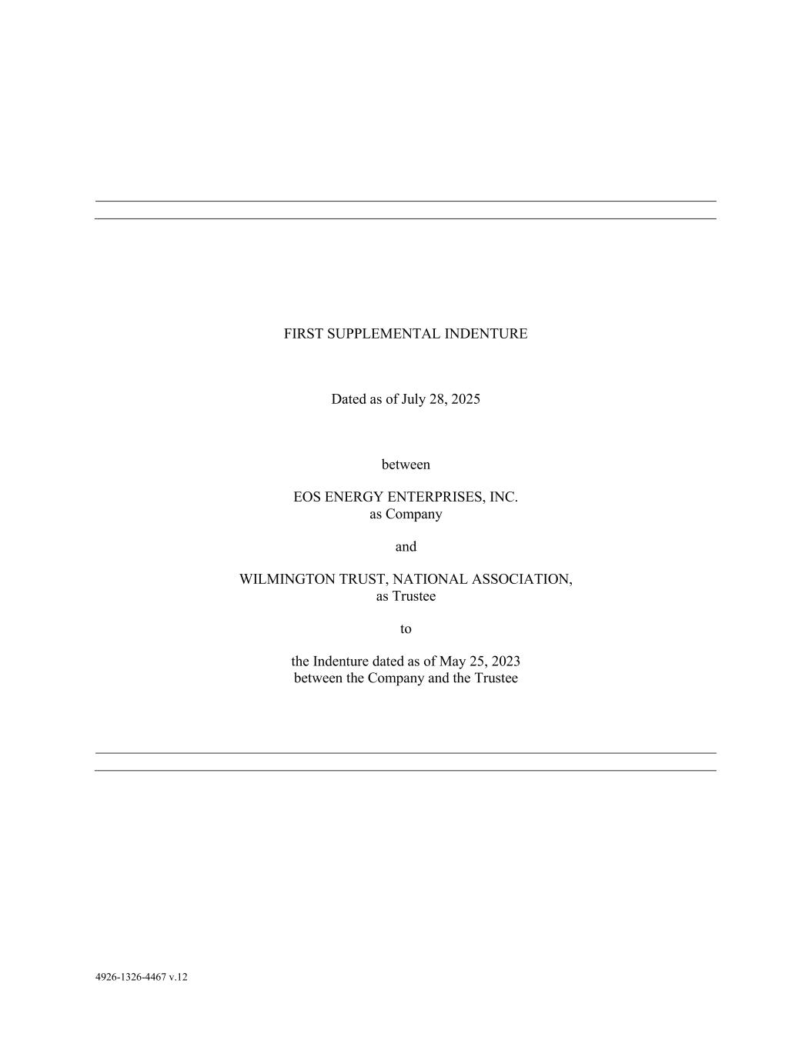
66
4926-1326-4467 v.12 FIRST SUPPLEMENTAL INDENTURE Dated as of July 28, 2025 between EOS ENERGY ENTERPRISES, INC. as Company and WILMINGTON TRUST, NATIONAL ASSOCIATION, as Trustee to the Indenture dated as of May 25, 2023 between the Company and the Trustee

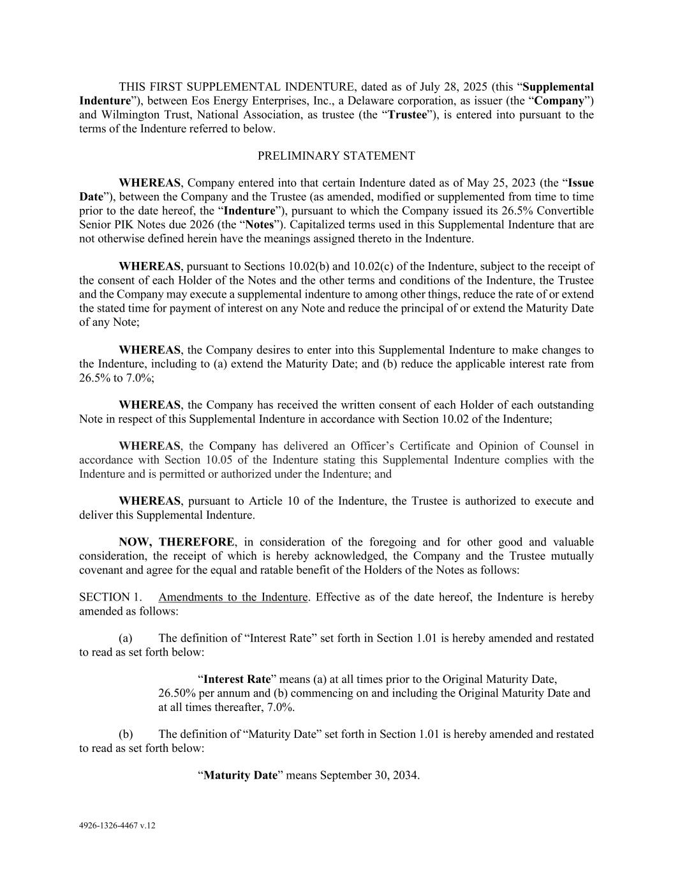
4926-1326-4467 v.12 THIS FIRST SUPPLEMENTAL INDENTURE, dated as of July 28, 2025 (this “Supplemental Indenture”), between Eos Energy Enterprises, Inc., a Delaware corporation, as issuer (the “Company”) and Wilmington Trust, National Association, as trustee (the “Trustee”), is entered into pursuant to the terms of the Indenture referred to below. PRELIMINARY STATEMENT WHEREAS, Company entered into that certain Indenture dated as of May 25, 2023 (the “Issue Date”), between the Company and the Trustee (as amended, modified or supplemented from time to time prior to the date hereof, the “Indenture”), pursuant to which the Company issued its 26.5% Convertible Senior PIK Notes due 2026 (the “Notes”). Capitalized terms used in this Supplemental Indenture that are not otherwise defined herein have the meanings assigned thereto in the Indenture. WHEREAS, pursuant to Sections 10.02(b) and 10.02(c) of the Indenture, subject to the receipt of the consent of each Holder of the Notes and the other terms and conditions of the Indenture, the Trustee and the Company may execute a supplemental indenture to among other things, reduce the rate of or extend the stated time for payment of interest on any Note and reduce the principal of or extend the Maturity Date of any Note; WHEREAS, the Company desires to enter into this Supplemental Indenture to make changes to the Indenture, including to (a) extend the Maturity Date; and (b) reduce the applicable interest rate from 26.5% to 7.0%; WHEREAS, the Company has received the written consent of each Holder of each outstanding Note in respect of this Supplemental Indenture in accordance with Section 10.02 of the Indenture; WHEREAS, the Company has delivered an Officer’s Certificate and Opinion of Counsel in accordance with Section 10.05 of the Indenture stating this Supplemental Indenture complies with the Indenture and is permitted or authorized under the Indenture; and WHEREAS, pursuant to Article 10 of the Indenture, the Trustee is authorized to execute and deliver this Supplemental Indenture. NOW, THEREFORE, in consideration of the foregoing and for other good and valuable consideration, the receipt of which is hereby acknowledged, the Company and the Trustee mutually covenant and agree for the equal and ratable benefit of the Holders of the Notes as follows: SECTION 1. Amendments to the Indenture. Effective as of the date hereof, the Indenture is hereby amended as follows: (a) The definition of “Interest Rate” set forth in Section 1.01 is hereby amended and restated to read as set forth below: “Interest Rate” means (a) at all times prior to the Original Maturity Date, 26.50% per annum and (b) commencing on and including the Original Maturity Date and at all times thereafter, 7.0%. (b) The definition of “Maturity Date” set forth in Section 1.01 is hereby amended and restated to read as set forth below: “Maturity Date” means September 30, 2034.

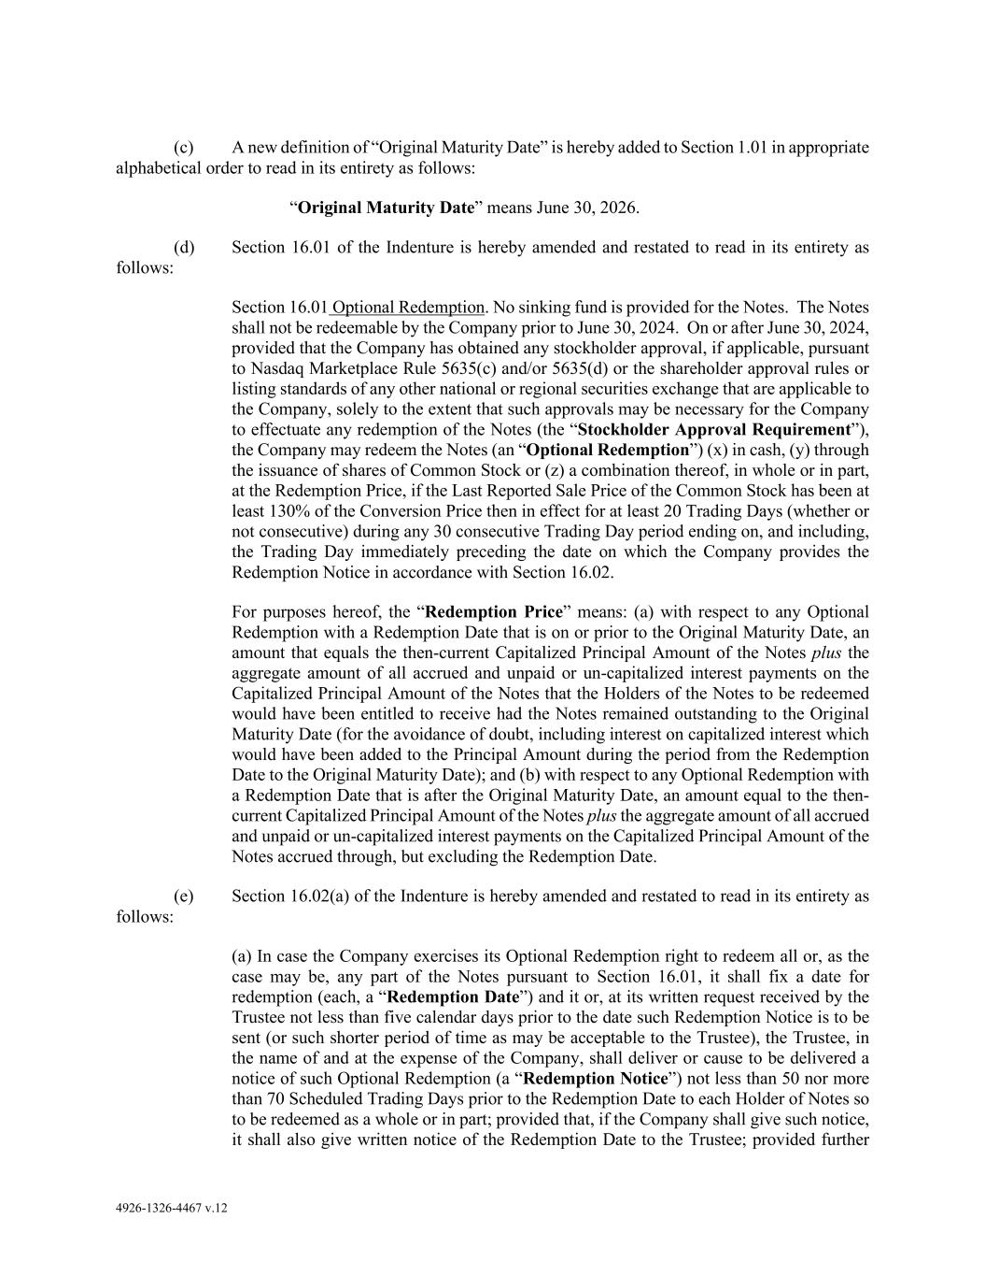
4926-1326-4467 v.12 (c) A new definition of “Original Maturity Date” is hereby added to Section 1.01 in appropriate alphabetical order to read in its entirety as follows: “Original Maturity Date” means June 30, 2026. (d) Section 16.01 of the Indenture is hereby amended and restated to read in its entirety as follows: Section 16.01 Optional Redemption. No sinking fund is provided for the Notes. The Notes shall not be redeemable by the Company prior to June 30, 2024. On or after June 30, 2024, provided that the Company has obtained any stockholder approval, if applicable, pursuant to Nasdaq Marketplace Rule 5635(c) and/or 5635(d) or the shareholder approval rules or listing standards of any other national or regional securities exchange that are applicable to the Company, solely to the extent that such approvals may be necessary for the Company to effectuate any redemption of the Notes (the “Stockholder Approval Requirement”), the Company may redeem the Notes (an “Optional Redemption”) (x) in cash, (y) through the issuance of shares of Common Stock or (z) a combination thereof, in whole or in part, at the Redemption Price, if the Last Reported Sale Price of the Common Stock has been at least 130% of the Conversion Price then in effect for at least 20 Trading Days (whether or not consecutive) during any 30 consecutive Trading Day period ending on, and including, the Trading Day immediately preceding the date on which the Company provides the Redemption Notice in accordance with Section 16.02. For purposes hereof, the “Redemption Price” means: (a) with respect to any Optional Redemption with a Redemption Date that is on or prior to the Original Maturity Date, an amount that equals the then-current Capitalized Principal Amount of the Notes plus the aggregate amount of all accrued and unpaid or un-capitalized interest payments on the Capitalized Principal Amount of the Notes that the Holders of the Notes to be redeemed would have been entitled to receive had the Notes remained outstanding to the Original Maturity Date (for the avoidance of doubt, including interest on capitalized interest which would have been added to the Principal Amount during the period from the Redemption Date to the Original Maturity Date); and (b) with respect to any Optional Redemption with a Redemption Date that is after the Original Maturity Date, an amount equal to the then- current Capitalized Principal Amount of the Notes plus the aggregate amount of all accrued and unpaid or un-capitalized interest payments on the Capitalized Principal Amount of the Notes accrued through, but excluding the Redemption Date. (e) Section 16.02(a) of the Indenture is hereby amended and restated to read in its entirety as follows: (a) In case the Company exercises its Optional Redemption right to redeem all or, as the case may be, any part of the Notes pursuant to Section 16.01, it shall fix a date for redemption (each, a “Redemption Date”) and it or, at its written request received by the Trustee not less than five calendar days prior to the date such Redemption Notice is to be sent (or such shorter period of time as may be acceptable to the Trustee), the Trustee, in the name of and at the expense of the Company, shall deliver or cause to be delivered a notice of such Optional Redemption (a “Redemption Notice”) not less than 50 nor more than 70 Scheduled Trading Days prior to the Redemption Date to each Holder of Notes so to be redeemed as a whole or in part; provided that, if the Company shall give such notice, it shall also give written notice of the Redemption Date to the Trustee; provided further

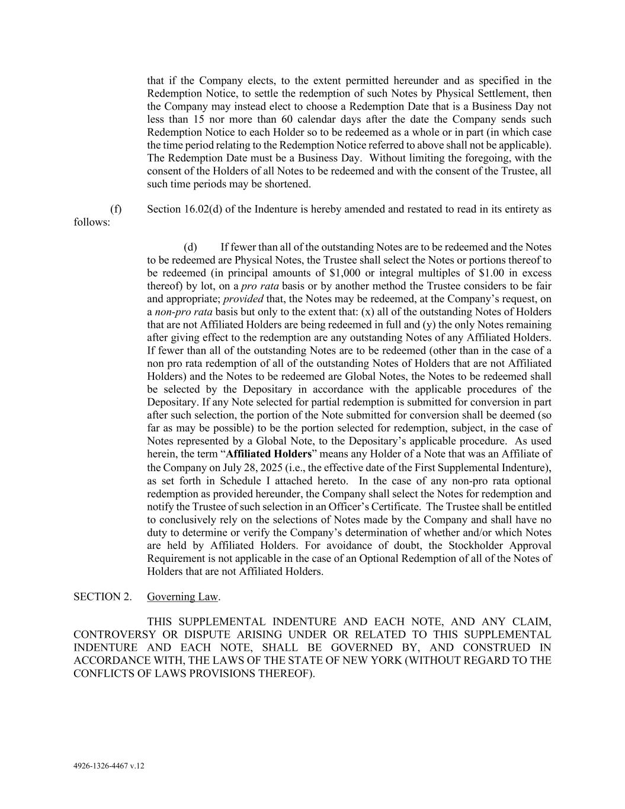
4926-1326-4467 v.12 that if the Company elects, to the extent permitted hereunder and as specified in the Redemption Notice, to settle the redemption of such Notes by Physical Settlement, then the Company may instead elect to choose a Redemption Date that is a Business Day not less than 15 nor more than 60 calendar days after the date the Company sends such Redemption Notice to each Holder so to be redeemed as a whole or in part (in which case the time period relating to the Redemption Notice referred to above shall not be applicable). The Redemption Date must be a Business Day. Without limiting the foregoing, with the consent of the Holders of all Notes to be redeemed and with the consent of the Trustee, all such time periods may be shortened. (f) Section 16.02(d) of the Indenture is hereby amended and restated to read in its entirety as follows: (d) If fewer than all of the outstanding Notes are to be redeemed and the Notes to be redeemed are Physical Notes, the Trustee shall select the Notes or portions thereof to be redeemed (in principal amounts of $1,000 or integral multiples of $1.00 in excess thereof) by lot, on a pro rata basis or by another method the Trustee considers to be fair and appropriate; provided that, the Notes may be redeemed, at the Company’s request, on a non-pro rata basis but only to the extent that: (x) all of the outstanding Notes of Holders that are not Affiliated Holders are being redeemed in full and (y) the only Notes remaining after giving effect to the redemption are any outstanding Notes of any Affiliated Holders. If fewer than all of the outstanding Notes are to be redeemed (other than in the case of a non pro rata redemption of all of the outstanding Notes of Holders that are not Affiliated Holders) and the Notes to be redeemed are Global Notes, the Notes to be redeemed shall be selected by the Depositary in accordance with the applicable procedures of the Depositary. If any Note selected for partial redemption is submitted for conversion in part after such selection, the portion of the Note submitted for conversion shall be deemed (so far as may be possible) to be the portion selected for redemption, subject, in the case of Notes represented by a Global Note, to the Depositary’s applicable procedure. As used herein, the term “Affiliated Holders” means any Holder of a Note that was an Affiliate of the Company on July 28, 2025 (i.e., the effective date of the First Supplemental Indenture), as set forth in Schedule I attached hereto. In the case of any non-pro rata optional redemption as provided hereunder, the Company shall select the Notes for redemption and notify the Trustee of such selection in an Officer’s Certificate. The Trustee shall be entitled to conclusively rely on the selections of Notes made by the Company and shall have no duty to determine or verify the Company’s determination of whether and/or which Notes are held by Affiliated Holders. For avoidance of doubt, the Stockholder Approval Requirement is not applicable in the case of an Optional Redemption of all of the Notes of Holders that are not Affiliated Holders. SECTION 2. Governing Law. THIS SUPPLEMENTAL INDENTURE AND EACH NOTE, AND ANY CLAIM, CONTROVERSY OR DISPUTE ARISING UNDER OR RELATED TO THIS SUPPLEMENTAL INDENTURE AND EACH NOTE, SHALL BE GOVERNED BY, AND CONSTRUED IN ACCORDANCE WITH, THE LAWS OF THE STATE OF NEW YORK (WITHOUT REGARD TO THE CONFLICTS OF LAWS PROVISIONS THEREOF).

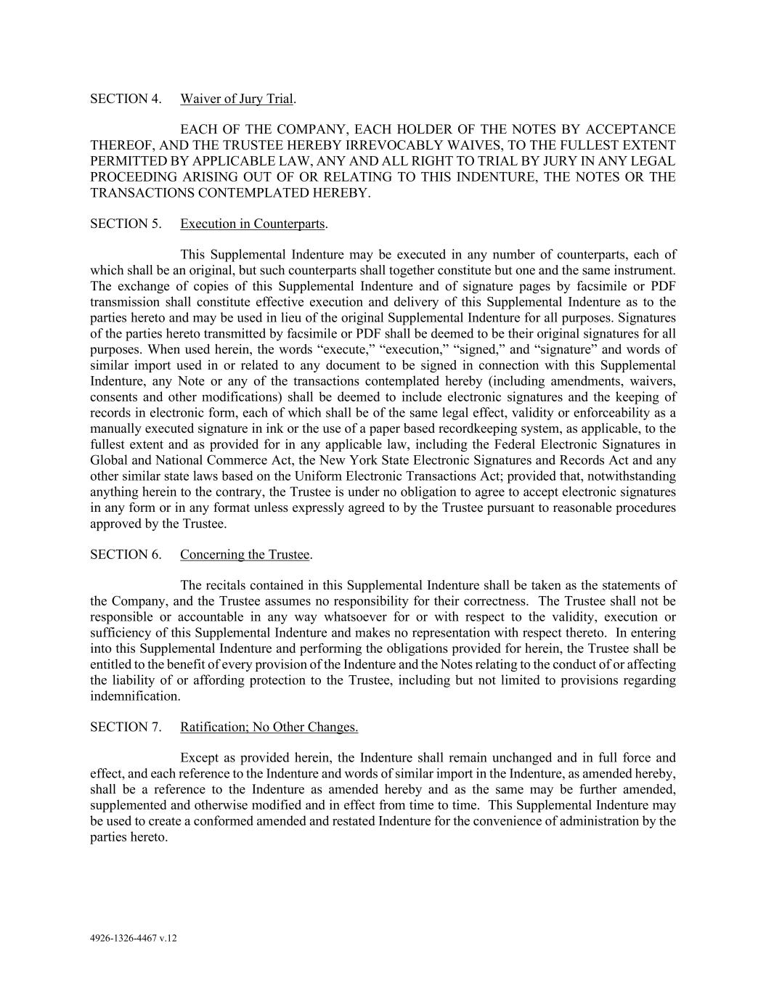
4926-1326-4467 v.12 SECTION 4. Waiver of Jury Trial. EACH OF THE COMPANY, EACH HOLDER OF THE NOTES BY ACCEPTANCE THEREOF, AND THE TRUSTEE HEREBY IRREVOCABLY WAIVES, TO THE FULLEST EXTENT PERMITTED BY APPLICABLE LAW, ANY AND ALL RIGHT TO TRIAL BY JURY IN ANY LEGAL PROCEEDING ARISING OUT OF OR RELATING TO THIS INDENTURE, THE NOTES OR THE TRANSACTIONS CONTEMPLATED HEREBY. SECTION 5. Execution in Counterparts. This Supplemental Indenture may be executed in any number of counterparts, each of which shall be an original, but such counterparts shall together constitute but one and the same instrument. The exchange of copies of this Supplemental Indenture and of signature pages by facsimile or PDF transmission shall constitute effective execution and delivery of this Supplemental Indenture as to the parties hereto and may be used in lieu of the original Supplemental Indenture for all purposes. Signatures of the parties hereto transmitted by facsimile or PDF shall be deemed to be their original signatures for all purposes. When used herein, the words “execute,” “execution,” “signed,” and “signature” and words of similar import used in or related to any document to be signed in connection with this Supplemental Indenture, any Note or any of the transactions contemplated hereby (including amendments, waivers, consents and other modifications) shall be deemed to include electronic signatures and the keeping of records in electronic form, each of which shall be of the same legal effect, validity or enforceability as a manually executed signature in ink or the use of a paper based recordkeeping system, as applicable, to the fullest extent and as provided for in any applicable law, including the Federal Electronic Signatures in Global and National Commerce Act, the New York State Electronic Signatures and Records Act and any other similar state laws based on the Uniform Electronic Transactions Act; provided that, notwithstanding anything herein to the contrary, the Trustee is under no obligation to agree to accept electronic signatures in any form or in any format unless expressly agreed to by the Trustee pursuant to reasonable procedures approved by the Trustee. SECTION 6. Concerning the Trustee. The recitals contained in this Supplemental Indenture shall be taken as the statements of the Company, and the Trustee assumes no responsibility for their correctness. The Trustee shall not be responsible or accountable in any way whatsoever for or with respect to the validity, execution or sufficiency of this Supplemental Indenture and makes no representation with respect thereto. In entering into this Supplemental Indenture and performing the obligations provided for herein, the Trustee shall be entitled to the benefit of every provision of the Indenture and the Notes relating to the conduct of or affecting the liability of or affording protection to the Trustee, including but not limited to provisions regarding indemnification. SECTION 7. Ratification; No Other Changes. Except as provided herein, the Indenture shall remain unchanged and in full force and effect, and each reference to the Indenture and words of similar import in the Indenture, as amended hereby, shall be a reference to the Indenture as amended hereby and as the same may be further amended, supplemented and otherwise modified and in effect from time to time. This Supplemental Indenture may be used to create a conformed amended and restated Indenture for the convenience of administration by the parties hereto.

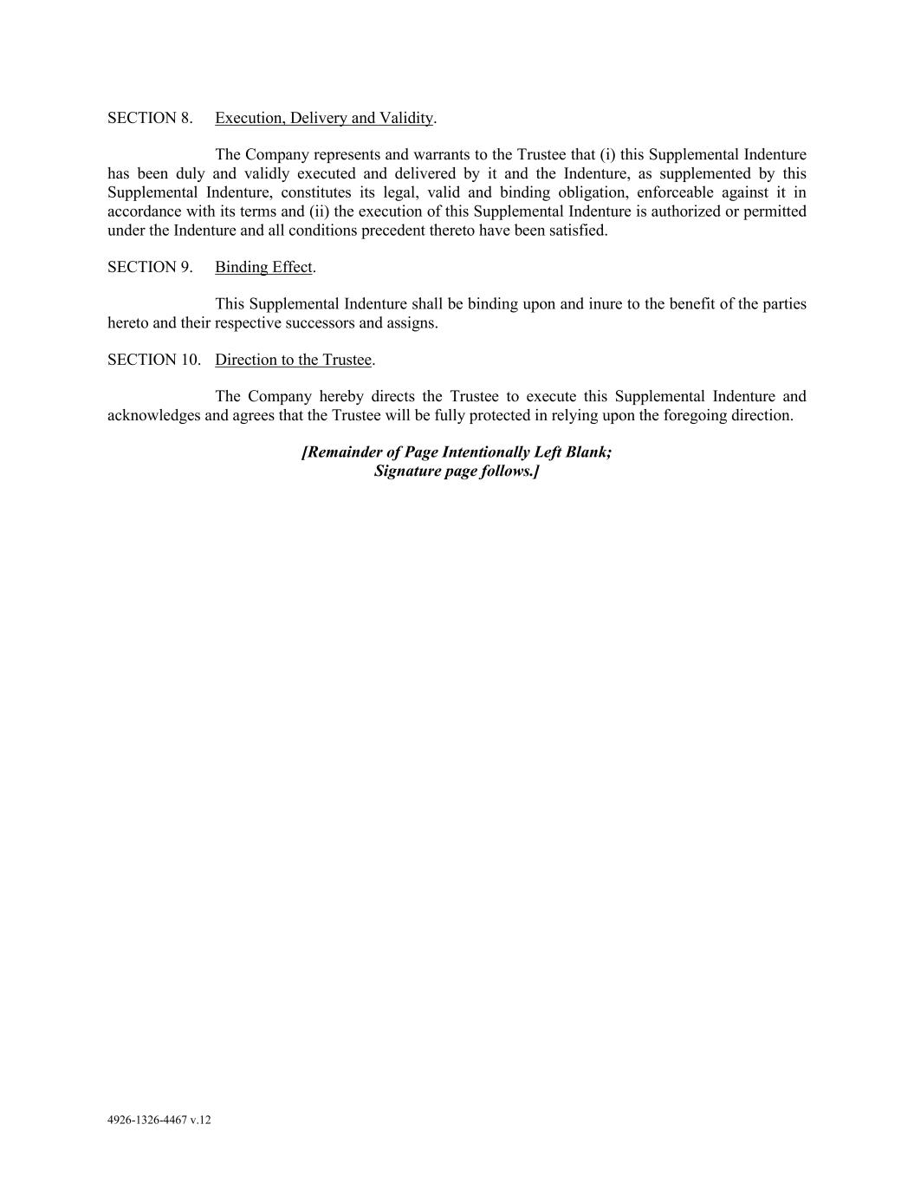
4926-1326-4467 v.12 SECTION 8. Execution, Delivery and Validity. The Company represents and warrants to the Trustee that (i) this Supplemental Indenture has been duly and validly executed and delivered by it and the Indenture, as supplemented by this Supplemental Indenture, constitutes its legal, valid and binding obligation, enforceable against it in accordance with its terms and (ii) the execution of this Supplemental Indenture is authorized or permitted under the Indenture and all conditions precedent thereto have been satisfied. SECTION 9. Binding Effect. This Supplemental Indenture shall be binding upon and inure to the benefit of the parties hereto and their respective successors and assigns. SECTION 10. Direction to the Trustee. The Company hereby directs the Trustee to execute this Supplemental Indenture and acknowledges and agrees that the Trustee will be fully protected in relying upon the foregoing direction. [Remainder of Page Intentionally Left Blank; Signature page follows.]

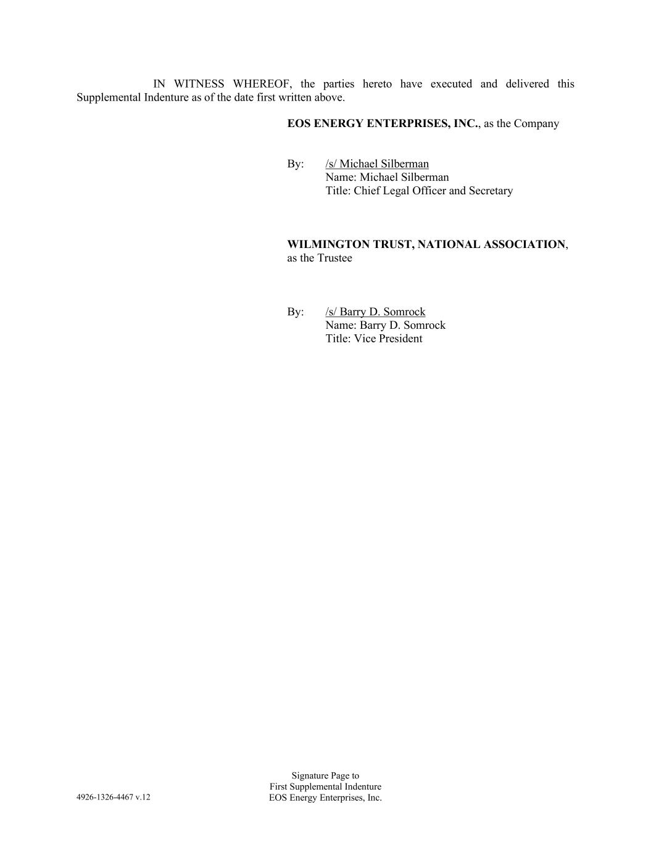
4926-1326-4467 v.12 Signature Page to First Supplemental Indenture EOS Energy Enterprises, Inc. IN WITNESS WHEREOF, the parties hereto have executed and delivered this Supplemental Indenture as of the date first written above. EOS ENERGY ENTERPRISES, INC., as the Company By: /s/ Michael Silberman Name: Michael Silberman Title: Chief Legal Officer and Secretary WILMINGTON TRUST, NATIONAL ASSOCIATION, as the Trustee By: /s/ Barry D. Somrock Name: Barry D. Somrock Title: Vice President


4926-1326-4467 v.12 Signature Page to First Supplemental Indenture EOS Energy Enterprises, Inc. SCHEDULE I AE Convert, LLC


4901-5195-9128 v.2 CERTAIN INFORMATION IN THIS EXHIBIT MARKED [*] HAS BEEN EXCLUDED FROM THIS EXHIBIT BECAUSE IT IS BOTH (A) NOT MATERIAL AND (B) WOULD BE COMPETITIVELY HARMFUL IF PUBLICLY DISCLOSED FOURTH AMENDMENT TO CREDIT AND GUARANTY AGREEMENT This FOURTH AMENDMENT TO CREDIT AND GUARANTY AGREEMENT (this “Agreement”) is made as of July 29, 2025, by and among EOS ENERGY ENTERPRISES, INC., a Delaware corporation, as borrower (the “Borrower”) and grantor, the guarantors and other grantors party hereto, the Lenders party hereto, and CERBERUS US SERVICING, LLC, as Administrative Agent (in such capacity, the “Administrative Agent”) and Collateral Agent (in such capacity, the “Collateral Agent”, together with the Administrative Agent, the “Agent”). RECITALS: WHEREAS, the Borrower, the other Credit Parties, the Agent and Lenders are party to that certain Credit and Guaranty Agreement, dated as of June 21, 2024 (as amended by the First Omnibus Amendment to Credit Documents, dated as of November 26, 2024, as further amended by the First Amendment to Credit and Guaranty Agreement, dated as of April 30, 2025, as further amended by the Second Amendment to Credit and Guaranty Agreement, dated as of May 28, 2025, as further amended by the Third Amendment to Credit and Guaranty Agreement, dated as of May 30, 2025 and as further amended, amended and restated, supplemented, extended, refinanced and/or otherwise modified and in effect prior to the date hereof, the “Existing Credit Agreement”; the Existing Credit Agreement as amended by this Agreement, the “Credit Agreement”; unless otherwise defined herein, capitalized terms used herein that are not otherwise defined herein shall have the respective meanings assigned to such terms in the Credit Agreement). WHEREAS, the Borrower has requested that the Lenders and the Agent agree to make certain amendments to the Existing Credit Agreement. WHEREAS, the Borrower, the Lenders and the Agent have so agreed on the terms and conditions set forth herein. NOW, THEREFORE, in consideration of the premises and the agreements, provisions and covenants herein contained, the parties hereto agree as follows: 1. Amendment to the Credit Agreement. Effective as of the Amendment Effective Date: (a) Schedule 1.1 to the Existing Credit Agreement is hereby deleted in its entirety and replaced with the Schedule 1.1 attached as Exhibit A hereto and made a part hereof. 2. Effectiveness. This Agreement shall become effective on the date (the “Amendment Effective Date”) on which the Administrative Agent shall have received counterparts of this Agreement duly executed by each Credit Party, each Lender and the Agent. 3. Representations and Warranties. Each Credit Party hereby represents and warrants as follows: (a) Authority. Each Credit Party has the requisite corporate or limited liability company power and authority to execute and deliver this Agreement, and to perform its obligations hereunder and under the Credit Documents (as amended or modified hereby) to which it is a party. The

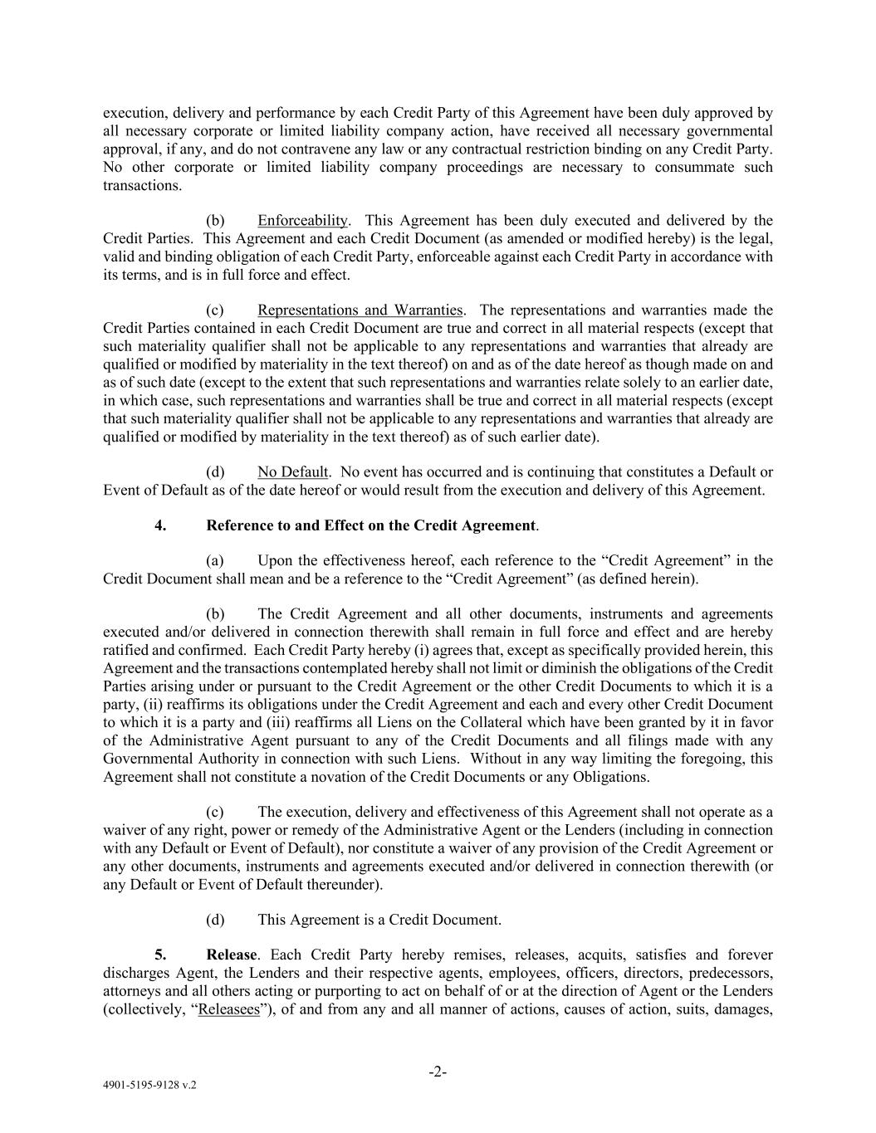
4901-5195-9128 v.2 -2- execution, delivery and performance by each Credit Party of this Agreement have been duly approved by all necessary corporate or limited liability company action, have received all necessary governmental approval, if any, and do not contravene any law or any contractual restriction binding on any Credit Party. No other corporate or limited liability company proceedings are necessary to consummate such transactions. (b) Enforceability. This Agreement has been duly executed and delivered by the Credit Parties. This Agreement and each Credit Document (as amended or modified hereby) is the legal, valid and binding obligation of each Credit Party, enforceable against each Credit Party in accordance with its terms, and is in full force and effect. (c) Representations and Warranties. The representations and warranties made the Credit Parties contained in each Credit Document are true and correct in all material respects (except that such materiality qualifier shall not be applicable to any representations and warranties that already are qualified or modified by materiality in the text thereof) on and as of the date hereof as though made on and as of such date (except to the extent that such representations and warranties relate solely to an earlier date, in which case, such representations and warranties shall be true and correct in all material respects (except that such materiality qualifier shall not be applicable to any representations and warranties that already are qualified or modified by materiality in the text thereof) as of such earlier date). (d) No Default. No event has occurred and is continuing that constitutes a Default or Event of Default as of the date hereof or would result from the execution and delivery of this Agreement. 4. Reference to and Effect on the Credit Agreement. (a) Upon the effectiveness hereof, each reference to the “Credit Agreement” in the Credit Document shall mean and be a reference to the “Credit Agreement” (as defined herein). (b) The Credit Agreement and all other documents, instruments and agreements executed and/or delivered in connection therewith shall remain in full force and effect and are hereby ratified and confirmed. Each Credit Party hereby (i) agrees that, except as specifically provided herein, this Agreement and the transactions contemplated hereby shall not limit or diminish the obligations of the Credit Parties arising under or pursuant to the Credit Agreement or the other Credit Documents to which it is a party, (ii) reaffirms its obligations under the Credit Agreement and each and every other Credit Document to which it is a party and (iii) reaffirms all Liens on the Collateral which have been granted by it in favor of the Administrative Agent pursuant to any of the Credit Documents and all filings made with any Governmental Authority in connection with such Liens. Without in any way limiting the foregoing, this Agreement shall not constitute a novation of the Credit Documents or any Obligations. (c) The execution, delivery and effectiveness of this Agreement shall not operate as a waiver of any right, power or remedy of the Administrative Agent or the Lenders (including in connection with any Default or Event of Default), nor constitute a waiver of any provision of the Credit Agreement or any other documents, instruments and agreements executed and/or delivered in connection therewith (or any Default or Event of Default thereunder). (d) This Agreement is a Credit Document. 5. Release. Each Credit Party hereby remises, releases, acquits, satisfies and forever discharges Agent, the Lenders and their respective agents, employees, officers, directors, predecessors, attorneys and all others acting or purporting to act on behalf of or at the direction of Agent or the Lenders (collectively, “Releasees”), of and from any and all manner of actions, causes of action, suits, damages,

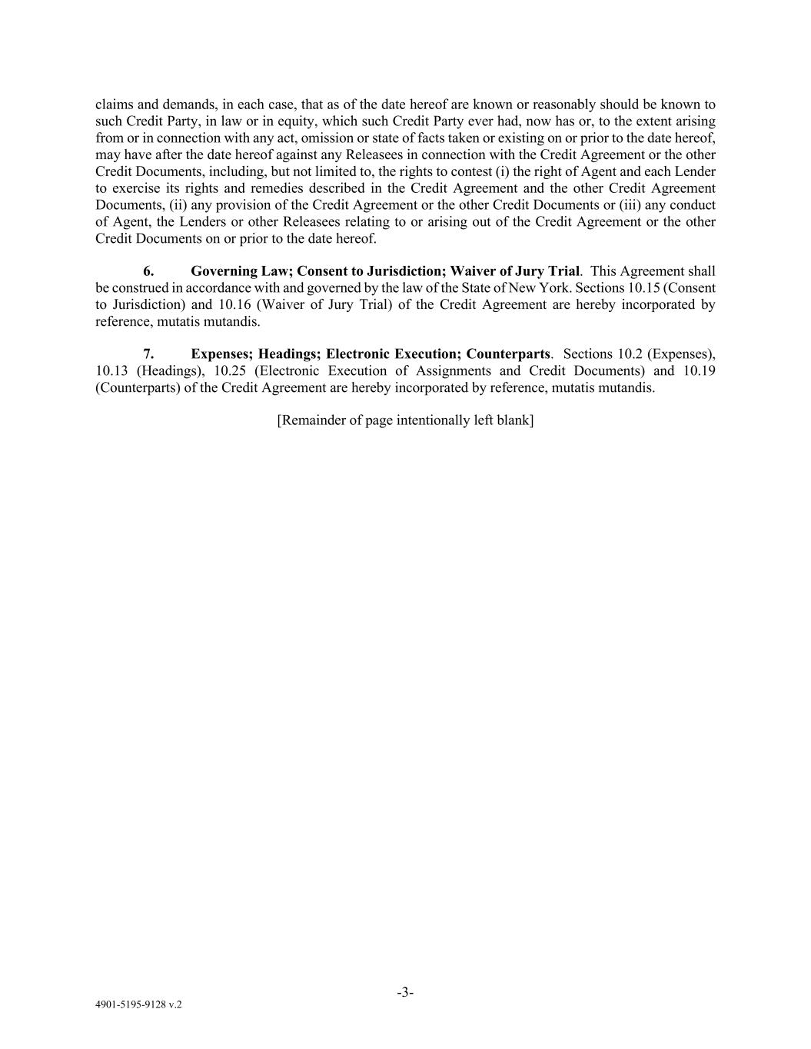
4901-5195-9128 v.2 -3- claims and demands, in each case, that as of the date hereof are known or reasonably should be known to such Credit Party, in law or in equity, which such Credit Party ever had, now has or, to the extent arising from or in connection with any act, omission or state of facts taken or existing on or prior to the date hereof, may have after the date hereof against any Releasees in connection with the Credit Agreement or the other Credit Documents, including, but not limited to, the rights to contest (i) the right of Agent and each Lender to exercise its rights and remedies described in the Credit Agreement and the other Credit Agreement Documents, (ii) any provision of the Credit Agreement or the other Credit Documents or (iii) any conduct of Agent, the Lenders or other Releasees relating to or arising out of the Credit Agreement or the other Credit Documents on or prior to the date hereof. 6. Governing Law; Consent to Jurisdiction; Waiver of Jury Trial. This Agreement shall be construed in accordance with and governed by the law of the State of New York. Sections 10.15 (Consent to Jurisdiction) and 10.16 (Waiver of Jury Trial) of the Credit Agreement are hereby incorporated by reference, mutatis mutandis. 7. Expenses; Headings; Electronic Execution; Counterparts. Sections 10.2 (Expenses), 10.13 (Headings), 10.25 (Electronic Execution of Assignments and Credit Documents) and 10.19 (Counterparts) of the Credit Agreement are hereby incorporated by reference, mutatis mutandis. [Remainder of page intentionally left blank]

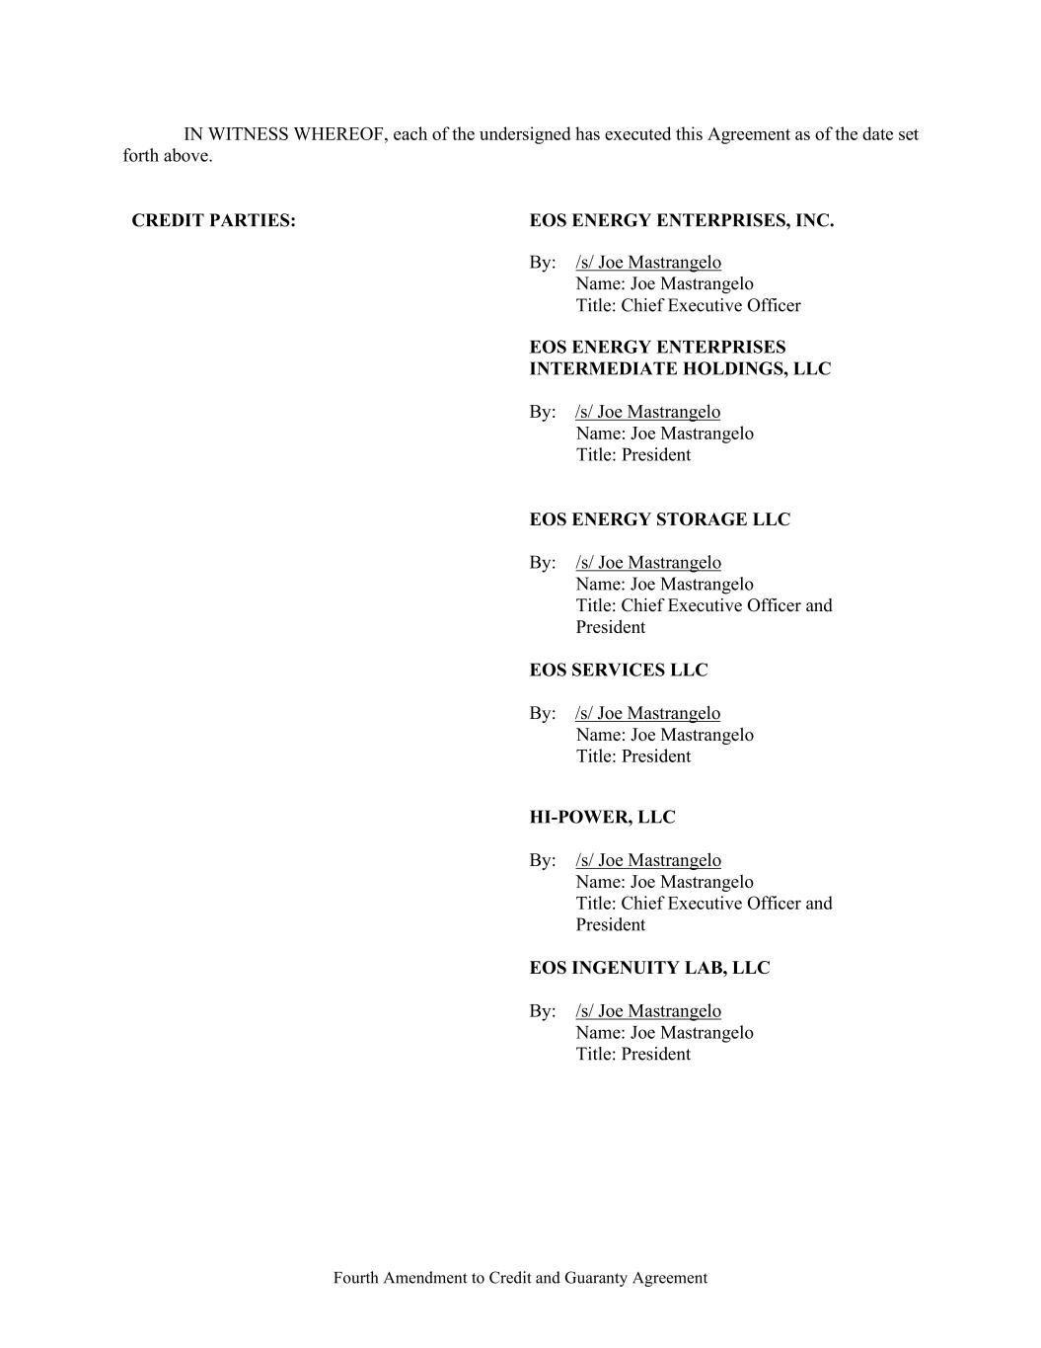
Fourth Amendment to Credit and Guaranty Agreement IN WITNESS WHEREOF, each of the undersigned has executed this Agreement as of the date set forth above. CREDIT PARTIES: EOS ENERGY ENTERPRISES, INC. By: /s/ Joe Mastrangelo Name: Joe Mastrangelo Title: Chief Executive Officer EOS ENERGY ENTERPRISES INTERMEDIATE HOLDINGS, LLC By: /s/ Joe Mastrangelo Name: Joe Mastrangelo Title: President EOS ENERGY STORAGE LLC By: /s/ Joe Mastrangelo Name: Joe Mastrangelo Title: Chief Executive Officer and President EOS SERVICES LLC By: /s/ Joe Mastrangelo Name: Joe Mastrangelo Title: President HI-POWER, LLC By: /s/ Joe Mastrangelo Name: Joe Mastrangelo Title: Chief Executive Officer and President EOS INGENUITY LAB, LLC By: /s/ Joe Mastrangelo Name: Joe Mastrangelo Title: President

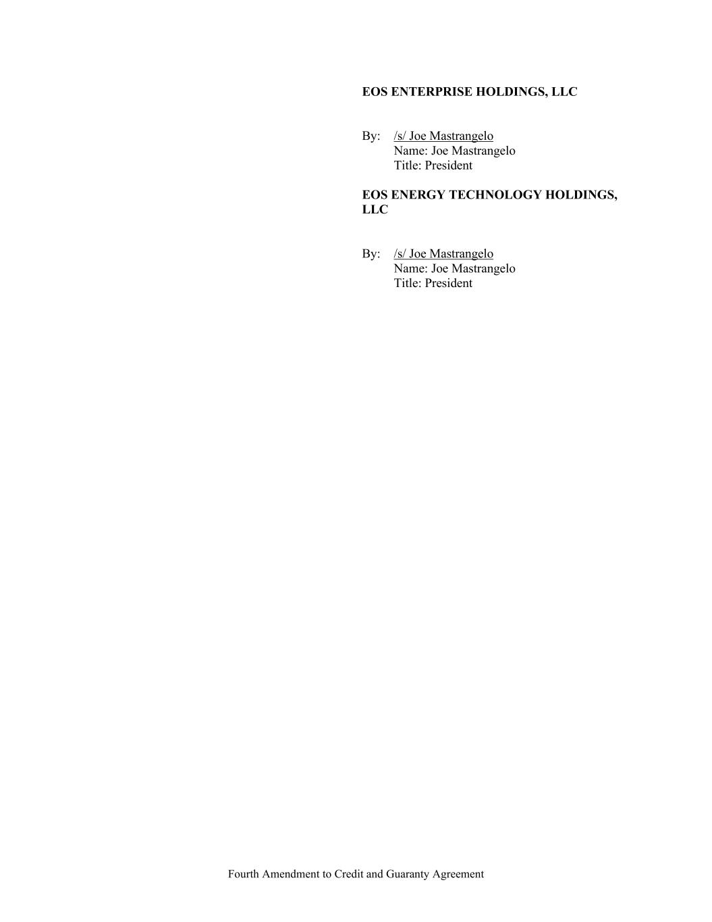
Fourth Amendment to Credit and Guaranty Agreement EOS ENTERPRISE HOLDINGS, LLC By: /s/ Joe Mastrangelo Name: Joe Mastrangelo Title: President EOS ENERGY TECHNOLOGY HOLDINGS, LLC By: /s/ Joe Mastrangelo Name: Joe Mastrangelo Title: President

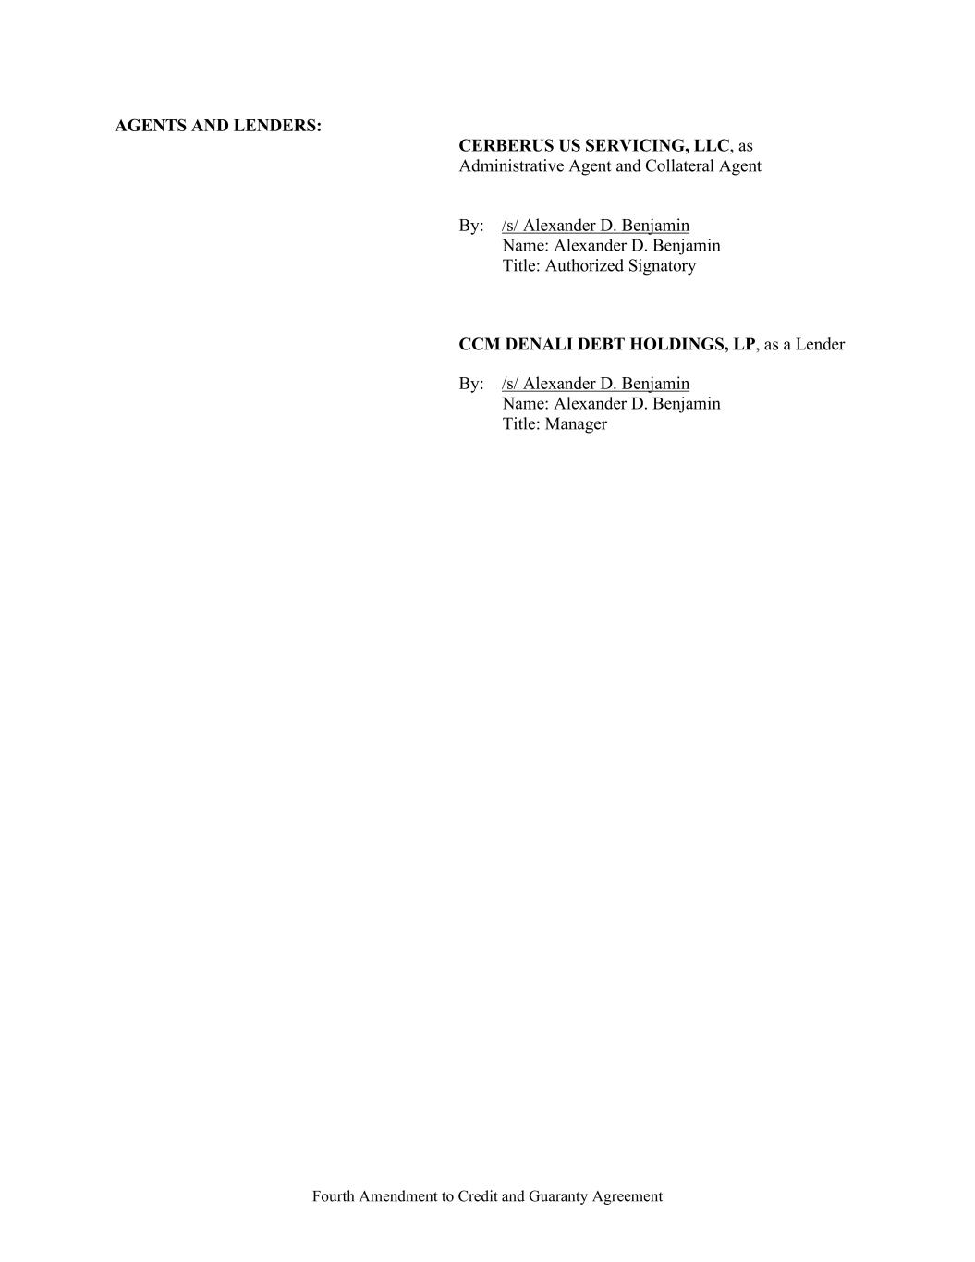
Fourth Amendment to Credit and Guaranty Agreement AGENTS AND LENDERS: CERBERUS US SERVICING, LLC, as Administrative Agent and Collateral Agent By: /s/ Alexander D. Benjamin Name: Alexander D. Benjamin Title: Authorized Signatory CCM DENALI DEBT HOLDINGS, LP, as a Lender By: /s/ Alexander D. Benjamin Name: Alexander D. Benjamin Title: Manager


4901-5195-9128 v.2 Exhibit A Schedule 1.1 to the Credit Agreement Attached.

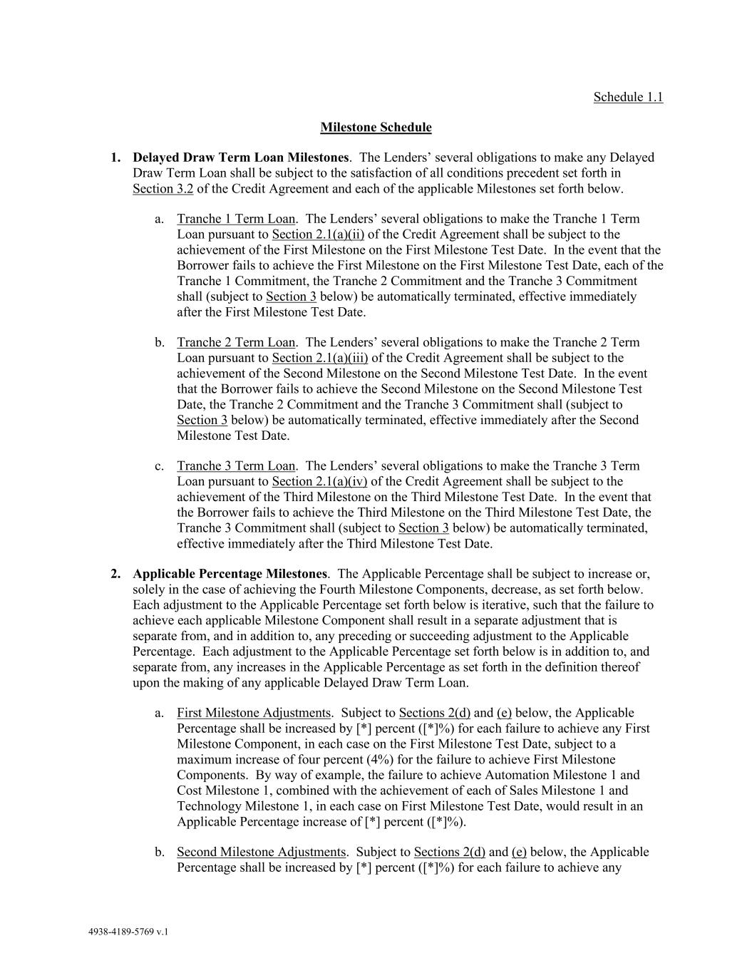
4938-4189-5769 v.1 Schedule 1.1 Milestone Schedule 1. Delayed Draw Term Loan Milestones. The Lenders’ several obligations to make any Delayed Draw Term Loan shall be subject to the satisfaction of all conditions precedent set forth in Section 3.2 of the Credit Agreement and each of the applicable Milestones set forth below. a. Tranche 1 Term Loan. The Lenders’ several obligations to make the Tranche 1 Term Loan pursuant to Section 2.1(a)(ii) of the Credit Agreement shall be subject to the achievement of the First Milestone on the First Milestone Test Date. In the event that the Borrower fails to achieve the First Milestone on the First Milestone Test Date, each of the Tranche 1 Commitment, the Tranche 2 Commitment and the Tranche 3 Commitment shall (subject to Section 3 below) be automatically terminated, effective immediately after the First Milestone Test Date. b. Tranche 2 Term Loan. The Lenders’ several obligations to make the Tranche 2 Term Loan pursuant to Section 2.1(a)(iii) of the Credit Agreement shall be subject to the achievement of the Second Milestone on the Second Milestone Test Date. In the event that the Borrower fails to achieve the Second Milestone on the Second Milestone Test Date, the Tranche 2 Commitment and the Tranche 3 Commitment shall (subject to Section 3 below) be automatically terminated, effective immediately after the Second Milestone Test Date. c. Tranche 3 Term Loan. The Lenders’ several obligations to make the Tranche 3 Term Loan pursuant to Section 2.1(a)(iv) of the Credit Agreement shall be subject to the achievement of the Third Milestone on the Third Milestone Test Date. In the event that the Borrower fails to achieve the Third Milestone on the Third Milestone Test Date, the Tranche 3 Commitment shall (subject to Section 3 below) be automatically terminated, effective immediately after the Third Milestone Test Date. 2. Applicable Percentage Milestones. The Applicable Percentage shall be subject to increase or, solely in the case of achieving the Fourth Milestone Components, decrease, as set forth below. Each adjustment to the Applicable Percentage set forth below is iterative, such that the failure to achieve each applicable Milestone Component shall result in a separate adjustment that is separate from, and in addition to, any preceding or succeeding adjustment to the Applicable Percentage. Each adjustment to the Applicable Percentage set forth below is in addition to, and separate from, any increases in the Applicable Percentage as set forth in the definition thereof upon the making of any applicable Delayed Draw Term Loan. a. First Milestone Adjustments. Subject to Sections 2(d) and (e) below, the Applicable Percentage shall be increased by [*] percent ([*]%) for each failure to achieve any First Milestone Component, in each case on the First Milestone Test Date, subject to a maximum increase of four percent (4%) for the failure to achieve First Milestone Components. By way of example, the failure to achieve Automation Milestone 1 and Cost Milestone 1, combined with the achievement of each of Sales Milestone 1 and Technology Milestone 1, in each case on First Milestone Test Date, would result in an Applicable Percentage increase of [*] percent ([*]%). b. Second Milestone Adjustments. Subject to Sections 2(d) and (e) below, the Applicable Percentage shall be increased by [*] percent ([*]%) for each failure to achieve any

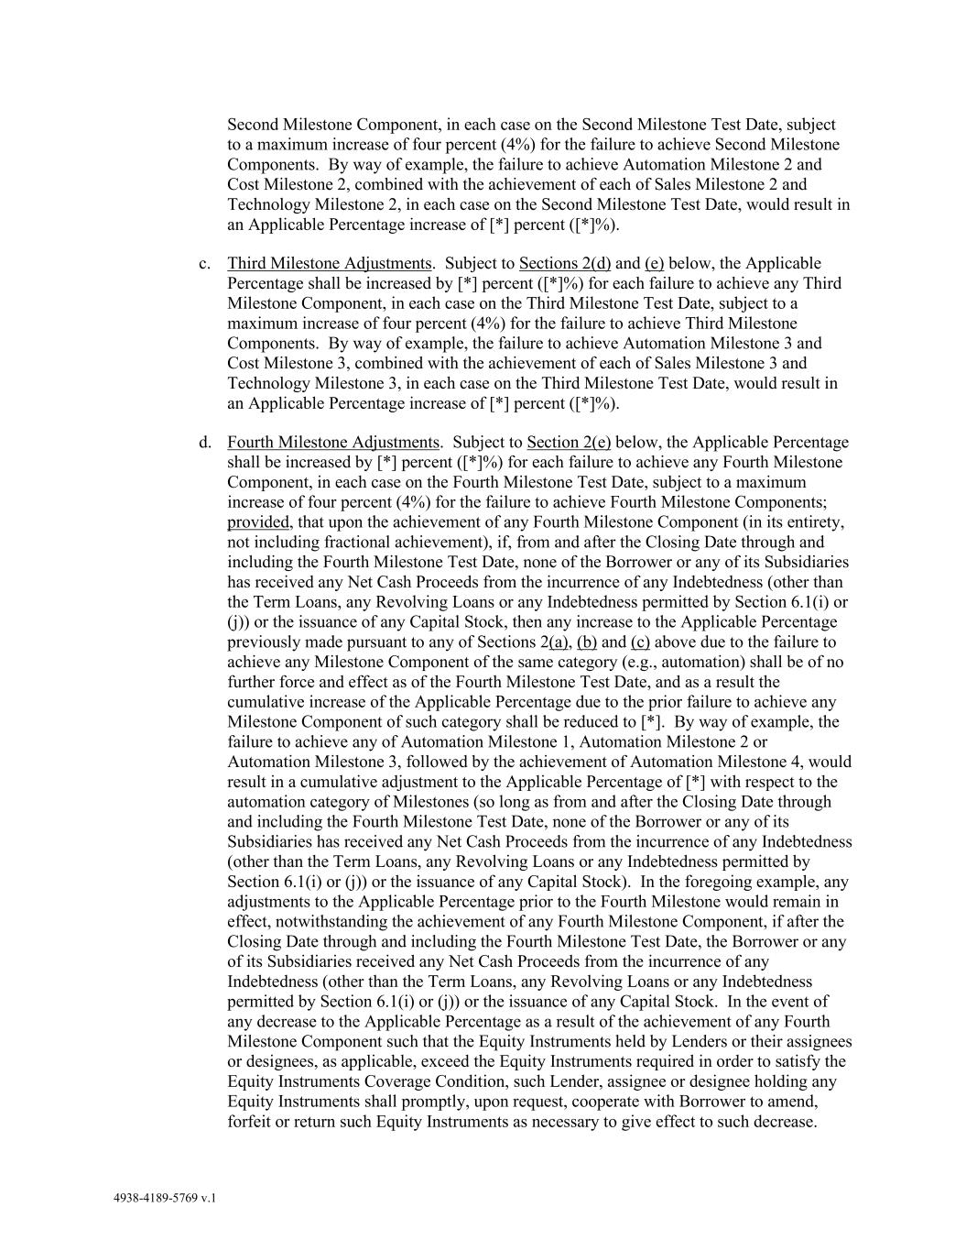
4938-4189-5769 v.1 Second Milestone Component, in each case on the Second Milestone Test Date, subject to a maximum increase of four percent (4%) for the failure to achieve Second Milestone Components. By way of example, the failure to achieve Automation Milestone 2 and Cost Milestone 2, combined with the achievement of each of Sales Milestone 2 and Technology Milestone 2, in each case on the Second Milestone Test Date, would result in an Applicable Percentage increase of [*] percent ([*]%). c. Third Milestone Adjustments. Subject to Sections 2(d) and (e) below, the Applicable Percentage shall be increased by [*] percent ([*]%) for each failure to achieve any Third Milestone Component, in each case on the Third Milestone Test Date, subject to a maximum increase of four percent (4%) for the failure to achieve Third Milestone Components. By way of example, the failure to achieve Automation Milestone 3 and Cost Milestone 3, combined with the achievement of each of Sales Milestone 3 and Technology Milestone 3, in each case on the Third Milestone Test Date, would result in an Applicable Percentage increase of [*] percent ([*]%). d. Fourth Milestone Adjustments. Subject to Section 2(e) below, the Applicable Percentage shall be increased by [*] percent ([*]%) for each failure to achieve any Fourth Milestone Component, in each case on the Fourth Milestone Test Date, subject to a maximum increase of four percent (4%) for the failure to achieve Fourth Milestone Components; provided, that upon the achievement of any Fourth Milestone Component (in its entirety, not including fractional achievement), if, from and after the Closing Date through and including the Fourth Milestone Test Date, none of the Borrower or any of its Subsidiaries has received any Net Cash Proceeds from the incurrence of any Indebtedness (other than the Term Loans, any Revolving Loans or any Indebtedness permitted by Section 6.1(i) or (j)) or the issuance of any Capital Stock, then any increase to the Applicable Percentage previously made pursuant to any of Sections 2(a), (b) and (c) above due to the failure to achieve any Milestone Component of the same category (e.g., automation) shall be of no further force and effect as of the Fourth Milestone Test Date, and as a result the cumulative increase of the Applicable Percentage due to the prior failure to achieve any Milestone Component of such category shall be reduced to [*]. By way of example, the failure to achieve any of Automation Milestone 1, Automation Milestone 2 or Automation Milestone 3, followed by the achievement of Automation Milestone 4, would result in a cumulative adjustment to the Applicable Percentage of [*] with respect to the automation category of Milestones (so long as from and after the Closing Date through and including the Fourth Milestone Test Date, none of the Borrower or any of its Subsidiaries has received any Net Cash Proceeds from the incurrence of any Indebtedness (other than the Term Loans, any Revolving Loans or any Indebtedness permitted by Section 6.1(i) or (j)) or the issuance of any Capital Stock). In the foregoing example, any adjustments to the Applicable Percentage prior to the Fourth Milestone would remain in effect, notwithstanding the achievement of any Fourth Milestone Component, if after the Closing Date through and including the Fourth Milestone Test Date, the Borrower or any of its Subsidiaries received any Net Cash Proceeds from the incurrence of any Indebtedness (other than the Term Loans, any Revolving Loans or any Indebtedness permitted by Section 6.1(i) or (j)) or the issuance of any Capital Stock. In the event of any decrease to the Applicable Percentage as a result of the achievement of any Fourth Milestone Component such that the Equity Instruments held by Lenders or their assignees or designees, as applicable, exceed the Equity Instruments required in order to satisfy the Equity Instruments Coverage Condition, such Lender, assignee or designee holding any Equity Instruments shall promptly, upon request, cooperate with Borrower to amend, forfeit or return such Equity Instruments as necessary to give effect to such decrease.

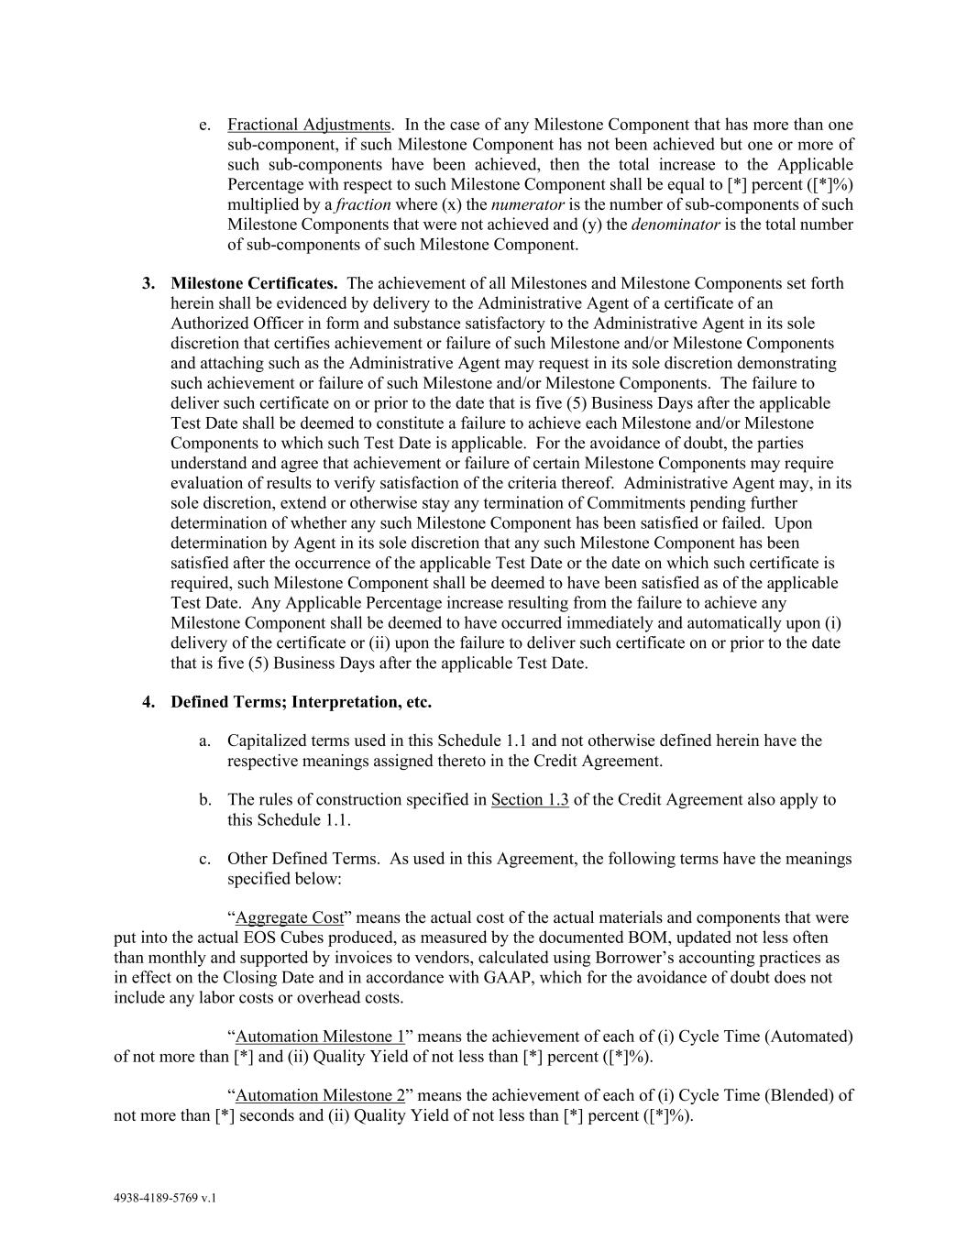
4938-4189-5769 v.1 e. Fractional Adjustments. In the case of any Milestone Component that has more than one sub-component, if such Milestone Component has not been achieved but one or more of such sub-components have been achieved, then the total increase to the Applicable Percentage with respect to such Milestone Component shall be equal to [*] percent ([*]%) multiplied by a fraction where (x) the numerator is the number of sub-components of such Milestone Components that were not achieved and (y) the denominator is the total number of sub-components of such Milestone Component. 3. Milestone Certificates. The achievement of all Milestones and Milestone Components set forth herein shall be evidenced by delivery to the Administrative Agent of a certificate of an Authorized Officer in form and substance satisfactory to the Administrative Agent in its sole discretion that certifies achievement or failure of such Milestone and/or Milestone Components and attaching such as the Administrative Agent may request in its sole discretion demonstrating such achievement or failure of such Milestone and/or Milestone Components. The failure to deliver such certificate on or prior to the date that is five (5) Business Days after the applicable Test Date shall be deemed to constitute a failure to achieve each Milestone and/or Milestone Components to which such Test Date is applicable. For the avoidance of doubt, the parties understand and agree that achievement or failure of certain Milestone Components may require evaluation of results to verify satisfaction of the criteria thereof. Administrative Agent may, in its sole discretion, extend or otherwise stay any termination of Commitments pending further determination of whether any such Milestone Component has been satisfied or failed. Upon determination by Agent in its sole discretion that any such Milestone Component has been satisfied after the occurrence of the applicable Test Date or the date on which such certificate is required, such Milestone Component shall be deemed to have been satisfied as of the applicable Test Date. Any Applicable Percentage increase resulting from the failure to achieve any Milestone Component shall be deemed to have occurred immediately and automatically upon (i) delivery of the certificate or (ii) upon the failure to deliver such certificate on or prior to the date that is five (5) Business Days after the applicable Test Date. 4. Defined Terms; Interpretation, etc. a. Capitalized terms used in this Schedule 1.1 and not otherwise defined herein have the respective meanings assigned thereto in the Credit Agreement. b. The rules of construction specified in Section 1.3 of the Credit Agreement also apply to this Schedule 1.1. c. Other Defined Terms. As used in this Agreement, the following terms have the meanings specified below: “Aggregate Cost” means the actual cost of the actual materials and components that were put into the actual EOS Cubes produced, as measured by the documented BOM, updated not less often than monthly and supported by invoices to vendors, calculated using Borrower’s accounting practices as in effect on the Closing Date and in accordance with GAAP, which for the avoidance of doubt does not include any labor costs or overhead costs. “Automation Milestone 1” means the achievement of each of (i) Cycle Time (Automated) of not more than [*] and (ii) Quality Yield of not less than [*] percent ([*]%). “Automation Milestone 2” means the achievement of each of (i) Cycle Time (Blended) of not more than [*] seconds and (ii) Quality Yield of not less than [*] percent ([*]%).

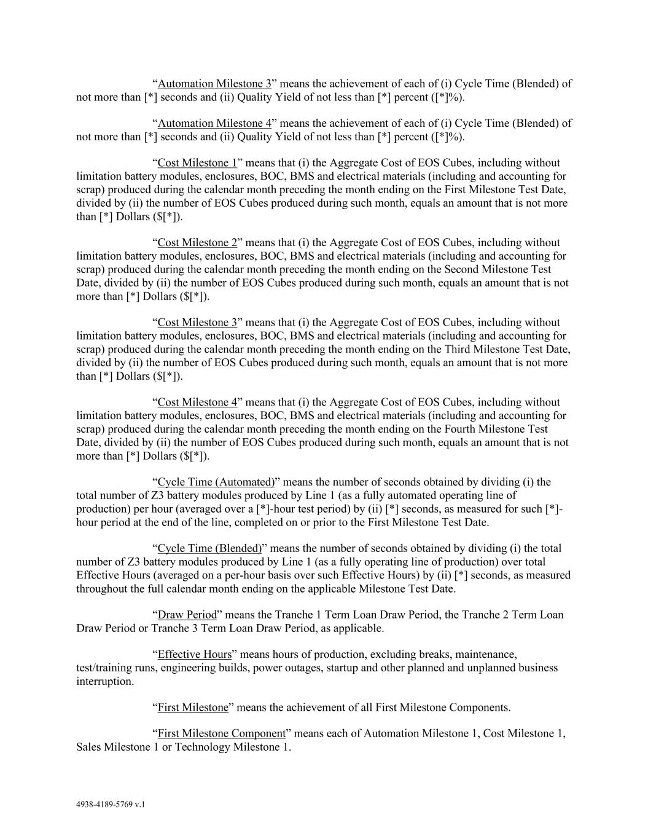
4938-4189-5769 v.1 “Automation Milestone 3” means the achievement of each of (i) Cycle Time (Blended) of not more than [*] seconds and (ii) Quality Yield of not less than [*] percent ([*]%). “Automation Milestone 4” means the achievement of each of (i) Cycle Time (Blended) of not more than [*] seconds and (ii) Quality Yield of not less than [*] percent ([*]%). “Cost Milestone 1” means that (i) the Aggregate Cost of EOS Cubes, including without limitation battery modules, enclosures, BOC, BMS and electrical materials (including and accounting for scrap) produced during the calendar month preceding the month ending on the First Milestone Test Date, divided by (ii) the number of EOS Cubes produced during such month, equals an amount that is not more than [*] Dollars ($[*]). “Cost Milestone 2” means that (i) the Aggregate Cost of EOS Cubes, including without limitation battery modules, enclosures, BOC, BMS and electrical materials (including and accounting for scrap) produced during the calendar month preceding the month ending on the Second Milestone Test Date, divided by (ii) the number of EOS Cubes produced during such month, equals an amount that is not more than [*] Dollars ($[*]). “Cost Milestone 3” means that (i) the Aggregate Cost of EOS Cubes, including without limitation battery modules, enclosures, BOC, BMS and electrical materials (including and accounting for scrap) produced during the calendar month preceding the month ending on the Third Milestone Test Date, divided by (ii) the number of EOS Cubes produced during such month, equals an amount that is not more than [*] Dollars ($[*]). “Cost Milestone 4” means that (i) the Aggregate Cost of EOS Cubes, including without limitation battery modules, enclosures, BOC, BMS and electrical materials (including and accounting for scrap) produced during the calendar month preceding the month ending on the Fourth Milestone Test Date, divided by (ii) the number of EOS Cubes produced during such month, equals an amount that is not more than [*] Dollars ($[*]). “Cycle Time (Automated)” means the number of seconds obtained by dividing (i) the total number of Z3 battery modules produced by Line 1 (as a fully automated operating line of production) per hour (averaged over a [*]-hour test period) by (ii) [*] seconds, as measured for such [*]- hour period at the end of the line, completed on or prior to the First Milestone Test Date. “Cycle Time (Blended)” means the number of seconds obtained by dividing (i) the total number of Z3 battery modules produced by Line 1 (as a fully operating line of production) over total Effective Hours (averaged on a per-hour basis over such Effective Hours) by (ii) [*] seconds, as measured throughout the full calendar month ending on the applicable Milestone Test Date. “Draw Period” means the Tranche 1 Term Loan Draw Period, the Tranche 2 Term Loan Draw Period or Tranche 3 Term Loan Draw Period, as applicable. “Effective Hours” means hours of production, excluding breaks, maintenance, test/training runs, engineering builds, power outages, startup and other planned and unplanned business interruption. “First Milestone” means the achievement of all First Milestone Components. “First Milestone Component” means each of Automation Milestone 1, Cost Milestone 1, Sales Milestone 1 or Technology Milestone 1.

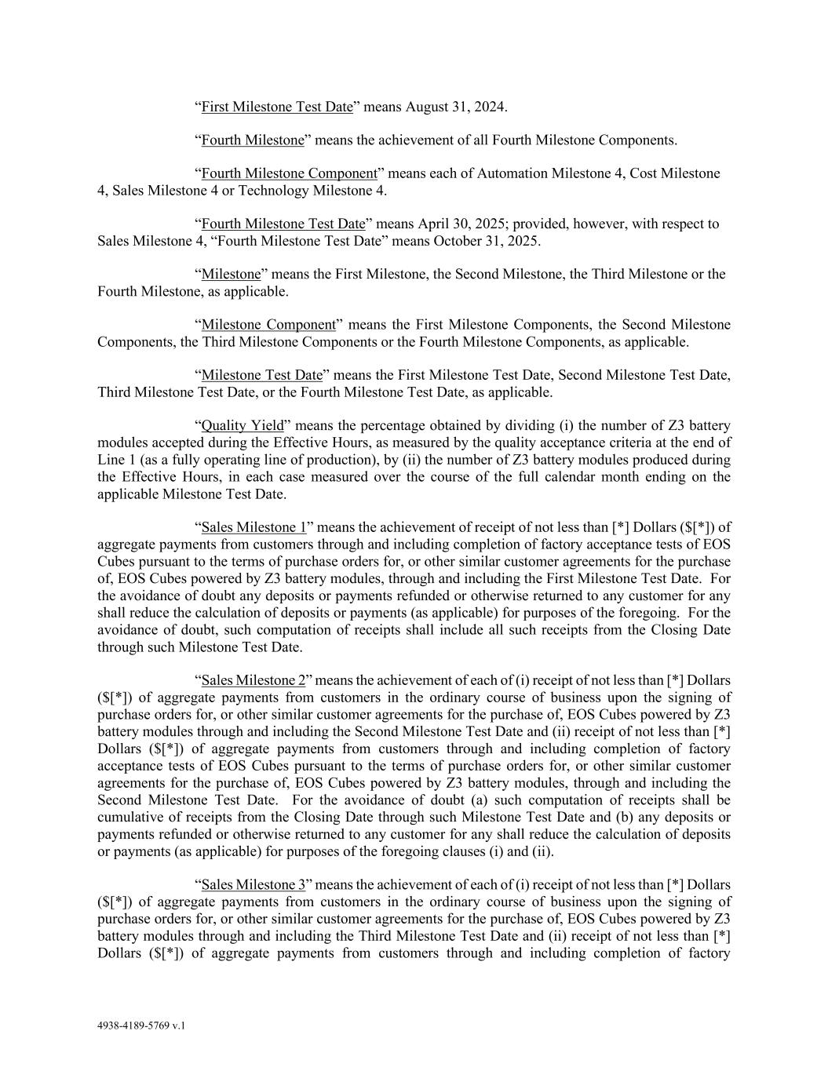
4938-4189-5769 v.1 “First Milestone Test Date” means August 31, 2024. “Fourth Milestone” means the achievement of all Fourth Milestone Components. “Fourth Milestone Component” means each of Automation Milestone 4, Cost Milestone 4, Sales Milestone 4 or Technology Milestone 4. “Fourth Milestone Test Date” means April 30, 2025; provided, however, with respect to Sales Milestone 4, “Fourth Milestone Test Date” means October 31, 2025. “Milestone” means the First Milestone, the Second Milestone, the Third Milestone or the Fourth Milestone, as applicable. “Milestone Component” means the First Milestone Components, the Second Milestone Components, the Third Milestone Components or the Fourth Milestone Components, as applicable. “Milestone Test Date” means the First Milestone Test Date, Second Milestone Test Date, Third Milestone Test Date, or the Fourth Milestone Test Date, as applicable. “Quality Yield” means the percentage obtained by dividing (i) the number of Z3 battery modules accepted during the Effective Hours, as measured by the quality acceptance criteria at the end of Line 1 (as a fully operating line of production), by (ii) the number of Z3 battery modules produced during the Effective Hours, in each case measured over the course of the full calendar month ending on the applicable Milestone Test Date. “Sales Milestone 1” means the achievement of receipt of not less than [*] Dollars ($[*]) of aggregate payments from customers through and including completion of factory acceptance tests of EOS Cubes pursuant to the terms of purchase orders for, or other similar customer agreements for the purchase of, EOS Cubes powered by Z3 battery modules, through and including the First Milestone Test Date. For the avoidance of doubt any deposits or payments refunded or otherwise returned to any customer for any shall reduce the calculation of deposits or payments (as applicable) for purposes of the foregoing. For the avoidance of doubt, such computation of receipts shall include all such receipts from the Closing Date through such Milestone Test Date. “Sales Milestone 2” means the achievement of each of (i) receipt of not less than [*] Dollars ($[*]) of aggregate payments from customers in the ordinary course of business upon the signing of purchase orders for, or other similar customer agreements for the purchase of, EOS Cubes powered by Z3 battery modules through and including the Second Milestone Test Date and (ii) receipt of not less than [*] Dollars ($[*]) of aggregate payments from customers through and including completion of factory acceptance tests of EOS Cubes pursuant to the terms of purchase orders for, or other similar customer agreements for the purchase of, EOS Cubes powered by Z3 battery modules, through and including the Second Milestone Test Date. For the avoidance of doubt (a) such computation of receipts shall be cumulative of receipts from the Closing Date through such Milestone Test Date and (b) any deposits or payments refunded or otherwise returned to any customer for any shall reduce the calculation of deposits or payments (as applicable) for purposes of the foregoing clauses (i) and (ii). “Sales Milestone 3” means the achievement of each of (i) receipt of not less than [*] Dollars ($[*]) of aggregate payments from customers in the ordinary course of business upon the signing of purchase orders for, or other similar customer agreements for the purchase of, EOS Cubes powered by Z3 battery modules through and including the Third Milestone Test Date and (ii) receipt of not less than [*] Dollars ($[*]) of aggregate payments from customers through and including completion of factory

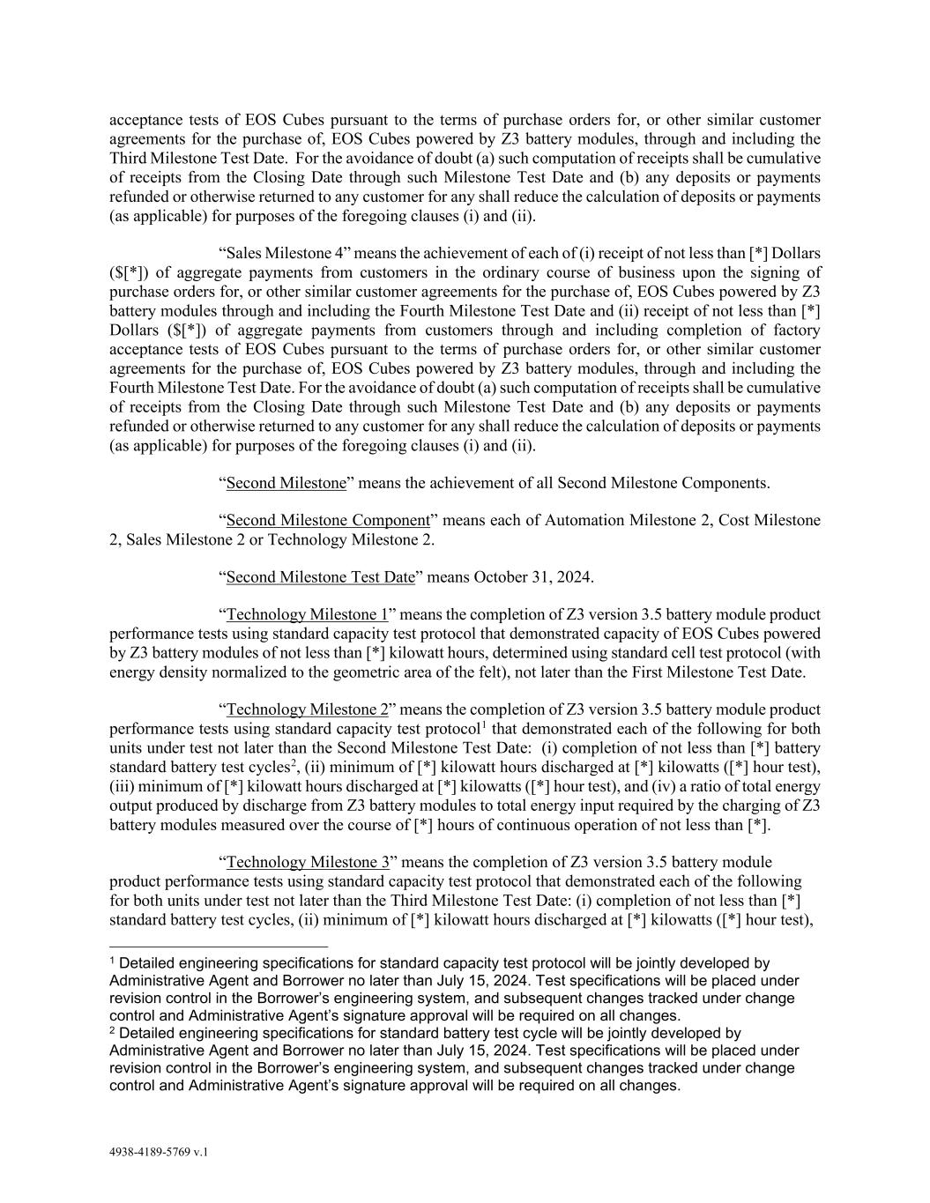
4938-4189-5769 v.1 acceptance tests of EOS Cubes pursuant to the terms of purchase orders for, or other similar customer agreements for the purchase of, EOS Cubes powered by Z3 battery modules, through and including the Third Milestone Test Date. For the avoidance of doubt (a) such computation of receipts shall be cumulative of receipts from the Closing Date through such Milestone Test Date and (b) any deposits or payments refunded or otherwise returned to any customer for any shall reduce the calculation of deposits or payments (as applicable) for purposes of the foregoing clauses (i) and (ii). “Sales Milestone 4” means the achievement of each of (i) receipt of not less than [*] Dollars ($[*]) of aggregate payments from customers in the ordinary course of business upon the signing of purchase orders for, or other similar customer agreements for the purchase of, EOS Cubes powered by Z3 battery modules through and including the Fourth Milestone Test Date and (ii) receipt of not less than [*] Dollars ($[*]) of aggregate payments from customers through and including completion of factory acceptance tests of EOS Cubes pursuant to the terms of purchase orders for, or other similar customer agreements for the purchase of, EOS Cubes powered by Z3 battery modules, through and including the Fourth Milestone Test Date. For the avoidance of doubt (a) such computation of receipts shall be cumulative of receipts from the Closing Date through such Milestone Test Date and (b) any deposits or payments refunded or otherwise returned to any customer for any shall reduce the calculation of deposits or payments (as applicable) for purposes of the foregoing clauses (i) and (ii). “Second Milestone” means the achievement of all Second Milestone Components. “Second Milestone Component” means each of Automation Milestone 2, Cost Milestone 2, Sales Milestone 2 or Technology Milestone 2. “Second Milestone Test Date” means October 31, 2024. “Technology Milestone 1” means the completion of Z3 version 3.5 battery module product performance tests using standard capacity test protocol that demonstrated capacity of EOS Cubes powered by Z3 battery modules of not less than [*] kilowatt hours, determined using standard cell test protocol (with energy density normalized to the geometric area of the felt), not later than the First Milestone Test Date. “Technology Milestone 2” means the completion of Z3 version 3.5 battery module product performance tests using standard capacity test protocol1 that demonstrated each of the following for both units under test not later than the Second Milestone Test Date: (i) completion of not less than [*] battery standard battery test cycles2, (ii) minimum of [*] kilowatt hours discharged at [*] kilowatts ([*] hour test), (iii) minimum of [*] kilowatt hours discharged at [*] kilowatts ([*] hour test), and (iv) a ratio of total energy output produced by discharge from Z3 battery modules to total energy input required by the charging of Z3 battery modules measured over the course of [*] hours of continuous operation of not less than [*]. “Technology Milestone 3” means the completion of Z3 version 3.5 battery module product performance tests using standard capacity test protocol that demonstrated each of the following for both units under test not later than the Third Milestone Test Date: (i) completion of not less than [*] standard battery test cycles, (ii) minimum of [*] kilowatt hours discharged at [*] kilowatts ([*] hour test), 1 Detailed engineering specifications for standard capacity test protocol will be jointly developed by Administrative Agent and Borrower no later than July 15, 2024. Test specifications will be placed under revision control in the Borrower’s engineering system, and subsequent changes tracked under change control and Administrative Agent’s signature approval will be required on all changes. 2 Detailed engineering specifications for standard battery test cycle will be jointly developed by Administrative Agent and Borrower no later than July 15, 2024. Test specifications will be placed under revision control in the Borrower’s engineering system, and subsequent changes tracked under change control and Administrative Agent’s signature approval will be required on all changes.

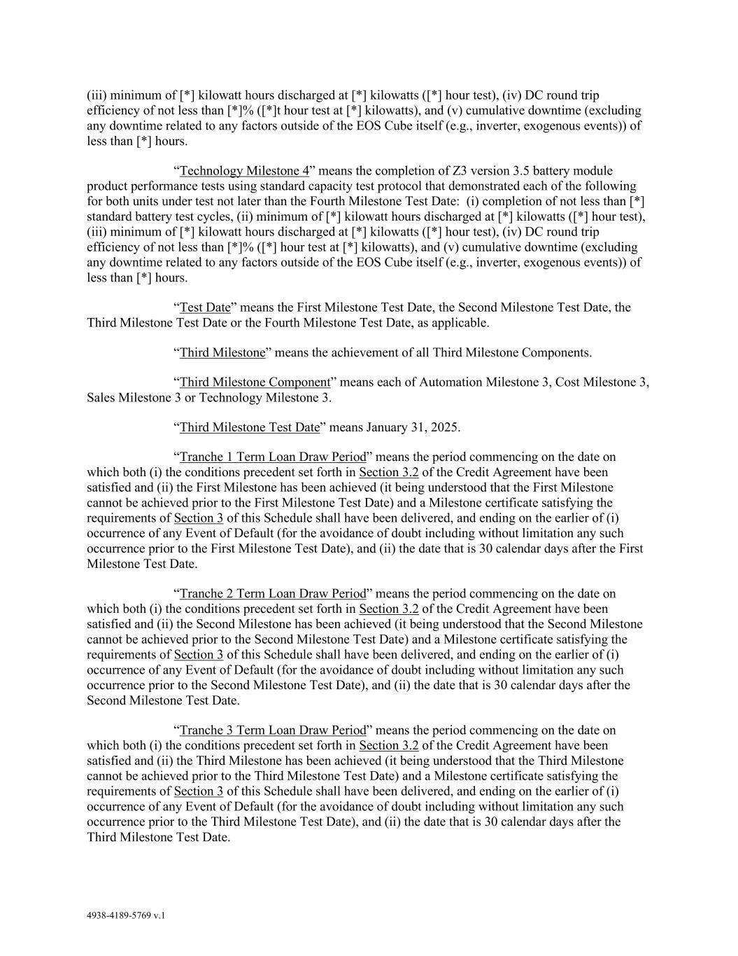
4938-4189-5769 v.1 (iii) minimum of [*] kilowatt hours discharged at [*] kilowatts ([*] hour test), (iv) DC round trip efficiency of not less than [*]% ([*]t hour test at [*] kilowatts), and (v) cumulative downtime (excluding any downtime related to any factors outside of the EOS Cube itself (e.g., inverter, exogenous events)) of less than [*] hours. “Technology Milestone 4” means the completion of Z3 version 3.5 battery module product performance tests using standard capacity test protocol that demonstrated each of the following for both units under test not later than the Fourth Milestone Test Date: (i) completion of not less than [*] standard battery test cycles, (ii) minimum of [*] kilowatt hours discharged at [*] kilowatts ([*] hour test), (iii) minimum of [*] kilowatt hours discharged at [*] kilowatts ([*] hour test), (iv) DC round trip efficiency of not less than [*]% ([*] hour test at [*] kilowatts), and (v) cumulative downtime (excluding any downtime related to any factors outside of the EOS Cube itself (e.g., inverter, exogenous events)) of less than [*] hours. “Test Date” means the First Milestone Test Date, the Second Milestone Test Date, the Third Milestone Test Date or the Fourth Milestone Test Date, as applicable. “Third Milestone” means the achievement of all Third Milestone Components. “Third Milestone Component” means each of Automation Milestone 3, Cost Milestone 3, Sales Milestone 3 or Technology Milestone 3. “Third Milestone Test Date” means January 31, 2025. “Tranche 1 Term Loan Draw Period” means the period commencing on the date on which both (i) the conditions precedent set forth in Section 3.2 of the Credit Agreement have been satisfied and (ii) the First Milestone has been achieved (it being understood that the First Milestone cannot be achieved prior to the First Milestone Test Date) and a Milestone certificate satisfying the requirements of Section 3 of this Schedule shall have been delivered, and ending on the earlier of (i) occurrence of any Event of Default (for the avoidance of doubt including without limitation any such occurrence prior to the First Milestone Test Date), and (ii) the date that is 30 calendar days after the First Milestone Test Date. “Tranche 2 Term Loan Draw Period” means the period commencing on the date on which both (i) the conditions precedent set forth in Section 3.2 of the Credit Agreement have been satisfied and (ii) the Second Milestone has been achieved (it being understood that the Second Milestone cannot be achieved prior to the Second Milestone Test Date) and a Milestone certificate satisfying the requirements of Section 3 of this Schedule shall have been delivered, and ending on the earlier of (i) occurrence of any Event of Default (for the avoidance of doubt including without limitation any such occurrence prior to the Second Milestone Test Date), and (ii) the date that is 30 calendar days after the Second Milestone Test Date. “Tranche 3 Term Loan Draw Period” means the period commencing on the date on which both (i) the conditions precedent set forth in Section 3.2 of the Credit Agreement have been satisfied and (ii) the Third Milestone has been achieved (it being understood that the Third Milestone cannot be achieved prior to the Third Milestone Test Date) and a Milestone certificate satisfying the requirements of Section 3 of this Schedule shall have been delivered, and ending on the earlier of (i) occurrence of any Event of Default (for the avoidance of doubt including without limitation any such occurrence prior to the Third Milestone Test Date), and (ii) the date that is 30 calendar days after the Third Milestone Test Date.

EXHIBIT 31.1
CERTIFICATION PURSUANT TO RULE 13a-14(a) OR 15d-14(a) OF
THE SECURITIES EXCHANGE ACT OF 1934, AS ADOPTED PURSUANT TO SECTION 302
OF THE SARBANES-OXLEY ACT OF 2002

I, Joseph Mastrangelo, certify that:
1. I have reviewed this quarterly report on Form 10-Q (the “Report”) of Eos Energy Enterprises, Inc. (the “Registrant”);
2. Based on my knowledge, this Report does not contain any untrue statement of a material fact or omit to state a material fact necessary to make the statements made, in light of the circumstances under which such statements were made, not misleading with respect to the period covered by this Report;
3. Based on my knowledge, the financial statements, and other financial information included in this Report, fairly present in all material respects the financial condition, results of operations and cash flows of the Registrant as of, and for, the periods presented in this Report;
4. The Registrant’s other certifying officer and I are responsible for establishing and maintaining disclosure controls and procedures (as defined in Exchange Act Rules 13a-15(e) and 15d-15(e)) and internal control over financial reporting (as defined in Exchange Act Rules 13a-15(f) and 15d-15(f)) for the Registrant and have:
a. Designed such disclosure controls and procedures, or caused such disclosure controls and procedures to be designed under our supervision, to ensure that material information relating to the Registrant, including its consolidated subsidiaries, is made known to us by others within those entities, particularly during the period in which this Report is being prepared;
b. Designed such internal control over financial reporting, or caused such internal control over financial reporting to be designed under our supervision, to provide reasonable assurance regarding the reliability of financial reporting and the preparation of financial statements for external purposes in accordance with generally accepted accounting principles;
c. Evaluated the effectiveness of the Registrant’s disclosure controls and procedures and presented in this Report our conclusions about the effectiveness of the disclosure controls and procedures, as of the end of the period covered by this Report based on such evaluation; and
d. Disclosed in this Report any change in the Registrant’s internal control over financial reporting that occurred during the Registrant’s most recent fiscal quarter that has materially affected, or is reasonably likely to materially affect, the Registrant’s internal control over financial reporting; and
5. The Registrant’s other certifying officer and I have disclosed, based on our most recent evaluation of internal control over financial reporting, to the Registrant’s auditors and the audit committee of the Registrant’s board of directors (or persons performing the equivalent functions):
a. All significant deficiencies and material weaknesses in the design or operation of internal control over financial reporting which are reasonably likely to adversely affect the Registrant’s ability to record, process, summarize and report financial information; and
b. Any fraud, whether or not material, that involves management or other employees who have a significant role in the Registrant’s internal control over financial reporting.
Date: July 30, 2025 |  |  |  |  |  |  |  |  | By: |  |  |  |  |  |  |  |  | /s/ Joseph Mastrangelo
 |  |  |  |  |  |  |  |  |  |  |  |  |  |  |  |  |  | Joseph Mastrangelo
 |  |  |  |  |  |  |  |  |  |  |  |  |  |  |  |  |  | Chief Executive Officer
 |  |  |  |  |  |  |  |  |  |  |  |  |  |  |  |  |  | (Principal Executive Officer)

EXHIBIT 31.2
CERTIFICATION PURSUANT TO RULE 13a-14(a) OR 15d-14(a) OF
THE SECURITIES EXCHANGE ACT OF 1934, AS ADOPTED PURSUANT TO SECTION 302
OF THE SARBANES-OXLEY ACT OF 2002

I, Nathan Kroeker, certify that:
1. I have reviewed this quarterly report on Form 10-Q (the “Report”) of Eos Energy Enterprises, Inc. (the Registrant”);
2. Based on my knowledge, this Report does not contain any untrue statement of a material fact or omit to state a material fact necessary to make the statements made, in light of the circumstances under which such statements were made, not misleading with respect to the period covered by this Report;
3. Based on my knowledge, the financial statements, and other financial information included in this Report, fairly present in all material respects the financial condition, results of operations and cash flows of the Registrant as of, and for, the periods presented in this Report;
4. The Registrant’s other certifying officer and I are responsible for establishing and maintaining disclosure controls and procedures (as defined in Exchange Act Rules 13a-15(e) and 15d-15(e)) and internal control over financial reporting (as defined in Exchange Act Rules 13a-15(f) and 15d-15(f)) for the Registrant and have:
a. Designed such disclosure controls and procedures, or caused such disclosure controls and procedures to be designed under our supervision, to ensure that material information relating to the Registrant, including its consolidated subsidiaries, is made known to us by others within those entities, particularly during the period in which this Report is being prepared;
b. Designed such internal control over financial reporting, or caused such internal control over financial reporting to be designed under our supervision, to provide reasonable assurance regarding the reliability of financial reporting and the preparation of financial statements for external purposes in accordance with generally accepted accounting principles;
c. Evaluated the effectiveness of the Registrant’s disclosure controls and procedures and presented in this Report our conclusions about the effectiveness of the disclosure controls and procedures, as of the end of the period covered by this Report based on such evaluation; and
d. Disclosed in this Report any change in the Registrant’s internal control over financial reporting that occurred during the Registrant’s most recent fiscal quarter that has materially affected, or is reasonably likely to materially affect, the Registrant’s internal control over financial reporting; and
5. The Registrant’s other certifying officer and I have disclosed, based on our most recent evaluation of internal control over financial reporting, to the Registrant’s auditors and the audit committee of the registrant’s board of directors (or persons performing the equivalent functions):
a. All significant deficiencies and material weaknesses in the design or operation of internal control over financial reporting which are reasonably likely to adversely affect the Registrant’s ability to record, process, summarize and report financial information; and
b. Any fraud, whether or not material, that involves management or other employees who have a significant role in the Registrant’s internal control over financial reporting.
Date: July 30, 2025 |  |  |  |  |  |  |  |  | By: |  |  |  |  |  |  |  |  | /s/ Nathan Kroeker
 |  |  |  |  |  |  |  |  |  |  |  |  |  |  |  |  |  | Nathan Kroeker
 |  |  |  |  |  |  |  |  |  |  |  |  |  |  |  |  |  | Interim Chief Financial Officer
 |  |  |  |  |  |  |  |  |  |  |  |  |  |  |  |  |  | (Principal Financial Officer)

EXHIBIT 32
CERTIFICATION PURSUANT TO 18 U.S.C. SECTION 1350,
AS ADOPTED PURSUANT TO SECTION 906 OF THE SARBANES-OXLEY ACT OF 2002

In connection with the Quarterly Report on Form 10-Q of Eos Energy Enterprises, Inc. (the “Registrant”), for the quarterly period ended June 30, 2025 as filed with the Securities and Exchange Commission on the date hereof (the “Report”), I, Joseph Mastrangelo, hereby certify, in the capacity and on the date indicated below, pursuant to 18 U.S.C. §1350, as adopted pursuant to Section 906 of the Sarbanes-Oxley Act of 2002, that, to my knowledge:

(1)The Report fully complies with the requirements of section 13(a) or 15(d) of the Securities Exchange Act of 1934, as amended; and
(2)The information contained in the Report fairly presents, in all material respects, the financial condition and results of operations of the Registrant.
Date: July 30, 2025 |  |  |  |  |  |  |  |  | By: |  |  |  |  |  |  |  |  | /s/ Joseph Mastrangelo
 |  |  |  |  |  |  |  |  |  |  |  |  |  |  |  |  |  | Joseph Mastrangelo
 |  |  |  |  |  |  |  |  |  |  |  |  |  |  |  |  |  | Chief Executive Officer
 |  |  |  |  |  |  |  |  |  |  |  |  |  |  |  |  |  | (Principal Executive Officer)

In connection with the Quarterly Report on Form 10-Q of Eos Energy Enterprises, Inc. (the “Registrant”), for the quarterly period ended June 30, 2025 as filed with the Securities and Exchange Commission on the date hereof (the “Report”), I, Nathan Kroeker, hereby certify, in the capacity and on the date indicated below, pursuant to 18 U.S.C. §1350, as adopted pursuant to Section 906 of the Sarbanes-Oxley Act of 2002, that, to my knowledge:

(1)The Report fully complies with the requirements of section 13(a) or 15(d) of the Securities Exchange Act of 1934, as amended; and
(2)The information contained in the Report fairly presents, in all material respects, the financial condition and results of operations of the Registrant.
Date: July 30, 2025 |  |  |  |  |  |  |  |  |  |  |  | By: |  |  |  |  |  |  |  |  | /s/ Nathan Kroeker
 |  |  |  |  |  |  |  |  |  |  |  |  |  |  |  |  |  |  |  |  | Nathan Kroeker
 |  |  |  |  |  |  |  |  |  |  |  |  |  |  |  |  |  |  |  |  | Interim Chief Financial Officer
 |  |  |  |  |  |  |  |  |  |  |  |  |  |  |  |  |  |  |  |  | (Principal Financial Officer)

