UNITED STATES
SECURITIES AND EXCHANGE COMMISSION
Washington, D.C. 20549
FORM 8-K
CURRENT REPORT
PURSUANT TO SECTION 13 OR 15(d) OF THE
SECURITIES EXCHANGE ACT OF 1934
Date of Report (Date of earliest event reported): July 8, 2026
EOS ENERGY ENTERPRISES, INC.
(Exact name of registrant as specified in its charter)
Delaware |  |  |  |  |  | 001-39291 |  |  |  |  |  | 84-4290188
(State or other jurisdiction  of incorporation) |  |  |  |  |  | (Commission  File Number) |  |  |  |  |  | (IRS Employer  Identification No.)
Two Allegheny Center
Nova Tower 2
Pittsburgh, Pennsylvania 15212
(Address of principal executive offices, including zip code)
Registrant’s telephone number, including area code: (732) 225-8400
3920 Park Avenue
Edison, New Jersey 08820
(Former name or former address, if changed since last report)
Check the appropriate box below if the Form 8-K filing is intended to simultaneously satisfy the filing obligation of the registrant under any of the following provisions:
☐ |  |  | Written communications pursuant to Rule 425 under the Securities Act (17 CFR 230.425)
☐ |  |  | Soliciting material pursuant to Rule 14a-12 under the Exchange Act (17 CFR 240.14a-12)
☐ |  |  | Pre-commencement communications pursuant to Rule 14d-2(b) under the Exchange Act (17 CFR 240.14d-2(b))
☐ |  |  | Pre-commencement communications pursuant to Rule 13e-4(c) under the Exchange Act (17 CFR 240.13e-4(c))
Securities registered pursuant to Section 12(b) of the Act:
Title of each class |  |  |  |  |  | Trading Symbol(s) |  |  |  |  |  | Name of each exchange on which registered
Common stock, par value $0.0001 per share |  |  |  |  |  | EOSE |  |  |  |  |  | The Nasdaq Stock Market LLC
Rights to Purchase Units, each Unit consisting of one share of Common Stock and 0.4388 of a Warrant |  |  |  |  |  | EOSER |  |  |  |  |  | The Nasdaq Stock Market LLC
Indicate by check mark whether the registrant is an emerging growth company as defined in Rule 405 of the Securities Act of 1933 (§230.405 of this chapter) or Rule 12b-2 of the Securities Exchange Act of 1934 (§240.12b-2 of this chapter).
Emerging growth company ☐
If an emerging growth company, indicate by check mark if the registrant has elected not to use the extended transition period for complying with any new or revised financial accounting standards provided pursuant to Section 13(a) of the Exchange Act. ☐

1

Item 5.02 Departure of Directors or Certain Officers; Election of Directors; Appointment of Certain Officers; Compensatory Arrangements of Certain Officers.
Resignation of Greg Nixon
On July 8, 2026, Greg Nixon resigned from his role as a preferred stock director of the Board of Directors (the “Board”) of Eos Energy Enterprises, Inc. (the “Company”), effective July 8, 2026, to devote more time to other business ventures. Nathaniel Fick will succeed Mr. Nixon as a preferred stock director of the Board, effective July 8, 2026.
Resignation and Appointment of Nathaniel Fick
On July 8, 2026, Nathaniel Fick resigned from his role as a Class III director of the Board, effective July 8, 2026, to accept an appointment as preferred stock director of the Board. Haiyan Song will succeed Mr. Fick as a Class III director of the Board, effective July 9, 2026.
On July 8, 2026, pursuant to the terms of the Series B Preferred Stock (as defined below) of the Company, the holder of the Series B- 1 Convertible Preferred Stock of the Company (“Series B-1 Preferred Stock”), Series B-2 Convertible Preferred Stock of the Company (“Series B-2 Preferred Stock”), Series B-3 Convertible Preferred Stock (“Series B-3 Preferred Stock”) and Series B-4 Convertible Preferred Stock of the Company (“Series B-4 Preferred Stock” and, collectively with Series B-1 Preferred Stock, Series B-2 Preferred Stock and Series B-3 Preferred Stock, “Series B Preferred Stock”) elected Mr. Fick to serve on the Board. Mr. Fick will continue to serve on the Nominating and Corporate Governance Committee.
Mr. Fick was not selected as a director pursuant to any arrangements or understandings with the Company or with any other person, and there are no transactions between the Company and Mr. Fick that would require disclosure under Item 404(a) of Regulation S-K.
Mr. Fick will not be compensated for his services on the Board in accordance with the policies of his employer.
The Company has entered into an indemnification agreement with Mr. Fick on the same basis as each of the Company’s other directors. This agreement, among other things, requires the Company to indemnify its directors for certain expenses, including attorneys’ fees, judgments, fines and settlement amounts incurred by a director in any action or proceeding arising out of their services as one of the Company’s directors or any other company or enterprise to which the person provides services at the Company’s request.
The foregoing description of the indemnification agreement does not purport to be complete and is qualified in its entirety by reference to the full text of the form of indemnification agreement, a copy of which is incorporated by reference as Exhibit 10.1 hereto and incorporated by reference herein.
Appointment of Haiyan Song
On July 9, 2026, the Board appointed Haiyan Song, age 60, to the Board. Ms. Song will serve as a Class III director, and shall hold office until the Company’s 2029 annual meeting, or until her successor is elected and qualified.
Ms. Song was not selected as a director pursuant to any arrangements or understandings with the Company or with any other person, and there are no transactions between the Company and Ms. Song that would require disclosure under Item 404(a) of Regulation S-K.
Ms. Song will be compensated for her services on the Board in accordance with the Company’s Non-Employee Director Compensation Policy (“Director Compensation Policy”). Under the Director Compensation Policy, each Non-Employee director is eligible to receive (i) an annual cash retainer equal to $50,000, payable in equal quarterly installments in arrears, and (ii) an annual equity-based retainer (the “Equity Retainer”) with a value of $150,000. The Equity Retainer consists entirely of restricted stock units with the number of restricted stock units determined using the 10-day weighted average price per share of our common stock. The Equity Retainer vests, subject to continued service, on the earlier of (i) the one-year anniversary of the grant date and (ii) immediately prior to the date of the next annual stockholders meeting of the Company following the grant date (with accelerated vesting upon a change in control).
The Company has entered into an indemnification agreement with Ms. Song on the same basis as each of the Company’s other directors. This agreement, among other things, requires the Company to indemnify its directors for certain expenses, including attorneys’ fees, judgments, fines and settlement amounts incurred by a director in any action or proceeding arising out of their services as one of the Company’s directors or any other company or enterprise to which the person provides services at the Company’s request.
2

The foregoing description of the indemnification agreement does not purport to be complete and is qualified in its entirety by reference to the full text of the form of indemnification agreement, a copy of which is incorporated by reference as Exhibit 10.1 hereto and incorporated by reference herein.

Item 8.01 Other Events.
On July 9, 2026, the Company issued a press release announcing the appointments and resignations described in Item 5.02. A copy of the Company’s press release is attached hereto as Exhibit 99.1 and is incorporated herein by reference.

Item 9.01 Financial Statement and Exhibits.
(d) Exhibits
Exhibit  Number |  |  |  |  |  | Description of Document
10.1 |  |  |  |  |  | Form of Indemnification Agreement for directors (incorporated by reference to Exhibit 10.13 to the Current Report on Form 8-K filed by Eos Energy Enterprises, Inc. on November 20, 2020).
99.1 |  |  |  |  |  | Press release of Eos Energy Enterprises, Inc., dated July 9, 2026
104 |  |  |  |  |  | Cover page of this Current Report on Form 8-K formatted in Inline XBRL

3

SIGNATURE
Pursuant to the requirements of the Securities Exchange Act of 1934, the registrant has duly caused this report to be signed on its behalf by the undersigned hereunto duly authorized.
 |  |  | EOS ENERGY ENTERPRISES, INC.
Dated: July 9, 2026 |  |  | By: |  |  | /s/ Alessandro Lagi
 |  |  |  |  |  | Name: |  |  | Alessandro Lagi
 |  |  |  |  |  | Title: |  |  | Chief Financial Officer
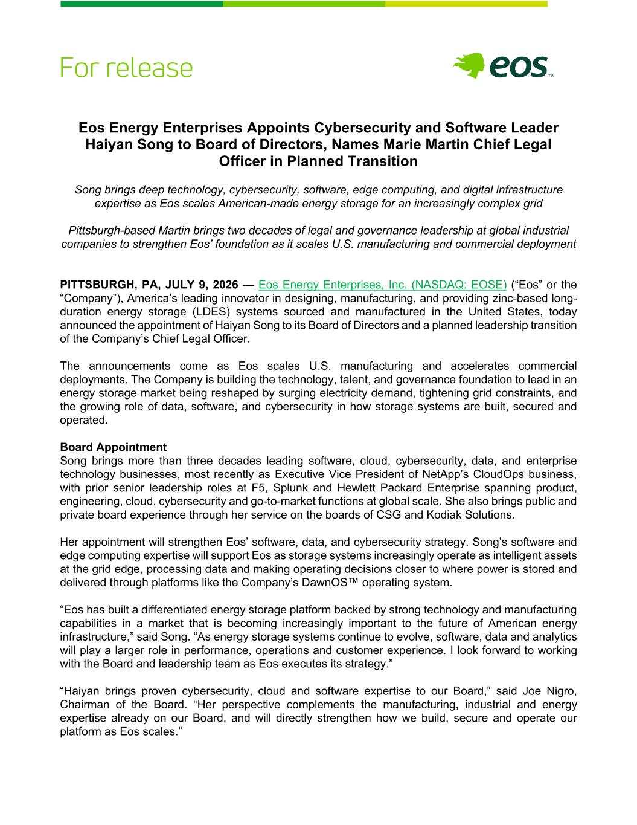
4
Eos Energy Enterprises Appoints Cybersecurity and Software Leader Haiyan Song to Board of Directors, Names Marie Martin Chief Legal Officer in Planned Transition Song brings deep technology, cybersecurity, software, edge computing, and digital infrastructure expertise as Eos scales American-made energy storage for an increasingly complex grid Pittsburgh-based Martin brings two decades of legal and governance leadership at global industrial companies to strengthen Eos’ foundation as it scales U.S. manufacturing and commercial deployment PITTSBURGH, PA, JULY 9, 2026 — Eos Energy Enterprises, Inc. (NASDAQ: EOSE) (“Eos” or the “Company”), America’s leading innovator in designing, manufacturing, and providing zinc-based long- duration energy storage (LDES) systems sourced and manufactured in the United States, today announced the appointment of Haiyan Song to its Board of Directors and a planned leadership transition of the Company’s Chief Legal Officer. The announcements come as Eos scales U.S. manufacturing and accelerates commercial deployments. The Company is building the technology, talent, and governance foundation to lead in an energy storage market being reshaped by surging electricity demand, tightening grid constraints, and the growing role of data, software, and cybersecurity in how storage systems are built, secured and operated. Board Appointment Song brings more than three decades leading software, cloud, cybersecurity, data, and enterprise technology businesses, most recently as Executive Vice President of NetApp’s CloudOps business, with prior senior leadership roles at F5, Splunk and Hewlett Packard Enterprise spanning product, engineering, cloud, cybersecurity and go-to-market functions at global scale. She also brings public and private board experience through her service on the boards of CSG and Kodiak Solutions. Her appointment will strengthen Eos’ software, data, and cybersecurity strategy. Song’s software and edge computing expertise will support Eos as storage systems increasingly operate as intelligent assets at the grid edge, processing data and making operating decisions closer to where power is stored and delivered through platforms like the Company’s DawnOS™ operating system. “Eos has built a differentiated energy storage platform backed by strong technology and manufacturing capabilities in a market that is becoming increasingly important to the future of American energy infrastructure,” said Song. “As energy storage systems continue to evolve, software, data and analytics will play a larger role in performance, operations and customer experience. I look forward to working with the Board and leadership team as Eos executes its strategy.” “Haiyan brings proven cybersecurity, cloud and software expertise to our Board,” said Joe Nigro, Chairman of the Board. “Her perspective complements the manufacturing, industrial and energy expertise already on our Board, and will directly strengthen how we build, secure and operate our platform as Eos scales.”

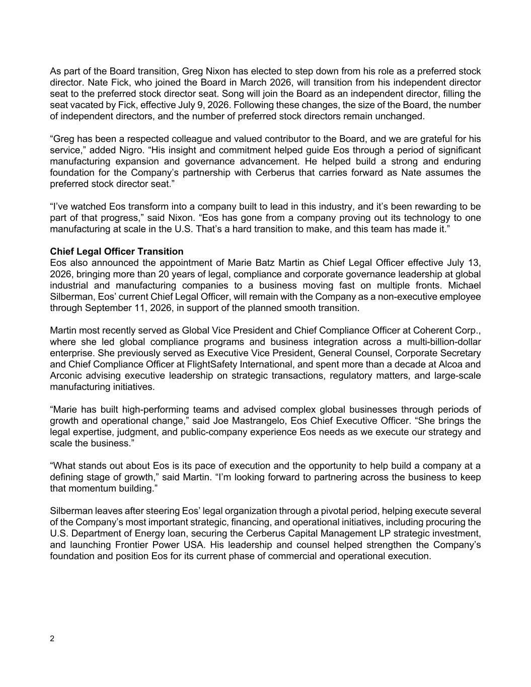
2 As part of the Board transition, Greg Nixon has elected to step down from his role as a preferred stock director. Nate Fick, who joined the Board in March 2026, will transition from his independent director seat to the preferred stock director seat. Song will join the Board as an independent director, filling the seat vacated by Fick, effective July 9, 2026. Following these changes, the size of the Board, the number of independent directors, and the number of preferred stock directors remain unchanged. “Greg has been a respected colleague and valued contributor to the Board, and we are grateful for his service,” added Nigro. “His insight and commitment helped guide Eos through a period of significant manufacturing expansion and governance advancement. He helped build a strong and enduring foundation for the Company’s partnership with Cerberus that carries forward as Nate assumes the preferred stock director seat.” “I’ve watched Eos transform into a company built to lead in this industry, and it’s been rewarding to be part of that progress,” said Nixon. “Eos has gone from a company proving out its technology to one manufacturing at scale in the U.S. That’s a hard transition to make, and this team has made it.” Chief Legal Officer Transition Eos also announced the appointment of Marie Batz Martin as Chief Legal Officer effective July 13, 2026, bringing more than 20 years of legal, compliance and corporate governance leadership at global industrial and manufacturing companies to a business moving fast on multiple fronts. Michael Silberman, Eos’ current Chief Legal Officer, will remain with the Company as a non-executive employee through September 11, 2026, in support of the planned smooth transition. Martin most recently served as Global Vice President and Chief Compliance Officer at Coherent Corp., where she led global compliance programs and business integration across a multi-billion-dollar enterprise. She previously served as Executive Vice President, General Counsel, Corporate Secretary and Chief Compliance Officer at FlightSafety International, and spent more than a decade at Alcoa and Arconic advising executive leadership on strategic transactions, regulatory matters, and large-scale manufacturing initiatives. “Marie has built high-performing teams and advised complex global businesses through periods of growth and operational change,” said Joe Mastrangelo, Eos Chief Executive Officer. “She brings the legal expertise, judgment, and public-company experience Eos needs as we execute our strategy and scale the business.” “What stands out about Eos is its pace of execution and the opportunity to help build a company at a defining stage of growth,” said Martin. “I’m looking forward to partnering across the business to keep that momentum building.” Silberman leaves after steering Eos’ legal organization through a pivotal period, helping execute several of the Company’s most important strategic, financing, and operational initiatives, including procuring the U.S. Department of Energy loan, securing the Cerberus Capital Management LP strategic investment, and launching Frontier Power USA. His leadership and counsel helped strengthen the Company’s foundation and position Eos for its current phase of commercial and operational execution.

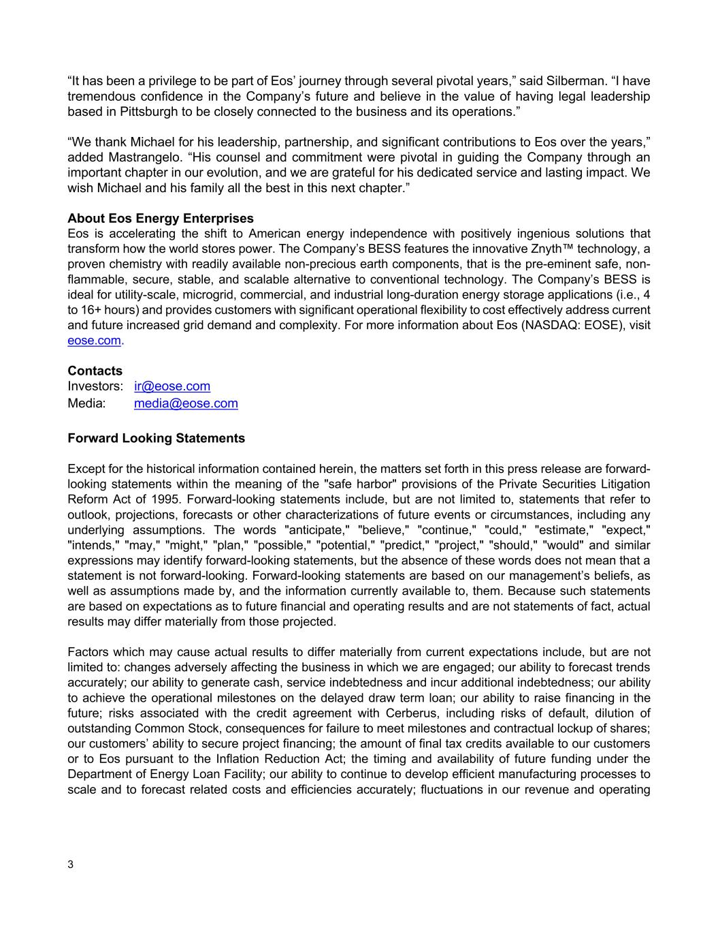
3 “It has been a privilege to be part of Eos’ journey through several pivotal years,” said Silberman. “I have tremendous confidence in the Company’s future and believe in the value of having legal leadership based in Pittsburgh to be closely connected to the business and its operations.” “We thank Michael for his leadership, partnership, and significant contributions to Eos over the years,” added Mastrangelo. “His counsel and commitment were pivotal in guiding the Company through an important chapter in our evolution, and we are grateful for his dedicated service and lasting impact. We wish Michael and his family all the best in this next chapter.” About Eos Energy Enterprises Eos is accelerating the shift to American energy independence with positively ingenious solutions that transform how the world stores power. The Company’s BESS features the innovative Znyth™ technology, a proven chemistry with readily available non-precious earth components, that is the pre-eminent safe, non- flammable, secure, stable, and scalable alternative to conventional technology. The Company’s BESS is ideal for utility-scale, microgrid, commercial, and industrial long-duration energy storage applications (i.e., 4 to 16+ hours) and provides customers with significant operational flexibility to cost effectively address current and future increased grid demand and complexity. For more information about Eos (NASDAQ: EOSE), visit eose.com. Contacts Investors: ir@eose.com Media: media@eose.com Forward Looking Statements Except for the historical information contained herein, the matters set forth in this press release are forward- looking statements within the meaning of the "safe harbor" provisions of the Private Securities Litigation Reform Act of 1995. Forward-looking statements include, but are not limited to, statements that refer to outlook, projections, forecasts or other characterizations of future events or circumstances, including any underlying assumptions. The words "anticipate," "believe," "continue," "could," "estimate," "expect," "intends," "may," "might," "plan," "possible," "potential," "predict," "project," "should," "would" and similar expressions may identify forward-looking statements, but the absence of these words does not mean that a statement is not forward-looking. Forward-looking statements are based on our management’s beliefs, as well as assumptions made by, and the information currently available to, them. Because such statements are based on expectations as to future financial and operating results and are not statements of fact, actual results may differ materially from those projected. Factors which may cause actual results to differ materially from current expectations include, but are not limited to: changes adversely affecting the business in which we are engaged; our ability to forecast trends accurately; our ability to generate cash, service indebtedness and incur additional indebtedness; our ability to achieve the operational milestones on the delayed draw term loan; our ability to raise financing in the future; risks associated with the credit agreement with Cerberus, including risks of default, dilution of outstanding Common Stock, consequences for failure to meet milestones and contractual lockup of shares; our customers’ ability to secure project financing; the amount of final tax credits available to our customers or to Eos pursuant to the Inflation Reduction Act; the timing and availability of future funding under the Department of Energy Loan Facility; our ability to continue to develop efficient manufacturing processes to scale and to forecast related costs and efficiencies accurately; fluctuations in our revenue and operating

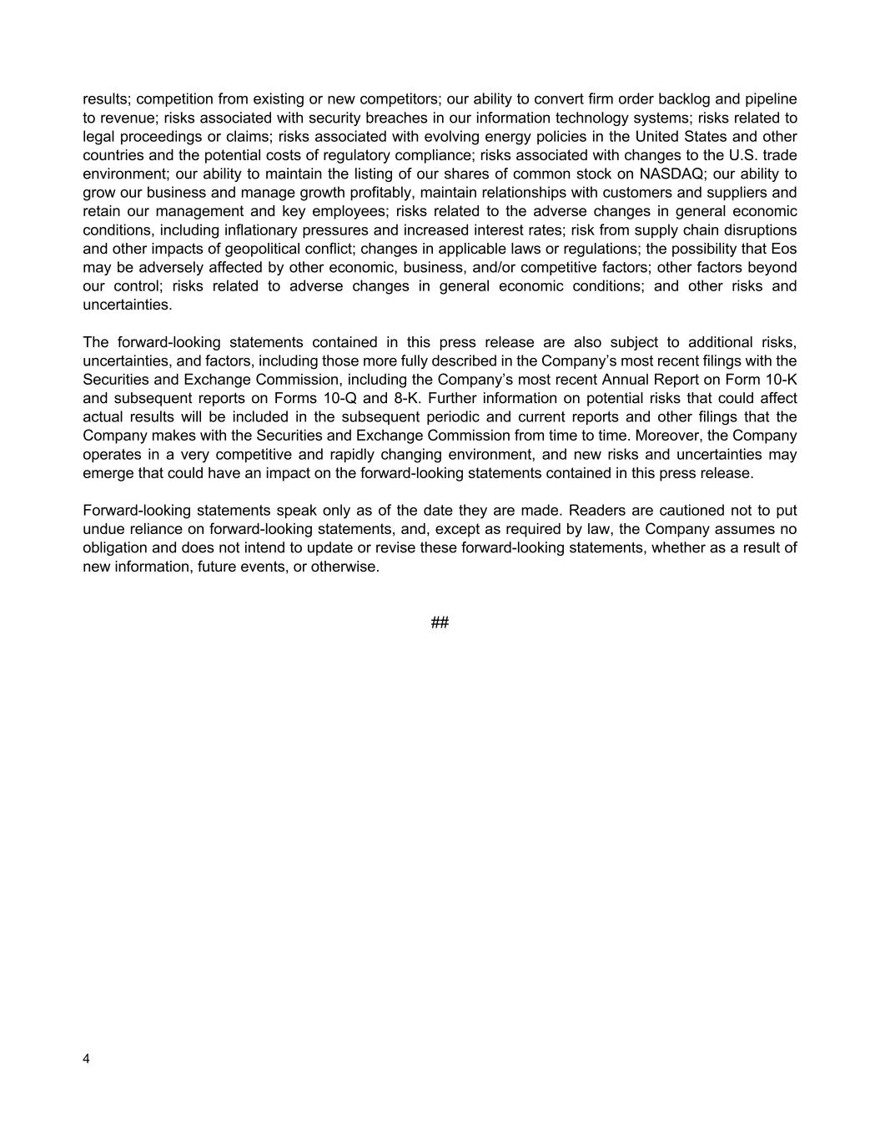
4 results; competition from existing or new competitors; our ability to convert firm order backlog and pipeline to revenue; risks associated with security breaches in our information technology systems; risks related to legal proceedings or claims; risks associated with evolving energy policies in the United States and other countries and the potential costs of regulatory compliance; risks associated with changes to the U.S. trade environment; our ability to maintain the listing of our shares of common stock on NASDAQ; our ability to grow our business and manage growth profitably, maintain relationships with customers and suppliers and retain our management and key employees; risks related to the adverse changes in general economic conditions, including inflationary pressures and increased interest rates; risk from supply chain disruptions and other impacts of geopolitical conflict; changes in applicable laws or regulations; the possibility that Eos may be adversely affected by other economic, business, and/or competitive factors; other factors beyond our control; risks related to adverse changes in general economic conditions; and other risks and uncertainties. The forward-looking statements contained in this press release are also subject to additional risks, uncertainties, and factors, including those more fully described in the Company’s most recent filings with the Securities and Exchange Commission, including the Company’s most recent Annual Report on Form 10-K and subsequent reports on Forms 10-Q and 8-K. Further information on potential risks that could affect actual results will be included in the subsequent periodic and current reports and other filings that the Company makes with the Securities and Exchange Commission from time to time. Moreover, the Company operates in a very competitive and rapidly changing environment, and new risks and uncertainties may emerge that could have an impact on the forward-looking statements contained in this press release. Forward-looking statements speak only as of the date they are made. Readers are cautioned not to put undue reliance on forward-looking statements, and, except as required by law, the Company assumes no obligation and does not intend to update or revise these forward-looking statements, whether as a result of new information, future events, or otherwise. ##

