9

UNITED STATES
SECURITIES AND EXCHANGE COMMISSION
Washington, D.C. 20549
FORM 8-K
CURRENT REPORT
PURSUANT TO SECTION 13 OR 15(d) OF THE
SECURITIES EXCHANGE ACT OF 1934
Date of Report (Date of earliest event reported): October 19, 2026
EOS ENERGY ENTERPRISES, INC.
(Exact name of registrant as specified in its charter)
Delaware |  |  |  |  |  | 001-39291 |  |  |  |  |  | 84-4290188
(State or other jurisdiction  of incorporation) |  |  |  |  |  | (Commission  File Number) |  |  |  |  |  | (IRS Employer  Identification No.)
Two Allegheny Center
Nova Tower 2
Pittsburgh, Pennsylvania 15212
(Address of principal executive offices, including zip code)
Registrant’s telephone number, including area code: (732) 225-8400
N/A
(Former name or former address, if changed since last report)
Check the appropriate box below if the Form 8-K filing is intended to simultaneously satisfy the filing obligation of the registrant under any of the following provisions:
☐ |  |  | Written communications pursuant to Rule 425 under the Securities Act (17 CFR 230.425)
☐ |  |  | Soliciting material pursuant to Rule 14a-12 under the Exchange Act (17 CFR 240.14a-12)
☐ |  |  | Pre-commencement communications pursuant to Rule 14d-2(b) under the Exchange Act (17 CFR 240.14d-2(b))
☐ |  |  | Pre-commencement communications pursuant to Rule 13e-4(c) under the Exchange Act (17 CFR 240.13e-4(c))
Securities registered pursuant to Section 12(b) of the Act:
Title of each class |  |  |  |  |  | Trading Symbol(s) |  |  |  |  |  | Name of each exchange on which registered
Common stock, par value $0.0001 per share |  |  |  |  |  | EOSE |  |  |  |  |  | The Nasdaq Stock Market LLC
Warrant, each whole warrant exercisable to purchase one share of Common Stock at an exercise price of $5.481 |  |  |  |  |  | EOSEW |  |  |  |  |  | The Nasdaq Stock Market LLC
Indicate by check mark whether the registrant is an emerging growth company as defined in Rule 405 of the Securities Act of 1933 (§230.405 of this chapter) or Rule 12b-2 of the Securities Exchange Act of 1934 (§240.12b-2 of this chapter).
Emerging growth company ☐
If an emerging growth company, indicate by check mark if the registrant has elected not to use the extended transition period for complying with any new or revised financial accounting standards provided pursuant to Section 13(a) of the Exchange Act. ☐

1

Item 2.02 Results of Operations and Financial Condition.
On October 19, 2026, the Company issued a press release providing its preliminary results for the quarter ended September 30, 2026 and certain other business updates. A copy of the press release is furnished herewith as Exhibit 99.1.
The information furnished under this Item 2.02 and in the accompanying Exhibit 99.1 shall not be deemed “filed” for purposes of Section 18 of the Securities Exchange Act of 1934, as amended (the “Exchange Act”), or incorporated by reference in any filing under the Securities Act of 1933, as amended, or the Exchange Act regardless of any general incorporation language in such filing, unless expressly incorporated by specific reference in such filing.

Item 7.01 Regulation FD Disclosure.
Item 2.02 above is incorporated herein by reference.
The information furnished under this Item 7.01 and in the accompanying Exhibit 99.1 shall not be deemed “filed” for purposes of Section 18 of the Exchange Act, or incorporated by reference in any filing under the Securities Act of 1933, as amended, or the Exchange Act regardless of any general incorporation language in such filing, unless expressly incorporated by specific reference in such filing.

Item 8.01 Other Events.
Based on preliminary financial information, Eos currently expects:
•Revenue of $82 million to $83 million for the three-month period ended September 30, 2026, driven by a 23% increase in shipments compared to the prior quarter.
•Gross margin loss between 53% and 55%, for the three-month period ended September 30, 2026 reflecting continued progress in manufacturing scale and operational execution. As the Company continues staffing and training employees to support additional shifts on Line 2 at Thorn Hill, Eos expects further margin expansion from higher production volumes, higher capacity utilization, consolidation into one footprint and ongoing cost-reduction initiatives.
•Total Cash, including restricted cash, of approximately $344 million as of September 30, 2026.
•Backlog of approximately $765 million as of September 30, 2026.
These preliminary results for the third quarter ended September 30, 2026 are preliminary and estimated based on the information available to us at this time, and should not be viewed as a substitute for our interim unaudited condensed consolidated financial statements prepared in accordance with GAAP. Actual financial results for the third quarter ended September 30, 2026, may differ materially from the preliminary financial results. Accordingly, you should not place undue reliance on these preliminary results. The preliminary results for the third quarter ended September 30, 2026 have been prepared by and are the responsibility of management. Neither our independent registered public accounting firm, nor any other independent accountants, have audited, reviewed, compiled or performed any procedures with respect to the preliminary results, nor have they expressed any opinion or any other form of assurance with respect thereto.

Item 9.01 Financial Statement and Exhibits.
(d) Exhibits
Exhibit  Number |  |  |  |  |  | Description of Document
99.1 |  |  |  |  |  | Press release of Eos Energy Enterprises, Inc., dated October 19, 2026
104 |  |  |  |  |  | Cover Page Interactive Date File (embedded with the Inline XBRL document).

2

SIGNATURE
Pursuant to the requirements of the Securities Exchange Act of 1934, the registrant has duly caused this report to be signed on its behalf by the undersigned hereunto duly authorized.
 |  |  | EOS ENERGY ENTERPRISES, INC.
Dated: October 19, 2026 |  |  | By: |  |  | /s/ Alessandro Lagi
 |  |  |  |  |  | Name: |  |  | Alessandro Lagi
 |  |  |  |  |  | Title: |  |  | Chief Financial Officer
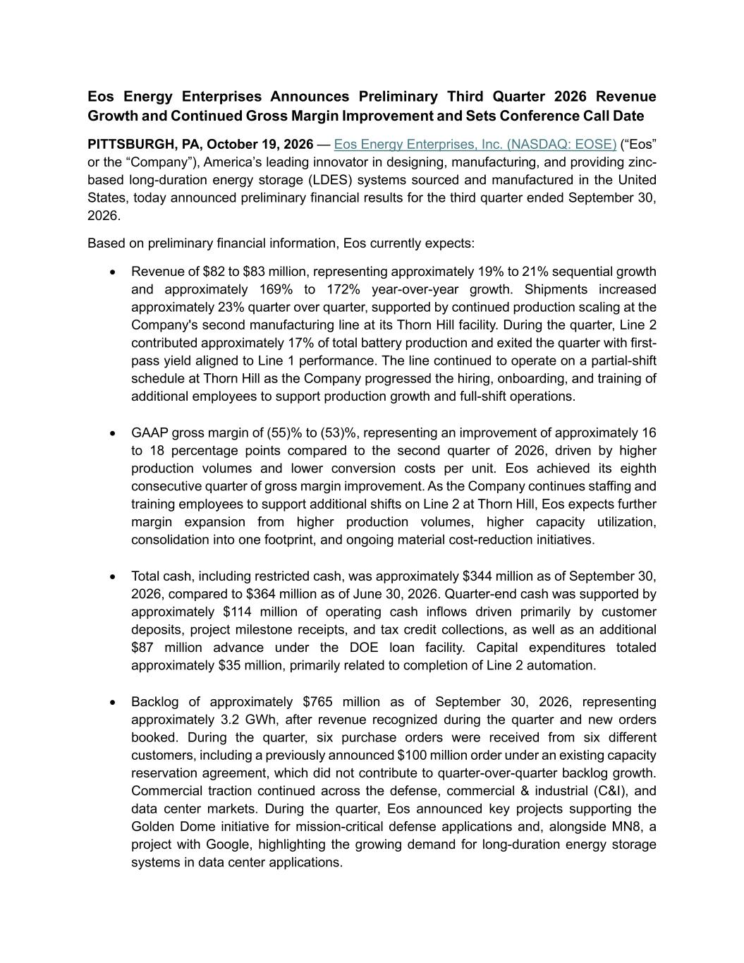
3
Eos Energy Enterprises Announces Preliminary Third Quarter 2026 Revenue Growth and Continued Gross Margin Improvement and Sets Conference Call Date PITTSBURGH, PA, October 19, 2026 — Eos Energy Enterprises, Inc. (NASDAQ: EOSE) (“Eos” or the “Company”), America’s leading innovator in designing, manufacturing, and providing zinc- based long-duration energy storage (LDES) systems sourced and manufactured in the United States, today announced preliminary financial results for the third quarter ended September 30, 2026. Based on preliminary financial information, Eos currently expects: • Revenue of $82 to $83 million, representing approximately 19% to 21% sequential growth and approximately 169% to 172% year-over-year growth. Shipments increased approximately 23% quarter over quarter, supported by continued production scaling at the Company's second manufacturing line at its Thorn Hill facility. During the quarter, Line 2 contributed approximately 17% of total battery production and exited the quarter with first- pass yield aligned to Line 1 performance. The line continued to operate on a partial-shift schedule at Thorn Hill as the Company progressed the hiring, onboarding, and training of additional employees to support production growth and full-shift operations. • GAAP gross margin of (55)% to (53)%, representing an improvement of approximately 16 to 18 percentage points compared to the second quarter of 2026, driven by higher production volumes and lower conversion costs per unit. Eos achieved its eighth consecutive quarter of gross margin improvement. As the Company continues staffing and training employees to support additional shifts on Line 2 at Thorn Hill, Eos expects further margin expansion from higher production volumes, higher capacity utilization, consolidation into one footprint, and ongoing material cost-reduction initiatives. • Total cash, including restricted cash, was approximately $344 million as of September 30, 2026, compared to $364 million as of June 30, 2026. Quarter-end cash was supported by approximately $114 million of operating cash inflows driven primarily by customer deposits, project milestone receipts, and tax credit collections, as well as an additional $87 million advance under the DOE loan facility. Capital expenditures totaled approximately $35 million, primarily related to completion of Line 2 automation. • Backlog of approximately $765 million as of September 30, 2026, representing approximately 3.2 GWh, after revenue recognized during the quarter and new orders booked. During the quarter, six purchase orders were received from six different customers, including a previously announced $100 million order under an existing capacity reservation agreement, which did not contribute to quarter-over-quarter backlog growth. Commercial traction continued across the defense, commercial & industrial (C&I), and data center markets. During the quarter, Eos announced key projects supporting the Golden Dome initiative for mission-critical defense applications and, alongside MN8, a project with Google, highlighting the growing demand for long-duration energy storage systems in data center applications.

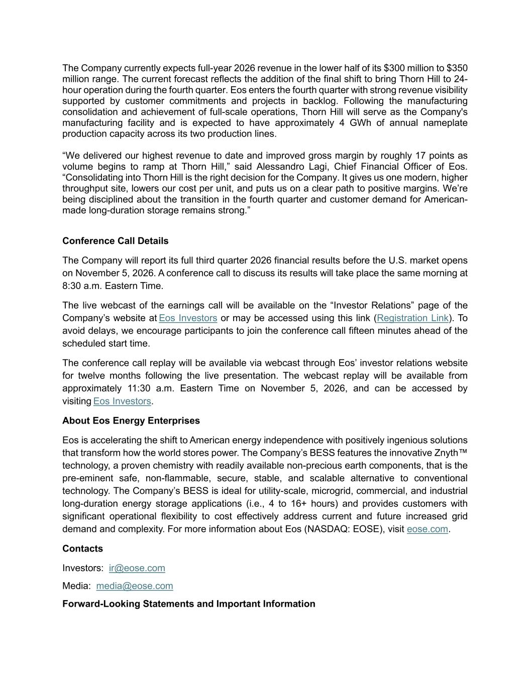
The Company currently expects full-year 2026 revenue in the lower half of its $300 million to $350 million range. The current forecast reflects the addition of the final shift to bring Thorn Hill to 24- hour operation during the fourth quarter. Eos enters the fourth quarter with strong revenue visibility supported by customer commitments and projects in backlog. Following the manufacturing consolidation and achievement of full-scale operations, Thorn Hill will serve as the Company's manufacturing facility and is expected to have approximately 4 GWh of annual nameplate production capacity across its two production lines. “We delivered our highest revenue to date and improved gross margin by roughly 17 points as volume begins to ramp at Thorn Hill,” said Alessandro Lagi, Chief Financial Officer of Eos. “Consolidating into Thorn Hill is the right decision for the Company. It gives us one modern, higher throughput site, lowers our cost per unit, and puts us on a clear path to positive margins. We’re being disciplined about the transition in the fourth quarter and customer demand for American- made long-duration storage remains strong.” Conference Call Details The Company will report its full third quarter 2026 financial results before the U.S. market opens on November 5, 2026. A conference call to discuss its results will take place the same morning at 8:30 a.m. Eastern Time. The live webcast of the earnings call will be available on the “Investor Relations” page of the Company’s website at Eos Investors or may be accessed using this link (Registration Link). To avoid delays, we encourage participants to join the conference call fifteen minutes ahead of the scheduled start time. The conference call replay will be available via webcast through Eos’ investor relations website for twelve months following the live presentation. The webcast replay will be available from approximately 11:30 a.m. Eastern Time on November 5, 2026, and can be accessed by visiting Eos Investors. About Eos Energy Enterprises Eos is accelerating the shift to American energy independence with positively ingenious solutions that transform how the world stores power. The Company’s BESS features the innovative Znyth™ technology, a proven chemistry with readily available non-precious earth components, that is the pre-eminent safe, non-flammable, secure, stable, and scalable alternative to conventional technology. The Company’s BESS is ideal for utility-scale, microgrid, commercial, and industrial long-duration energy storage applications (i.e., 4 to 16+ hours) and provides customers with significant operational flexibility to cost effectively address current and future increased grid demand and complexity. For more information about Eos (NASDAQ: EOSE), visit eose.com. Contacts Investors: ir@eose.com Media: media@eose.com Forward-Looking Statements and Important Information

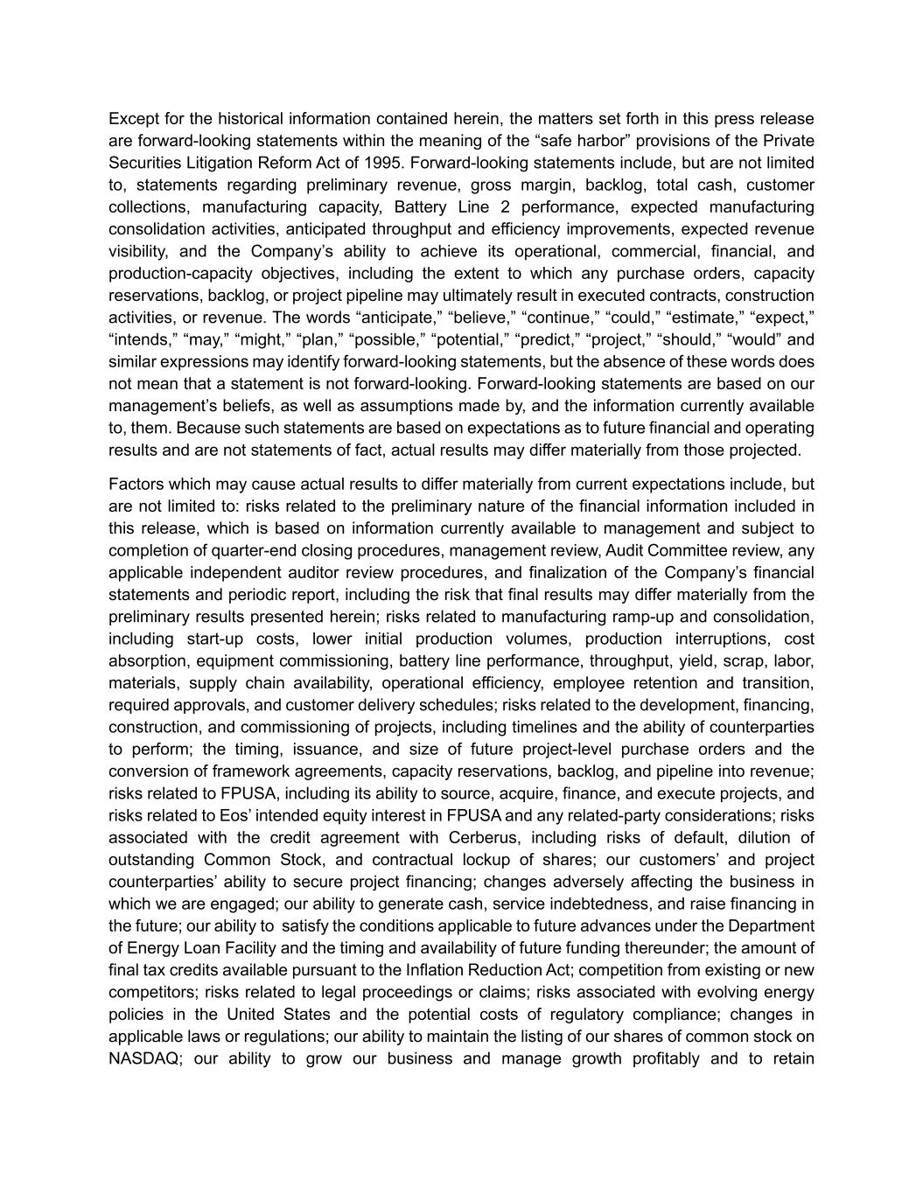
Except for the historical information contained herein, the matters set forth in this press release are forward-looking statements within the meaning of the “safe harbor” provisions of the Private Securities Litigation Reform Act of 1995. Forward-looking statements include, but are not limited to, statements regarding preliminary revenue, gross margin, backlog, total cash, customer collections, manufacturing capacity, Battery Line 2 performance, expected manufacturing consolidation activities, anticipated throughput and efficiency improvements, expected revenue visibility, and the Company’s ability to achieve its operational, commercial, financial, and production-capacity objectives, including the extent to which any purchase orders, capacity reservations, backlog, or project pipeline may ultimately result in executed contracts, construction activities, or revenue. The words “anticipate,” “believe,” “continue,” “could,” “estimate,” “expect,” “intends,” “may,” “might,” “plan,” “possible,” “potential,” “predict,” “project,” “should,” “would” and similar expressions may identify forward-looking statements, but the absence of these words does not mean that a statement is not forward-looking. Forward-looking statements are based on our management’s beliefs, as well as assumptions made by, and the information currently available to, them. Because such statements are based on expectations as to future financial and operating results and are not statements of fact, actual results may differ materially from those projected. Factors which may cause actual results to differ materially from current expectations include, but are not limited to: risks related to the preliminary nature of the financial information included in this release, which is based on information currently available to management and subject to completion of quarter-end closing procedures, management review, Audit Committee review, any applicable independent auditor review procedures, and finalization of the Company’s financial statements and periodic report, including the risk that final results may differ materially from the preliminary results presented herein; risks related to manufacturing ramp-up and consolidation, including start-up costs, lower initial production volumes, production interruptions, cost absorption, equipment commissioning, battery line performance, throughput, yield, scrap, labor, materials, supply chain availability, operational efficiency, employee retention and transition, required approvals, and customer delivery schedules; risks related to the development, financing, construction, and commissioning of projects, including timelines and the ability of counterparties to perform; the timing, issuance, and size of future project-level purchase orders and the conversion of framework agreements, capacity reservations, backlog, and pipeline into revenue; risks related to FPUSA, including its ability to source, acquire, finance, and execute projects, and risks related to Eos’ intended equity interest in FPUSA and any related-party considerations; risks associated with the credit agreement with Cerberus, including risks of default, dilution of outstanding Common Stock, and contractual lockup of shares; our customers’ and project counterparties’ ability to secure project financing; changes adversely affecting the business in which we are engaged; our ability to generate cash, service indebtedness, and raise financing in the future; our ability to satisfy the conditions applicable to future advances under the Department of Energy Loan Facility and the timing and availability of future funding thereunder; the amount of final tax credits available pursuant to the Inflation Reduction Act; competition from existing or new competitors; risks related to legal proceedings or claims; risks associated with evolving energy policies in the United States and the potential costs of regulatory compliance; changes in applicable laws or regulations; our ability to maintain the listing of our shares of common stock on NASDAQ; our ability to grow our business and manage growth profitably and to retain

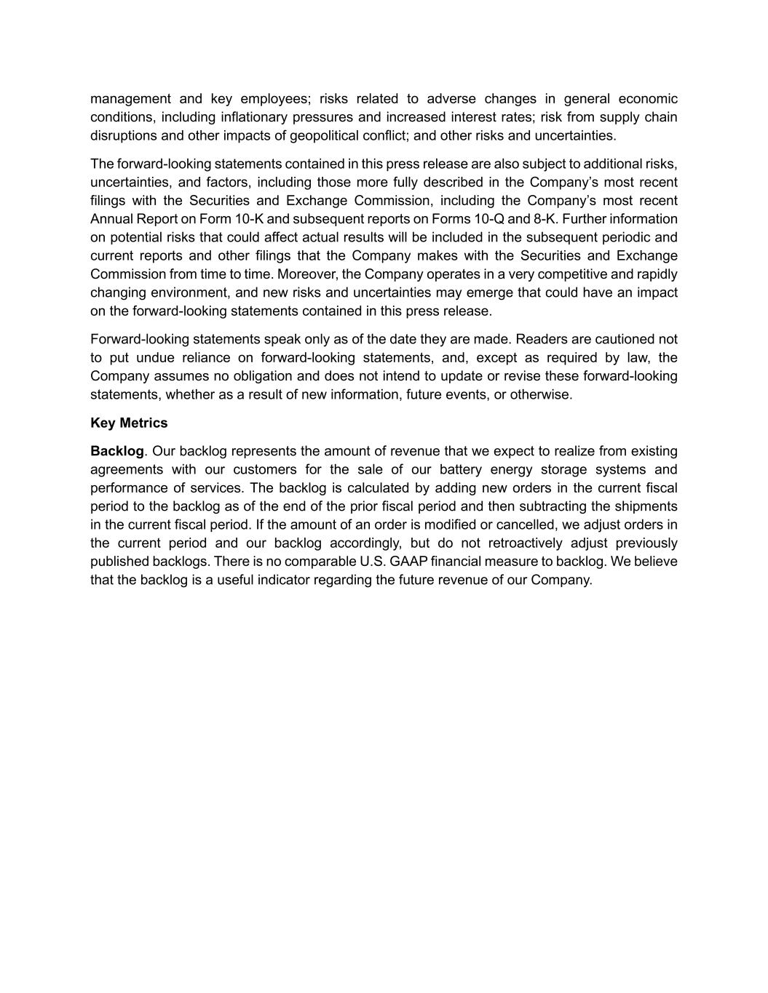
management and key employees; risks related to adverse changes in general economic conditions, including inflationary pressures and increased interest rates; risk from supply chain disruptions and other impacts of geopolitical conflict; and other risks and uncertainties. The forward-looking statements contained in this press release are also subject to additional risks, uncertainties, and factors, including those more fully described in the Company’s most recent filings with the Securities and Exchange Commission, including the Company’s most recent Annual Report on Form 10-K and subsequent reports on Forms 10-Q and 8-K. Further information on potential risks that could affect actual results will be included in the subsequent periodic and current reports and other filings that the Company makes with the Securities and Exchange Commission from time to time. Moreover, the Company operates in a very competitive and rapidly changing environment, and new risks and uncertainties may emerge that could have an impact on the forward-looking statements contained in this press release. Forward-looking statements speak only as of the date they are made. Readers are cautioned not to put undue reliance on forward-looking statements, and, except as required by law, the Company assumes no obligation and does not intend to update or revise these forward-looking statements, whether as a result of new information, future events, or otherwise. Key Metrics Backlog. Our backlog represents the amount of revenue that we expect to realize from existing agreements with our customers for the sale of our battery energy storage systems and performance of services. The backlog is calculated by adding new orders in the current fiscal period to the backlog as of the end of the prior fiscal period and then subtracting the shipments in the current fiscal period. If the amount of an order is modified or cancelled, we adjust orders in the current period and our backlog accordingly, but do not retroactively adjust previously published backlogs. There is no comparable U.S. GAAP financial measure to backlog. We believe that the backlog is a useful indicator regarding the future revenue of our Company.

